Please adjust your screen reader settings to recognize underline and strikethrough text.

Aesthetics and Visual Resources
This section evaluates the potential for implementation of the proposed CalVTP to affect aesthetic and visual resources. It describes the visual environments found in the treatable landscape and the nature of potential impacts that could occur to visual resources as a result of treatment activities. This section also examines potential impacts related to light and glare. Information used in this section was obtained from resource data compiled by CAL FIRE and widely used visual assessment guidelines.
Comments on the Notice of Preparation related to aesthetics and visual resources requested coordination with the California Department of Transportation (Caltrans) when tree removal or trimming within a state scenic highway is proposed (see Appendix A). Impacts related to scenic resources in or along state scenic highways are addressed in Section 3.2.3, “Impacts and Mitigation Measures,” below.

Environmental Setting

General Methodology for Visual Impact Analysis
When evaluating the impacts of vegetation treatments on the visual environment, the focus is on three overarching parameters: existing visual conditions; how these would be altered by implementing a treatment; and the significance of the change on scenic qualities of the landscape and publicly available viewpoints. Visual resources considered in an evaluation include those features in the natural and cultural landscapes that comprise the visible world and contribute to a person‘s understanding of and reaction to the scene before them. Visual resources include both natural elements, such as topography, vegetation, and water, and constructed features, such as earthworks, roads, and structures.
Two basic factors involved in determining a visual impact are (1) the susceptibility of the setting to impact based on its existing characteristics and (2) the degree of visible change anticipated as a result of a treatment. These two factors are identified respectively as visual sensitivity (of the setting and viewers) and landscape change (due to the treatment) that is visible from public viewpoints.
This visual analysis considers visual quality, viewer concern, visibility, number of viewers, and duration of view. These are ranked as being high to low. These and other elements of the visual analysis methodology are described below.
Visual quality is an expression of the visual impression or appeal of a given landscape and the associated public value attributed to the resource. A high rating is generally reserved for landscapes viewers might describe as picture-perfect. Landscapes rated high generally are memorable because of the way the components combine in a visual pattern. In addition, those landscapes are free from encroaching elements that would compromise the landscapes’ visual integrity. In contrast, landscapes rated low often are dominated by visually discordant alterations that have been introduced by humans. Visual quality is evaluated using the approach to visual analysis adopted by the Federal Highway Administration and Caltrans, employing the concepts of vividness, intactness, and unity.
- Vividness: The extent to which the landscape is memorable. This is associated with the distinctiveness, diversity, and contrast of visual elements. A vivid landscape makes an immediate and lasting impression on the viewer.
- Intactness: The integrity of “visual order” in the landscape, which is the extent to which the natural landscape is free from visual intrusions. If all the various elements of a landscape appear to "belong" together, there will be a high level of intactness.
- Unity: The extent to which visual intrusions are sensitive to and in visual harmony with the natural landscape. Unity, in other words, represents the degree to which the visual elements maintain a coherent visual pattern.
Visual quality is evaluated based on the relative degree of vividness, intactness, and unity, as modified by its visual sensitivity. High quality views are highly vivid, relatively intact, and exhibit a high degree of visual unity.
Viewer sensitivity represents the reaction of a viewer to landscape changes in the viewshed (defined as the area visible from a fixed vantage point). For example, viewers have a high expectation for scenic quality of areas designated as a scenic area, scenic travel corridor, park, open space, recreational, and residential areas. Travelers on non-scenic highways and roads generally have moderate viewer concerns and expectations. Viewer sensitivity is lower for more heavily urbanized, non-residential areas, such as commercial or industrial uses.
Viewer exposure is a function of three elements: visibility, number of viewers, and duration of view. These elements are described below:
- Visibility is a measure of how well an object or site can be seen. It depends on the angle or direction of the view; extent of visual screening; and the topographical relationship between the object or site and existing vantage points. Visibility is determined by considering any obstructions that may be in the sightline, such as trees and other vegetation, buildings, landforms, and haze or fog. Distance becomes a factor; with increasing distance from the viewer, objects become less prominent in the view and less clearly distinguishable.
- Number of viewers is a measure of the number of viewers per day who would have a view of the proposed activity. As indicated in Appendix G of the State CEQA Guidelines, visual analysis focuses on public viewpoints, which emphasize locations with higher numbers of accessible viewers (as opposed to private views, such as residential viewers).
- Duration of view is the amount of time available to view the site or activity. For example, a high or extended view of a site may be 2 minutes or longer. In contrast, a low or brief duration of view occurs in a short amount of time — generally less than 10 seconds. For stationary locations, such as public vista points, the duration is extended. For travelers on a highway, the duration may be very short.
Visual Change is a function of contrast, dominance, and view blockage or disruption. Contrast and dominance contribute more to the degree of visual change than view disruption.
- Contrast concerns the degree to which a treatment’s visual characteristics or elements — such as its form, line, color, and texture — differ from the same visual elements in the existing landscape. The degree of contrast can range from low to high. A treatment resulting in forms, lines, colors, and textures similar to those of the existing landscape is more readily visually absorbed. When characteristics or elements are similar to those of the existing condition, a treatment or treated site is more capable of being accepted in the landscape as compared to a landscape in which similarities are absent. Generally, visual absorption is inversely proportional to visual contrast.
- Dominance is a measure of the proportion of the total field of view occupied by a treatment, a feature’s apparent size relative to other visible landscape features, and the conspicuousness of the feature due to its location or position in the view. A feature’s level of dominance is lower in a panoramic setting than in an enclosed setting with a focus on the feature itself. As the distance between a viewer and a feature increases, its apparent size decreases, decreasing its dominance. Objects seen against the sky are more prominent or dominant than objects viewed against trees, landforms, and buildings.
- View blockage is concerned with the extent to which previously visible landscape features become blocked from view. View disruption also occurs when view continuity is interrupted, such as when a treatment might break the line of a sweeping vista.

Scenic Views and Vistas
A scenic view is a high-quality visual environment experienced beyond an observer’s immediate surroundings. Scenic views are often available along trails and roads. For a hiker or roadway traveler, a scenic view would not include only the trail or road, but also the terrain immediately surrounding the trail or road.
Scenic vistas are broad, long-range scenic views that can be described as panoramic and having exceptional landscape-scale scenic quality. Sometimes, scenic vistas are recognized by public agencies through designation with protective policies in land management plans or placement of special destinations for viewers, such as an elevated vista point.

Affected environment
The treatable landscape comprises multiple counties and includes a variety of landscapes that present a wide assortment of visual conditions. These range from areas having few landforms or structures and little vegetation that would limit viewing distances (such are found in large expanses of open grasslands or chaparral), to heavily forested areas where trees and other vegetation limit viewing distances, to areas with a heterogeneous mix of development, open space, vegetation, and topography that may or may not limit viewing distances (such as in suburban communities, foothills, and Coastal Ranges valleys).
As described in Section 2.4.1 “Vegetation Formations,” in Chapter 2, three broad categories of vegetation (also called “fuel types”) comprise the treatable landscape: tree, shrub, and grass. However, the treatable landscape is in varied geomorphic and ecological regions throughout the SRA in California; therefore, the visual setting of the treatable landscape varies widely. The treatable landscape is in mountainous areas, valleys, along coastlines, near sandy beaches, and near urban areas. Some areas within the treatable landscape have ocean views; some have lake views; some have mountain views; and some have expansive views from hilltops, ridgelines, and mountaintops (refer to Figure 3.2-1). Because the treatable landscape exhibits such a diverse visual setting, it is not feasible to attempt to describe every specific visual resource contained within it. Instead, this environmental setting discussion focuses on two general aspects of visual resources: scenic views (generally panoramic, but sometimes more limited views, either of a notable feature or sweeping landscape) and visual character (defining features of a place, such as trees and other flora, water and other geologic features, and cultural features).
Treatment activities currently occur within the treatable landscape and are occasionally visible to public viewers. As described in Chapter 1, “Introduction” and Section 2.3.1, “Past and Current Treatments,” vegetation treatment currently occurs around the state under several other wildfire risk reduction programs implemented by various federal, state, and local agencies. In 2017–2018, CAL FIRE treated approximately 33,000 acres in California using the same treatment activities as proposed under the CalVTP.

Scenic Views
As previously described, scenic views are the visual environment experienced beyond an observer’s immediate surroundings and are often available along trails and roads. For a hiker or motorist traveling along a scenic corridor, a scenic view would not include only the trail or road, or the terrain immediately surrounding the trail or road, but any high-quality, more distant, often panoramic view. Caltrans Scenic Highway Program identifies over 60 officially designated scenic routes in California; some of these scenic routes pass through the treatable landscape. With respect to the treatable landscape, there are many more scenic views apart from those visible from a State Scenic Highway, including scenic vistas, which are often a trail user’s destination. Refer to Figure 3.14-1 in Section 3.14, “Recreation,” and Figure 3.2-2 herein for visual representations of recreation areas and state scenic highways in proximity to the treatable landscape.
Because the treatable landscape encompasses large areas of undeveloped land, it is common for scenic views of and within the SRA to exhibit substantial scenic quality with high levels of vividness, intactness, and unity. Landscape characteristics are diverse, distinctive, and naturally attractive. Scenic views of the treatable landscape in most areas generally exhibit high scenic quality. Figure 3.2-1 illustrates the types of scenic views available within and in the vicinity of the treatable landscape as well as examples of the diverse landscape characteristics and scenic views of the treatable landscape. These photographs illustrate the wide range of views available in the vicinity of the treatable landscape and scenic landscapes in the treatable landscape, from prominent ridgelines often forming the edges of a viewshed for a community, trail, or public vista point; to expansive rolling hillsides stretching as far as the eye can see.
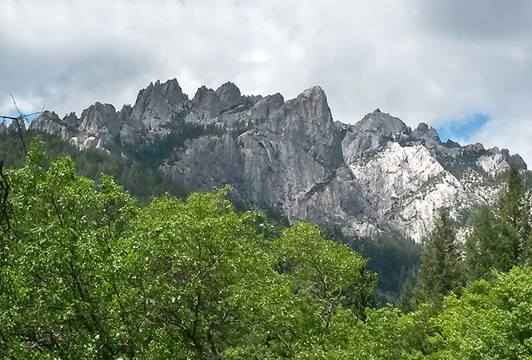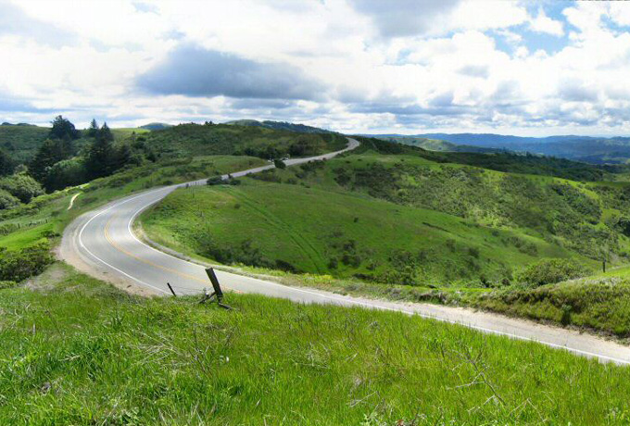
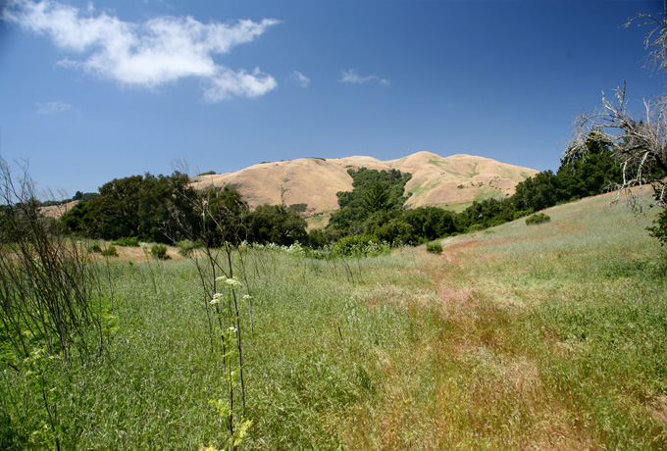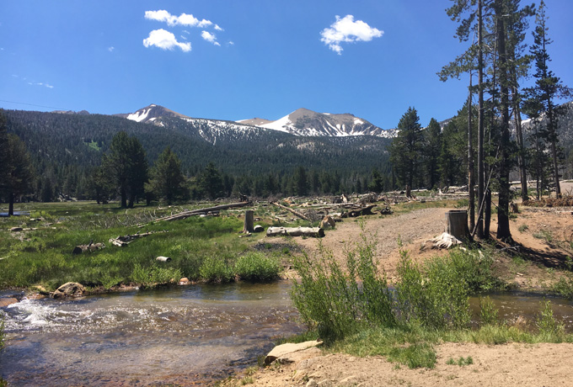
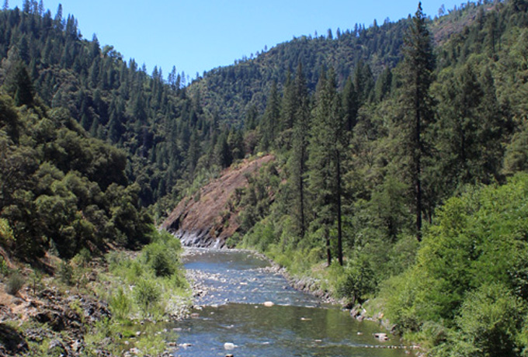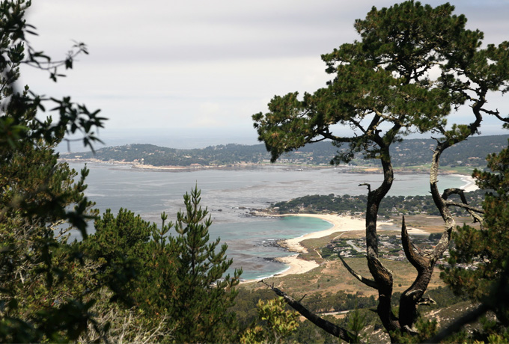
Figure 3.2-1 Examples of Scenic Views in the Vicinity of the Treatable Landscape
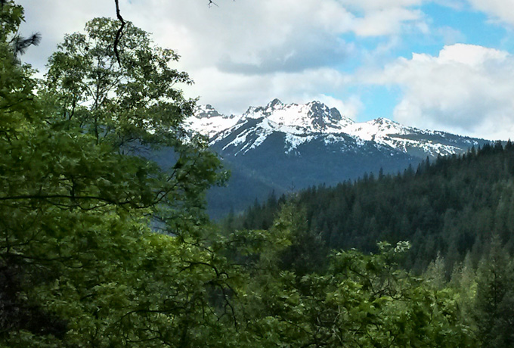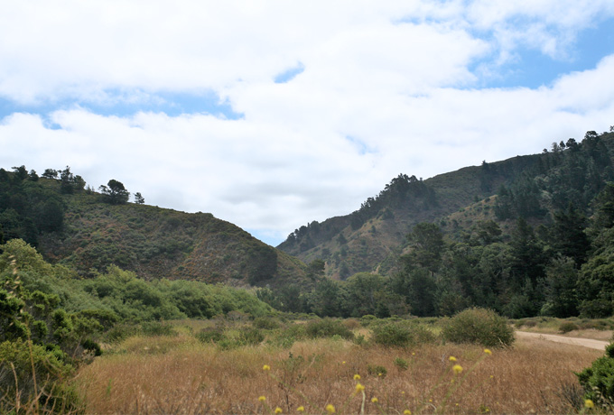
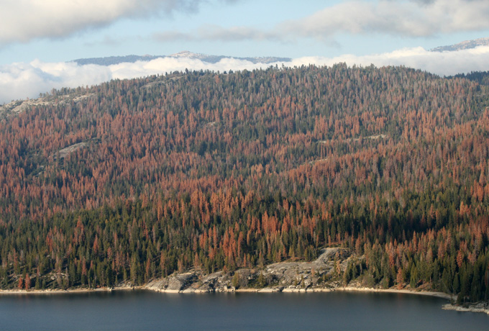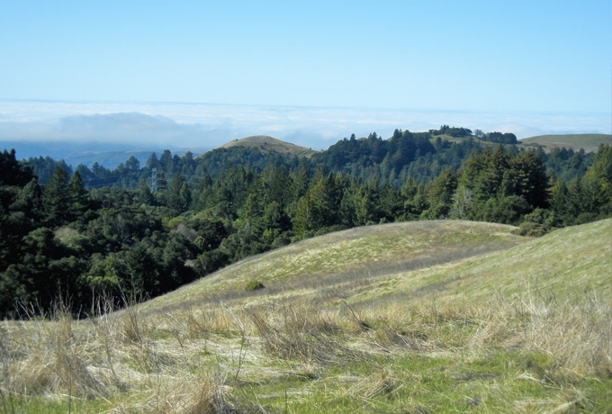
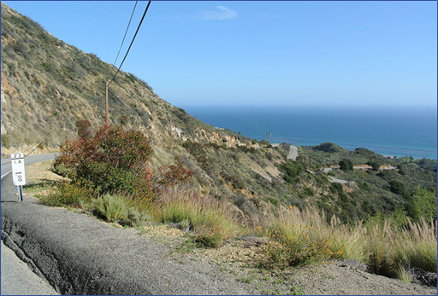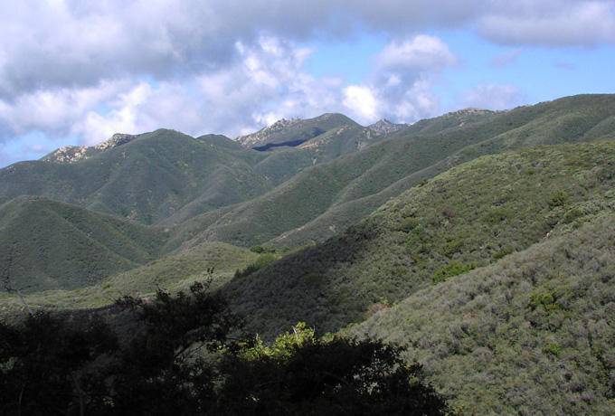
Figure 3.2-1 Examples of Scenic Views in the Vicinity of the Treatable Landscape (continued)
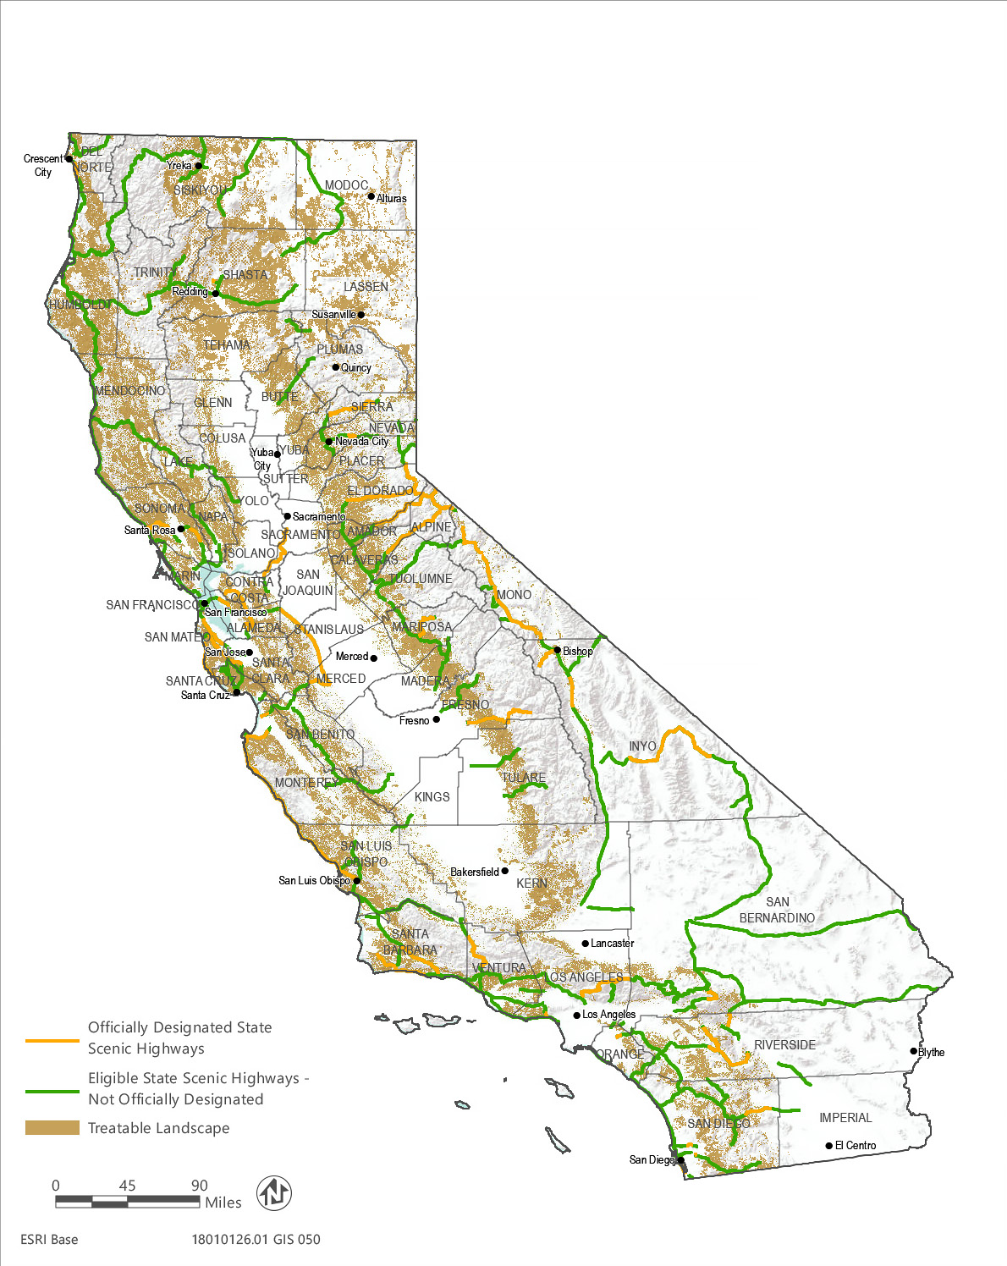
Source: Data downloaded from Caltrans in 2015 and received from the Department of Forestry and Fire Protection in 2019
Figure 3.2-2 State Scenic Highways in the Vicinity of the Treatable Landscape
Generally, views of the different fuel types differ as the elements that comprise the vegetation differ in stand height, relative bulk, form, color, and other visual characteristics. Grass fuel types tend to be low to the ground and thus do not impede long-range views. Grass fuel types are typically uniform in color, and often appear green or light brown with varying textures from smooth to rough and patchy. Shrub fuel types are taller than grass and may partially obscure views but often still allow for long-range views. They vary in color from shades of greens to shades of brown and tend to be rough looking in texture with many sharp edges, and can also be patchy in places. Depending on the density of trees, tree fuel types can completely obscure views out of the immediate forest viewshed, or can only partially obscure potions of a viewshed. They typically vary in shades of green and brown; however, leaves may appear in yellows and reds during autumn months. Tree dominated views tend to be dominated by the vertical shapes of trees, which can result in sharp looking treetop lined views from afar, or several lines of vertical tree trunks with intermixed greenery and horizontal branches in dense forests. Refer to Figure 3.2-3 for example photos of the grass, shrub, and tree fuel types.
Because of the geographically expansive nature of the treatable landscape, views of the treatable landscape are available to a variety of public viewer groups, including motorists, trail users, and recreationists, all with varying degrees of viewer sensitivity from low (e.g., commuting motorists) to high (e.g., recreationists).

Visual Character and Quality
Most of the treatable landscape is privately owned; however, portions are under the jurisdiction of local and regional agencies and conservation groups as park, open space, and recreation areas. Because of the varied landscape characteristics across the treatable landscape, existing visual character and quality of developed and undeveloped private lands and public lands managed as parks and open space is characterized in the following sections.

Private Lands
Portions of the treatable landscape across private lands are adjacent to developed areas, including residential communities, commercial and industrial parks, roadways, and freeways and highways. Residences and other buildings, roadways, transmission lines, and urban infrastructure are in some more developed areas of the treatable landscape. These are encroaching elements that have been constructed and can be visually discordant with the natural environment. The visual character in and adjacent to developed areas is defined by patches of varied greenery and small rolling hills with intervening disruptions such as paved transportation corridors, transportation related signage, wood and metal and fencing, linear vertical and horizontal elements such as overhead transmission lines, stop lights, streetlights, and buildings (refer to Figure 3.2-4). Therefore, colors and shapes are varied, including shades of green, brown, gray, silver, red, white, and yellow. Given the variety of colors, shapes, and patterns and presence of intervening urban elements, vividness, intactness, and unity of views in these areas tends to be low to moderate. Overall, visual character and quality are low to moderate.
Other portions of private lands in the treatable landscape are undeveloped and rural in nature. These areas are composed of dense forests, grasslands, and other vegetation and generally have little urban intrusion. Because these undeveloped areas are on private lands, no public access is permitted, and few trails or roadways are present. The visual character of the treatable landscape across private, undeveloped lands is defined by a variety of colors, textures, and patterns, including smooth rolling hills, large trees and dark forests, and natural colors in varying shades of greens, browns, grays, and blues (refer to Figure 3.2-5). Although some residences, water tanks, equipment, and other signs of rural development and infrastructure may be present and contrast with the natural elements of the treatable landscape, there is generally little urban intrusion relative to the expanse of natural areas. For these reasons, private, undeveloped areas of the treatable landscape tend to exhibit high vividness, intactness, and unity as they primarily remain in their natural form with little human alteration. Overall, visual character and quality are considered moderate to high.
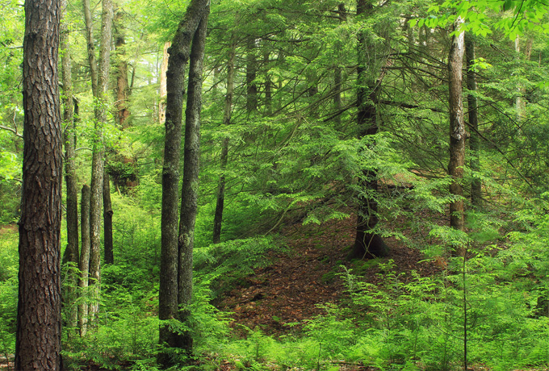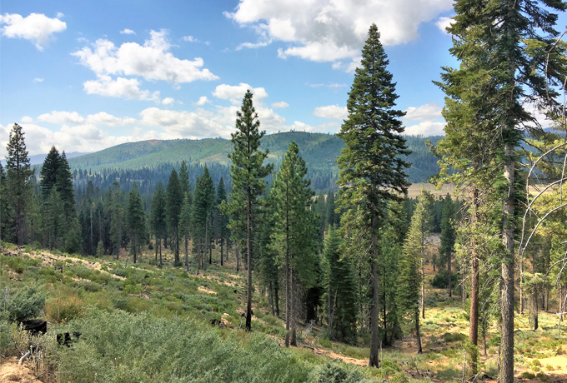
Examples of tree fuel types.
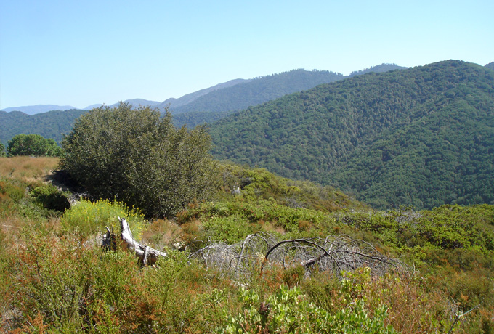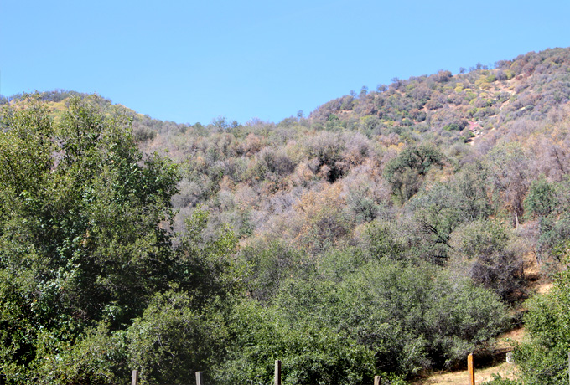
Examples of shrub fuel types.
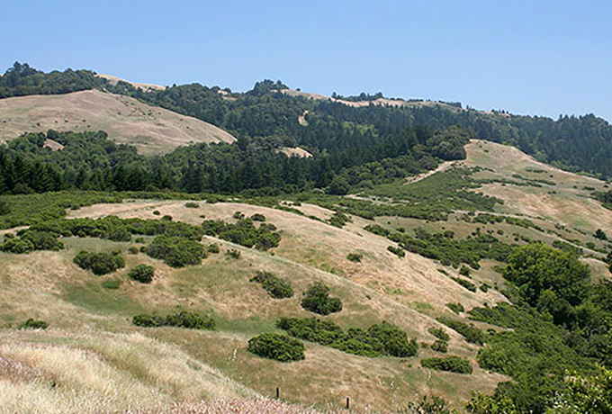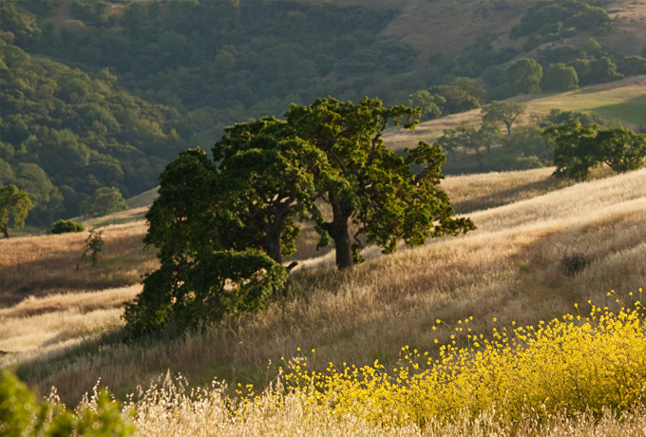
Examples of grass fuel types.
Figure 3.2-3 Examples of Tree, Shrub, and Grass Fuel Types in the Treatable Landscape
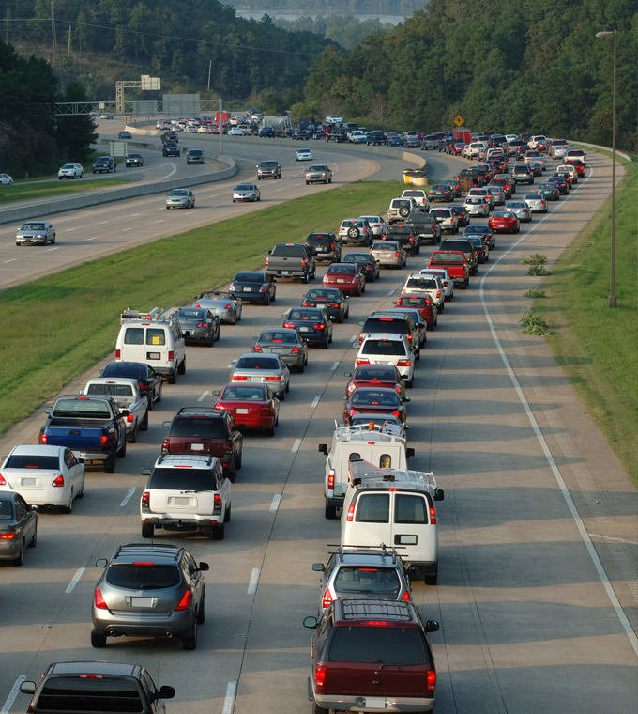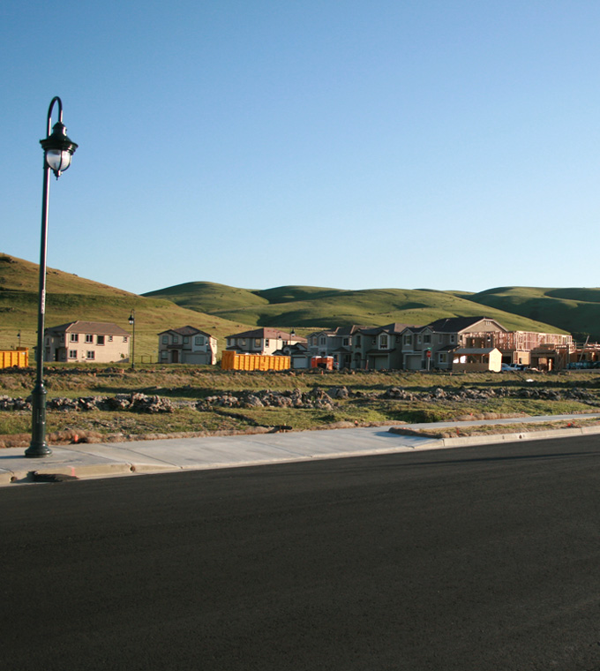
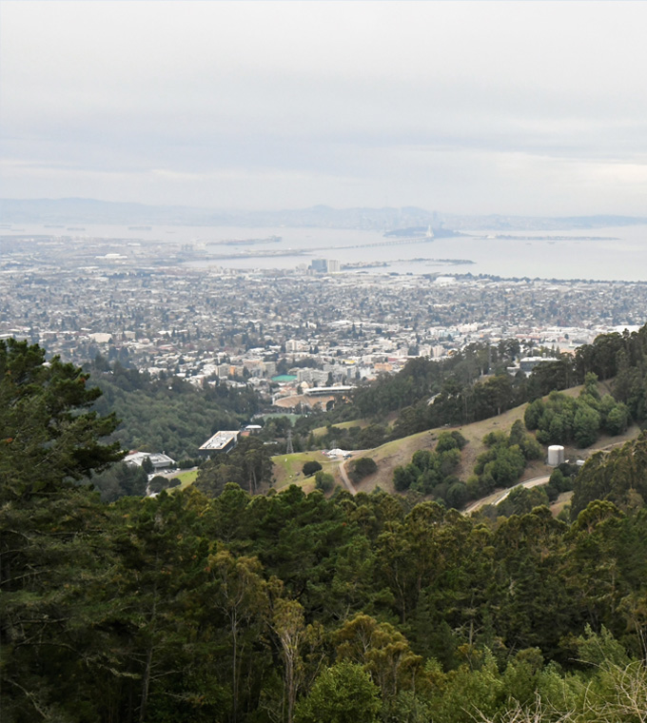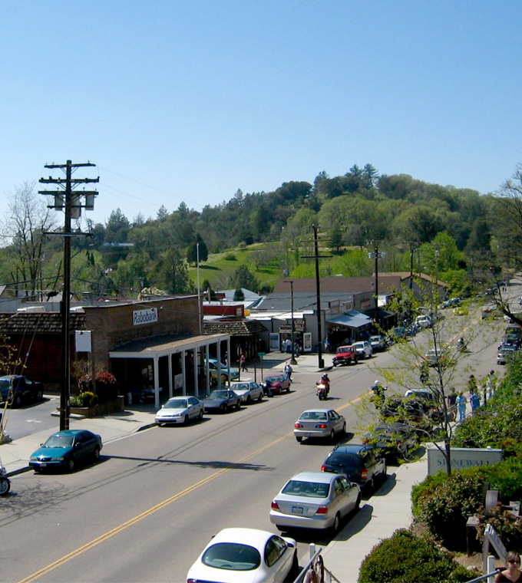
Figure 3.2-4 Examples of Development in the Vicinity of the Treatable Landscape
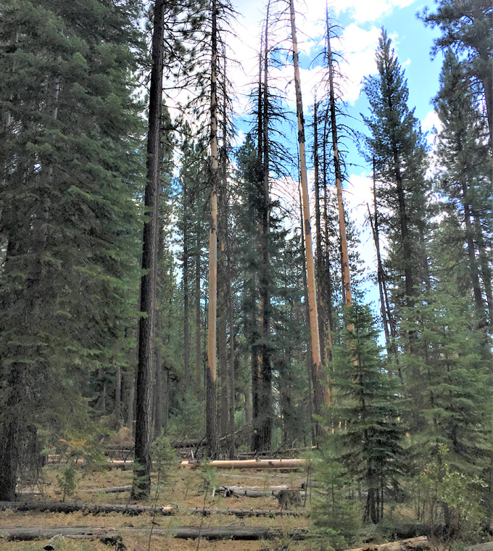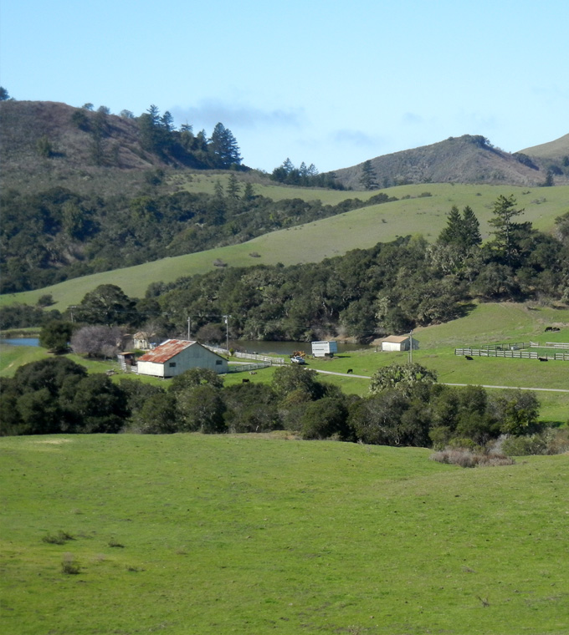
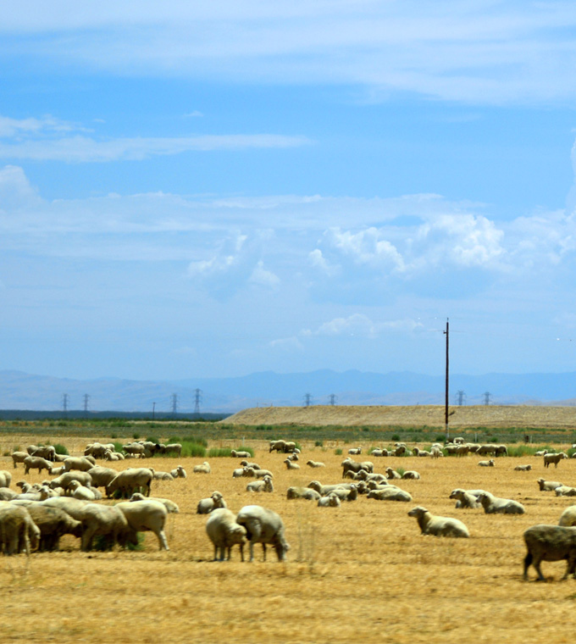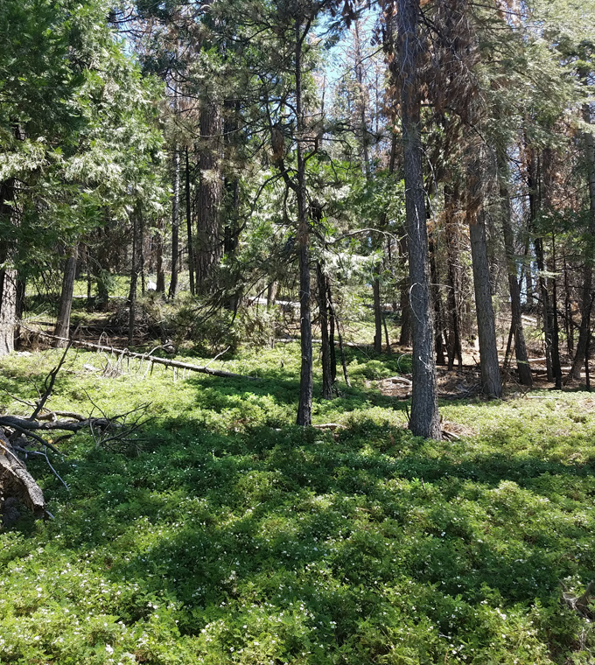
Figure 3.2-5 Examples of Rural Private Lands in the Vicinity of the Treatable Landscape

Public Lands
In public parks and open space areas, the visual character of roads and trails tend to be high quality, crossing remote and sometimes more pristine settings, particularly if a trail provides access to a scenic destination. The visual character of the treatable landscape across public lands is defined by a variety of colors, textures, and patterns, including smooth rolling hills, patterns of mountain top and tree-lined skylines, prominent ridgelines, sharp rocky outcroppings, dense and dark forests, visually captivating waterfalls, and natural colors in varying shades of greens, browns, grays, and blues (refer to Figures 3.2-1 and 3.2-6). Although some utility lines, roads, park buildings, water tanks, and other development and infrastructure may be present and contrast with the treatable landscape, they are typically most prevalent near a park entrance and public parking areas. Once inside a park and hiking or engaging in some other type of recreation, there is generally little urban intrusion relative to the expanse of natural areas, although vegetation treatments do occur under existing conditions and equipment may be visible when actively occurring. However, because of the undeveloped and often pristine nature of the treatable landscape in these areas, views are generally highly vivid, relatively intact, and exhibit a high degree of visual unity. Overall, visual character and quality in public parks and open space areas are high.

Light and Glare
For the purposes of this analysis, light refers to unnatural nighttime lighting, which may intrude into sky darkness when added to an area that currently contains little or no artificial lighting (also known as light pollution). Glare refers to unnatural light or reflected natural light that can be annoying or distracting. Lighting and glare levels tend to be much lower in undeveloped areas of the treatable landscape particularly as these areas occur further from developed areas. Lighting and glare are also lower near most trails and forested areas. Because the treatable landscape is in natural and vegetated areas, no substantial light or glare is currently generated from these areas. Urban areas in the vicinity of the treatable landscape contain varied light sources, such as street lights, car head lights, and in more urbanized areas, sky glow may be present (sky glow is an area-wide illumination of the night sky from human-made light sources). Particularly within or near the WUI, light, glare, and urban sky-glow may be visible from the treatable landscape.
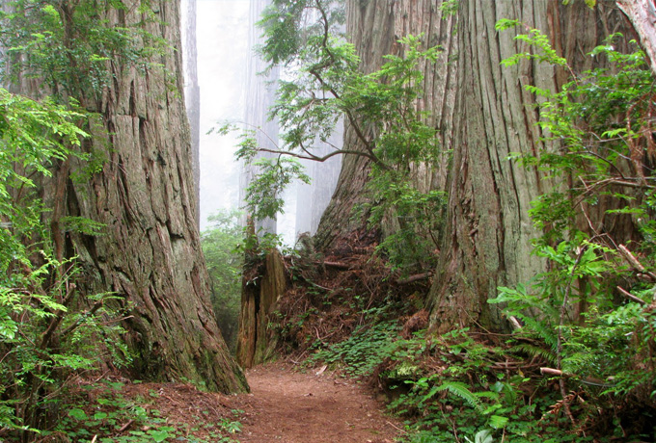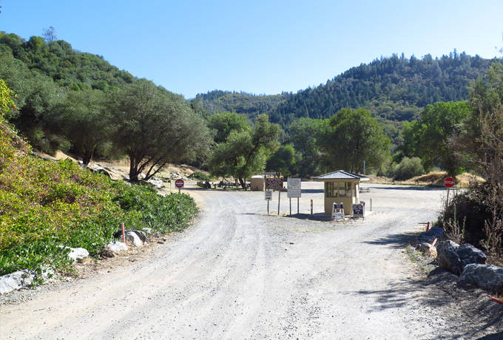
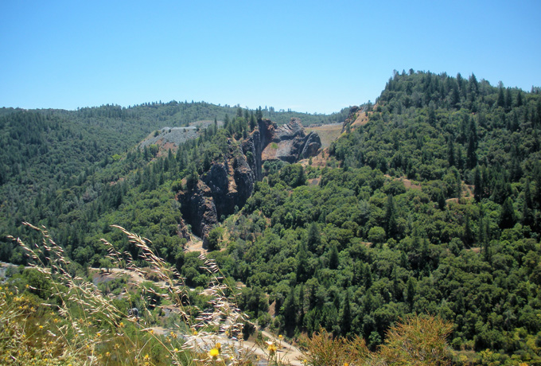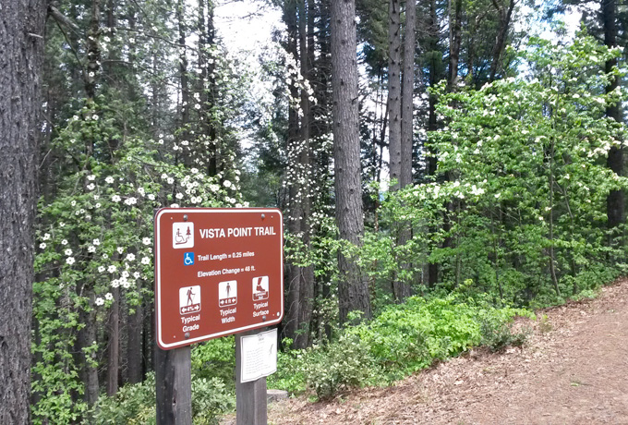
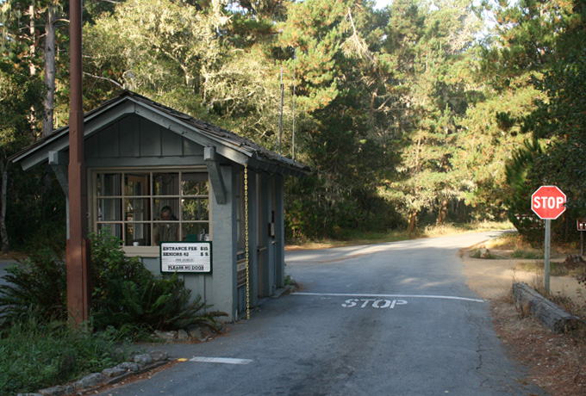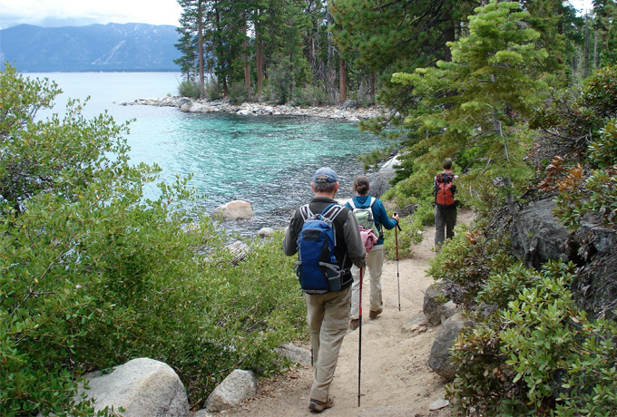
Figure 3.2-6 Examples of Public Lands in the Vicinity of the Treatable Landscape

Regulatory Setting

State

California State Scenic Highway Program
Created by the Legislature in 1963, the California Scenic Highway Program preserves and protects areas of natural scenic beauty of State highways and adjacent corridors. A highway may be designated as scenic depending upon how much of the natural landscape can be seen by travelers, the scenic quality of the landscape, and the extent to which development intrudes upon the travelers’ enjoyment of the view (Caltrans 2017).
For a highway to be officially designated as a scenic resource, the local city or county must adopt a scenic corridor protection program and apply to Caltrans for official designation (Caltrans 2017). Without official designation and the attendant scenic corridor protection program, development and other activities can degrade scenic value despite the highway’s “eligible” designation. Thus, the fact that a highway was at one time deemed eligible for the scenic highway designation does not mean that it retains its original scenic value. Implementation of treatments under the CalVTP would require compliance with this program if treatments occur within and would affect vegetation within a state scenic highway.

California Coastal Act
Section 30251 of the Coastal Act sets forth the Act’s aesthetic requirements. Under Section 30251, the scenic qualities of coastal areas must be considered and protected in the development process. Permitted development must be located and designed to protect the scenic and visual qualities of coastal areas. This includes protecting views to and along the ocean and scenic coastal areas, matching the visual character of surrounding areas, and, where feasible, restoring and enhancing visual quality in visually degraded areas. Pursuant to the Coastal Act, cities and counties within the Coastal Zone must develop local coastal plans, which, at a minimum, must be as protective and otherwise consistent with Coastal Act standards. Portions of the treatable landscape lie within the Coastal Zone, and treatment activities may be subject to Coastal Act or local coastal plan requirements in these areas, as applicable.

California Wild and Scenic Rivers Act
The California Wild and Scenic Rivers Act (Public Resources Code Sec. 5093.50 et seq.) was passed in 1972 to preserve California’s designated rivers possessing extraordinary scenic, recreation, fishery, or wildlife values. This act was patterned after the 1968 National Wild and Scenic Rivers Act, and both share similar criteria and definitions regarding the protection of rivers, the process used to designate rivers, and in the prohibition of new water impoundments on designated rivers. Unlike the national act, the California Wild and Scenic Rivers Act provides protection only up to the first line of permanent vegetation and does not require a management plan for designated rivers. The California Legislature is responsible for classifying or reclassifying rivers by statute, though the Resources Secretary may recommend classifications. State designated rivers may be added to the federal system upon the request of the state Governor and the approval of the Secretary of the Interior. Adding state rivers to the federal system under this act does not require approval of the Legislature or Congress. State rivers added to the federal system are managed by the state. Implementation of treatments under the CalVTP would require compliance with this Act if treatments occur within and would affect protected vegetation.

Local
When state agencies, including CAL FIRE, are conducting governmental activities under the authority of state law or the State Constitution, in this case, treatments implemented under the proposed CalVTP, they are exempt from local government plans, policies, and ordinances (unless a constitutional provision or statute directs otherwise). Nonetheless, CAL FIRE voluntarily seeks to operate consistently with local governance to the extent feasible. Given its statewide extent and the possible number of local and regional responsible agencies, this PEIR does not identify potentially applicable local government plans, policies, and ordinances. Types of local regulations relevant to aesthetics and visual resources include design guidelines for new development and general plan policies. This PEIR assumes that any vegetation treatments proposed by local or regional agencies under the CalVTP would be consistent with local plans, policies, and ordinances to the extent specific projects are subject to them, as required by Standard Project Requirement (SPR) AD-3.

Impact Analysis and Mitigation Measures

Analysis Methodology
The analysis of environmental impacts on aesthetics and visual resources focuses on the potential for substantial adverse effects to a scenic vista, substantial degradation of scenic resources within a state scenic highway or degradation of existing visual character or quality, and the creation of a new source of substantial light or glare. Significance determinations account for the influence of relevant SPRs, which are incorporated into treatment design and listed below.
- SPR AD-3 Consistency with Local Plans, Policies, and Ordinances: The project proponent will design and implement the treatment in a manner that is consistent with applicable local plans (e.g., general plans, Community Wildfire Protection Plans, CAL FIRE Unit Fire Plans), policies, and ordinances to the extent the project is subject to them. This SPR applies to all treatment activities and treatment types, including treatment maintenance.
- SPR AD-4 Public Notifications for Prescribed Burning: One to three days prior to the commencement of prescribed burning operations, the project proponent will: 1) post signs along the closest public roadway to the treatment area describing the activity and timing, and requesting persons in the area to contact a designated representative of the project proponent (contact information will be provided with the notice) if they have questions or smoke concerns; 2) publish a public interest notification in a local newspapers or other widely distributed media source describing the activity, timing, and contact information; 3) send the local county supervisor and county administrative officer (or equivalent official responsible for distribution of public information) a notification letter describing the activity, its necessity, timing, and measures being taken to protect the environment and prevent prescribed burn escape. This SPR applies only to prescribed burn treatment activities and all treatment types, including treatment maintenance.
- SPR AES-1 Vegetation Thinning and Edge Feathering: The project proponent will thin and feather adjacent vegetation to break up or screen linear edges of the clearing and mimic forms of natural clearings as reasonable or appropriate for vegetation conditions. In general, thinning and feathering in irregular patches of varying densities, as well as a gradation of tall to short vegetation at the clearing edge, will achieve a natural transitional appearance. The contrast of a distinct clearing edge will be faded into this transitional band. This SPR only applies to mechanical and manual treatment activities and all treatment types, including treatment maintenance.
- SPR AES-2 Avoid Staging within Viewsheds: The project proponent will store all treatment-related materials, including vehicles, vegetation treatment debris, and equipment, outside of the viewshed of public trails, parks, recreation areas, and roadways to the extent feasible. The project proponent will also locate materials staging and storage areas outside of the viewshed of public trails, parks, recreation areas, and roadways to the extent feasiblewhere they will minimize or avoid visual impacts. This SPR applies to all treatment activities and treatment types, including treatment maintenance.
- SPR AES-3 Provide Vegetation Screening: The project proponent will preserve sufficient vegetation within, at the edge of, or adjacent to treatment areas to screen views from public trails, parks, recreation areas, and roadways as reasonable or appropriate for vegetation conditions. This SPR applies to all treatment activities and treatment types, including treatment maintenance.
- SPR AQ-2 Submit Smoke Management Plan: The project proponent will submit a smoke management plan for all prescribed burns greater than 10 acres or estimated to produce more than 1 ton of particulate matter to the applicable air district, in accordance with 17 CCR Section 80160. Pursuant to this regulation a smoke management plan will not be required for burns less than 10 acres that also will not be conducted near smoke sensitive areas, unless otherwise directed by the air district. Burning will only be conducted in compliance with the burn authorization program of the applicable air district(s) having jurisdiction over the treatment area. Example of a smoke management plan is in Appendix PD-2. This SPR applies only to prescribed burning treatment activities and all treatment types, including treatment maintenance.
- SPR AQ-3 Create Burn Plan: The project proponent will create a burn plan using the CAL FIRE burn plan template for all prescribed burns. The burn plan will include a fire behavior model output of First Order Fire Effects Model and BEHAVE or other fire behavior modeling simulation and that is performed by a qualified fire behavior technical specialist that predicts fire behavior, calculates consumption of fuels, tree mortality, predicted emissions, greenhouse gas emissions, and soil heating. The project proponent will minimize soil burn severity from broadcast burning to reduce the potential for runoff and soil erosion. The burn plan will be created with input from a qualified technician or certified State burn boss. This SPR applies only to prescribed burning treatment activities and all treatment types, including treatment maintenance.
- SPR REC-1 Notify Recreational Users of Temporary Closures. If a treatment activity would require temporary closure of a public recreation area or facility, the project proponent to will coordinate with the owner/manager of that recreation area or facility. If temporary closure of a recreation area or facility is required, the project proponent will work with the owner/manager to post notifications of the closure approximately at least 2 weeks prior to the commencement of the treatment activities. Additionally, notification of the treatment activity will be provided to the Administrative Officer (or equivalent official responsible for distribution of public information) of the county(ies) in which the affected recreation area or facility is located. This SPR applies to all treatment activities and treatment types, including treatment maintenance.

Thresholds of Significance
Thresholds of significance are based on Appendix G of the State CEQA Guidelines. A treatment implemented under the proposed CalVTP would result in a significant impact on aesthetics and visual resources if it would:
- have a substantial adverse effect on a scenic vista;
- substantially damage scenic resources, including, but not limited to, trees, rock outcroppings, and historic buildings within a state scenic highway;
- in non-urbanized areas, substantially degrade the existing visual character or quality of public views of the site and its surroundings (public views are those that are experienced from a publicly accessible vantage point);
- in urbanized areas, conflict with applicable zoning and other regulations governing scenic quality; or
- create a new source of substantial light or glare which would adversely affect day or nighttime views in the area.

Issues Not Evaluated Further
The CalVTP has identified the areas in the SRA that are suitable for implementation of treatment activities; the treatable landscape includes undeveloped areas composed of grass-, shrub-, and tree-dominated vegetation. Although treatment activities would occur in the WUI near urban areas, no treatment activities would occur within urban areas. Therefore, the CalVTP would not conflict with applicable zoning or other regulations governing scenic quality in urban areas. This issue is not discussed further.
The CalVTP would not result in any new, permanent structures or lighting; therefore, no new permanent sources of light or glare would be created. During treatment activities there would be equipment and vehicles at treatment sites. Light reflected from vehicles and equipment could result in glare to nearby viewers; however, it would be temporary and often located in rural areas and within vegetation, thereby reducing its visibility. Prescribed burning could also temporarily produce light/skyglow in areas adjacent to burning activities. However, prescribed burning would typically occur in rural areas and away from large numbers of viewers. Furthermore, prescribed burning is ceased early to mid-afternoon for effective smoke management; therefore, no substantial light or skyglow would occur. Creation of light and glare is not discussed further.

Impact Analysis

Impact AES-1: Result in Short-Term, Substantial Degradation of a Scenic Vista or Visual Character or Quality of Public Views, or Damage to Scenic Resources in a State Scenic Highway from Treatment Activities
Varying degrees of temporary degradation of public views would result during active implementation of vegetation treatment activities under the proposed CalVTP. Herbicide application and prescribed herbivory would occur intermittently and move throughout a project area. These types of activities would not block any views, dominate a viewshed, or significantly disrupt views from a scenic vista or state scenic highway. Equipment and vehicles associated with manual and mechanical treatments and prescribed burning could be visible to public viewers at scenic vistas, along a state scenic highway, or other public view points. However, activities would be temporary, lasting from 1 week to 6 months, and implementation of SPR AES-2 would avoid and minimize visual impacts from the presence of treatment equipment. In addition, smoke from prescribed burns would not result in substantial short-term aesthetic impacts, because burning would temporary, lasting up to 1 week but typically only 1 day, and project proponents would be required to prepare and adhere to a smoke management plan (SMP) (SPR AQ-2) and a Burn Plan (SPR AQ-3) which prescribe the conditions under which prescribed burning can occur to reduce the generation and visibility of smoke. Therefore, this impact would be less than significant.
Varying degrees of degradation of public views would result during active implementation of vegetation treatment activities under the proposed CalVTP, as described below. This impact focuses on the short-term aesthetic effects of each of the treatment activities during active implementation whereas Impact AES-2 below addresses longer-term aesthetic effects of the result of these treatments activities being used in combination to implement a treatment type.

Herbicide Application
Under the CalVTP, herbicides would only be applied on the ground from equipment on vehicles (including all-terrain vehicles and tractors) or by manual application devices, and no aerial application would occur. Herbicide application would be temporary, intermittent, and continuously move throughout a project area. Herbicide application and would often occur within vegetation and thus be largely screened from view. For these reasons, herbicide application itself would not dominate a view or block any views from a scenic vista or a state scenic highway, nor would it substantially degrade the existing visual character and quality of the treatable landscape. Furthermore, CAL FIRE would incorporate SPR AES-2 during implementation of vegetation treatments, which would avoid the staging of equipment within a viewsheds of public trails, parks, recreation areas, and roadways to the extent feasible thereby reducing the visual presence of treatment-related materials and equipment. Because herbicide treatment would only use ground-level application, and be continuously moving throughout a project area, visibility in one location would be brief and it would not result in a substantial degradation of a scenic vista, of visual character and quality, or substantially damage scenic resources in a state scenic highway.

Prescribed Herbivory
Prescribed herbivory would be used to reduce target plant populations using domestic livestock such as cattle, horses, sheep, or goats. Prescribed herbivory would be temporary, intermittent, and often be screened from view by vegetation or barely perceptible due to distance from a scenic vista or temporarily visible because of the speed of passing vehicles along a state scenic highway. Furthermore, because livestock are a component inherent in natural landscapes, they would not contrast with the visual setting the way equipment and vehicles can. Relative vividness, intactness, and unity of views would remain intact, and thus visual character and quality would remain high. Because prescribed herbivory would be temporary, intermittent, and utilize livestock (as opposed to large equipment or machinery), it would not result in substantial degradation of a scenic vista, of visual character and quality, or substantially damage scenic resources within a state scenic highway.

Manual and Mechanical Treatment
During manual and mechanical vegetation treatment activities, hand-held and vehicle-mounted equipment would be used, such as chainsaws, loppers, tractors, and other specially designed vehicles with attached implements designed to cut, uproot, crush/compact, or chop vegetation. Examples of such equipment in use are shown in Figures 2-11 through 2-13 in Chapter 2, “Program Description.” A 260-acre manual treatment typically occurs over 3 to 6 months, depending on the type of vegetation being treated, and tends to utilize small hand equipment, such as a chainsaw. Equipment typically used in manual treatment activities (refer to Figure 2-13) would not be visible from a scenic vista, degrade visual character or quality, or degrade views from a scenic highway. Mechanical treatments use larger equipment than manual treatments (refer to Figures 2-11 and 2-12), but occur over a shorter duration than manual treatments, lasting typically between 1 week and 3 months in a project area. Treatments are faster when conducted in grass fuel types relative to shrub or tree fuel types. Although the presence of large mechanical equipment could contrast with the natural environment within a viewshed if visible (such as in the grass fuel type or adjacent to a roadway), the treatment and its visibility would be temporary and would not dominate a view or block any views from scenic vistas or state scenic highways. It also would not substantially degrade the existing visual character or quality of an area given that the activity would be limited in geographic extent. Furthermore, manual and mechanical treatments currently occur within the treatable landscape under existing vegetation treatment programs; the increase in pace and scale of treatments under the proposed CalVTP would not introduce a new feature on the landscape. However, the overall number of acres treated per year would increase. SPR AES-2 would be implemented during treatment activities to avoid staging equipment within a viewsheds of public trails, parks, recreation areas, and roadways to the extent feasible and to minimize the visual presence of treatment-related materials and equipment. Therefore, manual and mechanical treatment activities would not result in a substantial degradation of a scenic vista or of visual character and quality, or substantially damage scenic resources within a state scenic highway.

Prescribed Burning
As described in Chapter 2, “Program Description,” prescribed burning typically requires the construction of fire containment lines using manual or mechanical equipment in advance of burning. Workers must be on-site to implement and monitor the burn. Typical equipment used for a prescribed burn would include fire engines, bulldozers and bulldozer transports, masticators or track chippers (to create fuel break perimeter), and a water truck for fire suppression. Prescribed burning at any one site typically lasts one day, and may occur for up to one week and is usually conducted during late spring, or during the fall or winter. Figure 2-10 in Chapter 2, “Program Description,” and Figure 3.2-7 show typical prescribed burning operations, including broadcast burning and pile burning.
Within the tree fuel type, it is unlikely that the equipment and vehicles associated with a prescribed burn would cause significant degradation of a view from a scenic vista or a state scenic highway, due to the cover provided by trees and the wide ranging and expansive nature of views from scenic vistas. In addition, equipment and vehicles would be only temporarily visible due to the speed of vehicles traveling along a state scenic highway. Within shrub and grass fuel types, the equipment associated with prescribed burning, as well as fire and smoke (addressed below), may be visible from a scenic vista or a state scenic highway. However, as previously described, views from scenic vistas are expansive and the duration of the view from a passing vehicle along a state scenic highway would be short; therefore, the presence of equipment and vehicles at a prescribed burn site would not block any views nor dominate a viewshed. Although their presence could contrast with the existing visual setting and associated visual character and quality of a treatment site, presence would be temporary, lasting the duration of a given burn (up to 1 week). Per SPR AES-2, equipment would be staged outside of viewsheds of public trails, parks, recreation areas, and roadways to the extent feasible. In addition, implementation of SPR REC-1 would require a project proponent to identify public recreation areas near prescribed burning operations, coordinate with the agency with jurisdiction over the recreation area to minimize conflicts with recreation, and notify potential users prior to beginning prescribed burning. Although prescribed burning could temporarily degrade the existing visual character and quality of an area, public viewer exposure could be reduced through notification, affording potential viewers the choice to avoid treatment areas. Furthermore, prescribed burning currently occurs within the treatable landscape under existing vegetation treatment programs; the increase in pace and scale of prescribed burning under the proposed CalVTP would not introduce a new activity on the landscape, but would expand the areas being treated by prescribed burning.
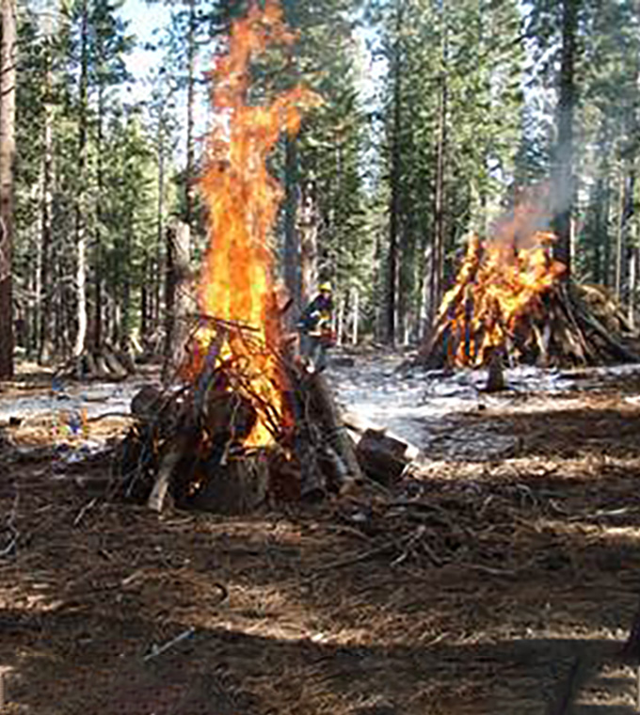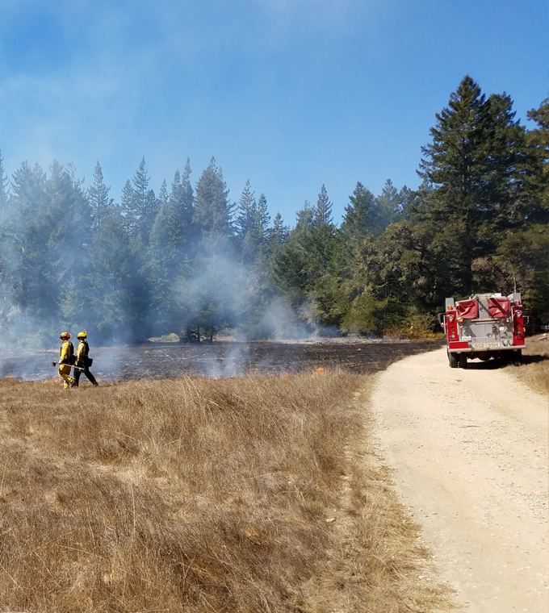
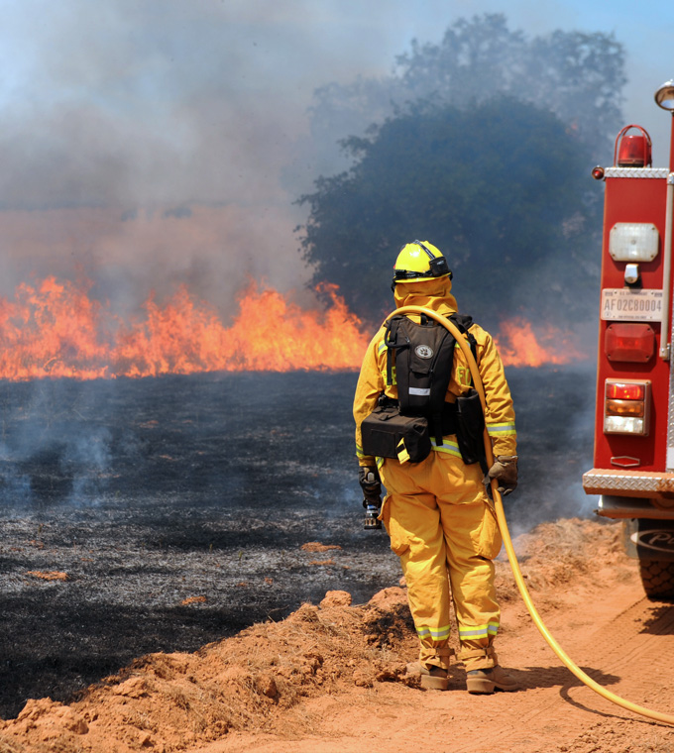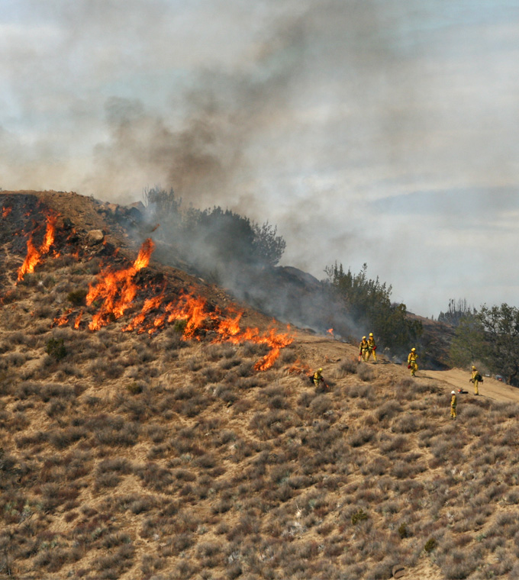
Figure 3.2-7 Examples of a Typical Prescribed Burn (Broadcast Burn and Pile Burning)
Varying levels of smoke would be generated by prescribed burning, which could affect scenic vistas, state scenic highways, and other public view points by dominating or blocking a view if excessive smoke is generated. Pursuant to SPR AQ-2, prior to obtaining air district permission to burn, an agency must prepare, submit, and get approval of a SMP. The SMP specifies the “smoke prescription,” which is a set of air quality, meteorological, and fuel conditions needed before burn ignition may be allowed, which are developed with the intention of minimizing smoke emissions. Depending on the size and complexity of the burn, the SMP would contain useful information for managing smoke, such as burn monitoring procedures, smoke travel projections (including maps), smoke minimization techniques, and public notification procedures. Once areas suitable for prescribed burning are selected, prescriptions (e.g., wind direction, humidity, weather conditions) are developed in conjunction with modeling in a program such as BEHAVE to provide specific parameters for burning, which are included in a Burn Plan (SPR AQ-3). If conditions ever deviate from the Burn Plan, also called “going out of prescription” (e.g., winds change direction, humidity decreases), the burn is rescheduled, and crews transition from active burning activities to patrolling and extinguishing. Adherence to the Burn Plan and SMP would minimize smoke emissions from prescribed burning. Although smoke emissions could substantially increase if conditions go out of prescription, such increases would be temporary as active burning would cease and crews would begin extinguishing the fire; therefore, smoke would quickly dissipate. Compliance with the SMP and the Burn Plan, as required by SPRs AQ-2 and AQ-3, would minimize smoke emissions and smoke-related impacts by only allowing prescribed burning to occur when the conditions are appropriate to minimize smoke. In addition, implementation of SPR REC-1 would require coordination with local park and open space jurisdictions to reduce viewer exposure as well as public notification prior to prescribed burning. Furthermore, prescribed burning would be temporary, lasting up to one week (but typically 1 day) in a given area, and any associated smoke emissions would dissipate once burning is complete. Therefore, prescribed burning would not result in a substantial degradation of a scenic vista or visual character and quality, or substantially damage scenic resources within a state scenic highway.

Summary
All of the treatments described and evaluated above could be used in various combinations to implement the treatments types (i.e., WUI fuel reduction, ecological restoration, and fuel breaks), which could potentially degrade short-term public views if visible as described above. However, because of the temporary nature of treatment activities, and incorporation of SPRs into qualifying projects under the CalVTP, short-term impacts from treatment activities to scenic vistas, to visual character or quality of public views, or to scenic resources in a state scenic highway would remain less than significant. Long-term effects of the treatment types are evaluated below in Impact AES-2 and Impact AES-3.

Mitigation Measures
No mitigation is required for this impact.

Impact AES-2: Result in Long-Term, Substantial Degradation of a Scenic Vista or Visual Character or Quality of Public Views, or Damage to Scenic Resources in a State Scenic Highway from WUI Fuel Reduction, Ecological Restoration, or Shaded Fuel Break Treatment Types
Long-term effects to aesthetics would occur from implementing WUI fuel reduction, ecological restoration, and shaded fuel break treatment types in the treatable landscape. Because ecological restoration would be designed to improve habitat quality and create a landscape appearance closer to native conditions, it would result in long-term beneficial visual impacts. WUI fuel reduction activities would reduce vegetation near communities. However, it would not be significantly noticeable because sufficient vegetation would remain and could aid in the visual transition from wildlands to urban environment. Prescribed burning in the grass fuel type would result in the most substantial visual change as grasses would turn a dark charcoal/black color directly following prescribed burning. However, grasses would regrow during the next growing season(s), and wildfire and prescribed burning currently occur within the treatable landscape, thus burned vegetation of all types is occasionally visible. Requirements from SPR AD-4 and SPR REC-1 would be incorporated into prescribed burning projects and ensure notification to the public prior to the commencement of burning operations.
In the case of shaded fuel breaks, because not all of the existing vegetation would be cleared, and large trees would remain, vividness, intactness, and unity of views would remain, and their presence would not substantially affect views from a scenic vista or from a state scenic highway. Requirements from SPR AES-1 and SPR AES-3 would be incorporated into vegetation treatments to break up or screen linear edges of a clearing and screen views from public view points as feasible. Therefore, these treatment types would not result in a long-term or substantial degradation of a scenic vista, substantially damage resources in a state scenic highway, or degrade the existing visual character and quality of a site. This impact would be less than significant.

Ecological Restoration and Wildland Urban Interface Fuel Reduction
Ecological restoration would involve vegetation treatments that seek to return the landscape closer to native conditions where natural fire processes can be reestablished, and habitat quality is improved. This treatment type could be implemented through various combinations of any of the treatment activities proposed under the CalVTP (i.e., herbicides, prescribed herbivory, manual and mechanical treatments, prescribed burning). Because ecological restoration would retain most visually dominant vegetation as shown in Figure 2-8 in Chapter 2, “Program Description,” and would likely be a barely perceptible change for viewers from a scenic vista or a state scenic highway, and would not substantially degrade the visual character and quality of a site.
The focus of WUI fuel reduction treatments is to reduce fuel loads and slow or prevent the spread of fire between wildlands and structures and vice versa. Also, where existing habitat within the WUI is degraded, such as by the infestation of non-native plant species (which poses a wildfire risk), WUI treatments would also enhance habitat quality. This treatment type could be implemented through various combinations of any of the treatment activities proposed under the CalVTP. As shown in Figure 3.2-4 above, views of the WUI as seen from a scenic vista can vary widely with the stark contrast between wildland vegetation, and buildings, transportation corridors, and other contrasting elements. It may not even be possible to identify the precise location of a WUI fuel reduction treatment from a scenic vista given the variety of colors, forms, shapes, patterns and topography. Although various levels of vegetation thinning would likely occur, it would not be significantly noticeable against the elevated view of wildlands and development, and it could aid in the visual transition from wildlands to urban environment. Some WUI fuel reduction treatments could occur along a state scenic highway. Given the viewer sensitivity and overall exposure in these areas, there could be an adverse visual impact to the existing visual character and quality of views from scenic highways and other public view points. However, the landscape would be only temporarily visible due to the speed of vehicles traveling along a state scenic highway. In addition, although less vegetation would be present where these treatment types occur, the visual change would not be substantial because large trees would mostly remain and successional vegetation would establish (refer to examples shown in Figure 2-3 in Chapter 2, “Program Description,” and Figure 3.2-8). Furthermore, SPR AES-1 would be implemented to break up or screen linear edges of clearing and mimic forms of natural clearings, as feasible and reasonable.
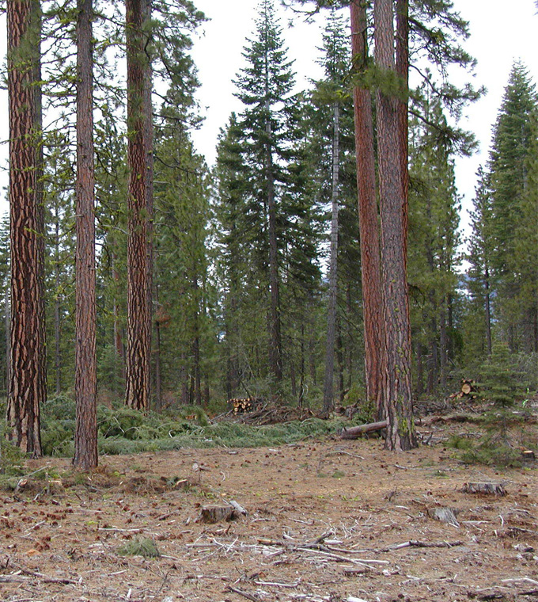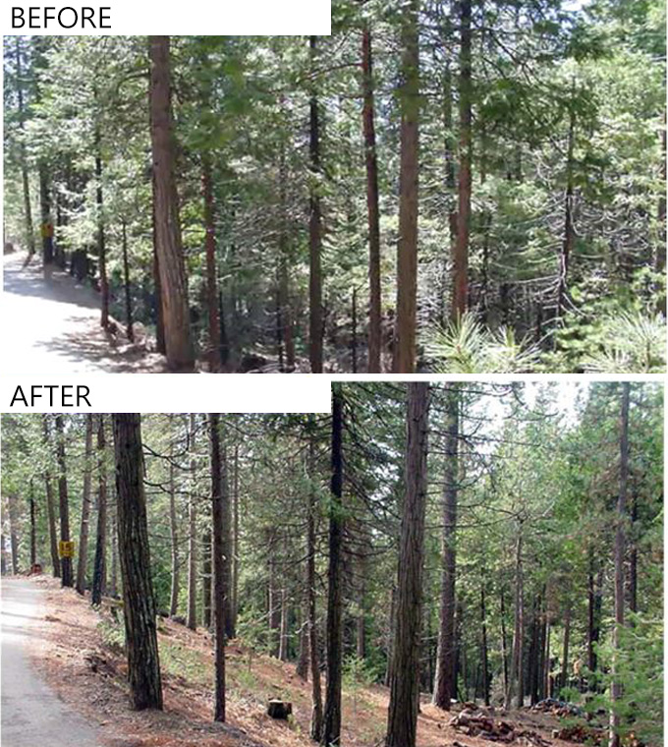
View of a manual/mechanical treatment area. Before and after manual/mechanical treatments.
Figure 3.2-8 Example Views of Treatment Areas
Where prescribed burning occurs in tree and shrub fuel types to implement ecological restoration or WUI fuel reduction treatment types, the visual change would be minimal because typically approximately 70 percent of vegetation would remain following a prescribed burn and there would be no new features contrasting with or blocking views of the existing environment from a scenic vista or state scenic highway. Long-range and expansive views from scenic vistas would continue to be dominated by the existing visual resources, including trees and other vegetation. In grass fuel types, prescribed burning would temporarily change the color of grasses from green or brown to a dark gray/black (refer to Figure 3.2-7), which could result in a short term and temporary adverse change in the visual character or quality of an area and could be visible from a scenic vista, state scenic highway, or other public view points. However, without treatment, annual grasses typically die off and turn brown each summer and regrow each winter; therefore, if prescribed burning of grass occurs in the fall, it would change the grass from a brown to a darker gray/black for a few months, until the grasses return in the winter. If prescribed burning of grass occurs in the spring, the grasses would become the darker gray/black color earlier in the year, may transition to brown over the summer months, and would be expected to regrow again during the winter or sooner. Furthermore, wildfire and prescribed burning currently occur within the treatable landscape under existing conditions, thus burned vegetation of all types is occasionally visible. SPR AD-4 and SPR REC-1 would be incorporated into prescribed burning treatments and requires notifying the public, including recreational users, prior to the commencement of burning operations of the timing and location of the prescribed burning activities thus affording potential viewers the choice to avoid recently treated areas. Therefore, ecological restoration and WUI fuel reduction would not result in a long-term, substantial degradation of a scenic vista, substantially damage resources in a state scenic highway, or degrade the existing visual character and quality of a site.

Shaded Fuel Breaks
As shown in Figures 3.2-9 and 3.2-10, several recreation areas and state scenic highways intersect with areas modeled for the fuel break treatment type. Therefore, this treatment type could be visible from a scenic vista, state scenic highway, or recreation areas with public view points. Shaded fuel breaks could also be visible from scenic vistas in the treatable landscape outside of established recreation areas. Shaded fuel breaks are typically used in forest settings and the tree canopy is thinned to reduce the potential for a crown fire to move through the canopy; larger trees are left in place. Because not all of the existing vegetation would be cleared, and large trees would remain within shaded fuel breaks, vividness, intactness, and unity of views would likely remain high and it is unlikely that they would substantially affect views from a scenic vista or from a state scenic highway (refer to Figure 2-6 in Chapter 2, “Program Description,” and Figure 3.2-11 for example views of shaded fuel breaks). Furthermore, SPR AES-1 and SPR AES-3 would be incorporated into vegetation treatment projects (including fuel breaks), as feasible, to break up or screen linear edges of a clearing, achieve a natural transitional appearance, and screen views from public trails, parks, recreation areas, and roadways as reasonable or appropriate for vegetation conditions. Therefore, establishment of shaded fuel breaks would not result in a long-term, substantial degradation of a scenic vista, substantially damage resources in a state scenic highway, or degrade the existing visual character and quality of a site.

Summary
Any of the proposed treatment types could be implemented in close proximity to public viewpoints and could result in long-term degradation of public views, as described above. However, because vegetation would remain under these treatment types and SPRs would be integrated into qualifying projects under the CalVTP to avoid and minimize aesthetic impacts and reduce viewer exposure, long-term degradation would not be substantial. Impacts from the proposed treatment types to scenic vistas, to visual character or quality of public views, or to scenic resources in a state scenic highway would be less than significant. Long-term effects of the non-shaded fuel break treatment type are evaluated below in Impact AES-3.

Mitigation Measures
No mitigation is required for this impact.
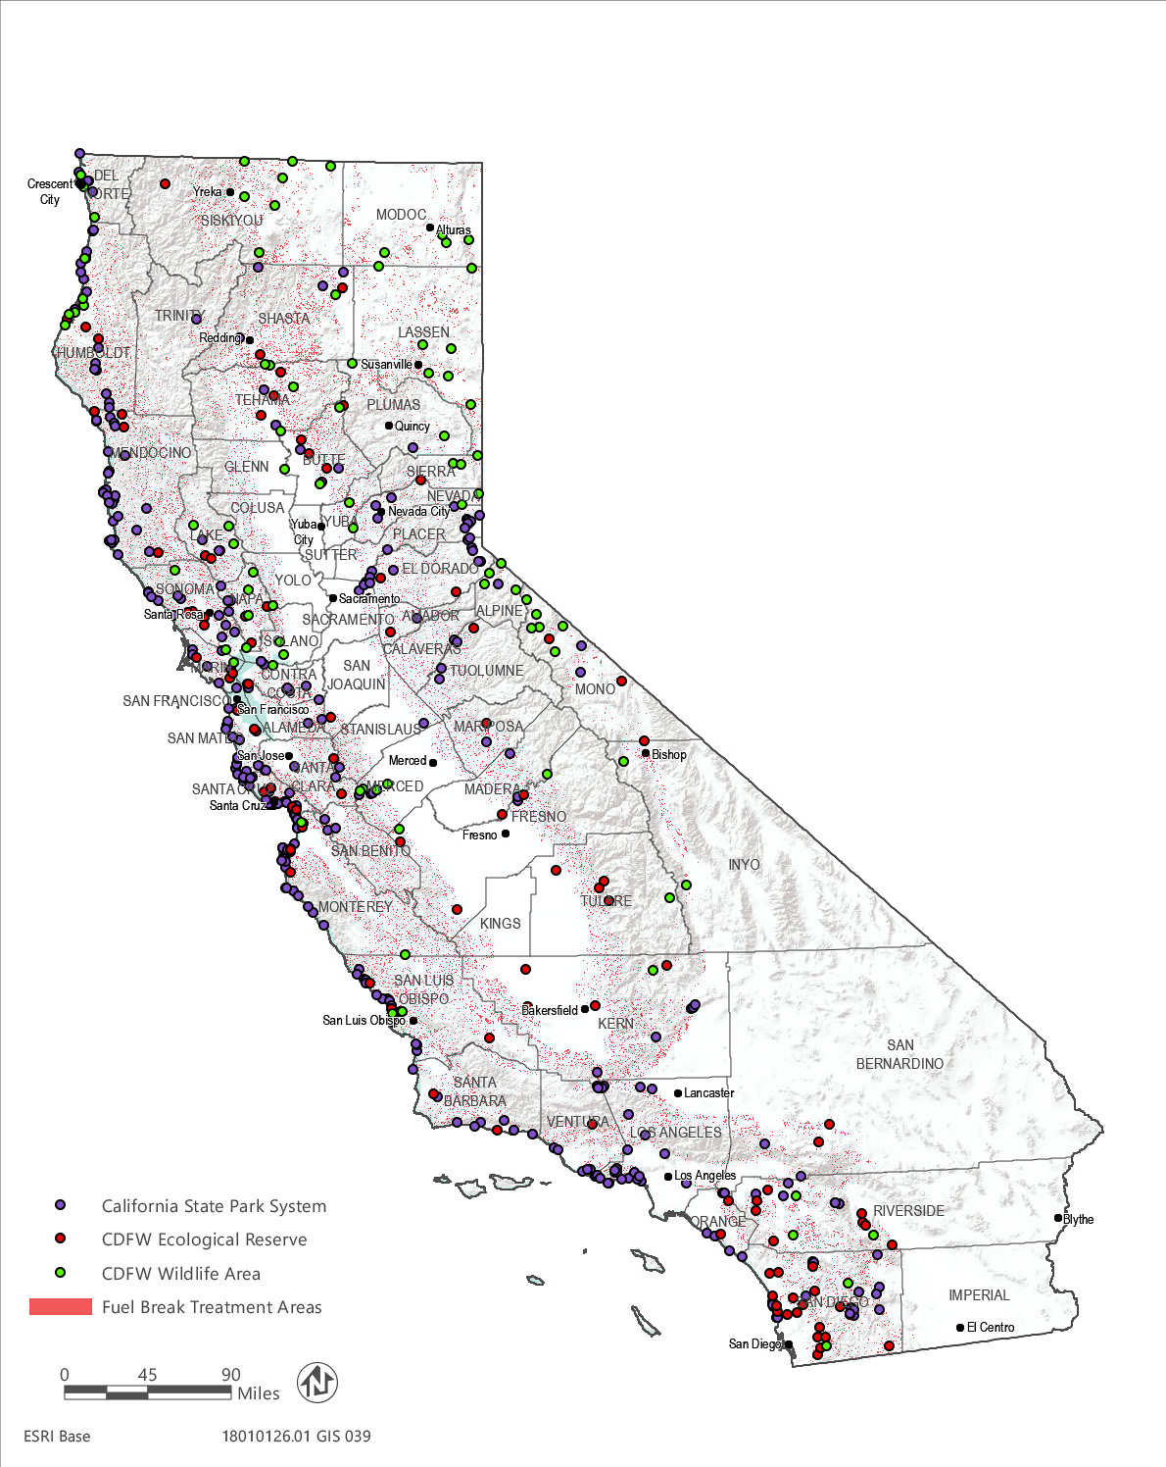
Source: Data downloaded from CDFW and CSP in 2019
Figure 3.2-9 Public Recreation Areas in the Vicinity of Modeled Fuel Breaks
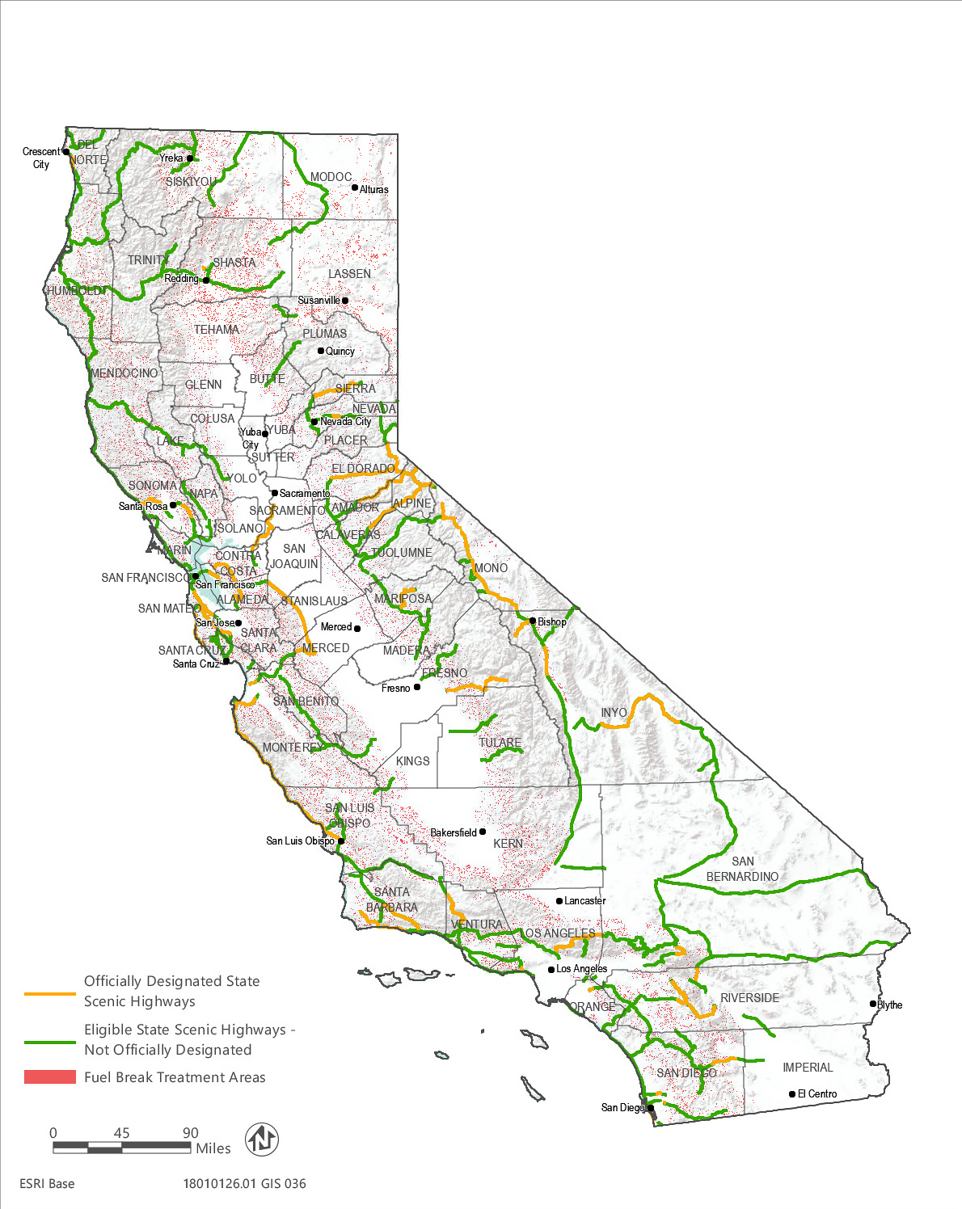
Source: Data downloaded from Caltrans in 2015 and received from the Department of Forestry and Fire Protection in 2019
Figure 3.2-10 State Scenic Highways in the Vicinity of Modeled Fuel Breaks
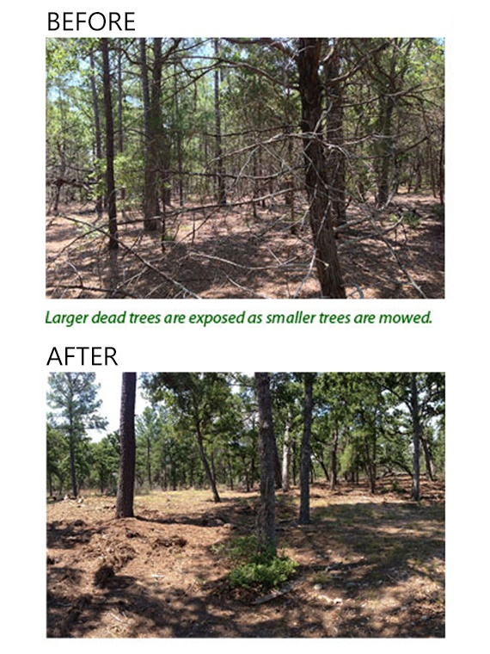
Figure 3.2-11 Example of a Shaded Fuel Break

Impact AES-3: Result in Long-Term Substantial Degradation of a Scenic Vista or Visual Character or Quality of Public Views, or Damage to Scenic Resources in a State Scenic Highway from the Non-Shaded Fuel Break Treatment Type
Implementation of non-shaded fuel breaks would remove all of the vegetation within a treatment area and could be visible from scenic vistas, state scenic highways, or other public view points. Because non-shaded fuel breaks remove all vegetation, this treatment type could lead to a long-term adverse visual change in the landscape by resulting in a contrasting linear element in an otherwise natural environment. This change would constitute substantial degradation of a scenic vista or the visual character and quality of public views, or substantial damage to scenic resources within a state scenic highway to the extent a non-shaded fuel break is visible to the public. This would be a potentially significant impact.
Non-shaded fuel breaks would be implemented in strategic locations within the treatable landscape, which unlike shaded fuel breaks, remove all of the vegetation from within the treatment area and are often established along ridgelines. Non-shaded fuel breaks can be visible from several vantage points including from a scenic vista, a state scenic highway, or from other public view points. As shown in Figure 3.2-9 and Figure 3.2-10, modeled fuel break treatment areas (some of which would be non-shaded) are located in areas potentially viewable from several recreation areas and state scenic highways. Non-shaded fuel breaks could also be visible from other scenic vistas in the treatable landscape outside of established recreation areas.
As shown in Figure 2-5 in Chapter 2, “Program Description,” and Figure 3.2-12, non-shaded fuel breaks can change the landscape by introducing a contrasting linear element in an otherwise natural environment, which could reduce vividness, intactness, and unity. This adverse change could constitute substantial degradation of visual character and quality, which could be visible from a scenic vista, a state scenic highway, or from other public viewing points in recreation areas or near the WUI. Non-shaded fuel breaks could also substantially damage scenic resources (i.e., trees and other vegetation) along a state scenic highway by directly removing trees and other vegetation. If this occurred from establishment of non-shaded fuel breaks, the impact to aesthetics and visual resources from would be potentially significant.
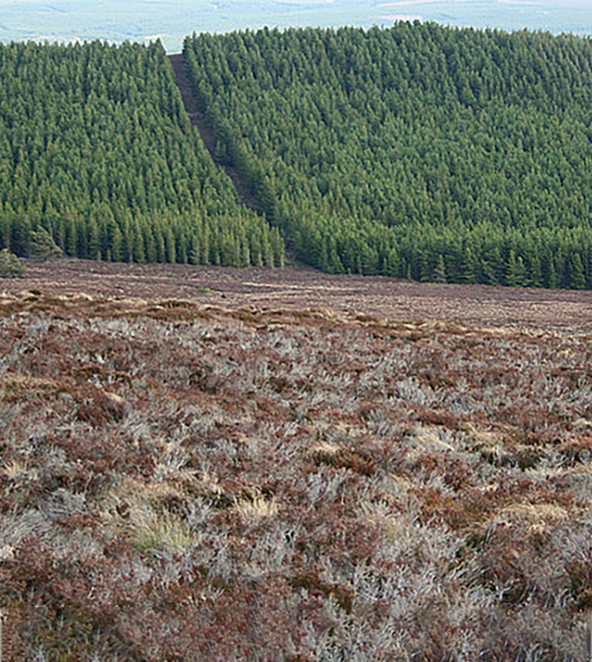
Figure 3.2-12 Example of a Non-Shaded Fuel Break

Mitigation Measures

Mitigation Measure AES-3: Conduct Visual Reconnaissance for Non-Shaded Fuel Breaks and Relocate or Feather and Screen Publicly Visible Non-Shaded Fuel Breaks
The project proponent will conduct a visual reconnaissance of the treatment area prior to implementing non-shaded fuel breaks to observe the surrounding landscape and determine if public viewing locations, including scenic vistas, public trails, and state scenic highways, have views of the proposed treatment area. If none are identified, the non-shaded fuel break may be implemented without additional visual mitigation
If the project proponent identifies public viewing points, including heavily used scenic vistas, public trails, recreation areas, and state scenic highways with lengthy views (i.e., longer than a few seconds) of a proposed non-shaded fuel break treatment area, the project proponent will, prior to implementation, attempt to identify any feasible change in location of the fuel break to reduce its visibility from public viewpoints. If no feasible location changes exist that would reduce impacts to public viewers and achieve the intended wildfire risk reduction objectives of the proposed non-shaded fuel break, the project proponent will implement, where feasible, a shaded fuel break rather than a non-shaded fuel break, if the shaded fuel break would achieve the intended wildfire risk reduction objectives. With the shaded fuel break, the project proponent will thin and feather adjacent vegetation to break up the linear edges of the fuel break and strategically preserve vegetation at the edge of the fuel break, as feasible, to help screen public views and minimize the contrast between the fuel break and surrounding vegetation.

Significance after Mitigation
As previously discussed, non-shaded fuel breaks would be established in strategic locations, typically where there is a natural change in vegetation type, to reduce fire spread to structures and natural resources and to provide access for fire suppression efforts. Because of the strategic nature of non-shaded fuel break siting, it may be infeasible to relocate a non-shaded fuel break to avoid public visibility, per Mitigation Measure AES-3. Further, converting a planned non-shaded fuel break to a shaded fuel break may not achieve the wildfire risk reduction objectives of the fuel break and vegetation feathering techniques may not fully and effectively mitigate the adverse visual impact from implementation of a non-shaded fuel break to public viewers. Therefore, if Mitigation Measure AES-3 is necessary to reduce a potentially significant impact and cannot be implemented in a way that would feasibly reduce the visual impact below significance, a substantial degradation of a scenic vista or visual character or quality of public views, or damage to scenic resources in a state scenic highway from the non-shaded fuel break treatment type could be unavoidable. Accordingly, the impact, if it occurred, would remain significant and unavoidable.

This page intentionally left blank.

