City of Lafayette

Safety Element

Public Hearing Draft
May 2023

Prepared for:
City of Lafayette
3675 Mount Diablo Blvd., #210
Lafayette, CA 94549

Prepared by:
PlaceWorks
2040 Bancroft Way, Suite 400
Berkeley, CA 94704

This page is intentionally left blank.

Table of Contents

1. Overview VI-1
1.1 Purpose and Content VI-1
1.1.1 Legislative Requirements VI-1
1.2 Relationship to Other Local Plans and Programs VI-1
1.2.1 General Plan Elements VI-2
1.2.2 Contra Costa County Hazard Mitigation Plan VI-2
1.2.3 Contra Costa Countywide Community Wildfire Protection Plan VI-3
1.2.4 Fire Prevention Efforts by Other Agencies VI-3
1.3 Climate Change Vulnerability VI-4
1.3.1 Vulnerability Assessment Results VI-5
2. Safety Issues VI-6
2.1 Emergency Preparedness and Response VI-7
2.1.1 Emergency Notifications VI-7
2.1.2 Evacuations VI-8
2.2 Flood and Inundation Hazards VI-12
2.2.1 Flood Hazards VI-12
2.2.2 Dam or pipeline Inundation VI-15
2.3 Seismic and Geologic Hazards VI-17
2.3.1 Seismic Hazards VI-17
2.3.2 Geologic Hazards VI-22
2.4 Fire Hazards VI-24
2.4.1 Wildfires VI-24
2.4.2 Wildland-Urban Interface Fires VI-25
2.4.3 Structural Fires VI-28
2.4.4 California Fire Code VI-28
2.4.5 Fire Hazard Severity Zones VI-28
2.4.6 Fire Protection VI-30
2.5 Hazardous Materials and Waste VI-34
2.6 Climate Change Resilience VI-36
2.6.1 Drought VI-36
2.6.2 Extreme Temperatures VI-37
2.6.3 Severe Weather VI-38
2.6.4 Human Health Hazards VI-39
3. Goals, Policies, and Programs VI-41
4. Glossary VI-61

List of Figures
Figure S-1 Evacuation Routes and Zonehaven Aware Zones 10
Figure S-2 Evacuation-Constrained Residential Parcels 11
Figure S-3 Flood Hazard Zones 14
Figure S-4 Dam Inundation Areas 16
Figure S-5 Regional Fault Lines 20
Figure S-6 Liquefaction Areas 21
Figure S-7 Landslide Susceptibility Areas 23
Figure S-8 Historic Wildfire Burn Areas 26
Figure S-9 Wildland-Urban Interface Areas 27
Figure S-10 Fire Hazard Severity Zones 29
Figure S-11 Land Uses in Very High Fire Hazard Severity Zones 32
Figure S-12 CPUC Fire Threat Zones 33
Figure S-13 Major Natural Gas Pipelines 35

Appendices

Appendix A: Safety Element Background Report
Appendix B: SB 747 Evacuation Analysis (prepared 2022)

Overview

Purpose and Content
The Safety Element is a State-mandated General Plan element that must identify potential natural and human-caused hazards that could affect the City of Lafayette’s (City’s) residents, businesses, and services. The purpose of the Safety Element is to establish a framework to anticipate these hazards and increase the community’s resilience to these risks. The Safety Element identifies the natural and human-caused hazards that affect existing and future development, describes present and expected future conditions, and sets policies and programs for improved public health and safety. This framework includes strategies to minimize physical harm to the people, buildings, and infrastructure in and around Lafayette to reduce damage to local economic systems, community services, and ecosystems.
The Safety Element serves the following functions:

- Frames safety considerations for the land use planning process.
- Facilitates the identification and mitigation of hazards for new development, including strengthening existing codes, project review, and permitting processes.
- Presents policies directed at identifying and reducing hazards in existing development.
- Strengthens disaster preparedness planning and post-disaster reconstruction policies.
- Identifies how natural hazards are likely to change in frequency and intensity in the future, including changes resulting from climate change, and provides policies to increase community resilience through preparedness and adaptation.

Legislative Requirements
California Government Code Section 65302(g) provides the requirements for the Safety Element, which must contain background information and policies to address multiple natural hazards, a vulnerability assessment analyzing how climate change will affect the community, policies to increase climate change adaptation and resilience, and mapping of residential areas with evacuation constraints.

Relationship to Other Local Plans and Programs
The Lafayette Safety Element does not exist in a vacuum but is one of several plans that address community safety, hazard mitigation, and related topics. These other plans include other General Plan elements, the Contra Costa County Hazard Mitigation Plan, the Contra Costa Countywide Community Wildfire Protection Plan, and various local regulations. The City works with many partners to ensure the community receives comprehensive services to support hazard mitigation and emergency response, preparation, and recovery from disasters and emergency events. The Safety Element incorporates information, technical analyses, and policies from these other documents where appropriate.

General Plan Elements
The Lafayette General Plan is the City’s blueprint for how and where the city will grow over the next 20 years. The General Plan includes an introduction and eight elements, each with goals, policies, and programs to support the community’s vision and comply with State requirements for general plans. The eight elements address:

- Land Use
- Circulation
- Open Space and Conservation
- Parks, Trails, and Recreation
- Housing
- Safety
- Noise
- Growth Management

Crucial relationships exist between the Safety Element and the other General Plan elements. Examples of these relationships include how land uses are determined in areas prone to natural hazards, what regulations limit development in these areas, and how hazards are mitigated for existing development. For instance, the Parks, Trails, and Recreation Element must consider how hazards will affect the park and recreation infrastructure and facilities, but also recognizes that parks can provide strategies to reduce hazard risks throughout the city. The Housing Element is also closely tied to the Safety Element. Future potential development in the city must be protected from hazards and able to adapt to climate change hazards to ensure homes and the people living in them and existing residential areas remain safe. Safety Element policies, especially those concerning evacuation routes and critical facilities, must be consistent with those of the Circulation Element. State Route (SR) 24 is Lafayette’s primary evacuation route, supported by routes designated as arterials in the Circulation Element. The Safety Element considers potential impacts on the other General Plan elements and is designed to work in concert with these other components of the City’s planning strategy.

Contra Costa County Hazard Mitigation Plan
In collaboration with the City and other local agencies and special districts, Contra Costa County prepared the 2018 Hazard Mitigation Plan (HMP) in accordance with the federal Disaster Mitigation Act of 2000 and the Federal Emergency Management Agency’s (FEMA’s) Hazard Mitigation Plan guidance. Contra Costa County’s HMP is a plan that assesses hazard vulnerabilities from natural and human-caused hazards, including risk to people and facilities, and identifies mitigation actions to reduce or eliminate short-term and long-term hazard risks in the county, including incorporated communities. The HMP has a dedicated annex for Lafayette that discusses the characteristics and history, development trends, hazard mitigation capabilities, integration with other hazard mitigation planning efforts, and specific facilities and infrastructure vulnerabilities specific to the city. The mitigation actions in the HMP include both short-term and long-term strategies and involve planning, policy changes, programs, projects, and other activities.
The HMP and Safety Element address similar issues, but the Safety Element provides a higher-level, long-term framework and set of policies that pertain to the safety of the city, and the HMP focuses on more specific mitigation, often short-term actions, to enable jurisdictions to better protect lives, property, and natural systems. The current HMP, as certified by FEMA, is incorporated into this Safety Element by reference, as permitted by California Government Code Section 65302.6.

Contra Costa Countywide Community Wildfire Protection Plan
In collaboration with the Contra Costa County Fire Chiefs Association, Hills Emergency Forum, and stakeholder committee members, the Diablo Fire Safe Council prepared and published the 2019 Contra Costa Countywide Community Wildfire Protection Plan (CWPP). The CWPP provides a snapshot of current wildfire protection challenges and capabilities, identifies and prioritizes areas for hazardous fuel reduction, and recommends types and methods of vegetation management that may help protect the affiliated communities from wildfire losses. The goal of the plan is to reduce hazards through increased information and education about wildfires, hazardous fuels reduction, actions to reduce structure ignitability, and other recommendations to assist emergency preparedness and fire-suppression efforts. The CWPP complements local agreements and existing plans for wildfire protection to coordinate efforts to determine appropriate fire management actions.

Fire Prevention Efforts by Other Agencies
The City of Lafayette benefits from several different agencies that provide fire prevention and protection services in the city. The agencies described provide fire protection, manage utilities, and manage the lands surrounding the city.
Contra Costa County Fire Protection District. The Contra Costa County Fire Protection District (ConFire), the agency responsible for providing fire protection services to Lafayette, manages the Wildfire Mitigation Program. This program is funded by the countywide Measure X sales tax and offers Contra Costa residents the opportunity to identify and apply for projects that will reduce the county’s overall exposure to wildfire risk. The program is designed to fund existing projects and programs, such as community chipping days, Firewise USA Community Strategic Plan Projects, Home Hardening Outreach Program, removal of dead trees, shaded fuel breaks, and vegetation management and fuel reduction. ConFire also maintains three fire stations throughout the City. ConFire has a dedicated crew of fire prevention specialists who, as part of Crew 12, work to remove potential wildfire fuel.
East Bay Municipal Utilities District. Every year in preparation for the fire season, the East Bay Municipal Utilities District (EBMUD) plans vegetation management and weed abatement activities around its facilities and along its rights-of-way. These activities include mowing, weeding, pruning, trimming, chipping, goat grazing, and herbicide application. EBMUD also leases some of its watershed lands for cattle and horse grazing, which provides additional vegetation management.
East Bay Regional Park District. The East Bay Regional Park District (EBRPD) has been implementing fuel management practices for decades. As EBRPD’s fuels management activities have expanded, the Stewardship Department has played an increasingly large role in the fuel management program, which includes:
- Clearing heavy underbrush and thinning dense park forests.
- Reducing vegetation with cattle, goat, and sheep grazing.
- Removing hazardous trees.
- Monitoring effects on habitat and wildlife populations.
Each year, EBRPD thins and removes hazardous vegetation on over 1,000 acres to reduce fire hazards. In 2022, EBRPD received fire hazard reduction grant funding from FEMA.
Pacific Gas and Electric Company. The Pacific Gas and Electric Company’s (PG&E’s) 2022 Wildfire Mitigation Plan outlines its program to reduce wildfires. Key strategies in this plan include underground utility lines, increased safety settings, more intensive vegetation management, and enhanced inspections. PG&E is undergrounding power lines in areas that have the greatest impact on reducing wildfire risk and outages for their customers. In Contra Costa County, PG&E completed six miles of undergrounding in 2022 and is planning to complete approximately three miles of undergrounding this year.

Climate Change Vulnerability
Changes to the global climate system are expected to affect future occurrences of natural hazards in and around Lafayette. Many hazards are projected to become more frequent and intense in coming years and decades, and in some cases, these trends have already begun. Key climate change considerations that affect Lafayette include increasing temperatures and changes in precipitation. Overall, precipitation levels are expected to decrease slightly, with more years of extreme precipitation events, and droughts that last longer and are more intense. According to California’s Fourth Climate Change Assessment, Lafayette can expect to experience various changes to climate-related hazard events.
What is vulnerability?
Vulnerability is the degree to which natural, built, and human systems are susceptible to harm from exposure to stresses associated with environmental and social change and from the absence of a capacity to adapt.
Source: California Governor’s Office of Emergency Services. 2020. California Adaptation Planning Guide. https://www.caloes.ca.gov/climate.

Wildfire risk in Lafayette is and will continue to be high. Climate change is expected to lead to an increase in wildfires in the surrounding area and across Contra Costa County due to hotter and drier conditions. Dry conditions are anticipated earlier in the year, leaving most of the region in moderate to extreme drought conditions prior to summer. These continued dry conditions with above-normal temperatures through spring will leave fuel moisture levels lower than normal, increasing the potential for wildfire activity. Diablo wind events will result in more erratic fire behavior, making fires harder to control. An extended wildfire season increases the likelihood that Diablo wind events coincide with wildfires, which can allow wildfires to spread more rapidly. Across the region, more frequent and intense wildfires could also create poor air quality for Lafayette.
Warmer temperatures are projected to cause an increase in extreme heat events. The number of extreme heat days, defined in Lafayette as a day when the high temperature is at least 93.9°F, is expected to rise from a historical annual average of 4 days to 17 days by the middle of the century (2035 to 2064) and an average of 29 days by the end of the century (2070 to 2099). In addition to the increases in extreme heat events, Lafayette is expected to see an increase in average daily high temperatures. The number of warm nights, defined in Lafayette as a day in April through October when the minimum temperature is above 59.6°F, is expected to rise from a historical annual average of 6 nights to 47 nights by the middle of the century (2035 to 2064) and 107 nights by the end of the century (2070 to 2099).
Both droughts and floods are expected to become more frequent because rainfall is expected in fewer, more intense storms. Although Lafayette is likely to experience minimal change in overall annual precipitation levels from climate change, the region is expected to see an increase in the number of extreme precipitation events. As a result, floods are expected to occur more often in Lafayette, primarily along creeks, and climate change may expand the parts of the city that are considered prone to flood. Increased flooding along creeks is likely to result in increased creek-bank erosion and sedimentation of waterways. Climate change is also expected to increase the frequency and severity of droughts, which cause soil to dry out and condense, affecting its permeability. When precipitation does return, the dry ground cannot absorb as much water and it runs off the surface, which can lead to floods and result in debris flows along slopes and hillsides.
Severe weather events, such as strong storms and high winds, may become more frequent and intense. Climate change is expected to cause an increase in intense rainfall, which is usually associated with strong storm systems. Heavy rainfall may also contribute to an increased risk of landslides in the hills around Lafayette. In Lafayette, most severe weather consists of atmospheric rivers, heavy rains, or thunderstorms. The types of dangers posed by severe weather vary widely and include injuries or deaths, damage to buildings and structures, fallen trees, roads blocked by debris, and fires sparked by lightning.
Climate change can increase the rates of infection for various diseases because many of the animals that carry diseases are more active during warmer weather. There are a number of diseases linked to climate change and can be harmful to the health of Lafayette community members, such as hantavirus pulmonary syndrome, Lyme disease, and West Nile fever. Many of these diseases are carried by mice, rats, ticks, and mosquitos, which are usually considered pests even if they do not cause infections. With warmer temperatures earlier in the spring and later in the winter, these animals can be active for longer periods, increasing the time that diseases can be transmitted.

Vulnerability Assessment Results
Under California law, the Safety Element is required to include a vulnerability assessment that looks at how people, buildings, infrastructure, and other key community assets may be affected by climate change. The City conducted a climate change vulnerability assessment in the winter of 2023 to analyze Lafayette’s susceptibility to climate change hazards. Lafayette’s vulnerability assessment was prepared in accordance with the most recent available guidance in the 2020 California Adaptation Planning Guide. It assesses how seven different climate change hazards (drought, extreme temperatures, flooding, human health hazards, landslides, severe storms, and wildfire and smoke) may affect 41 different population groups and community assets. Each population or asset received a score of V1 (minimal vulnerability) to V5 (severe vulnerability) for each climate change hazard. Lafayette’s vulnerability assessment is included in the Safety Element Background Report, Appendix A to this Safety Element.
The climate change vulnerability assessment found that Lafayette’s populations and assets are most vulnerable to wildfire and smoke, severe storms, and landslides. Overall, populations in Lafayette tend to be most vulnerable to wildfire and smoke, extreme temperatures, human health hazards, and flooding. The most vulnerable communities include households in poverty, low-resourced people of color, persons with chronic illness and/or disabilities, and seniors. Young children under 10 can also face an elevated risk from climate change-related hazards as they are more likely to feel the effects of hazardous events, like extreme heat or illnesses, to a greater degree.
Citywide, energy delivery and communication infrastructure and services are vulnerable to multiple hazards, including severe storms, high winds that can trigger Public Safety Power Shutoff (PSPS) events, extreme heat that reduces the capacity and strains the systems, and wildfires that damage the systems, ultimately disrupting energy and communication services. Furthermore, energy delivery services, specifically electricity delivery, are subject to harm during extreme heat events. Extreme heat can lead to power outages by causing mechanical failure of grid equipment or heat damage to power lines, and by creating a high demand for electricity to power air conditioners, all of which place stress on the network. This is likely to lead to more service disruptions. Extreme heat conditions can damage communication infrastructure, decreasing network capacity. There may be a higher demand for communication services during severe storms, potentially putting stress on the network and increasing the risk of service interruptions.
PSPS events or interruptions in energy service can create vulnerabilities for Lafayette community members. A loss of electricity can cause a loss of refrigeration for food and medical supplies; limit cooking; and cause loss of cooling, heating (particularly dangerous during extreme temperature events), lighting, and limited or no access to the internet or other information systems. Many businesses are forced to close during a power outage, causing economic hardships and depriving community members of important services, such as grocery stores, gas stations, and banks/ATMs. Power outages may also be harmful to people who depend on electrically powered medical devices.
Climate change is also expected to increase the parts of the city that are considered prone to flooding. As a result, transportation infrastructure within and adjacent to the 100-year floodplain will likely experience an increase in the frequency and magnitude of flood events in future years. Increases in damaging flood events in the city are expected to cause more property damage, public health and safety concerns, displacement, and loss of life. The City’s public transit services may be impacted by flood events that damage roads or equipment, interrupt service, or prevent community members from accessing transit.
Climate change could affect the transportation network and associated economic activity in Lafayette by creating strain on transportation infrastructure, resulting in impacts to travel behavior, goods movement, and supply chain continuity. Transportation infrastructure, such as roadways, bridge supports, and BART, are all potentially at increased risk due to severe storms, floods, higher temperatures, landslides, and increased wildfire risk. When part of the transportation infrastructure network fails, typical travel routes for both passenger travel and goods movement may be affected, including SR-24 and other major roadways. Disruption of these local roadways due to hazards such as flooding, landslides, or wildfire could significantly impact the transportation of goods and services in the city, the economic vitality of the community, and the livelihood of many businesses. Similarly, residents that rely on BART as transportation to work could be greatly impacted by disruptions in the operation of the railway.
To increase community resilience and help lower vulnerability scores, the Safety Element includes goals, policies, and implementation programs, several of which are particular to the populations and assets that received a moderate to high vulnerability score in the vulnerability assessment.

Safety Issues
The safety issues covered in this Safety Element include:

- Emergency Preparedness and Response
- Flood and Inundation Hazards
- Seismic and Geologic Hazards
- Fire Hazards
- Hazardous Waste and Materials
- Climate Change Resilience

The Safety Element provides background information and relevant mapping for each of these topics. It explains what the issue is and how it affects the safety and well-being of Lafayette, appropriate historical and regulatory context, and discussions of how safety issues may change in the future. This element is supported by the Safety Element Background Report (Appendix A), which provides detailed information for each of the safety issues addressed in this element.

Emergency Preparedness and Response
The Lafayette Police Department and ConFire provide primary emergency preparedness and response services in Lafayette. The Lafayette Police Department contracts with the Contra Costa County Sheriff’s Department for law enforcement activities. ConFire provides fire prevention, protection, and suppression services to the city. ConFire considers all parts of Lafayette, including those in the areas with the greatest wildfire risk, to have sufficient emergency service.
Compounding and Cascading Disasters
One concern in Lafayette, as in most communities, is the possibility of cascading and compounding disasters. These are instances where one hazard event triggers one or more other disasters. This includes strong flooding that results in mudflows, an earthquake that ruptures natural gas lines and causes fires to break out, and many other possibilities. Such events are often the most damaging and require the greatest amount of resources to address.

The City has an Emergency Operations Center (EOC), which is a centralized location where emergency management personnel gather during times of crisis or disaster to coordinate the response and recovery efforts. The Lafayette Police Department serves as the primary EOC. However, in the event of a major disaster, the EOC may be relocated to an alternate site, which is the Lafayette Public Works Department. The EOC serves as a command center where emergency managers can make decisions, allocate resources, and communicate with the public and response agencies.
The City of Lafayette’s EOC is activated during emergencies, such as natural disasters, public health crises, and other events that require coordinated response efforts. The EOC is staffed by trained emergency personnel from the City and partner agencies, who work together to manage the emergency response and coordinate with other jurisdictions and organizations as needed. The EOC also plays a crucial role in maintaining communication with the public during emergencies. It serves as a centralized location for disseminating information to the media, elected officials, and the public, and for receiving feedback and requests for assistance. In addition, the Moraga-Orinda Fire District provides Community Emergency Response Team (CERT) Program training, or “Lamorinda CERT,” for the Lamorinda community. Lamorinda CERT educates people about disaster preparedness for hazards that may impact their area and trains them in basic disaster response skills, such as fire safety, light search and rescue, team organization, and disaster medical operations.
The Contra Costa County Office of Emergency Services is required under state law to prepare and maintain a Standardized Emergency Management System (SEMS) Multi-hazard Functional Plan. The SEMS Multi-hazard Functional Plan outlines the roles, responsibilities, and procedures for responding to various hazards and emergencies in a given jurisdiction. The plan is designed to be flexible, scalable, and adaptable to the needs of the community and the hazards it faces.

Emergency Notifications
During an emergency, the Contra Costa County Sherriff’s Office uses the Community Warning System (CWS) to notify residents and businesses in the county that are impacted or are in danger of being impacted by an emergency. The system provides residents with real-time information about incidents and events that may impact their safety and well-being, such as natural disasters and other public safety incidents. The system also provides important information about road closures, evacuations, and other emergency response efforts and works as a partnership with the Contra Costa County Office of the Sheriff, the Contra Costa County Health Services Department, other government agencies, industry, news media, and nonprofit organizations. The Lafayette Police Department also manages a local emergency warning system, Nixle. Other notification systems that can be activated to provide alerts include sirens, the national Emergency Alert System, statewide Emergency Digital Alert System, National Oceanic and Atmospheric Administration weather radios, and social media posts.
The City operates the Community Information and Emergency Radio Station, which transmits information 24 hours a day, seven days a week, at AM 1670. During normal conditions, the radio station transmits news and information. During emergencies, the station will provide important updates on emergency conditions and evacuations. Community members can also listen to the radio station online at: https://bit.ly/LafayetteRadio1670AM.

Evacuations
With advanced warning, evacuation can be effective in reducing injury and loss of life during a natural disaster. The Lafayette Police Department and ConFire carry out centralized emergency management to ensure the successful coordination of the response and the initiation of recovery operations within the City, operating under a Unified Command that allows for effective coordination between the two agencies. During a wildland fire response, the Unified Command establishes evacuation triggers that would be executed by the Lafayette Police Department. The Lafayette Police Department is responsible for management of the evacuation process. The Lafayette Police Department, in conjunction with ConFire and all other concerned agencies, plan, coordinate, and execute all evacuation plans in the affected area. The Lafayette Police Department maintains the security of the affected area and grants access based on the conditions of the incident.
In preparation for wildfires and other disasters, the City set up Zonehaven Aware, which is a comprehensive evacuation support system supported by the Contra Costa County CWS. Zonehaven Aware provides the community with critical evacuation updates, resources, and latest updates on active incidents. In the event of an emergency situation, the Lafayette Police Department and ConFire can issue evacuation warnings or evacuation orders for impacted areas. These notices are issued for a zone with an evacuation status. Emergency service agencies coordinate using the Zonehaven zones to direct emergency warnings and evacuation orders for timely and orderly evacuations. The County’s website has an interactive evacuation map and lookup tool so that residents can find possible evacuation routes based on their address and respective zone.
Figure S-1 shows the evacuation routes throughout the city that may be used during an evacuation event, along with the Zonehaven Aware evacuation zones. Primary emergency access and evacuation routes are SR-24, which intersects the city from west to east, and Upper Happy Valley Road, Happy Valley Road, Mount Diablo Boulevard, Pleasant Hill Road, Reliez Valley Road, St. Mary’s Road, Acalanes Road, and Moraga Road. Figure S-2 shows residential parcels with evacuation constraints, which are parcels that have access to only one evacuation route for use in an emergency. In such locations, the limited access for emergency responders and safe routes out of the area for evacuating community members can create challenges. Steep topography and suburban cul-de-sac design throughout the city can make these potential constraints worse, especially in rural areas of Lafayette.
Some of the more rural neighborhoods are adjacent to open space and within, or in close proximity to the wildland-urban interface (WUI). Given these conditions, wildfire is a serious threat to rural neighborhoods. The City’s Emergency Operations Plan acknowledges that Lafayette has a character that encourages the mix of population with the vegetation and open spaces; this wildland intermix is subject to wildland fires that can cause the loss of life and property. The limited number of ingress and egress points can further complicate the evacuation planning process. In the event of widespread disruption to primary evacuation routes, the remaining evacuation routes can become congested, slowing evacuation of the community or specific neighborhoods. This issue can be compounded where evacuation routes for Lafayette also serve surrounding communities, such as Orinda and Moraga, meaning potential disruptions could have regional effects.

Evacuation Study
In 2022, the City prepared a General Plan Emergency Evacuation Assessment to analyze evacuation routes and their capacity, safety, and viability under different emergency situations. The assessment looked at three different wildfire scenarios to determine who in Lafayette may need to evacuate, how long an evacuation may take, and to recommend actions the City and its partners can take to improve evacuation conditions. The three scenarios studied were developed in concert with the Lafayette Planning Department, Lafayette Police Department, Lafayette Emergency Preparedness Commission, and ConFire to conduct a broad assessment of potential evacuation scenarios. These scenarios and their outcomes represent static analyses that do not directly mirror the approach taken during a real-world evacuation scenario wherein zones could be evacuated in a dynamic method in response to the fire movement as opposed to evacuations occurring all at once. Depending on the scenario, some neighborhoods could fully evacuate in less than an hour, while others may take close to four hours. More details are included in the Safety Element background report and the full results of the evacuation study are available at https://tinyurl.com/tacd5k9a.

Evacuation Drills
The City of Lafayette engages in evacuation drills with neighboring communities, such as Moraga and Orinda. Evacuation drills are led by the police departments of the three cities, along with the Moraga-Orinda Fire District and ConFire. These drills allow residents to test CWS emergency notifications in preparation for an emergency event. Each municipality has an evacuation plan that includes specific geographical evacuation zones. In an actual emergency, evacuation messages are issued for these zones when there is extreme danger to an area.
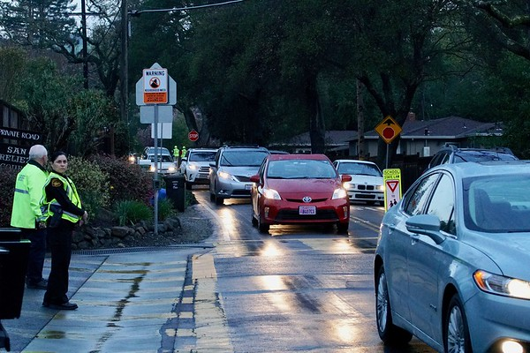
Vehicles following an evacuation route during the Springhill Evacuation Drill. Photo by the City of Lafayette.
Figure S-1 Evacuation Routes and Zonehaven Aware Zones
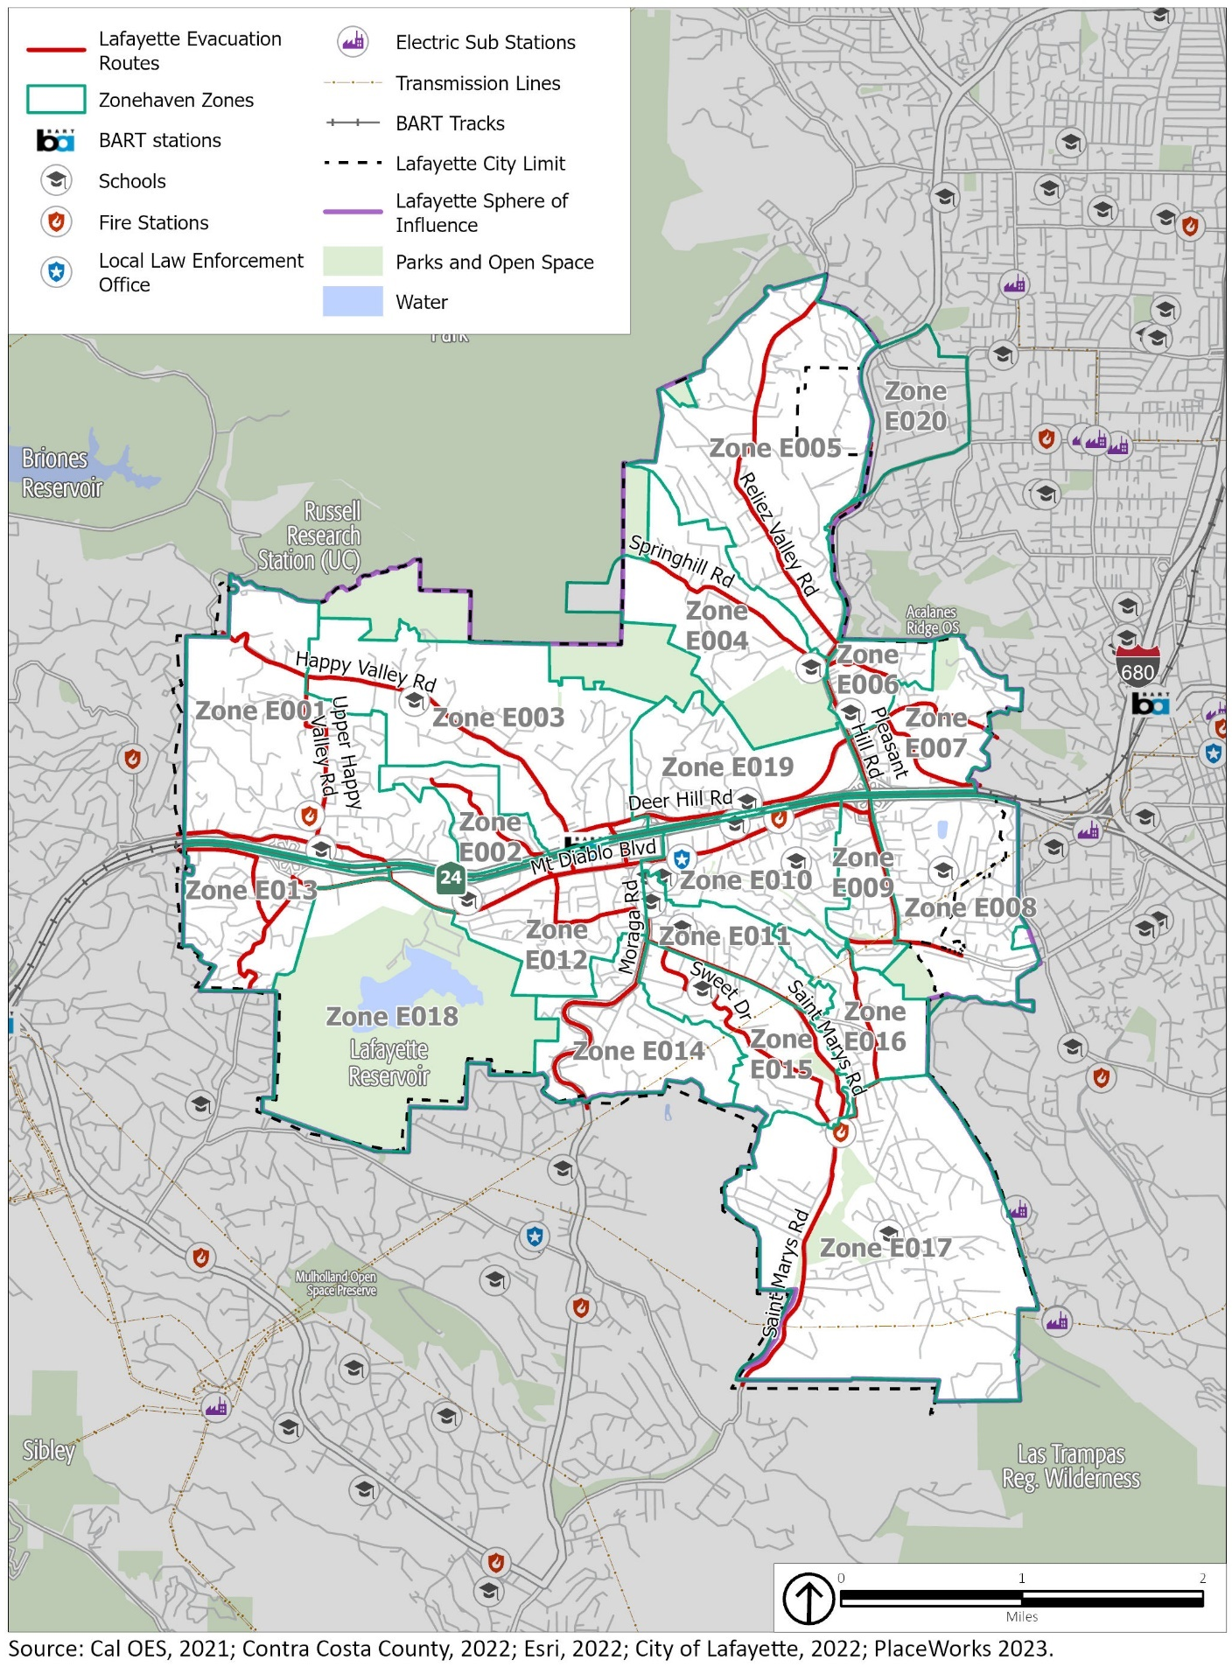
Figure S-2 Evacuation-Constrained Residential Parcels
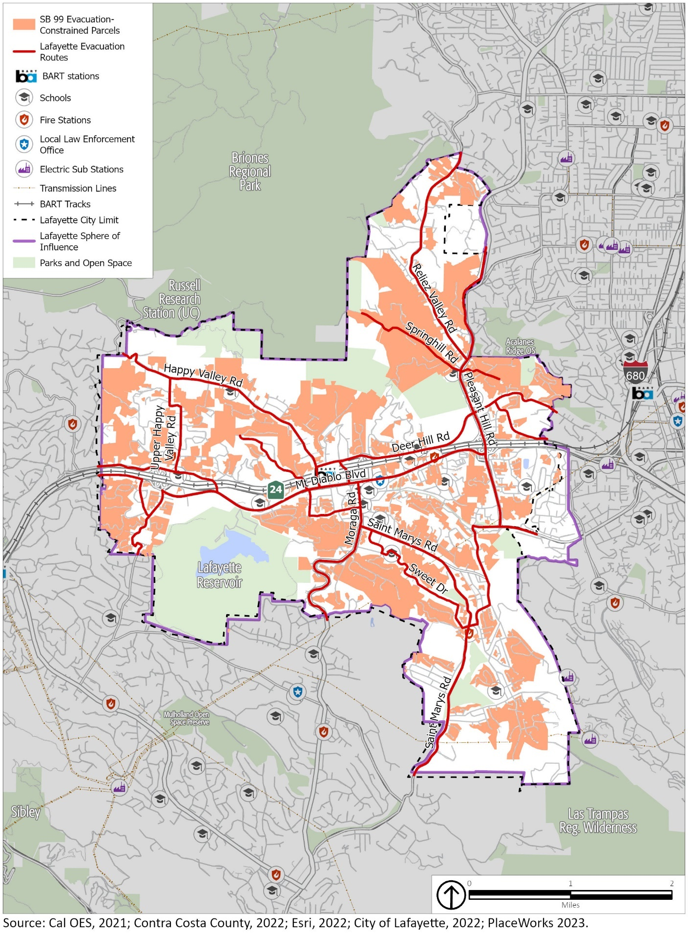

Flood and Inundation Hazards

Flood Hazards
Flooding is the rising and overflowing of a body of water onto normally dry land. Floods are usually caused by large amounts of stormwater, either from a period of very intense precipitation or a long period of steady precipitation. Historically, Lafayette has been at risk of flooding primarily during the winter and spring months when stream systems swell with heavy rainfall, especially when prior rainfall has saturated the ground. Occasionally, flash flooding from short-duration, high-intensity precipitation (often during atmospheric river events) may occur. Atmospheric rivers are long, narrow regions in the atmosphere that transport most of the water vapor carried away from the tropics, accompanied by strong winds. When atmospheric rivers make landfall, they often release this water vapor in the form of rain or snow, causing heavy rains that can lead to flooding and mudslides. They can also cause flash flooding, which can occur with little to no warning.
Flooding can be extremely dangerous and poses a variety of challenges for prevention and recovery efforts. As little as six inches of moving water can knock a person over, given a strong current. Floodwater can transport large objects downstream, and ground saturation can result in instability, collapse, or other damage that breaks utility lines and interrupts services. Objects can also be buried or destroyed through sediment deposition from heavy flooding. Standing water can damage roads, foundations, and electrical circuits and spread vector-borne illnesses. Other hazards connected with flooding and stormwater runoff include erosion, degradation of water quality, and loss of environmental resources. Flash flooding can tear out trees, undermine buildings and bridges, and scour new channels. In urban areas, flash flooding is an increasingly serious problem due to removal of vegetation and replacement of groundcover with impermeable surfaces such as roads, driveways, and parking lots.
Areas at an elevated risk of flooding are divided into 100- and 500-year floodplains. A 100-year floodplain has a 1 percent chance (1 in 100) of experiencing a major flood in any given year, and a 500-year floodplain has a 0.2 percent chance (1 in 500) of flooding in any given year. Figure S-3 shows the 100- and 500-year floodplains in and around Lafayette. The 100-year floodplain is primarily along Las Trampas Creek, Lafayette Creek, Grizzley Creek, and the Lafayette Reservoir Recreation Area as well as drainage areas from the northeast to the southeast portion of the city. The 500-year floodplain includes areas around Las Trampas Creek and Lafayette Creek, the downtown area, areas near the BART station and SR-24, and areas around Acalanes High School.
Agencies responsible for flood control in Lafayette include the US Army Corps of Engineers (USACE), Contra Costa County Flood Control and Water Conservation District (FC District), Federal Insurance Administration, and California Department of Water Resources (DWR). USACE, FC District, EBMUD, and DWR develop and manage flood control infrastructure in and around the city, including creeks, channelized drainage channels which provides flood control for development downstream. FEMA and the Federal Insurance Administration delineate flood-prone areas on Flood Insurance Rate Maps and manage the National Flood Insurance Program to ensure homeowners with federally subsidized mortgages living in floodplains have flood insurance. The City of Lafayette manages stormwater drains throughout the community that drain to the creek network and can contribute to flooding when a large volume of water falls in a short period of time.
Although heavy precipitation events are a regular feature in California, atmospheric rivers have caused major flooding in Contra Costa County in recent years. In January 2006, widespread county flooding occurred after 2 to 4 inches of rain fell on the area in about 24 hours. In 2012, a series of significant winter storms affected the county during late November and early December, causing gusty winds, heavy rainfall, and flooding. In December 2022 and January 2023, a series of atmospheric rivers caused flooding, mudslides, and power outages across the county.
Although climate change may not change average precipitation levels significantly, scientists expect that it will cause more years with extreme precipitation events. This means that more years are likely to see intense storm systems that drop substantial volumes of precipitation over a short period and cause flooding. Because of this, floods are expected to happen more often in Lafayette, and climate change may expand the parts of the city that are considered prone to flooding. Increases in damaging floods will cause more property damage, public health and safety concerns, displacement, and loss of life. Displacement of residents includes temporary and long-term displacement and increases in insurance rates or restriction of insurance coverage in vulnerable areas.

Figure S-3 Flood Hazard Zones
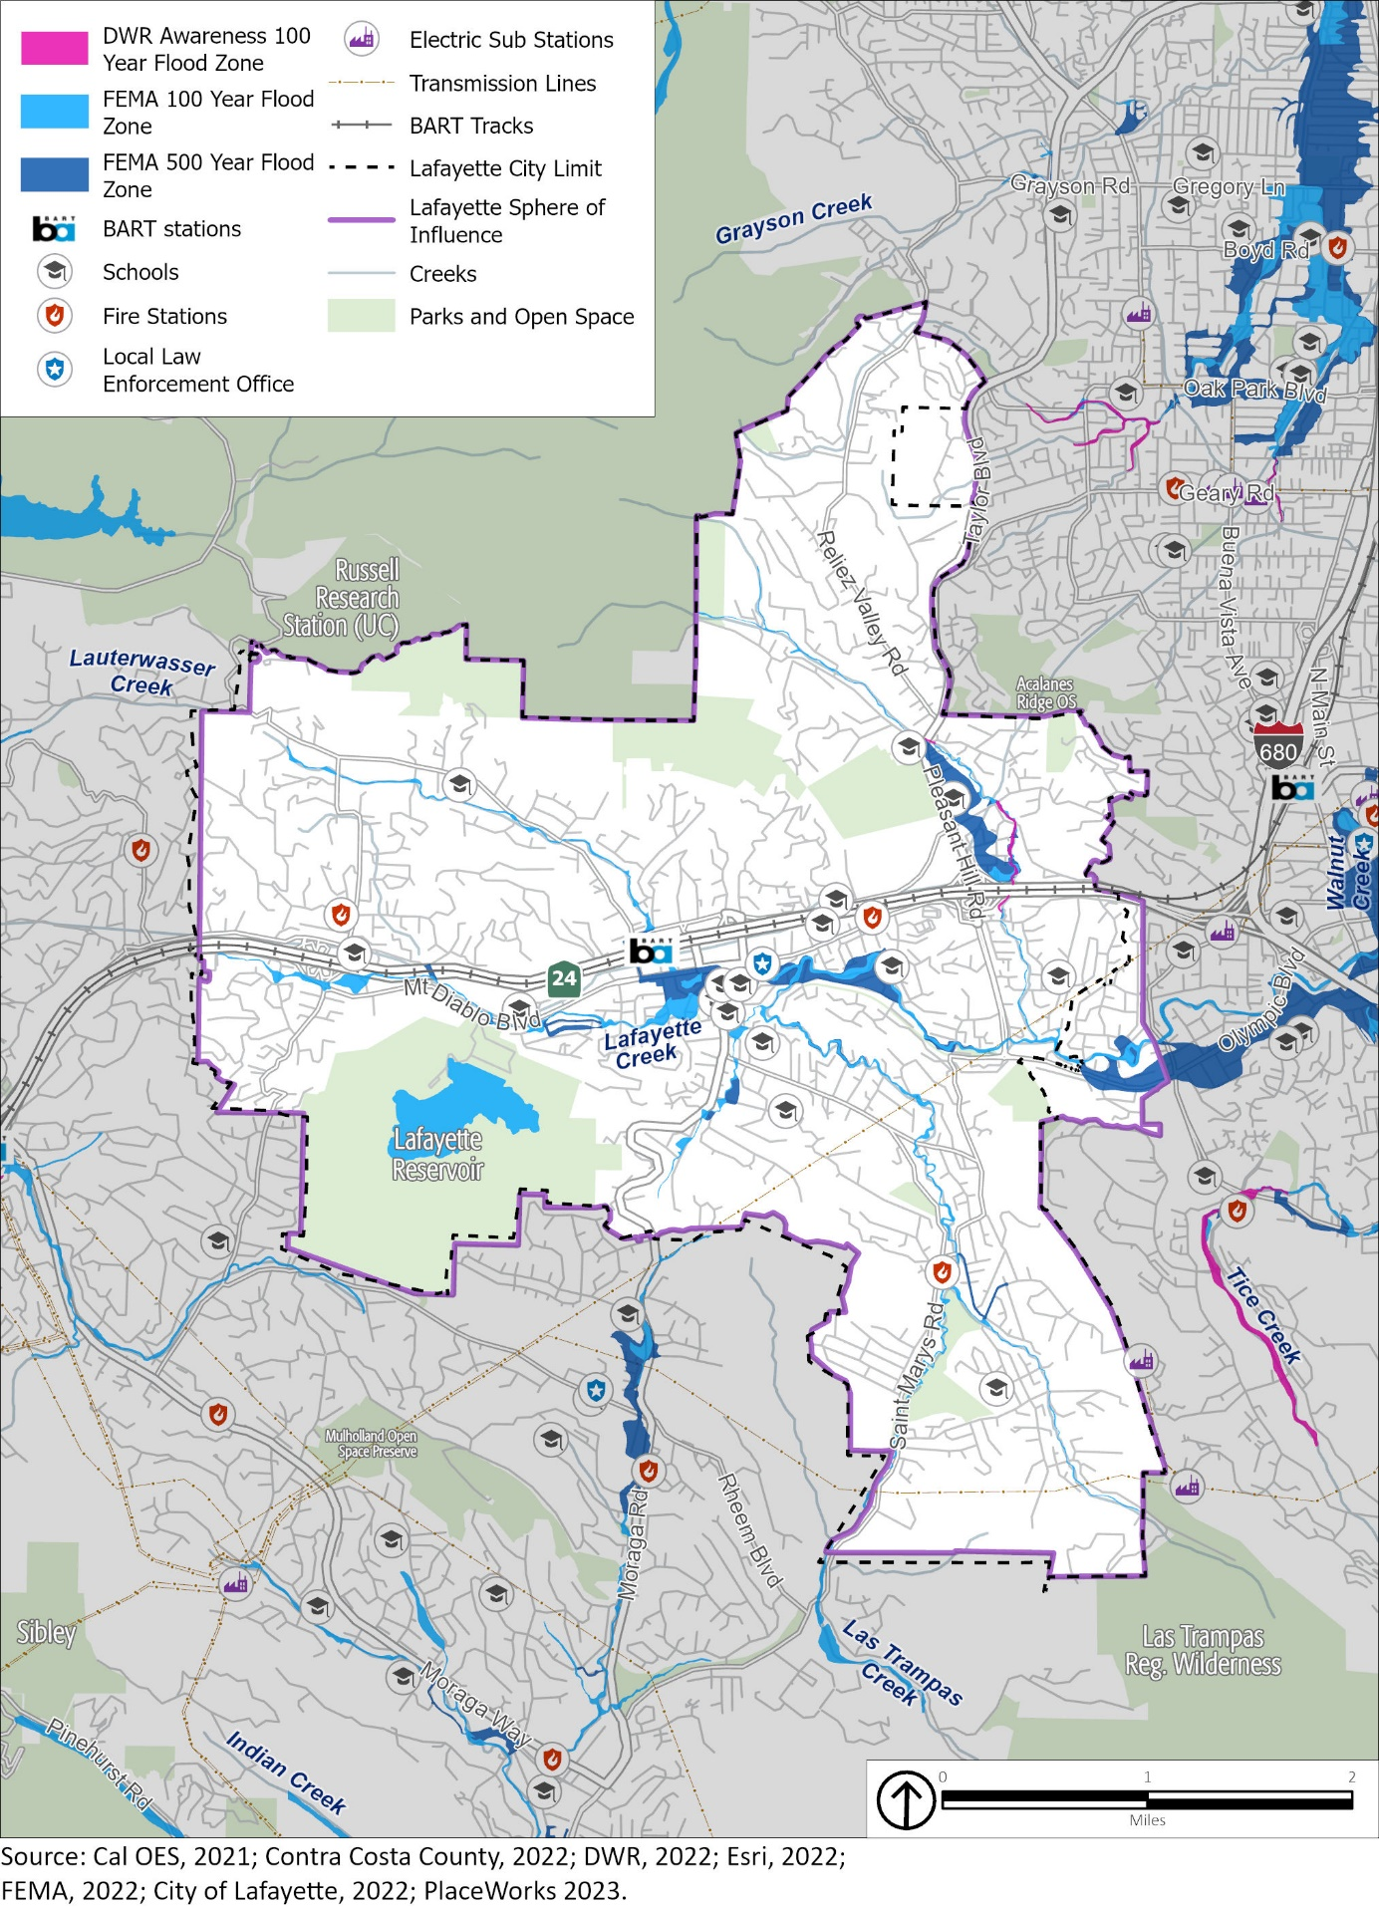

Dam or Pipeline Inundation
A dam failure is an uncontrolled release of water from a reservoir through a dam because of structural failures or deficiencies. Pipeline failures are a similar uncontrolled release from a water pipeline or aqueduct. The primary danger from dam or pipeline failure is the high-velocity flooding downstream of the dam and limited warning times for evacuation.
Dam or pipeline failures can range from minor to catastrophic, potentially harming human life and property downstream from the failure. In addition, ecosystems and habitats can be destroyed by fast-moving floodwaters, debris, and sedimentation from the inundation. Failures are rare but not unprecedented; they can be caused by overtopping, foundation defects, piping and seepage failures, or conduit and valve failures. Many dam or pipeline failures are the secondary result of other natural disasters, such as earthquakes, landslides, and extreme storms.
Figure S-4 illustrates areas in the city that would be affected by dam inundation. The Lafayette Reservoir, owned by EBMUD and completed in 1933, poses an inundation risk to the city; in the event of a dam failure land surrounding Lafayette Creek and Las Trampas Creek would flood, affecting the downtown and residential areas. EBMUD has a comprehensive dam safety program, proactively inspecting, upgrading, and improving its dams and water supply structures as needed and in consultation with regulatory agencies such as USACE and DWR’s Division of Safety of Dams. Engineers monitor dams using instruments, monthly visual inspections, and periodic dam safety reviews to prevent loss of life, personal injury, and property damage from the failure of dams.
Dam failure poses a significant risk to EBMUD’s Mokelumne Aqueduct System. The aqueduct carries water from the Sierra Nevada foothills to the Walnut Creek Water Treatment Plant near Lafayette. A series of other pipelines, including some that pass through Lafayette, carry water from the aqueduct to other treatment plants and to EBMUD customers. For example, a large water pipeline crosses from east to west through downtown Lafayette, connecting to the water treatment plant near the Lafayette Reservoir. In the event of a dam failure at facilities along the aqueduct, a sudden and massive release of water can generate a high-pressure surge of water in the pipelines. A surge of water can create a force that exerts pressure on the walls of the aqueduct, which has the potential to rupture the aqueduct and other infrastructure in its path. The rupture could allow water to escape and flood the surrounding area. Although EBMUD’s Mokelumne Aqueduct System is designed to withstand normal flow rates, the sudden surge of water could cause it to rupture. Aqueducts that are old or in poor condition are generally more vulnerable to damage.
Due to the monthly visual inspection of and planned seismic retrofits for the Lafayette Reservoir, the potential for a dam failure in Lafayette is likely to remain a low risk in future years, although heavy precipitation events and atmospheric rivers may increase that risk.

Figure S-4 Dam Inundation Areas
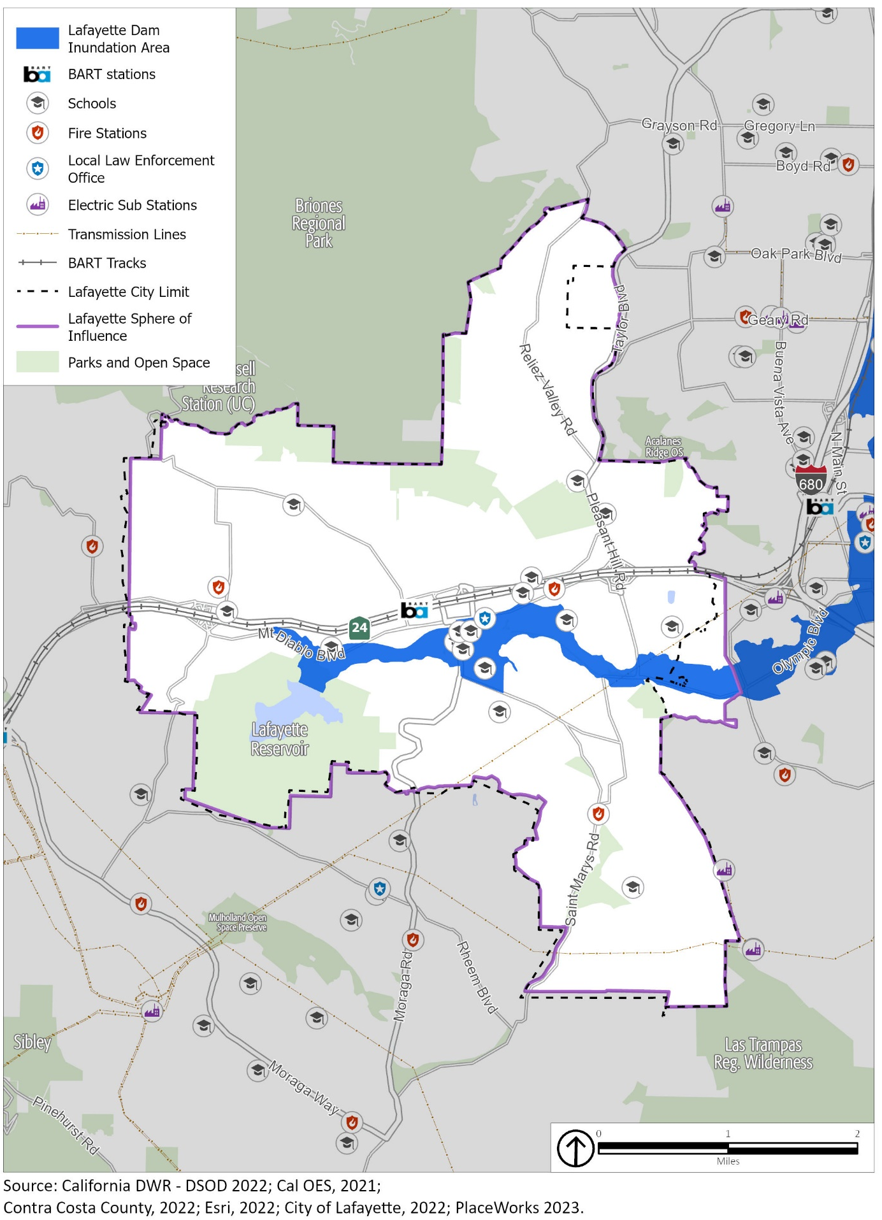

Seismic and Geologic Hazards
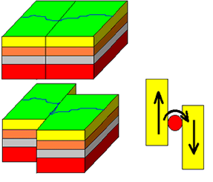
Seismic and geologic hazards are risks caused by the movement of different parts of the Earth’s crust, or surface. Seismic hazards include earthquakes and hazardous events caused by them. Geologic hazards are other hazards involving land movements that are not linked to seismic activity and are capable of inflicting harm to people or property.

Seismic Hazards
Seismic activity occurs along boundaries in the Earth’s crust, called faults. Pressure along the faults builds over time and is ultimately released, resulting in ground shaking that we refer to as an earthquake. Earthquakes can also trigger other hazards, including surface rupture (cracks in the ground surface), liquefaction (causing loose soil to lose its strength), landslides, subsidence (sinking of the ground surface), and sinkholes.
A simple illustration of a strike-slip fault, the same type as the San Andreas Fault. As the two land masses on either side of the fault move past each other, pressure builds up along the boundary. Eventually, the pressure exceeds the force of friction and the ground shifts suddenly, creating an earthquake. Image by the US Geological Survey.
The Bay Area region lies within the active boundary between the Pacific and the North American tectonic plates. Earthquakes in the region result from strain energy constantly accumulating because of the motion of the Pacific Plate against the North American Plate. The San Andreas Fault is the major plate boundary and has the potential to cause the strongest earthquakes. Earthquake risk is very high in Contra Costa County, including the City of Lafayette, due to the presence of several active faults in the region—the Calaveras North Fault, Concord-Green Valley Fault, Greenville Fault, Hayward Fault, and Mount Diablo Fault. As shown on Figure S-5, there are several faults near the city; however, there are no Alquist-Priolo fault zones in the city. Nevertheless, a major earthquake along any of these faults could result in substantial casualties and damage from collapsed buildings, damaged roads and bridges, fires, flooding, and other threats to life and property. Most of the loss of life and injuries from earthquakes are due to the damage and collapse of buildings and structures.
Alquist-Priolo Act

The Alquist Priolo Act was adopted by the State legislature and established Special Studies Zones throughout California. Today, Special Studies Zones are known as Alquist-Priolo earthquake fault zones. Alquist-Priolo earthquake fault zones are regulatory zones surrounding the surface traces of active faults in California. (A trace is a line on the earth's surface defining a fault.) Geologic investigations must be prepared prior to certain types of new development in these zones. There are, at present, no Alquist-Priolo earthquake fault zones in the Lafayette Planning Area.

The San Andreas Fault, the fastest-slipping fault along the Pacific and North American Plate boundary, has caused earthquakes of magnitude 7.8 and 7.9 in the past, including the 1906 San Francisco earthquake. In 1989, the Loma Prieta earthquake, which also originated along the San Andreas Fault, produced a magnitude 7.2 earthquake. The earthquake caused extensive damage and created a seven-county major disaster area, including Contra Costa County. Though major earthquakes are rare in Lafayette, minor earthquakes are not.

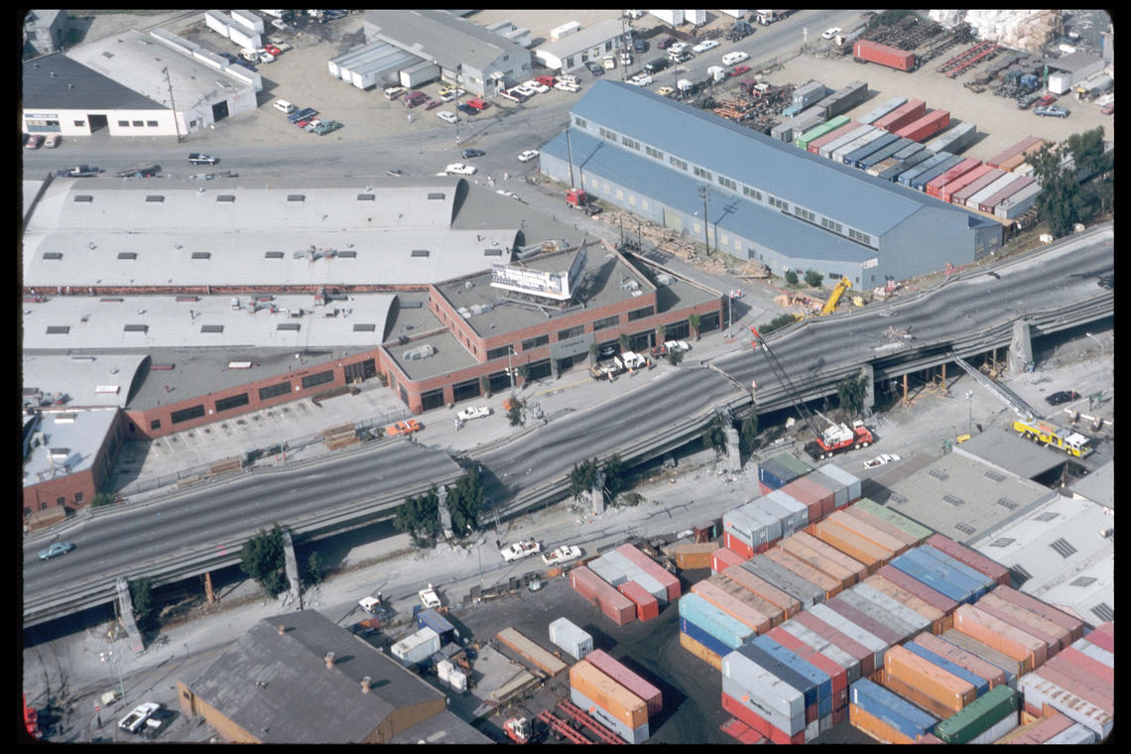
A collapsed section of the Cypress Street Viaduct along Interstate 880 in Oakland following the Loma Prieta Earthquake. Photo by the US Geological Survey.
Earthquakes are likely to continue to occur on an occasional basis. Most are expected to cause no substantive damage and may not even be felt by most people. A major earthquake along any of the nearby faults could result in substantial casualties and damage, although the greatest risk in Lafayette is from the Calaveras Fault or Mount Diablo Fault due to their proximity and high potential to cause a severe earthquake. A major earthquake on the Hayward Fault could damage or destroy transportation infrastructure, such as the BART railway, SR-24, or bridges, limiting access in and out of the community. A number of small-scale earthquakes happen weekly, but larger-scale or catastrophic shaking is less likely.

Liquefaction
Liquefaction is the complete failure of soils, occurring when soils lose shear strength and flow horizontally. Shaking causes the soil to lose strength and behave as liquid, usually in saturated soils in areas with high groundwater. Excess water pressure is vented upward through fissures and soil cracks and can result in a water-soil slurry flowing onto the ground surface. Groundwater that is less than 10 feet from the surface can cause the highest liquefaction susceptibility, and lower groundwater levels cause lower liquefaction risks. Soils susceptible to liquefaction are typically found in areas of low-lying, current, or former floodplains. Portions of the city near the floodplains of Lafayette Creek, Las Trampas, and Grizzley Creek are areas likely to face liquefaction during an earthquake event. Figure S-6 shows the areas facing an elevated liquefaction risk in Lafayette.
In most cases, proper design and construction of subgrade soils and building foundations provides a mechanism to mitigate the risk of seismic hazards to an acceptable level in conformance with the California Building Code. The representation of areas having a liquefaction potential is only intended as notification to seek further site-specific information and analysis of this potential hazard as part of future site development.

Seismic Seiche
Seismic seiches are waves that can occur in a body of water, such as the Lafayette Reservoir, because of seismic shaking. When an earthquake occurs, the ground shakes and can cause the water in a reservoir to slosh back and forth, creating standing waves that can cause significant damage to the dam structure and the surrounding area. The likelihood of a seismic seiche occurring in a reservoir during an earthquake depends on the size and shape of the reservoir, the amount of water in the reservoir, the strength and frequency of the seismic waves, and the soil and rock conditions around the reservoir. Seismic seiches can also occur in wastewater storage tanks, particularly if the tanks are large and filled with a significant amount of water.

Other Seismic Hazards
Earthquake-induced landslides pose a significant risk due to the presence of landslide-prone areas and proximity of earthquake faults. Ground shaking from seismic activity can cause rocks, debris, and hillside soils to loosen and fall downslope, harming facilities and infrastructure in their path. Sinkholes, which are depressions or holes in the ground that form when the surface collapses into an underground space, are also a hazard in Lafayette. They can be formed by natural processes, such as earthquakes or subsidence, when the ground’s surface sinks as a result of underlying soil or rock being compressed, compacted, or eroded. Sinkholes can occur suddenly and can be very dangerous if they form underneath buildings, roads, or other structures. They can also cause damage to natural ecosystems. Landslides and sinkholes are discussed in further detail in the Geologic Hazards section that follows.

Figure S-5 Regional Fault Lines
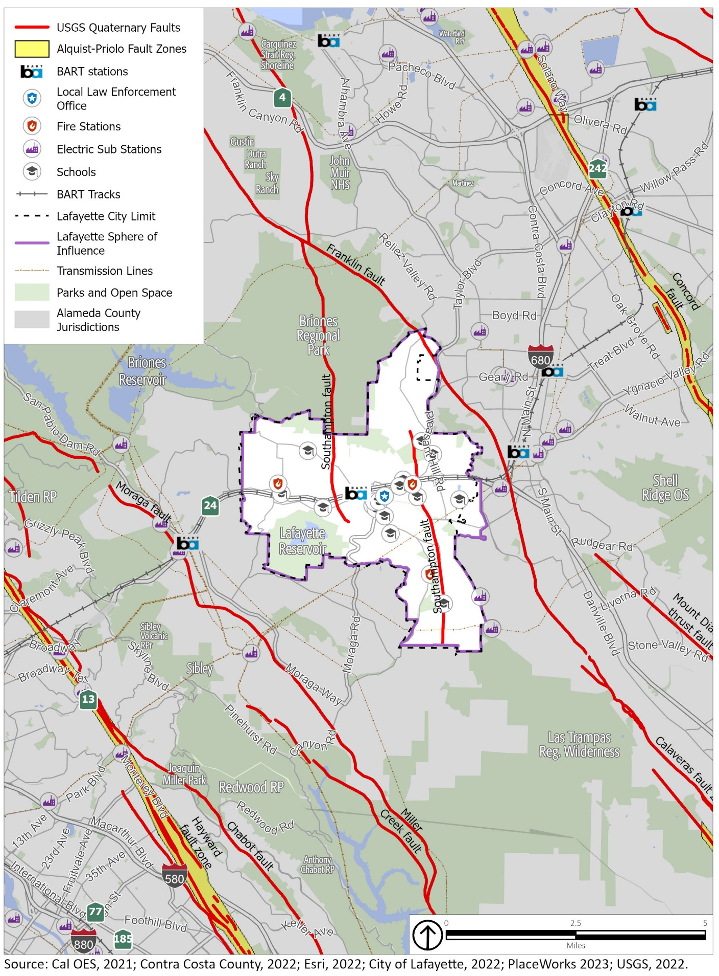
Figure S-6 Liquefaction Areas
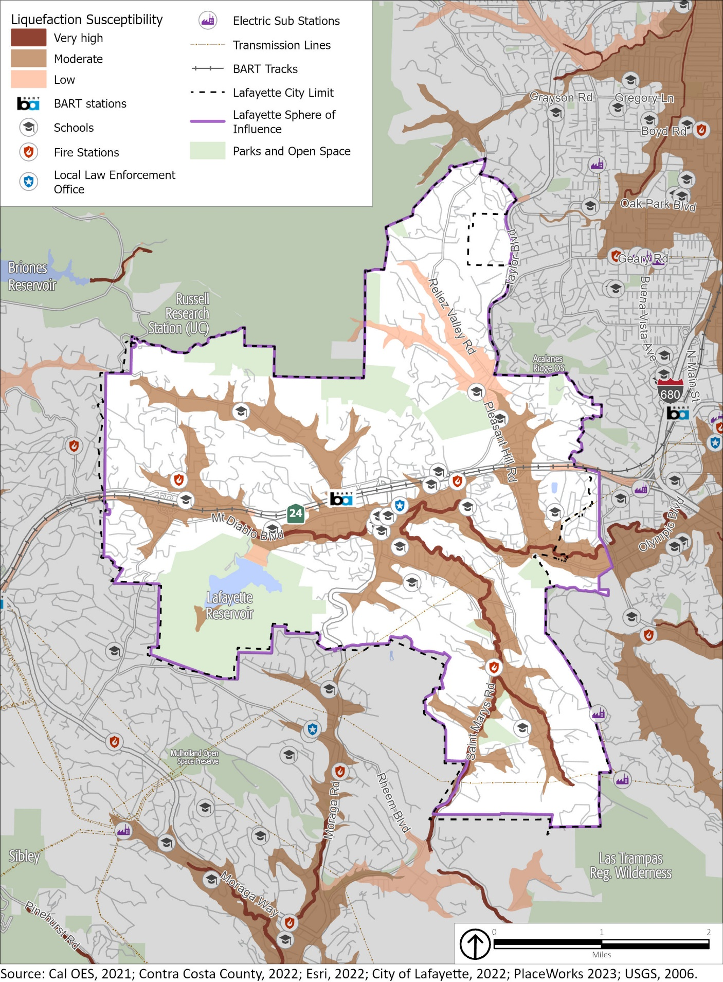

Geologic Hazards
Geologic hazards in Lafayette include landslides and erosion. Landslides and rock falls may occur in sloped areas, especially areas with steep slopes, and usually in areas of loose and fragmented soil. Landslides, rockfalls, and debris flows occur continuously on all slopes; some processes act very slowly, and others occur very suddenly, often with disastrous results. Landslides are often triggered by other natural hazards, such as earthquakes, heavy rain, floods, or wildfires, so landslide frequency is typically related to the frequency of these other hazards.
Due to the hilly terrain, large sections of Lafayette are in areas with an elevated risk of landslides, as shown on Figure S-7. Multiple critical facilities—communication, power, water, wastewater, bridges, fire district, and schools—are at moderate to high risk for landslides.
In Contra Costa County, landslides typically occur during and after heavy precipitation, so the risk of landslides often rises during and after atmospheric river events. According to the National Centers for Environmental Information’s storm event database, Contra Costa County has been impacted by heavy precipitation at least once every three years. Landslides and mudslides are a common occurrence and have caused damage to homes, public facilities, roads, parks, and sewer lines in particular.
Climate change is expected to result in more precipitation extremes. More frequent periods of heavy rainfall could cause an increase in the number of landslides or make landslides larger than normal. Increased wildfire frequency can destabilize hillsides due to loss of vegetation and changes in soil composition, which can contribute to greater runoff and erosion. Climate change will also cause more frequent and extreme droughts, which dries out soil. When precipitation does occur, the soil cannot absorb as much water, which creates higher levels of runoff, potentially leading to landslides and mudflows. The combination of a generally drier climate in the future, which will increase the chance of drought and wildfires, and the occasional extreme downpour, is likely to cause more mudslides and landslides.
Lafayette is also susceptible to hazards related to erosion, or the geological process in which earthen materials are worn away and transported by natural forces such as water or wind, causing the soil to deteriorate. Eroded topsoil can be transported into streams and other waterways. Water erosion is the removal of soil by water and transportation of the eroded materials away from the point of removal. The impact of soil erosion on water quality becomes significant, particularly as soil surface runoff increases. Highly erosive soil can damage roads, bridges, buildings, and other structures, potentially creating hazardous conditions. Sinkholes can also be formed by the erosion of soil or sediment by water flowing through the ground. This can happen in areas with sandy or porous soils, or in areas with a high water table. Sinkholes can pose a hazard to infrastructure and human safety. They can cause damage to buildings, roads, and other structures, and can also pose a risk to people and animals if they are not properly identified and managed.

Figure S-7 Landslide Susceptibility Areas
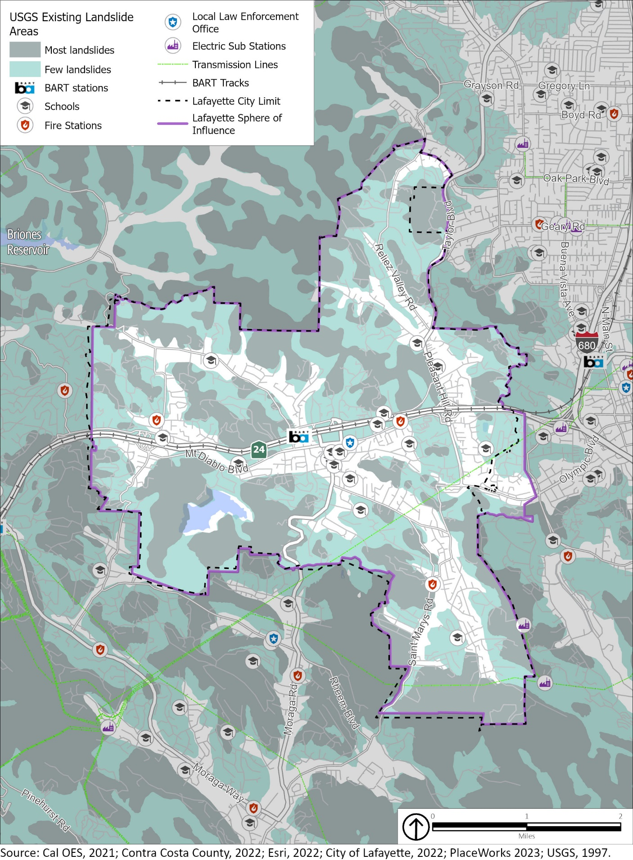

Fire Hazards
The combination of complex terrain, Mediterranean climate, and ample natural ignition sources has created conditions for wildfires in Lafayette. Historically, the fire season extended from early summer through late fall of each year during the hotter, dryer months; however, wildfires have become a hazard that can occur year-round due to increased temperatures and drier conditions. Three types of fires are of particular concern to Lafayette, which are discussed in greater detail below: (1) wildfires, (2) wildland-urban interface fires, and (3) structural fires.

Wildfires
Wildfires occur on mountains, hillsides, and grasslands, with fuel, weather, and topography as the primary factors for how wildfires spread. In and around Lafayette, grassland and woodland habitat provide highly flammable fuel that is conducive to wildfires. Wildfire potential for Contra Costa County is typically greatest in the months of August, September, and October, when dry vegetation coexists with hot, dry winds from the north or northeast, known as Diablo winds. The Diablo winds can quickly desiccate vegetation and other combustible materials and can push a fire down or up a slope at very high speeds, causing erratic fire behavior. These winds often occur during the spring and fall but are especially dangerous in the driest months of late summer and fall.
Because areas of the city with extensive vegetation are extremely flammable during late summer and fall, wildfire is a serious hazard in undeveloped areas and on large-lot home sites with unirrigated vegetation. Wildfires, particularly near the end of the dry season, tend to burn fast and very hot, threatening homes and leading to serious destruction of vegetative cover.
The predominant canopy cover in Lafayette is provided by oak woodlands. Many species of oaks are relatively tolerant to fire and are known to be part of California’s fire-dependent ecosystem. However, fire suppression in the twentieth century has led to the buildup of dense understories and higher densities of small trees, enhancing the risk of high-severity fires under hot, dry, and windy conditions. Invasive and non-native tree species that are not well-adapted to California’s fire regime, such as eucalyptus, are highly flammable and can exacerbate the spread of wildfires. In addition, tree mortality due to drought, sudden oak death, and forest pests (beetles) has increased densities of dead fuels and contributed to higher fire risk in the Bay Area. Under moderate drought conditions, oak woodlands generally present low fire risk, and treatments that remove ground fuels further reduce risk of high-severity fire. However, in Lafayette, an oak woodland wildfire has the potential to spread rapidly due to the community’s steep topography, fuel load, and climatic conditions during the summer and fall, making fire suppression challenging.
Areas adjacent to the city are also of concern as these conditions could exacerbate vulnerabilities within the city. These areas include State Responsibility Area (SRA) lands in the Las Trampas Regional Wilderness, the hillsides around the San Pablo and Briones Reservoirs, and the Briones Regional Park, as well as Local Responsibility Area (LRA) lands in the open space areas of Orinda and Moraga.
Figure S-8 shows the area’s historical wildfire perimeters near Lafayette. In 1998, the Sibley Fire 2 burned approximately 200 acres in the southwestern area of Orinda. The fire began in the Sibley Volcanic Regional Preserve, encroaching on the hillsides of Orinda, approximately five miles from Lafayette. In 1991, the Oakland Hills west of Lafayette suffered one of the worst wildland-urban interface (WUI) firestorm disasters to ever strike the United States. This wildfire resulted in 25 deaths, 150 injuries, and destruction of 2,900 structures, causing losses of more than $1.5 billion. In September 2019, electrical equipment and high winds ignited a wildfire near Camino Diablo that burned 7 acres and destroyed three structures, including the Lafayette Tennis Club. Residents in the area near Acalanes High School were evacuated and ConFire managed to control the fire within hours.
ConFire’s Wildfire Mitigation Program
ConFire provides several programs throughout the county to reduce wildfire risks.
- Community chipping days
- Evacuation route cleanups
- Firewise USA Community Strategic Plan Projects
- Removal of dead trees
- Shaded fuel breaks
- Vegetation management and fuel reduction
- Home hardening outreach programs
- Low-income exterior hazard control program

Changing climate conditions are expected to increase the fire risk in and around Lafayette. Warmer temperatures brought on by climate change can exacerbate drought conditions. Droughts can kill or dry out plants, creating more fuel for wildfires. Warmer temperatures are also expected to increase the number of pest outbreaks, such as the bark beetle, creating more dead trees and increasing the fuel load.
Hot, dry spells may also increase disease and insect infestations, resulting in higher fuel loads. Increased winds will result in more erratic fire behavior, making fires harder to contain. Warmer temperatures are also expected to occur later in the year, extending the wildfire season, which is likely to begin earlier in the year and extend later than it has historically. Diablo winds can also exacerbate the wildfire risk in and around Lafayette.

Wildland-Urban Interface Fires
The WUI is an area where buildings (e.g., schools) and infrastructure (e.g., cell towers and water supply facilities) mix with areas of flammable wildland vegetation, allowing wildland fires to easily spread to buildings and structures. Figure S-9 identifies the WUI in and around Lafayette. The WUI is made up of three distinct zones.
- The intermix zone contains housing development or improved parcels interspersed in an area dominated by wildland vegetation subject to wildfire.
- The interface zone contains dense housing next to vegetation that can burn in a wildfire but is not dominated by wildland vegetation.
- The influence zone contains wildfire-susceptible vegetation within 1.5 miles from the WUI or wildland-urban intermix zones. In the WUI, efforts to prevent ignitions and limit wildfire loss hinge on hardening structures and creating defensible space through a multifaceted approach, which includes engineering, enforcement, education, emergency response, and economic incentive.
Figure S-8 Historic Wildfire Burn Areas
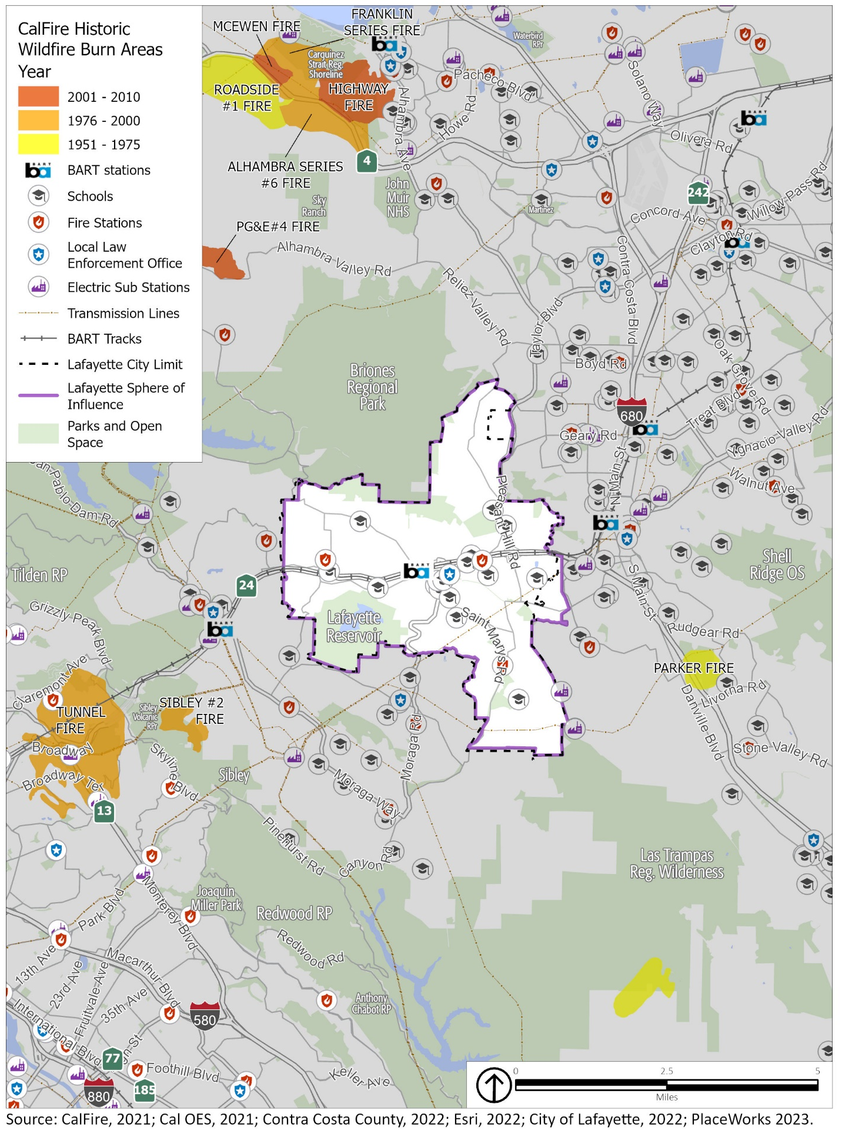
Figure S-9 Wildland-Urban Interface Areas
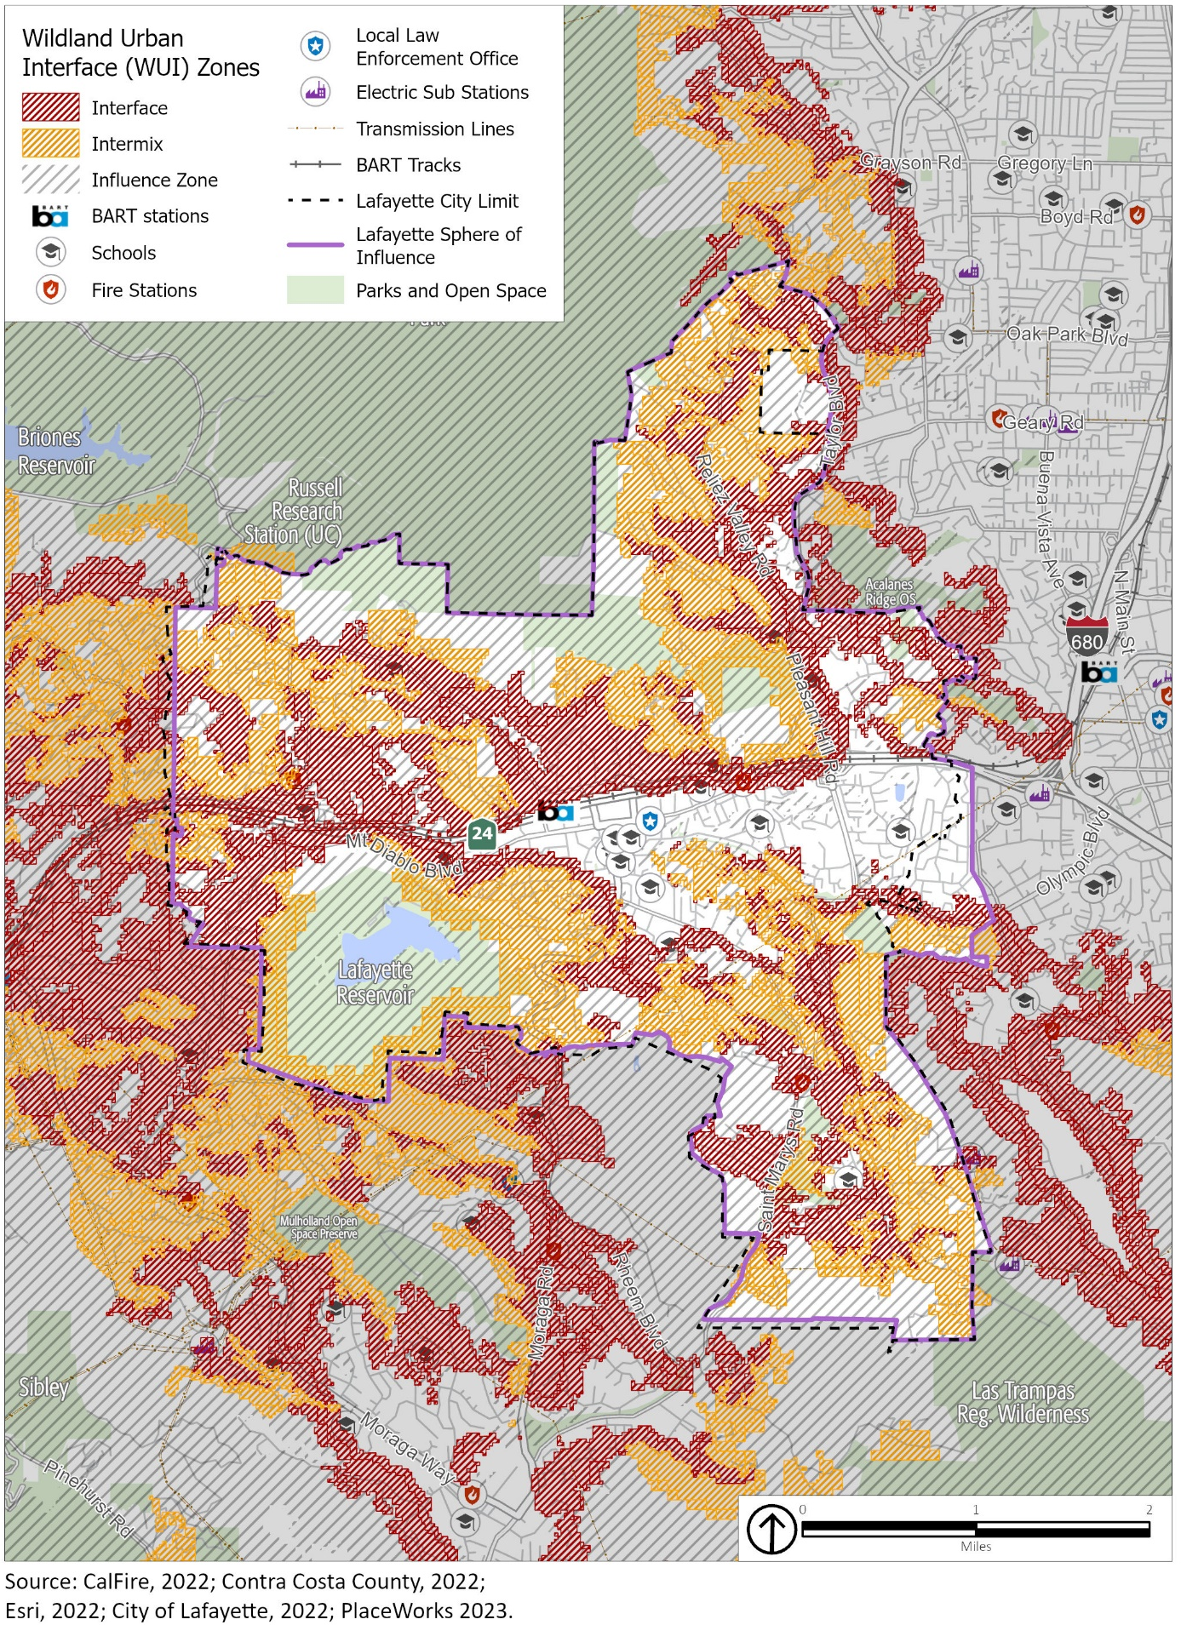

Structural Fires
Lafayette is also at risk from structural fires. These fires occur in built-up environments, destroying buildings and other human-made structures. Structural fires are often due to faulty wiring, mechanical equipment, or combustible construction materials. The absence of fire alarms and fire sprinkler systems often exacerbate the damage associated with a structural fire. Older buildings that lack modern fire safety features may face greater risk of damage from fires. To minimize fire damage and loss, the City’s fire code, based on California Code of Regulations, Title 24, sets standards for building and construction. The Fire Code requires, among other preventative and preparatory measures, the provision of adequate water supply for firefighting, fire-retardant construction, and minimum street widths. The Fire Prevention Division of ConFire is tasked with providing the highest level of fire prevention through public education, inspection, code enforcement, and detailed plan review. One way in which this prevention work is undertaken is through referral of development projects to ConFire to evaluate potential hazards to be addressed and emergency service needs, like sufficient access for fire trucks. Under the direction of the Fire Marshal, ConFire’s Fire Prevention Division personnel strive to provide the public with the most updated information available to safely protect their homes and places of business from fire and hazards.

California Fire Code
Fire Responsibility Areas
Local Responsibility Area (LRA): Incorporated communities are financially responsible for wildfire protection.
State Responsibility Area (SRA): CAL FIRE and contracted counties are financially responsible for wildfire protection.
Federal Responsibility Area (FRA): Federal agencies are responsible for wildfire protection.
The California Fire Code contains regulations related to the construction, operation, and demolition of buildings and other structures to minimize the risk of fire and explosion. The Fire Code is consistent with nationally recognized and accepted practices for safeguarding life and property from the hazards of fire and explosion; reducing dangerous conditions arising from the storage, handling, and use of hazardous materials and devices; and minimizing hazardous conditions in the use or occupancy of buildings or premises. The California Fire Code also contains provisions to assist emergency response personnel. Every three years, new editions of the state codes are published and, in addition to local amendments, reflect changes in technology, fire safety techniques, and the building industry.
Title 14, Division 1.5, Chapter 7 of the California Code of Regulations establishes SRAs, Very High Fire Hazard Severity Zones (VHFHSZs) in LRAs, and Fire Safe Regulations for these areas. These regulations constitute the basic wildland fire protection standards of the California Board of Forestry and establish minimum wildfire protection standards in conjunction with building, construction, and development in SRAs and VHFHSZs.

Fire Hazard Severity Zones
CAL FIRE establishes Fire Hazard Severity Zones of moderate, high, or very high severity. As shown in Figure S-10, areas in the northern, northwest, and western portion of the city are in a VHFHSZ. Many of these high-risk areas are also the most difficult to access, as they are at the end of winding roads bordering undeveloped hillsides. Furthermore, areas adjacent to the city that are susceptible to wildfires are also of concern as these conditions could exacerbate vulnerabilities within the city.

Figure S-10 Fire Hazard Severity Zones
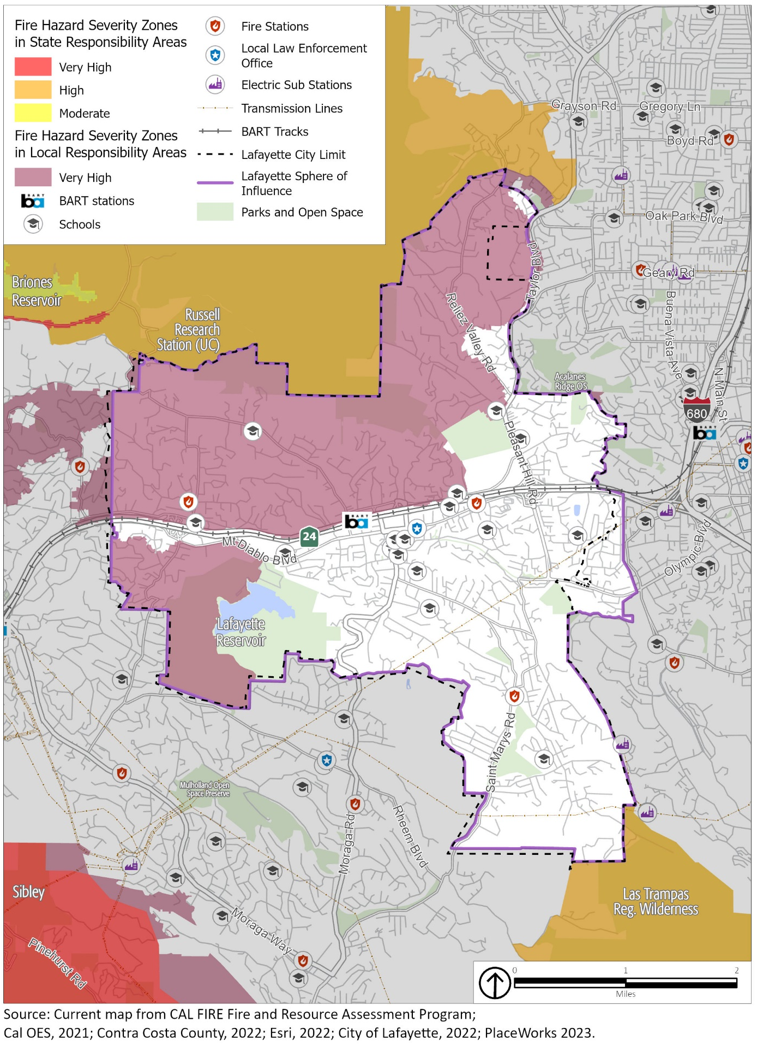
Residential development in the WUI, the introduction and proliferation of exotic plant species, accumulated fuel because of wildfire suppression efforts, and climate-change-driven compression of the historical rainy season exacerbates the fires. Though large-scale wildfires do not occur every year, wildfire incidents driven by extreme weather conditions have repeatedly been difficult to contain.
A combination of factors, including weather, topography, and vegetation, create a higher risk of wildfire hazards in Lafayette, particularly in the VHFHSZs and WUI. CAL FIRE periodically reviews and revises the FHSZ boundaries based on updated modeling and scientific information. Individuals interested in these FHSZ boundaries should consult the most recent available mapping available from CAL FIRE’s Fire and Resource Assessment Program (FRAP) at https://frap.fire.ca.gov/. Future updates to the Safety Element will incorporate new mapping data as it becomes available.
Figure S-11 shows land uses in VHFHSZs, as determined in 2007. These land uses primarily consist of residential and open space. In Lafayette, there are 2,968 residential parcels and 91 open space parcels in the VHFHSZ, representing approximately 46% of all parcels in Lafayette existing in these high risk zones.

CPUC Fire Threat Zones
The California Public Utilities Commission (CPUC) has also created tiers to designate areas that are at risk from wildfires associated with overhead power lines, which have become a significant cause of wildfires in California. Two of these designations are substantially present in and around Lafayette. CPUC Tier 2 zones identify areas at an “elevated” risk of power line-associated wildfires, while Tier 3 zones are those that face an “extreme” risk. According to the CPUC, the Tier 3 zones differ from Tier 2 because they have the highest chance of power lines causing wildfires that would harm people and property, and are where the strictest regulations are needed to reduce the risk. Figure S-12 shows the CPUC fire threat zones in and around Lafayette.

Fire Protection
As described in Section 2.1, Emergency Preparedness and Response, fire protection in Lafayette is provided by ConFire. ConFire operates three fire stations in the city, two near SR-24 on Mt. Diablo and Los Arabis Drive, and one in southern Lafayette on St. Mary’s Road. There are additional ConFire fire stations outside the city’s boundaries in Pleasant Hill and Walnut Creek that can assist in emergencies as needed. As development continues in Lafayette, the City and ConFire will continue to monitor the changing fire protection needs in the community.

Firewise Program
Firewise is a national program helping neighbors work together with their local fire jurisdiction to protect their communities from wildfire danger. In the Contra Costa County Fire Protection District, this program is administered by ConFire’s Community Risk Reduction Unit of the Fire Prevention Bureau. The Firewise program emphasizes a community-based approach to wildfire preparedness. It encourages homeowners to work together to create defensible space around their homes by reducing the amount of flammable vegetation, debris, and other materials in the surrounding area.
The Firewise program provides homeowners and communities with a range of resources and tools to help them reduce the risk of wildfire damage. These resources include educational materials, training courses, and online tools to help homeowners assess their property’s risk and develop a plan to reduce their vulnerability to wildfire. The program also offers recognition to communities that have taken steps to reduce their wildfire risk. Communities that meet certain criteria can become recognized as a Firewise Community, which demonstrates their commitment to wildfire preparedness and can help them qualify for grants and other resources to support their efforts.

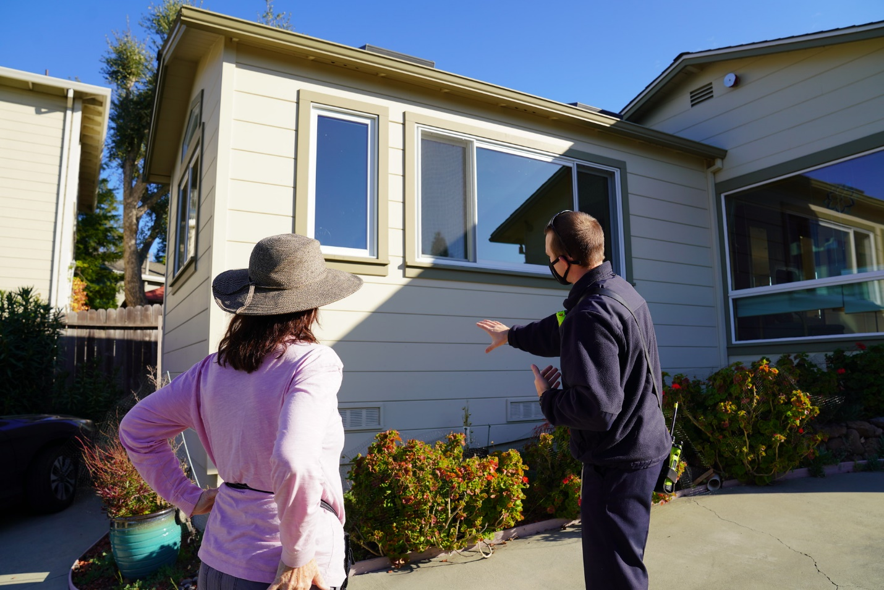
A ConFire inspector performs a Firewise property inspection with a Lafayette resident. Photo by the City of Lafayette.
Figure S-11 Land Uses in Very High Fire Hazard Severity Zones
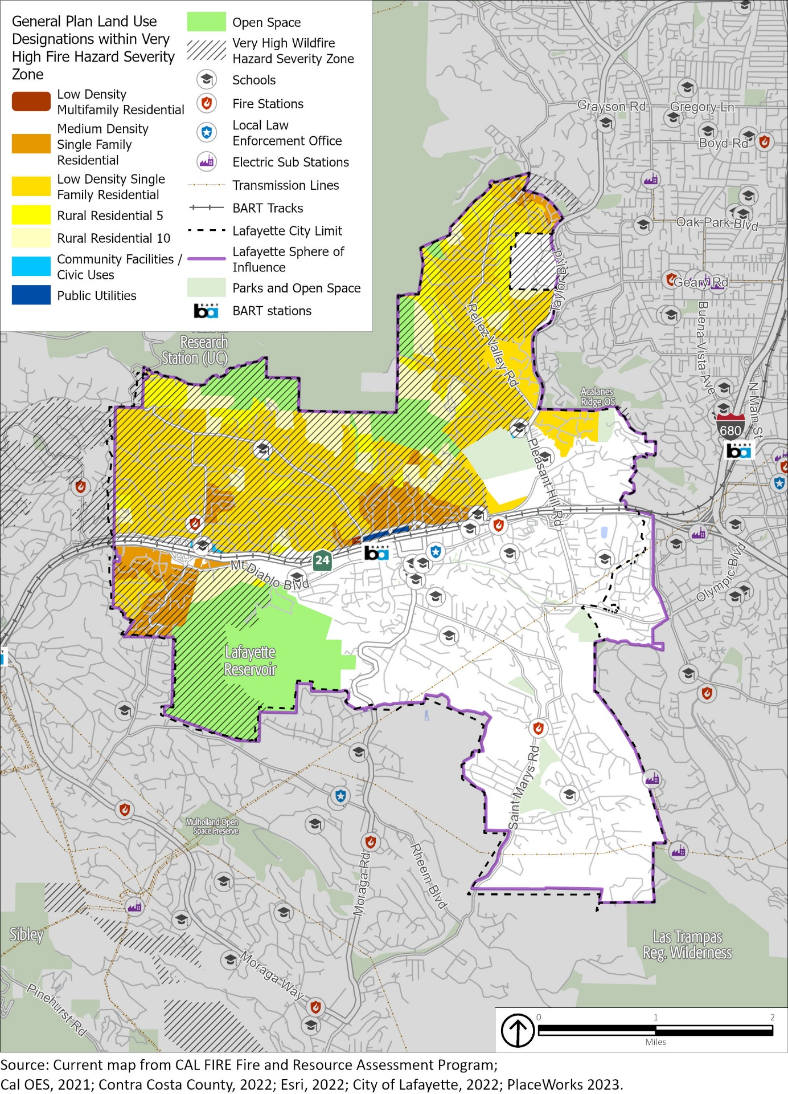
Figure S-12 CPUC Fire Threat Zones
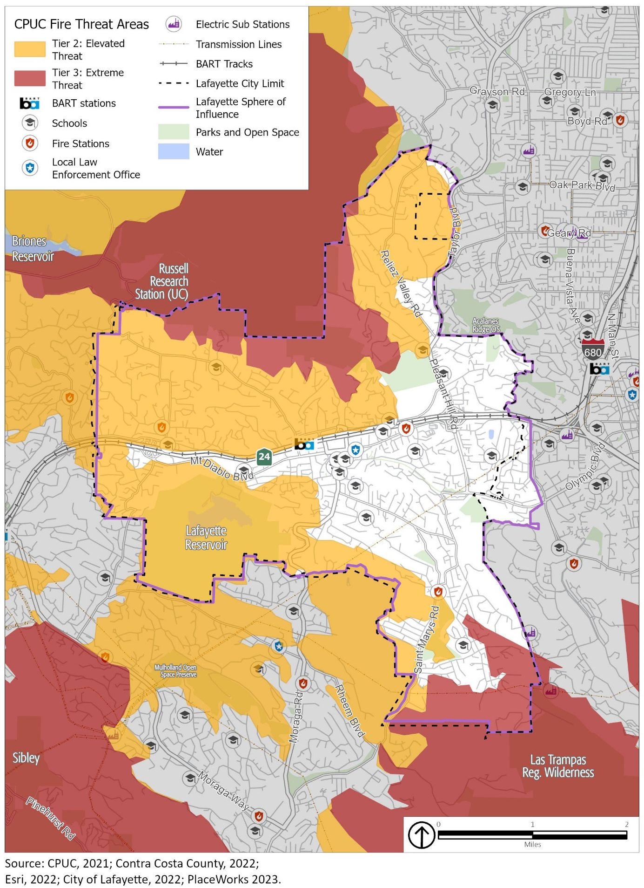

Hazardous Materials and Waste
Hazardous materials are materials that pose a significant risk to public safety or human or environmental health. These include toxic chemicals, flammable or corrosive materials, petroleum products, and unstable or dangerously reactive materials. Hazardous materials can be released through human error, malfunctioning or broken equipment, or as an indirect consequence of other emergencies (e.g., if a flood damages a hazardous material storage tank). A release or spill of bulk hazardous materials could result in fire, explosion, toxic cloud, or direct contamination of water, people, and property. Health problems may be immediate, such as corrosive effects on skin and lungs, or gradual, such as the development of cancer from a carcinogen. Damage to property could range from immediate destruction by explosion to permanent contamination by a persistent hazardous material.
Most hazardous materials in the region are transported on truck routes along major roadways that pass through Lafayette, such as SR-24. The most vulnerable areas along this route are considered the on- and off-ramps and interchanges. The transport of hazardous materials/wastes and explosives through the city is regulated by the California Department of Transportation (Caltrans). Transporters of hazardous wastes are required to be certified by the United States Department of Transportation, and manifests are required to track the hazardous waste during transport. Since 1970, there have been no reported roadway hazardous materials incidents in Lafayette.
Several natural gas transmission pipelines run through Lafayette, providing natural gas service to community members. These transmission pipelines are operated by PG&E. Ruptures in natural gas transmission pipelines can happen as a consequence of other natural disasters, such as wildfires or earthquakes, or as a result of infrastructure failure. Another common cause of ruptures are dig-ins where excavation or trenching work breaks a line leading to release of gas. To mitigate this risk, Lafayette has instituted a “Call Before You Dig” program through Underground Service Alert 811 for projects involving digging to identify underground utilities prior to beginning work. When ruptures occur, flammable natural gas is released and can ignite, causing fires or explosions. Figure S-13 shows the major natural gas transmission pipelines in Lafayette.
Hazardous materials and waste in Lafayette are managed by the Certified Unified Program Agency (CUPA), a local administrative agency within the Contra Costa County Environmental Health Division. The CUPA consolidates, coordinates, and makes consistent the regulatory activities of several hazardous materials and hazardous waste programs, including Hazardous Materials Management, California Accidental Release Prevention, Hazardous Waste Management, Underground Storage Tanks, Aboveground Storage Tanks, and Emergency Response.
Several state agencies monitor hazardous materials/waste facilities. Potential and known contamination sites are monitored and documented by the Regional Water Quality Control Board (RWQCB) and the California Department of Toxic Substances Control (DTSC). A review of the leaking underground storage tank (LUST) list produced by the RWQCB and the DTSC EnviroStor database indicates one nonoperating school cleanup site in the city, which is the Lafayette Elementary School Expansion (former Lafayette Library), at 952 Moraga Road, and 26 other LUST cleanup sites with closed cases.
The danger of hazardous materials/waste spills during transport does exist and will potentially increase as transportation of these materials increases on SR-24. ConFire, Contra Costa County Emergency Services Division, and Contra Costa County Division of Environmental Health are responsible for hazardous materials accidents at all locations within the city.

Figure S-13 Major Natural Gas Transmission Pipelines
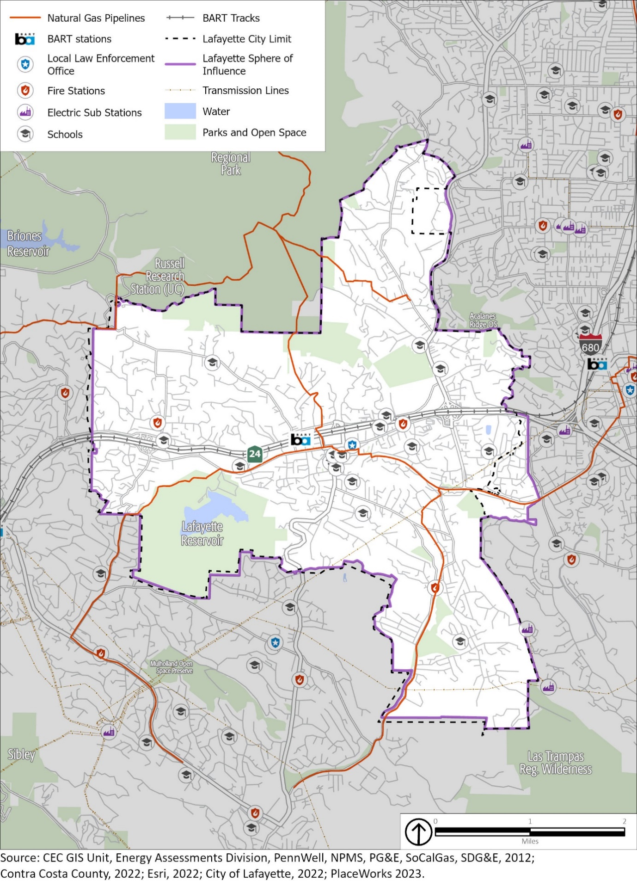

Climate Change Resilience

Drought
A drought is an extended period, often lasting multiple years, when precipitation levels are well below average. Like most of California and the western United States, Lafayette experiences regular drought conditions.
The U.S. Drought Monitor recognizes a five-point scale for droughts: D0 (abnormally dry), D1 (moderate drought), D2 (severe drought), D3 (extreme drought), and D4 (exceptional drought). According to the U.S. Drought Monitor, the most intensive drought conditions in recent years were during most of 2014, when all of Contra Costa County was classified as being in “extreme” drought. More recently, for the entire year of 2022 the county was classified as being in “severe” drought. As of March 2023, Contra Costa County, including Lafayette, was classified as being in an “abnormally dry” drought. During severe drought conditions, water restrictions may be imposed to meet essential community needs. EBMUD’s 2020 Water Shortage Contingency Plan contains actions to implement and enforce regulations and restrictions for managing a water shortage when it declares a water shortage emergency under the authority of the California Water Code.
Lafayette’s water supply comes from imported water. The Lafayette Water Treatment Plant is connected to the EBMUD water distribution system, which delivers water to Lafayette. EBMUD’s water supply begins at the Mokelumne River watershed in the Sierra Nevada and extends 90 miles to the East Bay, passing through the Sacramento-San Joaquin Delta. Snowmelt in the Sierra Nevada accounts for approximately 90 percent of EBMUD’s drinking water supply. Approximately 10 percent of the water supply originates as runoff from the protected watershed lands in the East Bay area.
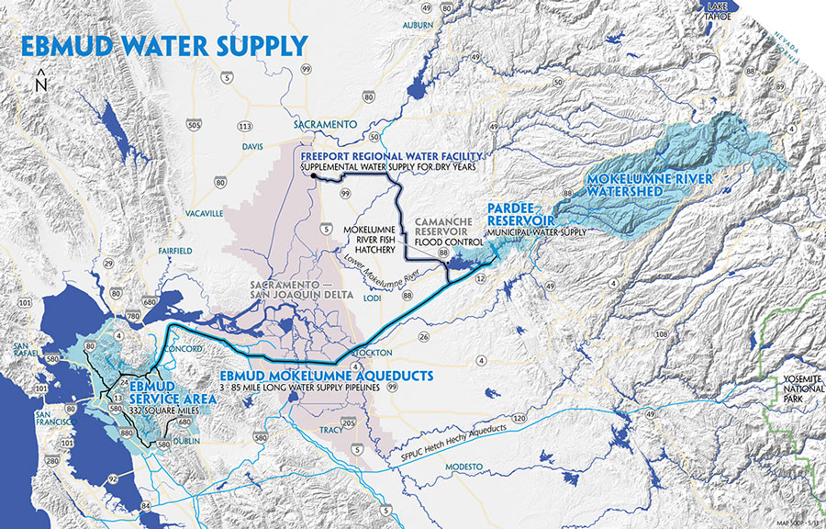
Map of the Mokelumne Aqueduct system. Image by East Bay Municipal Utilities District.
Although droughts are a regular feature of California’s climate, scientists expect that climate change will lead to more frequent and intense droughts statewide. Overall, precipitation levels are expected to remain similar to historical levels in Lafayette, potentially increasing by the end of the century. However, there are likely to be more years with extreme levels of precipitation, both high and low. This is expected to cause more frequent and intense droughts, compared to historical norms, that cause soil to dry out and become hard. When precipitation does return, more water runs off the surface than is absorbed into the ground, which can lead to floods. Higher air temperatures are expected to increase evaporation, causing more water loss from lakes and reservoirs and exacerbating drought conditions.
Reduced winter precipitation levels and warmer temperatures have greatly decreased the size of the Sierra Nevada snowpack (the volume of accumulated snow), which in turn makes less fresh water available for communities throughout California, including the imported water supply for Lafayette. A continued decline in the Sierra Nevada snowpack volume is expected, which may lead to lower volumes of available imported water.

Extreme Temperatures
While there is no universal definition of extreme heat, California guidance documents define extreme heat as temperatures that are hotter than 98 percent of the historical high temperatures for the area, as measured between April and October of 1961 to 1990. In Lafayette, the extreme heat threshold is 93.9°F, and an event with five extreme heat days in a row is called a heat wave. Extreme heat events and heat waves have occurred several times in Lafayette, most recently in June of 2019 and July 2021. Extreme cold refers to temperatures that are well below average or well below freezing. Extremely cold temperatures often accompany winter storms. Wind chill, which measures the combined effect of wind and temperature on the human body, can also play a role in determining the severity of extreme cold events.
Health impacts are the primary concern with these hazards, though economic and service impacts are also an issue. Extreme heat events are dangerous because people exposed to extreme heat can suffer several heat-related illnesses, including heat cramps, heat exhaustion, and (most severely) heat stroke. From 2004 to 2018, studies by the U.S. Department of Health and Human Services indicate that an average of 702 deaths annually are directly or indirectly linked to extreme heat. Extreme cold weather-related conditions may also lead to serious health problems. Cold weather can exacerbate symptoms of chronic illnesses such as arthritis, asthma, and heart disease, leading to increased pain and discomfort. Individuals with chronic illnesses or disabilities may have decreased physical activity levels, making them more susceptible to hypothermia.
Seniors, persons with chronic illnesses and/or disabilities, persons experiencing homelessness, outdoor workers, low resourced people of color, immigrant/linguistically isolated communities, and households in poverty are the most vulnerable to extreme temperatures. Most homes in Lafayette were constructed before 1980, and some homes may not have air conditioning or effective insulation. During extreme heat or extreme cold days, temperatures in poorly insulated homes may reach unhealthy temperatures. Therefore, people living in these homes, especially vulnerable populations, are at higher risk for heat and cold-related illnesses from extreme heat and extreme cold events.
Extreme temperatures can harm plants and animals as well as natural ecosystems. Extreme heat can increase the temperature of water in lakes, streams, creeks, and other water bodies, especially during drought conditions when water levels are lower. Indirectly, extreme heat puts more stress on power lines, causing them to run less efficiently. The heat also causes more demand for electricity (usually to run air conditioning units), and in combination with the stress on the power lines, may lead to brownouts and blackouts. Extreme cold can cause decreased electrical conductivity, conductor sag, and ice buildup. Cold temperatures can decrease the electrical conductivity of the transmission line materials, reducing the efficiency of power transmission. In rare cases, extreme cold can also cause power outages and equipment damage.
Warmer temperatures brought on by climate change are likely to cause an increase in extreme heat events and heat waves. The Cal-Adapt database indicates that the number of extreme heat days is expected to rise from a historical annual average of 4 days to 17 days by the middle of the century (2035 to 2064), and to 29 days by the end of the century (2070 to 2099). Though extreme cold weather events may occur more frequently in some regions, climate projections show increasingly warmer temperatures and more frequent extreme heat events and heat waves.

Severe Weather
Severe weather is generally any destructive weather event, but usually occurs in Lafayette as localized storms that bring heavy rain, hail, thunderstorms, and strong winds. Severe weather is generally caused by intense storm systems, although types of strong winds can occur without a storm. The dangers posed by severe weather vary widely and may include injuries or deaths, damage to buildings and structures, fallen trees, roads and railways blocked by debris, and fires sparked by lightning. Severe weather often produces high winds and lightning that can damage structures and cause power outages. Lightning from these storms can ignite wildfires and structure fires that can cause damage to buildings and endanger people. Objects such as vehicles, unprotected structures (e.g., bus stops, car ports), fences, telephone poles, or trees can also be struck directly by lightning, which may result in an explosion or fire.
Atmospheric rivers are a relatively common weather pattern that brings southwest winds and heavy rain to Lafayette. High winds, often accompanying severe storms, can cause significant property damage, threaten public safety, and have adverse economic impacts from business closures and power loss. High winds, as defined by the National Weather Service, are sustained wind speeds of 40 mph or more lasting one hour or longer, or wind gusts of 58 mph or more for any duration. These winds may occur as part of a seasonal climate pattern or in relation to other severe weather events, such as thunderstorms.
Lafayette and surrounding Contra Costa County have experienced several severe storms historically.
- In January 2008, Contra Costa County reported 110 mph winds in the East Bay Hills and Diablo Range. During this high wind event, a very strong cyclone slammed into the San Francisco and Monterey Bay areas, bringing rain, high winds, record high surf, and coastal flooding.
- In December 2014, Contra Costa County reported 83 mph winds. This atmospheric river event brought heavy rain and gusty winds with a strong winter storm that impacted the Bay Area for several days in mid-December.
- On October 24, 2021, the Bay Area experienced an atmospheric river in the midst of a multi-year drought that brough record-setting volumes of rain and wind speeds. Winds were recorded between 50-60 mph and intense downpours. Reports of storm impacts included flooding, downed trees, power outages, and some minor mud slides.
- Beginning in late December 2022 and extending through mid-January 2023, a series of storms brought a wide variety of hazardous weather to the Bay Area, including Lafayette. The result of these storms produced hazardous weather over a three-week period, including wind gusts over 100 mph, as well as widespread flooding, gusty thunderstorm outflow winds, small hail, and several reported shallow landslides.
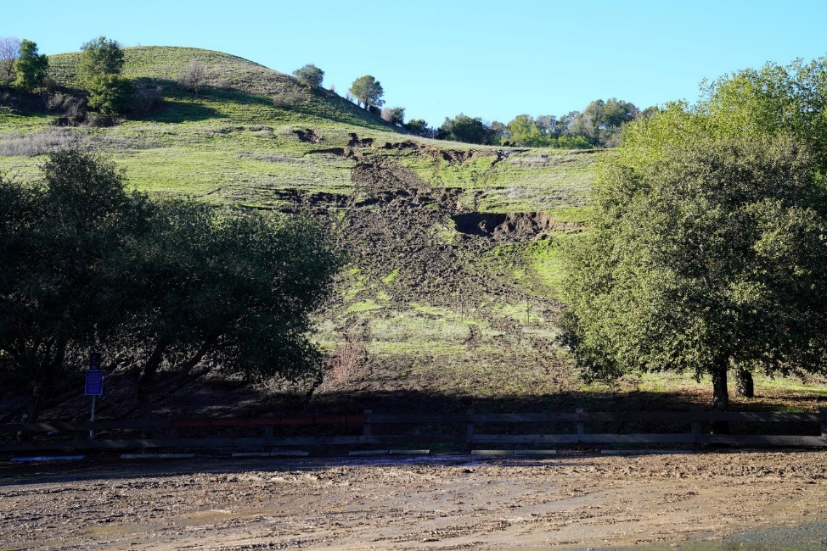
A mudslide above the Lafayette Ridge Staging Area parking lot, caused by intense storms in January 2023.
Photo by the City of Lafayette.
Electricity utilities throughout California, including PG&E, have also begun to occasionally “de-energize,” or turn off the electricity for power lines that run through areas where there is an elevated fire risk. This is intended to reduce the risk of power lines sparking or being damaged and starting a wildfire. As previously described, these activities, called Public Safety Power Shutoff (PSPS) events, result in a loss of power for customers served by the affected power lines. A PSPS event may occur at any time of the year, usually during high wind events and dry conditions. PSPS events can impact emergency management activities and create vulnerabilities for community members that lack backup power supplies and depend on electricity for heating or cooling homes and buildings, medical devices, lighting, and internet. Although critical public health and safety facilities often have backup generators, the loss of power may disable other key infrastructure systems. While PSPS events have been smaller and less frequent recently, these events still pose a risk to PG&E customers across Contra Costa County, including Lafayette.
Climate change is expected to increase the occurrence of intense rainfall and strong storm systems, meaning Lafayette could see more intense weather resulting from these storms in the coming years and decades. While average annual rainfall may increase only slightly, climate change is expected to increase the number of years with extreme levels of precipitation. Heavy rainfall can increase the frequency and severity of other hazards, including flooding and landslides.

Human Health Hazards
Human health hazards are bacteria, viruses, parasites, and other organisms that cause diseases and illness in people. Some of these diseases may cause only mild inconvenience, but others are potentially life threatening. These diseases can be and often are carried by animals, such as mice and rats, ticks, and mosquitos. Warmer temperatures and high levels of precipitation can lead to increased populations of disease-carrying animals, creating a greater risk of disease and increased rates of infection.
Populations most vulnerable to human health hazards are those who spend a disproportionate amount of time outdoors (such as outdoor workers or persons experiencing homelessness), those with weakened immune systems or chronic illnesses, senior citizens, and those who may live in substandard housing or not have access to health insurance and medical care (households in poverty, low-resourced people of color, immigrant/linguistically isolated communities, and cost-burdened/low-income/overcrowded households). These persons may live in conditions that increase their chances of catching illnesses, lack the ability to fight off infections that may occur, or lack the financial resources to seek timely medical care.
Historically, there have been cases of West Nile virus, Lyme disease, and hantavirus in Contra Costa County. Increases in average temperature and changes in precipitation patterns favoring larger precipitation events may facilitate the growth and activity of disease-carrying vectors. Many of the vector-carrying organisms thrive in warmer and wetter conditions, and therefore the overall risk of human health hazards is expected to increase.

Goals, Policies, and Programs
The goals, policies, and programs in this section indicate how the City will address the safety issues in the previous section, helping to create a safer and more resilient Lafayette for all. Goals state the City’s general, overall, and ultimate purpose, aim, or end toward which the City will direct effort. Policies are specific statements of principle or guiding action that implies a clear commitment. They indicate a general direction that the City elects to follow to meet its goals. Programs are actions, activities, or strategies carried out in response to adopted policy to achieve a specific goal.

Goal S-1: Prepare for and respond to natural and human-caused disasters, avoiding loss of life and minimizing the impacts to health, property, and community welfare.
  - Emergency Operations Plan: Maintain an Emergency Operations Plan that meets current and anticipated community needs in the event of a major disaster and conforms with the California Standardized Emergency Management System (SEMS).
    - Conduct regular training programs for personnel involved in implementing the Emergency Operations Plan and operating the City’s Emergency Operations Center (EOC). Personnel expected to be involved in the operation of the EOC shall receive training on the EOC operations and management within 1 year of being hired, and existing staff shall receive refresher training every 5 years. This training should take the form of multiday intensive training and be responsive to current emergency issues and conditions.
    - Review periodically and revise, as appropriate, the City's Emergency Operations Plan.
    - Coordinate with Contra Costa County’s Emergency Services Division when revising the City's Emergency Operations Plan to ensure that it is consistent and in compliance with Contra Costa County's Emergency Preparedness Plan.
    - Provide clear and current information to the public through emergency notification systems, as prescribed in the Emergency Operations Plan.
  - Emergency Operations Center: Ensure that Lafayette has adequate and well-equipped critical facilities.
    - Identify specific facilities, such as City offices, schools, fire stations, and police buildings, and lifelines such as telephone, electric, water, and sewer service, that are critical to effective emergency and disaster response. Evaluate their abilities to operate efficiently immediately after a disaster. Designate alternate facilities for post-disaster assistance in the event that the primary facilities become unusable.
    - Upgrade the existing EOC and alternate EOC sites so they are resilient to potential hazards and are outside of mapped hazard-prone areas.
  - Public Education: Conduct public education campaigns to increase awareness of and preparation for hazards in the community, such as geologic and seismic risks, flooding, wildfire, drought, and extreme heat. Educational campaigns should offer residents information on ways to protect their property and preserve personal health and safety from various hazards, and on available incentives and other financial resources. Educational and informational materials should be available in multiple languages commonly used in the City based on Census data and in formats appropriate for people with access and functional needs, such as low-income households or seniors.
  - Equitable Emergency Preparation and Response Communication: Ensure that communication, education and information materials, assistance in preparedness activities, and evacuation and short-term recovery activities are available to all residents. Educational and informational materials should be available in multiple languages and in formats appropriate for people with access and functional needs, such as low-income households, persons with disabilities, and seniors. They should focus on methods to reduce the dangers from natural and human-caused hazards, ways to prepare for emergency situations, such as Public Safety Power Shutoff (PSPS) events, and promote neighborhood prevention and emergency response programs.
    - Promote registration with the Contra Costa County Community Warning System (CWS).
    - Encourage coordination between neighborhoods to share information and support emergency preparations.
  - CERT Training: Support and encourage Community Emergency Response Team (CERT) training to residents and members of the business community to increase disaster awareness and emergency response capability.
    - Coordinate with the Moraga-Orinda Fire District and Lafayette Emergency Preparedness Committee to conduct emergency services training in support of appropriate goals and standards for training efforts.
  - Hazard Mitigation Plan Incorporation: Incorporate the Contra Costa County Hazard Mitigation Plan and the City of Lafayette Annex, as approved by the Federal Emergency Management Agency, into this Safety Element by reference, as permitted by California Government Code Section 65302.6, to ensure that emergency response and evacuation routes are accessible throughout the city.
  - Agency Cooperation: Continue to cooperate with other public agencies to ensure adequate medical and other emergency services, including assessing and projecting future emergency service needs.
    - Coordinate with local and State emergency management agencies using the Standardized Emergency Management System (SEMS) and National Incident Management System (NIMS) to facilitate multiagency emergency response.
    - Maintain inter-jurisdictional cooperation and coordination, including automatic aid agreements with fire protection and suppression agencies in Contra Costa County.
    - Continue to maintain agreements with other local, state, and federal agencies to ensure coordinated disaster response.
  - Emergency Power Supplies: Install emergency power supplies at City-owned and -operated critical facilities and encourage the installation of emergency power supplies for residential properties in partnership with regional partners. Emergency power supplies can include power generators and battery storage and should prioritize renewable energy systems where feasible.
  - Renewable Energy Generation Systems: Renovate existing City-owned facilities and design future City facilities to incorporate renewable energy generation systems, battery energy storage systems, and energy-efficient design and features, as feasible.
  - Large-Scale Disaster Preparation and Response: Prepare for and respond to large-scale disasters by coordinating and sharing data, experience, and strategies with other emergency management agencies in state or regional efforts on disaster planning.
    - Ensure that communication systems used by emergency responders and key City staff have sufficient redundancy and resiliency to meet City needs during and after an emergency or hazard event. The City will work with utility and communication providers to ensure that systems are in place to maintain communication services for community members, City staff, and emergency responders, especially during power outages.
    - Coordinate with emergency management staff in neighboring cities, special districts, Contra Costa County, and fire districts on an annual basis to review disaster planning strategies, resources, and available funding.
    - Cooperate with communities in Contra Costa County to establish a network of equitably located resilience centers that would offer local or regional refuge for community members in the event of a large-scale disaster or extreme heat event. Participating communities should strive to make these locations known to the public through outreach as well as posting informational resources and educational materials on city websites.
  - Increased Community Resilience to Climate-Related Hazards: Increase community resilience to climate-related hazards projected to impact Lafayette. Use the reported data and findings of applicable local, regional, or state climate change studies, models, reports, or plans pertaining to climate-related hazards that could impact the City of Lafayette, including the California Climate Change Assessment, the California Adaptation Planning Guide, and the California Climate Adaptation Strategy.
    - Integrate the results of the Climate Change Vulnerability Assessment into other City planning documents where feasible, including the Hazard Mitigation Plan, Capital Improvement Program, zoning code, building code, and other applicable plans and codes.
  - Shelter for Households with Large Animals and Pets: Ensure that evacuation shelters and resources are available for households with large animals, such as horses and livestock, and pets in the event of a community-wide emergency or disaster.
  - Evacuation Assistance: Develop and implement an evacuation assistance program, in coordination with Contra Costa County Transportation Authority, paratransit, and dial-a-ride agencies, to help those with limited mobility, lack of access to a vehicle, and other at-risk populations evacuate safely.
  - Evacuation Routes: Coordinate with emergency responders and CalTrans to maintain potential evacuation routes to ensure adequate capacity, safety, and viability of those routes in the event of an emergency, including making improvements to existing roads to support safe evacuations as needed.
    - Maintain an emergency evacuation routes system.
    - Encourage the use of trails as evacuation routes in the Emergency Operations Plan, in coordination with emergency responders.
    - Maintain designated evacuation routes in a passable condition at all times, and, as feasible, improve function of these routes for emergency evacuations.
    - Publicize the City’s evacuation routes and other aspects of its Emergency Operations Plan.
    - Review recommendations of the General Plan Emergency Evacuation Analysis (Appendix A1 of the Housing Element Final EIR) and, as feasible, conduct further analyses regarding:
1. Developing emergency evacuation signal timing plans
2. Identifying evacuation route constrained locations (low functioning intersections or segments).
3. Considering evacuation route capacity when considering roadway or intersection design modifications.
4. Analyzing evacuation concerns and needs of vulnerable residents.
5. Identifying routes where reversible traffic lanes are feasible.
6. Identifying road segments for Red Flag parking restrictions.

    - Ensure road and intersection improvements consider potential impacts on evacuation routes and are designed in coordination with emergency responders.
  - Emergency Service Response: Work to improve emergency medical, fire, and police responses service in Lafayette.
    - Periodically monitor the response times for emergency medical, fire, and police response services in Lafayette and coordinate with providers to maintain adequate service.
    - In coordination with emergency service providers, identify barriers to improving emergency response times on an ongoing basis.
  - Police Services: Work with the Contra Costa County Sheriff’s Department and neighboring jurisdictions to improve police service in Lafayette.
  - New Essential Facilities: To the greatest extent possible, locate new essential public facilities, such as police stations, schools, and community centers, outside of mapped hazard zones. If essential facilities must be located in these zones, site and design them to minimize the risk of damage and maintain their operational capacity during and after a hazard.
  - Red Flag Parking: Explore establishing parking restrictions during red flag days or other periods of high wildfire risk utilizing best practices from neighboring jurisdictions.
  - Property Disclosure: Explore requiring property owners to disclose the presence of hazardous conditions and mapped hazard zones on or near the property at time of sale.
  - Lamorinda Village Evacuation Assistance: Coordinate with Lamorinda Village to encourage them to provide evacuation assistance for senior citizens.

Goal S-2: Minimize risk to property and protect lives from flood hazards.

  - Reduce Flood Hazards: Reduce flood risk by maintaining effective stormwater drainage systems, regulating construction, and updating stormwater infrastructure design requirements, and retrofit storm drainage systems as needed. These efforts are subject to funding availability and are intended to maintain consistency with federal, state, and local regulatory requirements and to convey runoff from more intense storms resulting from climate change.
    - Update the municipal code as necessary to comply with State requirements and future flood projections.
    - Develop and implement minor repairs and replacement of City-maintained drainage facilities as problems are identified through the ongoing storm drain planning and inventory work during the storm season or through ongoing inspections.
    - Maintain current inundation maps and drainage plans for existing and new water storage tanks in the city.
    - Develop an Adopt-a-Drain program for community members to contribute towards the maintenance of storm drains to prevent drain backups and flooding during wet-weather events.
    - Consult with the Contra Costa County Flood Control District as well as upstream and downstream jurisdictions regarding regional approaches to the planning, construction, operation, and maintenance of drainage and flood-control facilities. Include these entities in the referral of project applications, as appropriate.
    - Develop a creek maintenance program that seeks to reduce flooding by removing debris from creeks, implementing erosion-control practices along creek beds, and restoring natural creek flow.
    - Provide information to creekside property owners on their responsibilities and best practices associated with creek maintenance.
  - Flood Protection Standard: Review development applications to mitigate flood recurrence intervals for 100-year floods to match the Contra Costa County Flood Control District standards. (Reso. 2009-021, 2009)
    - Use the Federal Emergency Management Agency’s Flood Insurance Rate Map and California Department of Water Resources Best Available Mapping to reduce risk of flooding, to identify 100-year and 500-year floods, to calculate flow rates within identified stream channels, and to review development proposals.
    - Maintain participation in the National Flood Insurance program.
  - Storm Drainage System: Maintain unobstructed water flow in the storm drainage system.
    - Enforce measures to minimize the volume and velocity of surface runoff, soil erosion, and sedimentation both during and after construction through implementation of the grading ordinance.
    - As feasible, carry out annual inspection of the drainage systems in Lafayette.
    - Require siltation/detention ponds to be incorporated into the design and construction of development projects where deemed necessary.
Refer to Program S-2.1.1 for other measures, including detention ponds, aimed at reducing peak runoff.
    - All work done within creeks must be done under applicable permits from the appropriate agencies, such as the City, Department of Fish and Wildlife, US Army Corps of Engineers, and the Regional Water Quality Control Board.
    - Conduct regular cleaning and maintenance of storm drains along key roadways, especially in advance of the rainy season. The City shall address potential ponding and the need for storm drain improvements on major roadways, subject to funding availability.
  - Finance the Storm Drain System: Cooperate with the Contra Costa County Flood Control and Water Conservation District and other jurisdictions to pursue all available sources of funding to finance improvements to storm drainage facilities.
    - Enforce the storm drainage impact fee ordinance requiring development to cover the costs of drainage facilities needed as a result of new development.
    - Periodically assess the need to establish improvement districts and other financing mechanisms to fund necessary storm drainage and watercourse improvements to minimize flood hazards and creek erosion.
  - Green Infrastructure: Promote the use of green infrastructure and permeable paving materials to reduce flood risk on public and private property.
    - Where appropriate, promote the use of stormwater retention basins rather than standard engineering modifications to natural channels.
    - Encourage use of meandering drainage channels in all new developments and wherever channels are replaced.
    - Condition new development to maintain or minimize post-development peak runoff rate and average volume similar to predevelopment conditions, to the maximum extent feasible. Consider use of green infrastructure and low impact development that use on-site infiltration to slow runoff during peak periods. Where this is not feasible, mitigate the increase in peak stormwater runoff. Include clear and comprehensive mitigation measures as part of the project approvals with financial and other measures to ensure their implementation.
    - Require runoff from all new impervious surfacing to be directed either to landscaping at least 50 percent the size of the contributing impervious surfacing, or to bioretention treatment facilities.
    - Require all development projects where impervious coverage of a lot exceeds 50 percent to treat the runoff from all impervious surfacing on the lot with bio-retention facilities.
  - Dam and Pipeline Inundation Risk: Coordinate with the East Bay Municipal Utilities District to assess the dam and pipeline inundation risk in Lafayette and upgrade facilities and infrastructure at risk.
    - Coordinate with the State Division of Safety of Dams to ensure that the City is aware of the timeline for the maintenance and inspection of dams whose failure would impact the city.
  - Water Supply Infrastructure Maintenance: Coordinate with the East Bay Municipal Utilities District to support maintenance of water pipelines and aqueducts.

Goal S-3: Minimize geologic and seismic hazard risks to public health, safety, and welfare.

  - Seismic and Geologic Safety: Consider potential seismic or geologic hazards when reviewing future projects and determining building density and siting dwellings. Development proposals in areas with seismic or geologic hazards shall be reviewed by an engineering geologist to determine whether the proposed development is feasible, and to define the required construction standards and mitigation measures. Intensity of development shall be minimal in areas of high risk.
    - Require submittal and review of a site-specific geotechnical report for proposed development in areas with liquefaction potential as illustrated on Figure S-6, Liquefaction Areas, or in areas with landslide susceptibility, as illustrated on Figure S-7, Landslide Susceptibility Areas. Development shall be supervised and certified by a geotechnical engineer, and where necessary, by an engineering geologist.
    - Require financial protection for public agencies and individuals as a condition of development approval where geological conditions indicate a potential for ongoing maintenance costs related to the geological conditions.

Financial protection would ensure that developers will have the resources to carry out such maintenance on properties where geological analysis identifies a risk of high ongoing maintenance costs. This program would also serve to limit the City’s liability. Examples include bonds, liens, or other suitable security to ensure that landscaped slopes in areas with unstable soils are maintained to prevent hazardous soil movement. A soils report prepared by a qualified soils engineer would be required to establish standards for City protection.
    - As a condition of project approval, require new development to repair or stabilize areas of soil creep or possible debris flow, or to avoid construction on or directly below such areas.
    - Require professional inspection of foundation and excavation, earthwork and other geotechnical aspects of site development during construction on those sites identified as being prone to slope instability.
    - Carefully review applications for development in areas with liquefaction potential, as shown on Figure S-6, Liquefaction Areas, or in areas with very high landslide susceptibility, as shown on Figure S-7, Landslide Susceptibility.
  - Drainage Requirements: Require new development in hillside areas to prepare drainage plans to direct runoff and drainage away from potentially unstable slopes.
  - Roadways and Roadway Improvements: Prohibit new roadways or roadway modifications that would create unstable geological conditions. (An example would be cuts and fills in areas with unstable soils.) Condition roadway improvements to implement best soil and slope stability management practices.
  - Creekbank Protection: Prohibit structures of any kind that might be impacted by or exacerbate creekbank slippage and erosion through enforcement of the creek setback ordinance.
  - Seismic and Geologic Hazards: Minimize exposure to seismic and geologic hazards through site planning and building design for all new development, including subdivisions, new construction, and remodels or expansions of existing structures as well as critical high-occupancy or essential services buildings. A geotechnical investigation and report shall be required for all new development in landslide and liquefaction zones. Any other facility that could create a geologic hazard, such as a road on hillside terrain, must also conduct such an investigation. Evidence of probable geologic hazard shall require a geotechnical study by a registered soil engineer or registered geologist that shall be reviewed by geotechnical consultants selected by the City.
    - The City will require a geotechnical evaluation prior to construction of buildings intended for public occupancy in areas with potential risk related to geologic conditions or soil limitations, as identified on maps maintained by the City. The geotechnical evaluation shall evaluate all relevant risks, which may include but are not limited to erosion, landslide, expansive soils, subsidence, and seismic activity. Recommendations from the geotechnical evaluation shall be incorporated into the subject project or plan in order to reduce risk to levels acceptable to the City. The City will also incorporate geotechnical evaluations and recommendations into its own public investments, as appropriate.
    - Comply with the provisions of the State Alquist-Priolo Act, as appropriate.
    - Strengthen existing structures against seismic events to applicable, nationally recognized standards. Give priority to emergency buildings, schools, theaters, meeting halls, apartment complexes, and major transportation facilities.
    - Provide information to the public on ways to reinforce buildings to reduce damage from earthquakes.
    - Provide information to the public on how to respond to an earthquake.
  - Minimize Risk Potential: Minimize exposure to seismic and geologic hazards through site planning and building design for all new development, including subdivisions, new construction, and remodels or expansions of existing structures as well as critical, high-occupancy, or essential services buildings.
    - Require that development in areas identified by Figure 5, Regional Fault Lines, be supervised and certified by a geotechnical engineer and, where necessary, by an engineering geologist.
  - Seismic Retrofits: Identify City infrastructure with seismic vulnerabilities and pursue funding to conduct appropriate seismic retrofits.

Goal S-4: Avoid and minimize risk of loss of life, injury, and property damage from wildfires and urban fires.
  - Adequate Fire Protection: Enforce regulations and standards that contribute to adequate fire protection.
    - Improve access for emergency response vehicles and response times of emergency personnel.
    - Retrofit existing traffic signals, as necessary, and ensure that new traffic signals include an EMTRAC system that allows emergency vehicles to change the signal.
    - Coordinate with the Contra Costa County Fire Protection District, including paramedic services, to improve and maintain response times in Lafayette to five minutes, particularly in the Very High Fire Hazard Severity Zones. (Reso. 2009-021, 2009)
    - Establish and enforce no parking zones on narrow roads to allow access by emergency vehicles and to facilitate evacuation.
    - Require development that includes private access roads or fire roads to provide access rights and keys to all gates to the Contra Costa County Fire Protection District.

    - Conduct fire response drills on an ongoing basis to ensure that the Contra Costa County Fire Protection District is prepared for emergencies impacting the community.
    - Require that new development be located where fire and emergency services have sufficient capacity to meet project needs or require that they be upgraded to provide necessary capacity as part of the proposed development activities to ensure new development has adequate fire protection.
    - Work with the Contra Costa County Fire Protection District to evaluate development proposals, enforce the fire code, and improve fire prevention measures and protection services.

  - Development and Mitigation Fees: Maintain development and mitigation fees at a level to adequately finance fire protection costs.
    - Periodically assess fees for fire protection to ensure that existing and new development pay its fair share of the cost of fire protection facilities, personnel, and maintenance.
  - Mutual Aid Agreements: Participate in mutual aid agreements with the County and State fire-fighting agencies.
  - Vegetation Management: Require new and existing development and infrastructure in areas of elevated wildfire risk to establish and maintain vegetation management practices to reduce the risk of wildfire ignition and spread. This shall include responsible site planning, vegetation management, the use of native drought-tolerant and fire-resistant species, and defensible space consistent with State, local, and Contra Costa County Fire Protection District regulations.
    - All new development within mapped Very High Fire Hazard Severity Zones established by the Contra Costa County Fire Protection District shall be required to develop and implement a Vegetation Management Plan in compliance with Chapter 49 of the California Fire Code. The plan shall be part of the development application and approved by the Contra Costa County Fire District and the City. The plan shall be developed by an arborist or vegetation management specialist. The City shall ensure that the actions recommended in the plan are implemented in the future and should amend the municipal code to allow the City the right to conduct actions recommended in the plan at the property owner’s expense, if those actions are not performed in a timely fashion by the property owner. The Contra Costa County Fire Protection District shall have the right to review properties to judge whether actions recommended in the Vegetation Management Plan are being properly implemented in a timely fashion.
    - Establish buffer areas for new and existing buildings in Very High Fire Hazard Severity Zones.
    - Maintain the Tree Protection Ordinance to address fire risks created by dead, dying, or non-native trees.
Defensible Space
“Defensible space” means the area within the perimeter of a parcel providing a key point of defense from an approaching wildland or escaping structure fire, as defined by the Lafayette Municipal Code. Defensible space rarely requires the complete removal of a tree. Trees may be maintained provided they are well spaced, well pruned, and do not create a “fire ladder” that would promote the spread of fire to a structure. When defensible space warrants complete removal of a tree, the tree is typically a nonnative species, is completely dead, or contains substantial amounts of dead branches or leaves/needles that would readily burn.

    - All new development must comply with fire-resistant landscaping and defensible space requirements. These standards shall meet or exceed Title 14 of the California Code of Regulations (CCR). This specifically includes Division 1.5, Chapter 7, Subchapter 2, Articles 1-5 (commencing with section 1270, SRA Fire Safe Regulations); and Division 1.5, Chapter 7, Subchapter 3, Article 3 (commencing with section 1299.01, Fire Hazard Reduction Around Buildings and Structures Regulations). New development shall also comply with the California Public Resource Code Section 4291 (State Defensible Space Requirements) which requires the following:
- Create a defensible space of at least 100 feet around the structure.
- Remove all dead plants, grass, weeds, and other flammable vegetation from the defensible space.
- Remove tree limbs that are within 10 feet of the chimney or stovepipe of the structure.
- Trim tree limbs that are within 6 feet of the ground or within 10 feet of the structure.
- Remove all dead branches, leaves, and other debris from roofs and rain gutters.
- Create horizontal and vertical spacing between trees and shrubs to prevent the spread of fire.
- Space trees at least 10 feet apart from each other.
- Maintain the defensible space throughout the year, not just during fire season.
- Obtain any necessary permits from local fire agencies before conducting any vegetation management activities.
- Provide and maintain access to the property for emergency vehicles.

    - Provide or connect elderly residents, low-income residents, and persons with access and functional needs assistance with information on maintaining defensible space around their homes.
    - Coordinate with Contra Costa County Fire Protection District, fire safe councils, other agencies, community organizations, and landowners to develop and maintain fuel breaks in dedicated open space and fire-access easements, including through prescribed burns or the use of goats.
    - Work with CAL FIRE, Contra Costa County Fire Protection District, fire safe councils, other agencies, community organizations, and landowners to ensure maintenance of existing fuel breaks, vegetation clearance, and emergency access routes for effective fire suppression on public and private roads.
    - Coordinate with East Bay Regional Parks District, CalTrans, Pacific Gas and Electric Company, and the East Bay Municipal Utilities District to undertake vegetation management programs to reduce fire hazards on their properties.
  - Avoid Development in Fire-Prone Areas: Encourage new development to occur outside of Very High Fire Hazard Severity Zones. Any development that does occur in the Very High Fire Hazard Severity Zones shall demonstrate compliance with applicable state and local building and fire code regulations as well as appropriate mitigation measures and design considerations.
  - New Development: Require review by the Planning Department and Contra Costa County Fire Protection District prior to the issuance of development permits for proposed construction projects and conceptual landscaping plans in Very Fire Hazard Severity Zones identified by CAL FIRE (see Figure 10, Fire Hazard Severity Zones). Plans for proposed development in such areas shall include, at a minimum:
- Site plan, planting plan, planting palette, and irrigation plan to reduce the risk of fire hazards and with consideration to site conditions, including slope, structures, and adjacencies.
- Development and maintenance of defensible space.
- Multiple points of ingress and egress to improve evacuation, emergency response, and fire equipment access and adequate water infrastructure for water supply and fire flow that meets or exceeds the standards in the California Fire Safe Regulations. This specifically includes two sections of Title 14 of the CCR, Division 1.5, Chapter 7: Subchapter 2, Articles 1-5 (commencing with section 1270, SRA Fire Safe Regulations); and Subchapter 3, Article 3 9commencing with section 1299.01, Fire Hazard Reduction Around Buildings and Structures Regulations).
- Class A roof materials for new and replacement roofs.
- Location and source of anticipated water supply.
    - Continue to implement the City’s most currently adopted fire code to ensure that development is constructed in a structurally safe manner. To the extent feasible, conduct periodic fire safety inspections to ensure compliance with adopted codes.
    - Permit new development where there is adequate fire flow (fire hydrant or water main water pressure) and adequate emergency vehicular access. Where these are not present, allow new development to utilize alternative fire prevention methods approved by ConFire, such as sprinkler systems.
    - For structures within or adjacent to Very High Fire Hazard Severity Zones, require a greater degree of fire resistance in roof coverings and exterior building materials than what is specified in the Unified Facility Criteria, as determined by the Chief Building Official and upon making findings specified in Health and Safety Code Section 13143.4.
    - Require fire protection plans for all new development projects located in the Very High Fire Hazard Severity Zone, including plans for long-term, comprehensive, fuel reduction and management. The main components of a fire protection plan include:
  - Risk Analysis
  - Fire Response Capabilities
  - Fire Safety Requirements – Defensible Space, Infrastructure, and Building Ignition Resistance
  - Mitigation Measures and Design Considerations for Non-Conforming Fuel Modification
  - Wildfire Education Maintenance and Limitations
  - Recovery and Redevelopment After a Large Fire: Develop programs and provide updates, as appropriate, that ensure recovery and redevelopment after a large fire and reduce future vulnerabilities to fire hazard risks through site preparation, redevelopment layout design, fire resistant landscape planning, and fire retarding building design and materials.
  - Educational and Outreach Materials: Make available and share relevant educational and outreach materials, including the Wildfire Preparedness and Evacuation Guide, with the public to help residents understand appropriate fire mitigation activities, such as vegetation management, defensible space, evacuation routes, and emergency evacuation procedures during a fire hazard.
  - Long-Term Water Supply: Coordinate with the East Bay Municipal Utilities District to maintain an adequate, long-term water supply for fire suppression needs for the community.
    - Identify and improve areas lacking adequate water service for firefighting, including capacity for peak load under a reasonable worst-case wildland fire scenario determined by the Contra Costa County Fire Protection District. The City shall identify areas lacking adequate water service, including areas where future development may occur.
    - Work with the East Bay Municipal Utility District and Contra Costa County Fire Protection District to ensure that fire hydrants throughout Lafayette have sufficient water flow.
  - Fire Hazards Response Support: Support measures that help firefighting crews and emergency response teams respond to fire hazards or work under low-visibility conditions, such as high-visibility signage for streets and building addresses that meet or exceed the standards in the California Fire Safe Regulations (Title 14 of the CCR, Division 1.5, Chapter 7, Articles 2 and 3, Sections 1273 and 1274).
  - Access for Fire and Emergency Vehicles and Equipment: Require proposed development to provide adequate access for fire and emergency vehicles and equipment that meets or exceeds the standards. These standards are found in two parts of the California Fire Safe Regulations (California Code of Regulations, Title 14, Division 1.5, Chapter 7): Subchapter 2, Articles 1-5 (commencing with section 1270, SRA Fire Safe Regulations); and Subchapter 3, Article 3 (commencing with section 1299.01, Fire Hazard Reduction Around Buildings and Structures Regulations).
  - Retrofitting City-Owned Roadways: Identify existing public and private roadways in fire hazard severity zones that are not in compliance with current fire safety regulations, to the extent resources are available. Work at retrofitting and maintaining City-owned roadways as needed to meet current standards and encourage private property owners to do the same, to the extent feasible and given the absence of other site constraints. These standards include road standards for evacuation and emergency vehicle access, vegetation clearance, and other requirements of the California Fire Safe Regulations, Title 14 of the CCR, Division 1.5, Chapter 7): specifically Subchapter 2, Articles 1-5 (commencing with section 1270, SRA Fire Safe Regulations); and Subchapter 3, Article 3 (commencing with section 1299.01, Fire Hazard Reduction Around Buildings and Structures Regulations).
  - Power and Natural Gas Lines: Coordinate with PG&E to regularly review their safety maintenance schedule and fire risk mitigation plans for both energy distribution systems in the Lafayette service area.
    - Coordinate with the Pacific Gas and Electric Company (PG&E) to fund and implement efforts in mapped wildfire risk areas, including work to underground power lines throughout the community, especially in Very High Fire Hazard Severity Zones, as feasible.
    - Continue to consult and coordinate with PG&E to acquire underground utility funding for Lafayette.
  - Roadside Fuels Reduction: Collaborate with Contra Costa County Fire Protection District to provide roadside fuel reduction, defensible space, and vegetation management, particularly along evacuation routes.
  - Poor Air Quality Event Assistance: Work with local agencies and community-based organizations to provide resources to help residents respond to poor air quality events (e.g., transportation to resilience centers and supply free N95 masks).
  - Firewise Communities: Publicize the Firewise USA program to neighborhoods in areas with high fire risks and support neighborhoods in Very High Fire Hazard Severity Zones and the Wildland-Urban Interface in pursuing designation as Firewise Communities.

Goal S-5: Avoid loss of life, injury, and serious illness and minimize property damage resulting from the use, transport, treatment, and disposal of hazardous materials and wastes.

  - Storage of Hazardous Materials: Coordinate with Contra Costa County Health Services, the Certified Unified Program Agency (CUPA) to enforce the regulations governing the storage of chemical, biological, and other hazardous materials as set forth in California Code of Regulations, Title 22, Division 4.5.
  - Transport of Hazardous Materials: Develop, in cooperation with Contra Costa County Health Services and neighboring cities, regulations prohibiting through-transport by truck of hazardous materials on the local street systems and require that this activity be limited to State highways.
    - Provide measures to protect the public from the hazards associated with the transportation, storage and disposal of hazardous wastes.
    - Refer land use and transportation decisions and other programs involving hazardous materials regulations to the appropriate agencies.
    - Maintain the Hazardous Materials and Waste Ordinance.
    - Require, as a condition of City development project approvals, that the Contra Costa County Fire Protection District be notified of all hazardous substances that are transported, stored, treated, or could be released accidentally into the environment.
    - Support thorough environmental review for hazardous waste transportation, storage and disposal facilities proposed in the Lafayette planning area and throughout Contra Costa County, since the potentially significant, widespread, and long-term impacts on public health and safety of these facilities do not respect jurisdictional boundaries.
  - Hazardous Materials Risk Reduction: Coordinate with the Contra Costa County Emergency Services Division, Contra Costa County Health Services, and Contra Costa County Fire Protection District to support efforts to reduce the level of risk from toxic and hazardous materials in Lafayette by regulating the transportation and storage of these materials in the community, and through an education program on the proper disposal methods for hazardous, toxic, and polluting materials.
  - Hazardous Materials and Wastes Public Disclosure: Require public disclosure of all companies, facilities, buildings, and properties that use, store, produce, and/or import/export any hazardous materials and wastes in the city. The City will maintain and share its inventory with the Contra Costa County Environmental Health Department.
  - On-Site Green Infrastructure: Encourage use of on-site green infrastructure to protect and enhance community water quality, and use of landscape design (e.g., berms, grasslands, plantings) to either contain released hazardous materials or to process and/or absorb pollutants to prevent them from infiltrating the soil or watershed.
  - Grading and Trenching Safety: Continue to require project applicants to call 811 or consult the California 811 Center’s website (https://www.usanorth811.org/) prior to conducting any grading, trenching, or similar activities.

Goal S-6: Adapt to climate-related hazards.

  - Equitably Located Resilience Centers: Establish one or more equitably located resilience centers in Lafayette. Ensure that resilience centers are not in areas at risk from hazard impacts, to the extent possible; offer refuge from extreme heat and extreme weather events as well as poor air quality and disasters; and are equipped with renewable energy generation and backup power supplies. Such facilities should be in easily accessible locations and available to all community members. Resilience centers consist of new, well‐used, existing, community‐serving facilities that are upgraded to provide local communities with shelter, water, and electricity during these events or disasters.
    - Work with owners and operators of local schools and community centers to allow these facilities to serve as resilience centers during emergencies and interruptions in essential services, offering water, electricity, and other necessary services.
  - Resilience Center Transit Services: Work with transit, dial-a-ride, and paratransit services to provide transit services to and from resilience centers for seniors and people with disabilities in the community.
  - Sustainable Water Supplies: Prepare for a reduced long-term water supply resulting from more frequent and severe droughts, including working with regional water providers to implement extensive water conservation measures and ensure sustainable water supplies, including for fire suppression needs.
  - Energy Storage Capacity and Generation Efficiency: Coordinate with PG&E to explore ways to improve and increase energy storage capacity and generation efficiency for public facilities.
  - Shading and Heat-Mitigating Materials: Coordinate with the Contra Costa County Transportation Authority and BART to increase shading and heat-mitigating materials on pedestrian walkways and at transit stops.
    - Evaluate, and revise as needed, City requirements for vegetative landscaping and tree planting to provide increased shade for sidewalks, parking lots, plazas, and other open space.
  - Sustainable, Energy-Efficient, and Environmentally Regenerative Features: Encourage new developments and existing property owners to incorporate sustainable, energy-efficient, and environmentally regenerative features into their facilities, landscapes, and structures to reduce energy demands and improve on-site resilience. Support financing efforts to increase community access to these features. Environmentally regenerative features refer to design or operational features of buildings, infrastructure, and systems that help to restore, renew, or regenerate the natural environment. Examples include green roofs and living walls, permeable pavement, on-site renewable energy generation, rainwater harvesting and reuse, or use of low-impact materials and construction techniques.
  - Drought-Tolerant Green Infrastructure: Promote the use of drought‐tolerant green infrastructure, including landscaped areas, as part of cooling strategies in public and private spaces.
  - Water Conservation: Promote water conservation measures in all public and private development.
    - Replace irrigated landscaping with drought-resistant vegetation to the extent feasible and consider use of graywater or rainwater harvesting for irrigation in City-owned facilities.
    - Develop a landscape improvement program for residential properties that prioritizes water conservation through water-efficient landscaping practices and design strategies.
    - Provide information about native and drought-resistant species to community members and applicants who seek to install new or replacement landscaping, including resources prepared by the East Bay Municipal Utilities District.
    - Promote graywater and rainwater harvesting for residential properties.
  - Natural Resources and Infrastructure: Use natural resources and infrastructure to absorb the impacts of climate-related hazards and associated natural hazards, as feasible.
    - Where feasible, the City shall encourage the use of existing natural features and ecosystem processes, or their restoration, when considering alternatives and adaptation projects through the conservation, preservation, or sustainable management of open space.
  - Extreme Heat Response Plan: Coordinate with neighboring communities to develop an extreme heat response plan that designates cooling centers and establishes a temperature threshold to trigger citywide notification and coordination for opening designated cooling centers to the public.
  - Minimized Disruption of Medical-Supply Chain: Collaborate with the Contra Costa County Department of Public Health and health-care providers to minimize disruptions of the medical-supply chain for facilities in Lafayette.
  - Severe Weather Resiliency: Increase the resiliency of City-owned structures to severe weather events and support homeowners and business owners to increase the resilience of their buildings and properties through retrofits, weatherization, and other improvements.
  - Collaboration with Utility Providers: Collaborate with utility providers to mitigate effects of service disruptions, such as Public Safety Power Shutoff events.
  - Property Insurance: Educate both property owners and renters on the benefits of property or renters’ insurance policies that provide sufficient protection against all applicable hazards, including wildfires, floods, landslides, and seismic events.

Glossary
Active fault: An active fault is a geological formation in the Earth’s crust that is currently experiencing tectonic activity and capable of producing earthquakes. These faults are at or near the boundary of tectonic plates, where the plates are moving relative to one another. As the plates move, stress builds along the fault lines, and when the stress becomes too great, the rock on either side of the fault ruptures, causing an earthquake.
Alquist-Priolo Earthquake Fault Zone: An Alquist-Priolo Earthquake Fault Zone is a California Geologic Survey-designated zone in California that is subject to special regulations for development and construction in the presence of certain active faults. These are faults that have surface traces, or a line on the Earth’s surface defining a fault.
Critical Facilities: Critical facilities refer to physical locations or infrastructure that are essential for the functioning of government operations and continuity of essential services in the event of emergencies, disasters, or other disruptions. These facilities may include:
- Government buildings: Includes city halls, courthouses, police stations, fire stations, school facilities, and emergency operations centers.
- Transportation infrastructure: Highways, bridges, rail lines, and similar structures.
- Energy infrastructure: Includes power lines, substations, and fuel storage facilities.
- Communication infrastructure: Includes radio and television stations and antennae, emergency communication centers, and data centers.
- Water and sewage infrastructure: Includes water treatment plants, reservoirs, water pipelines, and pumping stations.
- Health care facilities: Includes hospitals, clinics, and emergency medical services facilities.
Cooling Center: A cooling center is a designated public facility or space that is opened during hot weather to provide people with a cool and comfortable place to escape from high temperatures. Cooling centers are typically opened by local authorities, such as city or county governments, or by non-profit organizations, during heat waves or other extreme weather events that can pose a risk to public health.
Cooling centers are often set up in public buildings such as community centers, libraries, or senior centers, and may be equipped with air conditioning, fans, and water stations. They are intended to provide a safe and accessible space for people who do not have access to air conditioning or who are at risk of heat-related illnesses, such as seniors, people with disabilities, or those who are homeless.
Drought: A drought is a prolonged period of drier-than-normal weather conditions. A drought results in a water shortage and can have significant impacts on human activities and the environment. Droughts can occur due to a variety of factors, including changes in climate patterns, lack of precipitation, increased water demand, and poor water management practices.
Extreme Heat: Extreme heat refers to a prolonged period of abnormally high temperatures that can be dangerous to human health and can cause heat-related illnesses or other health hazards. While there is no universal definition of extreme heat, California guidance documents define extreme heat as temperatures that are hotter than 98 percent of the historical high temperatures for the area, as measured between April and October of 1961 to 1990.
Flooding: A flood is when there is too much water on the ground to be carried away by drains or creeks, or to soak into the soil. Flooding can also be caused by an inundation of water from a dam break or a break in water pipelines, which can cause secondary hazards, such as sinkholes.
Fire Flow: The flow rate of the locally-available water supply that can be used for fighting fires, measured as an amount of water over a time period (e.g., gallons per minute). The California Fire Code sets minimum standards for fire flow in the water infrastructure of new buildings.
Fire Hazard Severity Zone: A Fire Hazard Severity Zone is a CAL FIRE-designated zone to classify a wildland zone as Moderate, High, or Very High fire hazard based on the average hazard across the area included in the zone. These zones are based on fuel loading, slope, fire weather, and other relevant factors present, including areas where winds have been identified by CAL FIRE as a major cause of wildfire spread.
Heat Wave: A heat wave refers to an event with five consecutive extreme heat days.
Human Health Hazards: Human health hazards are bacteria, viruses, parasites, and other organisms that cause diseases and illness in people. For the purposes of this Safety Element, this term refers to diseases caused by pathogens that are spread by animals, such as mice and rats, ticks, and mosquitos.
Inundation: Inundation refers to the process of flooding or being flooded by water. It occurs when an area or a place is filled or covered with a large amount of water, which can be due to natural disasters such as heavy rainfall, overflowing rivers, storm surges, or human-made events such as dam failure or urban flooding.
Quaternary Fault: A Quaternary fault is a geological fault that has been recognized at the surface and that has moved in the past 1.6 million years. This places fault movement during the Quaternary Period, which spans from 2.6 million years ago to the present. Figure S-5 in this Safety Element shows Quaternary faults in and around Lafayette.
Resilience Center: A resilience center is a facility that focuses on helping individuals, communities, and organizations build their capacity to withstand and recover from adverse events, including natural disasters, economic shocks, and social crises. Resilience centers typically provide resources, services, and expertise that support physical, economic, social, and emotional resilience.
Severe Weather: Severe weather includes intense winds (including Diablo winds), lightning, hail, and related events, which can create secondary effects such as Public Safety Power Shutoff events.
Wildland-Urban Interface: The wildland-urban interface (WUI) is an area where buildings (e.g., schools) and infrastructure (e.g., cell towers and water supply facilities) mix with areas of flammable wildland vegetation, allowing wildland fires to easily spread to buildings and structures. The WUI is made up of three distinct zones.
- The intermix zone contains housing development or improved parcels interspersed in an area dominated by wildland vegetation subject to wildfire.
- The interface zone contains dense housing next to vegetation that can burn in a wildfire but is not dominated by wildland vegetation.
- The influence zone contains wildfire-susceptible vegetation within 1.5 miles from the intermix or influence zones.
In the WUI, efforts to prevent ignitions and limit wildfire loss hinge on hardening structures and creating defensible space through a multifaceted approach, which includes engineering, enforcement, education, emergency response, and economic incentive.

Language regarding evacuation addresses recommendations by CAL FIRE.

