CHAPTER 9. SAFETY
The purpose of the Safety Element is to establish a policy framework for maintaining and improving the safety of Beaumont’s residents. It identifies proactive measures to minimize public safety challenges to community residents, structures, public facilities, infrastructure, and to enable the City to expediently and efficiently respond in the event of a public safety challenge. Public safety challenges include crime prevention and naturals hazards and disasters from earthquake, fires, storms, and floods. The Safety Element also promotes education about disasters and hazards, to ensure all members of a community understand how to prepare and recover from potential disasters.
Topics covered in this chapter include seismic, flooding, geological hazards, hazardous waste, and climate change. Crime prevention, police and fire protection, and emergency preparedness and response are also addressed within this Element.

STATUTORY REQUIREMENTS
As required by State law (Government Code Section 65302(g)), the Safety Element identifies forces of nature and events resulting from human action that have the potential to cause harm to life and property in the city. The goal of the Safety Element is to reduce the potential short and long-term risk of death, injuries, property damage, and economic and social dislocation resulting from fires, floods, droughts, earthquakes, landslides, climate change, and other hazards. Identifying the source of such threats allows decision-makers to take preemptory action to minimize the damage, particularly as it relates to new development. Other locally relevant safety issues, such as police services, crime prevention, emergency response, and hazardous materials spills, are also included in this Element.

RELEVANT PLANS + DOCUMENTS

LOCAL HAZARD MITIGATION PLAN
The City’s Local Hazard Mitigation Plan (LHMP) was last updated in 2017. The LHMP’s purpose is to identify potential City hazards, review and assess past disaster occurrences, estimate the probability of future occurrences, and set goals to mitigate potential risks to reduce or eliminate long-term damage to people and property from natural and man-made hazards. The plan identifies vulnerabilities, prioritizes mitigation actions, evaluates resources and identifies mitigation shortcomings, provides future mitigation planning, and maintenance guidelines for the existing plan. Mitigation strategies included in the LHMP will serve as the implementation plan for the Safety Element. Under Assembly Bill 2140, cities may adopt their LHMP into their Safety Elements in order to ensure eligibility for potential reimbursement of post-disaster public assistance.

EMERGENCY OPERATIONS PLAN
The City of Beaumont has an adopted Emergency Operations Plan (EOP) and Standardized Emergency Management System (SEMS) / National Incident Management System (NIMS). This plan establishes the emergency organization, assigns tasks, specifies policies and general procedures, and provides for coordination of planning efforts of the various emergency staff and service elements. Further, it is an extension of the State Emergency Plan. The EOP addresses the planned response to extraordinary situations associated with natural disasters and/or human caused incidents. The plan is intended to facilitate multi-agency and multi-jurisdictional coordination, particularly between the City of Beaumont and Riverside County, special districts, and state agencies. The EOP references and is consistent with the Safety Element goals and policies.

CLIMATE ACTION PLAN
The City updated its Climate Action Plan called Sustainable Beaumont in October 2015. The Plan outlines a summary of greenhouse gas (GHG) emissions and establishes a roadmap to reduce GHG emissions and conserve energy. By using energy more efficiently and reducing emissions, Beaumont will keep dollars in the local economy, create jobs, and improve the community’s quality of life and public health. Through the Sustainable Beaumont Plan, the City has established goals and policies that incorporate environmental responsibility into its daily community and municipal operations. These are coordinated with and implemented through the Safety Element General Plan goals, policies and actions.

CAL FIRE/RIVERSIDE COUNTY UNIT STRATEGIC FIRE PLAN
The California Department of Forestry and Fire Protection (CAL FIRE)/Riverside County Unit Strategic Fire Plan (Fire Plan) was updated in May 2016. The Fire Plan is a cooperative effort between the State Board of Forestry, California Department of Forestry and Fire Protection, and CAL FIRE. The plan provides a road map for prevention and reduction of firefighting costs and losses to property, life, and the environment in San Jacinto Mountain communities including Beaumont. The Safety Element incorporates relevant policies from the Fire Plan.

RESILIENT IE
Western Riverside Council of Governments (WRCOG) and San Bernardino County Transportation Authority (SBCTA) developed climate change vulnerability assessments and adaptation strategies to support regional and local efforts to prepare for and mitigate risks associated with climate change. The Western Riverside County Adaptation and Resiliency Strategy Part 1, Vulnerability Assessment and Part 2, Adaptation Strategies (2019) includes a summary of expected climate change effects, identifies assets in the Western Riverside County region that are vulnerable to climate change effects, and presents adaptation strategies intended to reduce vulnerability and increase resilience. The WRCOG Member Community Vulnerability Profiles identify climate-related hazards and critical assets at-risk within the City limits of Beaumont. The Community Vulnerability Profile report also identifies evacuation routes that pass-through hazard zones, over bridges, and water crossings. In addition, WRCOG and SBCTA prepared a regionally-tailored climate resilient transportation infrastructure guidebook that identifies adaptation strategies specific to increasing resilience of the transportation system in the region.

BEAUMONT DRAINAGE MANAGEMENT PLAN
In accordance with the requirements of the State Regional Water Quality Control Board, the Beaumont-Cherry Valley Water District adopted a 2015 Urban Water Management Plan. The purpose of this plan is to analyze drainage problems in Beaumont and consider flood protection for existing and future development. Additionally, the plan aims to provide guidance on reducing levels of pollutants within stormwater runoff and increasing public awareness of water quality problems.
The Riverside County Flood Control and Water Conservation District (District) provides flood control facilities planning, design, operation, and maintenance within the City limits. The District’s Master Drainage Plan for the Beaumont Area analyzes drainage issues in Beaumont and provides solutions for drainage issues within the plan area. The Plan also describes the location, size, and capacity of flood control facilities that are needed for current development and anticipated growth.

SETTING THE SCENE
Public safety challenges include crime prevention and naturals hazards and disasters from earthquakes, fires, storms, winds, and floods. Emergencies and natural disasters can create a variety of hazards for community members and response teams. Both natural conditions and social behaviors generate risks to individuals and properties in the community. Preparing for the disaster risk can help reduce community exposure to hazards. This section presents existing conditions relative to public safety in Beaumont.

POLICE
The City of Beaumont Police Department (BPD) currently operates with a total of 38 sworn staff members. In addition to traditional law enforcement services, the Department administers animal services, code enforcement, and a K-9 program. The Department has a long-standing and successful tradition of maintaining positive relationships with community members through effective community partnerships, such as Police Explorers and Cadets, Police Chaplains, Citizen Volunteers, and a Community-Oriented Policing and Problem Solving (COPPS) team. Community outreach events include Trunk or Treat, a Drug and Gang Awareness Workshop, and National Night Out.
The City has a three-minute response time objective. As of 2017, the BPD met this goal with average response times of three minutes for in-progress calls.

FIRE
The City of Beaumont contracts with the Riverside County Fire Department in conjunction with CAL FIRE for City-wide fire protection, emergency medical services, and fire safety education. Additionally, the U.S. Forest Service, a Federal agency, manages nearby public land in national forests and grasslands.
CAL FIRE has access to seven shared engines in San Jacinto, five shared engines in Desert Hot Springs and nine shared engines in Moreno Valley. Current fire service response times in the City of Beaumont are approximately 8 to 12 minutes. The City’s goal is a five-minute response time.
In addition to fire services provided by CAL FIRE / Riverside County Fire Department, the City employs a Fire Safety Specialist who oversees plan review, installation, and inspections of fire suppressant systems.

Emergency Preparedness
The City of Beaumont’s public safety personnel plan trains for responses to all types of emergency and disaster situations that could affect the health and safety of the City’s residents, visitors, and business owners. The City of Beaumont seeks to reduce loss of life and protect the environment and property from natural hazards and man-made disasters by promoting citizen awareness and preparedness emergency situations.
During an emergency in the City of Beaumont, operations are coordinated from the City’s Emergency Operations Center (EOC). The EOC centralizes the collection and dissemination of information about the emergency and makes policy-level decisions about response and the allocation of resources. The Primary EOC location is at the Chatigny Recreation Center (CRC) located on the northeast corner of Oak Valley Parkway and Cherry Avenue. The alternate EOC location is the Beaumont City Hall Facility located at 550 E 6th Street. The City Emergency Services Coordinator (ESC) is responsible for maintaining operations of each emergency facility; ensuring it is always ready to operate.
The City's Emergency Services Department manages a highly effective community engagement program including facilitating a Community Emergency Response Team (CERT) training program, conducting emergency preparedness presentations for local private community organizations and service groups, and participates in the Beaumont Unified School District response program. The City also contracts with the Riverside County Fire Department for hazardous materials response and has a working relationship with the County of Riverside's Environmental Health Agency.

Emergency Evacuation
The City has major evacuation routes which include Interstate 10 and Highway 60 as well as several major roadways including Brookside Avenue, Oak Valley Parkway, Highland Springs Avenue, and Beaumont Avenue. Once improved, the Potrero Boulevard to Westward Avenue roadway will also serve as an evacuation route.
Figure 9.1: Emergency Facilities Map
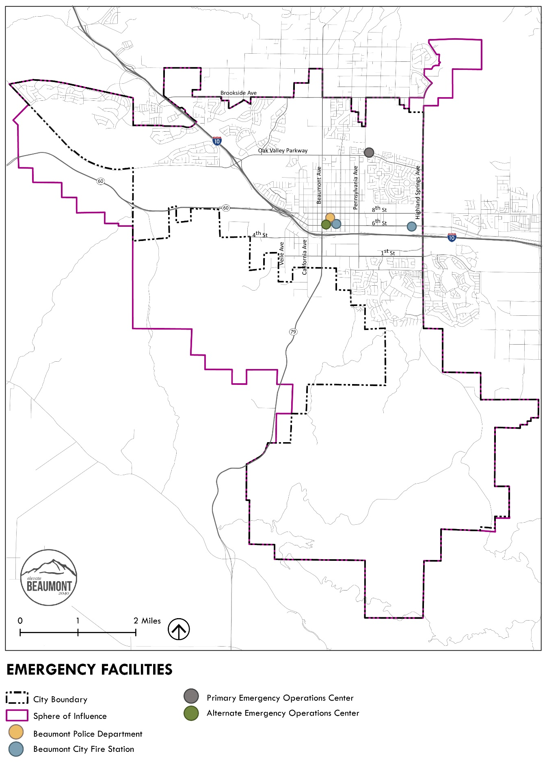
Figure 9.2: Emergency Evacuation Routes Map
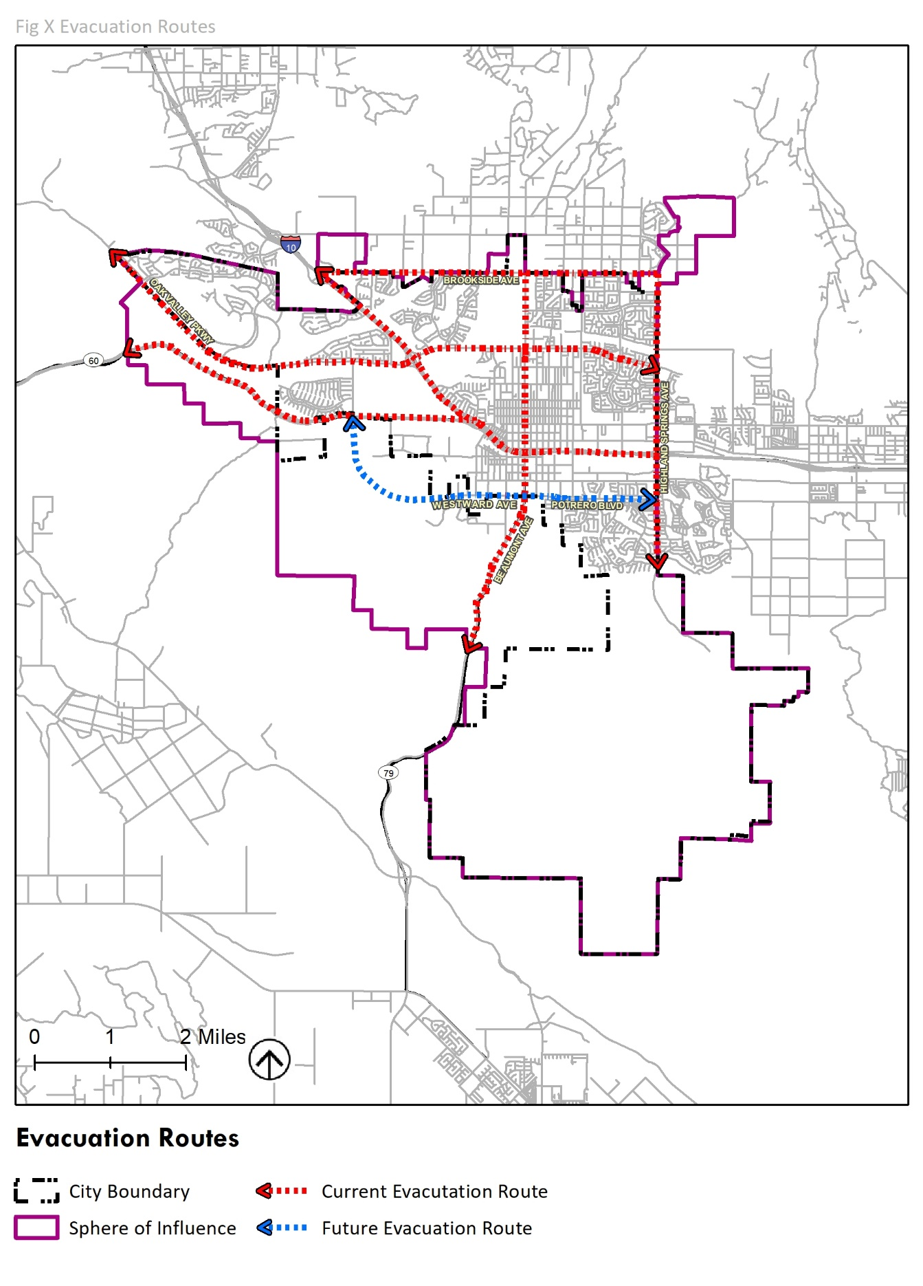

KEY ISSUES + OPPORTUNITIES
This section provides a snapshot of several key issues and opportunities related to safety, including natural and human-caused hazards. It is organized around six priority safety issues required by State law:
- Fire and wildfire hazards
- Seismic and geologic hazards
- Flooding
- High Wind Hazards
- Climate Change and Extreme Weather
- Emergency Evacuation
The Safety Element establishes and supports the implementation of mitigation strategies to reduce potential safety risks in the community.

Fire HAZARDS
The City relies on the California Fire Code and Riverside County Ordinance 787, including guidance on fire prevention, safety, and evacuation. As noted in Figure 9.1, both fire stations in the City are located in Downtown Beaumont. Recent increases in residential development on the west end of town have raised concerns regarding the Fire Department’s ability to meet acceptable response times and community needs.

Wildfire hazards
The City is located in the San Gorgonio Pass between the San Bernardino Mountains and the San Jacinto Mountains. Both mountain regions are heavily forested and routinely subject to forest fires. Table 9.1 below shows large fires, 300 acres and greater, that have burned in Riverside County since 2013. Fires in the county can threaten structures and people in Beaumont directly by burning areas in the city, and indirectly by generating air pollution.
Table 9.1: Riverside County Fires 300 acres and Greater from 2013-2021
Fire Name | Start Date | Acres Burned
Mountain Fire | 2013-07-15 | 27,531
Silver Fire | 2013-08-07 | 20,292
Manzanita Fire | 2017-06-26 | 6,309
Palmer Fire | 2017-09-02 | 3,874
Summit Fire | 2013-05-01 | 3,166
Sanderson Fire | 2020-12-13 | 1,933
Tenaja | 2019-09-04 | 1,926
Falls Fire | 2013-08-05 | 1,383
Opera Fire | 2017-04-30 | 1,350
Patterson Fire | 2018-05-17 | 1,261
Airport Fire | 2020-12-01 | 1,087
Highway Fire | 2015-04-18 | 1,049
Blaine Fire | 2017-08-13 | 1,044
Sandalwood Fire | 2019-10-10 | 1,011
Wildomar Fire | 2017-10-26 | 866
Mias Fire | 2017-08-14 | 545
Anza Fire | 2015-08-10 | 543
Jerry Fire | 2019-06-21 | 525
Horseshoe Fire | 2019-09-14 | 520
Gorgonio Fire | 2013-05-04 | 510
Hill Fire | 2019-10-30 | 494
Reche Fire | 2019-10-10 | 350
Flats Fire | 2021-06-13 | 341
46 Fire | 2019-10-31 | 328
Liberty Fire | 2017-12-07 | 300
Davis Fire | 2021-05-18 | 300
Source: CAL FIRE. 2021. Incidents. Available: https://www.fire.ca.gov/incidents/. Accessed September 25, 2021.
Fire Hazard Severity Zone Maps chart the areas across the State that are at risk for wildfires. These risk maps, drawn by CAL FIRE in 2007, are created by a computerized model that considers terrain, vegetation and the location of past fires. In Beaumont, Moderate, High, and Very High Fire Hazard Severity Zones (FHSZ) are in and near undeveloped land, both within the existing City limits and in the Sphere of Influence. High and Very High FHSZ are in the northeast portion of the City and Sphere near the San Bernardino Mountains as well as in undeveloped areas in the Potrero Reserve along State Route-79 in the southern portion of the City (See Figure 9.3). The undeveloped area within the Potrero Reserve is largely composed of shrub and grassland communities, which may provide fuel for wildfires.
Beaumont has also been identified by CAL FIRE as being located within a “wildland-urban interface”. The “wildland-urban interface” includes areas where homes or structures are intermixed with wildlands, which creates high wildfire risk. Historically, several fires have occurred in the wildland-urban interface in Riverside County and the threat intensifies under the Santa Ana winds and other extreme fire weather conditions.
As shown in Figure 9.3, parts of the area within the City and the Sphere of Influence that fall under the VHFHSZ are designated (developed or planned for development) for industrial, institutional, office and retail, and lower density residential uses west of SR-79. East of SR-79, planned land uses include mixed use residential and high density, multi-family residential. Any future development in these areas must mitigate wildfire risk with appropriate protections.
Climate change is expected to exacerbate drought conditions, potentially increasing the frequency and intensity of wildfires and altering the distribution and character of natural vegetation. California’s Fourth Climate Change Assessment reported a projected increase in wildfire frequency Statewide by 50 percent under a high emission scenario. Across the Inland Desert region, which includes San Bernardino and Riverside Counties, weather is expected to get hotter and drier over the 21st century. An increase in wildfires will place more buildings and infrastructure at risk and can also be a significant source of air quality pollution.
Figure 9.3: Fire Hazard Severity Zone Map
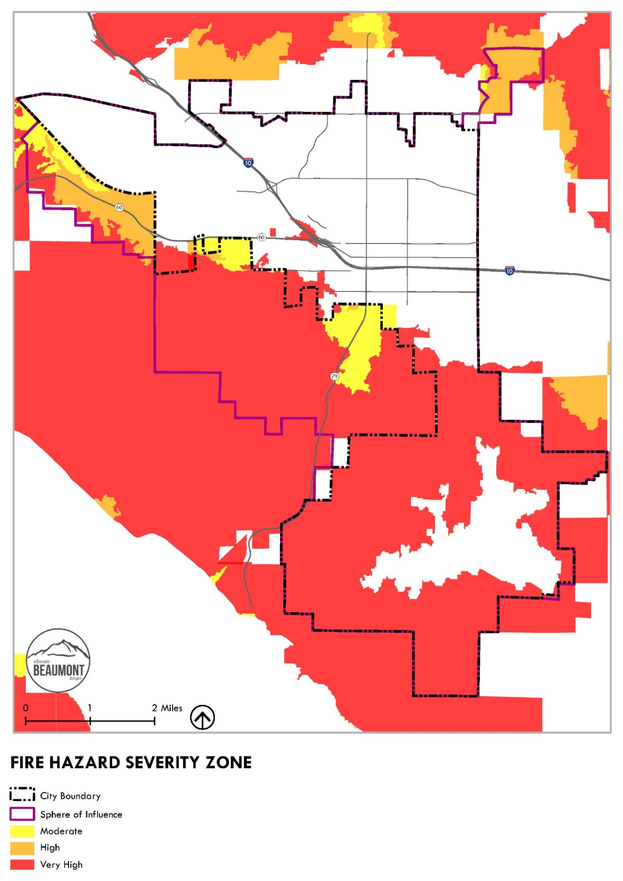
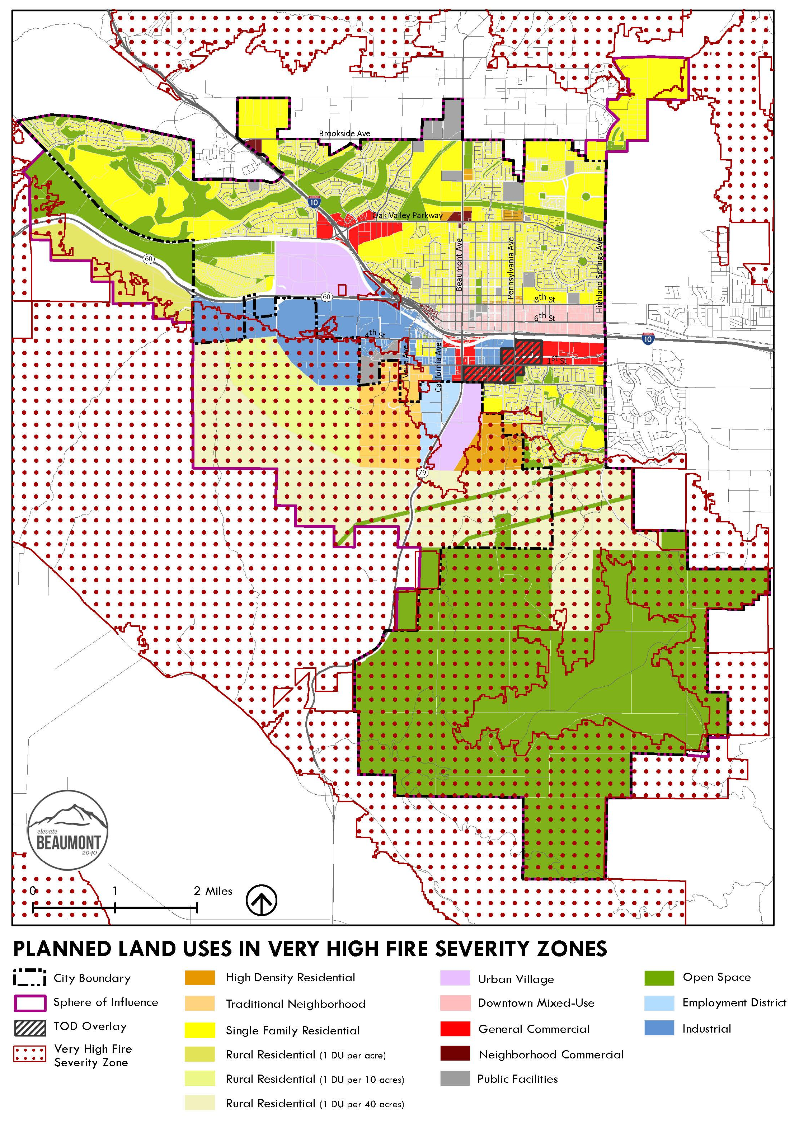
Figure 9.4: Fire Hazard Severity Zone + Planned Land Uses Map

Seismic Hazards
The City of Beaumont is located within a seismically active region located at the junction of the Transverse Ranges and the Peninsular Ranges. These two physiographic provinces experience continual seismic activity associated with the lateral movement of the North American and Pacific tectonic plates. The San Andreas Fault system, located northeasterly of the City, is believed to form the boundary between these two plates, although some of the seismic motion is distributed to nearby, related faults. Important faults that could affect the City in the future include the San Jacinto Fault, San Andreas Fault Zone, Banning Fault, and Beaumont Plains Fault Zone. The City of Beaumont seismic zones are identified in Figure 9.5.

Soils
Liquefaction is a phenomenon in which loose, water saturated, granular soils temporarily behave similarly to a fluid when subjected to high intensity ground shaking. Liquefaction occurs when three general conditions exist: 1) shallow groundwater, 2) low-density silty or fine sandy soils, and 3) high intensity ground motion. Areas within Riverside County susceptible to liquefaction hazards are depicted within the County of Riverside’s General Plan. The City of Beaumont has areas of low and moderate liquefaction susceptibility as reflected on Figure 9.6.
Ground subsidence refers to the sudden shrinking or gradual downward settling and compaction of the soil and other surface material with little or no horizontal movement. It may be caused by a variety of human and natural activities including groundwater withdrawal and ground shaking due to earthquakes. Land subsidence and associated fissuring have been documented in some areas of Riverside County. The City of Beaumont has known areas susceptible to ground subsidence as identified on Figure 9.6. Majority of the existing City is in the low susceptibility areas, but some of the areas in the western portion of the City, where newer development is proposed, are in a moderate susceptibility area. Geotechnical analyses will be required for new development projects to ensure that buildings are designed adequately to address impacts from ground subsidence.
Expansive soils have a significant amount of clay particles that can give up water (shrink) or take on water (swell). The change in volume exerts stress on buildings and other loads placed on these soils. The occurrence of these soils is often associated with geologic units having marginal stability. Expansive soils can be widely dispersed and can occur in hillside areas, as well as low-lying alluvial basins. Although expansive soils are now routinely alleviated by following the California Building Code, problems related to past inadequate grading or site preparation practices constantly appear. Expansive soils are not the only cause of structural distress in existing structures. Poor compaction and construction practices, settlement and landslides can cause similar damage, but require different mediation efforts. Once expansion has been verified as the source of the problem, mitigation can be achieved through reinforcement of the existing foundation or through the excavation and removal of the expansive soils in the affected area.

Figure 9.5: Seismic Zones
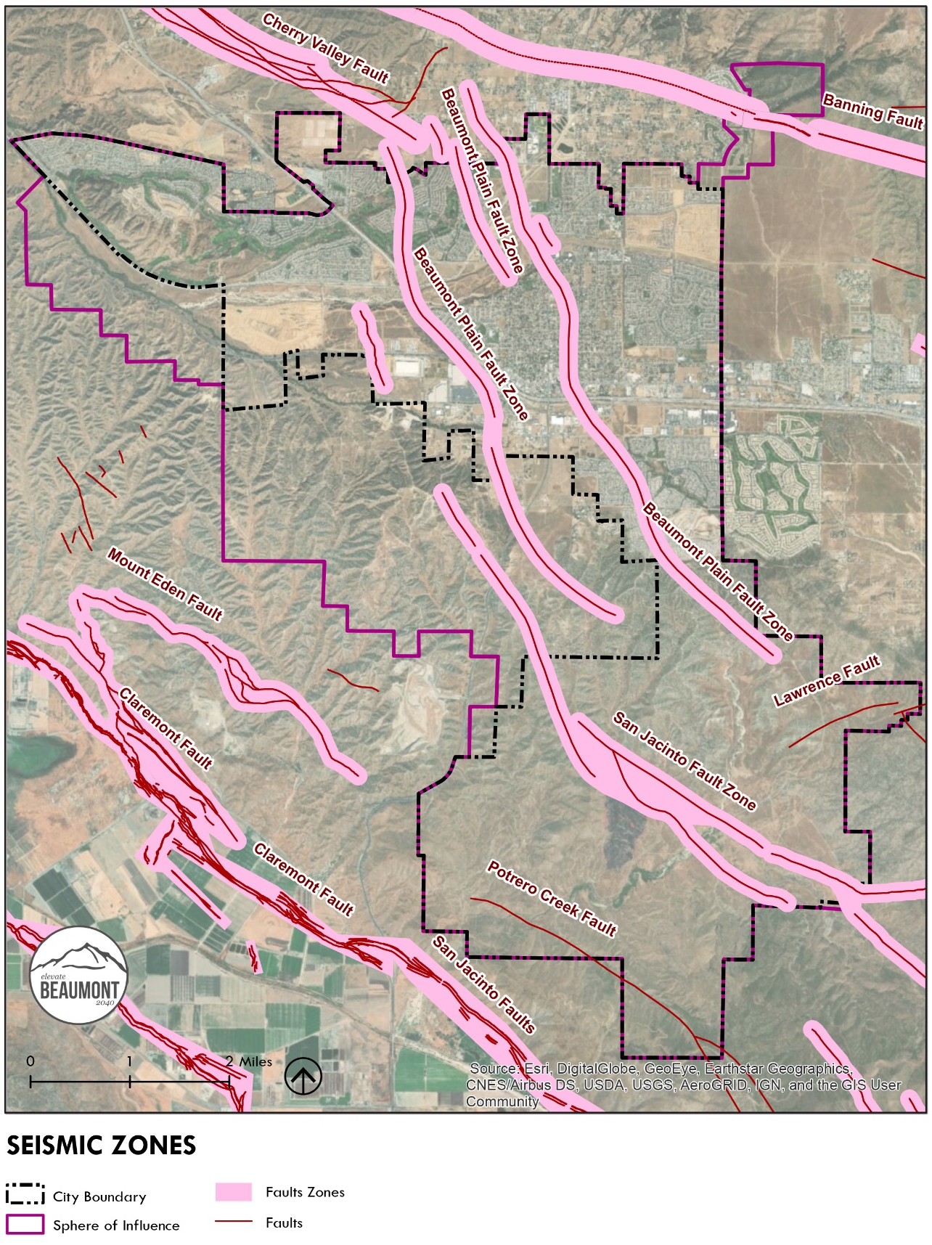
Figure 9.6: Liquefaction Areas
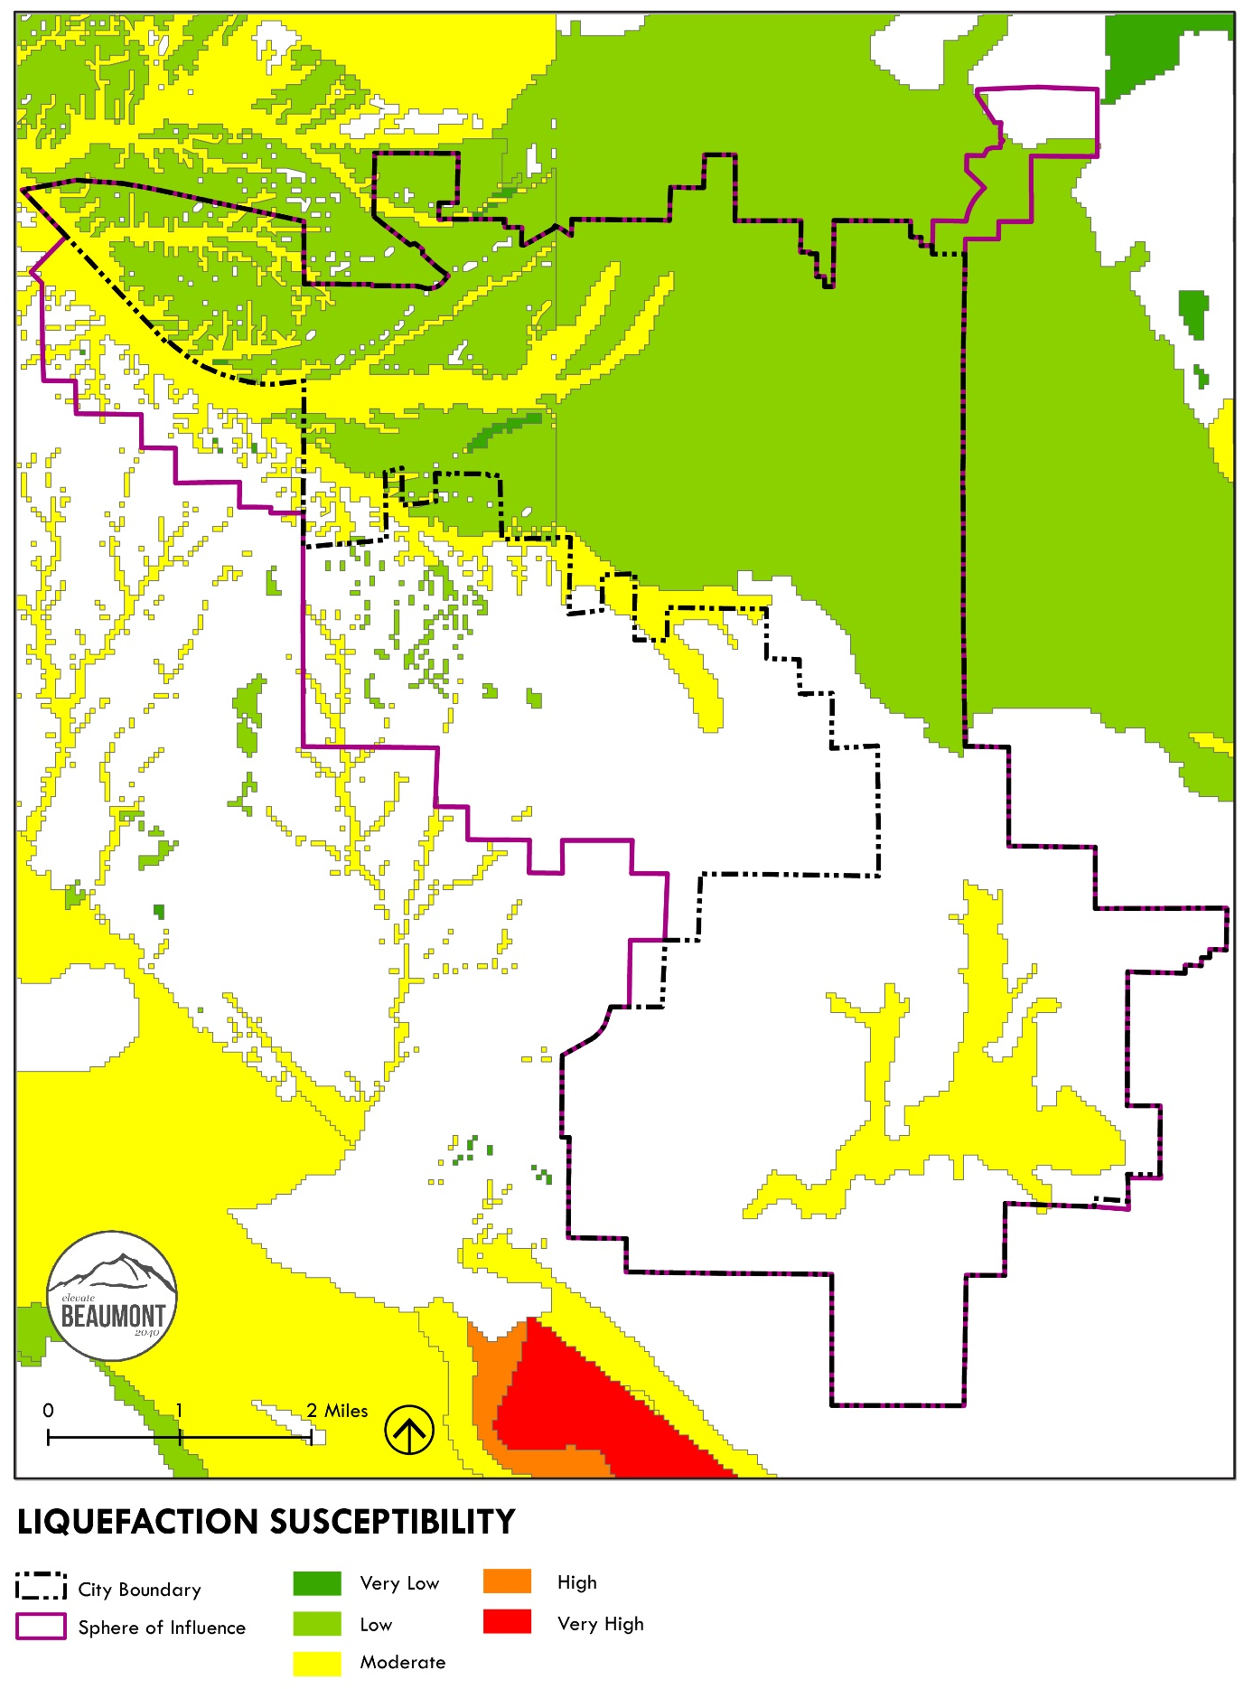
Figure 9.7: Ground Subsidence Areas
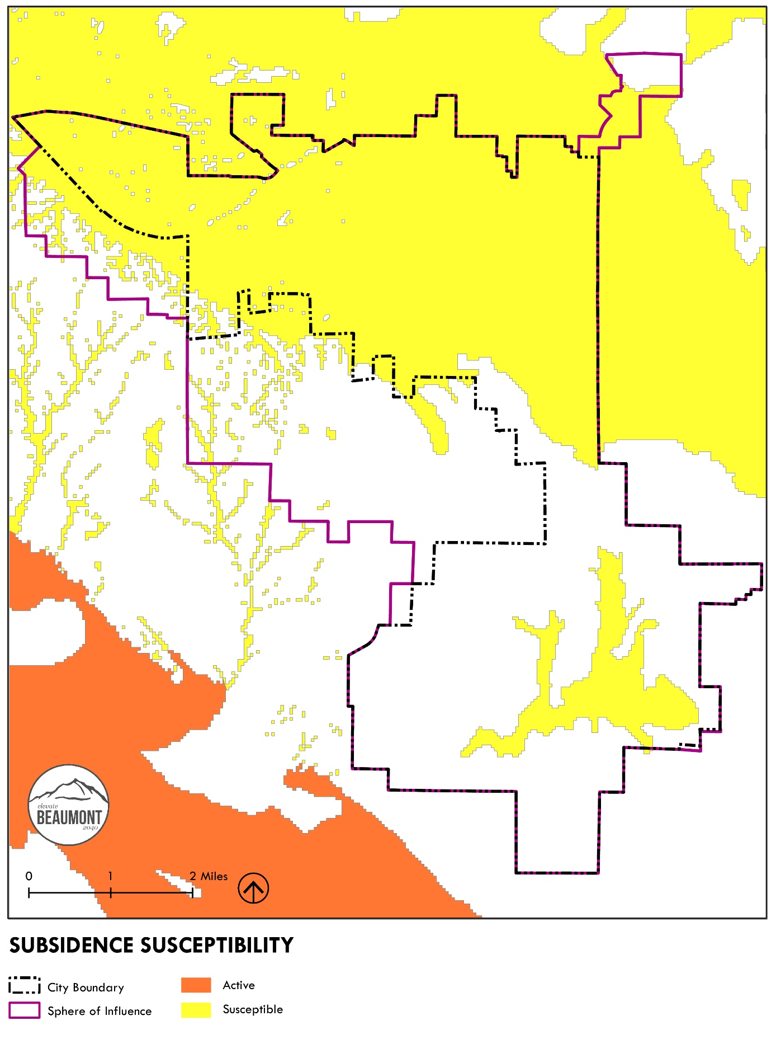

Tsunami hazards
Due to Beaumont’s inland location, tsunami hazards are not a threat to the City.

Flooding hazards
Beaumont’s location at the top of the San Gorgonio Pass causes streams in and around the City to drain into three distinct drainage areas. San Timoteo Creek drains westward from San Gorgonio Pass into the Santa Ana River Basin. Two drainage areas lie west of the peak. Part of the area drains generally south into Potrero Creek that traverses the “Badlands” area to flow into the San Jacinto River, which then flows into the Santa Ana River Basin. The third drainage area drains east into Smith Creek. Smith Creek descends into the east side of San Gorgonio Pass into the Whitewater River, continuing southeast through the Coachella Valley into the Salton Sea.
Flooding within the City has historically resulted from seasonal storms. Precipitation from these storms occasionally lasts for several days, with higher rainfall amounts recorded in the nearby mountains than on the valley floor. Local winter storms may occur concurrent with strong cold fronts or deep upper level low pressure centers, and like localized summer storms, may be of high intensity with concentrated precipitation over small areas. Minor floods occasionally exceed natural channel capacities, with localized inundation of adjacent urban and agricultural areas. For the most part, these are considered nuisance drainage problems. Planned regional drainage improvements have removed significant flood hazards from most developed areas of the City. When flooding occurs, it originates from the steep mountainous area to the north of the community, which contains sparse vegetation and is relatively arid. As a result, floodwaters develop rapidly and can cause flash floods.
Severe storms also produce high water levels in flood channels (north of the City) and flooding. The northern areas that have been subject to these floods are: Noble and Little San Gorgonio Creeks located north of Cherry Valley, and Smith and Pershing Creeks located northeast in Highland Springs. The periodic flash floods reach high velocities due to the steep terrain in the north and carry a significant amount of debris which blocks the flood channel at slope areas of 1% to 2%, causing heavy deposition. When this occurs, debris blocks flood control channels, particularly where they cross under freeways, resulting in significant flooding in the vacant land areas within the City's Sphere of Influence. According to the most recent FEMA maps, the portions of the planning area located in a 100-year flood zone are found in the Old Town area, along Cherry Avenue, and along a portion of Highland Springs Road. Figure 9.8 illustrates the 100-year and 500-year flood zones within the City. As a result of climate change, more intense and more frequent flooding is expected to occur in the 100‐year flood zone within the City along portions of Interstate 10, Palm Avenue, east of Highland Springs Avenue, and near Beaumont High School. During extreme flood events, Downtown Beaumont could be flooded.
The Riverside County Flood Control and Water Conservation District (District) provides flood control facilities planning, design, operation, and maintenance within the City limits. The District has several flood control facilities currently within the City, including, underground storm drains, open channels, retention basins, debris basins, spreading grounds, and culverts. The District’s Master Drainage Plan for the Beaumont Area analyzes drainage issues in Beaumont and provides solutions for drainage issues within the plan area. The Plan also describes the location, size and capacity of flood control facilities that are needed for current development and anticipated growth.
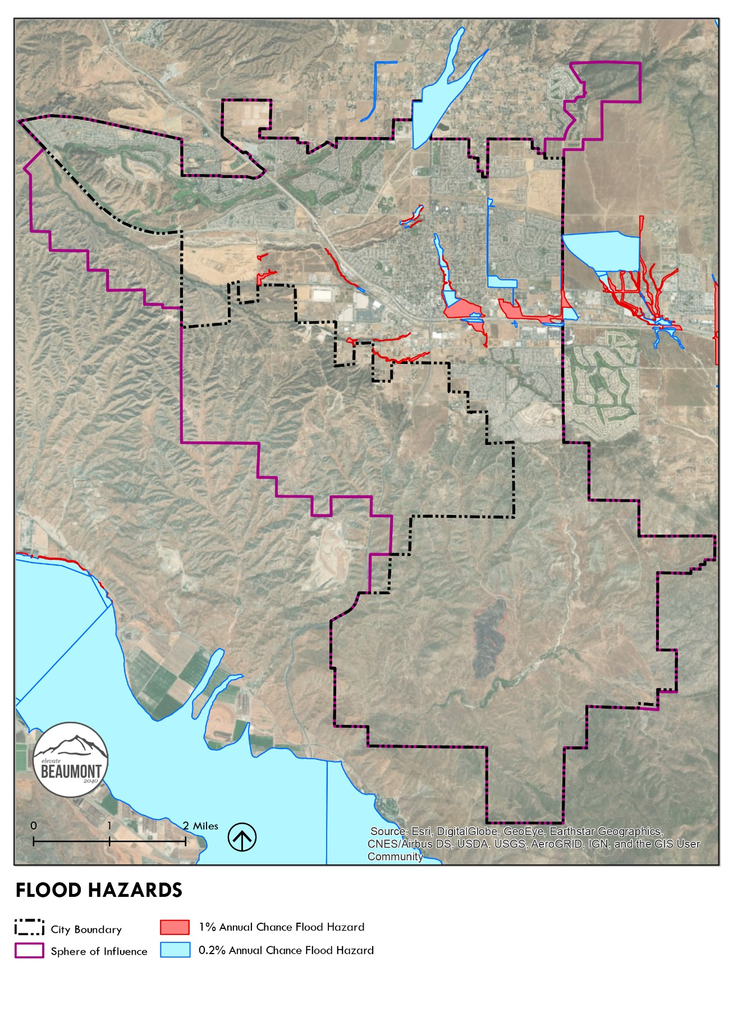
Figure 9.8: Flood Hazards Map

high Wind hazards
High winds are common in the Pass Area and in Beaumont. Beaumont is considered an extreme wind area and a combination of unfavorable conditions can make it deadly for citizens and firefighters. High winds can be hazardous and result in property damage or risk to residents.
High winds in the City are influenced by the City’s proximity to the San Gorgonio Pass, which is one of the windiest places in southern California. The prevailing winds are from the west in spring, summer, and early fall. During summer thunderstorms, the winds will sometimes be from the southeast. The westerly winds that blow through the far eastern portion of the Pass are a function of the marine air layer, which develops over Coastal Southern California. When this layer attains a thickness of over 3,000 feet, a condition associated with spring and early summer, it pours cool air through the San Gorgonio Pass and into the Coachella Valley, causing high winds.
Potentially hazardous conditions exist in open, sparsely developed areas. Such hazards can be placed in three major categories: 1) damage directly from the wind (e.g., falling trees or limbs, damaged power lines, and roofs), 2) blowing sand and dust, and 3) soil erosion.

Erosion
Beaumont is located within a moderate wind erodibility susceptibility area, as noted in the County of Riverside General Plan (2015). Erosion is a normal geologic process whereby earth materials are loosened, worn away, decomposed, or dissolved and are removed from one place and transported to another. The hazard of erosion is also increased when vegetation is removed and the soil surface is disturbed and left barren. The City of Beaumont and the Sphere of Influence face exposure to potential erosion hazards due to wind, although the large number of trees and windbreaks in developed portions of Beaumont greatly reduce the adverse impacts of wind.
Blowing sand and dust, and soil erosion are most likely to be significant during a change from open space to other land uses, as well as when agricultural land is exposed down to bare soil. At such times, plowing or grading operations, if not properly controlled, expose soils and create wind erosion hazards. As such, this Element includes policies aimed at mitigating dangers posed by high winds and soil erosion, especially during construction.

Climate Change + EXTREME WEATHER
Climate change describes the long-term shift in global and regional weather patterns. This includes changes in average annual temperatures, timing and amount of local precipitation, frequency and intensity of extreme weather events, sea level changes, and other aspects of weather. In California, climate change is expected to account for the loss of at least 48 percent of the Sierra snowpack by 2050. The snowpack provides natural water storage for the State. The Metropolitan Water District (MWD) of Southern California is the primary importer of water to the region. Nearly half of the Los Angeles region’s water supply comes from the Sacramento, San Joaquin, and Colorado Rivers. Additionally, groundwater makes up about 30 percent of California’s total annual water supply in normal years, but it can be up to 60 percent in drought years. The percentage of water supply from each source varies between cities in the Gateway Cities region
Additionally, two-thirds of California’s native flora will experience a greater than 80 percent reduction in suitable climate range within a century. Depending on the extent of these changes, climate change may result in significant social, economic, and environmental consequences for residents and businesses.

Temperature
Since the early 20th century, average surface temperature worldwide has risen at an average rate of 0.15°F per decade (1.5°F per century). Average surface temperatures across the lower 48 states have risen at an average rate of 0.14°F per decade (1.4°F per century). In the US, average surface temperatures have risen more quickly since the late 1970s (0.36 to 0.55°F per decade), with seven of the top ten warmest years on record occurring since 1998.
For California, the average annual temperature is expected to rise 1.8°F to 5.4°F by 2050 and 3.6°F to 9°F by the end of the century. For the Beaumont area, scientists expect average temperatures to increase between 3.7°F and 6.7°F. These long-term temperature increases will be experienced along with short-term variation (daily, annual, and multi-year) in temperature related to earth system changes, such as El Niño, La Niña, or volcanic eruptions. As a result, temperatures for a single day or year may be higher or lower than the long-term average.

Extreme Heat Events
Beaumont is likely to see a significant increase in the number of days when temperature exceeds the extreme heat threshold of 101°F. Between 1950 and 2011, the average number of extreme heat days was four. Under the lower emissions scenario by 2050, the number of extreme heat days could increase to more than 30 per year, and more than 50 per year in the high emissions scenario. Extreme heat events will impact agriculture, public health, and could lead to more heat-related deaths, especially for vulnerable populations.

Precipitation
Research suggests that in California, climate change is likely to decrease annual precipitation amounts by more than 15% by the end of the 21st century. In Beaumont, precipitation is expected to decline over the next century, falling from around 16.2 inches per year to approximately 14.8 inches per year. Seasonal precipitation will change more significantly with March and April receiving less rainfall than in the past. As a result of the seasonal change, Beaumont will likely experience longer periods of drought, as the summer dry season starts earlier in the spring and extends later into the fall. Wet extremes are also expected to increase in the future, resulting in more intense and more frequent flooding and increasing the likelihood of landslides. Deep‐seated landslides could occur along San Gorgonio Creek, the San Jacinto foothills near the junction of I‐10 and SR‐60, and at various other locations in the City.

Vulnerable Populations
The impacts of climate change present serious health risks to California’s most vulnerable populations, particularly extreme heat events. The effects of extreme heat on human health are well-documented. Increased temperature or extreme heat days can increase heat-related mortality, cardiovascular-related mortality, respiratory mortality, and heart attacks, while increasing hospital admissions and emergency room visits. Extreme heat can also affect a person’s ability to thermo-regulate, causing heat stress and even death. Exposure to extreme heat during pregnancy is related to lower birth weight, especially in the second and third trimesters.
A number of factors contribute to the vulnerability of an individual to extreme heat. Internal factors include age (over 65 and infants and children) and medical conditions (e.g., cardiovascular disease, diabetes, and mental illness). This presents an increasing risk to Beaumont, which has a large aging population, 67% of residents are over age 50, and under age 5 population (12%), which continues to grow as more young children and families move to Beaumont. External factors also contribute to climate change vulnerability, such as homelessness, poverty, and environment, particularly for populations living in close proximity to the freeway, areas with low tree canopy, and lack of access to resources, like air conditioning or a vehicle. Because climate change impacts are closely intertwined with vulnerable populations and inequities, climate adaptation planning presents a unique opportunity to address some of the external factors that contribute to climate change vulnerability, which are also root causes of inequity. Addressing these underlying causes can help increase resilience for all Beaumont community members.

Vulnerable Assets
There are a number of critical assets in Beaumont that are vulnerable to the effects of climate change, including transportation infrastructure, government facilities, electrical and natural gas services and facilities, police and fire facilities and emergency services, commercial and residential properties, medical facilities, parks and recreation centers, and schools. Key assets at risk in Beaumont were assessed as part of Resilient IE and are presented in Table 9.1.
Table 9.1: Critical Assets in Beaumont at Risk from Climate Change
Asset Category | Asset Name
Local and Regional Infrastructure | Beaumont Civic Center, Beaumont Police Department, Riverside County Fire Station, I‐10 and SR‐60 freeways, Yuma railway subdivision, Southern California Edison power lines and substations, Southern California Gas natural gas pipelines
Major Commercial/Economic Hubs | Oak Valley Towne Center, Sun Lakes Village Shopping Center, Beaumont Center, Marketplace Beaumont
Medical | Highland Springs Care Center, Highland Springs Surgical Center, Independent Options (Donna House; Orange House), Joshua Generation Group, Palm Grove Healthcare, RAI E 6th Street Beaumont
Parks | Beaumont Sports Park, Mountain View Park, Rangel Park, Stewart Park, Three Rings Ranch Community Park
Schools | 21st Century Learning Institute, Anna Hause Elementary, Beaumont 8th St HeadStart, Beaumont Adult School, Beaumont HeadStart, Beaumont Senior High, Brookside Elementary, Glen View High, Highland Academy (Charter) (K‐8), Mountain View Middle, Palm Elementary, San Gorgonio Middle, Starlight Elementary, Sundance Elementary, Three Rings Ranch Elementary, Tournament Hills Elementary
Source: WRCOG and SBCTA, 2020

Adaptation + Resilience
Climate change will impact the health of residents. Certain populations such as older adults, young children and infants, pregnant women, and people with chronic illnesses are more susceptible to health impacts. Lower-income communities and communities of color are also more susceptible to the effects of extreme heat due to existing social inequities. In Riverside County, extreme heat, poor air quality, regional drought, vector-borne disease, among other climate hazards are anticipated to negatively affect human health, health behaviors, and the socioeconomic factors that influence health outcomes.

Urban Forest
Urban tree canopy, green streets, and parks are all part of the infrastructure that supports an urban forest. In addition to providing shade, cleaning the air, energy savings, and reducing stormwater pollution, urban forests are beneficial to physical and mental health. Urban forests contribute to a healthier, more livable, and prosperous community. In addition to providing shade to a home, urban forest can also have a positive effect on property value. The City has articulated goals to preserve, protect and increase its urban forest.
Oak trees are a valuable asset in the city, but can be negatively impacted by land uses, invasive species, and vegetation changes. The longevity and slow reproductive rates of oaks make them particularly susceptible to the effects of climate change. Oak trees within unincorporated areas of Riverside County are protected by the County Tree Management Guidelines, County General Plan, and Tree Removal Ordinance. As a part of this General Plan, the City is adopting policies to protect Oak trees within the City limits. (see Land Use + Community Design Element)
Lower-income areas and communities of color are more likely to live in urban areas lacking enough park space or tree canopy coverage, and are therefore, more prone to suffer from urban heat island effect, which increases the magnitude of extreme heat events.

Emergency Evacuation
There are two residential neighborhoods in the City that have been identified as having only a single access road for entry and exit, as illustrated in Figure 9.9. These neighborhoods pose additional emergency evacuation logistic challenges when coordinating disaster response.
Risk to emergency evacuation routes from hazardous events was assessed as part of Resilient IE. Emergency evacuation routes cross through hazard zones, over bridges, and water. Table 9.2 shows how much of Beaumont’s evacuation network could be at risk from fire, flood or landslide hazards. It also identifies bridges and over water crossings which could become impassable during an evacuation event.
Table 9.2: Hazard Impacts, Bridges, and Water Crossings to Beaumont’s Evacuation Route Network
Description | Miles or Quantity | Percent of Beaumont’s Network
Evacuation Route Miles in Fire Hazard Zones | 14 | 26%
Evacuation Route Miles in Flood Hazard Zones | 12 | 22%
Evacuation Route Miles in Landslide Hazard Zones | 24 | 43%
Beaumont’s Total Evacuation Network Miles | 55 | 100% | 2.9%*
Bridge Crossings in Beaumont’s Evacuation Network | 28 | Not Available
Water Crossings in Beaumont’s Evacuation Network | 53 | Not Available
*Indicates the percentage of Beaumont’s total network as part of the larger Western Riverside County network.
Source: WRCOG and SBCTA, 2020

Figure 9.9: Single-access Road Residential Neighborhoods Map
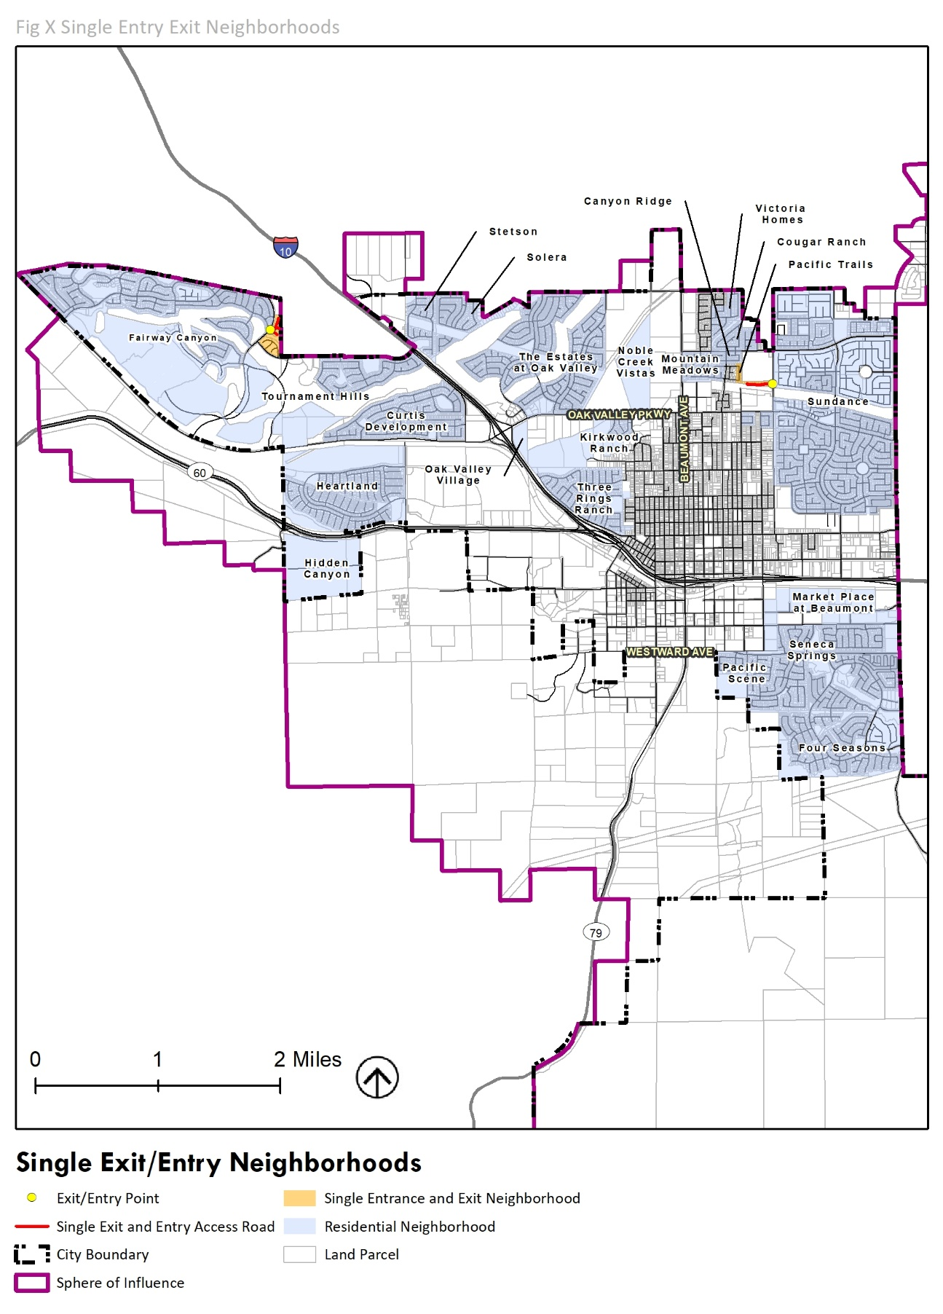

GOALS + POLICIES
The following section includes goals and policies for the Safety Element. Goals and policies are followed by implementation actions.

CRIME PREVENTION
Goal 1. A City with a high standard of law enforcement services that has a focus on community-based crime prevention.
Policies:
- Maintain sufficient levels of City law enforcement services and facilities to support existing residents and future growth. Coordinate with the Riverside County Sheriff in its efforts to provide adequate law enforcement services within the City’s Sphere of Influence.
- Strive to improve service delivery and efficiency of the Beaumont Police Department.
- Coordinate with local, State, and Federal law enforcement agencies in crime prevention efforts.
- Continue to foster positive, peaceful, mutually supportive relationships between Beaumont residents and the police. Encourage increased community involvement and activities, such as block parties, to reduce criminal activity.
- Coordinate with local partners to encourage community-based crime prevention efforts.
- Promote after school, volunteer, and Business and Neighborhood Watch programs, and other innovative programs to help maintain a safe environment.
- Encourage development and operation of community and recreational facilities as a pre-emptive strategy to reduce youth-related crime. Expand opportunities for positive law enforcement and youth interaction.
Goal2. A City with improved community safety and reduced opportunities for criminal activity through appropriate physical design.
Policies:
- Implement Crime Prevention Through Environmental Design (CPTED) principles with:
  - Site design techniques that maximize natural surveillance and reduce the potential for criminal activity.
  - Policies and regulations that encourage a mixture of compatible land uses to promote visibility and higher levels of activity and increase the safety of public use areas and of pedestrian travel.
  - Improve lighting and nighttime security across all City neighborhoods, especially in existing or potential crime problem areas.
- Involve the City’s Police Department in the development review process for evaluation of building and site plan vulnerabilities to criminal activities, especially for public areas within developments.

DISASTER PREPAREDNESS
Goal 3. A City that provides effective emergency response following a natural or human-caused disaster.
Policies:
- Ensure that the City’s Emergency Operations Plan is regularly updated to be compatible with Federal, State and local emergency requirements and latest FEMA Best Practices.
- Continue to partner with local emergency management organizations to implement coordinated emergency response planning.
- Continue to educate City staff, residents, and businesses regarding appropriate actions to take during an emergency.
- Promote community-based, emergency preparedness programs (i.e., defensible space and evacuation routes) and disaster education awareness, including the City’s annual emergency system training, focusing on the most vulnerable communities such as those who live or work in the Very High Fire Hazard Severity Zone, individuals with access or language limitations, seniors, and youth.
- Support the existing Community Emergency Response Team (CERT) program to educate volunteers about disaster preparedness and train them in basic disaster response skills, such as fire safety, light search and rescue, team organization, and disaster medical operations.
- Maintain emergency procedures for the evacuation and control of population in identified flood hazard areas in accordance with Section 8589.5 of the California Government Code.
- Develop and employ evacuation alternatives and/or alternative emergency access routes in neighborhoods that have single ingress/egress.
- Develop and maintain evacuation options for residents with mobility challenges.
- Maintain emergency evacuation roadways and improve them as necessary and appropriate to ensure ongoing serviceability.
- Ensure redundancy of critical transportation routes to allow for continued access and movement in the event of an emergency.
- Prioritize undergrounding of utilities for designated evacuation routes to make them more reliable.
Goal 4. A City that is protected from the effects of natural and manmade disasters.
Policies:
- Continue coordinated review of development proposals with the Police Department and Fire Safety Specialist to ensure that police and fire staff and resources keep pace with new development planned or proposed in the City and City’s Sphere of Influence.
- Conduct a community risk assessment or hazard profile in partnership with fire crews, community members, and city staff to identify specific target hazards, including critical facilities, community assets, and historical buildings.
- Maintain adequate levels of staffing for fire protection and emergency services by
  - Retention of current staffing positions,
  - Forecast of future demand, and
  - Provision of additional staff, equipment and technology acquisition, and facilities when fiscally appropriate and needed.
- Ensure that backup power is maintained in critical facilities across the City.

FIRE AND WILDFIRE
Goal 5. A City with enhanced fire and emergency response services.
Policies:
- Ensure that the locations of new and existing fire protection facilities provide a consistent level of service across the City. Fund and support new fire stations, personnel, and equipment as needed to meet NFPA and County Fire response standards. Partner with CAL FIRE to establish minimum staffing levels for each fire company or each duty shift.
- Increase Fire Department resources and facilities to the western portion of Beaumont to decrease current response times to the targeted response time of five minutes.
- Provide an adequate level of paramedic service for emergency medical aid for patients.
- Continue code enforcement efforts to reduce fire hazards associated with older buildings.
- Coordinate with the Beaumont-Cherry Valley Water District to ensure that there is adequate water supply and water pressure for existing and future developed areas for firefighting purposes.
- Provide fire suppression water system guidelines and implementation plans for existing and acquired lands, including fire protection water volumes, system distribution upgrades, and emergency water storage.
- Continue to provide technical and policy information regarding structural and wild land fire hazards to developers, interested parties, and the general public through all available media.
- Coordinate with CAL FIRE, Riverside County Fire Department, and other agencies to provide emergency services training for residents at a block-by-block level and City staff, and promote fire prevention programs, including raising awareness about structure hardening, fire safe landscaping and buffer zones in areas of wildfire risk.
Goal 6. A City that protects human life, land, and property from the effects of wildland fire hazards.
Policies:
- Inventory and assign risk levels for wildfire hazards to assist in regulating the allowable type, density, location, and/or design and construction of new developments, both public and private.
- Update development standards to meet or exceed the California Code of Regulations Title 14 State Responsibility Area Fire Safe Regulations and Fire Hazard Reduction Around Buildings and Structures Regulations.
- Ensure that development in Very High Fire Hazard Severity Zones minimizes the risks of wildfire through planning and design of structures in accordance with the California Building Code Chapter 7A. Ensure adequate provisions for vegetation management, emergency access, and firefighting.
- Require new development in the High and Very High Fire Hazard Severity Zones to develop a fire protection and evacuation plan and ensure that the plan includes adequate fire access to new development.
- Prohibit new public or critical facilities in Very High Fire Hazard Severity Zones, except when other options do not exist.
- Require property owners to clear brush fuel vegetation and maintain fire-safe zones (a minimum distance of 30 feet from the structure or to the property line, whichever is closer) to reduce the risk of fires. For structures located within a Very High Fire Hazard Severity Zone, the required brush distance is up to 200 feet from structures up to their property line.
- Continue to enforce the weed abatement ordinance to mitigate potential fire hazard risks.
- Require that existing and new developments located in wildland interface areas incorporate and enforce standards for construction, including a fuel modification program (i.e., brush clearance, planting of fire-retardant vegetation) to reduce the threat of wildfires.
- Ensure that re-development after a large fire complies with the requirements for construction in the High and Very High Fire Hazard Severity Zones for fire safety.
- Evaluate soils and waterways for risks from flooding, water quality, and erosion to ensure that they are suitable to support redevelopment following a large fire.
- Ensure the safety of residents by identifying and providing residents safe and viable evacuation routes during potential hazards.
- Minimize risks to existing development in Very High Fire Hazard Severity Zones by identifying existing non-conforming development that do not meet road and vegetation fire safe standards in accordance with the California Building Code Chapter 7A and Chapter 15.20 of the City of Beaumont Municipal Code and applicable updates. Bring properties into conformance through incentive programs, code enforcement actions, and/or permit requirements for redevelopments and remodels.
- Work with Federal, State, and local authorities to establish and maintain community fire breaks and fuel modification/reduction zones, including public and private road clearance, to slow the spread of wildfire, reduce its strength and help protect homes and other development from direct flames. Update the City’s Local Hazard Mitigation Plan to include descriptions of these long term maintenance of fire reduction projects.

SEISMIC SAFETY
Goal 7. A City that protects safety of human life, land, and property from the effects of earthquakes and geotechnical hazards.
Policies:
- As new versions of the California Building Code (CCR Title 24, published triennially) are released, adopt and enforce the most recent codes that contain the most recent seismic requirements for structural design of new development and redevelopment to minimize damage from earthquakes and other geologic activity.
- Require that all development projects within designated Alquist-Priolo Earthquake Fault Zones are accompanied by appropriate geotechnical analysis.
- Coordinate with the National Earthquake Hazard Reduction Program of the Federal Emergency Management Agency (FEMA) to identify earthquake risks and available mitigation techniques.
- Proactively seek compliance with the Alquist-Priolo Earthquake Fault Zoning Act by coordinating with the California Geological Survey and the United States Geological Survey (USGS) to establish and maintain maps establishing affected parcels within the City boundaries and the Sphere of Influence.
- Ensure that code enforcement agencies include thorough plan checks and inspections of structures vulnerable to seismic activity, fire risk, and flood hazards. Additionally, recommend the periodic observation of construction by design professionals.
- Promote greater public awareness of existing state incentive programs for earthquake retrofit, such as Earthquake Brace and Bolt, to help property owners make their homes more earthquake safe.

FLOODING
Goal 8. A City with reduced potential flood hazards.
Policies:
- In coordination with the Public Works Department, annually review the City’s Land Use and Flood Hazard Maps to ensure that they accurately reflect areas recognized by FEMA as being subject to flooding.
- Restrict development in Flood Hazard Areas.
- Work closely with Federal and regional partners to perform timely reviews of potential flood hazards and identify mitigation strategies.
- Require all new developments to mitigate potential flooding that may result from development, such as grading that prevents adverse drainage impacts to adjacent properties, on-site retention of runoff, and the adequate siting of structures located within flood plains.
- Limit future development of critical facilities including, but not limited to, hospitals and health care facilities, emergency shelters, fire stations, emergency command centers, and emergency communications facilities within the boundaries of the 100-year flood plain.
- Encourage critical facilities to implement feasible design mitigation measures that ensure the building will not flood during a 100-year flood event to greatest extent practical.
- Support regional efforts to control and mitigate existing potential flood related problems.
- Evaluate the feasibility of expanded joint-use of open space lands and utility easements for flood control.
- Encourage property owners and residents to purchase flood insurance for areas outside of the FEMA-mapped 100-year flood zones, especially in areas that have experienced flooding in the past.

HIGH WINDS
Goal 10. A City that promotes preparedness related to the adverse effects of high winds common in the Pass area.
Policies:
- Consider potential risk posed by high winds in the City in the review of new development applications including those for signs.
- Require implementation of best practices for dust control at all excavation and grading projects.
- Prohibit excavation and grading during high wind conditions, defined as instantaneous wind speeds that exceed 25 miles per hour by South Coast AQMD.
- Continuously monitor multi-hazard threats during high wind and associated wildfire conditions. Allocate appropriate firefighting and emergency personnel resources to effectively respond to multi-hazard threats.

CLIMATE CHANGE
Goal 11. A City that is prepared for the potential impacts of climate change.
Policies:
- Establish partnerships with Federal, State, regional, and local agencies to cooperate and better understand regional impacts of climate change and develop multijurisdictional solutions.
- Encourage new development and redesign of existing buildings to take steps to reduce the impacts of extreme heat events, including:
  - Design buildings to use less mechanical heating and cooling through use of passive solar techniques.
  - Support and incentivize, as feasible, energy efficiency, indoor air improvements and weatherization programs.
  - Protect and expand the City’s urban tree canopy to provide shade, increase carbon sequestration, and purify the air.
  - Provide shade structures in public parks, outdoor playgrounds, and bus shelters.
- Partner with the Riverside County University Health System-Public Health to develop and enhance disaster and emergency early warning systems to incorporate objective data and information for potential health threats such as heat-illness, and illnesses complicated by low air quality due to climate change hazards.
- Require enhanced water conservation measures in new development and redesign of existing buildings to address the possibility of constrained future water supplies, including:
  - Compliance with existing landscape conservation ordinance (Chapter 17.06 of the Municipal Code).
  - Use of water conservation measures in new development beyond current requirements.
  - Installation of recycled water use and graywater systems.
- Continue to work with the Riverside University Health Services Department and County of Riverside Emergency Management Department to establish public outreach programs (through social media and websites) to distribute information on climate change impacts on vulnerable populations including actions they can take to reduce exposure to unhealthy conditions.
- Prioritize programs that ensure the benefits of climate action programs are fairly distributed and prioritized to those most in need, particularly populations most likely to be impacted by climate change.
- Pursue climate change grant funding opportunities for expanding education programs and funding necessary retrofits.
- Establish ordinances that require critical facilities, such as fire and police stations, civic buildings, medical facilities, schools, hospitals, cooling centers and resilience hubs (community-based centers that streamline health programming and resources at a community-trusted site), to provide redundant backup systems including generator power, solar, and wind turbine power sources and energy storage systems.

- Integrate climate adaptation considerations into the LHMP, emergency operations plans and other public safety documents.
- Incorporate consideration of climate change impacts as part of infrastructure planning and operation. Identify projects as part of capital improvement programs that should consider climate adaptation priorities.
- Use available data and studies to simulate how expanded wildfire, flooding, and landslide impacts might affect the transportation system; In particular, study changes along designated evacuation routes associated with more frequent and severe wildfire, flood, and landslide events.

HAZARDOUS MATERIALS
Goal 12. A City with minimized risk associated with hazardous materials.
Policies:
- Require all users, generators, and transporters of hazardous materials and wastes to provide and maintain an updated inventory of hazardous waste and materials, associated handling procedures, and clean up response plans.
- Require an assessment of hazardous materials use as part of environmental review and/or include approval of the development of a hazardous management and disposal plan, as a condition of a project, subject to review by the County Environmental Health Department.
- Work with responsible Federal, State, and County agencies to effectively regulate the management, disposal, and appropriate remediation for accidental spills of hazardous materials and hazardous waste.
- Work with responsible Federal, State, and County agencies to prepare contingency plans for potential accidental spills of hazardous materials along the major transportation freeways, roadways and rail corridors that transect the City.
- Prohibit placement of proposed new facilities that will be involved in the production, use, storage, transport, or disposal of hazardous materials near existing sensitive land uses (such as homes, schools, child-care centers, nursing homes, senior housing, etc.), that may be adversely affected by such activities.
- Establish clear policies and procedures in the event of a hazardous contamination. Recommend and offer trainings to private sector companies.
- Coordinate with regulatory agencies regarding remnant safety hazards and future utilization of contaminated sites within Potrero Reserve and elsewhere in the City.
- Adopt ordinances that reduce the level of risk from hazardous materials, hazardous waste, infectious waste, and radioactive materials to the public, industries, and businesses.
- Promote proper hazardous waste disposal by hosting regular bi-annual or quarterly collection events.

IMPLEMENTATION
Table 9.3: Safety Implementation Programs*
 | Description | Priority | Time Frame | Responsibility
Crime Prevention
S1 | Police Department Staffing Ratio. Work with the police department to establish resource needs to sustain minimum staffing levels. | High | Short | Planning, Beaumont Police
S2 | Crime Prevention Design. Update zoning code to ensure that site design and planning techniques that reduce the potential for criminal activity (e.g., CPTED) are included. | Medium | Medium | Planning, Beaumont Police
S3 | Safety Taskforce. Establish a safety task force that meets with staff from the Riverside County Sheriff, police department, and other law enforcement agencies to coordinate crime prevention strategies in the City and within the Sphere of Influence. | Medium | Medium | Planning, Beaumont Police
S4 | Community and Recreational Programs. Establish/expand community and after-school programming for at-risk youth. | Medium | Long | Planning, Police, Parks & Recreation
S5 | Budget Review. Coordinate a periodic review with the Police Department and the Fire Safety Specialist to ensure that police and fire staff and resources keep pace with new planned or proposed development. | Medium | Medium | Planning, Beaumont Police, CAL FIRE
S6 | Lighting Study. Assess existing lighting needs in the city, including areas that need improved lighting or potential crime prone areas. | Medium | Medium | Planning, Public Works
Disaster Preparedness
S7 | Community Risk Assessment. Conduct a community risk assessment to identify critical facilities and community assets. | High | Medium | Planning, Public Works
S8 | Climate Change Risk Assessment. Conduct a detailed climate change vulnerability assessment to identify potential risks and vulnerable populations and assets. Include a fire hazard risk assessment consistent with the latest OPR Technical Advisory. Develop adaptation strategies to reduce risk and increase resilience.  Prioritize programs and funding for populations and critical assets most likely to be impacted by climate change. | High | Medium | Planning, Public Works
S9 | Emergency Evacuation Scenarios. Evaluate evacuation route capacity, safety, and viability under a range of emergency scenarios as part of the next update to the LHMP or emergency operation plan, in accordance with AB747. | High | Short | Planning,
S10 | Safety Information Campaign. Develop an information program to familiarize citizens with seismic risk and to develop seismic awareness. Develop an educational campaign for residents and business owners to learn what to do during an earthquake and how to better prepare for an earthquake. | Medium | Medium | CAL FIRE, Beaumont Police, Planning
S11 | Community Preparedness Toolkit. Adopt a local Community Preparedness Toolkit that can be used to prepare for disasters, including fires, earthquakes, and extreme heat events. | Medium | Medium | CAL FIRE, Beaumont Police, Planning
S12 | Maintenance Fund. Re-evaluate development impact fees to cover costs of maintaining community fire breaks and other similar activities. | Medium | Medium | Planning
Fire and Wildfire
S13 | Fire Hazard Risk Assessment. Inventory all buildings, assigning risk level for all wildfire hazards in the City and developing regulations for each level to minimize wildfire risk. | High | Medium | CAL FIRE, Planning
S14 | Zoning Code Updates. Update zoning code to require that  - new public facilities are located outside of Very High Fire Hazard Severity Zones, when feasible.  - developments located in wildland interface areas incorporate and enforce standards for construction, including a fuel modification program (i.e., brush clearance, planting of fire-retardant vegetation).  - development in High and Very High Fire Hazard Severity Zones prepares a fire protection and evaluation plan.  - new development provides emergency access (i.e., two viable points of ingress and egress) for emergency vehicles and evacuation in the event of a fire.  - all existing and new homes and businesses have visible street addressing and signage. | High | Short-Medium | Public Works, CAL FIRE, Planning
S15 | Fire Suppression Guidelines. Develop fire suppression water system guidelines and implementation plans for existing and acquired lands, including fire protection water volumes, system distribution upgrades, and emergency water storage. | High | Medium | CAL FIRE, Planning
S16 | Buffer Zone. Define a protected buffer zone that separates wildlands from vulnerable development to mitigate the risk of potential wildfires. | High | Medium | CAL FIRE, Planning
S17 | Water Assessment. Confirm that water pressure is adequate for firefighting purposes in existing and future developed areas. | High | Short | CAL FIRE, Planning, BCVWD
Seismic Safety
S18 | California Building Codes. Adopt the latest version of the California Building Code (CCR Title 24, published triennially) when released. | High | Medium | Planning, Public Works, Building & Safety
S19 | Earthquake Hazard Reduction Ordinance. Update zoning code to require strengthening of existing wood-frame buildings with soft, weak, or open-front wall lines in housing constructed before 1980. | Medium | Medium | Planning
S20 | Code Enforcement. Continue the code enforcement program, including identification of pre-1933 structures of large scale or occupied by large numbers of people, and require correction or demolition of structures found to be dangerous. | High | Medium | Planning, Police, Building & Safety
S21 | Seismic Retrofit Incentive Program. Develop a retrofit incentive program to help reduce earthquake hazards, focused on existing public facilities as well as existing multifamily housing constructed prior to 1980. | Medium | Medium | Planning
S22 | Geologic Instability Mitigation. Update zoning code to adopt regulatory techniques to mitigate public safety hazards, and if necessary, prohibit development where geologic instability is identified. | High | Medium | Planning
Flood Control
S23 | Flood Control Maps. Regularly update City’s maps to reflect latest FEMA designations. | High | Short | Planning, Public Works
S24 | Update Zoning Code. Update zoning code to require:  - on site stormwater runoff retention  - limit stormwater runoff impacts on adjacent properties | High | Short | Planning, Public Works
High Winds
S25 | Design Review. Develop guidelines for multi-hazard design measures that mitigate the effects of high winds and consider other potential risks. | Medium | Medium | Planning
S26 | Dust Control. Develop guidelines for dust control at all excavation and grading projects, including addressing high wind conditions. | Short | Medium | Planning
Climate Change
S27 | Cooling Centers and Resilience Hubs. Establish cooling centers and resilience hubs to reduce Beaumont residents’ vulnerability to extreme heat events, severe storms, and poor air quality. Resilience hubs should have other essential resources such as health programming and resources, food, refrigeration, charging stations, basic medical supplies, and other emergency supplies. | High | Short | Planning, Public Works
S28 | Critical Facilities. Upgrade building code to require critical facilities, including cooling centers and resilience hubs, to operate on micro-grids, including generator power, solar, and wind turbine power sources and energy storage systems. | Medium | Medium | Public Works, Planning, Building & Safety
S29 | - Water Conservation. Review Chapter 17.06 of the Municipal Code to consider adding additional water conservation measures. | High | Medium | Public Works, Planning
S30 | - Capital Improvement Program. Regularly evaluate capital improvement projects to identify opportunities to integrate climate adaptation priorities. | High | Medium | Public Works, Planning
Hazardous Materials
S41 | - Remediation Strategies. Establish protocols for regular coordination with regulating agencies regarding remediation strategies for hazardous and toxic materials. | High | Medium | Department of Toxic Substances Control, Planning
S31 | Hazardous Materials Inventory. Develop an inventory of hazardous materials used by businesses in the City. Maintain this inventory as a living document. | Medium | Long | Planning
S32 | Contaminated Sites. Maintain a public record of property locations, which contain hazardous materials, including a timetable for and the extent of remediation to be expected. | High | Medium | Department of Toxic Substances Control, Planning

City of Beaumont EOP, 2018
The County of Riverside General Plan can be found here: https://planning.rctlma.org/ZoningInformation/GeneralPlan.aspx
California Department of Water Resources. 2019. Available from: https://water.ca.gov/Programs/All-Programs/Climate-Change-Program/Climate-Change-and-Water

