Table of Contents
7.0 Safety Element 1
7.1 Purpose and Content 1
7.2 Relationship to Other Documents 2
7.2.1 Other General Plan Elements 2
7.2.2 Placer County Local Hazard Mitigation Plan 2
7.2.3 Placer County Community Wildfire Protection Plan 3
7.2.4 CAL FIRE NEU Strategic Fire Plan 4
7.3 Climate Change Vulnerability 4
7.3.1 Vulnerability Assessment Results 5
7.4 Public Safety Issues 7
7.4.1 Emergency Preparation and Response 7
7.4.2 Fire Hazards 13
7.4.3 Seismic and Geologic Hazards 25
7.4.4 Hazardous Waste and Materials 32
7.4.5 Crime 33
7.4.6 Additional Climate-Related Hazards 34
7.5 Safety Goals, Policies, and Implementation Measures 39
Tables
Table 1 Count and Value of Parcels by Fire Severity Zone 20
Figures
Figure 1 Residential Parcels with Evacuation Constraints 11
Figure 2 Evacuation Routes 12
Figure 3 Fire Hazard Severity Zones 17
Figure 4 Parcels in Very High Fire Hazard Severity Zones 18
Figure 5 Wildland-Urban Interface Zones 19
Figure 6 Colfax Wildfire History 24
Figure 7 Fault Lines 27
Figure 8 Landslide Risk 31

This page intentionally left blank.

Safety Element

Purpose and Content
The Colfax Safety Element is a is a state-mandated General Plan element that must identify potential natural and human-created hazards that could affect the City of Colfax’s (City) residents, businesses, and services. The purpose of the Safety Element is to establish a framework that anticipates these hazards and prepares the community to minimize exposure to these risks.
The Safety Element conveys the City’s goals, policies, and implementation measures to minimize the hazardous situations and protect and improve public health in and around Colfax. It identifies the natural and human-caused hazards that affect existing and future development, describes present and expected future conditions, and sets policies and standards for improved public safety. This includes efforts to minimize physical harm to the buildings and infrastructure in and around Colfax to reduce damage to local economic systems, community services, and ecosystems.
Some degree of risk is inevitable because the potential for many disasters cannot be eliminated completely, and the ability to predict when such disasters is limited. However, the Safety Element aims to reduce this risk through the following functions:
- Develop a framework to introduce safety and public health considerations into the land use planning process.
- Establish a policy framework for periodic updates of the hazard mitigation plan.
- Facilitate the identification and mitigation of hazards for new development and strengthen existing codes, project review, and permitting processes.
- Present policies directed at identifying and reducing hazards in existing developed areas.
- Support efforts to improve community health, emphasizing equity and comprehensive health issues.
- Strengthen preparedness planning and post-disaster reconstruction policies for earthquake, flood, dam inundation, wildland fire, and other relevant hazards.
- Identify how natural and climate-related hazards are likely to increase in frequency and intensity in the future, and provide policies to increase community resilience through preparedness and adaptation.
The Safety Element addresses the topic of public health and safety following state requirements, as presented in Section 65302(g) of the California Government Code. State law requires that the Safety Element contain background information and policies to address multiple natural hazards, analyze the vulnerabilities from climate change and contain policies to improve climate change resilience, and assess residential areas with evacuation constraints. The public safety issues in Colfax include emergency preparedness and response, fire hazards, seismic and geologic hazards, hazardous waste and materials, crime, as well as climate-related hazards such as drought, extreme heat, and severe weather. The Safety Element identifies goals and policies for these hazards and other public health and safety issues.

Relationship to Other Documents
The Safety Element does not exist in a vacuum but is one of several plans that address community public safety and related topics, including other General Plan elements, the Placer County Local Hazard Mitigation Plan (LHMP), and various local regulations. The Safety Element should be consistent with these other elements and plans to minimize conflicts between documents and ensure that the City has a unified strategy to address public safety issues. The Safety Element incorporates information, technical analyses, and policies from these other documents where appropriate to help support this consistency.

Other General Plan Elements
The Safety Element is one of several elements of the Colfax General Plan. Other social, economic, political, and aesthetic factors must be considered and balanced with safety needs. The Safety Element provides policy direction and identifies safety improvements that complement the intent and policies of other General Plan elements. Crucial relationships exist between the Safety Element and the other General Plan elements. How land uses are determined in areas prone to natural hazards, what regulations limit development in these areas, and how hazards are mitigated for existing development are among the issues that tie the elements together. For instance, the Land Use Element diagram and policies must consider the potential for various hazards identified in the Safety Element and must be consistent with the policies to address those hazards. Safety Element policies, especially those concerning evacuation routes and critical facilities, must also be consistent with those of the Circulation Element. Interstate (I-) 80 is Colfax’s primary evacuation route, supported by routes designated as major or primary arterials in the city. This Safety Element is consistent with the other elements of the Colfax General Plan.

Placer County Local Hazard Mitigation Plan
In collaboration with the City and other local agencies and special districts, Placer County prepared the 2021 LHMP in accordance with the federal Disaster Mitigation Act of 2000 and the Federal Emergency Management Agency’s (FEMA’s) LHMP guidance. Placer County’s LHMP is a plan that assesses hazard vulnerabilities from natural and human-caused hazards, including risk to people and facilities, and identifies mitigation actions to reduce or eliminate hazard risks in Placer County, including in incorporated communities. The LHMP includes a dedicated annex for Colfax, which discusses additional information specific to the community, with a focus on providing additional details on the planning process, risk assessment, and mitigation strategy for the city. The mitigation actions in the LHMP include both short-term and long-term strategies, and involve planning, policy changes, programs, projects, and other activities. These mitigation actions are identified based on assessments of hazards, vulnerabilities, and risks and the participation of a wide range of stakeholders and the public in the planning process. Local governments are required to develop a hazard mitigation plan as a condition for receiving certain types of non-emergency disaster assistance.
The LHMP and Safety Element address similar issues, but the Safety Element provides a higher-level framework and policies that pertain to the safety of the city, while the LHMP focuses on more specific mitigation, often short-term, and actions to enable jurisdictions to better protect lives, property, and natural systems. LHMPs form the foundation for a community’s long-term strategy to reduce disaster losses and break the cycle of disaster damage, reconstruction, and repeated damage. The current 2021 LHMP, certified by FEMA, is incorporated into this Safety Element by reference, as permitted by California Government Code Section 65302.6. It is available online at: https://www.placer.ca.gov/1381/Local-Hazard-Mitigation-Plan.

Placer County Community Wildfire Protection Plan
The Placer County CWPP is the result of an area-wide planning effort. In collaboration with the Placer County Fire Safe Alliance, Foresthill/Iowa Hill Fire Safe Council (FSC), Greater Auburn Area FSC, Greater Lincoln FSC, Placer Sierra FSC, California Department of Forestry and Fire Protection (CAL FIRE), United States Forest Service (USFS), Placer County Resource Conservation, other Placer County officials, numerous local fire departments and protection districts, and landowners, Placer County prepared and published the 2012 Placer County Community Wildfire Protection Plan (CWPP).
The plan incorporates new and existing information relating to wildfire, which is intended to serve and be of value to citizens, policy makers, and public agencies throughout western Placer County. The Placer County CWPP is a comprehensive document aimed at reducing the risk of wildfires in Placer County. The plan identifies areas of high wildfire risk and proposes measures to prevent and mitigate the effects of wildfires in these areas. It outlines a coordinated approach between federal, state, and local agencies, as well as private stakeholders, to create defensible space, improve evacuation procedures, and enhance firefighting capabilities. The CWPP also includes community outreach and education efforts to increase awareness and promote fire prevention and safety measures. The plan serves as a roadmap for improving wildfire resiliency in Placer County and provides a framework for future collaboration and planning.

CAL FIRE NEU Strategic Fire Plan
The Nevada-Yuba-Placer Unit (NEU) Fire Management Plan is a product of the implementation of the State Fire Plan. The State Fire Plan provides an analysis procedure utilizing, in part, computer based geographical information data that is validated by experienced fire managers to assess fire fuel hazards and risks to design and implement mitigating activities. The plan identifies areas of high wildfire risk and proposes measures to prevent and mitigate the effects of wildfires in these areas. The NEU Fire Management Plan provides background information, fuels and fire data, proposed projects, and individual Battalion reports outlining mitigating activities commonly carried out each year. The NEU Fire Management Plan is CAL FIRE’s local road map to create and maintain defensible landscapes to protect those assets vital to the state.

Climate Change Vulnerability
Changes to the global climate system are expected to affect future occurrences of natural hazards in and around Colfax. Many hazards are projected to become more frequent and intense in coming years and decades, and in some cases, these trends have already begun. Key climate change considerations that affect Colfax include increasing temperatures, changes in precipitation, wildfire, and drought. Overall, precipitation levels are expected to increase slightly; however, there are likely to be more years of extreme precipitation events and droughts that last longer and are more severe. According to California’s Fourth Climate Change Assessment, Colfax can expect to experience various changes to climate-related hazard events.
What Is Vulnerability?
Vulnerability is the degree to which natural, built, and human systems are susceptible to harm from exposure to stresses associated with environmental and social change and from the absence of a capacity to adapt.
Source: California Governor’s Office of Emergency Services. 2020. California Adaptation Planning Guide.
https://resilientca.org/apg/
- Both droughts and floods are expected to become more frequent because rain is expected to fall in fewer, more intense storms due to climate change. Dry ground as a result of drought can also increase runoff, leading to floods. Drought conditions may also affect Colfax’s sources of water in the long term. More rapid melting of the Sierra snowpack is likely to increase the risk of spring flooding, while droughts may become more likely in the late summer and autumn.
- Severe weather events, such as lightning, hail, heavy rainfall, and high winds, may become more frequent and intense due to climate change. Climate change is expected to cause an increase in severe weather, such as intense rainfall and high winds. This may also contribute to an increased risk of landslides in the hills around Colfax. Increases in severe wind may coincide more frequently with wildfire conditions. This can cause fires to grow and spread more rapidly and cause more frequent public safety power shutoff (PSPS) events to prevent wildfires from sparking.
- Warmer temperatures are projected to cause an increase in extreme heat events, rising from a historical annual average of 4 to an average of 53 days per year by the end of the century. In addition to the increases in extreme heat events, Colfax is expected to see an increase in the average warmer nights.
- Hotter, drier weather because of climate change is expected to lead to an increase in wildfires in the surrounding area and across Placer County. While locations higher in the Sierra face the greatest risk, the areas immediately around Colfax are still projected to see an increase in wildfire activity. According to the Placer County Sustainability Plan, wildfire activity across Placer County is expected to increase approximately 127 percent above historic levels by the end of the century. Across the region, more frequent and intense wildfires may also create poor air quality for Colfax.
- Pests and organisms that cause or spread disease may be active for a longer period of time due to warmer temperatures. Changes in temperature and precipitation patterns could cause new pests and diseases to be active in and around Colfax. Such pests and diseases may not only affect human health but could harm local ecosystems and agricultural activities.

Vulnerability Assessment Results
Under California law, the Safety Element is required to include a vulnerability assessment that looks at how people, buildings, infrastructure, and other key community assets may be affected by climate change. The City conducted a Climate Change Vulnerability Assessment in the winter of 2023 to analyze Colfax’s susceptibility to climate-related hazards. Colfax’s vulnerability assessment, prepared in accordance with the most recent available guidance in the California Adaptation Planning Guide, assesses how eight different climate-related hazards (agricultural pests and diseases, drought, extreme heat, flooding, human health hazards, landslides, severe storms, and wildfire and smoke) may affect 46 different population groups and community assets. Each population or asset received a score of V1 (minimal vulnerability) to V5 (severe vulnerability) for each climate-related hazard. The Climate Change Vulnerability Assessment indicates that Colfax’s populations and assets are most vulnerable to wildfire, severe weather, and extreme heat.
Overall, populations in Colfax tend to be most vulnerable to severe weather, extreme heat, wildfire and smoke, and human health hazards, which directly affect health outcomes. The most vulnerable communities include households in poverty, outdoor workers, and senior citizens living alone, all of which are highly or severely vulnerable to most climate change hazards. Additional highly vulnerable populations include immigrant communities, persons experiencing homelessness, and persons with chronic illnesses and/or disabilities.
Climate change could affect the transportation network, including passenger and goods movement. Transportation infrastructure such as roadways, bridges, and railways are all potentially at increased risk due to landslides, wildfire, and severe weather events. When parts of the transportation infrastructure network fail, typical travel routes for both passenger travel and goods movement may disrupted, including I-80.
Localized disruption of these local transportation roadways due to hazards such as landslides, wildfires, or severe weather could significantly impact the transportation of goods, services in the city, the economic vitality of the community, the ability to evacuate during an emergency, and the livelihood of many businesses, particularly if the impacted areas include key nodes of Colfax’s transportation network.
Citywide, energy delivery is vulnerable to multiple hazards, including severe weather, such as high winds that can trigger PSPS events, extreme heat that reduces the capacity and strains the system, and wildfires that damage the system, ultimately disrupting energy service. Electrical transmission infrastructure is also subject to harm from landslides, which can undermine the foundations of transmission towers. Loss of energy service can create loss of cooling (particularly dangerous during extreme heat events), disrupt medically necessary electric devices, and reduce access to the internet or other information systems. Many businesses are forced to close during power outages, causing economic hardships and depriving community members of important services such as grocery stores, gas stations, and banks/ATMs. Power outages can also be harmful to people who depend on electrically powered medical devices.
The Safety Element includes goals, policies, and implementation measures to increase community resilience and help lower vulnerability scores, particularly for the populations and assets that received a score of V4 or V5 in the Vulnerability Assessment. A full list of the Vulnerability Assessment results can be found in Appendix A.

Public Safety Issues
This section outlines the existing hazardous conditions and likely future hazardous conditions and other public safety issues in Colfax and policy responses to these issues. The public safety issues in Colfax include:
- Emergency preparedness and response
- Fire hazards
- Seismic and geologic hazards
- Hazardous waste and materials
- Crime
- Additional climate-related hazards (drought, extreme heat, and severe weather)
This section provides details pertaining to probable locations where each hazard or issue is likely to occur (per availability of data), past notable events in and around Colfax, agencies responsible for providing protection, and other background information as required by California Government Code Section 65302(g)(4).
The results of the Vulnerability Assessment are integrated into the hazards and other public safety issues previously mentioned.

Emergency Preparation and Response

Local Emergency Response
The Placer County Sheriff’s Office and CAL FIRE conduct emergency preparedness activities in Colfax.

Placer County Sheriff’s Office
The Placer County Sheriff’s Office provides contract law enforcement services to the City of Colfax. The Placer County Sheriff’s Office has a substation located at 10 Culver Street. In an agreement that began in 1996, the City contracted with the County to supply all law enforcement services including patrol, detectives, juvenile services, traffic enforcement, and traffic accident investigation. The Sheriff’s Office plays a significant role in the safety and quality of life within the community. Some of the Police Department’s crime prevention programs include Business Watch, Crime Stoppers, Identify Theft, Chaplaincy, Megan’s Law, National Night Out, and Neighborhood Watch.

Placer County Fire Department/CAL FIRE
Fire protection in the City of Colfax is provided by contract through the Placer County Fire Department and CAL FIRE. The 24 hour per day service includes a paid part-time Fire Chief, fire marshal services, dispatch, and staffing. CAL FIRE maintains an active volunteer program with 17 members. The City maintains two volunteer staffed fire stations. The City of Colfax participates in the Western Placer County Fire Chief's Association Cooperative Response Agreement, where fire agencies have agreed to automatically support each other on incidents using the closest available resource concept. No areas in Colfax are currently lacking access to fire protection services.

U.S. Forest Service/Bureau of Land Management
The Bureau of Land Management manages public lands in the area, including portions of the Tahoe National Forest, which surrounds Colfax on its northern, eastern, and southern sides. Additionally, the BLM manages several recreational areas and trails in the region, such as the Stevens Trail and the Western States Trail. The Tahoe National Forest surrounds Colfax on its northern, eastern, and southern sides, and includes over 800,000 acres of public land for recreation and other uses. The U.S. Forest Service (USFS) manages the Tahoe National Forest. Both the BLM and USFS are responsible for wildland fire management and protection on these lands.

Community Warning Systems
The City of Colfax participates in the Placer County Alert Network, which operates an emergency notification system that allows public safety agencies to help protect lives and property by providing critical information to residents during emergencies and dangerous situations. The Placer County Alert Network is managed by the Placer County Sheriff’s Office and allows public safety agencies to quickly send an emergency alert to citizens in any affected geographic area within Placer, Sacramento, and Yolo Counties. This system enables the Placer County Sheriff’s Office to provide residents with critical information quickly in a variety of situations, such as severe weather, unexpected road closures, missing persons, and evacuations of buildings or neighborhoods. Placer Alert provides community members with emergency notifications through telephone call, text message, and email notifications.

Mutual Aid Agreements
Additional emergency management and response services in Colfax are assisted through the California Master Mutual Aid Agreement. This agreement is signed by the Governor of California and managed by the California Office of Emergency Services (Cal OES) with a purpose “to provide for systematic mobilization, organization, and operation of necessary fire and rescue resources of the state and its political subdivisions in mitigating the effects of disasters, whether natural or man-caused.”
Other systems include the Emergency Alert Systems (EAS) and the Emergency Digital Information System (EDIS). The EAS is a national public warning system commonly used by state and local authorities to deliver important emergency information, such as weather and AMBER alerts, to affected communities. EAS participants include radio and television broadcasters, cable systems, satellite radio and television providers, and wireline video providers. FEMA, the Federal Communications System, and the National Oceanic and Atmospheric Administration’s National Weather Service work collaboratively to maintain the EAS and Wireless Emergency Alerts, which are the two main components of the national public warning system and enable authorities at all levels of government to send urgent emergency information to the public. The EDIS is a wireless emergency and disaster information service operated by the California Governor’s Office of Emergency Services and is an enhancement to the EAS. These systems are available in multiple languages.

Public Safety Power Shutoffs
Electricity utilities throughout California, including PG&E, have begun to occasionally “de-energize,” or turn off the electricity for power lines that run through areas where there is an elevated fire risk. This is intended to reduce the risk of power lines sparking or being damaged and starting a wildfire. As previously described, these activities, called PSPS events, result in a loss of power for customers served by the affected power lines. A PSPS event may occur at any time of the year, usually during high wind events and dry conditions. PSPS events may be limited to specific communities or they may affect broad swaths of the state. In October 2020, PG&E conducted one large-scale PSPS event, shutting off power to approximately 345,470 customers, including customers in Colfax. In September 2020, PG&E conducted two large-scale PSPS event, shutting off power to approximately 236,244 customers, including customers in Colfax. While smaller, these events still affected thousands of PG&E customers across Placer County, including Colfax.
PSPS events can impact emergency management activities. A loss of power can make it more difficult for homes or businesses to receive emergency notifications if needed. PSPS events can also create vulnerabilities for community members that lack backup power supplies and depend on electricity for heating or cooling homes and buildings, lighting, and internet. PSPS events may also be harmful to people who depend on electrically powered medical devices. Additionally, community members may be faced with economic hardships and be deprived of important services, such as grocery stores, gas stations, and banks/ATMs. Traffic lights and other traffic-control systems may not work, which can complicate any evacuation needs and may hinder emergency response. Although critical public health and safety facilities often have backup generators, the loss of power may also disable other key infrastructure systems.

Emergency Evacuation
With advanced warning, evacuation can be effective in reducing injury and loss of life during a catastrophic event. Figure 1 shows residential parcels with evacuation constraints. All parcels identified as having evacuation constraints are at last a half mile from a major roadway and may have access to only one emergency evacuation route. The lack of multiple emergency access points limits roadway access for these properties, which may create difficulties if there is a need to evacuate. Figure 2 shows the evacuation routes throughout the city. Primary emergency access and evacuation routes include I-80, which intersects the city from north to south, as well as other local roadways that connect to this primary evacuation route. In the event of widespread disruption to local evacuation routes, remaining evacuation routes may become congested, slowing down evacuation of the community or specific neighborhoods. This issue could be compounded because evacuation routes for Colfax will also likely serve as evacuation routes for surrounding communities, and so potential disruptions may have regional effects.

Disaster Preparedness
In recent years, Placer County has expanded its emergency preparedness planning. The County is required under state law to prepare and maintain a Standardized Emergency Management System (SEMS) Multi-hazard Functional Plan. The California Governor’s Office of Emergency Services has extensive guidelines outlining the requirements of the Placer County SEMS.

Figure 1
Residential Parcels with Evacuation Constraints
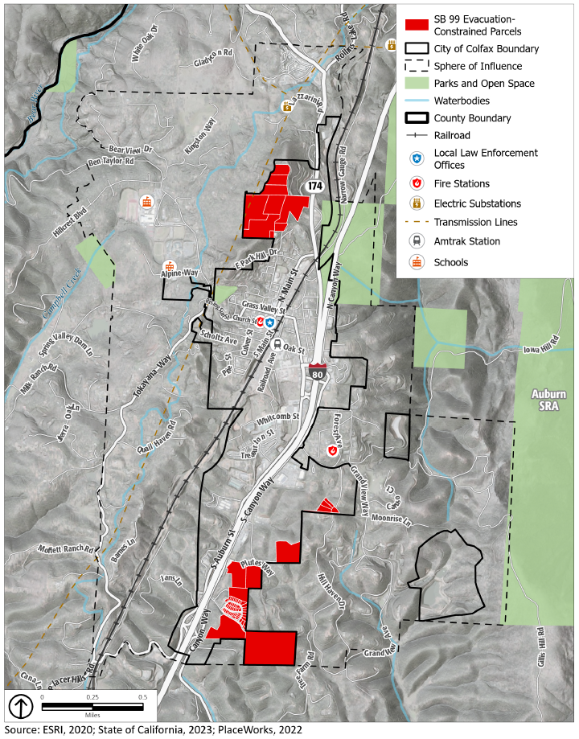
Figure 2
Evacuation Routes
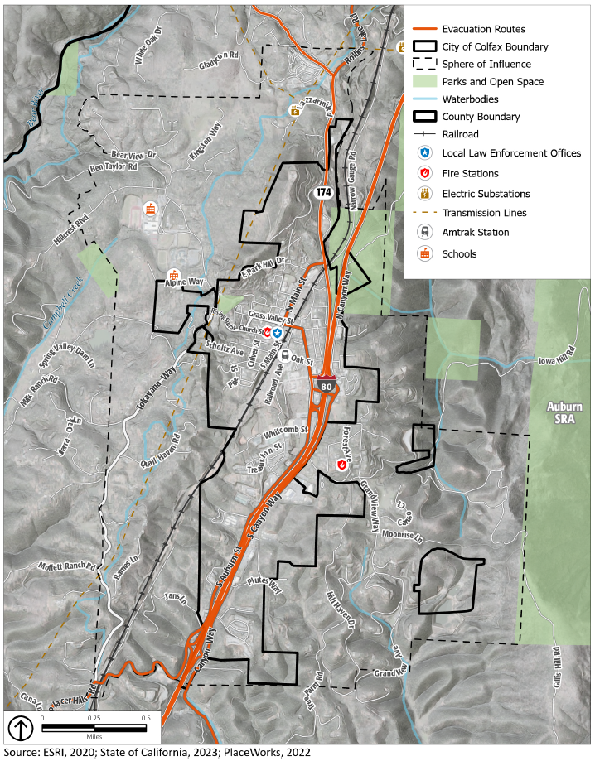

Fire Hazards
Fire hazards can come in the form of both wildfires and urban fires. California is recognized as one of the most fire-prone and consequently fire-adapted landscapes in the world. The combination of complex terrain, Mediterranean climate, and productive natural plant communities, along with ample natural ignition sources, has created conditions for extensive wildfires. Wildfire is an ongoing concern for communities in Placer County. Generally, the fire season extends from early spring through late fall of each year during the hotter, dryer months. Fire conditions arise from a combination of high temperatures, low moisture content in the air and fuel, an accumulation of vegetation, and high winds.
Three types of fires are of concern to the City of Colfax: (1) wildfires, (2) wildland-urban interface (WUI) fires, and (3) to a lesser extent, structural fires.

Wildfires
Wildfires occur on mountains, hillsides, and grasslands. Vegetation, wind, temperature, humidity, and slope are all factors that affect how these fires spread. In Colfax, native vegetation, such as chaparral, oak woodlands, and grasslands provide fuel that allows fire to spread easily across large tracts of land. These plant species are capable of regeneration after a fire, making periodic wildfires a natural part of the ecology of these areas. The climate of the Colfax region keeps the grass dry and more readily combustible during fire season. Steep slopes bring grass and brush within reach of upward flames while impeding the access of fire-fighting equipment. Seasonal drought conditions exacerbate fire hazards.
Because areas of the city with natural vegetation are extremely flammable during late summer and fall, wildfire is a serious hazard in undeveloped areas. Grassland fires are easily ignited, particularly in dry seasons. These fires are relatively easily controlled if they can be reached by fire equipment, although after a fire, the burned slopes are highly subject to erosion and gullying. While brush-lands are naturally adapted to frequent small fires, fire protection in recent decades has resulted in heavy fuel accumulation on the ground. Brush fires, particularly near the end of the dry season, tend to burn fast and very hot, threatening homes and leading to serious destruction of vegetative cover. A brush fire that spreads to a woodland can generate a destructive crown fire, which burns materials at the top of trees and jumps from treetop to treetop. Crown fires can be very intense and difficult to contain.
Many species of oaks are tolerant to fire and are known to be part of California’s fire-dependent ecosystem. In general, oak woodlands are well adapted to periodic fire in the landscape. However, fire suppression in the 20th century led to the buildup of a dense understory of conifers, hardwoods, and shrubs in woodlands throughout the region. The buildup of dense understories and the higher density of small trees, especially conifers, enhance the risk of high-severity fires under hot, dry, and windy conditions. The combustibility of the fuel depends on its moisture content, physical structure, and chemical content. The drier the fuel, the more flammable it will be. Regardless, all vegetation in the region reaches some degree of combustibility during the dry summer months and, under certain conditions, during the winter months.
In addition, tree mortality due to drought and sudden oak death have increased densities of dead fuels and likely contributed to higher fire risk. Under moderate drought conditions, oak woodlands generally present low fire risk, and treatments that remove understory fuels further reduce risk of high-severity fire. High-intensity fires increase the likelihood of a fire growing and spreading quickly. Furthermore, production of burning embers carried through the wind can lead to spot fires beyond the immediate perimeter, and these are often the primary cause of ignition for structures. In Colfax, an oak woodland wildfire has the potential to spread rapidly and may be very difficult to contain due to the community’s topography, fuel load, and climatic conditions during the summer and fall.

Wildfire Smoke
Increasing local and regional fire frequency can create recurring air quality degradation events, leading to respiratory health effects. Wildfire smoke consists of a mix of gases and fine particulate matter from burning vegetation and materials. The pollutant of most concern from wildfire smoke is fine particulate matter (PM_{2.5}). PM_{2.5} from wildfire smoke is damaging to human health due to its ability to deeply penetrate lung tissue and affect the heart and circulatory system. Although wildfire smoke presents a health risk to everyone, sensitive groups may experience more severe acute and chronic symptoms from exposure to wildfire smoke, such as children, older adults, people with chronic respiratory or cardiovascular disease, or people with low socioeconomic status.

Wildland-Urban Interface Fires
The wildland-urban interface is an area where buildings and infrastructure (e.g., cell towers, schools, water supply facilities) are in or adjacent to areas prone to wildfire. Wildfires and urban interface fires have occurred close to or encroached into the city, especially in the heavily fueled areas. The WUI is composed of both interface and intermix communities. The distinction between these is based on the characteristics and distribution of houses and wildland vegetation across the landscape. Intermix WUI refers to areas where housing and wildland vegetation intermingle, and interface WUI refers to areas where housing is in the vicinity of a large area of dense wildland vegetation. The influence WUI zone refers to an area consisting of wildfire-susceptible vegetation up to 1.5 miles from the WUI. According to a publication in the International Journal of Wildfire, 50 percent of all buildings destroyed by wildfires in California are in the interface WUI, compared to 32 percent in the intermix WUI. And wildfires destroyed an average of 15.6 percent of all buildings in the interface WUI compared to 11 to 14 percent of all buildings in other zones. The results demonstrated that the interface WUI is where most buildings were destroyed in California, despite less wildland fuel. Humans are the leading cause of wildland fires, and with thousands of people living near and visiting wildland areas, the frequency of human-caused fires is growing.
In the wildland-urban interface, efforts to prevent ignitions and limit wildfire losses hinge on hardening structures and creating defensible space through a multi-faceted approach, which includes engineering, enforcement, education, emergency response, and economic incentive. Different strategies in the defense and threat zones of the WUI help to limit the spread of fire and reduce the risk to people and property.
Wildfire is a constant threat to the City of Colfax. Wildfire and wildland-urban interface fires occur relatively frequently. The entire city and surrounding areas are at a very high threat of wildfire.

Structural Fires
Colfax is also at risk from structural fires. These fires occur in built-up environments, destroying buildings and other human-made structures. These disasters are often due to faulty wiring or mechanical equipment, combustible construction materials. The absence of fire alarms and sprinkler systems often exacerbate the damages associated with a structural fire. Structural fires are largely from human accidents, although deliberate fires (arson) may be a cause of some events. Older buildings that lack modern fire safety features may face greater risk of damage from fires. To minimize fire damage and loss, the City’s Fire Code, based on the State Fire Code, sets standards for building and construction. They require the provision of adequate water supply for firefighting, fire retardant construction, and minimum street widths, among other things.

Fire Hazard Severity Zones
CAL FIRE establishes Fire Hazard Severity Zones (FHSZ), designating each as moderate, high, or very high severity. CAL FIRE is required to identify all areas in the State that are moderate, high, and very high which includes local responsibility areas (LRA). Incorporated areas, such as Colfax, are considered LRAs. CAL FIRE only designates very high fire hazard severity zones within LRAs. In unincorporated areas where state agencies provide fire protection services (known as State Responsibility Areas or SRAs), the state has identified moderate, high, and very high FHSZs.

State Responsibility Areas
SRAs are areas where CAL FIRE has responsibility for wildfire protection. SRAs are generally unincorporated areas that are not federally owned, are undeveloped, and are covered by wildland vegetation or rangeland. Most of the land around Colfax city limits is an SRA.

Local Responsibility Areas
LRAs are areas protected by local agencies, including city and county fire departments, local fire protection districts, and CAL FIRE when under contract to local governments. Most land in the City of Colfax is an LRA.
Areas of wildland/urban interface, where high-value structures such as homes meet highly flammable native vegetation, are more vulnerable and, as a result of serious wildland fires throughout the state in recent years, are more stringently subject to fire-prevention regulations on development.
Residential development in the WUI, the introduction and proliferation of exotic species, accumulated fuel because of the exclusion of naturally occurring fire, and climate-change-driven compression of the historical rainy season exacerbate the fire problem. Taken together, these factors result in more people, property, critical infrastructure, and natural resources in harm’s way on a more frequent basis. Though large-scale wildfires do not occur every year, wildfire incidents driven by extreme weather conditions have repeatedly been difficult to contain.
A combination of factors, including weather, topography, and vegetation, put Colfax, including both the high FHSZ and the WUI, at a high risk. Figure 3 shows the wildfire hazard severity zones in and around Colfax, Figure 4 shows the parcels in the very high severity zones, and Figure 5 identifies the WUI. CAL FIRE periodically reviews and revises the FHSZ boundaries based on updated modeling and scientific information. Users should consult the most recent available mapping, available from CAL FIRE’s Fire and Resource Assessment Program (FRAP) at https://frap.fire.ca.gov/. Future updates to this Safety Element will incorporate new mapping data as it becomes available.

Federal Responsibility Areas
FRAs are areas that are managed by a federal agency, including the USFS, the U.S. Fish and Wildlife Service, and the Bureau of Land Management. The federally-owned open space along the American River is an FRA.

Figure 3
Fire Hazard Severity Zones
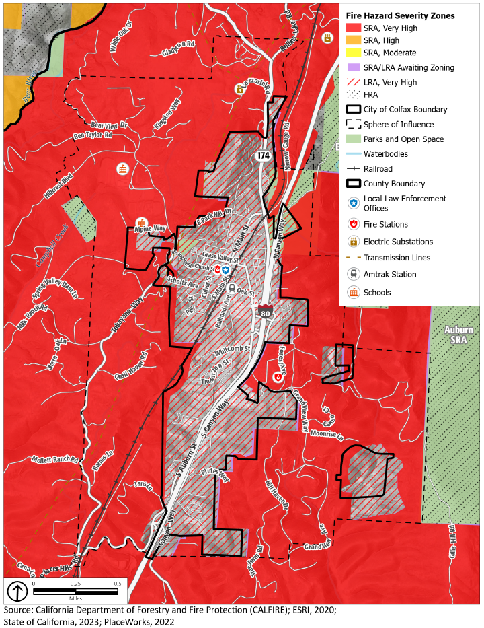
Figure 4
Parcels in Very High Fire Hazard Severity Zones
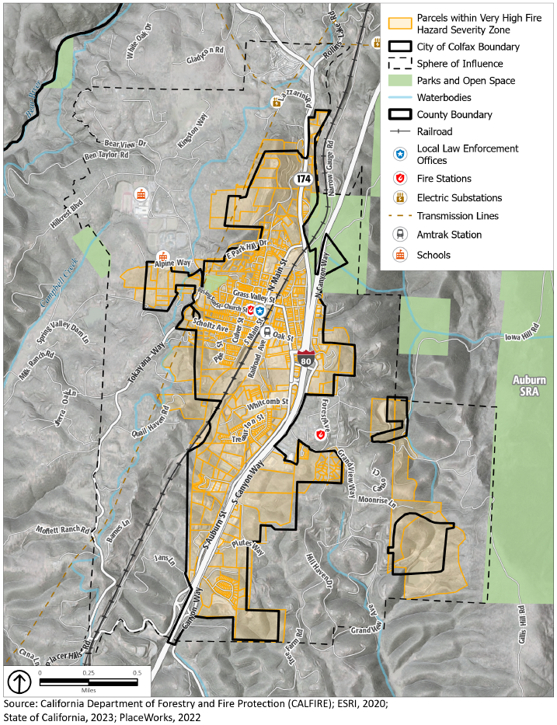
Figure 5
Wildland-Urban Interface Zones
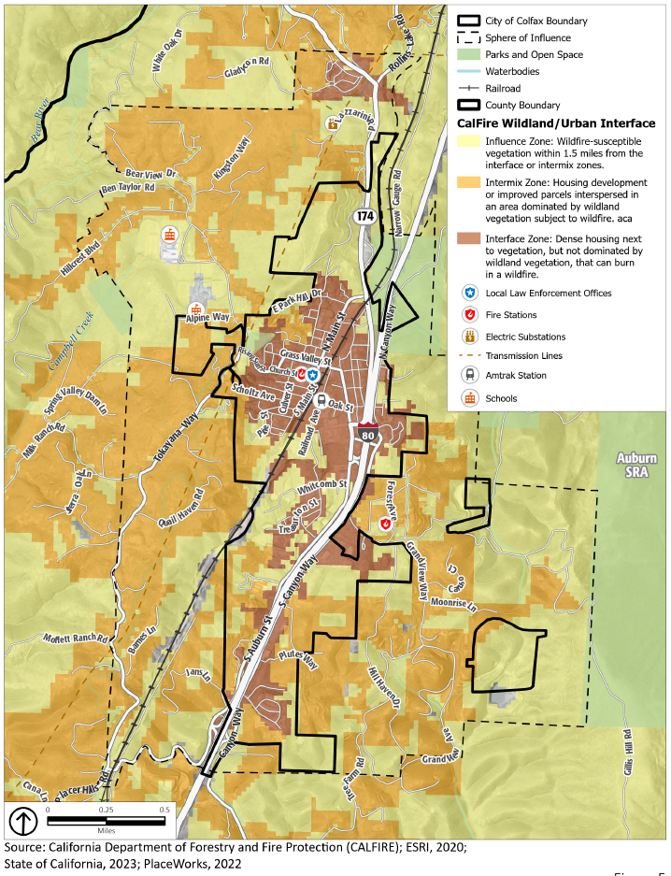
Analysis results for the City of Colfax are summarized in Table 1, including total parcel counts, improved parcel counts, and their improved and land values by property use.
Table 1
Count and Value of Parcels by Fire Severity Zone
Total Parcel Count | Improved parcel Count | Total Land Value | Improved Structure Value | Estimated Contents Value | Total Value
Very High Fire Severity
988 | 711 | $64,997,967 | $ 152,168,583 | $104,699,837 | $321,866,387
High Fire Severity
0 | 0 | $0 | $0 |  | $0
Moderate Fire Severity
0 | 0 | $0 | $0 |  | $0
Urbanized Un-zoned Fire Severity
0 | 0 | $0 | $0 |  | $0
Non-Wildland/Non-Urban Fire Severity
0 | 0 | $0 | $0 |  | $0
None Assigned
0 | 0 | $0 | $0 |  | $0
Total
988 | 711 | $64,997,967 | $ 152,168,583 | $104,699,837 | $321,866,387
Source: Placer County 2021 Local Hazard Mitigation Plan (LHMP)

Past Occurrences
There is no record of historical fires within the Colfax city limits. However, seven historical fires have occurred near the city. In 1975 and 1977, the Sawmill Fire and another fire occurred three miles north of Colfax. In 2001, the Narrow Gauge Fire burned 30 acres. Notably, in 2004, the Stevens Fire threatened the city and burned 934 acres. In recent years, the River Fire, Bear Fire, Oak Fire, and Mosquito Fire occurred near the City of Colfax. Figure 6 shows the areas burned by historic wildfires in and around Colfax dating back to 1975.
1975/1977 Sawmill Fire – The Sawmill Fire and another fire occurred in the area of Cape Horn and the Alpine Meadows subdivision, just three miles northeast of Colfax.
1990 Placer County Fire² – This fire burned approximately 300 acres of grass, brush, and oaks in the area of Placer Canyon. The fire resulted in evacuations and destroyed several outbuildings.
2000 Heather Glen Fire² – The Heather Glen Fire, caused by sparks from a lost trailer wheel along Interstate (I-) 80, destroyed one home and forced a neighborhood evacuation in Applegate. While only 10 acres in size, this fire resulted in $350,000 in damage.
2000 American Fire – The American Fire occurred below the City of Auburn in what is now known as “China Bar” on the American River. The fire consumed approximately 200 acres and posed a threat to development in the southern portion of Auburn. No structures losses or structure damaged was reported in this incident.
August 12-20, 2001, Narrow Gauge Fire² – This fire near Colfax burned 30 acres and forced closure of I-80 for about an hour due to dense smoke. This fire, blamed on a catalytic converter, was quickly contained as CAL FIRE air tankers were already in the area and able to respond quickly.
2002 Sierra Fire – Within the communities of Loomis and Granite Bay, approximately 595 acres of grass, brush, and oaks burned in the area of I-80, Barton Road, Wells Avenue, Morgan Place, Indian Springs, and Cavitt-Stallman Road. The fire destroyed six structures and threatened two schools.
2004 Stevens Fire – The Stevens Fire, located at Cape Horn/Iowa Hill near Colfax, was 100 percent contained at 934 acres.
2007 Ralston Fire – The Ralston Fire was a large wildfire in the area of the North Fork of the Middle Fork of the American River. Approximately 8,400 acres burned.
June-July 2008 American River Complex Fire – Several large wildfires resulted from a system of major lightning storms that impacted the entire Northern California region. In Placer County, approximately 10 wildfires resulted from the lightning storm, and four grew to major fires, which later were collectively labeled the American River Complex (ARC) fires. The ARC fires were in Tahoe National Forest in the North Fork American River watershed northeast of Foresthill, California. The fires consumed approximately 20,500 acres of forest land.
September 2008 Gladding Fire – The wind-driven fire started northeast of Lincoln and consumed approximately 960 acres, 6 residences, and 10 outbuildings.
September 2009 49 Fire – The wind-driven fire started about 2 pm near Highway 49 and Rock Creek Road near Auburn. The fire burned 343 acres before being contained. Sixty-three residences and three commercial buildings were destroyed, and another three residences and six commercial properties were severely damaged. The damages were concentrated in neighborhoods east and south of Dry Creek Road. Three people were injured in the wildfire. Most notable about this fire was its location in a well-developed area and the speed at which the fire consumed nearby structures.
2012 Robbers Fire – The Robbers Fire was a human-caused fire that was ignited on July 11, 2012. The fire was located northwest of Foresthill, near Shirttail Canyon Road and Yankee Jims Road. The fire burned 2,650 acres, destroyed one residence and four outbuildings, and caused 12 injuries. 912 fire personnel were involved in the firefighting efforts. A 28-year-old Sacramento man was charged with unlawfully causing a fire. Firefighting costs and damages were estimated at $12.4 million.
2013 American Fire – On August 10, 2013, the American Fire was ignited near Deadwood Ridge, northeast of Foresthill. Located in Tahoe National Forest, the American Fire burned in steep and hazardous terrain as well as timber fuels that had not burned in several decades. Consumption of heavy fuels contributed to heavy smoke in the surrounding areas. Approximately 540 Forest Service and CAL FIRE personnel were assigned to the fire, which burned 27,440 acres.
2014 Iowa Hill Fire – On July 22, 2014, the Iowa Fire ignited near Iowa Hill Road south of Colfax, burning approximately 14 acres. The fire was contained within one day and no death or injuries were reported.
2014 King Fire – Hazard Mitigation Planning Committee representatives from Placer Hills and Foresthill Fire Protection Districts noted damaging wildfires that occurred in the Foresthill and Applegate areas during the winter of 2014. Specific information on this can be found in their respective annexes to this plan. The fire started in El Dorado County and crossed into Placer County. An estimated 97,717 acres burned, 12 residences were destroyed, along with 68 other minor structures. Twelve injuries occurred that can be attributed to the fire.
2014 Applegate Fire – A fire occurred on the east side of I-80 in the Applegate area of Placer County. The fire started on October 8, 2014, and its cause was unknown. The fire burned 459 acres before containment. Six residences and four outbuildings were destroyed. Two injuries were reported; however, no deaths were reported.
2021 River Fire – The River Fire burned 2,619 acres in the Colfax area in Nevada County. The fire was first reported on August 4, 2021, and was fully contained on August 13, 2021. The River Fire destroyed 142 structures, damaged 21 structures, and resulted in four injuries to firefighters and civilians. It was the fifth most destructive fire of 2021 in California. The cause of the fire is unknown, however CAL FIRE officials stated after an investigation that it had been determined to be of human cause, originating in the overnight camping area of Bear River Campground west of Colfax.
2022 Bear Fire – On July 28, 2022, the Bear Fire ignited in the Bear River drainage area near the Bear River Bridge and Highway 174. The fire burned 9.7 acres which briefly caused evacuation warnings in the area of Gladycon Road and Highway 174 outside of Colfax. The fire was contained within one day and no death or injuries were reported.
2022 Oak Fire – On August 15, 2022, the Oak Fire was ignited near Weimar, along Live Oak Road & Smothers Ravine Road. The fire burned 22 acres total. The Oak Fire was contained 16 days later on August 31, 2022. The cause of the fire remains under investigation. No deaths were reported, and no structures were damaged or destroyed.
2022 Mosquito Fire – On September 6, 2022, the Mosquito Fire was ignited near Mosquito Road and Oxbow Reservoir, approximately four miles east of Foresthill. The fire encompassed the Tahoe and Eldorado National Forests in Placer and El Dorado counties, respectively. The fire burned 76,788 acres total. The Mosquito Fire was contained 50 days later on October 27, 2022. The cause of the fire remains under investigation. No deaths were reported as a result of the Mosquito Fire, but at least two firefighter injuries were noted. Additionally, at least 78 structures were destroyed and 13 damaged.

Potential Changes to Fire Risk in Future Years

Likelihood of Future Occurrence
The wildfire season in Placer County historically lasts from May through October. Extreme weather conditions during periods of low humidity, low fuel moisture, and high winds also contribute to the severity of any potential wildfires. Extreme weather conditions during periods of low humidity, low fuel moisture, and high winds also contribute to the severity of any potential wildfires. Fires that start during these times typically burn hot and fast and are difficult to control without immediate initial suppression. According to the California Governor’s Office of Emergency Services, the wildfire recurrence rate in Colfax is approximately five years. The threat of wildfire and potential losses are constantly increasing as human development and population increase and the wildland-urban interface areas expand. Due to its high fuel load and long, dry summers, most of Placer County continues to be at risk from wildfire, and smoke impacts from local and regional wildfires are likely to remain problematic. The likelihood of structural fires in the city is low since these fires are usually associated with human accidents or mechanical issues in buildings that rarely happen.

Shifts in Climate Norms and Wildfire
Changing climate conditions are expected to increase the wildfire risk in and around Colfax. Warmer temperatures brought on by shifts in climate conditions can exacerbate drought conditions. Droughts can kill or dry out plants, creating more fuel for wildfires. Warmer temperatures are also expected to increase the number of pest outbreaks, such as the western pine beetle, creating more dead trees and increasing the fuel load. Hot, dry spells may also increase disease and insect infestations, resulting in higher fuel loads. Increased winds may result in more erratic fire behavior, making fires harder to contain. Warmer temperatures are also expected to occur later in the year, extending the wildfire season, which is likely to begin earlier in the year and extend later than it has historically.

Figure 6
Colfax Wildfire History
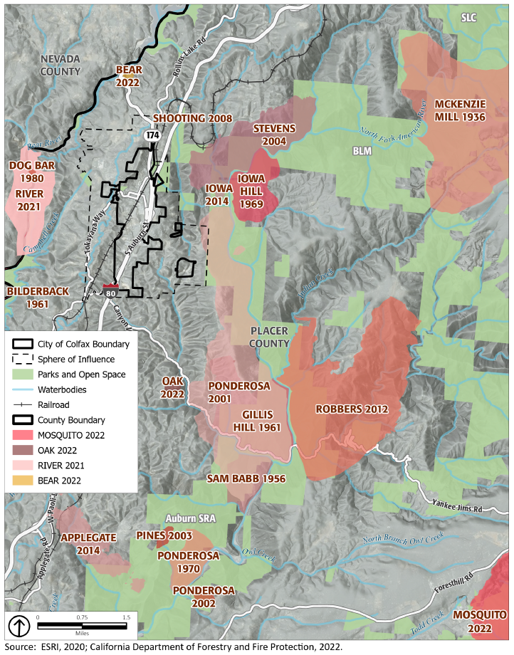

Seismic and Geologic Hazards
Seismic and geologic hazards are risks caused by the movement of different parts of the Earth’s crust, or surface. Seismic hazards are the hazards associated with potential earthquakes in a particular area. Geologic hazards are other hazards involving land movements that are not linked to seismic activity and are capable of inflicting harm to people or property.

Seismic Hazards
The City of Colfax is in a seismically active region, and there is a high potential that the area will be subject to at least moderate earthquakes one or more times over the next century. Seismic activity occurs along boundaries in the Earth’s crust, called faults. Pressure along the faults builds over time and is ultimately released, resulting in ground shaking that we refer to as an earthquake. Earthquakes can also trigger other hazards, including surface rupture (cracks in the ground surface), liquefaction (causing loose soil to lose its strength), landslides, and subsidence (sinking of the ground surface). Earthquakes and other seismic hazards often damage or destroy property and public infrastructure, including utility lines, and falling objects or structures pose a risk of injury or death.

Earthquakes
Active and potentially active faults pose risk to the City of Colfax. Active faults have experienced displacement in historic time, suggesting that future displacement may be expected, whereas potentially active faults are those that have shown displacement within the last 1.6 million years and may or may not have a reasonable chance of creating future earthquakes.
- Structures most likely to be affected are those that are old or near earthquake faults, such as the Bear Mountain Fault and Melones Fault. These faults are situated approximately three to four miles west and east from Colfax, respectively. These faults would have the greatest potential for damaging buildings in Colfax, especially the unreinforced masonry structures in the older part of the city and structures built before 1960 without adequate anchorage of framing and foundations.
- The closest identified active fault is the Cleveland Hills fault, approximately 20 miles northwesterly of Colfax. This fault is considered one of the most active in the area in terms of destructive potential and was the source of a strong earthquake in 1975 around the City of Oroville.
- Another potential earthquake source is the Midland Fault Zone to the west, where an 1892 earthquake centered between Vacaville and Winters caused minor damage in nearby Lincoln.
- Active faults located between 50 and 100 miles from Colfax include the Mohawk Valley Fault, the Stampede Valley Fault, and the Fort Sage Fault; all located northeast of Colfax. Given the relationship to these various active faults, there is a high potential that the area will be subject to at least moderate earthquake shaking one or more times over the next century.
Additionally, Colfax may experience minor ground shaking from distant major to great earthquakes on faults to the west and east. For example, to the west, both the San Andreas Fault (source of the 8.0-estimated Richter magnitude San Francisco earthquake that damaged Sacramento in 1906) and the closer Hayward Fault have the potential for experiencing major to great events. To the east in Nevada, the several faults associated with the series of earthquakes in 1954, especially the major (7.1 Richter magnitude) December 16, 1954, Fairview Peak event (about 100 miles east of Carson City) could cause minor ground shaking in Colfax. The San Andreas Fault near San Francisco and the Hayward Fault in the East Bay area are 116 and 110 miles, respectively, from Colfax.
Figure 7 shows the fault lines in and around Colfax.
Figure 7
Fault Lines
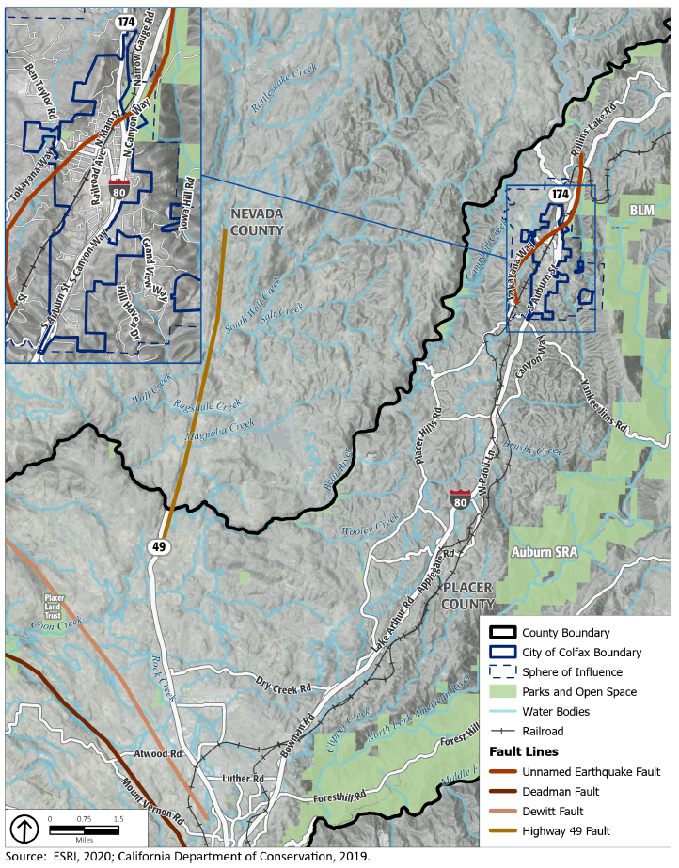
In case of a major earthquake in the region, critical damage may occur to public and private buildings, homes, and structures, including those that provide emergency services (hospitals, fire stations, schools, emergency shelters) and essential services and infrastructure such as roads and utility lines for water, gas, power, telephone, sewer, and storm drainage. Access and continuity of services may be disjointed, and services could be offline for extended periods. Damage to essential and critical structures require special attention in the public safety programs of the city. Damage to the following infrastructure systems could occur, in addition to the damage to public and private buildings:
- Unreinforced masonry buildings: Unreinforced masonry buildings are vulnerable structures that may be subject to damage or collapse because of an earthquake.
- I-80: There are several overpasses on I-80 that could possibly be threatened in the event of a severe earthquake, greater than those previously experienced. Under such a scenario, the County would be virtually cut in half between the eastern and western portions. Similar conditions have resulted from past winter storms requiring limited emergency measures.
- Train derailments: Union Pacific Railroad tracks run adjacent to I-80. Passenger trains run between Sacramento and Reno through the I-80 corridor. A derailment in the higher elevations would pose logistics problems involved in freeing passengers, especially those caught in snowsheds during winter months. A derailment resulting from an earthquake could also cause a hazardous materials release.
- Telephone communications: Telephone communications could be adversely affected due to overloading resulting from post-earthquake calls within the area and from outside, and the electronics needed to support communication systems could be damaged. The situation could be further complicated by physical damage to equipment due to ground shaking, loss of services due to loss of electrical power, and lack of access to maintain auxiliary power and the subsequent failure of some power sources.
- Propane: Properties in Colfax rely on propane for fuel. Earthquakes could cause damage to propane tanks by knocking them off their foundations, posing potential fire hazards.

Geologic Hazards
Geologic hazards, such as landslides, depend on the geologic composition of the area. Landslides and rock falls may occur in sloped areas, especially areas with steep slopes, and usually in areas of loose and fragmented soil. Landslides, rockfalls, and debris flows occur continuously on all slopes; some processes act very slowly, but others happen very suddenly, often with disastrous results. There are predictable relationships between local geology and landslides, rockfalls, and debris flows. Slope stability is dependent on many factors and interrelationships, including rock type, pore water pressure, slope steepness, and natural or human-made undercutting.
Landslides are often triggered by other natural hazards, such as earthquakes, heavy rain, floods, or wildfires, so landslide frequency is often related to the frequency of these other hazards. In Placer County, landslides typically occur during and after severe storms, so the potential for landslides largely coincides with the potential for sequential severe storms that saturate steep, vulnerable soils. In Placer County, landslides and mudslides are a common occurrence and have caused damage to homes, public facilities, roads, parks, and sewer lines in particular.
In Colfax, consolidated rocks make up the mountains and rocky buttes while alluvial soils are found on stream beds and the valley floor. Beneath the alluvial soils are the same hard rocks found in the mountain areas. Geologic hazards are present in the form of unstable soils and certain ground formations that render some areas unsuitable for intensive human activity. Colfax has steep and unstable slopes with areas subject to erosion and landslides. Increased excavation on these slopes can expose more weaknesses of the underlying rock mass, creating a greater potential for failure. Lands around major fault zones are exposed to greater geologic hazards as a result of repeated fault movement, which creates looser ground material that is more likely to move. The area around Colfax also includes highly expansive soils, which can shrink and swell as ground moisture levels change.
Figure 8 shows the landslide risk in and around Colfax. Rock Strength and slope are combined to create classes of landslide susceptibility which range from 0 to X (i.e., very low to very high). These classes express the generalization that on very low slopes, landslide susceptibility is low even in weak materials, and that landslide susceptibility increases with slope and in weaker rocks. Very high landslide susceptibility, classes VIII, IX, and X, includes very steep slopes in hard rocks and moderate to very steep slopes in weak rocks.

Potential Changes to Geologic and Seismic Risk in Future Years

Likelihood of Future Occurrence

Seismic Risk
Earthquakes are likely to continue to occur on an occasional basis. Most earthquakes are likely to be small. They may cause no substantive damage and may not even be felt by most people. Major earthquakes are rare, but a possibility in the region. If serious shaking does occur, newer construction is in general more earthquake resistant than older construction because of improved building codes. Manufactured housing is very susceptible to damage because their foundation systems are rarely braced for earthquake motions.
Earthquake losses would vary across Placer County depending on the source and magnitude of the event. Although new growth and development corridors would fall in the area affected by earthquake, given the small chance of major earthquake and the building codes in effect, development in the earthquake area would continue to occur.

Geologic Risk
Minor landslides and similar geologic hazards have occurred in the past, probably over the last several hundred years, as evidenced both by past deposits exposed in erosion gullies and recent landslide events. With significant rainfall, additional failures are likely to occur within the identified landslide hazard areas. Given the nature of localized problems identified within the county, minor landslides will likely continue to impact the area when heavy precipitation occurs, as they have in the past. In addition, areas affected by recent fires show an increased area of landslide risk.

Shifts in Climate Norms and Geologic and Seismic Hazards
While shifts in climate conditions are unlikely to increase earthquake frequency or strength, the threats from seismic and geologic hazards are expected to continue. Changes to climate conditions may result in precipitation extremes (i.e., wetter wet periods and drier dry periods). Total average annual rainfall may not change significantly, but rainfall may be concentrated into more-intense precipitation events. Heavy rainfall or snowfall could cause an increase in the number of landslides or make landslides larger than normal. Increased wildfire frequency can destabilize hillsides, due to loss of vegetation, and change soil composition, which can contribute to greater runoff and erosion. The combination of a generally drier climate in the future, which will increase the chance of drought and wildfires, and the occasional extreme downpour is likely to cause more mudslides and landslides. Impacts from these conditions would compound landslide potential for the most susceptible locations.

Figure 8
Landslide Risk
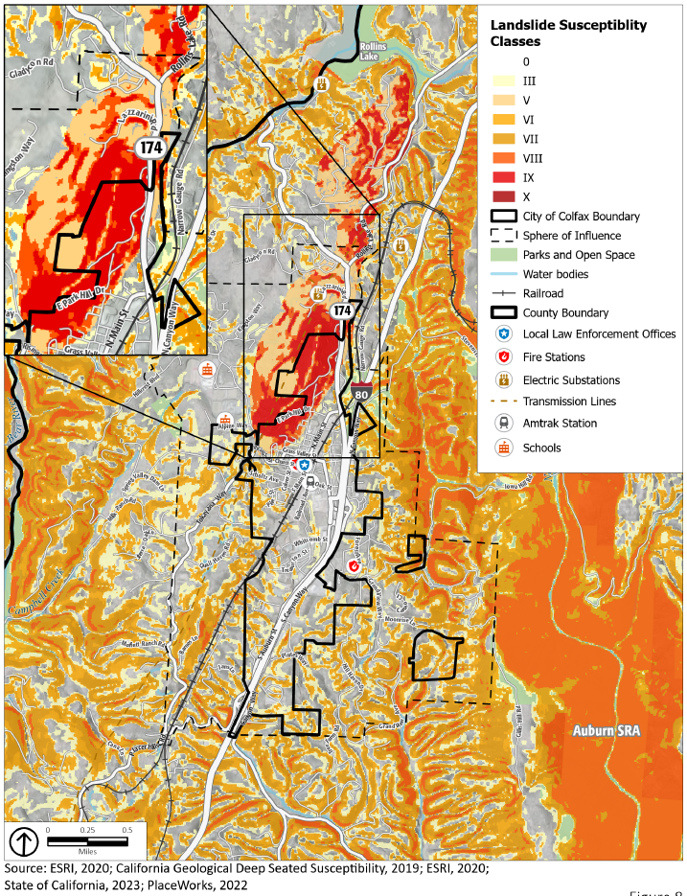

Hazardous Waste and Materials
Hazardous materials pose a significant risk to public safety or human or environmental health. These include toxic chemicals, flammable or corrosive materials, petroleum products, and unstable or dangerously reactive materials. They can be released through human error, malfunctioning or broken equipment, or as an indirect consequence of other emergencies (e.g., if a flood damages a hazardous material storage tank). Hazardous materials can also be released accidentally during transportation, as a consequence of vehicle accidents and train derailment.
Most hazardous materials in the community are transported on truck routes along major roadways that pass through Colfax, such as I-80. The bulk of truck-carried hazardous materials that enter the county do so via I-80. The cargos consist of a wide range of hazardous substances. Although I-80 is well maintained and a controlled access roadway, there are some steep and sharp turns that severely tax the brakes and handling ability of semi-trailer trucks.
In addition to highway traffic, other hazardous materials are transported through Colfax on the Union Pacific Railroad. Hazardous materials are regularly shipped via the rail line and, while unlikely based on past occurrences, an incident involving a rail accident within the city could have devastating effects. The City has little control over the types of materials that are shipped via the rail line. With regard to government activities, the content of shipments may be confidential for reasons of security and/or is generally unknown to the City. While the City has little influence over the types of material transported via the rail line, the potential for rail incidents can be reduced by ensuring that at-grade crossings within the city are operating in a safe and effective manner. In the event of an emergency involving hazardous materials, there is potential for extreme risk to life and property.
Federal, State, and local laws regulate the production, storage, handling, and disposal of hazardous materials and waste. These are materials that pose a significant hazard to human health and safety or to the environment, including industrial wastes, pesticides, radioactive wastes, asbestos, and combustible fuels. Hazardous materials commonly used in the home include garden pesticides, waste oil, paint supplies, car batteries, and pool chemicals. Limited quantities of household hazardous waste may be transported to and dropped off at a recycling center.
Both the State and the federal government require businesses that store or handle hazardous materials to comply with inventory and reporting programs. Businesses that store more than 55 gallons of hazardous liquids, 500 pounds of solids, or 200 cubic feet of compressed gases must also file an annual business plan to establish incident prevention measures, hazardous-materials handling protocols, and emergency response and evacuation procedures.
Hazardous materials and waste within Colfax are managed by the Certified Unified Program Agency (CUPA), a local administrative agency within the Placer County Environmental Division of Environmental Health. The CUPA consolidates, coordinates, and makes consistent the regulatory activities of several hazardous materials and hazardous waste programs, including Hazardous Materials Management, California Accidental Release Prevention, Hazardous Waste Management, Underground Storage Tanks, Aboveground Storage Tanks, and Emergency Response.
Several state agencies monitor hazardous materials/waste facilities. Potential and known contamination sites are monitored and documented by the Department of Health Services (DHS) and the Regional Water Quality Control Board (RWQCB). A review of the leaking underground storage tank list produced by the RWQCB, and the Hazardous Waste and Substances Sites List produced by the Office of Planning and Research indicates no hazardous waste sites in Colfax.
If a hazardous material spill poses an imminent public health threat, the City will support local regulating agencies in notifying the public. The transport of hazardous materials/wastes and explosives through the planning area is regulated by the California Department of Transportation (Caltrans). Transporters of hazardous wastes are required to be certified by the United States Department of Transportation, and manifests are required to track the hazardous waste during transport. The danger of hazardous materials/waste spills during transport does exist and will potentially increase as transportation of these materials increases on I-80 and the railroad. The Placer County Office of Emergency Services (OES), Placer County Division of Environmental Health, the Placer County Sheriff’s Office, and CAL FIRE are responsible for hazardous materials accidents at all locations within the city.

Potential Changes to Hazardous Materials in Future Years

Likelihood of Future Occurrence
The Union Pacific Railroad line passes through the City of Colfax. Hazardous materials are regularly shipped via the rail line and, while unlikely based on past occurrences, an incident involving a rail accident within the city could have devastating effects.
The City has little control over the types of materials that are shipped via the rail line. With regard to government activities, the content of shipments may be confidential for reasons of security and/or is generally unknown to the City. While the City has little influence over the types of material transported via the rail line, the potential for rail incidents can be reduced by ensuring that at-grade crossings within the city are operating in a safe and effective manner. I-80 passes through the city which is a designated Caltrans haz-mat route. According to Caltrans, most incidents are related to releases of fluids from the transporting vehicles themselves and not the cargo. The likelihood of a significant hazardous materials release within the city from either transportation or stationary sources is considered low, but possible.

Shifts in Climate Norms and Hazardous Materials
Shifts in climate conditions are unlikely to affect hazardous materials transportation incidents. However, increases in the frequency and intensity of severe storms may create a greater risk of hazardous materials releases during these events.

Crime
Crime and other acts of violence undermine the community's sense of security and threaten public safety. As Colfax develops, the increasing concentration of population will bring increasing criminal activities, although not necessarily increasing the crime rate (number of crimes per 1,000 population). While it is expected that individuals will take normal precautions to protect themselves from danger, the City provides additional protection from harm brought on by the malicious intent of others. The Sheriff’s Office plays a significant role in the safety and quality of life within the community. Some of the Police Department’s crime prevention programs include Business Watch, Crime Stoppers, Identify Theft, Chaplaincy, Megan’s Law, National Night Out, and Neighborhood Watch.

Additional Climate-Related Hazards

Drought
A drought is an extended period when precipitation levels are well below normal. Drought is a normal part of the climate cycle. Drought may contribute to wildfire or affect domestic water supply, energy production, public health, and wildlife. Like most of California and the western United States, Colfax chronically experiences drought cycles. Drought impacts the city’s water supply, which may, in severe instances, make less water available for people, businesses, and natural systems.
Less snow falling in mountainous areas causes water levels in lakes and reservoirs to drop, which can affect recreation activities. Local ecosystems that are not well adapted to drought conditions can be more easily harmed by it. During drought events, the flow of water in creeks and streams is reduced, creating more slow-moving or standing water. This can concentrate sediment and toxins in the low water levels, causing harm to plants and animals. Many fish species also prefer specific stream flow speeds, especially for spawning and egg incubation, and changes to stream velocity as a result of drought conditions can affect reproduction. Droughts can also indirectly lead to more wildfires, and the stress caused by water shortages can weaken plants, making them more susceptible to pests and diseases.
The US Drought Monitor recognizes a five-point scale for drought events: D0 (abnormally dry), D1 (moderate drought), D2 (severe drought), D3 (extreme drought), and D4 (exceptional drought). According to the US Drought Monitor, the most intense drought conditions in recent years were during most of 2016, when all of Placer County was classified in “exceptional” drought. More recently, in 2021, from May through the end of the year, the county was also classified in “extreme” drought. As of November 2022, Placer County, including Colfax, was classified in “severe” drought. During severe drought conditions, water shortages are common, and water restrictions may be imposed so as to meet essential community needs.
Domestic water for the City of Colfax is provided by the Placer County Water Agency. The source of water for the City of Colfax is the South Fork of the Yuba River and the Bear River. The water is conveyed from Lake Spaulding via the PG&E Drum Canal, into the Agency’s Boardman Canal, and then in a pipe to the Colfax Water Treatment Plant. Near the City’s ballpark, the Agency has an additional 1.0-million-gallon reservoir.
A multiple year drought can severely compromise the water supply within the district and adversely impact natural resources. In 2014, after 2 years of below-average rainfall and very low snowmelt run off, Governor Brown declared a state of emergency for drought conditions statewide. The final California Department of Water Resources showed snowpack water content at only 5 percent of normal. On October 19, 2021, Governor Newsome declared a drought emergency for the entire state of California. With the unknowns of drought and globally changing climate conditions, the City continues to promote water conservation throughout the community.

Potential Changes to Drought in Future Years

Likelihood of Future Occurrence
Drought is different than many of the other natural hazards in that it is not a distinct event and usually has a slow onset. Drought can severely impact a region both physically and economically, affecting different sectors in different ways and with varying intensities. Adequate water is the most critical issue for commercial and domestic use. As the population in the city continues to grow, so will the demand for water.
Based on historical information, the occurrence of drought in California, including Placer County, is cyclical, driven by weather patterns. Drought has occurred in the past and will occur in the future. Periods of actual drought with adverse impacts can vary in duration, and the period between droughts is often extended. Although an area may be under an extended dry period, determining when it becomes a drought is based on comparing observed precipitation with what is normal (climatologic), comparing soil moisture and crop conditions with what is normal (agricultural), or by looking at how much water is contained in snow, the level or flow rate of moving water, water in reservoirs, or groundwater levels (hydrologic). However, how individuals recognize drought depends on the ways in which it affects them. The impacts from drought include reduction in water supply and an increase in dry fuels.

Shifts in Climate Norms and Drought
Although droughts are a regular feature of California’s climate, scientists expect that climate change will lead to more frequent and intense droughts statewide. Overall, precipitation levels are expected to stay similar and may even increase in some places. However, the state’s current data say that there will be more years with extreme levels of precipitation, both high and low, as a result of climate change. This is expected to cause more frequent and intense droughts, compared to historical norms, that cause soil to dry out and become hard. When precipitation does return, more water runs off the surface than is absorbed into the ground, which can lead to floods. Higher air temperatures are expected to increase evaporation, causing more water loss from lakes and reservoirs and exacerbating drought conditions. Reduced winter precipitation levels and warmer temperatures have greatly decreased the Sierra Nevada snowpack (the volume of accumulated snow), which in turn makes less fresh water available for communities throughout California. Continued decline in the Sierra Nevada snowpack is expected, which may lead to lower volumes of available imported water. Depending on the location and emissions levels, the state Cal-Adapt database indicates the snowpack (i.e., snow water equivalent) for the Tahoe-Sierra Integrated Regional Water Management Region in the spring is expected to decline from a historical average of 16.1 inches to an average of 7.8 inches (a 52 percent decrease) by the middle of the century (2035 to 2064) and an average of 2.9 inches (an 82 percent decrease) by the end of the century (2070 to 2099).
If heat-trapping emissions continue unabated, more precipitation will fall as rain instead of snow, and the snow that does fall will melt earlier, reducing the Sierra Nevada spring snowpack by as much as 70 to 90 percent. How much snowpack will be lost depends in part on future precipitation patterns, the projections for which remain uncertain. However, even under wetter climate projections, the loss of snowpack would pose potential water shortage issues and exacerbate drought conditions.

Extreme Heat
While there is no universal definition of extreme heat, California guidance documents define extreme heat as temperatures that are hotter than 98 percent of the historical high temperatures for the area, as measured between April and October of 1961 to 1990. Days that reach this level are called extreme heat days. In Colfax, the extreme heat threshold is 100.1°F. An event with five extreme heat days in a row is called a heat wave.
In the foothills of Placer County, monthly average maximum temperatures in the warmest months (May through October) range from the mid-70s to the low 90s. From late spring through fall, it is not unusual for temperatures to exceed 90°F and higher. The highest recorded daily extreme was 118°F in August of 1933. In a typical year, maximum temperatures exceed 90°F on 89 days.
Health impacts are the primary concern with this hazard, though economic impacts are also an issue. The Centers for Disease Control and Prevention recognize extreme heat as a substantial public health concern. Historically, National Oceanic and Atmospheric Administration data indicate that about 175 Americans succumb to summer heat, although this number has increased in recent years. From 2004 to 2018, studies by the US Department of Health and Human Services indicate an average of 702 deaths annually that are directly or indirectly linked to extreme heat.
Extreme heat events are dangerous because people exposed to extreme heat can suffer a number of heat-related illnesses, including heat cramps, heat exhaustion, and (most severely) heat stroke. As reflected in the Vulnerability Assessment, elderly persons, small children, chronic invalids, those on certain medications or drugs, and persons with weight and alcohol problems are particularly susceptible to heat reactions. The elderly and individuals below the poverty level are the most vulnerable to extreme heat. Nursing homes and elder-care facilities are especially vulnerable to extreme heat events if power outages occur and air conditioning is not available. Individuals below the poverty level may be at increased risk to extreme heat if air conditioning is not affordable. Areas with lower extreme heat thresholds are not necessarily at lower risk, because persons and community assets used to cooler temperatures may be less prepared for extreme heat events.
Trees and other vegetation in the natural and urban environment help to lower surface and air temperatures by providing shade and through evapotranspiration. Evapotranspiration, alone or in combination with shading, can help reduce peak summer temperatures by 2°F to 9°F..,
Very high temperatures can harm plants and animals that are not well adapted to them, including natural ecosystems. Extreme heat can increase the temperature of water in lakes, streams, creeks, and other water bodies, especially during drought events when water levels are lower. In some cases, water temperatures may exceed comfortable levels for several plants and animals, causing ecological harm. Outdoor workers in construction or landscaping are also much more exposed to the elements than most people, so they are more susceptible to extreme heat conditions and the potential illnesses associated with very high temperatures.
Indirectly, extreme heat puts more stress on power lines, causing them to run less efficiently. The heat also causes more demand for electricity (usually to run air conditioning units), and in combination with the stress on the power lines, may lead to brownouts and blackouts.

Potential Changes to Extreme Heat in Future Years

Likelihood of Future Occurrence
Extreme heat occurs on an annual basis, most commonly at the peak of the summer season. From late spring through fall, days with temperatures exceeding 90°F and higher will increase.

Shifts in Climate Norms and Extreme Heat
The warmer temperatures brought on by shifts in climate conditions are likely to cause an increase in extreme heat events. Depending on the location and emissions levels, the state Cal-Adapt database indicates the number of extreme heat days is expected to rise from a historical annual average of 4 to 26 by the middle of the century (2035 to 2064), and an average of 53 by the end of the century (2070 to 2099), with some years occasionally experiencing much more extreme heat days.
Overall, Colfax is expected to see an increase in the average daily high temperatures. Depending on the future severity of climate change, the state Cal-Adapt database indicates the annual average maximum temperature is expected to increase from a historical annual average of 71.2°F to an average of up to 75.3°F by the middle of the century (2035 to 2064), and an average of up to 76.9°F by the end of the century (2070 to 2099). Although the temperature increases may appear modest, the projected high temperatures are substantially greater than historical norms. These increases also make it more likely that an above-average high temperature will cross the extreme heat threshold. As temperatures increase, Colfax is expected to face increased risk of death from dehydration, heat stroke, heat exhaustion, heart attack, stroke, and respiratory distress caused by extreme heat.

Severe Weather
Severe weather includes strong winds, hail, and lightning. Severe weather is usually caused by intense storm systems, although types of strong winds can occur without a storm. The types of dangers posed by severe weather vary widely and may include injuries or deaths, damage to buildings and structures, fallen trees, roads and railways blocked by debris, and fires sparked by lightning. In Placer County, most severe weather is linked to high winds. Hail events are rare, and there have been no reported injuries from hail in Colfax. Lightning happens occasionally, although there has been no direct injury or damage from lightning reported in Colfax.
According to the Placer County Sustainability Plan, severe winter weather includes heavy snowfall, ice storms, extreme cold, and similar events. In Placer County these events are usually limited to the Sierra Nevada region, although in rare cases severe winter weather can occur at lower elevations, such as the City of Colfax.

Potential Changes to Severe Weather in Future Years

Likelihood of Future Occurrence
According to historical hazard data, severe weather is an annual occurrence in the City of Colfax. Damage and disaster declarations related to severe weather have occurred and will continue to occur in the future. Heavy rain and thunderstorms are the most frequent type of severe weather occurrence in the area. Wind and lightning often accompany these storms and have caused damage in the past and could contribute to future wildfires. Although unlikely, severe winter storms may also bring heavy snowfall to the City of Colfax. In addition to localized flooding issues, the storms can cause several mudslides and lightning can cause many electrical poles to short with a resultant loss of power, hazardous downed lines, and the potential for fire.
Problems associated with the primary effects of severe weather include flooding, pavement deterioration, and debris clogging of drainages and roadways. Areas located on S. Main Street are the areas of the city most often affected during these heavy storm events.

Shifts in Climate Norms and Severe Weather
Shifts in climate norms are expected to cause an increase in intense rainfall, and in some instances snowfall, which is usually associated with strong storm systems. This means that Colfax could see more intense storms in the coming years and decades. Such an increase may not affect all forms of severe weather and may not always be apparent. For example, hail is rare enough in Colfax that even if it does become more common, the increase and any effects may not be apparent. Overall, shifts in climate norms are expected to increase average temperatures, so the total number of days with cooler temperatures is expected to drop. However, a change in global climate conditions may increase the number of severe storms affecting Placer County, including Colfax. These intense storm systems could create severe winter weather conditions in the Sierra Nevada and more severe winter weather events in areas such as Colfax.

Safety Goals, Policies, and Implementation Measures
GOAL 7.1 Protect the life and property of residents, businesses, and visitors to Colfax from natural and human-caused hazards.
Policy 7.1.1 Require a review of all potential hazards in areas identified for development.
Policy 7.1.2 Continue to partner with Placer County and other cities within the county to regularly update and implement the Placer County LHMP.
Policy 7.1.3 Incorporate by reference the current Placer County Local Hazard Mitigation Plan and subsequent local updates into the Safety Element.
Policy 7.1.4 Enhance public education and awareness of natural and climate-related induced hazards and public understanding of disasters.
Policy 7.1.5 Identify and, as feasible, retrofit any City-owned buildings and facilities in areas prone to landslide/debris flows or wildfire to maximize defensible space and outdoor fireproofing, stabilize nearby slopes, and take other actions to harden the property as needed.
Policy 7.1.6 Work with local and regional transportation agencies to help protect primary evacuation routes from being blocked or damaged by a hazard event.
Policy 7.1.7 Provide the public with information on specified emergency evacuation routes.
Policy 7.1.8 Maintain inter-jurisdictional cooperation and coordination, including automatic aid agreements, with fire protection and suppression agencies in Placer County.
Policy 7.1.9 Continue to cooperate with other public agencies to ensure adequate medical and other emergency services needs.
Policy 7.1.10 Design and site critical facilities to minimize potential damage and increase their ability to remain operational during and after hazard events.
Policy 7.1.11 Coordinate with Placer County Fire Department and CAL FIRE to conduct emergency services training in support of appropriate goals and standards for training efforts.
Policy 7.1.12 Work with the County on the next revision to the LHMP to ensure AB 747 requirements are integrated into the next update of the Safety Element. AB 747 requires that safety elements must identify evacuation routes, their capacity, safety, and viability under a range of emergency scenarios.
Policy 7.1.13 Provide information to members of the public about evacuation concerns, including designated evacuation routes and evacuation plan details, through multiple formats and in multiple languages.
Implementation Measures
7.1.A Make information relating to potential hazards on site specific areas in the City available to all City agencies and staff.
7.1.B Continue to work with the County to update the LHMP upon its expiration to ensure that Colfax maintains eligibility for pre-disaster mitigation funding.
7.1.C Review and update as needed the Safety Element at least once every eight years, ideally concurrent with updates to the County’s LHMP or the Colfax Housing Element so that the best available hazard data is concurrently incorporated into the Safety Element. The LHMP, most recently approved by FEMA in June 2021, is incorporated by reference into this Safety Element, as permitted by California Government Code Section 65302.6.
7.1.D Encourage all persons in hazard-prone areas, especially those living in neighborhoods along single-access roads to prepare and keep an emergency and evacuation kit.
7.1.E Create a community support network in partnership with community-based organizations to check on socially vulnerable or isolated persons during dangerous conditions. Similarly, the City will use said network to provide information and services related to hazard mitigation and emergency preparation to persons with limited access to transportation, communication, and other lifeline resources and services.
7.1.F When identifying projects for inclusion in the Capital Improvements Program list, note any potential vulnerabilities to climate-related hazards and ensure that the project maximizes its resilience potential and minimizes any climate vulnerabilities.
7.1.G Provide the public with information and training on what to do until help arrives in emergency situations.
GOAL 7.2 Minimal risk of injuries, loss of life, property damage, and economic and social disruption resulting from seismic and geologic hazards in Colfax.
Policy 7.2.1 Identify opportunities to strengthen or relocate existing weak critical structures and lifeline utilities to increase public safety and minimize or avoid potential damage from seismic and geologic hazards.
Policy 7.2.2 Incorporate resilient design features for roads and trails that are on or below steep slopes and have a history of being damaged or blocked by landslide events.
Policy 7.2.3 Continually identify areas of Colfax susceptible to damage from seismic shaking, liquefaction, subsidence, and other geologic risks.
Policy 7.2.4 Require detailed soils and geologic studies prior to approval for development in potentially hazardous areas. Require mitigation measures if significant hazards are identified.
Policy 7.2.5 Avoid development in areas of steep slope and high erosion potential.
Policy 7.2.6 Encourage upgrading of unreinforced masonry buildings to prevent disastrous earthquake damage.
Implementation Measures
7.2.A Work to stabilize burned slopes located above developed areas, important infrastructure, or key transportation corridors as soon as possible after a wildfire event. The City will cooperate with the Placer County Department of Public Works and/or Caltrans when necessary.
7.2.B Work to make single-access roads and key trails less vulnerable to landslides and mudflows through the use of retaining walls, slope stabilization techniques, and other strategies.
7.2.C Ensure that site development on steep slopes is designed to avoid creating areas that may be subject to slippage or movement from storm events.
7.2.D Continue to implement the California Building Code.
7.2.E Encourage clustering of development away from areas considered geologically unstable.
GOAL 7.3 Minimal risk of injuries, property damage, and economic loss resulting from urban and wildland fires in Colfax.
Policy 7.3.1 Continually identify any areas of likely wildfire risks or urban conflagration in Colfax.
Policy 7.3.2 Prevent fuel accumulation around any City-owned infrastructure where fires are known to occur.
Policy 7.3.3 Maintain an adequate peak load water supply for fire suppression efforts in Colfax.
Policy 7.3.4 Continue to enforce and, as necessary, adopt new development standards to reduce fire hazard risks for new and existing development to minimize property damage and loss of life.
Policy 7.3.5 Continue to work with Placer County, state agencies, and federal agencies to support wildfire fuel management activities in areas devastated by bark beetle and other pests.
Policy 7.3.6 Continue to partner with Placer County and other entities within the County to regularly update and implement the Placer County Community Wildfire Protection Plan (CWPP).
Policy 7.3.7 Promote the use of fire-resistant landscaping in public and private developments.
Policy 7.3.8 Require fire protection plans for all new development projects, including plans for long-term, comprehensive, fuel reduction and management. The main components of a fire protection plan include:
- Risk Analysis
- Fire Response Capabilities
- Fire Safety Requirements – Defensible Space, Infrastructure, and Building Ignition Resistance
- Mitigation Measures and Design Considerations for Non-Conforming Fuel Modification
- Wildfire Education Maintenance and Limitations
Policy 7.3.9 Require review by the Planning Department prior to the issuance of development permits for proposed construction projects and conceptual landscaping plans. Plans for proposed development shall include, at a minimum:
- Site plan, planting plan, planting palette, and irrigation plan to reduce the risk of fire hazards and with consideration to site conditions, including slope, structures, and adjacencies.
- Development and maintenance of defensible space.
- Multiple points of ingress and egress to improve evacuation, emergency response, and fire equipment access, and adequate water infrastructure for water supply and fire flow.
- Class A roof materials for new and replacement roofs.
- Location and source of anticipated water supply.
Policy 7.3.10 Enforce fire-resistant landscaping and defensible space requirements for new residential and commercial development and require development standards that meet or exceed Title 14, CCR, Division 1.5, Chapter 7, Subchapter 2, Articles 1-5 (commencing with section 1270) (SRA Fire Safe Regulations) and Title 14, CCR, Division 1.5, Chapter 7, Subchapter 3, Article 3 (commencing with section 1299.01) (Fire Hazard Reduction Around Buildings and Structures Regulations). All new residential development must comply with California Fire Safe Regulations (Section 1276 of the California Code of Regulations – Title 24, Division 1.5, Chapter 7, Article 5), as well as Chapter 17.122 of the Municipal Code, which requires a landscape design plan for projects in fire-prone areas that addresses fire safety and prevention, as well as defensible space.
Policy 7.3.11 Coordinate with CAL FIRE and Placer County Fire Department to identify and maintain evacuation routes to ensure adequate capacity, safety, and viability of those routes in the event of an emergency.
Policy 7.3.12 Coordinate with CAL FIRE and Placer County Fire Department, fire safe councils, and other agencies to maintain existing fuel breaks and emergency access routes for effective fire suppression.
Policy 7.3.13 Support measures that help firefighting crews and emergency response teams respond to fire hazards or work under low-visibility conditions, such as high-visibility signage for streets and building addresses that meet or exceed the standards in the California Fire Safe Regulations (Sections 1273 and 1274 of the California Code of Regulations – Title 24, Division 1.5, Chapter 7, Articles 2 and 3).
Policy 7.3.14 Ensure that new development be located where fire and emergency services have sufficient capacity to meet project needs or require that they be upgraded to provide necessary capacity as part of the proposed development activities to ensure new development has adequate fire protection.
Policy 7.3.15 Develop and update programs as needed that ensure recovery and redevelopment after a large fire and that reduce future vulnerabilities to fire hazard risks through site preparation, redevelopment layout design, fire-resistant landscape planning, and home hardening building design and materials.
Policy 7.3.16 Provide information to the community about wildland and urban fire hazards, evacuation routes, and ways to minimize damage caused by fires such as through defensible space. The City shall identify and map at-risk populations within the community and prioritize public outreach, as well as fire education and training among these populations.
Policy 7.3.17 Identify existing public and private roadways in fire hazard areas not in compliance with contemporary fire-safe standards, including road standards, vegetation clearance, and other requirements of Sections 1273 and 1274 of the California Code of Regulations to the extent resources are available. Work at retrofitting City-owned roadways as needed to meet current standards and require private property owners to do the same, to the extent feasible and given the absence of other site constraints.
Policy 7.3.18 Require proposed development to provide adequate access for fire and emergency vehicles and equipment that meets or exceeds the standards in the California Fire Safe Regulations (Sections 1273 and 1274 of the California Code of Regulations – Title 24, Division 1.5, Chapter 7, Articles 2 and 3).
Policy 7.3.19 Coordinate with the Placer County Water Agency to maintain an adequate, long-term water supply for fire suppression needs for the community.
Implementation Measures
7.3.A Require each new large-scale development to submit a water usage plan showing that Colfax’s water system can supply the new development with minimum water amounts while maintaining optimal water supply for fire suppression work.
7.3.B Continue to enforce requirements to provide defensible space around homes and other buildings in fire-prone areas, and strengthen standards as needed to provide adequate protection in response to changing fire regimes.
7.3.C Seek to develop a fire-safe assessment to use prior to issuing a building permit or other formal approval for significant retrofits to buildings, including installation of sprinklers and fire-safe exterior materials as feasible.
7.3.D Require new developments to include fuel reduction plans. These plans must include a finance plan, necessary fees for maintenance of fuel break areas, and maintenance requirements in any applicable covenants, conditions, and restrictions.
7.3.E Continue to work with the County to update the CWPP upon its expiration to ensure that Colfax maintains eligibility for pre-disaster mitigation funding and applies mitigation measures to protect the City of Colfax from wildfire.
GOAL 7.4 The city shall work to reduce crime levels in Colfax.
Policy 7.4.1 Work with the Sheriff’s Office to maintain response times sufficient to rapidly respond to 911 calls.
Policy 7.4.2 Ensure that new development projects use environmental design to reduce the risk of crime.
Policy 7.4.3 Promote citizen engagement in crime awareness in existing crime reduction programs.
Implementation Measures
7.4.A Work with the Placer County Sheriff’s Office to address law enforcement personnel needs in Colfax resulting from future population growth.
7.4.B Work with the Placer County Sheriff’s Office to evaluate new project design to reduce the potential for crime. The City and Sheriff’s Office may draft and adopt a set of Crime Prevention Through Environmental Design (CPTED) guidelines for use by project applicants during project design and by City staff during permit and plan review.
7.4.C Coordinate with the Placer County Sheriff’s Office to continue its Citizens Awareness Academy and Neighborhood-Business Watch Program.
GOAL 7.5 Reduced likelihood of hazardous materials release, exposure, and contamination in Colfax.
Policy 7.5.1 Encourage commercial or industrial development using hazardous materials in areas away from residential uses and discourage commercial and industrial development using hazardous materials in areas of identified wildfire risk.
Policy 7.5.2 Collaborate with other cities/towns, Placer County, and regional hazardous waste management organizations to limit the risk of hazardous materials release.
Policy 7.5.3 Reduce the risk of exposure to hazardous materials in Colfax.
GOAL 7.6 City and ecological resiliency to climate-related hazards.
Policy 7.6.1 Encourage collaboration with regional organizations and agencies to increase resilience.
Policy 7.6.2 Work with Placer County Office of Emergency Services to ensure that there are safe places for community members to gather during hazardous events like extreme heat.
Policy 7.6.3 Prepare for a reduced long-term water supply resulting from more frequent and severe drought events, including working with regional water providers to implement extensive water conservation measures and ensure sustainable water supplies, including for fire suppression needs.
Policy 7.6.4 Reduce health and economic risks associated with extreme heat and human health hazards.
Implementation Measures
7.6.A Coordinate climate resiliency efforts with the Capital Region Climate Readiness Collaborative, the Sierra Climate Adaptation and Mitigation Partnership, and other regional bodies.
7.6.B Engage in partnerships and support local and regional interagency efforts to assess climate-related impacts and to develop and implement strategies that increase resilience of vulnerable ecosystems.
7.6.C Work with regional, state, and federal plant and wildlife management agencies and organizations to protect vulnerable habitat and improve ecosystem connectivity.
7.6.D Work to ensure that its facilities used as cooling centers or resilience hubs are equipped with backup power supplies, including on-site renewable energy generation and energy storage systems.
7.6.E Provide shaded areas, air conditioners, and other features at City community centers, parks, and other outdoor spaces that can offer refuge from extreme heat and weather events.
7.6.F Continue to promote water conservation programs to reduce water use in the City of Colfax.
7.6.G Support and cooperate with the Placer County Water Agency during updates to its urban water management plan to support ongoing efforts to plan for sustainable, long-term drinking water supply for City residents and businesses.
7.6.H Encourage projects that include landscaping to use plants that will continue to be viable in the area under long-term future climate conditions.
7.6.I Coordinate with Placer County Public Health Department to ensure that free or reduced-cost vaccinations for vector-borne diseases are widely available for Colfax residents.

GIS data for this historical wildfire event is unavailable and is therefore not displayed in Figure 3. Wildfire History.
Louise Bedsworth, Dan Cayan, Guido Franco, Leah Fisher, and Sonya Ziaja, “Statewide Summary Report,” in California’s Fourth Climate Change Assessment, publication number: SUMCCCA4-2018-013, California Governor’s Office of Planning and Research, Scripps Institution of Oceanography, California Energy Commission, California Public Utilities Commission, 2018.
Kramer, Heather Anu; Mockrin, Miranda H.; Alexandre, Patricia M.; Radeloff, Volker C. 2019. High wildfire damage in interface communities in California. International Journal of Wildland Fire. 28(9): 641-. https://doi.org/10.1071/WF18108.
Huang, J., H. Akbari, and H. Taha. 1990. The Wind-Shielding and Shading Effects of Trees on Residential Heating and Cooling Requirements. ASHRAE Winter Meeting, American Society of Heating, Refrigerating and Air-Conditioning Engineers. Atlanta, Georgia.
Kurn, D., S. Bretz, B. Huang, and H. Akbari. 1994. The Potential for Reducing Urban Air Temperatures and Energy Consumption through Vegetative Cooling. ACEEE Summer Study on Energy Efficiency in Buildings, American Council for an Energy Efficient Economy. Pacific Grove, California.

