Subdivision Map Findings Report

Board of Forestry and Fire Protection

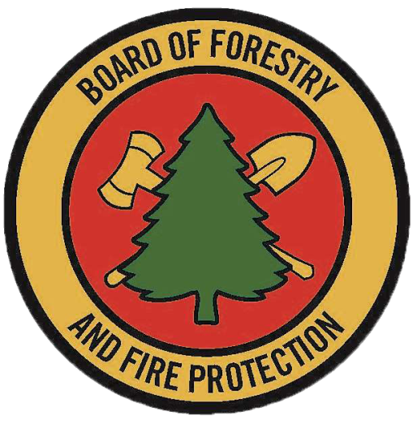 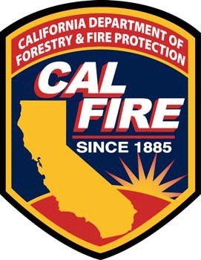

November 2020

Contents

Purpose and Background 3

Site information 3

Map approval information 4

Finding 1: Compliance with Requirements in Regulations based on PRC 4290 and 4291 4

Section 1: PRC 4290 4

Emergency Access and Egress 4

Signing and Building Numbering 4

Emergency Water Standards 5

Fuel Modification Standards 5

Verification of compliance with certified local ordinances 5

Section 2: PRC 4291 5

Zone 1 Requirements (applicable 30 feet from each building or to property line, whichever comes first) 5

Zone 2 Requirements (applicable 30-100 feet from each building but not past property lines) 6

Requirements for Zones 1 & 2 6

Finding 2: Structural fire protection and suppression services 6

# Purpose and Background

For tentative or parcel maps approved in state responsibility areas (SRA) or very high fire hazard severity zones (VH), the approving body is required to make and submit two findings to the State Board of Forestry and Fire Protection (Board) within 30 calendar days of map approval (14 CCR § 1266.02).

The required findings are as follows:

(1) A finding supported by substantial evidence in the record that the subdivision is consistent with:

(A) regulations adopted by the State Board of Forestry and Fire Protection pursuant to Sections 4290 and 4291 of the Public Resources Code, or

(B) consistent with local ordinances certified by the State Board of Forestry and Fire Protection as meeting or exceeding the state regulations.

(2) A finding supported by substantial evidence in the record that structural fire protection and suppression services will be available for the subdivision through any of the following entities:

(A) A county, city, special district, political subdivision of the state, or another entity organized solely to provide fire protection services that is monitored and funded by a county or other public entity.

(B) The Department of Forestry and Fire Protection by contract entered into pursuant to Section 4133, 4142, or 4144 of the Public Resources Code.

(14 CCR § 1266.01.)

Note: Authority cited: Section 66474.02, Government Code; and Sections 4202, 4203 and 4204, Public Resources Code. Reference: Section 66474.02, Government Code; and Sections 4201, 4202, 4203 and 4204, Public Resources Code.

# Site information

Subdivision name: Click or tap here to enter text.

Jurisdiction name:Click or tap here to enter text.

Point of contact: Click or tap here to enter text.

Mailing address: Click or tap here to enter text.

Email address: Click or tap here to enter text.

Phone number: Click or tap here to enter text.

Fax number: Click or tap here to enter text.

Subdivision is located within: State Responsibility Area LRA Very High Fire Hazard Severity Area

# Map approval information

Name of meeting at which tentative and/or parcel maps were approved: Click or tap here to enter text.

Meeting date: Click or tap to enter a date.

Meeting location: Click or tap here to enter text.

Meeting agenda and agenda item number: Click or tap here to enter text.

Relevant staff report(s): Click or tap here to enter text.

# Finding 1: Compliance with Requirements in Regulations based on PRC 4290 and 4291

In the column titled “Attached supporting evidence”, please provide reference to attached materials showing compliance with the corresponding requirement. Such documents may include but are not limited to maps, plans, XXX. If an exception has been granted, please note how same practical effect is achieved and refer to evidence, including the exception granted by the inspection authority or findings made by the local jurisdiction pursuant to 14 CCR 1270.06.

## Section 1: PRC 4290

### Emergency Access and Egress

| Requirements | Meets | Attached supporting evidence |
| --- | --- | --- |
| [14 CCR Ch. 7 § 1273.01 Width](https://govt.westlaw.com/calregs/Document/I1F513A89DAC54694B7705AE6776CBBE1?viewType=FullText&originationContext=documenttoc&transitionType=CategoryPageItem&contextData=(sc.Default)) |  | Click or tap here to enter text. |
| [§ 1273.02. Road Surfaces](https://govt.westlaw.com/calregs/Document/I9F6D7130461C4EC4AD17257902E63C2A?viewType=FullText&originationContext=documenttoc&transitionType=CategoryPageItem&contextData=(sc.Default)) |  | Click or tap here to enter text. |
| [§ 1273.03. Grades](https://govt.westlaw.com/calregs/Document/I0F7BB9F74173430A8591450B5BB35257?viewType=FullText&originationContext=documenttoc&transitionType=CategoryPageItem&contextData=(sc.Default)&bhcp=1) |  | Click or tap here to enter text. |
| [§ 1273.04. Radius](https://govt.westlaw.com/calregs/Document/I659969CCACF14A9C8DF5FE6C32FBE1CF?viewType=FullText&originationContext=documenttoc&transitionType=CategoryPageItem&contextData=(sc.Default)) |  | Click or tap here to enter text. |
| [§ 1273.05. Turnarounds](https://govt.westlaw.com/calregs/Document/ID85C86F3EB9E478C84E1FBE7F6DDBD39?viewType=FullText&originationContext=documenttoc&transitionType=CategoryPageItem&contextData=(sc.Default)) |  | Click or tap here to enter text. |
| [§ 1273.06. Turnouts](https://govt.westlaw.com/calregs/Document/I1C46346B6E6C4E299DB83FD43CC331E0?viewType=FullText&originationContext=documenttoc&transitionType=CategoryPageItem&contextData=(sc.Default)) |  | Click or tap here to enter text. |
| [§ 1273.07. Road and Driveway Structures](https://govt.westlaw.com/calregs/Document/I37FD4746DBD7481EAE56D6E7AC9230AE?viewType=FullText&originationContext=documenttoc&transitionType=CategoryPageItem&contextData=(sc.Default)) |  | Click or tap here to enter text. |
| [§ 1273.08. Dead-end Roads](https://govt.westlaw.com/calregs/Document/I884DA16F90D04ADBB21799FDC7767C20?viewType=FullText&originationContext=documenttoc&transitionType=CategoryPageItem&contextData=(sc.Default)) |  | Click or tap here to enter text. |
| [§ 1273.09. Gate Entrances](https://govt.westlaw.com/calregs/Document/IE0DF3B3EF36940C489B24DA5827E484E?viewType=FullText&originationContext=documenttoc&transitionType=CategoryPageItem&contextData=(sc.Default)) |  | Click or tap here to enter text. |

### Signing and Building Numbering

**§ 1274.01. Road Signs.**

**§ 1274.02. Road Sign Installation, Location and Visibility.**

**§ 1274.03. Addresses for Buildings.**

**§1274.04. Address Installation, Location, and Visibility.**

### Emergency Water Standards

**§1275.02. Water Supply.**

**§ 1275.03. Hydrants and Fire Valves.**

**§ 1275.04. Signing of Water Sources.**

### Fuel Modification Standards

**§ 1276.01. Setback for Structure Defensible Space**

**§1276.02. Maintenance of Defensible Space Measures.**

**§1276.03. Disposal of Flammable Vegetation and Fuels.**

**§ 1276.04. Greenbelts.**

### Verification of compliance with certified local ordinances

The undersigned verifies that the subdivision for which this report is written complies with the requirements in any local ordinances certified as equaling or exceeding and therefore applicable in place of the Fire Safe Development Regulations.



Print name: Click or tap here to enter text.

Position of signing county official: Click or tap here to enter text.

## Section 2: PRC 4291

### Zone 1 Requirements (applicable 30 feet from each building or to property line, whichever comes first)

| Requirement | Meets | Attached supporting evidence |
| --- | --- | --- |
|  |  |  |
| (2) Remove dead tree or shrub branches that overhang roofs, below or adjacent to windows, or which are adjacent to wall surfaces, and keep all branches a minimum of ten feet (10 ft.) away from chimney and stovepipe outlets. |  |  |
|  |  |  |
|  |  |  |

### Zone 2 Requirements (applicable 30-100 feet from each building but not past property lines)

| Requirement | Meets | Attached supporting evidence |
| --- | --- | --- |
|  |  |  |
|  |  |  |

### Requirements for Zones 1 & 2

| Requirement | Meets | Attached supporting evidence |
| --- | --- | --- |
| (1) “Outbuildings” and Liquid Propane Gas (LPG) storage tanks shall have the following minimum clearance: ten feet (10 ft.) of clearance to bare mineral soil and no flammable vegetation for an additional ten feet (10 ft.) around their exterior. |  |  |
| (2) Protect water quality. Do not clear vegetation to bare mineral soil and avoid the use of heavy equipment in and around streams and seasonal drainages. Vegetation removal can cause soil erosion, especially on steep slopes. Keep soil disturbance to a minimum on steep slopes. |  |  |

# Finding 2: Structural fire protection and suppression services

Structural fire protection and suppression services must be available to the subdivision through any of the following entities. Please mark which type of fire service entity applies to this subdivision and reference attached evidence

| Fire Protection Entity |  | Attached supporting evidence |
| --- | --- | --- |
| A county, city, special district, political subdivision of the state, or another entity organized solely to provide fire protection services that is monitored and funded by a county or other public entity. |  |  |
| The Department of Forestry and Fire Protection by contract entered into pursuant to Section 4133, 4142, or 4144 of the Public Resources Code. |  |  |

Local fire official description of how structural fire protection and suppression services will be provided:

Click or tap here to enter text.

If a) is checked above, name of entity providing fire protection services:

Click or tap here to enter text.

Local fire official sign-off



Print name: Click or tap here to enter text.

Title: Click or tap here to enter text.