6

6

Chapter 6

Public Safety and Noise

Claremont General Plan

**Our Vision: A Safe and Nurturing Place to Live, Work, and Play**

C

laremont takes pride in maintaining a safe environment for its citizens. Public safety means promoting protection from hazards and providing a secure environment to live, work, play, and learn. Although it is impossible to predict our future, history of local disasters shows that Claremont is vulnerable to excessive noise and hazards such as earthquakes, flood inundation, wildfire, mud flow, landslide, and traffic safety.

**Public Safety and Noise Vision Statement** This Vision Statement was crafted by the Citizens’ Committee for Claremont, Public Safety and Noise Subcommittee.

Maintaining a safe environment requires constant assessment of the City’s needs regarding hazards. The presence of fault lines, hillside terrain, wildland fire interface, Interstates 10 and 210, and the San Antonio Dam raise more than a few public safety and noise concerns. Since many natural and man-made hazards have regional impacts, the City coordinates with regional, state, and federal agencies to mitigate natural hazards and noise abatement. Claremont is an integral network of communities with varying geographic features and diverse populations, and the provisions for public safety will assure access and equal protection to all citizens.

How We Identify and Guard Against Hazards

The Public Safety and Noise Element establishes policies to protect the Claremont community from natural and human-caused hazards, and to abate noise by identifying its sources and assessing alternative methods of reducing noise impacts.

Scope and Content of the Public Safety and Noise Element

This Element fulfills requirements for two mandatory elements: Safety and Noise. Since these two elements overlap with regard to mitigation of hazards, they are combined into one chapter.

Historically, Claremont has placed an emphasis on planning, and part of this proactive approach to building a sustainable community involves identifying and avoiding or mitigating those hazards present in the environment that may adversely affect property and threaten lives. Government Code Sections 65302(g) and 65302(f) identify several issues to consider in such planning efforts, as does California Health and Safety Code Section 56050.1. In Claremont, issues of concern include:

**Fire Sprinklers** As required by the Claremont Municipal Code, an automatic fire sprinkler system must be installed in all new development projects as a preventative safety measure against fire hazards.

* Seismic hazards, including ground shaking, surface rupture due to earthquake faults, landslides, and dam failure
* Non-seismic slope instability leading to landslides
* Geologic hazards, including subsidence and liquefaction
* Flooding and dam inundation
* Wildland fires
* Excessive noise
* Presence of hazardous materials
* Climate change

Since the goals and policies of the Public Safety and Noise Element aim to mitigate hazards and abate noise, they correlate closely to the Land Use, Community Design, and Heritage Preservation Element. Claremont’s location at the base of the San Gabriel Mountains creates seismic, geologic, flood, and fire hazards. Climate change is anticipated to affect Claremont by increasing the severity of wildland fires and rain events, increasing the number of extreme heat days and overall temperatures, exacerbating drought conditions, and worsening air quality. To help guide land use decision-making, this Element identifies areas prone to these hazards and sets guidelines and land use limitations focused on minimizing their impacts. Noise contour maps show which areas of the city are exposed to freeway, railway, and other major noise sources. By highlighting these areas and establishing noise/land use compatibility criteria, the City can use this information to protect residents from excessive noise. Policies in the Land Use, Community Design, and Heritage Preservation Element respond to these conditions.

Public Safety

The history of natural disasters in Claremont, and the effects from natural calamities and terrorism we experience throughout the nation, have elevated public safety issues in this century. We have seen that clear identification of threats to our safety allows us to better guard against disasters and to develop effective response plans. Foremost, we strive to minimize hazards and protect public health, to provide Claremont residents with timely response in times of emergencies, to supply adequate facilities and equipment, and to educate the public about hazards.

Natural Hazards

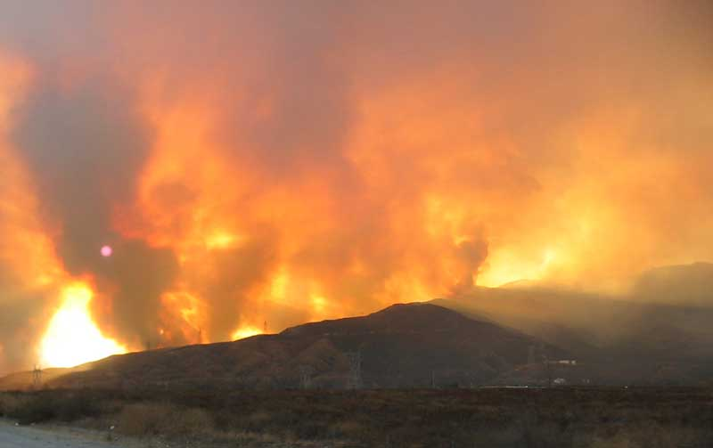The historical record shows that locally and regionally, Claremont has experienced earthquakes, landslides, floods, and wildland fires.[1] The flood of 1938 significantly damaged the street system, flooded basements, and resulted in the death of several residents,[2] According to local lore, the walls surrounding Scripps College were constructed to prevent damage from any subsequent floods, not as a barrier between Scripps students and the young scholars at then-named Claremont Men’s College.[3]

**Wildland Fires** The Grand Prix fire in 2003 scorched most of Claremont’s hillsides and destroyed or damaged over 70 homes.

In 2003, the massive Grand Prix fire, which ultimately combined with the Old Fire to form a 40-mile front across the San Gabriel Mountains, consumed almost 60,000 acres, and destroyed and/or damaged 71 homes in and around Claremont. Thousands of Claremont residents were forced to evacuate and seek temporary shelter elsewhere. The damage caused by the fire in the City of Claremont was estimated at $20 million.[4]

**Photo Credit: Dan Sullivan, 2003**

Seismic Hazards

Seismic hazards represent a concern in Claremont given the City’s location at the base of the San Gabriel Mountains, a seismically active range, and the fact that California sits at the edge of the Pacific Plate. Earthquakes are part of our lives, and we recognize that regional seismic events can result in property damage, deaths, fires, and other secondary effects.[5] The primary results from earthquakes are strong ground shaking and surface fault rupture. Secondary effects include landslides, slope deformation, liquefaction, and ground subsidence.

Ground-shaking effects felt locally depend upon many factors, most notably the intensity of the event, distance to the earthquake epicenter, the depth of the earthquake, and local soils conditions. Seismologists use a logarithmic magnitude scale to describe the intensity of earthquakes. However, what impresses us most when an earthquake occurs are its effects. What kind of damage correlates to, for example, a 5.4 magnitude earthquake? The Modified Mercalli Scale, presented in Table 6-1, was developed to further public understanding of the potential destructive effects of earthquakes of varying magnitudes.

Although earthquakes have not resulted in catastrophic property damage, deaths, or widespread injuries in Claremont, the community has sustained damage and disruption to the street system during recent and historical seismic events. Early recorded earthquakes and earthquake-related incidents that have affected Claremont include the 1812 Wrightwood Earthquake of 7.0 to 7.5 magnitude, the 1858 San Bernardino Earthquake of a 5.5 to 6.5 magnitude, and the 1899 Cajon Pass Earthquake of 5.7 to 6.5 magnitude.[6]

During the twentieth century, many earthquakes have shaken up Claremont. Notable events that affected wide areas of Southern California include the 1933 Long Beach, 1971 Sylmar, and 1987 Whittier earthquakes. In 1992, Claremont was shaken by two events: a 7.3 magnitude earthquake originating from the desert community of Landers and a 6.4 magnitude in Big Bear. The Northridge tremor of 1994 rattled windows and nerves throughout the city, but Claremont was spared the widespread destruction experienced in the San Fernando Valley. In 1988 and 1990, earthquakes with a magnitude of 5.5 centered in Claremont caused minor structural damages.[7] Historic patterns show, however, that any of the minor or major faults traversing the region are capable of causing significant disruption to our lives.

Table 6-1

Earthquake Magnitude and Intensity Comparison

| Descriptor | Magnitude | Intensity | Description |
| --- | --- | --- | --- |
| Not felt | 1. - 3.0 | I | I. Not felt except by a very few under especially favorable conditions. |
| Weak | 3.0 - 3.9 | II - III | II. Felt only by a few persons at rest, especially on upper floors of high-rise buildings. Delicately suspended objects may swing.  III. Felt quite noticeably indoors, especially on upper floors of buildings, but many people do not recognize it as an earthquake. Standing automobiles may rock slightly. Vibrations like passing of a truck. Duration estimated. |
| Light  Moderate | 4.0 - 4.9 | IV - V | IV. During the day felt indoors by many, outdoors by few. At night, some awakened. Dishes, windows, doors disturbed; walls make creaking sound. Sensation like heavy truck striking building. Standing motor cars rocked noticeably.  V. Felt by nearly everyone; many awakened. Some dishes, windows and so on broken; cracked plaster in a few places; unstable objects overturned. Disturbances of trees, poles, and other tall objects sometimes noticed. Pendulum clocks may stop. |
| Strong  Very strong | 5.0 - 5.9 | VI - VII | VI. Felt by all, many frightened and run outdoors. Some heavy furniture moved, few instances of fallen plaster and damaged chimneys. Damage slight.  VII. Everybody runs outdoors. Damage negligible in buildings of good design and construction; slight to moderate in well-built ordinary structures; considerable damage in poorly built or badly designed structures; some chimneys broken. Noticed by persons driving cars. |
| Severe  Violent | 6.0 - 6.9 | VIII - IX | VIII. Damage slight in specially designed structures; considerable in ordinary substantial buildings with partial collapse; great in poorly built structures. Panel walls thrown out of frame structures. Fall of chimneys, factory stacks, columns, monuments, walls. Heavy furniture overturned. Sand and mud ejected in small amounts. Changes in well water. Persons driving cars disturbed.  IX. Damage considerable in specially designed structures; well-designed frame structures thrown out of plumb; great in substantial buildings with partial collapse. Buildings shifted off foundations. Ground cracked conspicuously. Underground pipes broken. |
| Extreme | 7.0 -7.9  8.0 and higher | X - XII | X. Some well-built wooden structures destroyed; most masonry and frame structures destroyed; ground badly cracked. Rails bent. Landslides considerable from river banks and steep slopes. Shifted sand and mud. Water splashed, slopped over banks.  XI. Few, if any (masonry) structures remain standing. Bridges destroyed. Broad fissures in ground. Underground pipelines completely out of service. Earth slumps and land slips in soft ground. Rails bent greatly.  XII. Damage total. Waves seen on ground surface. Lines of sight and level are distorted. Objects thrown into the air. |
| Source: United States Geological Survey (USGS) National Earthquake Information Center, October 2002, and Wilson Geosciences, Inc. Seismic and Geologic Technical Background Report, June 2005. G-26. | | | |

Figure 6-1 illustrates the spaghetti-like pattern of faulting surrounding our City, and Table 6-2 identifies faults thought capable of producing very substantial seismic events.

**Table 6-2**

**Magnitude and Intensity of Maximum Credible Earthquake (MCE)**

**for Faults Potentially Impacting Claremont**

| Regional Fault Name | Distance to Claremont1 (miles) | Magnitude of MCE | Intensity Range of MCE (1) | Last Major Rupture |
| --- | --- | --- | --- | --- |
| San Jose | 0.7 | 6.4 | X | Late Quaternary |
| Cucamonga | 1.4 | 6.9 | X | Late Quaternary; Historic |
| Sierra Madre | 1.6 | 7.2 | X | Holocene and Late Quaternary |
| Chino-Central Avenue | 5.3 | 6.8 | X | Late Quaternary |
| Puente Hills Blind Thrust | 11.4 | 7.0 | IX | No documented surface faulting |
| San Andreas-1857 Rupture | 17.2 | 7.8 | IX | Historical (1857) SE to Wrightwood |
| San Andreas - Carrizo | 17.2 | 7.8 | IX | Holocene |
| Source: Wilson Geosciences, Inc. *Seismic and Geologic Technical Background Report.* June 2005. G-24.  Notes: 1) Latitude 34.107, longitude 117.720 2. Blake, 2002, | | | | |

Primary-Action Earthquake Hazards

In Claremont, the two types of fault impacts of concern are ground shaking and fault rupture.

Ground Shaking

Fault-generated ground shaking can result in extensive structural damage, injury, and death. Five faults that may cause ground shaking are the Sierra Madre, Cucamonga, San Jose, Indian Hill, and San Antonio faults. In addition to ground shaking, these faults have the potential to cause groundwater movement and create groundwater barriers.

The Sierra Madre and the Cucamonga fault lines meet under the northern part of the City. Although they are not expected to rupture for several thousand years, these faults have the potential to create earthquakes with magnitudes of 7.2 for the Sierra Madre and 6.9 for the Cucamonga, with the additional threat of ground rupture.[8] More information and study are needed to assess potential earthquake activity and threats posed by the San Jose, Indian Hill, and San Antonio faults.

Fault Rupture

Fault rupture is a ground movement that occurs during an earthquake. Although impact is limited, these ground movements can cause structures to collapse, make roads impassable due to offsets, and sever utility lines.[9] The chance of an earthquake leading to surface rupture hazards is minimal, but both “active” faults and “potentially active” faults should not be discounted as sources of potential seismic harm. Although no Alquist-Priolo Earthquake Fault Zone had been mapped in Claremont as of 2005, studies continue to determine if the Cucamonga and Sierra Madre faults traversing Claremont should be zoned as major fault lines.

Secondary-Action Earthquake Hazards

Secondary-action earthquake hazards include earthquake-induced landslides, liquefaction, subsidence, ground cracking, ridgetop spreading, and fill slope deformation.

Earthquake-Induced Landslides

Earthquakes can induce landslides on hillsides or steep slopes. In a landslide, surface rocks and bedrocks can fall onto the roads, buildings, and utility lines below the slope, causing damage to residents and properties.

The Seismic Hazard Map (Figure 6-2) outlines the boundaries of areas vulnerable to earthquake-induced landslides and slope instability. The map shows that the northwestern and eastern parts of Claremont are sensitive to landslides following an earthquake. The map also indicates areas requiring landslide considerations for future developments.

Liquefaction

Liquefaction occurs when severe ground shaking leads to loss of shear strength of a soil. Liquefaction areas are locations where a low alluvium level and shallow groundwater contribute to high possibility of soils losing cohesion during an earthquake.

Fortunately, most of Claremont’s groundwater is at least 100 feet deep, and the underlying alluvial-sized soil particles reduce chances of liquefaction. The only two areas of liquefaction concern are the Thompson Wash in the northern portion of the city and properties along Indian Hill Boulevard between Foothill Boulevard and Bonita Avenue (Figure 6-2).

Since liquefaction-prone soils pose significant hazards to structures and inhabitants, landowners looking to develop within these two areas should refer to Seismic Hazard Zone maps that delineate approximate liquefaction areas. Aside from the Seismic Hazard Zone map, geotechnical borings, laboratory testing, and groundwater level information will identify liquefaction areas.[10]

Subsidence

Subsidence occurs when an earthquake causes loose soil to depress or consolidate, causing the land surface to break or sink. Generally, areas with younger alluvium are more susceptible to subsidence. Hazards related to subsidence occur when the foundation or walls of structures cause building to buckle or collapse.

Ground Cracking, Ridgetop Spreading, and Fill Slope Deformation

Other seismic-induced hazards include ground cracking, ridgetop spreading, and fill slope deformation. The extent of ground cracking depends on the ground material and usually involves only minor damage. On the other hand, ridgetop spreading could result in structural damage to residential buildings or utility infrastructures commonly located in steep slope areas, such as the northern region of Claremont. Earthquakes may also damage structures on fill slopes in the northwest region of the city. Damage to utility lines or buildings on the ridgetops or fill slopes can compromise emergency communication, water supply, and other vital services.[11] Development proposals on steep slopes or fill slopes require thorough review to determine their appropriateness.

**Claremont Hillsides** The terrain in the Claremont hillsides is very diverse, with many small and large canyons creating a very hilly environment. Many of the hillside slope faces are greater than 30 percent. Elevations within the hillside areas of Claremont range from 1,300 feet to as high as 3,360 feet above sea level.

Geologic Hazards

The topography and geology that give our city character – from the beautiful hillsides to the “Claremont potatoes” we see comprising the wonderful rock work in historic homes – reveal much about local geologic conditions. These conditions make us aware that soil conditions and slopes profoundly affect land use decisions.

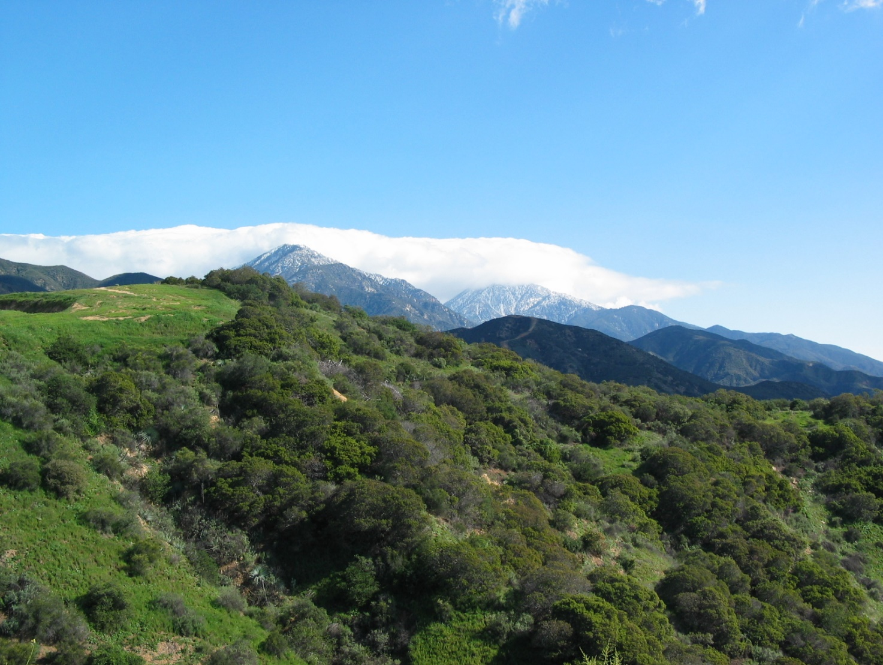

Non-Seismic Landslides

Landslides that occur naturally are potential hazards in hillside areas. Landslides on steep slopes can move rapidly, damage property and infrastructure, interrupt utility lines, and restrict delivery of water, gas, electricity, and telecommunications. Heavy rainfall, removal of vegetation, excavations, and groundwater flows can also trigger landslides. In Claremont, properties north of Base Line Road have the most potential for slope instability.[12]

Many levels of landslide prevention and mitigation exist. Some of the structural methods include placing engineered buttresses along the hillside to provide support to loose materials. Another way to strengthen the soil is to place surface and subsurface drainage systems to drain out water from the soil. Debris basins at strategic locations can capture loose materials and prevent landslides from obstructing roads and destroying property.[13]

Except in hillside areas, most of the City is not affected by non-seismic landslides. Past landslides in Claremont involved minor inconveniences such as frequent debris removal from catch basins and roads.

Collapsible and Expansive Soil Hazards

Collapsible and expansive soils lay under Claremont’s hillside areas and most of the city. The expansive soil of the hillside areas contain clay minerals in older alluvium and bedrock formation that are prone to collapse during dry seasons. The expansive soil in much of the urban area is prone to expand during the wet season. The collapse and expansion of these soils can be enough to cause structural damage to foundations, floor slabs, and concrete floors. Geotechnical investigations conducted prior to development can identify such hazards, and standard engineering techniques are available to mitigate potential hazards.

Flooding

Flooding has always been an issue in Claremont, as storm runoff from Mount Baldy rushes rapidly down the many canyons that outlet onto the Claremont alluvial plain. In 1938, a tremendous flood hit Claremont, damaging many properties and destroying most city streets. Prior to construction of the San Antonio Dam, major floods occurred in 1916, 1921, 1934, 1938, 1941, and 1943. Since completion of the San Antonio Dam in 1956, the structure has served important flood control and water supply functions for Claremont, holdingstorm water for the area. Since construction of the Dam, two flooding incidents in 1969 impacted Claremont. These incidents resulted in minimal damage likely due to the protection provided by flood channels and the dam. Localized flooding is still an issue during heavy rainfall, but the dam has halted most of the severe floods.[14]

Flood hazards in Claremont are divided into three categories: natural flooding, dam failure, and debris flow.

Natural Flooding

Two types of flood classification are flash floods and slow-rise floods. During slow-rise floods, emergency personnel have ample time to warn the community, but with flash floods, there is little time for preparation or warning. Although floods in other areas are due to water overflow, slow-rise floods in Southern California are the result of heavy rainfall or a combination of wet soil and lack of vegetation on the land.[15]

Most of the city has been developed on a foothill and along a downward slope; thus, flooding hazards are generally low. No property within the city lies within a federally designated 100‑year or 500-year flood zone as shown in Figure 6-3. With the construction of debris basins at the base of Chicken Creek, most areas of Claremont are protected from the risk of flooding and mudflows, as assessed by the Federal Emergency Management Agency (FEMA). The remaining portions of the city have not been assessed by FEMA, as shown in Figure 6-3.

that captures stormwater for the purpose of inundation mitigation

in tandem4Should the San Antonio Dam fail due to heavy rainfall and/or a structural failure of heavy erosion or inadequate spillway capacity the effects are projected to be of medium impact. Per the 1986 U.S. Army Corps of Engineers map provided within the Monte Vista Hazard Mitigation Plan (HMP) and re-illustrated in Figure 6-4, the probability is low of dam failure and the inundation zone is far reaching under the scenario of failure. 4time from dam failure for an area to be affected by inundation

Both structures have been analyzed by the U.S. Army Corps of Engineers in terms of hazard breadth of impact. The Thompson Creek Reservoir has an extremely high downstream hazard rating with a flow path crossing Highway 210 and coming just short of Highway 10 for a cumulative 8.82 miles traveled and eight separate cross sections. The maximum inundation depth during a failure is modeled for 15.3 feet. The Live Oak Dam also has an extremely high downstream hazard rating and though mostly outside of city limits some inundation may occur just west of Griffith Park in a dam failure scenario. The scenario map provided by LA County Public Works shows a maximum depth of 17.9 feet and a flow distance of 4.3 miles traveled in the event of a Live Oak Dam failure.

Mud and Debris Flows

Poor drainage and deep topsoil can cause mud and debris flows. Debris flows contain a soaked mixture of natural concrete that slide down the slope and valleys. Mudflows can damage property and block roads. Debris is formed when parts of the hill become wet and loose enough to fall off the slope. In Claremont’s sphere of influence, Palmer Canyon has the greatest potential for debris flows.[16]

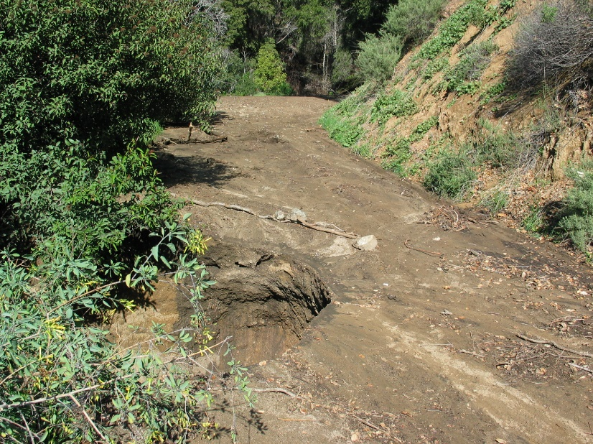

Due to the steep grade of the San Gabriel Mountains and the low permeability of the soils**,** soils are very likely to erode. The erosion potential increases when fire destroys the vegetative cover and soils in steep areas become exposed. Debris basins at the mouth of canyons are designed to trap sediment, rock, and debris carried by storm flows, to protect property from the destructive force of debris flows, and to help retain channel capacity further downstream.

Thompson Creek Dam forms a debris basin at the confluence of Burbank, Cobal, Williams, and Palmer Canyons. This debris basin is maintained by the County of Los Angeles. As with all debris basins, the Thompson Creek Basin must be cleaned out periodically to restore storage capacity. Excavated sediments are used as fill material and disposed of in abandoned quarries.

**Mudflow** Mudflows (or debris flows) are rivers of rock, earth, and other debris saturated with water. They develop when water rapidly accumulates in the ground, such as during heavy rainfall or rapid snowmelt, changing the earth into a flowing river of mud.

Fire Hazards

Fire hazard is prominent in the undeveloped land of the San Gabriel Mountains, as well as within Claremont’s urban areas. Parts of the City are designated a Very High Fire Hazard Severity Zone (VHFHZ)(see Figure 6-5).[17] Most of the land in VHFHZ is designated for residential use. However, there are non-residential areas near the San Antonio Creek wash on the city’s eastern side, including the Eastern edge of the Claremont colleges. No areas in Claremont have been identified as lacking emergency service. More information about wildfire hazard areas is available from CAL FIRE and the United States Geological Survey.

Claremont’s proximity to the mountains, the hillsides, low humidity, and the seasonal Santa Ana winds contribute to a constant threat of wildfires and the spread of fire into urban areas.

Wildland Fires

As described above, the hills of Claremont have burned many times, including the three fires which hit Claremont and neighboring San Bernardino County cities in October of 2003. Considered one of the worst disasters in the history of the area, the Old Fire, Grand Prix Fire, and Padua Fire devastated thousands of homes and caused billions of dollars in damage. Hot temperatures, low humidity, and fierce Santa Ana winds contributed to the fire’s rapid spread beyond the San Bernardino National Forest to suburbs along the Interstate 210. The 2003 Grand Prix fire damaged residential and commercial structures and infrastructure amounting to an estimated $20 million. [18]

The steep slopes along the San Gabriel Mountain foothills and the seasonal Santa Ana winds makes rapid wildland fires a top public safety concern in Claremont. Weather, topography, and vegetation type all affect the intensity of fires. California has extended droughts, which increase the number of days with low humidity and consequently, the amount of dried vegetation (fuel). Santa Ana winds — the hot, very dry winds that intermittently blow across Southern California in the fall — further increase the potential for ignition and spread of fires. In addition, a significant portion of north Claremont remains undeveloped and consists of rugged topography with highly flammable native vegetation. The major fire fuels are chaparral, sage, and grasses. These vegetation types typically have a very high oil content that creates a severe fire potential. The greatest potential of high fire hazard within Claremont lies to its north. Wildfire hazard is compounded when isolated development occurs in and near brush-covered areas, particularly hillsides and steep canyons. Steep, rugged hillsides and steep canyons allow fire to spread rapidly.

**Hillside Zoning Ordinance**

The hillside zoning ordinance of 1981 limits uses of the hillside area by providing permitted uses and intensity according to the steepness of the hill and available facilities. The intent is to prevent landslides, fire hazards, to reduce the need for grading and to limit removal of trees.

To minimize potential fire danger, future developments must adhere to fire safety development guidelines, such as the Hillside Zoning Ordinance (1981), brush clearances, fire resistance construction materials, sufficient water, and backup power.[19]

Windstorms

The seasonal Santa Ana wind conditions pose windstorm threats in Claremont. Windstorms are severe winds blowing at over 40 miles per hour. Windstorms can cause damage to properties, overhead utility lines, and infrastructure.[20] A windstorm incident in January 1997 resulted in the City and County of Los Angeles declaring a state of local emergency. This 1997 windstorm produced winds of up to 106 miles per hour, uprooted over 1,000 of Claremont’s treasured trees, and damaged residences, automobiles, and utility lines.[21] In January 2022, another severe windstorm incident impacted the city. Winds in excess of 70 miles per hour felled over 300 trees, damaged homes and other structures, interrupted power service to approximately 1,400 homes and required weeks of clean-up activities. [22]

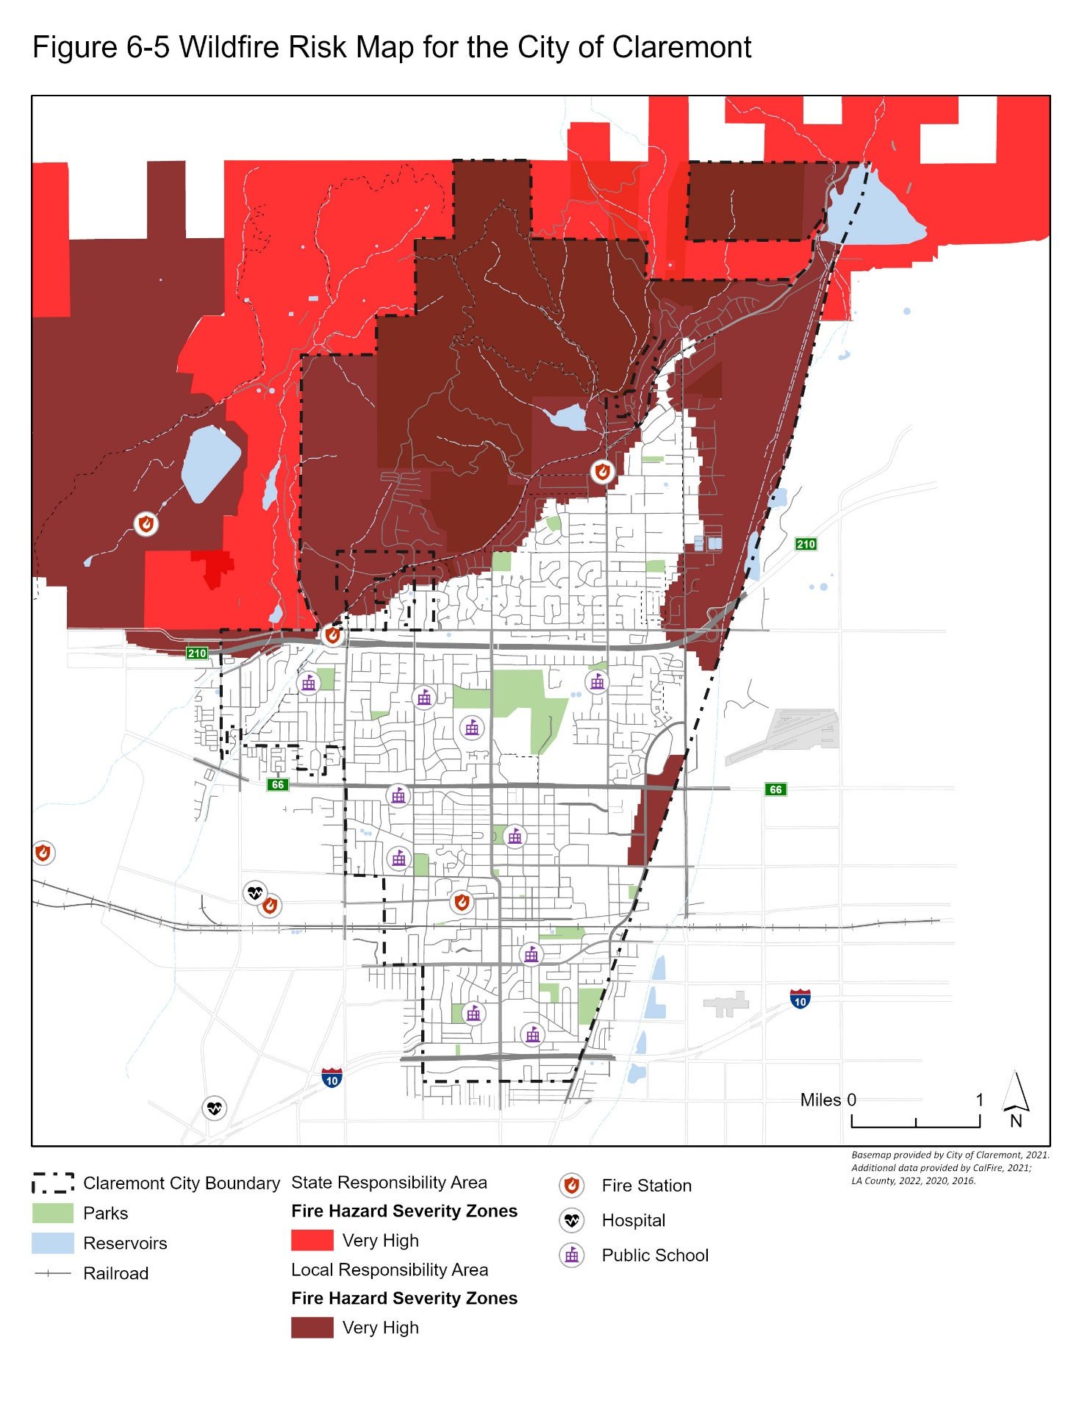

Climate Change

Climate change is anticipated to affect Claremont by increasing the severity of wildland fires and rain events, increasing the number of extreme heat days and overall temperatures, exacerbating drought conditions, and worsening air quality. Although climate change is anticipated to affect all community members of Claremont, there are population groups that will be more vulnerable to its effects.

Climate change adaptation and resilience strategies must be included in the City’s General Plan via its Safety Element in accordance with Senate Bill 379. The review and update must consist of the following components:

1. A vulnerability assessment that identifies the risks climate change poses to the local jurisdiction and the geographic areas at risk from climate change.
2. Set of adaptation and resilience goals, policies, and objectives based on the information specified in the vulnerability assessment.
3. Set of feasible implementation measures designed to carry out the goals, policies, and objectives identified in the adaptation objectives.

The Intergovernmental Panel on Climate Change (IPCC) provides several greenhouse gas (GHG) emissions scenarios used to describe possible future GHG emissions and associated changes to global climate patterns. The State recommends two ‘Representative Concentration Pathways (RCPs) in order to assess the City’s potential vulnerability to climate change. RCP 4.5 represents a “mitigation” scenario in which global emissions peak around 2040 and then decline at the end of the century. This scenario assumes global agreement and implementation of GHG reduction strategies. RCP 8.5 represents a “business as usual” scenario in which emissions continue to rise throughout the 21st century.

The State provides the Cal-Adapt tool to local jurisdictions for climate adaptation and resilience planning. Cal-Adapt is a web-based platform that provides climate change projections and climate impact research that are downscaled to the local level for different RCP scenarios. The projections are based on the extensive body of climate research described in California’s Fourth Climate Change Assessment. Climate change projections taken from Cal-Adapt for the RCP 4.5 and RCP 8.5 scenarios will be assessed under Temperature and Wildfire relative to the health and safety of Claremont residents.

Temperature

Observations over the past century indicate that temperature has increased across the Southern California region. Based on historical temperature records (1896-2015) from the California South Coast NOAA Climate Division, which encompasses the LA region, significant trends were identified in annual average, maximum, and minimum temperatures averaging around 0.16°C per decade.[23]

Warming is expected to increase across the Los Angeles region in the coming decades. Under RCP 4.5, future model-average temperature values are projected to increase by 2.3°F by the early-21st century, 4.2°F by the mid-21st century, and 5.2°F by the late-21st century compared to the modeled historical annual average maximum temperature of 72.5°F. Furthermore, the intensity and frequency of extreme heat days are also projected to increase over the Los Angeles region. Under RCP 4.5, the average hottest day of the year is expected to increase by 4-7°F.

Average maximum temperatures in Claremont are expected to rise between 5.5°F (RCP4.5) and 8.6°F (RCP8.5) by the end of the century.[24] Average minimum temperatures in Claremont are expected to rise between 5.1°F (RCP4.5) and 8.3°F (RCP8.5) by the end of the century.

The number of extreme heat days per year is also expected to increase. In Claremont, an extreme heat day is when the maximum temperature exceeds 99.1°F. Historically, the region experiences four extreme heat days per year on average. By the end of the century, extreme heat days are expected to increase by 16 days annually under RCP4.5 and approximately 36 days annually under RCP 8.5.

Changes in temperature are in Figures 6-6 and 6-7 below. In both figures, the purple line shows high emissions scenario (RCP 8.5), the blue line shows the medium emissions scenario (RCP 4.5), the grey line illustrates the current trend (observed), and the gold line shows the modeled historical data. The shaded areas indicate the range for the emissions scenario. For example, the blue shaded area represents the range of data for the medium emissions scenario (RCP 4.5).

Figure 6-6 Annual Average Maximum Temperature Graph for City of Claremont

Figure 6-7 Extreme Heat Days Graph for City of Claremont

Precipitation

Precipitation over the LA region is highly variable from year to year. Typically, about five storms each year make up 50 percent of the annual precipitation total.[25] Model projections are inconsistent regarding the projected changes in precipitation in Southern California. Generally, small changes are projected relative to the region’s historic variability. However, dry and wet extremes are both expected to increase in the future thus increasing the potential for higher variability in precipitation. By the late-21st century, the wettest day of the year is expected to increase across most of the Los Angeles region, with some locations experiencing 25-30 percent increases under RCP8.5.

At the City level, Claremont is projected to have little variability in precipitation levels by the end of the Century. The maximum 1-day precipitation by the late 21st century is projected to increase by 0.28 inches under RCP 8.5. The annual average precipitation total is expected to range between a 0.1-inch increase (RCP 4.5) and a 0.6-inch decrease (RCP 8.5).

Wildfire

In the Southern California region wildfire hazard is influenced by a multitude of compounding factors that include its dry and warm Mediterranean climate, periodic episodes of offshore Santa Ana winds, drought events, the type and spatial distribution of vegetation, varying topography, large urban-wildland interfaces, past fire suppression attempts, and human activities.[26] Regionally, approximately 80 percent of wildfire events occur during the summer and fall, with a quarter of annual wildfires occurring during Santa Ana wind events. Future projections using statistical models indicate that Southern California may experience a larger number of wildfires and burned area by the mid-21st century under RCP 8.5. Overall burned area is projected to increase over 60 percent for Santa Ana-based fires and over 75 percent for non-Santa Ana fires.

In the city, the baseline 30-year average (1961-1990) of acres burned ranges between 37.1 acres and 37.6 acres depending on the emissions scenario.[27] [28] Although this is the historical modeled 30-year average, many factors affect projected future occurrence of wildfire as a result of climate change. There are significant uncertainties associated with the influence of climate change on the future occurrence of wildfire in the city. However, by both the mid-century and the end of century, the 30-year average acres burned is expected to slightly increase under an intermediate emissions scenario (RCP4.5) but decrease under a high emissions scenario (RCP8.5). Figure 6-8 below shows wildfire scenario projections use a statistical model based on historical data of climate, vegetation, population density, and fire history between 1953 and 2099.

Figure 6-8 Annual Average Area Burned (Acres) Graph for City of Claremont

Vulnerable Populations

Communities will be affected by climate change to varying degrees depending on their sensitivity to its impacts. Social vulnerabilities can greatly inhibit the adaptive capacity of a community. On a larger scale, communities may be more vulnerable because of limited access to financial capital and resources, various institutional barriers, social networks, and access to critical infrastructure. Adaptive capacity is largely influenced by governance, management, and institutions thus making it imperative that adaptive capacity is addressed through effective policy implementation. On a more local level, the sensitivity of a community depends more on the specific makeup of the community (i.e., specific populations and assets). The most likely impacts of climate change that Claremont may experience include increases in average maximum and minimum temperatures, more severe storms, increases in extreme heat events, changes in precipitation patterns, extended drought conditions, and increasing wildfire hazard.

Certain population groups may be disproportionately harmed by the impacts of climate change in Claremont. The California Healthy Places Index tool identifies vulnerable populations by census tract. Vulnerable populations identified in Claremont include but are not limited to; unemployed, seniors, young children, and individuals with physical disabilities.

The City’s residents rely on infrastructure for mobility, water, power, and communications. These systems are vulnerable to climate change, which in turn can reduce the ability of people to adapt. Health risks may arise as a result of damaged infrastructure which may further stem from the loss of access to electricity, impacts to sanitation, safe food, water supplies, health care, communication, and transportation. To help reduce negative impacts on vulnerable populations and increase adaptive capacity, strategies and policies must be identified regarding vulnerable infrastructure, ensuring a high standard of condition and performance on infrastructure systems, and overall disaster preparedness.

External factors that also contribute to climate change vulnerability include homelessness, poverty, and other environment conditions. These factors affect particularly affect populations living in close proximity to freeways, areas with low tree canopy, and lack of access to resources, like air conditioning or a vehicle. Because climate change impacts are closely intertwined with vulnerable populations and inequities, climate adaptation planning presents a unique opportunity to address some of the external factors that contribute to climate change vulnerability, which are also root causes of inequity. Addressing these underlying causes can help increase resilience for all citizens of Claremont.

Human-Caused Hazards

Securing public safety also includes protection from hazards we create ourselves, particularly the public safety risks posed by hazardous materials, gang violence, or transportation-related hazards such as aircraft crashes.

Hazardous Materials

Hazardous materials seem insignificant as household products, but when massive amounts of these products amass in landfills, they can pose serious environmental and health risks to the community. Hazardous materials include waste labeled as toxic, poisonous, corrosive, flammable, combustible, or irritant.[29] These materials require special methods of storage and treatment that common sewage and drainage systems are not capable of handling. Improper disposal harms our environment and people who work in the waste management industry. Not only is it illegal to discard hazardous materials in the trash or to pour them into the storm drain or sewer system, doing so will contaminate the ground, water, and air.

The Los Angeles County Fire Department’s Health Hazardous Materials Division identifies potential hazardous materials and protects public health and environment throughout the County from hazardous waste pollution. The County enforces proper handling of hazardous materials through inspections, emergency response, and site mitigation.

The City also ensures proper handling of hazardous waste through a waste collection program. This program is an extension of the County program and allows Claremont residents to properly dispose of hazardous household and electronic waste according to the Los Angeles County Waste Management Plan. The program is paid by County residents as a tax on waste disposed at County’s landfills and the sanitation district fee on property tax. The City also collects used motor oil for free when scheduled through the Community Services Department, and the County provides appointment-based mobile units that collect hazardous materials at locations throughout the County.

The County reuses most of the collected materials such as paint for anti-graffiti programs, motor oil as lubricants, fuel and tar products for asphalt cover, and other materials as cement. Materials that cannot be recycled are handled separately for proper disposal. These sustainable practices keep the materials from entering the waste stream.

Air Crash Hazards

Air crash incidents are rare, but when they do occur, the results can be devastating. Such incidents concern residents of Claremont because the City has three airports nearby that serve small private aircrafts, as well as national and international passenger and air cargo carriers. The variety of air services and flight paths require regional coordination to prevent confusion in flight patterns and to maintain safety. Potential damages to aircrafts may also result in loss of life and property along its flight path. To avoid such outcomes, the Federal Aviation Administration has established land use restrictions to areas surrounding airports and flight paths.

The eastern parts of Claremont are within some of the compatibility zones, as identified in the 2015 Cable Airport Land Use Compatibility Plan. The purpose of the Compatibility Plan is to promote compatibility between Cable Airport and the land uses that surround it. As required by state law, the plan provides overarching guidance to affected land use jurisdictions with regard to airport land use compatibility. The Plan also outlines measures to guide use of the document by particular local agencies, including Los Angeles County Airport Land Use Commission and the City of Claremont, specifically, coordination between the jurisdictions should occur to encourage appropriate land use compatibility review.

The 2015 Cable Airport Land Use Compatibility Plan can be found in Appendix XX of this document.

Police and Emergency Services

Claremont sets high standards for public safety and protection. The City’s Police Department coordinates with the Los Angeles County Fire Department and the Red Cross to fulfill emergency services and safety needs of residents. The Claremont Police Department serves as the primary responding agency to emergencies, and provides law enforcement services to residences and businesses. The City contracts with the County Fire Department for fire and paramedic response and hazard mitigation. The Red Cross works with the City to manage and operate shelters. The City educates the public regarding disaster prevention and welcomes the help of community volunteers. Public awareness and education provide essential knowledge about how to assess and respond to emergency situations, and increase the community’s ability to minimize undesired outcomes.

Police Services

Until Claremont incorporated in 1907, the Los Angeles County Sheriff provided law enforcement services. The first City Marshal worked part time enforcing the first speed limits and guarding the town at night. Over the years, the Claremont Police force continued to develop with additional members, full facilities, and better compensation. The duty of the police officers also continued to grow in terms of the area covered and population that needed protection. [30]

The Claremont Police Department staff responds to emergency situations within the City and patrols our neighborhoods to promote a safe environment. The staff also holds official criminal records, investigates crime, and in an emergency, assesses situations and quickly dispatches appropriate emergency responses. The Police Department also utilizes reserve police officers who perform similar duties as regular police officers[31] and enhance police services to the community.

Claremont Policy Facility

The Police Station located at 570 W. Bonita Avenue no longer meets the needs of the Claremont Police Department. A Space Needs Assessment/Site Feasibility Study for the Police Station, conducted in 2002, identified the facility as being at the end of its useful life. The station suffers from excessive overcrowding, lack of key functional space, wear and tear due to age and round-the-clock usage, inability to address technological changes, and difficulty meeting regulatory requirements, including the Americans with Disabilities Act, CALOSHA, and California Board of Corrections. The study also identified the current site of the Police Station as very challenging to meet the demands of a new police station, if one were to be built on the same site. Any revitalized/expanded or new Police Station must address all of its traditional roles, yet accommodate the expanding needs of Claremont. The need for a new or expanded/improved facility is addressed in Policy 6-9.1.

Crime Prevention and Personal Safety

The Police Department promotes safety by increasing awareness of child abuse, domestic violence, rape, robbery, burglary, gang violence, check fraud, and identity theft. Crime prevention also involves educating the public about vacation security, business and neighborhood watch programs, security when residents are home alone, information regarding Megan’s Law, and poison accidents.

Community-Oriented Policing

The Police Department emphasizes community-based policing, and relies on the voluntary assistance of its community members to provide effective and comprehensive policing services. In its efforts to increase public awareness and improve relations with the community, the Police Department coordinates the following community outreach programs:

* Community Emergency Response Team (CERT) Training
* Youth Academy
* Ride-alongs
* Crime Alert Program
* Community Patrol Volunteer Program
* Citizen Police Academy
* Bicycle Safety Programs
* Drug Abuse Resistance Education (D.A.R.E.)
* Senior Outreach Programs
* School Resource Officer (SRO)
* Department Tours

Police Commission

The Police Commission, composed of Claremont residents, provides a public forum to discuss police issues including department policies, procedures and police actions, and to help create a climate of mutual respect and partnership among community members and the Police Department. The commission’s six areas of best practices include department policy, recruitment and hiring, training, community outreach, technology, citizen complaints, and officer accountability. The commission creates ad hoc committees to address public safety issues within the city and to support unbiased policing by the Police Department.

Police Review Ad Hoc Committee (PRAH)

The Police Review Ad Hoc Committee (PRAH) is an advisory sub-committee of the Police Commission. Complaints of police misconduct are investigated by the Police Department and forwarded to the Chief of Police. The Chief forwards these completed investigations to the PRAH for review.

The PRAH is charged with reviewing the investigation and determining if the information gathered in the investigation is satisfactory or if there is additional investigation needed before the investigation can be concluded.

City Communications System

The City operates its own three-channel, Ultra High Frequency (UHF) radio communications system. Two of the channels are utilized by the Police Department and the third is used for all other City departments. The third channel is also used as the Emergency Operations Center (EOC) channel during a disaster.

The communications system includes a local repeater site in the City and a remote repeater site in Chino Hills. The primary communications center is housed in the Police Department and is utilized for daily public safety operations by up to two communications officers. There are additional alternative communications positions in the City Emergency Operations Center and the Mobile Command Post.

**Mobility and Circulation** Issues related to mobility and circulation are addressed in Chapter 4, Community Mobility Element.

Bicycle Patrol

Since 1993, officers have used bicycles to patrol small areas with high visibility access. Bicycles allow for increased contact and trust between police officers and members of the community. These officers also promote bicycle safety education programs to local students participating in youth programs.

Community Patrol Volunteer Program

Community members over 45 years of age can participate in the Community Patrol Volunteer Program to provide assistance to the Police Department in programs such as vacation house checks, fingerprinting, community patrol, evidence transportation, traffic control, parking enforcement, clerical support, and serving as reserve crossing guards.

**Explorer Program**

The Explorer Program is sponsored by the Police Department and the Boy Scouts of America, and encourages youth interest in law enforcement and community service through practical experience in law enforcement. The program is designed to improve self-confidence, discipline, and build character in youth participants.

**Traumatic Intervention Services**

This program provides emotional support services to victims of traumatic events such as deaths, rape, assault, robbery, burglary, and traffic collisions. The service operates with the assistance of community volunteers who provide on-call service.

**Neighborhood Watch**

This program emphasizes the importance and effectiveness of crime reporting by neighbors. It allows citizens to report suspicious behavior or incidents to the Claremont Police Department. By encouraging a Neighborhood Watch group in each neighborhood and promoting neighbors to keep an eye on their community, the City is able to increase security for its residents. The program also provides public awareness and prevention seminars.

**Business Watch**

This program is sponsored by the Police Department and the Chamber of Commerce and encourages business owners and operators to educate employees regarding business-related crime prevention. Business-related crimes include credit and check fraud, robbery, burglary, and shoplifting,

Traffic Safety

Public safety entails road safety for drivers, pedestrians, and bicyclists. Claremont relies on its officers to enforce traffic regulations. Officers in cars and on motorcycles direct enforcement activities to areas with high traffic collision rates, and areas of concern to community members where violations are most common. Radar speed trailers are placed on streets to encourage drivers to drive within the speed limits. A community hotline is used by residents to communicate traffic safety concerns.

Traffic and Transportation Commission

The Traffic and Transportation Commission reviews and makes recommendations on issues which help to promote a safe environment while traveling within the city. The commission serves as a liaison between the community and City government in evaluating matters pertaining to traffic and transportation. Traffic safety issues routinely reviewed by the commission include, but are not limited to:

* Traffic circulation around school sites
* Traffic hazard mitigation
* Mitigation of traffic noise and maintenance of good air quality
* Traffic impacts on city streets resulting from proposed development
* Traffic volumes and speeds on residential streets
* Establishment of city-wide speed limits
* Pedestrian and bicyclist safety issues

Engineering Division

The Engineering Division is responsible for traffic safety features in the city. All traffic safety features are installed and maintained under the direction of the City Traffic Engineer. This includes the installation and maintenance of traffic control devices, as well as the implementation of traffic safety programs and the establishment of traffic regulation within the Municipal Code. Some of the assigned responsibilities of the City’s Engineering division include:

* Installation of traffic striping and signage
* Installation of traffic signals
* Review of stop sign requests
* Overview of crosswalk installations
* Radar speed survey
* Review of all traffic control plans
* Review of traffic impact reports and all traffic studies
* Issuance of oversized permits
* Issuance of all permits pertaining to the public right of way
* Insuring proper roadway and traffic control maintenance
* Bikeway planning and implementation
* Pedestrian safety

Fire Prevention and Protection Services

The first fire protection group in Claremont was made up of a diverse group of volunteers, including representatives from all types of professions. With a college bell as their alarm system, a horse, a cart, and the help of Sanborn fire insurance maps, these volunteers fought fires from 1903 until the 1960s, when the City hired its first fire chief and firemen. The City continued to rely on volunteers to supplement its fire fighters until the City hired an all professional staff in the 1970s.[32]

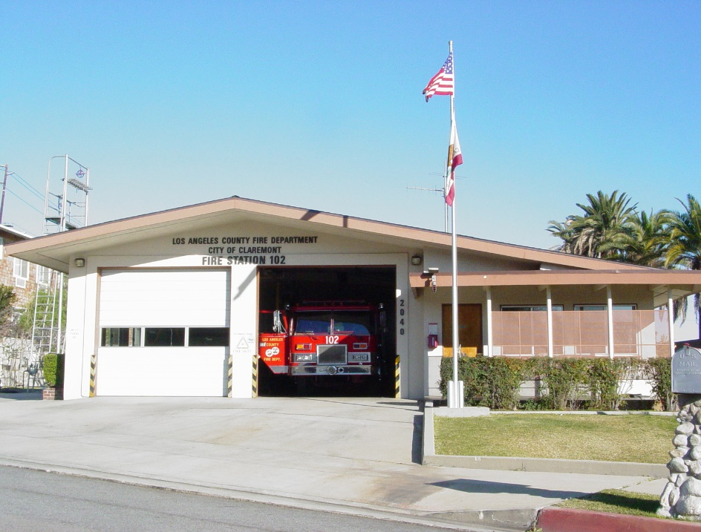

**Los Angeles County Fire Department** Los Angeles County Fire Station 102 is located just south of Base Line Road on Sumner Avenue.

Since 1975, fire services have been provided to residents of Claremont through a contract with the Consolidated Fire Protection District of Los Angeles County. A Los Angeles County Assistant Fire Chief is responsible for communications between the City and the Los Angeles County Fire Department. The Fire Department is responsible for the protection of life and property from losses due to fire, explosion, and other disasters. The City receives wildland fire protection and forestry tree service from the County Fire Department’s County Forester and Fire Warden. The City has three Los Angeles County fire stations at the locations listed in Table 6-3; however, since the County serves emergency cases within the county regardless of city boundaries, services from stations in Pomona, San Dimas, or Glendora can be dispatched depending on availability and distance. The city of Upland is also under automatic aid agreement with the County to provide fire protection to the area bounded by Pomello Drive, Mills Avenue, and Foothill Boulevard. The County can also deploy ladder companies from Glendora and Pomona.

All emergency calls are answered by police dispatchers, who redirect fire-related services to the Fire Department. Aside from fire and medical services, every emergency medical incident receives basic life support and advanced life support. The average first-in emergency response time in Claremont is under five minutes, and the average response time for truck serve is less than eight minutes. The County Fire Department also provides the following services: home fire safety inspection, assistance developing home fire escape plans, business inspections, rescue youth program, fire cause determination, hazardous material inspections, teaching fire prevention in schools, coordinating educational programs with other agencies, hospitals and schools, and answering citizens’ questions regarding fire hazards.[33] The Consolidated Fire Protection District is funded by a designated portion of the property taxes paid by the owners of all taxable parcels within Claremont and the unincorporated areas.

Table 6-3

Claremont Fire Station Locations

|  |  |  |  |  |
| --- | --- | --- | --- | --- |
| Fire Station | Address | Battalion | Equipment | Services |
| Station 62 | 3710 N. Mills Ave. | 2 | 3-person assessment engine company (a fire company with some limited paramedic capabilities) and an unstaffed patrol | Fire and emergency basic life support medical services |
| Station 101 | 606 W. Bonita Ave. | 2 | 3-person engine company and an unstaffed patrol, and a paramedic 2-person squad | Fire, emergency medical services, advanced life support/ paramedic service |
| Station 102 | 4370 Sumner Ave. | 2 | 3-person engine company | Fire and emergency basic life support medical services |
| Source: Los Angeles County Fire Department, 2004.  **Los Angeles County Fire Department** Los Angeles County Fire Department personnel work to contain the Grand Prix fire burning Claremont hillsides in 2003. | | | | |

Wildland Fire Protection

The Los Angeles County Fire Department constantly monitors fire hazards in the county and hosts ongoing programs for investigation and alleviation of hazardous situations. In the event of a major wildfire, the Fire Department warns owners of homes and inhabitants of communities in the path of the flames and recommends evacuation if the threat is eminent. The responsibility for warning and evacuation is in the hands of the law enforcement agencies. Evacuation can only be recommended, not ordered, since no one can be forced to leave his or her home. Formal evacuation routes are not predetermined due to the unpredictability of a fire. Thus, law enforcement agencies react according to the needs of each situation.

**Photo Credit: Dan Sullivan, 2003**

[The](https://osfm.fire.ca.gov/media/ugwfw535/2022-los-angeles-county-unit-fire-plan.pdf) [Los Angeles County Fire Department 2022 Strategic Fire Plan](https://osfm.fire.ca.gov/media/ugwfw535/2022-los-angeles-county-unit-fire-plan.pdf) establishes goals and strategies to improve fire protection throughout Los Angeles. The three primary goals are emergency operations, public service, and organizational effectiveness. The Plan identifies strategies, tactics, and projects centering around fire hazard reduction for communities in Los Angeles County, including the City of Claremont. One of the projects identified for the City of Claremont is the development of a Claremont Hills Wilderness Park and Community Wildfire Protection Plan.

Government Code Section 51178 specifies that the Director of the California Department of Forestry and Fire Protection, in cooperation with local fire authorities, is required to identify areas that are Very High Fire Hazard Severity Zones in Local Responsibility Areas. This requirement is based on the Bates Bill, adopted September 29, 1992, which was initiated following the 1991 Oakland Hills Tunnel Fire.

Emergency Preparedness

Emergency Operations Center

The City maintains an Emergency Operations Center (EOC) at City Hall. An alternate EOC, located at the Community Service Facility, can be utilized if the primary EOC is damaged in a disaster. In addition to these EOC facilities, the Police Department maintains a Mobile EOC that is capable of establishing a field EOC.

Mobile Emergency Operations Center

The Police Department maintains the City mobile EOC. This vehicle contains two communications positions, amateur radio systems, and a wireless access system. The mobile EOC can function as a primary EOC.

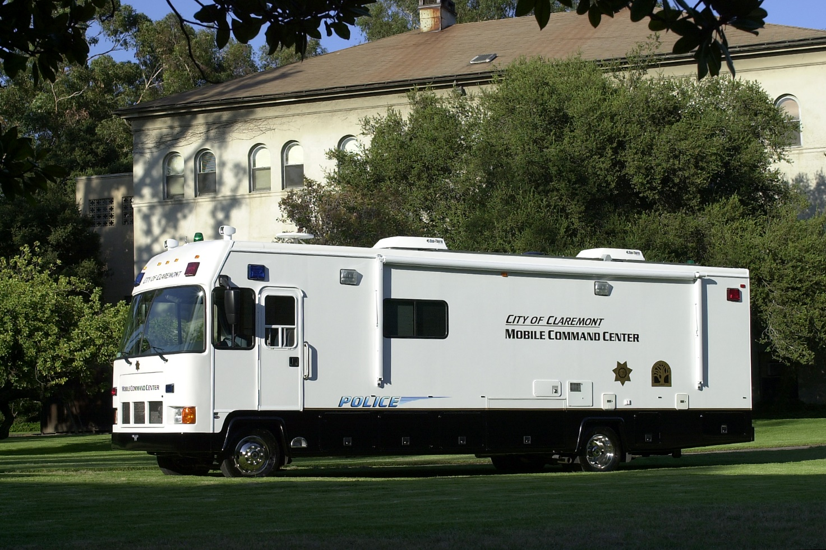

**Mobile EOC** The Claremont Police Department Mobile EOC serves as a portable Emergency Operations Center.

Standardized Emergency Management System (SEMS)

Claremont has adopted the Standardized Emergency Management System (SEMS) for responding to any large-scale disaster requiring a multi-agency and multi-jurisdictional response. Under the SEMS model, five functions activate in the event of a disaster, including:

* Management
* Operations
* Planning and Intelligence
* Logistics
* Finance and Administration

The City has prepared a SEMS Multi-hazard Functional Plan that will allow the City to take advantage of regional, State, and federal resources following any large-scale disaster. The duties of each function are coordinated through the EOC.

National Incident Management System (NIMS)

NIMS is the federal equivalent to the SEMS response plan and will become the national standard for responses to large-scale disasters and emergency responses.

Community Emergency Response Team (CERT) Program

In 2005, the Claremont Police Department partnered with the Los Angeles County Fire Department to coordinate a CERT program to teach and involve citizens in disaster identification, mitigation, and relief. In addition to public safety protection offered by the City, public education gives each community member the knowledge and power to respond quickly and wisely to disasters. The goal of the program is to minimize hazards by empowering citizens with the information to identify and detect hazards at an early stage, and to facilitate faster recovery. The program educates residents and City administrators who wish to learn about topics such as disaster preparedness, disaster fire suppression, disaster medical operations, search and rescue, disaster psychology and organization, and terrorism. Upon completion, participants will be able to identify hazards likely to impact their homes, perform steps to prepare for such hazards, and utilize basic medical treatments.

Mutual Aid

The City relies on mutual aid agreements with adjacent cities, counties, and resources from other government agencies to meet demands regarding emergency services, hospital needs in regional emergencies, and terrorism readiness.

Mutual Aid OES (Area D)

The City, through the Police Department, is a member/participant in the State of California Office of Emergency Services (OES) mutual aid and disaster management program. Through “Operational Areas,” OES staff coordinates training, development of disaster training and response plans, and coordinates the response to disasters and emergency related incidents. A supervisory or management level employee is assigned as the department’s liaison to Area D.

The Operation Emergency Management program provides a duty officer on a 24-hour basis to address inquires and concerns from county, local, and state officials regarding potential or escalating emergency conditions.

The City maintains a link to the County Emergency Operations Center. This link provides the City EOC with direct access to Office of Emergency’s Management Incident System (EMIS) via microwave and does not rely on typical phone line or computer access points. EMIS provides up to date emergency management information and the ability for the 88 cities in Los Angeles County to provide up-to-minute reports on situations impacting their communities.

Mutual Aid Platoon (Area D)

The Police Department participates in a countywide law enforcement mutual aid program managed by the Los Angeles County Sheriff Department, Emergency Operations Bureau. A supervisory or management level employee is assigned as the department’s liaison to Area D.

Mutual aid groups are utilized to respond to emergencies, both natural and human-caused, that exceeded the management capabilities of the law enforcement agency that has primary jurisdiction. Agencies participating in the mutual aid platoon system agree to participate in training exercises held annually by each of the areas. Each agency also agrees to send 50 percent of their on-duty personnel to any request for mutual aid.

Hospitals and Ambulance Service

In Claremont, emergency medical services are provided by Fire Station 101’s paramedic squad. If that station’s squad is busy, another paramedic squad from fire stations outside of Claremont is dispatched. Patients requiring further attention can seek medical assistance at the nearest hospitals, including Pomona Valley Community Hospital in Pomona and San Antonio Community Hospital in Upland. Disaster relief services are provided by the Claremont Chapter of the American Red Cross.

Evacuation Routes

Pursuant to State law, Safety Elements must indicate evacuation routes that would be used in the event of an emergency. Senate Bill 99 requires all cities and counties, upon the next revision of the housing element on or after January 1, 2020, to update the safety element to include information identifying residential developments in hazard areas that do not have at least two emergency evacuation routes. There are currently nine neighborhoods in the city that have been identified as having only a single access road. Figure 6-10 illustrates the nine identified neighborhoods that have a singular point of entry and exit. These neighborhoods pose additional logistics challenges when coordinating disaster response. The City has major evacuation routes which include State Route 210 and Interstate 10 as well as several major roadways including West Foothill Boulevard, East Baseline Road, North Mills Avenue, North Claremont Boulevard, and Redlands Avenue.

Terrorism Readiness and Response

Although terrorism may not appear to be a significant issue in Claremont since no critical or credible targets exist, the City nevertheless prepares its citizens for potential threats through informal seminars. To increase emergency survival during a terrorist attack, the Police Department offers presentations on terrorism readiness and response. The program is an extension of the Department of Justice Office of Community Oriented Policing Homeland Security Program, and educates the community on terrorism, emergency plans, updating emergency supplies, and procedures to follow in case of a terrorist threat or attack. The department also coordinates the Community Emergency Preparedness Action Committee (CEPAC) and Community Emergency Business Action Team (CEBAT).

Terrorist Early Warning Group (TEW)

The Terrorism Early Warning Group supports the County Emergency Operations Center. In the early 2000s, the Operational Area established a response or planning effort to deal with the response to terrorism. It established a Terrorism Working Group, chaired by the County Office of Emergency Management (an interagency entity) that also brings together many of the cities in the county. Key members are the Federal Bureau of Investigation, the Sheriff’s Department, city and county fire departments, and the Department of Health Services, as well as the state Office of Emergency Services.

Operationally, the TEW provides support in the event of a potential field response to terrorism. Area Command Teams support field response elements. Area Command Team is the law enforcement term, while Incident Management Team is the fire service counterpart. Both would be present at an actual terrorist event. These teams are essentially the overhead command elements that manage complex incidents in the field.

The TEW provides threat assessments, and works in conjunction with law enforcement agencies throughout the county in providing intelligence information and updates. A supervisory or management level employee from the Police Department is assigned as the departments’ liaison to the TEW.

Public Safety Goals and Policies

These goals and policies outline the City’s intent to promote safety and security through prevention and mitigation.

**Goal 6-1 Work to promote a safe community in which residents can live, work, and play.**

Policy 6-1.1 Foster an environment of trust by ensuring non-biased policing in Claremont, and by adopting policies and encouraging collaboration that creates transparency about the activities of the Police Department.

Policy 6-1.2 Facilitate traffic safety for motorists and pedestrians through proper street design and traffic monitoring.

**Goal 6-2 Minimize the risk of injury, loss of life, and damage to property resulting from natural and human-caused disasters and conditions.**

Policy 6-2.1 Practice proactive planning and development approaches that require developers to identify potential hazards that might affect a development and mitigate the potential hazards as needed to the satisfaction of the City.



Policy 6-2.2 Enforce Uniform Building Code standards for grading.

Policy 6-2.3 Review and explore disaster preparedness and emergency response capabilities on a regular basis.

Policy 6-2.4 Cooperate with and coordinate emergency preparedness and response programs with jurisdictions, agencies, and organizations such as surrounding cities, The Claremont Colleges, the Claremont School District, and the Los Angeles County Fire Department.

Policy 6-2.5 Continue and expand public educational programs to include all aspects of public safety.

Policy 6-2.6 Maintain a list of public buildings that could support emergency functions in the event of a disaster.

Policy 6-2.7 Require that development of major facilities and high-occupancy buildings in the hazardous zone submit design analysis, soils, geologic, and seismic reports to the City to indicate that an undue hazard does not exist or would not result from construction on the property.



Policy 6-2.8 Continually review the City's disaster communication system, and update/ modify as needed with added plans and accessibility measures for at-risk populations of unemployed, seniors, young children, and individuals with physical disabilities.

Policy 6-2.9 Continue to implement the City’s hillside plan to reduce harm to future residents at the urban interface.





Policy 6-2.10 Restrict vehicular and recreational use of the undeveloped foothill areas during critically hazardous periods.

Policy 6-2.11 Coordinate with electric utilities and emergency management services to establish backup power and emergency grid shutdown protocols that protect unemployed, seniors, young children, and individuals with physical disabilities.

Policy 6-2.12 Establish and maintain community fire breaks and fuel modification/reduction zones, including public and private road clearance.

Policy 6-2.13 Regularly update the City of Claremont Local Hazard Mitigation Plan to maintain eligibility for FEMA funding. Implement the recommended mitigation actions of the [2021 City of Claremont Local Hazard Mitigation Plan](https://www.ci.claremont.ca.us/home/showpublisheddocument/17937/637830222715800000) to better protect people and property from natural disasters and hazard events. Include an assessment and projection of future emergency service needs in the next update of the Local Hazard Mitigation Plan.

Goal: 6-3 Lower the risks of aircraft accidents.

Policy: 6-3.1 Adhere to airport comprehensive land use plans and restrictions established by the Federal Aviation Administration to reduce damage resulting from aircraft accidents.

Policy: 6-3.2 Coordinate with Los Angeles County Airport Land Use Commission to update the Los Angeles County Airport Land Use Plan and adopt the Cable Airport’s Airport Influence Area within Los Angeles County.

Policy: 6-3.3 Coordinate with Los Angeles County Airport Land Use Commission to request the Los Angeles County Planning Commission adopt the 2015 Cable Airport Land Use Compatibility Plan.

Policy: 6.3.4 Request City Council adoption of the 2015 Cable Airport Land Use Compatibility Plan and incorporate relevant compatibility policies into regulatory documents, as appropriate.

Seismic Hazards

The presence of multiple faults within and near Claremont poses constant seismic threats to residents and workers. Continuing investigation of faults will provide important information to help assess their potential threats. The goals and policies for seismic hazards emphasize land use and building requirements for structures in seismic hazard zones and retrofit of hazardous buildings.

**Goal 6-4 Minimize risks to public safety from seismic events.**

Policy 6-4.1 Enforce the most recent building codes governing seismic safety and structural design to minimize damage from earthquakes.

Policy 6-4.2 Continue to support efforts to identify location, potential activity, and dangers associated with faults under investigation, and implement recommendations (setbacks, foundation/building design methods, etc.) contained in geotechnical reports.

Geologic Hazards

Development could expose future residents to geologic hazards particularly in hillside areas. The goals and policies of geologic hazards address the need for proper land use requirements to prevent foreseeable geologic hazards.

**Goal 6-5 Minimize risks to public safety from geologic events.**

Policy 6-5.1 Require geotechnical evaluation and recommendations prior to new development, as appropriate. Such geotechnical evaluation shall analyze the potential hazards from:

* Landslides
* Liquefaction
* Expansive soils
* Mud and debris flow

Recommendations shall include mitigation to avoid or minimize the identified hazards.

Flood Hazards

Claremont will protect its residents from flood hazards through structural and non-structural planning such as dam reinforcement and adequate evacuation plans.

**Goal 6-6 Minimize the risks associated with storm flooding and dam inundation.**

Policy 6-6.1 Work with the U.S. Army Corps of Engineers and Los Angeles County to ensure dam structures are upgraded as needed to withstand earthquakes and prevent inundation of downstream areas.

Policy 6-6.2 Work with the U.S. Army Corps of Engineers and Los Angeles County to encourage regular maintenance and monitoring of flood-control facilities.

Policy 6-6.3 Complete the Chicken Creek flood control measures, and transfer operations and management to Los Angeles County.

Fire Hazards

Large portions of the City are located within VHFHSZ’s and are susceptible to wildfire. The City will strive to administer proper fire mitigation through public education, fuel identification and reduction, and land use restrictions within and around VHFHSZ’s. In case of fire emergencies, the City will strive to be sufficiently equipped with facilities and personnel to mitigate fire hazards.

**Goal 6-7 Minimize the risks associated with urban and wildland fires.**

Policy 6-7.1 Work with the Fire Department to establish minimum standards for water supply and access for fire-fighting equipment. Ensure that water supply and system pressure is sufficient to provide adequate fire flow for current and planned peak demand and that maintenance and long-term integrity of water supplies will be provided.

Policy 6.7-2 Work with Fire Department to enforce restrictions on vehicular and recreational use of foothill areas during critically hazardous periods.

Policy 6-7.3 Update the City's development standards to be in conformance with title 14, CCR, division 1.5, chapter 7, subchapter 2, articles 1-5 (commencing with section 1270) (SRA Fire Safe Regulations) and title 14, CCR, division 1.5, chapter 7, subchapter 3, article 3 (commencing with section 1299.01) (Fire Hazard Reduction Around Buildings and Structures Regulations).

Policy 6-7.4 Continue to work with the Fire Department to establish an aggressive fire inspection and code enforcement program with a focus on low-cost retrofitting for existing developments and limiting new developments in VHFHSZs.

Policy 6-7.5 Identify and/or map existing development that does not conform to current state and/or locally adopted fire safety standards for access, water supply and fire flow, signing, and vegetation clearance in SRAs or VHFHSZs.

Policy 6-7.6 Permit new development only within areas that have adequate water pressure or fire flows and provide adequate access (ingress, egress) and a minimum of two roadways with widths and lengths in compliance with California Building Code Chapter 7A requirements.

Policy 6-7.7 Conduct a City-wide survey of vegetation conditions in drainage corridors and similarly well vegetated areas that could provide opportunities for wildfire to approach valued assets and specify recommended actions to continually reduce wildfire risks in these locations.

Policy 6-7.8 Require fire safe development codes to use as standards for fire protection for new development in SRAs or VHFHSZs that meet or exceed the statewide minimums in the SRA Fire Safe Regulations including zoning public facility buildings to exclusively areas outside of VHFHSZs.

Policy 6-7.9 Develop and maintain building and landscaping requirements and protocols that integrate CAL FIRE and LACFD regulations and procedures for existing non-conforming development, low-cost retrofits, and future development including a fire protection plan for all new development in VHFHSZs.

Policy 6-7.10All redevelopment after large fires in the VHFHSZ shall comply with current codes related to fire safety and building construction standards.

Policy 6-7.11 Conduct evacuation route capacity analysis as part of regular updates to the City-adopted Hazard Mitigation Plan to identify areas with inadequate access (for both personal and emergency vehicles), capacity or evacuation routes and examine possible mitigations. Maintain and update an Evacuation Plan every 8 years at a minimum to account for all types of emergencies.

Policy 6-7.12 Develop and maintain a GIS-based land inventory to identify fuel reduction status and points of contact to inform load reduction activities. Consult this inventory for new development in SRAs or VHFHSZs.

Policy 6-7.13 Establish and maintain a Disaster Recovery Plan that includes debris removal and evaluation of post-disaster re-development options.

Policy 6-7.14 Actively collaborate with the Los Angeles County Fire Department to develop and maintain a citywide Vegetation Management Plan that aligns with the Los Angeles County Fire Department Vegetation Management Program. This plan should:

- Discourage development and encourage sensitive siting of structures within hazardous fire areas as higher priorities than attempting to implement fuel modification techniques that would adversely affect significant biological resources

- Include updated requirements and guidelines regarding landscaping design, species preferences, installation, and maintenance to reduce vulnerability to ember ignition, and generally, wildfire impacts in new development and proposed retrofits.

- Address long term maintenance of fire hazard reduction projects, including community fire breaks, private road and public road clearance, and fuel modification and reduction zones.

Policy 6-7.15 Actively coordinate with CAL FIRE during their updates to Fire Hazard Severity Zone maps and update planning documents, as necessary, to address changes to Fire Hazard Severity Zones in the city.

Policy 6-7.16 Prohibit new development in VHFHSZs unless the new development is surrounded by existing or entitled development, meets secondary ingress and egress route requirements, and the capacity of adjoining streets and highways can accommodate evacuation.

Policy 6-7.17 Engage the Los Angeles County Fire Department in the review of development to ensure that any new development will have adequate fire protection, including provisions for fire flow and emergency vehicle access.

Hazardous Waste Management

The City will promote proper disposal of hazardous waste material by educating the community of the dangers of improperly handled hazardous materials and by adhering to the guidelines of the Los Angeles County Hazardous Waste Management Plan. This will promote a healthy and safe environment for workers and residents of Claremont.

**Goal 6-8 Minimize the improper storage and dumping of hazardous waste materials.**

****Policy 6-8.1 Educate residents regarding the types of household hazardous waste and proper manners of disposal and continue to have yearly hazardous waste round-ups.

Policy 6-8.2 Utilize the Los Angeles County Hazardous Waste Management Plan as a guide to future hazardous waste management planning efforts.

Policy 6-8.3 Continue to require that all proposals for businesses involved in hazardous materials use, storage, or transport areas submit a hazards safety plan to appropriate City agencies, and the County Fire Department for review of potential hazards.

Policy 6-8.4 Inform residents about the dangers of improper disposal of hazardous materials.

Police Services

The City will strive to provide police services through unbiased staff members and police officers, state-of-the-art facilities, and the use of the latest technologies. Preventative policing practices, community-oriented policing, and use of volunteers and outreach activities are intended to involve the Claremont community in providing comprehensive policing services.

**Goal 6-9** Provide effective and comprehensive policing services and enforce laws in an equitable way.

Policy 6-9.1 Provide a state-of-the-art Police Station and up-to-date emergency communications technology for the Claremont Police Department.

Policy 6-9.2 Continue to encourage design concepts that inhibit criminal behaviors.

Policy 6-9.3 Provide timely responses to emergency and non-emergency calls for service 24 hours a day.

Policy 6-9.4 Strive for the smooth and efficient movement of traffic throughout the community.

Policy 6-9.5 Recruit, hire, and train personnel to provide public service in an unbiased manner.

Policy 6-9.6 Continue to develop and implement community oriented Policing Project to foster accountability, mutual trust, and respect between the community and the Police Department.

Policy 6-9.7 Assign personnel and resources, such that each police patrol unit can maintain 30 to 35 percent “free patrol” time to provide preventative crime patrol, proactive traffic enforcement and regulation, and community-oriented public safety service.

Policy 6-9.8 Initiate proactive crime suppression and prevention strategies throughout the community.

Policy 6-9.9 Provide additional, cost-effective public safety services through the utilization of volunteers in our Police Reserve Officer, Community Patrol Volunteer Program, Explorer Program, Traumatic Intervention Service, and Community Emergency Response Team (CERT).

Policy 6-9.10 Participate in school liaison activities such as Healthy Start Collaborative Program (School Resource Officer), Drug Abuse Resistance Education (D.A.R.E.), School Attendance Review Board (SARB), and other joint police/school district projects that may be developed in the future.

Policy 6-9.11 Participate in community outreach activities such as Neighborhood Watch, Business Crime Watch, security surveys, crime prevention presentations, Designated Driver, Bike Safety Rodeos, CERT, Citizen’s Academy, and other activities that may be developed in the future.

Policy 6-9.12 Continue to monitor gang activities in the community, and work with surrounding jurisdictions and outside groups and organizations to prevent criminal activities and gang violence.

Emergency Services

The City will work to provide proper response and preparedness to natural and human-caused disasters by collaborating with other jurisdictions and by abiding by the City’s Emergency Plan both before and after emergencies. The City will continue public educations regarding emergency preparedness to protect its citizens in case of local, regional, and national threats and emergencies. The City will develop and maintain these services with attention to vulnerable populations and adapt services to different areas and populations.

**Goal 6-10 Strive to m**aintain the highest level of emergency preparedness for natural and human-caused disasters and threats.

Policy 6-10.1 Educate residents of hazards and threats addressed in the Claremont Emergency Plan/SEMS Multi-hazard Functional Plan and the Natural Hazard Mitigation Basic Plan and use these plans as a guide to prevention and mitigation of natural and human-caused hazards.

Policy 6-10.2 Educate City staff to follow established procedures and responsibilities stated in the Emergency Plan/SEMS Multi-hazard Functional Plan and the Natural Hazard Mitigation Basic Plan in the event of an emergency. Include goals and standards for emergency service training in future updates of the Emergency Plan.

Policy 6-10.3 Complete implementation of a reverse 911 system to facilitate evacuation in case of an emergency.

Policy 6-10.4 Respond to emergency calls for service within an average of less than four minutes.

Policy 6-10.5 Work to ensure the adequacy of disaster response and coordination of all segments and populations in the community with focus on unemployed, seniors, young children, and individuals with physical disabilities.

Policy 6-10.6 Continue to have a paramedic squad assigned within Claremont boundaries.

Policy 6-10.7 Establish and maintain a Disaster Recovery Plan that includes critical needs, such as debris removal and evaluation of post-disaster re-development options.

Policy 6-10.8 Provide bilingual (English and Spanish) public health, emergency preparedness, and evacuation information to citizens through libraries, the City website, radio, and other platforms.

Policy 6-10.9 Conduct regular evacuation trainings with single-access community HOAs and residents; encourage residents in single-access communities to maintain emergency supplies for at least 3 days.

Policy 6-10.10 Develop customized evacuation trainings for seniors, household with young children, and households that include people with mental and physical disabilities.

**Evacuation Preparedness**

The City will develop plans and procedures to increase the readiness of residents, facilities, and infrastructure in the event of an evacuation. Evacuation plans will encompass the range of potential natural disasters that are expected to impact the City of Claremont. The City will additionally enforce building codes and ordinances ensuring facility preparedness for anticipated evacuation needs.

**Goal 6-11 Strive to maintain the highest level of evacuation preparedness for natural and human caused disasters and threats.**

Policy 6-11.1 Create evacuation plans for seniors, young children, and individuals with physical disabilities that may need assistance to evacuate and maintain a plan of evacuation for those populations updated annually.

Policy 6-11.2 Conduct evacuation trainings with the community by collaborating with community groups at the neighborhood-scale.

Policy 6-11.3 Develop a school evacuation training to be taught to kindergarten through 12th grade students on an annual basis coordinated with the School District. The training should include wildfire preparedness.

Policy 6-11.4 Have a specific VHFHSZ evacuation plan created for the residential communities zoned within the area updated annually.

Policy 6-11.5 Continue to disseminate information relating to fire prevention, evacuation and defensible space measures and resident response to emergency situations with added plans and accessibility measures for at-risk populations including, seniors, and individuals with physical disabilities.

Policy 6-11.6 Enforce maintenance of visible home and street addressing and signage.

Policy 6-11.7 Regularly evaluate the availability and anticipated demand for community facilities to serve as evacuation centers or designated cooling or smoke relief center during emergencies. Designate such facilities and regularly maintain them to comply with industry standards.

Policy 6-11.8 Encourage advanced coordination between transit operators to facilitate evacuations during natural and human caused disasters and threats to community centers serving as evacuation centers.

Policy 6-11.9 Use available data and studies to simulate how expanded wildfire, flooding, and landslide impacts might affect the transportation system; In particular, study changes along designated evacuation routes associated with more frequent and severe wildfire, flood, and landslide events.

**Extreme Heat**

**Goal 6-12 Minimize the risk associated with extreme heat.**

Policy 6-12.1 Increase shading and use of heat-mitigating materials on pedestrian walkways and transit stops.

Policy 6-12.2 Increase general vegetative coverage by expanding and maintaining the urban tree canopy and appropriate shade structures, including planting native bushes and trees that provide shade canopy.

Policy 6-12.3 Improve outreach to and prepare resources for vulnerable populations including seniors, households with young children, and individuals with physical disabilities to better prepare for and deal with extreme heat events.

Policy 6-12.4 Review and update local heat response plan considering climate change (heat events) projections.

Policy 6-12.5 Work with local California Energy and Power as well as the City Manager’s Office to review the adequacy of programs designed to help vulnerable populations stay cool during heat waves, with attention to ways to offset the economic impacts on seniors and low-income groups.

Policy 6-12.6 Coordinate with transit agencies to identify ways for unemployed, seniors, young children, individuals with physical disabilities and/or limited mobility to reach cooling centers.

Policy 6-12.7 Invest in sustainable backup power sources to provide redundancy and continued services for critical facilities during periods of high demand during extreme heat events.

**Climate Change Adaptation**

**Goal 6-13 Increase the ability of the City and its residents to adapt to climate change.**

Policy 6-13.1 Facilitate planning and implementation of adaptation measures in communities with unequal burdens or insufficient resources to respond to climate risks associated with extreme heat, wildfire, drought, or landslides . Consider equity as part of grants for local adaptation.

Policy 6-13.2 Increase the resiliency of existing residential and commercial development through structural strengthening, fire safe landscaping, and energy efficiency upgrades.

Policy 6-13.3 Identify projects as part of capital improvement programs that should consider climate risks and incorporate adaptive design elements and strategies.

Policy 6-13.4 Provide incentives to promote air pollution reduction, including incentives for developers who go above and beyond applicable requirements and mitigate pollution for facilities and operations that are not otherwise regulated.

Policy 6-13.5 Mitigate landslide risks by improving drainage, reconstructing retaining walls, installing netting and vegetation, avoiding clear cutting, and stabilizing the soil after tree clearing, such as with compost and mulch.

Policy 6-13.6 Establish a regular inspection and maintenance cycle for existing physical landslide defenses, including inspections prior to heavy rain events and post-wildfire events.

Policy 6-13.7 Restore degraded ecosystems to enhance the natural adaptive capacity of biological communities that are vulnerable to the effects of climate change.

Policy 6-13.8 Partner with the Los Angeles County Health Department to develop and enhance disaster and emergency early warning systems to incorporate objective data and information for potential health threats such as heat-illness, and illnesses complicated by low air quality due to climate change hazards.

Noise

Excessive noise can disrupt our lives. From the continuous thrum of cars and trucks traveling the freeways to the unnerving whine of gasoline-powered leaf blowers on an otherwise quiet morning, noise can interrupt our conversations, our thoughts, and our leisure activities. Noise sensitivity varies depending on the time of day, its duration and pitch, and preferences of individuals. Despite this variability, most residents agree that too much noise or the wrong type of noise irritates us and can adversely affect our health.

In Claremont, transportation corridors are the major source of noise. Interstate 10, Interstate 210, and the Metrolink and planned Gold Line train tracks all traverse the breadth of the City west to east. In addition, aircraft operations at Cable Airport and Brackett Field, and aircraft flights from Ontario International Airport, fly over Claremont.



**San Bernardino Metrolink Line** The San Bernardino Line is Metrolink’s busiest line. The line connects downtown Los Angeles, Union Station to San Bernardino. Over 30 trains stop at Claremont TransCenter on a daily basis.

Scope of Noise Element

In recognition of the adverse health effects associated with excessive noise, the California Government Code, Section 65302(f) very specifically identifies the types of community noise to be addressed in the General Plan. The Noise Element is to identify noise sources from:

* Highways and freeways
* Primary arterials and major local streets
* Passenger and freight on-line railroad operations and ground rapid transit systems
* Commercial, general aviation, heliport, and military airport operations, aircraft over-flights, jet engine tests stands, and all other ground facilities and maintenance functions related to airport operations
* Local industrial plants, including, but not limited to, railroad classification yards
* Other stationary ground noise sources identified by local agencies as contributing to the community noise environment

Noise Metrics

Evaluating noise is complex. The unit of measurement is an A-weighted sound pressure level, or dB(A), which accounts for sound pressure level, as well as the pitch of sound and the way the average human ear responds to the pressure and pitch. Health considerations associated with excessive noise exposure include hearing loss or damage, interference with oral communication, and interference with sleep. At prolonged exposure at sound levels over 85 dB(A), a person experiences hearing loss. At 60 dB(A), noise impairs speech intelligence, and sound levels over 40 to 45 dB(A) can disturb sleep.[34]

To account for the fact that noise during night-time hours can be more irksome than day-time noise, acousticians have developed noise metrics that apply a weighed ambient noise level average over a 24-hour period, giving “penalties” to noise that occurs during the 10:00 p.m. to 7:00 a.m. period. These metrics are defined as either the Community Equivalent Noise Level (CNEL) or Day-Night Level (Ldn). Noise contour maps – similar to topographic maps that show steepness of terrain – can then be developed to identify noise level averages throughout the community.

Noise Conditions in 2005

Figure 6-6 shows noise exposure contours in the City of Claremont, represented by Ldn, for baseline year 2005. These contours take into account the following noise sources.

Traffic Noise

Noise from the freeways crossing Claremont exceeds 65 Ldn, which is generally considered a threshold noise level for residential use.[35] Freeways are under the state’s jurisdiction, and local jurisdictions encountered difficulties through the years having Caltrans address community noise concerns. Concerned Claremont community members organized Citizens Against Freeway Noise following the opening of the Interstate 210. The group held public meetings to 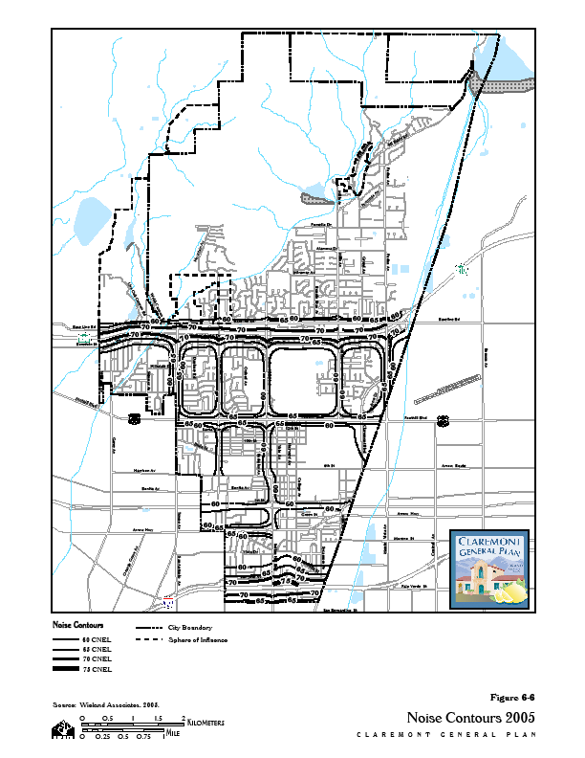address noise abatement issues and made recommendations regarding freeway noise impacts in Claremont. Caltrans has refused to implement any of these recommendations, and noise from the freeway continues to rise as the number of vehicles using the freeway increase. As a result, noise from the freeway remains an important issue for many residents in the community. To achieve any relief from the noise, Claremont will need to continue to press California Department of Transportation (Caltrans) and State and federal legislators for noise mitigation programs.

**Interstate 10 Freeway**

Although only a small segment of the 10 Freeway crosses Claremont, noise surveys show an Ldn level of 70 to 74 dB near the 10 Freeway, impacting residential neighborhoods along the route. Noise emanating from the 10 Freeway is due in part to the rough freeway surface, and thus far remains unmitigated by Caltrans.[36]

**Interstate 210 Freeway**

Noise surveys undertaken in 2003-2004 showed an Ldn level of 67 to 72 dB near the 210 Freeway. Noise concerns and abatement are similar to the 10 Freeway. At the time of freeway planning and construction, Claremont residents monitored Caltrans’ efforts to ensure that freeway noise would not adversely impact the residential neighborhoods flanking the route. However, after the 210 Freeway opened and traffic volumes increased, the sound levels exceeded those predicted by planning models, negatively affecting a very large section of the city. Causes for the excessive noise includes poor choice in paving material, the grade changes at the east and west ends of the city, and lack of landscaping.

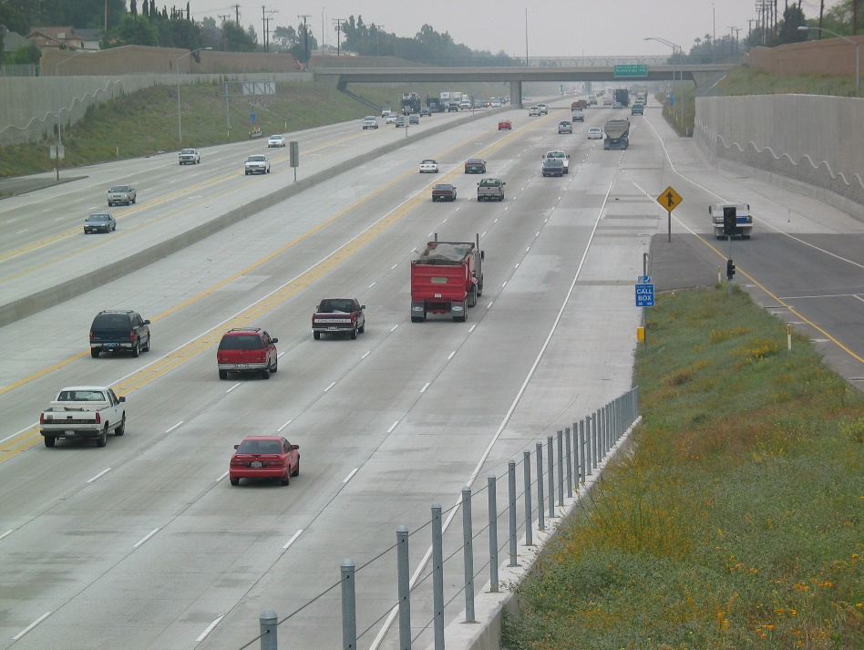

Major and Secondary Arterials

Residents near Major and Secondary Arterial roadways also experience high noise levels during peak commute hours. Community noise monitoring and modeling studies conducted in 2004 indicated that noise levels along most major roadways in Claremont exceed the 65 Ldn threshold.

**Table 6-4**

**Arterial Segments Generating an Ldn in Excess of 65 dB**

|  |  |
| --- | --- |
| **Arterial** | **Segment** |
| Arrow Highway | West City limits to Indian Hill Boulevard |
| Base Line Road | N. Towne Avenue to East City limits |
| Foothill Boulevard | N. Towne Avenue to East City limits |
| Indian Hill Boulevard | Arrow Highway to Foothill Boulevard. |
| Monte Vista Avenue | Claremont Boulevard. to Base Line Road |
| N. Towne Avenue | Foothill Boulevard. to Base Line Road |

Railway Noise

The Metrolink San Bernardino County Line, operated by Southern California Regional Rail Authority (SCRRA), stops at the Claremont Station. The line operates seven days a week, with trains running between 4:00 a.m. to 10:00 p.m., with the schedule varying on weekends and weekdays. The noise levels from the trains are within the required sound limits, but the whistle and warning bells are a source of annoyance.

**Cable Airport** Cable Airport is the largest privately owned airport open to the public in the country and was established in 1945 by Dewey and Maude Cable.

Once fully operational, the Metro Gold Line light-rail passenger service will travel from the Montclair Transit Center to Los Angeles’ Union Station. Through Claremont, the Gold Line will run along tracks parallel to the Metrolink route. This increased rail traffic will elevate the bell and whistle noise from the trains through the City, and depending upon Gold Line schedules and train frequency, some form of noise abatement may be needed.



Aircraft Noise

Although not as significant as the other noise sources, airplanes and helicopters represent a third source of transportation-related noise in Claremont. The proximity of Cable Airport, Ontario International Airport, and Brackett Field, and law enforcement patrol helicopters, all contribute to aircraft noise in our skies.

Cable Airport

Cable Airport, located just beyond the Claremont city limit in Upland, is a privately owned and operated general aviation facility that allows public access. Measured noise contours associated with Cable Airport operations are identified in the Cable Airport Land Use Compatibility Plan, which promotes compatibility between Cable Airport and the land uses that surround it. The Compatibility Plan outlines noise compatibility criteria to avoid establishment of noise-sensitive land uses in the portions of the airport environs that are exposed to some levels of aircraft noise. The plan identifies compatibility zones and establishes policies, as appropriate, for land use within the zones.

The Plan also outlines measures to guide use of the document by particular local agencies, including Los Angeles County Airport Land Use Commission and the City of Claremont, specifically, coordination between the jurisdictions should occur to encourage appropriate land use compatibility review.

The 2015 Cable Airport Land Use Compatibility Plan can be found in Appendix XX of this document.

Ontario International Airport

Ontario International Airport serves over seven million passengers annually, and its capacity is increasing as Inland Empire air cargo service and passengers continue to grow. The airport’s proximity to Claremont provides convenient access for trips, both domestic and international travel.

Aircraft take-offs from Ontario International Airport impact the local environment since the established flight path for aircraft departing the airport follows the 10 Freeway through the south part of Claremont. The noise impacts increase when pilots deviate from the established flight path by turning early and flying north over the central part of Claremont.

Over the years, Claremont has worked with officials from the Los Angeles World Airports (LAWA), which operates Ontario International Airport, to minimize the “early turns.” LAWA established a “no early-turns” notification program to increase pilot awareness regarding noise intrusion over the City of Claremont. The program instructs the pilots that they are not to fly north over Claremont except when conditions for traffic safety dictate alternative flight paths. This program has helped reduce the number of early turns. Reducing early turns requires constant monitoring of the number of early turns and the on-going efforts of LAWA to continually remind pilots of the no early turns policy.

Brackett Field

Brackett Field, also a general aviation airport, is owned by Los Angeles County and services private and business aircraft. The airport, located in La Verne, serves around 2,500 annual passengers. Although Brackett Field’s noise contours do not impact Claremont, flight paths cross over the City, and Claremont residents occasionally voice concerns over associated noise.

Helicopters

Helicopter noise can be more irritating than noise from other aircraft because helicopters operate at low altitudes and produce more noise. Air surveillance and patrol are essential public safety services that often involve helicopter operations, and we tend to tolerate this occasional noise. Helicopter operations also include news and traffic monitoring helicopters. However, helicopter operations during late-night hours can be bothersome, and the frequency of helicopter operations has increased since the opening of the 210 Freeway.

Non-Transportation Noise Sources

Noise sources are not limited to planes, trains, and automobiles. In Claremont, activities in our commercial and industrial districts are potential stationary noise sources. Because most business are low scale, low intensity, and conducted indoors, with the exception of vehicle sales, noise generally is limited to that associated with loading dock operations, frequent truck uses, mechanical equipment, and use of outdoor paging systems. The City regulates construction activity to prevent disturbances at night and on weekends.

Claremont residents value their quiet residential neighborhoods. However, this quietness can be interrupted by noise generating from property maintenance equipments such as lawnmowers or home repair activities. Such activities conducted at early morning and late evening hours can disturb sleep and affect quality of living. Implementation of the City’s noise regulations will help maintain optimal interior and exterior noise levels within residential areas.

Noise and Land Use Compatibility Guidelines

Integral to sustaining our quality of life is ensuring we live in an environment where we can hear ourselves think, enjoy outdoor activities free from excessive or irritating noise, and sleep soundly with our windows open. Students in our schools and at The Colleges deserve and benefit from quiet places to study. Our goals are twofold: 1) to plan land uses that avoid noise/land use conflicts to the greatest extent possible, and 2) to mitigate noise sources that impact our quality of life.

Table 6-5 sets forth the guidelines we use for planning new land uses and the goals we seek to achieve for indoor and outdoor noise environments. Of particular importance are the standards for residential land uses, whereby an exterior noise level of 65 Ldn (70 Ldn for higher-density developments) is considered the maximum acceptable level. This 65 Ldn standard also applies to schools.

Noise Impact Areas – Baseline Conditions

Based on noise measurements obtained during 2003-2004, the City developed noise contour maps that illustrate 24-average noise conditions throughout Claremont. Figure 6-6 is the noise contour map for baseline year 2005.

For the most part, residential neighborhoods in Claremont experience noise environments consistent with the City’s guidelines. However, homes along the 10 Freeway and the 210 Freeway are exposed to noise levels at or above 65 Ldn. Residential properties that back up to Foothill Boulevard also lie within the 65 to 70 Ldn contour. Other noise-sensitive uses exposed to higher noise levels include:

* Claremont Adult School
* The Claremont Colleges
* Community Day School
* Mountain View Elementary School
* San Antonio High School
* School of Theology at Claremont
* Mallows Park
* Memorial Park
* Rancho San Jose Park

##### **Table 6-5**

Claremont Land Use/Noise Guidelines

|  |  |  |  |
| --- | --- | --- | --- |
| **Property Receiving Noise** | | **Maximum Noise Level**  **(Ldn or CNEL, dBA)** | |
| Type of Use | Zoning Designations | Interior | Exterior3 |
| Residential | Hillside | 45 | 65 |
| Rural |
| Very Low |
| Low |
| Low Medium |
| Medium | 45 | 65 / 701 |
| High | 45 | 701 |
| Commercial and Office | Professional Commercial | -- | 70 |
| Neighborhood |
| Limited |
| Major |
| Highway |
| Freeway |  |  |
| Professional Office | 50 | 70 |
| Business Park | Business Park | 55 | 75 |
| Public/Institutional | Schools | 50 | 65 |
| All others | 50 | 70 |
| Open Space | Active Open Space | -- | 70 |
| Passive Open Space | -- | 70 /652 |
| 1 Maximum exterior noise levels up to 70 dB CNEL are allowed for Multiple-Family Housing.  2 Where quiet is a basis required for the land use.  3 Regarding aircraft-related noise, the maximum acceptable exposure for new residential development is 60 dB CNEL. | | | |

Noise Impact Areas – Year 2025 Conditions

Land use policy set forth in the Land Use, Community Design, and Heritage Preservation Element provides for some moderate growth with the inclusion of mixed use designations. Thus, any change in noise levels over time will be attributable to increased traffic volumes and projected land use development activity. Figure 6-8 shows noise exposure contours in the City of Claremont for the projected future noise environment based on future traffic volumes.

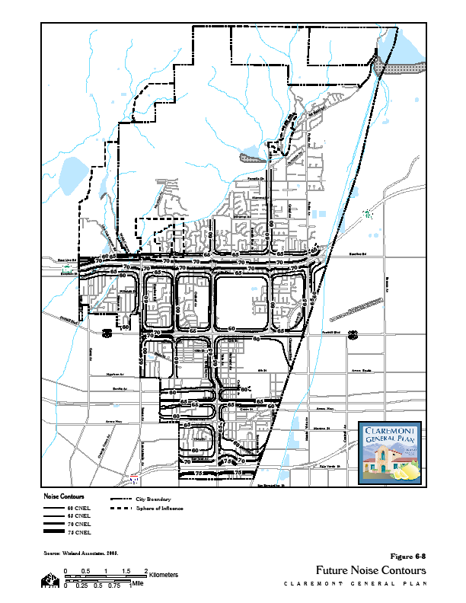Noise Goals and Policies

The goals and policies regarding community noise aim to abate noise and preserve high quality of life for Claremont residents. The City will maintain a peaceful environment by identifying noise impacts and mitigating noise problems through acoustical treatments and appropriate land use policies.

Transportation-Related Noise

Transportation routes represent the predominant noise source in Claremont. Sounds emitted from rail, aircraft, and automobiles can be mitigated through sound barriers and a stricter adherence to noise level requirements. Since most transportation-related noise problems are regional or outside the City’s jurisdiction, the City will negotiate/work with responsible agencies to address noise concerns.

**Goal 6-14 Work with other agencies to minimize the impact of transportation-related noise, including noise associated with freeways, rail lines, and airports.**

Policy 6-14.1 Require development which is, or will be, affected by railroad noise to include appropriate measures that will minimize adverse noise effects to the City’s future residents.

Policy 6-14.2 Encourage existing City vehicles and equipment to the extent practical to reduce or eliminate unnecessary noise.

Policy 6-14.3 Participate with federal, state, and local government agencies in the development and implementation of noise abatement programs.

Policy 6-14.4 Support the efforts of local property owners and residents to reduce noise impacts associated with the 10 and 210 Freeways.

Policy 6-14.5 Work with and monitor the efforts of the Los Angeles County Metropolitan Transportation Authority and other responsible agencies to minimize any noise impacts associated with Gold Line operations.

Policy 6-14.6 Work with Southern California Regional Rail Authority so that noise intrusions from operation of Metrolink trains are minimized in neighborhoods along the commuter line.

Policy 6-14.7 Encourage the operators of Cable Airport (City of Upland) and Brackett Field (City of La Verne and the County of Los Angeles) to ensure that the users of the airports know and obey the flight-pattern requirements and altitude restrictions.

Policy 6-14.8 Encourage the installation of noise-mitigating equipment and noise-attenuation devices at Ontario International Airport, and encourage full evaluation of noise impacts on major changes related to operations at Ontario International Airport.

Policy 6-14.9 Continue to work with Los Angeles World Airport and Federal Aviation Administration officials to minimize noise impacts from aircraft take-offs from Ontario International Airport. Efforts should include ensuring established flight patterns are adhered to utilizing technically more advanced, less noisy aircraft.

Policy 6-14.10 Persuade operators of helicopters within the Claremont planning area to modify operational procedures, to the extent possible, to reduce noise levels produced by helicopters.

Non-Transportation Noise Sources

**Goal 6-15** Minimize the impact of excessive noise levels throughout the community, and adopt appropriate noise level requirements for all land uses.

Policy 6-15.1 Use noise contour maps and noise/land use compatibility criteria in planning and development decisions.

Policy 6-15.2 Develop standards and encourage private property owners to locate, screen, and/or buffer equipment in order to reduce noise impacts on surrounding areas.

Policy 6-15.3 Minimize noise from property maintenance equipment, construction activities and other non transportation noise sources by enforcing designated construction and maintenance hours.

Policy 6-15.4 Require mitigation of any potential noise impacts before allowing mining of aggregate resources.

1. City of Claremont *City of Claremont Natural Hazard Mitigation Basic Plan*, adopted by City Council 26 October 2004, p. 10.
2. Wright. p. 331
3. James Manifold. Member of the Citizens Committee for Claremont. 2004-06.
4. Jay Atenen. “Inferno Engulfs Claremont, Approaches Campus,*”* The *Student Life News*. 2003.
5. City of Claremont, *SEMS Multihazard Functional Plan*, March 18, 2004. p. 50.
6. Wilson Geosciences, Inc. *Seismic and Geologic Technical Background Report for the Claremont General Plan Update.* June 2005, p. G-20.
7. Wilson Geosciences, p. G-1.
8. Wilson Geosciences, p. G-12.
9. Wilson Geosciences. P. G-10
10. Wilson Geosciences, p. G-36.
11. Wilson Geosciences, p. G-39.
12. Wilson Geosciences, p. G-40.
13. Wilson Geosciences, p. G-40.
14. Wright. p. 363.
15. City of Claremont, *SEMS Multihazard Functional Plan*, p. 74.
16. City of Claremont, *SEMS Multihazard Functional Plan*, pp. 74-75.
17. City of Claremont, *Natural Hazard Mitigation Basic Plan*. pp. 8-15.
18. City of Claremont, *Natural Hazard Mitigation Basic Plan*. p. 11.
19. 21P&D Consultants, *Hillside Existing Conditions Paper,* July 2004. p. 8-9.
20. City of Claremont, *Natural Hazards Mitigation Basic Plan*, pp. 9:7.
21. City of Claremont, *SEMS Multihazard Functional Plan*, p. 73.
22. Claremont Courier, January 27, 2022 (https://claremont-courier.com/police-blotter/latest-windstorm-information-from-claremont-police-57132/)
23. https://www.energy.ca.gov/sites/default/files/2019-11/Reg%20Report-%20SUM-CCCA4-2018-007%20LosAngeles_ADA.pdf
24. https://cal-adapt.org/tools/local-climate-change-snapshot/
25. https://www.energy.ca.gov/sites/default/files/2019-11/Reg%20Report-%20SUM-CCCA4-2018-007%20LosAngeles_ADA.pdf
26. https://www.energy.ca.gov/sites/default/files/2019-11/Reg%20Report-%20SUM-CCCA4-2018-007%20LosAngeles_ADA.pdf
27. https://cal-adapt.org/tools/local-climate-change-snapshot/
28. https://cal-adapt.org/tools/local-climate-change-snapshot/
29. Los Angeles County Department of Public Works website. < http://www.lacofd.org/about_hhmd.htm > (October 3, 2005).
30. Wright. pp. 177-181.
31. Claremont Police Department website. <[http://www.claremontpd.org/uniform_services/records/records.htm> (10](http://www.claremontpd.org/uniform_services/records/records.htm%3e%20%20(10) October 2005).
32. Wright. pp. 171-175.
33. City of Claremont, *Natural Hazards Mitigation Basic Plan*. pp. 8-14, 15.
34. Wieland Associates, Inc., *Evaluation of the Existing Noise Environment for the City of Claremont General Plan*, February 2005, p. 5.
35. Wieland Associates, Inc., p. 10.
36. Urban Crossroads, Inc. *Notes from Foothill Freeway Impacts*. 29 January 2003. and *State Route Freeway Draft Noise Impact Assessment* . 9 January 2004.