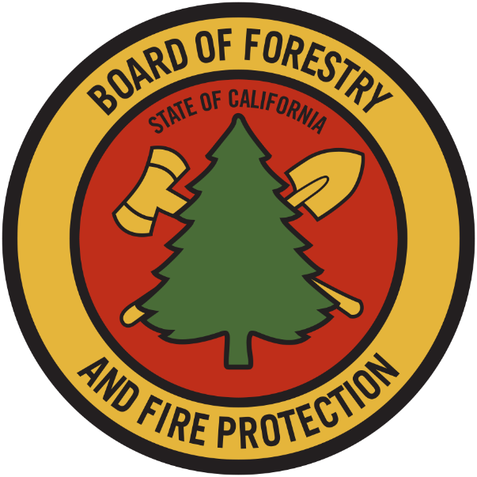

THE BOARD OF

FORESTRY AND

FIRE PROTECTION

**ANNUAL**

REPORT

*2018*

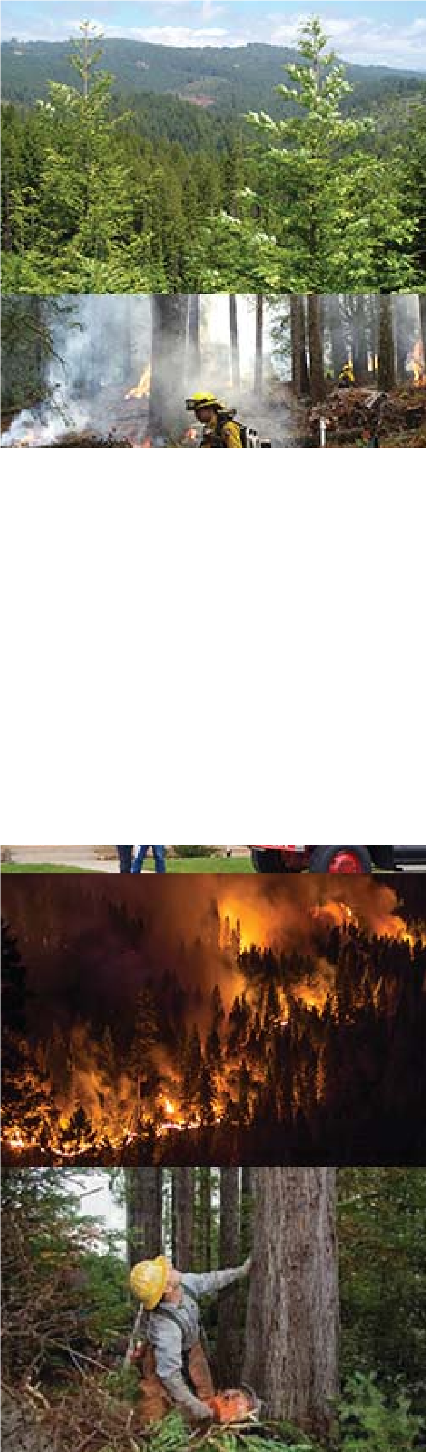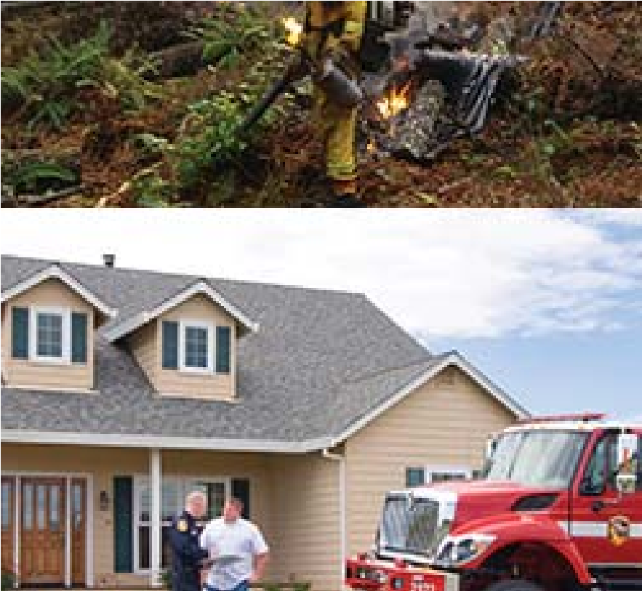

# MEMBERS OF THE CALIFORNIA

**STATE BOARD OF FORESTRY AND FIRE PROTECTION**

J. KEITH GILLESS, CHAIR

MARK ANDRE, Vice Chair

**Susan Husari**

**RICH WADE**

**MIKE JANI**

**MARC LOS HUERTOS**

**DARCY WHEELES**

**KATIE DELBAR**

**CHRIS CHASE**

**STAFF**

**MATT DIAS, EXECUTIVE OFFICER**

**DAN STAPLETON, ASSISTANT EXECUTIVE OFFICER**

**EDITH HANNIGAN, PLANNING POLICY MANAGER**

**CONNOR POMPA, FORESTRY ASSISTANT II**

**ERIC HEDGE, REGULATIONS COORDINATOR**

**KATIE HARRELL, JOINT INSTITUTE FOR WOOD PRODUCTS INNOVATION**

**BRANDI GOSS, ENVIRONMENTAL SCIENTIST**

**TABLE OF CONTENTS**

BOARD BACKGROUND AND ORGANIZATION ------------------------------------------------ 4

CHAPTERED LEGISLATION ----------------------------------------------------------------------- 7

FOREST HEALTH TRENDS ------------------------------------------------------------------------ 8

FOREST PRODUCTS TRENDS -------------------------------------------------------------------- 11

RANGELAND AND HARDWOODS TRENDS -------------------------------------------------- 16

FIRE PROTECTION TRENDS ---------------------------------------------------------------------- 17

ACCOMPLISHMENTS 2018 - REGULATORY 24

ACCOMPLISHMENTS 2018 - POLICY 25

STATE RESPONSIBILITY AREA FIRE PREVENTION FEE -------------------------------------- 30

AB 1504 CALIFORNIA FOREST ECOSYSTEM AND HARVESTED WOOD PRODUCT

CARBON INVENTORY ------------------------------------------------------------------------------- 31

AB 1492 DEVELOPMENT OF ECOLOGICAL PERFORMANCE MEASURES FOR

CALIFORNIA TIMBERLANDS -----------------------------------------------------------------------32

STATE FORESTS --------------------------------------------------------------------------------------- 34

STEWARDSHIP LANDS ------------------------------------------------------------------------------ 34

PROFESSIONAL LICENSING AND

FOREST PRACTICE ENFORCEMENT 35

APPENDIX A (2019 STANDING COMMITTEE PRIORITIES) ---------------------------------- 37

***Board of Forestry and Fire Protection Mission***

*The mission of the Board is to lead California in developing policies and programs that serve the public interest in environmentally, economically, and socially sustainable management of forest and rangelands and a fire protection system that protects and serves the people of the state*.

The California State Board of Forestry and Fire Protection (Board) is a Governor-appointed body within the Department of Forestry and Fire Protection (CAL FIRE). Members are appointed on the basis of their professional and educational qualification and their general knowledge or interest in problems that relate to watershed management, forest management, wildland fire management, fish and wildlife, range improvement, forest economics, or land use policy. Of its nine members, five are chosen from the general public, three from the forest products industry, and one from the range-livestock industry.

The Board is responsible for developing the general forest policy for the State, determining the guidance policies of CAL FIRE, and representing the State's interests in federal land located within California. Together, the Board and CAL FIRE work to carry out the California Legislature's mandate to protect and enhance the State's unique forest and wildland resources.

## Committees of the Board

### Committees Required by Statute

1. Range Management Advisory Committee
2. Professional Foresters Examining Committee
3. Soquel Advisory Committee

### Internal Standing Committees

1. Forest Practice: The mission of the Forest Practice Committee is to evaluate and promote an effective regulatory system which ensures the continuous growth and harvest of commercial forests and protects soil, air, fish, wildlands, and water resources.
2. Resource Protection: The mission of the Resource Protection Committee is to develop and promote a policy and regulatory program that implements fire safe land use planning and effective vegetation management, pursues a fire prevention program in alignment with the State Fire Plan, and improves forest and rangeland health in California.
3. Management: The mission of the Management Committee is to evaluate and promote long-term, landscape-level planning approaches to support natural resource management on California’s non-federal forests and rangelands and to evaluate State Forest management plans.

### External Advisory Committees

1. Effectiveness Monitoring Committee
2. Monitoring Study Group
3. California Forest Pest Council and the California Oak Mortality Task Force
4. Forestry Climate Action Team
5. Jackson Advisory Group
6. Joint Institute on Wood Products Innovation

### Committee Updates

**Range Management Advisory Committee**

The Range Management Advisory Committee (RMAC) stayed engaged with a variety of issues affecting rangelands in California, including water quality, grazing on public lands, rangeland health indicators, and drought impacts. RMAC’s chief 2018 concerns were to:

• Ensure that the State Water Resources Control Board’s (Control Board) efforts to develop statewide regulations for rangeland water quality protection were science based, capable of being implemented across the wide variety of ecosystems and management practices in the state, and that the Control Board is effectively engaged with land managers and technical specialists (chiefly UC Cooperative Extension) to shape policies;

• Aid State agencies in developing tools for grazing, where appropriate, to accomplish land management objectives on State lands – including invasive weed control, improvement and maintenance of wildlife habitats, and management of fine fuels in wildland-urban interface (WUI) areas;

• Stay current on state agency policies and practices that impact the ecological condition and health of State lands, including wildlife management (special status species, predators, and game species in rangeland habitats), fuels management, and water quality.

**Professional Foresters Examining Committee**

The Professional Foresters Examining Committee (PFEC) and the Office of Professional Foresters Registration had an active year in 2018. The PFEC considered four items under direction from the Board including a petition for rulemaking regarding the Certified Rangeland Management Specialty (CRM). The petition, from Rancho Guejito, proposed changes under the specialty related to the disciplinary process. After extensive review, the PFEC recommended that specific items outlined in the petition not be adopted. However, the review of the petition did identify several potential areas for clarification within the Specialty and CRM regulations (PRC 1650 §§ & 1651) and the PFEC is working with Board staff on a regulatory proposal, independent of the petition.

The PFEC also reviewed several applications for the Registered Professional Foresters (RPF) Exam. They reviewed exam results, certified new licensees for Board approval, and reviewed questions for the upcoming exams. The Executive Officer for Foresters Registration received five RPF complaints, of which one case is now closed with a letter of concern sent to the respondent and four others remain to be heard by the PFEC. The PFEC discussed matters relating to the RPF Fund; the fund has been depleted because of retirements which are projected to increase in the next decade due to the older demographic of RPFs. Renewal fees for RPFs have not increased for over 27 years and the registry has dropped by 1/3 over that same period. This demographic condition leaves few alternatives but to cut costs and seek increased funding. This will require consideration of a substantial increase in the renewal fee. Another alternative being discussed is a limited license for RPFs with over 25 years in the registry. This would freeze the current renewal rate for a qualifying RPF but would limit the licensee’s ability to sign timber harvest documents and some grants, where it is required by CAL FIRE. However, such a solution may still not be enough to address the financial shortfall. There is a possibility that the RPF fund will require a subsidy for the first time in over 45 years. These discussions will continue at the next PFEC meeting in January, 2019.

Lastly, the Executive Officer for Professional Foresters Registration has been involved in outreach to increase awareness of careers in forestry in California and the licensing requirements for foresters. Representatives have attended the National Society of American Foresters convention in Portland, Oregon and traveled throughout the state to universities, community colleges, high schools, and California Conservation Corps field offices to inform young people about the opportunities that exist in the California Forestry sector.

**Effectiveness Monitoring Committee**

The Board formed the Effectiveness Monitoring Committee (EMC) in 2014 to develop and implement a monitoring program to address both watershed and wildlife concerns and to provide a more effective feedback loop to policymakers, managers, agencies, and the public. Effectiveness monitoring is necessary to assess whether management practices are achieving the resource goals and objectives set forth in the California Forest Practice Rules (FPRs) and other natural resource protection statutes, laws, codes, and regulations. This kind of monitoring is a key component of adaptive management. Effectiveness monitoring is also a crucial component for complying with the “ecological performance” reporting requirements outlined in AB 1492. The EMC and the Board developed a suite of critical monitoring questions based on input from a variety of stakeholders and organized them into 11 themes. The EMC uses these themes and critical questions as guidance to solicit and evaluate monitoring projects with the goal of developing a process-based understanding of the effectiveness of the FPRs and associated regulations in maintaining and enhancing water quality and aquatic and wildlife habitats.

Five projects were funded by the EMC in 2018 and seven new submissions were received in response to the September 7, 2018 request for proposals. EMC meetings continued to be held approximately once a month. The following is a summary of EMC activities and progress made in 2018:

• The Strategic Plan was updated and an Annual Report and Work Plan were created. It is the goal of the EMC to update the Annual Report and Work Plan yearly, and to update the Strategic Plan as necessary.

• Strategic plan themes and critical questions for 2017 were reviewed and retained. No additions or alterations were made to the priorities for 2018.

• The Strategic Plan EMC project ranking procedure continued to be refined and was beta tested.

• Received an allocation of $425,000 each year for the 2017/2018 and 2018/2019 fiscal years from the Timber Regulation and Forest Restoration Fund.

• A Request for Proposals (RFP) was developed and posted to the EMC website, soliciting monitoring projects for 2019.

• An academic member and an agency representative were selected to fill EMC vacancies.

• Strategic Plan project ranking procedures were used to rank four proposed monitoring projects. Additional information on each project, request for funding, and ranking are located on the [EMC website](http://bofdata.fire.ca.gov/board_committees/effectiveness_monitoring_committee_/).

**Joint Institute for Wood Products Innovation**

The Board is working with the University of California and California State University to establish a Joint Institute for Wood Products Innovation in response to Senate Bill 859 and the California Forest Carbon Plan. Now in its formative stage, the Institute will ultimately work to implement those aspects of the Forest Carbon Plan focused on wood products.

## Chaptered Legislation with Future Regulatory Action by the Board

SB 901:

Affects fire safety regulations by requiring the Board to expand standards for residential, commercial, and industrial building construction in the State Responsibility Area (SRA) and Very High Fire Hazard Severity Zones (VHFHSZ). Further, it requires that the Board develop, regularly review, and revise regulations for fuel breaks and greenbelts near communities within the SRA, including the preservation of undeveloped ridgelines. It adds a new code section, PRC 4290.1, which requires the Board to maintain a Fire Risk Reduction Communities list.

This bill also affects timber harvest standards by revising the Working Forest Management Plan, the Nonindustrial Timber Management Plan, and several exemptions. The Working Forest Management Plan acreage has been limited to 10,000 acres and has been revised to clarify that multiple land owners can participate. It also initiates changes to erosion control measures. The Nonindustrial Timber Management Plan has been limited to 2,500 acres and has similarly been altered to clarify that multiple land owners may participate.

Changes to exemptions include: the clarification that a Small Timberland Owner Exemption is available, the inclusion of new standards for the Forest Fire Prevention Exemption, and the directive to make regulatory standards for all exemptions more consistent, where appropriate.

SB 1260:

Requires that local jurisdictions notify the Board when Very High Fire Hazard Severity Zones are adopted via local ordinance, when they begin working on their safety element updates, and when they make the two findings on subdivision maps which identify that a subdivision is compliant with PRC 4290 and PRC 4291 and has fire protection services.

If a local agency rejects any of the Board’s safety element recommendations, the Board may request a consultation with that jurisdiction.

AB 2911:

Requires the Board to survey local governments and fire districts to identify subdivisions without secondary egress routes that are at significant fire risk, develop recommendations to address them, and maintain a list of these subdivisions and their progress toward implementing recommendations. The Board is also required to consult with the Governor’s Office of Planning and Research, CAL FIRE, and other fire experts to develop the “Fire Hazard Planning, General Plan Technical Advice Series.”

AB 2518:

Requires that the Board collaborate with CAL FIRE and other appropriate parties to identify barriers to in-state production of mass timber and other forest products and develop solutions that are consistent with the State’s climate objectives.

## Forest Health Trends

### Stand Management

Monitoring of the Forest Practice Rules on private and public forestlands shows generally high compliance with implementation and effectiveness when implemented properly (FORPRIEM 2014). An additional [FORPRIEM](http://www.bof.fire.ca.gov/board_committees/monitoring_study_group/msg_monitoring_reports/forpriem_report_final_022715.pdf) effort will occur in 2019 to reassess compliance. Effectiveness is monitored on a continuing basis through the EMC – a sub-committee of the Board. The Exemption-Emergency Notice pilot monitoring project was also recently completed and the initial reporting is forthcoming in January 2019.

Even as harvest levels have declined, the number of acres harvested using uneven-aged systems has remained constant, resulting in an increase in the overall percentage of acres harvested using uneven-aged systems. However, as climate change continues to impact California’s landscape, there will likely be changes in where timberland occurs. Losses of between 0.6 and 1.4 million acres of timberland are predicted. This may result in changes in timber harvest locations and management practice trends ([FRAP Assessment 2017](http://frap.fire.ca.gov/assessment2017/FinalAssessment2017/Assessment2017.pdf)).

Additionally, estimates indicate that between 5.5 and 9.5 million acres of productive timberland are potentially in need of treatment to improve stocking levels. Commercial conifer species, specifically, have a similar number of acres in the “overstocked” and “understocked” categories if 60% is used as the threshold for “overstocking.” Understocked stands are particularly common on nonindustrial lands where technical and financial assistance for reseeding is not readily available after a burn event [(FRAP Assessment 2017).](http://frap.fire.ca.gov/assessment2017/FinalAssessment2017/Assessment2017.pdf)

A recent [Forest Inventory Analysis](https://www.fs.fed.us/sites/default/files/fs_media/fs_document/publication-15817-usda-forest-service-fia-annual-report-508.pdf) indicates that while lands are sequestering carbon at a positive rate, long-term carbon storage will be a function of management inputs over the next 100 years. See the discussion pertaining to AB 1504 on page 31.

### Pest Conditions

The following is a summary of notable pest and disease issues that continued to threaten and alter urban and wildland forests in California in 2018. Forest pest conditions can change dramatically from year to year. For a summary of forest pests and diseases, see the [2017 California Forest Pest Conditions Report](https://www.fs.usda.gov/Internet/FSE_DOCUMENTS/fseprd578546.pdf). The 2018 California Forest Pest Conditions Report will be available on the [California Forest Pest Council website](http://caforestpestcouncil.org/) in early 2019.

### Coastal Pine Decline

A widespread decline of bishop pine was identified in the Fort Bragg area (Mendocino County) in 2005. The working hypothesis was that a pulse of fire-adapted pine regeneration after World War II had established most of the stands, and that the pine had begun to senesce and become susceptible to a multitude of native tree pests. A systematic survey of the decline began in 2014. It became evident that not only bishop pine but also Monterey and shore pine were experiencing stand-level die-off in various locations around the Fort Bragg area. By 2016, pine stands in Sonoma County (Salt Point State Park and Sea Ranch) were also in decline.

In 2018, this large-scale decline continued to progress. So far, 18 native and non-native insects and pathogens have been identified on bishop pine. The most widespread native pests include western gall rust (*Endocronartium harknessii*), root diseases caused by native pathogens in the genera *Phaeolus, Onnia,* and *Armillaria*, and stem-decaying fungi. The most significant non-natives include the pitch canker pathogen (*Fusarium circinatum*) and soilborne pathogens that infect and consume fine roots including *Phytophthora cinnamomi* and *Elongisporangium undulatum* (also called *Pythium undulatum*)*.*

Goldspotted Oak Borer (*Agrilus auroguttatus*)

In 2018, goldspotted oak borer (GSOB) experienced new and expanded infestations. GSOB was discovered for the first time in San Bernardino County (in Oak Glen) in late October; this is believed to be another introduction of GSOB via long-distance firewood movement. In San Diego County, the Los Penasquitos Canyon County Preserve (city of San Diego) and Daley Ranch Park (Escondido) were found to have significant infestations. In southeast Orange County, an apparent new infestation was identified on the Cleveland National Forest near El Cariso, and the existing Weir Canyon infestation moved east over Highway 241 into Gypsum Canyon. The Riverside County infestation in the Idyllwild/Pine Cove area expanded beyond the community and into the surrounding San Bernardino National Forest; notably, the new infestations in Orange and San Bernardino Counties are both located very close to the Riverside County line. In Los Angeles County, the Green Valley infestation spread (or been moved in firewood) to the southeast near Bouquet Canyon Reservoir.

**Polyphagous and Kuroshio Shot Hole Borers (collectively known as Invasive Shot Hole Borer; *Euwallacea* spp.) and Associated Fusarium Dieback (*Fusarium* spp.)**

The polyphagous and Kuroshio shot hole borers (PSHB and KSHB, respectively) and associated Fusarium Dieback complex continued to spread in southern California. Currently there are 64 known PSHB reproductive host species and 15 KSHB reproductive host species. PSHB has been found in Ventura, Los Angeles, Orange, Riverside, San Bernardino, and San Diego Counties; KSHB has been found in San Diego, Orange, Santa Barbara (southern region), and Los Angeles Counties. Aside from one trap catch in 2016, there have been no confirmed invasive shot hole borer recoveries in San Luis Obispo County.

In Santa Barbara County, KSHB continued to spread in Montecito, Lotus Land, and San Ysidro Creek, and a new infestation was found along Sycamore Canyon Rd. PSHB continued to spread along the Santa Clara River. In Ventura County, the Hedrick Ranch Nature Area (Santa Paula) and surrounding parcels of land continued to be infested with PSHB (first detected in 2016). Based on monitoring from fixed plots, the number of PSHB-infested trees has increased substantially in the area, from 27% in 2017 to 49% in 2018. In Orange County, PHSB continues to spread in 39 county parks and wilderness areas. A new infestation was identified at Crystal Cove State Park in Laguna Beach. A total of 5,196 trees were infested in county parks and open areas, with an estimated 52,000 trees infested in county wildlands. In San Diego County, John Boland published a report on the KSHB infestation in the Tijuana Estuary in 2018 ([Boland, 2018](http://trnerr.org/wp-content/uploads/2018/07/Boland-KSHB-April2018-FINAL.pdf)). Report findings were as follows: in wet forests along the main estuary channels, infestation rates decreased from 97% in 2015/16 to 6% in late 2017 (KSHB was not found in resprouts up to 10 cm in size). Dry forest infestation rates increased from 9% in 2015/16 to 78% in late 2017; however, mortality rates in these areas were only 6%. Riparian scrub areas dominated by mule fat had infestation rates of 0%; the few willows present in these areas had a 2% infestation rate.

Sudden Oak Death (Phytophthora ramorum)

In 2018, the US Forest Service Aerial Detection survey documented a large increase in Sudden Oak Death (SOD)-related mortality from Big Sur to Humboldt County. The most dramatic die off appeared in the wettest areas along the coast.

This seemingly contrasted with results from the 2018 citizen science “Sudden Oak Death (SOD) Blitz” surveys, which reported generally less prevalent infection in the wildland-urban interface areas surveyed. In these surveys, 3.5% of trees sampled were *P. ramorum* positive*,* a threefold drop from infection incidence in 2017. The seeming discrepancy is accounted for by noting that the mounting mortality seen in 2018 results from a typical 2-3-year lag between tree infection and mortality; whereas, the SOD Blitzes monitor the current year’s foliar and twig infection on California bay laurel and tanoak.

The SOD Blitzes did note new urban outbreaks in several locations, including areas of Alameda and Marin Counties, southern Mendocino County near Yorkville, the city of Napa, several Silicon Valley locations, Boulder Creek in Santa Cruz County, and inland Sonoma County cities. The survey also found SOD*-*infected trees in the Salmon Creek watershed in southern Monterey County, where the pathogen was also detected in stream water.

Other notable areas of new mortality included ridgetops in Big Sur with extensive tanoak mortality (up to 3,000 ft elevation), extensive areas of symptomatic coast live oak, and pervasive tanoak mortality throughout the Santa Cruz Mountains. In the North Bay area, locations of note included Mount Tamalpais, the Timber Cove/Fort Ross area of the Sonoma coast, the Coast Range in Sonoma County, and inland southern Humboldt County. SOD was causing new, discrete mortality centers within Jackson Demonstration State Forest and near Piercy in Mendocino County. SOD was “newly” detected in two streams in Humboldt County: Chadd Creek (previously positive in 2015), a tributary to the Eel River that flows along the Avenue of the Giants, and Yager Creek, a tributary to the Van Duzen River. Additionally, disease expansion was recorded south and upstream of the original infestation along the Mad River; along Stover Road, south (upstream) of the original Redwood Valley infestation; and along Mattole Canyon Creek in southwestern Humboldt, from the expanding Mattole watershed infestations. In far northern Humboldt County, the aerial survey detected extensive spread upriver along Redwood Creek within Redwood National Park, at the edges of previously managed areas.

## Forest Products Trends

## In-State Harvest and Production

About 80% of lumber and 90% of all wood products used in the state of California are imported. There has been a major decline in timber harvesting that has resulted in a 72% decrease in volume since 1955. Sawmills have seen a similar decline in response to lower harvest volumes as well as improvements in technology and automation (about 675 sawmills were in operation in 1956 versus 30 in 2012). Softwood sawmill capacity in California has somewhat stabilized over the last several years after decades of constriction. In response to this decline in processing facilities, the state has shown growth in diversified markets for wood products. However, that diversification is not necessarily equivalent to the historic economic benefits of softwood sawmills ([FRAP Assessment 2017](http://frap.fire.ca.gov/assessment2017/FinalAssessment2017/Assessment2017.pdf)).

Generally, the volume of timber harvested has declined steadily from a high in 1988. It has recently started to level out after a significant drop in 2009 likely attributed to the housing market crash of 2008. Figure 1 below illustrates the changes in harvest levels for public and private lands, indicating that recently more volume is harvested from private lands by a wide margin.

**Figure 1. Annual Volume Harvested (**[FRAP](http://frap.fire.ca.gov/projects/BOE/BOETimberTax)**)**

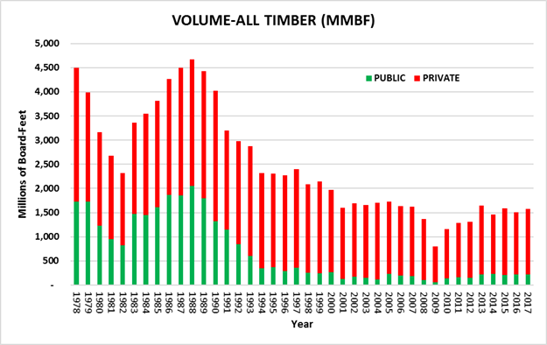

**\*PUBLIC is timber removed from local, state, and federal government lands. It does not include timber removed from tribal lands.**

California has also been experiencing a fluctuating export market over the past few years, with logs being shipped via container to Asia. This is a very volatile market with demand ebbing and flowing dramatically from one year to another and even from month to month. As of 2012, there were 52,000 workers in the forest products sector with total earnings of over $3.3 billion annually.

For managed timberlands, net growth of softwoods (commercial conifer species) provides a measure of whether harvest levels can be sustained. In California, forest industry management is regulated under the Forest Practice Act and the Forest Practice Rules, which require maximum sustained production of high-quality timber products. A recent USFS statewide inventory of the re-measurement period between 2001-2006 and 2011-2016 produced key findings as it pertains to net growth of softwoods. On forest industry timberlands, the most actively managed lands within California, growth exceeded harvest and mortality by an average of 22 ft3/acre/year over the re-measurement period. On nonindustrial timberlands, a portion of which are actively managed, growth exceeded harvest and mortality by an average of over 85 ft3/acre/year. On Forest Service timberlands, which are managed for multiple objectives including ecosystem services, growth exceeded harvest and mortality by an average of over 33 ft3/acre/year. These values can be shown on the graph below, Figure 2 ([FRAP Assessment 2017](http://frap.fire.ca.gov/assessment2017/FinalAssessment2017/Assessment2017.pdf)).

**Figure 2. Net Softwood Timberland Growth**

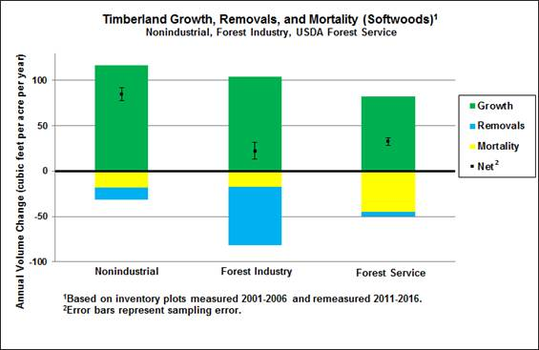

Of the approximately 33 million forested acres in California, about 57 percent are owned and managed by federal agencies, three percent by state and local agencies, 40 percent by families and Native American Tribes, and 14 percent by industrial timber companies. “9 million acres are owned by individuals with nearly 90 [percent] of these owners having less than 50 acres of forest land.” ([UCANR](https://ucanr.edu/sites/forestry/California_forests/), 2019) Ownership patterns have changed for large industrial forest landowners within California. All industrial ownerships are now privately held firms, in contrast with 1970 when 56 percent were publicly owned firms.

There has been an increase in investor-based Timber Management Organizations in the last several years. Individual Timber Harvesting Plans (THPs) increased in number in 2018, but only slightly in acreage (Figure 5). The number of Non-Industrial Timber Management Plans (NTMPs) dropped from 2017, but acreage remained consistent, indicating that NTMPs are likely larger in size in 2018 (Figure 6). The Working Forest Management Plan is currently in flux due to legislative changes to the enabling statute (SB 901, 2018) as well as pending litigation and is expected to be available for applications sometime in 2019.

The utilization of exemptions, as allowed for under PRC § 4584 and 14 CCR § 1038, increased again this year in acreage, but not in number. Specifically, the number of Drought Exemptions dropped slightly but increased in total acreage, indicating that each exemption contains a larger stretch of land (Figure 3). Emergency Notices provided for under 14 CCR § 1052.1 increased slightly in 2018, but are still not quite as high as the 2014/15 and 2015/16 fiscal years (Figure 4). The Board and CAL FIRE recently completed the Exemption-Emergency Notice Pilot study and are currently analyzing data. The Exemption-Emergency Notice Pilot study gathered data on the utilization of exemptions and emergency notices and a variety of environmental indicators to begin to determine how the use of exemptions impacts the land. An initial report is forthcoming in January, 2019. Monitoring will continue with additional reporting to the Legislature required beginning December, 2019.

|  |  |  |  |  |
| --- | --- | --- | --- | --- |
| **Figure 3. Exemption Statistics for Fiscal Years 14/15 – 17/18** | | | | |
|
| **Fiscal Year** | **Harvest Document Type** | **Number of Notifications** | **Acres** | **Total Acres** |
| 2014/15 |  |  |  |  |
|  | 1038(b) Exemptions¹ | 781 | 2,884,982 |  |
|  | All other Exemptions² | 1,009 | 41,563 |  |
|  | Total Exemptions | 1,790 |  | 2,926,545 |
| 2015/16 |  |  |  |  |
|  | 1038(b) Exemptions¹ | 697 | 2,589,358 |  |
|  | 1038(k) Exemptions³ | 776 | 110,224 |  |
|  | All other Exemptions² | 1,003 | 27,433 |  |
|  | Total Exemptions | 2,476 |  | 2,721,015 |
| 2016/17 |  |  |  |  |
|  | 1038(b) Exemptions¹ | 522 | 2,592,252 |  |
|  | 1038(k) Exemptions³ | 956 | 10,358 |  |
|  | All other Exemptions² | 1,032 | 208,111 |  |
|  | Total Exemptions | 2,510 |  | 2,910,721 |
|  |  |  |  |  |
| **Fiscal Year** | **Harvest Document Type** | **Number of Notifications** | **Acres** | **Total Acres** |
| 2017/18 |  |  |  |  |
|  | 1038(b) Exemptions¹ | 554 | 2,933,286 |  |
|  | 1038(k) Exemptions³ | 414 | 44,357 |  |
|  | All other Exemptions² | 1042 | 482,206 |  |
|  | Total Exemptions | 2,010 |  | 3,459,849 |

¹1038(b) is the 10% or less Dead and Dying Exemption. Due to the lack of the requirement for mapping specific project areas, the numbers reported are elevated beyond what specific areas are managed by the exemption.

²The category includes 1038(a) Christmas Trees, 1038(c) Up to 300 Foot Habitable Structure, 1038(d) Biomass, 1038(g) Slash Pile Removal, 1038(i) the original Forest Fire Prevention Exemption (FFPE), and 1038(j) Pilot Project FFPE.

³1038(k) Drought Mortality Exemption, adopted by the Board in July, 2015.

Note: 2017/18 Year calculated as Exemptions Accepted by CAL FIRE July 1, 2017-June 30, 2018.

Note: 14 CCR §§ 1038 (e), (f), and (h) are not exemptions for the commercial harvesting of trees, but rather are regulatory provisions that apply to exemptions that address special conditions, such as geographic location or the presence of large trees that may be harvested under an exemption.

|  |  |  |  |
| --- | --- | --- | --- |
| **Figure 4. Emergency Notices Statistics for Fiscal Years 14/15 – 17/18** | | | |
| **Fiscal Year** | **Harvest Document Type** | **Number of Notifications** | **Total Acres** |
| 2014/15 | Emergency Notice | 270 | 66,876 |
| 2015/16 | Emergency Notice | 231 | 30,348 |
| 2016/17 | Emergency Notice | 83 | 15,176 |
| 2017/18 | Emergency Notice | 194 | 14,416 |

|  |  |  |  |
| --- | --- | --- | --- |
| Note: 2017/18 Year calculated as Emergency Notices Accepted by CAL FIRE July 1, 2017-June 30, 2018.  Figure 5. THP Statistics for Fiscal Years 11/12 – 17/18 | | | |
| Fiscal Year | **Harvest Document Type** | **Number of Plans** | **Acres** |
| 2011-12 | THP | 270 | 139,553 |
| 2012-13 | THP | 243 | 107,051 |
| 2013-14 | THP | 278 | 146,384 |
| 2014-15 | THP | 260 | 128,644 |
| 2015-16 | THP | 249 | 99,271 |
| 2016-17 | THP | 219 | 91,067 |
| 2017-18 | THP | 266 | 105,433 |

Note: 2017/18 Year calculated as THPs Approved by CAL FIRE July 1, 2017-June 30, 2018.

|  |  |  |  |
| --- | --- | --- | --- |
| Figure 6. NTMP Statistics for Fiscal Years 11/12 – 16/17 | | | |
| Fiscal Year | **Harvest Document Type** | **Number of Plans** | **Acres** |
| 2011-12 | NTMP | 14 | 10,932 |
| 2012-13 | NTMP | 12 | 7,365 |
| 2013-14 | NTMP | 10 | 4,126 |
| 2014-15 | NTMP | 12 | 3,367 |
| 2015-16 | NTMP | 17 | 8,100 |
| 2016-17 | NTMP | 23 | 5,105 |
| 2017-18 | NTMP | 14 | 4,448 |

Note: 2017/18 Year calculated as NTMPs Approved by CAL FIRE July 1, 2017-June 30, 2018.

## Biomass

Biomass utilization is recognized by many stakeholders as a carbon-neutral opportunity to facilitate management of California’s forested ecosystems. The expenses of forest restoration and sustainable management on both public and private lands can be supported through the sale of biomass and wood products. However, for this sale to be profitable, there is a need for increased biomass processing capacity to handle dead trees and other unmerchantable vegetative material removed for hazard control. For these reasons, the Board is interested in the development of biomass utilization policy as an important component of the forest product sector within California ([Forest Carbon Plan 2018](http://resources.ca.gov/wp-content/uploads/2018/05/California-Forest-Carbon-Plan-Final-Draft-for-Public-Release-May-2018.pdf)).

The forest products biomass market remains narrow. Challenges to expansion include short-term contracts between energy producers and purchasers, fluctuating energy values, lack of energy sector subsidies, and the economics involved in the treatment, handling, and transportation of forest material ([Forest Carbon Plan 2018](http://resources.ca.gov/wp-content/uploads/2018/05/California-Forest-Carbon-Plan-Final-Draft-for-Public-Release-May-2018.pdf)).

Biomass facilities across the state have been closing for many years. The retention of the remaining biomass facilities is a priority for the legislature. Thus, SB 859 was passed by the legislature and ultimately chaptered by the Brown Administration. The bill, in part, calls on electricity retailers to enter into five-year contracts for 125 megawatts of biomass power from facilities that have the ability to generate energy from wood harvested from high fire hazard zones, as identified by the Tree Mortality Task Force. SB 901 (2018) both expanded the fuels and feedstocks which are eligible to meet those wildfire risk reduction requirements and requires that any organization which currently has an active contract for electricity generated from biomass expiring on or before December 31, 2023 seek to extend that contract for 5 additional years ([Forest Carbon Plan 2018](http://resources.ca.gov/wp-content/uploads/2018/05/California-Forest-Carbon-Plan-Final-Draft-for-Public-Release-May-2018.pdf)).

The Forest Carbon Plan[1] recommends building out the 50MW small scale wood-fired bioenergy facilities that were mandated through SB 1122 (Rubio). The California Energy Commission’s Electric Program Investment Charge will continue public investment in this build out. Additionally, there will be an effort to expedite the contracting and interconnection for facilities fueled by feedstock from tree mortality High Hazard Zones ([Forest Carbon Plan 2018](http://resources.ca.gov/wp-content/uploads/2018/05/California-Forest-Carbon-Plan-Final-Draft-for-Public-Release-May-2018.pdf)).

## Rangeland and Hardwood Trends

## Rangelands and Range Industry

Beef cattle production generated $2.5 billion in revenue in 2017 (a drop of 22% from $3.2 billion in 2015), placing it as California’s 4th most valuable agricultural commodity in 2017. California is also the 7th largest national producer of cattle and calves with 5.15 million cattle and calves produced in 2017, according to the [California Agricultural Statistics Service Report](https://www.cdfa.ca.gov/Statistics/PDFs/2016-17AgReport.pdf). The majority of this production comes from grazed forages, most of which is produced on rangelands.

The value of rangelands to the State extends well beyond their value for feeding domestic livestock. These ecosystems also contribute to environmental quality and ecosystem services by improving water quantity and quality, air quality, and atmospheric carbon capture. Additionally, rangelands serve as wildlife habitat for a variety of species, including many special-status species. Rangelands also provide opportunities for public recreation and production of wind and solar power. Overall, rangelands are an important California resource because they often occur in arid and semi-arid regions; as climate change continues to worsen the number, length, and severity of droughts, these arid communities become even more important for economic production and wildlife habitat.

Rangelands are being impacted by a variety of anthropogenic and environmental issues. Development is one of the greatest anthropogenic impacts to rangeland; since 1984, nearly 20,000 acres of rangeland have been lost per year to intensive agriculture and urbanization. Additionally, impacts from climate change and invasive species are resulting in changes in forage production and composition. Restoration of some of these functions will be difficult and expensive to accomplish. Therefore, the Range Management Advisory Committee has been engaging with users and managers of the State’s rangelands to improve their beneficial and sustainable uses, protect their resources and productive capacities, and ensure that sound management and monitoring continues contributing to the State’s environmental and economic objectives into the future.

### Hardwoods Trends

California’s hardwood resource provides economic value to landowners and supports more species of wildlife than any other habitat type. Hardwoods are found on rangelands, in montane regions, and riparian corridors and serve as key species in each of these areas. Hardwoods contribute significantly to carbon sequestration and are one of the most cost-effective tree species options in areas where water availability is of concern. Most of the State’s oak woodlands are found on privately owned rangeland and support over 300 terrestrial vertebrates and a wide variety of insects. Oak woodlands are threatened by pests and diseases such as the goldspotted oak borer and sudden oak death (*Phytophthora ramorum*). Hardwoods in conifer-dominated forests are important for wildlife habitat, but are taking over some softwood stands due to disturbances and past management strategies. Alder and willow are key species in riparian corridors and contribute significantly to water quality, wildlife habitat, and temperature regulation. Land use changes, development, fire, and degradation due to conifer encroachment are the greatest threats to these forests. Revisions by Board staff to the Joint Hardwood Policy in collaboration with the Fish and Game Commission are underway and place an emphasis on research, collaboration, and education regarding the status and needs of California’s hardwoods.

## Fire Protection Trends

### Snow Drought

California appears to be entering drought conditions following the above average water year of 2017. Average temperatures are also rising. This combination of events typically results in a general water shortage as well as a shortage of snowpack, even in years when precipitation is closer to historical averages. Snowpack is incredibly important in California’s Mediterranean climate as it typically predicts how much water will reach streams and reservoirs in summer months. Snowpack provides about one-third of the water used by State cities and farms as it melts during the summer and autumn months.

Figure 7 indicates that precipitation levels were slightly lower than average in the 2018 water year. Satellite photography indicates that snowpack was significantly lower than average and much lower than the high precipitation 2017 water year. Snow pack levels for 2018 are more akin to levels seen during the last severe drought (2011-2017).

**Snow Pack Satellite Imagery February 2015 and February 2017**

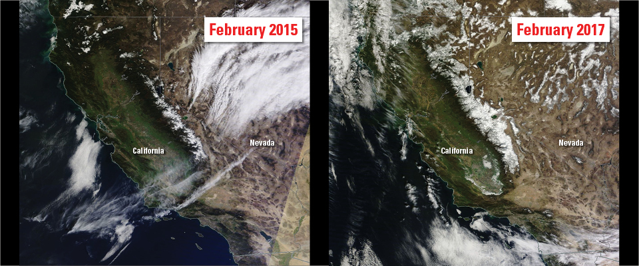

**Snow Pack Satellite Imagery January 2017 and February 2018**

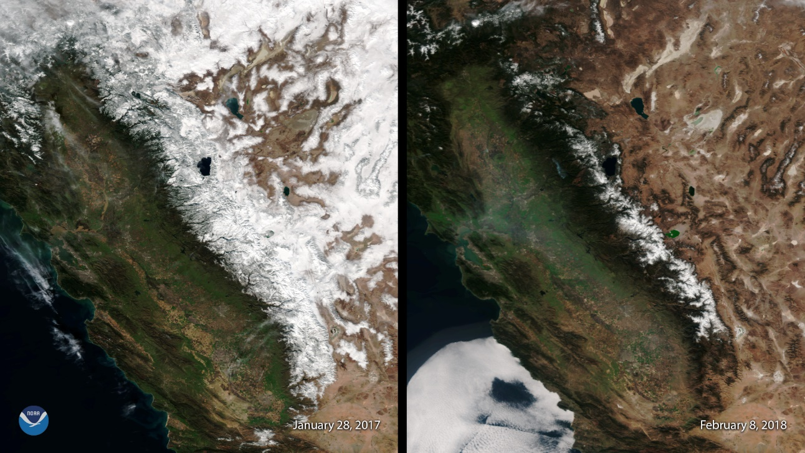

The reality of available snowpack, despite a less severe drought, makes sense when considering average winter temperatures (see Figure 9). Average temperatures were significantly higher than normal from November 2017 to April 2018 when snowpack would normally accumulate. The multifaceted effects of climate change are resulting in less precipitation in California, and in less precipitation accumulating as snowpack to be utilized later in the year when conditions are warmer and drier.

**Figure 7. Precipitation Rankings for January-June 2018 When Compared with Local Averages From 1895-2018. NOAA National Centers for Environmental Information.**

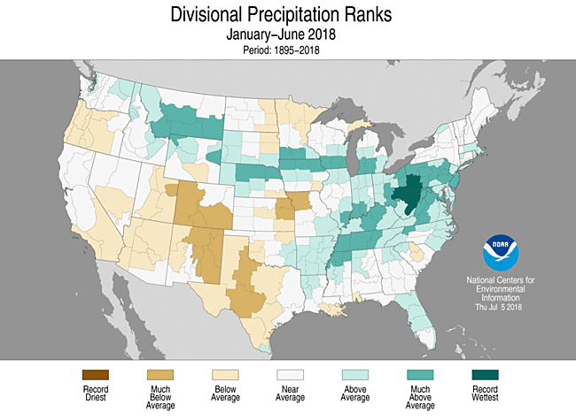

**Figure 8. Temperature Rankings for April-September 2018 When Compared with Local Averages From 1895-2018. NOAA National Centers for Environmental Information.**

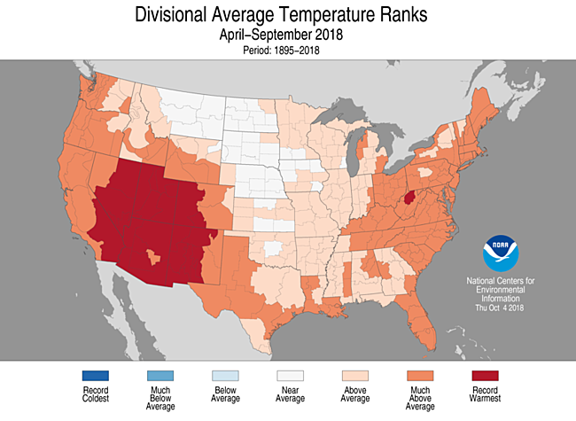

**Figure 9. Temperature Rankings for November 2017-April 2018 When Compared with Local Averages From 1895-2018. NOAA National Centers for Environmental Information.**

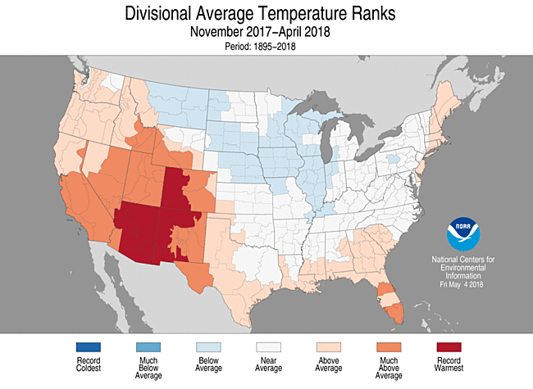

***Prescribed Fire and Fuel Reduction Efforts***

As fire size and severity has worsened over the past decade, focus on various types of fuel reduction has increased. Fuel treatments are intended to reduce the amount of surface and ladder fuels and thereby reduce the risk of catastrophic fires that burn longer, further, and hotter. The modification of fire behavior as a result of fuel reduction efforts may prevent loss of lives, reduce fire suppression costs, reduce property losses, and protect natural resources. Fuel treatments utilized by CAL FIRE include, but are not limited to, prescribed fire, mechanical clearing, cooperative fuel reduction grants, and encouraging stand management by timber owners through NTMPs and an array of exemptions and emergency notices. The expanded use of these methods to prevent catastrophic wildfire continues to be a high priority for the Board and CAL FIRE.

CAL FIRE’s Vegetation Management Program (VMP) is a cost-sharing program that encourages fuel reduction in the SRA and focuses on prescribed fire. The use of fire mimics natural processes, enables fuel reduction, and restores fire to its historic role in wildland ecosystems, which may improve native communities. The VMP can be utilized by private land owners to accomplish fuel reduction goals on their property using prescribed fire and other fuel management techniques. Figures 10 and 11 below illustrate the acreage goals and number of acres treated by the VMP in the 2017/2018 and 2018/2019 Fiscal Years.

**Figure 10. Broadcast/Prescribed Burn Targets and Acres Completed 2017/2018 and 2018/2019* Fiscal Years**

**\*Through December 31, 2018**

|  |  |  |  |
| --- | --- | --- | --- |
| **Fiscal Year** | **Target** | **Completed** | **% Completed** |
| 2017/2018 | 20,000 | 19,413 | 97.07% |
| 2018/2019 | 25,000 | 9,497 | 37.99% |

**Figure 11. All Other Fuel Reduction Method Targets and Acres Completed 2017/2018 and 2018/2019* Fiscal Years**

**\* Through December 31, 2018**

|  |  |  |  |
| --- | --- | --- | --- |
| **Fiscal Year** | **Target** | **Completed** | **% Completed** |
| 2017/2018 | 20,000 | 13,344 | 66.70% |
| 2018/2019 | 20,000 | 4,164 | 20.82% |

Defensible space is an area within a parcel of land where wildland fire protection practices and measures are implemented to enable defense against wildfires and suppression of wildfires. Defensible space and the management of fuels, particularly around homes and public buildings, has become increasingly important as the WUI continues to expand and more severe fires threaten WUI areas. CAL FIRE recently updated the Defensible Space Collector App to make inspections more efficient and accurate. Figure 12 illustrates the goals for defensible space inspections and how many were completed in the 2017/2018 Fiscal Year, as well as how many have been completed so far in the 2018/2019 Fiscal Year.

**Figure 12. Defensible Space Inspections 2017/2018 and 2018/2019* Fiscal Years**

**\* Through December 31, 2018**

|  |  |  |  |
| --- | --- | --- | --- |
| **Fiscal Year** | **Target** | **Completed** | **% Completed** |
| 2017/2018 | 250,000 | 217,666 | 87.07% |
| 2018/2019 | 250,000 | 95,077 | 38.00% |

CAL FIRE also sponsors several grant opportunities which focus on fuel reduction and forest health. The California Forest Improvement Program can be used by small land owners for reimbursement of forestry practices that improve their forested land from non-merchantable material to merchantable material. These activities may include fuel reduction practices. Additionally, CAL FIRE sponsors the Forest Health, Urban and Community Forestry, and Fire Prevention grants, which are funded through the Greenhouse Gas Reduction Fund. Part of their overarching goal is improving carbon sequestration by reducing the risk of intense wildfires and improving general forest health.

Finally, CAL FIRE has developed a designated fuels reduction crew. Previously, fuels reduction was often completed by local CAL FIRE teams when they were not fighting fire. The development of designated crews for fuels reduction is anticipated to increase prescribed fire and manual fuels treatment numbers in the coming years. Three crews are expected to be headquartered in the Northern Region and three in the Southern Region. CAL FIRE has approved 246 applications for the Forestry Technician examination for 60 positions available crew positions. These crews are expected to be staffed in mid-January 2019 and will begin training in early spring, 2019.

Significant changes to how California approaches fuel reduction are expected in the coming years in response to Governor Brown’s Executive Order B-52-18, which addresses the pace and scale of fuel treatment across the state.

***California Statewide Vegetation Treatment Program***

The Board is completing a Statewide Program Environmental Impact Report titled “California Statewide Vegetation Treatment Program,” known as the CalVTP PEIR. The document will streamline California Environmental Quality Act (CEQA) compliance for CAL FIRE and other state and local public agencies’ vegetation management projects. The CalVTP PEIR is intended for vegetation management activities that lower the risk of catastrophic wildfires on nonfederal lands by managing vegetation to modify or reduce hazardous fuels.

Numerous comments were received on a previous draft of the CalVTP PEIR that was authorized for public comment. The scale and complexity of the public response prompted the Board to commission an independent group of scientists to review the draft. Their report, received in 2014, was used by a new agency team to begin an update of the plan. A Revised Notice of Preparation was distributed in 2015 and the new draft was presented to the Board at their August 2015 meeting. The Board hosted a series of workshops thereafter to discuss the preliminary draft document. A draft incorporating revisions from these workshops was presented to the Board in March 2016 and released for public comment under CEQA from April 1 to May 31, 2016. The Board reviewed the comments at various workshops in 2016 and 2017 and the PEIR was revised to include additional data and significant new information. It was recirculated under CEQA for public comments on the adequacy and completeness of the environmental analysis in the document from November 13, 2017 through January 12, 2018.

The Board spent 2018 reviewing those comments and revising the document to address the concerns raised in the letters. This work is ongoing and expected to continue into 2019, when the Board plans to certify a Final PEIR.

***Wildfire Activity***

Once again, 2018 was another active fire season throughout the state. Significant decreases in precipitation and snowpack from 2017 may have contributed to fires of unprecedented size and severity. The total number of fires responded to by CAL FIRE personnel were similar to the 2017 season (Figure 14). However, this year produced fires that have burned twice as many acres, resulting in some of the largest and most destructive fires in state history (Figure 13, Figure 14).

On July 27, 2018, the Ranch Fire began burning near Ukiah and the River Fire began burning near Hopland. These fires were then managed as the Mendocino Complex Fire - the largest fire since at least 1932 in the State of California at 459,123 acres. It consumed 281 structures and took one life. The second and third largest wildfires in California history were 281,893 acres and 273,246 acres, making the Mendocino Complex one and a half times as large as the next largest fires (Figure 13).

The Carr Fire began burning outside of Redding on July 23, 2018. It consumed 229,651 acres, making it the seventh largest wildfire ever in California. It destroyed 1,614 structures and took seven human lives, making it the seventh most destructive wildfire in California and the fourteenth most deadly since 1932 (Figure 13).

The Camp Fire began burning near Pulga on November 8, 2018. It destroyed the town of Paradise and burned 153,336 acres. Most significantly, it burned almost 19,000 structures and took 86 lives, making it the most destructive and most deadly wildfire in California history (Figure 13).

| **Figure 13. CAL FIRE Most Destructive Direct Protection Incidents 2018**  **\* Through December 31, 2018** | | | |
| --- | --- | --- | --- |
| **Name** | **Acreage** | **Structures Destroyed** | **Fatalities** |
| Ranch Fire (Mendocino Complex) | 410,203 | 246 | 1 |
| River Fire (Mendocino Complex) | 48,920 | 35 | 0 |
| Carr Fire | 229,651 | 1,614 | 7 |
| Camp Fire | 153,336 | 18,804 | 86 |
| Woolsey Fire | 96,949 | 1,643 | 3 |
| County Fire | 90,288 | 29 | 0 |
| Delta Fire | 63,311 | 42 | 0 |
| Klamathon Fire | 38,008 | 83 | 1 |
| Whaleback Fire | 18,703 | 0 | 0 |
| Pawnee Fire | 15,185 | 22 | 0 |
| Waverly Fire | 12,300 | 1 | 0 |
| **TOTAL** | **1,174,891** | **22,519** | **98** |

**Figure 14. Fire Season 2017 and 2018 Comparison**

**\* Through December 31, 2018**

| **Interval** | **Fires** | **Acres** |
| --- | --- | --- |
| January 1, 2018 through December 23, 2018 | 6,284 | 876,147 |
| January 1, 2017 through December 23, 2017 | 7,117 | 505,956 |
| 5 year average (same interval) | 5,756 | 233,483 |
| 2018 Combined YTD (CALFIRE & US Forest Service) | 7,571 | 1,671,203 |

***Note: These values tabulate wildfires responded to by CAL FIRE in SRA and LRA regions under contract with CALFIRE.***

***Accomplishments 2018 - Regulatory***

***Emergency Rulemaking to Facilitate Post-Fire Recovery Efforts within Counties of Napa, Sonoma, and Mendocino***

Promulgation of these regulations was immediate and necessary to provide a person engaging in the cutting or removal of dead or dying trees with an exemption option. This exemption removes the burdens of plan preparation, submission requirements (PRC § 4581), completion reports, and stocking report requirements (PRC §§ 4585 and 4587) of the Forest Practice Act. This exemption helps facilitate the removal of hazardous materials and encourage the re-building and recovery from catastrophic wildfires.

***Emergency Rulemaking to Facilitate Post-Fire Recovery Efforts within Counties of Lake, Siskiyou, Mendocino, Shasta, Trinity, and Napa***

Promulgation of these regulations was immediate and necessary to provide a person engaging in the cutting or removal of dead or dying trees with an exemption option. This exemption removes the burdens of plan preparation, submission requirements (PRC § 4581), completion reports, and stocking report requirements (PRC §§ 4585 and 4587) of the Forest Practice Act. This exemption helps facilitate the removal of hazardous materials and encourages the re-building and recovery from catastrophic wildfires.

***Cumulative Impacts Assessment Checklist, Technical Rule Addendum No. 2 and Appendix Amendments***

The amendments to Technical Rule Addendum No. 2 align the FPRs with significant provisions made to California Environmental Quality Act (CEQA), specifically regarding fire hazard impacts and Greenhouse Gas (GHG) emissions. This helps preparers meet CEQA requirements while completing Timber Harvest Plans and maintains transparency for the Director of CAL FIRE, other interested agencies, and the regulated public. This action also serves to update 30-year-old guidance, including providing additional clarity in 14 CCR § 895, 895.1, 912.9 [932.9, 952.9], Technical Rule Addendum No. 2, and Appendix. Generally, the implementation of this amendment may improve environmental quality, lower wildfire risk, and thus improve the welfare and safety of California residents and workers. This regulatory action was approved on October 15, 2018 and is expected to become effective on January 1, 2019.

***Exemption Amendments 14 CCR § 1038 & 1038.1, 2018***

The purpose of this proposed action is to clarify the fuel treatment standards in 1038(j), extend the sunset date for Drought Mortality Amendments an additional 3 years due to apparent ongoing need, and to implement standardized notification procedures for the commencement of operations. These changes allow for consistent application and enforcement of exemption notices and operations by clarifying standards and implementing notification requirements. Additionally, threats from tree mortality, including falling, and wildfire hazards are addressed by this amendment by extending the life of the Drought Mortality Amendment. The extension may also provide economic benefit to landowners within California who are provided a simplified regulatory mechanism for harvesting dead and dying trees. This regulatory action was approved by OAL on November 13, 2018 and is expected to become effective on January 1, 2019.

***Timberland Conversion Amendments, 14 CCR § 1104.1, 2018***

Issues related to timberland conversion have been increasingly important to landowners and regulatory bodies. This regulation proposes an amendment to the Less than Three Acre Conversion Exemption, which disallows the use of the Exemption where prior conversion has occurred on a contiguous ownership parcel. This eliminates the ability of Licensed Timber Operators to transfer the responsibility of slash and woody debris cleanup to the landowner. It also requires the inclusion of a map as part of the notification to adjacent landowners and Native Americans, improves the notification procedure for the commencement of timber operations, and improves other issues of clarity and consistency as they exist. These changes ensure clear and consistent application and enforcement of the Less than Three Acre Conversion Exemption and may improve environmental quality by improving slash treatment and timing, which can improve air quality and reduce fuel loading and fire hazard. This regulatory action was approved by OAL on September 6, 2018 and is expected to become effective on January 1, 2019.

***SRA Fire Safe Development Regulations Revisions 14 CCR § 1270***

The SRA Fire Safe Regulations are key to establishing and maintaining a well-developed framework that establishes infrastructure that is resistant to wildfire events. These regulations are updated regularly to maintain consistency with the California Fire Code and other statutes. Additionally, changes were needed to improve the process for local jurisdictions by providing clearer lines of authority and implementation processes, and to create standards that reflect modern firefighting apparatus dimensions and fire prevention policies. These regulations will improve citizens’ ability to defend their property from wildfire and escape oncoming fires. They will also improve firefighters’ ability to find, defend, and protect property. Comments have been received from the public and responded to in the Final Statement of Reasons. This regulatory action is expected to go to OAL for review in the coming months.

## Accomplishments 2018 - Policy

## Strategic Fire Plan

The [Strategic Fire Plan](http://cdfdata.fire.ca.gov/pub/fireplan/fpupload/fpppdf1614.pdf) is one of the Board’s preeminent policies. The Board has adopted Strategic Fire Plans since the 1930s and periodically updates them to reflect current and anticipated needs. As the environmental, social, and economic landscape of California’s wildlands has changed, the Board has evolved the Strategic Fire Plan to better respond to these changes and to provide CAL FIRE with appropriate guidance “…for adequate statewide fire protection of state responsibility areas” (PRC § 4130). This plan was last updated in 2010, and the current Plan has adopted the previous Plan’s method of keeping the document broad and providing general direction to CAL FIRE, versus the very detailed documents of the past. The latest edition encompasses changes in California’s fire regimes, reflecting more severe and destructive wildfires that have been termed the “new normal.”

### State Forests

The Board continues to provide general direction to CAL FIRE regarding the eight (8) Demonstration State Forests (DSFs) managed by CAL FIRE. This year has been an especially busy year with the Board completing a rulemaking package, policy updates, and management plan reviews and approvals.

#### Rulemaking

Board staff undertook rulemaking to update regulations which did not encompass current issues affecting State forests. The rulemaking package titled “State Forest Regulations Update, 2018” (14 CCR §§ 1400.5 et al.) allows use fees to be charged at a standardized rate and updates and clarifies rule language. This rulemaking update has been approved by the Board, has completed a 45 day notice period with no public comment, and is expected to be completed in early 2019.

#### Policy Updates

The Board’s State Forest Policy was updated in 2018. Many of the changes were editorial in nature, but others were more substantive. The substantive updates aim to clarify existing language, place a greater emphasis on effectiveness monitoring of management actions, and encourage expanding the land base of DSFs. Additionally, the Board has changed the review periods for Initial Studies and Management Plans from five years to ten. This change was made following concerns expressed by DSF managers, citing limited staffing and increasing workload. The longer period will allow the plans to be more broad, encompass longer term changes and trends, and reduce pressures on staff.

#### Management Plan Review

Boggs Mountain DSF’s Initial Study and Management Plan were approved by the Board this year. Drastic changes in forest conditions due to the Valley Fire in 2015 resulted in a heavy workload for Boggs Mountain DSF for this update.

Mountain Home DSF’s Initial Study and Management Plan were initially due for Board review in 2018, but were deferred to 2020 due to the increase in review intervals by the Board.

### Nursery

The Board’s policy regarding nurseries was reviewed by Board staff and Board committees, with contributions from CAL FIRE’s LA Moran Reforestation Center staff. This policy update improves clarity and includes changes that reflect current conditions and needs. The revised policy also stresses the importance of the nursery and places emphasis on increasing size and seed capacity. The nursery intends to provide seed stock for areas experiencing low stock due to wildfire and will have a mandated symbiotic relationship with federal and local government agencies to meet this need.

### Fire Protection Policies

The Board’s fire protection policies have gone through extensive changes throughout the years. In 2018, the Board reviewed these policies with significant buy-in from CAL FIRE, and changes are on schedule to be approved in early 2019. These changes include encouraging SRA contracted fire departments to enforce forest and fire policy and law, enhancing local governments’ involvement in response to wildland fire incidents, reducing Amador Plan agreements when local governments improve their capabilities, and advising the US Forest Service on management decisions for lands adjacent to SRA.

### Local Government

#### General Plan Safety Elements

Under Government Code § 65302.5, the Board is required to review the General Plan Safety Elements for jurisdictions with SRA or VHFHSZ. Utilizing staff from CAL FIRE’s Land Use Planning team, the Board has established a standardized method to review the safety element of general plans. The methodology includes:

1. Reviewing the safety element for the requirements in Government Code §65302, subdivision (g)(3)(A),
2. Examining the safety element for goals, policies, objectives, and implementation measures that mitigate the wildfire risk in the planning area (Gov. Code, § 65302, subd. (g)(3)(B) & (C)), and
3. Making recommendations for methods and strategies that would reduce the risk of wildfires (Gov. Code, § 65302.5, subd. (b)(3)(B)).

Once completed, the Safety Element Assessment should provide clear guidance to a city or county regarding any areas of deficiency in the safety element as well as specific goals, policies, objectives, and implementation measures the Board recommends adopting in order to mitigate or reduce the wildfire threat in the planning area. The Board does not have the authority to approve safety elements, but rather offers recommendations to improve fire hazard planning in the planning area. If jurisdictions choose not to implement the Board’s recommendations, they must respond in writing to the Board discussing the reasons why not. SB 1260 (Jackson, 2018) now allows the Board to request a consultation with local jurisdictions who choose not to adopt the Board’s recommendations and prevents the jurisdiction from approving the draft element or amendment if a consultation is requested. These changes will improve communication between the Board and local jurisdictions and enable further dialogue to better protect citizens. Regulations to implement this consultation process are expected to be effective in 2019.

**Figure 15. General Plan Safety Elements Reviewed by the Board in 2018**

|  |  |  |  |  |  |
| --- | --- | --- | --- | --- | --- |
| **Region** | **Type** | **Jurisdiction** | **Received** | **Reviewer** | **Board Review** |
| CSR | City | Walnut | 2/7/18 | Heather McCulley | 3/6/2018 |
| CSR | City | Redlands | 2/12/18 | Raymond Martinez | 4/11/2018 |
| CSR | City | Westlake Village | 2/15/18 | Heather McCulley | 4/11/2018 |
| CSR | County | Riverside | 4/30/18 | N/A - Seismic Updates Only | 6/12/2018 |
| CNR | County | Santa Cruz | 6/26/2018 | Jeff Hakala | 8/21/2018 |
| CSR | City | Stockton | 7/2/18 | No VHFHSZ |  |
| CNR | City | Eureka | 7/10/2018 | No VHFHSZ |  |
| CSR | City | Rancho Santa Margarita | 9/20/18 | Brian Barkley | 11/6/18 |
| CSR | County | Tuolumne | 10/4/18 | Kevin Lindo | 11/6/18 |
| CSR | City | Rancho Palos Verdes | 9/24/18 | Heather McCulley | 11/6/18 |
| CNR | County | Shasta | 10/4/18 | Shane Vargas | 11/6/18 |
| CSR | City | Colton | 10/4/18 | Raymond Martinez | 11/6/18 |

**Figure 16. Local Ordinances Certified as Meeting or Exceeding SRA Fire Safe Regulations (14 CCR § 1270 *et seq.)* in 2018**

|  |  |  |
| --- | --- | --- |
| **SRA Counties** | **Certification Date** | **Ordinance Number** |
| **Orange** | 3/6/2018 | Ordinance 16-022 |
| **Plumas** | 11/6/2018 | Ordinance 18-1114 |
| **San Diego** | 1/23/2018 | Ordinance 10466 |

***Appointment of Authorized Designees for Less Than Three Acre Conversions***

The Board has been working on issues of conversion of timberland to cannabis cultivation for the past several years. The conversion of timberland to a use other than growing timber requires, prior to conversion, a Timberland Conversion Permit (or its equivalent) to be approved by CAL FIRE or, if eligible, a Less Than 3 Acre Conversion Exemption to be accepted by CAL FIRE. In the context of cooperation with local entities, the Board, pursuant to §1104.1(a)(1)(D) of Title 14 of the California Code of Regulations (14 CCR), gives the county the opportunity to determine if proposed timberland conversions are in conformance with all county regulatory requirements through the incorporation of a signed and dated statement from an authorized designee of the County Board of Supervisors. When a county does not have an authorized designee, the authority falls to the RPF preparing the Exemption to certify that the county has been contacted and the conversion is in conformance with county regulatory requirements. RPFs have communicated that this determination can be challenging if they work in multiple counties, each of which may have different regulatory requirements. Consequently, the Board communicated with County Boards of Supervisors to encourage them, if they have not already done so, to appoint an authorized designee to ensure land uses conform to county regulatory requirements. Figure 17 below indicates the response to the Board's request for counties to appoint an Authorized Designee to determine if conversions are in compliance with county regulatory requirements. These efforts have been successful since their inception, with many counties appointing Authorized Designees. In 2018, the Board continued outreach and policy related to Less Than 3 Acre Conversions.

|  |  |  |  |  |  |  |  |  |  |  |  |
| --- | --- | --- | --- | --- | --- | --- | --- | --- | --- | --- | --- |
| **Figure 17. Response to Board's Request to Appoint an Authorized Designee** | | | | | | | | | | | |
| **County Office** | **County Provided Response** | **Appointed Prior to Request** | **Appointed After Request** | **County Office** | **County Provided Response** | | **Appointed Prior to Request** | | **Appointed After Request** | | | |
| Alameda |  |  |  | Monterey | 6/4/2018 | |  | |  | | | |
| Alpine | 10/23/2017 |  | X | Napa | | 4/13/2018 | | X | | |  | |
| Amador | 10/13/2017 | X | X | Nevada | 10/26/2017 | |  | |  | | | |
| Butte | 11/28/2017 |  | X | Placer | WILL NOT | | REVIEW | |  | | | |
| Calaveras |  | X |  | Plumas |  | | X | |  | | | |
| Colusa | 10/4/2017 |  | X | Riverside | 5/15/2018 | |  | | X | | | |
| Del Norte | 11/16/2017 |  | X | Sacramento | 9/18/2017 | |  | |  | | | |
| El Dorado | 10/10/2017 |  | X | San Bernardino | 9/12/2017 | |  | |  | | | |
| Fresno |  |  |  | San Diego |  | |  | | | | | |
| Glenn | 10/6/2017 |  | X | San Mateo |  | |  | | | | | |
| Humboldt | 9/26/2017 | X | X | Santa Barbara |  | |  | |  | | | |
| Inyo |  |  | | Santa Clara |  | |  | |  | | | |
| Kern | 12/11/2017 |  | X | Santa Cruz |  | | X | |  | | | |
| Lake |  |  |  | Shasta | 6/26/2018 | |  | | X | | | |
| **County Office** | **County Provided Response** | **Appointed Prior to Request** | | **Appointed After Request** | **County Office** | | **County Provided Response** | | | **Appointed Prior to Request** | | |
| Lassen |  | X | | Sierra |  | | X | | |  | | |
| Los Angeles |  |  |  | Siskiyou |  | |  | | |  | | |
| Madera |  |  |  | Sonoma | 4/25/2018 | |  | | | X | | |
| Marin |  |  |  | Tehama | 9/25/2017 | | X | | | | | |
| Mariposa | 10/25/2017 |  | X | Trinity |  | | X | | |  | | |
| Mendocino |  |  |  | Tulare |  | |  | | | | | |
| Modoc |  | X |  | Tuolumne |  | |  | | |  | | |
| Mono |  |  |  | Ventura | 6/2/2018 | |  | | | X | | |
|  |  |  | | Yuba | 10/25/2017 | |  | | |  | | |

**\*Note: The following counties identified as not having timberland and are not contained in Figure 17 because they have no need for an authorized designee: Contra Costa, San Benito, Orange, San Joaquin, Solano, Stanislaus, yolo, Merced, Kings, Imperial, and San Luis Obispo.**

## State Responsibility Area Fire Prevention Fee

In 2017, Assembly Bill 398 was chaptered into law suspending the State Responsibility Area Fire Prevention Fee (SRAFPF). The bill retroactively took effect on July 1, 2017. Following the signing of the new law, CAL FIRE worked with the Department of Tax and Fee Administration, formerly the Board of Equalization, to curtail plans for future billings of fee payers. CAL FIRE published its last Informational Report on the SRAFPF, which is available [online](http://www.fire.ca.gov/firepreventionfee/downloads/Report%20for%20State%20Responsibility%20Area%20Fire%20Prevention%20Fee%20FY16-17%20final_Locked_Approved%2010.23.18.pdf).

The 2018-19 Governor’s Budget reported the SRAFPF had a $49.4 million fund balance at the end of Fiscal Year 16/17.  In Fiscal Year 17/18, CAL FIRE and the Board’s fire prevention activities and programs were funded entirely with the Greenhouse Gas Reduction Fund. In Fiscal Year 2018/19, the remaining SRAFPF balance of $43.9 million was appropriated to partially fund CAL FIRE and the Board’s fire prevention activities. This action then brought the 2018-19 Governor’s Budget SRAFPF balance to zero. While the collection of money had long stopped, CAL FIRE is still ramping down the SRAFPF Program, as fee payer calls and record retention continue.

## AB 1504 California Forest Ecosystem and Harvested Wood Product Carbon Inventory

California has set a net carbon sequestration target for the forest sector of 5 million metric tons (MMT) of carbon dioxide equivalent (CO2e) annually until 2020. The Board is required to analyze above ground and below ground carbon stocks within all forested landscapes in California (AB 1504, Skinner). In response, the Board published a report in December 2017 entitled the AB 1504 California Forest Ecosystem and Harvested Wood Product Carbon Inventory, which discusses several elements of the State's effort to meet these Green House Gas (GHG) emissions reduction targets using 2015 Forest Inventory and Analysis ([FIA](https://www.fs.fed.us/sites/default/files/fs_media/fs_document/publication-15817-usda-forest-service-fia-annual-report-508.pdf)) data.

In the spring of 2018, the Board released an erratum to the report correcting errors that were identified after publication. The Board also released an update to the report using the 2016 FIA data, indicating that California’s forests are sequestering carbon at a rate of 30.7 MMT CO2e per year, down slightly from the 2015 measurement cycle which estimated 32.8 MMT CO2e per year. These numbers include changes from forest land conversions and other non-CO2 GHG emissions from wildfires, but exclude contributions from the Harvested Wood Products Carbon (HWP C) pool. An agreement was established with the US Forest Service Pacific Northwest Research Station (PNW) and the University of Montana – Bureau of Business and Economic Research (BBER) to modify their original HWP C model for use by California and provide carbon stock and flux estimates following the Intergovernmental Panel on Climate Change production approach. Revisions to the model and HWP C estimates from historic harvests going back to 1952 up to 2017 are near completion. The Board has been committed to a transparent process that engages stakeholders.

Additionally, to continue work on the forest ecosystem portion of the inventory, the Board established a 3-year agreement with PNW to complete a full carbon report using 2017 FIA data, complete a full set of data tables for the Forest Management Reference Level period of 2001-2010, and provide an update with the 2018 FIA data when it becomes available. The carbon inventory for the 2017 reporting period will include litter estimates that were previously unavailable, refined soil organic carbon estimates, and data at the Forest Practice District, county, and National Forest levels. This inventory is nearing completion and will also include HWP C results. It is anticipated that this report will be finalized at the January 2019 Board meeting. It is also expected that the states of Oregon and Washington will follow suit and produce reports similar to California’s AB 1504 inventory in 2019.

**Figure 18. Carbon Sequestration\***

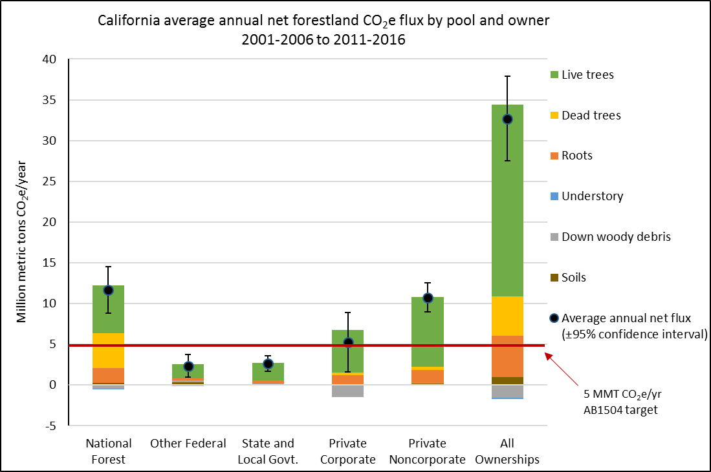

*excludes contributions from forest land-use changes, non-CO2 GHG from fire, and HWP C.

## AB 1492 Development of Ecological Performance Measures for California Timberland

The Timber Regulation and Forest Restoration Fund (TRFRF) Program is a component of Assembly Bill 1492. The major elements of the TRFRF Program are to provide a funding stream via a one-percent assessment on lumber and engineered wood products sold at the retail level, seek transparency and efficiency improvements to the State’s timber harvest regulation programs, provide for development of ecological performance measures, establish a forest restoration grant program, and require program reporting to the Legislature. The following are areas of AB 1492 Program activities that the Forest Practice Committee has been and will continue to track on behalf of the Board:

* Working Group Charters Completed (June 2015).
* Background paper on approaches to ecological performance measures completed (late 2018).
* Initial public engagement on Ecological Performance Measures (January 2019).
* Began phased implementation of CalTREES on-line timber harvest permitting system on October 1, 2018, with full implementation to occur by the end of December, 2018.
* Campbell Creek Planning Watershed Pilot Project Completed (End of 2018)
* Complete development of Ecological Performance Measures (mid-2019).
* Development of an approach to integrate information required for Lake and Streambed Alteration Agreements (Department of Fish and Wildlife) and Waste Discharge Requirements (Regional Water Quality Control Boards) in Timber Harvesting Plans, with the intent of more efficient “parallel processing” of permits and more rapid approval of the two non-CAL FIRE permit types following CAL FIRE approval of the THP completed (Late 2018).
* Continue to support the work of the Board’s Effectiveness Monitoring Committee.
* Forest restoration grant programs continue to deliver $4 million per year (from the Timber Regulation and Forest Restoration Fund) to restoration projects via grant programs at the Department of Fish and Wildlife and the State Water Resources Control Board.

**Figure 19. Past and Projected Revenues and Expenditures of TRFRF**

|  |  |  |  |  |
| --- | --- | --- | --- | --- |
| **Summary of TRFRF Revenues and Expenditures, FY 2015-16 and**  **FY 2017-18, and Projections for FY 2018-19 ($1,000)** | | | | |
| **Fund Item** | **FY 2016-17** | **FY 2017-18** | **FY 2018-19** | |
| Adjusted Beginning Balance | $29,742 | $30,737 | $25,998 | |
| Adjusted Revenues | $41,663 | $43,454 | $46,000* | |
| Total Resources | $71,405 | $74,191 | $71,998* | |
| Expenditures | $40,668 | $48,203 | $54,847* | |
| Ending Fund Balance | $30,737 | $25,988 | $17,141* | |
| *Estimated projections | | |  |

|  |  |  |  |  |
| --- | --- | --- | --- | --- |
| **TRFRF Expenditures, FY 2015-16 and FY 2017-18,**  **and Projections for FY 2018-19 ($1,000)** | | | | |
| **Administrative Unit/Category** | **FY 2016-17** | **FY 2017-18** | **FY 2018-19** | |
| Government Operations |  |  | $500* | |
| Sierra Nevada Conservancy |  |  | $1,000* | |
| Natural Resources Agency | $853 | $767 | $2,021* | |
| CAL FIRE | $19,263 | $23,246 | $26,719* | |
| Fish and Wildlife | $8,020 | $11,354 | $9,837* | |
| State and Regional Water Boards | $5,525 | $5,476 | $6,432* | |
| California Geological Survey | $3,857 | $4,242 | $4,428* | |
| Department of Tax and Fee Administration | $603 | $856 | $1,279* | |
| Fi$CAL | $49 | $47 | $5* | |
| Administrative Pro Rata | $2,498 | $2,215 | $2,184* | |
| Supplemental Pension Payments |  |  | $442* | |
| **Total Expenditures** | **$40,668** | **$48,203** | **$54,847\*** | |
| *Estimated projections | | |  |

## State Forests

### Boggs Mountain Demonstration State Forest (BMDSF)

The Board was responsible for updating the Boggs Mountain Demonstration State Forest Management Plan in 2015. The 2015 fire season took a toll on BMDSF. The Valley Fire, noted as the State’s third most destructive fire at the time of the incident (now the fifth most destructive fire in state history), significantly impacted BMDSF and surrounding communities. Over 90% of the forest was burned. As such, significant updates were made to their Initial Study and Management Plan to reflect the changes to the forest from this significant fire event. Forest staff, with help from members of CAL FIRE, completed the drafts in 2018 and included activities that occurred due to the Valley Fire such as: harvesting of dead trees, implementation of various post-fire trend monitoring projects, artificial regeneration of forested stands, road upgrading and re-designing, and/or re-establishment of trail systems that support recreational activities. Both documents were submitted to and approved by the Board in 2018.

### Mountain Home Demonstration State Forest (MHDSF)

The Board, in conjunction with the Mountain Home Demonstration State Forest Manager Jim Kral and the CAL FIRE Tulare Unit, have completed a draft Initial Study and are in the process of creating an updated Management Plan. This draft Initial Study and draft Management Plan were submitted to the Board for committee review after extensive work from Manager Kral and Board staff. Due to limited staffing and extensive forest management work being conducted at MHDSF, an extension was requested and granted on a final submission of the Management Plan. The Board is directly working with Manager Kral and the Tulare Unit with hopes of final submission and approval in 2020.

## Stewardship Lands

The Stewardship Council Board has recommended fee title transfer of lands within the North Fork Mokelumne River, Pit River, Tunnel Reservoir, Battle Creek, Cow Creek, Lake Spaulding, and Bear River planning units to CAL FIRE. With the Stewardship Council Board recommendation for transfer of lands to CAL FIRE at Bear River in November 2018, fee title recommendations have been completed. In 2018, the Stewardship Council Board approved final Land Conservation and Conveyance Plans (conservation easements and agreements known also as LCCPs) for North Fork Mokelumne River, Pit River, and Tunnel Reservoir. Additionally, the Stewardship Council is expected to review final LCCPs for several additional projects during 2019.

The Department of General Services (Department) and PG&E have developed the final form and content of each of the transaction documents, which will be utilized to construct documents for each of the transactions going forward. The California Natural Resources Agency has also participated in these discussions and is working to bring along associated transactions with State Parks. It is anticipated that final Department documents will be brought back to the Management Committee for discussion in mid to late 2019.

Conservation easement holders for each of the properties have been recommended by the Stewardship Council Board and include: Shasta Land Trust (Pit River, Tunnel Reservoir, Cow Creek), Western Shasta Resource Conservation District (Battle Creek), Mother Lode Land Trust (North Fork Mokelumne River), Placer Land Trust (Lake Spaulding), and Bear, Yuba, and Placer Land Trusts (Bear River).

## Professional Licensing and Forest Practice Enforcement

Pursuant to California Public Resources Code (PRC) § 750 *et seq.,* the Board is authorized to grant licenses to Registered Professional Foresters (RPFs) and specialty certificates (Certified Rangeland Managers (CRMs)). Earning either license is contingent upon meeting certain moral standards, educational and work experience, and ultimately passing an examination specific to the license or specialty.

The term “Professional Forester” is defined in PRC § 752 and refers to a person who, by reason of his or her knowledge of the natural sciences, mathematics, and the principles of forestry, acquired by forestry education and experience, performs services, including, but not limited to, consultation, investigation, evaluation, planning, or responsible supervision of forestry activities when those professional services require the application of forestry principles and techniques. The CRM certification is the only “Certified Specialist” (pursuant to 14 CCR § 1600) credential bestowed and recognized by the Board. A CRM is defined in 14 CCR § 1651 as “… a person who provides services pursuant to 14 California Code of Regulations (CCR) 1602, at the request of the landowner or hiring agent, relating to the application of scientific principles to the art and science of managing rangelands and range.”

**Figure 20. Board Licensed Professionals**

|  |  |  |
| --- | --- | --- |
| **Year** | **RPFs** | **CRMs** |
| 2018 | 1132 | 88 |
| 2017 | 1161 | 84 |
| 2016 | 1194 | 85 |
| 2015 | 1205 | 86 |
| 2013 | 1254 | 79 |
| 2011 | 1251 | 78 |
| 2009 | 1285 | 81 |
| 2007 | 1341 | 80 |
| 2005 | 1334 | 74 |

### Professional Discipline

Most professional disciplinary matters are confidential in nature. They are handled administratively and do not culminate in a hearing before an Administrative Law Judge and/or the Board. In 2018, the Professional Foresters Examining Committee (PFEC) received four complaints of which one required the issuance of a Private Letter of Concern from the PFEC to the RPF respondent. The remaining four are still in the investigation process.

### Enforcement

PRC § 4601 *et seq.* authorizes the Board to investigate and discipline, “Any person who willfully violates any provision of this chapter or rule or regulation of the Board….” These civil penalties are identified, investigated, and pursued by CAL FIRE, with final adjudicative authority on these matters residing with the Board. During the 2018 calendar year, the Board deliberated and took action upon six civil penalties for non-compliance with the Forest Practice Act and/or the Forest Practice Rules.

**APPENDIX A**

**2019 Standing Committee Priorities**

1.