2018 EFFECTIVENESS MONITORING COMMITTEE ANNUAL REPORT AND WORKPLAN

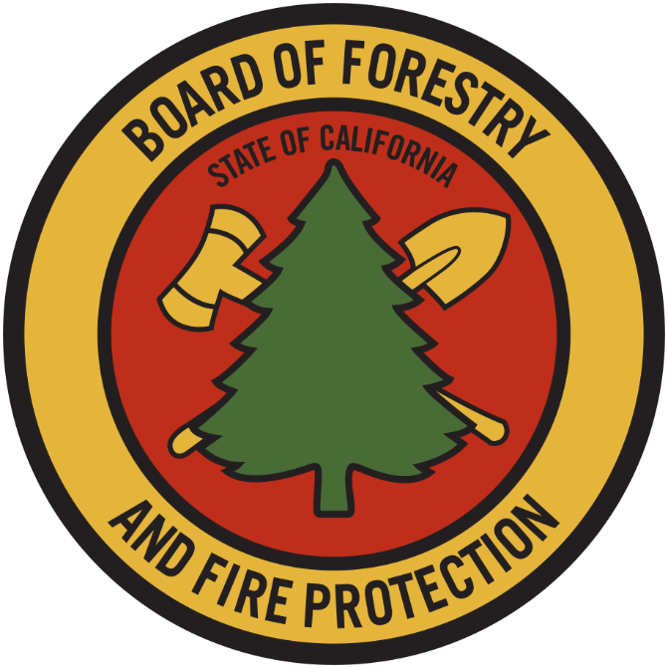

STATE BOARD OF FORESTRY AND FIRE PROTECTION

November 7, 2018

EXECUTIVE SUMMARY
The Effectiveness Monitoring Committee (EMC) Annual Report and Workplan documents yearly accomplishments and the status of ongoing EMC efforts. The Annual Report and Workplan is updated annually and is linked to the EMC Strategic Plan. The Annual Report and Workplan is provided to the Board for yearly approval, includes a summary of EMC accomplishments, details the Committee funding actions for the year, and provides an update of current EMC membership and staffing. Finally, it tracks all projects submitted to the EMC, both those considered and those selected for funding. For fiscal year 2017/2018, the EMC selected six proposed effectiveness monitoring projects to fund and support.

EMC PROCESS SUMMARY
Project Submission Timeline for Funding for Current Year (approximate)
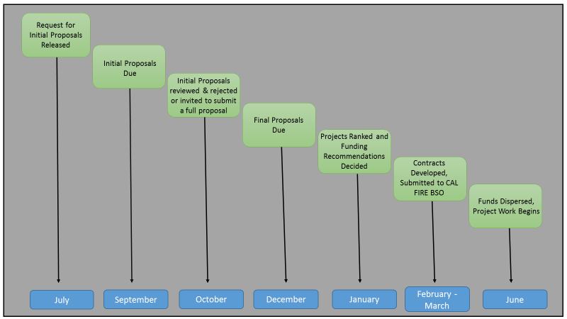

The EMC Strategic Plan will now have an update cycle of approximately three years, and the EMC Annual Report and Work Plan will be updated every calendar year. This approach of a brief annual report and a detailed periodically updated strategic plan was made in response to Board member suggestions. EMC projects are solicited through a once-a-year Request for Proposals (RFP) released after the start of the fiscal year. The EMC conducts a preliminary technical review of all Initial Concept Proposals that are received by the due date. This review considers the completeness of the proposals and whether they are within the scope of the Themes and Critical Monitoring Questions elaborated in the Strategic Plan. The EMC works with Board staff to screen proposals for any conflicts of interest and may request the Principal Investigator to provide additional information within a reasonable period.

When the EMC determines that an Initial Concept is complete and within scope, it invites the Principal Investigator to submit a Full Project Proposal by a specified date. The EMC then conducts a thorough technical review of all Full Project Proposals that are received. When a Full Project Proposal is deemed complete and ready for ranking, EMC members rank the proposal according to the ranking process detailed in the Strategic Plan. EMC members individually rank each project and the average ranking score is calculated for each project. No specific minimum average ranking score is required for support; rather, individual project scores will be considered relative to other project scores. Once all Full Project Proposals for the annual project cycle have been ranked, EMC members vote to make recommendations for allocation of available EMC funds to the proposals, taking into consideration the project ranking score, how well the project tests the effectiveness of the FPRs, and the reasonableness of the requested budget. Utilizing the EMC’s funding recommendations, Board staff will make the final funding decisions, as delegated to them by the Board. It is the intent of the EMC to keep the ranking process transparent, with the ranking done in an easily trackable manner. The EMC receives periodic updates on the projects that have received funding and presentations on findings from completed projects.

EMC FUNDING
For fiscal years 2018/2019 and 2019/2020, the EMC has been allocated ongoing funding of $425,000 per year from the Timber Regulation and Forest Restoration Fund (TRFRF), established by AB 1492 (2012). This funding is being used to support EMC projects and is granted through the Board/CAL FIRE contracting process.

EMC ACCOMPLISHMENTS
During 2018 the EMC accomplished the following:

- Received an ongoing allocation of $425,000 each fiscal year from the Timber Regulation and Forest Restoration Fund. The Board is using the funds for EMC- supported monitoring projects based.
- Added Board Member Susan Husari as a new EMC Co-Chair.
- Regularly met in open, webcast public meetings to conduct its work.
- Utilized the project ranking procedure included in the EMC Strategic Plan to select six (6) proposed effectiveness monitoring projects to fund and support (Table 1).
- Made determinations on total project funding for each submitted project, and developed contracts for four of the funded projects (two projects only required funding for equipment purchase).
- Revised the EMC project ranking process with the support of a two-person sub-committee.
- Developed new standard initial concept proposal and full concept proposal forms for potential principal investigators to use when submitting their projects to the Committee for review. These forms can be found here: http://bof.fire.ca.gov/board_committees/effectiveness_monitoring_committee_/.
- Developed and released a Request for Proposals (RFP) soliciting monitoring project initial concept proposals. Proposals were due to the EMC by September 7, 2018.
- Completed a detailed Class II- Large literature review at the request of a Board of Forestry and Fire Protection member.
- Updated the EMC Strategic Plan and developed the newly formed EMC Annual Report and Workplan. Held a field meeting at the University of California, Berkeley, Blodgett Forest to observe and discuss two EMC-funded monitoring projects.

Table 1. EMC Projects Ranked and Funded (2018)

Project | Project Title | Primary Investigator & Project Collaborators | Ranking Score | EMC Funding Allocation
EMC-2016-003 | Repeat LiDAR surveys to detect landslides | Dr. Matt O'Connor (OEI) with collaboration from California Geologic Survey | 18.25 | $100,000.00
EMC-2017-004 | Class III watercourse monitoring | CAL FIRE Watershed Protection Program | 20.36 | $18,930.00
EMC-2017-006 | Wildfire hazards in WLPZs | Dr. Rob York (UC Berkeley) | 19.95 | $114,855.00
EMC-2017-007 | Tree mortality and snag retention in the Sierra Nevada | Dr. John Battles (UC Berkeley) | 19.22 | $71,238.00
EMC-2017-008 | California FPRs and relation to fir mortality | Dr. Richard Cobb (Cal Poly, SLO) with collaboration from Collins Pine Company | 18.50 | $108,986.00
EMC-2017-012 | Bat community impacts on State Forests | Dr. Michael Baker (CAL FIRE) | 17.40 | $10,991.00

Table 2. EMC Projects not Ranked and/or Funded (2018)

Project | Project Title | Primary Investigator | Ranking Score | Reason
EMC-2017-003 | Road effectiveness monitoring for Caspar Creek - 3rd Experiment | Drew Coe (CAL FIRE) | N/A | Revised project proposal requested
EMC-2017-005 | NSO and Emergency Notices for Timber Operations | CA Dept. of Fish and Wildlife and US Fish and Wildlife Service | N/A | Revised project proposal requested
EMC-2017-009 | Effectiveness of Class II WLPZ Rules | Dr. Kevin Bladon, Dr. Catalina Segura (Oregon State University) | N/A | Revised project proposal requested
EMC-2017-010 | Alternative Meadow Restoration | Dr. Chris Surfleet (Cal Poly, SLO) | 18.92 | Project Rescinded
EMC-2017-011 | Detecting barred owls using current survey protcols | Mike Stephens (Strix Wildlife Conulsting) | N/A | Revised project proposal requested
EMC-2017-XXX | Water Quality Monitoring for Hemlock Forest Restoration | Dr. Martha Conklin (UC Merced) | N/A | Project outside scope of EMC

EMC SUPPORTED MONITORING PROJECTS – 2015 to 2018
The comprehensive list of EMC supported monitoring projects can be found on the Board’s EMC webpage at: http://bof.fire.ca.gov/board_committees/effectiveness_monitoring_committee_/. All projects, both past and present are listed in a date-sequential order.

EMC PRIORITIES
EMC priorities are drawn from what the committee believes are pertinent and current so the committee may meet its goals, vision and mission. The Board may introduce or request current priorities from the committee so they better fulfill their mission as a Board advisory committee.
- Following the EMC review and ranking processes, consider the project proposals received during the 2018 EMC RFP cycle.
- Based on EMC recommendations, the Board staff will make final funding decisions for project proposals and develop agreements to support distribution of EMC funds to selected projects for this fiscal year (2018/2019).
- Promote and provide support for projects related to the EMC themes, including projects that test the effectiveness of Class II-Large watercourses (14 California Code of Regulations (CCR) § 916.9 [936.9, 956.9]).
- Monitor progress on previously EMC-funded or -supported monitoring projects.
- Continue recruitment for current academic vacancies on the committee.
- Hold at least one EMC meeting per year in the field to observe active or proposed monitoring projects.

SUMMARY OF SUBMITTED PROJECTS FOR CONSIDERATION BY FEBRUARY 2019
The following summary table is a catalog of monitoring projects under consideration by the Effectiveness Monitoring Committee. For individual Project Summary(s) and concept proposals that provide more detailed project information, see the EMC website (bofdata.fire.ca.gov/board_committees/effectiveness_monitoring_committees_/).

Table 3. Summary of Projects Under Consideration for Ranking and/or Funding by February 2019.
Project Number | Project Title |  | Current  Status |  | Principal Investigator(s)
EMC-2018-001 |  | 14 CCR § 1038(j) Exemption Monitoring |  | Awaiting Committee Review |  | Board of Forestry and Fire Protection, FRAP, Consulting Registered Professional Foresters
EMC-2018-002 |  | Decision Support Tool – Northern Spotted Owl use of Post-Fire Landscapes |  | Awaiting Committee Review |  | Dr. Michelle Reilly (USDA Forest Service)
EMC-2018-003 |  | Alternative Meadow Restoration |  | Awaiting Committee Review |  | Dr. Chris Surfleet (Cal Poly, SLO), Bethany Johnson (Collins Pine Co.)
EMC-2018-004 |  | Impacts of Mechanical Harvesting in the WLPZ |  | Awaiting Committee Review |  | Jason Poburko (CAL FIRE: LaTour Demonstration State Forest), Dr. Chris Surfleet (Cal Poly, SLO)
EMC-2018-005 |  | Characterizing Amphibian Distribution as a Foundation for Improving Riparian Function |  | Awaiting Committee Review |  | CAL FIRE: Jackson Demonstration State Forest
EMC-2018-006 |  | Effectiveness of Class II Watercourse and Lake Protection Zone (WLPZ) Forest Practice Rules (FPRs) and Aquatic Habitat Conservation Plan (AHCP) Riparian Prescriptions at Maintaining or Restoring Canopy Closure, Stream Water Temperature, and Primary Productivity |  | Awaiting Committee Review |  | Dr. Kevin Bladon and Dr. Catalina Segura (Oregon State University), Drew Coe (CAL FIRE), Matt House (Green Diamond Resource Co.)
EMC-2018-007 |  | Effects of Experimental Site Exclusion on Pacific Martens |  | Awaiting Committee Review |  | Dr. Katie Moriarity (National Council for Air and Stream Improvement), Matthew Delheimer (USDA Forest Service Pacific Southwest Research Station)

CURRENT EMC APPOINTED MEMBERS AND STAFF
For FY 2018/2019, the Committee has two Co-Chair positions, 8 agency representatives, 5 EMC Members (2 academic vacancies), and five support staff. The EMC and Board staff are conducting outreach to both the monitoring and academic communities to fill vacated positions.

Table 4. Current EMC Membership and Support Staff.
Name | Specialty | Affiliation | Term  Expiration
Co-Chairs
Russ Henly, Ph.D. | Co-Chair, RPF 2560 | California Natural Resources Agency | n/a
Susan Husari | Co-Chair, Forestry/Fire Management | Board of Forestry and Fire Protection | n/a
Agency Representatives
Stacy Drury, Ph.D. | Fire Ecology | USDA Forest Service Pacific Southwest Research Station | n/a
Mandy Culpepper | Wildlife | California Department of Fish and Wildlife | n/a
Drew Coe | Hydrology/Forestry, RPF 2981 | CAL FIRE | n/a
Cliff Harvey | Water Quality/Hydrology | State Water Resources Control Board | n/a
Justin LaNier | Geology/Hydrology/Water Quality | Central Valley Regional Water Quality Control Board | n/a
Clarence Hostler | Fisheries | NOAA National Marine Fisheries Service | n/a
Bill Short | Engineering Geology/ Hydrogeology | California Geological Survey | n/a
Jim Burke | Geology/Water Quality | North Coast Regional Water Quality Control Board | n/a
Monitoring Community
Greg Giusti | Forestry, RPF 2709 | University of California Cooperative Extension Advisor Emeritus-Lake and Mendocino counties | 7/1/2021
Matt House | Hydrology/Fisheries | Green Diamond Resource Company | 8/31/2020
Sal Chinnici | Wildlife | Humboldt Redwood Company | 7/1/2020
Matt O’Connor, Ph.D. | Geology/Geomorphology | Public | 7/1/2019
Emily Burns, Ph.D. | Forest Ecology/Forestry | Public, Save the Redwood League | 7/1/2021
VACANT |  | University
VACANT |  | University
Support Staff
Matt Dias | Forestry, RPF 2773 | Board of Forestry and Fire Protection Executive Officer | n/a
Support Staff
Pete Cafferata | Hydrology/Forestry, RPF 2184 | CAL FIRE | n/a
Stacy Stanish | Biology/Fisheries, RPF 3000 | CAL FIRE | n/a
Dave Fowler | Geology/Water Quality | North Coast Regional Water Quality Control Board | n/a
Connor Pompa | Forestry | Board of Forestry and Fire Protection | n/a
Brandi Goss | Biology/Environmental Science | Board of Forestry and Fire Protection | n/a

EMC PROJECT UPDATES
- EMC-2015-001 Class II-Large Monitoring (ongoing): Oregon State University Master of Science (MS) student Adam Pate selected three main areas to implement the regional scale component of the Class II Large watercourse study, which is assessing the effectiveness of rule criteria for identifying Class II watercourses susceptible to thermal loading. Field work took place during the summer of 2018 in three Jackson Demonstration State Forest watersheds, two upper Klamath River basins, and the Cow Creek watershed (South Cow Creek on LaTour Demonstration State Forest). A total of at least 100 sites are being studied. Data analysis is being conducted this fall, including the use of LiDAR and NetMap data.

- EMC-2015-002 Forest Practice Rules Implementation and Effectiveness Monitoring (FORPRIEM) ver. 2.0.: A final statistical consultation report, which was funded by the EMC, was written by Dr. Ashley Steel and Pat Cunningham, USFS Pacific Northwest Research Station (PNW), was prepared and submitted to the EMC (see: http://www.bof.fire.ca.gov/board_committees/effectiveness_monitoring_committee_/mm0618/emc_4-a-_calfire_erosion_statistical_final_report_20june2018.pdf).
Project implementation (not currently funded by the EMC) based upon the PNW statistical consultation is ongoing and planned for 2019.

- EMC-2015-004 Effectiveness of Road Rules in Reducing Hydrologic Connectivity and Significant Sediment Discharge (completed): A final statistical consultation report, which was funded by the EMC, was written by Dr. Ashley Steel and Pat Cunningham, USFS Pacific Northwest Research Station (PNW), was prepared and submitted to the EMC (see: http://www.bof.fire.ca.gov/board_committees/effectiveness_monitoring_committee_/mm0618/emc_4-a-_calfire_erosion_statistical_final_report_20june2018.pdf).
Project implementation (not currently funded by the EMC) based upon the PNW statistical consultation is ongoing and planned for 2019.

- EMC-2016-002: Post-fire effectiveness of the Forest Practice Rules in protecting water quality on Boggs Mountain Demonstration State Forest (ongoing): Three wet seasons of data collection have been completed, and measurements will continue for an additional two wet seasons to fully capture post-fire and post-salvage recovery. Runoff simulations to test various skid trail BMP treatments will be performed in the spring of 2019. A manuscript on the role of soil compaction and ground cover in post-fire logged areas will be submitted to Journal of Hydrology in Fall 2018.

- EMC-2016-003: Road Rules Effectiveness at Reducing Mass Wasting (Repeat LiDAR Surveys to Detect Landslides) (ongoing): The CAL FIRE/CGS contract has been augmented to purchase LiDAR. Contracting with USGS to conduct the LiDAR survey is underway.
- EMC-2017-001 Caspar Creek Nutrient Study (ongoing): UC Davis MS student Seanna McLaughlin and Drs. Helen Dahlke and Randy Dahlgren prepared a final report for pre-harvest biogeochemical analysis of four Caspar Creek sub-watersheds for the Save the Redwoods League, one of the project funders (see: http://www.bof.fire.ca.gov/board_committees/effectiveness_monitoring_committee_/proposed_projects/emc-2017-001_final_report.pdf). A bromide/nitrate stream injection took place during September of 2018, allowing the characterization of in-stream nitrogen dynamics (data analysis ongoing).

- EMC-2017-002 Boggs Mountain Demonstration State Forest (BMDSF) Post-Fire Automated Bird Recorders Study (ongoing): The second year of bird recordings were made in the late spring of 2018 and the bird call expert is currently interpreting the recordings. Stacy Stanish prepared a poster for the Western Section of the Wildlife Society Meeting held in February 2018. She will be presenting the study and preliminary results to the CARCD Annual Conference "Celebrating Resilient Landscapes and Adaptive Communities" in San Diego in November.

- EMC-2017-004: Monitoring Class III Watercourses (ongoing): Equipment for this project has been purchased by BOF and CAL FIRE staff, including 120 Onset temperature loggers. Project implementation is planned for 2019.

- EMC-2017-006: Tradeoffs Between Riparian Buffers, Fire, and Regeneration (ongoing): Dr. Rob York, UC Berkeley, has implemented this project on Blodgett Forest Research Station. Feller bunchers and skidders have been used in Class I and II WLPZs; logging slash has been hand piled for burning. Parameters being measured include soil strength (index of soil compaction), species composition/structure, fuel loading, canopy cover/light availability, water temperature, and stream sediment.

- EMC-2017-007: The Life Cycle of Dead Trees and Implications for Management (ongoing): Dr. John Battles, UC Berkeley, has implemented this project on Blodgett Forest Research Station. The 2018 snag inventory in compartment 160 was updated using a 40-m grid to map snags with GPS. An additional component of the project, a long-term study of downed wood decay rates, has been implemented using eight log decay sites (e.g., “log cemeteries”) in compartment 160 and four functional groups of trees (fir, pine, oak and cedar). Log density and volume will be measured over the next 20 years.

- EMC-2017-008: FPRs to Minimize Fir Mortality from Root Diseases (ongoing): The contract for this project has been approved. The study will be conducted by Dr. Richard Cobb, Cal Poly San Luis Obispo.

- EMC-2017-012: Bat Study on Demonstration State Forests (ongoing): Primary equipment (i.e., acoustic detectors, insect traps, bat call analysis software, etc.) for this project has been purchased by Dr. Michael Baker, CAL FIRE. Dr. Baker’s California Scientific Collecting Permit, first acquired from CDFW in 2007 for a study of pallid bat habitat use on the Plumas National Forest, was renewed in August 2018 (application was made in March 2018), enabling the purchase of bat capture mist nets (sold only to permitted researchers). Once the nets arrive, only a few back-ordered minor equipment items will remain. The study is now on-schedule to be initiated in May of 2019 on Jackson Demonstration State Forest.

EMC PROJECT RESULTS AND PRODUCTS
EMC-2015-002 Forest Practice Rules Implementation and Effectiveness Monitoring (FORPRIEM) ver. 2.0.: A final statistical consultation report, written by Dr. Ashley Steel and Pat Cunningham, USFS Pacific Northwest Research Station (PNW), was prepared for the EMC (see: http://www.bof.fire.ca.gov/board_committees/effectiveness_monitoring_committee_/mm0618/emc_4-a-_calfire_erosion_statistical_final_report_20june2018.pdf).

EMC-2015-004 004 Effectiveness of Road Rules in Reducing Hydrologic Connectivity and Significant Sediment Discharge: A final statistical consultation report, written by Dr. Ashley Steel and Pat Cunningham, USFS Pacific Northwest Research Station (PNW), was prepared for the EMC (see: http://www.bof.fire.ca.gov/board_committees/effectiveness_monitoring_committee_/mm0618/emc_4-a-_calfire_erosion_statistical_final_report_20june2018.pdf).

EMC-2016-002: Post-fire effectiveness of the Forest Practice Rules in protecting water quality on Boggs Mountain Demonstration State Forest: A manuscript titled “Hydrologic and erosive responses of compaction versus cover in post-fire logged areas Part I: Isolating the key factors” was submitted to the Journal of Hydrology by Drs. Sergio Prats and collaborators. The study used soil collected from BMDSF and replicated post-fire salvage logging conditions and practices in a laboratory setting. Will Olsen’s 2016 Master of Science Thesis, Michigan Tech, titled: “Effects of Wildfire and Post-Fire Salvage Logging on Rill Networks and Sediment Delivery in California Forests” is available at: https://digitalcommons.mtu.edu/etdr/287/
Drew Coe’s presentation abstract for the 2016 Geological Society of America Cordilleran Section 112th Annual Meeting titled “Post-Fire Erosion and Sediment Delivery Rates to Headwater Streams in the California Coast Ranges” is available at: https://gsa.confex.com/gsa/2016CD/webprogram/Paper274597.html

EMC-2017-001 Caspar Creek Nutrient Study: The final report prepared by UC Davis MS student Sienna McLaughlin and Drs. Helen Dahlke and Randy Dahlgren for the Save the Redwoods League, one of the EMC project funders, is available at: http://www.bof.fire.ca.gov/board_committees/effectiveness_monitoring_committee_/proposed_projects/emc-2017-001_final_report.pdf.

EMC-2017-002 Boggs Mountain Demonstration State Forest (BMDSF) Post-Fire Automated Bird Recorders Study: A poster and poster abstract were prepared for the Western Section of the Wildlife Society Meeting held in February 2018. See: http://www.wildlifeprofessional.org/western/tws_abstract_detail.php?abstractID=2020.

POTENTIAL EMC PROJECT IMPACTS TO REGULATIONS
The EMC provides valuable insight to the Board on testing the effectiveness of their rules and regulations by way of science-based research projects. EMC funded studies may have the ability to show that regulatory modifications, either minor or major, may need to occur to help construct effective Forest Practice Rules (14 CCR § 895 et seq.). At this time, EMC funded projects have not identified any rulemaking possibilities.

Fiscal year denotes from the July 1st of one year to July 1st of the next. The State of California uses this time frame for tax and accounting purposes.
http://leginfo.legislature.ca.gov/faces/billNavClient.xhtml?bill_id=201120120AB1492.

