2018 STRATEGIC FIRE PLAN FOR CALIFORNIA

A vision for a natural environment that is more fire resilient; buildings and infrastructure that are more fire resistant; and a society that is more aware of and responsive to the benefits and threats of wildland fire; all achieved through local, state, federal, tribal, and private partnerships.

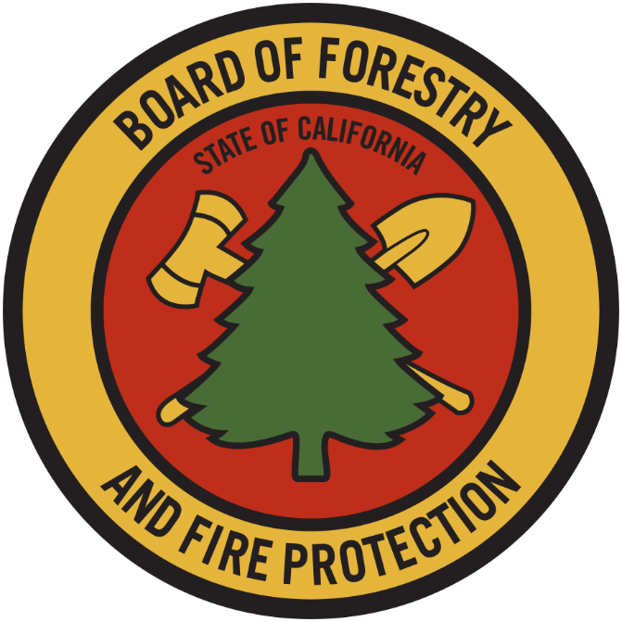

STATE BOARD OF FORESTRY AND FIRE PROTECTION

CALIFORNIA DEPARTMENT OF FORESTRY AND FIRE PROTECTION (CAL FIRE)

August 22, 2018

EDMUND G. BROWN, JR.
Governor

NATURAL RESOURCES AGENCY
JOHN LAIRD, Secretary

STATE BOARD OF FORESTRY AND FIRE PROTECTION
Members

J. KEITH GILLESS, Ph.D., Chair
MARK S. ANDRE, Vice Chair
CHRIS CHASE
KATIE DELBAR
SUSAN HUSARI
MARC LOS HUERTOS, Ph.D.
MIKE JANI
RICHARD WADE
DARCY WHEELES

CAL FIRE
KEN PIMLOTT, Director

ACKNOWLEDGMENTS

FIRE PLAN STEERING COMMITTEE MEMBERS

Darcy Wheeles Board of Forestry and Fire Protection, Co-Chair Daniel Berlant CAL FIRE, Co-Chair
Dr. Russ Henly Natural Resources Agency
Matt Dias Board of Forestry and Fire Protection Michael Bradley CAL FIRE
Liz Berger USDA Forest Service
Jerry Bird USDA Forest Service
Dave Sapsis CAL FIRE
Matthew Reischman CAL FIRE
J. Lopez Los Angeles County Fire Department
Joe Tyler CAL FIRE
Jim McDougald CAL FIRE
Kevin O’Meara CAL FIRE Local 2881

CONTRIBUTORS

Edith Hannigan Board of Forestry and Fire Protection Dave Shew CAL FIRE

TABLE OF CONTENTS

Executive Summary 1
State Board of Forestry and Fire Protection 4
Setting the Stage 6
Moving Forward While Checking Back 13
Vision 16
Goals and Objectives 16
Appendix A: CAL FIRE Budget Augmentation Through Implementation of the 2010Strategic Fire Plan ….………………..…………………………..…...…. 29
Appendix B: Glossary……………………………………………………………..….. .31
Appendix C: Bibliography…………………………….……………….………………..35

EXECUTIVE SUMMARY

The Strategic Fire Plan is one of the Board of Forestry and Fire Protection’s (Board) preeminent policies. The Board has adopted these Plans since the 1930s and periodically updates them to reflect current and anticipated needs. Over time, as the environmental, social, and economic landscape of California’s wildlands has changed, the Board has evolved the Strategic Fire Plan to better respond to these changes and to provide the Department of Forestry and Fire Protection (CAL FIRE) with appropriate guidance “…for adequate statewide fire protection of state responsibility areas.” (PRC § 4130)

Earlier iterations of this plan were exhaustive and provided fine-grained detail on vegetation types, placement of suppression personnel and equipment, budgetary considerations, and assets at risk. During preparation of the 2010 Strategic Fire Plan (2010 Plan), the Board changed the previous Plan structure to provide broad, strategic direction to CAL FIRE. The 2010 Plan also required CAL FIRE—a decentralized agency with 21 administrative field units, along with 6 contract counties, implementing multiple fire prevention, natural resource management, and fire suppression programs—to annually report back to the Board on their Unit Fire Plans and accomplishments.

The 2010 Plan approach has proven successful. CAL FIRE’s annual updates to the Board, coupled with its Unit Fire Plans, have demonstrated CAL FIRE’s ability to meet the 2010 Plan’s goals and objectives. The structure and flexibility built into the 2010 Plan provided clear guidance to CAL FIRE and its partners, and CAL FIRE has continued successful implementation at all levels. The policy direction provided by the 2010 Plan also has helped to support CAL FIRE budget requests for additional resources required to attain the provided goals and objectives. Given the success of the new approach, the Board continued this format for the 2018 Strategic Fire Plan (2018 Plan) and incorporated updated goals and objectives to reflect lessons learned, new priorities, and changed conditions.

Since the 2010 Plan, California has experienced environmental changes, and CAL FIRE has made significant organizational changes. The effects of climate change, overly dense forests, and prolonged drought have resulted in unprecedented tree mortality in the state’s forests, as well as an increase in the number, area, and severity of wildland fires. Loss of life and structures as a direct or proximate result of wildland fires is at an all-time high. In turn, CAL FIRE has set its focus upon increasing the pace and scale of fire prevention activities while simultaneously fielding a growing year-round wildland fire suppression force. The 2018 Plan anticipates that these trends will continue.

This 2018 Plan reflects CAL FIRE’s focus on (1) fire prevention and suppression activities to protect lives, property, and ecosystem services, and (2) natural resource management to maintain the state’s forests as a resilient carbon sink to meet California’s climate change goals and to serve as important habitat for adaptation and mitigation. Additionally, the continued inclusive collaboration among local, state, federal, tribal, and private partners remains paramount to effectively manage towards a more fire resilient wildland-urban interface and natural environment. The Plan construes “collaboration” very broadly, from working together to implement a single fuel break, working together to develop a Community Wildfire Protection Plan, to developing and administering the statewide, multi-agency California Fire Management Agreement.

The elements of the 2018 Plan are all consistent with the findings and direction provided in recent assessments, policy reports, and high-level collaborative strategies referenced herein. This scope includes Governor Brown’s Executive Order B-52-18 and establishment of the California Forest Management Task Force.

Implementation of the 2010 Plan demonstrated to the Board and to CAL FIRE that its goals and objectives are not discrete and separate elements, but rather are highly inter-related parts of a holistic strategy. The seven goals in the 2010 Plan have been expanded to eight goals, with a new goal focusing on a wide range of fire prevention activities throughout the state.

New technology allows more rapid and expansive data collection and analysis across the state in pre-, during-, and post-fire environments. Over time, detailed analysis of these data will further assist CAL FIRE in focused efforts to meet the goals and objectives of the 2018 Plan. This is most readily apparent in the ability of CAL FIRE to analyze and share data within and across Departmental programs and Units, as well as with other public and private partners. Moving forward requires melding of knowledge that is informed through emerging science, improved data, and integrated analysis of a variety of factors (e.g., environmental conditions, prevention activities, suppression tactics, land use planning, forest health initiatives, and the effects of wildland fire on the built environment). The Board, CAL FIRE, and our partners can build on this emerging science and data to achieve higher levels of success in the implementation of this 2018 Plan.

This Strategic Fire Plan is focused and concise, ensuring it will be efficient guidance for CAL FIRE and the many stakeholders who share similar missions, responsibilities, and common interests. It was developed through collaboration among the members of the Fire Plan Steering Committee, which included representatives of federal, state, and local governments, as well as labor. This Committee of subject matter experts worked for over a year preparing this document, and the 2018 Plan went through a Board-led public review and comment process to incorporate additional input. This process included two public workshops, which were held in Santa Rosa and Ventura in May 2018.
The Board expects Unit Fire Plans will continue to implement current efforts, and where necessary, establish new programs and projects to meet the 2018 Plan goals and objectives. As a monitoring mechanism, CAL FIRE will report to the Board annually on progress toward meeting the 2018 Plan’s goals, provide an aggregation of the Unit Fire Plans, and identify opportunities for adaptive management. The ability of the Board and CAL FIRE to meet the 2018 Plan’s goals and objectives will evolve over time as statewide initiatives are implemented and as funds, resources, staffing, and collaborative opportunities become available.
The Board looks forward to working with CAL FIRE and our many partners toward successful implementation of this 2018 Strategic Fire Plan. This success will not be possible without strong collaboration and dedicated funding that targets fire prevention, natural resource management, and fire suppression activities across the state. For Californians to live sustainably in conjunction with fire over the long term, the State must deploy a multi-faceted and balanced approach to all elements of fire management including fire prevention, natural resource management, planning, and fire suppression and recognize both the inevitability and the necessity of fire in healthy wildland ecosystems.

Vision

A vision for a natural environment that is more fire resilient; buildings and infrastructure that are more fire resistant; and a society that is more aware of and responsive to the benefits and threats of wildland fire; all achieved through local, state, federal, tribal, and private partnerships.

Goals as Summarized

The goals that are critical to achieving the 2018 Strategic Fire Plan’s (2018 Plan) vision revolve around fire prevention, natural resource management, and fire suppression efforts, as broadly construed. Major components are:

- Improve the availability and use of consistent, shared information on hazard and risk assessment;
- Promote the role of local planning processes, including general plans, new development, and existing developments, and recognize individual landowner/homeowner responsibilities;
- Foster a shared vision among communities and the multiple fire protection jurisdictions, including county-based plans and community-based plans such as Community Wildfire Protection Plans (CWPP);
- Increase awareness and actions to improve fire resistance of man-made assets at risk and fire resilience of wildland environments through natural resource management;
- Integrate implementation of fire and vegetative fuels management practices consistent with the priorities of landowners or managers;
- Determine and seek the needed level of resources for fire prevention, natural resource management, fire suppression, and related services; and
- Implement needed assessments and actions for post-fire protection and recovery.

STATE BOARD OF FORESTRY AND FIRE PROTECTION

The Board of Forestry and Fire Protection (Board) is a Governor-appointed body, whose members are appointed based on their professional and educational qualifications and their general knowledge or interest in watershed management, forest management, fish and wildlife, range improvement, forest economics or land use policy. Of the Board’s nine members, five are representatives from the general public, three are from the forest products industry, and one member is from the range-livestock industry.

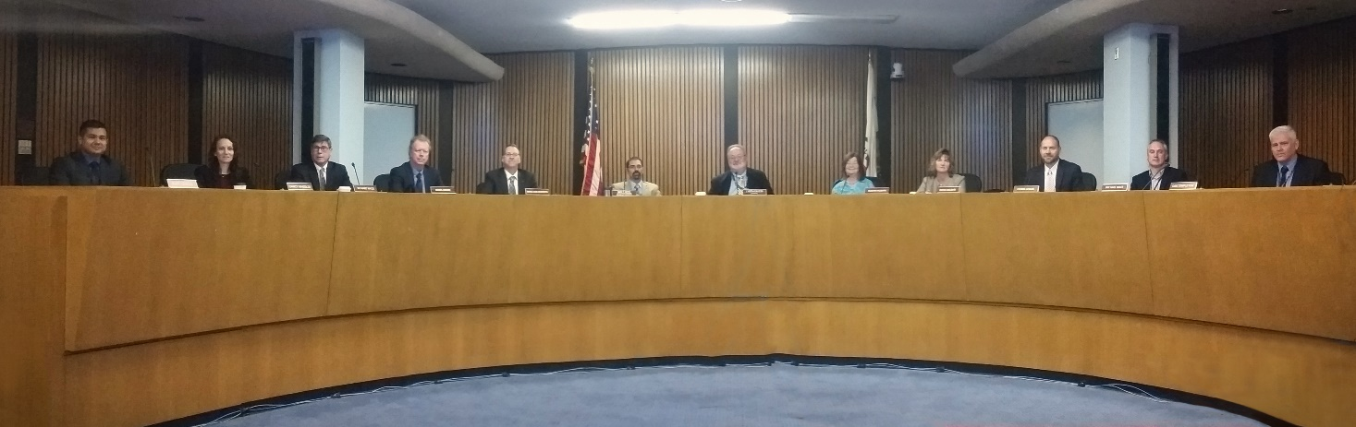
State Board of Forestry and Fire Protection.

The mission of the Board is to lead California in developing policies and programs that serve the public interest in environmentally, economically, and socially sustainable forest and rangeland management; and a fire protection system that protects and serves the people of the state. Its statutory responsibilities are to:

- Establish and administer forest and rangeland policy for the State of California;

- Protect and represent the state’s interest in all forestry and rangeland matters;

- Provide direction and guidance to CAL FIRE on fire protection and natural resource management;

- Accomplish a comprehensive regulatory program for forestry and fire protection;

- Conduct its duties to inform and respond to the people of the State of California; and

- Address minimum fire safety standards for developments in the State Responsibility and fire hazard planning in General Plan Safety Elements.

In concert with the mission of the Board, the mission of the California Department of Forestry and Fire Protection (CAL FIRE) is to serve and safeguard the people and protect the property and resources of California.

The Board is responsible for developing the general forest policy of the state, setting CAL FIRE guiding policies, and representing the state's interest in federal land management. Central among these are the Board-promulgated Forest Practice Rules, which set standards and best management practices for commercial management of nonfederal forests in the state, including measures for reducing wildland fire risks and improving forest resilience.

CAL FIRE implements and enforces the Board’s policies and regulations. The Board is within CAL FIRE and, together, they work to carry out the mandates of the Governor and the Legislature to protect and enhance the state's unique forest, wildland, and watershed resources.

To carry out these responsibilities, the Board engages in a strategic planning process which defines and communicates the Board’s guiding values and priorities and directs resources to the most important issues. It also defines both the Board’s and CAL FIRE’s vision, and how to measure and report performance.

The development of the Strategic Fire Plan is a critical element of this planning process. The Strategic Fire Plan forms the basis for assessing California’s complex and dynamic natural and built environments, and it identifies a variety of actions to minimize the negative effects and enhance the positive effects of fire.

The Public Resources Code authorizes the Board to establish a fire plan which, among other things, establishes the levels of statewide fire protection services for State Responsibility Area (SRA) lands. CAL FIRE and other federal and local fire protection resources collectively provide regional and statewide emergency response services. In addition, California’s integrated mutual aid fire protection system provides statewide fire protection services through automatic and mutual aid agreements for wildland fire and other emergency incidents.

SETTING THE STAGE

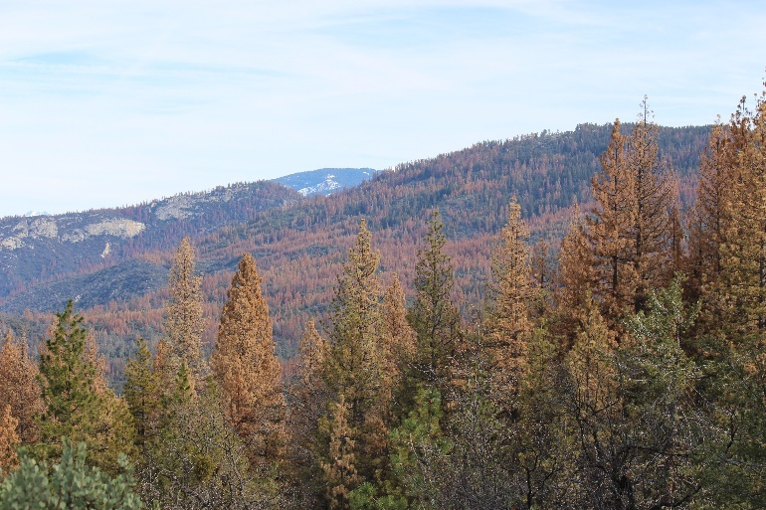
Fire is a primary driving force that has shaped California’s ecosystems for millennia, recurring at varying intervals in virtually all vegetation types. It is estimated that between 4.5 and 12 million acres burned annually prior to Euro-American settlement, although there was significant variability in pre-settlement fire regimes across vegetation types and regions. Wildland fire activity always has been closely connected to climate and continues to be an endemic part of natural systems of much of the state. Our continuing quest to manage these systems in the face of fire’s inevitability requires both looking backward for patterns and successes and looking forward for new innovations and strategies.
Extensive Drought Mortality within the Central Sierra Photo courtesy of CAL FIRE

Wildland Fire Trends

The modern era has seen a marked change in natural fire regimes due to land management practices and fire suppression. The disruption of fire regimes within ecosystems has created conditions across California that, in concert with climate change and expanding development, are manifesting themselves in the form of increased wildland fire impacts, with ecological, economic and human consequences.
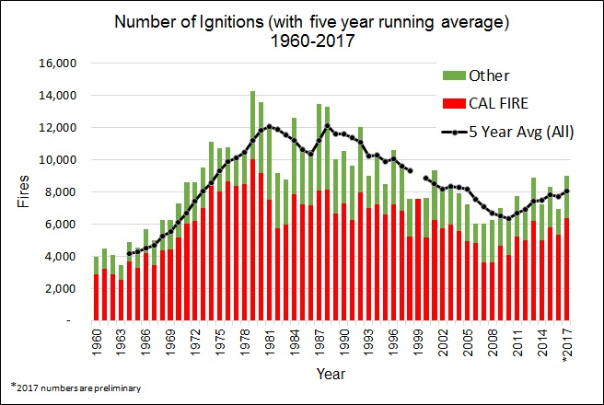
Figure 1. Number of ignitions (with five year running average)
Data Source: CAL FIRE Historical Wildfire Statistics, 1960- 2017
(A data gap exists for “other” wildland fire ignitions in 1999, which disallows calculation of a 5-year rolling average for 1999)

Recent trends have shown an increase in the number of ignitions, area burned, and impacts to ecosystems. Ignitions, which are correlated to increased workload, have been on the rise since 2007 (Figure 1) after decades of reductions. While this increase in ignitions is indicative of a increased fire suppression workload for CAL FIRE, it also highlights the continued need for a robust fire prevention program.

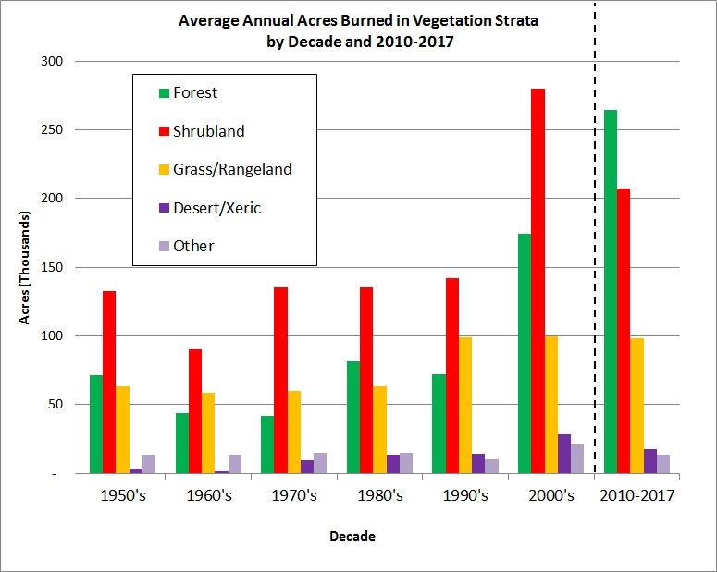
The burn area, whether looked at in aggregate or by vegetation type, shows an increasing trend that mirrors signatures of climate change, such as rising mean temperature and increasing length of fire seasons. Figure 2 shows annual average rates of burning (acres/year) by vegetation type and decade. Annually since 2000, the average annual acres burned in California has more than doubled the average of the 1960s (FRAP 2018, forthcoming). By decade, this annual average rose steadily through the 1990s to a peak in the first decade of the 2000s and beyond. Average annual area burned within the state since 2000 has maintained at a rate of approximately 700,000 acres each year.
Figure 2: Average annual area burned (acres) by decade and vegetation strata, 1960- 2017. Data source: CAL FIRE California Interagency Fire Perimeter Database 2017.

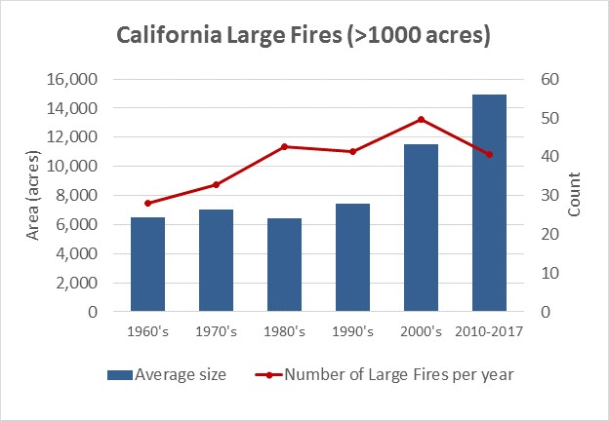
Of particular note, Figure 2 shows that there has been a steady increase in burn area in forest fuel types. The amount of forest area burned has increased each decade since the 1990s, and, since 2010, more forest area has burned than any other vegetation type.

The increasing prevalence of very large fires (>100,000 acres) across the West, as well as large scale tree mortality events, has led many experts to posit that the US has entered into an era of “mega-fires” or “mega-disturbances.” During this decade, although the number of large annual fires has decreased compared to the 2000s, the average fire size has increased (Figure 3). Fourteen of the twenty largest wildland fires of the modern era have occurred since 2000, including the 2017 Thomas Fire, which burned over 280,000 acres. In fact, 2017 had the
Figure 3: Number of large wildfires (>1000 acres) and average
size by decade, 1960-2017. Data source: CAL FIRE California
Interagency Fire Perimeter Database 2017.

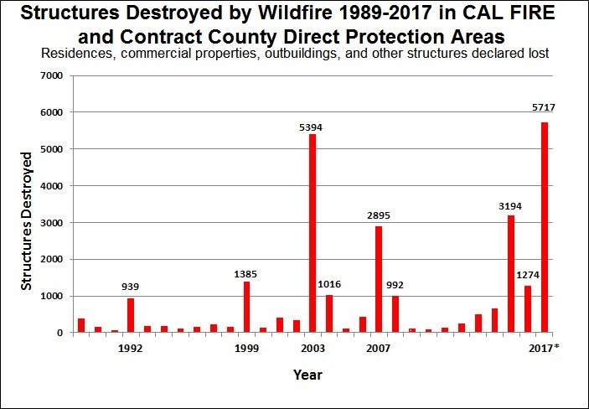
most structures destroyed by wildland fire within the last three decades, totaling 5,717 structures within Direct Protection Areas (DPA). More than 10,000 structures were lost in the DPA and Local Response Areas combined. Since the turn of the century there has been a steep increase in structures lost compared to the 1990s, which is correlated to the average fire size increasing (Figure 4).

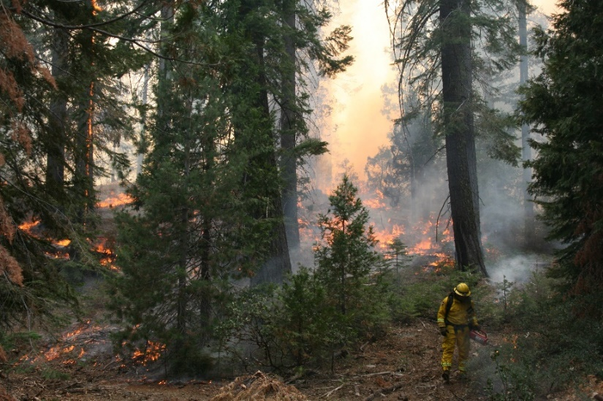
Climate change and wildland fire now drive forest and watershed policy and management. Forests sequester and store significant amounts of atmospheric carbon, thereby helping to check greenhouse gas impacts such as rising mean temperatures. However, both the increasing number and nature of wildland fires cause massive losses in stored carbon and significant reductions in carbon sequestration. As such, carbon stability now plays a central role in forest policy (cf. AB1504 Forest Carbon Inventory, California Forest Carbon Plan, Little Hoover Commission Report, Forestry Note 121, Executive Order B-52-18, and the Governor’s Forest Management Task Force). Policies are designed to greatly increase the pace and scale of actions to improve forest health and resiliency and to promote long-term carbon stability, uptake, and storage by promoting larger healthy trees. These trees are more resistant to fire and other disturbances that can lead to loss of forest cover and ultimately result in lower carbon density ecosystems. Similar plans directed at other land types are also being developed (e.g., Natural and Working Lands Carbon Plan). Collectively, these plans promote policies to get the right kind of fire on the right kind of landscape at the right time, thereby enhancing the long-term carbon trends and ecosystem health across the state.
Prescribed Fire in the forested setting Photo courtesy of CAL FIRE
Figure 4: Number of structures destroyed by wildfire between the years 1989-2017 in CAL FIRE and contract county direct protection areas

Managing wildland fire in the face of complex and sometimes competing interests is a major challenge. As land managers continue to increase the use of proactive fuel treatments, greater funding and collaboration are increasingly necessary to address fire and vegetative fuels at landscape scales.
Examples of existing collaborative approaches include the Sierra Nevada Watershed Improvement Program, Western Klamath Restoration Partnership, Prescribed Fire MOU, Good Neighbor Authority agreements between CAL FIRE and USFS Region 5, and the California Fire Management Agreement. In addition, the California Forest Carbon Plan and the Forest Management Task Force emphasize the importance of landscape-level collaboration to ensure the achievement of its forest health and resiliency goals. Critical funding sources (such as the California Climate Investment Forest Health Grant Program at CAL FIRE and State bond act support for grant programs at multiple State agencies) are also necessary to support these collaborative efforts. The Fiscal Year (FY) 2018 Federal Omnibus Spending Bill provides new wildfire funding and forest management authorities to the Forest Service. These new resources will offer significant support to the Forest Service in achieving its goals for healthier forests and the benefits they deliver to the public, including through collaborative efforts with the State of California and other partners.

Population

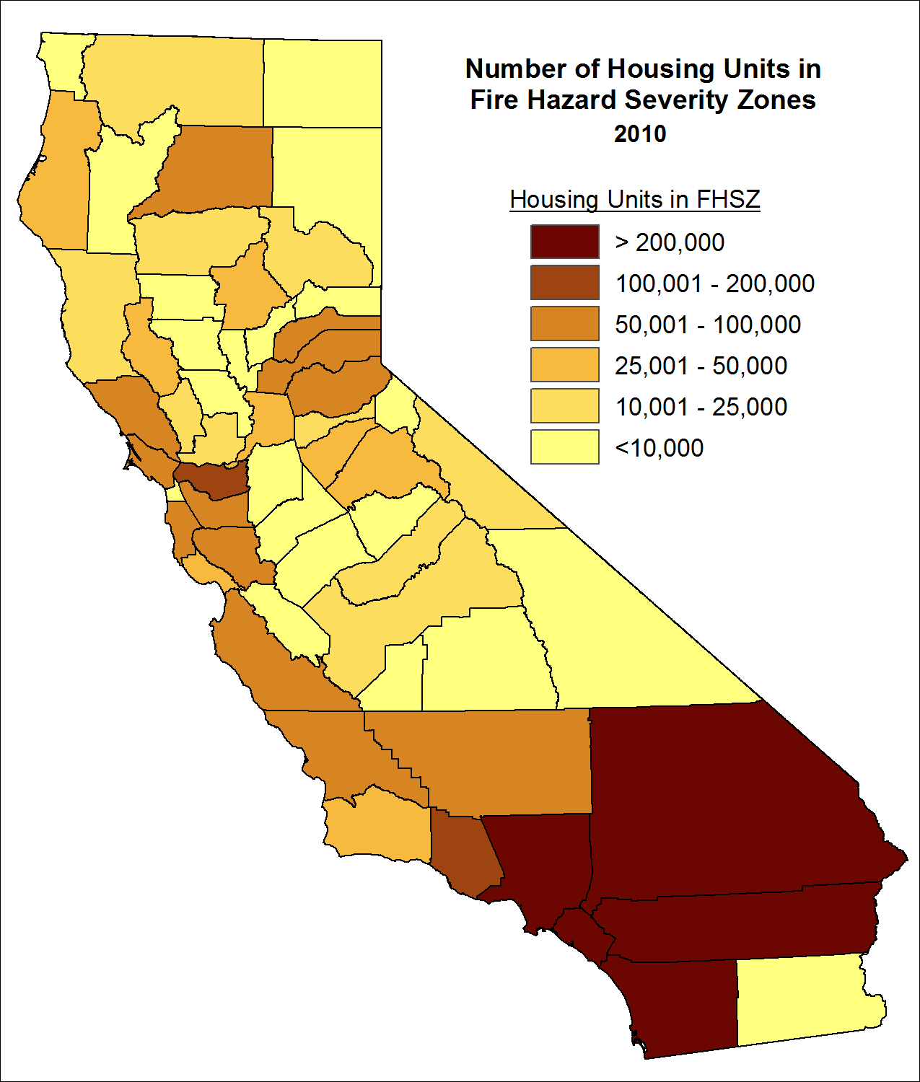
Demographic pressures continue to put more people, homes, and infrastructure in harm’s way from wildland fire. The most recent assessment of California’s Wildland-Urban Interface shows that as of 2010, there were about 3 million housing units in Fire Hazard Severity Zones (FHSZ) that are potentially at risk from wildland fire. Figure 5 shows how these housing units are distributed among California counties. The figure shows that a large proportion of the houses within FHSZ are in the southern portion of the state. The top five counties for FHSZ housing units, all in southern California, contain about half of all statewide housing units in FHSZ. However, this is a statewide problem, with 37 counties have at least 10,000 housing units in FHSZ.
Figure 5: Census Housing Units in Fire Hazard Severity Zones, 2010.
Data Sources: Fire Hazard Severity Zones, FRAP, v11; Census block data, U.S. Census Bureau, 2010.

Further, since the frequency of extreme weather events is projected to increase, urban areas both immediately adjacent to and near wildlands will be at risk. The 2017 October Fire Siege clearly showed that the damage from wildland fires can occur in areas previously thought to be at low risk. Recent wildland fires also have demonstrated that post-fire events can cause substantial loss of life and damage to property and natural resources. CAL FIRE is continuing to explore new data, science, and tools to revise its Fire Hazard Severity Zone maps to account for localized extreme wind events. In addition to improving mapping, expanded policies and incentives will help existing communities to proactively improve their resistance to wildland fire damage. The end goal is to limit structure and infrastructure impacts and minimize urban conflagrations, where the majority of damage occurs.

Fire Protection

Climate change has rendered the term “fire season” obsolete, as wildfires now burn on a year-round basis across the State. Coupled with the ever-increasing number of people and structures exposed to wildland fire risks, it is not surprising that the state’s largest and most destructive fires have occurred in just the past three years. It is impossible to ignore the reality that wildland fires are having a greater impact than ever before.

State, local, federal and tribal agencies each have wildland fire protection responsibilities that are essential to address this difficult situation. Current circumstances require a strong combination of fire protection efforts that marry the strengths of fire suppression with aggressive and robust fire prevention activities. While neither of these efforts can be completely successful on its own, there is growing evidence of success when both efforts are applied in concert.

Fire suppression in California relies on integrated, inter-agency efforts to maximize the use of firefighting resources. This integration is essential to allow the most appropriate resource to respond to an emergency incident, regardless of jurisdiction, and avoids duplication of resources. Existing statutes allow and interagency agreements guide the state’s emergency and non-emergency response to local and/or federal agencies, and vice versa.

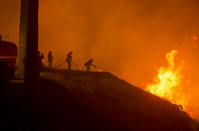
While each agency has its own primary mission and responsibilities, wildland fires do not recognize jurisdictional boundaries. Because of varying missions, ownership responsibilities, and land management objectives, applying fire management policies can be complicated. A one-size-fits-all approach to wildland fire suppression does not work in California; hence the need for differing suppression, prevention, and mitigation strategies must be recognized.
Fire Suppression Efforts on Thomas Fire, Dec. 2017.
Photo courtesy of USFS Region V.
.

This integrated fire suppression model has been tested by the growing wildland fire extent and severity. Despite California’s highly effective wildland fire protection system, some fires escape control efforts. Under extreme weather and fuel conditions or when resource availability is limited due to significant fire activity, a small percentage of wildland fires become large and damaging. These events have become more frequent and destructive, straining suppression efforts and requiring the best training, resources, technological advancements, and interagency collaboration.

Since the 2010 Plan was approved, fire prevention efforts have improved dramatically. Relying on fire suppression resources alone will never be enough to combat the growing wildland fire impacts. A proactive approach incorporating many layers of prevention activities is now vital to wildfire mitigation strategies. CAL FIRE must continue to seek out and utilize the latest and most effective technologies, data, and research efforts to enhance fire protection efforts across the state. Pre- and post-fire smart device technology, coupled with more robust geographic information systems providing real-time data, provides around the clock feedback both on the ground and in the air.

The State Responsibility Area Fire Prevention Fee (now wholly replaced with the California Climate Initiatives funding) was essential to the successful introduction and implementation of many fire prevention programs. It is critical that these programs continue to move forward, incorporating efforts to create an environment that is more resilient and resistant to wildland fire impacts, continue to develop new policies and procedures to promote public and firefighter safety, and educate the public that wildfire is a natural and inevitable part of California’s landscape. As more data are gathered in both pre- and post-fire environments, research will provide insight on how to further improve these efforts.

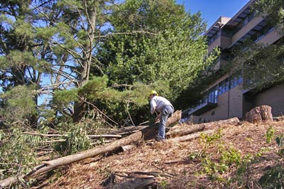
Individual landowners, homeowners, and communities share wildland fire protection and prevention responsibilities with federal, state, tribal, and local fire protection agencies. Homeowners have a primary responsibility to create and maintain defensible space around their structures and to utilize ignition resistant building materials and construction methods. These efforts, combined with a long-term maintenance plan for the built environment, can help create structure resistance to embers, which are now known to be the leading cause of structure ignitions during many wildland fires. Homeowners and landowners in a community must work together to plan and implement fire prevention measures, such as education programs and fuel treatment projects, and incorporate new strategies and technological innovations as they are developed. None of these efforts will be successful on its own. It is the holistic combination of all these actions that will reduce the impacts of wildland fires.
Private Landowner working to clear defensible space around a habitable structure

Integration of fire prevention and fire suppression activities will provide a successful path forward to respond to California’s growing wildland fire impacts. This integration requires a shift in the way California’s fire service moves forward. Historically, fire prevention and fire suppression have been treated as two separate and distinct functions within the fire service and by the general public. Moving forward, this can no longer be the case.

The artificial separation between prevention and suppression activities has now been dissolved. Suppression resources, when available, are committed year-round in performing fire prevention activities. As we expand fuel reduction treatments across the landscape, they will play an increasing role during fire suppression. Inspections and public education programs continue to help further fire preparedness efforts by embedding fire service personnel as important members of the local fire planning community. Thorough research, data collection, and analysis informs all aspects of prevention and suppression. As CAL FIRE becomes even more adept at integrating these efforts, fire protection and mitigation will be more successful. Creating a single integrated fire protection model composed of both fire prevention, natural resource management, and fire suppression strategies is a primary intent of this 2018 Strategic Fire Plan.

Preventing Wildland Fire Threats to Ecosystem Health

While historically wildfire has been a key component in ecosystem dynamics, a number of factors have disrupted the natural fire regime occurring in many of California’s ecosystems. There are many cases where the type of wildland fire and the pattern of its occurrence, when compared to historical conditions, are creating adverse impacts on ecosystem composition, structure, and function. Factors such as fire suppression, land use, exotic invasive species, and climate change all place stresses in the manner in which fire interacts with ecosystem health, function (such as biodiversity) and sustainability.

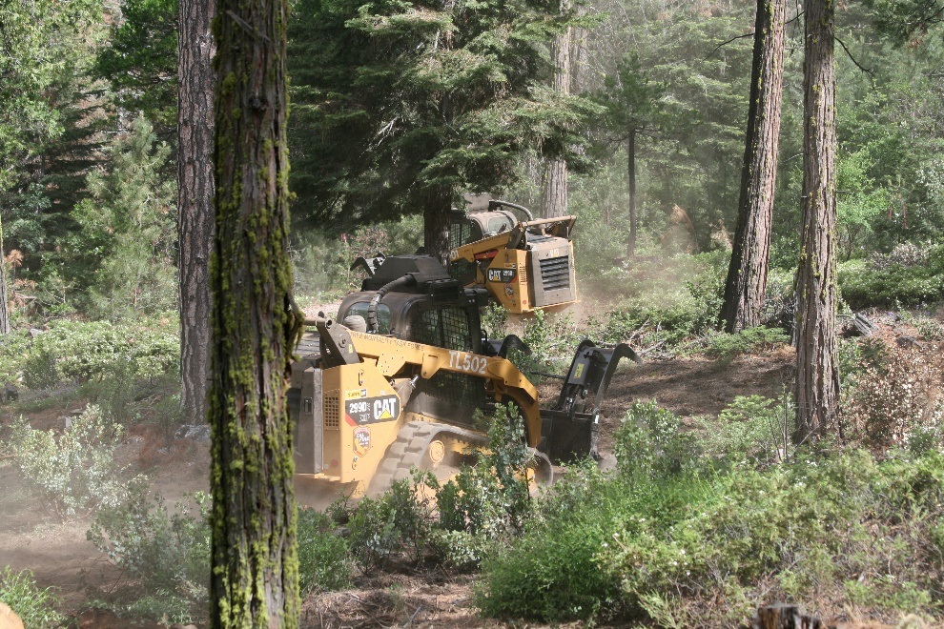
While these issues are reasonably well defined, an analytical approach using these concepts to define priority treatment areas across the state is needed to frame a strategic response to these impending risks. One example of the evolution of these strategies is the Fire MOU, which was signed in 2015 by multiple parties, including CAL FIRE, the USDA Forest Service, the National Park Service, and multiple conservation organizations. The California Forest Carbon Plan also identifies the expanded use of prescribed fire and other fuels treatments to enhance forest ecological resilience. CAL FIRE’s Vegetation Treatment Program Programmatic EIR, when finalized, will also be an important tool to reduce fuels on SRA lands.
Mechanized management of vegetative fuels Photo courtesy of CAL FIRE

CAL FIRE Staffing and Capacity

Since Board approval of the 2010 Strategic Fire Plan, CAL FIRE has been successful in several budget augmentations. The goals and objectives of the 2010 Plan provided CAL FIRE program managers with a strong basis to justify budget augmentations to increase the pace and scale of fire prevention, natural resource management, administration, and fire suppression activities statewide. This process has ultimately resulted in CAL FIRE moving forward into the era of the combined fire protection disciplines. Examples of the most significant efforts in strengthening CAL FIRE and its implementation of the 2010 Plan goals and objectives through budgetary augmentation can be reviewed in Appendix A.

While not all budgetary matters over the life of the 2010 Plan have been covered in Appendix A, the budget augmentations have increased the pace and scale of fire prevention, natural resource management, and fire suppression resources. The interconnectedness of the 2010 Fire Plan goals allowed CAL FIRE program managers to successfully justify the bolstered staff and other resources to continue to conduct the critical work for the state. The Board intends that the modified goals and objectives of this 2018 Strategic Fire Plan will result in supporting the continued efforts of CAL FIRE as the agency moves toward further development of fire prevention, natural resource management, and fire suppression strategies.

MOVING FORWARD WHILE CHECKING BACK

Adaptive Management

Consistent with the principle of adaptive management, this 2018 Strategic Fire Plan is designed to be flexible and allow for changing internal and external conditions. Objectives may be reevaluated by the Board and their relational importance may change. Decisions made because of these reevaluations need to rely on analysis and interpretation of vast amounts of data. Advances in science and technology will allow CAL FIRE to continue in these analytical efforts. For the lifespan of this 2018 Plan, the state must continue to take full advantage of improvements to gather more and increasingly accurate data for study and research. Findings will result in a better understanding of how climate issues continue to affect forest health and other natural resources, and how the built environment can become more resistant and resilient to the effects of wildfire. As improvements continue to be made in data collection and analysis, the results can be used to improve forest health initiatives, wildfire prevention goals, and strive toward a future that improves safety and resilience and resistance to increasing wildfire impacts. The Board’s Effectiveness Monitoring Committee can contribute to 2018 Plan-related adaptation through the evaluation of the fire prevention and resource management effectiveness of the Forest Practice Rules.

Goals and Objectives

The foundation of this dynamic 2018 Plan is the eight goals and their associated objectives. Collectively, these goals and objectives provide a framework to address the protection of lives, property and natural resources from wildland fire.

Priorities

The 2018 Plan and its associated goals and objectives frame the programs of fire prevention, natural resource management, and fire suppression work for CAL FIRE over the life of the 2018 Plan. Program priorities, funding levels and measures of success are dynamic and subject to change.

The Board and CAL FIRE will remain diligent in attempting to secure the appropriate level of resources through direct funding requests, grant opportunities, or agreements with collaborative partners. CAL FIRE will prioritize the goals and objectives to make the most effective use of existing staff and funding. CAL FIRE, to the extent feasible, will maximize the ability to meet the stated goals and objectives with the level of resources available.

During the first two years of this 2018 Plan, each CAL FIRE Unit, and contract county, will revise its individual Unit Fire Plan to identify its priorities for the implementation of the identified goals and objectives. Throughout the remaining life of this 2018 Plan, the priorities will be periodically reviewed and updated as necessary.

Timelines

CAL FIRE will report to the Board annually on its accomplishments of the goals and objectives of this 2018 Plan. The next comprehensive update to the 2018 Plan will take place in 2026, or as necessary based upon changing environmental or social needs.

Monitoring Wildland Vegetation Changes and Using Risk Assessment Models

In addition to Board monitoring of 2018 Plan implementation, the state should engage in comprehensive monitoring of key features of the wildland and wildland-urban interface (WUI) landscape through which wildland fires move. The state needs robust risk assessment models to predict fire behavior and effects across these landscapes, including those that address forest resilience and carbon-sequestration. Further needs include evaluation of how vegetative treatments affect wildland fire behavior and outcomes where the two interact. To meet the goals and objective of this of this 2018 Plan, the Board recommends:
- Expanded, frequently refreshed data about forest, shrubland, and watershed areas, including WUI;
- Tools that support integrated risk modeling that couples spatially explicit stochastic fire modeling with fire-behavior-specific value change curves;
- Watershed-based analytical frameworks based on or similar to the Sierra Nevada Watershed Improvement Program that couple local land owner/land manager, agency, and stakeholder involvement with spatial data risk tools;
- A statewide, multi-partner forest health monitoring program, leveraging Demonstration State Forests for CAL FIRE contributions. This program will go a long way to providing quantitative measures of ecosystem structure and function, and form the backbone of trend analysis to inform policy change. Maintain long-term permanent monitoring plots designed to describe forest changes in response to climate change, disturbance, and treatment activities;
- Programmatic monitoring of post-treatment results (vegetation and fuels, effects on soils, water, habitat, and other resources) and effectiveness where treatment areas are burned in wildland fires;
- Development and dedicated support for a Prescribed Fire Working Group, Vegetation Treatment Program, California Forest Improvement Program, Forest Health Grant Program, Fire Prevention Grant Program, Forest Practice Program, and other relevant programs. All programs should report vegetation treatment activities into a common spatial database for evaluation and summarization; and
- Support for a coordinated research program, including but not limited to: Research on Demonstration State Forests; funding for research through the California Climate Investment Forest Health Program and other state grant funds; and collaborative efforts with the Forest Service Pacific Southwest and Pacific Northwest Research Stations, that supports broad land management goals and specific treatment objectives across all CAL FIRE natural resource management programs.

VISION

A vision for a natural environment that is more fire resilient; buildings and infrastructure that are more fire resistant; and a society that is more aware of and responsive to the benefits and threats of wildland fire; all achieved through local, state, federal, tribal, and private partnerships.

GOALS AND OBJECTIVES

Goals

Through government and community collaboration, the following goals will enhance the protection of lives, property and natural resources from wildland fire, as well as improve environmental resilience to wildland fire. Community protection includes promoting the safety of the public and emergency responders, as well as protection of property and other improvements. Each goal listed here is meant to build upon the previous one (e.g., Goal 3 builds upon the accomplishments in Goals 1 and 2). Although full attainment of a goal is ultimately dependent upon the success of previous goals, any of the goals can be worked on at any given time based on available funding and other opportunities.

- Identify and evaluate wildland fire hazards and recognize life, property and natural resource assets at risk, including watershed, habitat, social and other values of functioning ecosystems. Facilitate the collaborative development and sharing of all analyses and data collection across all ownerships for consistency in type and kind.

- Promote and support local land use planning processes as they relate to:
(a) protection of life, property, and natural resources from risks associated with wildland fire, and (b) individual landowner objectives and responsibilities.

- Support and participate in the collaborative development and implementation of local, county and regional plans that address fire protection and landowner objectives.

- Increase fire prevention awareness, knowledge and actions implemented by individuals and communities to reduce human loss, property damage and impacts to natural resources from wildland fires.

- Integrate fire and fuels management practices with landowner/land manager priorities across jurisdictions.

- Determine the level of resources necessary to effectively identify, plan and implement fire prevention using adaptive management strategies.

- Determine the level of fire suppression resources necessary to protect the values and assets at risk identified during planning processes.

- Implement post-fire assessments and programs for the protection of life, property, and natural resource recovery.

Objectives

For each of the identified goals, this 2018 Plan lays out a number of objectives to be accomplished. The identified objectives are not meant to be all-inclusive. There may be additional objectives that the Board, CAL FIRE or other cooperative partners identify and could utilize in reaching the primary goals.

Goal 1: Identify and evaluate wildland fire hazards and recognize life, property and natural resource assets at risk, including watershed, habitat, social and other values of functioning ecosystems. Facilitate the collaborative development and sharing of all analyses and data collection across all ownerships for consistency in type and kind.

Objectives:

  - Continue to identify, develop and provide automated tools to facilitate the timely collection, analysis and consistent presentation of datasets.

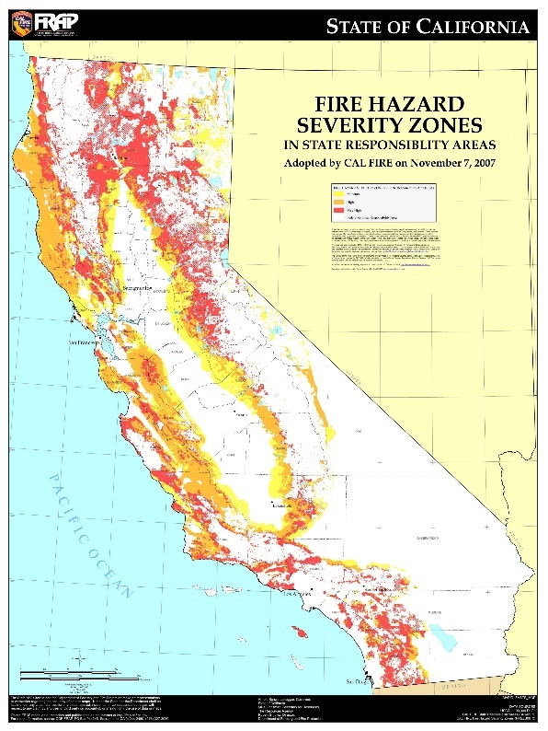
  - Update and maintain consistent, detailed vegetation and fuels maps across all ownerships in an
efficient and cost-effective manner.

  - Provide regular updates to the CAL FIRE’s Fire Hazard Severity Zone maps.

  - Develop and validate weather and climatology information for use in predicting fire behavior.

  - Update fire history information and re-evaluate existing fire prediction models to obtain composite fire threat across all ownerships.

  - Collaborate with other agencies to update existing data for values and assets at risk utilizing geographic information systems (GIS) data layers and other mapping solutions, including fire behavior-specific effects.
California Fire Hazard Severity Zone Map. Source: CAL FIRE, Fire and Range Assessment Program

  - Use science-based approaches to evaluate, understand and protect against the negative impacts of new and emerging threats such as climate change, insect and disease outbreaks or land use changes on forest health and public safety, including the buildup of hazardous fuel conditions and resulting fire behavior.

  - Engage and participate with local stakeholder groups (e.g., fire safe councils and others) to validate and prioritize the assets at risk.

Goal 2: Promote and support local land use planning processes as they relate to: (a) protection of life, property, and natural resources from risks associated with wildland fire, and (b) individual landowner objectives and responsibilities.

Objectives:

- Provide expertise to appropriate governmental bodies in the development and/or revision of a comprehensive set of wildland and wildland urban interface (WUI) protection policies for inclusion in each county general plan and/or other appropriate local land use planning documents.

- Identify key elements necessary to achieve a fire safe community, and incorporate these elements into land use planning, CWPPs and regional, county, and Unit Fire Plans.

- Engage in the development, review, and adoption of local land use plans to ensure compliance with fire safe regulations and current building standards and protection of natural resources.

- Collaborate with other agencies to assemble and distribute required and other supporting data for local land use planning.
Goal 3: Support and participate in the collaborative development and implementation of local, county, and regional plans that address fire protection and landowner objectives.

Objectives:

- Coordinate Unit Fire Plans with regional and county fire plans or Community Wildfire Protection Plans to encourage and support one consistent approach.

- Create and support venues in which individual community members can be actively involved in local fire safe councils, community emergency response teams, FIREWISE, collaboratives, and other community-based efforts to develop readiness plans and educate landowners to mitigate the risks and effects of wildland fire.

- Collaborate with federal, tribal and local governments, other state agencies, fire service, and other organizations,
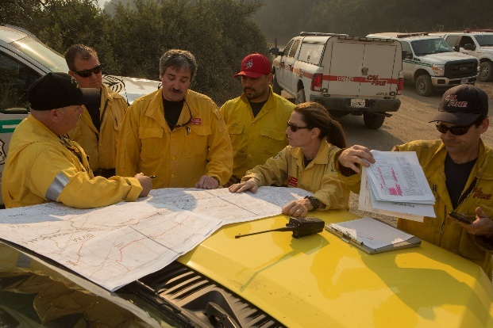
to maintain and improve emergency response plans.

- Ensure planning efforts are consistent with the Cohesive Strategy, Healthy Forest Restoration Act, the Statewide Hazard Mitigation Plan, federal land management plans, as well as local hazard mitigation plans and other relevant statewide or regional strategic planning documents.

Interagency coordination and planning.
Photo courtesy of USFS Region 5

- Maximize available resources to strengthen planning and increase implementation efforts through the development of public/private partnerships.

- Develop and utilize available fire risk mitigation treatment decision support tools to assist in project planning, design, implementation, and validation.

Goal 4: Increase fire prevention awareness, knowledge and actions implemented by individuals and communities to reduce human loss, property damage, and impacts to natural resources from wildland fires.

Objectives:

- Educate landowners, residents, and business owners about the risks and their incumbent responsibilities of living in the wildlands, including applicable regulations, impacts to natural resources, and prevention measures and preplanning activities.

- Educate landowners, residents, fire safe councils, and business owners to understand that fire
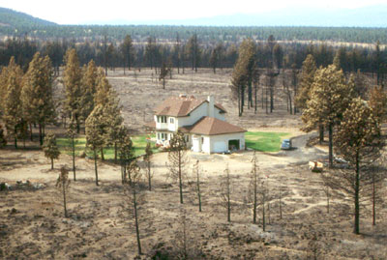
prevention is more than defensible space, including why structures ignite, the role embers play in such ignitions, and the importance of fire safe building materials, designs, and retrofits.

- Facilitate activities
Home surrounded by wildland that survived a fire due to good defensible space.

with individuals and organizations, as appropriate, to assist individual property owners in complying with fire safe regulations, including utilizing social media and emerging technologies.

- Continue to improve regulatory effectiveness, compliance monitoring and reporting pursuant to Public Resources Code (PRC) §4290 and §4291.

- Continue to increase the number and effectiveness of defensible space inspections and promote an increasing level of compliance with defensible space laws and regulations through the use of CAL FIRE staffing as available, public and private organizations, and alternative inspection methods.

- Promote the coordination of Fire Safe Regulations contained in California Code of Regulations (CCR) Title 14, with CCR Titles 19 and 24, to achieve uniform application of building standards.

- Continue to evaluate new, ignition-resistant construction technologies and materials and promote the strengthening of California building standards.

- Seek out authority and funding incentives to promote the retrofit of existing structures to meet ignition-resistant building codes.

- Actively enforce and seek updates as necessary to fire prevention codes, regulations, and statutes that address fire ignition.

- Actively investigate all wildland fires. For those resulting from negligent acts, pursue appropriate civil and/or criminal actions, including cost recovery.

- Identify fire prevention performance measures and metrics for documenting and evaluating progress, measuring future performance, and communicating results to the Board and the public.

- Analyze trends in fire cause, and focus prevention and education efforts to modify human behavior and reduce ignitions.

Goal 5: Integrate fire and fuels management practices with landowner/land manager priorities across all ownerships and jurisdictions.

Objectives:

- Promote efforts to restore the ecological role of prescribed and managed fire in areas and upon jurisdictions where doing so is consistent with local land management objectives and does not present an unacceptable risk to human health and safety or security of adjacent ownerships.

- Increase support of landowner-initiated fuels reduction by using all available authorities and programs.

- Work to streamline or remove regulatory or policy barriers that limit fuels reduction activities.

- Promote and develop programmatic documents to increase the pace and scale of fuels treatment activities

- Assist collaborative partners by educating, increasing grant funding and administration capacity, providing technical assistance, and other means that achieve fuels reduction work on the landscape.

- Promote forest and rangeland health and resilience through fuels reduction, and sustainable commercial forest management. Improve markets for and utilization of all forest products, including dead trees, waste, and biomass.

- Increase public education and awareness in support of ecologically sensitive and economically efficient vegetation management activities, including prescribed fire, grazing, forest thinning, and other fuels treatment projects.

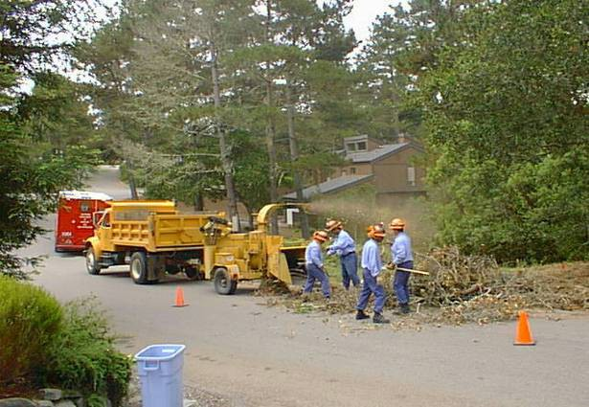
- Expand the development of collaborative multi-agency/landowner fuels reduction policies, plans and activities at the watershed and fireshed level.

- Support the availability and utilization of CAL FIRE hand crews and other CAL FIRE resources, as well as local, state, federal, tribal, and private resources, for fuels management activities, including ongoing maintenance.
CAL FIRE inmate crew working on a fuel reduction chipping project.

Goal 6: Determine the level of resources necessary to effectively identify, plan and implement fire prevention using adaptive management strategies.

Objectives:

- Seek additional staffing for implementing enhanced fire prevention activities, including related natural resource management programs.

- Initiate and maintain agreements with local, state, federal, tribal, and private partners that value the importance of integrated and cooperative fire prevention activities to implement efficient and cost effective programs and projects beneficial to all stakeholders.

- Develop a process and criteria for determining prevention resource levels and allocation based on goals and on current projected needs.

- Evaluate and develop the use of science, data and innovative technology to implement fire prevention actives in a more collaborative and efficient manner.

- Review data, conduct analysis and implement adaptive management related to fire prevention activities.

- Increase opportunities to enable all personnel’s engagement in the practice, benefits, and understanding of fire prevention activities.

Goal 7: Determine the level of fire suppression resources necessary to protect the values and assets at risk identified during planning processes.

Objectives:

- Maintain an aggressive wildland fire initial attack policy that places a priority on protecting lives, property and natural resources. At the same time, consider suppression strategies that incorporate values and assets at risk, as well as cost factors wherever possible.

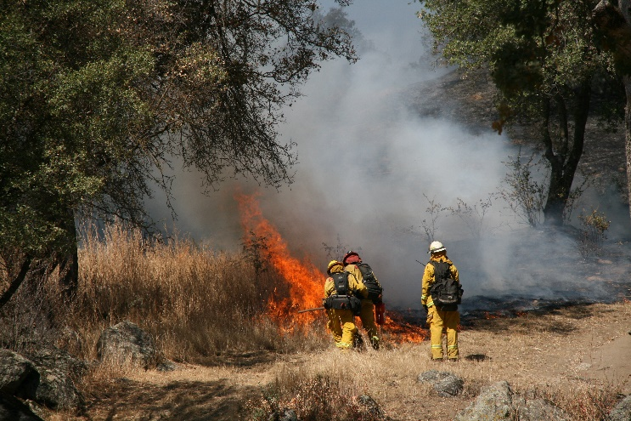
- Maintain current criteria and develop new criteria utilizing emerging technology for determining suppression resource allocation based on elements such as identified values and assets at risk, ignition density, fire history, vegetation type and condition, as well as local weather and topography.
Backfire suppression tactics on a wildland fire.

- Continue to analyze appropriate staffing levels and equipment needs commensurate with the current and projected emergency response environment.

- Seek to increase the number of CAL FIRE hand crews for use in wildland fire suppression and other emergency response activities.

- Establish, periodically evaluate, and maintain cooperative fire protection agreements with local, state, tribal, and federal partners that support an integrated, cooperative, fire protection system and deliver efficient and cost effective emergency response capabilities beneficial to all stakeholders.

- Improve policies and strategies to minimize injuries or loss of life to the public and emergency responders during emergency response activities throughout the state.

- Ensure all firefighters are provided appropriate training, equipment, facilities, and other infrastructure necessary to successfully and safely

meet the increasingly complicated and challenging emergency response environment.

- Continue to evaluate and implement new technologies to improve firefighter safety, situational awareness and emergency response effectiveness.
- Provide for succession planning and employee professional development at all levels within CAL FIRE to maintain leadership, emergency response capabilities, administrative management skills, and critical areas of expertise.

- Effectively engage and train all CAL FIRE employees across all disciplines to address both planning and emergency response.

Goal 8: Implement post-fire assessments and programs for the protection of life, property, and natural resource recovery.

Objectives:

- Encourage rapid post-fire assessment, when and where appropriate, to determine values at risk within and downstream of the fire perimeter from flooding, debris flows, and excessive surface erosion. Provide preliminary emergency protection measures that can be implemented in a timely manner, and help coordinate project implementation with appropriate agencies.

- Work with landowners, land management agencies, and other stakeholders across the state to design burned area rehabilitation actions that encourage salvage and reforestation activities, create resilient and sustainable landscapes, and restore functioning ecosystems.

- Effectively utilize available resources, including CAL FIRE hand crews, grants, and assistance programs to accomplish restoration and protection activities.

- Assess the effects of pre- and post-fire treatments to refine best management practices.
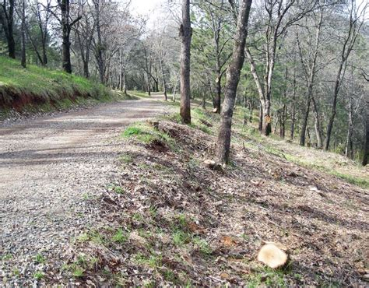

- Assist landowners and local government in the evaluation of the need to retain and utilize features (e.g., roads, firelines, and water sources) developed during a fire suppression effort, taking into consideration those features identified in previous planning efforts.
Shaded fuelbreak in the forested setting

- Aid landowners in

recently burned areas in developing and implementing vegetation treatment plans to manage the re-growth of vegetation and to maintain reduced fuels conditions.

- Promote native species seed bank and seedling production capacity to provide the availability of appropriate species for reforestation and restoration across the state’s diverse forestlands.

- Use after-action reports to evaluate and implement new technologies and practices to improve post-fire assessment and rehabilitation.

- Encourage the development of necessary interagency agreements, procedures, funding, and training to ensure that watershed emergency response teams can be assembled and deployed in a timely basis where needed.

APPENDIX A: Summary of CAL FIRE Budget Augmentation Supported By Implementation of the 2010 Strategic Fire Plan

- In Fiscal Year (FY) 2010-11, CAL FIRE received permanent funding for day-to-day fire suppression operating costs, including the Aviation Management Unit operations, San Diego Helitack staffing, funding to support a contract for a Very Large Air Tanker, two engines for the Tahoe Basin, and dedicated Defensible Space inspection staff.

- In FY 2011-12, CAL FIRE received permanent funding to further support Aviation Management Services, permanent staff for two single-engine stations within the Tahoe Basin, staffing for two contracted firefighting helicopters, and dedicated State Responsibility Area (SRA) Fee funding to support the enhancement of CAL FIRE wildland fire prevention programs.

- In FY 2013-14, Fire Severity, Treatment, Education, Prevention and Planning programs were provided permanent SRA Fee funding and significant staffing to implement the provisions of SB 1241 that focused on meeting the demand for vegetative fuel treatment and to educating homeowners on ways to prevent the ignition and spread of unwanted human-caused fires by hiring seasonal Defensible Space Inspectors and to build a Land Use Planning Program to work with local jurisdictions. Limited-term positions were provided for grant administration and technical oversight for CAL FIRE’s Cooperative Forestry Assistance programs. Funding was authorized that facilitated collaboration between CAL FIRE and California Department of Corrections and Rehabilitation to maintain inmate camps to support suppression activities, and, lastly, additional funding was authorized to facilitate collaboration between CAL FIRE and the California Conservation Corps (CCC) on wildland fire prevention and suppression activities.

- In FY 2014-15, CAL FIRE was granted significant Greenhouse Gas Reduction Funds (GGRF) and position authority that presented CAL FIRE the opportunity to greatly bolster forest health programs and reduce fuel loads in light of climate change. This legislative action also allowed for a renewed focus on fire prevention and fire risk mitigation. This was accomplished through collaboration with State and Local Fire Safe Councils, local governments, fire and community service districts, and homeowners associations. Additionally, GGRF funding was allocated to support many other natural resource management opportunities, including addressing reforestation needs for burned areas, reduction in the rate of spread of forest diseases and removal of dead and dying trees. CAL FIRE was also the recipient of funding and staff positions to provide fire prevention and suppression in the San Bernardino Mountains, the San Jacinto Mountains, and the Lake Tahoe Basin as a means of addressing drought conditions within the State’s forests. This funding effort also facilitated further collaboration with local governments, nonprofits, and local conservation corps to assist in both prevention and suppression activities within this portion of the State.

- In FY 2015-16, CAL FIRE received fiscal and staff support to address heightened fire conditions brought on by the extended drought. A fiscal allocation was also approved for to allow for the replacement of a Large Air Tanker that was lost to an aviation accident. In a cooperative effort with the CCC, CAL FIRE reopened the Butte Fire Center. CAL FIRE and CCC crews will provide fire suppression forces, as well as, support for other emergency incidents. CAL FIRE and CCC crews will work cooperatively on wildland fire prevention projects in the form of vegetative fuels reduction work from the re-opened fire center. SRA Funds were provided to CAL FIRE for a public education campaign centered on the prevention of and preparedness for wildland fires throughout California, targeting homeowners, residents, and visitors to the 31 million acres of the SRA.

- In FY 2016-17, CAL FIRE was granted staffing and support for firefighter surge capacity that included staffing 23 additional engines previously scheduled for replacement. This support also addressed required fireline support positions, including relief coverage and, retention of seasonal firefighters on engines and at air attack and Helitack bases beyond the budgeted fire season, to provide additional defensible space inspectors, and to enhance air attack capabilities. Several existing CAL FIRE programs were also allocated fiscal support to address technology needs. This support included funding for upgrades to Information Technology, Situation Command Awareness Data Acquisition, Automated Vehicle Location and Mobile Data Computer devices. A one-time funding allocation was provided to CAL FIRE to mitigate the public health and safety threats posed by the massive tree mortality in the central and southern Sierra Nevada. Funding for two new helicopter airframes, along with supporting staff was also provided. CAL FIRE was also granted a one-time allocation of 200 million from the Green House Gas Reduction Fund that was focused on implementation of projects that increase long-terms rates of carbon sequestration within the state.

- In FY 2017-18, CAL FIRE received funding through December 31, 2017 that includes retaining seasonal firefighters on engines beyond the budgeted fire season, firefighter surge, required fireline support positions, dedicated sawyers for the California National Guard crews, and additional defensible space inspectors; CCC fire suppression crews at the Placer Residential Center; increased vehicle maintenance, and contract funds for leasing one Exclusive Use Large Air Tanker. Support for natural resource management, such as continued tree mortality removal and disposal and updating and re-opening of the Louis A. Moran Reforestation Center also was allocated. Approximately 268 positions and an additional 42 year-round engines were funded to assist in suppression efforts, but are also expected to assist in tree removal and drought related environmental issues when wildland fire suppression is not underway. Lastly, the Legislature added additional funding for SRA Fire Prevention Fund Grants, Tree Mortality Grants to local agencies in 10 counties subject to the tree mortality highest rates of tree mortality, which can be used to leverage an additional $2 million General Fund. A large sum, $200 million of California Climate Investments funds, was allocated to CAL FIRE for Forest Health and fire prevention grants.

APPENDIX B: Glossary

Built Environment - Human-made surroundings that provide the setting for human activity, ranging in scale from buildings to parks, including the human-made space in which people live, work, and recreate on a day-to-day basis.

Climate Change – Any long-term significant change in the “average weather” that a given region experiences. Average weather may include average temperature, precipitation, and wind patterns. (http://frap.cdf.ca.gov/assessment2010/definitions.html)

Community Wildfire Protection Plan (CWPP) – A community-based collaborative plan developed by local stakeholders that identifies and prioritizes areas for hazardous fuel reduction treatments to protect communities and infrastructure from wildfire.
Stakeholders, applicable local government, local fire departments, state forestry, and federal land management agencies agree to the plans.

Cooperative Fire Protection Agreements – Agreements established between federal, state, tribal and local government entities to provide long-term fire and emergency service protection. These agreements include the California Fire Management Agreement (CFMA) and the California Fire Assistance Agreement (CFAA).
CFMA: https://gacc.nifc.gov/oscc/cwcg/cfma.php
CFAA: http://www.caloes.ca.gov/FireRescueSite/Documents/CalOES-2015_CFAA_Agreement_with%20Signatures.pdf

Defensible Space – The area within the perimeter of a parcel, development, neighborhood, or community where basic wildland fire protection practices and measures are implemented, providing the key point of defense from an approaching wildfire or defense against encroaching wildfires or escaping structure fires. (http://cdfdata.fire.ca.gov/fire_er/fpp_engineering_view?guide_id=8 )

Direct Protection Areas (DPA) - Intermingled and adjacent lands delineated by boundaries regardless of jurisdictional agency. Wildfire protection in these areas are negotiated, created and agreed to by the administrative units of either the Federal Agencies or the State.

Effectiveness Monitoring Committee – This Board-appointed committee is responsible for supporting, through review and funding, research and monitoring efforts to evaluate the effectiveness of the Forest Practice Rules and associated regulations in maintaining and enhancing water quality and aquatic and terrestrial wildlife habitats. (http://bofdata.fire.ca.gov/board_committees/effectiveness_monitoring_committee_/)

Fire Hazard – A fuel complex, defined by volume, type condition, arrangement, and location, that determines the degree of ease of ignition and of resistance to control. (http://www.nwcg.gov/pms/pubs/glossary)

Fire MOU - Memorandum of Understanding for the Purpose of Increasing the Use of Fire to Meet Ecological and Other Management Objectives, Forest Service Agreement No. 16-MU-11052012-148.

Fire Prevention – Activities such as public education, community outreach, building code enforcement, engineering (construction standards), and reduction of fuel hazard that is intended to reduce the incidence of unwanted human-caused wildfires and the risks they pose to life, property, or resources. (http://www.nwcg.gov/pms/pubs/glossary

Fire Protection - The study and practice of mitigating the unwanted effects of potentially destructive fires.

Fire Resilient – The ability of a vegetation type, ecosystem, or community to respond positively to or recover quickly from the effects of a wildfire burning within, across or
adjacent to them.

Fire Resistant – The condition of an asset that resists ignition and damage from wildfire. Structures are built using ignition resistant materials such as stucco, tile roofs, and boxed eaves with the likelihood that they will withstand most wildland fires or at least reduce damage caused by them.

Fire Risk –The chance of fire starting, as determined by the presence and activity of causative agents; a causative agent or a number related to the potential number of firebrands (embers) to which a given area will be exposed during the day. (http://www.nwcg.gov/pms/pubs/glossary)

Fire Safe Building Standards – Various laws and codes that apply accepted fire safety practices (as determined by scientific research panels and associations, with replicated results) into construction of assets. Examples of laws and codes include; California Fire Code Chapter 49, California Building Code Chapter 7A, Public Resource Code, §4290 and Fire Safe Regulations, §1270.

Fire Safe Councils (FSC) – A group of concerned citizens organized to educate groups on fire safe programs, projects and planning. The Councils work closely with the local fire agencies to develop and implement priorities. (http://www.firesafecouncil.org)

Fireshed – A contiguous area displaying similar fire history and problem fire characteristics (e.g., intensity, resistance to control) and requiring similar suppression response strategies.

Fire Suppression Resources – State, federal, tribal, local and private equipment and resources gathered to extinguish and mitigate wildland fires.

FIREWISE – A national program designed to reach beyond the fire service by involving homeowners, community leaders, planners, developers, and others in the effort to protect people, property, and natural resources from the risk of wildland fire before a fire starts. The Firewise program is community driven.

Fire Hazard Severity Zones – Areas of significant fire hazards based on fuels, terrain, weather, and other relevant factors. These zones, then define the application of various mitigation strategies to reduce risk associated with wildland fires.

Forest and Rangeland Health – An expression of the prevalent ecological conditions on a landscape as compared to benchmark conditions yielding maximum benefit to multiple resource values - ecological, economic, and social/political.

Fuels Treatment – The manipulation or removal of fuels to reduce the likelihood of igniting and to reduce fire intensity (e.g., lopping, chipping, crushing, piling and burning).

Fuels Reduction Projects – The modification of vegetation in order to reduce potential fire threat. These projects often result in improved wildlife habitat capability, timber growth, and/or forage production.

GIS – Geographic Information Systems is a configuration of computer hardware and software that stores, displays, and analyzes geographic data spatially or through attribute features.

Hand Crews – A number of individuals organized, trained, and supervised principally for fire suppression or fuel reduction projects. A CAL FIRE hand crew may be staffed by inmates or California Conservation Corps.

Hazards Mitigation Plan – Plans that form the foundation for a community's long term strategy to reduce disaster losses and break the cycle of disaster damage, reconstruction, and repeated damage. These plans are required by the Federal Emergency Management Agency (FEMA).
http://www.caloes.ca.gov/cal-oes-divisions/hazard-mitigation/hazard-mitigation-planning/local-hazard-mitigation-program

Initial Attack – A planned response to a wildfire given the wildfire's potential fire behavior. The objective of initial attack is to stop the fire and put it out in a manner consistent with firefighter and public safety and values to be protected. (http://www.nwcg.gov/pms/pubs/glossary)

Land Use Planning – A comprehensive assessment leading to a set of decisions that guide use of land within an identified area.

Local Responsibility Areas – Lands in which a local government agency is responsible for all fire protection.

Managed Fire – The use of natural or human-caused ignition within burn a prescription for purposes, including public safety and ecosystems benefits, where allowed under the policy of the agencies with primary jurisdiction.

Mutual Aid – An agreement in which two or more parties agree to furnish resources and facilities and to render services to each and every other party of the agreement to prevent and combat any type of disaster or emergency.

Native Species Seed Bank – A storage area for seed that is collected from a species which is a part of the original vegetation of the area in question.

Prescribed Fire – A planned wildland fire designed to meet specific management objectives.

Private Partners – This includes, but is not limited to, businesses, large landowners, small landowners, non-governmental organizations, and utilities.

Reforestation –The establishment of forests on land that had recent (less than 10 years) tree cover. (http://frap.cdf.ca.gov/assessment2010/definitions.html)

Salvage – The harvesting of dead, dying, and damaged trees to recover their economic values that would otherwise be lost to deterioration.

Situational Awareness –The application of the human senses to current and predicted weather, fire, or other emergency conditions to plan and execute actions that provide for the safety of all personnel and equipment engaged in an emergency; this includes development of alternative strategies of fire suppression and the net effect of each.

Suppression Strategy - The general plan or direction selected to accomplish incident objectives.

Unit Fire Plan – Plans developed by individual CAL FIRE Units or contract counties to address wildfire protection areas, initial attack success, assets and infrastructure at risk, pre-fire management strategies, and accountability within their geographical boundaries. http://cdfdata.fire.ca.gov/fire_er/fpp_planning_plans

Values and Assets at Risk – Accepted principles or standards and any constructed or landscape attribute that has value and contributes to community or individual well- being and quality of life. Examples include property, structures, physical improvements, natural and cultural resources, community infrastructure, commercial standing timber, ecosystem health, and production of water.

Wildfire – An unplanned ignition; unwanted wildland fire including unauthorized human-caused fires, escaped wildland fire use events, escaped prescribed fire projects, and all other wildland fires where the objective is to put the fire out.

Wildland –Those unincorporated areas covered wholly or in part by trees, brush, grass, or other flammable vegetation.

Wildland Fire – Fire that occurs in the wildland as the result of an unplanned ignition.

Wildland Urban Interface (WUI) –The line, area, or zone where structures and other human development meet or intermingle with undeveloped wildland or vegetative fuels. (http://www.nwcg.gov/pms/pubs/glossary)

APPENDIX C: Bibliography

California State Board of Forestry and Fire Protection.2010 Strategic Fire Plan for California (revised April 2016), State Board of Forestry and Fire Protection. California Board of Forestry and Fire Protection, P.O. Box 944246, Sacramento, CA 94244-2460.

California Department of Forestry and Fire Protection. (2010). California’s Forests and Rangelands: 2010 Assessment. California State Board of Forestry and Fire Protection, P.O. Box 944246, Sacramento, CA 94244-2460.

California Department of Forestry and Fire Protection. DRAFT California’s Forests and Rangelands: 2018 Assessment. California State Board of Forestry and Fire Protection, P.O. Box 944246, Sacramento, CA 94244-2460.

California Department of Forestry and Fire Protection. (2016) Forest Fire, Drought, Restoration Treatments, and Carbon Dynamics: A Way Forward. California Forestry Note 121. California Department of Forestry and Fire Protection, P.O. Box 944246, Sacramento, CA 94244-2460

Christensen, G.A., Gray, A.N., Kuegler, O., Tase, N., Rosenberg, M. (2017). AB 1504 California Forest Ecosystem and Harvested Wood Product Carbon Inventory: 2006 - 2015. Portland, OR: U.S. Department of Agriculture, Forest Service, Pacific Northwest Research Station. California State Board of Forestry and Fire Protection, P.O. Box 944246, Sacramento, CA 94244-2460.

Forest Climate Action Team. (2018). California Forest Carbon Plan: Managing our Forest Landscapes in a Changing Environment. CAL FIRE, California Natural Resources Agency, and California Environmental Protection Agency, Sacramento.

Little Hoover Commission. (2018) Fire on the Mountain: Rethinking Forest Management in the Sierra Nevada, Report # 242, February 2018, Little Hoover Commission, 925 L Street, Suite 805

Stephens, S.L., Burrows, N., Buyantuyev, A., Gray, R.W., Keane, R.E., Kubian, R., Liu, S., Seijo, F., Shu, L., Tolhurst, K.G. and Van Wagtendonk, J.W. (2014). Temperate and boreal forest mega‐fires: characteristics and challenges. Frontiers in Ecology and the Environment, 12(2), pp.115-122.

United States Department of Agriculture, United States Forest Service. Memorandum of Understanding for the Purpose of Increasing the Use of Fire to Meet Ecological and Other Management Objectives, Forest Service Agreement No. 16-MU-11052012-148

Working Draft of the Vegetation Treatment Program Programmatic Environmental Impact Report (2018, forthcoming). Board of Forestry and Fire Protection, Sacramento.

The Board develops and adopts the Strategic Fire Plan pursuant to broad direction provided under Public Resources Code (PRC) §§ 4114 and 4130.
See p.ii for a full listing of Steering Committee members.
Temperate and boreal forest mega‐fires: characteristics and challenges. Frontiers in Ecology and the Environment, 12(2), pp.115-122.

