PROFESSIONAL FORESTERS REGISTRATION PROGRAM POLICIES OF THE BOARD
The following policies have been readopted by the State Board of Forestry and Fire Protection at an open meeting held on January 10, 2007 upon the recommendation of the Professional Foresters Examining Committee (PFEC). The policies are provided as guidance to registrants and other interested parties and do not supersede existing law or regulation. These policies will remain in effect until such time as the Board with notice to the public and in consultation with the PFEC determines otherwise.

POLICY NUMBER 1: REVIEW OF APPLICATIONS FOR REGISTRATION AS A PROFESSIONAL FORESTER
All applications are reviewed first by the Executive Officer of Foresters Registration who determines what further action to be taken based upon Public Resources Code (PRC), Sections 750 et seq., and Title 14, California Code of Regulation (14 CCR), Sections 1600, et seq. as follows:
- Applications which are incomplete will be returned to the applicant for completion, or retained pending submission of supporting documents. The burden of proof rests with the applicant and, therefore, so does the responsibility for any such delays beyond the time frames and deadlines established by codes.
- The applicants whose applications are complete and verified as meeting the experience requirements, will have their names forwarded to the Professional Foresters Examining Committee with recommendation of authorization to take the examination.
- If an applicant’s qualifications are unclear or in doubt, the application is reviewed by the Professional Foresters Examining Committee and appropriate action may be taken. The Committee may request clarifying information and/or delegate to the Executive Officer the option of authorizing the applicant to take the exam immediately prior to the examination offering. Such authorization may only be granted if the applicant agrees to waive the thirty (30) day examination authorization notice, and provides the requested clarifying information.

POLICY NUMBER 2: RPF EXAMINATION SCORING
Examinations are scored by two Registered Professional Foresters in good standing retained as Expert Examiners. The Examiners independently grade each question for each applicant working off of copies of the original examination responses completed by applicants. The name of every applicant is kept confidential, as the applicant’s number is the only identification provided on examination responses.
Applicant responses are graded utilizing an answer key developed concurrent with the drafting of the examination, as well as forestry texts, reference materials, and professional expertise. The Examiners may also encounter other appropriate responses by applicants that are not found in the answer key and these will be counted in an applicant’s favor.
The Examiners then meet with the Executive Officer of Foresters Registration to report their scores for each applicant response and compare them for variation. When there are instances in which the Examiners’ scoring of a response varies considerably, the Examiners’ discuss their respective reasons for the score and make adjustments where necessary and appropriate. The Examiners’ scores for each response are summed and averaged to determine the composite score for each response. The Examiners’ composite scores for each of an applicant’s responses are then summed and averaged to determine the overall examination score.

POLICY NUMBER 3: MAINTENANCE AND ACCESSIBILITY OF APPLICANT/REGISTRANT RECORDS
The following provides the basis by which applicant and registrant records are maintained by the Office of Professional Foresters Registration and the manner in which they may be accessed:
- Files pertaining to an individual applicant or registrant shall be made available only to that person or their designee in writing. Professional Foresters Registration staff or designated persons acting in an official capacity regarding registration may also be granted access to this information. Applicant files will be retained two (2) years from the year of receipt.
- The names of persons denied qualification for the examination or registration will not be released, and information about those denied will not be supplied to anyone except the applicant or other person designated in writing, and those acting in an official capacity regarding Professional Foresters Registration.
- Applicant examinations will be retained at least 45 days after mailing of the examination results to each individual applicant. An applicant’s original examination responses absent the Expert Examiners’ grading marks will be provided upon request by that applicant or their designee. Applicant examination scores will only be released to the individual applicant and will not otherwise be released in summary form correlating to applicant numbers, names or license numbers under any circumstance. Computerized data regarding exam results and education substitution for qualifying experience will be retained by applicant number. This data retention commenced in 1986.
- The registrant’s file and the corresponding computerized data will be maintained while the RPF or Certified Specialist such as a Certified Rangeland Manager (CRM) is currently registered. Upon approval of withdrawal, computerized data regarding the status of the license will be retained; the original data will be restored upon approval of request for reinstatement. Files will be retained during withdrawal status. Persons whose license is revoked through a disciplinary action will be treated in this same manner.
- A confidential list showing all RPFs and Certified Specialists (CRMs), and preferred mailing addresses will be maintained indefinitely starting 1984. A list by registration number, name and license status is available to the public.
- RPFs and Certified Specialists (CRMs) whose registration is voluntarily relinquished, revoked for non-renewal, or who have passed away, will have their files held for two years from the year of occurrence.
- Access to investigation files and records is governed by various California Codes. When disciplinary actions by the Board involving suspension or revocation occur, the public has the right to know those items specified in 14 CCR §1612.2. Unless the Board’s decision is overturned by a reviewing court order, the circumstances or conditions imposed are available only in the form presented in the Licensing News and news release.

POLICY NUMBER 4: NOTIFICATION OF DISCIPLINARY ACTION
This Policy became redundant prior to re-adoption of licensing policies on October 4, 2000 with the Board’s adoption of 14 CCR §1612.2 (Notification of Disciplinary Action).

POLICY NUMBER 5: COMPILATION AND DISTRIBUTION OF REGISTRANT LISTS
The following describes the three (3) kinds of registrant lists that are generated by the Office of Professional Foresters Registration. All lists are available to the public upon request. A duplication fee may be charged at the discretion of the Executive Officer of Foresters Registration.
Statewide Consumer List - All RPFs and Certified Specialists (CRMs) are listed by registration number, name, and status of license. This list is expected to become accessible through the Board’s Professional Foresters Registration website in 2007.
Public List - A directory of all RPFs and Certified Specialists (CRMs) who wish to include contact information for use by the general public is compiled each year after renewals are finalized. The mailing addresses and phone numbers listed are identified as “preferred” on the information form submitted upon initial licensing and renewal.
Consultant Lists - A directory of consulting RPFs and Certified Specialists (CRMs) is compiled by county of residence. The service is provided as supplemental to the records kept by Professional Foresters Registration, and there is no intent to develop or maintain a business directory. A consultant may request on their initial licensing or renewal form to be listed in this directory.
At a minimum, lists will be revised annually after the renewal process is complete.
A statement will be included on the consultant list stating that most consultants provide forestry services statewide, and that the Association of Consulting Foresters (ACF) maintains a separate list of their members, and provide the address to request same.
All listed information will come directly from the renewal information form as submitted by the RPF/Certified Specialist (CRM), and will include:
  - Name - The registrant’s first and last name with registration number is the first line printed.
  - Address - Consultants will have their business name, address and phone listed as noted on the renewal information form.

POLICY NUMBER 6: RESPONSE TO COMPLAINTS OF UNLICENSED PRACTICE OF FORESTRY OR A CERTIFIED SPECIALTY
Complaints involving non-licensed persons using the title of, or acting in the capacity of a “Professional Forester” or “Certified Specialist” (such as Certified Rangeland Manager) without being registered, or otherwise exempted, are acting illegally (Public Resources Code Section 766) and are handled in a manner consistent with Policy 8. The Executive Officer may hire expert witnesses to review investigation results and establish prudent standards of conduct.
If the investigation, expert witness, or Executive Officer’s evaluation show sufficient cause, the appropriate District Attorney General’s office may be asked to prosecute the case. Such prosecution may be based upon unfair or unlawful business practices, or false and misleading advertising. Action against a non-licensed person may include the Civil Code of Procedure, Section 1029.8 which governs cost recovery and punitive awards in the case of damages caused by an unlicensed person.

POLICY NUMBER 7: SUMMARY OF CASE LAW FOR PURPOSE OF CLARIFYING GROUNDS FOR RPF/CERTIFIED SPECIALIST DISCIPLINARY ACTION UNDER RESOURCES CODE, SECTION 778(b)
The failures of responsibility which subject a RPF or Certified Specialist (CRM) to “Disciplinary Action” (Pursuant to PRC, 778) are summarized as below, to provide general reference and guidance only. CURRENT APPLICABLE CODES AND CASE LAW TAKE PRECEDENCE.
- Deceit is either:
- The suggestion, as a fact, of that which is not true, by one who does not believe it be true; or,
- The assertion, as a fact, of that which is not true, by one who has no reasonable grounds for believing it to be true; or,
- The suppression of a fact, by one who is bound to disclose it, or who gives information of other facts which are likely to mislead for want to communication of that fact; or,
- A promise, made without any intention of performing it. Civil Code, Section 1710.
Fraudulent Deceit: “One who willfully deceives another with intent to induce him to alter his position to his injury or risk, is liable for any damages which he thereby suffers.” Civil Code, Section 1709.
Deceit Upon the Public: “One who practices a deceit with intent to defraud the public, or a particular class of persons, is deemed to have intended to defraud every individual in that class, who is actually misled by the deceit.” Civil Code, Section 1711.
- Fraud is a bad faith, dishonest or overreaching act done with intent to deprive another of his right, or in some manner to do a person an injury. It includes all surprise, trick, cunning, dissembling and unfair ways by which another is cheated. As distinguished from gross negligence, it is always intentional.
Actual Fraud. See Deceit above with addition of:
- Any other act fitted to deceive. Civil code, Section 1572.
- Incompetence is a demonstrated lack of ability, skill, or knowledge to perform professional functions. Such lack may be demonstrated by a single and specific incident or by a series of lesser failures in performance. This is not to say that a single honest failing in performing his/her duties constitutes incompetence in a RPF or Certified Specialist’s (CRM) practice. Because of the difficulty in defining incompetence, performance standards are established by expert witnesses and relate to specific instances, time and place.
- Material Misstatement of Fact is a misstatement that would be likely to affect the decision of the administrative agency or reasonable person in the transaction in question. In contracts, material facts are those which constitute substantially the consideration of the contract, or without which it would not have been made. For purposes of the Forest Practice Act and Code Section 4583.5 in particular, a material misstatement in a Timber Harvesting Plan or a report submitted to the Department would thus include any misstatements which would be likely to affect the Department’s decision with respect to the Timber Harvesting Plan or report.
“A ‘misrepresentation’ is ‘material’ if it would be likely to affect the conduct of a reasonable man with reference to the transaction in question.” Costello v. Roer (1946) 77 Cal.App.2d 174, 175 Pp.2d 65.
- Misrepresentation is a conduct or a representation contrary to fact made by a RPF or Certified Specialist (CRM), under circumstances in which a reasonable RPF or Certified Specialist (CRM) would not have made the representation. There need not be actual or constructive intent to deceive. Misrepresentation can occur when a RPF or Certified Specialist (CRM) holds himself/herself out to be specially qualified, when in fact the RPF/Certified Specialist (CRM) is not; it may also occur when a RPF or Certified Specialist (CRM) knowingly acts on an insufficient basis of readily available information commonly accepted by a reasonable and prudent by the RPF/Certified Specialist (CRM) community in making a representation.
Negligent Misrepresentation:
  - The respondent must have made a representation as to a past existing material fact;
  - The representation must have been untrue;
  - Regardless of respondent’s actual belief, the representation must have been made without any reasonable ground for believing It to be true;
  - The representation must have been with the intent to induce plaintiff to rely upon it;
  - The plaintiff must have been unaware of the falsity of the representation; he must have acted in reliance upon the truth of the representation and he must have been justified in relying upon the representation.
  - And, finally as a result of his reliance upon the truth of the representation, the plaintiff must have sustained damage. Book of Approved Jury Instructions (BAJI), 12.45.
- Gross Negligence is an extreme departure from the prudent standards of conduct or performance, which may be established by expert witnesses. It is the exercise of so little care that it justifies the belief that the person was indifferent to the interests and welfare of other people or natural resources. Gross negligence does not require actual or constructive intent.
“The intentional, conscious failure to do a thing that is incumbent upon one to do, or the doing of a thing intentionally that one ought not to do.” Pilot Industries v. Southern Bell Tel. & Tel. Co., D.C.S.C., F.Supp. 356, 362.
“The exercise of so slight a degree of care as to raise a presumption of conscious indifference to the consequences. A finding a gross negligence is made by applying an objective test: If a reasonable person in the defendant’s position would have been aware of the risk involved, then the defendant is presumed to have had such an awareness.” People v. Soledad (1987, 5th Dist) 190 Cal.App.3d 74, 235. Cal.Rptr.
208.
Gross – great; absolute; exists in its own right, and not as an appendage of another thing of all measure; beyond allowance; not to be excused; flagrant; gross carelessness.
Negligence – “Negligence is the doing of something which a reasonably prudent person would not do, or the failure to do something which a reasonably prudent wpuld do, under circumstances similar to those shown by the evidence. It is the failure to use ordinary or reasonable care. Ordinary or reasonable care is that care which persons of ordinary prudence would use in order to avoid injury to themselves or others under circumstances similar to those shown by the evidence. [You will note that the person whose conduct we set up as a standard is not the extraordinary cautious individual, not the exceptional skillful one, but a person of reasonable and ordinary prudence.]” BAJI 3.10.
Actionable Negligence: “[A] legal duty to use due care, breach of that duty, and a proximate or legal casual connection between the breach and plaintiff’s injuries.” E.F. Hutton & Co. v. City National Bank (1983, 2nd Dist) 149 Cal. App. 3d 60, 196 Cal. Rptr. 614).
- CODE SECTIONS NOTED IN FELONY CRITERIA, 14 CCR §1613 that may be substantially related to the duties of a RPF or Certified Specialist (CRM):
  - Public Contract Code
Section 10422 Corrupt performance of official act. “Any officer or employee of the department who corruptly performs any official act under this chapter to the injury of the state…”
Section 10423 Corruptly permitting violation of contract; felony. “Any person contracting with the state by contract who corruptly permits the violation of any contract made under this chapter…”
  - Business and Professions Code
Division 7 – Part 2 – Preservation and Regulation of Competition
  - Health and Safety Code Division IX, Part I, Explosives
- Failure of Fiduciary Responsibility may be tied to Grounds for Disciplinary Action.
Fiduciary Responsibility – A relation subsisting two persons in regard to a business, contract, or piece of property, or in regard to the general business or estate of one of then, of such a character that each must repose trust and confidence. It may involve an agreement where a person delivers a thing to another on the condition he will restore it to him. Violation of fiduciary responsibility may arise from recklessness (inadequate records, etc.). It differs from fraud which is willful.
(Fiduciary Responsibility – Duty)
“In performing professional services for a client, a [forester/certified specialist] has the duty to have that degree of learning and skill ordinarily possessed by reputable [foresters/certified specialists], practicing in the same or a similar locality and under similar circumstances.” It is the [forester’s/certified specialist’s] “duty to use the care and skill ordinarily used in like cases by reputable members if his or her profession practicing in the same or a similar locality under similar circumstances, and to use reasonable diligence and his or her best judgment in application of his or her learning, in a effort to accomplish the purpose for which he or she was employed. A failure to fulfill such duty is negligence: BAJI 6.37.
Note: A felony conviction could occur when a contractor received payment and does not pay for materials or labor rendered – the word “fraudulent” is not mentioned in this statute. Federal or out-of-state codes may also not refer to fraud in some situations.

POLICY NUMBER 8: PROCESSING OF A COMPLAINT AGAINST A RPF OR CERTIFIED SPECIALIST (DISCIPLINARY REVIEW PROCESS)
Note: The disciplinary process is governed by the Public Resources Code (PRC); Title 14 California Code of Regulation (14 CCR), Evidence Code (EC), Code of Civil Procedure (CCP), and Government Code (GC). For the benefit of interested persons, the following provides a narrative of the typical sequence followed in implementing these Codes. The attached flow charts are a visual presentation of this process.

The Complaint
A complaint can be filed by a person, in writing, with Professional Foresters Registration, or the Board of Forestry and Fire Protection (Board) can proceed upon its own (PRC, Section 775). The RPF’s/Certified Specialist’s (CRM’s) vested property right of the license is protected under “due process”. The Executive Officer must verify that the complaint is legally subject to possible disciplinary action (i.e., fraud, deceit, misrepresentation, gross negligence, etc; PRC, Section 778). If the matter is, or becomes, a criminal court action, the Administrative action will likely be delayed until a judicial determination is rendered.

Confidentiality
A complaint is a CONFIDENTIAL matter (GC §6254(f), and §11183). The identity of the person filing the complaint remains confidential throughout the investigation (EC §1041). This may become public information if Hearing testimony from the complainant is required or if the person’s identity is otherwise pertinent to the case. If the complaint does not come under the grounds for discipline, the RPF/Certified Specialist (CRM) will still be notified that a complaint was received and of their subsequent exoneration. Confidentiality will likely limit the amount of information that can be provided.

Processing a Complaint
The Executive Officer may take the matter to the Professional Foresters Examining Committee (PFEC) at any stage of processing.
If the failures of RPF/Certified Specialist (CRM) responsibility are well-documented (e.g. violations, citations, court records, or other documents), the RPF/Certified Specialist (CRM) is given an opportunity to provide his or her side of the story in response to the issues of concern (allegations). The RPF/Certified Specialist (CRM) is advised that the reply may be used against him or her in the process, and may choose not to respond. If needed, expert witnesses may be involved to establish RPF/Certified Specialist (CRM) prudent standards of conduct given the same set of circumstances. If the RPF/Certified Specialist (CRM) is willing to admit to any failures of responsibility, the Executive Officer may suggest the RPF/Certified Specialist (CRM) sign a Stipulated Agreement implementing specified discipline (i.e., suspension--some portion of which may be “stayed” thereby triggering probation; or revocation).
When the issues are not well-documented, the Executive Officer initiates an investigation. This may involve professional investigators from the Department of Consumer Affairs, which is the agency most involved with California licensing boards. The investigator gathers the evidence of what occurred, and is subject to the Evidence Code. Professional investigator direction and advice is provided by the Executive Officer, and in some cases, independent RPFs/Certified Specialists (CRMs). The investigator interviews witnesses while stressing the confidential nature of the matter, and gathers leads as appropriate.

As soon as all information necessary for professional investigation is obtained, the RPF/Certified Specialist (CRM) is notified by the Executive Officer who will explain that Professional Foresters Registration is coordinating an investigation on complaint allegations. The Executive Officer may enumerate the allegations to the RPF/Certified Specialist (CRM) under investigation or the investigator may make the allegations known when presenting questions. When the RPF/Certified Specialist (CRM) is personally contacted by the investigator, the RPF/Certified Specialist (CRM) will be asked if he/she is willing to be interviewed to discuss facts important to the case. The RPF/Certified Specialist (CRM) is also allowed to make a written statement. The RPF/Certified Specialist (CRM) may refuse to be interviewed. The investigator may ask the RPF/Certified Specialist (CRM) details about occurrences important to the case. Information gathered may be used against the RPF/Certified Specialist (CRM).
These stages in the process are sensitive because many RPFs/Certified Specialists (CRMs) feel they should be able to face his/her accuser at this point. Because no Accusation has been filed, there is no accuser. Many RPFs/Certified Specialists (CRMs) feel they should have an attorney present when talking with the investigator, but it is not required. Only facts are being gathered for consideration by the PFEC to recommend appropriate action. At any time evidence warrants criminal action, however, the investigator may read the RPF the Miranda rights prior to gathering statements. A Criminal Complaint may be independently requested by Consumer Affairs, Division of Investigation, or a District Attorney if the evidence warrants such action.

Peer Review
The Executive Officer reviews the RPF’s/Certified Specialist’s (CRM’s) response to the allegations, stipulated Agreement, or investigation report with the PFEC. Statements made and evidence presented in the review, however, could be used in an Accusation.
When incriminating evidence is sufficient at any time in the process, one or more RPFs/Certified Specialists (CRMs) serving as “Expert Witnesses” may examine the situations regarding the complaint.
“Standards” of performance are established using the “prudent forester concept” where the evaluation by independent RPFs/Certified Specialists (CRMs) of similar qualifications and experience, is used to establish proper and prudent actions in any specific situation.

Disciplinary Recommendations
The possible action recommended by the PFEC to the Executive Officer at this point can include: 1) Exoneration; no further action warranted, 2) Confidential Letter stating the Committee’s concerns, 3) Private Reprimand issued by the Board, 4) Board approval of Stipulated Agreement, or 5) filing of an Accusation. Cases are considered ‘closed’ upon Exoneration, PFEC issuance of a Confidential Letter, or Board issuance of a Private Reprimand. Cases are not considered ‘closed’ upon Stipulated Agreement or the filing of an Accusation.

The Accusation
If disciplinary action without a Stipulated Agreement is anticipated, the Executive Officer, in coordination with counsel from the Attorney Generals’ Office, prepares a Statement of Issues and the formal Accusation(s) is included. Filing the Accusation with the Office of Administrative Hearings makes the matter public, and the Accusation is available upon request.
Sent with the Accusation, the Statement to Respondent notifies the RPF/Certified Specialist (CRM) that a Notice of Defense may be filed requesting a hearing. At this point, the RPF/Certified Specialist (CRM) is advised he/she may want seek representation by legal counsel. The RPF/Certified Specialist (CRM) cannot access the investigation working notes or attorney work product. The evidence which will be submitted at the hearing, including reports of any witnesses, can be obtained so he/she may prepare a defense. This is called “discovery.” (GC §11507.6) If the RPF/Certified Specialist (CRM) finds the evidence to be submitted at the hearing is true and complete, he/she may choose to accept, on the merits of the Accusation, possible Board disciplinary action. This is done by signing a Stipulated Agreement which imposes license suspension or revocation with conditions satisfactory to the Board as appropriate discipline.

Hearing
In the absence of a Stipulated Agreement, an Administrative Law Judge (ALJ) weighs the investigation evidence and the standards of prudent conduct established by the expert witnesses against the evidence provided by the accused RPF/Certified Specialist (CRM). The cost of each party’s counsel is borne by the respective party. The accused RPF/Certified Specialist (CRM) can provide self representation (no counsel). The burden of proof is “clear and convincing evidence of reasonable certainty.” The ALJ prepares a recommendation for Board action. The ALJ is encouraged to utilize the Disciplinary Guidelines in 14 CCR §1612.1 and Criteria for Rehabilitation in 14 CCR §1614.

Board Actions from Hearings Findings
A second counsel from the Attorney General’s Office represents the Board in considering the decision of the ALJ. In considering the decision of the ALJ, the Board may adopt, modify the recommendations, send the entire matter back to the same ALJ, or reject the proposed decision and review the case on the record and arrive at a decision (GC §11517). The proposed decision of the ALJ is not binding, unless the Board fails to act within a specified time period. Acting within the specified time period, the Board shall render the final decision relative to suspension or revocation. The Board’s final options are: 1) exoneration, 2) suspension, or 3) revocation of license. The Board may allow the RPF/Certified Specialist (CRM) to complete existing contracts if action is taken. In a suspension, part can be “stayed” which creates probation; the existing employer or clients must be notified of the discipline per 14 CCR
§1612.2. The Board may specify possible conditions for rehabilitation for consideration when the RPF/Certified Specialist (CRM) later requests license reinstatement. The Government Code, Section 11522, requires that a minimum of one year pass before the Board can consider a petition for reinstatement. The applicant may submit evidence of rehabilitation.

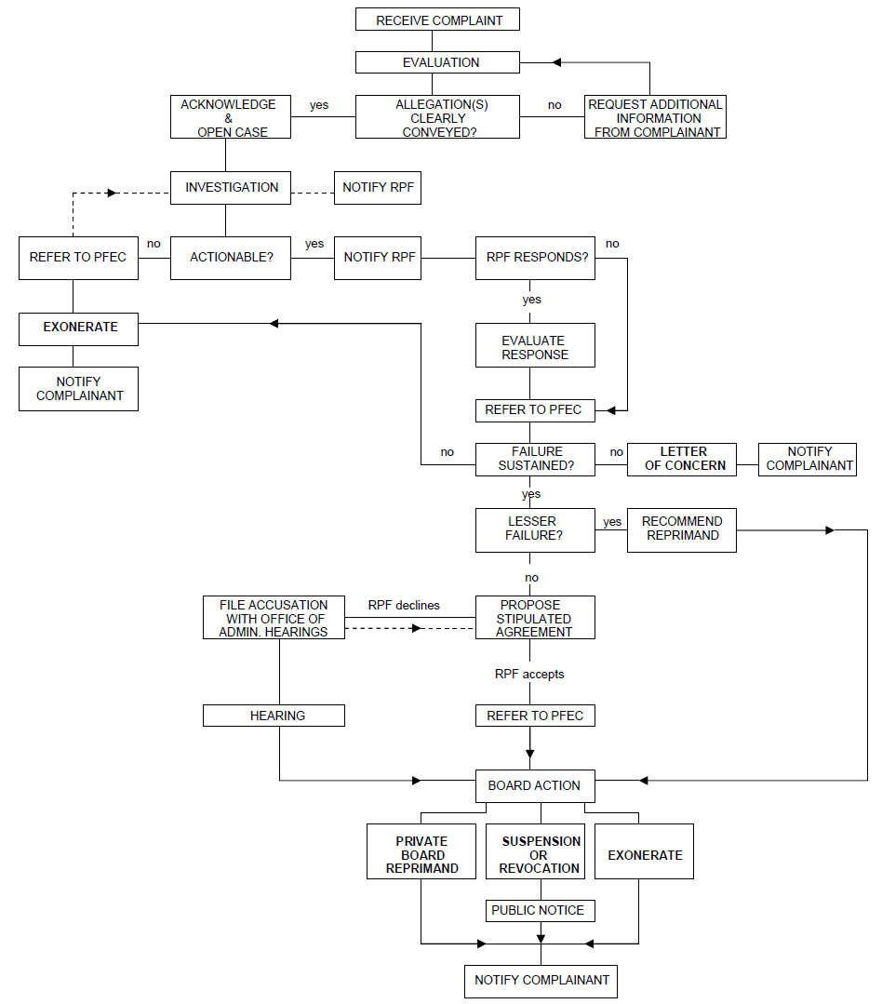
Complaint Against RPF

License Suspension or Revocation
(ref: Government Code §11517)
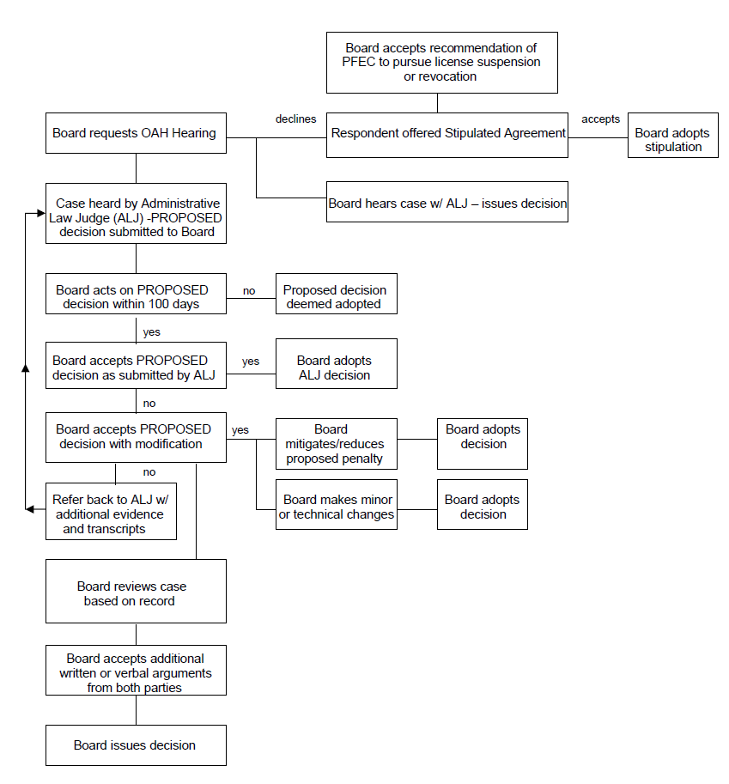

POLICY NUMBER 9: PROCEDURE FOR FILING OF A COMPLAINT WITH THE OFFICE OF PROFESSIONAL FORESTERS REGISTRATION
If a person wishes to file a complaint of professional misconduct against a Registered Professional Forester or Certified Specialist (CRM), the complaint must be submitted in writing, and mailed to Professional Foresters Registration, P.O. Box 94426, Sacramento, CA 94244- 2460, (916) 653-8031.
For purpose of providing direction to the Executive Officer of Foresters Licensing, the Board of Forestry and Fire Protection (Board) suggests that all complaints be filed in a consistent format and include the following information:
- The identity of the person who is the subject of the complaint, including his or her license number if known;
- A short description of the transaction or circumstances involved;
- The date and place (city or county) where the events occurred;
- The identity and addresses or telephone number of any other person(s) who have knowledge of the events described;
- A description of the loss, damage or other adverse consequences of the licensee’s conduct;
- Copies of pertinent portions of any plans, reports, letters, business records or other documents which support the complaint.
All complaints should contain the following verification:

VERIFICATION
I CERTIFY UNDER PENALTY OF PERJURY OF THE LAWS OF CALIFORNIA THAT THE FACTS STATED HEREIN ARE TRUE AND CORRECT TO THE BEST OF MY KNOWLEGE AND BELIEF.
DATE:
CITY OR PLACE:
SIGNATURE:
NOTE TO COMPLAINANTS: The complainant will receive a letter from Professional Foresters Registration acknowledging receipt of the complaint approximately 3 weeks after submittal. The complaint will then go through an initial review by the Executive Officer. You may be contacted by the Board to provide clarification or additional information. If a complaint you file results in prosecution, you must be willing to testify in the case. You will be notified by the Board if this is necessary. You will also be notified of the final action taken on the case.

POLICY NUMBER 10: REVIEW OF PROBATIONARY WORK PRODUCTS
As part of some stipulated agreements between the Board of Forestry and Fire Protection (Board) and disciplined RPFs to resolve licensing cases, independent review is required of written timber harvest plans and other related documents done by the RPF while on probation before they are submitted to the California Department of Forestry and Fire Protection (Department) for review and possible approval. It is the responsibility of the RPF being disciplined to arrange for the independent review of his/her work product while on probation. It is the intent of the Board that this type of review will increase the thoroughness and completeness of the work that goes into professional documents prepared by the RPF. To help guide those involved in this review and reporting, the Board suggests that the following standards may be useful to achieve the rehabilitation objective:

Products to be reviewed
All current forms of specified documents should be reviewed prior to the original submission to the Department. This includes, but is not limited to standard timber harvesting plans, emergency timber harvesting plans, modified timber harvesting plans, and any other type(s) of plans involving timber harvest or major amendments to any of these documents the Board may create in the future. Depending on the nature of the case, this review may also apply to Confidential Archaeological Addenda, stocking reports and other THP related documents.

RPF Reviewer
Must be a Registered Professional Forester or other appropriate professional who is involved in the timber harvest plan process, either in reviewing or writing THPs, and who has a working knowledge of current timber harvest plan regulations. The RPF must have a valid license to practice forestry, not be subject to any open disciplinary case concerning their RPF license, and must not have any conflict of interest in the performance of professional review. Those RPFs directly involved in the regulatory review of the specific plan (either in an office or on the ground) after submission to the Department shall not be involved in this prior review of the plan.

Review
A Stipulated Agreement may specify that review of probationary work products include an office check of the completeness of information that went into the specified document(s), and the presentation of that information in the document(s). When an office check is specified in the stipulation, the RPF under probation is not prevented from getting the reviewer to evaluate the document, or portions of the document in the field. Field evaluation of professional practice may also be specified as part of a Stipulated Agreement particularly where professional failures by the respondent RPF in the course of fieldwork have been specifically identified.
The review of the document should include what sources were used to obtain information, the documentation the RPF has of those sources, and how it is presented. For example, where the list of adjacent landowner names and addresses for Public Notice was obtained, where it is documented, and how is it presented in the plan. It is not expected of the reviewer to check whether the names are spelled correctly or that the addresses are accurate. A guide for the reviewer is the THP checklist originally developed by California Licensed Foresters Association, or other appropriate documents. Completing the checklist would provide an adequate review of the plan, combined with assessment of adequacy of source information.
Should reviewer find deficiencies in the document being reviewed, suggestions should be made to the RPF to correct problem(s) before submitting the document to the Department. It is not the responsibility of the reviewer to make sure that those corrections are made, but rather it is up to the RPF. A second review of document before submission is up to the RPF, and is not mandatory.
Where other resource professionals are required to provide specific input on any document, as specified in a Stipulated Agreement, the RPF Reviewer shall ensure that this input was received and the input appropriately utilized.

Certification of Review
The reviewer shall document and certify in writing to the PFEC that a review of a specific document has occurred. A letter to the PFEC shall be sent within 7 days of the review, stating what was reviewed, what the results of that review were, and if reviewer believes the document met generally acceptable professional standards for timber harvest plans documents submitted to the Department.

Costs
The respondent RPF shall be solely responsible for the cost of independent review of his/her probationary work product.

Other Work Products
Other work plans or documents reporting work done by or under the supervision of the RPF may require independent RPF review of those work products during probation. If so, that review shall be specifically addressed on a case by case basis in the stipulated agreement.

POLICY NUMBER 11: Guidance on the Practice of Forestry as it Relates to Other Professions

Introduction

The Professional Foresters Law, Public Resources Code §750, et seq. provides that a Registered Professional Forester (RPF) must be involved in projects that require the application of forestry principles and techniques for managing forested landscapes. Forested landscapes are those upon which are growing or naturally capable of growing in perpetuity significant stands of native conifer and/or hardwood trees and their associated vegetation types. These landscapes are typically tree dominated and not devoted to non-forestry commercial, urban or farming uses (Public Resources Code §754).
The Professional Foresters Law provides that a professional forester may only perform forestry services in those areas of expertise for which the person has achieved competency through training or experience. When a professional forester’s expertise is exceeded in a particular activity, the forester is compelled to utilize the services of other qualified experts including but not limited to arborists, archaeologists, botanists, civil engineers, ecologists, fisheries biologists, geologists, hydrologists, land surveyors, landscape architects, range scientists, soil scientists, or wildlife biologists. The Professional Foresters Law does not preclude these other environmental professionals from the application of their knowledge and expertise outside of the practice of forestry.

Statement I:
The Board recognizes consistent with the Professional Foresters Law, Public Resources Code §752(b), that there are other environmental professionals capable of supplying technical information relative to particular features of a forested landscape setting by virtue of education, training and experience.
The Board endorses an interdisciplinary approach in the management and treatment of natural landscapes. Just as the Professional Foresters Law requires that an RPF interact with other qualified experts when the RPF’s expertise is exceeded in the context of a particular activity, the Board finds that other qualified experts should likewise interact with RPF’s as appropriate to the environmental setting.

Statement II:
The Board recognizes that forested landscapes may be identified using a variety of vegetation classification systems including but not limited to the California Wildlife Habitat Relationship System (see the California Department of Fish and Game website link to the CWHR System (http://www.dfg.ca.gov/whdab/html/cwhr.html) and the California Department of Forestry and Fire Protection-Fire and Resources Assessment Program link to CWHR map layers (http://frap.cdf.ca.gov/data/frapgismaps/select.asp)); A Manual of California Vegetation by Sawyer and Keeler-Wolf; CDFG’s Vegetation Classification and Mapping Program (VegCAMP); various California Native Plant Society (CNPS) publications; and Preliminary Descriptions of the Terrestrial Natural Communities of California by R.F. Holland (updated 1996).

Statement III:
The Professional Foresters Law provides that the practice of forestry and rangeland management on forested landscapes includes among other things actions directed toward fuels management, forest protection, grazing on forested rangelands, timber growing and utilization, forest inventory, forest economics, forest valuation and finance, and the evaluation and mitigation of impacts from forestry activities on watershed and scenic values. Tasks associated with the practice of forestry and rangeland management include but are not limited to the following:
- Development of fuel hazard reduction prescriptions. Participation in the interdisciplinary development of technical aspects of wildfire protection plans.
- Evaluation of fire hazard, pest conditions (insects and disease), and the effects of damaging agents on the overall health of forests and woodlands. Development of treatments for the prevention and control of damage to forests and woodlands.
- Management planning and prescription development in support of wood product utilization.
- The determination of diameter, height, form, weight, growth rate, volume, or age of individual or groups of trees; or interpretation of such determinations to support forest management actions or the treatment of forest cover in general.
- The determination of economic value of a particular forest or woodland.
- The evaluation of forest/woodland conditions in response to past management actions and the development of mitigation measures for remediation or control of potentially deleterious effects.
- Recommendations regarding prescriptive grazing on forested rangelands.

Statement III (Continued):
The Board recognizes that performance of the following tasks does not constitute the practice of forestry or rangeland management unless the tasks are exclusively directed toward the management and treatment of forests and woodlands:
- Providing retention or removal recommendations for trees associated with specific development improvements.
- Classification of vegetative or habitat types as indicated in item II above.
- Collection of tree species data (i.e. number of trees per acre, tree diameters, heights, etc.)
- Characterization of individual tree condition (i.e. pathology, injury assessment, health and vigor rating, etc.)
- Valuation or appraisal of individual tree(s) value, or loss as landscape elements, for trees associated with development.
- Preparation of tree protection plans pursuant to jurisdictional requirements if it is concluded by the Lead Agency that individual or groups of trees shall be retained on site in proximity to construction activities.
- Mapping, acreage/canopy cover determination or other site evaluations through photogrammetry, Geographical Information Systems (GIS), and/or surveyed location of individual or stands of trees.
- Mitigating or recommending mitigation of impacts from previous or proposed land use activities by other environmental experts within their field of expertise.
- Determinations of significance under CEQA.

Statement IV:
The Board acknowledges that pursuant to 14 CCR §15149(b) a CEQA document such as an EIR is not a technical document that must be prepared solely by state registered professionals. CEQA documents are intended to disclose for public benefit and agency review the potential adverse effects of a proposed project on the environment and to identify ways to reduce or mitigate such potential adverse effects. The extent to which full and accurate disclosure of potential adverse effects and mitigations necessitates the preparation of technical studies by state licensed professionals is at the discretion of the lead agency.

POLICY NUMBER 12: GUIDANCE ON THE CERTIFIED RANGELAND MANAGER PROGRAM

Introduction
The purpose of this policy statement is to clarify those management activities on rangelands that are most appropriately carried out by a Certified Rangeland Manager (CRM). The Professional Foresters Law, Public Resources Code §750, et seq. provides for the issuance of specialty certificates, “… in such fields of specialization as the Board may by regulation establish” (PRC §762). The only specialty certificate currently provided by Board regulation is that of the Certified Rangeland Manager. This specialty was created in 1995 through the efforts of the California Section of the Society for Range Management with the support of the California Department of Forestry and Fire Protection. In so doing, the California Section, now the California-Pacific Section (Cal-Pac SRM) sought to promote and strengthen professional standards in all activities devoted to rangeland resources. The Cal-Pac SRM professional certification is designed to distinguish and maintain a professional level of rangeland management expertise and provide continuing education and accreditation services to the profession.
The CRM Program provides for professional and ethical standards of performance, and establishes a mechanism for reviewing charges of professional misconduct with associated disciplinary guidelines. The Board of Forestry and Fire Protection, through its Professional Foresters Examining Committee (PFEC), provides administrative oversight and annual review of the Society’s program to insure compliance with State-mandated requirements to fully protect the public’s interest.
A Certified Rangeland Manager applies scientific principles to the art and science of managing rangelands. Rangelands are lands supporting grass, shrub, and savanna vegetation types pursuant to the Cal-Pac SRM Program for Certification of Professional Rangeland Managers (14 CCR §1651(c)). This program of certification is a service provided by Cal-Pac SRM as a means for demonstrating and supporting the special expertise required to practice as a Certified Rangeland Manager. Pursuant to 14 CCR §1651(a), a CRM shall perform professional services only in those subjects in which he or she is competent by training and experience.
The CRM license is required for professional practice of rangeland management on non-federal forested landscapes as a specialty authorized under a modification of the Professional Foresters Licensing Act (AB1903) that requires the Registered Professional Forester license for the practice of forestry. The CRM license recognizes expertise that is desirable, and recommended for all rangeland management activities, but it is not legally required unless the activity occurs on forested landscapes.

Statement I:
The Board recognizes that rangelands may be identified using a variety of vegetation classification systems including but not limited to the California Wildlife Habitat Relationship System (see the California Department of Fish and Game website link to the CWHR System (http://www.dfg.ca.gov/whdab/html/cwhr.html) and the California Department of Forestry and Fire Protection-Fire and Resources Assessment Program link to CWHR map layers (http://frap.cdf.ca.gov/data/frapgismaps/select.asp); A Manual of California Vegetation by Sawyer and Keeler-Wolf; CDFG’s Vegetation Classification and Mapping Program (VegCAMP); various California Native Plant Society (CNPS) publications; and Preliminary Descriptions of the Terrestrial Natural Communities of California by R.F. Holland (updated 1996).
The board further recognizes the boundaries between forests and rangelands and the associated professional practices are often overlapping. Thus the CRM license requirements apply to any landscape of mixed forested and non-forested vegetation types with significant interactions of range and forest management.

Statement II:
Tasks associated with the practice of rangeland management include but are not limited to the following:
- Drafting rangeland management plans to meet specific natural resource objectives, including:
  - Vegetative fuel management on rangelands;
  - Control or management of invasive species;
  - Reintroduction or increase of desirable species;
  - Improvement of economic viability of rangeland;
  - Mitigation of potential environmental effects.
- Developing and implementing means of improving or maintaining watershed function.
- Conducting rangeland inventories and assessments.
- Making recommendations regarding prescriptive grazing on rangelands.
- Planning and implementation of rangeland monitoring programs.
- Providing recommendations regarding conservation of, and regard for, rangeland as an expression of open space, viewshed, watershed and other public benefits.

Statement III:
The Board recognizes that performance of the following tasks does not constitute the practice of rangeland management, under the Professional Foresters Law, unless the tasks are exclusively directed toward the management and treatment of rangelands:
- Mapping, acreage/vegetative cover determination or other site evaluations through photogrammetry, Geographical Information Systems (GIS), and/or surveyed location.
- Mitigating or recommending mitigation of impacts from previous or proposed land use activities by other environmental experts within their field of expertise.
- Determinations of significance pursuant to the California Environmental Quality Act (CEQA).
It is important to note that, pursuant to PRC §757, landowners are specifically exempted from the necessity of compliance with the Professional Foresters Law, including the provisions of the CRM Program, when directly managing their own lands. It is likewise noteworthy and illustrative of the distinction between the roles of the CRM and the Registered Professional Forester (RPF) that pursuant to 14 CCR §1651(b), a CRM providing range management services related to rangeland resources on forested landscapes must consult with a RPF if there are potential impacts on related forest resources. And conversely, RPFs providing services related to forest resources must either have rangeland experience or consult with a CRM if there are potential impacts on related rangeland resources.

Statement IV:
The Board acknowledges that pursuant to 14 CCR §15149(b) a CEQA document such as an EIR is not a technical document that must be prepared solely by state certified professionals. CEQA documents are intended to disclose for public benefit and agency review the potential adverse effects of a proposed project on the environment and to identify ways to reduce or mitigate such potential adverse effects. The extent to which full and accurate disclosure of potential adverse effects and mitigations necessitates the preparation of technical studies by state certified professionals is at the discretion of the lead agency.

