Please adjust your screen reader settings to recognize underline and strikethrough text.

Biological Resources
This section describes the biological resources that are known or have the potential to occur in the treatable landscape. Biological resources include common vegetation and wildlife, sensitive plant communities, special-status plant and animal species, and biologically important lands. Regulatory requirements that pertain to biological resources are summarized. The analysis describes potential impacts from implementation of the proposed CalVTP and identifies mitigation measures for those impacts determined to be significant.
Comments on the Notice of Preparation (included in Appendix A) related to biological resources requested that the PEIR consider the following: use of multiple data sources to determine potential biological resources in treatment areas including conducting protocol-level surveys; potential impacts of vegetation treatment within chaparral; potential for vegetation treatments to increase invasive plant species and measures to control spread; and potential effects on sensitive vegetation and wildlife from vegetation removal, prescribed burns, and prescribed herbivory.

Environmental Setting

Treatable Landscape and Ecoregional Approach
The treatable landscape, which encompasses the area within which the proposed CalVTP would be implemented, covers much of California and includes numerous habitats, sensitive natural communities, and special-status plant and animal species. The biological resources setting description and environmental analysis are geographically organized into ecological regions or “ecoregions.” Generally, an ecoregion is a geographic area with similar or recurring patterns of physical and biological characteristics that may include geology, soils, geomorphology, hydrology, climate, vegetation types, animal species composition, biodiversity, and land use history. The objectives of organizing this analysis by ecoregions are to: (1) describe the range of key biological resources that could be affected by program implementation; (2) identify the sensitive resources that potentially occur within or near a treatment area based on vegetation communities, special-status species, and sensitive habitats described for that same ecoregion; (3) provide a relevant geographic scale for analyzing cumulative impacts on biological resources; and (4) provide increased efficiency during project-specific review of later treatment activities for determining whether affected resources and impacts of proposed treatments under the CalVTP were considered within the scope of the PEIR.
Several ecoregion classification systems have been established by various agencies and organizations locally, nationally, and internationally. Classifications were developed for different purposes and each has its own benefits and limitations. After evaluation of several classification systems, the U.S. Forest Service (USFS) National Hierarchical Framework of Ecological Units (Framework) at the ecological section level was selected for use in the CalVTP PEIR for the reasons listed below. Figure 3.6-1 displays the USFS ecological sections (also referred to as “ecoregions” in this PEIR) and the treatable landscape. The treatable landscape is present in some portion of every ecoregion in California, with the exception of the Sonoran Desert Section.
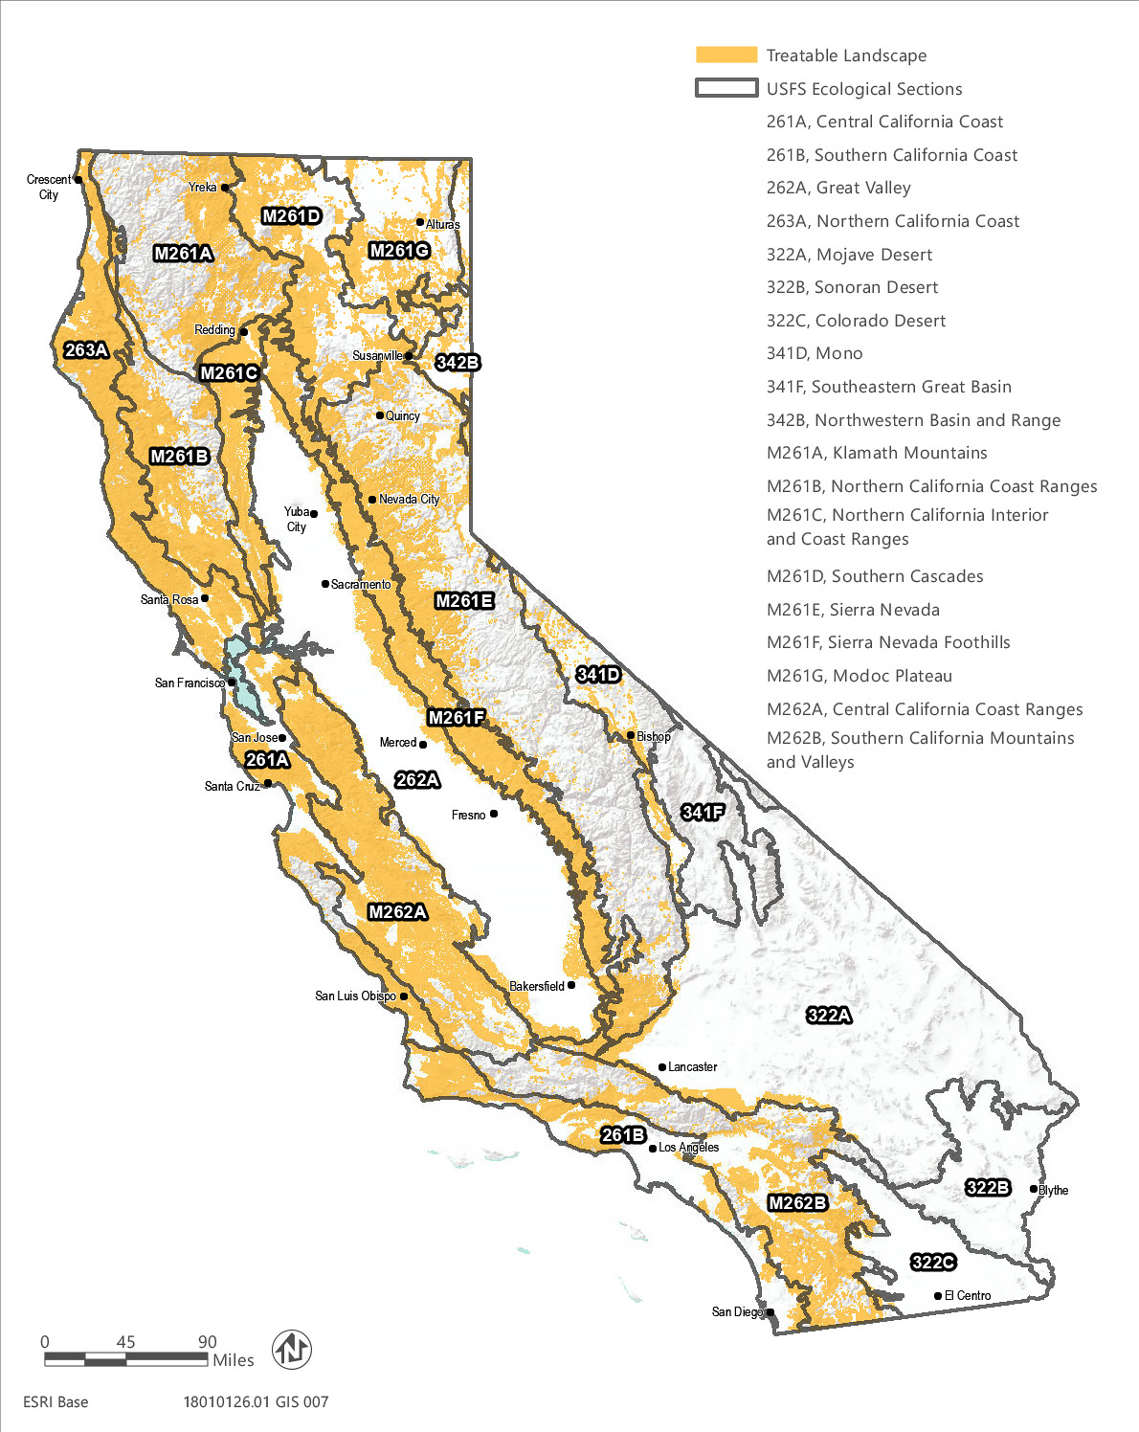
Source: Data downloaded from CAL FIRE in 2018
Figure 3.6-1 Ecoregions and Treatable Landscape
- The Framework contains multiple hierarchical levels of organization, providing flexibility as to the scale of application. Organizing ecosystems within a hierarchical framework provides a means of describing resources at an appropriate scale, while allowing for the ability to examine conditions at coarser or finer levels, if needed. Because of the broad (statewide) distribution of potential treatment areas, combined with unique regional and vegetation-specific issues requiring evaluation in the CalVTP, multiple hierarchical levels may be useful. In the USFS National Hierarchical Framework of Ecological Units, the largest ecological units are domains, which are groups of related climates that are differentiated based on precipitation and temperature. Divisions represent a further refinement of the climates within domains and are differentiated based on precipitation levels and patterns as well as temperature. Divisions are subdivided into provinces, which are differentiated based on vegetation or other natural land covers. Sections are subdivisions of provinces, delineated primarily by physical and biological components such as climate, physical geography, soils, and potential natural communities. Sections are further subdivided into smaller units. Sections are the primary ecological unit used to describing biological resources in the CalVTP. In this document, ecological sections, or sections, are also referred to generally as “ecoregions.”
- At the ecological section level, the Framework provides a higher resolution and number of ecological units in California than the other classification systems considered. Eighteen of 19 sections delineated in California contain at least some treatable landscape (except the Sonoran Desert Section). Using ecoregions is inherently a coarse-level approach to characterizing resource conditions and potential impacts across the treatable landscape; therefore, a classification with more subareas (i.e., greater degree of refinement) allows for the efficient presentation of more detailed information in the CalVTP PEIR setting (i.e., baseline conditions) and provides more specificity in analyzing impacts in key ecoregions within the treatable landscape.
- The Framework has been used in other statewide natural resource plans and environmental documents, such as the Statewide Wildlife Action Plan (SWAP) (CDFW 2015a) and the California Forest Carbon Plan (Forest Climate Action Team 2018). These plans provide the most current resource descriptions and data and use of the same classification system provides efficiency and consistency for the CalVTP PEIR.
- Vegetation types and descriptions in the Framework follow A Manual of California Vegetation (Sawyer et al. 2009 or current version; most current natural community data available at http://vegetation.cnps.org/), which is the current standard for vegetation classification in California and is consistent with the National Vegetation Classification System.
- California Wildlife Habitat Relationships (CWHR) System species range maps used the Framework; therefore, the mapped California ranges for many special-status species correspond well with USFS ecological unit boundaries.
- The Framework includes well-documented and useful descriptions that offer strong evidence supporting the system’s organization (McNab et al. 2007)
Importantly, while the ecoregion organization in this PEIR provides a comprehensive approach to the program-level environmental impact analysis and would guide project-specific biological resource evaluations, it does not replace the need for project-specific environmental review when sensitive resources could likely be present. During project-level planning and evaluation, a combination of data sources and survey efforts would be used to verify the specific biological resources known or with potential to occur in a specific treatment area. Additional biological analysis for a Project-Specific Analysis (PSA) may include field assessments, confirmation of biological resources that could be affected, protocol or other pre-construction surveys for special-status species, and the implementation of SPRs and mitigation measures during individual treatment activities (refer to Appendix PD-3, “Project-Specific Analysis”).

Methods
The environmental setting for biological resources describes the common and sensitive resources that potentially occur in the treatable landscape. While several of these resources are appropriately summarized for the entire treatable landscape (refer to “Overview of Biological Resources Described at the Treatable Landscape Level“ below), most of the resources are summarized at the ecoregion level (refer to “Overview of Ecoregion Description Content” below). The information on biological resources was gathered through review of existing data sources and is presented as a general summary of resources that may occur in the treatable landscape. During the PSA, additional data sources would be used to determine locally present, sensitive biological resources with potential to occur in a project area, including reconnaissance surveys. The following primary sources of information were used:
- Vegetation and habitat types: Information on the major vegetation and habitat types within the treatable landscape was determined from maps and associated data from CAL FIRE’s Fire and Resource Assessment Program (FRAP). Supplemental information was provided by the Manual of California Vegetation Online (CNPS 2019) and CWHR System habitat type descriptions (CWHR 2019).
- Sensitive biological resources: Information on sensitive biological resources, including special-status species and sensitive natural communities, within the treatable landscape of each ecoregion was compiled from the following:
- The California Natural Diversity Database (CNDDB) and its GIS application were used to identify reported occurrences of special-status species and sensitive natural communities. The CNDDB is a statewide database managed by the California Department of Fish and Wildlife (CDFW) that is continually updated with the reported location and condition of the State’s rare and declining species. Although the CNDDB is the most current and reliable tool available for tracking occurrences of special-status species statewide, it contains only those records that previously have been reported to CDFW.
- CWHR range maps and habitat types were used to supplement CNDDB data to determine the potential to occur for special-status amphibian, reptile, bird, and mammal species within the treatable landscape. The CWHR types are described in terms of vegetation and are grouped according to vegetative dominance or distinguishing characteristics to which wildlife are thought to respond (Mayer and Laudenslayer 1988). The CWHR System was developed to identify and classify existing vegetation types important to wildlife in California and it is, therefore, appropriate as a tool for analyzing potential species occupancy and use of proposed treatment areas.
- U.S. Fish and Wildlife Service (USFWS) critical habitat GIS data were used to identify designated critical habitat. USFWS official lists of federal candidate, proposed, threatened, and endangered species and USFWS range lists were used to help determine the potential for special-status species occurrence. Official lists from all applicable USFWS offices were accessed using the USFWS Information for Planning and Conservation (IPaC) website.
- Other sources of information were sought to determine the ranges, habitat, and potential for special-status species to occur in the treatable landscape, such as the SWAP (CDFW 2015a) and others described below, under “Special-Status Species.”
- USFWS National Wetland Inventory (NWI) GIS datasets and the National Hydrography Dataset (NHD) were used to identify wetland and aquatic habitats within the treatable landscape.
- Conservation lands, special management areas, and other biologically important lands:
- For purposes of identifying potential wildlife movement corridors at a statewide scale, regional landscape linkages and habitat connectivity areas were identified and mapped within the treatable landscape using CDFW’s Terrestrial Connectivity dataset (CDFW 2018a). The Terrestrial Connectivity dataset is one of the four key components of CDFW’s Areas of Conservation Emphasis (ACE) suite of terrestrial conservation data, along with Terrestrial Biodiversity, Significant Habitats, and Climate Resilience. The ACE Terrestrial Connectivity dataset provides a single snapshot of connectivity information across the state. The dataset summarizes information on terrestrial connectivity by ACE hexagon, including the presence of mapped habitat corridors or linkages; the juxtaposition to large, contiguous, natural areas; and a relative intactness (ecological condition) score. Mapped corridors or linkages incorporated into the Terrestrial Connectivity dataset include California Essential Habitat Connectivity Areas and Natural Landscape Blocks (Spencer et al. 2010), and several other regional and statewide corridor/linkage-mapping products.
The Terrestrial Connectivity dataset was developed to support conservation planning efforts by allowing users to spatially evaluate the relative contribution of an area to terrestrial connectivity based on the results of statewide, regional, and other connectivity analyses. Each ACE hexagon is assigned a connectivity rank from 1 to 5, which indicates the degree to which the hexagon is part of a large, contiguous natural area or a mapped linkage or corridor. A rank of 5 indicates that the area is within the core of a natural landscape block or linkage and has high landscape intactness. A rank of 1 indicates that the area has low landscape intactness and is not part of a natural landscape block or linkage (CDFW 2018a).
- Habitat conservation plans (HCPs) and natural community conservation plans (NCCPs) adopted or in progress for areas within the treatable landscape were identified using CDFW’s Conservation Plan Boundaries GIS data (CDFW 2017).
- Locations, ownership, and acreages of other protected open space and conservation lands in the treatable landscape were obtained from the California Protected Areas Database (CPAD 2018).
- BIOS is a system that enables the management and visualization of biogeographic data collected by CDFW and partner organizations. Partner organizations that provide data layers to BIOS include the U.S. Geological Survey, U.S. Bureau of Land Management, USFWS, California Coastal Conservancy, California Geological Survey, and USFS. BIOS facilitates the sharing of data within the BIOS community through integrating GIS, relational database management, and ESRI’s ArcGIS Server technology to create a statewide, integrated information management tool that can be used on any computer with access to the Internet (http://www.dfg.ca.gov/biogeodata/bios/). BIOS was used to access data layers including Essential Habitat Connectivity areas, lakes and streams, state refuges, state parks, California Protected Areas, lands under conservation easements, and CDFW-owned and operated lands.

Overview of Biological Resources Described at the Treatable Landscape Level
The topics in this section are summarized for the entire treatable landscape. Topics are described at this level, which is coarser than the ecoregion level, because they are either relevant to the entire state or cross multiple ecoregion boundaries. More refined identification, characterization, and analysis of these topics would be completed during the PSA.

Fire Regime
This section provides a general discussion about fire regime for different vegetation types throughout the state. This topic is generally not discussed further in the ecoregion descriptions; however, additional information about fire regimes for the CWHR types within the treatable landscape is provided in Appendix BIO-1.
Fire characteristics, or fire regime, can be described based on seven attributes that are generally considered important to ecosystem function. These attributes are comprised of the temporal attributes of seasonality and fire return interval, the spatial attributes of fire size and spatial complexity, the magnitude attributes of fireline intensity and fire severity, and fire type (Van Wagtendonk et al. 2018). The Manual of California Vegetation (Sawyer et al. 2009: Appendix 2, Table A2) provides a list of the fire regime attributes of the vegetation alliances described in California (most current natural community data available at http://vegetation.cnps.org/).
Many of California’s ecosystems are fire-adapted; however, semi-arid forests and grasslands are often not experiencing fire as frequently as needed to maintain their ecological structure and function. Other ecosystems, such as coastal sage scrub and chaparral, are experiencing fires too frequently, resulting in changes to their ecology (CDFW 2015a). The fire return interval and fire response for chaparral and coastal scrub alliances, as reported in the Manual of California Vegetation (Sawyer et al. 2009) is provided in Table 3.6-1. Studies found 34 percent of coastal sage scrub sites were converted to nonnative annual grasslands between 1930 and 2009 and that annual grass encroachment was positively correlated with frequent fire and air pollution (Talluto and Suding 2008).
Forest vegetation types are generally adapted to relatively frequent, moderate to low intensity fires that burn understory fuels and not mature trees. In addition, there is growing recognition that forests adapted to moderate and low intensity fires also experienced a small proportion of high-severity fire, providing opportunities for early-seral habitat development and the production of large pieces of deadwood resources that are important to many wildlife species (Fontaine and Kennedy 2012, Marlon et al. 2012).
Relative to forest vegetation types, southern chaparral vegetation types are adapted to less frequent, higher intensity crown fires that kill most of the above-ground biomass. While the above-ground parts of the dominant plants are killed during these fires, these species quickly regenerate from sprouts and a viable seed bank and return to their pre-fire composition as long as fires are not so hot as to sterilize the soil and destroy the seed bank and root crown systems, or too frequent to allow shrubs to mature. Natural fire return intervals for individual chaparral types across the state are variable, ranging from around 30 years in northern chaparral types to 100 years or more in coastal southern chaparral types (Van de Water and Safford 2011). Fire return intervals in coastal scrub habitats are likewise widely variable but are generally short to medium, ranging from 1 to 5 years for the shortest and up to 50 to 100 years (Table 3.6-1). The longest fire return interval for a coastal scrub type is 50 to 200 years for California buckwheat scrub in desert regions.
Fires have increased substantially in southern California coastal areas, and in places this has led to a conversion of native chaparral and coastal scrub vegetation to annual grassland cover dominated by nonnative species (Underwood et al. 2018). Some chaparral species resprout from root crowns and also regenerate from seed (facultative seeders) and some are obligate seeders (regenerate only from seed). Facultative seeders are more resilient to fire than obligate seeders, which can be eliminated from an area if fire return intervals are too short (Underwood et al. 2018). For example, Bigberry manzanita chaparral is an obligate seeder with a medium fire return interval that ranges from 20 to over 100 years.
Table 3.6-1 Fire Return Interval
CWHR Classification/MCV Alliance | Fire Response | Fire Return Interval
Chamise-redshank Chaparral
Chamise chaparral | facultative seeder | medium (10-100+ years)
Chamise - white sage chaparral* | facultative seeder | medium (30-60 years)
Chamise - black sage chaparral | facultative seeder | medium (30-60 years)
Redshank chaparral | facultative seeder | medium (10-100+ years)
Eastwood manzanita chaparral | facultative seeder | medium (10-100+ years)
Bigberry manzanita chaparral | obligate seeder | medium (20-100+ years)
Hoary leaf ceanothus chaparral | obligate seeder | medium (10-100 years)
Wedge leaf ceanothus chaparral/Buck brush chaparral | obligate seeder | medium (20-100 years)
Cup leaf ceanothus chaparral* | obligate seeder | medium (10-100 years)
Mission manzanita chaparral* | facultative seeder | medium (30-100+ years)
Coastal scrub
Dune mat* | — | —
California sagebrush scrub | facultative seeder | medium (20-100+ years)
California sagebrush - California buckwheat scrub | facultative seeder | medium (20-50+ years)
California sagebrush - black sage scrub | facultative seeder | medium (15-70+ years)
Quailbush scrub | obligate seeder | long (35-100 years)
Coyote brush scrub | facultative seeder | medium (15-50+ years)
Broom patch^{N} | facultative seeder | —
Sea rocket sands | — | —
Sand dune sedge swath* | — | —
Blue blossom chaparral | obligate seeder | medium (20-50 years)
Giant coreopsis scrub* | facultative seeder | —
Hazelnut scrub* | facultative seeder | short (1-5 years)
Bush monkeyflower scrub* | facultative seeder | medium (20-50 years)
Live-forever - lichen/moss sparse herbaceous rock outcrop | — | —
California brittle bush - Ashy buckwheat scrub* | obligate sprouter | medium (15-70 years)
Brittle bush scrub | facultative seeder | medium
Narrowleaf goldenbush - bladderpod scrub | obligate seeder | —
Palmer's goldenbush scrub* | — | —
California yerba santa scrub | facultative seeder | short (>10-50 years)
California buckwheat scrub | facultative seeder | south/central coast: medium (15-30+ years); desert: long (50-200 years)
California buckwheat - white sage scrub* | facultative seeder | medium (15-70+ years)
Wright's buckwheat - Heerman's buckwheat - Utah butterfly-bush scrub* | — | —
California coffee berry scrub | facultative seeder | —
Coastal silk tassel scrub* | — | —
California match weed patch* | — | —
Sawtooth golden bush scrub* | obligate sprouter | medium (20-100 years)
Goldenaster patch* | — | —
Menzies's golden bush scrub* | — | medium to long
Salt rush swales* | — | —
Bush penstemon scrub* | — | medium (20-100 years)
Scale broom scrub* | obligate sprouter | —
Deer weed scrub | obligate seeder | short (5-50 years)
Silver bush lupine scrub | obligate seeder | short (5-50 years)
Yellow bush lupine scrub | facultative seeder | long
Silver dune lupine - mock heather scrub* | — | long
California desert-thorn scrub* | obligate sprouter | —
Bush mallow scrub | facultative seeder | medium (20-50+ years)
Laurel sumac scrub | facultative seeder | short to medium (10-60 years)
Ice plant mats^{N} | — | —
Wax myrtle scrub* | obligate sprouter | long
Coast prickly pear scrub* | facultative seeder | medium (10-50 years)
Coastal sage and Island scrub oak chaparral* | obligate sprouter | medium to long (50-100+ years)
Lemonade berry scrub* | obligate sprouter | medium (15-70+ years)
Coastal bramble* | obligate sprouter | medium (20-100 years) (drought years)
White sage scrub* | facultative seeder | medium (15-70+ years)
Purple sage scrub | facultative seeder | medium (15-70+ years)
Black sage scrub | facultative seeder | medium (15-90+ years)
Coast range stonecrop draperies | — | —
Bushy spikemoss mats* | obligate sprouter | —
Jojoba scrub* | — | —
Bush seepweed scrub* | — | —
Poison oak scrub | facultative seeder | short to medium
Mixed Chaparral
Baker manzanita stand* | — | —
Hoary, common, and Stanford manzanita chaparral* | obligate seeder | —
Brittle leaf - woolly leaf manzanita chaparral* | facultative seeder | medium (30-100+ years)
Eastwood manzanita chaparral | See above under Chamise-redshank chaparral
Bigberry manzanita chaparral | See above under Chamise-redshank chaparral
Hooker's manzanita chaparral* | — | —
Hoover's manzanita chaparral* | obligate seeder | medium (50-100+ years)
Mount Tamalpais manzanita chaparral* | obligate seeder | medium (50-100+ years)
Monterey manzanita chaparral* | — | —
Morro manzanita chaparral* | obligate seeder | medium (50-100+ years)
Ione manzanita chaparral* | obligate seeder | medium (30-100+ years)
Glossy leaf manzanita chaparral* | obligate seeder | medium (30-100+ years)
Pajaro manzanita chaparral* | obligate seeder | medium (30-100+ years)
Sandmat manzanita chaparral* | — | —
Pointleaf manzanita - pink-bract manzanita chaparral* | obligate seeder | medium (20-50+ years)
Burton Mesa chaparral* | — | —
Silverleaf manzanita chaparral* | — | —
Whiteleaf manzanita chaparral | obligate seeder | medium (20-70+ years)
Hoary leaf ceanothus chaparral | See above under Chamise-redshank chaparral
Wedge leaf ceanothus chaparral, Buck brush chaparral | See above under Chamise-redshank chaparral
Cup leaf ceanothus chaparral* | See above under Chamise-redshank chaparral
Deer brush chaparral | facultative seeder | medium (10-50+ years)
Chaparral whitethorn chaparral | facultative seeder (south of Tulare County); obligate seeder (north of Tulare County) | medium (25-65 years)
Bigpod ceanothus chaparral | obligate seeder | medium (25-55 years)
Hairy leaf - woolly leaf ceanothus chaparral* | obligate seeder | medium (25-100 years)
Wart leaf ceanothus chaparral* | obligate seeder | medium (20-100 years)
Wart stemmed ceanothus chaparral* | — | —
Birch leaf mountain mahogany chaparral | facultative seeder | medium (40-80 years)
Golden chinquapin thickets* | obligate sprouter | short
Bush poppy scrub | — | medium (20-100 years)
California yerba santa scrub | facultative seeder | short (>10-50 years)
Thick leaf yerba santa scrub* | — | —
California coffee berry scrub | See above under coastal scrub
Ocean spray brush* | obligate sprouter | medium
Deer weed scrub | See above under coastal scrub
Silver bush lupine scrub | See above under coastal scrub
Bush mallow scrub | See above under coastal scrub
Laurel sumac scrub | See above under coastal scrub
Shrub tanoak chaparral* | obligate sprouter | medium (20-80 years)
Holly leaf cherry - toyon - greenbark ceanothus chaparral | obligate sprouter | medium to long
Choke cherry thickets* | — | —
Scrub oak chaparral | obligate sprouter | medium (30-100+ years)
Scrub oak - chamise chaparral | obligate sprouter | medium (20-100 years)
Canyon live oak chaparral | obligate sprouter | medium (30-100+ years)
Muller oak chaparral | obligate sprouter | medium (30-100+ years)
Coastal sage and Island scrub oak chaparral* | See above under coastal scrub
Leather oak chaparral | facultative seeder | medium (30-100+ years)
Tucker oak chaparral | — | medium (30-100+ years)
Palmer oak chaparral* | obligate sprouter | long
Interior live oak chaparral | obligate sprouter | medium (30-100+ years)
Sugarbush chaparral | facultative seeder | —
Oak gooseberry thicket* | — | —
Poison oak scrub | See above under coastal scrub
Canyon sunflower scrub* | facultative seeder | —
Montane Chaparral
Mount Tamalpais manzanita chaparral | See above under mixed chaparral
Green leaf manzanita chaparral | facultative seeder | medium (20-50 years)
Whiteleaf manzanita chaparral | See above under mixed chaparral
Mountain whitethorn chaparral | facultative seeder | medium (20-50+ years)
Deer brush chaparral | See above under mixed chaparral
Tobacco brush or snow bush chaparral | facultative seeder | medium (40-75 years)
Birch leaf mountain mahogany chaparral | See above under mixed chaparral
Bush chinquapin chaparral | obligate sprouter | medium (5-50 years)
Bitter cherry thicket | — | —
Choke cherry thicket | — | —
Brewer oak scrub | facultative seeder | medium (25-50+ years)
Sadler oak or deer oak brush field | obligate sprouter | medium (25-75+ years)
Huckleberry oak chaparral | obligate sprouter | medium (25-75+ years)
*These are designated sensitive natural communities with a state rarity rank of S1 (critically imperiled), S2 (imperiled), or S3 (vulnerable).
^{N} These alliances are dominated by nonnative vegetation.
Definitions (Parker et al. 2015):
Facultative seeders: shrubs that survive wildfire and sprout new shoots after the fire. These types of plants also have persistent soil seed banks that fire stimulates, and they recruit new individuals from seedlings that successfully establish in the postfire environment.
Obligate sprouter: shrubs that can survive wildfire and sprout new shoots after the fire. Generally, no seedlings are recruited in the postfire environment.
Obligate seeders: shrubs or trees that are killed by wildfire and persist in the habitat because they have persistent soil seed banks that fire stimulates. Obligate seeders recruit new individuals after wildfire from the seed bank and establish new populations in the postfire environment.
Source: Sawyer et al. 2009, CNPS 2019; Compiled by Ascent Environmental in 2019
Prior to European settlement, conifer forests in the Sierra Nevada were reportedly open, park-like stands of large pine and fir trees with a grassy understory. Frequent low-intensity fires rejuvenated grasslands and consumed dead woody debris and leaf litter from the forest floor and high-intensity crown fires that consumed mature individuals were infrequent. During the 20th century, policies of fire exclusion were implemented throughout the region, reducing fire frequency and allowing the recruitment of large numbers of trees that would have been removed as saplings under a regime of frequent fire. As a result, many forest stands have become denser, and have higher loads of surface fuels. This change in stand structure has increased fire hazards because more intense fires, which may spread through the canopy and cause substantial tree mortality, are now much more likely.
Some plant species, such as closed-cone cypress and pine species and some chaparral species, need hot fires to regenerate (CDFW 2015a, Sawyer et al. 2009). Closed-cone pine-cypress vegetation types, including Baker cypress stand, Mendocino pygmy cypress woodland, Piute cypress woodland, and Bishop pine-Monterey pine forest, are adapted to low complexity, high intensity, high to very high severity fires with a medium fire return interval. Fire return intervals generally need to be longer than 15 years to allow a new cone crop to develop but short enough to ensure viable seed crops are present. In general, fire kills most closed-cone cypress and pine species but ensures seed dissemination and germination. Seeds fall on bare mineral soil and seedlings establish dense thickets (CNPS 2019). Additional information on the fire ecology of CWHR types found in the treatable landscape is provided in Appendix BIO-1.
Although many wildlife species in California evolved with fire, large high-intensity wildfires, such as the ones recorded in 2017 and 2018, are considered a threat to some already threatened or endangered species due to direct mortality and habitat loss (USFWS 2018, Chiono et al. 2017). Fuel management has been suggested as a method to decrease the risk of wildfire on these already vulnerable species (USFWS 2018, Chiono et al. 2017). However, current fire risk reduction and suppression activities also have variable effects on wildlife, depending on the specific management actions and environment in which the actions occur. For example, an analysis of multiple areas across the U.S. found that overall bird and mammal diversity and abundance remained neutral or increased with moderate levels of forest thinning for fire fuel management, although biodiversity decreased in some areas in the short-term (Verschuyl et al. 2011).
Other than direct residential development, one of the more important changes in shrubland ecosystems has been the anthropogenic alteration of the natural fire regime. Despite a long-standing policy of fire suppression, the primary impact to these ecosystems has been a dramatic acceleration of human-caused fire occurrence. Because of the increase in anthropogenic ignitions associated with human population centers, more fires now occur in the wildland-urban interface than in the backcountry. Too-frequent fire may promote the invasion of nonnative plant species by providing canopy openings, reducing cover of competing vegetation, and creating favorable soil conditions, such as newly exposed soil surfaces and increased nutrient availability. Invasive plants may change fire behavior and fire regimes, often by increasing fuel bed flammability, which increases fire frequency. These changes may also impact habitat loss and small mammal populations. Cheatgrass serves as a classic example of an invasive plant that has significantly altered the fire ecology in the Western United States and Canada; it is a winter annual that grows rapidly during late winter and early spring and provides a continuous fuel bed of light, flashy fuel once cured in early summer.
The restoration of native, fire-adapted plant communities is a critical need across portions of the western United States (Agee and Skinner 2005). In California, prescribed burning and some mechanical and manual fuel treatments are currently occurring on lands within the SRA at a smaller scale than that proposed by the CalVTP (refer to Chapter 2, “Project Description”). Fuel treatments have been shown to reduce wildfire severity (Stephens et al. 2009), although fuel reduction projects within forested settings appear to be more effective in reducing burn severity as compared to some southern California chaparral ecosystems. This objective recognizes that appropriately designed vegetation treatments can mimic the disturbance processes that historically controlled plant community composition and structure. In addition, restoring native, fire-adapted ecosystems can increase ecosystem resiliency to wildfire, drought, and potentially climate change.

Invasive Species
For purposes of this PEIR, as discussed with and agreed upon by CDFW, invasive species means those plant species identified as invasive by the California Invasive Plant Council (Cal-IPC) or defined as noxious weeds under California law by the CDFA. Cal-IPC categorizes plants as invasive based on assessment of ecological impacts conducted with transparent, science-based criteria and expert review. It focuses on invasive plant species that can have substantial ecological impacts in California wildlands and represents the best available knowledge of invasive plant experts in California (Cal-IPC 2019). There are currently over 300 plant species in the Cal-IPC inventory, approximately 200 of which are rated as invasive and approximately 100 of which are on a watch list of species at high risk of becoming invasive in the future. The CDFA has approximately 90 plant species on its noxious weed list. Many of these species are also rated invasive by Cal-IPC.
Infestations of invasive plants generally originate in areas where soil and vegetation have been disturbed; the removal of native vegetation provides an opportunity for propagules of introduced species to establish, grow, and reproduce and eventually spread throughout the disturbed area and possibly into adjacent undisturbed vegetation.
Human activities have facilitated the expansion of thousands of plant species beyond their native ranges; a small fraction of these, generally around 10 percent of introduced species, spread and persist into native ecosystems and have serious impacts on their introduced environment (Williamson and Fitter 1996). While invasive plant species represent only about 3 percent of the species growing in California’s wildlands, they cover a greater proportion of the landscape than noninvasive plants (Cal-IPC 2019). As described by Cal-IPC, invasive plants are species that are not native to, but can spread into California wildland ecosystems, and have the ability to displace or hybridize with native species, alter biological communities, or alter ecosystem processes. These impacts can include alteration of hydrological patterns, fire cycles, and soil chemistry; reduction of nutrient, water, and light availability; and reduced biodiversity (Coblentz 1990, Vitousek et al. 1996, Cal-IPC 2006). The impacts of invasive plant species can decrease wildlife habitat values and reduce the quality of rangeland forage for livestock. Infestations of invasive plants generally originate in areas where soil and vegetation have been disturbed; the removal of native vegetation provides an opportunity for propagules of introduced species to establish, grow, and reproduce. Prescribed-fire and mechanical treatments can each increase the abundance of invasive plant species, and this increase is generally greatest with combined mechanical and prescribed-fire treatments (Stephens et al. 2012).

Wildlife Movement Corridors
A wildlife movement corridor is generally a topographical/landscape feature or movement zone that connects two or more natural habitat areas. Wildlife corridors link areas of suitable wildlife habitat that are separated by variation in vegetation, rugged terrain, human disturbance and habitat fragmentation, or other biophysical factors. Movement corridors may provide favorable locations for wildlife to travel between different habitat areas, such as foraging sites, breeding sites, cover areas, and preferred summer and winter range locations. They may also function as dispersal corridors allowing animals to move between various locations within their range. Therefore, wildlife movement and migration corridors are considered an important ecological resource by CDFW and other agencies and are protected by many local governments in California.
Ecological movement corridors have been addressed in several conservation biology and landscape planning applications. As landscapes become increasingly fragmented, organisms that occupy remaining patches of suitable habitat may experience a reduction in habitat quality and area, and become at risk to processes that affect small or isolated populations. These processes may include changes in microclimates, limits to daily or seasonal movements, inbreeding depression, and random demographic or environmental catastrophes. These factors can result in increased mortality or local extinction of populations. Protecting and managing ecological corridors that link core areas of habitat, and facilitate movement or dispersal among habitat patches, has been widely proposed to reduce the adverse effects of habitat fragmentation. By maintaining or increasing connectivity among habitat patches or distinct regions, corridors may play an important role in maintaining population persistence and genetic diversity, facilitating recolonization of sites where populations have gone extinct, or allowing for traditional seasonal movements within a population’s overall range.
Because of the statewide geographic scope of this PEIR, potential wildlife movement corridors within the treatable landscape were preliminarily identified at a regional scale using CDFW’s statewide Terrestrial Connectivity dataset. As described previously under “Methods,” the Terrestrial Connectivity dataset characterizes spatially the relative contribution of an area to terrestrial connectivity based on the results of statewide, regional, and other connectivity analyses. Each ACE hexagon is assigned a connectivity rank from 1 to 5, which indicates the degree to which the hexagon is part of a large, contiguous natural area or a mapped linkage or corridor. A rank of 5 indicates that the area is within the core of a natural landscape block or linkage and has high landscape intactness. A rank of 1 indicates that the area has low landscape intactness and is not part of a natural landscape block or linkage (CDFW 2018a). Appendix BIO-2 provides a map showing connectivity rankings for lands in the treatable landscape for each ecoregion, and a table that summarizes the acreages of each ranking within the ecoregions.
In addition to large blocks of open space and corridors formally mapped in CDFW’s Terrestrial Connectivity dataset and other studies, many habitat features provide wildlife dispersal and other movement opportunities at more local or site-specific scales. For example, depending on their landscape position and habitat quality, riparian areas in all ecoregions can function as important movement corridors for amphibians, reptiles, birds, mammals, and fish by providing connectivity between other areas of natural habitat and between populations. Additionally, relatively small open space lands (e.g., County and regional parks) can function as part of a regional corridor or “stepping stones” for species whose movements are less sensitive to the presence of human disturbance and major roads or other impediments to movement, such as birds.

Wildlife Nursery Sites
Nursery sites are locations where fish and wildlife concentrate for hatching and/or raising young, such as nesting rookeries for birds, spawning areas for native fish, fawning areas for deer, and maternal roosts for bats. In this PEIR, nursery sites are considered for native wildlife that are not defined as special-status species; special-status species are considered separately. The treatable landscape could contain a variety of wildlife nursery sites. For example, herons and egrets will nest communally in rookies that may contain a few to hundreds of pairs of birds. Based on a statewide heron rookery inventory conducted in the early 1980s, CDFW identified important geographic areas for breeding great egret (Ardea alba) and snowy egret (Egretta thula) within the Great Valley and Northern California Coast Sections. Great blue heron (Ardea herodias) rookeries were found statewide and cattle egret (Bubulcus ibis) rookeries were primarily found in southern California (CDFG 1982). Many of the state’s major river systems provide important spawning habitat for native fish. For example, Chinook salmon (Oncorhynchus tshawytscha) runs are supported mainly by the Klamath River basin, which contains the Klamath and Trinity Rivers and their tributaries and the Central Valley, including the Sacramento and San Joaquin River basins (CDFW 2013). These basins occur within the Northern California Coast, Klamath, and Southern Cascades Sections, and the Great Valley, North, and Central California Coast Ranges, Northern California Interior Coast Ranges, Modoc Plateau, Southern Cascades, Sierra Nevada Foothills, and Sierra Nevada Sections, respectively. Fawning areas also have the potential to occur throughout the treatable landscape. For example, mule deer in California occur in chaparral and woodland habitats such as mixed chaparral, chamise-redshank chaparral, coastal scrub, coastal oak woodlands, blue oak woodlands, blue oak-gray pine woodlands, montane hardwood, montane hardwood-conifer, and valley oak woodlands, and could use these areas for fawning habitat. Riparian habitats, including montane and valley foothill riparian, are also used for fawning (Sommer et al. 2007). Bat maternity roost sites occur state-wide and could be found throughout the treatable landscape. Roost sites depend on the bat species, but may include specialized roosting habitat, such as caves or tree foliage, or a bat species may use multiple different habitat types for maternity roosts. Other roosting habitat includes buildings, bridges, and other built structures, cliffs including rock crevices and cracks, rip-rap, and tree hollows. Some bat species will also use different types of roost habitat in different geographic regions within their range. Native nursery sites are not mapped on a regional scale and would need to be evaluated at a project-specific level.

Environmentally Sensitive Habitat Areas
The Coastal Act defines environmentally sensitive [habitat] areas (ESHAs) as: “Any area in which plant or animal life or their habitats are either rare or especially valuable because of their special nature or role in an ecosystem and which could easily be disturbed or degraded by human activities and developments.” Therefore, to designate an ESHA, the following three elements must be evaluated:
- presence of species or habitats that are rare, or,
- presence of species or habitats that are valuable, and
- sensitivity of species or habitat to human disturbance or degradation.
Rare habitats in the context of designating ESHAs consist of habitats in the following categories: 1) natural communities with a state or global rarity ranking of S1 or G1 (critically imperiled), S2 or G2 (imperiled), or S3 or G3 (vulnerable to extirpation or extinction) and 2) habitat areas that support rare or special-status plant or animal species. Rare or special-status species consist of those with a state or global rarity ranking of S1 or G1 (critically imperiled), S2 or G2 (imperiled), or S3 or G3 (vulnerable to extirpation or extinction); species listed as endangered, threatened, or candidates under federal Endangered Species Act (ESA) or California Endangered Species Act (CESA); animals designated as California Fully Protected Species, California Species of Special Concern, and any species for which there is compelling evidence of rarity and, pursuant to CEQA Guidelines Section 15380(d); plants designated as rare under the Native Plant Protection Act; California Fully Protected Species, California Species of Special Concern, any species for which there is compelling evidence of rarity and, pursuant to CEQA Guidelines Section 15380(d), and plants/animals listed as locally important species under a Local Coastal Program (LCP). Plant species with a California Native Plant Society (CNPS) Rare Plant Rank of 1B (plants presumed extinct in California, or that are rare, threatened, or endangered in California and elsewhere), and 2 (plants that are rare, threatened, or endangered in California but more common elsewhere) (California Coastal Commission 2019). Examples of ESHAs include coastal sage scrub, maritime chaparral, coastal bluff habitats, coastal dune habitats, wetlands as defined under the Coastal Act, riparian habitats, eucalyptus trees supporting overwintering monarch butterflies, and tree stands supporting nesting raptors.
Habitat areas may be especially valuable because of their “special nature,” such as being an unusually pristine example of a habitat type, containing an unusual mix of species, supporting species at the edge of their range, or containing species with extreme variation or populations with unique genetic characteristics. Habitats or species may also be considered valuable because of their special “role in the ecosystem” because they provide habitat for endangered species, protect water quality, provide essential corridors linking one sensitive habitat to another, or provide critical ecological linkages, such as the provision of pollinators or crucial trophic connections. Wetlands are defined under the Coastal Act as “lands within the coastal zone which may be covered periodically or permanently with shallow water and include saltwater marshes, freshwater marshes, open or closed brackish marshes, swamps, mudflats, and fens.” Under this definition, a feature need only exhibit one of the three wetland parameters (i.e., wetland vegetation, hydric soils, wetland hydrology) used by U.S. Army Corps of Engineers (USACE) to define a wetland under the Clean Water Act (CWA). Also see Coastal Commission Regulations 14 CCR Section 13577(b).
The California Coastal Commission considers that species and habitats meeting the definitions of rare or especially valuable, as described in the preceding paragraphs, are vulnerable to human disturbance or degradation because of historic losses and adverse effects of urbanization in coastal California. The Coastal Act restricts development in ESHAs to only those uses dependent on the resource (e.g., hiking, educational signs and kiosks, research, and restoration), requires protection of ESHAs against any significant disruption of habitat values, and requires that development adjacent to ESHAs be designed to avoid degradation of the ESHAs and be compatible with continuance of habitat and recreation areas. Development setbacks are required and vary depending on the resource and type and intensity of disturbance but are commonly between 100 50 and 500 300 feet.
LCPs set the guidelines for development and resource protection within a the portion of the coastal zone contained in a city or county, when a local jurisdiction has a certified LCP, in compliance with the Coastal Act. An LCP consists of a coastal land use plan and implementing regulations, adopted by a city council or a county board of supervisors and certified by the Coastal Commission. With a certified LCP, the local agency receives coastal development permit authority delegated by the Coastal Commission. Each of the 76 coastal counties and cities is encouraged to develop its their own LCPs (though not all of them have) and many of them divide their coastal jurisdictions into smaller segments so there are currently over 125 individual LCPs. Where no LCP has been adopted, the Coastal Commission retains direct permitting authority over development in the coastal zone within that local jurisdiction. Where an LCP has been adopted, the Commission retains appellate authority over certain local permitting decisions. See PRC Section 30603(a)(1)-(5).

Overview of Ecoregion Description Content
The environmental setting for biological resources describes the common and sensitive resources that potentially occur in the treatable landscape, within each ecoregion. These resources are characterized at the ecoregion level (Figure 3.6-1). The ecoregion descriptions present primary or characteristic common and sensitive biological resources that are known or have the potential to occur within the treatable landscape.
The following biological resources are described for each ecoregion (to the extent each is present within an ecoregion):
- Vegetation and habitat types:
- Sensitive biological resources; including:
- special-status species;
- critical habitat; and
- sensitive natural communities and habitats, including:
- sensitive natural communities;
- wetlands and waters of the United States and State; and
- other sensitive habitats (i.e., riparian habitats, oak woodlands, and chaparral and coastal sage scrub);
- Conservation lands, special management areas, and other biologically important lands, including:
- areas subject to habitat conservation plans, natural community conservation plans, and other conservation plans; and
- protected open space lands.
The following introduces the types of resources described for each ecoregion in the treatable landscape and summarizes the methods and data sources used to identify these resources.

Vegetation and Habitat Types
A vegetation community, or vegetation type, is an assemblage of plants that coexist in a similar environment (USNVC 2017). California contains some of the highest diversity of vegetation types of any area of comparable size in North America due to its complex combinations of geology, climate, natural disturbance regimes, topography, and high plant species diversity (Sawyer et al. 2009). California supports over 100 forest and woodland vegetation types, over 200 chaparral and scrub types, and over 150 herbaceous vegetation types (CDFW 2015a). Vegetation types are defined by structure, growth form, and species composition. Growth form (e.g., tree, shrub, or herb) is a broad-scale vegetation grouping that reflects climate, substrate, and disturbance regime of the environment. At finer scales, vegetation is grouped based on plant species that co-occur in a given area and interact with each other and their environment (USNVC 2017). At all scales, vegetation types can be described by repeating patterns of form, structure, and species composition and relationships to their environment. CDFW uses the terms natural communities and vegetation communities interchangeably (VegCAMP 2018).
Habitat generally refers to the environmental setting, or place, in which a plant or animal lives, including the abiotic (physical) and biotic factors that characterize that environment. Habitat is often characterized by a dominant plant form or physical characteristic and vegetation is often the best representation of habitat (VegCAMP 2018).
CAL FIRE’s FRAP vegetation layer was used to identify the habitat/vegetation types within the treatable landscape of each ecoregion. The FRAP vegetation layer is developed from various data sets representing the best available land cover data for the state. Data from these various sources are then converted to CWHR habitat types and merged into a single statewide vegetation layer. The FRAP vegetation layer is the most comprehensive data set of vegetation mapping available for the state.
CDFW’s Vegetation Classification and Mapping Program (VegCAMP) developed and maintains a standardized statewide classification system in compliance with National Vegetation Classification (NVC) standards as described in the Survey of California Vegetation Classification and Mapping Standards (VegCAMP 2018). The classification for California was first published as the Manual of California Vegetation in 1995, updated in the second edition of the manual (Sawyer et al. 2009), and is now most easily accessed in Manual of California Vegetation Online where the most current natural community data are available at http://vegetation.cnps.org/ (CNPS 2019). CDFW is continually updating the classification based on new projects, so much information is also in project-specific classification and mapping reports. As the creator of VegCAMP, CDFW is in the process of mapping vegetation across the state according to the statewide classification standard. To date, however, only five of the state’s 19 ecoregions are more than 50 percent mapped by VegCAMP. FRAP incorporates VegCAMP data where available and includes the best available land cover data from other sources where VegCAMP is not available.
A major source of cover data for the FRAP vegetation layer is the Classification and Assessment with Landsat of Visible Ecological Groupings (CALVEG). This is a vegetation classification and mapping system developed for the state of California by the Pacific Southwest Region of the U.S. Forest Service. A statewide CALVEG map was originally produced in 1979 and large areas have been updated over time; however, the focus of the CALVEG mapping effort is forests and rangelands and it does not cover the entire state (Center for Geographical Studies 2015). CALVEG vegetation types generally correspond to the alliance level of NVC and there are currently 213 vegetation types classified in CALVEG, but CALVEG types were mapped from satellite imagery at a coarse scale with very little ground verification. The coarse scale of the mapping effort makes it ineffective for identifying sensitive natural communities that are only distinguishable at finer floristic levels (Center for Geographical Studies 2015).
Approximately 29 percent of the FRAP vegetation data was mapped by VegCAMP using the Manual of California Vegetation (MCV) classification standard and approximately 57 percent was derived from CALVEG. The remaining approximately 14 percent was derived primarily from federal sources used to identify urban areas (NLCD), Agriculture (NASS), and LANDFIRE to fill in desert lands that had not been mapped by any California efforts.
While FRAP is an amalgamation of the best available vegetation cover data, when FRAP merges VegCAMP and CALVEG data into their vegetation layer, it is converted to CWHR types and the higher resolution of the source data is lost. For example, there are currently 213 vegetation types in the CALVEG data and over 450 vegetation types identified so far in the Manual of California Vegetation Online (CNPS 2019), but there are only 59 CWHR types. Therefore, the best available data at the local scale will need to be reviewed during the project specific analysis to help identify sensitive vegetation and habitat types that are typically defined at a finer scale than is available in the FRAP vegetation layer.
According to the state classification system, a stand of vegetation that contains trees that are evenly distributed and conspicuous throughout, and with generally 10 percent or greater tree canopy cover is classified as a forest or woodland. A stand of vegetation where woody shrubs or subshrubs are conspicuous throughout, shrub cover is at least 10 percent, and tree canopy cover is generally less than 10 percent, is classified as a shrubland. Stands of vegetation dominated by herbaceous plants (i.e., grasses and forbs) and having less than 10 percent cover of subshrubs, shrub, and trees (Sawyer et al. 2009) is classified as herbaceous vegetation. In general, the sources of the FRAP vegetation data conform to these standards for distinguishing forests and woodlands, shrublands, and herbaceous vegetation.
Thirty-seven of the 59 CWHR types occur in the treatable landscape, consisting of 25 woodland and forest habitats, 10 scrub and chaparral habitats, and two grassland (or herbaceous) habitats. Some CWHR types were excluded from the potential vegetation types that could be treated under this program because their wildfire risks are negligible (e.g., wet meadow, estuarine, riverine, and emergent wetland). However, broadcast burns may be implemented in wetland habitats that were not identified in the FRAP vegetation layer and therefore excluded from the treatable landscape. Agricultural land is excluded from the SRA, so agricultural vegetation types (e.g., cropland, orchards, vineyards) are also excluded from this program. Other CWHR types excluded from the treatment program include desert wash, desert riparian, and palm oasis. Appendix BIO-1 provides a list of all the CWHR types mapped within the statewide treatable landscape and an ecological description of each type. The Manual of California Vegetation Online (CNPS 2019) classification conversion tool was used to develop a list of MCV alliances that are associated with each CWHR type in each ecoregion, and these are presented in table format in the ecoregion descriptions later in this section.

Sensitive Biological Resources
Sensitive biological resources addressed in this PEIR include those that are afforded special protection or consideration through CEQA, the California Fish and Game Code (including but not limited to the CESA), ESA, CWA, Porter-Cologne Water Quality Control Act (Porter-Cologne Act), and local or regional policies.

Special-Status Species
Plants and animals may be special-status species due to declining populations, vulnerability to habitat change, or restricted distributions. Special-status species include those species legally protected under the CESA, the ESA, or other regulations, as well as species considered sufficiently rare by the scientific community to qualify for such listing. In this document, special-status species are defined as the following.
- Species listed or proposed for listing as threatened or endangered under ESA (50 CFR 17.12 for listed plants, 50 CFR 17.11 for listed animals, and various notices in the Federal Register for proposed species) or candidates for possible future listing as threatened or endangered under ESA (75 CFR 69222);
- Species listed or candidates for listing by the State of California as threatened or endangered under CESA (14 Cal. Code Regs., Section 670.5);
- Animals fully protected under the California Fish and Game Code (FGC) (Section 3511 for birds, Section 4700 for mammals, Section 5050 for reptiles and amphibians, and Section 5515 for fish);
- Plants listed as rare under the California Native Plant Protection Act (FGC Section 1900 et seq.);
- Plants considered by CDFW to be “rare, threatened or endangered in California” (California Rare Plant Ranks of 1A, presumed extinct in California and either rare or extinct elsewhere; 1B, considered rare or endangered in California and elsewhere; 2A, presumed extinct in California but common elsewhere; and 2B, considered rare or endangered in California but more common elsewhere). Note, that while these rankings do not afford the same type of legal protection as ESA or CESA, the uniqueness of these species requires special consideration under Section 15380 of the CEQA Guidelines;
- Animals identified by CDFW as species of special concern;
- Species considered locally significant, that is, a species that is not rare from a statewide perspective but is rare or uncommon in a local context such as within a county or region (CEQA Section 15125 (c)) or is so designated in local or regional plans, policies, or ordinances (CEQA Guidelines, Appendix G); or
- Species that otherwise meets the definition of rare or endangered under CEQA Section 15380.
Three sets of special-status species tables are provided in Appendix BIO-3 for plants, fish, and wildlife (other than fish). These tables list special-status species that are known to occur or have the potential to occur within the treatable landscape for each ecoregion. Additional habitat information is provided in the table for each plant and wildlife (other than fish) species.
For special-status plant species, known occurrences from CNDDB were used to identify species known to occur within the treatable landscape for each ecoregion. Habitat associations for special-status plants were compiled from CNDDB and California Native Plant Society (CNPS) habitat descriptions and bloom periods were derived from CNPS data. California has the greatest number of native plant taxa in the United States at approximately 6,500 species, subspecies, and varieties; and nearly one third of these are endemic, meaning they occur in California and nowhere else in the world (CDFW 2015a). Over 200 of these plant taxa are designated as rare, threatened, or endangered and over 2,000 more are of conservation concern (CDFW 2015a). Nearly all of the plant taxa designated as rare, threatened, or endangered in the state are known or have potential to inhabit some portion of the treatable landscape.
For special-status fish species, known occurrences from CNDDB and species ranges from the PISCES Database website (Santos et al. 2014) and BIOS were used to identify species known or with potential to occur within the treatable landscape for each ecoregion (Appendix BIO-3, Table 19). The fish species tables were cross-checked with CDFW’s Special Animals List (CDFW 2018b) and the SWAP for completeness (CDFW 2015a).
For special-status invertebrate, amphibian, reptile, bird, and mammal species, known occurrences from CNDDB and species ranges from CWHR, Xerces Society (Xerces Society et al. 2019), and USFWS were used to identify species known or with potential to occur within the treatable landscape for each ecoregion. Species, or sub-species for taxa recognized at this level, with ranges that intersect the treatable landscape and species with known CNDDB occurrences within the treatable landscape, were included in the species tables. If spatial data for species or sub-species ranges were not available, a qualified ecologist used best available science to determine species potential to occur within the treatable landscape and associated CWHR types. If spatial data were available for species or sub-species range, these data were overlaid with CAL FIRE’s FRAP vegetation maps (refer to “Vegetation and Habitat Types” above) to identify the CWHR types that occur within the treatable landscape and are associated with each special-status species (as described in CWHR 2019 or other species accounts). These types are disclosed in the species tables in Appendix BIO-3. Although the treatable landscape excludes areas mapped as CWHR aquatic types (i.e., riverine, lacustrine, estuarine, marine, or water) or herbaceous wetland types (i.e., wet meadow, fresh emergent wetland, and saline wetland), wildlife species known to require aquatic habitat are noted in the tables. For example, most amphibians require aquatic habitat for breeding and therefore they would have the potential to occur within the appropriate CWHR types in the treatable landscape if aquatic breeding habitat is nearby. The wildlife species tables were cross-checked with CDFW’s Special Animals List (CDFW 2018b) and the SWAP for completeness (CDFW 2015a).

Critical Habitat
Critical habitat is a USFWS-designated geographic area that is essential for the conservation of a threatened or endangered species that may require special management and protection. Critical habitat may include an area that is not currently occupied by the species, but that will be needed for its recovery. A critical habitat designation only affects activities performed by Federal agencies or that involve a Federal permit, license, or funding, and that are likely to destroy or adversely modify the area of critical habitat. CAL FIRE, as a state agency, is not required to consult with USFWS for actions within critical habitat. The descriptions below provide a complete list of the plant and animal species that have designated critical habitat within each section for informational purposes. Appendix BIO-4 provides a list and acreage of critical habitat within the treatable landscape of each ecoregion.

Sensitive Natural Communities and Habitats
Sensitive habitats include those that are of special concern to resource agencies or are afforded specific consideration through CEQA, Section 1602 of the California Fish and Game Code, Section 404 of the CWA, and the state’s Porter-Cologne Act. Sensitive natural habitat may be of special concern to agencies and conservation organizations for a variety of reasons, including their locally or regionally declining status, or because they provide important habitat to common and special-status species. Sensitive natural communities are those native plant communities defined by CDFW as having limited distribution statewide or within a county or region and that are often vulnerable to environmental effects of projects (CDFW 2018c). In addition to habitats officially identified by CDFW as sensitive natural communities or meeting the definition of waters of the United States, other sensitive habitats include riparian habitats, oak woodlands, chaparral, and coastal sage scrub. Appendix BIO-1 lists and provides a description of all the riparian, oak woodland, chaparral, and coastal sage scrub CWHR types mapped within the statewide treatable landscape. The paragraphs that follow provide an overview discussion of sensitive natural communities and sensitive habitat types, why they are sensitive, and their condition and value at a statewide scale. Specific information about sensitive habitat types in each ecoregion and a list of MCV alliances associated with each of these types in each ecoregion is provided in the respective ecoregional section descriptions.

Sensitive Natural Communities
CDFW maintains a list of plant communities that are native to California. Sensitive natural communities are ranked by CDFW from S1 to S3, where S1 is critically imperiled, S2 is imperiled, and S3 is vulnerable. CDFW’s natural-community rarity rankings follow the 2009 NatureServe Conservation Status Assessments: Methodology for Assigning Ranks (Faber-Langendoen et al. 2012), in which all alliances are listed with a global (G) and state (S) rank, where G1 is critically imperiled, G2 is imperiled, G3 is vulnerable, G4 is apparently secure, and G5 is secure. These communities may or may not contain special-status species or their habitat. Known occurrences of sensitive natural communities are included in the CNDDB; however, no new occurrences have been added to the CNDDB since the mid-1990s when funding was cut for this portion of the CNDDB program. Additionally, the sensitive natural communities included in the CNDDB are based on the Holland 1986 classification and are not consistent with the state’s current vegetation mapping and classification standards. The legacy sensitive natural community data from CNDDB is currently being validated and moved to BIOS. Sensitive natural communities are currently being mapped as part of the VegCAMP statewide vegetation mapping program and are being added to BIOS as mapping is completed and verified. VegCAMP data, the BIOS website, and local or regional vegetation maps would need to be reviewed during project specific analyses to help identify potentially occurring sensitive natural communities. The Manual of California Vegetation Online (CNPS 2019) was used to develop a list of sensitive natural communities that may occur within each CWHR type in each ecoregion and these are identified in the ecoregional section descriptions.

Wetlands and Other Waters of the United States and Waters of the State
Waters of the United States include navigable waters of the United States; interstate waters; all other waters where the use, degradation, or destruction of the waters could affect interstate or foreign commerce; tributaries to any of these waters; and wetlands that meet any of these criteria or that are adjacent to any of these waters or their tributaries. Wetlands are defined as those areas that are inundated or saturated by surface water or groundwater at a frequency and duration sufficient to support, and that under normal circumstances do support, a prevalence of vegetation typically adapted for life in saturated soil conditions. To qualify for federal protection, wetlands must occur in hydrologic locations subject to federal jurisdiction and meet three wetland delineation criteria: hydrophytic vegetation, hydric soil types, and wetland hydrology. Many surface waters and wetlands in California meet the criteria for waters of the United States, including intermittent streams and seasonal lakes and wetlands.
Waters of the state are defined as any surface water or groundwater, including saline waters, within the boundaries of the state. This includes all waters of the United States, but also areas not regulated under the federal Clean Water Act. The State Water Resources Control Board (California Water Boards 2019) defines an area as a wetland as follows:
An area is wetland if, under normal circumstances, (1) the area has continuous or recurrent saturation of the upper substrate caused by groundwater or shallow surface water or both; (2) the duration of such saturation is sufficient to cause anaerobic conditions in the upper substrate; and (3) the area’s vegetation is dominated by hydrophytes the area lacks vegetation.
Wetlands provide numerous ecosystem functions including flood water storage, groundwater recharge, shoreline stabilization, water filtration, and support of native biological diversity (Technical Advisory Team 2012). It has been estimated that nearly 150 species of birds and more than 200 species of fish in in the United States depend on wetlands for their survival and over 30 percent of plants and 50 percent of animals listed as threatened or endangered under the federal Endangered Species Act depend on wetland habitats (Technical Advisory Team 2012). The CWHR lists a total of 366 amphibians, reptiles, birds, and mammals in California that depend on aquatic habitats for their survival, including 34 species that are listed as threatened or endangered under ESA or CESA.
Areas mapped in the FRAP vegetation data as aquatic habitats (i.e., riverine, lacustrine, estuarine, or marine) or herbaceous wetlands (i.e., wet meadow, fresh emergent wetland, and saline wetland) were eliminated from the treatable landscape; however, many aquatic and herbaceous wetland habitats, including seasonal streams and wetlands, are too small to be included in the FRAP data. For example, vernal pools occur in many areas mapped as annual grasslands and are not accounted for in the FRAP vegetation data. There are 11 vegetation alliances described in the MCV that qualify as wetlands and are categorized and mapped as annual grassland in the FRAP vegetation data. Other wetlands, such as seeps, fens, and marshes may be hidden beneath a woodland or forest canopy making them undetectable from aerial or satellite imagery.
The National Wetland Inventory and the National Hydrography Dataset Wetland were used to help identify aquatic habitats within the treatable landscape for this PEIR; however, project-specific analysis would be required to identify wetlands and other waters that are typically defined at a finer scale than is available in the FRAP vegetation layer. Aquatic habitats and their acreage within the treatable landscape of each ecoregion, according to the NWI, is provided in Table 3.6-2.
Table 3.6-2 Wetland Types within the Treatable Landscape by Ecoregion
 |  |  |  | Wetland Type (Acres)
Ecoregion | Estuarine and Marine Deepwater | Estuarine and Marine Wetland | Freshwater Emergent Wetland |  | Freshwater Forested and Shrub Wetland | Freshwater Pond |  | Lake | Riverine | Other Freshwater Wetland | Total
Central California Coast | 20 | 115 | 3,210 |  | 9,999 | 859 |  | 417 | 12,316 | 18 | 22,954
Southern California Coast | 3 | 49 | 865 |  | 7,885 | 360 |  | 486 | 9,073 | — | 18,721
Great Valley | — | 1 | 33,201 |  | 2,627 | 1,230 |  | 589 | 5,787 | <1 | 43,435
Northern California Coast | 131 | 517 | 5,806 |  | 13,594 | 917 |  | 197 | 22,100 | — | 43,262
Mojave Desert | — | — | 1,153 |  | 745 | 224 |  | 1,858 | 2,279 | — | 6,259
Colorado Desert | — | — | <1 |  | <1 | 25 |  | 23 | 252 | — | 300
Mono | — | — | 7,079 |  | 2,105 | 170 |  | 387 | 1,825 | — | 11,566
Southeastern Great Basin | — | — | — |  | — | — |  | — | <1 | — | <1
Northwestern Basin and Range | — | — | 12,034 |  | 38,201 | 809 |  | 141 | 1,379 | — | 52,564
Klamath Mountains | — | — | 2,660 |  | 5,928 | 283 |  | 91 | 16,502 | — | 25,646
Northern California Coast Ranges | — | — | 1,187 |  | 1,698 | 566 |  | 305 | 14,393 | — | 18,149
Northern California Interior and Coast Ranges | — | — | 2,393 |  | 1,144 | 630 |  | 33 | 10,764 | — | 14,964
Southern Cascades | — | — | 12,458 |  | 9,696 | 381 |  | 226 | 7,541 | — | 30,302
Sierra Nevada | — | — | 16,271 |  | 9,699 | 1,426 |  | 647 | 17,567 | <1 | 45,610
Sierra Nevada Foothills | — | — | 6,008 |  | 5,479 | 2,540 |  | 876 | 21,344 | — | 36,247
Modoc Plateau | — | — | 17,784 |  | 1,647 | 310 |  | 289 | 3,322 | — | 23,352
Central California Coast Ranges | — | — | 2,644 |  | 6,242 | 1,124 |  | 624 | 18,033 | 4 | 28,667
Southern California Mountains and Valleys | — | — | 3,232 |  | 8,406 | 626 |  | 1,590 | 14,596 | — | 28,450
TOTAL | 154 | 682 | 127,985 |  | 125,095 | 12,480 |  | 8,775 | 179,073 | 22 | 454,266
Source: Compiled by Ascent Environmental in 2019 from the USFWS National Wetlands Inventory

Riparian Habitats
Riparian habitats are found on the banks, floodplains, and terraces of rivers and streams where flooding occurs periodically or where groundwater is near to the surface. Riparian habitat may be associated with lakes and other water bodies, as well, and are transitional areas between wetlands and uplands. Riparian habitats located near rivers, streams, and lakes are subject to regulation under Section 1602 of the California Fish and Game Code, even if they are not included on CDFW’s list of special-status natural communities, and riparian habitats often support high wildlife species diversity and abundance relative to surrounding habitats. Riparian woodland and scrub habitats provide important nesting habitat for numerous neotropical migrant bird species during the breeding season, as well as stopover habitat during spring and fall migration. Riparian vegetation stabilizes banks against erosion, provides shade to keep water temperatures down during summer months, provides cover for fish and amphibians, supports insects that feed fish, filters stormwater, and provides large woody debris input that provides vital habitat for salmonids and other aquatic species. Many species of amphibians, reptiles, birds, and mammals use riparian habitats for nesting, foraging, roosting, or basking, and riparian areas can also serve as important wildlife movement corridors providing connectivity between other areas of natural habitat and between populations. The CWHR identifies a total of 545 amphibians, reptiles, birds, and mammals in California that utilize riparian habitats, including 67 species that are listed as threatened or endangered under ESA or CESA. Riparian habitat areas may qualify as waters of the United States if they occur within the ordinary high-water mark of waters of the United States or if they meet the three parameters of wetland vegetation, hydric soils, and wetland hydrology and are located in areas subject to federal jurisdiction. Two riparian habitat types are mapped in the treatable landscape: valley and foothill riparian and montane riparian; however, these are generic categories that comprise numerous vegetation alliances, many of which are designated as sensitive natural communities based on their rarity rank (e.g. California sycamore woodlands, Fremont cottonwood forest, black cottonwood forest, red willow thickets, shining willow groves).
Riparian habitats face many threats including agriculture and urbanization, climate change, stream alteration (e.g., damming, channelization, diversion), wildfire, poorly managed grazing, drought, and invasive plants. It is estimated that conversion to agriculture during the 19th and 20th centuries reduced the amount of native riparian vegetation in the Central Valley by 90 to 95 percent from pre-European settlement (Orr and Merrill 2018). Flow regulation and creation of levees have reduced river dynamics necessary to the maintenance of native riparian vegetation on most major rivers in the state (Orr and Merrill 2018) and it is estimated that land conversion and hydrological modifications have eliminated over 95 percent of the historic riparian habitat statewide (Riparian Habitat Joint Venture 2004). Much or the remaining riparian habitat in the state is seriously degraded. Increased fuel loads, aridification, and invasive species such as giant reed (Arundo donax) have turned many riparian habitats into dispersal corridors that conduct fire across the landscape (Orr and Merrill 20108).

Oak Woodlands
The importance of protecting oak woodlands is recognized through the passage of the Oak Woodlands Conservation Act and Public Resources Code Section 21083.4, which addresses how county lead agencies must address impacts to oak woodlands in environmental documents. Generally, a plant community is defined in the Public Resources Code as a forest land or woodland, rather than a grassland or shrubland, if there is at least 10 percent tree canopy cover (Public Resources Code Section 12220[g]). Oak woodlands have at least 10 percent tree cover and the tree layer is dominated by one or more species of oak. Oak woodlands provide important habitat to numerous common and special-status wildlife species supporting some 5,000 species of insects, over half of the state’s 662 species of terrestrial vertebrates, and several thousand plant taxa (CDFW 2015a, McCreary 2009). As such, oak woodland communities are considered sensitive habitats by wildlife resource agencies, including USFWS and CDFW; and many California counties have ordinances protecting oak woodlands.
There is a great deal of concern about oak and other hardwood communities in California (Harris and Kocher 2002) because the rapid rate of urban and agricultural development in California’s foothills is fragmenting and altering these communities. Studies suggest that oak and other hardwood habitats are at risk throughout California (California Oak Foundation 2006, Saving and Greenwood 2002, Giusti and Merenlender 2002, Light and Pedroni 2002). The California Oak Foundation (2006) found that 20 percent of California’s oak woodlands were at risk of loss from urbanization by 2040, with the Central Valley and Sierra Foothills facing the most immediate threats. Eighty percent of the anticipated oak woodland losses would be in the Central Valley. In addition, there has been concern for many years that some species of oak (blue oak, valley oak, coast live oak, and Engelmann oak) appear not to be regenerating in portions of the state, primarily the foothills of the Sierra, Coast, and Transverse ranges, at rates sufficient to maintain existing population densities and stand structure (McCreary 2009). There are many theories regarding the cause of poor regeneration of these oaks, including expansion of nonnative annual grasses, livestock grazing, and changing fire frequencies (McCreary 2009). There is little evidence, however, to support the theory that fire suppression has led to reduced regeneration in oak woodlands, since studies have shown that recently-burned stands had no greater density of oak seedlings than stands that had not burned in 25 or more years, and that prescribed burning in blue oak woodlands did not affect seedling recruitment (McCreary 2009). Oak woodlands are sensitive habitats because they face intensive development pressures, appear not to be regenerating, are at risk from Sudden Oak Death Syndrome, and because of the high habitat value they provide to native wildlife.

Chaparral and Coastal Sage Scrub
Chaparral and coastal sage scrub are sensitive habitat types, because of the large-scale loss of these vegetation types from development and type conversion. Senate Bill 1260, Statutes of 2018, mandates that CAL FIRE’s “prescribed burning, mastication, herbicide application, mechanical thinning, or other vegetative treatments” can only be carried out if they will not result in “type conversion” away from existing chaparral and coastal sage scrub vegetation types. For purposes of this PEIR, type conversion of chaparral and coastal sage scrub habitats means a change from a vegetation type dominated by native shrub species that are characteristic of chaparral and coastal sage scrub vegetation alliances to a vegetation type characterized predominantly by weedy herbaceous cover or annual grasslands. This definition is consistent with those provided in Syphard et al. (2019), Underwood et al. (2018), and Halsey (2008). Short fire-return intervals can lead to type conversion by prohibiting shrub regeneration (Underwood et al. 2018). Chaparral and coastal sage scrub vegetation provide essential habitat and other ecosystem functions in portions of California that are not suited to support grassland or forest and woodland vegetation due to geology, climate, topography, or other factors.
Large-scale conversion of native shrub communities to nonnative annual grasslands is likely the result of several interacting factors including fire, common grazing practices utilized by domestic livestock managers, habitat fragmentation, competition (from invasive plants), and nitrogen deposition (from air pollution) (Cox et al. 2014, Underwood et al. 2018). Widespread conversion of chaparral and coastal sage scrub to agricultural uses occurred in the late 19th to 20th century and urbanization in the latter half of the 20th century resulted in large-scale and rapid conversion coastal sage scrub and chaparral. It is estimated that 60 to 90 percent of historic coastal sage scrub habitat has been lost and much of what remains is heavily invaded by nonnative grasses (Cox et al. 2014). The role of nitrogen in causing conversion of sage scrub to herbaceous cover has been hypothesized and studied for more than a decade and research results suggest that a combination of nitrogen deposition, drought, and frequent fire have all contributed to this change (Talluto & Suding, 2008). Nitrogen deposition has consequences for chaparral communities including species composition shifts and soil acidification (Underwood et al. 2018). Nitrogen deposition has been linked to an increase in the establishment of nonnative annual grasses and forbs in both chaparral and coastal sage scrub habitats (Cox et al. 2014, Underwood et al. 2018).
Chaparral is a type of shrubland vegetation dominated by drought-tolerant, deep-rooted shrubs with sclerophyllous (i.e., stiff, firm, hard), waxy, evergreen leaves such as manzanita (Arctostaphylos spp.), ceanothus (Ceanothus spp.), chamise (Adenostoma fasciculatum), redshank (Adenostoma sparsifolium), or scrub oak species (e.g., Quercus berberdifolia, Q. dumosa). There are three chaparral CWHR types mapped in the treatable landscape: chamise-redshank chaparral, mixed chaparral, and montane chaparral; however, these three types can include many different vegetation alliances, including alliances that are designated as sensitive natural communities based on their statewide rarity or inclusion of narrow endemic and special-status plant species. Some coastal chaparral alliances are dominated by a single, locally endemic species of manzanita or ceanothus (Underwood et al. 2018, Sawyer et al. 2009). Chaparral habitats are high in plant species diversity although they often appear to be shrub monocultures. Woody shrubs generally comprise approximately 20 percent of the chaparral flora, while herbaceous annuals and perennial comprise approximately 35 percent and 40 percent of the flora, respectively (Underwood et al. 2018).
Coastal sage scrub is also a shrubland vegetation type, but it is typically dominated by lower-growing, shallow-rooted, aromatic shrubs with soft, flexible branches, and soft, deciduous leaves that drop off in response to drought. Characteristic dominant shrubs in coastal sage scrub include California sagebrush (Artemisia californica), white sage (Salvia apiana), black sage (Salvia mellifera), purple sage (Salvia leucophylla), and buckwheat (Eriogonum spp.). CWHR includes a single, broad category, called coastal scrub, that captures the myriad of vegetation types referred to collectively as coastal sage scrub. This category includes numerous alliances that are designated as sensitive natural communities based on their statewide rarity. It is estimated that up to 92 percent of the historical coastal sage scrub habitat in the state has already been lost (CDFW 2015a, Pollack 2001) and coastal sage scrub is considered one of the most threatened vegetation types in North America (Cox et al. 2014).
Chaparral and coastal sage scrub are diverse habitats that support numerous native plant and wildlife species. Of 712 regularly occurring mammals, birds, amphibians, and reptiles inventoried in CWHR, 388 occur at some point in their life cycle in chaparral or coastal sage scrub habitats; and 374 of these (114 mammals, 172 birds, 30 amphibians, and 58 reptiles) are native and 141 of these are special-status species with 70 of them being officially listed under ESA or CESA (Underwood et al. 2018). The mixed chaparral type supports over 150 terrestrial animal species (CDFW 2015a). California chaparral supports nearly 400 vertebrate species and an unknown number of invertebrates, as well as a high proportion of endemic and special-status plant species (Underwood et al. 2018). Although the number of invertebrates is unknown, there is high diversity of hymenopterans (wasps, bees, ants), lepidopterans (butterflies and moths), and coleopterans (beetles) and especially high diversity of arthropods (Underwood et al. 2018). These shrubland ecosystems support a high degree of endemism in both plant and wildlife species because of unique biotic and abiotic factors including varied topography, geology, and climatic conditions (Underwood et al. 2018). Montane chaparral supports a wide variety of wildlife, including numerous small mammals, birds, and reptiles, provides seasonal forage for herbivores when grasses are not in abundance, and also provides important habitat for deer for critical summer range foraging, escape cover, and fawning habitat (CWHR 2019). Many bird species eat seeds and fruits produced in chaparral, or insects associated with the shrublands, take cover from predators and weather in shrubs, as well as utilize shrubs as singing, roosting, and nesting sites (CWHR 2019). Shrubs are important habitat elements in otherwise open environments to provide shade during hot weather and shelter from wind rain. Populations of small vertebrates usually decline sharply or are eliminated when chaparral is converted to grassland (CWHR 2019, Quinn 1983). Rodents appear to be particularly sensitive to modification of chaparral habitats (Quinn 1983). Chaparral also provides valuable ecosystem services including flood and erosion control, sediment retention, biomass sequestration, and biodiversity (Underwood et al. 2018).

Conservation Lands, Special Management Areas, and Other Biologically Important Lands
The treatable landscape includes several areas covered under adopted HCPs or NCCPs, and numerous open space lands protected and managed for natural resource values such as State Parks, CDFW Wildlife Areas and Ecological Reserves, County parks, and other open space and habitat preserves. Additionally, environmentally sensitive areas within the coastal zone, local and regional wildlife movement corridors, and wildlife nursery sites are important features of California’s biodiversity and ecosystem function and are analyzed in this PEIR.

Habitat Conservation Plan, Natural Community Conservation Plan, and other Conservation Plan Areas
Nearly 100 HCPs and NCCPs (or joint HCPs/NCCPs) have been adopted or are being planned for areas within the treatable landscape across 15 ecoregions. HCPs and NCCPs provide the basis for issuance of long-term species “take” permits under Section 10 of ESA and the California Natural Community Conservation Planning Act (NCCPA), respectively. Section 3.6.2, “Regulatory Setting,” describes the regulatory framework and requirements for HCPs and NCCPs in greater detail. The purpose of developing an HCP or NCCP is to facilitate a permittee or project applicant in obtaining an incidental take permit from the USFWS and/or an NCCPA permit from CDFW, and to develop a long-term conservation plan to protect and contribute to the conservation of covered species and natural communities in a plan area while allowing for covered activities that are compatible with other local policies and regulations.

Protected Open Space Lands
The treatable landscape contains numerous lands that are owned in fee and protected for open space purposes by public agencies or non-profit organizations. Examples of these lands that are important for sensitive and common biological resources and contribute to regional habitat connectivity include:
- State Parks and regional parks,
- CDFW Wildlife Areas and Ecological Reserves,
- large and small urban parks that are managed primarily as open space,
- land trust preserves, and
- special district open space lands and other types of open space.

Ecoregions

Central California Coast Section
The Central California Coast Section (261A) encompasses 3,377,765 acres and consists of mountains, hills, valleys, and plains in the outer southern Coast Ranges of California, alluvial river valleys, coastal dunes and terraces, bluffs, and cliffs along the rugged coastline. Small mountain ranges run parallel to the coastline, including the Santa Cruz and Santa Lucia mountains and elevations range from sea level to 2,400 feet. Summer daytime temperatures are often modified by morning fog and sea breezes. This ecoregion contains 1,321,334 acres of treatable landscape, which represents approximately 39 percent of the total landscape within the ecoregion. Within the treatable landscape exist modeled treatment areas for the following treatment types: WUI fuel reduction (1,015,242 acres), fuel break (204,364 acres), and ecological restoration (258,292 acres). The treatable landscape covers much of this ecoregion surrounding the urban centers, agriculture areas, and federal lands. The treatable landscape in this ecoregion is displayed in Figure 3.6-2.

Vegetation and Habitat Types
The combined acreage of woodland and forest habitat types is approximately 684,332 acres, or 52 percent, of the treatable landscape and the combined acreage of chaparral and scrub habitat types is approximately 264,145 acres, or 20 percent, of the treatable landscape. Herbaceous habitat types (annual and perennial grasslands) comprise approximately 369,858 acres, or nearly 28 percent of the treatable landscape. Annual grassland is the most common habitat type in the treatable landscape of this ecoregion followed by coastal oak woodland.
While annual grassland makes up the largest amount of the land cover, this CWHR type represents a diversity of vegetation types ranging from those dominated by invasive plants, such as cheatgrass – Medusahead grassland and yellow star-thistle fields, to those characterized by native wildflowers, such as popcorn flower fields, squirreltail patches, and California poppy – lupine fields. Annual grasslands may also include uncommon vegetation assemblages, such as tarplant patches and Monolopia – leafy-stemmed tickseed fields. Vernal pools may also be present in areas mapped as annual or perennial grasslands in this ecoregion. There are 16 unique vegetation alliances mapped and described within areas classified as annual grassland within this ecoregion. Five unique vegetation alliances have been mapped and described within areas mapped as coastal oak woodlands in this ecoregion, three of which are designated sensitive natural communities.
Coastal habitats include coastal scrub and maritime chaparral. Coastal scrub and grasslands also extend inland along river valleys, like the lower Salinas Valley, where the moist maritime climate reaches through gaps in the coastal ranges. Within this ecoregion, there are 29 vegetation alliances identified within the coastal scrub CWHR type and 33 vegetation alliances identified within the CWHR chaparral habitat types.
Table 3.6-3 provides the acreage of each CWHR habitat type within the treatable landscape of this ecoregion and the associated MCV vegetation alliances that may occur within each CWHR type in this ecoregion. Alliances that are designated as sensitive natural communities and those that are dominated by nonnative vegetation are indicated in Table 3.6-3. Sensitive natural communities are discussed in more detail below. The distribution of CWHR types within this ecoregion is shown in Figure 3.6-2.
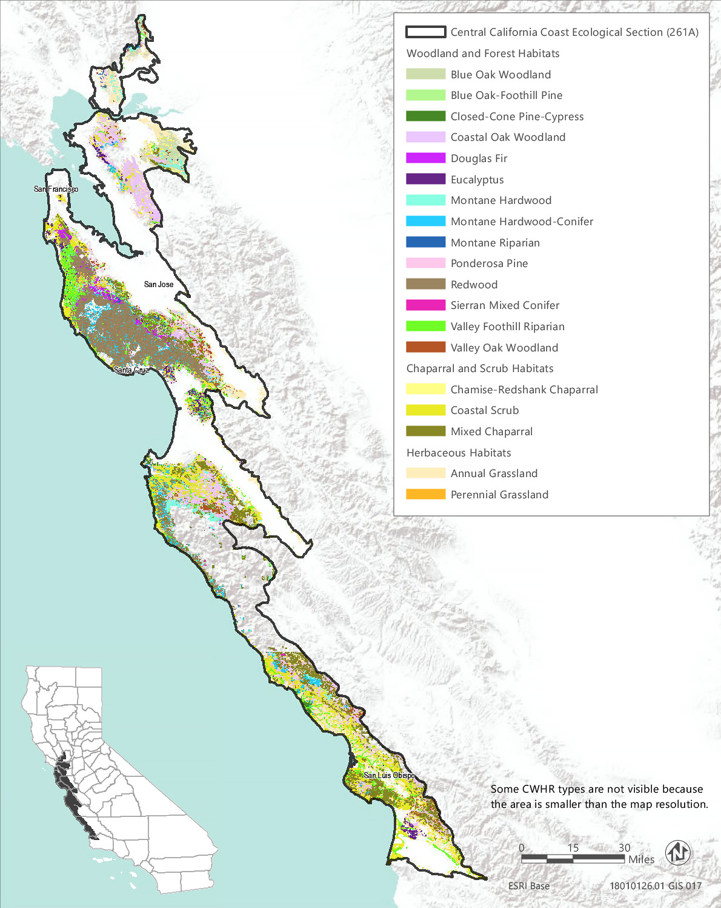
Source: Data received from CAL FIRE in 2018
Figure 3.6-2 CWHR Types - Central California Coast Ecological Section (261A)
Table 3.6-3 Vegetation and Habitat Types within the Treatable Landscape for the Central California Coast Ecological Section
CWHR Classification | Acres | MCV Alliances
Woodland and Forest Habitats
Blue Oak Woodland | 39,127 | - Blue oak woodland | - Interior live oak woodland
Blue Oak-Foothill Pine | 5,341 | - Blue oak woodland | - Foothill pine woodland
Closed-Cone Pine-Cypress | 18,213 | - Santa Cruz cypress grove*  - Monterey pygmy cypress stand*  - Monterey cypress stand* | - Sargent cypress woodland*  - Knobcone pine forest  - Bishop pine – Monterey pine forest*
Coastal Oak Woodland | 352,837 | - Madrone forest*  - Coast live oak woodland  - Mixed oak forest | - Shreve oak forest*  - California bay forest*
Douglas Fir | 28,397 | - Bigleaf maple forest*  - Douglas fir forest | - Douglas fir - tanoak forest*
Eucalyptus | 9,866 | - Eucalyptus - tree of heaven - black locust groves
Montane Hardwood | 19,764 | - Santa Lucia fir grove*  - Bigleaf maple forest*  - California buckeye grove*  - Red alder forest  - Tanoak forest* | - Coulter pine woodland  - Mixed oak forest  - Canyon live oak forest  - Interior live oak woodland
Montane Hardwood-Conifer | 78,837 | - Santa Lucia fir grove*  - Bigleaf maple forest* | - Red alder forest  - Coulter pine woodland
Montane Riparian | 592 | - White alder grove  - Torrent sedge patch*  - Hinds's walnut and related stand* | - Fremont cottonwood forest*  - Black cottonwood forest*  - Sandbar willow thicket
Ponderosa Pine | 1,126 | - Ponderosa pine forest
Redwood | 111,975 | - Western azalea patch* | - Redwood forest*
Sierran Mixed Conifer | 145 | - Incense cedar forest*
Valley Foothill Riparian | 15,722 | - Box-elder forest*  - Torrent sedge patch*  - California sycamore woodland*  - Fremont cottonwood forest*  - Black cottonwood forest* | - Himalayan blackberry - rattlebox - edible fig riparian scrub^{N}  - Sandbar willow thicket  - Red willow thicket*  - Shining willow groves*  - Pepper tree or Myoporum grove^{N}
Valley Oak Woodland | 5,390 | - Valley oak woodland*
Chaparral and Scrub Habitats
Chamise-Redshank Chaparral | 45,229 | - Chamise chaparral  - Chamise - black sage chaparral | - Eastwood manzanita chaparral  - Wedge leaf ceanothus chaparral/Buck brush chaparral
Coastal Scrub | 154,826 | - Dune mat*  - California sagebrush scrub  - California sagebrush - California buckwheat scrub  - California sagebrush - black sage scrub  - Quailbush scrub  - Coyote brush scrub  - Broom patch^{N}  - Sea rocket sands  - Sand dune sedge swath*  - Blue blossom chaparral  - Giant coreopsis scrub*  - Hazelnut scrub*  - Bush monkeyflower scrub*  - Live-forever - lichen/moss sparse herbaceous rock outcop | - Narrowleaf goldenbush - bladderpod scrub  - California buckwheat scrub  - California coffee berry scrub  - California match weed patch*  - Salt rush swale*  - Deer weed scrub  - Silver bush lupine scrub  - Yellow bush lupine scrub  - Silver dune lupine - mock heather scrub*  - Ice plant mats^{N}  - Wax myrtle scrub*  - Purple sage scrub  - Black sage scrub  - Coast range stonecrop draperies  - Poison oak scrub
Mixed Chaparral | 64,090 | - Hoary, common, and Stanford manzanita chaparral*  - Brittle leaf - woolly leaf manzanita chaparral*  - Eastwood manzanita chaparral  - Hooker's manzanita chaparral*  - Hoover's manzanita chaparral*  - Monterey manzanita chaparral*  - Morro manzanita chaparral*  - Glossy leaf manzanita chaparral*  - Pajaro manzanita chaparral*  - Sandmat manzanita chaparral*  - Silverleaf manzanita chaparral*  - Wedge leaf ceanothus chaparral, Buck brush chaparral  - Deer brush chaparral | - Hairy leaf - woolly leaf ceanothus chaparral*  - Wart leaf ceanothus chaparral*  - Birch leaf mountain mahogany chaparral  - Golden chinquapin thickets*  - California coffee berry scrub  - Ocean spray brush*  - Deer weed scrub  - Silver bush lupine scrub  - Holly leaf cherry - toyon - greenbark ceanothus chaparral  - Scrub oak chaparral  - Scrub oak - chamise chaparral  - Leather oak chaparral  - Interior live oak chaparral  - Poison oak scrub
Herbaceous Habitats
Annual Grassland | 367,603 | - Fiddleneck - phacelia field  - Wild oat grassland^{N}  - Upland mustard and other ruderal forbs^{N}  - Annual brome grassland^{N}  - Red brome or mediterranean grass grassland^{N}  - Cheatgrass - medusahead grassland^{N}  - Yellow star-thistle field^{N}  - Tar plant field* | - Annual dogtail grassland^{N}  - Squirreltail patch  - California poppy - lupine field  - California goldfields - dwarf plantain - small fescue flower fields  - Perennial rye grass field^{N}  - Spanish clover field  - Monolopia - leafy-stemmed tickseed field*  - Popcorn flower field
Perennial Grassland | 2,255 | - Bent grass - tall fescue meadow  - Water foxtail meadow*  - European beach grass sward^{N}  - Upland mustard and other ruderal forbs^{N}  - California brome - blue wildrye prairie*  - Pacific reed grass meadow*  - Poison hemlock or fennel patch^{N}  - Pampas grass patch^{N}  - California oat grass prairie*  - Tufted hair grass meadow  - Squirreltail patch | - Idaho fescue grassland*  - Gum plant patch*  - Common velvet grass - sweet vernal grass meadow^{N}  - Ashy ryegrass - creeping ryegrass turf*  - Sea lyme grass patch*  - Deer grass bed*  - Needle grass - melic grass grassland  - Fountain grass sward^{N}  - Harding grass - reed canary grass sward^{N}  - Curly blue grass grassland*
Total | 1,321,335
*These are designated sensitive natural communities with a state rarity rank of S1 (critically imperiled), S2 (imperiled), or S3 (vulnerable).
^{N} These alliances are dominated by nonnative vegetation.
Source: CWHR 2019, CNPS 2019, compiled by Ascent Environmental in 2019

Sensitive Biological Resources

Special-Status Species
More than 100 special-status wildlife taxa and 240 plant taxa are known or have the potential to occur within the treatable landscape of the Central California Coast Section. These include 54 wildlife taxa and 60 plant taxa that are officially listed as rare, threatened, or endangered, candidates for listing, or fully protected. Many of the special-status plants are narrow endemics associated with the maritime chaparral or coastal scrub habitats of the ecoregion or with dunes, sandstone, or serpentine substrates. A list of all the special-status plant species known or with potential to occur within the treatable landscape of the Central California Coast Section, along with their listing status and detailed habitat descriptions, is provided in Appendix BIO-3, Table 1a. A list of special-status wildlife (other than fish) species known or with potential to occur in the treatable landscape of this ecoregion, along with the CWHR types they are associated with, is provided in Appendix BIO-3, Table 1b. Special-status fish known or with potential to occur within the treatable landscape of this ecoregion are identified in Appendix BIO-3, Table 19.

Critical Habitat
Critical habitat has been designated within the treatable landscape of this ecoregion for eight plant taxa and 13 wildlife taxa. Appendix BIO-4 lists and provides the acreage of critical habitat designated within the treatable landscape of this ecoregion for these species. The treatable landscape includes critical habitat for Santa Cruz tarplant (Holocarpha macradenia), California red-legged frog (Rana draytonii), marbled murrelet (Brachyramphus marmoratus), and bay checkerspot butterfly (Euphydryas editha bayensis).

Sensitive Natural Communities and Habitats

Sensitive Natural Communities
A total of 45 sensitive natural communities have been identified in the Central California Coast Ecological Section and may be present within the treatable landscape. This includes 14 MCV alliances in the maritime chaparral of this ecoregion, including hoary, common, and Stanford manzanita chaparral, Hooker's manzanita chaparral, Monterey manzanita chaparral, Morro manzanita chaparral, Pajaro manzanita chaparral, and wart leaf ceanothus chaparral. Maritime chaparral is discussed in more detail under “Other Sensitive Habitats.” Madrone forest, Shreve oak forest, California bay forest, bigleaf maple forest, tanoak forest, and California buckeye groves, may be present in areas mapped as oak woodlands in this ecoregion. Other notable sensitive natural communities in this ecoregion include Santa Cruz cypress grove, Monterey pygmy cypress stand, Santa Lucia fir grove, Monterey cypress stand, redwood forest, western azalea patches, and wax myrtle scrub. A complete list of the sensitive natural communities that are associated with each CWHR type in the treatable landscape of this section is provided in Table 3.6-3.

Wetlands and Waters of the United States and State
Wetland habitats known to occur within the treatable landscape of the Central California Coast Section include estuarine and marine deepwater, estuarine and marine wetland, freshwater emergent wetland, freshwater forested and shrub wetland, freshwater pond, lake, riverine, and other freshwater wetlands (Table 3.6-2,). In addition, vernal pools, salt rush swales, water foxtail meadows and Pacific reedgrass meadows may be included in areas mapped as annual or perennial grasslands. Major waterways include the Pajaro, Salinas, Carmel, and Santa Maria rivers and Pescadero Creek. Elkhorn Slough and Morro Bay are the region’s two largest estuaries, with other significant wetlands found at the Pajaro, Salinas, Carmel, and Santa Maria river mouths, Devereux Slough, and Goleta Slough, and Pescadero Marsh (Page and Shuford 2000 in CDFW 2015a).

Other Sensitive Habitats
Riparian habitats mapped within the treatable landscape in this ecoregion consist of 592 acres of montane riparian and 15,722 acres of valley and foothill riparian. There are 10 MCV alliances that may occur within the valley foothill riparian habitat type within this ecoregion and six MCV alliances with potential to occur in the montane riparian habitat type. Eight of these riparian vegetation types are designated sensitive natural communities, including Hind’s walnut and related stands, box-elder forest, California sycamore woodland, and Fremont cottonwood forest. All riparian habitats are considered sensitive and those located near rivers, streams, and lakes are protected under California Fish and Game Code. Major stands of riparian habitat are associated with the largest rivers and streams of the ecoregion; however, riparian vegetation may be present along smaller intermittent streams, and smaller stands may not have been captured in the source land cover data used to create the FRAP vegetation layer. The majority of the ecoregion’s large river-valley floodplain and riparian forests have been replaced by agriculture (CDFW 2015a).
Oak woodland habitats in the treatable landscape of the Central California Coast Section consist of approximately 352,837 acres of coastal oak woodland, 39,127 acres of blue oak woodland, 5,341 acres of blue oak – foothill pine woodland, and 15,722 acres of valley oak woodland. In addition, there are approximately 19,764 acres of montane hardwood that may include mixed oak forest, canyon live oak forest, and interior live oak woodland. Valley oak woodland is a designated sensitive natural community, as is Shreve oak forest, which may be present in areas mapped as coastal oak woodland. While oak woodlands face intense development pressure statewide, in this ecoregion, oak woodlands are at low risk of development (only 3 percent projected loss from development) (California Oak Foundation 2006). According to the 2015 SWAP, oak woodland habitats in this ecoregion support more than 200 species of plants, 300 vertebrates, and 5,000 invertebrates are associated with these oak woodlands.
Maritime chaparral, characterized by manzanita and California lilac (Ceanothus spp.) species adapted to the foggy coastal climate, once dominated sandy hills along Monterey Bay, Nipomo Mesa, Burton Mesa, and Morro Bay. Maritime chaparral is now one of the region’s most threatened vegetation types, with its extent severely reduced by development. Central maritime chaparral occurs in nutrient-poor soils (e.g., weathered sandstone and shale outcrops) on windward slopes and coastal lowlands along the northern and central coast from Mendocino County to Santa Barbara County (Holland 1986, Sawyer et al. 2009). Areas classified as mixed chaparral within the treatable landscape of this ecoregion (64,090 acres) may be composed of maritime chaparral types. This is a sensitive habitat type that is characterized by one or more species of manzanita or ceanothus, including many that are special-status species and narrow endemics (Sawyer et al. 2009). As noted previously, 14 designated sensitive natural communities have been identified in the maritime chaparral of this ecological section.

Conservation Lands, Special Management Areas, and Other Biologically Important Lands

Habitat Conservation Plan, Natural Community Conservation Plan, and Other Conservation Plan Areas
The treatable landscape in the Central California Coast Section includes plan areas for the East Contra Costa County HCP/NCCP and the San Bruno Mountain HCP, which have been adopted and are being implemented. An additional four HCPs and two HCP/NCCPs are currently being planned in the treatable landscape. Table 3.6-4 summarizes the conservation plans adopted or in progress within the treatable landscape.
Table 3.6-4 Conservation Plans Adopted or In Progress in the Treatable Landscape—Central California Coast Section
Conservation Plan | Plan Type | Stage | Plan Area Within the Treatable Landscape (Acres)
Los Osos | HCP | Planning | 2,069
San Bruno Mountain | HCP | Implementation | 3,868
Santa Barbara Multi-Species | HCP | Planning | 5,039
Santa Cruz Sandhills | HCP | Planning | 8,323
Solano Multi-Species | HCP | Planning | 51,176
Bay/Delta Conservation Plan | HCP/NCCP | Planning | 3,606
East Contra Costa County | HCP/NCCP | Implementation | 73,397
Santa Clara Valley | HCP/NCCP | Planning | 124,932
 |  | Total | 272,410

Protected Open Space Lands
The treatable landscape in the Central California Coast Section contains 691 protected open space units that are recognized in the California Protected Areas Database (CPAD). These lands cover 355,139 acres, which represent 27 percent of the treatable landscape in the ecoregion. Some of the major land owners include State Parks, San Francisco Public Utilities Commission (SFPUC), East Bay Regional Park District (EBRPD), Midpeninsula Regional Open Space District, CDFW, and Peninsula Open Space Trust. Examples of some of the prominent open space units in the Central California Coast Section include Mount Diablo State Park, Henry Cowell Redwoods State Park, Wilder Ranch State Park, The Forest of Nisene Marks State Park, La Honda Creek Open Space Preserve, Elkhorn Slough Ecological Reserve, San Luis Obispo Wildlife Area, and San Francisco Watershed Lands.

Central California Coast Ranges Section
The Central California Coast Ranges Section (M262A) encompasses 6,141,171 acres and is the interior part of the southern Coast Ranges of California, south of the Carquinez Strait. It extends south to the Transverse Ranges. Elevations range from 500 to 3,500 feet. It is inland from the coast far enough that the climate is modified only slightly by marine influence. This ecoregion contains 1,985,255 acres of treatable landscape, which represents approximately 32 percent of the total landscape within the ecoregion. Within the treatable landscape exist modeled treatment areas for the following treatment types: WUI fuel reduction (508,486 acres), fuel break (453,108 acres), and ecological restoration (1,199,875 acres). The treatable landscape in this ecoregion consists of treatment areas on many of the slopes and ridgelines of the north-south running mountain ranges, with fewer treatment areas located in the valley depressions and is displayed in Figure 3.6-3.
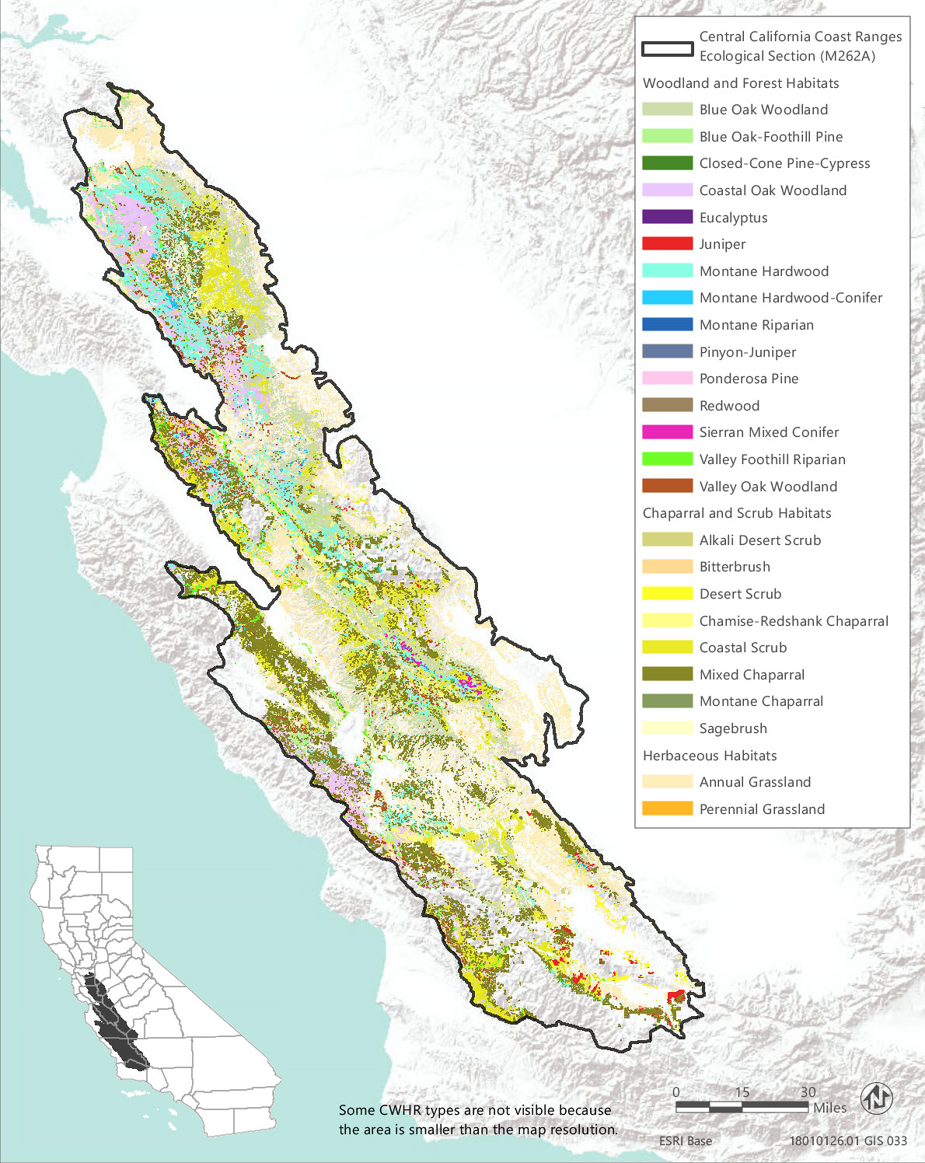
Source: Data received from CAL FIRE in 2018
Figure 3.6-3 CWHR Types - Central California Coast Ranges Ecological Section (M262A)

Vegetation and Habitat Types
The predominant habitat types in the treatable landscape of the Central California Coast Ranges Section are annual grassland and blue oak woodland, which comprise approximately 32 percent and 23 percent of the treatable landscape, respectively. Chaparral habitats (chamise-redshank chaparral and mixed chaparral) make up approximately 15 percent of the treatable landscape area. Other common habitat types are coastal oak woodland and coastal scrub, which comprise approximately 12 and 7 percent of the treatable landscape, respectively. Annual grasslands in this ecoregion represent a diversity of vegetation types ranging from those dominated by invasive plants, such as barbed goatgrass patches and yellow star-thistle fields, to those characterized by native wildflowers, such as fiddleneck – Phacelia fields and California goldfields-dwarf plantain-small fescue flower fields. Annual grasslands may also include uncommon vegetation assemblages, such as goldenaster patches and Monolopia – leafy-stemmed tickseed fields. Vernal pools may also be present in areas mapped as annual or perennial grasslands in this ecoregion. Within the Central California Coast Ranges ecoregion, 18 unique vegetation alliances have been described and mapped within areas classified as annual grassland in the CWHR system.
Chaparral and scrub habitats are likewise very diverse. In Central California Coast Ranges ecoregion, there are 24 vegetation alliances that may occur within coastal scrub habitat, 24 alliances that may occur within mixed chaparral, nine within alkali desert scrub, and seven within chamise – redshank chaparral habitat. Many of these are designated as sensitive natural communities because of their rarity based on range and distribution and threat level.
Table 3.6-5 provides the acreage of each CWHR habitat type within the treatable landscape of this ecoregion and the associated MCV vegetation alliances that may occur within each CWHR type in this ecoregion. Alliances that are designated as sensitive natural communities and those that are dominated by nonnative vegetation are indicated in Table 3.6-5. Sensitive natural communities are discussed in more detail below. The distribution of CWHR types within this ecoregion is shown in Figure 3.6-3.
Table 3.6-5 Vegetation and Habitat Types within the Treatable Landscape for the Central California Coast Ranges Ecoregion
CWHR Classification | Acres | MCV Alliances
Woodland and Forest Habitats
Blue Oak Woodland | 461,022 | - Blue oak woodland | - Interior live oak woodland
Blue Oak-Foothill Pine | 71,881 | - Blue oak woodland | - Foothill pine woodland
Closed-Cone Pine-Cypress | 892 | - Sargent cypress woodland* | - Knobcone pine forest
Coastal Oak Woodland | 240,716 | - Madrone forest*  - Coast live oak woodland | - Mixed oak forest  - California bay forest*
Eucalyptus | 543 | - Eucalyptus groves^{N}
Juniper | 12,754 | - California juniper woodland
Montane Hardwood | 68,739 | - California buckeye groves*  - Mixed oak forest  - Canyon live oak forest | - California black oak forest  - Interior live oak woodland
Montane Hardwood-Conifer | 2,382 | - Santa Lucia fir groves*  - Coulter pine woodland | - Bigcone Douglas fir forest*
Montane Riparian | 26 | - White alder groves  - Torrent sedge patches*  - Fremont cottonwood forest* | - Black cottonwood forest*  - Sandbar willow thickets
Pinyon-Juniper | 219 | - Singleleaf pinyon – Utah juniper woodlands
Ponderosa Pine | 31 | - Ponderosa pine forest
Redwood | 65 | - Redwood forest*
Sierran Mixed Conifer | 1,738 | - Incense cedar forest* | - Mixed conifer forest
Valley Foothill Riparian | 6,468 | - Wild tarragon patches  - Torrent sedge patches*  - California sycamore woodlands*  - Fremont cottonwood forest*  - Black cottonwood forest*  - California rose briar patches*  - Himalayan blackberry – rattlebox – edible fig riparian scrub^{N} | - Brewer willow thickets*  - Sandbar willow thickets  - Red willow thickets*  - Shining willow groves*  - Pepper tree or Myoporum groves^{N}
Valley Oak Woodland | 12,171 | - Valley oak woodland*
Chaparral and Scrub Habitats
Alkali Desert Scrub | 7,836 | - Iodine bush scrub*  - Fourwing saltbush scrub  - Shadscale scrub  - Quailbush scrub  - Allscale scrub | - Spinescale scrub  - Winterfat scrubland*  - Alkali sacaton – scratchgrass – alkali cordgrass alkaline wet meadow*  - Bush seepweed scrub*
Bitterbrush | 4 | - Bitterbrush scrub
Chamise-Redshank Chaparral | 143,057 | - Chamise chaparral  - Chamise – white sage chaparral*  - Chamise – black sage chaparral  - Redshank chaparral | - Eastwood manzanita chaparral  - Bigberry manzanita chaparral  - Wedge leaf (or buck brush) ceanothus chaparral
Coastal Scrub | 146,864 | - California sagebrush scrub  - California sagebrush – California buckwheat scrub  - California sagebrush – black sage scrub  - Quailbush scrub  - Coyote brush scrub  - Blue blossom chaparral  - Bush monkeyflower scrub*  - Live-forever – lichen/moss sparse herbaceous rock outcrop  - Narrowleaf goldenbush – bladderpod scrub  - California buckwheat scrub  - Wright’s buckwheat patches* | - Wright’s buckwheat – Heermann’s buckwheat – Utah butterfly-bush scrub*  - California coffee berry scrub  - California match weed patches*  - Goldenaster patches*  - Scale broom scrub*  - Deer weed scrub  - Silver bush lupine scrub  - Bush mallow scrub  - Purple sage scrub  - Black sage scrub  - Coast Range stonecrop draperies  - Bushy spikemoss mats*  - Bush seepweed scrub*
Desert Scrub | 2,383 | - Cheesebush – sweetbush scrub  - Narrowleaf goldenbush – bladderpod scrub | - Heerman’s buckwheat patches*  - Wright’s buckwheat – Heerman’s buckwheat – Utah butterfly-bush scrub*
Mixed Chaparral | 163,843 | - Brittle leaf – woolly leaf manzanita chaparral*  - Eastwood manzanita chaparral  - Bigberry manzanita chaparral  - Hoover’s manzanita chaparral*  - Wedge leaf (or buck brush) ceanothus chaparral  - Deer brush chaparral  - Chaparral whitethorn chaparral  - Hairy leaf – woolly leaf ceanothus chaparral*  - Wart leaf ceanothus chaparral*  - Birch leaf mountain mahogany chaparral | - Bush poppy scrub  - California coffee berry scrub  - Ocean spray brush*  - Deer weed scrub  - Silver bush lupine scrub  - Bush mallow scrub  - Holly leaf cherry chaparral *  - Holly leaf cherry – toyon – greenbark ceanothus chaparral  - Scrub oak chaparral  - Scrub oak – chamise chaparral  - Leather oak chaparral  - Tucker oak chaparral  - Interior live oak chaparral  - Oak gooseberry thickets*
Montane Chaparral | 65 | - Deer brush chaparral | - Birch leaf mountain mahogany chaparral
Sagebrush | 2 | - Big sagebrush | - Rubber rabbitbrush scrub
Herbaceous Habitats
Annual Grassland | 641,005 | - Barbed goatgrass patches^{N}  - Fiddleneck – Phacelia fields  - Wild oats grasslands^{N}  - Upland mustards and other ruderal forbs^{N}  - Annual brome grasslands^{N}  - Red brome or Mediterranean grass grasslands^{N}  - Cheatgrass-Medusahead grasslands^{N}  - Yellow star-thistle fields^{N}  - Annual dogtail grasslands^{N} | - Squirreltail patches  - California poppy-lupine fields  - Goldenaster patches*  - Holocarpha (Heermanii, virgata) fields  - California goldfields-dwarf plantain-small fescue flower fields  - Perennial rye grass fields^{N}  - Monolopia - leafy-stemmed tickseed fields*  - Popcorn flower fields  - White-tip clover swales*
Perennial Grassland | 549 | - Upland mustards and other ruderal forbs^{N}  - Sand-aster and perennial buckwheat fields  - Pampas grass patches^{N}  - Squirreltail patches  - Ashy ryegrass – creeping ryegrass turfs*  - Creeping ryegrass turfs* | - Perennial rye grass fields^{N}  - Torrey’s melic grass patches*  - Deer grass beds*  - Nodding needle grass grassland*  - Foothill needle grass grassland*  - Purple needle grass grassland*  - Needle grass – melic grass grassland  - Harding grass – reed canary grass swards^{N}  - Curly blue grass grassland*
Total | 1,985,255
*These are designated sensitive natural communities with a state rarity rank of S1 (critically imperiled), S2 (imperiled), or S3 (vulnerable).
^{N} These alliances are dominated by nonnative vegetation.
Source: CWHR 2019, CNPS 2019, Compiled by Ascent Environmental in 2019

Sensitive Biological Resources

Special-Status Species
More than 90 special-status wildlife taxa and 121 plant taxa are known or have the potential to occur within the treatable landscape of the Central California Coast Ranges Section. Eighteen of the special-status plant taxa and 49 of the wildlife taxa are state or federally listed as rare, threatened, or endangered, candidates for listing, or fully protected. One of the plant species, Camatta Canyon amole (Chlorogalum pupureum var. reductum), is known from only two occurrences on the northeast side of the La Panza Range in San Luis Obispo County and nowhere else in the world. A portion of one of these occurrences and all of the other occurrence, along with 1,730 acres of the species’ designated critical habitat, is within the treatable landscape. A list of all the special-status plant species known or with potential to occur within the treatable landscape of the Central California Coast Ranges, along with their listing status and detailed habitat descriptions, is provided in Appendix BIO-3, Table 2a.
A list of special-status wildlife (other than fish) species known or with potential to occur in the treatable landscape of this ecoregion, along with the CWHR types they are associated with, is provided in Appendix BIO-3, Table 2b. Special-status fish known or with potential to occur within the ecoregion are identified in Appendix BIO-3, Table 19.

Critical Habitat
Critical habitat has been designated within the treatable landscape of Central California Coast Ranges Section for two plant species and nine wildlife species. The treatable landscape includes critical habitat for Camatta Canyon amole, Contra Costa goldfields (Lasthenia conjugens), longhorn fairy shrimp (Branchinecta longiantenna), California red-legged frog, California tiger salamander (Ambystoma californiense), and Alameda striped racer (Masticophis lateralis euryxanthus). Appendix BIO-4 provides the acreage of critical habitat designated within the treatable landscape of this ecoregion for these species.

Sensitive Natural Communities and Habitats

Sensitive Natural Communities
There are 38 sensitive natural communities that have potential to occur within the treatable landscape of the Central California Coast Ranges Section. The sensitive natural communities associated with each CWHR type in this ecoregion are identified in Table 3.6-5. Notable examples for this ecoregion include Santa Lucia fir groves, Sargent cypress woodland, Brewer willow thickets, Heerman’s buckwheat patches, brittle leaf – woolly leaf manzanita chaparral, Hoover’s manzanita chaparral, and wart leaf ceanothus chaparral.

Wetlands and Other Waters of the United States and Waters of the State
Wetland habitats known to occur within the treatable landscape of the Central California Coast Ranges Section include freshwater emergent wetland, freshwater forested and shrub wetland, freshwater pond, lake, and riverine wetlands totaling over 28,000 acres. The acreage of each general wetland type mapped in the treatable landscape by NWI is provided in Table 3.6-2. In addition, white-tip clover swales, creeping ryegrass turfs, and vernal pools are wetlands that may be included in areas mapped as annual or perennial grasslands. Alkali sacaton – scratchgrass – alkali cordgrass alkaline wet meadow, bush seepweed scrub, and iodine bush scrub are wetland types that may be included in areas mapped as alkali desert scrub. Major waterways include Salinas River, San Benito River, San Antonio River, Arroyo Seco, Coyote Creek, Clear Creek, Sawmill Creek, and Upper White Creek.

Other Sensitive Habitats
CWHR riparian habitat types identified within the treatable landscape of the Central California Coast Ranges Section consist of approximately 6,468 acres of valley foothill riparian habitat and 26 acres of montane riparian habitat. There are 12 MCV alliances that may occur within the valley foothill riparian habitat type within this ecoregion and five MCV alliances with potential to occur in the montane riparian habitat type. Many of these, such as Torrent sedge patches, California rose briar patches, California sycamore woodlands, Fremont cottonwood forest, black cottonwood forest, red willow thickets, and shining willow groves are designated sensitive natural communities, but all riparian habitats are considered sensitive, and those located near rivers, streams, and lakes are protected under California Fish and Game Code. Prominent stands of riparian habitat are associated with the major waterways of the ecoregion including the Salinas River, San Benito River, San Antonio River, Arroyo Seco, Coyote Creek, Clear Creek, Sawmill Creek, and Upper White Creek; however, stands of riparian vegetation may occur along any intermittent or perennial stream, and many may not have been captured in the source land cover data used to create the FRAP vegetation layer.
Oak woodland habitats in the treatable landscape of the Central California Coast Ranges Section consist of approximately 461,022 acres of blue oak woodland, 71,881 acres of blue oak – foothill pine woodland, 240,716 acres of coastal oak woodland, and 12,171 acres of valley oak woodland. In addition, there are approximately 68,739 acres of montane hardwood that may include mixed oak forest, canyon live oak forest, California black oak forest, and interior live oak woodland. The only one of these oak woodland types that is a designated sensitive natural community is valley oak woodland; however, other sensitive natural communities, including madrone forest, California bay forest, and California buckeye groves, may be present in areas mapped as oak woodlands. According to the 2015 SWAP, oak woodland habitats in this ecoregion support more than 200 species of plants, 300 vertebrates, and 5,000 invertebrates are associated with these oak woodlands. In this ecoregion, oak woodlands are at low risk of development (only 3 percent projected loss from development) (California Oak Foundation 2006).
Chaparral and coastal scrub habitats in the treatable landscape of the Central California Coast Ranges Section consist of approximately 143,057 acres of chamise – redshank chaparral, 163,843 acres of mixed chaparral, 65 acres of montane chaparral, and 146,864 acres of coastal scrub. Designated sensitive natural communities that may be present within these habitat areas include chamise – white sage chaparral, bush monkeyflower scrub, California match weed patches, scale broom scrub, Hoover’s manzanita chaparral, holly-leaf cherry chaparral, ocean spray scrub, and oak gooseberry thickets. The south and central coast regions, including the Central California Coast Ranges ecoregion, support large contiguous patches of chaparral with high wildlife species endemism compared to the rest of the state, especially among mammals and reptiles (Underwood et al. 2018). There is also a high degree of plant species endemism within chaparral and coastal scrub habitats in this ecoregion.

Conservation Lands, Special Management Areas, and Other Biologically Important Lands

Habitat Conservation Plan, Natural Community Conservation Plan, and other Conservation Plan Areas
The treatable landscape in the Central California Coast Ranges Section includes plan areas for the San Joaquin County HCP and East Contra Costa County HCP/NCCP, which have been adopted and are being implemented. Additionally, one HCP and two HCP/NCCPs are currently being planned in the treatable landscape. Table 3.6-6 summarizes the conservation plans adopted or in progress, including the acreages of plan areas within the treatable landscape.
Table 3.6-6 Conservation Plans Adopted or In Progress in the Treatable Landscape—Central California Coast Ranges Section
Conservation Plan | Plan Type |  | Stage | Plan Area Within the Treatable Landscape (Acres)
Kern County Valley Floor | HCP |  | Planning | 12,475
San Joaquin County | HCP |  | Implementation | 33,171
East Contra Costa County | HCP/NCCP |  | Implementation | 23,404
Northeastern San Luis Obispo County | HCP/NCCP |  | Planning | 176,849
Santa Clara Valley | HCP/NCCP |  | Planning | 248,036
 |  |  | Total | 493,935

Protected Open Space Lands
The treatable landscape in the Central California Coast Ranges Section contains 132 protected open space units that are recognized in CPAD. These lands cover 182,207 acres, which represent 9 percent of the treatable landscape in the ecoregion. Some of the major land owners include State Parks, CDFW, SFPUC, EBRPD, Contra Costa Water District, Monterey County, Santa Clara County, and the University of California. Examples of some of the prominent open space units in the Central California Coast Ranges Section include Henry W. Coe State Park, Pacheco State Park, Carrizo Plains Ecological Reserve, Los Vaqueros Watershed, San Francisco Watershed Lands, Ohlone Regional Wilderness, and Sunol Regional Wilderness.

Colorado Desert Section
The Colorado Desert Section (322C) encompasses 2,929,221 acres and consists of alluvial plains, slopes, basins, and dunes. Elevations range from the current level of the Salton Sea, about 230 feet below sea level, to 1,000 feet. This hot and dry ecoregion contains 25,179 acres of treatable landscape, which represents less than 1 percent of the total landscape within the ecoregion. Within the treatable landscape exist modeled treatment areas for the following treatment types: WUI fuel reduction (8,256 acres), fuel break (16,193 acres), and ecological restoration (3,857 acres). The treatable landscape of this ecoregion is limited to a few higher-elevation areas north of Palm Springs and west of the Salton Sea. The treatable landscape in this ecoregion is displayed in Figure 3.6-4.

Vegetation and Habitat Types
Desert scrub is the predominant habitat type in the treatable landscape of the Colorado Desert Section, comprising 84 percent of the habitat cover. The remaining habitat consists primarily of coastal scrub habitat (12 percent) and small amounts of alkali desert scrub, desert succulent shrub, and annual grassland habitat types. There is a minimal amount (approximately 10 acres) of chaparral and sagebrush habitats, and 1 acre or less each of juniper, pinyon-juniper, montane hardwood, and montane riparian habitat. The distribution of CWHR types within the treatable landscape of this ecoregion is shown in Figure 3.6-4 and the acreage of each type is provided in Table 3.6-7.

Sensitive Biological Resources

Special-Status Species
There are at least 65 special-status wildlife taxa and 40 plant taxa with potential to occur within the treatable landscape of the Colorado Desert Section including three plant taxa and 36 animal taxa that are state or federally listed as rare, threatened, or endangered. Many of these species are associated with desert wash or desert scrub habitats. A notable example unique to this ecoregion is Casey’s June beetle (Dinacoma caseyi), which is known from a less than 800-acre area in southern Palm Springs and nowhere else in the world. A list of all the special-status plant species known or with potential to occur within the treatable landscape of the Colorado Desert Section, along with their listing status and detailed habitat descriptions, is provided in Appendix BIO-3, Table 3a. A list of special-status wildlife (other than fish) species known or with potential to occur in the treatable landscape of this ecoregion, along with the CWHR types they are associated with, is provided in Appendix BIO-3, Table 3b. Special-status fish known or with potential to occur in the ecoregion are identified in Appendix BIO-3, Table 19.

Critical Habitat
Critical habitat has been designated within the treatable landscape of this ecoregion for two wildlife taxa, Casey’s June beetle and peninsular bighorn sheep (Ovis canadensis nelson) and one plant, Coachella Valley milk-vetch (Astragalus lentiginosus var. coachellae). Appendix BIO-4 lists and provides the acreage of critical habitat designated within the treatable landscape of this ecoregion for these species.
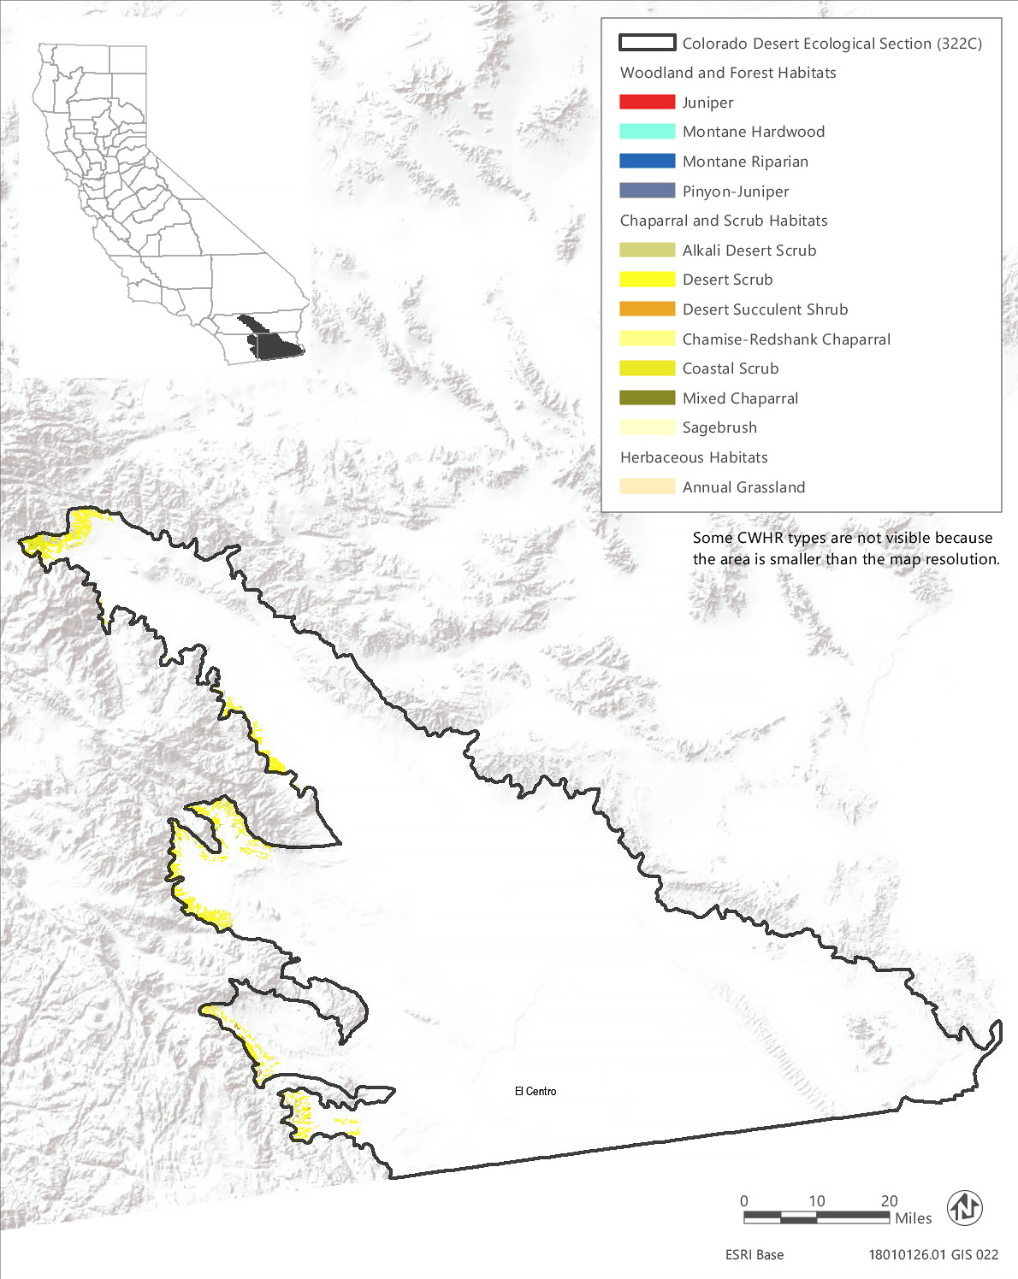
Source: Data received from CAL FIRE in 2018
Figure 3.6-4 CWHR Types - Colorado Desert Ecological Section (322C)
Table 3.6-7 Vegetation and Habitat Types within the Treatable Landscape for the Colorado Desert Ecological Section
CWHR Classification | Acres | MCV Alliances
Woodland and Forest Habitats
Juniper | 1 | - Utah juniper woodland*
Montane Hardwood | <1 | - Coulter pine woodland  - Interior live oak woodland | - Canyon live oak forest
Montane Riparian | <1 | - Fremont cottonwood forest* | - Sandbar willow thicket
Pinyon-Juniper | <1 | - Singleleaf pinyon – Utah juniper woodlands
Chaparral and Scrub Habitats
Alkali Desert Scrub | 475 | - Iodine bush scrub*  - Fourwind saltbush scrub  - Desert holly scrub  - Quailbush scrub | - Allscale scrub  - Alkali sacaton - scratchgrass - alkali cordgrass alkaline wet meadow*  - Bush seepweed scrub*
Chamise-Redshank Chaparral | 4 | - Cup leaf ceanothus chaparral*
Coastal Scrub | 3,131 | - Quailbush scrub  - Deer weed scrub | - Brittle bush scrub  - Bush seepweed scrub*
Desert Scrub | 21,049 | - Desert agave scrub*  - Iodine bush scrub*  - White bursage scrub  - Desert needlegrass grassland*  - Cheesebush - sweetbush scrub  - Fourwind saltbush scrub  - Desert holly scrub  - Quailbush scrub  - Allscale scrub  - Crucifixion thorn stand*  - Rigid spineflower - hairy desert sunflower  - Mojave-Sonoran desert dunes*  - Acton's and Virgin River brittlebush - net-veined goldeneye scrub* | - Brittle bush scrub  - California buckwheat - Parish's goldeneye scrub Creosote bush scrub  - Creosote bush - white bursage scrub Creosote bush - brittle bush scrub  - Big galleta shrub-steppe*  - Desert almond - Mexican bladdersage scrub  - Catclaw acacia - desert lavender - chuparosa scrub  - Alkali sacaton - scratchgrass - alkali cordgrass alkaline wet meadow*  - Bush seepweed scrub*
Desert Succulent Shrub | 284 | - Desert agave scrub*  - Elephant tree stands* | - Teddy bear cholla patches*  - Mojave yucca scrub
Mixed Chaparral | 2 | - Cup leaf ceanothus chaparral* | - Deer weed scrub
Sagebrush | 4 | - Big sagebrush
Herbaceous Habitats
Annual Grassland | 229 | - Red brome or mediterranean grass grassland^{N}
Total | 25,179
*These are designated sensitive natural communities with a state rarity rank of S1 (critically imperiled), S2 (imperiled), or S3 (vulnerable).
^{N} These alliances are dominated by nonnative vegetation.
Source: CWHR 2019, CNPS 2019, Compiled by Ascent Environmental in 2019

Sensitive Natural Communities and Habitats

Sensitive Natural Communities
There are 17 sensitive natural communities that may occur within the treatable landscape of the Colorado Desert Section. The sensitive natural communities associated with each CWHR type in this ecoregion are identified in Table 3.6-7. They include iodine bush scrub, bush seepweed scrub, desert agave scrub, crucifixion thorn stand, Elephant tree stands, and teddy bear cholla patches.

Wetlands and Other Waters of the United States and Waters of the State
A total of only 300 acres of wetland habitats have been mapped by NWI within the treatable landscape of the Colorado Desert Section. These consist primarily of riverine wetlands with a small amount (48 acres) of freshwater ponds and lakes and less than 1 acres each of freshwater emergent wetland and freshwater forested and shrub wetland. It is likely there is greater acreage than what has been previously mapped of each of these types. The acreage of each general wetland type mapped in the treatable landscape by NWI is provided in Table 3.6-2. In addition, bush seepweed scrub, iodine bush scrub, and alkali sacaton - scratchgrass - alkali cordgrass alkaline wet meadow are wetland sensitive natural communities that may be present within areas mapped as alkali desert scrub, coastal scrub, or desert scrub.

Other Sensitive Habitats
Oak woodland stands may be present in areas mapped as montane hardwood, but this represents very minimal acreage within the ecoregion. Less than 1 acre of riparian habitat has been mapped within the treatable landscape. While more riparian habitat is likely present, it is not likely to be abundant within the treatable landscape. Chaparral cover is also minimal in this ecoregion with only a total of 6 acres mapped in the treatable landscape.

Conservation Lands, Special Management Areas, and Other Biologically Important Lands

Habitat Conservation Plan, Natural Community Conservation Plan, and other Conservation Plan Areas
The treatable landscape in the Colorado Desert Section includes the plan area for the Coachella Valley Multiple Species Habitat Conservation Plan, which has been adopted and is being implemented. Two additional HCP/NCCPs are currently being planned in the treatable landscape. Table 3.6-8 summarizes the conservation plans adopted or in progress, including the acreages of plan areas within the treatable landscape.
Table 3.6-8 Conservation Plans Adopted or In Progress in the Treatable Landscape—Colorado Desert Section
Conservation Plan | Plan Type | Stage | Plan Area Within the Treatable Landscape (Acres)
Coachella Valley Multiple Species Habitat Conservation Plan | HCP/NCCP | Implementation | 16,406
Desert Renewable Energy Conservation Plan | HCP/NCCP | Planning | 19,761
San Diego East County Multiple Species Conservation Plan | HCP/NCCP | Planning | 19,407
 |  | Total | 55,575

Protected Open Space Lands
The treatable landscape in the Colorado Desert Section contains 20 protected open space units that are recognized in CPAD. These lands cover 12,794 acres, which represent 51 percent of the treatable landscape in the ecoregion. Some of the major land owners include State Parks, CDFW, Anza-Borrego Foundation, Coachella Valley Mountains Conservancy, California State Lands Commission (CSLC), Riverside County Regional Park and Open Space District, Borrego Water District, San Diego County, University of California, and Friends of the Desert Mountains. Examples of some of the prominent open space units in the Colorado Desert Section include Anza-Borrego Desert State Park, Peninsular Ranges Ecological Reserve, Santa Rosa and San Jacinto Mountains National Monument, Agua Caliente Regional Park, and Borrego Salton Seaway.

Great Valley Section
The Great Valley Section (262A) encompasses 13,094,068 acres and contains the alluvial plains of the Sacramento and San Joaquin Valleys. Summers are hot and dry and winters are mild. Elevations range from sea level to 800 feet. This ecoregion contains 605,440 acres of treatable landscape, which represents approximately 5 percent of the total landscape within the ecoregion. Within the treatable landscape exist modeled treatment areas for the following treatment types: WUI fuel reduction (432,249 acres), fuel break (182,840 acres), and ecological restoration (40,853 acres). The treatable landscape within this ecoregion is limited to the outer edges of the ecoregion and contains valley edges at the base of the Sierra Nevada and Interior Coast Range foothills. The treatable landscape in this ecoregion is displayed in Figure 3.6-5.

Vegetation and Habitat Types
The predominant habitat type in the treatable landscape of this ecoregion is annual grassland, which makes up approximately 82 percent of the habitat cover. The next most abundant type is blue oak woodland, which makes up only about 7 percent of the land cover, followed closely by alkali desert scrub at about 6 percent cover. The annual grassland habitat type in this ecoregion represents a diversity of vegetation types including several that are dominated by nonnative and invasive plants, such as wild oat grassland, annual brome grassland, and knapweed and purple-flowered star-thistle field. Several vegetation types identified as annual grasslands may be characterized by native wildflowers, such as California poppy – lupine fields and popcorn flower fields. Annual grasslands in this ecoregion may also include uncommon vegetation assemblages, such as goldenaster patches and Monolopia – leafy-stemmed tickseed fields. Within the Great Valley ecological section, 25 unique vegetation alliances have been described and mapped within areas classified as annual grassland in the CWHR system. The distribution of CWHR types within the treatable landscape of this ecoregion is shown in Figure 3.6-5 and the acreage of each type is provided in Table 3.6-9.

Sensitive Biological Resources

Special-Status Species
There are at least 94 special-status wildlife taxa and 68 plant taxa known or with potential to occur in the treatable landscape of the Great Valley Section, including 23 plant taxa and 49 animal taxa that are state or federally listed as rare, threatened, or endangered or fully protected. Many of these species are associated with the vernal pool habitats of the region. A list of all the special-status plant species known or with potential to occur within the treatable landscape of the Great Valley Section, along with their listing status and detailed habitat descriptions, is provided in Appendix BIO-3, Table 4a. A list of special-status wildlife (other than fish) species known or with potential to occur in the treatable landscape of this ecoregion, along with the CWHR types they are associated with, is provided in Appendix BIO-3, Table 4b. Special-status fish known or with potential to occur in the ecoregion are identified in Appendix BIO-3, Table 19.

Critical Habitat
Critical habitat has been designated within the treatable landscape of this ecoregion for eight wildlife taxa and 10 plant taxa. Most of these species are associated with vernal pool habitats, including California tiger salamander, vernal pool fairy shrimp (Branchinecta lynchi), vernal pool tadpole shrimp (Lepidurus packardi), Colusa grass (Neostpafia colusana), San Joaquin Orcutt grass (Orcuttia inaequalis), and Sacramento Orcutt grass (Orcuttia viscida). Appendix BIO-4 lists and provides the acreage of critical habitat designated within the treatable landscape of this ecoregion for these species.

Sensitive Natural Communities and Habitats

Sensitive Natural Communities
There are 38 sensitive natural communities that may occur within the treatable landscape of the Great Valley Section. The sensitive natural communities associated with each CWHR type in this ecoregion are identified in Table 3.6-9. Many of these are vernal pool communities that may be interspersed within annual grasslands. Other examples of sensitive natural communities in this ecoregion include goldenaster patches, tar plant field, Indian rice grass grassland, California brome – blue wildrye prairie, and gum plant patch.
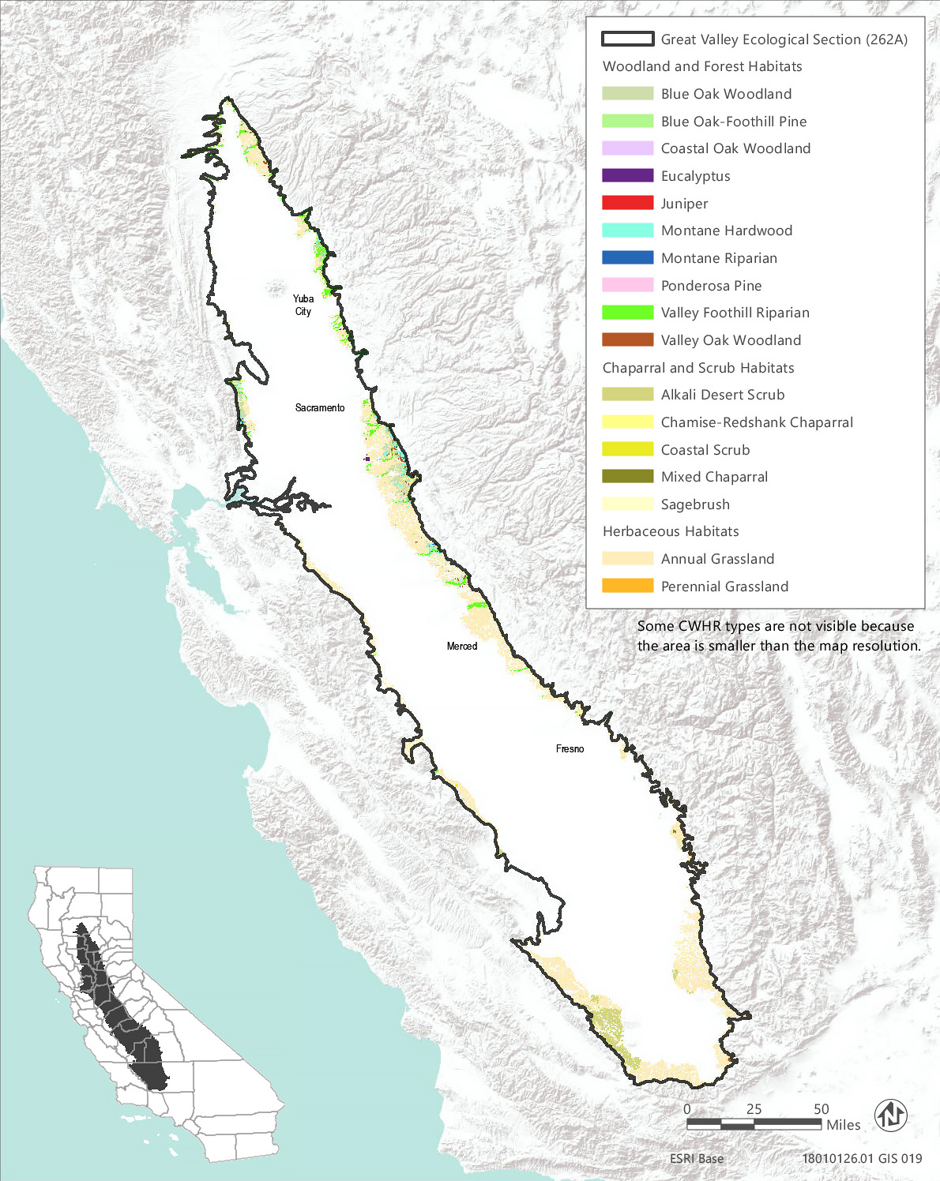
Source: Data received from CAL FIRE in 2018
Figure 3.6-5 CWHR Types - Great Valley Ecological Section (262A)
Table 3.6-9 Vegetation and Habitat Types within the Treatable Landscape for the Great Valley Ecological Section
CWHR Classification | Acres | MCV Alliances
Woodland and Forest Habitats
Blue Oak Woodland | 40,722 | - Blue oak woodland | - Interior live oak woodland
Blue Oak-Foothill Pine | 2,607 | - Foothill pine woodland | - Blue oak woodland
Coastal Oak Woodland | 37 | - Coast live oak woodland | - California bay forest*
Eucalyptus | 700 | - Eucalyptus - tree of heaven - black locust groves^{N}
Juniper | <1 | - None¹
Montane Hardwood | 7,001 | - California buckeye grove* | - Interior live oak woodland
Montane Riparian | 465 | - White alder grove  - Red osier thicket*  - Oregon ash grove*  - Sandbar willow thicket | - Hinds's walnut and related stand*  - Fremont cottonwood forest*  - Wild grape shrubland*
Ponderosa Pine | 1 | - None¹
Valley Foothill Riparian | 10,471 | - Box-elder forest*  - Button willow thicket*  - Red osier thicket*  - California sycamore woodland*  - Fremont cottonwood forest*  - California rose briar patch* | - Himalayan blackberry - rattlebox - edible fig riparian scrub^{N}  - Sandbar willow thicket  - Red willow thicket*  - Shining willow groves*  - Pepper tree or Myoporum grove^{N}  - Wild grape shrubland*
Valley Oak Woodland | 768 | - Valley oak woodland*
Chaparral and Scrub Habitats
Alkali Desert Scrub | 38,843 | - Iodine bush scrub*  - Fourwind saltbush scrub  - Shadscale scrub  - Quailbush scrub  - Allscale scrub | - Spinescale scrub  - Winterfat scrubland*  - Alkali sacaton - scratchgrass - alkali cordgrass alkaline wet meadow*  - Bush seepweed scrub*
Chamise-Redshank Chaparral | 2,163 | - None¹
Coastal Scrub | 600 | - Quailbush scrub  - Coyote brush scrub  - Broom patch^{N}  - Narrowleaf goldenbush - bladderpod scrub  - Ice plant mats^{N}  - Bush seepweed scrub* | - California buckwheat scrub  - California match weed patch*  - Goldenaster patch*  - Deer weed scrub  - Silver bush lupine scrub
Mixed Chaparral | 4,150 | - Hoary, common, and Stanford manzanita chaparral*  - Silver bush lupine scrub | - Deer weed scrub
Sagebrush | 30 | - Big sagebrush
Herbaceous Habitats
Annual Grassland | 496,870 | - Western ragweed meadow  - Fiddleneck - phacelia field  - Wild oat grassland^{N}  - Upland mustard and other ruderal forbs^{N}  - Annual brome grassland^{N}  - Red brome or mediterranean grass grassland^{N}  - Cheatgrass - medusahead grassland^{N}  - Yellow star-thistle field^{N}  - Knapweed and purple-flowered star-thistle field^{N}  - Tar plant field*  - Alkali weed - salt grass playas and sinks*  - Perennial rye grass field^{N}  - Spanish clover field  - Monolopia - leafy-stemmed tickseed field*  - Water blinks - annual checkerbloom vernal pool* | - California button-celery patch*  - California poppy - lupine field  - Goldenaster patch*  - California goldfields - dwarf plantain - small fescue flower fields  - Fremont's goldfields - salt grass alkaline vernal pool*  - Fremont's goldfields - Downingia vernal pools*  - Smooth goldfields vernal pool bottom*  - Fremont's tidy-tips - blow wives vernal pool*  - Popcorn flower field  - White-tip clover swales*
Perennial Grassland | 13 | - Indian rice grass grassland*  - Bent grass - tall fescue meadow  - Upland mustard and other ruderal forbs^{N}  - California brome - blue wildrye prairie*  - Knapweed and purple-flowered star-thistle field^{N}  - Poison hemlock or fennel patch^{N}  - Sand-aster and perennial buckwheat field  - Pampas grass patch^{N} | - Tufted hair grass meadow  - Gum plant patch*  - Ashy ryegrass - creeping ryegrass turf*  - Needle grass - melic grass grassland  - Fountain grass sward^{N}  - Harding grass - reed canary grass sward^{N}  - Curly blue grass grassland*
Total | 605,441
*These are designated sensitive natural communities with a state rarity rank of S1 (critically imperiled), S2 (imperiled), or S3 (vulnerable).
^{N} These alliances are dominated by nonnative vegetation.
¹ There are no MCV alliances recognized for this CWHR type in this ecoregion.
Source: CWHR 2019, CNPS 2019, Compiled by Ascent Environmental in 2019

Wetlands and Other Waters of the United States and Waters of the State
NWI has mapped over 43,000 acres of wetlands in the treatable landscape of the Great Valley Section. The majority, over 33,000 acres, is freshwater emergent wetland. Other wetlands mapped in the NWI are riverine, lake, freshwater pond, freshwater forested and shrub wetland, and just 1 acre of estuarine and marine wetland. The acreage of each general wetland type mapped in the treatable landscape by NWI is provided in Table 3.6-2. Vernal pools are also prevalent in areas mapped as annual grasslands in this ecoregion and may include water blinks - annual checkerbloom vernal pools, California button-celery patches, Fremont's goldfields - salt grass alkaline vernal pools, and Fremont's goldfields - Downingia vernal pools, among other vernal pool types.

Other Sensitive Habitats
There are 10,471 acres of valley foothill riparian habitat mapped in this ecoregion. Sensitive natural communities that may be included in this acreage are box elder forest, button willow thicket, red osier thicket, California sycamore woodland, Fremont cottonwood forest, California rose briar patch, red willow thicket, and shining willow groves.
Oak woodlands found in the treatable landscape of the Great Valley Section consist of blue oak woodland, blue oak-foothill pine woodland, valley oak woodland, and a small amount (37 acres) of coastal oak woodland. There are also about 7,000 acres of montane hardwood that likely contain interior live oak woodland stands. Oak woodlands in this ecoregion face the greatest threat from urbanization of anywhere in the state (California Oak Foundation 2006).
There is minimal chaparral habitat in the treatable landscape of this ecoregion, consisting of a little over 2,000 acres of chamise-redshank chaparral and a little over 4,000 acres of mixed chaparral. Sensitive chaparral natural communities that may occur in this ecoregion are hoary, common, and Stanford manzanita chaparral.

Conservation Lands, Special Management Areas, and Other Biologically Important Lands

Habitat Conservation Plan, Natural Community Conservation Plan, and other Conservation Plan Areas
The treatable landscape in the Great Valley Section includes plan areas for the Metropolitan Bakersfield HCP, San Joaquin County HCP, and East Contra Costa County HCP/NCCP, which have been adopted and are being implemented. Additionally, five HCPs and seven HCP/NCCPs are currently being planned in the treatable landscape. Table 3.6-10 summarizes the conservation plans adopted or in progress, including the acreages of plan areas within the treatable landscape.
Table 3.6-10 Conservation Plans Adopted or In Progress in the Treatable Landscape—Great Valley Section
Conservation Plan | Plan Type | Stage | Plan Area Within the Treatable Landscape (Acres)
Calaveras County | HCP | Planning | 75,323
East Fresno | HCP | Planning | 15,013
Kern County Valley Floor | HCP | Planning | 119,249
Metropolitan Bakersfield | HCP | Implementation | 24,081
San Joaquin County | HCP | Implementation | 70,077
Solano Multi-Species | HCP | Planning | 13,807
South Sacramento | HCP | Planning | 61,552
Bakersfield Regional Habitat Conservation Plan | HCP/NCCP | Planning | 59,234
Bay/Delta Conservation Plan | HCP/NCCP | Planning | 2,153
Butte Regional Conservation Plan | HCP/NCCP | Planning | 80,861
East Contra Costa County | HCP/NCCP | Implementation | 2,194
Northeastern San Luis Obispo County | HCP/NCCP | Planning | 524
Placer County Conservation Plan Phase I | HCP/NCCP | Planning | 18,987
Yolo Natural Heritage Program | HCP/NCCP | Planning | 31,633
Yuba-Sutter | HCP/NCCP | Planning | 9,745
 |  | Total | 584,433

Protected Open Space Lands
The treatable landscape in the Great Valley Section contains 110 protected open space units that are recognized in CPAD. These lands cover 34,901 acres, which represent 6 percent of the treatable landscape in the ecoregion. Some of the major land owners include The Wildlands Conservancy, The Nature Conservancy, CDFW, National Audubon Society, East Bay Municipal Utility District, Central Valley Flood Protection Board, Sacramento County, and State Parks. Examples of some of the prominent open space units in the Great Valley Section include Wind Wolves Preserve, Bobcat Ranch, Oroville Wildlife Area, Thomes Creek Ecological Reserve, Cosumnes River Parkway, and Grizzly Island Wildlife Area.

Klamath Mountains Section (M261A)
The Klamath Mountains Section encompasses 5,576,544 acres and includes the hills, valleys, and plains between the Southern Cascades Mountains and the Coast Range mountains. Elevations range from 1,500 to 8,000 feet. This ecoregion contains 1,267,874 acres of treatable landscape, which represents approximately 23 percent of the total landscape within the ecoregion. Within the treatable landscape exist modeled treatment areas for the following treatment types: WUI fuel reduction (404,249 acres), fuel break (150,122 acres), and ecological restoration (843,735 acres). The treatable landscape covers much of this eastern half of the ecoregion to the north and west of Redding. The treatable landscape in this ecoregion is displayed in Figure 3.6-6.

Vegetation and Habitat Types
The predominant habitat types in the treatable landscape of the Klamath Mountains Section are Douglas fir and Klamath mixed conifer, which comprise approximately 25 percent and 23 percent of the treatable landscape, respectively. Montane hardwood and montane hardwood-conifer habitats combined make up approximately 23 percent of the treatable landscape area. Other common habitat types are ponderosa pine, mixed chaparral, and annual grassland, which comprise approximately 6, 6, and 5 percent of the treatable landscape, respectively. This ecoregion supports diverse habitat types and the remaining 12 percent of the treatable landscape area is comprised of 22 other habitat types. Douglas fir in this ecoregion represents eight vegetation alliances, and five of these are designated as sensitive natural communities. Klamath mixed conifer in this ecoregion represents five vegetation alliances, and all of them are designated as sensitive natural communities.
Table 3.6-11 provides the acreage of each CWHR habitat type within the treatable landscape of this ecoregion and the associated MCV vegetation alliances that may occur within each CWHR type in this ecoregion. Alliances that are designated as sensitive natural communities and those that are dominated by nonnative vegetation are indicated in Table 3.6-11. Sensitive natural communities are discussed in more detail below. The distribution of CWHR types within this ecoregion is shown in Figure 3.6-6.

Sensitive Biological Resources

Special-Status Species
There are 91 special-status wildlife taxa and 135 plant taxa with potential to occur within the treatable landscape of the Klamath Mountains Section including seven plant taxa and 33 animal taxa that are state or federally listed as rare, threatened, or endangered. The Klamath Mountains ecoregion contains a wide diversity of plant species, including habitat specialists and species known only to occur locally. Over 45 special-status plant species in this ecoregion are associated with serpentine soils and over 17 species are associated with bogs and fens. Three salamander species, Shasta salamander (Hydromantes shastae), Scott Bar salamander (Plethodon asupak), and Siskiyou Mountains salamander (Plethodon stormi), are endemic to this ecoregion. A complete list of all the special-status plant species known or with potential to occur within the treatable landscape of the Klamath Mountains Section, along with their listing status and detailed habitat descriptions, is provided in Appendix BIO-3, Table 5a and a list. A list of special-status wildlife (other than fish) species known or expected to occur in the treatable landscape of this ecoregion, along with the CWHR types they are associated with, is provided in Appendix BIO-3, Table 5b. Special-status fish with potential to occur within the ecoregion are identified in Appendix BIO-3, Table 19.
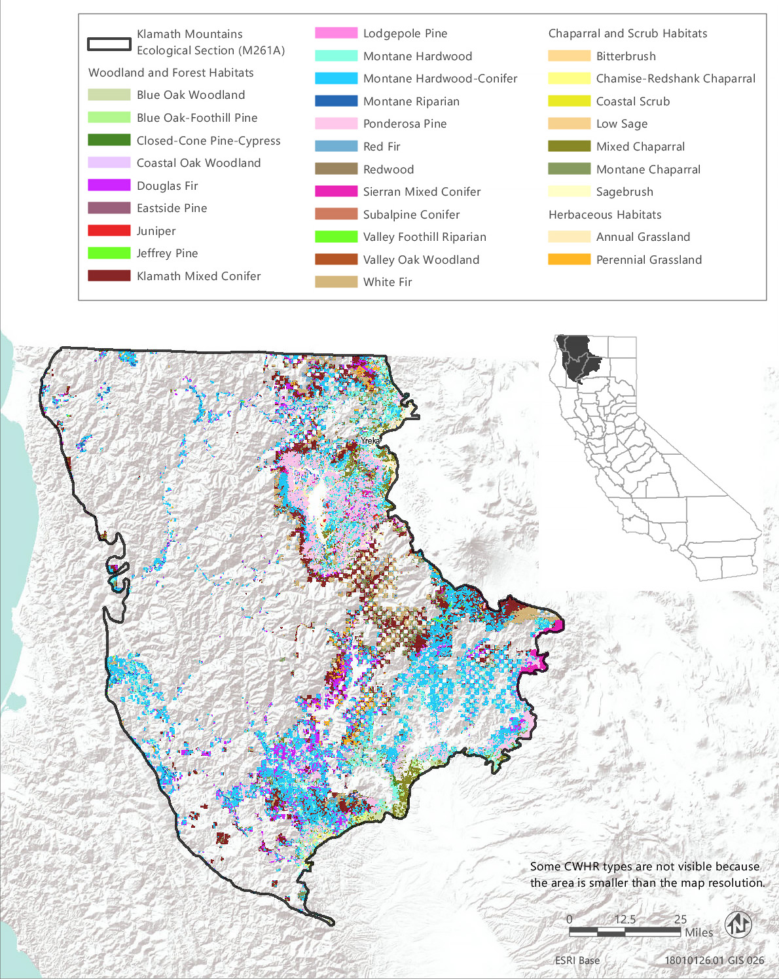
Source: Data received from CAL FIRE in 2018
Figure 3.6-6 CWHR Types - Klamath Mountains Ecological Section (M261A)
Table 3.6-11 Vegetation and Habitat Types within the Treatable Landscape for the Klamath Mountains Ecological Section
CWHR Classification | Acres | MCV Alliances
Woodland and Forest Habitats
Blue Oak Woodland | 14,732 | - Blue oak woodland | - Interior live oak woodland
Blue Oak-Foothill Pine | 24,335 | - Foothill pine woodland | - Blue oak woodland
Closed-Cone Pine-Cypress | 2,357 | - Baker cypress stand*  - McNab cypress woodland*  - Knobcone pine forest | - Beach pine forest*  - Bishop pine - Monterey pine forest*
Coastal Oak Woodland | 275 | - Madrone forest* | - California bay forest*
Douglas Fir | 318,537 | - White fir - Douglas fir forest  - Bigleaf maple forest*  - Port Orford cedar forest*  - Ponderosa pine - Douglas fir forest | - Douglas fir forest  - Douglas fir - incense cedar forest*  - Douglas fir - tanoak forest*  - Western hemlock forest*
Eastside Pine | 3,092 | - Jeffrey pine forest | - Ponderosa pine forest
Jeffrey Pine | 6,587 | - Jeffrey pine forest
Juniper | 13,695 | - Western juniper woodland
Klamath Mixed Conifer | 294,869 | - Pacific silver fir forest*  - Subalpine fir forest* | - Alaska yellow-cedar stand*  - Brewer spruce forest*  - Engelmann spruce forest*
Lodgepole Pine | 7 | - Lodgepole pine forest
Montane Hardwood | 138,850 | - Bigleaf maple forest*  - California buckeye grove*  - Red alder forest  - Tanoak forest* | - Canyon live oak forest  - Oregon white oak woodland*  - Interior live oak woodland
Montane Hardwood-Conifer | 155,132 | - Bigleaf maple forest*  - Red alder forest
Montane Riparian | 3,881 | - Rocky Mountain maple thicket*  - Mountain alder thicket*  - White alder grove  - Sitka alder thicket*  - Resin birch thicket*  - Water birch thicket*  - Torrent sedge patch* | - Fremont cottonwood forest*  - Black cottonwood forest*  - Sandbar willow thicket  - Jepson willow thicket*  - Wild grape shrubland*
Ponderosa Pine | 71,302 | - Ponderosa pine forest | - Ponderosa pine - Douglas fir forest
Red Fir | 6,482 | - Red fir forest | - Red fir - white fir forest
Redwood | 200 | - Western azalea patch* | - Redwood forest*
Sierran Mixed Conifer | 12,093 | - Incense cedar forest*  - Mixed oak forest  - Ponderosa pine - Douglas fir forest | - Douglas fir - incense cedar forest*  - Giant sequoia forest*
Subalpine Conifer | 273 | - Engelmann spruce forest*  - Whitebark pine forest  - Foxtail pine woodland* | - Western white pine forest  - Mountain hemlock forest
Valley Foothill Riparian | 428 | - Torrent sedge patch*  - Button willow thicket*  - Fremont cottonwood forest*  - Black cottonwood forest* | - Himalayan blackberry - rattlebox - edible fig riparian scrub^{N}  - Sandbar willow thicket  - Wild grape shrubland*
Valley Oak Woodland | 89 | - Valley oak woodland*
White Fir | 27,296 | - White fir forest  - White fir - sugar pine forest | - White fir - Douglas fir forest  - Red fir - white fir forest
Chaparral and Scrub Habitats
Bitterbrush | 187 | - Bitter brush scrub*
Chamise-Redshank Chaparral | 5,501 | - Chamise chaparral | - Wedge leaf ceanothus chaparral/Buck brush chaparral
Coastal Scrub | 4 | - California yerba santa scrub | - Coast range stonecrop draperies
Low Sage | 19 | - Little sagebrush scrub
Mixed Chaparral | 69,662 | - Hoary, common, and Stanford manzanita chaparral*  - Whiteleaf manzanita chaparral  - Wedge leaf ceanothus chaparral, Buck brush chaparral  - Deer brush chaparral  - Birch leaf mountain mahogany chaparral | - Bush poppy scrub  - California yerba santa scrub  - Ocean spray brush*  - Shrub tanoak chaparral*  - Scrub oak chaparral
Montane Chaparral | 27,793 | - Green leaf manzanita chaparral  - Whiteleaf manzanita chaparral  - Mountain whitethorn chaparral  - Deer brush chaparral  - Tobacco brush or snow bush chaparral  - Birch leaf mountain mahogany chaparral | - Bush chinquapin chaparral*  - Bitter cherry thicket  - Brewer oak scrub  - Sadler oak or deer oak brush field*  - Huckleberry oak chaparral
Sagebrush | 1,934 | - Little sagebrush scrub  - Big sagebrush  - Curl leaf mountain mahogany scrub | - Rubber rabbitbrush scrub  - Bitter brush scrub*
Herbaceous Habitats
Annual Grassland | 61,398 | - Wild oat grassland  - Annual brome grassland^{N}  - Red brome or mediterranean grass grassland^{N}  - Cheatgrass - medusahead grassland^{N} | - Yellow star-thistle field^{N}  - Knapweed and purple-flowered star-thistle field^{N}  - Annual dogtail grassland^{N}
Perennial Grassland | 6,863 | - Water foxtail meadow*  - Small-fruited sedge meadow*  - Knapweed and purple-flowered star-thistle field^{N}  - California oat grass prairie*  - Tufted hair grass meadow | - Idaho fescue grassland*  - Ashy ryegrass - creeping ryegrass turf*  - Needle grass - melic grass grassland  - Kentucky blue grass turf^{N}  - Curly blue grass grassland*
Total | 1,267,873
*These are designated sensitive natural communities with a state rarity rank of S1 (critically imperiled), S2 (imperiled), or S3 (vulnerable).
^{N} These alliances are dominated by nonnative vegetation.
Source: CWHR 2019, CNPS 2019, Compiled by Ascent Environmental in 2019

Critical Habitat
Critical habitat has been designated within the treatable landscape of this ecoregion for only two wildlife taxa, northern spotted owl (Strix occidentalis caurina) and marbled murrelet (Brachyramphus marmoratus). Appendix BIO-4 provides the acreage of critical habitat designated within the treatable landscape of this ecoregion for each species.

Sensitive Natural Communities and Habitats

Sensitive Natural Communities
There are 56 sensitive natural communities that may occur within the treatable landscape of the Klamath Mountains Section. The sensitive natural communities associated with each CWHR type in this ecoregion are identified in Table 3.6-11. They include Pacific silver fir forest, subalpine fir forest, Alaska yellow-cedar stand, Brewer spruce forest, Engelmann spruce forest, and Sadler oak or deer oak brush field.

Wetlands and Other Waters of the United States and Waters of the State
Wetland habitats known to occur within the treatable landscape of the Klamath Mountain Section include freshwater emergent wetland, freshwater forested and shrub wetland, freshwater pond, lake, and riverine wetlands. The acreage of each general wetland type mapped in the treatable landscape by NWI is provided in Table 3.6-2. In addition, torrent sedge patch, water foxtail meadow, and small-fruited sedge meadow are wetland sensitive natural communities that may be present within areas mapped as montane riparian, valley foothill riparian, or perennial grassland. Major waterways include the Klamath River, Trinity River, Salmon River, Rogue River, and Scott River.

Other Sensitive Habitats
There are 4,309 acres of montane riparian and valley foothill riparian habitat mapped in this ecoregion. Sensitive natural communities that may be included in this acreage are Rocky Mountain maple thicket, mountain alder thicket, Sitka alder thicket, resin birch thicket, water birch thicket, torrent sedge patch, Fremont cottonwood forest, black cottonwood forest, Jepson willow thicket, wild grape shrubland, and button willow thicket.
Oak woodlands found in the treatable landscape of the Klamath Mountains Section consist of blue oak woodland, blue oak-foothill pine woodland, and a small amount of coastal oak woodland and valley oak woodland. There are also about 138,850 acres of montane hardwood that likely contain canyon live oak forest, Oregon white oak woodland, and interior live oak woodland stands.
Chaparral habitats in the treatable landscape of the Klamath Mountains Section consist of approximately 69,662 acres of mixed chaparral, 27,793 acres of montane chaparral, and 5,501 acres of chamise – redshank chaparral. Designated sensitive chaparral natural communities that may be present within these habitat areas include bush chinquapin chaparral, Sadler oak or deer oak brush field, hoary, common, and Sanford manzanita chaparral, shrub tanoak chaparral, and ocean spray scrub.

Conservation Lands, Special Management Areas, and Other Biologically Important Lands

Habitat Conservation Plan, Natural Community Conservation Plan, and other Conservation Plan Areas
No conservation plans have been adopted for lands within the treatable landscape in the Klamath Mountains Section.

Protected Open Space Lands
The treatable landscape in the Klamath Mountains Section contains 37 protected open space units that are recognized in CPAD. These lands cover 11,921 acres, which represent 0.9 percent of the treatable landscape in the ecoregion. Some of the major land owners include State Parks, CDFW, The Nature Conservancy, CSLC, City of Yreka, CAL FIRE, and Trinity County. Examples of some of the prominent open space units in the Klamath Mountains Section include Castle Crags State Park, McCloud River Preserve, Del Norte Coast Redwoods State Park, Jedediah Smith Redwoods State Park, Greenhorn Park, Ellen Pickett State Forest, Cantara-Ney Springs Wildlife Area, and China Point Ecological Reserve.

Modoc Plateau Section
The Modoc Plateau Section (M261G) encompasses 3,538,741 acres and contains northwesterly trending block ranges and basins commonly interspersed with volcanic formations such as cinder cones or lava flows. Elevations range from 3,000 to 9,900 feet. This ecoregion contains 746,035 acres of treatable landscape, which represents approximately 21 percent of the total landscape within the ecoregion. Within the treatable landscape exist modeled treatment areas for the following treatment types: WUI fuel reduction (61,005 acres), fuel break (89,469 acres), and ecological restoration (676,564 acres). The treatable landscape primarily consists of mountains, ridges, and valleys within the southern half of this ecoregion. The treatable landscape in this ecoregion is displayed in Figure 3.6-7.

Vegetation and Habitat Types
Chaparral and scrub habitats make up the majority of habitat types in the Modoc Plateau Section, comprising approximately 53 percent of the cover in the treatable landscape. There are 14 MCV alliances associated with the chaparral and scrub habitats of this ecoregion. Sagebrush is the predominant scrub type and makes up 36 percent of the vegetative cover of the treatable landscape. Woodland and forest habitats make up approximately 40 percent of the land cover with eastside pine being the predominant forest type. Annual and perennial grasslands make up approximately 6 percent of the treatable landscape. This is one of the few ecoregions where perennial grassland is more abundant than annual grassland. These grasslands support a diversity of native and nonnative vegetation alliances. The distribution of CWHR types within the treatable landscape of this ecoregion is shown in Figure 3.6-7 and the acreage of each type, as well as associated MCV alliances, is provided in Table 3.6-12.

Sensitive Biological Resources

Special-Status Species
There are 57 special-status wildlife taxa and 67 plant taxa known or with potential to occur in the treatable landscape of the Modoc Plateau Section, including two plant taxa and 27 animal taxa that are state or federally listed as rare, threatened, or endangered or fully protected. A list of all the special-status plant species known or with potential to occur within the treatable landscape of the Great Valley Section, along with their listing status and detailed habitat descriptions, is provided in Appendix BIO-3, Table 6a. A list of special-status wildlife (other than fish) species known or with potential to occur in the treatable landscape of this ecoregion, along with the CWHR types they are associated with, is provided in Appendix BIO-3, Table 6b. Special-status fish known or with potential to occur in the ecoregion are identified in Appendix BIO-3, Table 19.

Critical Habitat
Designated critical habitat within the treatable landscape of the Modoc Plateau exists for only two species, shortnose sucker (Chasmistes brevirostris) and Lost River sucker (Deltistes luxatus). Appendix BIO-4 lists and provides the acreage of critical habitat designated within the treatable landscape of this ecoregion for these species.
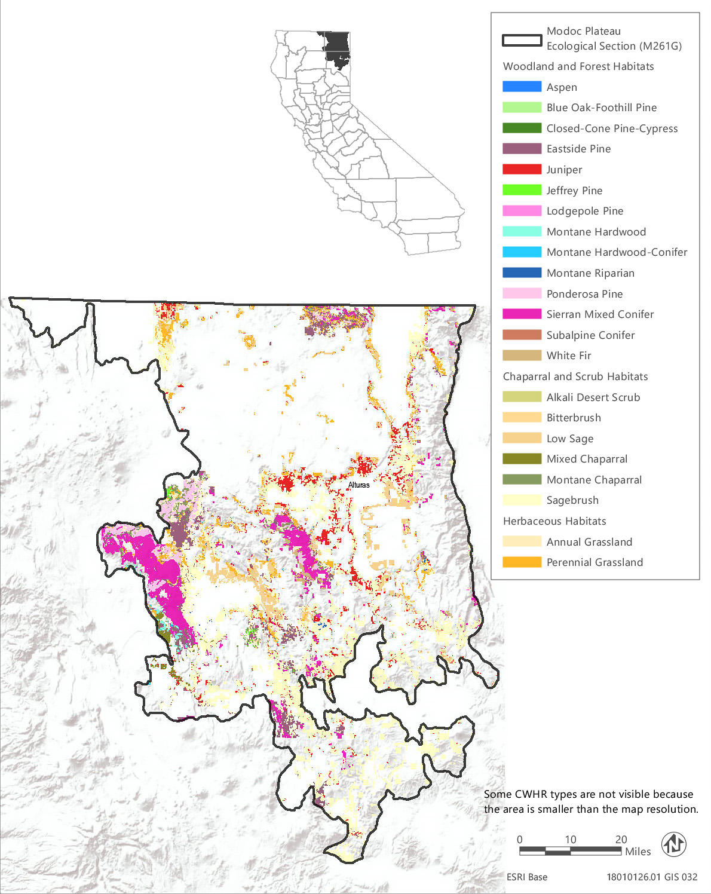
Source: Data received from CAL FIRE in 2018
Figure 3.6-7 CWHR Types - Modoc Plateau Ecological Section (M261G)
Table 3.6-12 Vegetation and Habitat Types within the Treatable Landscape for the Modoc Plateau Ecological Section
CWHR Classification | Acres | MCV Alliances
Woodland and Forest Habitats
Aspen | 380 | - Aspen groves*
Blue Oak-Foothill Pine | 22 | - Foothill pine woodland
Closed-Cone Pine-Cypress | 8 | - Baker cypress stand* | - Knobcone pine forest
Eastside Pine | 126,499 | - Jeffrey pine forest  - Ponderosa pine forest | - Washoe pine woodland*
Jeffrey Pine | 1,827 | - Jeffrey pine forest
Lodgepole Pine | 387 | - Lodgepole pine forest
Montane Hardwood | 3,356 | - Oregon white oak woodland*
Montane Hardwood-Conifer | 654 | - None¹
Montane Riparian | 756 | - Resin birch thickets*  - Water birch thickets*  - Black cottonwood forest*  - Western Labrador-tea thickets*  - Interior rose thickets* | - Bebb's willow thickets*  - Sandbar willow thickets  - Geyer willow thickets*  - Lemmon's willow thickets*
Ponderosa Pine | 34,674 | - Ponderosa pine forest | - Washoe pine woodland*
Sierran Mixed Conifer | 77,609 | - Incense cedar forest* | - Mixed oak forest
Subalpine Conifer | 30 | - Whitebark pine forest | - Western white pine forest
White Fir | 3,312 | - White fir forest | - White fir - sugar pine forest
Chaparral and Scrub Habitats
Alkali Desert Scrub | 286 | - Greasewood scrub | - Alkali sacaton - scratchgrass - alkali cordgrass alkaline wet meadow*
Bitterbrush | 3,119 | - Bitter brush scrub*
Low Sage | 76,105 | - Little sagebrush scrub | - Lahontan sagebrush scrub
Mixed Chaparral | 4,296 | - Deer brush chaparral | - Choke cherry thickets*
Montane Chaparral | 20,570 | - Green leaf manzanita chaparral  - Deer brush chaparral  - Tobacco brush or snow bush chaparral | - Choke cherry thickets*  - Brewer oak scrub
Sagebrush | 225,203 | - Little sagebrush scrub  - Lahontan sagebrush scrub  - Silver sagebrush scrub*  - Big sagebrush | - Mountain big sagebrush Curl leaf mountain mahogany scrub  - Rubber rabbitbrush scrub  - Bitter brush scrub*
Herbaceous Habitats
Annual Grassland | 11,346 | - Wild oats grassland^{N}  - Annual brome grassland^{N}  - Red brome or mediterranean grass grassland^{N}  - Cheatgrass - medusahead grassland  - Knapweed and purple-flowered star-thistle field^{N} | - Needle spike rush stands*  - Fremont's goldfields - Downingia vernal pools*  - Spanish clover field
Perennial Grassland | 28,017 | - Crested wheatgrass rangeland^{N}  - Bent grass - tall fescue meadows  - Water foxtail meadow*  - Small-fruited sedge meadow*  - Knapweed and purple-flowered star-thistle field^{N}  - Tufted hair grass meadows | - Idaho fescue grassland*  - Ashy ryegrass - creeping ryegrass turf*  - Mat muhly meadow  - Harding grass - reed canary grass sward^{N}  - Kentucky blue grass turf^{N}  - Curly blue grass grassland*  - Bluebunch wheat grass grassland*
Total | 618,456
*These are designated sensitive natural communities with a state rarity rank of S1 (critically imperiled), S2 (imperiled), or S3 (vulnerable).
^{N} These alliances are dominated by nonnative vegetation.
¹ There are no MCV alliances recognized for this CWHR type in this ecoregion.
Source: CWHR 2019, CNPS 2019, Compiled by Ascent Environmental in 2019

Sensitive Natural Communities and Habitats

Sensitive Natural Communities
There are 48 sensitive natural communities that may occur within the treatable landscape of the Modoc Plateau Section. The sensitive natural communities associated with each CWHR type in this ecoregion are identified in Table 3.6-12. Examples of sensitive natural communities in this ecoregion include aspen groves, silver sagebrush scrub, Washoe pine woodland, bitterbrush scrub, Idaho fescue grassland, and bluebunch wheat grass grassland.

Wetlands and Other Waters of the United States and Waters of the State
Wetlands mapped in the treatable landscape of the Modoc Plateau consist of over 23,000 acres of freshwater emergent wetland, freshwater forested and shrub wetland, freshwater pond, lake, and riverine habitats. Freshwater emergent wetland is the most abundant wetland type with over 17,700 acres inventoried in the NWI. The acreage of each general wetland type mapped in the treatable landscape by NWI is provided in Table 3.6-2. Additional wetland types that may be present within other CWHR types in the treatable landscape include silver sagebrush scrub, tufted hair grass meadows, water foxtail meadows, needle spike rush stands, and Fremont's goldfields - Downingia vernal pools.

Other Sensitive Habitats
CWHR riparian habitat types identified within the treatable landscape of the Modoc Plateau Section consist of approximately 756 acres of montane riparian habitat. There are nine MCV alliances that may occur in the montane riparian habitat type. All but one of these are designated sensitive natural communities. Examples include resin birch thickets, western Labrador-tea thickets, interior rose thickets, and Bebb's willow thickets. All riparian habitats are considered sensitive and those located near rivers, streams, and lakes are protected under California Fish and Game Code.
Oak woodlands within the treatable landscape of this ecoregion are limited with only 22 acres of blue oak-foothill pine and 3,356 acres of montane hardwood that likely supports Oregon white oak woodland, a designated sensitive natural community.
Chaparral habitats in the treatable landscape consist of approximately 4,300 acres of mixed chaparral and over 20,500 acres of montane chaparral. Mixed chaparral alliances found in this ecoregion consist of deer brush chaparral and choke cherry thickets, and montane chaparral alliances include green leaf manzanita chaparral, tobacco brush or snow bush chaparral, and Brewer oak scrub. Choke cherry thickets are a designated sensitive natural community. The green leaf manzanita chaparral, tobacco brush or snow bush chaparral community types are successional following fire with the dominant shrub species (e.g., green leaf manzanita and tobacco brush) sprouting prolifically from their root crowns after fire. In addition, tobacco brush and green leaf manzanita develop seed banks that remain dormant in the soil until stimulated to germinate following fire. The combination of sprouting and seedling recruitment following fire rapidly replenishes the shrub layer of these communities, and crown fires that remove the tree canopy from forest and woodland types in this ecoregion can result in post-fire dominance of chaparral shrubs. If fires recur too frequently, conifer regeneration can be eliminated resulting in permanent conversion to chaparral. The return interval is 40 to 75 years for tobacco brush or snow bush chaparral and 20 to 50 years for green leaf manzanita chaparral (Sawyer et al. 2009).

Conservation Lands, Special Management Areas, and Other Biologically Important Lands

Habitat Conservation Plan, Natural Community Conservation Plan, and other Conservation Plan Areas
No conservation plans have been adopted for lands within the treatable landscape in the Modoc Plateau Section.

Protected Open Space Lands
The treatable landscape in the Modoc Plateau Section contains 18 protected open space units that are recognized in CPAD. These lands cover 12,530 acres, which represent 2 percent of the treatable landscape in the ecoregion. The land owners are CSLSC, CDFW, Lassen County, Modoc County, and University of California. Examples of some of the prominent open space units in the Modoc Plateau Section include Fitzhugh Creek Wildlife Area, Ash Creek Wildlife Area, Silver Creek Wildlife Area, Surprise Valley Wildlife Area, Great Basin Springs, and Eagle Lake Field Station.

Mojave Desert Section
The Mojave Desert Section (322A) encompasses 16,527,027 acres and consists of widely separated short ranges in desert plains and contains isolated mountains, plateaus, playas, basins, and dunes. Elevations in this hot and dry ecoregion range from 300 feet below sea level to 11,000 feet. This ecoregion contains 307,905 acres of treatable landscape, which represents approximately 2 percent of the total landscape within the ecoregion. Within the treatable landscape exist modeled treatment areas for the following treatment types: WUI fuel reduction (206,080 acres), fuel break (109,085 acres), and ecological restoration (29,825 acres). The treatable landscape within this ecoregion is limited to small swaths along the base of the southern end of the Sierra Nevada and the north-northeastern side of the Transverse Ranges. The treatable landscape in this ecoregion is displayed in Figure 3.6-8.

Vegetation and Habitat Types
Desert scrub is the predominant habitat type, comprising approximately 41 percent of the treatable landscape of the Mojave Desert Section. Other chaparral and scrub habitats make up about 21 percent of the treatable landscape, while woodland and forest habitats and herbaceous habitats comprise approximately 29 percent and 9 percent, respectively. The desert scrub habitat is very diverse, representing as many as 36 unique vegetation alliances. The distribution of CWHR types within the treatable landscape of this ecoregion is shown in Figure 3.6-8 and the acreage of each type, as well as associated MCV alliances, is provided in Table 3.6-13.

Sensitive Biological Resources

Special-Status Species
There are 94 special-status wildlife taxa and 56 plant taxa known or with potential to occur in the treatable landscape of the Mojave Desert Section, including seven plant taxa and 37 animal taxa that are state or federally listed as rare, threatened, or endangered or fully protected. A list of all the special-status plant species known or with potential to occur within the treatable landscape of the Great Valley Section, along with their listing status and detailed habitat descriptions, is provided in Appendix BIO-3, Table 7a. A list of special-status wildlife (other than fish) species known or with potential to occur in the treatable landscape of this ecoregion, along with the CWHR types they are associated with, is provided in Appendix BIO-3, Table 7b. Special-status fish known or with potential to occur in the ecoregion are identified in Appendix BIO-3, Table 19.
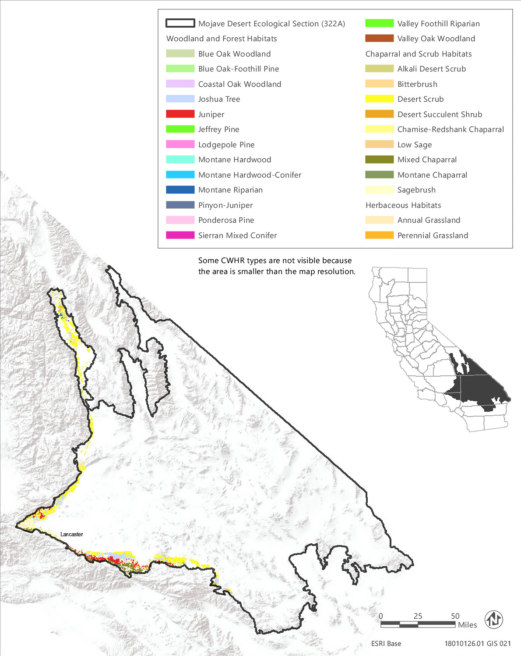
Source: Data received from CAL FIRE in 2018
Figure 3.6-8 CWHR Types - Mojave Desert Ecological Section (322A)
Table 3.6-13 Vegetation and Habitat Types within the Treatable Landscape for the Mojave Desert Ecological Section
CWHR Classification | Acres | MCV Alliances
Woodland and Forest Habitats
Blue Oak Woodland | 421 | - Blue oak woodland
Blue Oak-Foothill Pine | 196 | - Foothill pine woodland
Coastal Oak Woodland | 15 | - California bay forest*
Jeffrey Pine | 17 | - Jeffrey pine forest
Joshua Tree | 45,888 | - Joshua tree woodland*
Juniper | 40,553 | - Needleleaf rabbitbrush scrub  - California juniper woodland  - Utah juniper woodland* | - Two-needle pinyon stands*  - Singleleaf pinyon - Utah juniper woodlands
Lodgepole Pine | 3 | - Lodgepole pine forest
Montane Hardwood | 573 | - Bigcone Douglas fir forest* | - Canyon live oak forest
Montane Hardwood-Conifer | 6 | - Bigcone Douglas fir forest*
Montane Riparian | 343 | - Water birch thicket*  - Fremont cottonwood forest* | - Sandbar willow thicket  - Wild grape shrubland*
Pinyon-Juniper | 1,307 | - Utah juniper woodland* | - Singleleaf pinyon - Utah juniper woodlands
Ponderosa Pine | 1 | - Ponderosa pine forest
Sierran Mixed Conifer | 2 | - Mixed conifer forest
Valley Foothill Riparian | 204 | - Fremont cottonwood forest*  - Himalayan blackberry - rattlebox - edible fig riparian scrub^{N}  - Sandbar willow thicket | - Red willow thicket*  - Wild grape shrubland*
Valley Oak Woodland | 325 | - Valley Oak Woodland*
Chaparral and Scrub Habitats
Alkali Desert Scrub | 15,437 | - Iodine bush scrub*  - Fourwind saltbush scrub  - Shadscale scrub  - Desert holly scrub  - Quailbush scrub  - Parry's saltbush scrub*  - Allscale scrub | - Spinescale scrub  - Winterfat scrubland*  - Greasewood scrub  - Alkali sacaton - scratchgrass - alkali cordgrass alkaline wet meadow*  - Bush seepweed scrub*
Bitterbrush | 2,996 | - Bitter brush scrub*
Chamise-Redshank Chaparral | 1 | - Chamise chaparral
Desert Scrub | 127,346 | - Desert needlegrass grassland*  - Iodine bush scrub*  - White bursage scrub  - Cheesebush - sweetbush scrub  - Fremont's chaffbush - woolly sage scrub*  - Fourwind saltbush scrub  - Shadscale scrub  - Desert holly scrub  - Quailbush scrub  - Parry's saltbush scrub*  - Allscale scrub  - Spinescale scrub  - Saguaro - foothill palo verde - velvet mesquite desert scrub*  - Crucifixion thorn stand*  - Rigid spineflower - hairy desert sunflower  - Mojave-Sonoran desert dunes*  - Greasewood scrub  - Catclaw acacia - desert lavender - chuparosa scrub  - Alkali sacaton - scratchgrass - alkali cordgrass alkaline wet meadow* | - Nevada joint fir - Anderson's boxthorn - spiny hop sage scrub  - Narrowleaf goldenbush - bladderpod scrub  - California buckwheat - Parish's goldeneye scrub  - Wright's buckwheat - Heerman's buckwheat - Utah butterfly-bush scrub*  - Apache plume scrub*  - Snakeweed scrub*  - Winterfat scrubland*  - Creosote bush scrub  - Creosote bush - white bursage scrub  - Creosote bush - brittle bush scrub  - Spiny menodora scrub*  - James' galleta shrub-steppe*  - Big galleta shrub-steppe*  - Desert almond - Mexican bladdersage scrub  - Bush seepweed scrub*  - Acton's and Virgin River brittlebush - net-veined goldeneye scrub*  - Brittle bush scrub
Desert Succulent Shrub | 1,400 | - Saguaro - foothill palo verde - velvet mesquite desert scrub*  - Teddy bear cholla patch* | - Nolina scrub*  - Mojave yucca scrub
Low Sage | 1 | - Black sagebrush scrub*
Mixed Chaparral | 24,068 | - Muller oak chaparral
Montane Chaparral | 17 | - Green leaf manzanita chaparral | - Deer brush chaparral
Sagebrush | 19,468 | - Black sagebrush scrub*  - Big sagebrush  - Black brush scrub  - Death Valley joint fir scrub* | - Mormon tea scrub  - Rubber rabbitbrush scrub  - Stansbury cliff rose scrub*  - Bitter brush scrub*
Herbaceous Habitats
Annual Grassland | 26,952 | - Fiddleneck - phacelia field  - Tournefort's mustard and other ruderal desert forb patch^{N}  - California poppy - lupine field  - Monolopia - leafy-stemmed tickseed field | - California goldfields - dwarf plantain - small fescue flower fields  Red brome or mediterranean grass grassland^{N}
Perennial Grassland | 367 | - Indian rice grass grassland*  - Desert needlegrass grassland*  - Tournefort's mustard and other ruderal desert forb patch^{N}  - Sand-aster and perennial buckwheat field | - Ashy ryegrass - creeping ryegrass turf*Deer grass bed*  - Needle grass - melic grass grassland  - Curly blue grass grassland*
Total | 307,907
*These are designated sensitive natural communities with a state rarity rank of S1 (critically imperiled), S2 (imperiled), or S3 (vulnerable).
^{N} These alliances are dominated by nonnative vegetation.
Source: CWHR 2019, CNPS 2019, Compiled by Ascent Environmental in 2019

Critical Habitat
Designated critical habitat within the treatable landscape of the Mojave Desert exists for seven species. Appendix BIO-3 lists and provides the acreage of critical habitat designated within the treatable landscape of this ecoregion for these species. Examples include arroyo toad, California condor, Cushenbury milk-vetch (Astragalus albens), and Cushenbury buckwheat (Eriogonum ovalifolium var. vineum). Appendix BIO-4 lists and provides the acreage of critical habitat designated within the treatable landscape of this ecoregion for these species.

Sensitive Natural Communities and Habitats

Sensitive Natural Communities
There are 35 sensitive natural communities that may occur within the treatable landscape of the Mojave Desert Section. The sensitive natural communities associated with each CWHR type in this ecoregion are identified in Table 3.6-13. Examples of sensitive natural communities in this ecoregion include Bigcone Douglas fir forest, Joshua tree woodland, Utah juniper woodland, crucifixion thorn stand, Wright's buckwheat - Heerman's buckwheat - Utah butterfly-bush scrub, desert needlegrass grassland, and Death Valley joint fir scrub.

Wetlands and Other Waters of the United States and Waters of the State
Wetlands mapped in the treatable landscape of the Mojave Desert consist of just over 6,000 acres of freshwater emergent wetland, freshwater forested and shrub wetland, freshwater pond, lake, and riverine habitats (Table 3.6-2). Additional wetland types that may be present within other CWHR types in the treatable landscape include alkali sacaton - scratchgrass - alkali cordgrass alkaline wet meadows, water foxtail meadows, iodine bush scrub, and bush seepweed scrub.

Other Sensitive Habitats
CWHR riparian habitat types identified within the treatable landscape of the Mojave Desert Section consist of approximately 343 acres of montane riparian habitat and 204 acres of valley and foothill riparian habitat. There are four MCV alliances that may occur in the montane riparian habitat type and five that may occur in the valley and foothill riparian habitat. Four of riparian alliances are designated sensitive natural communities. Examples include water birch thicket, Fremont cottonwood forest, and red willow thicket. All riparian habitats are considered sensitive and those located near rivers, streams, and lakes are protected under California Fish and Game Code.
Approximately 420 acres of blue oak woodland and 200 acres of valley oak woodland habitat have been mapped within the treatable landscape of this ecoregion and canyon live oak forest may be present in the 573 acres of montane hardwood.
Just over 24,000 acres of mixed chaparral and 17 acres of montane chaparral have been mapped in the treatable landscape of this ecoregion. Muller oak chaparral, green leaf manzanita chaparral, and deer brush chaparral are the most likely vegetation alliances within the chaparral habitat types. Muller oak (Quercus Cornelius-mulleri), green leaf manzanita (Arctostaphylos patula), and deer brush (Ceanothus integerrimus) all sprout prolifically from root crowns following fire and also establish from seed. Muller oak chaparral is adapted to episodic fires of variable intensity and severity with a fire return interval of 30 to 100 years (Sawyer et al. 2009). Deer brush and green leaf manzanita also reestablish readily from seed after fires. The return interval is 10 to 50 years for deer brush chaparral and 20 to 50 years for green leaf manzanita chaparral (Sawyer et al. 2009).

Conservation Lands, Special Management Areas, and Other Biologically Important Lands

Habitat Conservation Plan, Natural Community Conservation Plan, and other Conservation Plan Areas
The treatable landscape in the Mojave Desert Section includes plan areas for the West Mojave Plan (HCP), Desert Renewable Energy Conservation Plan (HCP/NCCP), and Town of Apple Valley Multi-Species HCP/NCCP, which are currently being planned in the treatable landscape. Table 3.6-14 summarizes the acreages of the plan areas within the treatable landscape.
Table 3.6-14 Conservation Plans Adopted or In Progress in the Treatable Landscape—Mojave Desert Section
Conservation Plan | Plan Type |  | Stage | Plan Area Within the Treatable Landscape (Acres)
West Mojave Plan | HCP |  | Planning | 362,660
Desert Renewable Energy Conservation Plan | HCP/NCCP |  | Planning | 427,563
Town of Apple Valley Multi-Species | HCP/NCCP |  | Planning | 0.2
 |  |  | Total | 790,233

Protected Open Space Lands
The treatable landscape in the Mojave Desert Section contains 46 protected open space units that are recognized in CPAD. These lands cover 44,646 acres, which represent 14 percent of the treatable landscape in the ecoregion. Some of the major land owners include City of Los Angeles Department of Water and Power (LADWP), The Wildlands Conservancy, State Parks, CSLC, CDFW, County of Los Angeles, Mountains Recreation and Conservation Authority, and Arroyos and Foothills Conservancy. Examples of some of the prominent open space units in the Mojave Desert Section include Pioneertown Mountains Preserve, Red Rock Canyon State Park, Antelope Valley California Poppy Reserve, Blalock Wildlife Sanctuary, King Clone Ecological Reserve, Cartago Wildlife Area, and Black Mesa Significant Ecological Area.

Mono Section
The Mono Section (341D) encompasses 1,973,879 acres and consists of block ranges separated by desert basins and alluvial fans, just east of the Sierra Nevada. Elevations in this ecoregion range from 4,000 feet to over 14,000 feet. This ecoregion contains 188,748 acres of treatable landscape, which represents approximately 10 percent of the total landscape within the ecoregion. Within the treatable landscape exist modeled treatment areas for the following treatment types: WUI fuel reduction (75,966 acres), fuel break (33,022 acres), and ecological restoration (99,980 acres). The treatable landscape is dispersed across much of the ecoregion and includes areas surrounding cities and communities along Highway 395. The treatable landscape in this ecoregion is displayed in Figure 3.6-9.

Vegetation and Habitat Types
The predominant CWHR type in the treatable landscape of the Mono Section is sagebrush, which makes up about 49 percent of the land cover. There are 13 MCV alliances that may be found within areas mapped as sagebrush. Six other scrub habitat types are also present, comprising almost 35 percent of the treatable landscape. The desert scrub and alkali desert scrub types are also highly diverse with 16 associated MCV alliances recognized in this ecoregion. Woodland and forest habitats make up just 17,721 acres, or almost 10 percent of the treatable landscape and annual and perennial grasslands 12,330 acres, or about 6 percent. Annual grassland here is mostly composed of one vegetation alliance – cheatgrass-medusahead grassland with cheatgrass being dominant (Bromus tectorum). Eight MCV alliances have been mapped and described in the perennial grasslands in this ecoregion, however, and these include both nonnative and native types. The distribution of CWHR types within the treatable landscape of this ecoregion is shown in Figure 3.6-9 and the acreage of each type, as well as associated MCV alliances, is provided in Table 3.6-15.

Sensitive Biological Resources

Special-Status Species
There are 84 special-status wildlife taxa and 70 plant taxa known or with potential to occur in the treatable landscape of the Mono Section, including four plant taxa and 25 animal taxa that are state or federally listed as rare, threatened, or endangered or fully protected. A list of all the special-status plant species known or with potential to occur within the treatable landscape of the Mono Section, along with their listing status and detailed habitat descriptions, is provided in Appendix BIO-3, Table 8a. A list of special-status wildlife (other than fish) species known or with potential to occur in the treatable landscape of this ecoregion, along with the CWHR types they are associated with, is provided in Appendix BIO-3, Table 8b. Special-status fish known or with potential to occur in the ecoregion are identified in Appendix BIO-3, Table 19.

Critical Habitat
Designated critical habitat is present within the treatable landscape of the Mono Section for five species: yellow-billed cuckoo (Coccyzus americanus), Owens tui chub (Gila bicolor ssp. snyderi), Sierra Nevada bighorn sheep (Ovis canadensis sierra), Fish slough milk-vetch (Astragalus lentiginosus var. piscinensis), and Webber’s ivesia (Ivesia webberi). Appendix BIO-4 lists and provides the acreage of critical habitat designated within the treatable landscape of this ecoregion for these species.
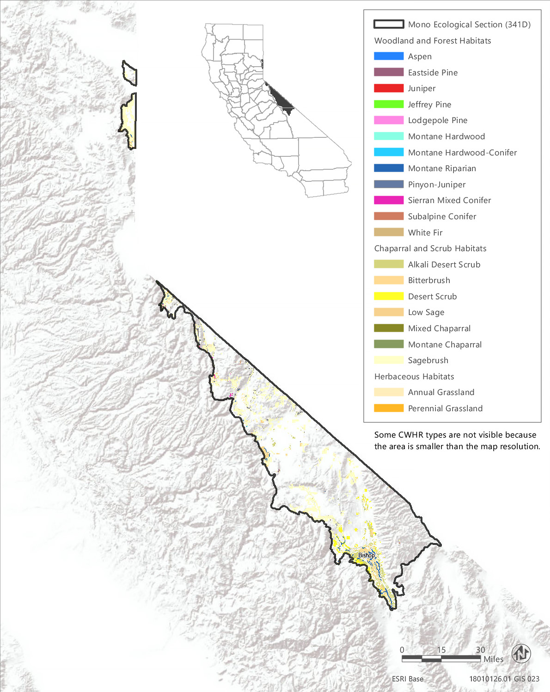
Source: Data received from CAL FIRE in 2018
Figure 3.6-9 CWHR Types - Mono Ecological Section (341D)
Table 3.6-15 Vegetation and Habitat Types within the Treatable Landscape for the Mono Ecological Section
CWHR Classification | Acres | MCV Alliances
Woodland and Forest Habitats
Aspen | 838 | - Aspen groves*
Eastside Pine | 2,383 | - Jeffrey pine forest | - Ponderosa pine forest
Jeffrey Pine | 118 | - Jeffrey pine forest
Juniper | 40 | - Needleleaf rabbitbrush scrub  - Mountain juniper woodland | - Utah juniper woodland*  - Singleleaf pinyon - Utah juniper woodlands
Lodgepole Pine | 62 | - Lodgepole pine forest
Montane Hardwood | 92 | - California black oak forest | - Interior live oak woodland
Montane Hardwood-Conifer | 106 | - None¹
Montane Riparian | 3,413 | - Rocky Mountain maple thickets*  - Water birch thicket*  - Fremont cottonwood forest*  - Black cottonwood forest* | - Interior rose thicket*  - Sandbar willow thicket  - Geyer willow thickets*  - Yellow willow thickets*
Pinyon-Juniper | 10,366 | - Utah juniper woodland*  - Singleleaf pinyon - Utah juniper woodlands | - Ponderosa pine forest
Sierran Mixed Conifer | 164 | - Mixed conifer forest
Subalpine Conifer | 60 | - Whitebark pine forest  - Limber pine woodland*  - Bristlecone pine woodland* | - Western white pine forest  - Mountain hemlock forest
White Fir | 79 | - White fir forest
Chaparral and Scrub Habitats
Alkali Desert Scrub | 21,419 | - Iodine bush scrub*  - Shadscale scrub  - Quailbush scrub  - Parry's saltbush scrub* | - Winterfat scrubland*  - Greasewood scrub  - Alkali sacaton - scratchgrass - alkali cordgrass alkaline wet meadow*  - Bush seepweed scrub*
Bitterbrush | 27,987 | - Bitter brush scrub*
Desert Scrub | 13,314 | - Iodine bush scrub*  - White bursage scrub  - Shadscale scrub  - Quailbush scrub  - Parry's saltbush scrub*  - Rigid spineflower - hairy desert sunflower  - Mojave-Sonoran desert dunes*  - Acton's and Virgin River brittlebush - net-veined goldeneye scrub*  - Nevada joint fir - Anderson's boxthorn - spiny hop sage scrub | - California buckwheat - Parish's goldeneye scrub  - Wright's buckwheat - Heerman's buckwheat - Utah butterfly-bush scrub*  - Winterfat scrubland*  - Spiny menodora scrub*  - James' galleta shrub-steppe*  - Greasewood scrub  - Alkali sacaton - scratchgrass - alkali cordgrass alkaline wet meadow*  - Bush seepweed scrub*
Low Sage | 1,710 | - Little sagebrush scrub | - Black sagebrush scrub*
Mixed Chaparral | 3 | - Deer brush chaparral
Montane Chaparral | 891 | - Mountain whitethorn chaparral | - Tobacco brush or snow bush chaparral
Sagebrush | 93,464 | - Little sagebrush scrub  - Silver sagebrush scrub*  - Black sagebrush scrub*  - Rothrock's sagebrush*  - Big sagebrush  - Mountain big sagebrush  - Small leaf mountain mahogany scrub* | - Curl leaf mountain mahogany scrub  - Black brush scrub  - Mormon tea scrub  - Rubber rabbitbrush scrub  - Parry's rabbitbrush scrub*  - Bitter brush scrub*
Herbaceous Habitats
Annual Grassland | 12,117 | - Cheatgrass - medusahead grassland^{N}
Perennial Grassland | 213 | - Crested wheatgrass rangeland^{N}  - Purple three-awn meadow*  - Poison hemlock or fennel patch^{N}  - Tufted hair grass meadow | - Ashy ryegrass - creeping ryegrass turf*  - Kentucky blue grass turf^{N}  - Curly blue grass grassland*  - Bluebunch wheat grass grassland*
Total | 188,839
*These are designated sensitive natural communities with a state rarity rank of S1 (critically imperiled), S2 (imperiled), or S3 (vulnerable).
^{N} These alliances are dominated by nonnative vegetation.
¹ There are no MCV alliances recognized for this CWHR type in this ecoregion.
Source: CWHR 2019, CNPS 2019, Compiled by Ascent Environmental in 2019

Sensitive Natural Communities and Habitats

Sensitive Natural Communities
There are 29 sensitive natural communities that may occur within the treatable landscape of the Mono Section. The sensitive natural communities associated with each CWHR type in this ecoregion are identified in Table 3.6-15. Examples of sensitive natural communities in this ecoregion include aspen groves, limber pine woodland, bristlecone pine woodland, Utah juniper woodland, winterfat scrubland, James' galleta shrub-steppe, black sagebrush shrub, Rothrock's sagebrush, small leaf mountain mahogany scrub, and purple three-awn meadow.

Wetlands and Other Waters of the United States and Waters of the State
Over 11,500 acres of freshwater emergent wetland, freshwater forested and shrub wetland, freshwater pond, lake, and riverine habitats have been mapped within the treatable landscape of the Mono Section (Table 3.6-2). Additional wetland types that may be present within other CWHR types in the treatable landscape include alkali sacaton - scratchgrass - alkali cordgrass alkaline wet meadows, silver sagebrush scrub, iodine bush scrub, and bush seepweed scrub.

Other Sensitive Habitats
There are just over 3,400 acres of montane riparian habitat mapped in the treatable landscape of this ecoregion. There are eight MCV alliances that may occur in the montane riparian habitat type and all but one of these are designated sensitive natural communities, including Rocky Mountain maple thickets, water birch thicket, Geyer willow thickets, and yellow willow thickets.
A minor amount of black oak forest and interior live oak woodland may be present within the 92 acres of montane hardwood mapped in the treatable landscape of this ecoregion. Unlike many oak woodlands in the state, black oak forest is not seriously threatened by development and has not sustained substantial losses. There are no chaparral or coastal sage scrub habitats present.

Conservation Lands, Special Management Areas, and Other Biologically Important Lands

Habitat Conservation Plan, Natural Community Conservation Plan, and other Conservation Plan Areas
No conservation plans have been adopted for lands within the treatable landscape in the Mono Section.

Protected Open Space Lands
The treatable landscape in the Mono Section contains 35 protected open space units that are recognized in CPAD. These lands cover 99,925 acres, which represent 53 percent of the treatable landscape in the ecoregion. Some of the major land owners include LADWP, CDFW, CSLC, State Parks, and Mono County. Examples of some of the prominent open space units in the Mono Section include Hallelujah Junction Wildlife Area, Slinkard/Little Antelope Wildlife Area, Mono Lake Tufa State Reserve, Bodie State Historic Park, and East Walker River Wildlife Area.

Northern California Coast Section
The Northern California Coast Section (263A) encompasses 4,240,135 acres and encompasses parallel mountain ranges, hills, and valleys in the northern California Coast Ranges and small parts of the Klamath mountains, as well as alluvial river valleys, coastal dunes and terraces, bluffs, and cliffs along the rugged coastline. This ecoregion extends from the Oregon-California border south to the San Francisco Bay. Summer daytime temperatures are often modified by fog and sea breezes. Elevations range from sea level to 3,000 feet. This ecoregion contains 2,395,236 acres of treatable landscape, which represents approximately 56 percent of the total landscape within the ecoregion. Within the treatable landscape exist modeled treatment areas for the following treatment types: WUI fuel reduction (1,315,341 acres), fuel break (229,665 acres), and ecological restoration (1,017,802 acres). The treatable landscape is dispersed across much of the ecoregion and is displayed in Figure 3.6-10.

Vegetation and Habitat Types
The predominant habitat types in the treatable landscape of the Northern California Coast Section are montane hardwood-conifer and redwood, which comprise approximately 21 percent and 20 percent of the treatable landscape, respectively. Douglas fir makes up approximately 18 percent of the treatable landscape area. Other common habitat types are montane hardwood and annual grassland, which comprise approximately 16 and 13 percent of the treatable landscape, respectively. This ecoregion also supports several unique and diverse habitat types. For example, redwood habitat in this ecoregion represents four vegetation alliances, and all of these are designated as sensitive natural communities. Fourteen of the 23 habitat types within the treatable landscape of this ecoregion have potential to include at least one sensitive natural community.
Table 3.6-16 provides the acreage of each CWHR habitat type within the treatable landscape of this ecoregion and the associated MCV alliances that may occur within each CWHR type in this ecoregion. Klamath mixed conifer, white fir, and desert scrub are mapped within this ecoregion; however, none of the corresponding MCV vegetation alliances have been previously identified in this ecoregion. Incense cedar forest, a vegetation alliance that is also designated a sensitive community, is not included in any CWHR type mapped within this ecoregion and is not shown in Table 3.6-16; however, it is known to occur in this ecoregion. Alliances that are designated as sensitive natural communities and those that are dominated by nonnative vegetation are indicated in Table 3.6-16. Sensitive natural communities are discussed in more detail below. The distribution of CWHR types within this ecoregion is shown in Figure 3.6-10.

Sensitive Biological Resources

Special-Status Species
More than 83 special-status wildlife taxa and 269 plant taxa are known or have the potential to occur within the treatable landscape of the Northern California Coast Section, including 45 plant taxa and 47 animal taxa that are state or federally listed as rare, threatened, or endangered. One of these plant species, Tiburon mariposa lily (Calochortus tiburonensis) is known from only one occurrence at Ring Mountain Preserve on the Tiburon Peninsula and nowhere else in the world. Over 65 special-status plant species in this ecoregion are sometimes associated with serpentine soils and 26 plant species in this ecoregion are sometimes associated with bogs and fens. A list of all the special-status plant species known or with potential to occur within the treatable landscape of the Northern California Coast Section, along with their listing status and detailed habitat descriptions, is provided in Appendix BIO-3, Table 9a. A list of special-status wildlife (other than fish) species known or with potential to occur in the treatable landscape of this ecoregion, along with the CWHR types they are associated with, is provided in Appendix BIO-3, Table 9b. Special-status fish known or with potential to occur within the treatable landscape of this ecoregion are identified in Appendix BIO-3, Table 19.
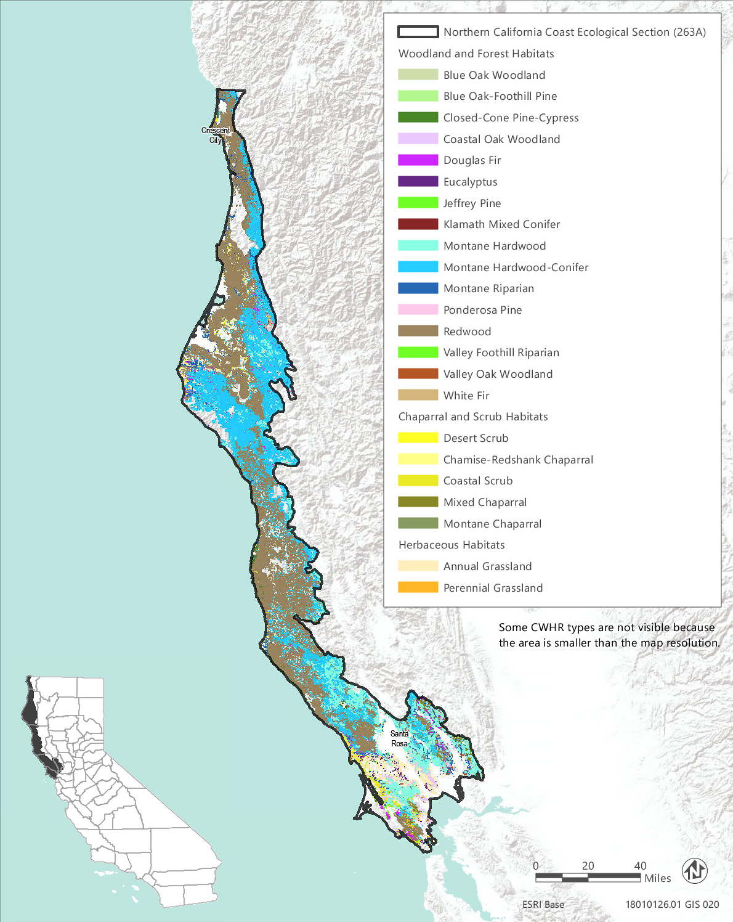
Source: Data received from CAL FIRE in 2018
Figure 3.6-10 CWHR Types - Northern California Coast Ecological Section (263A)
Table 3.6-16 Vegetation and Habitat Types within the Treatable Landscape for the Northern California Coast Ecological Section
CWHR Classification | Acres | MCV Alliances
Woodland and Forest Habitats
Blue Oak Woodland | 4,245 | - Blue oak woodland | - Interior live oak woodland
Blue Oak-Foothill Pine | 1,049 | - Foothill pine woodland | - Blue oak woodland
Closed-Cone Pine-Cypress | 35,165 | - McNab cypress woodland*  - Mendoncino pygmy cypress woodland*  - Sargent cypress woodland* | - Knobcone pine forest  - Beach pine forest*  - Bishop pine - Monterey pine forest*
Coastal Oak Woodland | 79,781 | - Madrone forest*  - Coast live oak woodland | - Mixed oak forest  - California bay forest*
Douglas Fir | 430,231 | - Bigleaf maple forest*  - Port Orford cedar forest*  - Ponderosa pine - Douglas fir forest | - Douglas fir forest  - Douglas fir - tanoak forest*  - Western hemlock forest*
Eucalyptus | 1,830 | - Eucalyptus - tree of heaven - black locust groves^{N}
Jeffrey Pine | 482 | - Jeffrey pine forest
Klamath Mixed Conifer | 1,384 | - None¹
Montane Hardwood | 394,942 | - Bigleaf maple forest*  - California buckeye grove*  - Red alder forest  - Tanoak forest* | - Mixed oak forest  - Canyon live oak forest  - Oregon white oak woodland*  - Interior live oak woodland
Montane Hardwood-Conifer | 495,403 | - Bigleaf maple forest* | - Red alder forest
Montane Riparian | 41,397 | - White alder grove  - Torrent sedge patch*  - Oregon ash grove*  - Hinds's walnut and related stand*  - Fremont cottonwood forest* | - Black cottonwood forest*  - Western Labrador-tea thicket*  - Sandbar willow thicket  - Wild grape shrubland*
Ponderosa Pine | 320 | - Ponderosa pine forest | - Ponderosa pine - Douglas fir forest
Redwood | 470,976 | - Grand fir forest*  - Sitka spruce forest* | - Western azalea patch*  - Redwood forest*
Valley Foothill Riparian | 756 | - Box-elder forest*  - Torrent sedge patch*  - Fremont cottonwood forest*  - Black cottonwood forest*  - Himalayan blackberry - rattlebox - edible fig riparian scrub^{N} | - Brewer willow thicket*  - Sandbar willow thicket  - Red willow thicket*  - Shining willow groves*  - Wild grape shrubland*
Valley Oak Woodland | 947 | - Valley oak woodland*
White Fir | 866 | - None¹
Chaparral and Scrub Habitats
Chamise-Redshank Chaparral | 12,079 | - Chamise chaparral  - Eastwood manzanita chaparral | - Wedge leaf ceanothus chaparral/Buck brush chaparral
Coastal Scrub | 55,792 | - Dune mat*  - California sagebrush scrub  - Coyote brush scrub  - Broom patch^{N}  - Sea rocket sands  - Sand dune sedge swath*  - Blue blossom chaparral  - Hazelnut scrub*  - Live-forever - lichen/moss sparse herbaceous rock outcop  - California coffee berry scrub  - Coastal silk tassel scrub* | - Goldenaster patch*  - Salt rush swale*  - Deer weed scrub  - Silver bush lupine scrub  - Yellow bush lupine scrub  - Silver dune lupine - mock heather scrub*  - Ice plant mats^{N}  - Wax myrtle scrub*  - Coastal bramble*  - Coast range stonecrop draperies  - Poison oak scrub
Desert Scrub | 4 | - None¹
Mixed Chaparral | 38,938 | - Baker manzanita stand*  - Hoary, common, and Stanford manzanita chaparral*  - Eastwood manzanita chaparral  - Mount Tamalpais manzanita chaparral*  - Glossy leaf manzanita chaparral*  - Wedge leaf ceanothus chaparral, Buck brush chaparral  - Deer brush chaparral | - Hairy leaf - woolly leaf ceanothus chaparral*  - Golden chinquapin thickets*  - California coffee berry scrub  - Ocean spray brush*  - Deer weed scrub  - Silver bush lupine scrub  - Scrub oak chaparral  - Leather oak chaparral  - Interior live oak chaparral  - Poison oak scrub
Montane Chaparral | 9,245 | - Mount Tamalpais manzanita chaparral* | - Deer brush chaparral
Herbaceous Habitats
Annual Grassland | 316,561 | - Wild oat grassland^{N}  - Upland mustard and other ruderal forbs^{N}  - Annual brome grassland^{N}  - Red brome or mediterranean grass grassland^{N}  - Cheatgrass - medusahead grassland^{N}  - Yellow star-thistle field^{N}  - Annual dogtail grassland^{N}  - Squirreltail patch | - California poppy - lupine field  - Goldenaster patch*  - California goldfields - dwarf plantain - small fescue flower fields  - Perennial rye grass field^{N}  - White-tip clover swales*
Perennial Grassland | 2,841 | - Bent grass - tall fescue meadow  - Water foxtail meadow*  - European beach grass sward^{N}  - Upland mustard and other ruderal forbs^{N}  - California brome - blue wildrye prairie*  - Pacific reed grass meadow*  - Poison hemlock or fennel patch^{N}  - Sand-aster and perennial buckwheat field  - Pampas grass patch^{N} | - California oat grass prairie*  - Tufted hair grass meadow  - Squirreltail patch  - Idaho fescue grassland*  - Red fescue grassland*  - Gum plant patch*  - Common velvet grass - sweet vernal grass meadow^{N}  - Ashy ryegrass - creeping ryegrass turf*  - Sea lyme grass patch*  - Needle grass - melic grass grassland  - Harding grass - reed canary grass sward^{N}
Total | 2,395,234
*These are designated sensitive natural communities with a state rarity rank of S1 (critically imperiled), S2 (imperiled), or S3 (vulnerable).
^{N} These alliances are dominated by nonnative vegetation.
¹ There are no MCV alliances recognized for this CWHR type in this ecoregion.
Source: CWHR 2019, CNPS 2019, Compiled by Ascent Environmental in 2019

Critical Habitat
Critical habitat has been designated within the treatable landscape of this ecoregion for four plant taxa and eight wildlife taxa. Appendix BIO-4 lists and provides the acreage of critical habitat designated within the treatable landscape of this ecoregion for these species. Examples include northern spotted owl (Strix occidentalis caurina), marbled murrelet (Brachyramphus marmoratus), California red-legged frog (Rana draytonii), and Contra Costa goldfields (Lasthenia conjugens).

Sensitive Natural Communities and Habitats

Sensitive Natural Communities
There are over 49 sensitive natural communities that may occur within the treatable landscape of the Northern California Coast Section. The sensitive natural communities associated with each CWHR type in this ecoregion are identified in Table 3.6-16. They include Mendocino pygmy cypress forest, Sargent cypress woodland, beach pine forest, bishop pine – Monterey pine forest, grand fir forest, Sitka spruce forest, redwood forest, tanoak forest, hazelnut scrub, coastal silk tassel scrub, California oat grass prairie, Pacific reed grass meadow, and red fescue grassland.

Wetlands and Other Waters of the United States and Waters of the State
Wetland habitats known to occur within the treatable landscape of the Central California Coast Section include estuarine and marine deepwater, estuarine and marine wetland, freshwater emergent wetland, freshwater forested and shrub wetland, freshwater pond, lake, and riverine (Table 3.6-2). In addition, vernal pools, white-tip clover swales, water foxtail meadows and Pacific reed grass meadows may be included in areas mapped as annual or perennial grasslands. Major waterways include the Mattole, Klamath, Eel, Mad, Trinity, Van Duzen, Ten Mile, Navarro, and Russian rivers. Humboldt and Arcata Bay support several sloughs and other significant wetlands include Inglenook Fen and Laguna de Santa Rosa.

Other Sensitive Habitats
CWHR riparian habitat types identified within the treatable landscape of the Northern California Coast Section consist of approximately 41,397 acres of montane riparian and 756 acres of valley and foothill riparian habitats. There are 14 MCV alliances that may occur in the montane and valley and foothills riparian habitat types. Eleven of these are designated sensitive natural communities. Examples include Oregon ash grove, western Labrador-tea thickets, box-elder forests, Brewer willow thicket, and shining willow groves. All riparian habitats are considered sensitive and those located near rivers, streams, and lakes are protected under California Fish and Game Code.
Approximately 79,781 acres of coastal oak woodland, 4,245 acres of blue oak woodland, and 947 acres of valley oak woodland habitat have been mapped within the treatable landscape of this ecoregion. In addition, 1,049 acres of blue oak-foothill pine and 394,942 acres of montane hardwood habitat within the treatable landscape of this ecoregion support several additional oak alliances, including Oregon white oak woodland, a designated sensitive natural community.
Chaparral and coastal sage scrub habitats in the treatable landscape consist of approximately 55,792 acres of coastal scrub, 38,938 acres of mixed chaparral, 12,079 acres of chamise-redshank chaparral, and 9,245 acres of montane chaparral. Twenty-two MCV alliances have been mapped and described within areas classified as coastal scrub in this ecoregion, including eight alliances designated as sensitive natural communities. Seventeen MCV alliances have been mapped and described within areas classified as mixed chaparral in this ecoregion, including seven alliances designated as sensitive natural communities. Montane chaparral alliances consist of Mount Tamalpais manzanita chaparral, a designated sensitive community, and deer brush chaparral. Chamise-redshank chaparral consists of chamise chaparral, Eastwood manzanita chaparral, and wedge leaf ceanothus chaparral/buck brush chaparral.
The 470,976 acres of redwood forest habitat within the treatable landscape of this ecoregion support old-growth redwood forest, a designated sensitive natural community. Old-growth redwood forests are a relict vegetation type with roughly five percent of its range remaining (Save the Redwoods League 2019) that support a wide variety of plant and animal species closely associated with this vegetation type.

Conservation Lands, Special Management Areas, and Other Biologically Important Lands

Habitat Conservation Plan, Natural Community Conservation Plan, and other Conservation Plan Areas
The treatable landscape in the Northern California Coast Section includes plan areas for the Green Diamond HCP and Humboldt Redwoods (formerly Pacific Lumber) Company HCP, which have been adopted and are being implemented. Additionally, one HCP and one HCP/NCCP are currently being planned in the treatable landscape. Table 3.6-17 summarizes the conservation plans adopted or in progress, including the acreages of plan areas within the treatable landscape.
Table 3.6-17 Conservation Plans Adopted or In Progress in the Treatable Landscape—Northern California Coast Section
Conservation Plan | Plan Type | Stage | Plan Area Within the Treatable Landscape (Acres)
Green Diamond | HCP | Implementation | 487,027
Humboldt Redwoods (formerly Pacific Lumber) Company | HCP | Implementation | 202,280
Solano Multi-Species | HCP | Planning | 16,917
Mendocino Redwood Company | HCP/NCCP | Planning | 156,706
 |  | Total | 862,930

Protected Open Space Lands
The treatable landscape in the Northern California Coast Section contains 440 protected open space units that are recognized in CPAD. These lands cover 271,895 acres, which represent 11 percent of the treatable landscape in the ecoregion. Some of the major land owners include State Parks, CAL FIRE, The Conservation Fund, CDFW, Marin County Open Space District, and Sonoma Land Trust. Examples of some of the prominent open space units in the Northern California Coast Section include Humboldt Redwoods State Park, Mount Tamalpais State Park, Samuel P. Taylor State Park, Lake Earl Wildlife Area, Mottole River Ecological Reserve, Petaluma Marsh Wildlife Area, and Lucas Valley Open Space Preserve.

Northern California Coast Ranges Section
The Northern California Coast Ranges Section (M261B) encompasses 3,836,186 acres and includes mountains, hills, and valleys in the interior part of the northern California Coast Ranges mountains, north of the Carquinez Straight. Elevations range from 1,000 to 7,500 feet. This ecoregion contains 1,529,503 acres of treatable landscape, which represents approximately 40 percent of the total landscape within the ecoregion. Within the treatable landscape exist modeled treatment areas for the following treatment types: WUI fuel reduction (719,591 acres), fuel break (206,294 acres), and ecological restoration (754,399 acres). The treatable landscape within this ecoregion consists of treatment areas on many of the western and southern slopes and ridgelines of the north-south running ranges and is displayed in Figure 3.6-11.

Vegetation and Habitat Types
The predominant habitat types in the treatable landscape of the North California Coast Ranges Section are montane hardwood and Douglas fir, which comprise approximately 35 percent and 16 percent of the treatable landscape, respectively. Annual grassland and montane hardwood-conifer habitats combined make up approximately 12 percent and 11 percent, respectively, of the treatable landscape area. Four chaparral habitats make up approximately 12 percent of the treatable landscape area. Combined, montane hardwood and Douglas fir in this ecoregion represent 14 vegetation alliances, and half of these are designated as sensitive natural communities. Vernal pools may also be present in areas mapped as annual or perennial grasslands in this ecoregion.
Table 3.6-18 provides the acreage of each CWHR habitat type within the treatable landscape of this ecoregion and the associated MCV vegetation alliances that may occur within each CWHR type in this ecoregion. Alliances that are designated as sensitive natural communities and those that are dominated by nonnative vegetation are indicated in Table 3.6-18. Sensitive natural communities are discussed in more detail below. The distribution of CWHR types within this ecoregion is shown in Figure 3.6-11.
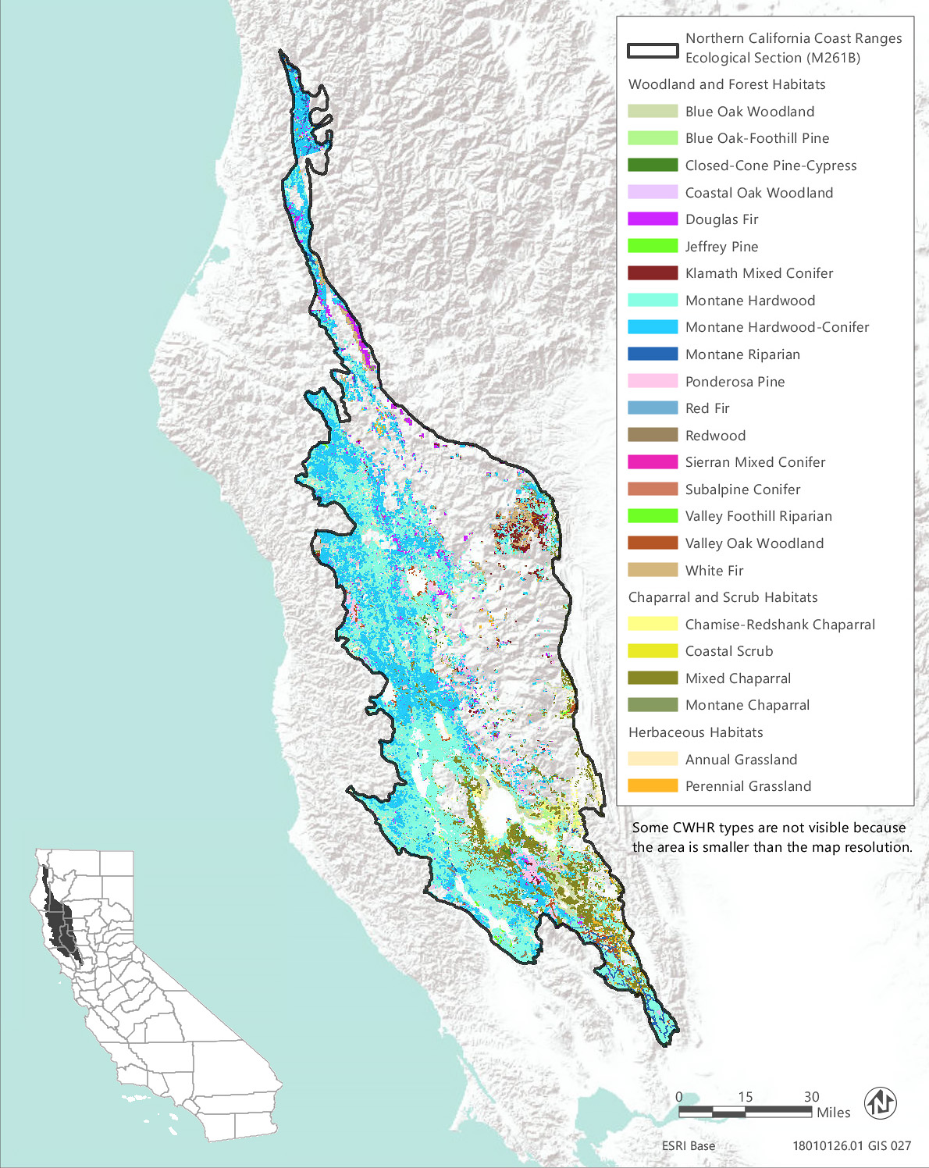
Source: Data received from CAL FIRE in 2018
Figure 3.6-11 CWHR Types - Northern California Coast Ranges Ecological Section (M261B)
Table 3.6-18 Vegetation and Habitat Types within the Treatable Landscape for the Northern California Coast Ranges Ecological Section
CWHR Classification | Acres | MCV Alliances
Woodland and Forest Habitats
Blue Oak Woodland | 70,372 | - Blue oak woodland | - Interior live oak woodland
Blue Oak-Foothill Pine | 42,203 | - Foothill pine woodland | - Blue oak woodland
Closed-Cone Pine-Cypress | 9,715 | - McNab cypress woodland*  - Sargent cypress woodland* | - Knobcone pine forest
Coastal Oak Woodland | 26,913 | - Madrone forest*  - Coast live oak woodland | - Mixed oak forest  - California bay forest*
Douglas Fir | 249,160 | - White fir - Douglas fir forest  - Bigleaf maple forest*  - Ponderosa pine - Douglas fir forest | - Douglas fir forest  - Douglas fir - incense cedar forest*  - Douglas fir - tanoak forest*  - Western hemlock forest*
Jeffrey Pine | 223 | - Jeffrey pine forest
Klamath Mixed Conifer | 27,056 | - None¹
Montane Hardwood | 536,562 | - Bigleaf maple forest*  - California buckeye grove*  - Tanoak forest*  - Mixed oak forest | - Canyon live oak forest  - Oregon white oak woodland*  - Interior live oak woodland
Montane Hardwood-Conifer | 161,685 | - Bigleaf maple forest*
Montane Riparian | 5,610 | - Mountain alder thicket*  - White alder grove  - Sitka alder thicket*  - Torrent sedge patch*  - Oregon ash grove* | - Hinds's walnut and related stand*  - Fremont cottonwood forest*  - Black cottonwood forest*  - Sandbar willow thicket  - Wild grape shrubland*
Ponderosa Pine | 16,650 | - Ponderosa pine forest | - Ponderosa pine - Douglas fir forest
Red Fir | 1,207 | - Red fir forest | - Red fir - white fir forest
Redwood | 1,348 | - Redwood forest*
Sierran Mixed Conifer | 2 | - Incense cedar forest*  - Mixed oak forest | - Ponderosa pine - Douglas fir forest  - Douglas fir - incense cedar forest*
Subalpine Conifer | 28 | - Foxtail pine woodland* | - Mountain hemlock forest
Valley Foothill Riparian | 646 | - Box-elder forest*  - Torrent sedge patch*  - Button willow thicket*  - Fremont cottonwood forest*  - Black cottonwood forest* | - Himalayan blackberry - rattlebox - edible fig riparian scrub^{N}  - Brewer willow thicket*  - Sandbar willow thicket  - Wild grape shrubland*
Valley Oak Woodland | 3,822 | - Valley oak woodland*
White Fir | 7,328 | - White fir forest  - White fir - sugar pine forest | - White fir - Douglas fir forest  - Red fir - white fir forest
Chaparral and Scrub Habitats
Chamise-Redshank Chaparral | 39,933 | - Chamise chaparral  - Eastwood manzanita chaparral | - Wedge leaf ceanothus chaparral/Buck brush chaparral
Coastal Scrub | 225 | - Coyote brush scrub  - Blue blossom chaparral  - Live-forever - lichen/moss sparse herbaceous rock outcop  - California coffee berry scrub | - Goldenaster patch*  - Deer weed scrub  - Silver bush lupine scrub  - Coast range stonecrop draperies
Mixed Chaparral | 128,611 | - Baker manzanita stand*  - Hoary, common, and Stanford manzanita chaparral*  - Eastwood manzanita chaparral  - Wedge leaf ceanothus chaparral, Buck brush chaparral  - Deer brush chaparral  - Hairy leaf - woolly leaf ceanothus chaparral* | - Birch leaf mountain mahogany chaparral  - California coffee berry scrub  - Ocean spray brush*  - Deer weed scrub  - Silver bush lupine scrub  - Holly leaf cherry - toyon - greenbark ceanothus chaparral  - Leather oak chaparral  - Interior live oak chaparral
Montane Chaparral | 6,130 | - Green leaf manzanita chaparral  - Whiteleaf manzanita chaparral  - Mountain whitethorn chaparral  - Deer brush chaparral | - Birch leaf mountain mahogany chaparral  - Bush chinquapin chaparral*  - Brewer oak scrub  - Huckleberry oak chaparral
Herbaceous Habitats
Annual Grassland | 182,054 | - Barbed goatgrass patch^{N}  - Wild oat grassland^{N}  - Upland mustard and other ruderal forbs^{N}  - Annual brome grassland^{N}  - Red brome or mediterranean grass grassland^{N}  - Cheatgrass - medusahead grassland^{N} | - Yellow star-thistle field^{N}  - Annual dogtail grassland^{N}  - Squirreltail patch  - California poppy - lupine field  - Goldenaster patch*  - California goldfields - dwarf plantain - small fescue flower fields California coffee berry scrub
Perennial Grassland | 2,019 | - Bent grass - tall fescue meadow  - Water foxtail meadow*  - Upland mustard and other ruderal forbs^{N}  - California brome - blue wildrye prairie*  - Small-fruited sedge meadow*  - Pampas grass patch^{N} | - California oat grass prairie*  - Squirreltail patch  - Idaho fescue grassland*  - Ashy ryegrass - creeping ryegrass turf*  - Needle grass - melic grass grassland  - Harding grass - reed canary grass sward^{N}  - Kentucky blue grass turf^{N}
Total | 1,519,502
*These are designated sensitive natural communities with a state rarity rank of S1 (critically imperiled), S2 (imperiled), or S3 (vulnerable).
^{N} These alliances are dominated by nonnative vegetation.
¹ There are no MCV alliances recognized for this CWHR type in this ecoregion.
Source: CWHR 2019, CNPS 2019, Compiled by Ascent Environmental in 2019

Sensitive Biological Resources

Special-Status Species
More than 75 special-status wildlife taxa and 130 plant taxa are known or have the potential to occur within the treatable landscape of the Northern California Coast Ranges Section, including 24 plant taxa and 24 animal taxa that are state or federally listed as rare, threatened, or endangered. Approximately one-third of these plants and animals listed as rare, threatened, or endangered are associated with vernal pools. Over 49 special-status plant species in this ecoregion are associated with serpentine soils. A list of all the special-status plant species known or with potential to occur within the treatable landscape of the Central California Coast Section, along with their listing status and detailed habitat descriptions, is provided in Appendix BIO-3, Table 10a. A list of special-status wildlife (other than fish) species known or with potential to occur in the treatable landscape of this ecoregion, along with the CWHR types they are associated with, is provided in Appendix BIO-3, Table 10b. Special-status fish known or with potential to occur within the treatable landscape of this ecoregion are identified in Appendix BIO-3, Table 19.

Critical Habitat
Critical habitat has been designated within the treatable landscape of this ecoregion for one plant taxa, slender Orcutt grass (Orcuttia tenuis), and three wildlife taxa, northern spotted owl (Strix occidentalis caurina), marbled murrelet (Brachyramphus marmoratus), and California red-legged frog (Rana draytonii). Appendix BIO-4 lists and provides the acreage of critical habitat designated within the treatable landscape of this ecoregion for these species.

Sensitive Natural Communities and Habitats

Sensitive Natural Communities
There are 37 sensitive natural communities that may occur within the treatable landscape of the Northern California Coast Ranges Section. The sensitive natural communities associated with each CWHR type in this ecoregion are identified in Table 3.6-18. They include McNab cypress woodland, Sargent cypress woodland, western hemlock forest, foxtail pine woodland, box-elder forest, button-willow thicket, and goldenaster patch.

Wetlands and Other Waters of the United States and Waters of the State
Wetland habitats known to occur within the treatable landscape of the Northern California Coast Ranges Section include freshwater emergent wetland, freshwater forested and shrub wetland, freshwater pond, lake, and riverine wetlands (Table 3.6-2). In addition, torrent sedge patch may be present within areas mapped as montane riparian or valley foothill riparian, and vernal pools, water foxtail meadow, and small-fruited sedge meadow are wetland communities that may be present in areas mapped as annual or perennial grasslands in this ecoregion. Major water features include Clear Lake, the Eel River, and Russian River.

Other Sensitive Habitats
CWHR riparian habitat types identified within the treatable landscape of the Northern California Coast Ranges Section consist of approximately 5,610 acres of montane riparian habitat and 646 acres of valley and foothill riparian habitat. There are 10 MCV alliances that may occur in the montane riparian habitat type and nine that may occur in the valley and foothill riparian habitat. All but four of the riparian alliances are designated sensitive natural communities. Examples include mountain alder thicket, Sitka alder thicket, Hind’s walnut and related stand, and brewer willow thicket. All riparian habitats are considered sensitive and those located near rivers, streams, and lakes are protected under California Fish and Game Code.
Approximately 112,575 acres of blue oak woodland and blue oak-foothill pine, 26,913 acres of coastal oak woodland, and 3,822 acres of valley oak woodland habitats have been mapped within the treatable landscape of this ecoregion. Mixed oak forest, canyon live oak forest, Oregon white oak woodland, and interior live oak woodland may be present in the 536,562 acres of montane hardwood.
Chaparral habitats in the treatable landscape consist of approximately 128,611 acres of mixed chaparral, 39,933 acres of chamise-redshank chaparral, and 6,130 acres of montane chaparral. Over 20 MCV chaparral alliances, including five designated as sensitive natural communities, are present within the treatable landscape of this ecoregion. Examples include Eastwood manzanita chaparral, Baker manzanita chaparral, birch leaf mountain mahogany chaparral, hairy leaf-woolly leaf ceanothus chaparral, and bush chinquapin chaparral.

Conservation Lands, Special Management Areas, and Other Biologically Important Lands

Habitat Conservation Plan, Natural Community Conservation Plan, and other Conservation Plan Areas
The treatable landscape in the Northern California Coast Ranges Section includes plan areas for the Green Diamond HCP and Humboldt Redwoods (formerly Pacific Lumber) Company HCP, which have been adopted and are being implemented. Additionally, one HCP and two HCP/NCCPs are currently being planned in the treatable landscape. Table 3.6-19 summarizes the conservation plans adopted or in progress, including the acreages of plan areas within the treatable landscape.
Table 3.6-19 Conservation Plans Adopted or In Progress in the Treatable Landscape—Northern California Coast Ranges Section
Conservation Plan | Plan Type |  | Stage | Plan Area Within the Treatable Landscape (Acres)
Green Diamond | HCP |  | Implementation | 87,875
Humboldt Redwoods (formerly Pacific Lumber) Company | HCP |  | Implementation | 638
Solano Multi-Species | HCP |  | Planning | 3,190
Mendocino Redwood Company | HCP/NCCP |  | Planning | 29
Yolo Natural Heritage Program | HCP/NCCP |  | Planning | 100
 |  |  | Total | 91,832

Protected Open Space Lands
The treatable landscape in the Northern California Coast Ranges Section contains 93 protected open space units that are recognized in CPAD. These lands cover 47,825 acres, which represent 3 percent of the treatable landscape in the ecoregion. Some of the major land owners include CSLC, CAL FIRE, California Academy of Sciences, CDFW, The Wildlands Conservancy, State Parks, and Napa County Regional Park and Open Space District. Examples of some of the prominent open space units in the Northern California Coast Ranges Section include Boggs Mountain Demonstration State Forest, Pepperwood Ranch Natural Preserve, Cache Creek Wildlife Area, and Clear Lake State Park.

Northern California Interior Coast Ranges Section
The Northern California Interior Coast Ranges Section (M261C) encompasses 1,851,914 acres and consists of the southeastern edge of the northern California Coast Ranges and hills and terraces along the west side and north end of the Sacramento Valley. Elevations range from 200 to 2,500 feet. This ecoregion contains 904,575 acres of treatable landscape, which represents approximately 49 percent of the total landscape within the ecoregion. Within the treatable landscape exist modeled treatment areas for the following treatment types: WUI fuel reduction (384,620 acres), fuel break (144,246 acres), and ecological restoration (474,254 acres). The treatable landscape is dispersed throughout much of this ecoregion, from the city of Redding area in the north to near the city of Vacaville in the south and is displayed in Figure 3.6-12.
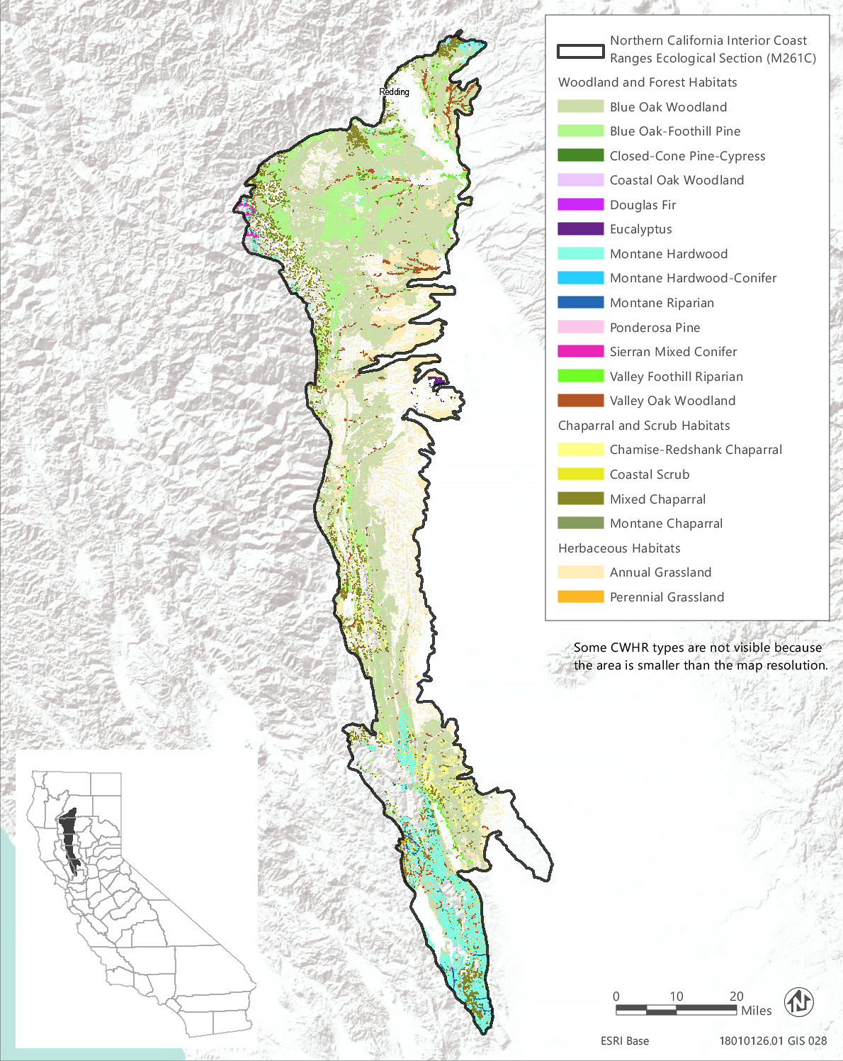
Source: Data received from CAL FIRE in 2018
Figure 3.6-12 CWHR Types - Northern California Interior Coast Ranges Ecological Section (M261C)

Vegetation and Habitat Types
Woodland habitats make up the majority of the treatable landscape of the North California Interior Coast Ranges Section and the predominant woodland types are blue oak woodland and blue oak-foothill pine, which comprise approximately 66 percent of the treatable landscape. Eleven other woodland habitats representing up to 22 vegetation alliances are also present and make up approximately 7 percent of the treatable landscape. Annual grassland is the next most common habitat type comprising approximately 21 percent of the treatable landscape. Three chaparral and one scrub habitat type make up approximately 6 percent of the treatable landscape area. The distribution of CWHR types within the treatable landscape of this ecoregion is shown in Figure 3.6-12 and the acreage of each type, as well as associated MCV alliances, is provided in Table 3.6-20.
Table 3.6-20 Vegetation and Habitat Types within the Treatable Landscape for the Northern California Interior and Coast Ranges Ecological Section
CWHR Classification | Acres | MCV Alliances
Woodland and Forest Habitats
Blue Oak Woodland | 434,646 | - Blue oak woodland
Blue Oak-Foothill Pine | 164,089 | - Foothill pine woodland | - Blue oak woodland
Closed-Cone Pine-Cypress | 6 | - Knobcone pine forest
Coastal Oak Woodland | 719 | - Coast live oak woodland | - California bay forest*
Douglas Fir | 2 | - Douglas fir forest
Eucalyptus | 991 | - Eucalyptus - tree of heaven - black locust groves^{N}
Montane Hardwood | 41,321 | - California buckeye grove*  - Canyon live oak forest | - Oregon white oak woodland*  - Interior live oak woodland
Montane Hardwood-Conifer | 341 | - Bigleaf maple forest*
Montane Riparian | 749 | - White alder grove  - Fremont cottonwood forest* | - Sandbar willow thicket  - Wild grape shrubland*
Ponderosa Pine | 106 | - Ponderosa pine forest
Sierran Mixed Conifer | 687 | - Mixed conifer forest
Valley Foothill Riparian | 2,826 | - Box-elder forest*  - Button willow thicket*  - Fremont cottonwood forest*  - Himalayan blackberry - rattlebox - edible fig riparian scrub^{N} | - Sandbar willow thicket  - Red willow thicket*  - Wild grape shrubland*
Valley Oak Woodland | 6,926 | - Valley oak woodland*
Chaparral and Scrub Habitats
Chamise-Redshank Chaparral | 20,948 | - Chamise chaparral | - Wedge leaf ceanothus chaparral/Buck brush chaparral
Coastal Scrub | 437 | - Live-forever - lichen/moss sparse herbaceous rock outcop  - California yerba santa scrub  - Wright's buckwheat - Heerman's buckwheat - Utah butterfly-bush scrub* | - California coffee berry scrub  - Goldenaster patch*  - Deer weed scrub  - Silver bush lupine scrub
Mixed Chaparral | 36,350 | - Hoary, common, and Stanford manzanita chaparral*  - Whiteleaf manzanita chaparral  - Wedge leaf ceanothus chaparral, Buck brush chaparral  - Hairy leaf - woolly leaf ceanothus chaparral*  - Birch leaf mountain mahogany chaparral | - Bush poppy scrub  - California yerba santa scrub  - California coffee berry scrub  - Deer weed scrub  - Silver bush lupine scrub  - Scrub oak chaparral  - Leather oak chaparral  - Interior live oak chaparral
Montane Chaparral | 889 | - Whiteleaf manzanita chaparral | - Birch leaf mountain mahogany chaparral
Herbaceous Habitats
Annual Grassland | 192,383 | - Fiddleneck - phacelia field  - Wild oat grassland^{N}  - Annual brome grassland^{N}  - Red brome or mediterranean grass grassland^{N}  - Cheatgrass - medusahead grasslandN  - Yellow star-thistle field^{N} | - Annual dogtail grassland  - Goldenaster patch*  - California goldfields - dwarf plantain - small fescue flower fields  - Popcorn flower field  - White-tip clover swales*  - California yerba santa scrub
Perennial Grassland | 160 | - Water foxtail meadow*  - Needle grass - melic grass grassland | - Curly blue grass grassland*
Total | 904,576
*These are designated sensitive natural communities with a state rarity rank of S1 (critically imperiled), S2 (imperiled), or S3 (vulnerable).
^{N} These alliances are dominated by nonnative vegetation.
Source: CWHR 2019, CNPS 2019, Compiled by Ascent Environmental in 2019

Sensitive Biological Resources

Special-Status Species
More than 62 special-status wildlife taxa and 44 plant taxa are known or have the potential to occur within the treatable landscape of the Northern California Interior Coast Ranges Section, including four plant taxa and 32 animal taxa that are state or federally listed as rare, threatened, or endangered, are candidates for listing, or are fully protected. Over 49 special-status plant species in this ecoregion are associated with serpentine soils. A list of all the special-status plant species known or with potential to occur within the treatable landscape of the Central California Coast Section, along with their listing status and detailed habitat descriptions, is provided in Appendix BIO-3, Table 11a. A list of special-status wildlife (other than fish) species known or with potential to occur in the treatable landscape of this ecoregion, along with the CWHR types they are associated with, is provided in Appendix BIO-3, Table 11b. Special-status fish known or with potential to occur within the treatable landscape of this ecoregion are identified in Appendix BIO-3, Table 19.

Critical Habitat
Designated critical habitat is present within the treatable landscape of the Northern California Interior Coast Ranges Section for six species. Four of these species – California tiger salamander, vernal pool fairy shrimp, vernal pool tadpole shrimp, and slender Orcutt grass – are associated with vernal pool habitats. Appendix BIO-4 lists and provides the acreage of critical habitat designated within the treatable landscape of this ecoregion for these species.

Sensitive Natural Communities and Habitats

Sensitive Natural Communities
There are 17 sensitive natural communities that may occur within the treatable landscape of the Northern California Interior Coast Ranges Section. The sensitive natural communities associated with each CWHR type in this ecoregion are identified in Table 3.6-20. Examples of sensitive natural communities in this ecoregion include California bay forest, Oregon white oak woodland, valley oak woodland, white-tip clover swales, and Curly blue grass grassland.

Wetlands and Other Waters of the United States and Waters of the State
Wetland habitats known to occur within the treatable landscape of the Northern California Interior Coast Ranges Section consist of nearly 15,000 acres of freshwater emergent wetland, freshwater forested and shrub wetland, freshwater pond, lake, and riverine wetlands (Table 3.6-2). Vernal pools and swales and water foxtail meadows may also be present in areas mapped as annual or perennial grasslands in this ecoregion.

Other Sensitive Habitats
CWHR riparian habitat types identified within the treatable landscape of the Northern California Interior Coast Ranges Section consist of approximately 2,826 acres of valley and foothill riparian habitat and 749 acres of montane riparian habitat. There are seven MCV alliances that may occur in the valley and foothill riparian habitat and four that may occur in the montane riparian habitat type. Five of the riparian alliances are designated sensitive natural communities. Examples include wild grape shrubland, box-elder forest, button willow thicket, and red willow thicket. All riparian habitats are considered sensitive and those located near rivers, streams, and lakes are protected under California Fish and Game Code.
Approximately 598,735 acres of blue oak woodland and blue oak-foothill pine, 719 acres of coastal oak woodland, and 6,926 acres of valley oak woodland habitats have been mapped within the treatable landscape of this ecoregion. In addition, canyon live oak forest, Oregon white oak woodland, and interior live oak woodland may be present in the 41,321 acres of montane hardwood.
Combined, chaparral and coastal scrub habitats in this ecoregion represent 18 vegetation alliances, and four of these, Hoary, common, and Stanford manzanita chaparral hairy leaf - woolly leaf ceanothus chaparral, Wright's buckwheat - Heerman's buckwheat - Utah butterfly-bush scrub and goldenaster, patches are designated as sensitive natural communities.

Conservation Lands, Special Management Areas, and Other Biologically Important Lands

Habitat Conservation Plan, Natural Community Conservation Plan, and other Conservation Plan Areas
No conservation plans have been adopted for lands within the treatable landscape in the Northern California Interior Coast Ranges Section.

Protected Open Space Lands
The treatable landscape in the Northern California Interior Coast Ranges Section contains 43 protected open space units that are recognized in CPAD. These lands cover 18,677 acres, which represent 2 percent of the treatable landscape in the ecoregion. Some of the major land owners include CDFW, National Audubon Society, University of California, Quail Ridge Wilderness Conservancy, and Yolo County. Examples of some of the prominent open space units in the Northern California Interior Coast Ranges Section include Knoxville Wildlife Area, Bobcat Ranch, Cache Creek Wildlife Area, Putah Creek Wildlife Area, Quail Ridge Ecological Reserve, and Stebbins Cold Canyon Reserve.

Northwestern Basin and Range Section
The Northwestern Basin and Range Section (342B) encompasses 1,291,437 acres and consists of nearly level basins and valleys, long alluvial fans, north-south trending mountain ranges, and volcanic plateaus. Elevations range from 4,000 to 7,200 feet. This ecoregion contains 276,954 acres of treatable landscape, which represents approximately 21 percent of the total landscape within the ecoregion. Within the treatable landscape exist modeled treatment areas for the following treatment types: WUI fuel reduction (50,594 acres), fuel break (58,482 acres), and ecological restoration (216,049 acres). The treatable landscape in dispersed across this ecoregion, located in the northeastern part of the state. The treatable landscape in this ecoregion is displayed in Figure 3.6-13.
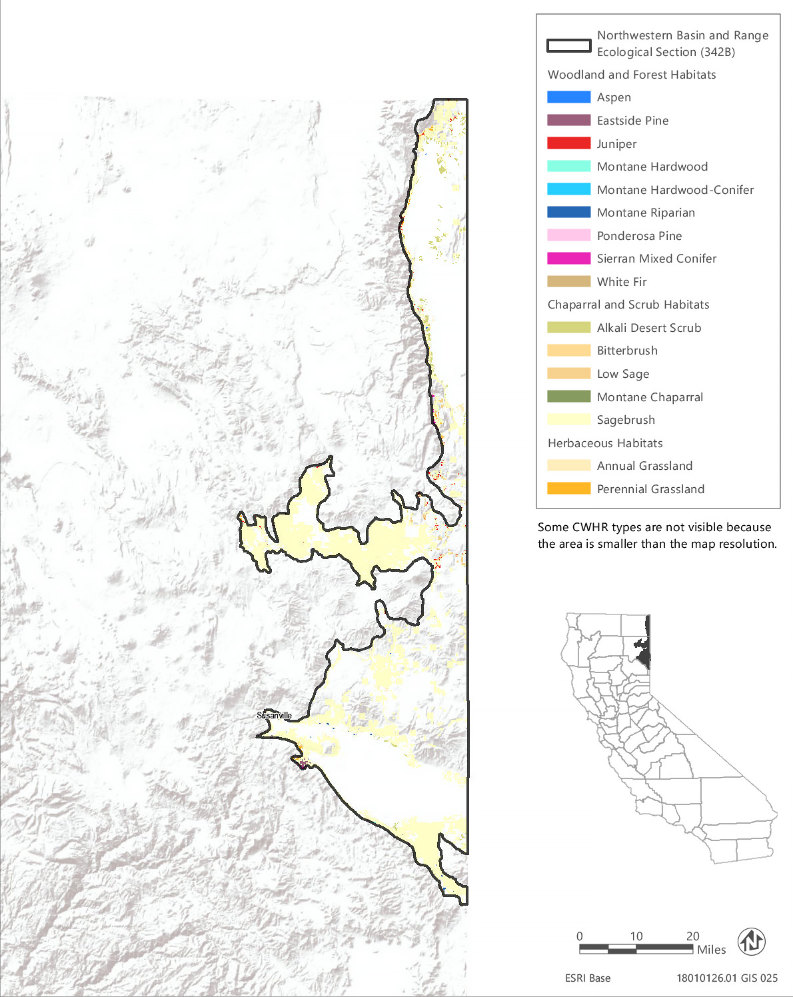
Source: Data received from CAL FIRE in 2018
Figure 3.6-13 CWHR Types - Northwestern Basin and Range Ecological Section (342B)

Vegetation and Habitat Types
The predominant CWHR type in the treatable landscape of the Northwestern Basin and Range Section is sagebrush, which makes up about 90 percent of the land cover. There are seven MCV alliances that may be found within areas mapped as sagebrush in this ecoregion. Other scrub habitat types comprise less than 4 percent of the treatable landscape while woodland and forest habitats make up just over 4 percent of the treatable landscape. Annual and perennial grasslands comprise 5,688 acres, or just 2 percent of the treatable landscape. Annual grassland here is composed of nonnative vegetation alliances while perennial grasslands include mostly native alliances that are also sensitive natural communities. The distribution of CWHR types within the treatable landscape of this ecoregion is shown in Figure 3.6-13 and the acreage of each type, as well as associated MCV alliances, is provided in Table 3.6-21.
Table 3.6-21 Vegetation and Habitat Types within the Treatable Landscape for the Northwestern Basin and Range Ecological Section
CWHR Classification | Acres | MCV Alliances
Woodland and Forest Habitats
Aspen | 366 | - Aspen groves*
Eastside Pine | 3,166 | - Ponderosa pine forest
Juniper | 7,458 | - Western juniper woodland
Montane Hardwood | 135 | - California black oak forest
Montane Hardwood-Conifer | 115 | - None¹
Montane Riparian | 376 | - Sandbar willow thicket
Ponderosa Pine | 45 | - Ponderosa pine forest
White Fir | 6 | - White fir forest
Chaparral and Scrub Habitats
Alkali Desert Scrub | 5,384 | - Iodine bush scrub*  - Fourwind saltbush scrub  - Shadscale scrub  - Winterfat scrubland* | - Greasewood scrub  - Alkali sacaton - scratchgrass - alkali cordgrass alkaline wet meadow*  - Bush seepweed scrub*
Bitterbrush | 1,416 | - Bitter brush scrub*
Low Sage | 3,991 | - Little sagebrush scrub | - Lahontan sagebrush scrub
Montane Chaparral | 101 | - Tobacco brush or snow bush chaparral
Sagebrush | 248,457 | - Little sagebrush scrub  - Lahontan sagebrush scrub  - Silver sagebrush scrub* | - Big sagebrush  - Curl leaf mountain mahogany scrub  - Rubber rabbitbrush scrub  - Bitter brush scrub*
Herbaceous Habitats
Annual Grassland | 4,097 | - Wild oat grassland^{N}  - Annual brome grassland^{N} | - Red brome or mediterranean grass grassland^{N}  - Cheatgrass - medusahead grassland^{N}
Perennial Grassland | 1,591 | - Indian rice grass grassland*  - Crested wheatgrass rangeland^{N}  - Idaho fescue grassland* | - Ashy ryegrass - creeping ryegrass turf*  - Curly blue grass grassland*  - Bluebunch wheat grass grassland*
Total | 276,704
*These are designated sensitive natural communities with a state rarity rank of S1 (critically imperiled), S2 (imperiled), or S3 (vulnerable).
^{N} These alliances are dominated by nonnative vegetation.
¹ There are no MCV alliances recognized for this CWHR type in this ecoregion.
Source: CWHR 2019, CNPS 2019, Compiled by Ascent Environmental in 2019

Sensitive Biological Resources

Special-Status Species
There are 55 special-status wildlife taxa and 66 plant taxa known or with potential to occur in the treatable landscape of the Mono Section, including 22 animal taxa that are state or federally listed as rare, threatened, or endangered or fully protected. There are no plant species listed state or federally listed as rare, threatened, or endangered in this ecoregion. A list of all the special-status plant species known or with potential to occur within the treatable landscape of the Great Valley Section, along with their listing status and detailed habitat descriptions, is provided in Appendix BIO-3, Table 12a. A list of special-status wildlife (other than fish) species known or with potential to occur in the treatable landscape of this ecoregion, along with the CWHR types they are associated with, is provided in Appendix BIO-3, Table 12b. Special-status fish known or with potential to occur in the ecoregion are identified in Appendix BIO-3, Table 19.

Critical Habitat
There is no designated critical habitat within the treatable landscape of the Northwestern Basin and Range Section.

Sensitive Natural Communities and Habitats

Sensitive Natural Communities
There are 12 sensitive natural communities that may occur within the treatable landscape of the Northwestern Basin and Range Section. The sensitive natural communities associated with each CWHR type in this ecoregion are identified in Table 3.6-21. Examples of sensitive natural communities in this ecoregion include aspen groves, Bitter brush scrub, Indian rice grass grassland, Idaho fescue grassland, ashy ryegrass - creeping ryegrass turf, and Curly blue grass grassland.

Wetlands and Other Waters of the United States and Waters of the State
Over 52,500 acres of freshwater emergent wetland, freshwater forested and shrub wetland, freshwater pond, lake, and riverine habitats have been mapped within the treatable landscape of the Northwestern Basin and Range Section (Table 3.6-2). Additional wetland types that may be present within other CWHR types in the treatable landscape include alkali sacaton - scratchgrass - alkali cordgrass alkaline wet meadows, silver sagebrush scrub, iodine bush scrub, and bush seepweed scrub.

Other Sensitive Habitats
There are just 375 acres of montane riparian habitat mapped in the treatable landscape of this ecoregion and only one MCV alliance, sandbar willow thicket, associated with this CWHR type in this ecoregion.
A minor amount of black oak forest may be present within the 135 acres of montane hardwood mapped in the treatable landscape of this ecoregion. This is the only MCV alliance recognized to occur in this CWHR type in this ecoregion. Unlike many oak woodlands in the state, black oak forest is not seriously threatened by development and has not sustained substantial losses. There are 101 acres of montane chaparral mapped within the treatable landscape and one MCV alliance, tobacco brush or snow bush chaparral, associated with this type in this ecoregion. This is a fire successional chaparral type with a fire return interval of 40 to 75 years (Sawyer et al. 2009). Both these species sprout vigorously following fire and also reestablish form seed following fire.

Conservation Lands, Special Management Areas, and Other Biologically Important Lands

Habitat Conservation Plan, Natural Community Conservation Plan, and other Conservation Plan Areas
No conservation plans have been adopted for lands within the treatable landscape in the Northwestern Basin and Range Section.

Protected Open Space Lands
The treatable landscape in the Northwestern Basin and Range Section contains 13 protected open space units that are recognized in CPAD. These lands cover 29,711 acres, which represent 11 percent of the treatable landscape in the ecoregion. The four land owners of these open space units are CDFW, CSLC, Lassen County, and Modoc County. Examples of some of the prominent open space units in the Northwestern Basin and Range Section include Doyle Wildlife Area, Surprise Valley Wildlife Area, Honey Lake Wildlife Area, and Susanville Ranch Park.

Sierra Nevada Section
The Sierra Nevada Section (M261E) encompasses 12,749,269 acres and includes much of the Sierra Nevada, which is a north-northwest aligned mountain range that is much steeper on the east than on the west side. Elevations range from 1,000 to 14,495 feet and include temperate to very cold areas. Local relief ranges from 500 to 2,000 feet. This ecoregion contains 2,138,620 acres of treatable landscape, which represents approximately 17 percent of the total landscape within the ecoregion. Within the treatable landscape exist modeled treatment areas for the following treatment types: WUI fuel reduction (1,083,025 acres), fuel break (236,577 acres), and ecological restoration (1,010,243 acres). The treatable landscape is dispersed across the mountains and ridges of the ecoregion, outside of the large tracts of federal land. The treatable landscape in this ecoregion is displayed in Figure 3.6-14.

Vegetation and Habitat Types
The predominant habitat types in the treatable landscape of the Sierra Nevada Section are Sierran mixed conifer and ponderosa pine, which comprise approximately 28 percent and 10 percent of the treatable landscape, respectively. There are four MCV alliances that may be found within areas mapped as Sierran mixed conifer and three MCV alliances that may be found in areas mapped as ponderosa pine in this ecoregion. Montane hardwood-conifer and annual grassland habitats make up approximately 9 percent each of the treatable landscape area. Chaparral and scrub habitats make up approximately 14 percent of the treatable landscape area and represent a large diversity of vegetation alliances. This ecoregion supports diverse habitat types and the treatable landscape area is comprised of 31 habitat types and over 178 vegetation alliances.
Table 3.6-22 provides the acreage of each CWHR habitat type within the treatable landscape of this ecoregion and the associated MCV vegetation alliances that may occur within each CWHR type in this ecoregion. Alliances that are designated as sensitive natural communities and those that are dominated by nonnative vegetation are indicated in Table 3.6-22. Sensitive natural communities are discussed in more detail below. The distribution of CWHR types within this ecoregion is shown in Figure 3.6-14.

Sensitive Biological Resources

Special-Status Species
There are 118 special-status wildlife taxa and 213 plant taxa known or with potential to occur in the treatable landscape of the Sierra Nevada Section, including 42 animal taxa and 19 plant taxa that are state or federally listed as rare, threatened, or endangered. The Sierra Nevada ecoregion contains over 22 special-status plant species found in the subalpine or alpine zone. A list of all the special-status plant species known or with potential to occur within the treatable landscape of the Sierra Nevada Section, along with their listing status and detailed habitat descriptions, is provided in Appendix BIO-3, Table 13a. A list of special-status wildlife (other than fish) species known or with potential to occur in the treatable landscape of this ecoregion, along with the CWHR types they are associated with, is provided in Appendix BIO-3, Table 13b. Special-status fish known or with potential to occur in the ecoregion are identified in Appendix BIO-3, Table 19.

Critical Habitat
Critical habitat has been designated within the treatable landscape of this ecoregion for one plant taxa, Webber’s ivesia (Ivesia webberi), and nine wildlife taxa. Appendix BIO-4 lists and provides the acreage of critical habitat designated within the treatable landscape of this ecoregion for these species. Examples of wildlife taxa include Sierra Nevada yellow-legged frog (Rana sierrae) and California condor (Gymnogyps californianus).
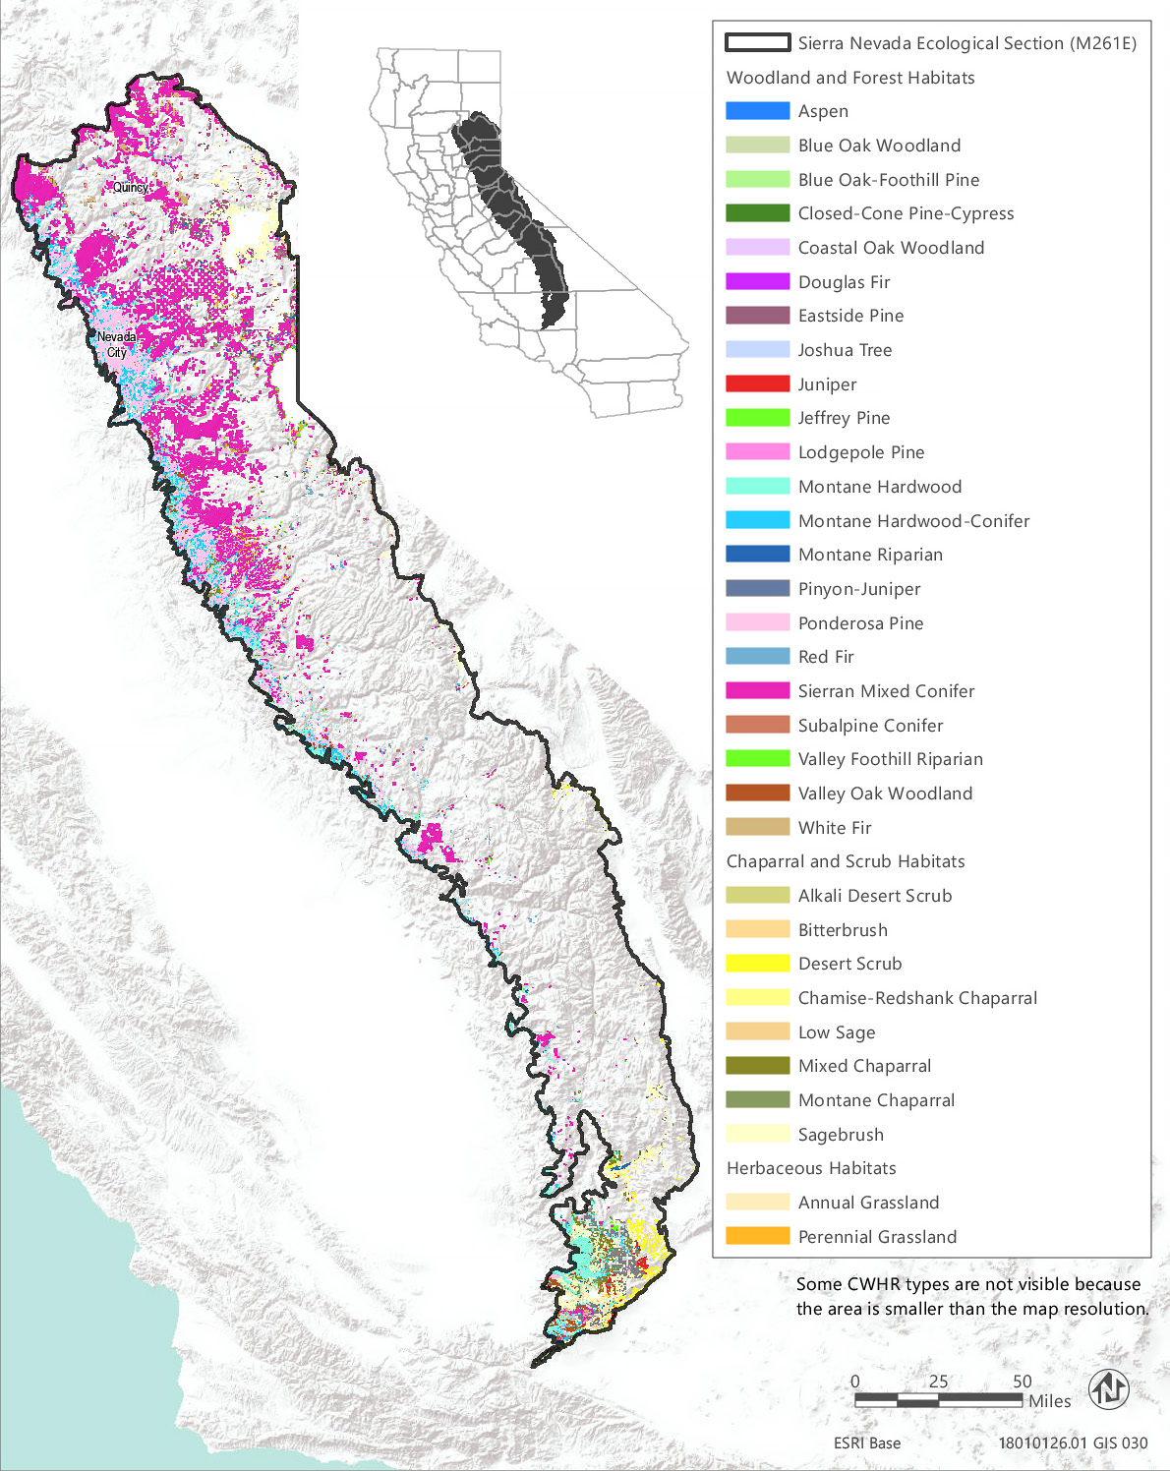
Source: Data received from CAL FIRE in 2018
Figure 3.6-14 CWHR Types - Sierra Nevada Ecological Section (M261E)
Table 3.6-22 Vegetation and Habitat Types within the Treatable Landscape for the Sierra Nevada Ecological Section
CWHR Classification | Acres | MCV Alliances
Woodland and Forest Habitats
Aspen | 1,187 | - Aspen groves*
Blue Oak Woodland | 53,836 | - Blue oak woodland | - Interior live oak woodland
Blue Oak-Foothill Pine | 25,331 | - Foothill pine woodland | - Blue oak woodland
Closed-Cone Pine-Cypress | 154 | - Baker cypress stand*  - Knobcone pine forest | - McNab cypress woodland*  - Piute cypress woodland*
Coastal Oak Woodland | 117 | - Madrone forest*  - California bay forest*
Douglas Fir | 7,297 | - White fir - Douglas fir forest  - Bigleaf maple forest*  - Ponderosa pine - Douglas fir forest | - Douglas fir forest  - Douglas fir - tanoak forest*
Eastside Pine | 76,351 | - Jeffrey pine forest  - Ponderosa pine forest | - Washoe pine woodland*
Jeffrey Pine | 21,165 | - Jeffrey pine forest
Joshua Tree | 127 | - Joshua tree woodland*
Juniper | 20,607 | - Needleleaf rabbitbrush scrub  - California juniper woodland  - Mountain juniper woodland | - Utah juniper woodland*  - Singleleaf pinyon - Utah juniper woodlands
Lodgepole Pine | 3,715 | - Lodgepole pine forest
Montane Hardwood | 346,069 | - Bigleaf maple forest*  - California buckeye grove*  - Tanoak forest* | - Canyon live oak forest  - Interior live oak woodland
Montane Hardwood-Conifer | 189,323 | - Bigleaf maple forest*
Montane Riparian | 11,084 | - Rocky Mountain maple thicket*  - Mountain alder thicket*  - White alder grove  - Water birch thicket*  - Torrent sedge patch*  - Red osier thicket*  - Oregon ash grove*  - Fremont cottonwood forest*  - Black cottonwood forest*  - Western Labrador-tea thicket* | - Interior rose thicket*  - Sandbar willow thicket  - Geyer willow thicket*  - Jepson willow thicket*  - Lemmon's willow thicket*  - Yellow willow thicket*  - Sierra gray willow thicket  - Tea-leaved willow thicket*  - Wild grape shrubland*
Pinyon-Juniper | 31,983 | - Utah juniper woodland* | - Singleleaf pinyon - Utah juniper woodlands
Ponderosa Pine | 216,768 | - Ponderosa pine forest  - Ponderosa pine - Douglas fir forest | - Washoe pine woodland*
Red Fir | 4,830 | - Red fir forest | - Red fir - white fir forest
Sierran Mixed Conifer | 599,348 | - Incense cedar forest*  - Mixed oak forest | - Ponderosa pine - Douglas fir forest  - Giant sequoia forest*
Valley Foothill Riparian | 8 | - Torrent sedge patch*  - Button willow thicket*  - Red osier thicket*  - California sycamore woodland*  - Fremont cottonwood forest*  - Black cottonwood forest* | - Himalayan blackberry - rattlebox - edible fig riparian scrub^{N}  - Sandbar willow thicket  - Red willow thicket*  - Shining willow groves*  - Wild grape shrubland*
Valley Oak Woodland | 5,378 | - Valley oak woodland*
White Fir | 11,544 | - White fir forest  - White fir - sugar pine forest | - White fir - Douglas fir forest  - Red fir - white fir forest
Chaparral and Scrub Habitats
Alkali Desert Scrub | 262 | - Shadscale scrub
Bitterbrush | 12,220 | - Bitter brush scrub*
Chamise-Redshank Chaparral | 8,185 | - Chamise chaparral  - Cup leaf ceanothus chaparral*  - Bigberry manzanita chaparral | - Wedge leaf ceanothus chaparral/Buck brush chaparral
Desert Scrub | 23,922 | - Coast range stonecrop draperies  - Desert needlegrass grassland*  - Shadscale scrub  - Acton's and Virgin River brittlebush - net-veined goldeneye scrub*  - Nevada joint fir - Anderson's boxthorn - spiny hop sage scrub | - Narrowleaf goldenbush - bladderpod scrub  - California buckwheat - Parish's goldeneye scrub  - Wright's buckwheat - Heerman's buckwheat - Utah butterfly-bush scrub*  - Desert almond - Mexican bladdersage scrub
Low Sage | 480 | - Little sagebrush scrub
Mixed Chaparral | 97,306 | - Bigberry manzanita chaparral  - Whiteleaf manzanita chaparral  - Wedge leaf ceanothus chaparral, Buck brush chaparral  - Cup leaf ceanothus chaparral*  - Deer brush chaparral  - Chaparral whitethorn chaparral  - Birch leaf mountain mahogany chaparral | - Bush poppy scrub  - California yerba santa scrub  - Ocean spray brush*  - Deer weed scrub  - Choke cherry thickets*  - Scrub oak chaparral  - Tucker oak chaparral  - Oak gooseberry thicket*
Montane Chaparral | 67,021 | - Green leaf manzanita chaparral  - Whiteleaf manzanita chaparral  - Mountain whitethorn chaparral  - Deer brush chaparral  - Tobacco brush or snow bush chaparral  - Birch leaf mountain mahogany chaparral | - Bush chinquapin chaparral*  - Bitter cherry thicket  - Choke cherry thicket*  - Brewer oak scrub  - Huckleberry oak chaparral
Sagebrush | 88,670 | - Little sagebrush scrub  - Silver sagebrush scrub*  - Rothrock's sagebrush*  - Big sagebrush  - Mountain big sagebrush | - Curl leaf mountain mahogany scrub  - Black brush scrub  - Mormon tea scrub  - Rubber rabbitbrush scrub  - Bitter brush scrub*
Herbaceous Habitats
Annual Grassland | 192,780 | - Fiddleneck - phacelia field  - Wild oat grassland^{N}  - Upland mustard and other ruderal forbs^{N}  - Annual brome grassland^{N}  - Red brome or mediterranean grass grassland^{N}  - Cheatgrass - medusahead grassland^{N}  - Yellow star-thistle field^{N} | - Knapweed and purple-flowered star-thistle field^{N}  - Needle spike rush stand*  - California goldfields - dwarf plantain - small fescue flower fields  - Spanish clover field  - Monolopia - leafy-stemmed tickseed field*
Perennial Grassland | 21,198 | - Indian rice grass grassland*  - Desert needlegrass grassland*  - Bent grass - tall fescue meadow  - Water foxtail meadow*  - Upland mustard and other ruderal forbs^{N}  - Bluejoint reed grass meadow*  - Fell-fields with purple reed grass  - Small-fruited sedge meadow*  - Knapweed and purple-flowered star-thistle field^{N}  - California oat grass prairie* | - Tufted hair grass meadow  - Blue wild rye montane meadow*  - Common velvet grass - sweet vernal grass meadow^{N}  - Ashy ryegrass - creeping ryegrass turf*  - Mat muhly meadow  - Deer grass bed*  - Needle grass - melic grass grassland  - Harding grass - reed canary grass sward^{N}  - Kentucky blue grass turf^{N}  - Curly blue grass grassland*
Total | 2,138,266
*These are designated sensitive natural communities with a state rarity rank of S1 (critically imperiled), S2 (imperiled), or S3 (vulnerable).
^{N} These alliances are dominated by nonnative vegetation.
Source: CWHR 2019, CNPS 2019, Compiled by Ascent Environmental in 2019

Sensitive Natural Communities and Habitats

Sensitive Natural Communities
There are 58 sensitive natural communities that may occur within the treatable landscape of the Sierra Nevada Section. The sensitive natural communities associated with each CWHR type in this ecoregion are identified in Table 3.6-22. They include aspen groves, Washoe pine woodland, Utah juniper woodland, giant sequoia forest, Acton's and Virgin River brittlebush - net-veined goldeneye scrub, and Rothrock’s sagebrush.

Wetlands and Other Waters of the United States and Waters of the State
Wetland habitats known to occur within the treatable landscape of the Sierra Nevada Section include freshwater emergent wetland, freshwater forested and shrub wetland, freshwater pond, lake, riverine, and other freshwater wetlands (Table 3.6-2). In addition, needle spike rush stands, water foxtail meadows and small-fruited sedge meadows may be included in areas mapped as annual or perennial grasslands. The headwaters for several major waterways are found in this ecoregion, including the Feather, Yuba, American, San Joaquin, Merced, and Kern Rivers. Other significant waters include Lake Tahoe, vernal pools, bogs and fens, and montane meadows.

Other Sensitive Habitats
CWHR riparian habitat types identified within the treatable landscape of the Sierra Nevada Section consist of approximately 11,092 acres combined of montane riparian and valley foothill riparian habitats. There are 25 MCV alliances that may occur in the montane and valley foothills riparian habitat types. Twenty of these are designated sensitive natural communities. Examples include Rocky mountain maple thickets, mountain alder thicket, water birch thicket, western Labrador-tea thickets, and Geyer, Jepson, Lemmon’s, yellow, and tea-leaved willow thickets. All riparian habitats are considered sensitive and those located near rivers, streams, and lakes are protected under California Fish and Game Code.
Approximately 53,836 acres of blue oak woodland, 5,378 acres of valley oak woodland, and 117 acres of coastal oak woodland habitats have been mapped within the treatable landscape of this ecoregion. In addition, 25,331 acres of blue oak-foothill pine and 346,069 acres of montane hardwood habitat within the treatable landscape of this ecoregion support several additional oak alliances, including canyon live oak forest and interior live oak woodland habitats.
Chaparral habitats in the treatable landscape consist of approximately 97,306 acres of mixed chaparral, 67,021 acres of montane chaparral, and 8,185 acres of chamise-redshank chaparral. Mixed chaparral in this ecoregion consist of 15 alliances, including four alliances designated as sensitive natural communities. Montane chaparral in this ecoregion consist of 11 alliances, including two alliances designated as sensitive natural communities. Chamise-redshank chaparral consists of four alliances, one of which is a designated sensitive community.

Conservation Lands, Special Management Areas, and Other Biologically Important Lands

Habitat Conservation Plan, Natural Community Conservation Plan, and other Conservation Plan Areas
The treatable landscape in the Sierra Nevada Section includes plan areas for the West Mojave Plan (HCP), Calaveras County HCP, El Dorado County Integrated Natural Resources Management Plan (INRMP)/HCP, Desert Renewable Energy Plan (HCP/NCCP), and Placer County Conservation Plan (Phase II and III) (HCP/NCP), which are currently being planned in the treatable landscape. Table 3.6-23 summarizes the acreages of the plan areas within the treatable landscape.
Table 3.6-23 Conservation Plans Adopted or In Progress in the Treatable Landscape—Sierra Nevada Section
Conservation Plan | Plan Type | Stage | Plan Area Within the Treatable Landscape (Acres)
West Mojave Plan | HCP | Planning | 86,542
Calaveras County | HCP | Planning | 218,504
El Dorado County | INRMP/HCP | Planning | 462,214
Desert Renewable Energy Conservation Plan | HCP/NCCP | Planning | 263,221
Placer County Conservation Plan Phase II And III | HCP/NCCP | Planning | 234,006
 |  | Total | 1,264,487

Protected Open Space Lands
The treatable landscape in the Sierra Nevada Section contains 237 protected open space units that are recognized in CPAD. These lands cover 94,059 acres, which represent 4 percent of the treatable landscape in the ecoregion. Some of the major land owners include CDFW, CAL FIRE, State Parks, LADWP, California Tahoe Conservancy, The Nature Conservancy, and Truckee Donner Land Trust. Examples of some of the prominent open space units in the Sierra Nevada Section include Canebrake Ecological Reserve, Antelope Valley Wildlife Area, Calaveras Big Trees State Park, Hope Valley Wildlife Area, Auburn State Recreation Area, and Emerald Bay State Park.

Sierra Nevada Foothills Section
The Sierra Nevada Foothills Section (M261F) encompasses 4,495,115 acres and comprises the foothills on the west side of the Sierra Nevada and the southwestern end of the Cascade Ranges, adjacent to the Great Valley. Elevations range from 500 to 3,500 feet. This ecoregion contains 2,721,585 acres of treatable landscape, which represents approximately 61 percent of the total landscape within the ecoregion. Within the treatable landscape exist modeled treatment areas for the following treatment types: WUI fuel reduction (1,812,275 acres), fuel break (335,937 acres), and ecological restoration (817,565 acres). The treatable landscape is dispersed across the hills and valleys of the entire ecoregion and is displayed in Figure 3.6-15.
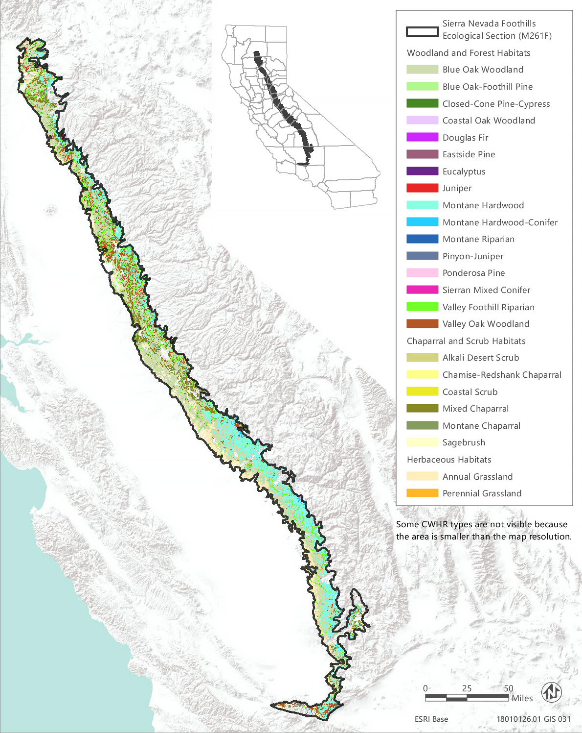
Source: Data received from CAL FIRE in 2018
Figure 3.6-15 CWHR Types - Sierra Nevada Foothills Ecological Section (M261F)

Vegetation and Habitat Types
The predominant habitat types in the treatable landscape of the Sierra Nevada Foothills Section are blue oak woodland and annual grassland, which comprise approximately 35 percent and 31 percent of the treatable landscape, respectively. Blue oak woodland and interior live oak woodland vegetation alliances may be found within areas mapped as blue oak woodland habitat and 24 MCV alliances may be found in areas mapped as annual grassland in this ecoregion. Other common habitat types are blue oak-foothill pine woodland and montane hardwood, which comprise approximately 14 and 13 percent of the treatable landscape, respectively. Chaparral habitats make up only five percent of the treatable landscape in this ecoregion.
Annual grassland within this ecoregion is comprised of a diversity of vegetation types, including nonnative vegetation alliances such as wild oat, annual brome, and cheatgrass-medusahead grasslands, and native vegetation alliances, including California poppy-lupine field and popcorn flower field. Annual grassland in the treatable landscape of this ecoregion may also include several vernal pool vegetation alliances, such as Fremont’s goldfields- salt grass alkaline vernal pool, Fremont’s goldfields-downingia vernal pools, and smooth goldfields vernal pool bottom.
Table 3.6-24 provides the acreage of each CWHR habitat type within the treatable landscape of this ecoregion and the associated MCV vegetation alliances that may occur within each CWHR type in this ecoregion. Alliances that are designated as sensitive natural communities and those that are dominated by nonnative vegetation are indicated in Table 3.6-24. Sensitive natural communities are discussed in more detail below. The distribution of CWHR types within this ecoregion is shown in Figure 3.6-15.
Table 3.6-24 Vegetation and Habitat Types within the Treatable Landscape for the Sierra Nevada Foothills Ecological Section
CWHR Classification | Acres | MCV Alliances
Woodland and Forest Habitats
Blue Oak Woodland | 946,977 | - Blue oak woodland | - Interior live oak woodland
Blue Oak-Foothill Pine | 376,587 | - Foothill pine woodland | - Blue oak woodland
Closed-Cone Pine-Cypress | 404 | - McNab cypress woodland*
Coastal Oak Woodland | 352 | - Madrone forest* | - California bay forest*
Douglas Fir | 470 | - Bigleaf maple forest*  - Douglas fir forest | - Ponderosa pine - Douglas fir forest
Eastside Pine | 79 | - Jeffrey pine forest | - Ponderosa pine forest
Eucalyptus | 35 | - Eucalyptus - tree of heaven - black locust groves^{N}
Juniper | 2,799 | - California juniper woodland | - Singleleaf pinyon - Utah juniper woodlands
Montane Hardwood | 343,786 | - Bigleaf maple forest*  - California buckeye grove*  - Bigcone Douglas fir forest* | - Canyon live oak forest  - Interior live oak woodland
Montane Hardwood-Conifer | 5,145 | - Bigleaf maple forest* | - Bigcone Douglas fir forest*
Montane Riparian | 84 | - White alder grove  - Torrent sedge patch*  - Red osier thicket*  - Oregon ash grove* | - Fremont cottonwood forest*  - Sandbar willow thicket  - Wild grape shrubland*
Pinyon-Juniper | 5,601 | - Singleleaf pinyon - Utah juniper woodlands
Ponderosa Pine | 4,939 | - Ponderosa pine forest | - Ponderosa pine - Douglas fir forest
Sierran Mixed Conifer | 506 | - Incense cedar forest*  - Mixed oak forest | - Ponderosa pine - Douglas fir forest
Valley Foothill Riparian | 28,118 | - Torrent sedge patch*  - Button willow thicket*  - Red osier thicket*  - California sycamore woodland*  - Fremont cottonwood forest*  - California rose briar patch* | - Himalayan blackberry - rattlebox - edible fig riparian scrub^{N}  - Sandbar willow thicket  - Red willow thicket*  - Pepper tree or Myoporum grove^{N}  - Wild grape shrubland*
Valley Oak Woodland | 23,564 | - Valley oak woodland*
Chaparral and Scrub Habitats
Alkali Desert Scrub | 193 | - Allscale scrub | - Alkali sacaton - scratchgrass - alkali cordgrass alkaline wet meadow*
Chamise-Redshank Chaparral | 1,857 | - Chamise chaparral  - Bigberry manzanita chaparral | - Wedge leaf ceanothus chaparral/Buck brush chaparral
Coastal Scrub | 15 | - Broom patch^{N}  - Bush monkeyflower scrub*  - Live-forever - lichen/moss sparse herbaceous rock outcop  - Narrowleaf goldenbush - bladderpod scrub  - California yerba santa scrub  - California buckwheat - white sage scrub | - Wright's buckwheat - Heerman's buckwheat - Utah butterfly-bush scrub*  - California coffee berry scrub  - Goldenaster patch*  - Scale broom scrub*  - Deer weed scrub  - Silver bush lupine scrub  - Coast range stonecrop draperies  - Poison oak scrub
Mixed Chaparral | 120,716 | - Hoary, common, and Stanford manzanita chaparral*  - Bigberry manzanita chaparral  - Ione manzanita chaparral*  - Whiteleaf manzanita chaparral  - Wedge leaf ceanothus chaparral, Buck brush chaparral  - Deer brush chaparral  - Chaparral whitethorn chaparral  - Birch leaf mountain mahogany chaparral | - Bush poppy scrub  - California yerba santa scrub  - California coffee berry scrub  - Deer weed scrub  - Silver bush lupine scrub  - Holly leaf cherry - toyon - greenbark ceanothus chaparral  - Scrub oak chaparral  - Leather oak chaparral  - Tucker oak chaparral  - Poison oak scrub
Montane Chaparral | 4,227 | - Green leaf manzanita chaparral  - Whiteleaf manzanita chaparral  - Deer brush chaparral | - Birch leaf mountain mahogany chaparral  - Brewer oak scrub
Sagebrush | 4,627 | - Curl leaf mountain mahogany scrub
Herbaceous Habitats
Annual Grassland | 850,463 | - Fiddleneck - phacelia field  - Wild oat grassland^{N}  - Upland mustard and other ruderal forbs^{N}  - Annual brome grassland^{N}  - Red brome or mediterranean grass grassland^{N}  - Cheatgrass - medusahead grassland^{N}  - Yellow star-thistle field^{N}  - Tar plant field*  - Annual dogtail grassland^{N}  - Needle spike rush stand*  - Squirreltail patch  - California poppy - lupine field  - Goldenaster patch*  - California goldfields - dwarf plantain - small fescue flower fields | - Fremont's goldfields - salt grass alkaline vernal pool*  - Fremont's goldfields - Downingia vernal pools*  - Smooth goldfields vernal pool bottom*  - Fremont's tidy-tips - blow wives vernal pool*  - Perennial rye grass field^{N}  - Spanish clover field  - Monolopia - leafy-stemmed tickseed field*  - Water blinks - annual checkerbloom vernal pool*  - Popcorn flower field  - White-tip clover swales*
Perennial Grassland | 42 | - Bent grass - tall fescue meadow  - Water foxtail meadow*  - Upland mustard and other ruderal forbs^{N}  - California brome - blue wildrye prairie*  - California oat grass prairie*  - Squirreltail patch | - Common velvet grass - sweet vernal grass meadow^{N}  - Ashy ryegrass - creeping ryegrass turf*  - Deer grass bed*  - Needle grass - melic grass grassland  - Harding grass - reed canary grass sward^{N}
Total | 2,721,586
*These are designated sensitive natural communities with a state rarity rank of S1 (critically imperiled), S2 (imperiled), or S3 (vulnerable).
^{N} These alliances are dominated by nonnative vegetation.
Source: CWHR 2019, CNPS 2019, Compiled by Ascent Environmental in 2019

Sensitive Biological Resources

Special-Status Species
There are 117 special-status wildlife taxa and 135 plant taxa known or with potential to occur in the treatable landscape of the Sierra Nevada Foothills Section, including 48 animal taxa and 30 plant taxa that are state or federally listed as rare, threatened, or endangered. The Sierra Nevada Foothills ecoregion contains over 24 special-status plant species associated with serpentine soils, and 18 special-status plant species and 6 special-status animal species found in vernal pools. A list of all the special-status plant species known or with potential to occur within the treatable landscape of the Sierra Nevada Foothills Section, along with their listing status and detailed habitat descriptions, is provided in Appendix BIO-3, Table 14a. A list of special-status wildlife (other than fish) species known or with potential to occur in the treatable landscape of this ecoregion, along with the CWHR types they are associated with, is provided in Appendix BIO-3, Table 14b. Special-status fish known or with potential to occur in the ecoregion are identified in Appendix BIO-3, Table 19.

Critical Habitat
Critical habitat has been designated within the treatable landscape of this ecoregion for nine plant taxa, and six wildlife taxa. Appendix BIO-4 lists and provides the acreage of critical habitat designated within the treatable landscape of this ecoregion for these species. Examples of wildlife taxa California condor (Gymnogyps californianus), vernal pool tadpole shrimp (Lepidurus packardi), slender Orcutt grass (Orcuttia tenuis), and Butte County meadowfoam (Limnanthes floccosa ssp. californica).

Sensitive Natural Communities and Habitats

Sensitive Natural Communities
There are 35 sensitive natural communities that may occur within the treatable landscape of the Sierra Nevada Foothills Section. The sensitive natural communities associated with each CWHR type in this ecoregion are identified in Table 3.6-24. Several of these are vernal pool communities that may be interspersed within annual grasslands. Other examples of sensitive natural communities in this ecoregion include McNab cypress woodland, California sycamore woodland, Ione manzanita chaparral, and California brome – blue wildrye prairie.

Wetlands and Other Waters of the United States and Waters of the State
Wetland habitats known to occur within the treatable landscape of the Sierra Nevada Foothills Section include freshwater emergent wetland, freshwater forested and shrub wetland, freshwater pond, lake, and riverine (Table 3.6-2). Vernal pools are also prevalent in areas mapped as annual grasslands in this ecoregion and may include water blinks - annual checkerbloom vernal pools, Fremont's tidy-tips - blow wives vernal pool, Fremont's goldfields - salt grass alkaline vernal pools, and Fremont's goldfields - Downingia vernal pools, among other vernal pool types. Major waterways in this ecoregion include the Feather, Yuba, American, San Joaquin, Merced, and Kern Rivers and other significant waters including Lake Oroville, Folsom Lake, Don Pedro Reservoir, and Lake Isabella.

Other Sensitive Habitats
CWHR riparian habitat types identified within the treatable landscape of the Sierra Nevada Foothills Section consist of approximately 28,202 acres combined of valley foothill riparian and montane riparian habitats. There are 13 MCV alliances that may occur in the valley foothills and montane riparian habitat types. Nine of these are designated sensitive natural communities. Examples include red osier thicket, Fremont cottonwood forest, wild grape shrubland, California rose briar patch, and red willow thicket. All riparian habitats are considered sensitive and those located near rivers, streams, and lakes are protected under California Fish and Game Code.
Approximately 946,977 acres of blue oak woodland, 23,564 acres of valley oak woodland, and 352 acres of coastal oak woodland habitats have been mapped within the treatable landscape of this ecoregion. In addition, 376,587 acres of blue oak-foothill pine, and 343,786 acres of montane hardwood habitat within the treatable landscape of this ecoregion support several additional oak alliances, including canyon live oak forest and interior live oak woodland habitats.
Chaparral habitats in the treatable landscape consist of approximately 120,716 acres of mixed chaparral, 4,227 acres of montane chaparral, and 1,857 acres of chamise-redshank chaparral. Fifteen acres of coastal scrub also occur in this ecoregion. Chaparral habitats in this ecoregion consist of 23 alliances, including two alliances designated as sensitive natural communities.

Conservation Lands, Special Management Areas, and Other Biologically Important Lands

Habitat Conservation Plan, Natural Community Conservation Plan, and other Conservation Plan Areas
The treatable landscape in the Sierra Nevada Foothills Section includes plan area for the Metropolitan Bakersfield HCP, which has been adopted and is being implemented. Additionally, five HCPs and five HCP/NCCPs are currently being planned in the treatable landscape. Table 3.6-25 summarizes the conservation plans adopted or in progress, including the acreages of plan areas within the treatable landscape.
Table 3.6-25 Conservation Plans Adopted or In Progress in the Treatable Landscape—Sierra Nevada Foothills Section
Conservation Plan | Plan Type | Stage | Plan Area Within the Treatable Landscape (Acres)
Calaveras County | HCP | Planning | 330,558
East Fresno | HCP | Planning | 205,304
Kern County Valley Floor | HCP | Planning | 101,102
Metropolitan Bakersfield | HCP | Implementation | 576
South Sacramento | HCP | Planning | 13,881
El Dorado County | INRMP/HCP | Planning | 301,580
Bakersfield Regional Habitat Conservation Plan | HCP/NCCP | Planning | 13,052
Butte Regional Conservation Plan | HCP/NCCP | Planning | 171,860
Placer County Conservation Plan Phase I | HCP/NCCP | Planning | 103,342
Placer County Conservation Plan Phase II And III | HCP/NCCP | Planning | 26,075
Yuba-Sutter | HCP/NCCP | Planning | 560
 |  | Total | 1,267,890

Protected Open Space Lands
The treatable landscape in the Sierra Nevada Foothills Section contains 210 protected open space units that are recognized in CPAD. These lands cover 128,116 acres, which represent 5 percent of the treatable landscape in the ecoregion. Some of the major land owners include CDFW, The Wildlands Conservancy, The Nature Conservancy, University of California, State Parks, Placer County, and El Dorado County. Examples of some of the prominent open space units in the Sierra Nevada Foothills Section include Tehama Wildlife Area, Wind Wolves Preserve, Spenceville Wildlife Area, North Table Mountain Ecological Reserve, Folsom Lake State Recreation Area, and Bidwell Park.

Southeastern Great Basin Section
The Southeastern Great Basin Section (341F) encompasses 2,727,547 acres and consists of moderate elevation mountains separated by broad, sediment-filled valleys. Elevations range from 4,700 to 9,400 feet. This ecoregion contains 450 acres of treatable landscape, which represents less than 0.1 percent of the total landscape within the ecoregion. Within the treatable landscape exist modeled treatment areas for the following treatment types: fuel break (198 acres) and ecological restoration (285 acres); there are no WUI fuel reduction treatment areas modeled for this ecoregion. The treatable landscape within this ecoregion consists of a few small isolated areas on the western edges of the mountains and is displayed in Figure 3.6-16.

Vegetation and Habitat Types
The most common CWHR types in the treatable landscape of the Southeastern Great Basin Section are desert scrub and alkali desert scrub, which make up about 62 percent and 23 percent of the land cover, respectively. These are diverse habitat types with 26 MCV alliances recognized for the desert scrub category in this ecoregion. Other scrub habitat types comprise approximately 6 percent of the treatable landscape and there is less than 1 acre each of chaparral and grassland habitats. Pinyon-juniper is the only woodland habitat type mapped in the treatable landscape and it comprises 41 acres, or approximately 9 percent of the treatable landscape. The distribution of CWHR types within the treatable landscape of this ecoregion is shown in Figure 3.6-16 and the acreage of each type, as well as associated MCV alliances, is provided in Table 3.6-26.

Sensitive Biological Resources

Special-Status Species
There are 36 special-status wildlife taxa and five plant taxa known or with potential to occur in the treatable landscape of the Southeastern Great Basin Section, including 16 animal taxa that are state or federally listed as rare, threatened, or endangered or fully protected. There is one state listed endangered plant species that may occur within the treatable landscape in this ecoregion. A list of all the special-status plant species known or with potential to occur within the treatable landscape of the Southeastern Great Basin Section, along with their listing status and detailed habitat descriptions, is provided in Appendix BIO-3, Table 15a. A list of special-status wildlife (other than fish) species known or with potential to occur in the treatable landscape of this ecoregion, along with the CWHR types they are associated with, is provided in Appendix BIO-3, Table 15b. Special-status fish known or with potential to occur in the ecoregion are identified in Appendix BIO-3, Table 19.
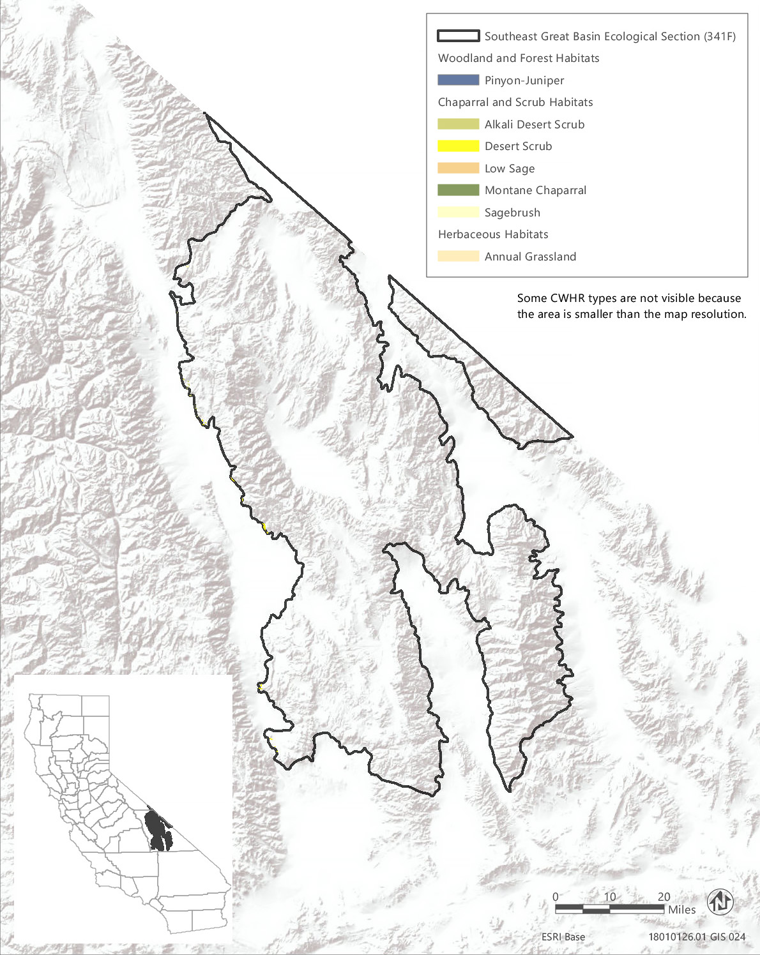
Source: Data received from CAL FIRE in 2018
Figure 3.6-16 CWHR Types - Southeast Great Basin Ecological Section (341F)
Table 3.6-26 Vegetation and Habitat Types within the Treatable Landscape for the Southeastern Great Basin Ecological Section
CWHR Classification | Acres | MCV Alliances
Woodland and Forest Habitats
Pinyon-Juniper | 41 | - Utah juniper woodland* | - Singleleaf pinyon - Utah juniper woodlands
Chaparral and Scrub Habitats
Alkali Desert Scrub | 103 | - Iodine bush scrub*  - Fourwing saltbush scrub  - Shadscale scrub  - Desert holly scrub  - Parry's saltbush scrub* | - Allscale scrub  - Winterfat scrubland*  - Alkali sacaton - scratchgrass - alkali cordgrass alkaline wet meadow*  - Bush seepweed scrub*
Desert Scrub | 278 | - Desert needlegrass grassland*  - Iodine bush scrub*  - White bursage scrub  - Cheesebush - sweetbush scrub  - Fremont's chaffbush - woolly sage scrub*  - Fourwing saltbush scrub  - Shadscale scrub  - Desert holly scrub  - Parry's saltbush scrub*  - Allscale scrub  - Rigid spineflower - hairy desert sunflower  - Mojave-Sonoran desert dunes*  - Acton's and Virgin River brittlebush - net-veined goldeneye scrub*  - Brittle bush scrub  - Nevada joint fir - Anderson's boxthorn - spiny hop sage scrub | - Narrowleaf goldenbush - bladderpod scrub  - California buckwheat - Parish's goldeneye scrub  - Wright's buckwheat - Heerman's buckwheat - Utah butterfly-bush scrub*  - Winterfat scrubland*  - Creosote bush scrub  - Creosote bush - white bursage scrub  - Creosote bush - brittle bush scrub  - Spiny menodora scrub*  - James' galleta shrub-steppe*  - Desert almond - Mexican bladdersage scrub  - Alkali sacaton - scratchgrass - alkali cordgrass alkaline wet meadow*  - Bush seepweed scrub*
Low Sage | 2 | - Little sagebrush scrub | - Black sagebrush scrub*
Montane Chaparral | <1 | - Mountain whitethorn chaparral | - Tobacco brush or snow bush chaparral
Sagebrush | 26 | - Little sagebrush scrub  - Black sagebrush scrub*  - Big sagebrush  - Small leaf mountain mahogany scrub*  - Curl leaf mountain mahogany scrub  - Black brush scrub | - Death Valley joint fir scrub*  - Mormon tea scrub  - Rubber rabbitbrush scrub  - Stansbury cliff rose scrub*  - Bitter brush scrub*
Herbaceous Habitats
Annual Grassland | <1 | - Red brome or mediterranean grass grassland^{N}  - Cheatgrass - medusahead grassland^{N} | - Yellow star-thistle field^{N}
Total | 450
*These are designated sensitive natural communities with a state rarity rank of S1 (critically imperiled), S2 (imperiled), or S3 (vulnerable).
^{N} These alliances are dominated by nonnative vegetation.
Source: CWHR 2019, CNPS 2019, Compiled by Ascent Environmental in 2019

Critical Habitat
There is no designated critical habitat within the treatable landscape of the Southeastern Great Basin Section.

Sensitive Natural Communities and Habitats

Sensitive Natural Communities
There are 18 sensitive natural communities associated with the CWHR types mapped in the treatable landscape of the Southeastern Great Basin Section. The sensitive natural communities associated with each CWHR type in this ecoregion are identified in Table 3.6-26. Examples of sensitive natural communities in this ecoregion include Parry’s saltbush scrub, spiny menodora scrub, black sagebrush scrub, and desert needlegrass grassland.

Wetlands and Other Waters of the United States and Waters of the State
There is less than 1 acre of wetland habitat mapped in the treatable landscape of the Southeastern Great Basin in the NWI (Table 3.6-2). However, wetland habitats may be present in areas mapped as upland CWHR types. Examples include alkali sacaton – scratchgrass – alkali cordgrass alkaline wet meadow, bush seepweed scrub, and iodine bush scrub.

Other Sensitive Habitats
There are no riparian or oak woodland habitats and less than 1 acre of chaparral habitat mapped in the treatable landscape of this ecoregion. However, montane riparian vegetation could be present along intermittent streams within the treatable landscape that are not captured in the FRAP vegetation source data.

Conservation Lands, Special Management Areas, and Other Biologically Important Lands

Habitat Conservation Plan, Natural Community Conservation Plan, and other Conservation Plan Areas
No conservation plans have been adopted for lands within the treatable landscape in the Southeastern Great Basin Section.

Protected Open Space Lands
The treatable landscape in the Southeastern Great Basin Section contains 259 acres of protected open space owned by LADWP. This protected area represents 58 percent of the treatable landscape in the ecoregion.

Southern California Coast Section
The Southern California Coast Section (261B) encompasses 3,349,763 acres and contains mountains, hills, valleys, and plains of the Transverse Ranges and Peninsular Ranges that are within the marine influence zone, as well as sandy beaches, alluvial river valleys, coastal dunes and terraces, and cliffs along the coastline. Elevations range from sea level to 3,000 feet. This ecoregion contains 860,305 acres of treatable landscape, which represents approximately 26 percent of the total landscape within the ecoregion. Within the treatable landscape exist modeled treatment areas for the following treatment types: WUI fuel reduction (599,915 acres), fuel break (155,782 acres), and ecological restoration (229,177 acres). The treatable landscape is distributed across much of this ecoregion, excluding the urban centers along the coast (e.g., Los Angeles and San Diego). The treatable landscape in this ecoregion is displayed in Figure 3.6-17.

Vegetation and Habitat Types
Habitat types in the treatable landscape of the Southern California Coast Section consist of 11 woodland and forest habitat types, four chaparral and scrub habitat types, and two herbaceous grassland habitat types. Coastal scrub makes up the greatest acreage within the ecoregion, followed by annual grassland, mixed chaparral, and coastal oak woodland. Chaparral and scrub habitats comprise 505,812 acres, or 59 percent, of the treatable landscape. Grasslands comprise 181,668 acres, or 21 percent, and woodland and forest habitats comprise approximately 172,825 acres, or 20 percent, of the treatable landscape, respectively. The acreage breakdown of habitat types is provided in Table 3.6-27. The distribution of CWHR types within this ecoregion is shown in Figure 3.6-17.
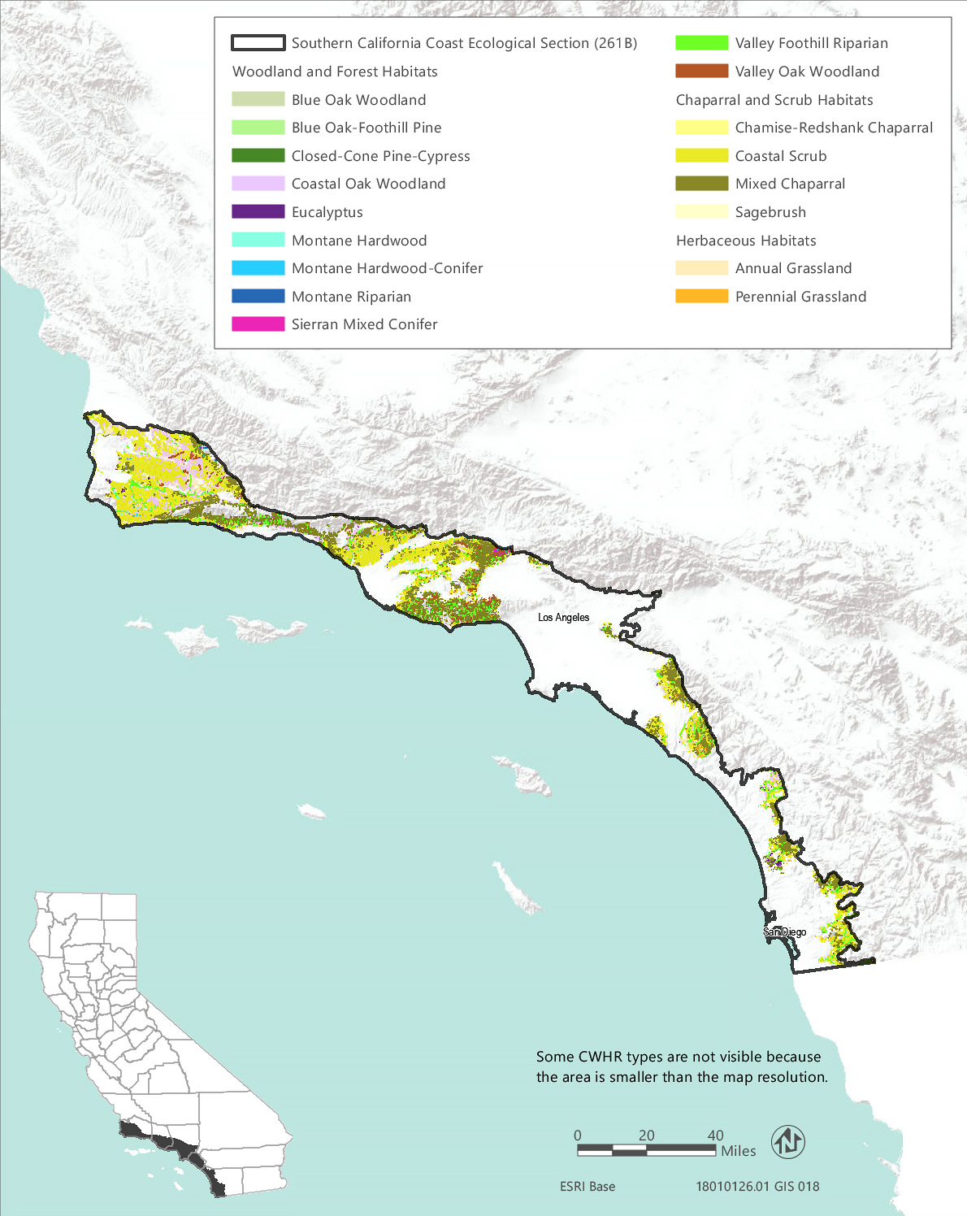
Source: Data received from CAL FIRE in 2018
Figure 3.6-17 CWHR Types - Southern California Coast Ecological Section (261B)
Table 3.6-27 Vegetation and Habitat Types within the Treatable Landscape for the Southern California Coast Ecological Section
CWHR Classification | Acres | MCV Alliances
Woodland and Forest Habitats
Blue Oak Woodland | 53 | - Blue oak woodland
Blue Oak-Foothill Pine | 159 | - Blue oak woodland
Closed-Cone Pine-Cypress | 721 | - Bishop pine - Monterey pine forest* | - Torrey pine woodland*
Coastal Oak Woodland | 151,835 | - California walnut groves*  - Coast live oak woodland  - California bay forest* | - Madrone forest*  - Engelmann oak woodland*
Eucalyptus | 1,477 | - Eucalyptus - tree of heaven - black locust groves^{N}
Montane Hardwood | 587 | - Coulter pine woodland  - Bigcone Douglas fir forest* | - Canyon live oak forest
Montane Hardwood-Conifer | 346 | - Coulter pine woodland | - Bigcone Douglas fir forest*
Montane Riparian | 159 | - White alder grove  - Fremont cottonwood forest*  - Black cottonwood forest* | - Sandbar willow thicket
Sierran Mixed Conifer | 594 | - Incense cedar forest*
Valley Foothill Riparian | 12,942 | - California sycamore woodland*  - Fremont cottonwood forest*  - Black cottonwood forest*  - California rose briar patch*  - Himalayan blackberry - rattlebox - edible fig riparian scrub^{N} | - Sandbar willow thicket  - Red willow thicket*  - Shining willow groves*  - Pepper tree or Myoporum grove^{N}
Valley Oak Woodland | 3,952 | - Valley oak woodland*
Chaparral and Scrub Habitats
Chamise-Redshank Chaparral | 6,032 | - Chamise chaparral  - Chamise - white sage chaparral*  - Chamise - black sage chaparral  - Redshank chaparral  - Mission manzanita chaparral* | - Eastwood manzanita chaparral  - Bigberry manzanita chaparral  - Hoary leaf ceanothus chaparral  - Wedge leaf ceanothus chaparral/Buck brush chaparral
Coastal Scrub | 329,074 | - Dune mat*  - California sagebrush scrub  - California sagebrush - California buckwheat scrub  - California sagebrush - black sage scrub  - Quailbush scrub  - Coyote brush scrub  - Broom patch^{N}  - Sea rocket sands  - California buckwheat scrub  - California buckwheat - white sage scrub  - Sawtooth golden bush scrub*  - Menzies's golden bush scrub*  - Bush mallow scrub  - Laurel sumac scrub  - Ice plant mats^{N}  - Coast prickly pear scrub*  - Coastal sage and Island scrub oak chaparral*  - Lemonade berry scrub*  - Bushy spikemoss mats*  - Poison oak scrub | - Sand dune sedge swath*  - Blue blossom chaparral  - Giant coreopsis scrub*  - Bush monkeyflower scrub*  - Live-forever - lichen/moss sparse herbaceous rock outcop  - California brittle bush - Ashy buckwheat scrub*  - Bush penstemon scrub*  - Scale broom scrub*  - Deer weed scrub  - Silver bush lupine scrub  - Yellow bush lupine scrub  - Silver dune lupine - mock heather scrub*  - California desert-thorn scrub*  - White sage scrub*  - Purple sage scrub  - Black sage scrub  - Desert needlegrass grassland*
Mixed Chaparral | 170,698 | - Brittle leaf - woolly leaf manzanita chaparral*  - Eastwood manzanita chaparral  - Bigberry manzanita chaparral  - Bigpod ceanothus chaparral  - Hairy leaf - woolly leaf ceanothus chaparral*  - Bush poppy scrub  - Deer weed scrub  - Silver bush lupine scrub  - Bush mallow scrub  - Laurel sumac scrub  - Coastal sage and Island scrub oak chaparral*  - Interior live oak chaparral  - Sugarbush chaparral  - Poison oak scrub  - Canyon sunflower scrub* | - Burton Mesa chaparral*  - Hoary leaf ceanothus chaparral  - Wedge leaf ceanothus chaparral, Buck brush chaparral  - Wart stemmed ceanothus chaparral*  - Birch leaf mountain mahogany chaparral  - Holly leaf cherry - toyon - greenbark ceanothus chaparral  - Scrub oak chaparral  - Scrub oak - chamise chaparral
Sagebrush | 8 | - California sagebrush scrub  - California sagebrush - California buckwheat scrub | - California sagebrush - black sage scrub
Herbaceous Habitats
Annual Grassland | 179,515 | - Western ragweed meadow  - Fiddleneck - phacelia field  - Wild oat grassland^{N}  - Upland mustard and other ruderal forbs^{N}  - Annual brome grassland^{N}  - Red brome or mediterranean grass grassland^{N}  - Cheatgrass - medusahead grassland^{N}  - Yellow star-thistle field^{N} | - Alkali weed - salt grass playas and sinks*  - California poppy - lupine field California goldfields - dwarf plantain - small fescue flower fields  - California goldfields - dwarf plantain - small fescue flower fields  - Perennial rye grass field^{N}
Perennial Grassland | 2,153 | - Bent grass - tall fescue meadow  - Water foxtail meadow*  - European beach grass sward^{N}  - Purple three-awn meadow*  - Upland mustard and other ruderal forbs^{N}  - California brome - blue wildrye prairie*  - Poison hemlock or fennel patch^{N}  - Sand-aster and perennial buckwheat field  - Pampas grass patch^{N} | - Gum plant patch*  - Ashy ryegrass - creeping ryegrass turf*  - Giant wild rye grassland*  - Sea lyme grass patch*  - Needle grass - melic grass grassland  - Fountain grass sward^{N}  - Harding grass - reed canary grass sward^{N}
Total | 860,305
*These are designated sensitive natural communities with a state rarity rank of S1 (critically imperiled), S2 (imperiled), or S3 (vulnerable).
^{N} These alliances are dominated by nonnative vegetation.
Source: CWHR 2019, CNPS 2019, Compiled by Ascent Environmental in 2019

Sensitive Biological Resources

Special-status Species
There are over 150 special-status plant taxa known to occur within the Southern California Coast Section, including 40 plant taxa that are officially listed as rare, threatened, or endangered. Many of the special-status plants are narrow endemics associated with the maritime chaparral or coastal scrub habitats of the ecoregion, such as the state and federally listed bigleaf crownbeard (Verbesina dissita), or with ultramafic soils. A complete list of all the special-status plant species known or with potential to occur within the treatable landscape of the Southern California Coast Section, along with their listing status and detailed habitat descriptions, is provided in Appendix BIO-3, Table 16a.
There are 58 special-status wildlife taxa, not counting fish, known or with potential to occur within the treatable landscape of this ecoregion. These species, along with the CWHR types they are associated with, are listed in Appendix BIO-3, Table 16b. Special-status fish with potential to occur within the ecoregion are identified in Appendix BIO-3, Table 19.

Critical Habitat
Critical habitat has been designated within the treatable landscape of this ecoregion for 14 plant taxa and 13 wildlife taxa, including coastal California gnatcatcher (Polioptila californica californica), Quino checkerspot butterfly (Euphydryas editha quino), Otay tarplant (Deinandra conjugens), Vandenberg monkeyflower (Diplacus vandenbergensis), Lompoc yerba santa (Eriodictyon capitatum), and Mexican flannelbush (Fremontodendron mexicanum). Appendix BIO-4 lists the acreage of critical habitat designated within the treatable landscape of this ecoregion for each species.

Sensitive Natural Communities and Habitat Types

Sensitive Natural Communities
There are 47 sensitive natural communities that have potential to occur within the treatable landscape of the Southern California Coast Section. The sensitive natural communities associated with each CWHR type in this ecoregion are identified in Table 3.6-27. Notable examples for this ecoregion include Torrey pine woodland, Engelmann oak woodland, Bigcone Douglas fir forest, California brittle bush - Ashy buckwheat scrub, bush penstemon scrub, canyon sunflower scrub, sawtooth golden bush scrub, and giant wild rye grassland.

Waters of the United States and State
Wetland habitats known to occur within the treatable landscape of the Southern California Coast Section include estuarine and marine deepwater, estuarine and marine wetland, freshwater emergent wetland, freshwater forested and shrub wetland, freshwater pond, lake, and riverine wetlands with the most abundant being riverine and freshwater forested and shrub wetland (Table 3.6-2). In addition, sand dune sedge swaths, gum plant patches, alkali weed saltgrass playas and sinks, needle spike rush stands, and water foxtail meadow are wetland types that may be included in areas mapped as scrub or grassland habitats.

Other Sensitive Habitats
CWHR riparian habitat types identified within the treatable landscape of the Southern California Coast Section consist of approximately 12,942 acres of valley foothill riparian habitat and 159 acres of montane riparian habitat. There are nine MCV alliances associated with the valley foothill riparian habitat type within this ecoregion and four MCV alliances associated with the montane riparian habitat type. Many of these are designated sensitive natural communities as indicated in Table 3.6-27.
Oak woodland habitats in the treatable landscape of the Southern California Coast Section consist of approximately 151,835 acres of coastal oak woodland, 3,952 acres of valley oak woodland, 53 acres of blue oak woodland, and 159 acres of blue oak – foothill pine woodland. There are approximately 587 acres of montane hardwood that may include canyon live oak forest stands. The only one of these oak woodland types that is a designated sensitive natural community is valley oak woodland; however, Engelmann oak woodland is a sensitive natural community included in areas mapped as coastal oak woodland. Additional sensitive natural communities that may be present in areas mapped as oak woodlands in this ecoregion, include madrone forest, California bay forest, and California walnut groves.
Southern maritime chaparral occurs in nutrient-poor soils (e.g., weathered sandstone and shale outcrops) on windward slopes and coastal lowlands along the southern California coast from Orange County to San Diego County (Sawyer et al. 2009). These chaparral types contain a high proportion of narrow endemic and special-status shrub species dominated by combinations of chamise, manzanita, sage, ceanothus, and Mission manzanita (Xylococcus bicolor). Special-status plant species associated with the southern maritime chaparral include California adolphia (Adolphia californica), Del Mar manzanita (Arctostaphylos glandulosa ssp. crassifolia) Rainbow manzanita (Arctostaphylos rainbowensis), wart-stemmed ceanothus (Ceanothus verrucosus), and scrub oak (Quercus dumosa). Chaparral sensitive natural communities in this ecoregion include chamise - white sage chaparral, mission manzanita chaparral, coastal sage and Island scrub oak chaparral, Burton Mesa chaparral, and wart stemmed ceanothus chaparral.
Coastal scrub habitats in this ecoregion are likewise very diverse and support a high proportion of rare and endemic plant species. There are 37 MCV alliances recognized in coastal scrub habitats in this ecoregion, of which 17 (46 percent) are designated sensitive natural communities. Table 3.6-27 lists all of the chaparral and coastal scrub alliances that may be found in the treatable landscape of this ecoregion and denotes which are sensitive natural communities and which are dominated by nonnative vegetation.

Conservation Lands, Special Management Areas, and Other Biologically Important Lands

Habitat Conservation Plan, Natural Community Conservation Plan, and other Conservation Plan Areas
The treatable landscape in the Southern California Coast Section includes plan areas for the Orange County Southern Subregion HCP, Central/Coastal Orange County HCP/NCCP, San Diego County Multiple Species Conservation Program (HCP/NCCP), San Diego County Water Authority HCP/NCCP, San Diego Gas and Electric Subregional HCP/NCCP, San Diego Multiple Habitat Conservation Program (HCP/NCCP), and Western Riverside County Multiple Species Habitat Conservation Plan (HCP/NCCP), which have been adopted and are being implemented. Additionally, one HCP and three HCP/NCCPs are currently being planned in the treatable landscape. Table 3.6-28 summarizes the conservation plans adopted or in progress, including the acreages of plan areas within the treatable landscape.
Table 3.6-28 Conservation Plans Adopted or In Progress in the Treatable Landscape—Southern California Coast Section
Conservation Plan | Plan Type | Stage | Plan Area Within the Treatable Landscape (Acres)¹
Orange County Southern Subregion | HCP | Implementation | 55,415
Santa Barbara Multi-Species | HCP | Planning | 164,868
Central/Coastal Orange County | HCP/NCCP | Implementation | 60,389
Orange County Transportation Authority | HCP/NCCP | Planning | 118,573
San Diego County Multiple Species Conservation Program | HCP/NCCP | Implementation | 97,337¹
San Diego County Water Authority | HCP/NCCP | Implementation | 97,337¹
San Diego East County Multiple Species Conservation Program | HCP/NCCP | Planning | 1,322
San Diego Gas and Electric Subregional | HCP/NCCP | Implementation | 97,337¹
San Diego Multiple Habitat Conservation Program | HCP/NCCP | Implementation | 1,701
San Diego North County MSCP | HCP/NCCP | Planning | 35,302
Western Riverside County Multiple Species Habitat Conservation Plan | HCP/NCCP | Implementation | 3,213
 |  | Total¹ | 538,120
Notes: ¹The San Diego Water Authority HCP/NCCP and San Diego Gas and Electric Subregional HCP/NCCP cover discrete linear or energy projects but have larger plan areas that are contained within the San Diego County Multiple Species Conservation Program. Therefore, the acreage total does not include separate acreages for these overlapping plan areas.

Protected Open Space Lands
The treatable landscape in the Southern California Coast Section contains 693 protected open space units that are recognized in CPAD. These lands cover 179,573 acres, which represent 21 percent of the treatable landscape in the ecoregion. Some of the major land owners include The Nature Conservancy, State Parks, CDFW, Orange County, City of San Diego, National Audubon Society, and Ventura County. Examples of some of the prominent open space units include Irvine Ranch Open Space, Point Magu State Park, Malibu Creek State Park, Topanga Canyon State Park, Starr Ranch, Hollenbeck Canyon Wildlife Area, and Rancho Jamul Ecological Reserve.

Environmentally Sensitive Habitat Areas
The treatable landscape in the Southern California Coast Section includes the Mediterranean Ecosystem in the Santa Monica Mountains, which are an established ESHA is rare, and especially valuable because of its relatively pristine character, physical complexity, and resultant biological diversity. Therefore, areas of undeveloped native habitat in the Santa Monica Mountains that are large and relatively unfragmented may meet the definition of ESHA by virtue of their valuable roles in that ecosystem, regardless of their relative rarity throughout the state. supporting extremely diverse flora and fauna owing to their geologic diversity. The Santa Monica Mountains support at least 17 native vegetation types and over 400 species of birds, 35 species of amphibians and reptiles, and over 40 mammal species, including over 80 special-status species (California Coastal Commission 2003).

Southern California Mountains and Valleys Section
The Southern California Mountains and Valleys Section (M262B) encompasses 6,807,985 acres and includes mountains, hills, and valleys of the Transverse Ranges and Peninsular Ranges that are near, but not bordering, the Pacific Ocean. The climate is modified only slightly by marine influence on the west side of these ranges. It is bordered by the Colorado and Mojave deserts to the east and the Great Valley and Coast Ranges to the north. Elevations range from 500 to 11,500 feet. This ecoregion contains 1,452,456 acres of treatable landscape, which represents approximately 21 percent of the total landscape within the ecoregion. Within the treatable landscape exist modeled treatment areas for the following treatment types: WUI fuel reduction (1,029,402 acres), fuel break (280,341 acres), and ecological restoration (351,278 acres). The treatable landscape is dispersed across this ecoregion, outside of the federal lands present in the ecoregion. The treatable landscape in this ecoregion is displayed in Figure 3.6-18.

Vegetation and Habitat Types
Habitat types in the treatable landscape of the Southern California Mountains and Valleys Section consists of 18 woodland and forest habitat types, nine chaparral and scrub habitat types, and two herbaceous grassland habitat types. Chaparral and scrub habitats comprise 1,011,089 acres, or 70 percent, of the treatable landscape with mixed chaparral being the predominant type followed by coastal scrub. Woodland and forest habitats make up 20 percent of the habitat cover. Grasslands comprise 143,634 acres, or 21 percent, and woodland and forest habitats comprise approximately 172,825 acres, or less than 10 percent, of the treatable landscape. The acreage breakdown of habitat types is provided in Table 3.6-29. The distribution of CWHR types within this ecoregion is shown in Figure 3.6-18.

Sensitive Biological Resources

Special-Status Species
There are at least 273 special-status plant taxa known or expected to occur within the Southern California Mountains and Valleys Section, including 46 plant taxa that are officially listed as rare, threatened, or endangered. A list of all the special-status plant species known or with potential to occur within the treatable landscape of this ecoregion, along with their listing status and detailed habitat descriptions, is provided in Appendix BIO-3, Table 17a. There are over 125 special-status wildlife taxa, not including fish, that may occur within the treatable landscape of this ecoregion, as listed in Appendix BIO-3, Table 17b. Special-status fish with potential to occur within the ecoregion are identified in Appendix BIO-3, Table 19.
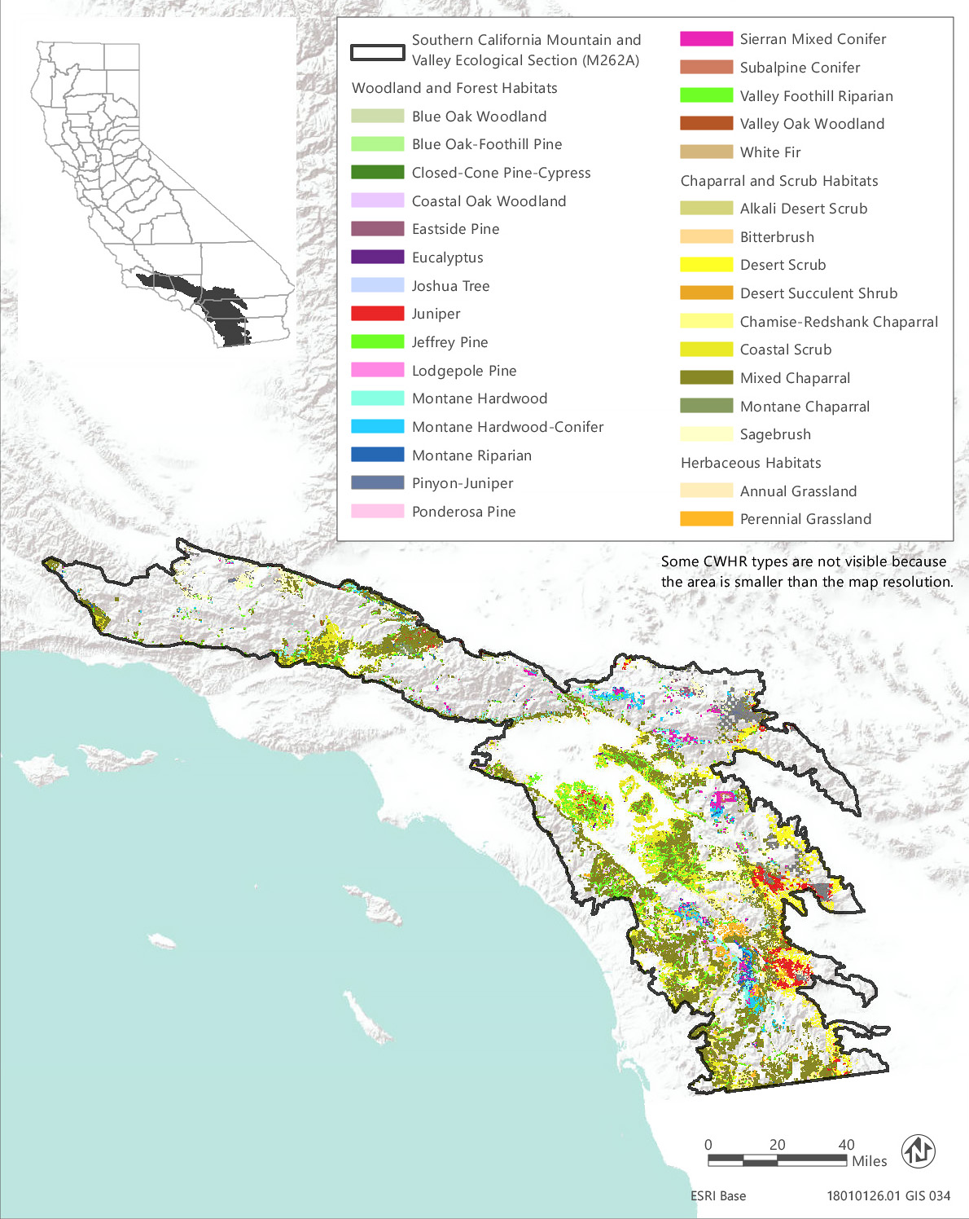
Source: Data received from CAL FIRE in 2018
Figure 3.6-18 CWHR Types - Southern California Mountain and Valley Ecological Section (M262B)
Table 3.6-29 Vegetation and Habitat Types within the Treatable Landscape for the Southern California Mountains and Valleys Ecological Section
CWHR Classification | Acres | MCV Alliances
Woodland and Forest Habitats
Blue Oak Woodland | 1,181 | - Blue oak woodland | - Interior live oak woodland
Blue Oak-Foothill Pine | 312 | - Foothill pine woodland | - Blue oak woodland
Closed-Cone Pine-Cypress | 110 | - Tecate cypress stand*  - Sargent cypress woodland* | - Cuyamaca cypress stand*  - Knobcone pine forest
Coastal Oak Woodland | 81,668 | - Madrone forest*  - California walnut groves*  - Coast live oak woodland | - Engelmann oak woodland*  - California bay forest*
Eastside Pine | 5,906 | - Jeffrey pine forest | - Ponderosa pine forest
Eucalyptus | 994 | - Eucalyptus - tree of heaven - black locust groves^{N}
Joshua Tree | 3,724 | - Joshua tree woodland*
Juniper | 54,469 | - Needleleaf rabbitbrush scrub  - California juniper woodland  - Mountain juniper woodland  - Utah juniper woodland* | - Singleleaf pinyon - Utah juniper woodlands  - Parry pinyon woodland*
Lodgepole Pine | 9 | - Lodgepole pine forest
Montane Hardwood | 33,081 | - Coulter pine woodland  - Bigcone Douglas fir forest* | - Canyon live oak forest  - Interior live oak woodland
Montane Hardwood-Conifer | 22,153 | - Coulter pine woodland | - Bigcone Douglas fir forest*
Montane Riparian | 9,102 | - White alder grove  - Fremont cottonwood forest*  - Black cottonwood forest* | - Sandbar willow thicket  - Wild grape shrubland*
Pinyon-Juniper | 39,345 | - Utah juniper woodland*  - Singleleaf pinyon - Utah juniper woodlands | - Parry pinyon woodland*
Ponderosa Pine | 408 | - Ponderosa pine forest
Sierran Mixed Conifer | 13,487 | - Incense cedar forest* | - Mixed oak forest
Valley Foothill Riparian | 19,664 | - Wild tarragon patch  - California sycamore woodland*  - Fremont cottonwood forest*  - Black cottonwood forest*  - California rose briar patch*  - Himalayan blackberry - rattlebox - edible fig riparian scrub^{N} | - Sandbar willow thicket  - Red willow thicket*  - Shining willow groves*  - Pepper tree or Myoporum grove^{N}  - Wild grape shrubland*
Valley Oak Woodland | 306 | - Valley oak woodland*
White Fir | 303 | - White fir forest  - White fir - sugar pine forest
Chaparral and Scrub Habitats
Alkali Desert Scrub | 882 | - Fourwind saltbush scrub  - Quailbush scrub | - Alkali sacaton - scratchgrass - alkali cordgrass alkaline wet meadow*  - Bush seepweed scrub*
Bitterbrush | 23 | - Bitter brush scrub*
Chamise-Redshank Chaparral | 125,460 | - Chamise chaparral  - Chamise - white sage chaparral*  - Chamise - black sage chaparral  - Redshank chaparral  - Eastwood manzanita chaparral | - Bigberry manzanita chaparral  - Hoary leaf ceanothus chaparral  - Wedge leaf ceanothus chaparral/Buck brush chaparral  - Cup leaf ceanothus chaparral*  - Mission manzanita chaparral*
Coastal Scrub | 275,280 | - California sagebrush scrub  - California sagebrush - California buckwheat scrub  - California sagebrush - black sage scrub  - Quailbush scrub  - Coyote brush scrub  - Broom patch^{N}  - Live-forever - lichen/moss sparse herbaceous rock outcop  - California brittle bush - Ashy buckwheat scrub*  - Brittle bush scrub  - Palmer's goldenbush scrub*  - California buckwheat scrub  - California buckwheat - white sage scrub  - Wright's buckwheat - Heerman's buckwheat - Utah butterfly-bush scrub* | - California coffee berry scrub  - Menzies's golden bush scrub*  - Bush penstemon scrub*  - Scale broom scrub*  - Deer weed scrub  - Bush mallow scrub  - Laurel sumac scrub  - Ice plant mats^{N}  - Coast prickly pear scrub*  - White sage scrub*  - Purple sage scrub  - Black sage scrub  - Coast range stonecrop draperies  - Bushy spikemoss mats*  - Jojoba scrub*  - Bush seepweed scrub*  - Poison oak scrub
Desert Scrub | 94,864 | - Desert agave scrub*  - White bursage scrub  - Desert needlegrass grassland*  - Fourwind saltbush scrub  - Quailbush scrub  - Rigid spineflower - hairy desert sunflower  - Mojave-Sonoran Desert dunes*  - Acton's and Virgin River brittlebush - net-veined goldeneye scrub*  - Brittle bush scrub  - Nevada joint fir - Anderson's boxthorn - spiny hop sage scrub  - California buckwheat - Parish's goldeneye scrub | - Wright's buckwheat - Heerman's buckwheat - Utah butterfly-bush scrub*  - Snakeweed scrub*  - Creosote bush scrub  - Creosote bush - white bursage scrub  - Big galleta shrub-steppe*  - Desert almond - Mexican bladdersage scrub  - Desert apricot scrub*  - Catclaw acacia - desert lavender - chuparosa scrub  - Jojoba scrub*  - Alkali sacaton - scratchgrass - alkali cordgrass alkaline wet meadow*  - Bush seepweed scrub*
Desert Succulent Shrub | 3,661 | - Desert agave scrub*  - Elephant tree stand* | - Nolina scrub*  - Mojave yucca scrub
Mixed Chaparral | 476,149 | - Eastwood manzanita chaparral  - Bigberry manzanita chaparral  - Pointleaf manzanita - pink-bract manzanita chaparral*  - Hoary leaf ceanothus chaparral  - Wedge leaf ceanothus chaparral, Buck brush chaparral  - Cup leaf ceanothus chaparral*  - Deer brush chaparral  - Chaparral whitethorn chaparral  - Bigpod ceanothus chaparral  - Hairy leaf - woolly leaf ceanothus chaparral*  - Wart stemmed ceanothus chaparral*  - Birch leaf mountain mahogany chaparral  - Bush poppy scrub  - Thick leaf yerba santa scrub* | - California coffee berry scrub  - Deer weed scrub  - Bush mallow scrub  - Laurel sumac scrub  - Holly leaf cherry - toyon - greenbark ceanothus chaparral  - Choke cherry thickets*  - Scrub oak chaparral  - Scrub oak - chamise chaparral  - Canyon live oak chaparral*  - Muller oak chaparral  - Tucker oak chaparral  - Palmer oak chaparral*  - Interior live oak chaparral  - Sugarbush chaparral  - Oak gooseberry thicket*  - Poison oak scrub
Montane Chaparral | 11,484 | - Green leaf manzanita chaparral  - Mountain whitethorn chaparral  - Deer brush chaparral | - Birch leaf mountain mahogany chaparral  - Bush chinquapin chaparral*  - Choke cherry thicket*
Sagebrush | 23,286 | - California sagebrush scrub  - California sagebrush - California buckwheat scrub  - California sagebrush - black sage scrub  - Black sagebrush scrub*  - Rothrock's sagebrush* | - Big sagebrush  - Small leaf mountain mahogany scrub*  - Curl leaf mountain mahogany scrub  - Black brush scrub  - Rubber rabbitbrush scrub  - Bitter brush scrub*
Herbaceous Habitats
Annual Grassland | 133,508 | - Western ragweed meadow  - Fiddleneck - phacelia field  - Wild oat grassland^{N}  - Upland mustard and other ruderal forbs^{N}  - Annual brome grassland^{N}  - Red brome or Mediterranean grass grassland^{N}  - Cheatgrass - medusahead grassland^{N}  - Yellow star-thistle field^{N}  - Tar plant field* | - Annual dogtail grassland^{N}  - Clustered tarweed field*  - California poppy - lupine field  - California goldfields - dwarf plantain - small fescue flower fields  - Spanish clover field  - Monolopia - leafy-stemmed tickseed field*
Perennial Grassland | 10,126 | - Bent grass - tall fescue meadow  - Purple three-awn meadow*  - Upland mustard and other ruderal forbs^{N}  - California brome - blue wildrye prairie*  - Small-fruited sedge meadow*  - Sand-aster and perennial buckwheat field  - Pampas grass patch^{N} | - Ashy ryegrass - creeping ryegrass turf*  - Deer grass bed*  - Needle grass - melic grass grassland  - Fountain grass sward^{N}  - Harding grass - reed canary grass sward^{N}  - Kentucky blue grass turf^{N}  - Curly blue grass grassland*
Total | 1,440,945
*These are designated sensitive natural communities with a state rarity rank of S1 (critically imperiled), S2 (imperiled), or S3 (vulnerable).
^{N} These alliances are dominated by nonnative vegetation.
Source: CWHR 2019, CNPS 2019, Compiled by Ascent Environmental in 2019

Critical Habitat
Critical habitat has been designated within the treatable landscape of this ecoregion for 19 plant taxa and 17 wildlife taxa. These include Munz’s onion (Allium munzii), ash-grey paintbrush (Castilleja cinerea), southern mountain wild buckwheat (Eriogonum kennedyi var. austromontanum), San Bernardino Mountains bladderpod (Lesquerella kingii ssp. bernardina), arroyo toad, Laguna Mountains skipper (Pyrgus ruralis lagunae) mountain yellow-legged frog, southwestern willow flycatcher (Empidonax traillii extimus), San Bernardino Merriam's kangaroo rat (Dipodomys merriami parvus), and Santa Ana sucker (Catostomus santaanae). Appendix BIO-4 provides the acreage of critical habitat designated within the treatable landscape of this ecoregion for these species.

Sensitive Natural Communities and Habitats

Sensitive Natural Communities
There are 63 sensitive natural communities that have potential to occur within the treatable landscape of the Southern California Mountains and Valleys Section. The sensitive natural communities associated with each CWHR type in this ecoregion are identified in Table 3.6-29. Notable examples for this ecoregion include Tecate cypress stands, Cuyamaca cypress stands, Joshua tree woodland, Parry pinyon woodland, Palmer’s goldenbush scrub, Menzies’s golden bush scrub, snakeweed scrub, desert apricot scrub, jojoba scrub, and clustered tarweed field. Chaparral sensitive natural communities are discussed below.

Wetlands and Other Waters of the United States and Waters of the State
Over 28,000 acres of wetland habitats have been identified in the NWI within the treatable landscape of the Southern California Mountains and Valleys Section consisting of freshwater emergent wetland, freshwater forested and shrub wetland, freshwater pond, lake, and riverine wetlands with the most abundant being riverine and freshwater forested and shrub wetland (Table 3.6-2). In addition, alkali sacaton - scratchgrass - alkali cordgrass alkaline wet meadow, small-fruited sedge meadows, and bent grass-tall fescue meadows are wetland types that may be included in areas mapped as scrub or grassland habitats. Vernal pools and swales may also be present, as well as other seasonal wetlands.

Other Sensitive Habitats
CWHR riparian habitat types identified within the treatable landscape of the Southern California Mountains and Valleys Section consist of approximately 19,664 acres of valley foothill riparian habitat and 9,102 acres of montane riparian habitat. There are 11 MCV alliances associated with the valley foothill riparian habitat type within this ecoregion and five MCV alliances associated with the montane riparian habitat type. Seven of these are designated sensitive natural communities as indicated in Table 3.6-29.
Oak woodland habitats in the treatable landscape of the Southern California Mountains and Valleys Section consist of approximately 81,668 acres of coastal oak woodland, 1,181 acres of blue oak woodland, and 312 acres of blue oak – foothill pine woodland, and 306 acres of valley oak woodland. There are approximately 33,081 acres of montane hardwood that may include oak woodlands stands. Valley oak woodland is a designated sensitive natural community and Engelmann oak woodland is a sensitive natural community that may be present in areas mapped as coastal oak woodland. Additional sensitive natural communities that may be present in areas mapped as oak woodlands in this ecoregion, include madrone forest, California bay forest, and California walnut groves.
Chaparral and coastal scrub habitats in the treatable landscape of the Southern California Mountains and Valleys Section consist of approximately 125,460 acres of chamise – redshank chaparral, 476,149 acres of mixed chaparral, 11,484 acres of montane chaparral, and 275,280 acres of coastal scrub. Chaparral habitat in this ecoregion is extremely diverse with 30 MCV alliances recognized in the mixed chaparral type, 10 recognized in the chamise-redshank chaparral type, and six in the montane chaparral type. Thirteen of these chaparral types are designated sensitive natural communities, including cup leaf ceanothus chaparral, mission manzanita chaparral, pointleaf manzanita - pink-bract manzanita chaparral, thick leaf yerba santa scrub, canyon live oak chaparral, Palmer oak chaparral, and bush chinquapin chaparral. The southern maritime chaparral extends into this ecoregion and, as in the Southern California Coast Section, there is a high degree of endemism and several special-status chaparral species are present including San Gabriel manzanita (Arctostaphylos glandulosa ssp. gabrielensis), Otay manzanita (Arctostaphylos otayensis), Rainbow manzanita, Otay Mountain ceanothus (Ceanothus otayensis), wart-stemmed ceanothus, and scrub oak.
The coastal scrub habitat is also very diverse in this ecoregion with 30 MCV alliances recognized and all but two of these are native vegetation types. Eleven of the recognized alliances are designated sensitive natural communities as noted in Table 3.6-29. There is a high degree of plant species endemism within chaparral and coastal scrub habitats in this ecoregion and numerous special-status plant and wildlife species are associated with the coastal scrub habitat in this ecoregion.

Conservation Lands, Special Management Areas, and Other Biologically Important Lands

Habitat Conservation Plan, Natural Community Conservation Plan, and other Conservation Plan Areas
The treatable landscape in the Southern California Mountains and Valleys Section includes plan areas for the Orange County Southern Subregion HCP, Central/Coastal Orange County HCP/NCCP, Coachella Valley Multiple Species Habitat Conservation Plan (HCP/NCCP), San Diego County Multiple Species Conservation Program (HCP/NCCP), San Diego County Water Authority HCP/NCCP, San Diego Gas and Electric Subregional HCP/NCCP, San Diego Multiple Habitat Conservation Program (HCP/NCCP), and Western Riverside County Multiple Species Habitat Conservation Plan (HCP/NCCP), which have been adopted and are being implemented. Additionally, two HCPs and four HCP/NCCPs are currently being planned in the treatable landscape. Table 3.6-30 summarizes the conservation plans adopted or in progress, including the acreages of plan areas within the treatable landscape.
Table 3.6-30 Conservation Plans Adopted or In Progress in the Treatable Landscape—Southern California Mountains and Valleys Section
Conservation Plan | Plan Type | Stage | Plan Area Within the Treatable Landscape (Acres)¹
West Mojave Plan | HCP | Planning | 78,500
City of Colton Habitat Conservation Plan | HCP | Planning | 213
Orange County Southern Subregion | HCP | Implementation | 2,659
Central/Coastal Orange County | HCP/NCCP | Implementation | 4,148
Coachella Valley Multiple Species Habitat Conservation Plan | HCP/NCCP | Implementation | 77,189
Desert Renewable Energy Conservation Plan | HCP/NCCP | Planning | 144,056
Orange County Transportation Authority | HCP/NCCP | Planning | 17,818
San Diego County Multiple Species Conservation Program | HCP/NCCP | Implementation | 109,806¹
San Diego County Water Authority | HCP/NCCP | Implementation | 109,806¹
San Diego East County MSCP | HCP/NCCP | Planning | 545,169
San Diego Gas and Electric Subregional | HCP/NCCP | Implementation | 109,806¹
San Diego Multiple Habitat Conservation Program | HCP/NCCP | Implementation | 3,328
San Diego North County Multiple Species Conservation Plan | HCP/NCCP | Planning | 184,372
Western Riverside County Multiple Species Habitat Conservation Plan | HCP/NCCP | Implementation | 520,888
 |  | Total¹ | 1,688,146
Notes: ¹The San Diego Water Authority HCP/NCCP and San Diego Gas and Electric Subregional HCP/NCCP cover discrete linear or energy projects but have larger plan areas that are contained within the San Diego County Multiple Species Conservation Program. Therefore, the acreage total does not include separate acreages for these overlapping plan areas.

Protected Open Space Lands
The treatable landscape in the Southern California Mountains and Valleys Section contains 525 protected open space units that are recognized in CPAD. These lands cover 373,229 acres, which represent 26 percent of the treatable landscape in the ecoregion. Some of the major land owners include State Parks, CDFW, The Wildlands Conservancy, San Diego County, University of California, Riverside County, and The Nature Conservancy. Examples of some of the prominent open space units in the Southern California Mountains and Valleys Section include Anza-Borrego Desert State Park, Cuyamaca Rancho State Park, Santa Rosa Plateau Ecological reserve, and Santa Rosa Wildlife Area.

Southern Cascades Section
The Southern Cascades Section (M261D) encompasses 4,208,496 acres and comprises the mountains, hills, and valleys of the southern Cascade Ranges. These volcanic mountains are scattered and do not form a distinct range. Elevations range from 1,500 to 14,000 feet. This ecoregion contains 1,535,830 acres of treatable landscape, which represents approximately 36 percent of the total landscape within the ecoregion. Within the treatable landscape exist modeled treatment areas for the following treatment types: WUI fuel reduction (342,872 acres), fuel break (243,034 acres), and ecological restoration (1,168,867 acres). The treatable landscape covers much of this ecoregion, outside of the valleys, plateaus, and federal land in the east portion of the ecoregion. The treatable landscape in this ecoregion is displayed in Figure 3.6-19.

Vegetation and Habitat Types
Forest and woodland habitat types make up 85 percent the treatable landscape of the Southern Cascades Section. Twenty forest and woodland CWHR types occur in the treatable landscape and Sierran mixed conifer is the predominant forest type, covering nearly 640,000 acres, followed by ponderosa pine at just over 208,000 acres. There are approximately 40 MCV alliances associated with the forest and woodland habitats in this ecoregion. Chaparral and scrub habitat types compose approximately 8 percent of the treatable landscape and consist of alkali desert scrub, bitterbrush, low sage, mixed chaparral, and sagebrush, which is the most prevalent scrub type. Fourteen MCV alliances are associated with the chaparral and scrub CWHR types in this ecoregion. Annual and perennial grasslands make up approximately 4 percent and 2 percent of the treatable landscape, respectively. There are 11 MCV alliances recognized in the perennial grassland type in this ecoregion and seven of these are sensitive natural communities.
Table 3.6-31 provides the acreage of each CWHR habitat type within the treatable landscape of this ecoregion and the associated MCV vegetation alliances that may occur within each CWHR type in this ecoregion. Alliances that are designated as sensitive natural communities and those that are dominated by nonnative vegetation are indicated in Table 3.6-31. Sensitive natural communities are discussed in more detail below. The distribution of CWHR types within this ecoregion is shown in Figure 3.6-19.

Sensitive Biological Resources

Special-Status Species
There are 36 special-status wildlife taxa and at least 116 special-status plant taxa known or with potential to occur in the treatable landscape of the Southern Cascades Section, including 16 animal taxa and five plant taxa that are state or federally listed as rare, threatened, or endangered or fully protected. Approximately 35 percent of the special-status plant species in this ecoregion are associated with wetland or riparian habitats and several others are associated with serpentine substrates. A list of all the special-status plant species known or with potential to occur within the treatable landscape of the Southern Cascades Section, along with their listing status and detailed habitat descriptions, is provided in Appendix BIO-3, Table 18a. A list of special-status wildlife (other than fish) species known or with potential to occur in the treatable landscape of this ecoregion, along with the CWHR types they are associated with, is provided in Appendix BIO-3, Table 18b. Special-status fish known or with potential to occur in the ecoregion are identified in Appendix BIO-3, Table 19.

Critical Habitat
Critical habitat exists within the treatable landscape of this ecoregion for northern spotted owl, slender Orcutt grass, and Greene’s tuctoria (Tuctoria greenei). Appendix BIO-4 provides the acreage of critical habitat designated within the treatable landscape of this ecoregion for these species.
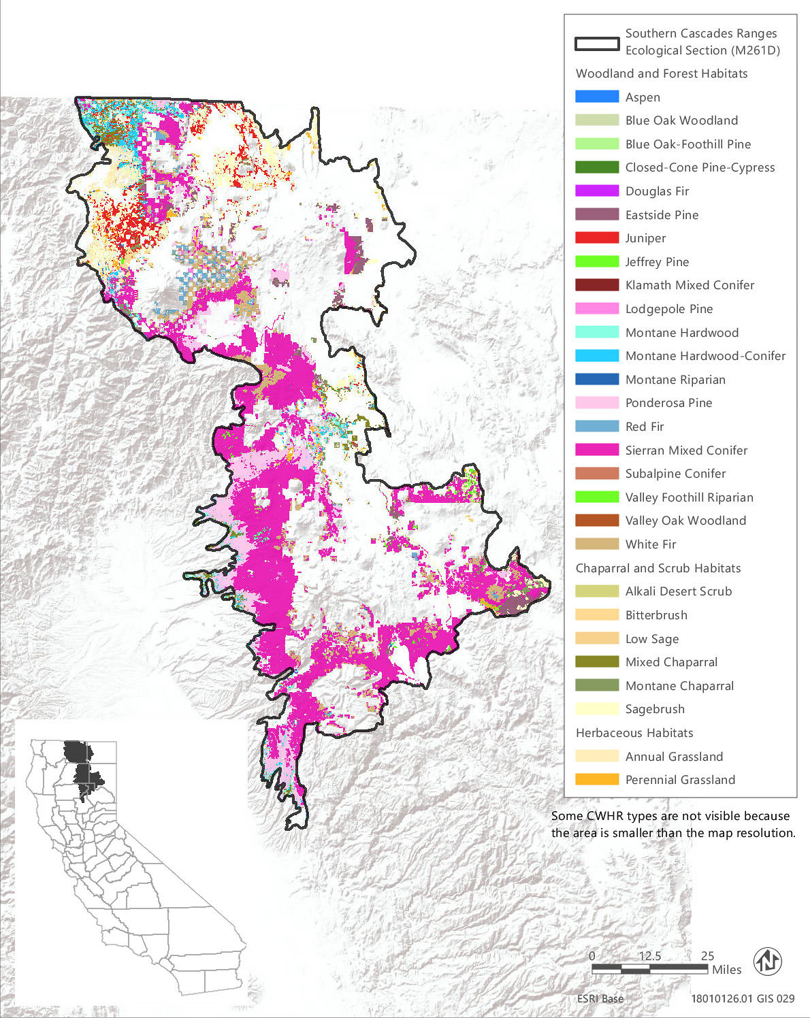
Source: Data received from CAL FIRE in 2018
Figure 3.6-19 CWHR Types - Southern Cascades Ecological Section (M261D)
Table 3.6-31 Vegetation and Habitat Types within the Treatable Landscape for the Southern Cascades Ecological Section
CWHR Classification | Acres | MCV Alliances
Woodland and Forest Habitats
Aspen | 539 | - Aspen groves*
Blue Oak Woodland | 11,878 | - Blue oak woodland
Blue Oak-Foothill Pine | 4,478 | - Foothill pine woodland | - Blue oak woodland
Closed-Cone Pine-Cypress | 454 | - Baker cypress stands*  - McNab cypress woodland* | - Knobcone pine forest
Douglas Fir | 821 | - White fir - Douglas fir forest  - Bigleaf maple forest*  - Ponderosa pine - Douglas fir forest | - Douglas fir forest  - Douglas fir - tanoak forest*
Eastside Pine | 111,981 | - Jeffrey pine forest  - Ponderosa pine forest | - Washoe pine woodland*
Jeffrey Pine | 20,740 | - Jeffrey pine forest
Juniper | 93,042 | - Western juniper woodland
Klamath Mixed Conifer | 144 | - Engelmann spruce forest*
Lodgepole Pine | 10,731 | - Lodgepole pine forest
Montane Hardwood | 43,375 | - Bigleaf maple forest*  - Tanoak forest*  - Mixed oak forest | - Canyon live oak forest  - Oregon white oak woodland*
Montane Hardwood-Conifer | 31,739 | - Bigleaf maple forest*
Montane Riparian | 3,040 | - Rocky Mountain maple thicket*  - Mountain alder thicket*  - White alder grove  - Resin birch thicket*  - Water birch thicket* | - Torrent sedge patch*  - Red osier thicket*  - Oregon ash grove*  - Black cottonwood forest*  - Sandbar willow thicket
Ponderosa Pine | 208,200 | - Ponderosa pine forest  - Ponderosa pine - Douglas fir forest | - Washoe pine woodland*
Red Fir | 16,291 | - Red fir forest | - Red fir - white fir forest
Sierran Mixed Conifer | 639,777 | - Incense cedar forest*  - Mixed oak forest | - Ponderosa pine - Douglas fir forest
Subalpine Conifer | 506 | - Engelmann spruce forest*  - Whitebark pine forest | - Western white pine forest  - Mountain hemlock forest
Valley Foothill Riparian | 483 | - Torrent sedge patch*  - Red osier thicket*  - Black cottonwood forest* | - Sandbar willow thicket  - Himalayan blackberry - rattlebox - edible fig riparian scrub^{N}
Valley Oak Woodland | 3 | - Valley oak woodland*
White Fir | 50,231 | - White fir forest  - White fir - sugar pine forest | - White fir - Douglas fir forest  - Red fir - white fir forest
Chaparral and Scrub Habitats
Alkali Desert Scrub | 18 | - Alkali sacaton - scratchgrass - alkali cordgrass alkaline wet meadow*
Bitterbrush | 21,080 | - Bitter brush scrub*
Low Sage | 4,166 | - Little sagebrush scrub
Mixed Chaparral | 45,105 | - Whiteleaf manzanita chaparral  - Wedge leaf ceanothus chaparral, Buck brush chaparral  - Deer brush chaparral  - Birch leaf mountain mahogany chaparral | - Ocean spray brush*  - Shrub tanoak chaparral*  - Scrub oak chaparral
Sagebrush | 60,249 | - Big sagebrush  - Mountain big sagebrush  - Curl leaf mountain mahogany scrub  - Little sagebrush scrub  - Bitter brush scrub* | - Rubber rabbitbrush scrub
Herbaceous Habitats
Annual Grassland | 65,103 | - Wild oat grassland  - Annual brome grassland^{N}  - Red brome or mediterranean grass grassland^{N} | - Cheatgrass - medusahead grassland^{N}  - Yellow star-thistle field^{N}  - Needle spike rush stand*
Perennial Grassland | 25,863 | - Water foxtail meadow*  - Small-fruited sedge meadow*  - California oat grass prairie*  - Harding grass - reed canary grass sward^{N}  - Kentucky blue grass turf^{N} | - Tufted hair grass meadow  - Idaho fescue grassland*  - Ashy ryegrass - creeping ryegrass turf*  - Mat muhly meadow  - Curly blue grass grassland*  - Bluebunch wheat grass grassland*
Total | 1,470,037
*These are designated sensitive natural communities with a state rarity rank of S1 (critically imperiled), S2 (imperiled), or S3 (vulnerable).
^{N} These alliances are dominated by nonnative vegetation.
Source: CWHR 2019, CNPS 2019, Compiled by Ascent Environmental in 2019

Sensitive Natural Communities and Habitats

Sensitive Natural Communities
There are 31 sensitive natural communities that may occur within the treatable landscape of the Southern Cascades Section. The sensitive natural communities associated with each CWHR type in this ecoregion are identified in Table 3.6-31. Examples include Baker cypress stands, bigleaf maple forest, Engelmann spruce forest, Douglas fir-tanoak forest, ocean spray brush, shrub tanoak chaparral, bluebunch wheat grass grassland, and California oat grass prairie. Some of these sensitive natural communities are dominated by special-status species. Engelmann spruce (Picea engelmannii) and Baker’s cypress (Hesperocyparis bakeri) are special-status plants that characterize sensitive natural communities in this ecoregion.

Wetlands and Other Waters of the United States and Waters of the State
Approximately 30,300 acres of wetland habitats have been mapped in the NWI within the treatable landscape of the Southern Cascades Section, consisting of freshwater emergent wetland, freshwater forested and shrub wetland, freshwater pond, lake, and riverine wetlands with the most abundant being freshwater emergent and freshwater forested and shrub wetland (Table 3.6-2). In addition, alkali sacaton - scratchgrass - alkali cordgrass alkaline wet meadow, small-fruited sedge meadows, water foxtail meadows, and needle spike rush stands are wetland types that may be included in areas mapped as scrub or grassland habitats.

Other Sensitive Habitats
CWHR riparian habitat types identified within the treatable landscape of the Southern Cascades Section consist of approximately 3,040 acres of montane riparian habitat and 483 acres of valley and foothill riparian habitat that may include 11 MCV alliances. Eight of these are designated sensitive natural communities as indicated in Table 3.6-31. Resin birch thickets are dominated by the special-status plant species resin birch (Betula glandulosa).
Blue oak and valley oak woodland have been mapped in the treatable landscape and mixed oak, canyon live oak, and Oregon white oak may be present in areas mapped as montane hardwood.
A little over 45,000 acres of mixed chaparral habitat are present in the treatable landscape of this ecoregion and may include seven different MCV alliances, of which two, ocean spray brush and shrub tanoak chaparral, are sensitive natural communities.

Conservation Lands, Special Management Areas, and Other Biologically Important Lands

Habitat Conservation Plan, Natural Community Conservation Plan, and other Conservation Plan Areas
No conservation plans have been adopted for lands within the treatable landscape in the Southern Cascades Section.

Protected Open Space Lands
The treatable landscape in the Southern Cascades Section contains 46 protected open space units that are recognized in CPAD. These lands cover 29,527 acres, which represent 2 percent of the treatable landscape in the ecoregion. Some of the major land owners include CAL FIRE, CDFW, State Parks, The Nature Conservancy, CSLC, and Feather River Land Trust. Examples of some of the prominent open space units in the Southern Cascades Section include Ahjumawi Lava Springs State Park, Latour Demonstration State Forest, Shasta Big Springs Ranch, Horseshoe Ranch Wildlife Area, Butte Valley Wildlife Area, Warner Valley Wildlife Area, and McArthur-Burney Falls Memorial State Park.

Regulatory Setting
Biological resources in California are protected and/or regulated by a variety of federal and state laws and policies. Key federal and state regulatory and conservation planning issues applicable to the program are discussed below. No specific local regulations are discussed in this section. As stated below, this PEIR assumes that any vegetation treatments proposed by local agencies under the CalVTP would be consistent with local plans, policies, and ordinances.

Federal

Federal Endangered Species Act
The ESA requires formal or informal consultation with USFWS or the National Oceanic and Atmospheric Administration (NOAA) National Marine Fisheries Service when it is likely that a project could affect species federally listed as threatened or endangered. The purpose of the ESA is to conserve the ecosystems upon which listed species depend. The law’s ultimate goal is to “recover” listed species such that the protections of the act are no longer needed. The ESA requires that recovery plans be developed that describe the steps necessary to restore the species. Similarly, the act provides for the designation of “critical habitat” when prudent and determinable. Critical habitat is geographic areas that contain physical and biological features essential to the conservation of the species and that may require special management considerations or protection. Critical habitat designations affect only federal agency actions or federally funded or permitted activities.
The act also regulates the “taking” of a species listed as threatened or endangered under the ESA. Under the ESA, the definition of “take” is to “harass, harm, pursue, hunt, shoot, wound, kill, trap, capture, or collect, or to attempt to engage in any such conduct.” USFWS has also interpreted the definition of “harm” to include significant habitat modification that could result in take. If implementing a project would result in take of a federally listed species, either the project applicant must acquire an incidental take permit under Section 10(a) of the ESA or, if a federal discretionary action is involved, the federal agency must consult with USFWS under Section 7 of the act.

Marine Mammal Protection Act
The Marine Mammal Protection Act (MMPA; 16 U.S.C. Chapter 31), first enacted in 1972, provides for protection of all marine mammals (whales, dolphins, seals and sea lions) in the United States. The MMPA provides that it shall be unlawful, with certain permitted exceptions, to take a marine mammal in waters of the United States. Under the MMPA, “take” is defined as “to harass, hunt, capture, collect, or kill, or attempt to harass, hunt, capture, collect, or kill any marine mammal.”

Bald and Golden Eagle Protection Act
The Bald and Golden Eagle Protection Act declares it is illegal to “take” bald eagles, including their parts, nests, or eggs, unless authorized. “Take” is defined as “pursue, shoot, shoot at, poison, wound, kill, capture, trap, collect, molest or disturb.” “Disturb” means to agitate or bother a bald or golden eagle to a degree that causes, or is likely to cause, injury to an eagle; a decrease in its productivity, by substantially interfering with normal breeding, feeding, or sheltering behavior; or nest abandonment. In addition to immediate impacts, this definition also covers impacts that result from human-induced alterations initiated around a previously used nest site during a time when eagles are not present if, upon the eagle's return, such alterations agitate or bother an eagle to a degree that interferes with or interrupts normal breeding, feeding, or sheltering habits and causes injury, nest abandonment, or death.

Migratory Bird Treaty Act
The Migratory Bird Treaty Act (MBTA), first enacted in 1918, provides for protection of international migratory birds and authorizes the Secretary of the Interior to regulate the taking of migratory birds. MBTA provides that it shall be unlawful, except as permitted by regulations, to pursue, take, or kill any migratory bird, or any part, nest, or egg of any such bird. Under the MBTA, “take” is defined as “to pursue, hunt, shoot, wound, kill, trap, capture, or collect, or any attempt to carry out these activities.” A take does not include habitat destruction or alteration, as long as there is not a direct taking of birds, nests, eggs, or parts thereof. The current list of species protected by the MBTA can be found in Title 50 of the Code of Federal Regulations (CFR), Section 10.13 (50 CFR 10.13). The list includes nearly all birds native to the United States.

Clean Water Act
Section 404 of the CWA requires a project applicant to obtain a permit before engaging in any activity that involves any discharge of dredged or fill material into waters of the United States, including wetlands. Fill material is material placed in waters of the United States that has the effect of replacing any portion of waters of the United States with dry land or changing the bottom elevation of any portion of waters of the United States. Waters of the United States include navigable waters; interstate waters; all other waters where the use, degradation, or destruction of the waters could affect interstate or foreign commerce; relatively permanent tributaries to any of these waters; and wetlands adjacent to these waters. Wetlands are defined as those areas that are inundated or saturated by surface water or groundwater at a frequency and duration sufficient to support, and that under normal circumstances do support, a prevalence of vegetation typically adapted for life in saturated soil conditions. Potentially jurisdictional wetlands typically must meet three wetland delineation criteria: hydrophytic vegetation, hydric soil types, and wetland hydrology. Wetlands that meet the delineation criteria may be jurisdictional under Section 404 of the CWA pending USACE verification.
Under Section 401 of the CWA, an applicant for a Section 404 permit must obtain a certificate from the appropriate state agency stating that the intended dredging or filling activity is consistent with the state’s water quality standards and criteria. In California, the authority to grant water quality certification is delegated by the State Water Resources Control Board to the nine regional water quality control boards (RWQCBs).

Coastal Zone Management Act
The Coastal Zone Management Act provides for the management of the nation’s coastal resources. It is administered by NOAA with the goal to preserve, protect, develop, and, where possible, restore or enhance the resources of the nation’s coastal zone. Portions of the assessment area for this PEIR fall within the coastal zone.

Z’berg-Nejedly Forest Practice Act
Although the proposed CalVTP excludes timber removal for commercial purposes, the Z’berg -Nejedly Forest Practice Act (Forest Practice Act) may be pertinent as it relates to identifying operating methods and procedures that seek to protect fish, wildlife, forests, and streams within timber harvesting areas where qualifying CalVTP treatments may also be implemented. The Forest Practice Act is intended to achieve “maximum sustained production of high-quality timber products…while giving consideration to values relating to recreation, watershed, wildlife, range and forage, fisheries, regional economic vitality, employment and aesthetic enjoyment” (PRC Section 4513[b]). The regulations created by the Forest Practice Act define factors such as the: size and location of harvest areas, include measures to prevent unreasonable damage to residual trees, and address the protection of riparian areas, water courses and lakes, wildlife, and habitat areas.

State

California Environmental Quality Act
CEQA (PRC Section 21000 et seq.) and the State CEQA Guidelines (CCR Section 15000 et seq.) provide that public agencies whose activities may affect the environment shall prevent environmental damage. Rare, threatened, or endangered plant species, subspecies, and varieties are specifically considered in various sections of CEQA and the Guidelines. State CEQA Guidelines Section 15380(b) provides the criteria for endangered, rare, and threatened species. Section 15380(d) states that species that are not on state and federal lists but meet the criteria in Section 15380(b) “shall nevertheless be considered to be endangered, rare or threatened.” California Rare Plant Rank 1A, 1B, 2A, and 2B species are presumed to meet these criteria. Additionally, under Section 15380, species will be considered endangered, rare, or threatened if they are listed as such under the CESA or the ESA. Species designated as candidates for listing by the California Fish and Game Commission under CESA also are “presumed to be endangered.” CESA presumes that candidate species meet the criteria for listing as endangered, rare, or threatened.

California Endangered Species Act
CDFW regulates the taking of species listed as threatened or endangered under CESA, which prohibits the taking of state-listed endangered or threatened species, as well as candidate species being considered for listing, without the issuance of incidental take permits. Project proponents may obtain an incidental take permit pursuant to Fish and Game Code Section 2081 if the impacts of the take are minimized and fully mitigated and if the take would not jeopardize the continued existence of the species. A “take” of a species, under CESA, is defined as "hunt, pursue, catch, capture, or kill, or attempt to hunt, pursue, catch, capture, or kill" an individual of a species. The CESA definition of “take” does not include “harm” or “harass” as is included in the ESA definition. As a result, the threshold for take under CESA may be higher than under the ESA.

Porter-Cologne Water Quality Control Act
The Porter-Cologne Act requires that each of the nine RWQCBs prepare and periodically update basin plans for water quality control. Each basin plan sets forth water quality standards for surface water and groundwater and actions to control nonpoint and point sources of pollution to achieve and maintain these standards. Basin plans offer an opportunity to protect wetlands through the establishment of water quality objectives. The RWQCB’s jurisdiction includes waters of the United States, as well as areas that meet the definition of “waters of the state.” “Waters of the state” is defined as any surface water or groundwater, including saline waters, within the boundaries of the state. The RWQCB has the discretion to take jurisdiction over areas not federally protected under CWA Section 404 provided they meet the definition of waters of the state and the State Water Resources Control Board published a new set of procedures for discharges of dredged or fill material into waters of the state on March 22, 2019. Mitigation requiring no net loss of wetlands functions and values of waters of the state typically is required by the RWQCB.
The State Water Resources Control Board has adopted the following definition of wetlands:
An area is wetland if, under normal circumstances, (1) the area has continuous or recurrent saturation of the upper substrate caused by groundwater or shallow surface water or both; (2) the duration of such saturation is sufficient to cause anaerobic conditions in the upper substrate; and (3) the area’s vegetation is dominated by hydrophytes the area lacks vegetation.

Section 1602 of the California Fish and Game Code
All diversions, obstructions, or changes to the natural flow or bed, channel, or bank of any river, stream, or lake in California that supports wildlife resources are subject to regulation by CDFW under Section 1600 et seq. of the California Fish and Game Code. Under Section 1602, it is unlawful for any person to substantially divert or obstruct the natural flow or substantially change the bed, channel, or bank of any river, stream, or lake designated by CDFW, or use any material from the streambeds, without first notifying CDFW of such activity and obtaining a final agreement authorizing such activity. CDFW’s jurisdiction in altered or artificial waterways is based on the value of those waterways to fish and wildlife.

Native Plant Protection Act
The Native Plant Protection Act (NPPA) (California Fish and Game Code Section 1900 et seq.) allows the California Fish and Game Commission to designate plants as rare or endangered. Sixty-four species, subspecies, and varieties of plants are protected as rare under the NPPA. The act prohibits take of endangered or rare native plants but includes exceptions for agricultural and nursery operations; for emergencies; and, after proper notification of CDFW, for vegetation removal from canals, roads, and other building sites, changes in land use, and other situations.

Fully Protected Species
Protection of fully protected species is described in Sections 3511, 4700, 5050, and 5515 of the California Fish and Game Code. These statutes prohibit take or possession of fully protected species and generally do not provide for authorization of incidental take. CDFW has informed nonfederal agencies and private parties that their actions must avoid take of any fully protected species. On October 8, 2011, the governor signed Senate Bill 618, authorizing CDFW to permit the incidental take of fully protected species if the species is covered and conserved in a natural community conservation plan.

Protection for Bird Nests and Raptors
Section 3503 of the California Fish and Game Code states that it is unlawful to take, possess, or needlessly destroy the nest or eggs of any bird. Section 3503.5 specifically states that it is unlawful to take, possess, or destroy any raptors (e.g., hawks, owls, eagles, and falcons), including their nests or eggs. Section 3513 of the California Fish and Game Code codifies the federal MBTA. Compliance with sections 3503 and 3503.5 is typically achieved by implementing avoidance and minimization measures to prevent project-related loss of active nests (e.g., conducting activities outside of the nesting bird season; identifying and avoiding disturbance by limiting project activities near an active nest; or monitoring active nests and delaying project activities near the nest until after young have fledged or the nest otherwise becomes inactive).

Natural Community Conservation Planning Act
The Natural Community Conservation Planning (NCCP) Act of 1991 is designed to conserve natural communities at the ecosystem scale while accommodating compatible land uses. CDFW is the principal state agency implementing the NCCP Program. Section 2800 et seq. of the California Fish and Game Code addresses NCCPs and a 2835 permit is issued by CDFW for all NCCPs. The Act established a process to allow for comprehensive, regional multi-species planning in a manner that satisfies the requirements of the State and federal ESAs (through a companion regional Habitat Conservation Plan). The NCCP program has provided the framework for innovative efforts by the State, local governments, and private interests to plan for the protection of regional biodiversity and the ecosystems upon which it depends. NCCPs seek to ensure the long-term conservation of multiple species, while allowing for compatible and appropriate economic activity to proceed.

Local
When state agencies, including CAL FIRE, are conducting governmental activities under the authority of state law or the State Constitution, in this case, treatments implemented under the proposed CalVTP, they are exempt from local government plans, policies, and ordinances (unless a constitutional provision or statute directs otherwise). Nonetheless, CAL FIRE voluntarily seeks to operate consistently with local governance to the extent feasible. Given its statewide extent and the possible number of local and regional responsible agencies, this PEIR does not identify potentially applicable local government plans, policies, and ordinances. This PEIR assumes that any vegetation treatments proposed by local or regional agencies under the CalVTP would be consistent with local plans, policies, and ordinances to the extent the project is subject to them, as required by SPR AD-3.

California Coastal Act
The California Coastal Act (CCA), administered by the California Coastal Commission (CCC), includes policies for development proposed within the coastal zone and recognizes California ports, harbors, and coastline beaches as economic and important coastal-dependent uses and resources. The CCC regulates all jurisdictional wetlands that are under the joint jurisdiction of USACE and the RWQCBs, as well as riparian habitat under the jurisdiction of CDFW. The CCA also defines “Environmentally Sensitive [Habitat] Area” as “any area in which plant or animal life or their habitats are either rare or especially valuable because of their special nature or role in an ecosystem and which could be easily disturbed or degraded by human activities and developments” (Section 30107.5). The CCA requires that such areas be protected and that development projects within or adjacent to such areas be limited only to uses dependent on the ESHA resources and planned and sited to prevent significant disruption or degradation of environmentally sensitive areas habitat values. Portions of the treatable landscape for this PEIR fall within the coastal zone. The California Coastal Zone is defined as land and water area of the State of California from the Oregon border to the border of the Republic of Mexico, extending seaward to the state's outer limit of jurisdiction, including all offshore islands, and extending inland generally 1,000 yards from the mean high tide line of the sea, but is specifically designated on maps held by the Legislature. In significant coastal estuarine, habitat, and recreational areas it extends inland to the first major ridgeline paralleling the sea or five miles from the mean high tide line of the sea, whichever is less, and in developed urban areas the zone generally extends inland less than 1,000 yards. The coastal zone does not include the area of jurisdiction of the San Francisco Bay Conservation and Development Commission, nor any area contiguous thereto, including any river, stream, tributary, creek, or flood control or drainage channel flowing into such area.

Given the large geographic area of the treatable landscape and anticipated use of this PEIR over the long-term, Appendix BIO-3 cannot identify every special-status species potentially affected by later CalVTP treatment activities. After certification of this PEIR, species status may change, taxonomic classification or scientific nomenclature may change, and new species may be designated as special status. If a proposed later treatment project would impact a species that meets the definition of special status in this PEIR but is not listed in Appendix BIO-3, the project could qualify for a “within the scope” finding if the potential impacts on the species’ life history group are adequately considered in the PEIR, pursuant to State CEQA Guidelines Ssections 15152 and 15168, and any applicable mitigation is imposed, as explained in the Project Specific Analysis Instructions (see Appendix PD-3).

