Range Management Advisory Committee   
*State Lands Grazing License and Land Management subcommittee*

Appendix B:

Management Action Plan (MAP) Template

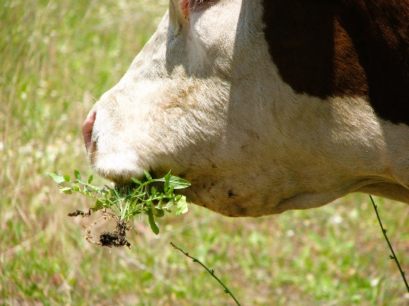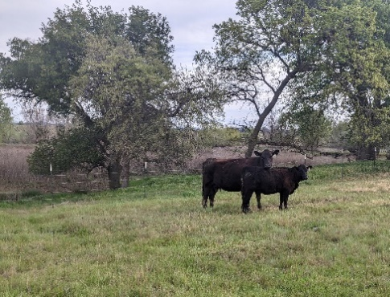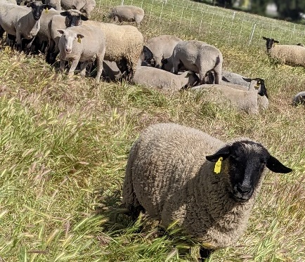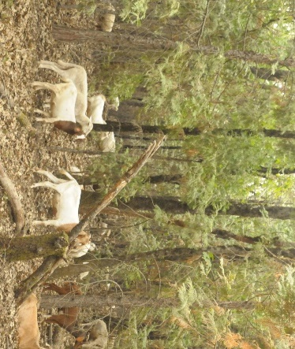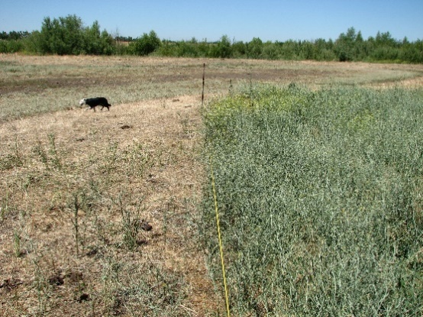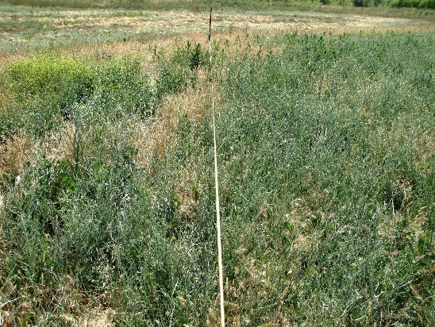

**California State Board of Forestry and Fire Protection (‘Board’)**

**Range Management Advisory Committee (RMAC)**

**State Lands Grazing License and Land Management Sub-Committee (‘RMAC Subcommittee’)**

**Approved: MONTH DAY 2025**

**Cover photos details and credits (from left to right, top to bottom): TOP ROW:** Sheep grazing on native grass enhancement research trial in Yolo County; Targeted goat grazing in wildland urban interface project in Nevada County; Cattle grazing along riparian pasture in Oak woodlands in Placer County (Credits: Tracy Schohr); **BOTTOM ROW:** Bulls grazing yellowstar thistle (*Centaurea solstitialis*) with before and after photos (Credits: Bart Cremers).

**Contents**

FOREWORD iv

Management Action Plan Members iv

I. INTRODUCTION 1

II. MANAGEMENT ACTION PLAN TEMPLATE 1

1.0 Introduction 1

*1.1 Relationship of this MAP to Other Documents 1

*1.2 Purposes and Uses of this MAP 1

*1.3 Preparers 1

2.0 Description of Current Site Conditions 1

*2.1 General Description of Property 1

*2.2 Native/Naturalized Vegetation 1

*2.3 Invasive Pest Plants 1

*2.4 Wildlife and Habitats 1

2.5 Aquatic and Hydrologic Resources 1

2.6 Soils and Topography - Ecological Site Descriptions, Productivity, Erosion, and Compaction 1

2.7 Fire Hazards and Risks 1

2.8 Woody Encroachment 1

3.0 Impacts of Grazing on Resources of Concern 1

*3.1 Grazing Context 1

*3.2 Summary of Expected Grazing Effects on Special Resources and Desired Management Outcomes 1

*3.3 Potential Conflicts with Wildlife, Recreation, or Neighbors 1

3.4 Expected Effects of Climate Change 1

3.5 Priorities for Ongoing Maintenance 2

4.0 Grazing Management Goals, Objectives, and Performance Standards 2

*4.1 Identify Goals, Objectives, and Performance Standards to Meet Resource Management Plan (RMP) Objectives 2

5.0 Grazing Program 2

*5.1 Glossary of Terms 2

*5.2 General Prescription 2

*5.3 Grazing Capacity and Recommended Initial Stocking Rates 2

*5.4 Forage Utilization and Residue Standards 2

*5.5 Special Management Areas for Targeted and Deferred Grazing 2

*5.6 Conflict Mitigation Strategies 2

*5.7 Fire Hazards and Risks Mitigation Strategies 2

*5.8 Supplemental Feeding and Feeding Areas 2

*5.9 Animal Distribution Improvements 2

*5.10 Restrictions 2

*5.11 Communications 2

*5.12 Livestock Agreement Options and Recommendations 2

*5.13 Grazing Fee Credit Options and Other Incentives for Stewardship Cooperation 2

*5.14 Infrastructure 2

5.15 Extreme Weather (drought, flood, debris flows, infrastructure damage) Preparations, Special Monitoring, and Response Plan 2

6.0 Monitoring, Reporting, and Plan Adaptation 3

*6.1 Monitoring and Reporting 3

*6.2 Plan and Practice Adaptation 3

*6.3 Roles and Responsibilities of Landlords and Grazing Operators 3

7.0 Summary of Requirements and Recommendations 3

*7.1 Concise Summary of Key Management Requirements Described in this MAP 3

*7.2 Supplementary Assessments and Planning 3

REFERENCES 4

# FOREWORD

A subcommittee of the Range Management Advisory Committee (RMAC) developed a Grazing Agreement template (see Appendix A, ‘Agreement’ template) (RMAC 2024a) and a Management Action Plan (MAP) template (Appendix B, this document) to guide and support California government agencies, land managers, and graziers in the use of managed livestock grazing as a tool to enhance ecological and sustainability values and to reduce fire fuels and risk on public lands. A Guidebook (RMAC 2024b) was developed to accompany the Agreement and MAP templates to provide more in-depth information related to the development of specific items and to provide a directory of related resources. Collectively, the three documents developed by the State Lands Grazing License and Land Management (SLGLLM) sub-committee—the Agreement template, MAP template, and Guidebook—are referred to as the ‘**State Lands Grazing Packet**’. A list of acronyms and definitions is provided in the associated Guidebook. **Please refer to the Guidebook for additional guidance in the use of this MAP template, and information on its relationship to the Agreement template.**

## Management Action Plan Members

* Lawrence Ford, PhD* – Rangeland Conservation Science (consultants)
* Jeanette Griffin – California Department of Fish & Wildlife (CDFW)
* Lance Criley* – RMAC member; U.S. Department of Agriculture (USDA) United States Forest Service

**With additional edits** by:**

* Bart Cremers* – RMAC member; WILDLANDS and rancher
* Marc Horney, PhD* – RMAC Chair; Professor, California Polytechnic State University, San Luis Obispo
* Kristina Wolf, PhD* – RMAC staff support, California State Board of Forestry & Fire Protection

***\**** *Certified Rangeland Manager (CRM), licensed by the Professional Forester’s Licensing Committee under a specialty certificate within the California’s Forest Practice Rules under the California Board of Forestry and Fire Protection*

** Additional editing and contributions were incorporated from stakeholders across various public agencies and during the two public comment periods, which were opened during the development of the State Lands Grazing Packet: a 30-day review period beginning July 22, 2022 and a 15-day review period beginning November 01, 2024. Suggested edits were also provided by various state agencies, including the California Department of Fish and Wildlife, California Natural Resources Agency (CNRA), the Natural and Working Lands Science Team (affiliated with CNRA), and Department of General Services.

**Disclaimer:** The State is not liable for the practices of any individual or organization in the use and application of these documents. Any revisions to the language or adaptations in the use of these documents is at the sole discretion and liability of the individual and/or organization utilizing these documents.

# INTRODUCTION

The Management Action Plan Team of the Board of Forestry’s Range Management Advisory Committee (RMAC) and State Lands Grazing License and Land Management (SLGLLM) sub-committee recommends the template below for the development of Management Action Plans (MAP), including sections specifically devoted to grazing management on state lands. Any stipulations described in the MAP should correspond to those in the Grazing Agreement (Appendix A, RMAC 2024a). Brief explanations of the information intended to be included in each section below is provided in the Guidebook (RMAC 2024b).

**Note:** If a simplified version of a MAP is desired or necessitated, Items identified with **asterisks (*)** in the outline are essential to address, although all items are still recommended to include in a MAP.

# MANAGEMENT ACTION PLAN TEMPLATE

## 1.0 Introduction

### *1.1 Relationship of this MAP to Other Documents

### *1.2 Purposes and Uses of this MAP

### *1.3 Preparers

## 2.0 Description of Current Site Conditions

For all items below, include relevant map(s).

### *2.1 General Description of Property

### *2.2 Native/Naturalized Vegetation

### *2.3 Invasive Pest Plants

### *2.4 Wildlife and Habitats

### 2.5 Aquatic and Hydrologic Resources

### 2.6 Soils and Topography - Ecological Site Descriptions, Productivity, Erosion, and Compaction

### 2.7 Fire Hazards and Risks

### 2.8 Woody Encroachment

## 3.0 Impacts of Grazing on Resources of Concern

### *3.1 Grazing Context

### *3.2 Summary of Expected Grazing Effects on Special Resources and Desired Management Outcomes

### *3.3 Potential Conflicts with Wildlife, Recreation, or Neighbors

### 3.4 Expected Effects of Climate Change

### 3.5 Priorities for Ongoing Maintenance

## 4.0 Grazing Management Goals, Objectives, and Performance Standards

### *4.1 Identify Goals, Objectives, and Performance Standards to Meet Resource Management Plan (RMP) Objectives

## 5.0 Grazing Program

### *5.1 Glossary of Terms

### *5.2 General Prescription

#### *5.2.1 Location(s) of treatment

#### 5.2.2 Period(s) of treatment

#### 5.2.3 Types, approximate weights, and numbers of animals to be used

#### 5.2.4 Anticipated length of grazing periods

#### 5.2.5 Frequency of grazing revisits to previously grazed units (if any)

### *5.3 Grazing Capacity and Recommended Initial Stocking Rates

### *5.4 Forage Utilization and Residue Standards

### *5.5 Special Management Areas for Targeted and Deferred Grazing

### *5.6 Conflict Mitigation Strategies

### *5.7 Fire Hazards and Risks Mitigation Strategies

### *5.8 Supplemental Feeding and Feeding Areas

### *5.9 Animal Distribution Improvements

### *5.10 Restrictions

### *5.11 Communications

### *5.12 Livestock Agreement Options and Recommendations

### *5.13 Grazing Fee Credit Options and Other Incentives for Stewardship Cooperation

### *5.14 Infrastructure

#### *5.14.1 Existing Grazing-related Infrastructure

#### *5.14.2 “Wildlife-friendly” fencing

#### *5.14.3 Required Improvements

#### *5.14.4 Maintenance and Unexpected Repairs

#### *5.14.5 Estimated Costs and Responsibilities

### 5.15 Extreme Weather (drought, flood, debris flows, infrastructure damage) Preparations, Special Monitoring, and Response Plan

## 6.0 Monitoring, Reporting, and Plan Adaptation

### *6.1 Monitoring and Reporting

### *6.2 Plan and Practice Adaptation

### *6.3 Roles and Responsibilities of Landlords and Grazing Operators

## 7.0 Summary of Requirements and Recommendations

### *7.1 Concise Summary of Key Management Requirements Described in this MAP

### *7.2 Supplementary Assessments and Planning

# REFERENCES

[RMAC] Range Management Advisory Committee. 2024a. Appendix A: Grazing Agreement template. State Lands Grazing License and Land Management subcommittee, Range Management Advisory Committee, Board of Forestry and Fire Protection, California Natural Resources Agency. Sacramento, CA. Available online: Verified To be updated once finalized and online.

RMAC. 2024b. Guidebook. State Lands Grazing License and Land Management subcommittee, Range Management Advisory Committee, Board of Forestry and Fire Protection, California Natural Resources Agency. Sacramento, CA. Available online: Verified To be updated once finalized and online.