– Community Safety, Services, and Facilities Element

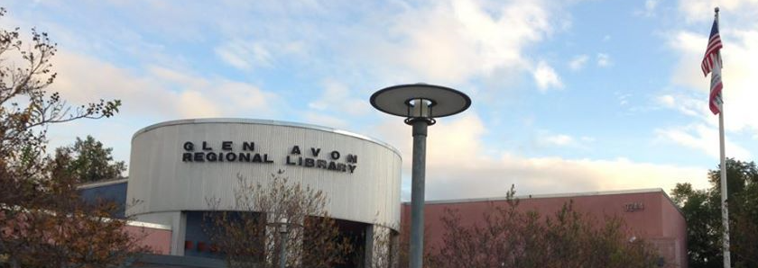
Figure 8-1: Glen Avon Regional Library in Jurupa Valley

Introduction
The Community Safety, Services, and Facilities Element contains goals, policies, and programs to ensure the safety of the community and the delivery of quality services and facilities to meet the City’s needs. Public facilities that help deliver these services and utilities, such as water, sewer, and storm drainage/urban runoff collection, are operated and maintained by multiple agencies and community services districts in Jurupa Valley. Jurupa Valley’s community services, facilities, and utilities are integral to individual and community well-being and to the City’s ability to attract and retain residents and businesses.
The General Plan Advisory Committee (GPAC) addressed community safety, services, and facilities in-depth, as summarized in Appendix 5.0. The Committee acknowledged the important contributions of the many public safety professionals that serve Jurupa Valley citizens and protect the City from natural and man-made hazards. In addition, the Committee urged that public safety services be enhanced and maintained, as expressed in the adopted Community Values Statement.
City of Jurupa Valley Community Values Statement
Public Safety. Support for public safety, law enforcement and emergency medical services is a value that’s widely held by Jurupa Valley residents. We honor and respect the safety professionals who faithfully serve Jurupa Valley. We support strong, collaborative efforts to prevent crime and homelessness, enforce planning and building codes, and to improve the safety of neighborhoods, homes, public facilities, streets, trails, and other transportation facilities. We take proactive measures to cope with and recover from emergencies and natural and man-made disasters.

The Community Safety, Services and Facilities Element is a hybrid element of the General Plan, combining the state-mandated Safety Element with an optional element addressing community services and facilities. The Safety Element overlaps some topics covered in the Land Use Element and the Conservation/Open Space Element in that it also addresses the protection of the community from hazards and risks. Community services and facilities have also been included in this element, addressing local resources and services that influence the physical development and the quality of life of Jurupa Valley.
In addition to Community Safety, Services and Facilities Element. the City maintains and regularly updates the Jurupa Valley Local Hazard Mitigation Plan (LHMP), which is incorporated herein by reference. The LHMP was prepared pursuant to the Federal Disaster Mitigation Act of 2000 and outlines a strategy for reducing the City's vulnerability to the impacts of natural and manmade disasters. By incorporating the LHMP into this Element by reference, the City may be eligible to receive increased state recovery funding in the event of a disaster.

Goals and Policy Sections
1. Community Safety
2. Community Services and Facilities

Background

Community Safety
Safety hazards are natural and man-made conditions that must be respected if life and property are to be protected as growth and development occur. As the ravages of wildland fires, floods, dam failures, earthquakes, and other disasters become clearer through the news, public awareness and sound public policy combine to require serious attention to these conditions.
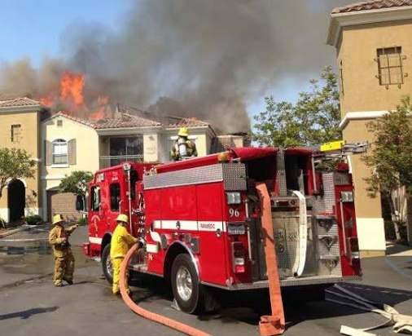
Portions of Jurupa Valley may be subjected to hazards such as flooding, dam inundation, seismic occurrences, and structure and wildland fire. These hazards are located throughout Jurupa Valley and pose varying degrees of risk and danger. Some hazards must be avoided entirely, while the potential impacts of others can be mitigated by special building techniques and other measures. Critical facilities and lifelines are those facilities that must remain operational after a disaster. Critical facilities include schools, hospitals, fire and police stations, emergency operation centers, communication centers, and industrial sites that use or store hazardous materials. Lifelines are utilities or networks that are essential to daily living such as transportation facilities, water and gas lines, electrical power, and communications networks. Critical facilities and lifelines must be sited and designed to reduce or avoid damage and plan for redundant and/or replacement facilities in the event they are compromised.
Figure 8-2: CAL FIRE crew responding to structure fire

Community Services and Facilities
Community services and facilities are essential to maintain Jurupa Valley’s quality of life and support existing and future development. Owing to the City’s historical development as an unincorporated community in Riverside County, services and facilities are provided by a variety of public and private agencies. To facilitate ongoing coordination between the City and these agencies, regular inter-agency meetings are held to discuss service needs, share information, coordinate programs, and ensure the timely provision of services throughout the City.
This element addresses the provision and maintenance of the following major services and facilities in Jurupa Valley: City governance, police services, fire and emergency medical services, educational facilities, libraries, parks and recreation, social services, water, wastewater, storm water and solid waste disposal. Additional services and facilities provided in Jurupa Valley but not specifically addressed in the General Plan include natural gas, electricity, landscape maintenance, and telecommunication services.

Community Safety, Services, and Facilities Goals, Policies and Programs

Goals
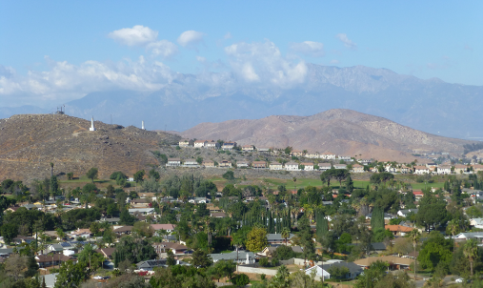
CSSF 1 Minimize risks resulting from natural and manmade hazards to its residents and businesses.
Figure 8-3: Hillside neighborhoods in Jurupa Valley
CSSF 2 Honor and support our public safety professionals.
CSSF 3 Provide a high level of community services and facilities to meet the existing and future needs of Jurupa Valley.
CSSF 4 Support the provision of excellent educational services and facilities to meet the existing and future needs of Jurupa Valley citizens.

Policies and Programs

CSSF 1 – Community Safety
1. Seismic and Geologic Hazards
The State of California requires that the General Plan Safety Element address seismic and geologic hazards and include policies to reduce the potential risk of death, injuries, property damage, and economic and social dislocation.
Seismic Hazards
Seismic hazards are related to earthquakes and earth movement, such as fault rupture, liquefaction, landslides, and rock falls. The Alquist-Priolo Earthquake Fault Zoning Act of 1972 requires the mapping of known surface faults to minimize the direct impact surface fault-rupture would have on structures designed for human habitation. Although Riverside County as a whole is considered seismically active, no known seismic faults exist within Jurupa Valley, nor is Jurupa Valley located within a mapped Alquist-Priolo Earthquake Fault Zone. While the potential earthquake risk is considered low, regional faults such as the Rialto-Colton, San Jacinto, and Chino faults pose earthquake risks to the West Riverside County area, including Jurupa Valley. New faults and fault traces may be identified in the future; consequently, new structures designed for human occupancy should be required to be set back from newly identified and potential seismic hazards. Figure 8-4 below shows the locations of mapped faults in northwestern Riverside County.

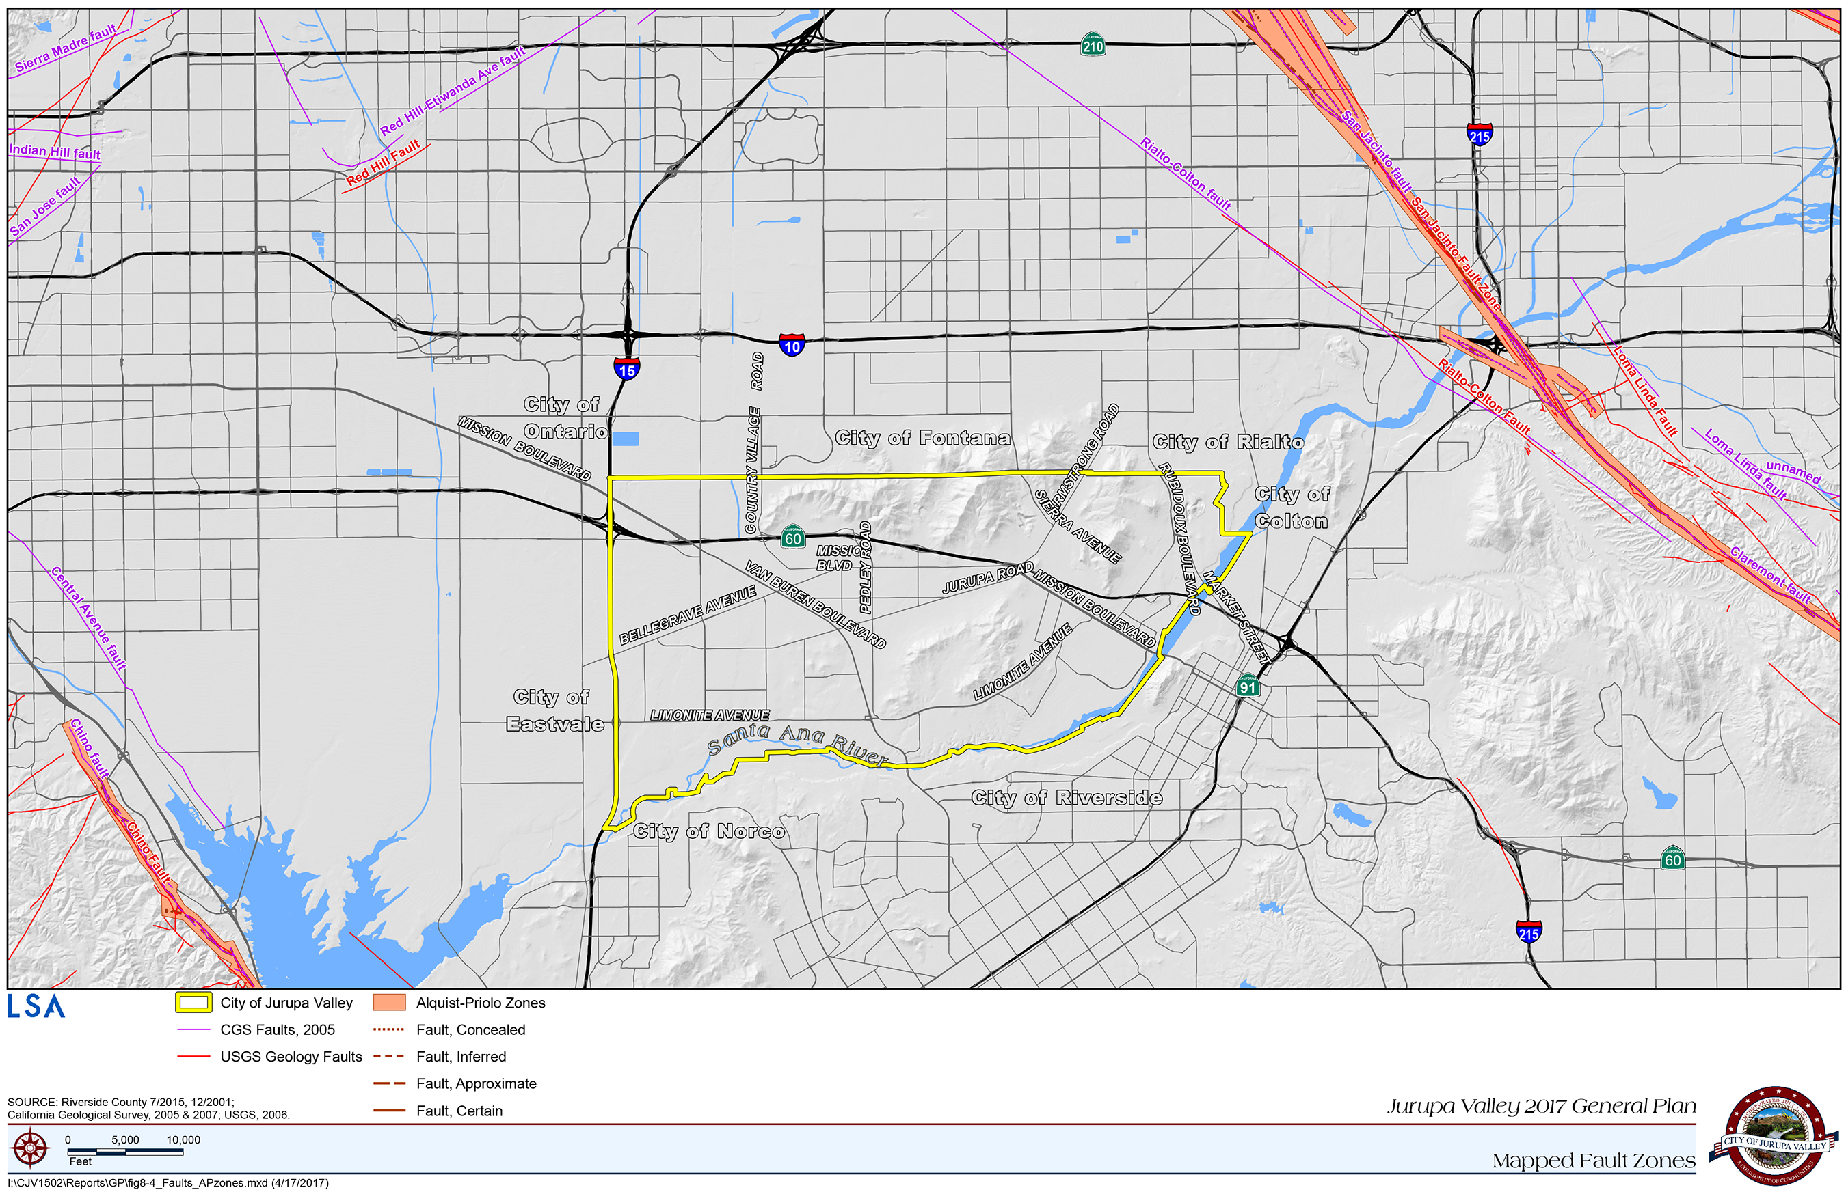
Figure 8-4: Mapped fault zones

Seismic shaking can cause liquefaction, landslides, and rock falls. Liquefaction occurs primarily in saturated, loose, fine- to medium-grained soils in areas with a high groundwater table. Shaking can cause the soils to lose strength and liquefy. Most of Jurupa Valley has a high groundwater table and is considered to have a “High” liquefaction potential. While a general risk of liquefaction can be provided based on soil type and groundwater depth, site-specific geotechnical studies are the only practical and reliable way of determining the specific liquefaction potential of a site. Figure 8-5 below shows the locations of liquefaction susceptibility in Jurupa Valley.
Seismically induced landslides and rock falls could occur in Jurupa Valley in a major earthquake. Landslides and rock falls occur most often on steep, eroded or undercut, or disturbed hillsides. Factors controlling the stability of slopes include: 1) slope height and steepness; 2) engineering characteristics of the earth materials comprising the slope; and 3) the intensity of ground shaking. Field investigation enables identification of slide-prone areas before an earthquake occurs. Figure 8-6 below contains a map of landslide susceptibility in Jurupa Valley. Typically, areas with steep slopes pose a higher risk of slope instability in an earthquake. Within Jurupa Valley, the Jurupa Mountains are designated as having steep slopes of 30% slope or greater.
Geologic Hazards
Geologic hazards also pose a safety risk in Jurupa Valley and include landslides, rock falls and debris flows, subsidence, expansive and collapsible soils, and wind erosion. Landslides, rock falls, and debris flows are associated with mountainous and hilly areas, and although natural processes, their risks are increased near housing and human activities. The Jurupa Mountains and the Pedley Hills are characterized by moderate to steep rocky slopes and are potentially prone to landslides, rock falls, and debris flows. The City’s building code establishes specific site investigation requirements for hillside development to reduce risks from landslides, rock falls, and debris flows.
Subsidence refers to the sudden sinking or gradual downward settling and compaction of soil and other surface material with little or no horizontal motion. This process can be gradual or rapid and can pose significant hazards to property and life. It may be caused by a variety of human and natural activities. In Jurupa Valley, ground subsidence and associated fissuring has resulted from rising and falling ground water tables.

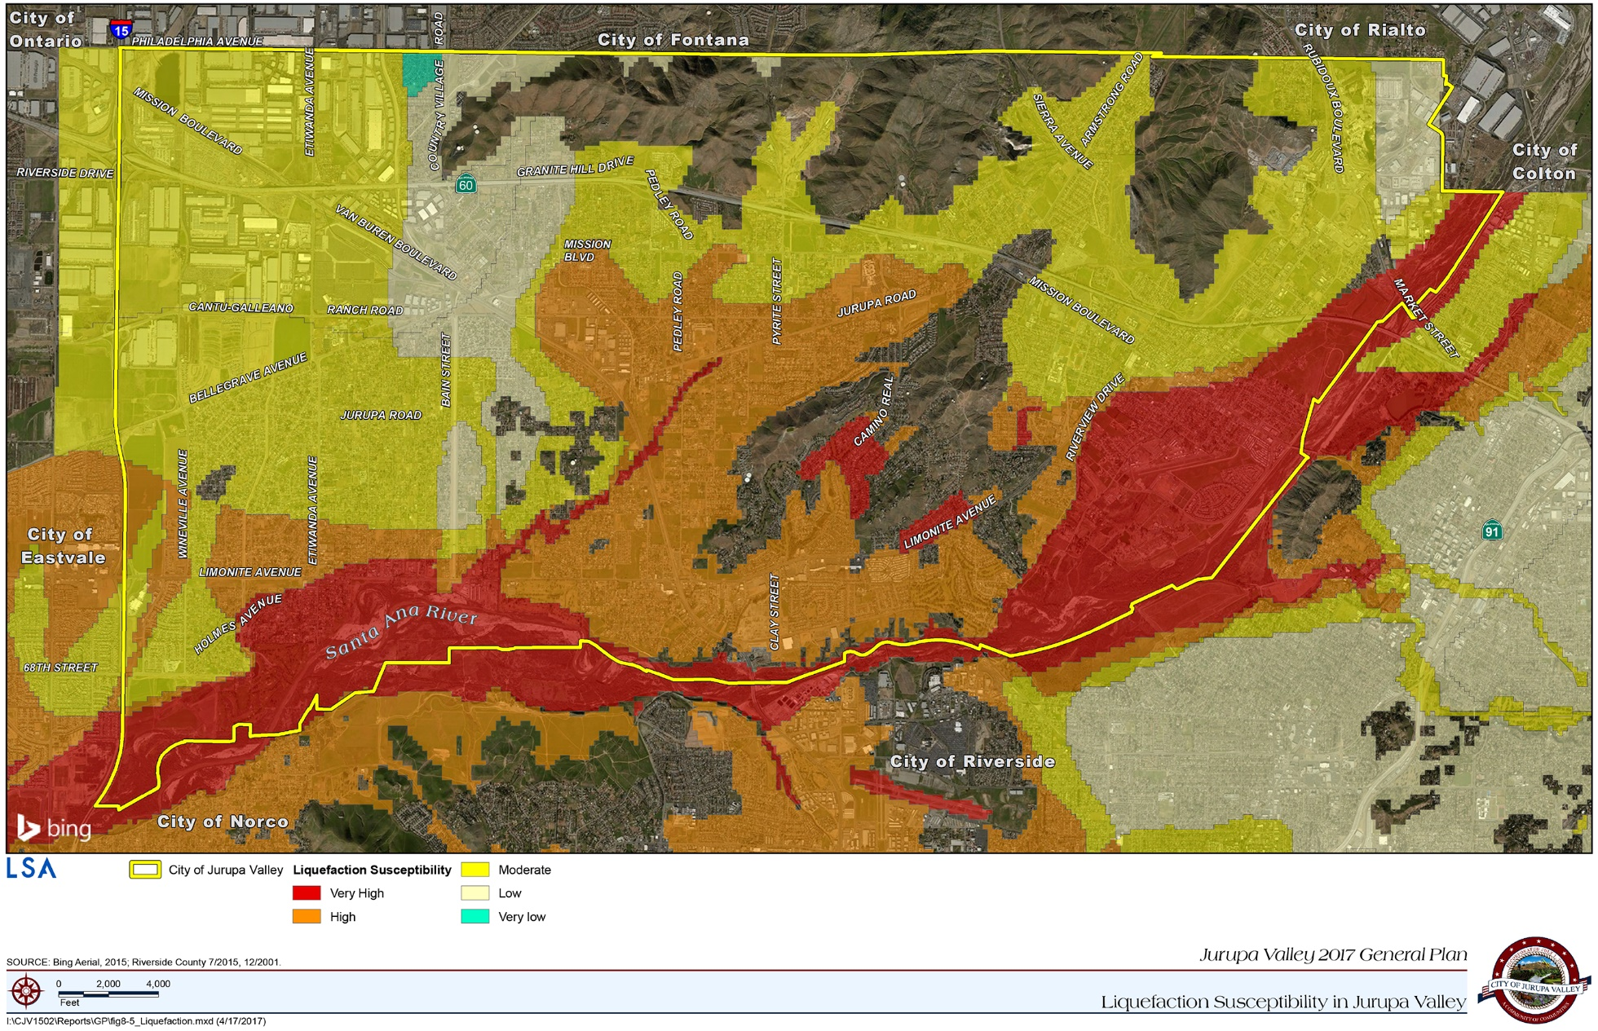
Figure 8-5: Liquefaction susceptibility in Jurupa Valley

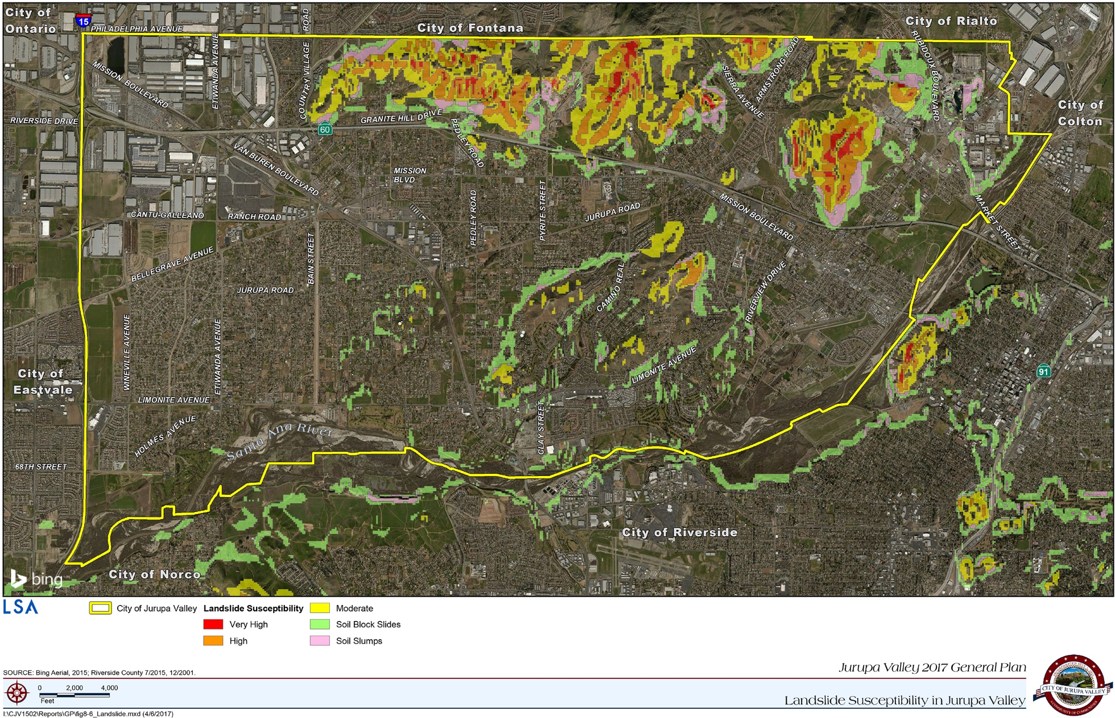
Figure 8-6: Landslide susceptibility in Jurupa Valley

Expansive and collapsible soils are also problematic for development. Expansive soils have a significant amount of clay particles, which can give up water (shrink) or take on water (swell), causing foundations and structures to crack, move, and/or fail. Geotechnical studies, appropriate grading, and construction methods can identify and mitigate adverse effects from expansive and collapsible soils.
Jurupa Valley is also susceptible to wind erosion. Wind erosion generates soil movement as blowing air exerts force against the surface of the ground, releasing soil particles, or dust. Atmospheric dust causes respiratory discomfort, may carry pathogens that cause eye infections and skin disorders, and reduces highway and air traffic visibility. Buildings, fences, roads, crops, trees, and shrubs can also be damaged by abrasive blowing soil.
Policies
CSSF 1.1 Fault Rupture Hazards. When reviewing new development, minimize fault rupture hazards through enforcement of Alquist-Priolo Earthquake Fault Zoning Act provisions and the following requirements:
1. Require geologic studies or analyses for new, critical structures, such as schools, medical facilities, senior or disabled housing, or other high-risk occupancies located within 0.5 mile of all active or potentially active faults.
2. Require geologic trenching studies for new developments within all designated Earthquake Fault Studies Zones, unless adequate evidence is presented and accepted by the City Engineer or a Building Official. The City may also require geologic trenching for new development located outside designated fault zones for especially critical or vulnerable structures or lifelines.
3. Require that critical infrastructure, including roads, bridges, and utilities be designed to resist, without failure, their crossing of a fault, if fault rupture occurs.
4. Encourage and support efforts by the geologic research community to better define the locations and risks of County faults. Such efforts could include data sharing and database development with regional entities, state and local governments, private organizations, utility agencies, or universities.
CSSF 1.2 Geologic Investigations. Require geological and geotechnical investigations as part of the environmental and development review process. This requirement shall apply to the development of any structure proposed for human occupancy or to unoccupied structures whose damage could cause secondary hazards in areas with potential for earthquake-induced liquefaction, landslides, or settlement.
CSSF 1.3 Structural/Non-Structural Assessment. Require structural and nonstructural assessment and, when necessary, mitigation for other types of potentially hazardous buildings that are undergoing substantial repair or improvements costing more than half of the assessed property value. Potential implementation measures could include:
1. Use of variances, tax rebates, fee waivers, credits, or public recognition as incentives.
2. Inventory and structural assessment of potentially hazardous buildings based on screening methods developed by the Federal Emergency Management Agency.
3. Development of a mandatory retrofit program for hazardous, high occupancy, essential, dependent, or high-risk facilities.
4. Development of a mandatory program requiring public posting of seismically vulnerable buildings.
CSSF 1.4 Structural Damage. Utilize the latest approaches to minimize damage to structures located in areas determined to have a high liquefaction potential during seismic events.
CSSF 1.5 Hillside Development. Encourage and, where possible require, mitigation of potential erosion, landslide, and settlement hazards for existing public and private development located on unstable hillside areas, especially slopes with recurring failures where City property or public right-of-way is threatened from slope instability, or where considered appropriate and urgent by the City Engineer, CAL FIRE, or County Sheriff’s Department.
Programs
CSSF 1.1.1 Hazard Mitigation. Mitigate potential seismic hazards through adoption and strict enforcement of current building codes, which will be amended as necessary when local deficiencies are identified.
CSSF 1.1.2 Liaison Program. Develop a liaison program with all water purveyors to prevent water extraction-induced subsidence.
CSSF 1.1.3 Density Transfer. Develop a program to allow the transfer of allowable density from high-risk areas to low-risk areas.
CSSF 1.1.4 Unreinforced Masonry Buildings. Inventory unreinforced masonry buildings in Jurupa Valley, develop retrofitting guidelines and research possible funding sources to assist with building retrofits.
2. Flood Hazards and Inundation
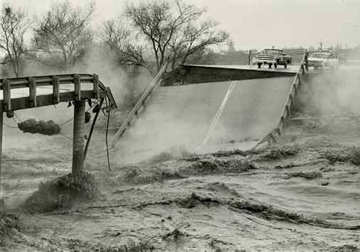
As identified by the GPAC, the Santa Ana River is tremendous asset to the City, providing open space, environmental, recreational, and visual amenities. It also presents the potential for flood hazards and inundation. Throughout the years, flooding events on the Santa Ana River have resulted in the loss of livestock, infrastructure, property, and even lives. To manage and minimize the risk of flooding, the Riverside County Flood Control and Water Conservation District was formed in 1945 to reduce the risks and damage due to flooding in western Riverside County.
Figure 8-7: Van Buren Bridge collapse during the 1969 Santa Ana River flood (Riverside County Flood Control and Water Conservation District)
The District’s responsibilities include the maintenance and construction of flood control structures and facilities, and regulating development in and near floodplains. Despite major improvements in flood management methods and planning, portions of Jurupa Valley are still at risk of flooding during major events. It continues to be in the City’s best interest to regulate and monitor development in floodplain and flood prone areas. Waterways and drainage facilities existing in 2017 are shown in Figure 4-12 (page 4-21).
The Federal Emergency Management Agency (FEMA) prepares Flood Insurance Rate Maps, or FIRM maps, to graphically show areas prone to flooding during 100-year and 500-year frequency floods. Figure 8-8 identifies the flood prone portions of Jurupa Valley based on FIRM maps and flood district data.
In addition to the Santa Ana River, the Riverside Basin (northeast of the Interstate 15/SR 60 interchange), and those areas bordering the Etiwanda Flood Control Channel, Pyrite Channel, and the Riverside Canal, are part of the 100-year floodplain. Most of these areas are also where a substantial amount of development exists or is intended to occur. Many techniques may be used to address the danger of flooding, such as preventing or limiting development in floodplains, reducing urban runoff, maintaining floodways, using special building techniques, elevating foundations and structures, and enforcing building setbacks.

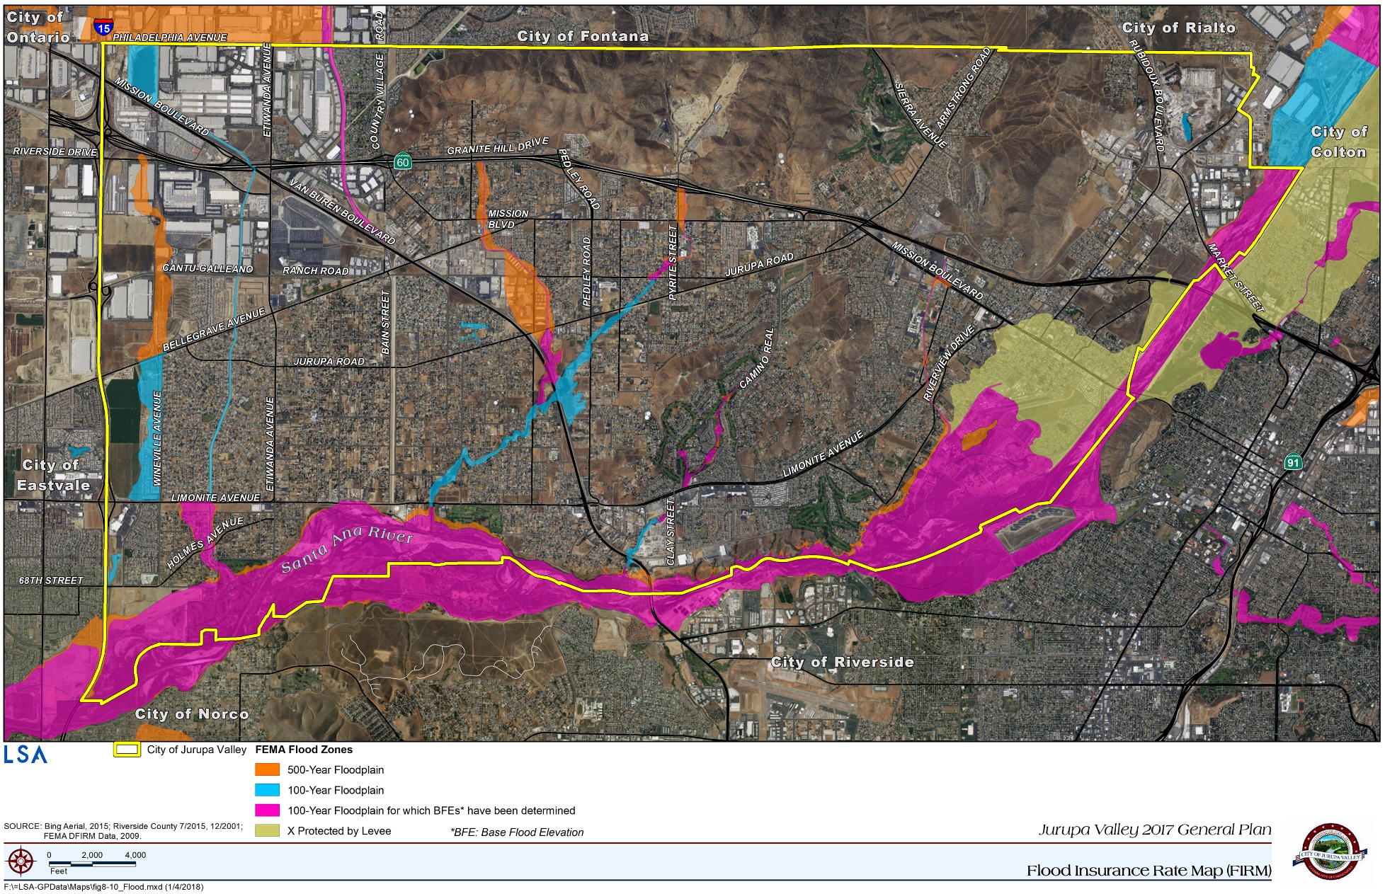
Figure 8-8: Flood Insurance Rate Map (FIRM)

One effective technique for maintaining floodways and reducing flood hazards is controlling the spread of Arundo donax (giant cane) and other non-native plant species. Giant cane is a highly invasive, non-native aquatic plan that grows in the Santa Ana River and other local drainage courses. The plant is hazardous from a flooding perspective because it grows quickly, clogs channels, and increases flood risks. Left unchecked, the plant can easily take over riparian areas, excluding native plants and damaging natural habitat. However, the Santa Ana Watershed Project Authority (SAWPA), the County of Riverside, and other agencies have been working to eliminate giant cane from the Santa Ana River Watershed and restore natural habitat.
Policies
CSSF 1.6 Flood Risk. In reviewing new construction and substantial improvements within the 100-year floodplain, the City shall disapprove projects that cannot minimize the flood risks to acceptable levels in areas mapped by FEMA or as determined by site-specific hydrologic studies for areas not mapped by FEMA. The City shall:
1. Prohibit the construction, location, or substantial improvement of structures in areas designated as floodways, except upon approval of a plan that provides that the proposed development will not result in any significant increase in flood levels during the occurrence of a 100-year flood; and
2. Prohibit the filling or grading of land for nonagricultural purposes and for non-authorized flood control purposes in areas designated as floodways, except upon approval of a plan, which provides that the proposed development will not result in any significant increase in flood levels during the occurrence of a 100-year flood discharge.
CSSF 1.7 Floodway Alteration. Require that any alterations of the floodway utilize naturalized edge treatments as outlined in the Conservation and Open Space Element (Policies 3.16 and 3.17).
CSSF 1.8 Building Codes. Enforce provisions of the Building Code in conjunction with the following guidelines:
1. Critical facilities shall not be permitted in floodplains unless the project design ensures that there are at least two routes for emergency ingress and egress, and minimizes the potential for debris or flooding to block emergency routes.
2. Development using, storing, or otherwise involved with substantial quantities of on-site hazardous materials shall not be permitted unless all standards for evaluation, anchoring, and flood-proofing have been satisfied; and hazardous materials are stored in watertight containers, not capable of floating, to the extent required by state and federal laws and regulations.
3. Specific flood-proofing measures that may be required include, but are not limited to: use of paints, membranes, or mortar to reduce water seepage through walls; installation of water tight doors, bulkheads, and shutters; installation of flood water pumps in structures; and proper modification and protection of all electrical equipment, circuits, and appliances so that the risk of electrocution or fire is eliminated. Fully enclosed areas that are below finished floors shall require openings to equalize the forces on both sides of walls.
CSSF 1.9 Permanent Structures. Prohibit construction of permanent structures for human housing or employment to the extent necessary to convey floodwaters without property damage or risk to public safety. Agricultural, recreational, or other similar, non-habitation uses are allowable if flood control and groundwater recharge functions are maintained.
CSSF 1.10 Floodway Alteration. Prohibit alteration of floodways and channelization unless alternative methods of flood control are not technically feasible or unless alternative methods are already utilized to the maximum extent practicable. The intent is to balance the need for protection with prudent land use solutions, recreation needs, and habitat preservation requirements, and as applicable to provide incentives for natural watercourse preservation. Preservation incentives may include density transfer programs as may be adopted.
CSSF 1.11 Modification of Water Courses. Prohibit substantial modification to water courses, unless modification does not increase erosion or adjacent sedimentation, or increase water velocities, so as to be detrimental to adjacent property, nor adversely affect adjacent wetlands or riparian habitat.
CSSF 1.12 Flood Control Improvements. Direct flood-control improvement measures toward the protection of existing and planned development.
CSSF 1.13 Environmental Protection. Ensure that any substantial modification to a watercourse is accomplished in the least environmentally damaging manner possible to maintain adequate wildlife corridors and linkages and maximize groundwater recharge
CSSF 1.14 Ability to Withstand Flooding. Require development within the floodplain to be capable of withstanding flooding and to minimize use of fill. Compatible uses shall not, however, obstruct flows or adversely affect upstream or downstream properties with increased velocities, flood heights, erosion backwater effects, or concentrations of flows.
CSSF 1.15 Regional Storm Drain System. All proposed development projects shall address and mitigate any adverse impacts on the carrying capacity of local and regional storm drain systems.
CSSF 1.16 Neighboring Jurisdictions. Encourage neighboring jurisdictions to require development occurring adjacent to the City to consider the impact of flooding and flood control measures on properties within the City.
CSSF 1.17 Hazardous Materials Storage. Require that facilities storing substantial quantities of hazardous materials within designated 100- or 500-year flood zones be adequately flood-proofed and that hazardous materials containers be anchored and secured to prevent flotation and contamination.
CSSF 1.18 Lifeline Facilities. Require that all lifeline and dependent care facilities, such as convalescent homes, group housing, police stations, fire stations, and emergency operation centers in designated flood zones be flood-proofed and to maintain and rehearse inundation response plans.
CSSF 1.19 Open Space Tools. Utilize various means of land acquisition tools and land use measures, such as density credit for open space and dedication of floodplain areas to the Riverside Conservation Agency, to create open space zoning in designated flood zones that are likely to be developed or redeveloped with uses that are more intensive.
CSSF 1.20 Risk Assessment. Continue to assess and upgrade inundation risk and protection in the City.
CSSF 1.21 Flood Hazard Zones. Encourage periodic reevaluation of the 500-year, 100-year, and 10-year flood hazard zones by state, federal, county, and other sources and use such studies to improve existing protection, review flood protection standards for new development and redevelopment, and update emergency response plans.
CSSF 1.22 Specific Plans. Encourage the use of specific plans to allow increased densities in certain areas of a proposed development and to transfer density to locate residential, commercial, industrial, and public facility uses outside of natural hazard areas; and to direct appropriate uses to these areas, such as open space, passive recreational uses, or other uses compatible with these hazards.
Programs
CSSF 1.1.5 Property Acquisition. As resources allow, acquire property in high-risk flood zones and designate the land as open space for public use or wildlife habitat.
CSSF 1.1.6 Giant Cane and Other Invasive Plant Species. Encourage and, as resources allow, support the efforts of SAWPA, the County of Riverside, and other agencies to remove Giant Cane and other invasive, non-native plant species from the Santa Ana River corridor and restore native riparian habitat.
CSSF 1.1.7 Lifeline Facilities. Develop an inundation response plan for any lifeline facilities and dependent care facilities located in designated flood zones.
CSSF 1.1.8 Risk Assessment. Assess and upgrade inundation risk and protection and utilize information and research from regional planning agencies and others focusing on resiliency after a disaster.
CSSF 1.1.9 Emergency Response Plans. Periodically review and update emergency response plans to reflect current flood protection standards.
3. Fire Hazards
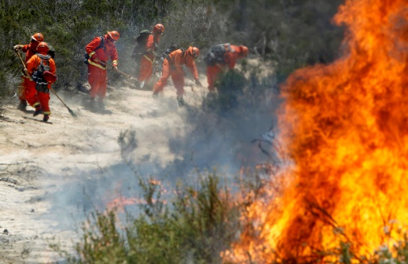
Due to the rural and somewhat mountainous nature of the City, and some of the flora, such as oak woodlands and chaparral habitat, the foothill areas and mountainsides are subject to a risk of fire hazards. The lush riparian vegetation of the Santa Ana River also poses conditions conducive to wildfires, and giant cane, where present in the watershed, is even more combustible than native species. The highest danger of wildfires can be found in the most rugged terrain where, fortunately, development intensity is relatively low. Methods to address this hazard include such techniques as not building in high-risk areas, creating setbacks that buffer development from hazard areas, maintaining brush clearance to reduce potential fuel, establishing low fuel landscaping, and applying special building techniques. In still other cases, safety-oriented organizations, such as the California Fire Safe Council, can provide assistance in educating the public and promoting practices that contribute to improved public safety.
Figure 8-9: CAL FIRE strike crew fighting a wildland fire
Since 2007, wildfires have burned a total of 1,738 acres. The largest wildfire to occur during that time was the Pedley Fire in 2010 which burned 716 acres. The Pedley Fire occurred almost entirely within a very high fire hazard severity area in the middle of the city, surrounded by developed area but no structures were reported to have been damaged. Since 2010, the largest wildfire to occur was the Hill Fire in 2019. The Hill Fire burned a total of 494 acres in the foothills of the Mount Jurupa, also a very high fire hazard severity area.
The vast majority of residential developments in very high fire hazard severity areas contain at least two means of ingress and egress with the exception of a small portion of Indian Hills and the Granite Ridge subdivision. The table below displays the streets with one means of ingress and egress.
Street Name | Neighborhood
Lakeside Drive | Indian Hills
Jayhawk Drive | Indian Hills
Boulder Drive | Granite Ridge

As stated in the State of California’s General Plan Guidelines, “California’s increasing population and expansion of development into previously undeveloped areas is creating more ’wildland-urban interface’ issues with a corresponding increased risk of loss to human life, natural resources, and economic assets associated with wildland fires.” To address this issue, the state passed Senate Bill 1241 to require that General Plan Safety Elements address the fire severity risks in State Responsibility Areas (SRAs) and Local Responsibility Areas (LRAs). As shown in Figure 8-10, Jurupa Valley contains several areas within Very High and High fire severity zones that are located in an SRA. SRAs are those areas of the state in which the responsibility of preventing and suppressing fires is primarily that of the Department of Forestry and Fire Protection, also known as CAL FIRE.

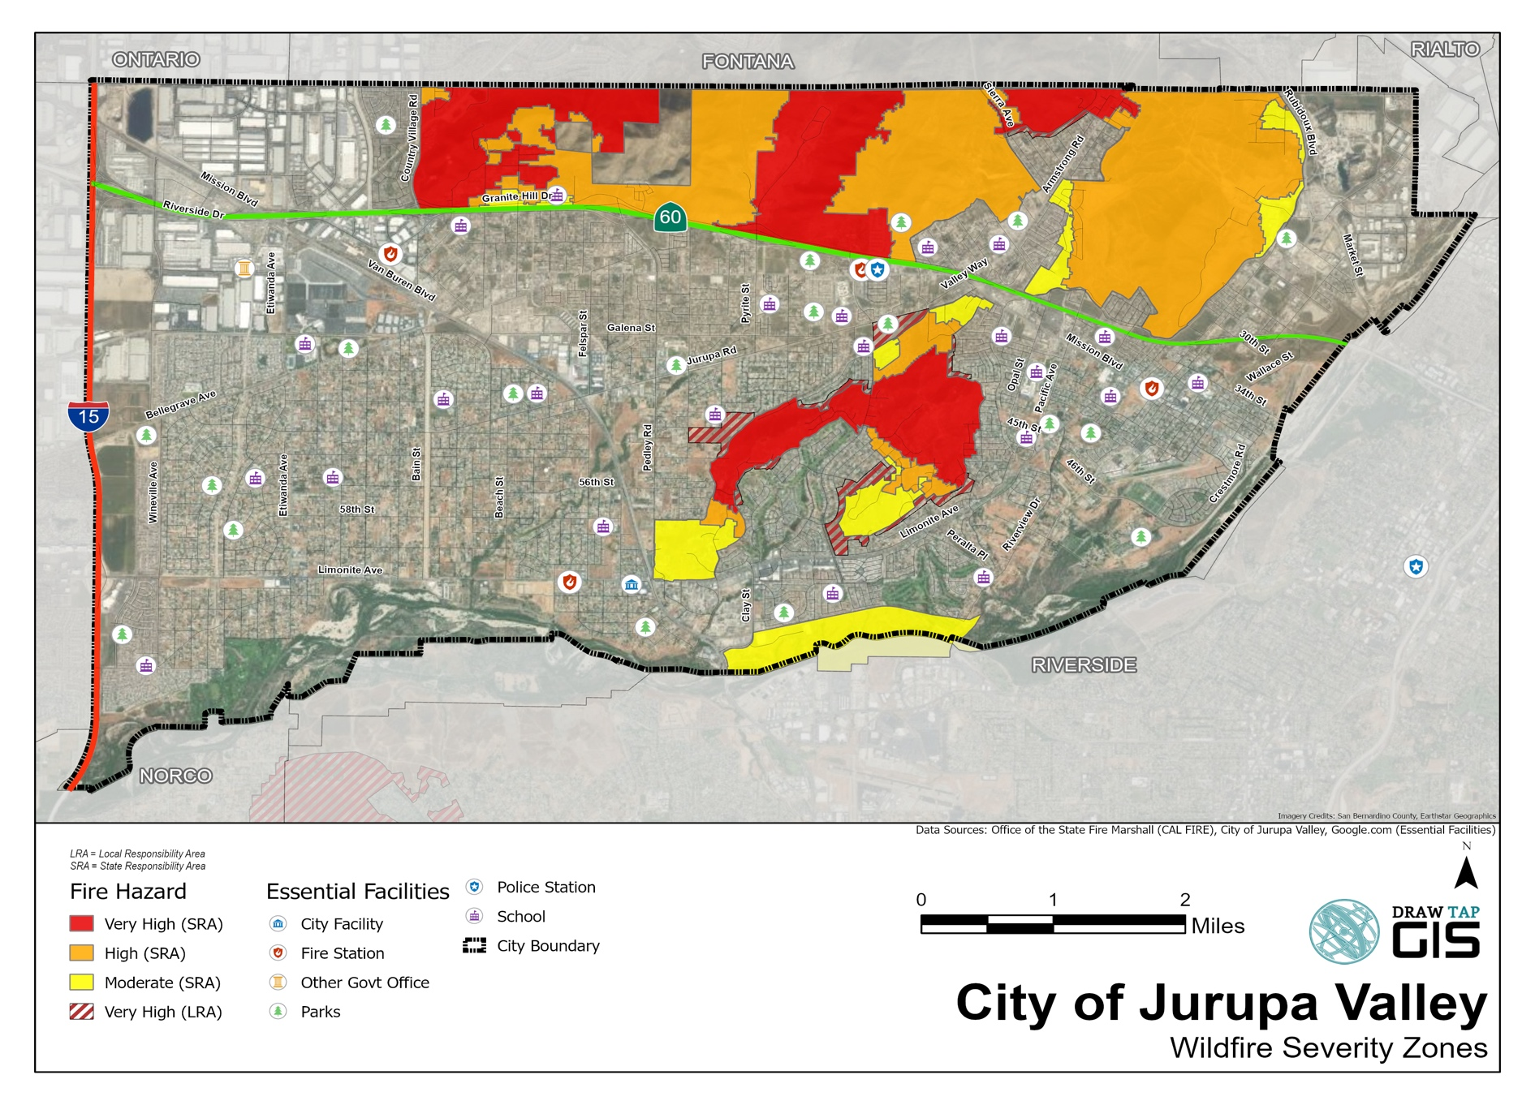
Figure 8-10: Wildfire severity zones and essential public facilities in Jurupa Valley

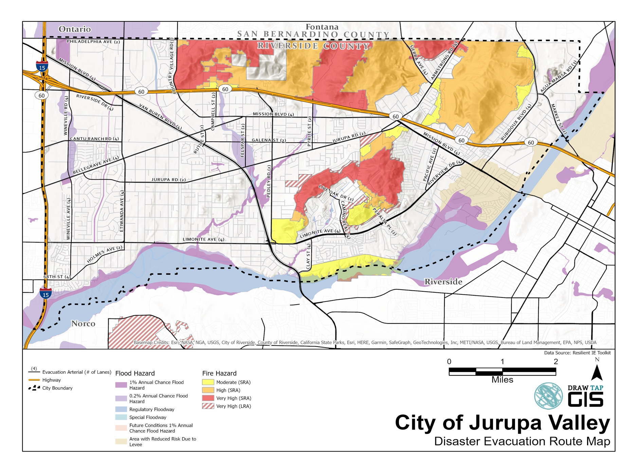
Figure 8-11: Evacuation Routes with Hazard Areas

Policies
CSSF 1.23 Fire Prevention. Develop and enforce construction and design standards that ensure that proposed development incorporates fire prevention features through the following:
1. All proposed construction shall comply with the California Fire and Building Codes as adopted and amended by the City or by City zoning, or as dictated by the Building Official or the Transportation Land Management Agency based on building type, design, occupancy, and use.
2. In addition to the fire safety provisions of the California Building Code and the California Fire Code, apply additional standards for high risk, high occupancy hospital and health care facilities, dependent care, emergency operation centers, and other essential or “lifeline” facilities, per county or state standards. These shall include assurance that structural and nonstructural architectural elements of the building will not:
a. impede emergency egress for fire safety staffing/personnel, equipment, and apparatus; nor
b. hinder evacuation from fire, including potential blockage of stairways or fire doors.
3. All proposed development in the very high fire hazard severity areas (VHFHSZs) shall comply with the most current version of the California Building Code and the California Fire Code.
4. Proposed development in Hazardous Fire areas shall provide secondary public access, unless determined unnecessary by CAL FIRE or City Building Official.
CSSF 1.24 Development in VHFHSZs. Require proposed development in High or Very High Fire Hazard Severity Zones to be located where fire and emergency services are available or will be constructed as part of the proposed development activities, to the extent such locations are available.
CSSF 1.25 Fire Protection Plan. Require developments located within VHFHSZs to submit and implement a fire protection plan as feasible and appropriate. The plan shall include provisions for roadways and access, firefighting infrastructure, signage, vegetation management, construction materials, and evacuations.
CSSF 1.26 Fire Hazard Reduction Management. Require continued long-term operation and maintenance of community fire breaks, brush management, public/private road clearance, and revegetation by the City of Jurupa Valley and private landowners.
CSSF 1.27 Emergency Access. Require any development within VHFHSZs provide secondary public access, in accordance with City ordinances to ensure multiple points of ingress and egress that allow for emergency response vehicle access. Points of access shall include visible street addresses and signs.
CSSF 1.28 Evacuation Standards. Establish minimum standards for evacuation of residential areas in VHFHSZs. Any areas lacking two means of ingress and egress are required to meet the provisions of Government Code Section 65302(g)(5).
CSSF 1.29 Non-Conforming Development. Identify mitigation measures for existing non-conforming development to incorporate contemporary fire standards including roadway standards and vegetative hazards.
CSSF 1.30 Adjacent Natural Vegetation. Development that adjoins large areas of native vegetation will require drought tolerant landscaping that blends with the natural vegetation to the greatest extent possible.
CSSF 1.31 Fuel Modification. Require new development in VHFHSZs and SRAs to locate, design, construct, and maintain fuel modification zones to provide adequate defensibility from wildfires.
CSSF 1.32 Vegetation Clearance. Identify and coordinate ongoing maintenance of vegetation clearance on public and private roads.
CSSF 1.33 Wildfire Hazards. Encourage and, as resources allow, support CAL FIRE and other agency efforts to reduce wildfire hazards and improve fire-fighting capacity to successfully respond to multiple fires.
CSSF 1.34 Gas Shutoff. Require automatic natural gas shutoff earthquake sensors in high-occupancy industrial and commercial facilities and encourage their installation in all residences.
CSSF 1.35 Coordination. During preparation and implementation of the City’s capital improvement programs, encourage coordination between CAL FIRE and Community Services Districts providing water services in Jurupa Valley to improve firefighting infrastructure, by proposing or requiring, when appropriate:
1. Replacement and/or relocation of old cast-iron pipelines and inadequate water mains when street improvements are planned;
2. Assessment of impact fees as a condition of development; and
3. Redundant emergency distribution pipelines in areas of potential ground failure or where determined to be necessary.
CSSF 1.36 Fire Protection Master Plan. Continue to utilize the Riverside County Fire Protection Master Plan and Jurupa Emergency Response Plan as the base documents to implement the goals and objectives of the Community Safety Element.
CSSF 1.37 Emergency Service Needs. Coordinate with CAL FIRE on a routine basis to ensure current and future emergency service needs are being addressed.
CSSF 1.38 Fire Safety Education. Work with the California Fire Safety Council, CAL FIRE, FEMA and others to educate and promote fire safety practices as well as public outreach efforts focused on defensible space and evacuation routes, particularly to at-risk populations.
CSSF 1.39 Water Resources. The City of Jurupa Valley will utilize Jurupa Community Services District, the Rubidoux Community Services District, and the Santa Ana River Water Company to identify future water supply needs, fire suppression needs, and long-term maintenance.
CSSF 1.40 Brush Clearance. Utilize ongoing brush-clearance fire inspections to educate homeowners on fire prevention tips.
Programs
CSSF 1.1.10 Fire Safety Planning. Conduct and implement long-range fire safety planning, including updating building, fire, subdivision, and municipal code standards, improved infrastructure, and improved mutual aid agreements with the private and public sectors.
CSSF 1.1.11 Fire Response Agreements. Review inter-jurisdictional fire response agreements, and improve firefighting resources as recommended in the County Fire Protection Master Plan, to keep pace with development and to ensure that:
1. Fire reporting and response times do not exceed those listed in the County Fire Protection Master Plan identified for each of the development densities described;
2. Fire flow requirements (water for fire protection) are consistent with the California Fire Code; and
3. The planned deployment and height of aerial ladders and other specialized equipment and apparatus are sufficient for the intensity of development anticipated.
CSSF 1.1.12 Fire Safe Development Codes. Develop fire safe development codes to use as standards for fire protection for new development in SRAs or VHFHSZs that meet or exceed the statewide minimums in the SRA Fire Safe Regulations.
CSSF 1.1.13 Emergency Preparedness Programs. Implement a training program to improve staff understanding of how vulnerable community members, including senior citizens, low-income persons, and persons with disabilities, may be impacted by wildfires.
CSSF 1.1.14 Emergency Service Training. Implement a long-term emergency service training and education program for government agencies and residents.
CSSF 1.1.15 Local Hazard Mitigation Plan (LHMP) Updates. Update the City’s LHMP to include implementation measures for fuel modification zone and vegetation clearance policies.
4. Hazardous Materials
Hazardous materials are those substances that have the potential to cause harm to humans, animals, or the environment, by themselves or through interaction with other factors (Institute of Hazardous Materials Management). In Jurupa Valley, hazardous materials include petroleum products, solvents, pesticides, and other substances used in or generated by commercial, industrial, agricultural, or residential activities. state and federal laws govern the storage, transport, and disposal of hazardous materials.
Contaminated sites are another source of hazardous materials in Jurupa Valley. The Stringfellow Remediation Site near SR 60 and Pyrite Street is perhaps the most well-known contaminated site in the region. The former hazardous waste disposal site leached toxins into the environment and has been undergoing remediation through the federal Superfund process. In addition to contaminating the surface and soil, the site leaked toxins into Pyrite Creek and the groundwater basin, which traveled in a southwest-trending “plume” to the community of Glen Avon and other areas. The remediation effort includes monitoring and remediation of groundwater supplies.
Policies
CSSF 1.41 Federal/State Laws. Comply with federal and state laws regarding the management of hazardous waste and materials.
CSSF 1.42 Hazardous Waste Storage/Disposal. Identify, assess, and mitigate safety hazards from the storage, use, and disposal of hazardous materials through the development review process.
CSSF 1.43 Hazardous Waste Collection. Encourage and, as resources allow, support household hazardous waste collection activities.
CSSF 1.44 Stringfellow Remediation Site. Encourage and support state and federal efforts to complete the clean-up of the Stringfellow Remediation Site and related groundwater and soil contamination.
CSSF 1.45 Information Dissemination. Disseminate information to the public on the storage, use, and disposal of hazardous materials through working with non-agencies, special districts and other agencies and organizations.
5. Disaster Preparedness
The Federal Emergency Management Agency (FEMA) defines disaster preparedness as “a continuous cycle of planning, organizing, training, equipping, exercising, evaluating, and taking corrective action in an effort to ensure effective coordination during incident response.” Disaster preparedness is important to Jurupa Valley to establish the most effective and efficient ways to address hazards and minimize the effects of hazards on life and property, reduce the potential for disasters, and recover from the effects of disasters as quickly as possible.
Hazard Mitigation Plans exist at the federal, state, regional, and local level. The Federal Disaster Mitigation Act of 2000 requires state, local, and tribal governments to prepare Hazard Mitigation Plans that address actions and strategies to mitigate hazards, risks, and vulnerabilities. As outlined in the introduction to this element, the City of Jurupa Valley regularly updates its Local Hazard Mitigation Plan (LHMP), which is incorporated herein by reference. In addition, the City participates in the County of Riverside Multi-Jurisdictional Local Hazard Mitigation Plan. Together, these plans set goals to mitigate potential risks from natural and man-made hazards, identify vulnerabilities, provide recommendations for actions, evaluate resources, and identify future mitigation planning.
The City also has an Emergency Operations Plan (EOP) that addresses how the City will respond to emergency situations ranging from minor incidents to large-scale disasters. The plan addresses four primary phases of emergency operation including Preparedness, Response, Recovery, and Mitigation. The plan discusses the activation and management of the City’s Emergency Operations Center (EOC), which may be set up during an emergency to manage the event and coordinate with other EOCs such as the Riverside County EOC. The EOC also coordinates the sharing of resources under the California Mutual Aid Agreement.
The City also participates in the County of Riverside’s HAZUS Program, which is a standardized methodology for earthquake loss estimation based on geographic information systems (GIS). HAZUS, which stands for Hazards – United States, is designed for use by state, regional, and local governments in planning for earthquake loss mitigation, emergency preparedness, response, and recovery.
Policies
CSSF 1.46 Multi-Hazard Functional Plan. Strengthen the Multi-Hazard Functional Plan and maintain mutual aid agreements with federal, state, local agencies and the private sector to assist in:
1. clearance of debris in the event of widespread slope failures, collapsed buildings or structures, or other circumstances that could result in blocking emergency access or regress;
2. heavy search and rescue;
3. fire suppression;
4. hazardous materials response;
5. temporary shelter;
6. geologic and engineering needs;
7. traffic and crowd control; and
8. building inspection.
CSSF 1.47 Hazardous Waste Handling. Require businesses, utilities, and industrial facilities that handle hazardous materials to:
1. install automatic fire and hazardous materials detection, reporting, and shut-off devices; and
2. install an alternative communication system in the event power is out or telephone service is saturated following an earthquake.
CSSF 1.48 Self-Sufficiency. Use incentives and disincentives to persuade private businesses, consortiums, and neighborhoods to be self-sufficient in an emergency by:
1. maintaining a fire control plan, including an on-site firefighting capability and volunteer fire response teams utilizing community organized Neighborhood Watch groups, CERT teams or similar teams to respond to and extinguish small fires; and
2. identifying medical personnel, employees, or local residents who are capable and certified in first aid and CPR.
CSSF 1.49 Critical Facilities. Ensure that critical facilities such as City Hall, Sheriff’s Substations, City Fire Stations, electrical substations, community services district offices, and water and sewer facilities are subject to the following design considerations:
1. Require the facilities to be located outside of high fire risk areas, such as VHFHSZs, when feasible.
2. Require that special development standards, designs, and construction practices be implemented to reduce risk of compromise in a disaster to acceptable levels for capital improvements, utility projects, and development projects involving critical facilities, large-scale residential development, and major commercial or industrial development. Special standards should be applied through conditional use permits and the subdivision review process and, where appropriate, impact fees should be assessed to finance required actions.
3. Require mitigation measures to reduce potential damage caused by ground failure for sites determined to have potential for liquefaction. Such measures shall apply to critical facilities, utilities, and large commercial and industrial projects as a condition of project approval.
4. Require that planned lifeline utilities, as a condition of project approval, be designed, located, structurally upgraded, and fit with safety shutoff valves; be designed for easy maintenance, and have redundant back-up lines where unstable slopes, earth cracks, active faults, or areas of liquefaction cannot be avoided.
5. Review proposed uses of fault setback areas closely to ensure that City infrastructure (roads, utilities, sanitary and storm sewers) are not unduly placed at risk by the developer. Insurance, bonding, or compensation plans should be used to compensate the City for the potential costs of repair.
CSSF 1.50 Strengthen Utilities/Lifelines. Encourage the strengthening of planned and existing utilities and lifelines, the retrofit and rehabilitation of structurally unsound utility structures and public facilities, and the relocation of certain critical facilities where appropriate.
CSSF 1.51 Alternative Facilities. Encourage alternatives that improve site safety for the protection of critical facilities, including property acquisition for open space, change in building use or occupancy, or other appropriate measures that can reduce risks posed by hazards.
CSSF 1.52 Critical Facilities in Inundation Areas. Discourage development of critical facilities that are proposed in dam failure inundation areas, and apply hazardous materials safety guidelines within such zones.
CSSF 1.53 Santa Ana River Levees. Ensure that the City’s emergency preparedness plans include response protocols for the breaching of the Santa Ana River levees.
CSSF 1.54 Rebuilding After Disaster. Allow rebuilding after a disaster consistent with the General Plan allowing exceptions on a case-by-case basis for previously non-conforming uses and structures when such an action would be consistent with public safety goals and in the City’s best interests.
Programs
CSSF 1.1.16 Post-Disaster Recovery. Develop plans for short-term and long-term post-disaster recovery utilizing information and research from regional planning organizations and other organizations focusing on resiliency after disaster.
CSSF 1.1.17 Safeguard Instructure. Coordinate with the Public Utilities Commission (PUC) and/or utilize the Capital Improvement Program, to strengthen, relocate, or take other appropriate measures to safeguard high-voltage lines, water, sewer, natural gas and petroleum pipelines, and trunk electrical and telephone conduits that:
1. Extend through areas of high liquefaction potential;
2. Cross active faults; or
3. Traverse earth cracks or landslides.
CSSF 1.1.18 Earthquake Drills. Conduct City earthquake drills and, where appropriate:
1. Develop internal scenarios for City emergency response, including emergency drills; and
2. Test back-up power generators in public facilities and other critical facilities taking part in emergency drills.
CSSF 1.1.19 Information Dissemination. Improve management and emergency dissemination of information using portable computers with geographic information systems and disaster-resistant Internet access, to obtain:
1. Hazardous Materials Disclosure Business Plans regarding the location and types of hazardous materials;
2. Real-time information on seismic, geologic, or flood hazards; and
3. The locations of high-occupancy, immobile populations, potentially hazardous building structures, utilities, and other lifelines.

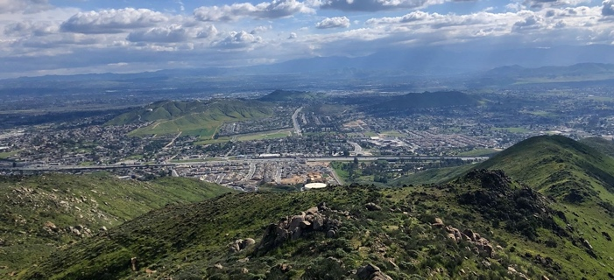
6. Climate Adaptation
Climate change is anticipated to result in increased average temperature and precipitation pattern variability globally. These changes translate into specific impacts to the city that may include increased frequency and intensity of wildfires, severe weather events, flooding, landslides, and reduced water availability associated with droughts.

According to California’s Fourth Climate Change Assessment, the region can expect a projected annual average maximum temperature increase around 4-5 degrees Fahrenheit by mid-century, an increase in the number of extremely hot days, and increased frequency and severity of atmospheric river events resulting in both wet and dry extremes. Lastly, an increase in wildfires is projected for the entirety of Southern California. Other impacts anticipated from climate change include food insecurity, increases in vector-borne diseases, degradation of air quality, reduced ability to enjoy outdoors, and potential economic impacts due to uncertainty and changing conditions.
Figure 8-12: Natural and built environments of Jurupa Valley

Climate adaptation is the process of adjusting to climate change in order to moderate its potential impacts. Curbing the dangerous effects of climate change requires steep reductions in greenhouse gas emissions and implementing climate adaptation strategies to ensure communities remain resilient to the associated impacts of climate change.

The city’s arid climate, rural terrain, and positioning along the Santa Ana River make it particularly vulnerable to climate change impacts and highlight the necessity of climate adaptation strategies as the city continues to grow in population and increase its developed area.
The Western Riverside Council of Governments has developed a countywide climate vulnerability assessment (CVA) – both for physical infrastructure and social vulnerabilities that provides detailed information for the region. The CVA analyzes climate hazards such as air quality, drought, extreme heat, flooding, wildfires, and human health hazards, among others. The assessment also addresses sensitive populations, buildings, biological resources, and key community services.

In addition to the CVA, the Western Riverside Council of Governments has created the Resilient IE Toolkit which is a comprehensive document bridging the Vulnerability Assessments, Adaptation Strategies, Hazard and Evacuation Maps, and Resilience Guidebook. The Toolkit contains information specific to Jurupa Valley such as key vulnerabilities, types of exposures impacting the city such as extreme heat, and threats to the city’s evacuation network by hazard type. The Toolkit’s information and resources are a key resource for the development of City’s climate adaptation policies and programs.
Policies
CSSF 1.55 Adaptation Strategies. Develop adaptation measures that address the climate change impacts on Jurupa Valley’s residents, businesses, and visitors.
CSSF 1.56 Coordinated Planning. Support initiatives, legislations, and actions which respond to climate change and consider potential climate change impacts in planning and decision-making processes.
CSSF 1.57 Regional Planning. Engage surrounding jurisdictions in climate adaptation planning to ensure policy and implementation alignment.
CSSF 1.58 Local Outreach. Work with local organizations to raise awareness about climate change impacts.

Programs
CSSF 1.1.20 Adaptation Planning. Based on the CVA and the Resilient IE Toolkit, establish implementation measures that ensure vulnerable community populations, structures, and functions are understood and appropriate actions are taken to protect these vulnerabilities.
CSSF 1.1.21 Planning for Climate Change. Coordinate adaptation planning with other city planning functions and update relevant city policies as necessary to include climate adaptation strategies, such as General Plan updates, development standards, building codes, and emergency response.
CSSF 1.1.22 Public Outreach Campaign. Collaborate with community-based organizations (e.g., health care providers, public health advocates, fire prevention organizations) to disseminate public preparedness and emergency response information related to climate change impacts.

CSSF 2 – Provide a High Level of Community Services and Facilities to Serve the Existing and Future Needs of Jurupa Valley
1. General
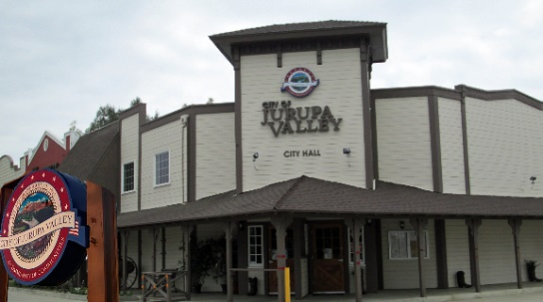
Jurupa Valley’s community services and facilities are a source of pride for the community and directly affect public health and safety, quality of life, land values, economic and environmental sustainability, and fiscal health. Due to the City’s recent history as an unincorporated area, community services and facilities are provided by a number of public and private agencies and service districts. Because of this, close coordination is needed to ensure that existing and future needs of the City are met.
Figure 8-13: Jurupa Valley City Hall
Policies
CSSF 2.1 Provide Facilities and Services. Work with community services agencies and districts on the planning and provision of adequate community facilities and services.
CSSF 2.2 Concurrency with Development. Ensure the provision of sufficient public facilities and services prior to, or concurrently with, new development.
CSSF 2.3 Facility Design. Work with service agencies to ensure that new public facilities are well designed, energy efficient and compatible with adjacent land uses.
CSSF 2.4 Fair Share. Ensure that new development pays its fair share of public facilities and service costs.
CSSF 2.5 Joint Use. Promote the joint use of public facilities to meet multiple needs of the community.
2. City Governance
After the incorporation of Jurupa Valley on July 1, 2011, the City began operating out of a small commercial storefront building in the De Anza Marketplace. City Council meetings were initially held at the Jurupa Valley Unified School District Education Center. However, in 2012, the City Council began meeting at the vacant Sam’s Western Wear, a vintage, western-themed building located at 8930 Limonite Avenue in the Pedley community. Soon thereafter, the City began converting Sam’s Western Wear into City Hall with offices, public counters, meeting rooms, and enhanced Council chambers. City staff and consultants moved into the new City Hall in early 2015, and a grand opening was held to celebrate the important milestone in February of 2015.
The City prides itself on providing quality municipal services in a cost effective manner. The City is responsible for police (including crime and traffic), fire suppression and prevention, street construction, maintenance and repair, building and grading permits and inspections, code enforcement, zoning and planning, water quality management, business registrations, and finance. The City of Jurupa Valley provides these services at City Hall through the following departments: City Manager, City Attorney, Finance, City Clerk, Engineering, Public Works, Building and Safety, Code Enforcement, Planning, and Economic Development. The City provides for police services through the Riverside County Sheriff’s Department, and fire services are provided by the Riverside County Fire Department and the Rubidoux Community Services District. In addition, the City Council and the Planning Commission operate from City Hall and conduct their meetings in the Council chambers. Regular City Council meetings are held on the first and third Thursdays of the month, and Planning Commission meetings are held on the second and fourth Wednesdays of the month.
Policies
CSSF 2.6 Municipal Services. Continue to consolidate municipal services at City Hall to meet the needs of Jurupa Valley citizens.
Programs
CSSF 2.1.1 Evaluate Municipal Services. Allocate municipal resources to evaluate the need, cost, and feasibility of the City assuming responsibility for providing facilities or services currently provided by other agencies.
3. Police Services
One of the primary benefits of the City’s incorporation in 2011 was to achieve enhanced police services. The Riverside County Sheriff’s Department provides police services in Jurupa Valley and throughout much of Riverside County. The department is the second largest Sheriff’s Office in California and includes ten stations, five correctional facilities and other facilities. Sheriff services are provided to Jurupa Valley through a contract with the City from the Jurupa Valley Sheriff’s station located at 7477 Mission Boulevard. The station also serves the cities of Norco, Eastvale, and several unincorporated areas of the County and is led by a commander who serves as the Police Chief for the area.
As of 2017, the Jurupa Valley Sheriff’s Station responds to approximately 35,000 total calls per year. Calls are broken down by priority level. Priority 1 calls are urgent calls that involve a threat to human life or property and have the potential for serious injury. Priority 2 calls involve circumstances that are urgent but not life threatening. Priority 3 and Priority 4 calls involve non-urgent nor life threatening issues. The Department’s 2015 response times for Priority 1 and Priority 2 calls within the service area of the Jurupa Valley Sheriff’s Station are shown in Table 8.1.

: 2015 Police Response Times, Jurupa Valley Sheriff’s Station
Type of Emergency Call | 2015 Response Times
Priority 1 | 7.57 minutes
Priority 2 | 21.31 minutes
Source: Captain Jason Horton, Riverside County Sheriff’s Department, 2/17/16

Graffiti. The Sheriff’s Department and the JCSD regularly patrol the City for graffiti to enable quick eradication and limit its proliferation. In addition, residents in Jurupa Valley are encouraged to report graffiti vandalism to the City of Jurupa Valley or JCSD as soon as it is encountered. The City contracts with the JCSD to paint out graffiti in the City. The Sheriff’s Department also actively pursues conviction of graffiti vandals in accordance with local and state laws.
Homelessness. As of January 2017, there were estimated to be 129 homeless individuals living within the City limits with 20 homeless encampments identified. A number of the encampments are located within the Santa Ana River as well as on public and private property along SR 60 and in other areas of the City. Homelessness is associated with a number of negative issues, including crime, blight, trash, unsanitary conditions, and illegal fires. In 2014, the Sheriff’s Department created a Homeless Outreach Team to identify homeless individuals, reduce the homeless population, and coordinate the delivery of resources to the homeless. The Sheriff’s Department coordinates homeless outreach with a number of additional agencies including, but not limited to, the City of Jurupa Valley, the Riverside County Department of Social Services, the Probation Department, the Department of Veteran’s Affairs, and the Riverside County Flood Control and Water Conservation District.
Residential Noise Complaints. Every weekend, the Sheriff’s Department receives numerous complaints about noise resulting from loud parties that keep residents awake at night. Residents have expressed concerns about loud parties with amplified music that last well into the night and early morning hours and disturb the peace. The Sheriff’s Department maintains a two-deputy noise unit on weekends that specifically deals with residential noise complaints and enforces the City’s Noise Ordinance.
Community-Oriented Policing. The Jurupa Valley Sheriff's Department actively engages in Community-Oriented Policing, which brings together law enforcement professionals with the community in a variety of outreach efforts to reduce crime. In addition, the Department assists the City incorporate Crime Prevention through Environmental Design, or CPTED, techniques in new development. CPTED is a concept supported by law enforcement officers, city planners, designers, and other professionals to design the physical environment in ways that discourage criminal activity and increase safety. The concept is based on three principles: natural surveillance, territoriality, and access control. When incorporated into development projects, these principles serve to eliminate hiding places and enhance visibility so that law-abiding people can easily watch over the physical environment and discourage criminal activities. For example, one effective design strategy to deter crime is to design buildings and sites to maximize visibility of public areas and avoid designs that create hidden entries or site areas that are difficult to monitor or secure.
Policies
CSSF 2.7 Community Safety. Coordinate with the Riverside County Sheriff’s Department on an ongoing basis to ensure the continued safety of the City.
CSSF 2.8 Criminal Activity. Support efforts to develop innovative methods to reduce criminal activity and increase safety in the community.
CSSF 2.9 Graffiti. Support efforts of the Sheriff’s Department and the JCSD to identify and remove graffiti and prosecute graffiti vandals.
CSSF 2.10 Homelessness. Support efforts to reduce the homeless population and provide outreach services to the homeless.
CSSF 2.11 Residential Noise Complaints. Discourage loud parties with amplified music in residential neighborhoods and support the Sheriff Department’s efforts to do the same.
CSSF 2.12 CPTED. Incorporate CPTED principles in the design of new development to encourage natural surveillance and reduce crime.
Programs
CSSF 2.1.2 Planning Applications. Route new Planning applications to the Sheriff’s Department to increase public safety and maintain close coordination with the Sheriff’s Department and law enforcement programs.
4. Fire and Emergency Medical Services
The Riverside County Fire Department, in cooperation with the California Department of Forestry and Fire Protection (CAL FIRE), provides full service municipal and wildland fire protection, emergency medical response, technical rescue services, and response to hazardous materials discharges in Jurupa Valley. The Department operates 99 fire stations throughout the County of Riverside with four of those located in Jurupa Valley, as shown in Table 8.2.

: Jurupa Valley Fire Stations
Station Number | Name/Location | Address
16 | Pedley Fire Station | 9270 Limonite Avenue
17 | Glen Avon Station | 10400 San Sevaine Way
18 | West Riverside Station | 7545 Mission Boulevard
38 | Rubidoux Station | 5721 Mission Boulevard

In 2021, the Department responded to 11,361 calls for service within the City with the majority for emergency medical assistance (70%), traffic collisions (9%), and false alarms (8%) (Riverside County Fire Department 2021 Annual Report).
Policies
CSSF 2.13 Fire Safety Techniques. Incorporate fire-safety techniques in new development
CSSF 2.14 Fire Department Review. Involve the Fire Department in the review of development applications in fire prone areas.
CSSF 2.15 Coordination. Coordinate with the Fire Marshal on fire prevention throughout the community.
CSSF 2.16 Adequate Facilities. Work with the Fire Department to ensure the provision of adequate fire stations, personnel, and equipment to meet the City’s needs over time.
CSSF 2.17 Public Education. Support efforts to educate the public about fire safety and prevention.
5. Educational Facilities
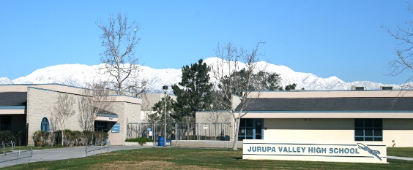
A well-educated population is essential to maintain and enhance the City’s overall quality of life and economic vitality. Educated citizens are more likely to participate in youth programs, community-based volunteer organizations, and civic affairs. In a very real sense, these citizens form the foundation of what it means to be a “community.” Local schools strengthen and support the City’s social fabric and are leaders in maintaining an educated and informed citizenry.
Figure 8-14: Jurupa Valley High School
Two school districts provide public educational services in Jurupa Valley. They are the Jurupa Unified School District (JUSD) and the Corona-Norco Unified School District (CNUSD). JUSD serves most of Jurupa Valley as well as a small portion of Eastvale west of I-15. The JUSD’s Benita B. Roberts Education Center is located at 4850 Pedley Road. Named after a former JUSD Superintendent, the Center contains district offices and the Board of Education meeting room. The District operates 16 elementary schools, 3 middle schools, and 4 high schools including one continuing education high school. Total student enrollment during the 2016/17 school year was 19,352.
CNUSD serves students living in the southwestern area of Jurupa Valley, as well as students living in the cities of Corona, Norco, and Eastvale, and portions of unincorporated Riverside County. The CNUSD Education Center is located in the City of Norco. The District operates one school in the City of Jurupa Valley: VanderMolen Fundamental Elementary School located at 6744 Carnelian Street. Older students living in this area attend River Heights Intermediate School and Roosevelt High School, both of which are located in Eastvale.
During the General Plan preparation process, the GPAC identified several issues related to schools. Community members pointed out that schools should ideally be community centers and serve as focal points where the community comes together for education, recreation, and other activities. The GPAC also identified the need to modernize and remodel several additional schools within JUSD and to provide a community college, occupational training institute, or similar facility. In addition, as most students walk, bike, or are driven to schools, community members identified the need to ensure the safety of travel routes to schools.
There are currently no institutions of higher education in Jurupa Valley. However, through a partnership between the Jurupa Unified School District and the Riverside Community College District, Rubidoux High School includes the Rubidoux Early College High School or RECHS where students can begin their college coursework in their junior year and complete their high school diploma while earning college credit at the same time. Other institutions of higher education in the area include Norco College, Riverside City College, and the University of California, Riverside. The GPAC stated a strong desire to build a satellite college campus and/or trade school in Jurupa Valley, and to provide other venues offering adult education.
Policies
CSSF 2.18 Coordination with School Districts. Coordinate with JUSD and CNUSD in planning for the current and future needs of Jurupa Valley students.
CSSF 2.19 Modernization. Encourage efforts of JUSD to modernize and renovate schools within the district.
CSSF 2.20 Safe Routes to School. Work with the school districts to ensure the safety of travel routes to and from schools.
CSSF 2.21 Schools as Neighborhood Centers. Develop new schools, as needed, that also serve as neighborhood centers and that are pedestrian- and bicyclist-friendly.
CSSF 2.22 Joint Use. Encourage school districts to allow joint use of schools for after-school sports, classes, childcare, or other uses to maximize the community value of these important public investments.
CSSF 2.23 Review of Development Proposals. Involve the school districts in the review of large residential development proposals to ensure that adequate schools are provided without affecting existing facilities.
CSSF 2.24 Higher Education. Encourage institutions of higher education, and other adult education providers, to locate facilities and programs in Jurupa Valley.
CSSF 2.25 Vocational and Trade Schools. Encourage and accommodate to the greatest extent possible the development and location of vocational and trade schools to broaden the local pool of skilled and technical workers.
Programs
CSSF 2.1.3 Incentivize Advanced Educational Opportunities. Review the Zoning Ordinance to identify potential zones, locations, development incentives, and requirements for advanced educational and occupational training schools and similar facilities. Make this information available to potential applicants, real estate and development professionals, marketing and construction firms, and local school districts.
6. Libraries
Libraries are sources of lifelong learning and enrichment. Jurupa Valley’s public libraries provide free access to collections of books and media in a wide range of subjects, titles and formats. In so doing, they provide the community with universal access to resources that are integral for education, leisure, personal growth, health, skill building, and vocational training. As community centers, libraries can also foster social interaction, community involvement, and lifelong learning for residents of all ages.
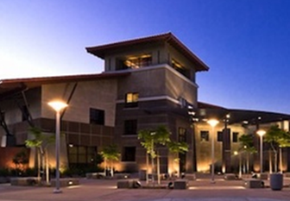
The Riverside County Library System provides library services in Jurupa Valley and throughout Riverside County. Overall, the Library System operates 35 libraries and 2 bookmobiles. Library facilities in Jurupa Valley include the Glen Avon Library located at 9244 Galena Street and the Louis Robidoux Library located at 5840 Mission Boulevard. The GPAC stressed the importance of Jurupa Valley’s libraries and their desire to provide additional libraries in underserved areas of the City such as the southwestern quadrant of the City. They also expressed a desire to develop libraries as focal points of the community with good access to pedestrian and bicycle routes, and public transit.
Figure 8-15: Louis Robidoux Library, Jurupa Valley
Policies
CSSF 2.26 Provide Adequate Facilities. Work with the Riverside County Library System to provide adequate facilities and services for the current and future population of Jurupa Valley and to promote and use the libraries for community meetings and events.
CSSF 2.27 New Libraries. Encourage the development of new libraries in underserved areas of the city.
CSSF 2.28 Libraries as Community Centers. Design new library facilities as community centers with access to pedestrian and bicycle routes as well as public transit.
CSSF 2.29 Educational Programming. Encourage the County of Riverside to provide reading and literacy programs and other educational programs at the local library branch or via other means for those who cannot visit library facilities.
CSSF 2.30 Funding. Encourage County of Riverside efforts to provide adequate funding for improvements to local library facilities and programs through county, state, and federal funding, private and corporate donations, or other resources.
CSSF 2.31 Technology. Encourage the adoption of technological advances that can provide improved access to library resources.
7. Parks and Recreation
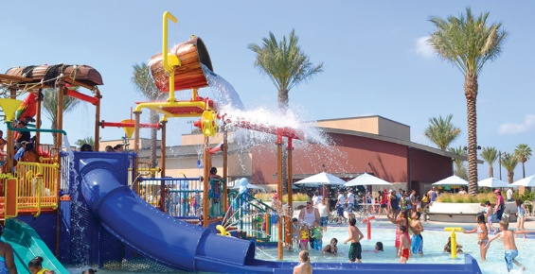
Parks, sports fields, trails, recreation facilities, special events, and programs are at the core of Jurupa Valley’s quality of life and provide residents with a healthy alternative to the built environment. Jurupa Valley’s active and passive parks, recreational facilities, and programs reflect the City’s local culture and unique history, and benefit residents and local businesses by promoting health and wellness, nurturing the City’s agricultural/ equestrian heritage, and fostering community interaction and pride. Recreational facilities help define who we are as a community and serve as gathering spaces for celebration, sport, and relaxation. In describing the Community’s values, the GPAC emphasized the importance of recreation in residents’ lives:
Figure 8-17: “The Cove” Waterpark, Jurupa Valley
Active Outdoor Life. Many Jurupa Valley residents were drawn here because of the City’s unique outdoor setting and the recreation opportunities it offers. Our parks and recreation facilities are essential to maintain and improve our health and quality of life. We place high value on our public parks, sports fields, pedestrian and equestrian trails and support facilities, golf courses, outdoor use areas, historic sites and nature centers, campgrounds, and airport and joint use school facilities.
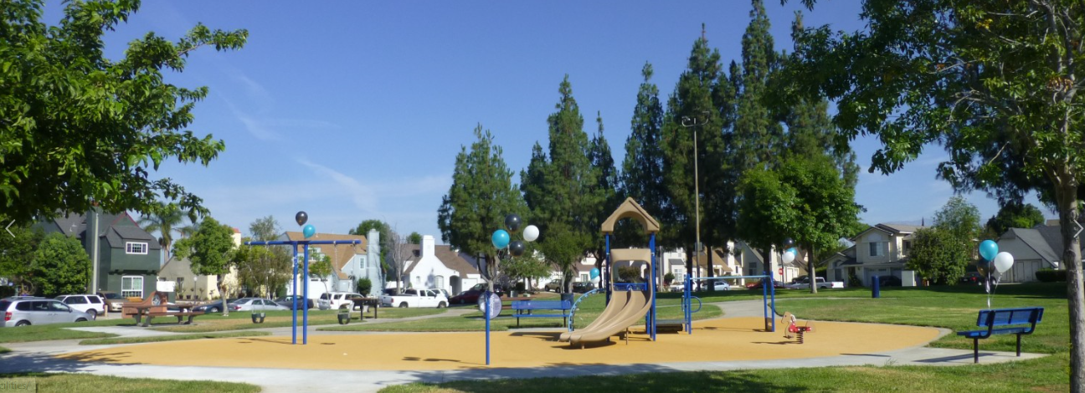
In Jurupa Valley, parks and recreation facilities and programs are provided primarily by the Jurupa Area Recreation and Park District (JARPD). Formed in 1984, the Jurupa Area Recreation and Park District (JARPD) provides parks and recreational facilities in Jurupa Valley and a portion of Eastvale. The District offices are located at 4810 Pedley Road and offers a wide variety of year-round recreational programs and opportunities at numerous facilities throughout the City. In 2017, a new park is planned at the south end of Downey Street to enhance access to the Santa Ana River and open space. Though not yet officially named, it initially includes 26 acres, eventually to be expanded to 41 acres with development of the Paradise Knolls residential project.
Figure 8-16: Jurupa Area Recreation and Parks District (JARPD) parks
Similar facilities and programs are provided by the Riverside County Regional Parks and Open Space District. Additional playground and sports field areas are made available to the public through joint use agreements with the Jurupa Unified School District.
The JARPD offers a diverse range of parks, playgrounds, greenbelts, trails, and recreation facilities. Figure 8-16 shows the locations of Jurupa Valley area parks managed by multiple agencies. JARPD owns and maintains over 125 acres of parkland, 173 acres of undeveloped parks and open space, and about 23 acres of trails, Citywide. Figure 8-17 (page 8-36) summarizes the JARPD’s recreation facilities and acreages. In addition, at the time of General Plan adoption (2017) a new City Park is being developed at Downey Street to enhance Santa Ana River Access and Open Space use.

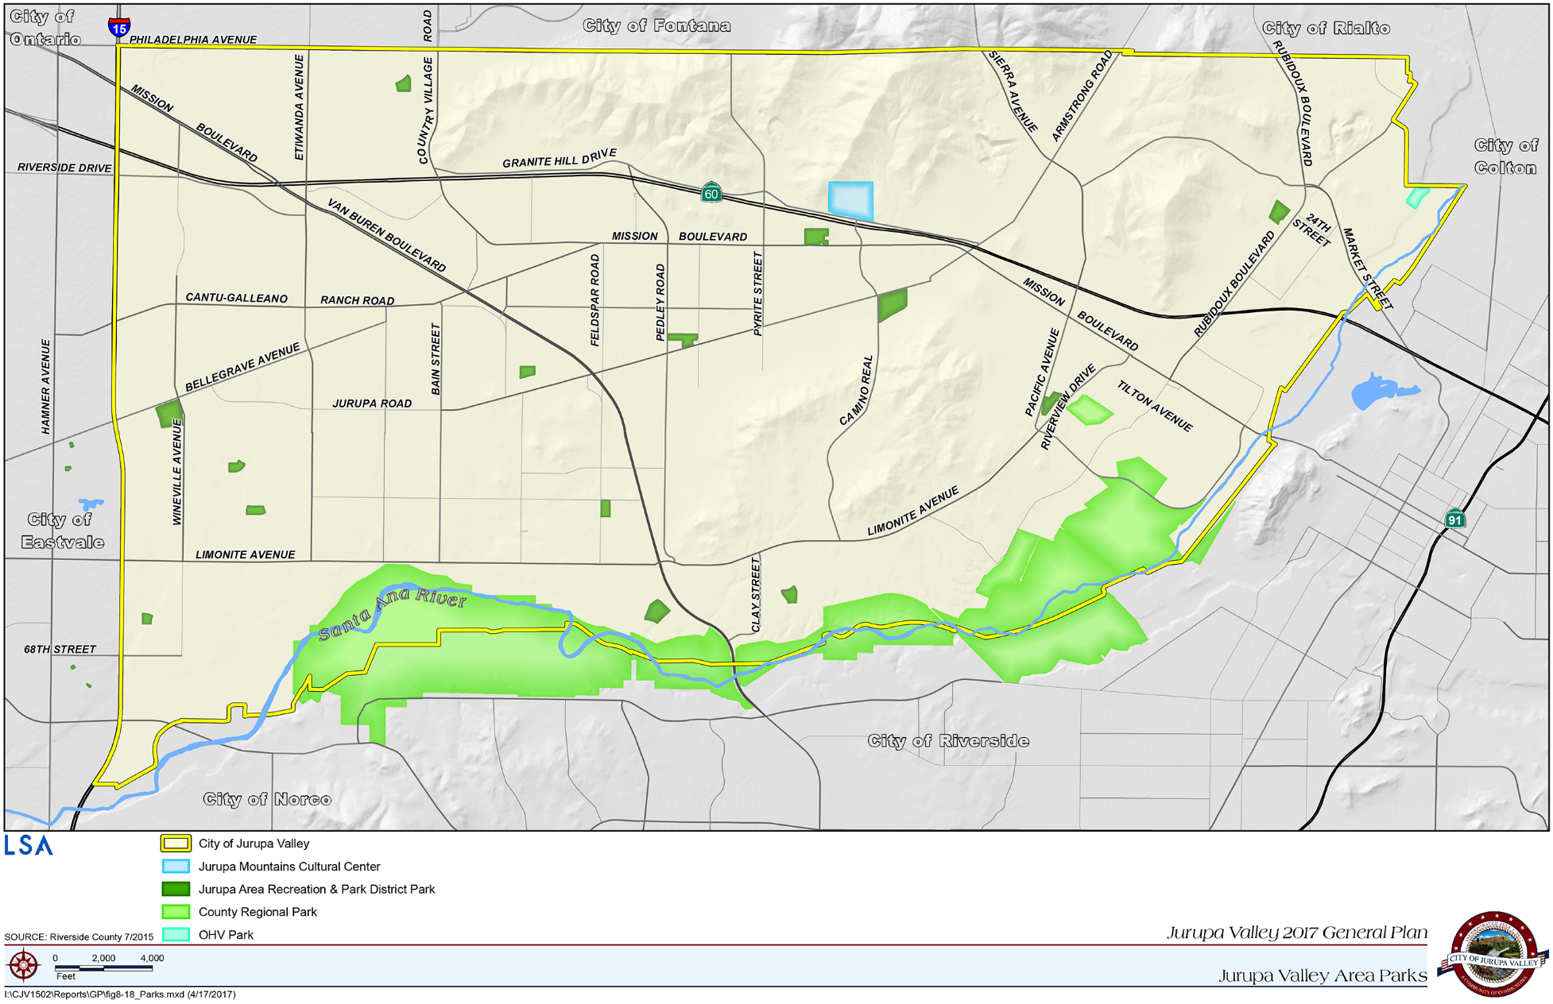
Figure 8-18: Jurupa Valley area parks

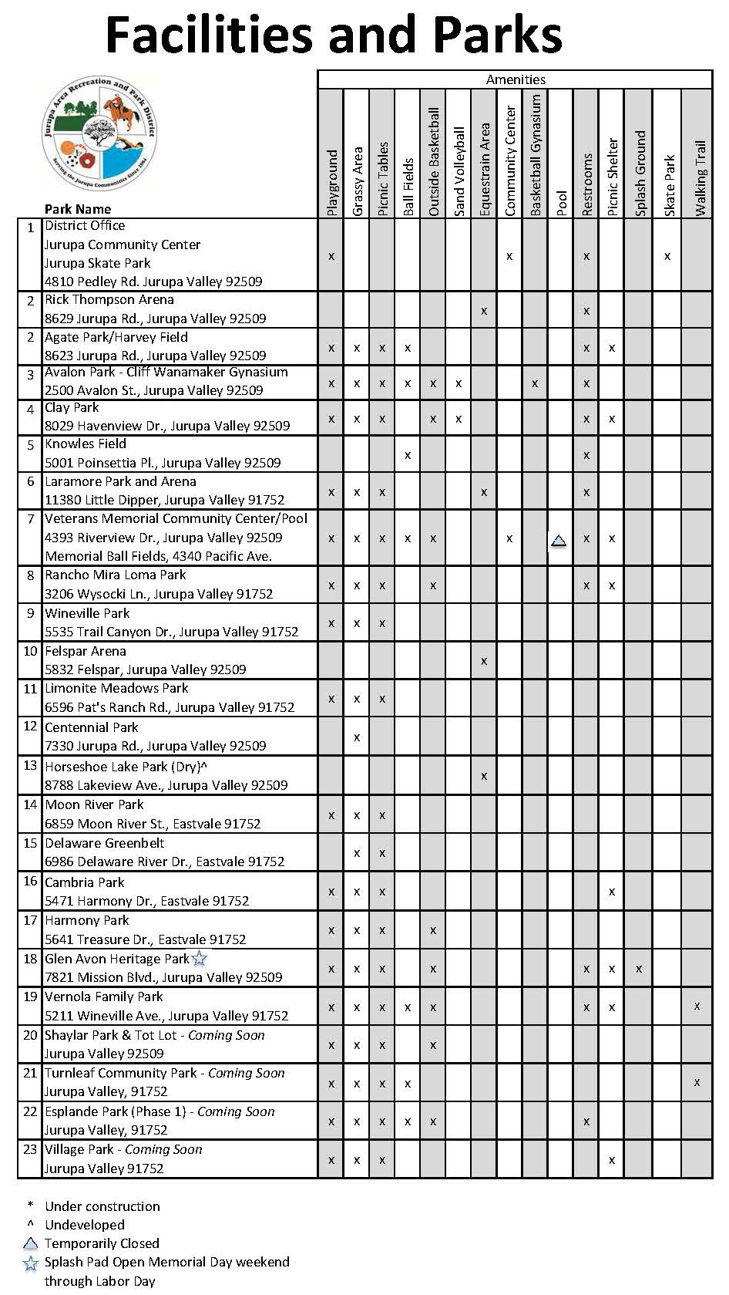
Figure 8-19: JARPD facilities and parks

The Riverside County Regional Park and Open Space District operates several important recreation facilities in Jurupa Valley that are available to all residents. These are:
1. The Louis Robidoux Nature Center. The Center is located at 5370 Riverview, in the heart of the Community of Rubidoux area, about 2 miles southeast of Limonite Avenue. Named after a Frenchman born in St. Louis, Missouri in 1796, the Louis Robidoux Nature Center provides educational programs and tours for the public and school groups on a variety of natural history topics, including Native American history, native plants and animals, astronomy, the environment, and local history.
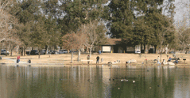
2. Rancho Jurupa Regional Sports Park. Located at 5249 Crestmore Road, the Rancho Jurupa Regional Sports Park provides 32 acres of well-maintained, natural, and synthetic turf fields. It comprises four large marked and lighted synthetic turf fields, two large natural turf fields, plus nine smaller natural turf fields, with a plaza with picnic shelters, restrooms, a snack bar, and two playgrounds. The Park provides individual, team, and group play facilities year around.
3. Rancho Jurupa Park and Campground. Located at 4800 Crestmore Road, Rancho Jurupa Park and Campground is a 200-acre regional park and serves as a popular destination for local campers and anglers as well as out-of-town visitors. The Park offers 140 camping sites, 5 cabins, and two 3-acre lakes. Rancho Jurupa Park offers many amenities, including a “splash pad” for water play, rock climbing, picnic areas, children’s playgrounds, miniature golf and a disc golf course, and fishing.
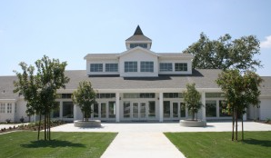
4. Historic Crestmore Manor. The historic Crestmore Manor, located at 4600 Crestmore Road, is a 10,830-square-foot colonial-style mansion built in the mid-1950s by W.W. “Tiny” Naylor, a restaurateur, and the state’s second-leading thoroughbred horse breeder of the time. The Manor, a California Historical Landmark, is owned by the Riverside County Regional Park and Open-Space District and is available for community, group, or individual events, such as meetings, festivals, shows, weddings, receptions, parties, and other special events, and can accommodate up to 400 guests.
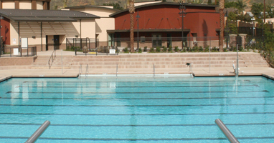
5. The Cove Waterpark. Located at 4310 Camino Real, The Cove is operated by a private concession under the auspices of the County of Riverside Park and Open-Space District. It was developed in partnership with the Economic Development Agency and the Jurupa Unified School District. Also called the Jurupa Aquatic Center, the facility consists of 7.5 acres with a waterpark and a competition sports pool. The Caribbean-themed waterpark consists of children’s activity pool and splash playground, river rafting, a water slide, a wave machine for surfing, a multi-purpose room, restrooms and lockers, a picnic area, and concessions.
In cooperation with community services districts, the County of Riverside, the Jurupa Unified School District, and other agencies, the City helps meet the diverse recreation needs of existing and new residents by requiring the dedication and improvement of new parks and recreation facilities as a condition of new development. The City also promotes recreation and healthy exercise by providing equestrian, bicycle, and walking paths within the public right of way and by requiring new residential neighborhoods to include pedestrian and equestrian paths, where appropriate. In California, local governments play a critical role in the effort to set aside parkland and open space for recreational purposes. Under the Quimby Act (California Government Code §66477), local governments can adopt ordinances requiring developers to set aside land, donate conservation easements, or pay fees for park improvements. Generally, the parkland dedication standard is 5 acres of parkland per 1,000 new residents. The Jurupa Area Recreation and Park District uses a standard parkland dedication requirement of 5 acres per 1,000 new residents. Frequently, developers choose to pay fees “in lieu” of actually providing parkland. The fees are set by the local agency and are equivalent to the value of the parkland dedication required. Special districts must work with cities to receive parkland dedications or in-lieu fees inasmuch as only cities and counties have the authority to tie such requirements to new development project entitlements.
As a young city, Jurupa Valley faces special challenges in meeting existing parks and recreation needs. Residents in some communities, such as Pedley, Mira Loma, and Glen Avon, are largely built out but remain underserved in terms of neighborhood-oriented park and recreation facilities. In addition, park administration and maintenance through multiple agencies can pose difficulties in meeting growing and/or changing park and recreation needs. In its new role as a city, Jurupa Valley seeks to play a more direct role in ensuring that residents’ park and recreation needs are met and in adopting the goals and standards to help improve and expand residents’ access to parks, playgrounds, trails, recreation facilities, and open space.
Policies
CSSF 2.32 Evaluation of User Needs. Encourage park and recreation service providers to evaluate user feedback, track facility use, and utilize projections to understand park and recreation facility needs and plan for future acquisition and development.
CSSF 2.33 Park and Recreation Facilities Maintenance. Encourage park and recreation service providers to maintain parks, trails, and other recreation facilities in good condition and strive to meet Council-adopted community parks and recreation goals.
CSSF 2.34 Joint Use Agreements. Maintain and improve joint-use recreational agreements with school districts and public agencies and seek new opportunities for joint recreational uses.
CSSF 2.35 Universal Access. Encourage responsible agencies to provide, where feasible, inclusive recreation facilities that meet or exceed accepted standards for universal access for all persons and abilities, and encourage others to do likewise.
CSSF 2.36 Users. Encourage responsible agencies to provide parks and recreation facilities and programs that meet the needs of all residents, regardless of income levels, ages, and abilities, and encourage others to do likewise.
CSSF 2.37 Historic Sites. Celebrate historic sites with recreational learning opportunities in parks and recreation facilities.
CSSF 2.38 Natural Environment. Protect and, where possible, utilize parks, trails, and open spaces for learning opportunities and passive recreation in conjunction with our environmental goals.
CSSF 2.39 Street Closures/Public Spaces. Support temporary and, where safe and appropriate, long-term street closures to create or expand public spaces and to accommodate street fairs, farmers’ markets, art shows, and other special community events.
CSSF 2.40 Equestrian Heritage. Work with community groups to encourage, promote, and as resources allow, help support projects that celebrate the City’s equestrian heritage, such as trails, staging areas, hitching posts, corrals, exercise areas, and performance arena.
Programs
CSSF 2.1.4 Master Plan. In cooperation with JARPD, County of Riverside and other responsible agencies, prepare and adopt a Joint Recreational Opportunities and Open Space Master Plan that identifies recreation goals, priorities for park expansion, acquisition, improvement, and funding. The Plan will be adopted within 2 years of General Plan adoption and updated at least every 10 years.
8. Social Services
Riverside County provides a variety of public assistance programs in Jurupa Valley. The County’s Department of Public Social Services (DPSS) operates several offices in the region including a Department office at 5961 Mission Boulevard and the Rubidoux Community Resource Center at 5473 Mission Boulevard. DPSS offers a number of programs to assist City residents become self-sufficient and access needed services. Services include the California Work Opportunity and Responsibility to Kids program, or CalWORKS, which provides temporary financial assistance to eligible families with minor children who have lost or had a reduction in their income. Other services include Medi-Cal, which provides no-cost or low-cost health care coverage for eligible participants, CalFresh/SNAP, which provides healthy food for needy families and child protective services. The California Family Life Center also operates the Youth Opportunity Center in Rubidoux which provides outreach services and career counseling to at-risk youth. The Rubidoux Family Resource Center, located at 5498 Mission Boulevard, offers on-site services for prenatal care, family planning, parenting classes, public health nurse in home visitation, nutrition and cooking classes, adult education, ESL classes, Healthy Children Connection, Healthy Families/Medi-Cal enrollment, free immunization clinic, utility assistance, Christmas baskets, WIC information, and Workforce Development (job search/job training programs).
Policies
CSSF 2.42 Social Services. Support Riverside County to assist Jurupa Valley residents with social services and other programs.
9. Water
Jurupa Valley is fortunate that it does not rely on imported water to provide its domestic needs. Instead, it relies on local groundwater from the Chino and Riverside Groundwater Basins. Three main agencies, as well as private water companies, provide water to the City of Jurupa Valley. The agencies are the Jurupa Community Services District, the Rubidoux Community Services District, and the Santa Ana River Water Company. These agencies rely on groundwater supplies for both “potable” and “non-potable” water. Potable water is that which is drinkable and fit for human consumption. Non-potable water contains chemicals or other contaminants that make the water unhealthy for humans and animals, but that with proper treatment, may be used for irrigation, manufacturing, and other purposes. Imported water is used by other agencies to recharge local groundwater supplies.
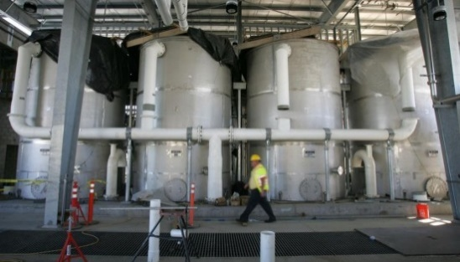
Although local groundwater supplies are forecast to meet Jurupa Valley’s water needs for the foreseeable future, ongoing drought conditions in California have severely impacted water supplies and the ability of water purveyors to meet various water demands. In response, water purveyors throughout California, including Jurupa Valley’s local community services districts, have implemented emergency water conservation regulations to eliminate or reduce water-wasting practices and to conserve precious water resources on an ongoing basis.
Figure 8-20: Water desalter plant, Jurupa Valley (Press-Enterprise)
Policies
CSSF 2.43 Grey Water Systems. Facilitate the utilization of grey water systems.
CSSF 2.44 Drought-Tolerant Landscaping. Require the use of drought-tolerant landscaping in all new development.
CSSF 2.45 Reclaimed Water. Encourage the development and use of reclaimed water for landscape irrigation and other uses.
CSSF 2.46 Public Education. Support public education efforts to promote water conservation throughout the community.
CSSF 2.47 Water Storage. Encourage local water purveyors to expand local domestic water storage and recycling capabilities.
CSSF 2.48 Water Conservation Ordinance. Implement and enforce the City’s Landscape Water Conservation ordinance.
CSSF 2.49 Water Conservation. Make use of state-of-the-art water conservation technology in all City facilities and landscaping, and require new developments to include drought-tolerant landscaping, permeable paving and water-saving systems and fixtures.
Programs
CSSF 2.1.5 Urban Water Management Plan. Work with local water purveyors to prepare a unified Urban Water Management Plan for Jurupa Valley and to ensure that the Plan is updated as needed.
CSSF 2.1.6 Alternative Water Resources. Explore the feasibility of desalinization and other regional projects as additional sources of local water.
10. Wastewater
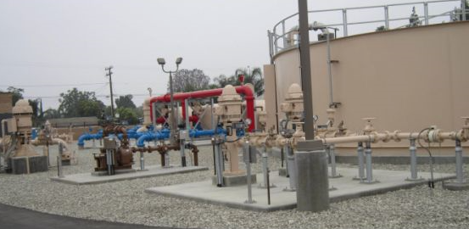
The Jurupa Community Services District and the Rubidoux Community Services District provide wastewater service to most of Jurupa Valley. However, some areas in the City, particularly in Old Mira Loma and Sky Country, still rely on private septic systems. The community services districts collect and distribute wastewater through a system of pipes, mains, lift stations, force mains, and pump stations. Wastewater is transported to two nearby municipal wastewater treatment plants. The Riverside Water Quality Control Plant is located in, and operated by, the City of Riverside. The Western Riverside County Regional Wastewater Authority (WRCRWA) operates the Western Riverside County Regional Wastewater Treatment Plant, which is located in the City of Corona. As of 2017, both treatment plants were undergoing expansion projects to serve future population growth.
Figure 8-21: Water Treatment Facility, Rubidoux Community Services District
The two treatment plants treat the majority of wastewater to very clean tertiary levels, which can then be discharged into the Santa Ana River. In addition, some of the wastewater is treated to recycled, or reclaimed, levels for irrigation purposes. The use of reclaimed water for irrigation has several environmental benefits including reducing the demand for potable (drinkable) water for landscaping, reducing the amount of groundwater withdrawal, and increasing the quality of groundwater supplies by reducing outflow.
Salty water produced through groundwater extraction and through commercial and industrial processes is transported to the Santa Ana Watershed Project Authority’s (SAWPA) Inland Empire Brine Line, which runs through Jurupa Valley. The Brine Line helps to maintain the water quality of the Santa Ana River Watershed by reducing the salt content of water that percolates into the groundwater basin.
Policies
CSSF 2.50 Adequate Wastewater Conveyance. Work with the Jurupa Community Services District and the Rubidoux Community Services District to ensure sufficient wastewater conveyance and pumping capacity to meet the existing and future needs of the City.
CSSF 2.51 Septic Systems. Work with the Jurupa Community Services District to convert areas of the City relying on septic systems to municipal wastewater service.
CSSF 2.52 Recycled Water. Encourage the continued production and expansion of recycled water for irrigation and other purposes.
CSSF 2.53 Wastewater Treatment Capacity. Encourage efforts of the City of Riverside and the Western Riverside County Regional Wastewater Authority (WRCRWA) to provide adequate wastewater treatment capacity to serve the existing and future needs of the City.
CSSF 2.54 Fair-Share Costs. Require new development to contribute fair-share costs for the provision of wastewater infrastructure and treatment.
CSSF 2.55 Brine Line. Support the continued maintenance and use of the Inland Empire Brine Line to transport salty wastewater to the ocean and maintain the quality of the Santa Ana River Watershed.
11. Storm Water
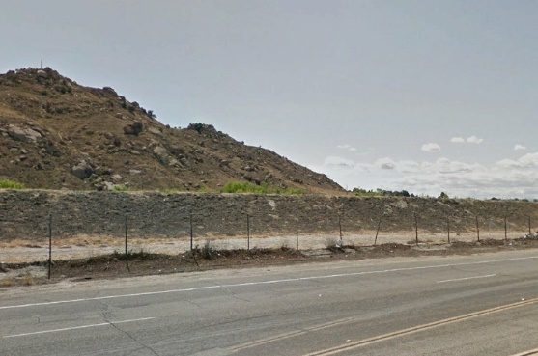
The Riverside County Flood Control and Water Conservation District serves as the regional flood management agency for western Riverside County. It was formed in 1945 largely in response to the devastating floods of 1938, which destroyed most of the bridges across the Santa Ana River including the Van Buren Bridge. The District provides flood protection including the identification of flood hazards, the regulation of floodplains, watercourse and drainage planning, and the design, construction, and maintenance of flood control facilities. The District operates a series of storm drains and channels throughout Jurupa Valley that collect runoff water and ultimately direct it to the Santa Ana River. As shown in Figure 8-19, a levee was built along portions of the Santa Ana River to prevent reoccurrence of catastrophic flooding.
Figure 8-22: Flood levee along Santa Ana River in Jurupa Valley
As runoff enters the storm drain system, it collects trash, debris, and pollutants, which ultimately make their way to the Santa Ana River. The Flood Control and Water Conservation District, Jurupa Valley, and other permittees along the Santa Ana River are regulated by the Environmental Protection Agency’s (EPA) National Pollutant Discharge Elimination System (NPDES) as well as a Municipal Separate Storm Sewer System (MS4) Permit issued by the Santa Ana Regional Water Quality Control Board. These regulations require the agencies to implement storm water management techniques to reduce the amount of pollutants entering the storm water system.
During preparation of the General Plan, the GPAC addressed issues of flooding and storm water. The GPAC generally agreed that storm water facilities in Jurupa Valley are adequate, except in some areas where flooding occurs, such as Old Mira Loma. In addition, a recurring theme among GPAC members was the desire to utilize property along flood control channels and creeks for walking, bicycling, and potentially even equestrian travel. These facilities crisscross the community and offer unimpeded routes to the Santa Ana River. While flood control, pollution prevention, and safety are paramount with these facilities, the potential for additional community use should be explored.
Policies
CSSF 2.56 Adequate Facilities. Work with the Riverside County Flood Control and Water Conservation District to develop and maintain adequate flood control facilities to reduce the potential for flooding and protect the quality of the Santa Ana River and other natural drainage courses.
CSSF 2.57 New Development. Require new development to implement on-site measures to clean and contain storm water runoff.
CSSF 2.58 Public Education. Support public education and other efforts to inform the community about the hazards of runoff pollution.
Program
CSSF 2.1.7 Multi-Modal Trails. Develop a multi-agency program with the Riverside County Flood Control and Water Conservation District, the Jurupa Area Recreation and Park District, and the City for the use of flood control channels and associated maintenance and accessways for pedestrian, bicycle, and equestrian trails.
12. Solid Waste Disposal
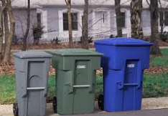
Waste and recycling disposal in Jurupa Valley is provided by private companies. Residential, commercial, and industrial subscription services are provided as well as specialized services such as dumpsters, construction containers, neighborhood clean-up events and twice-yearly residential bulk item pick-up days. Trash from Jurupa Valley is transported to the Agua Mansa Transfer Station and Material Recovery Facility at 1830 Agua Mansa Road. From there, recyclable materials are transferred to third-party providers, and waste materials are transported to various landfills in Riverside County. Community members may drop off waste, recycling, and bulk items at the Agua Mansa Station. Residents may also dispose of hazardous household wastes, such as petroleum products, garden chemicals, and paint, on Saturdays at the Riverside County Regional Household Hazardous Waste Facility located at 1780 Agua Mansa Road.
Figure 8-23: Residential waste and recycle bins
The semi-rural nature of many areas of the City has attracted individuals and businesses to dispose of unwanted items or construction materials along local roadways and vacant lots. This practice creates visual blight, health and safety issues and must be prevented to maintain the quality of life desired by those who live and work in the community. In addition to strict enforcement of anti-dumping regulations, a program is needed to facilitate the proper means of disposing of solid waste. Such a program could include free pick up on certain days several times per year or establishing small local disposal stations in key locations in the community.
Policies
CSSF 2.59 Solid Waste Services. Work with private disposal companies to ensure the continued provision of adequate solid waste and recycling services in Jurupa Valley, including the availability of adequate landfill capacity to meet the City’s future needs.
CSSF 2.60 Waste Reduction. Encourage the diversion of waste from landfills through reduction, reuse, and recycling efforts.
CSSF 2.61 Waste Management. Encourage new development to employ construction waste management techniques to divert construction materials and debris away from landfills.
CSSF 2.62 Public Education. Encourage and, as resources allow, support public education efforts to inform the public about waste reduction, reuse, and recycling.
CSSF 2.63 Neighborhood Clean-Up Efforts. Sponsor and/or participate in neighborhood clean-up efforts and anti-littering campaigns/strategies.
CSSF 2.64 Commercial Recycling. Expand mandatory recycling for commercial customers consistent with state requirements.
CSSF 2.65 Rubberized Asphalt. Consider using rubberized asphalt and recycled aggregate for City street projects, as appropriate.
CSSF 2.66 Waste Diversion. Achieve at least the minimum construction and demolition waste diversion requirement of 75%.
CSSF 2.67 Litter and Recycling Containers. Place public litter and recycling containers at key locations in the public right of way, as resources allow. Encourage other responsible agencies and service districts to do likewise.
CSSF 2.68 Anti-Littering Campaigns. Support and participate in anti-littering strategies and campaigns to encourage residents and other stakeholders to dispose of litter and debris properly.
CSSF 2.69 Illegal Dumping. Strictly enforce the laws and ordinances to prohibit illegal dumping along streets and highways or on vacant private property, establish convenient alternatives for local residents and businesses and consider increasing fines for littering and illegal dumping.

###

