**What is Zone 0?**

Zone 0 is a term that refers to defensible space from wildfire. It comprises the first 0 - 5 feet around a structure, including homes and other buildings larger than 120 square feet. A deck attached to a structure is considered an extension of the structure; therefore, Zone 0 starts where the attached deck ends.

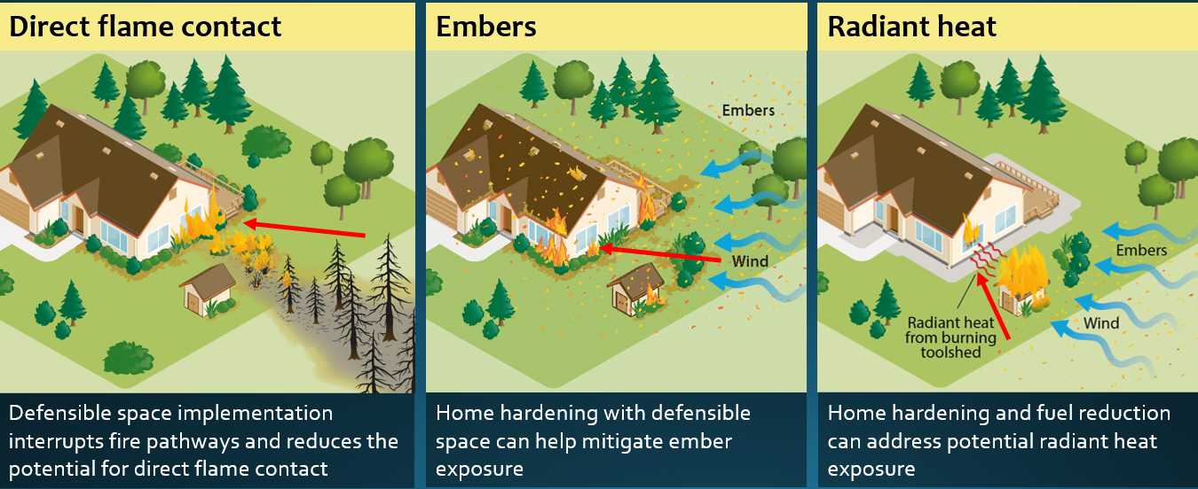Keeping the area closest to a structure clear of flammable material helps reduce the risk of the structure catching fire in a wildfire event. Most structures lost to wildfire are ignited by flying embers that can travel miles ahead of the fire. Embers cause a structure to catch fire by directly igniting it or by igniting vegetation or flammable material on or near the it, which results in flames coming in contact with the structure or creating radiant heat exposure that may directly ignite siding or break windows, allowing embers to enter the structure and ignite it.

Zone 0 regulations are currently being developed by the Board of Forestry and Fire Protection (Board) through an open, public process. The Board was directed to develop Zone 0 regulations by the Legislature through AB 3072 and SB 504. The regulations are scheduled to be adopted by the end of the year.

To help safeguard structures, Zone 0 will address flammable items, such as wood-based mulch, plants, grass, synthetic lawns, stored lumber, storage sheds, wooden gates attached to a structure, small trees, and other landscape materials within the first 5 feet of the structure or attached decks. It is also anticipated to address petroleum-based products and natural gas within the first 5 feet of a structure.

For more information, on Zone 0 or to learn how to get involved in the public rulemaking process, see the Board’s homepage as well as [Defensible Space- Zones 0, 1 & 2](https://calfire-umb05.azurewebsites.net/projects-and-programs/defensible-space-zones-0-1-2/).

*An ember-resistant Zone 0 helps save lives, protect homes, and protect communities.*