Draft
Emergency Evacuation Route Analysis
City of Santee Safety and Environmental Justice Element
July 2023
Prepared for:
City of Santee
10601 Magnolia Avenue
Santee, California 92071
Contact: Christina Rios, Senior Planner
Prepared by:
600 B Street, Suite 2000
San Diego, California 92101
(619) 236-1778
Contact: Darin Neufeld, AICP, Director

This page intentionally left blank.
Table of Contents
Section 1 Background 1
Section 2 Hazard Scenarios 3
Section 3 Data, Assumptions, and Definitions 5
Section 4 Methodology 7
Section 5 Results 9
Section 6 Evacuation Locations 21
Section 7 Conclusion 23
Section 8 Recommendations 25
Figures
Figure 1. Baseline Residential Evacuation Vulnerability Score 10
Figure 2. Northeast Wildfire Residential Evacuation Vulnerability Score 12
Figure 3. Northwest Wildfire Residential Evacuation Vulnerability Score 14
Figure 4. Southwest Wildfire Residential Evacuation Vulnerability Score 16
Figure 5. Flood Residential Evacuation Vulnerability Score 18
Figure 6. Earthquake Residential Evacuation Vulnerability Score 20

This page intentionally left blank.

Background
                - A variety of hazard scenarios could require an evacuation in parts of the City of Santee. These emergency situations could be caused by either natural or human-made events, such as wildfires, floods, or geologic or seismic hazards. Santee is responsible for ensuring emergency preparedness, response, and recovery activities for all populations within its jurisdiction. The City’s Emergency Operations Plan (EOP) was prepared with input from partnering jurisdictions within San Diego County to provide a system for the effective management of emergencies consistent with the County EOP and to ensure the protection of life, property, and the environment before, during, and after an emergency event, natural disaster, or technological incident. This Emergency Evacuation Route Analysis incorporates the City’s EOP by reference.
                - The results of this analysis are intended to identify evacuation capacity and network connectivity in Santee in addition to meeting the requirements associated with the following legislative updates:
- Assembly Bill (AB) 747 (2019) requires the City of Santee to update the Safety Element of its General Plan to identify evacuation routes and assess the capacity, safety, and viability of those routes under a range of emergency scenarios.
- Senate Bill (SB) 99 (2019) requires the City of Santee to identify residential developments in hazard areas that do not have at least two emergency evacuation routes (i.e., neighborhoods or households within a hazard area that have limited accessibility).
- AB 1409 (2021) requires the City of Santee to identify evacuation locations.
                - Authoritative state guidance has not yet been developed to determine the type and level of analysis that is mandated under AB 747, SB 99, or AB 1409. This analysis evaluates the efficacy of existing evacuation routes under various hazard scenarios, in compliance with AB 747, and uses the methodology described below to identify residential developments without sufficient evacuation routes, in compliance with SB 99. Evacuation locations are provided below in compliance with AB 1409.

This page intentionally left blank.

Hazard Scenarios
                - Evacuation route viability is largely determined by the location of the hazard. The city is surrounded by Very High Fire Hazard Severity Zones to the north and southwest as shown in Figures 2 through 4 of this Emergency Evacuation Route Analysis. Therefore, the City of Santee considered three scenarios with wildfire originating in the northeast, the northwest, and the southwest). Because flood zones exist along the San Diego River in the south-central portion of Santee, evacuation route viability is assessed for flood hazards (Figure 5, Flood Residential Evacuation Vulnerability Score). Lastly, due to the proximity of the Rose Canyon extension of the Newport Inglewood Fault Zone and the Mission Gorge Fault and La Nacion Fault Zone southwest of the city, evacuation route viability is assessed for an earthquake event (Figure 6, Earthquake Residential Evacuation Vulnerability Score).
                - Six hazard scenarios are considered in this analysis:
- Baseline (no hazard location specified)
- Wildfire (originating in the area northeast of the city)
- Wildfire (originating in the area northwest of the city)
- Wildfire (originating in the area southwest of the city)
- Flood
- Earthquake

This page intentionally left blank.

Data, Assumptions, and Definitions
                - The Evacuation Route Analysis uses updated data from UrbanFootprint and the OpenStreetMap Foundation that was published in 2021. The OpenStreetMap Foundation data builds on and includes all roads in the U.S. Census Bureau’s Topologically Integrated Geographic Encoding and Referencing (TIGER) database. The database includes primary roads, secondary roads, local neighborhood roads, rural roads, city streets, vehicular trails, ramps, service drivers, walkways, stairways, alleys, and private roads. Roads within the city are evaluated for evacuation route viability using the assumptions described below and methodology described in Section 4.
                - To develop a methodology that effectively evaluates the safety and capacity of evacuation routes and identifies residential areas that lack two evacuation routes, the following definitions and assumptions apply:
- “Evacuation route vulnerability” refers to the reduced ability of people to evacuate under emergency conditions. Evacuation route vulnerability scores are calculated for each residential parcel. Lower values indicate lower levels of vulnerability, while higher values indicate greater evacuation route vulnerability.
- “Capacity” is defined by the ability of a road to accommodate traffic volume. In this analysis, road type (local, collector, arterial, or highway/freeway) is used as an indicator of road capacity.
- “Local” roads are streets that are primarily used to gain access to property. Proximity to local roads was not considered a significant determinant of evacuation vulnerability.
- “Collector” roads are considered low-to-moderate capacity roads that serve to move traffic from local streets to arterial roads.
- An “arterial” road is a high-capacity urban road. The primary function of an arterial road is to deliver traffic from collector roads to highways/freeways, which are the highest capacity evacuation route.
- Evacuation proceedings are primarily reliant on “outbound” roads: roads that transport drivers away from the city. Outbound roads are either freeways or arterials. Outbound roads begin at the intersection closest to the city boundary.
- “Proximity” is defined by the distance from a residential parcel to nearest road (for collector roads) or “nodes”: the nearest intersection on the following road types: arterial, outbound, or highway/freeway.
- All roads have a potential role in evacuations. Closer proximity to higher capacity roads and outbound roads reduces evacuation vulnerability.
- Hazard scenarios influence the direction people evacuate (away from the hazard area).
- Under the earthquake hazard scenario, segments of roads with bridges are not viable.

This page intentionally left blank.

Methodology
                - Evacuation route vulnerability scores were assigned to each residential property based on several factors, including proximity, capacity, and viability. The geospatial analysis included the following steps:
- Map all residential parcels in Santee and all collector, arterial and outbound roads and freeways.
- Create nodes at the intersection of collector and local roads to arterial roads and all intersections on outbound roads, including on-ramps for highways/freeways.
- Determine the proximity of each residential parcel to the nearest evacuation route (highway/freeway or outbound road) using the following methodology:
- Calculate the distance from the parcel to the nearest collector road.
- Calculate the distance to the nearest arterial, outbound road, or highway/freeway node.
- Each distance value calculated in Step 3 is weighted based on road type. Apply the following vulnerability weights to the road type to reflect the higher vulnerability of lower capacity roads and roads with bridges:
Road Type | Vulnerability Weight
Freeway | 1
Outbound Road | 2
Arterial Road | 3
Collector Road | 4
Road segment with bridge | 10

- Add weighted distance values for each evacuation route to calculate the evacuation route vulnerability score. Lower values indicate the evacuation route has a lower vulnerability to the hazard scenario; higher values indicate greater vulnerability.
- For each hazard scenario, identify residential parcels whose evacuation route vulnerability has changed (increased or decreased) from the baseline, and determine if there are any residential areas with fewer than two evacuation routes. A geographic information systems (GIS) assessment that identifies potential vulnerabilities in Santee is performed to conclude whether all residential parcels have at least two points of egress.

This page intentionally left blank.

Results
- Baseline
                - The baseline scenario evaluates the evacuation route vulnerability of residential parcels absent a hazard event. In the baseline scenario, all outbound roads are available to residents for evacuation (Figure 1, Baseline Residential Evacuation Vulnerability Score). Key intersections within the city boundary are where two arterial roads connect. These key intersections are labeled on the baseline map. Major intersections are necessary to efficiently route residents to outbound roads. Residential parcels with higher evacuation route vulnerability scores are highlighted in red, orange, or yellow. Assuming all evacuation routes are viable, residents in the northern and southwestern regions of the city have the highest evacuation route vulnerability, as they have the farthest to travel to access outbound evacuation routes (i.e., State Route [SR-] 67, SR-52, SR-125, and Interstate [I-] 8).
                - In addition to considering evacuation route vulnerability, the vulnerability of residents should be considered in determining which areas may need to be prioritized by first responders during an evacuation. The areas in the Santee with a greater percentage of older adults, people with disabilities, and households that do not own a vehicle (i.e., transit-dependent populations) require greater levels of support during an evacuation. Other vulnerable groups beyond those within these demographics should be examined relative to evacuation route vulnerability.
                - For example, the following areas are defined as disadvantaged communities in the General Plan Safety and Environmental Justice Element:
- The area south of Mission Gorge Road and west of Fanita Road (Census Tract 0166.05)
- The area south of Mission Gorge Road and east of Fanita Road (Census Tract 0166.16)
- The area south of Mission Gorge Road and east of Cuyamaca Street (Census Tract 0166.17)
                - [See Figure 6.1 through Figure 6.3 in the Safety and Environmental Justice Element for the City’s disadvantaged communities.]

Figure 1. Baseline Residential Evacuation Vulnerability Score
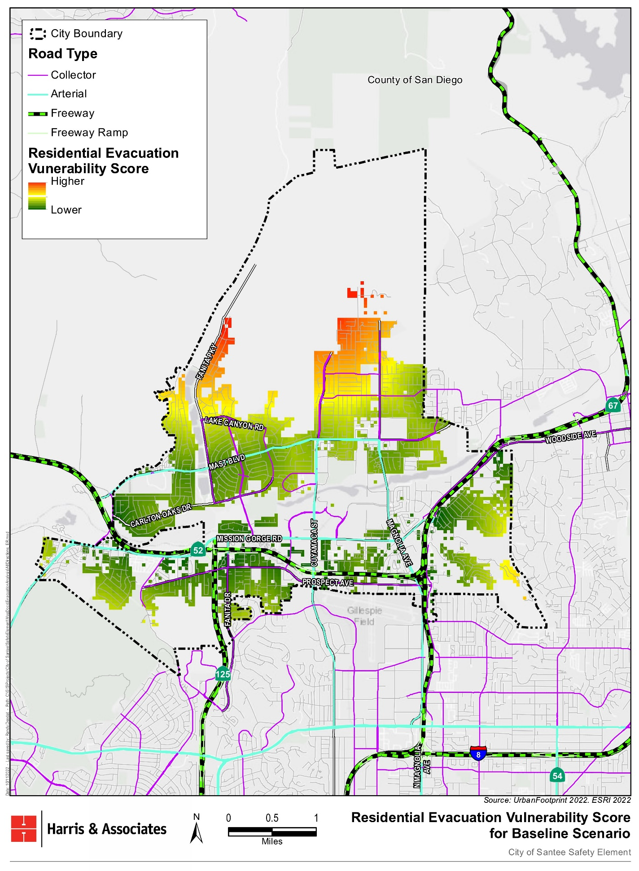
- Wildfire (Northeast)
                - This scenario assumes a mandatory residential evacuation due to a wildfire northeast of the city. Outbound roads leading north/northeast, such as SR-67 North, are assumed to be not viable due to the wildfire hazard. The south- and west-bound freeways are the most viable evacuation routes in Santee in this scenario. Evacuation vulnerability scores are re-calculated from the baseline scenario to account for the increased distance to the next closest, viable outbound road. Figure 2, Northeast Wildfire Residential Evacuation Vulnerability Score, highlights residential parcels with evacuation route vulnerability scores that increased as a result of the SR-67 North evacuation route being closed. SR-67 South, SR-52 West, and SR-125 South, as well as I-8, are the outbound roads most likely to be used in this scenario. Residents are able to travel along the following arterial roadways in Santee in order to access the viable south- and west-bound freeways: Mast Boulevard, Mission Gorge Road, Cuyamaca Street, and Magnolia Avenue. The viable south- and west-bound freeways under this scenario increase overall evacuation capacity in Santee. However, the city’s internal roadways (e.g., arterial roads) are subject to congestion as residents attempt to access the outbound freeways. Emergency responders should consider activating evacuation traffic management along arterial roads to allow for easier access to the freeways, although this requires extensive coordination and should be reserved for extreme wildfire threats.

Figure 2. Northeast Wildfire Residential Evacuation Vulnerability Score
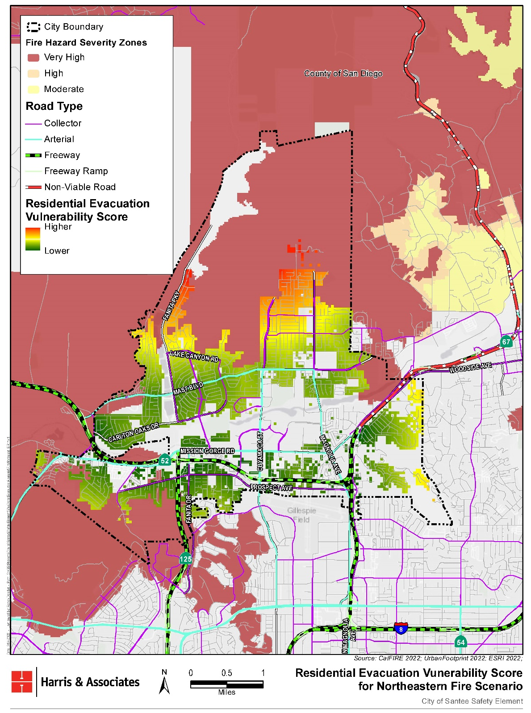
- Wildfire (Northwest)
                - This scenario assumes a mandatory residential evacuation due to a wildfire northwest of the city. Outbound roads leading north/northwest, including SR-52 West, are assumed to be not viable. The south- and east-bound freeways are the most viable evacuation routes in Santee in this scenario. Evacuation scores are re-calculated from the baseline scenario to account for the increased distance to the next closest, viable outbound road. Figure 3, Northwest Wildfire Residential Evacuation Vulnerability Score, highlights residential parcels with evacuation route vulnerability scores that increased as a result of the SR-52 West evacuation route being closed. SR-67 South, SR-52 East, SR-125 South, and I-8 East are the outbound roads most likely to be used in this scenario. Residents are able to travel along the following arterial roadways in Santee in order to access the viable south- and east-bound freeways: Mast Boulevard, Mission Gorge Road, Cuyamaca Street, and Magnolia Avenue. The viable south- and east-bound freeways under this scenario increase overall evacuation capacity in Santee. However, the city’s internal roadways (e.g., arterial roads) are subject to congestion as residents attempt to access the freeways. Emergency responders should consider activating evacuation traffic management along arterial roads to allow for easier access to the freeways, although this requires extensive coordination and should be reserved for extreme wildfire threats.

Figure 3. Northwest Wildfire Residential Evacuation Vulnerability Score
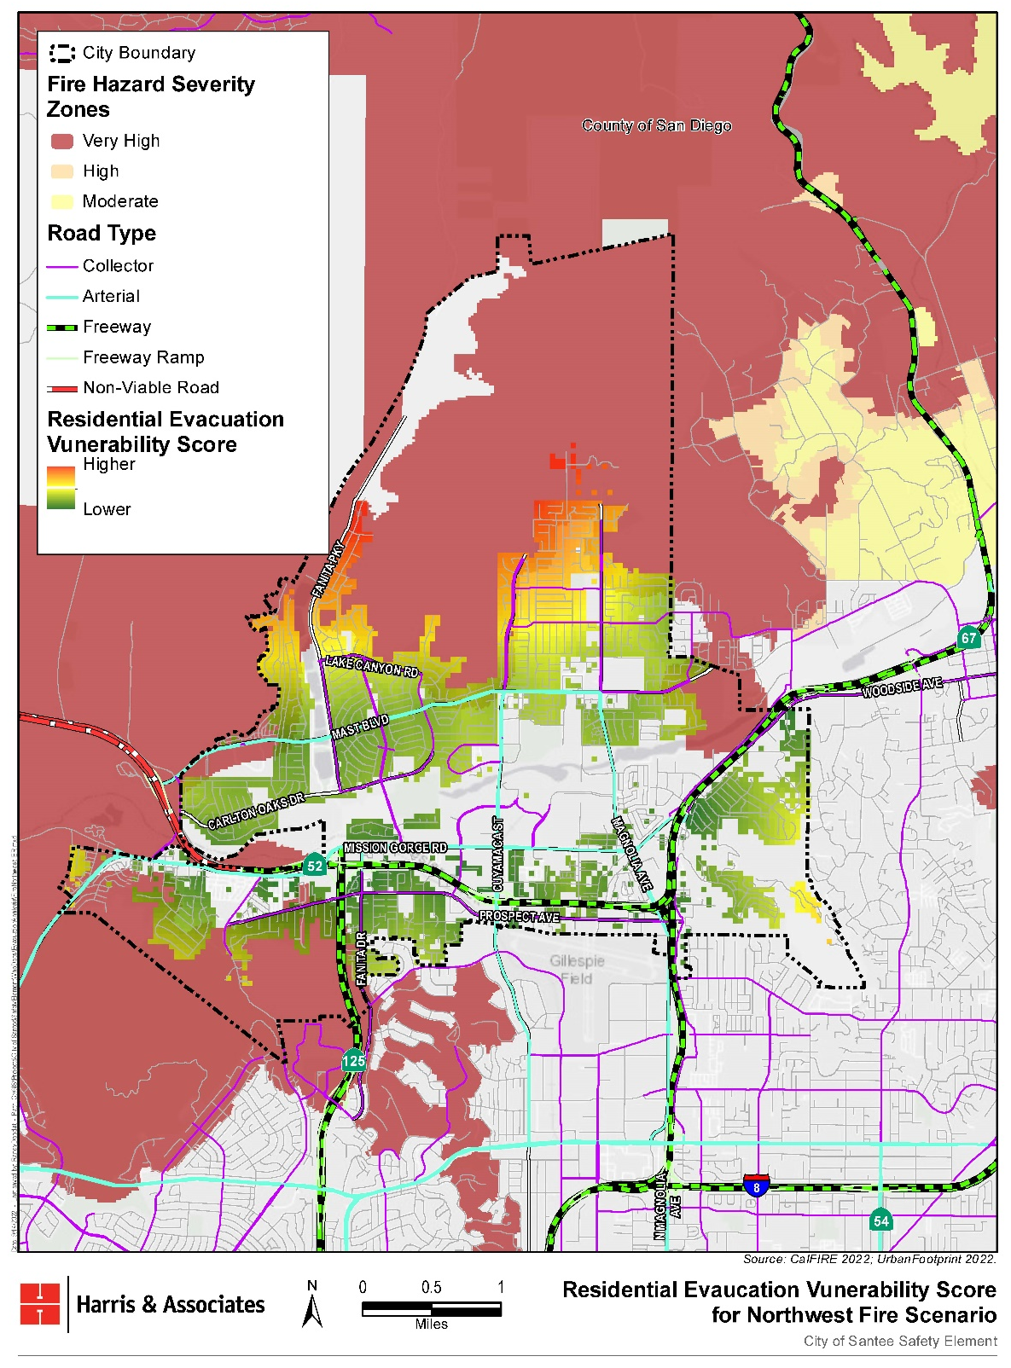
- Wildfire (Southwest)
                - This scenario assumes a mandatory residential evacuation due to a wildfire southwest of the city. Outbound roads leading south/southwest, including SR-52 West and SR-125 South, are assumed to be not viable. The north- and east-bound freeways are the most viable evacuation routes in Santee in this scenario. Evacuation scores are re-calculated from the baseline scenario to account for the increased distance to the next closest, viable outbound road. Figure 4, Southwest Wildfire Residential Evacuation Vulnerability Score, highlights residential parcels with evacuation route vulnerability scores that increased as a result of the SR-52 West and SR-125 South evacuation routes being closed. SR-67 North, SR-52 East, and I-8 East are the outbound roads most likely to be used in this scenario. Residents are able to travel along the following arterial roadways in Santee to access the viable north- and east-bound freeways: Mast Boulevard, Mission Gorge Road, Cuyamaca Street, and Magnolia Avenue. The viable north- and east-bound freeways under this scenario increase overall evacuation capacity in Santee. However, the evacuation of residents without life-saving resources or residents with reduced mobility, such as those who do not have access to a vehicle of their own, may be more challenging.

Figure 4. Southwest Wildfire Residential Evacuation Vulnerability Score
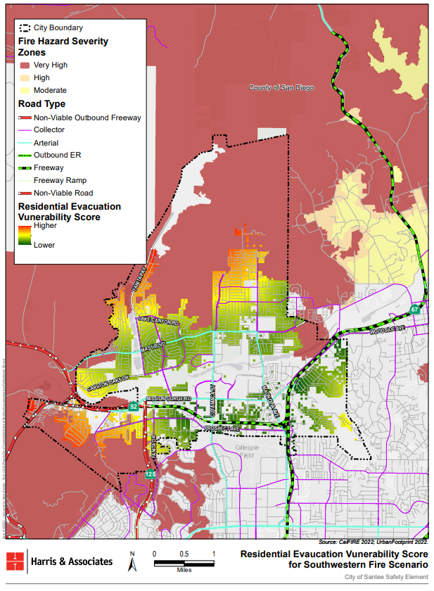
- Flood
                - The flood scenario assumes that all city residents will need to evacuate away from the flood zone. Because the flood zone is along the San Diego River, the roadways that cross the river (i.e., located within the floodway) are assumed to be non-viable routes. For example, the following roadways are non-viable in the event of a flood: West Hills Parkway, Carlton Hills Boulevard, Olive Lane, Cuyamaca Street, Magnolia Avenue, Riverford Road, and Channel Road (Figure 5, Flood Residential Evacuation Vulnerability Score). Evacuation scores are re-calculated from the baseline to account for the increased distance to the next closest, viable outbound road. Figure 5 highlights residential parcels with evacuation route vulnerability scores that increased as a result of the evacuation routes being closed. Given that all city residents are assumed to need to evacuate, residents in the north area of the city (furthest from the flood zone) are shown to have the highest vulnerability, although they are much less likely to be affected by a flood from the San Diego River. It should be noted that residents closest to the flood zone are at highest risk of being affected by a flood hazards, although these residents generally have more options for viable routes to evacuate the city.
                - The roadways (collector and arterial) that flow in directions away from the floodway are the outbound roads most likely to be utilized in this scenario (e.g., Mast Boulevard, Woodside Avenue, Mission Gorge Road, El Nopal, Fanita Drive, Cuyamaca Street, Magnolia Avenue). However, the floodway includes sections of several of the arterial roads in Santee (i.e., Cuyamaca Street and Magnolia Avenue, where they cross the floodplain). Roadways that connect residents to evacuation routes (e.g., arterial roads) may be inundated, limiting the ability of residents to evacuate. Also, first responders may have more difficulty accessing vulnerable populations that need to be evacuated once the water inundates the area. For example, people with mobility restrictions (e.g., wheelchairs) would not be able to cross a ladder and would be more difficult to access in a flooded area. The time it takes to evacuate is not as critical during a flooding event because a flood is a slower-onset hazard. However, people experiencing homelessness may be camped near the San Diego River and therefore, inundated with floodwaters before first responders can access the area.

Figure 5. Flood Residential Evacuation Vulnerability Score
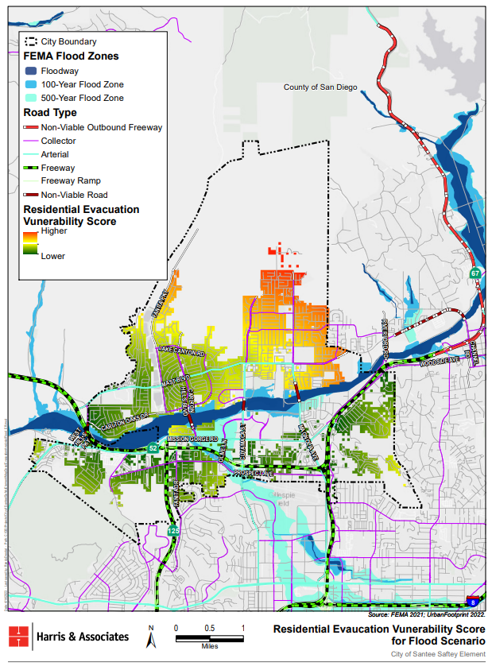
- Earthquake
                - Because earthquakes can cause damage to bridges, including freeway bridges, the following assumptions were made: (1) residential parcels that require a bridge crossing to access their most efficient evacuation route are more vulnerable compared to those that do not need to cross a bridge, and (2) outbound roads that require a bridge crossing may not be viable evacuation routes after an earthquake. To account for the first assumption, residential parcels that require a bridge crossing to access their otherwise most efficient evacuation route have a higher vulnerability weight assigned to the road segment with the bridge. The second assumption removes the majority of evacuation routes from the analysis. For example, the bridges along the following roads are assumed to not be accessible in the event of an earthquake: Carlton Hills Boulevard, Cuyamaca Street, and Magnolia Avenue. Vulnerable residential parcels with no viable evacuation routes are denoted in the shaded areas on Figure 6, Earthquake Residential Evacuation Vulnerability Score. Note: This figure represents a worst-case scenario where all bridges fail, meaning that no bridges can be traversed. The areas that do not have two points of egress have been included in this map to comply with SB 99. Compared to the baseline scenario, more residential parcels in this scenario are vulnerable due to their proximity to bridges, including those in the south central and northwest regions of the city. Residents in these areas would not be able to evacuate along the identified evacuation routes (i.e., freeways) because the arterials and collectors that connect to the freeways would not be accessible. Emergency responders should consider the possibility of bridge failure and should also encourage residents to pre-determine routes without bridge crossings that lead out of the city. Bridges should be inspected regularly and reinforced as needed to prevent the possibility of bridge failure during an evacuation event.

Figure 6. Earthquake Residential Evacuation Vulnerability Score
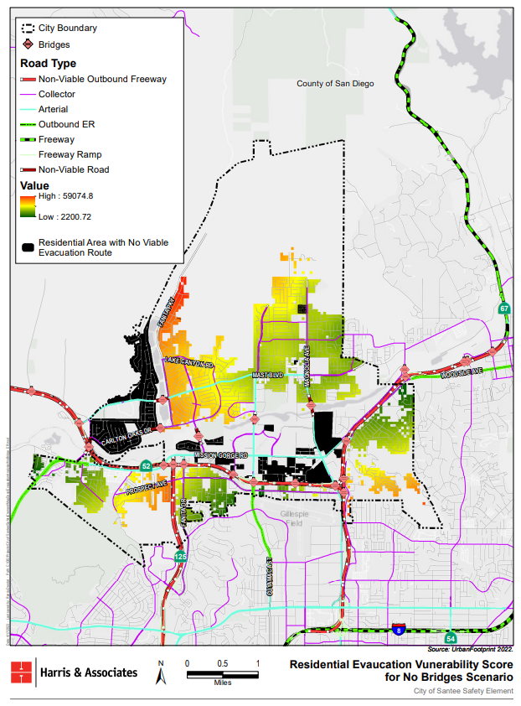

Evacuation Locations
                - In accordance with AB 1409, this Evacuation Route Analysis is required to identify evacuation locations for the city. Evacuation locations for city residents would be dependent on the type and location of hazardous event affecting the city and would be determined by first responders on site during emergency situations. For example, if a wildfire occurs north of the city, residents would be directed to evacuate to community centers and City buildings in the southern portion of the city, such as the City of Santee Emergency Operations Center (City of Santee Town Hall) or Alternate Emergency Operations Center (Santee Public Works Operations Center), or to areas south of the city, such as El Cajon. Evacuation locations would consist of places in Santee that residents are familiar with, such as parks, community centers, schools, libraries, City department buildings, or churches.

This page intentionally left blank.

Conclusion
                - The results of the Evacuation Route Analysis were as expected for each of the hazard scenarios. Residential parcels near outbound roads that were assumed to be non-viable under the hazard scenario saw an increase in their Evacuation Route Vulnerability Score compared to the baseline scenario, reflecting the greater distance residents would need to travel to access the next nearest outbound evacuation route:
- The baseline scenario suggests that residents closest to the northern region of the city center are most vulnerable given the distance they would need to travel to access an outbound road.
                - The Evacuation Route Analysis identified potential vulnerabilities in the city according to a GIS assessment that concludes whether all residential parcels have at least two points of egress. The analysis shows that residents closest to the southern and southwestern regions of the city are most vulnerable given the bridges they would need to traverse to access an outbound road:
- The residential parcels in the northern region of the city are the most vulnerable in the event of a wildfire from the northeast; however, these residents have more than two viable evacuation routes in this scenario.
- The residential parcels in the northern region of the city are the most vulnerable in the event of a wildfire from the northwest; however, these residents have more than two viable evacuation routes in this scenario.
- The residential parcels in the northern and western regions of the city are the most vulnerable in the event of a wildfire from the southwest; however, these residents have more than two viable evacuation routes in this scenario.
- The residential parcels in the northern region of the city are the most vulnerable in the event of a flood; however, these residents have more than two viable evacuation routes in this scenario.
- The residential parcels in the south central and northwest regions of the city do not have any viable evacuation routes in the event of an earthquake.
- The residential parcels in the southwestern region of the city only have one viable evacuation route in the event of an earthquake: Mission Gorge Road.

This page intentionally left blank.

Recommendations
                - The Evacuation Route Analysis suggests that emergency responders should be flexible in emergency scenarios since the location and extent of a hazard may disrupt established evacuation routes. Given the potential for congestion when certain evacuation routes are closed, emergency responders should consider contraflow lane reversal (i.e., the reversal of lanes in order to temporarily increase the capacity of congested roads) as one strategy to efficiently evacuate residents during all hazard scenarios. The majority of the outbound evacuation routes rely on a bridge, which are vulnerable to earthquakes and seismic hazards. Parcels that require access to bridges to evacuate should be prioritized as areas of concern in the event of an earthquake. In the event of a flood hazard, people experiencing homelessness may be camped near the San Diego River and therefore, inundated with floodwaters before first responders can access the area. First responders should focus first on evacuating areas closest to the flood zone. Additionally, first responders may have more difficulty accessing vulnerable populations that need to be evacuated. For example, people with mobility restrictions (e.g., wheelchairs) would not be able to cross a ladder and would be more difficult to access in a flooded or fire area. Special consideration should be made for accessing people with mobility restrictions (e.g., at hospitals, senior centers, etc.) during flood and fire hazards.
                - Social vulnerability indicators, including age, disability, and other mobility factors, should be further examined to determine other potential barriers to evacuation besides distance to and capacity of evacuation routes. The City, in coordination with the County of San Diego, continues to plan for the needs of individuals with disabilities and access and functional needs, including but not limited to providing accessible transportation during evacuations, providing public information in multiple languages, language translation services at evacuation and recovery centers, and training first responders on how to interact with persons with physical, cognitive, and emotional disabilities. The City’s EOP details the measures to ensure that preparedness and response strategies serve the needs of the entire population within the City, including vulnerable populations, such as people with physical, programmatic, and communications needs; children; and household pets and service animals.

This page intentionally left blank.

An act to add Section 65302.15 to the California Government Code.
An act to amend Section 65302 of the California Government Code.
An act to add Section 65302.15 to the California Government Code.
To account for the assumption that drivers would take the route that leads them out of the city most efficiently, if the distance from a parcel to a higher capacity road is less than the distance to a lower capacity road, the distance to the lower capacity road is assigned a value of 0.

