City of Santee Safety and Environmental Justice Element

July 2023

Table of Contents
Section 1. Executive Summary 1
1.1 Major Accomplishments 2
Section 2. Introduction 3
2.1 What Is a Safety Element? 3
2.2 What Is an Environmental Justice Element? 4
2.3 Why a Combined Safety and Environmental Justice Element? 4
2.4 Relationship to Other Elements 5
2.5 Related Plans 5
2.6 Grants and Future Funding Opportunities 7
2.7 Community Engagement 7
Section 3. Statutory Requirements 8
3.1 Safety Laws and Regulations 8
3.2 Environmental Justice Laws and Regulations 11
Section 4. Safety – Existing Conditions 12
4.1 Flood Hazards 13
4.2 Geologic/Seismic Hazards 19
4.3 Urban/Wildland Fire Hazards 35
4.4 Crime 44
4.5 Traffic Hazards 46
4.6 Light-Rail Transit Hazards 46
4.7 Airport Hazards 48
4.8 Disaster Preparedness 53
4.9 Hazardous Materials 55
4.10 Emergency Evacuation Route Analysis 61
Section 5. Climate Adaptation and Resilience 62
5.1 What is Climate Adaptation and Resilience? 62
5.2 What Is Climate Vulnerability? 63
5.3 Climate Adaptation Planning 63
Section 6. Environmental Justice – Existing Conditions 67
6.1 Community Engagement 68
6.2 Mapping Disadvantaged Communities 69
6.3 Key Findings of the Existing Conditions Assessment 74
Section 7. Goals, Objectives, and Policies 77
7.1 Safety Element 78
7.2 Environmental Justice Element 87
Section 8. Implementation 97
Figures
Figure 4.1. FEMA Flood Hazard Zone 15
Figure 4.2. Dam Inundation Map 18
Figure 4.3. Slope Gradient Greater than 15 Percent 27
Figure 4.4. Seismic and Geologic Hazards 31
Figure 4.5. Earthquake Shaking Potential based on the State Probabilistic Seismic Hazard Map 32
Figure 4.6. Fire Hazard Map 37
Figure 4.7. Wildland-Urban Interface Map 43
Figure 4.8. Airport Safety Zone Risk Level 49
Figure 6.1. City of Santee Disadvantaged Communities: CalEnviroScreen 71
Figure 6.2. City of Santee Disadvantaged Communities: Statewide Median Income 72
Figure 6.3. City of Santee Disadvantaged Communities: HCD State Income Limits 73
Tables
Table 2.1. Safety and Environmental Justice Stakeholder Meetings 7
Table 4.1. Federal Weather-Related Disaster Declarations for San Diego County (2017–2021) 14
Table 4.2. Major Dams Located Upstream of the City of Santee 17
Table 4.3. Historic Wildfires within the City of Santee (1950–2023) 36
Table 4.4. City of Santee EnviroStor Cleanup Sites 56
Table 6.1. CalEnviroScreen 4.0 Indicator and Component Scoring 69
Appendices
Appendix A. Vulnerability Assessment
Appendix B. Emergency Evacuation Route Analysis
Appendix C. Geotechnical/Seismic Hazard Study
Appendix D. Environmental Justice Existing Conditions Assessment
Appendix E. Environmental Justice Community Survey Results

Section 1. Executive Summary
The current Santee General Plan was adopted in 2003 by Resolution 63-2003 to guide new development in the City of Santee through the year 2020. This document serves as an update to the Santee General Plan’s Safety Element and incorporates a new Environmental Justice Element. The Safety and Environmental Justice Element is integral to guiding future development in Santee. Land use planning, implemented through the Santee Municipal Code and General Plan, is an important component of both hazard mitigation and environmental justice. Site selection that avoids proximity to natural hazards or hazardous facilities and building construction techniques designed for fire protection, life safety and temporary systems failure can reduce hazard risks in the built environment and promote quality of life.
The Safety and Environmental Justice Element provides an introduction (Section 2, Introduction) and a description of laws and regulations related to the Element (Section 3, Statutory Requirements). This Element provides a summary of existing conditions related to public safety and environmental justice and identifies a set of needs to be addressed by future actions (Section 4, Safety – Existing Conditions, and Section 6, Environmental Justice – Existing Conditions, respectively). Safety and environmental justice goals for the City are defined in Section 7, Goals, Objectives, and Policies along with objectives and policies intended to help achieve the goals, address community needs, and support the recommended improvements by providing the necessary legislative backing. The Safety and Environmental Justice Element builds on and coordinates with the City’s Vulnerability Assessment (Appendix A), which assesses climate change-related impacts on vulnerable populations and critical infrastructure (Section 5, Climate Adaptation and Resilience), and the Sustainable Santee Plan: The City’s Roadmap to Greenhouse Gas Reductions (Sustainable Santee Plan), which addresses impacts from climate change on all residents of the City. This Element also incorporates the Emergency Evacuation Route Analysis (Appendix B) and Environmental Justice Existing Conditions Assessment (Appendix D) prepared for the Element. Finally, this Element concludes with an implementation plan in Section 8, Implementation, which sets forth the intended process for monitoring, implementing, and maintaining the Safety and Environmental Justice Element.
The City is coordinating efforts to improve City staff’s ability to respond to and recover from major emergencies by managing critical information and limited resources and using technology. The effort to maintain and enhance overall preparedness to prevent, respond to, and recover from any hazard, whether natural or human-made, is ongoing. The City is also responsible for securing and managing funding opportunities (e.g., grants) for addressing hazards and environmental justice issues, which requires an updated Safety and Environmental Justice Element (see Section 2.6, Grants and Future Funding Opportunities). The Safety and Environmental Justice Element aims to ensure that residents have the opportunity to provide input on decisions that affect their quality of life through public participation, which is described in Section 2.7, Community Engagement.

1.1 Major Accomplishments
Since adoption of the City’s first General Plan in August 1984, the City has fulfilled many of the goals and implemented the policies in the Safety Element. Major accomplishments include the following:
- Since the 2000s, the City has implemented a traffic signal interconnect system on most of the arterials, which helps maintain traffic signal timing for enhancing traffic safety.
- Since the 2000s, the City has installed battery backups for traffic signals at key intersections to minimize interruption in operation and improve safety during power outages.
- Since the 2000s, the City has received Federal Highway Safety Improvement Program grants in the amount of $2.5 million for safety improvements, including raised medians, sign upgrades, speed feedback signs, and enhanced crosswalks.
- In conjunction with the State of California, the City completed significant bridge, drainage, and channel improvements on Forester Creek in 2005 while realigning the creek to accommodate improvements to State Route (SR-) 52. This multimillion-dollar award-winning project reduced the effects of flooding to surrounding properties while also improving the safety of surrounding streets and pedestrians.
- In 2008, the Board of the San Diego County Regional Airport Authority adopted the Marine Corps Air Station (MCAS) Miramar Airport Land Use Compatibility Plan (ALUCP).
- In 2010, the Board of the San Diego County Regional Airport Authority adopted the Gillespie Field ALUCP.
- In 2010, the Santee Emergency Operations Plan was adopted and prepared to ensure the most effective and economic allocation of resources for the maximum benefit and protection of the community in time of emergency.
- The City has consistently maintained one of the lowest traffic collision rates among all jurisdictions in San Diego County and among all cities of similar size in California.
- In 2015, the City completed the installation of a decorative pedestrian crossing that created an Americans with Disabilities Act (ADA)-compliant crossing from the existing Santee Trolley and San Diego Metropolitan Transit System (MTS) hub to the existing shopping center and future developments north of Town Center Parkway.
- In 2012, the City funded and began a corrugated metal pipe repair and replacement program to repair and or replace aging infrastructure with an ongoing program. This program has repaired and upgraded significant deficiencies identified in Santee’s master drainage facility inventory to reduce the impacts of flooding due to climate change.
- As part of the Highway Safety Improvement Program, the City completed the installation of raised medians on Mission Gorge Road in 2019 where accident data supported the approval of grant funding to complete the installation to improve traffic safety in the area.
- Planned upgrades to improve accessibility to City Hall were completed in 2019, providing accessible parking and paths of travel upgrades to meet current safety standards.
- As part of emergency operation improvements, Santee completed improvements to the Emergency Operations Center (EOC) in 2013 by adding a backup generator and completed significant communication and technology improvements to the EOC in 2019.
- With a partnership with the San Diego Association of Governments, Santee was able to secure redevelopment funding to complete significant safety improvements to Prospect Avenue between Cuyamaca Street and Magnolia Avenue. This award-winning multimillion-dollar project improved drainage and eliminated historical flooding by creating a new drainage system with water quality treatment features. The road was also widened to current standards with new sidewalks, accessible ramps, and bike lanes to improve pedestrian, bicycle, and traffic safety.
- The City continuously updates its Emergency Operations Plan and provides ongoing training to maintain compliance with the Statewide Emergency Management System (SEMS), increasing preparedness in the event of a disaster.
- The City has consistently maintained one of the lowest crime rates of any jurisdiction in San Diego County.

Section 2. Introduction
The Safety and Environmental Justice Element provides policy direction for new development and redevelopment in Santee related to safety hazards and environmental justice issues. In Santee, growth and development is expected to continue as the City approaches buildout. The City has developed a Safety and Environmental Justice Element to address public safety and equity concerns while allowing for continued planned growth. The following section provides an overview of the purpose of Safety Elements and Environmental Justice Elements, as well as the purpose of preparing a combined Element. The Introduction explains the relationship between this Element and other General Plan Elements and other planning documents. Finally, the Introduction explains the grants and funding opportunities available to address the issues discussed in this Element and the community engagement opportunities that helped to develop the Element.

2.1 What Is a Safety Element?
The purpose of a Safety Element is to include safety considerations in the planning and decision‐making process by establishing policies related to future development that will minimize unreasonable risk of personal injury, loss of life, property damage, and environmental damage associated with natural and human‐made hazards. The Safety Element provides policy direction that supports laws and regulations related to safety hazards and policies that support the overall goals established for the Santee General Plan. This Safety and Environmental Justice Element addresses the following safety considerations:
- Flood Hazards
- Geologic/Seismic Hazards
- Urban/Wildland Fire Hazards
- Crime
- Traffic Hazards
- Light-Rail Transit Hazards
- Airport Hazards
- Disaster Preparedness
- Hazardous Materials
- Climate Adaptation and Resilience

2.2 What Is an Environmental Justice Element?
The purpose of an Environmental Justice Element is to include strategies in the planning and decision-making process that will address the inequities resulting from environmental hazards and health impacts in the built environment. The policies that are included in an Environmental Justice Element are drafted to ensure that all residents have the right to live, work, and play in a safe and healthy community.
Government (Gov.) Code, Section 65040.12(e), defines “environmental justice” as the fair treatment of people of all races, incomes, and ethnicities with respect to the development, adoption, implementation, and enforcement of environmental laws, regulations, and policies. Per Gov. Code, Section 65040.12(e)(2), environmental justice includes but is not limited to the following:
- The availability of a healthy environment for all people
- The deterrence, reduction, and elimination of pollution burdens for populations and communities experiencing the adverse effects of that pollution so that the effects of the pollution are not disproportionately borne by those populations and communities
- The governmental entities engaging and providing technical assistance to populations and communities most impacted by pollution to promote their meaningful participation in all phases of the environmental and land use decision-making process
- The meaningful consideration of recommendations from populations and communities most impacted by pollution and other hazards into environmental and land use decisions

2.3 Why a Combined Safety and Environmental Justice Element?
New legislation requires the Safety Element to include climate change adaptation and requires local agencies to adopt environmental justice policies for disadvantaged communities (Section 3). Therefore, the City of Santee Department of Development Services is updating the Safety Element and integrating environmental justice. The Safety and Environmental Justice Element updates risks and policies for the protection of the community, provides goals and policies for environmental justice, and includes climate change adaptation and resiliency.
The City is adopting a Safety and Environmental Justice Element in compliance with state-mandated deadlines to concurrently create a safer, healthier community for its residents and improve its adaptability and resiliency to climate-related hazards. The fundamental objective of the Safety and Environmental Justice Element is to reduce the risk of hazard resulting from natural and human-caused events, including climate change-related hazards, particularly on disadvantaged communities (see Section 5). The Safety component of this Element directly relates to the Environmental Justice component because development plans must adequately account for public safety considerations and open space for public health, and ecological benefits often incorporate areas of increased hazard risk. For this reason, some of the figures prepared for the safety component of this Element also show disadvantaged communities for environmental justice. Additionally, combining the Elements also allowed the City to conduct robust community engagement to obtain input on the hazards and issues most affecting Santee residents (see Section 2.7).

2.4 Relationship to Other Elements
The Safety Element directly relates to topics also mandated in the Land Use Element, Conservation Element, Mobility Element, and Recreation and Trails Element (serving as the City’s Open Space Element as required by Governor’s Office of Planning and Research [OPR]). The Safety and Environmental Justice Element is most closely related to the Land Use Element since public safety and security information is used to guide the location of the City’s various land uses. For example, the safety policies identify the need to ensure that critical facilities and hazardous facilities are located and designed to be functional in the event of a disaster. The environmental justice policies also identify the need for access to recreational areas and healthy food. These needs inform the land use policies needed to guide future development in Santee.
The Safety and Environmental Justice Element is also related to the Housing Element. For example, the safety policies identify the need to regulate or prohibit housing within Flood or High Fire Hazard Severity Zones (FHSZs). The environmental justice policies promote access from low-income residential areas to public transit, public facilities and services, recreational opportunities, healthcare, and healthy food. The environmental justice policies also identify the need to mitigate unsafe, unhealthy housing conditions for vulnerable populations in Santee (see Section 7). This information is used to guide the location and design of future housing development in Santee.

2.5 Related Plans
The County of San Diego’s 2023 Multi-Jurisdictional Hazard Mitigation Plan (MJHMP) is a countywide plan that identifies risks and ways to minimize damage by natural and human-made disasters. The MJHMP was developed in accordance with the Disaster Mitigation Act of 2000 (DMA 2000) and followed the Federal Emergency Management Agency’s (FEMA’s) Local Hazard Mitigation Plan (LHMP) guidance. The LHMP incorporates a process where hazards are identified and profiled, people and facilities at risk are analyzed, and mitigation actions are developed to reduce or eliminate hazard risk. The implementation of these mitigation actions, which include both short-term and long-term strategies, involve planning, policy changes, programs, projects, and other activities. The MJHMP can be found at https://www.sandiegocounty.gov/oes/
emergency_management/oes_jl_mitplan.html.
The MJHMP is a comprehensive resource document that guides the County in reducing risks from disasters to people, property, economy, and environment and complies with federal and state hazard mitigation planning requirements to establish eligibility for funding under the FEMA grant programs (see Section 2.6).
The recently adopted MJHMP was revised to reflect changes to both the hazards threatening the County and its participating jurisdictions (including Santee), as well as the programs in place to minimize or eliminate those hazards. The City reviewed a set of jurisdictional-level hazard maps, including detailed critical facility information and localized potential hazard exposure/loss estimates, to identify the top hazards threatening its jurisdiction.
The City developed specific hazard mitigation goals, objectives, and related potential actions in its chapter of the County’s 2018 MJHMP after considering the risk assessment findings, localized hazard identification and loss/exposure estimates, and an analysis of the City’s current capabilities assessment. These goals represent a vision of long-term hazard reduction or enhancement of capabilities and align with the City’s goals and objectives for the Safety and Environmental Justice Element:
- Goal 1. Promote disaster-resistant future development.
- Goal 2. Increase public understanding, support, and demand for effective hazard mitigation.
- Goal 3. Build and support local capacity and commitment to continuously become less vulnerable to hazards.
- Goal 4. Improve coordination and communication with federal, state, local and tribal governments.
Reduce the possibility of damage and losses to existing assets, particularly people, critical facilities/infrastructure, and state-owned facilities, due to the following:
- Goal 5. Floods.
- Goal 6. Wildfires.
- Goal 7. Severe Weather.
- Goal 8. Infestations/Diseases.
- Goal 9. Geological Hazards.
- Goal 10. Extremely Hazardous Materials Releases.
- Goal 11. Other Human-Caused Hazards.
- Goal 12. Droughts.
The 2018 MJHMP is incorporated by reference into the Safety and Environmental Justice Element. If the 2023 update to the MJHMP is adopted prior to approval of the Safety and Environmental Justice Element, the City will incorporate that adopted plan by reference. However, much of the information included in this Element was informed by information gathered for preparation of the 2023 MJHMP update.

2.6 Grants and Future Funding Opportunities
The Safety and Environmental Justice Element is integrated with the County’s 2018 MJHMP, ensuring a coordinated approach to public safety and qualifying the City for additional funding opportunities (consistent with Gov. Code, Section 65302.6). Given that the City’s Safety and Environmental Justice Element includes goals, objectives, and policies that parallel those included in the County’s 2018 MJHMP, the Element’s adoption provides the opportunity for the City to secure grants and funding for hazard mitigation.
In addition, the Inflation Reduction Act of 2022 directs new federal spending toward reducing carbon emissions by providing significant federal funding for climate efforts. The Inflation Reduction Act directs nearly $400 billion in federal funding to clean energy with the goal of substantially lowering the nation’s carbon emissions by the end of this decade. The funds are delivered through a combination of tax incentives, grants, and loan guarantees, which are available to jurisdictions that adopt programs and policies aimed at increasing resiliency to climate-related events. The City’s incorporation of programs and policies aimed at climate resiliency into the Safety and Environmental Justice Element opens opportunities for grant funding to support these programs.

2.7 Community Engagement
The City recognizes the importance of community involvement in the planning and decision-making processes and is committed to creating transparent processes that are inclusive of all City residents. The City provided opportunities for the community to engage in the development of the Safety and Environmental Justice Element through stakeholder and City Council meetings, which are outlined in Table 2.1, Safety and Environmental Justice Stakeholder Meetings, and a Community Survey, which is discussed in Section 6 and in Appendix E, Environmental Justice Community Survey Results.
Table 2.1. Safety and Environmental Justice Stakeholder Meetings
Meeting | Date | Purpose
Safety Stakeholder Meetings
Stakeholder Meeting 1 | November 16, 2021 | - Confirm the hazard profiles (e.g., seismic/geologic hazards, flood hazards, fire hazards)  - Gather information on adaptive capacity (i.e., the City’s ability to respond to climate change impacts)
Stakeholder Meeting 2 | April 4, 2022 | - Present the results of the Vulnerability Assessment  - Solicit feedback on the safety-related goals, objectives, and policies of the Safety and Environmental Justice Element
Environmental Justice Stakeholder Meetings
Stakeholder Meeting 1 | June 16, 2021 | - Present the results of the Community Survey  - Solicit feedback on what should be included in the Environmental Justice Existing Conditions Assessment
Stakeholder Meeting 2 | December 1, 2021 | - Solicit feedback on the environmental justice-related goals, objectives, and policies of the Safety and Environmental Justice Element
The City also organized a City Council Workshop, held on October 12, 2022. The workshop provided a forum for City Council members and residents to provide their recommendations on the information that should be included in this Element, such as policies that would unlock funding for residents living in disadvantaged communities.

Section 3. Statutory Requirements

3.1 Safety Laws and Regulations
California planning and zoning laws identify a Safety Element for the protection of the community from unreasonable risks as one of the mandatory Elements in a General Plan. The City’s current Safety Element represents a consolidation of the previous Public Safety and Seismic Safety Elements.
The Safety Element must address public safety issues associated with the effects of seismic and geologic hazards, flooding, wildland and urban fires, and crime prevention. The Safety Element must identify evacuation routes, military installations, peak-load water supply requirements, and minimum road widths and clearances around structures because those items relate to identified fire and geologic hazards. This Element must also identify plans and programs for emergency response.

Disaster Mitigation Act of 2000 (42 USC Section 5121 et seq.)
The federal Disaster Mitigation Act of 2000 outlines how a Local Hazard Mitigation Plan (LHMP) can be developed individually or through an MJHMP. The successful completion of an LHMP makes the jurisdiction eligible to apply for federal Hazard Mitigation Grant Program post-disaster funding, pre-disaster mitigation funding, or flood management assistance funding (refer to Section 2.6).

Assembly Bill 2140 – Local Hazard Mitigation Plan
At the state level, Assembly Bill (AB) 2140 authorizes local governments to adopt their LHMPs with the Safety Elements of their General Plans (Gov. Code, Section 65302.6). Integration or incorporation by reference is encouraged through a post-disaster financial incentive that authorizes the state to use available California Disaster Assistance Act funds to cover local shares of the 25 percent non-federal portion of grant-funded post-disaster projects when approved by the legislature (Gov. Code, Section 8685.9). AB 2140 is one of the most important links between General Plans and hazard mitigation in California.
The Safety Element must identify hazards and hazard abatement provisions to guide local decisions related to zoning, subdivisions, and entitlement permits. Therefore, the Safety Element contains general hazard and risk reduction strategies complementary with those of the City’s chapter in the County’s 2018 MJHMP. The 2018 MJHMP is incorporated into the Safety Element by reference in accordance with AB 2140. Adopting the 2018 MJHMP with the Safety Element provides a vehicle for implementation of the 2018 MJHMP. This also provides for consistency across multiple documents such as the City’s Sustainable Santee Plan (i.e., Climate Action Plan), General Plan, and County 2018 MJHMP.

Gov. Code, Section 65302(g)(2) – Flood and Drought Hazards
Gov. Code, Section 65302(g)(2), requires the description of flood and drought hazards in the Safety Element. The impacts of climate change on the frequency, timing, and magnitude of flooding vary by geography throughout the state. The Safety Element must identify information regarding flood hazards; establish a set of comprehensive goals, policies, and objectives for the protection of the community from the unreasonable risks of flooding; and establish a set of feasible implementation measures designed to carry out the goals, policies, and objectives for flood protection. The Safety Element must also assess the availability of water resources for fighting fires.

Senate Bill 1241 and Gov. Code, Section 65302(g)(3) – Wildland and Urban Fire Hazards
SB 1241 and Gov. Code, Section 65302(g)(2), apply to communities with Very High FHSZs or unincorporated communities in State Responsibility Areas (SRAs). SB 1241 requires cities and counties to address fire risk in SRAs and identify areas in Very High FHSZs, as defined in Section 51177 of the California Public Resources Code, in the Safety Element of their General Plans upon the next revision of the Housing Element. Communities subject to SB 1241 need to ensure consistency between the Housing and Safety Elements to address fire risk. The Safety Element must also establish a set of goals, policies, and objectives based on the information identified for the protection of the community from the unreasonable risk of wildfire. SB 1241 also requires cities and counties to make certain findings regarding available fire protection and suppression services before approving a Tentative Map or Parcel Map.

Senate Bill 1035, Gov. Code, Section 65302, Senate Bill 379, and Gov. Code, Section 65302(g)(4) – Climate Change Adaptation and Resiliency
SB 1035 (Gov. Code, Section 65302) and SB 379 (Gov. Code, Section 65302[g][4]) require all cities to address climate change adaptation and resilience in their General Plan Safety Element. On October 8, 2015, Gov. Code, Section 65302, was amended by SB 379 to require the Safety Element to be reviewed and updated as necessary to include a climate change Vulnerability Assessment, measures to address vulnerabilities, and a comprehensive hazard mitigation and emergency response strategy. Policies in a Safety Element identify hazards and emergency response priorities and mitigation through avoidance of hazards by new projects and reduction of risk in developed areas.
The introduction of climate risk to the discussion of the Safety Element adds focus on a community’s longer-term preparation. Climate change will affect and potentially exacerbate the impacts of other hazards rather than being solely a distinct hazard with unique impacts. For example, extreme heat and heat waves are existing hazards that will be exacerbated by climate change.
SB 379 is triggered by the next update of a jurisdiction’s LHMP (updated every 5 years) or before January 1, 2022, whichever is first. SB 1035 built off SB 379, requiring that the Safety Element be updated every 8 years upon the next Housing Element update.

Gov. Code, Section 65302 (g)(6) – Flood Plain
Cities and counties that have Floodplain Management Ordinances that have been approved by FEMA, or have substantially equivalent provisions to the subdivision in their General Plans may use that information in the Safety Element to comply with this subdivision and shall summarize and incorporate by reference into the Safety Element the other General Plan provisions or the Floodplain Ordinance, specifically showing how each requirement of the subdivision has been met.

Assembly Bill 747, Senate Bill 99, Assembly Bill 1409, and Gov. Code, Section 65302(g)(1) – Evacuation Routes
AB 747, adopted in 2019, requires cities and counties to update the Safety Element of their General Plans to identify evacuation routes and assess the capacity, safety, and viability of those routes under a range of emergency scenarios. Gov. Code, Section 65302(g)(1), also specifies that Safety Elements must address evacuation routes.
SB 99, adopted in 2019, requires cities and counties to identify residential developments in hazard areas that do not have at least two emergency evacuation routes (i.e., neighborhoods or households in a hazard area that have limited accessibility).
AB 1409, adopted in 2021, requires cities and counties to identify evacuation locations.

Gov. Code, Section 65302(g)(8) – Consultation Requirements
Gov. Code, Section 65302(g)(8), requires the City to consult the California Geological Survey (CGS) of the California Department of Conservation and the California Office of Emergency Services (Cal OES) before preparing or revising the Safety and Environmental Justice Element to include information known by and available to the departments. Cal OES assists local governments with developing their Safety Elements and aligning General Plan strategies with those of the LHMPs and Emergency Operation Plans to ensure consistency. As required by Gov. Code, Section 65302.5(a), the City provided a draft of its Element to the CGS (at least 45 days) prior to adoption to determine if all known seismic and other geologic hazards are addressed and to Cal OES to ensure consistency between all Local and Regional Hazard Mitigation and Emergency Operation Plans.
Additionally, Gov. Code, Section 65302.5(b)(1), requires a draft Element of or draft amendment to the Safety Element of a county or a city’s General Plan to be submitted to the State Board of Forestry and Fire Protection if that county or city contains SRAs or Very High FHSZs. Because there are Very High FHSZs in Santee, the City provided a draft of the Safety Element to the State Board of Forestry and Fire Protection for review (at least 90 days) before adoption in accordance with Gov. Code, Section 65302.5(b). The State Board was provided the opportunity to recommend changes regarding land uses, policies, or strategies for reducing fire risk.

3.2 Environmental Justice Laws and Regulations

Senate Bill 1000 – Disadvantaged Communities
In an effort to address the inequitable distribution of pollution and associated health effects in low-income communities and communities of color, the California Legislature passed and Governor Brown signed SB 1000 in 2016. This law requires local governments to identify environmental justice communities (referred to as “disadvantaged communities”) in their jurisdictions and incorporate environmental justice policies into their General Plans upon adoption of two or more Elements concurrently on or after January 1, 2018.
SB 1000 defines “disadvantaged communities” as those disproportionally burdened by multiple sources of pollution and with population characteristics that make them more sensitive to pollution. Per this definition, disadvantaged communities are more likely to experience a lower quality of life and experience poor health outcomes compared to more affluent areas. Disadvantaged communities are often subject to disproportionate environmental burdens; therefore, SB 1000 requires that cities and counties develop objectives and policies in their General Plans to address the following:
- Improve air and water quality and promote access to public facilities, healthy food, safe and sanitary homes, and physical/recreational activity to reduce the unique or compounded health risks in disadvantaged communities
- Promote civic engagement in the public decision-making process
- Prioritize improvements and programs that address the needs of disadvantaged communities
See Section 6 for a discussion of disadvantaged communities in Santee.

Gov. Code, Section 65302(h)
Gov. Code, Section 65302(h)(2), requires the addition of an Environmental Justice Element that identifies disadvantaged communities in the General Plan (or related goals, policies, and objectives integrated in other Elements) upon the adoption or next revision of two or more Elements concurrently on or after January 1, 2018.
Disadvantaged communities are defined by Gov. Code, Section 65302(h)(4)(A), as “an area identified by the California Environmental Protection Agency (CalEPA) pursuant to Section 39711 of the Health and Safety Code OR an area that is low-income that is disproportionately affected by environmental pollution and other hazards that can lead to negative health effects, exposure, or environmental degradation.”
Gov. Code, Section 65302(h), requires the following:
- Identification of objectives and policies to reduce the unique or compounded health risks in disadvantaged communities by means that include the reduction of pollution exposure, and the promotion of public facilities, food access, safe and sanitary homes, and physical activity
- Identification of objectives and policies to promote civil engagement in the public decision-making process
- Identification of objectives and policies that prioritize improvements and programs that address the needs of disadvantaged communities

Assembly Bill 1553 – Office of Planning and Research Guidelines
Adopted in 2001, AB 1553 amends Gov. Code, Section 65040.2 and 65040.12, to require the OPR to provide guidance for local jurisdictions to incorporate environmental justice considerations.

Health and Safety Code, Section 39711 – Disadvantaged Communities
Health and Safety Code, Section 39711, requires that the CalEPA identify disadvantaged communities for investment opportunities, such as fostering job creation by promoting in-state greenhouse gas (GHG) emissions reduction projects carried out by California workers and businesses.

Governor’s Office of Planning and Research Environmental Justice Element Guidelines
The OPR adopts and periodically revises the California General Plan Guidelines as required by Gov. Code, Section 65040.2, for the preparation of General Plans for all cities and counties in California (OPR Guidelines). Chapter 4.8, Environmental Justice Element, of the OPR Guidelines serves as the “how to” resource for drafting the Element.
OPR Environmental Justice Element Guidelines recommend using the CalEnviroScreen, a computer mapping tool, to identify disadvantaged communities in a city or county. CalEnviroScreen uses several indicators to determine if a community is disadvantaged and disproportionately affected by pollution. In addition to using CalEnviroScreen, the OPR Guidelines recommend mapping low-income areas to identify disadvantaged communities. The OPR Environmental Justice Element Guidelines also recommend screening for areas that are below the state income limits established by the California Department of Housing and Community Development (HCD). The 2021 state income limits are on the department’s website (https://www.hcd.ca.gov/grants-funding/income-limits/state-and-federal-income-limits/docs/income-limits-2021.pdf). See Section 6 for a discussion of the disadvantaged communities and low-income areas mapped for the City’s environmental justice analysis.

Section 4. Safety – Existing Conditions
The Safety and Environmental Justice Element sets forth the City’s intention to develop goals, objectives, and policies to minimize pollution, flood, fire, and other hazards and their effects on all communities. The public safety considerations addressed in the Element include flooding, geotechnical and seismic hazards, fire hazards, crime prevention, traffic safety, light-rail transit safety, aircraft safety, disaster preparedness, and hazardous materials. Information on these topics is used in the planning process to guide the location, type, and design of future developments in Santee to avoid risks to public safety.

4.1 Flood Hazards
Flooding in Santee could result primarily from four conditions or a combination of them: (1) heavy, prolonged rain; (2) the collapse or cresting of a dam; (3) a degraded watershed or drainage system; (4) a release of water from upstream dams. One of the most serious watershed management problems is caused by wildland fires, which remove thick underbrush and chaparral, stripping the moisture-retaining ground cover from the soil and allowing water to run rapidly downslope. Runoff from bare slopes increases, resulting in flooding, mudslides, and soil erosion.

Rivers and Creeks
The City’s primary waterways include the San Diego River, Forester Creek, Sycamore Creek, and intermittent creeks paralleling Big Rock Road and Fanita Drive. FEMA mapped the San Diego River and Forester Creek and created updated maps as of May 16, 2012, as part of the National Flood Insurance Program.
Figure 4.1, FEMA Flood Hazard Zone, depicts the City’s 100-year and 500-year Flood Hazard Zones. The magnitude of flooding that is used as the standard for floodplain management in the United States is a flood with a probability of occurrence of 1 percent in any given year. This flood is also known as the 100-year flood or base flood. The most readily available source of information regarding the 100-year flood, as well as the 500-year flood (i.e., 0.2 percent probability of occurrence in any given year), is the system of Flood Insurance Rate Maps prepared by FEMA.
In Santee, a total of 1,020 acres of land is within the floodplain of the San Diego River, including approximately 596 acres within the floodway and 424 acres within the floodplain fringe. The Forester Creek floodplain is estimated to cover an area of approximately 100 acres. The low-flow channel of Sycamore Creek is estimated to cover roughly 42 acres. The low-flow channel of the creek parallel to Big Rock Road covers roughly 5 acres. The portion of the low-flow channel of the creek parallel to Fanita Drive in Santee covers roughly 2.8 acres. Various existing and designated land uses (i.e., residential, commercial, and industrial) are within the floodplain areas of these waterways. Depending on their siting and design considerations, many of these uses would be susceptible to flood damage in the event of a 100-year flood.
The U.S. Geological Survey maintains the San Diego River Gauge at Fashion Valley in Mission Valley, downstream from Santee. It provides historical data on peak streamflow for each year. The National Weather Service defines flood stage at this location as 11.3 feet with an estimated discharge of 2,700 cubic feet per second.
In 2019, the City completed a comprehensive update of the City’s Municipal Code that included updates to the Flood Damage Prevention Ordinance (Santee Municipal Code, Chapter 11.36) to minimize the public and private losses due to flooding. The intent of the ordinance is to reduce the risks to residents and public and private improvements from flooding. The ordinance precludes development in flood-prone floodway areas and requires all new development to be designed to be above the height of the 100-year flood. The ordinance establishes a basis for the areas deemed special flood hazard, incorporating an engineering analysis entitled San Diego River Flood Study (1992) and the City’s Flood Insurance Study from 1983. The studies identify the amended 100-year peak discharge for six locations and are on file at the City Engineer’s office. The City’s Flood Damage Prevention Ordinance is incorporated into this Safety and Environmental Justice Element by reference.
Historical flood records indicate extensive flood damage to surrounding areas in Santee associated with flood events along the San Diego River and, to a lesser extent, Forester Creek. Portions of both waterways have been improved to reduce flooding. The City completed the required environmental process, channel design, right-of-way acquisition, and future construction of improvements to Forester Creek between Mission Gorge Road and Prospect Avenue for approximately 1.2 miles. The improvements to the creek increased the flood-carrying capacity of the creek to sufficiently contain the 100-year flood flow. This project reduced the floodplain of Forester Creek from 100 acres under existing conditions to approximately 25 to 30 acres in size.
Santee and the greater San Diego County have experienced two declared disasters for severe weather, including fires, floods, and mudflows, in the last 5 years (Table 4.1, Federal Weather-Related Disaster Declarations for San Diego County (2017–2021)). Federal disaster declarations provide individual and public assistance to impacted counties. Historical flooding in the County notably occurred in 1862, 1916, 1927, and 1937. In 1945, the federal government authorized a report on flood control downstream of the San Diego River, and associated work on the flood control channel began in the 1950s (San Diego History Center, The Journal of San Diego History, Spring 1971, Volume 17, Number 2).
Table 4.1. Federal Weather-Related Disaster Declarations for San Diego County (2017–2021)
Disaster Declaration No. | Federal Declaration Date | Disaster Name | Incident Period
DR-4353 (Individual Assistance) | Jan. 2, 2018 | California Wildfires, Flooding, Mudflows, and Debris Flows | Dec. 4, 2017–Jan. 31, 2018
DR-4305 | Mar. 16, 2017 | California Severe Winter Storms, Flooding, and Mudslides | Jan. 18, 2017–Jan. 23, 2017

Figure 4.1. FEMA Flood Hazard Zone
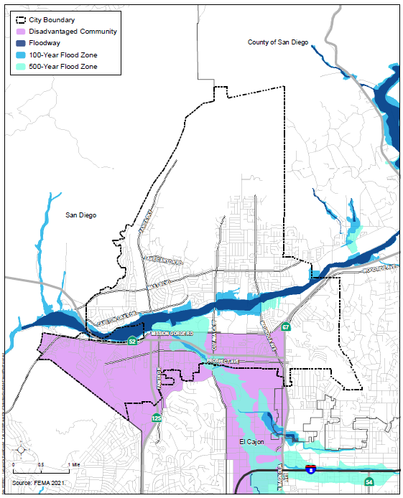

Water Reservoirs
The Padre Dam Municipal Water District (Padre Dam) provides potable water, recycled water, wastewater management services, and recreational facilities to an 80-square-mile service area, including the entire City. Padre Dam’s service area population is estimated at 95,000, with an average daily water demand of 8.1 million gallons. Padre Dam currently has over 330 miles of potable water mains, 140 miles of wastewater mains, and 25 miles of recycled water mains.
Padre Dam maintains seven water reservoirs in Santee. The Charles C. Price Reservoir, just east of SR-67 and Via Madonna, is the largest with a capacity of 15.5 million gallons. The Northcote Reservoir, at the end of Northcote Road, is the smallest reservoir with a capacity of 0.71 million gallons. The Fanita Terrace Reservoir, an aboveground tank just south of the southern terminus of Organdy Lane, is the only water tank in the City that holds recycled water. Padre Dam is planning two potable water reservoirs near the southern end of Mesa Road for future development in these areas. It is anticipated that a 3-million-gallon facility would be required for the Mesa Reservoir and a 4-million-gallon facility would be required for the Fanita Ranch Reservoir. Each of the reservoirs is on the top of a hill to minimize the need for pumps. In the event of the failure and release of water from any of the reservoirs, the land adjacent to and below the ruptured reservoir could be flooded. The reservoirs range from 150 to more than 1,500 feet from the nearest homes.
In addition, the City could be subject to flood damage from failure of other water storage tanks nearby. One water storage tank is near Grossmont College, just south of the City limits. This reservoir holds 3.6 million gallons of water for Padre Dam and the Helix Water District. Additionally, the nearby Fletcher Hills Reservoir on Weld Avenue, in El Cajon, has a capacity of 1.5 million gallons and could affect Santee with flooding caused by failure.

Dam Failure
The central portion of the City is in the San Diego River Valley downstream of three major dams in San Diego County: San Vicente Dam, El Capitan Dam, and Chet Harritt Dam (Lake Jennings Reservoir) (Table 4.2, Major Dams Located Upstream of the City of Santee). The Earthquake Engineering Research Institute San Diego Chapter’s publication San Diego Earthquake Planning Scenario, Magnitude 6.9 on the Rose Canyon Fault Zone, expects these dams to remain in service due to recent seismic retrofit and their distance from any major active faults. These dams are inspected annually by the California Department of Water Resources Division of Safety of Dams (DSOD) to ensure they are safe, performing as intended, and are not developing issues. Given their location upstream of communities and residential areas, the DSOD and the County classify these dams as possessing an “extremely high” downstream hazard and “high” hazard rating, respectively.
Table 4.2. Major Dams Located Upstream of the City of Santee
Dam Name | Distance from City | Year Constructed | Capacity (acre-feet) | Notes
San Vicente Dam | 3.5 miles | 1943 | 245,000 | Concrete gravity structure originally constructed with a capacity of 90,200 acre-feet and then raised an additional 117 vertical feet in 2016 using roller-compacted concrete to expand its capacity.
El Capitan Dam | 9 miles | 1934 | 112,800 | Hydraulically filled earth structure.
Chet Harritt Dam (Lake Jennings Reservoir) | 3 miles | 1962 | 9,790 | Earth-filled dam constructed by procedures to resist seismic damage.
Information regarding dam failure risk can be found in the County’s 2018 MJHMP. Maps prepared by the DSOD showing areas of inundation in the event of dam failure can be found online here: https://fmds.water.ca.gov/maps/damim/. Inundation zones for each of the three dams located upstream of Santee are shown on Figure 4.2, Dam Inundation Map. This figure was generated using a DSOD GIS layer showing the extent of dam inundation areas for extremely high, high, and significant hazard dams in Santee. Information concerning the safety of these dams is reviewed annually by the DSOD. To plan for long-term fire risks to certain demographics, physical assets, structures, and critical infrastructure in the community, the 2023 Community Risk Assessment Long-Range Master Plan prepared by the Santee Fire Department also shows dam inundation risk from potential failure of the San Vicente Dam. The 2023 Community Risk Assessment Long-Range Master Plan is incorporated into this Safety and Environmental Justice Element by reference. In addition, Annex Q of the County’s Office of Emergency Services’ 2022 Emergency Operations Plan outlines the evacuation procedures in the event of a dam failure.

Figure 4.2. Dam Inundation Map
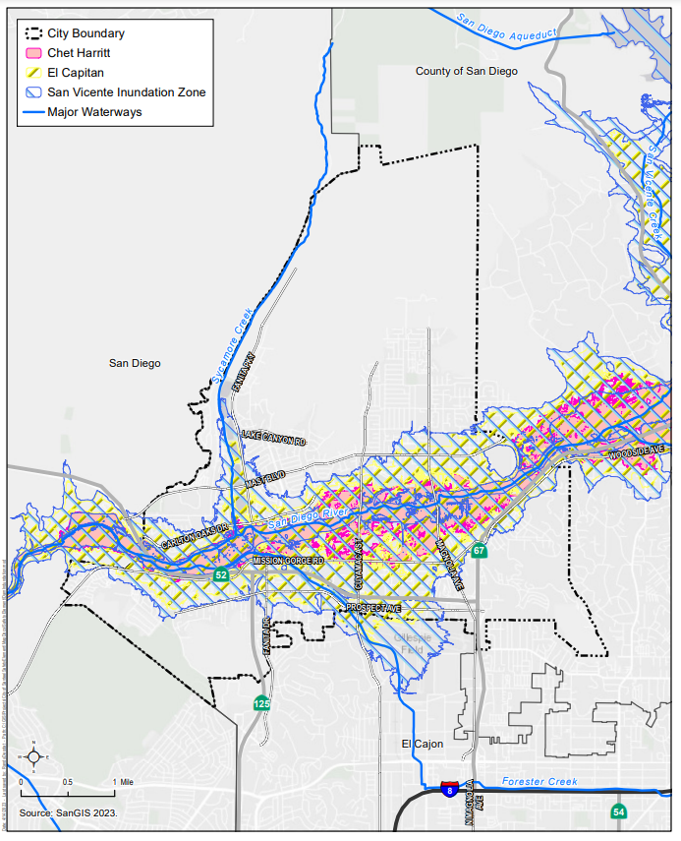

Summary of Needs to Address Flooding
The major waterways in Santee will continue to cause flooding and associated erosion and other effects, especially with worsening extreme precipitation events exacerbated by climate change (see Section 5.3, Climate Adaptation Planning, for further discussion of the impacts of climate change on extreme precipitation and floods). Some homes could be damaged by water runoff from a rupture of any of the seven water reservoirs in Santee and or three upstream dams. It is important that future planning takes into consideration the general direction of flow in the event of a rupture in any of the reservoirs and avoids the placement of buildings in those areas. The City should encourage Padre Dam to complete inundation studies for existing and planned reservoirs in Santee.
Since the impervious surfaces associated with urban development create more runoff than vegetated lands, it is important that future planning take into consideration the impacts of potential increased runoff. Any project proposed within a floodplain area is subject to site plan review. In addition, planning for flood control improvements for the San Diego River and other City waterways must be comprehensive and balanced with other goals, such as providing recreation and protecting valuable habitat and species. The City coordinates regularly with FEMA through the Flood Insurance Rate Map Program, which delineates special flood hazard areas and the risk premium zones in a community. These are used to determine flood insurance rates and premiums, serving as tools to understand and protect against flood risk.
The City’s Department of Development Services maintains flood zone and FEMA map information. The County’s Fire Department, Flood Control District, and Department of Public Works are also responsible for flood protection in the County.

4.2 Geologic/Seismic Hazards
Santee lies near the junction of the coastal plain and the Peninsular Ranges geologic provinces of southwestern California. The eastern portion of the coastal plain is in the west, south, and north portions of Santee and consist of a series of Tertiary-age formational sedimentary rocks that are deeply incised by canyons and tributaries, including the San Diego River and Sycamore Creek. The San Diego River generally bisects Santee from east to west. The drainage area of the San Diego River upstream of West Hills Parkway on the western edge of Santee is approximately 368 square miles. Downstream, the San Diego River flows through Mission Trails and Mission Valley in the City of San Diego and drains into the Pacific Ocean. Much of Santee is within the gentle gradient of the San Diego River Valley. Sycamore Creek is along the western boundary of the City and flows southward into Santee Lakes and the San Diego River. In the southeastern and eastern portions of Santee, the sedimentary rocks and alluvial valley province end abruptly in the foothills of the Peninsular Ranges exposing granitic rock. The formational units are covered by surficial soils.

Geologic Stratigraphy
According to the Geotechnical/Seismic Hazard Study (Appendix C), the geologic stratigraphy of Santee consists of several surficial soil types and formational units. The surficial soil deposits consist of human-made soil (undocumented fill and previously placed fill) and naturally occurring soil (topsoil, colluvium, young alluvium/debris flows, landslide deposits, and old alluvial floodplain deposits). In general, naturally occurring surficial soils are found in drainage areas such as the San Diego River Valley and Sycamore Creek and generally overlying undisturbed formational materials.
Formational materials in Santee include sedimentary rock units of the Eocene-age Pomerado Conglomerate, Stadium Conglomerate and Friars Formation, and the hard rock units of the Mesozoic-age (Cretaceous and Jurassic) granitic and volcanic rocks associated with the Peninsular Ranges. The claystone portions of the Friars Formation are typically weak, fractured, and prone to landsliding.
Each of the surficial soil types and formational units in Santee is described herein in order of increasing age.

Undocumented Fill
In many areas of Santee, fill soils presumed to be undocumented exist and have been mapped in certain site-specific geotechnical reports. An example of an undocumented fill deposit is in an undeveloped area north of the northern terminus of Strathmore Drive in the northwestern corner of Santee. These types of deposits typically contain a wide range of soil types, including silt, sand, clay, and rock derived from the local geologic formations.
Undocumented fills typically are poorly compacted and often are underlain by potentially compressible topsoil or alluvium. Consequently, where these deposits are in areas of proposed development, they require special evaluation and recommendations. Normally, the undocumented fill materials are removed, moisturized as necessary, and placed as compacted fill.

Previously Placed Fill
Most of the central and southern portions of Santee have been developed. Some of the largest master developments include Black Horse Estates, Cajon Park, Carlton Country Club, Carlton Hills, Carlton Oaks, Castlerock, Dakota Ranch, Deer Park, Fanita Corona, Fanita Rancho, Fanita Terrace, Los Ranchos, Mission Creek, Mission Trials Vista, Mountain Meadow, Rancho Fanita, Riderwood – The Heights, Santana North, Shadow Hill Terrace, Silver Country Estates, Sycamore Hills, Santee Trolley Square Town Center, Vista Monte, Sky Ranch, Woodglen, and Woodside Industrial Park. Developments will typically include infrastructure improvements associated with roadways, parks, underground utilities, and pump stations that are provided for Santee. Other previously placed fill within City limits is associated with California Department of Transportation (Caltrans) controlled roadways not under the purview of the City.
Previously placed fill generally consists of materials that were properly placed and compacted using the testing and observation services of a geotechnical engineering consultant. The fill materials placed during development of these projects generally consist of silty and clayey sand and sandy clay with gravel and cobble mixtures. Prior to grading or constructing additional improvements in previously graded areas, specific geotechnical evaluations and update reports should be performed to address the potential impacts to existing or proposed improvements underlain by these deposits. The existing fill materials should be tested to evaluate its suitability to support proposed structures and improvements.

Topsoil
In undeveloped areas, naturally developed topsoil blankets most of the formational units and range in thickness from approximately 1 to 3 feet. The topsoil is generally characterized as brown to dark brown, silty/clayey, fine to medium sands and sandy clays. Topsoil that overlies the Stadium Conglomerate at higher elevations are generally thinner than overlying the Friars Formation and have a greater percentage of gravel and cobble clasts. Topsoil is typically considered compressible in its natural state and ordinarily requires remedial grading in areas planned to receive structural fill and/or settlement-sensitive structures. The clayey topsoil characteristically overlying sedimentary units has a “medium” to “high” expansion potential (expansion index of 51 to 130) and, when present, commonly require remedial grading to help mitigate their impacts prior to construction operations.

Colluvium
Colluvial soils are relatively deep natural deposits of soil that have accumulated on the face and base of natural slopes through the weathering and erosion of exposed materials at higher elevations that accumulate from soil-creep processes. Colluvial deposits are typically thicker in the gentle, low-lying, bottom of slope areas near alluvial drainages. Figure 1 of the Geotechnical/Seismic Hazard Study (Appendix C) indicates areas of undifferentiated Quaternary-age young alluvium and colluvium designated as map symbol Qu in the southern portion of Santee. Other areas of unmapped colluvium are present near the base of natural sloping ground across Santee. Typically, these materials are deepest in areas underlain by the Friars Formation; however, they are also present, but typically thinner, in areas underlain by Stadium Conglomerate and granitic rock. Colluvial materials can also be present on landslide deposits, particularly in graben zones near the head or upper portions of the slides. The thickness of the colluvium is typically about 5 to 10 feet and locally can be thicker. These deposits generally possess “medium” to “high” expansion potential (expansion index of 51 to 130), are poorly consolidated, and often require remedial grading in areas of planned development.

Alluvium and Debris Flows
Holocene- to late Pleistocene-age young alluvium is typically present in drainage areas, such as the San Diego River channel, Sycamore Creek, and smaller natural tributary drainages. The San Diego River alluvium is relatively deep (locally up to 80 feet), and near the surface, it typically consists of clean, medium-grained sands that have historically been mined as a source of concrete sand. Alluvial soils cover a relatively large portion of Santee, while debris flows have limited exposure. Alluvial soils generally consist of relatively loose/soft, silty/clayey sands and sandy clays with little gravel and cobble and will be saturated below groundwater. However, larger size and higher cobbles and boulder contents are typical within the San Diego River drainage due to higher flows.
Debris flows are present on upper portions of steeper gradient drainages within Stadium Conglomerate and Friars Formation created by weathering, slope creep, and saturation of surface materials. Most of the historical debris flows occurred at higher elevations and are generally north of the San Diego River. Most of these debris flow deposits consists of silty/clayey, sandy gravel and cobble deposits.
The alluvial and debris flow deposits are often poorly consolidated, compressible, and typically require remedial grading or special design considerations. Where development is planned in main drainage channels, such as the San Diego River floodplain, soil improvement techniques and structural reinforcement to remediate the effects of potential liquefaction may be necessary. Within secondary drainage areas, the compressible young alluvium is usually removed and replaced as properly compacted fill. Where groundwater exists within the upper approximately 50 feet, the young alluvium is typically considered to possess a potential for liquefaction and related geologic hazards.

Landslide Deposits
Several confirmed landslides and suspected ancient landslides have been identified during this study and previous geotechnical investigations. The presence of inferred landslide deposits is based on topographic evaluation during field reconnaissance, interpretation of aerial photographs and topographic maps, and maps published by the CGS.
The landslides encountered in Santee occur on gentle to moderate sloping ground in the Friars Formation and generally below an elevation of approximately 600 feet above mean sea level (AMSL). On the southern portion of the City, landslides generally occur between elevations of 400 and 600 feet AMSL. Characteristic landslide morphology consists of a steep back-scarp; bulging, hummocky, distorted topography; and deflected drainages. Some landslide areas express a more subdued topography suggestive of incipient or older eroded landslide deposits.
The landslide deposits observed are characterized as deep-seated, relatively intact, block type movements or as shallow to deep-seated bedrock slides with a varying degree of slip plane development and slide mass disturbance. The thickness of landslide material is estimated to be approximately 45 to 50 feet; however, it can thicken toward the head scarp as much as 100 feet. The landslide debris varies from dense sandstone/claystone blocks to a variable mixture of intensely sheared and pulverized claystone breccia suspended in a stiff clay matrix. Highly disturbed cobble clay mixtures resembling debris flow materials have also been encountered and are known to exist within graben zones.
Most of the landslides appear to have occurred along inherently weak, previously sheared, low-angle, pre-existing bedding plane shears as part of a weak, thinly laminated claystone in the Friars Formation. This is suggested by the relatively uniform, near-horizontal slip surfaces typically observed along the base of the landslides, and because of the general correlation in exploratory borings at which bedding plane shears are present in the Friars Formation outside the limits of the landslides at the same elevation as the landslide basal shear zone. Further discussion of this correlation and an apparent regional zone of bedding plane shears in the Friars Formation are included in the Geologic Structure discussion below.
In general, new developments should be planned to avoid or mitigate ancient landslide deposits, where possible. Where landslide materials are present below proposed fill embankments or exposed in cut slopes or building pad areas, remedial grading is often required to properly buttress the existing landslides or proposed slopes. Some landslides will require complete removal, while other landslides will only require partial removal of the loose and compressible portions to be replaced with new compacted fills. Localized areas of deeper removals may be required in looser graben zones and/or more pulverized portions of the landslides. Still, other landslides will require only minor processing of the surficial materials prior to placing fill embankments. Slope stability analyses of landslide materials are typically included in geotechnical reports.
Cut slopes exposing landslide materials or basal slip planes or areas where basal slip surfaces occur near finish grade typically require stabilization by construction of stability fills, drained earthen buttresses, shear keys, shear pins, or other means. Slope stability is addressed in the Ancient Landslides/Slope Stability discussion below.

Terrace Deposits/Older Alluvium
Older alluvial floodplain deposits of Pleistocene-age exist within former floodplain areas and are exposed at the surface between the younger alluvial deposits and formational sedimentary or rock units. The older alluvium was deposited during previous geologic stream flow events with the soils typically consolidated by burial, cemented, and subsequently eroded to current valley floor elevations. These deposits are generally in the flatter portions of valleys and consist of slightly cemented, clayey sands with little gravel and cobble. These materials are generally dense to very dense and do not possess a potential for liquefaction or significant settlement.

Stadium Conglomerate and Pomerado Conglomerate
The Stadium Conglomerate (middle to late Eocene age) occurs throughout the southwestern, central, and northern parts of Santee. The Pomerado Conglomerate has a limited extent and is in the northern portion of Santee. These geologic units have similar characteristics and are difficult to distinguish between each other unless separated by the Mission Valley Formation. However, the Mission Valley Formation is not present within the City limits, and therefore, the Pomerado Conglomerate conformably overlies the Stadium Conglomerate above an elevation of roughly 1,000 feet AMSL. The Stadium Conglomerate conformably overlies the Friars Formation at elevations ranging from approximately 610 to 1,000 feet AMSL. The inferred thickness of this deposit in Santee varies from approximately 40 feet when eroded to an estimated 375 feet on less eroded ridgelines. Geomorphically, the Stadium Conglomerate forms characteristic resistant, dissected ridges in the upper elevations of Santee. Localized, steeply eroded scars occur in this formation where debris flows originated at the head of tributary canyons.
The Stadium Conglomerate generally consists of dense to very dense, slightly cemented, sandy to clayey, gravel and cobble conglomerate with interbedded silty sandstone. The cobble content of the Stadium Conglomerate can sometimes be up to about 60 percent with diameters up to 24 inches. The Stadium Conglomerate is regionally part of the upper Eocene Poway Geologic Group that also includes the Mission Valley Formation and Pomerado Conglomerate.
Moderate to very heavy excavation effort should be anticipated during grading and trenching within the Stadium Conglomerate due to its cementation and high cobble size and percentage and randomly occurring highly cemented zones. Cut or fill slopes composed of the Stadium Conglomerate generally possess adequate slope stability characteristics.

Friars Formation
The Friars Formation was deposited on an irregular erosion surface formed on the crystalline basement rock of the Southern California Batholith. The Friars Formation may be observed overlying granitic rocks in the southern and north-central parts of Santee. This unit generally occupies the gentler, lower portions of valley slopes below elevations ranging from 600 to 700 feet AMSL depending on the locality. The age of the Friars Formation is middle to late Eocene-age based on vertebrate fossil evidence. In the southwestern portion of Santee, this unit is exposed between Cuyamaca Street and the eastern base of Cowles Mountain and throughout the northern part of Santee except the most northeasterly section.
Numerous large, ancient landslides occur in the Friars Formation, discussed in detail in the Ancient Landslides/Slope Stability discussion below. The Friars Formation consists of relatively flat-lying lagoonal and alluvial claystone, sandstone, and conglomerate units. Specifically, weak, waxy claystone, and thinly laminated siltstone/claystone, sandstone, and conglomerate occur in the northern undeveloped portion of the City below an approximate elevation of 610 to 630 feet AMSL. Translational landslides are common throughout areas underlain by this geologic formation. Most of these landslides are remnants of wetter climatic conditions that occurred in late Pleistocene to early Holocene time (last 30,000 years).
As seen in the undeveloped area of Santee, the Friars Formation comprises a relatively continuous sequence of characteristic subunits consisting of thinly bedded sandstone/siltstone, underlain by relatively thin lenses of gravel/cobble conglomerate, which are in turn underlain by massive sandstone. A generally weak, fractured, waxy claystone unit containing abundant bedding plane shear zones underlies this sequence. It is likely the inherently weak nature of this basal claystone unit in combination with the presence of pre-existing shear zones is the causation of landsliding and landslide-prone hillsides.
Except for the sandstone and portions of the conglomeratic facies, soils derived from the Friars Formation typically possesses a “medium” to “high” expansion potential (expansion index of 51 to 130) and relatively low shear strength. Portions of the Friars Formation possess a “very high” expansion potential (expansion index of greater than 130) and require specialized grading and foundation recommendations. Where exposed in cut slopes, the claystone facies of the Friars Formation can be prone to surficial instability and often requires stabilization measures. Bedrock creep zones and areas of deeply weathered material also exist in the Friars Formation. During development, where weak, waxy, or highly weathered portions of this unit are exposed in embankments and/or “toe key” areas of proposed fill slopes, deeper remedial grading is typically required to provide a competent surface to support embankments.
Bedding plane shears are relatively common in the Friars Formation and are significant in that they represent inherent planes of weakness within the formation. Bedding plane shears have recently also been called bedding parallel shears. As the term implies, these shear zones are typically parallel to the bedding and are characterized by thin seams of very soft, wet, remolded plastic clay. During development, where the shears are anticipated to “daylight” in cut slopes, stabilization measures such as drained stability fills, buttresses, and/or shear pins are necessary.

Granitic Rock and Santiago Peak Volcanics
Cretaceous-age granitic rocks have a variety of compositions based on the percentage of quartz, plagioclase, and mafic mineralogy. Granitic rock also has a range of weathering and can vary from highly weathered decomposed granitic soils to hard fresh rock. Granitic rock can be classified as quartz-diorite, tonalite, and granodiorite with their finer-grained equivalents occurring in some areas. The granitic rocks that are deeply weathered can form extensive deposits of residuum or decomposed granitic rock that are locally mined for decomposed granite soils. The less weathered, more resistant rock has been used in the past as quarry stone and can be observed as large, rounded boulders on the hills east of Gillespie Field, near Carlton Oaks Golf Course, on Cowles Mountain, and in the eastern part of Santee. These hard rock units would require blasting prior to excavation and would require specialized grading techniques.
Santiago Peak Volcanic rock, also called Mesozoic Metavolcanic rock, from the lower Cretaceous and upper Jurassic Geologic Period is exposed in limited areas on the southwestern corner and in the eastern portion of Santee.

Geologic Structure
Bedding in the Eocene-age sediments is nearly horizontal or gently dipping. In general, strata in the Friars Formation and Stadium Conglomerate units dip very gently at inclinations of less than 5 degrees to the west and southwest. In the northern, undeveloped portion of Santee, the Friars Formation/Stadium Conglomerate contact dips generally south–southwest and varies in elevation from approximately 610 to 630 feet AMSL. Locally, bedding dip directions may vary or even reverse, depending on configuration of ancient, buried topography or other geologic structures. High-angle depositional contacts are also common locally between the sedimentary formations and underlying granitic rocks.
A high percentage of bedding plane shears and weak claystone materials were found to occur within this relatively narrow elevation range. A similar, less prominent grouping of shear zones was observed at other elevations in the Friars Formation. The elevations at which bedding plane shears occur in bedrock material and the elevation of basal slip surfaces in landslide areas are generally similar. This correlation has been observed on other projects in the county where the Friars Formation is present.
Regionally, the marine terraces in the coastal plain west of the Peninsular Ranges are underlain by flat-lying sediments with a few notable exceptions occurring near the coast. In the City of San Diego west of Santee, the terraces are broken in many areas by Tertiary and Pleistocene-age active and potentially active faults. However, in Santee, no known active or potentially active faults (movement within the last 1.8 million years) that cut Pleistocene-aged materials or any known major faults that cut Eocene or Cretaceous-age rocks occur.
Bedding plane shears, or more recently called “bedding parallel shears” (a term applied to minor shears within parallel bedding surfaces), are common in the Friars Formation and are believed to be a significant factor in landsliding processes both in the geologic past and at present. These features do not represent a seismic hazard; however, they are a significant geotechnical consideration in the analysis of slope and landslide stability (see Ancient Landslides/Slope Stability discussion below).

Ancient Landslides/Slope Stability
A landslide is defined as a mass movement of earth occurring below the limits of the soil mantle caused by shear failure along one or several surfaces. Ancient landslides have been dated by radiocarbon methods as being 8 to 30 thousand years old in the Southern California area by Stout (1969) and others. They are believed to have occurred primarily as a response of weak claystones exposed to intense rainfall causing high water table conditions in slopes during late Pleistocene and early Holocene times. Landslides occur throughout the area underlain by the Friars Formation.
Although the California Department of Conservation has not evaluated the Santee area for landslides, assessing slope gradient can help identify areas that may be susceptible to landslide risk. Areas with slopes that exceed 15 percent are highly susceptible to erosion and gully formation caused by running water. Without plant cover, these areas pose a risk for landslides. Figure 4.3, Slope Gradient Greater than 15 Percent, locates areas in Santee that have slopes of greater than 15 percent.

Figure 4.3. Slope Gradient Greater than 15 Percent
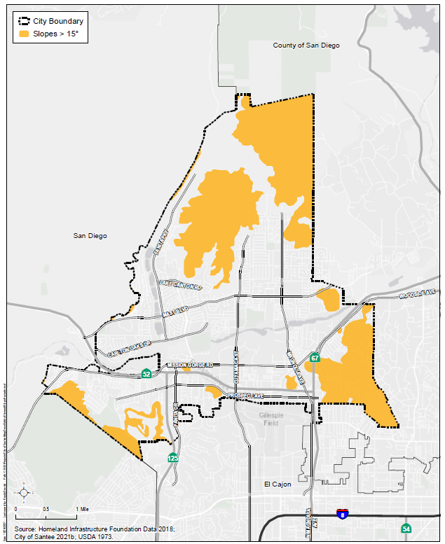

The anticipation of ancient landslides and the creation of new landslides have been most commonly caused by grading activities, a rise in groundwater level in a landslide area, areas containing bedding plane shears, or seismic activity. Identification of landslide-prone areas through detailed geotechnical studies is of primary importance in predicting future slope failure and landslides. The most common method of stabilizing landslides and landslide-prone areas is through remedial grading or buttressing and installation of subdrains and drainage panels to reduce the potential for buildup of excessive hydrostatic pressures. Other development options may include structural setbacks or stabilizing shear pins.
Landslide areas in Santee can usually be mitigated using generally accepted remedial grading techniques and buttresses. These techniques may consist of partial or complete removal and compaction of the deposits or stabilization with earthen buttresses, shear keys, stability fills, or other means, such as shear pins or retaining structures. Similar remedial grading procedures could be required where landslides are not present but where weak claystone beds, bedding plane shears, or thick surficial soil deposits are encountered. Such areas should be generally limited to where the Friars Formation will be exposed in cut slopes.
Reactivation of ancient landslides have been responsible for either partial or complete loss of 20 to 30 homes in the Santee area. Geotechnical firms that possess experience in landslide evaluation and stabilization should evaluate the potential for additional loss in areas already developed when building additions are proposed.

Debris Flow Deposits
A debris flow is a rapid downslope movement of saturated soil and near-surface rock debris. Numerous debris flows or mudflows have occurred in the Stadium Conglomerate. The debris flows or mudflows are initiated near the crests of very steep ridges underlain by Stadium Conglomerate and likely occur as a result of high intensity rainfall. As the near-surface soils become saturated and pore water pressure increases, the soils lose strength and fail relatively rapidly to form a river of mud and rock with considerable destructive power. These deposits consist of the accumulation of topsoil, colluvium, and debris derived from formational “parent material” near the base of moderate to steep slopes caused by rapid flow of saturated near-surface soils.
The physical appearance of these features indicates that they are relatively young compared to the ancient landslides. Most appear to be only a few hundred years old or less and are easily eroded. While the causes of debris flows are generally well understood, specific details concerning these events make them difficult to predict. Several well-formed debris flows can be observed on the northern side of SR-52 west of Santee. High rainfall, loss of vegetation cover through fire or other causes, and the steepness of the slope are the main causative factors of debris flows.
The primary difference between ancient landslides and debris flows, in terms of the potential for activation, is that debris flows do not possess a basal slip surface. Thus, they are much less likely than ancient landslides to become reactivated by grading. In areas of proposed development, mitigation of debris flow deposits is typically similar to that for alluvium and colluvium, and the presence of these materials is not likely to significantly affect development unless directed toward the boundary of the site.

Groundwater and Seepage
Groundwater and seepage conditions are significant factors in assessing engineering and geologic hazards. Groundwater is typically found in the deep alluvial drainage areas (such as the San Diego River and Sycamore Creek) but may also be found in shallower drainages as a result of stormwater infiltration (such as the Santee Recreation Lakes area). Because of fluctuating water levels in a given area, as a result of seasonal variations in precipitation and surface water runoff, the prediction of groundwater occurrence is difficult.
Seepage is typically the result of a groundwater table or perched water, either seasonal or permanent, being exposed. However, some human-made seepage conditions can develop in rural areas downslope of septic systems. Seepage conditions in slopes, either graded or natural, are usually the result of water flowing at the contact between materials of widely different permeabilities with the water perched on an underlying, less permeable layer. When the water flow encounters a slope face, it is manifested as seepage.
In addition to the nuisance caused by minor seepage from new slopes in residential areas, groundwater and seepage caused by excess irrigation are a major contributing factor to landsliding in the county, especially in the reactivation of old landslides. As pore pressures rise along an old slip surface as a result of rainfall or heavy landscape irrigation, the factor of safety against sliding will decrease.
The potential for groundwater and seepage conditions should be addressed in geotechnical reports submitted to the City for new developments and improvements. Procedures for water-related mitigation, such as canyon subdrains and proper grading procedures, should also be addressed. Groundwater conditions typically increase as a result of development primarily due to increased irrigation and areas of impervious surfaces, which result in surface water runoff rather than groundwater infiltration.
Perched groundwater or seepage has been encountered in alluvial drainages, hillside areas, and landslide zones during previous investigations in Santee. The groundwater/seepage in drainage courses is presumed to be associated with surface runoff of rainwater along the natural watershed. Subdrain systems are often necessary in areas of proposed development to intercept and convey seepage migrating along impervious strata. In particular, the main drainages, stability/buttress fill areas, and possibly where impervious layers daylight near the ultimate graded surface typically require subdrains. Specific subdrain locations and design details should be provided with the detailed grading plans for the site. Seepage conditions also occur in bedrock materials and at the base of landslide areas perched on relatively impervious strata in the Friars Formation and ancient landslide deposits. Additionally, relatively minor natural surface seeps were observed in the northern portion of Santee at the Friars Formation/Stadium Conglomerate contact. The existing perched groundwater levels in alluvial areas can be expected to fluctuate seasonally and may affect remedial grading.

Seismic Hazards
This discussion presents seismic hazards anticipated to affect Santee. Seismic hazards are caused by earthquake-induced ground shaking—specifically, liquefaction potential and seismically induced settlement and landsliding (refer to Ancient Landslides/Slope Stability discussion above for description of landslide-prone areas of Santee). A discussion of local and regional faulting and its impact on Santee is also presented.
Seismic hazards pertain to threats to life and property caused by earthquake-induced ground shaking. Based on current maps prepared by the California Department of Conservation and local geology maps, active or potentially active faults are not known to occur in or adjacent to Santee (Figure 4.4, Seismic and Geologic Hazards). However, as with all of California, Santee is subject to periodic seismic shaking due to earthquakes along remote or regional active faults.
A review of geologic literature indicates that no known active or potentially active faults cross Santee. An active fault is defined by the CGS as a fault showing evidence for activity within the last 11,700 years. The Rose Canyon/Newport Inglewood Fault Zone, approximately 10 miles west of the City, is the closest known active fault. The CGS has included portions of this Fault Zone within the Alquist-Priolo Earthquake Fault Zone. Currently, restrictions on development due to faulting (i.e., fault setback zones) related to the State of California requirements are not present in the City.
Considerations important in seismic design include the frequency and duration of motion and the soil conditions underlying the site. Seismic design of structures should be evaluated in accordance with the most recent applicable California Building Code (CBC) guidelines currently adopted by the local agency.

Faults in Southern California
The County of San Diego and Southern California region are seismically active. Figure 4.4 demonstrates that, although no Alquist-Priolo Fault Zones are within the City boundary, fault zones are in the greater San Diego County area. Notably, the Rose Canyon extension of the Newport Inglewood Fault Zone and the Mission Gorge Fault and La Nacion Fault Zone occur southwest of Santee.
Although no fault zones are within the City boundary, Santee could experience various levels of ground shaking as the result of an earthquake on a nearby fault system. Ground shaking is the motion felt on Earth’s surface caused by seismic waves from an earthquake. It is the primary cause of earthquake damage. The strength of ground shaking depends on the magnitude of the earthquake, type of fault, and distance from the epicenter. Buildings on poorly consolidated and thick soils will typically see more damage than buildings on consolidated soils and bedrock. The level of potential ground shaking that could occur in Santee is depicted on Figure 4.5, Earthquake Shaking Potential based on the State Probabilistic Seismic Hazard Map.
Overall, the earthquake shaking potential within the City boundary is low. The northern, southwestern, and southeastern portions of Santee may experience the lowest ground shaking potential, as indicated by the darker shades of green, while the middle-central portion of Santee and area along Fanita Parkway may experience low to low-moderate shaking potential as indicated by the yellow-green color. Ground shaking potential is analyzed using the State Probabilistic Earthquake Hazard Map. Earthquake probabilities are calculated by projecting earthquake rates based on earthquake history and fault slip rates. The result is expressed as the probability that an earthquake of a specified magnitude will occur on a fault or within an area.

Figure 4.4. Seismic and Geologic Hazards
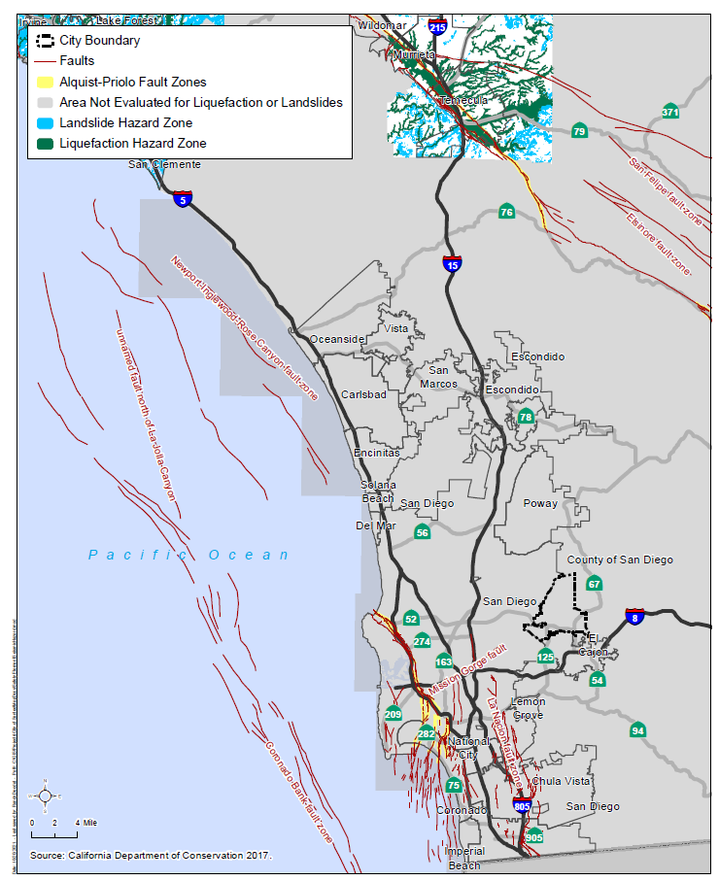

Figure 4.5. Earthquake Shaking Potential based on the State Probabilistic Seismic Hazard Map
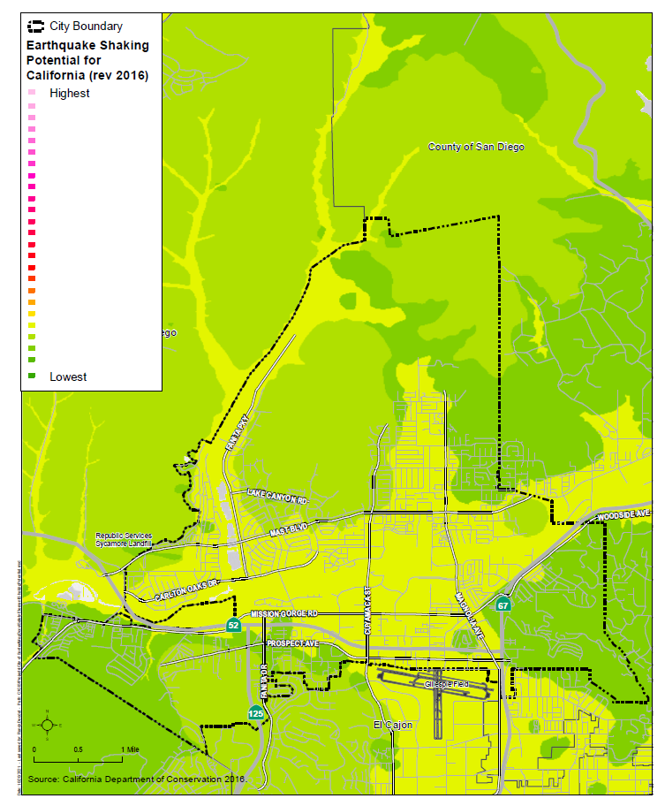

Other Geologic and Seismic-Related Hazards
Soil Liquefaction
Liquefaction typically occurs when a site is in a zone with seismic activity, on-site soils are cohesionless or silt/clay with low plasticity, groundwater is encountered within 50 feet of the surface, and soil densities are less than about 70 percent of the maximum dry densities. If these four criteria are met, a seismic event could result in a rapid pore water pressure increase from the earthquake-generated ground accelerations.
Although the California Department of Conservation did not identify liquefaction potential in Santee, the soil deposits that may be susceptible to liquefaction are the young alluvial soils found in the San Diego River and its deeper tributary channels, such as Sycamore Creek, due to the level of groundwater and soil densities in these areas.
Although the major deposits of alluvial soils maybe susceptible to liquefaction, some areas may have a water table sufficiently deep or may have particular soil conditions that result in a very low potential for liquefaction based on the anticipated maximum intensity of shaking for the area. In general, for deposits with a water table below a depth of 50 feet, a seismic event would have to be especially strong for liquefaction to occur, and therefore, these deposits will have a low potential for liquefaction as a result of the maximum events anticipated. The evaluation of liquefaction should be performed on a project-specific basis by the geotechnical engineer of record.
Liquefaction-related distress could range from small, localized areas, wherein specially designed structures may experience damage, to liquefaction covering a large area, resulting in lateral movement of the near-surface deposits and subsequent heavy damage to any affected structures. The potential risk to a structure should be evaluated whenever development is proposed in a liquefaction susceptible area. Liquefaction studies should conform to the recommendations of the 2008 CGS Special Publication 117A titled Guidelines for Evaluating and Mitigating Seismic Hazards in California or other approved publications.
Sand boils occur where liquefiable soil is extruded upward through the soil deposit to the ground surface. Providing an increase in overburden pressure and a compacted fill mat can mitigate surface manifestation. Proposed projects that possess a potential for liquefaction should also include an evaluation of the likelihood of sand boils.
Lateral spreading occurs when liquefiable soil is in the immediate vicinity of a free face, such as a slope. Factors controlling lateral displacement include earthquake magnitude, distance from the earthquake epicenter, thickness of liquefiable soil layer, grain size characteristics, fines content of the soil, and standard penetration test blow counts. Lateral spreading should be evaluated on projects where liquefaction potential exists (Appendix C).
The anticipation of potential hazards due to liquefaction can be accomplished by the densification or removal of the potentially liquefiable soil or the use of foundation systems that still provide acceptable structural support should liquefaction occur. Soil densification can be accomplished by compaction grouting, vibrocompaction, soil mixing, and deep dynamic compaction (among others). Soil densification is generally used to increase density and provide liquefaction mitigation of sensitive soil to relatively shallow depths over large areas. Deep foundation systems may be used to transmit structural loads to bearing depths below the liquefiable zones and may consist of driven piles or drilled piles. Deep foundations are designed to mitigate damage to the structures supported on the piles; however, they do not generally reduce the potential for damage to underground utilities and peripheral site improvements. The effects of differential settlement between rigid structures and attached settlement-sensitive surface improvements can be mitigated by designing the utilities to accommodate differential movement at the connections.
Seismically Induced Settlement
Settlement due to seismic shaking can occur on sites if liquefaction potential exists or not (e.g., loose sands). As with the susceptibility to liquefaction, the soils most susceptible to seismically induced settlement in the Santee area are the loose alluvial soils of the San Diego River and its tributaries. Site-specific studies should be performed in these areas to evaluate the settlement potential during anticipated maximum seismic events.
Seismically Induced Landslides and Rock Falls
Seismically induced landslides and rock falls are common in areas of high seismicity near the earthquake source. Over 11,000 such landslides occurred during the 1994 Northridge earthquake and mostly occurred in the mountains surrounding the Santa Clara River Valley. Seismically induced landslide and rock fall studies should be performed in accordance with current and applicable design standards, such as the CGS 2008 Guidelines for Evaluating and Mitigating Seismic Hazards in California.
Tsunamis and Seiches
A tsunami is a series of long period waves generated in the ocean by a sudden displacement of large volumes of water. Causes of tsunamis include underwater earthquakes, volcanic eruptions, or offshore slope failures. Wave heights and runup elevations from tsunamis along the San Diego coast have historically fallen within the normal range of the tides. Santee is not included in a high-risk tsunami hazard area due to the elevation and distance from the Pacific Ocean; therefore, tsunamis and seiches are not considered hazards of concern. A seiche is a run-up of water within a lake or embayment triggered by fault- or landslide-induced ground displacement. Seiches may be a hazard when adjacent to the bodies of water within the City limits. Site-specific evaluations and discussions would be required for proposed site developments adjacent to the inland bodies of water.
Subsidence
Subsidence is the gradual or sudden sinking of the ground surface. According to the County’s 2018 MJHMP, subsidence often occurs when large amounts of groundwater have been withdrawn from certain types of fine-grained sediments. However, the soils in the county are largely granitic; therefore, it presents a minor threat to limited parts of the county. There is no historical record of this hazard in the region, and this hazard was excluded from further analysis in the 2018 MJHMP.
Surface Rupture
Surface rupture is a break in the ground’s surface and associated deformation resulting from the movement of a fault. Since there are not any faults in Santee, surface rupture is not anticipated to be a hazard. Santee’s earthquake and ground shaking potential comes from nearby faults outside the City limits.
Summary of Needs to Address Geologic/Seismic Hazards
While the certainty of occurrence, timing, and degree of significance of geologic and/or seismic hazards cannot be accurately predicted, it is possible to take appropriate actions that may minimize the loss of life and destruction of property in Santee caused by geologic or seismic hazards.
The City shall require that potential geologic hazards be investigated and evaluated at the environmental review stage prior to project approval. Such investigations shall include those identified in Table A-1, Determination of Geotechnical Studies Required, of the Geotechnical/Seismic Hazard Study (Appendix C). The City may request additional studies depending on the project location, project type, and possible updated information.
The level of geologic risk or hazard in a particular area and the basis for design considerations regarding types of structures and proposed location shall consider the following factors:
- The type and/or function of a structure.
- The presence of geological hazards at the proposed site.
The level of risk that can be accepted. For instance, in areas of potentially higher risk or where structures that are more critical are planned, special design considerations will be necessary to reduce the level of risk to an acceptable factor.

4.3 Urban/Wildland Fire Hazards
California’s increasing population and expansion of development into previously undeveloped areas is creating more wildland-urban interface (WUI) with a corresponding risk of economic loss caused by wildland fire. A “wildland fire” is defined as a fire occurring in a suburban or rural area that contains uncultivated lands, timber, range, watershed, brush, or grasslands. This includes areas where developed lands are adjacent to undeveloped, such as in Santee. Santee’s location in Southern California, surrounded by large areas of vegetated land, makes it a medium fire hazard area. The prevalence of brush-covered hillsides, many of which are not easily accessible, add to Santee’s fire hazards.
The most common type of home fires involve heating equipment that has been improperly designed, incorrectly installed, poorly maintained, or misused. This equipment includes wood stoves, fireplaces, chimneys, portable heaters, and other space heaters. Roughly 80 percent of the fires in Santee are in single-family residences.
A significant fire, one that burns a minimum of 500 acres and requires the heavy use of mutual aid resources, occurs in Santee on a periodic basis. The 2023 Community Risk Assessment Long-Range Master Plan states that the southwestern, northern, and eastern areas of the City pose the greatest risk from a wildfire. The Fanita Ranch and Rattlesnake Mountain areas of Santee, both of which represent inaccessible, elevated, brush-covered hillsides, have a higher-than-average proportion of the fires. Since 1950, 13 wildfires have occurred in Santee (Table 4.3, Historic Wildfires within the City of Santee [1950–2023]).
Table 4.3. Historic Wildfires within the City of Santee (1950–2023)
Fire Name | Start Date | Size (acres)
Quarry Fire | October 1950 | 281
Carlton Hills Fire | July 1966 | 329
No Name | 1974 | 155
Assist #59 | June 1981 | 7,311
Assist #72 | July 1981 | 696
Outside Origin #4 | 1981 | 56
Outside Origin #1 | March 1984 | 122
Assist #21 | June 1984 | 62
Assist #38 | April 1987 | 380
Assist #78 | September 1988 | 935
Assist #59/Magnolia | November 1989 | 310
Rocoso Fire | January 1994 | 3,218
Cedar Fire | October 2003 | 280,278
In accordance with Gov. Code, Section 65302(g), this Safety Element update includes the evaluation of risk of fire for land classified as SRA and land classified as Very High FHSZs. SRAs are areas where the state has financial responsibility for fire protection. An FHSZ is an identified fire hazard area based on the physical conditions that create a likelihood and expected fire behavior over a 30-to-50-year period without mitigation measures, such as fuel reduction. These zones are based on factors such as fuel, slope, and fire weather.
The location of SRAs and FHSZs are identified using the California Department of Forestry and Fire Protection’s (CAL FIRE’s) Fire and Resources Assessment Program (FRAP). According to FRAP data, no SRAs are within the City boundary; therefore, the City has sole local financial responsibility for fire protection. There are, however, Very High FHSZs within the City boundary (Figure 4.6, Fire Hazard Map). The identification of FHSZs is used to implement WUI building standards for new construction, real estate disclosure at time of sale, 100-foot defensible space clearance requirements around buildings, and property development standards, such as road widths, water supply, and signage. Areas identified as a Very High FHSZs are primarily in the northern section of Santee. Much of the FHSZ covers undeveloped land. However, the zone also covers land along the western and eastern borders. Figure 4.6 identifies Santee’s critical facilities (e.g., City operations, fire stations, police departments, schools, medical facilities, utilities) in the Moderate, High, and Very High FHSZs.
Figure 4.6. Fire Hazard Map
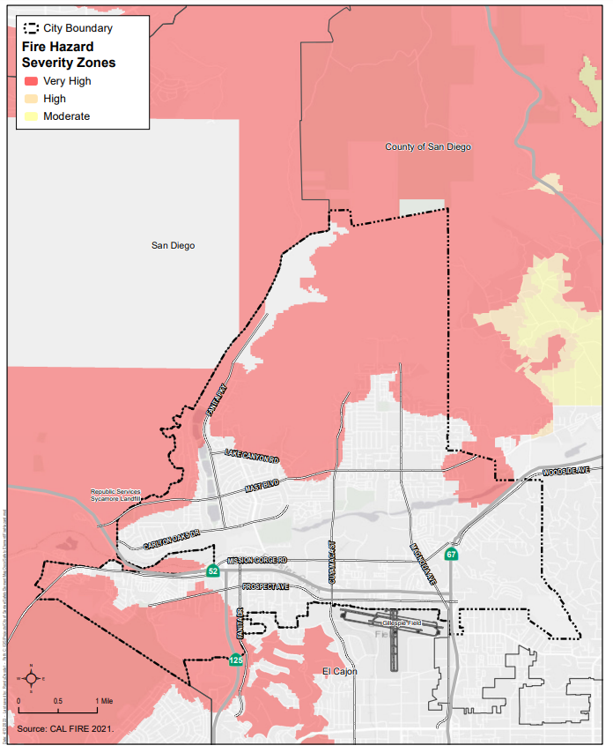

Fire and Life Safety Services and Regulations
The Santee Fire Department provides the community with fire and life safety education, fire inspection and prevention services, code enforcement, vegetation management, emergency medical services, and trauma support. The department is also the City’s lead for emergency preparedness, management, and response to earthquakes, floods, explosion, fires, hazardous materials, rescue, and medical services in Santee. To plan for long-term fire risks to certain demographics, physical assets, structures, and critical infrastructure in the community, the Santee Fire Department updates its Community Risk Assessment Long-Range Master Plan. The most recent Community Risk Assessment prepared by the Santee Fire Department was published in March 2023. The 2023 Community Risk Assessment Long-Range Master Plan is incorporated into this Safety and Environmental Justice Element by reference.
The Santee Fire Department provides fire protection and paramedic services to Santee. The Insurance Services Office (ISO) last surveyed Santee in 2021, and Santee received a Class 1 rating based on the ISO rating system of 1 through 10 (with the highest rating being 1 and the lowest being 10). The City maintains a minimum daily staffing of 17 emergency response personnel, including the battalion chief.
The Santee Fire Department currently has two fire stations—Station 4 and Station 5. Fire Station 4 is at 8950 Cottonwood Avenue, and Fire Station 5 is at 9130 Carlton Oaks Drive. In addition, a Fire Administration Building is at 10601 Magnolia Avenue (City Hall). The department is organized into the following three divisions:
Administrative: Finance, human resources, professional standards, information management, fleet and facilities support, grants, special programs and Emergency Management Services billing
Emergency Services: Incident response operations, training and safety, emergency medical services, emergency preparedness, communications, and special operations
Fire Prevention: Plan review, business inspections, public education, defensible space inspections for real estate transactions, community programs, water supply, and pre-fire planning
Additionally, vegetation management is contracted to a third-party consultant who performs weed abatement inspections and is overseen by the Santee Code Compliance Office. Fire investigation is contracted with the San Diego County Sheriff’s Department Bomb/Arson Unit.
Fire Station 4 currently has one battalion chief vehicle and four response units—one fire engine, one fire truck, one brush engine, one paramedic ambulance, and one Basic Life Support (BLS) ambulance with a minimum daily staffing of 11 personnel distributed as follows:
- Fire Engine 4 is staffed with one captain, one engineer, and one firefighter-paramedic.
- Fire Truck 4 is staffed with one captain, one engineer, and one firefighter-paramedic.
- Brush Engine 4 is cross-staffed with personnel from Fire Truck 4. This crew cross-staffs the Truck and Brush units and respond in the appropriate apparatus based on the nature of the alarm.
- Paramedic Ambulance 4 is staffed with two firefighter–paramedics.
- BLS 4 is staffed with two non-safety Emergency Medical Technicians (EMT).
- Battalion Vehicle 2 is staffed with one battalion chief.
Station 4 also houses two reserve fire engines and four reserve ambulances.
Fire Station 5 currently has three response units—two fire engines and one paramedic ambulance with a minimum daily staffing of eight personnel distributed as follows:
- Fire Engine 5 is staffed with one captain, one engineer, and one firefighter-paramedic.
- Fire Engine 205 is staffed with one captain, one engineer, and one firefighter-paramedic.
- Paramedic Ambulance 5 is staffed with two firefighter-paramedics.
Response time is defined as the amount of time it takes for the units from having received notification to their arrival at the scene. The National Fire Protection Association (NFPA) 1710 Standard for the Organization and Deployment of Fire Suppression Operations, Emergency Medical Operations, and Special Operations to the Public by Career Fire Departments establishes a 5-minute and 20-second benchmark response time goal for not less than 90 percent of dispatched incidents. The Santee Fire Department’s response times vary in Santee, but the first due response time for a structure fire is 7 minutes and 33 seconds. The first due response time for rescue and emergency medical services calls is 7 minutes and 27 seconds.
NFPA 1710 lists several travel time requirements for apparatus. The first defined travel time, 4 minutes, is for the first unit, either an engine or a truck that can operate as an engine, and the first engine should arrive within 8 minutes for a moderate-risk structure fire. NFPA historically defined advanced life support (ALS) unit’s travel time as 8 minutes. Certain areas in northern and southern Santee struggle to meet the 8-minute effective response force travel time goals established by the NFPA. In addition, much of the City does not meet the 4-minute travel benchmark. To meet the NFPA travel time standards, additional fire stations are needed.
However, the City has a signed automatic aid agreement on first alarm or greater fires with adjacent and nearby fire departments including Alpine Fire Protection District, El Cajon Fire Department, Lakeside Fire Protection District, La Mesa Fire Department, Lemon Grove Fire Department, San Miguel Fire Protection District, and City of San Diego Fire Department. Each participating member has a mutual aid agreement with the others and participate in the Unified San Diego County Emergency Services Organization to provide paramedic and fire protection services in the event that additional firefighting units are required. The City is also part of both the San Diego County and State of California Master Mutual Aid Agreements and maintains a separate agreement with CAL FIRE and the U.S. Forest Service.

Paramedic Services
Paramedic ALS services and BLS are currently provided with first responding fire companies and transport ambulances. All fire department apparatus and paramedic ambulances are staffed with firefighters and paramedics who are highly trained to administer advanced life support procedures on emergency incidents. A BLS ambulance is staffed with two non-safety emergency medical technicians and used for lower acuity calls to provide basic life support services. The Santee Fire Department and the Lakeside Fire Protection District previously provided ambulance transport service under terms of a contract with County Service Area 69. As of January 1, 2023, the Santee Fire Department and the Lakeside Fire Protection District provide ambulance transport service through the Santee Lakeside Emergency Medical Service Authority JPA. All firefighters hired by the Santee Fire Department are required to possess State of California and County of San Diego paramedic certifications.

Public Education and Awareness
The Santee Fire Department also operates many community outreach and education programs to help mitigate potential safety issues for Santee residents. These Community Risk Reduction activities include the following, along with a variety of other services designed to enhance the collective emergency preparedness for the community:
- Senior Smoke Detector Program
- Senior Citizen Outreach and Safety Education
- 3rd Grade Fire Prevention Poster Contest
- Annual Open House and Community Safety Fair
- Community Cardiopulmonary Resuscitation training
- Community Emergency Response Team training
- First-Aid/Community Risk Reduction information booths at Citywide events
- “Every 15-Minutes” participation with local high schools
- Fire station tours
- Classroom presentations
- Social Media Public Service Announcements

Requirements for New Development
All new construction in Santee requires the installation of fire sprinklers, which further reduces potential for fire loss. The City requires a minimum pressure flow of water for fire protection purposes based on the type of structure. While currently no firefighting water flow pressure problems occur in Santee, much of the future development may occur on the tops or sides of hills in the northern part of Santee where water pressures are lower.
To address fire and life safety issues on new development, the Santee Fire Marshal reviews all proposed residential, commercial, and industrial projects through the City’s Development Review process. In this way, it is possible to ensure that adequate fire hydrant locations, water flow pressures, access for emergency vehicles, and other requirements are met.

Summary of Needs to Address Urban/Wildland Fire Hazards
Santee’s fire problems are primarily related to fires in the Forester Creek and San Diego River areas, where 223 Fires have occurred between September 1, 2020, and February, 1, 2023. The fires in the Forester Creek and San Diego River appear to be related to the homeless population that resides in the area. Additionally, Santee’s fire problems are related to the large amount of brush-covered vacant land in Santee, which is often not easily accessible by emergency vehicles. As development in Santee’s vacant hillside areas proceeds, the preventative measures below should be required to ensure fire safety.

Construction
To avoid construction-related wildfires, adequate water shall be available to service construction activities, a Fire Prevention Plan shall be prepared, and proper wildfire awareness shall be provided, including reporting and suppression training to construction personnel and requiring that all construction-phase components of the fuel modification are complete prior to delivery of combustible materials/lumber to the project site. Prior to combustible materials being brought on site, utilities shall be in place, fire hydrants operational, an approved all-weather roadway must be in place, and the fuel modified defensible space must be established and approved by the fire code official.

Operation
Development should include a variety of fire protection features that form a redundant system of protection to minimize the likelihood of wildfire exposing people or structures to a significant risk of loss, injury, or death involving wildland fires. The development should provide a fire-hardened landscape, ignition-resistant residences and other buildings, and conversion of fuels to maintained developed areas with designated review of all landscaping and fuel modification areas and highly ignition-resistant structures.

Wildland-Urban Interface
The 2023 Community Risk Assessment Long-Range Master Plan includes a map of WUI areas within the City. These areas are primarily along the City’s boundaries in its northern, western, southwestern, southeastern, and eastern portions. The City’s critical fire station, hospitals, and medical clinics are all located outside of the WUI areas, as shown on Figure 4.7, Wildland-Urban Interface Map. Land uses within the WUI areas in the City primarily include planned development, parks and open space, and residential development.
The Santee City Council adopted a WUI development standard in November 2004 and then amended the City’s Fire Code with adoption in June 2006. Measures were also adopted into the 2007 CBC and have been retained and enhanced in code updates since then, including the 2022 CBC and California Fire Code. The following project features are required for new development in WUI areas and form the basis of the system of protection necessary to minimize structural ignitions and facilitate access by emergency responders as identified in the Fire Prevention Plan. Development within WUI shall comply with the most current codes and standards.

Fuel Modification Zones
Modified fuel areas separating wildland fuel areas from structures can reduce the number of fuel-related structure losses by providing separation between structures and heat generated by wildland fuels. Fuel Modification Zones provide appropriate buffers between native fuels and structures based on research indicating the type and width of Fuel Modification Zones that provide protection. Santee’s defensible space requirement is a 100-foot minimum for fuel modification between structures and wildland areas.

Fire Protection Infrastructure
Installation of a fire hydrant network, a dedicated fire water pipeline system to provide adequate fire flow to the project site, and fire department hose connections throughout the project site. The availability of the on-site fire suppression network and water supply would reduce potential wildfire impacts. The City’s Fire Code includes requirements for water supply, such as fire hydrants and storage tanks. Within FHSZs and WUI areas, fire hydrants must be spaced every 300 feet and must have a fire flow of 2,500 gallons per minute, or a fire flow approved by the Fire Chief. Additionally, the 2023 Community Risk Assessment Long-Range Master Plan depicts buildings within the City that may require a larger amount of water (i.e., greater than 3,000 gallons per minute) to extinguish a fire. The document also depicts the locations of all active fire hydrants within the City. Developments that require new or “stand alone” water storage facilities may also be required to provide secondary or backup systems, such as independently powered pumps that will ensure adequate water supply for firefighting emergencies. Secondary or backup systems create redundancy in the event the primary system fails and increases resilience of the system.
Establishing and adhering to minimum road width and clearances around structures ensures that fire response equipment and personnel can access buildings and people throughout Santee. According to City’s Fire Marshall, fire apparatus require a horizontal clearance of at least 26 feet and vertical clearance of at least 13.5 feet. The Circulation Plan in the Mobility Element of the Santee General Plan identifies the roadway classifications and cross-section for each. The different roadway classifications identify the minimum road width for prime arterials, major arterials, collector industrial, collector residential, parkway, multimodal corridors, and regional facilities. Refer to the Mobility Element for the individual widths for reach roadway classification. Adhering to these standards will ensure accessibility for emergency and fire personnel.

Emergency Vehicle Access
A Fire Protection Plan and Wildland Fire Evacuation Plan are required to meet City and County requirements and prevent any conflicts with current evacuation plans. Details of the emergency access routes must be described in the Fire Protection Plan and Wildland Fire Evacuation Plan prepared for a proposed project and must be designed to comply with current and future population growth, roadway conditions, and access availability.

Weed Abatement Program
The City contracts with a third-party consultant to conduct weed abatement inspections annually.
Figure 4.7. Wildland-Urban Interface Map
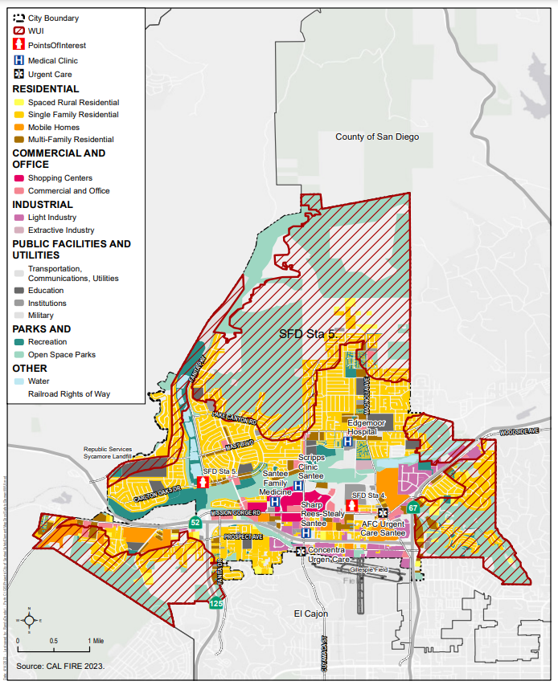

4.4 Crime
Police protection for Santee residents is provided by the County Sheriff’s Department, which operates out of the Santee Sheriff’s Station at 8811 Cuyamaca Street. Additionally, a Sheriff’s storefront is operated in the Santee Trolley Square Town Center at the northwestern corner of Mission Gorge Road and Cuyamaca Street. The storefront includes an active volunteer unit that provides community services including vacation checks and regular visits to homebound citizens.
The Santee Sheriff's Station has over 70 employees providing patrol and traffic services, criminal investigations, juvenile intervention, crime analysis, and crime prevention education. The ratio of officers to population in Santee is 1 per 1,000 residents, which is higher than the County average. Santee also has quicker response times than the County average. The average priority call response time for general law enforcement in Santee is 8.2 minutes, and the average for traffic law enforcement is 7.5 minutes. Santee has consistently had one of the lowest crime rates in the county. Santee’s average crime rate in 2019 was 15.48 per 1,000 population. This fell within the mid-range for crime rates throughout the county.
Larceny thefts and thefts from vehicles are now the largest reported crime problem in Santee, although Santee’s crime rate is well below the average for the county as a whole. In general, higher density residential areas tend to have more property-related crimes than single-family residential areas, with businesses being the main target for larceny crimes.
The County Sheriff’s Department administers a Neighborhood Watch Program in Santee, aimed at reducing the number of burglaries. Neighborhood Watch is a program involving the joint efforts of the County Sheriff’s Department and the community designed to enhance neighborhood security. The County Sheriff’s Department also administer a similar program called Kids Watch, which is oriented toward children and teaches them to watch their neighborhood and how to contact law enforcement when needed.
The County Sheriff’s Department uses a Community Oriented Policing and Problem Solving (COPPS) approach to crime prevention. COPPS is an effective community policing that has a positive impact on reducing crime, helping to reduce fear of crime, and enhancing the quality of life in the community by combining the efforts and resources of the police, local government, and community members.

Crime Prevention through Environmental Design
One of the proactive strategies used by the County Sheriff’s Department to address thefts and other crimes in the community is the Crime Prevention through Environmental Design (CEPTD) program. This program emphasizes the application of preventative measures in new construction and existing buildings or locations. The CEPTD emphasizes understanding and changing the physical environment of a building or neighborhood using four primary concepts to reduce potential incidents of crime—natural surveillance, territoriality, access control, and maintenance. Site design, landscaping, and lighting are major components of the four concepts. Decisions made by planners, designers, and law enforcement officials can influence resident and business conditions and behavior. The CEPTD program is incorporated into Section 13.10.040M of the Santee Municipal Code, establishing the minimum site and building standards, including defined entrances, landscaping, architectural design, lighting; natural surveillance through visibility and lighting; defined site boundaries and territorial reinforcement through landscaping and decorative fencing; designed wayfinding signage; and maintenance requirements.
The County Sheriff’s Department COPPS and Crime Prevention Units review all new development proposals as part of the City Development Review Committee development review process to incorporate safety recommendations and CEPTD principles into the design of new developments. For example, the City is promoting the establishment of video surveillance cameras in large retail parking lots to reduce vehicle theft incidents.

Graffiti
The Santee Sheriff’s Station is the only Sheriff’s command where deputies are assigned to investigate graffiti as a major function of their duties on a regular basis. The City’s graffiti investigators enjoy a 100 percent conviction rate on graffiti cases submitted to the San Diego County District Attorney’s Office. General acts of graffiti have been displaced to neighboring communities due to the investigative efforts of City deputies and the lower priority placed on this activity by neighboring law enforcement agencies.

School Resource Officers
The City also funds four School Resource Officer (SRO) positions, when funding is available. SROs are assigned to the Santee (Elementary) School District and the Santana and West Hills High Schools. The SROs are an educational resource, providing both intervention and follow-up services. They act as an on-campus resource for school students to both provide a law enforcement liaison and to ensure a safe environment for learning.

Las Colinas Detention and Reentry Facility
The County Sheriff’s Department operates the Las Colinas Detention and Reentry Facility, the primary point of intake for women in the county, with a capacity of 1,270 people and an inmate cap of 500 people. The facility is in Santee at 451 Riverview Parkway on a 45-acre site also listed as 9000 Cottonwood Avenue. The facility opened in August 2014, replacing the 1967 Las Colinas Detention Facility that operated for a period of time as a juvenile facility. More than 12,000 bookings of female prisoners every year are performed at the facility for regional law enforcement agencies. Las Colinas Detention and Reentry Facility is staffed by approximately 278 sworn employees and 143 professional staff members, making it one of the largest employers in Santee.

Summary of Needs to Address Crime
The most frequent crimes in Santee are thefts and burglaries within higher density residential areas and in businesses along Mission Gorge Road. These crimes can continue to be addressed for new development through the use of improved building design techniques and lighting, which take into consideration defensible space strategies, and the CEPTD. Additionally, the City can continue to address crime through the continued promotion of the COPPS, Neighborhood and Kids Watch Programs, and enforcement actions for existing developed areas of Santee. In addition, parking lot surveillance systems for large-scale commercial developments have also proven to be beneficial.

4.5 Traffic Hazards
Roughly 108 miles of roads are in Santee. Most streets have been well maintained and do not present significant driving hazards. The main cause of traffic collisions appears to be correlated with unsafe speed and improper turning. Most collisions occur on the major streets in or near intersections where traffic is heaviest and turning movements are frequent, such as the intersection of Mission Gorge Road at Cuyamaca Street. This intersection is the focal point of the Santee Trolley Square Town Center and serves as the terminus of the San Diego Trolley East (Green) Line.
Mission Gorge Road has the highest number of accidents due to the amount of traffic this facility handles per day. This east–west roadway serves primarily commercial and business establishments. With these types of land uses, an increase in conflicting traffic movements may contribute to potential vehicle collisions on this street. Currently there are over 45,000 vehicles per day on portions of Mission Gorge Road and 39,000 vehicles per day on Cuyamaca Street.
The City has installed light emitting diode (LED) traffic signal lights throughout Santee. These lights use less energy and are more visible. Major intersections have installed battery backup power so that in the event of a power outage, these key intersections will continue to operate smoothly, reducing the potential for traffic collisions. The City has also installed reflective tapes on traffic signal heads to make signals more visible in low lights and during power outages.

Summary of Needs to Address Traffic Hazards
Traffic collisions along Mission Gorge Road are primarily due to heavy traffic volumes in association with numerous entrances and exits, which results in an increase in conflicting traffic movements. The City should continue to require the installation of shared driveways and reciprocal access between adjoining properties in association with the implementation of other traffic control devices, including the use of center medians, left-turn pockets, and signalized intersections, all of which would reduce conflicting traffic movements and the potential for traffic collisions.

4.6 Light-Rail Transit Hazards
The San Diego Transit System was established in 1948, replacing the San Diego Electric Railway Company. On April 24, 1949, rail transit ended as motor buses made San Diego the first California city to convert to an all-bus system. In 1967, San Diego Transit became a nonprofit corporation with the City of San Diego. In 1976, then Metropolitan Transit Development Board was formed, and in 1981, San Diego Trolley, Inc., was formed. The San Diego Trolley inaugural run took place on the 15.9-mile “South Line” between the international border and Downtown San Diego on July 19, 1981, representing the first light-rail run in 3 decades. In 1984, the Metropolitan Transit Development Board broke ground on a 4-mile extension east from the 12th and Imperial Station, becoming the first leg of the future East Line (later renamed the Orange Line). On November 17, 1986, the Metropolitan Transit Development Board held a groundbreaking for the next 11.7-mile East (Orange) Line segment, and on July 26, 1995, the segment between the El Cajon Transit Center and Santee Trolley Square Town Center opened.
The MTS is currently the public transit service provider for San Diego County. The MTS San Diego Trolley system includes 63 stations serving three primary trolley lines. Most of the stations are at, or near, ground-level, including the Santee Trolley Square station. The Santee Trolley Square station includes free parking and connections to MTS bus lines. The San Diego Trolley’s main lines operate with regular service between 5:00 a.m. and midnight 7 days per week, with station stops every 15 to 30 minutes. In 2019, the entire San Diego Trolley system provided over 38 million passenger trips. The San Diego Association of Governments 2050 Regional Transportation Plan forecasts 156 new miles of trolley service; however, none of these new miles are proposed in Santee because Santee is at the end of the East (Green) Line. From the Grossmont Trolley Station in La Mesa, both the Orange and Green Lines head northeast to the Arnele Avenue station in El Cajon where the Orange line terminates. From there, the Green Line continues into Santee.
To prevent transit delays, a priority system is used to manage traffic signal operations at or near crossings. The trolley priority system works as follows:
- The trolley dwells in the station until a count-down timer counts to zero.
- The trolley departs within 5 seconds after the zero point of the count-down timer.
- If the departure window is missed, the trolley must wait until the beginning of the next cycle.
- As long as the trolley leaves the station during the departure window, it will receive green lights at all of the downstream signals until it reaches the next station.
The trolley priority system is successful in increasing the efficiency of trolley operations. The priority system has been enhanced from a “passive” to an “active” system including train detectors embedded at predetermined locations and traffic system controllers which trigger signal changes at intersections if a train is detected. The monitoring and management of traffic signals, signage, pavement markers, and related equipment at intersections protect public safety as trolleys traverse major intersections, such as the following:
- Cuyamaca Street and Prospect Avenue (four-way)
- Cuyamaca Street and the SR-52 eastbound off-ramp
- Cuyamaca Street and SR-52 westbound off-ramp
- Cuyamaca Street and Buena Vista Avenue (four-way)
- Cuyamaca Street and Mission Gorge Road (four-way)
Two private lanes cross the tracks and pedestrian track crossings are within the premise of the Santee Trolley Square Town Center. As a light-rail transit line, the trolley provides an important service for regional and local passenger transit. However, it also presents safety concerns as a potential source of collisions with vehicles, bicyclists, and pedestrians due to the rail line’s location adjacent to busy City streets.

Summary of Needs to Address Light-Rail Transit Hazards
The City should continue to assess safety conditions associated with collisions between vehicles, bicyclists, and pedestrians due to the rail line’s location adjacent to busy City streets.

4.7 Airport Hazards
The City is situated between two aircraft operation areas: MCAS Miramar to the northwest and Gillespie Field immediately south of Santee (Figure 4.8, Airport Safety Zone Risk Level). The San Diego County Regional Airport Authority, acting as the Airport Land Use Commission (ALUC) , is responsible for adopting ALUCPs. The basic function of an ALUCP is to promote compatibility between an airport and surrounding land uses that lie within the airport's designated Airport Influence Area to the extent that these areas are not already devoted to incompatible uses. The ALUCP is also intended to protect the safety of the public from airport-related hazards. The ALUCP includes specified limitations and conditions on the future development of new land uses surrounding the airport. The ALUCP consists of several components, including provision of airport information, compatibility policies and criteria (e.g., height restrictions to prevent obstructions to navigable airspace), compatibility maps, procedural policies, and land use information. It addresses noise, overflight, safety, and airspace protection concerns for land uses within the Airport Influence Area. The ALUCP also establishes standards for certain development projects to provide constructive notice to current and prospective property owners of aircraft activity within the vicinity of the airport.
Additionally, the Federal Aviation Administration (FAA) establishes airspace protection surfaces in the airspace above and surrounding airports to protect aircraft from obstructions, such as buildings and towers, in navigable airspace. ALUCP safety zones are derived from general aviation aircraft accident location data found in the California Land Use Planning Handbook and data regarding the airport’s runway configuration and operational procedures at the airport.
Under certain circumstances, developers of specific properties may be required to dedicate avigation easements to the airport owner. Among other things, an avigation easement grants the right of flight in the airspace above the property; allows the generation of noise and other impacts associated with overflight; restricts the height of structures, trees, and other objects on the property; prohibits potential on ground flight hazards (e.g., sources of light/glare); and permits access to the property to remove or mark objects exceeding the established height limit.
New development proposals in the Airport Influence Area must process a consistency determination application and be found to be consistent or conditionally consistent with applicable land use compatibility policies with respect to noise, safety, airspace protection, and overflight as contained in the ALUCP. Additionally, development proposals are required to comply with FAA regulations concerning the construction or alteration of structures that may affect navigable airspace.

Figure 4.8. Airport Safety Zone Risk Level
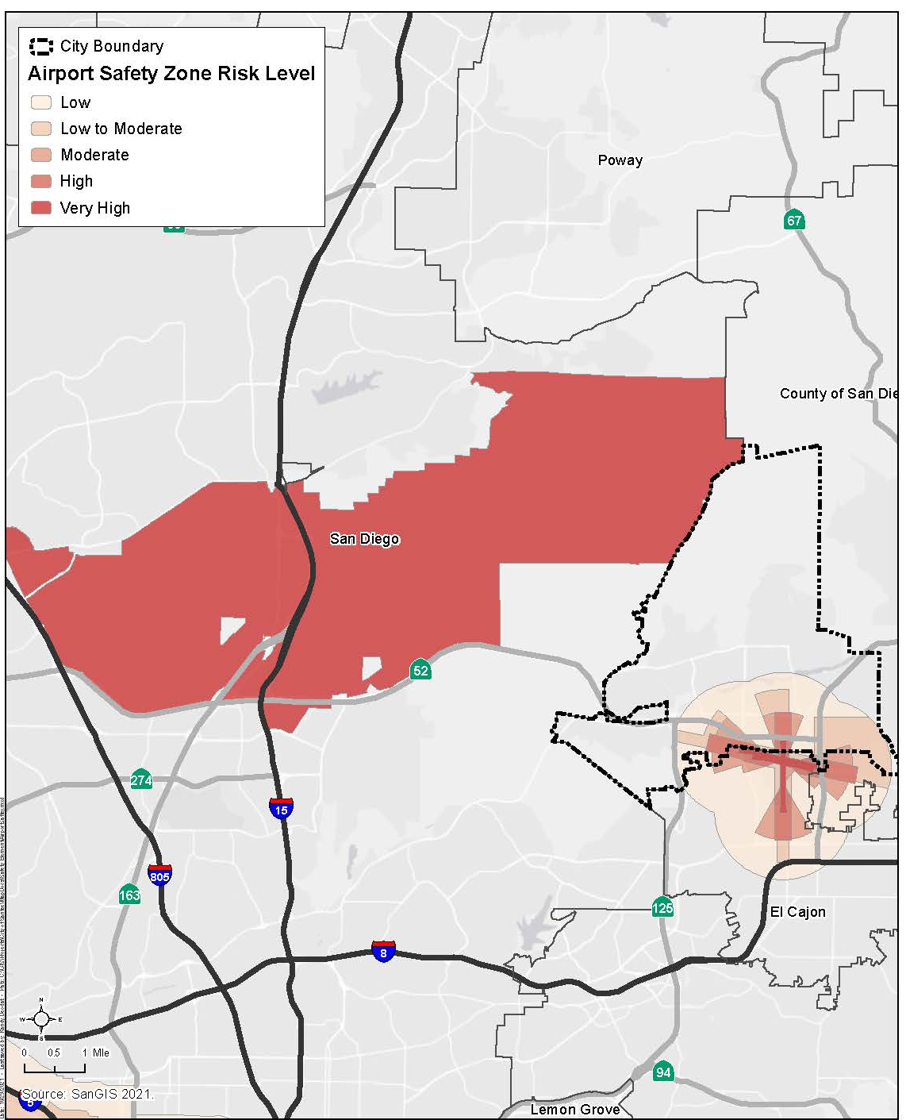

MCAS Miramar
MCAS Miramar, formerly Naval Auxiliary Air Station Miramar and Naval Air Station Miramar, is a U.S. Marine Corps installation that is home to the 3rd Marine Aircraft Wing, which is the aviation element of the 1st Marine Expeditionary Force. MCAS Miramar is adjacent to Santee’s northwestern boundary, and its runway is approximately 5.5 miles west of the City boundary. MCAS Miramar’s Airport Influence Area, Review Area 2, includes portions of Santee. MCAS Miramar is not a public airport and is restricted to military use, providing facilities and services to various Marine Corps and Navy operating units.
MCAS Miramar is composed of three runways, one helicopter landing deck strip, six helicopter pads, and multiple support facilities. The primary runway is 12,000 feet long, whereas the secondary runway is 8,000 feet long. The helicopter landing deck strip (24S/06S runway) is 1,000 feet long for helicopter pattern operations and parallels the primary and secondary runways to the south. Helicopter Pads 1 through 6 are northwest of the main runways. Due to the prevailing winds, Runways 24R and 24L historically receive 95 percent of all operations with aircraft departing and approaching into the offshore wind. During certain weather conditions (e.g., Santa Ana winds), Runways 6L and 6R are used to ensure safety of ﬂight.
Operational aircraft at MCAS Miramar have changed over the years from F-4s in the 1970s to the F-14s during the 1980/1990s. MCAS Miramar was identiﬁed for realignment during the 1993 Base Realignment and Closure round that subsequently recommended formal closure of MCAS El Toro and MCAS Tustin. The realignment of MCAS Miramar was completed with the relocation of personnel, support requirements, and airframes from MCAS El Toro and MCAS Tustin to the San Diego region. The move to MCAS Miramar from MCAS El Toro and MCAS Tustin included the assignment of both ﬁxed and rotary-wing aircraft, including the Fighter Attack (F/A)-18 “Hornets,” KC-130s “Hercules,” CH-46 “Sea Knights,” and CH-53 “Super Stallions.” MV-22B “Ospreys” (9-tiltrotor aircraft) have operated out of MCAS Miramar since 2008, while the F-35 was more recently homebased in 2020. MCAS Miramar will remain home to the projection of Marine Corps’ West Coast air power indeﬁnitely as the remaining F/A-18 squadrons transition to F-35B and F-35C squadrons.
Within the MCAS Miramar Airport Influence Area, the ALUCP establishes Airport Safety Zones for the purpose of evaluating safety compatibility of new/future land uses. The Airport Safety Zone boundaries depict relative risk of aircraft accidents occurring near the airport with accident potential zones extending west toward the Pacific Ocean. Portions of the City of Santee will experience regular overflight and noise from military aircraft.

Gillespie Field
Gillespie Field was established in 1942 and is operated by the County of San Diego. Located in the northwestern portion of El Cajon, with a small portion in Santee, the airport includes three runways, two of which are generally oriented east–west and one which is oriented north–south. Gillespie Field has a significant economic impact of over $900 million and over 6,000 jobs. Gillespie Field is essential in supporting emergency responders and is home to Sheriff Aerial Support to Regional Enforcement Agencies (ASTREA), firefighting helicopters, and medevac helicopters and jets. Gillespie Field also supports business aviation for companies in the Southern California region as well as supports nonprofits such as the Air and Space Museum Annex—where aircraft are flown in on their last voyage and decommissioned for museum display at Balboa Park. Gillespie Field is a public-use airport serving a vital role as a National Reliever for the National Plan of Integrated Airport Systems.
According to the FAA, the airport ran approximately 226,887 aircraft operations (takeoff and landings) during 2016, averaging 622 operations per day. This rate has dropped from a high of more than 300,000 operations in 1979, and a total of 247,478 operations per year are projected by 2025. Two-thirds of the operations are performed by single-engine piston aircrafts, and approximately 25 percent of total annual operations are performed by helicopters.
The Gillespie Field ALUCP has a designated Airport Influence Area. Runway Protection Zones (RPZs) are areas of significant risk resulting from aircraft takeoff and landing patterns. While the RPZs for Gillespie Field fall mainly within airport boundaries, there are several County-owned properties north of the airport on Prospect Avenue that are within the designated RPZ. These properties are designated as Park/Open Space to reflect their airport function. There are also a number of privately owned parcels within the RPZ that cannot be further built upon per FAA guidelines.
The Gillespie Field ALUCP is prepared according to Caltrans Division of Aeronautics requirements and adopted by the San Diego County Regional Airport Authority. The Gillespie Field ALUCP seeks to reduce exposure to excessive noise and safety hazards within the Airport Influence Area, provides for the orderly growth of the airport and the area surrounding the airport, and safeguards the general welfare of the inhabitants within the vicinity of the airport and the public in general.
The Airport Influence Area includes a large portion of Santee and portions of El Cajon and areas within unincorporated San Diego County. Within the Airport Influence Area, the Gillespie Field ALUCP establishes six Airport Safety Zones for the purpose of evaluating safety compatibility of new/future land use actions. The ALUCP limits development intensities in these zones by imposing floor area and lot coverage maximums, incorporating risk reduction measures in the design and construction of buildings, and/or restricting certain uses altogether. Generally, permissible uses and development intensities range from most restrictive in Airport Safety Zone 1 to least restrictive in Airport Safety Zone 6. For example, all residential and virtually all non-residential uses are considered incompatible land uses in Zone 1, while all land uses in Zone 6 are considered to be either compatible or conditionally compatible with the airport.

Summary of Needs to Address Airport Hazards
Various levels of governments have differing roles and interests with land use planning around airports.
Federal: The FAA approves airport noise studies, serves as the lead agency in the federal environmental review process, and manages the nation’s airspace. The FAA publishes airport standards and provides planning guidance for use by airport sponsors.
State: The state provides for the integration of aviation into transportation systems planning on a regional, statewide, and national basis. Staff administer noise regulation and land use planning laws that foster compatible land use around airports and encourages environmental mitigation measures to prevent incompatible land use encroachment.
ALUC: ALUCs prepare ALUCPs and ensure regional and local land use plans are consistent with the ALUCP. ALUCs establish policies on land uses surrounding the airport, ensuring they are compatible with airport operations. This is done on an advisory basis. ALUCs also evaluate the compatibility of proposed local agency land use policy actions with the relevant provisions in the ALUCP. Risks to people and property on the ground within the vicinity of the airport and to the people on board the aircraft are considered.
Local Government: Cities and/or counties have a responsibility to ensure the orderly development of the airports within their local jurisdiction and ensure that all applicable planning documents and building regulations are consistent with the ALUCP. They also have the final decision on local land use issues and can overrule ALUC determinations with findings, subject to statutory procedure.
For example, as established by state law (Pub. Util. Code, Section 21670), the ALUC has the responsibility both “to provide for the orderly development of airports” and “to prevent the creation of new noise and safety problems.” ALUC policies thus have the dual objectives of (1) protecting against constraints on airport expansion and operations that can result from encroachment of incompatible land uses, and (2) minimizing the public’s exposure to excessive noise and safety hazards. To meet these objectives, the City must continue to ensure that future development or redevelopment within the Airport Influence Area address the following noise, safety, airspace protection, and overflight factors to avoid potential airport compatibility impacts, as assessed in the Gillespie Field ALUCP.
Noise. The purpose of noise compatibility policies is to avoid the establishment of new incompatible land uses and exposure of the users to levels of aircraft noise that can disrupt the activities involved. The characteristics of Gillespie Field and the surrounding community are considered in determining the level of noise deemed acceptable for each type of land use. The noise contours established for the purpose of evaluating noise compatibility are depicted on Exhibit III-1 of the ALUCP. Strategies to minimize risk include the following:
- Prohibit outdoor and indoor noise-sensitive uses
- Require sound attenuation of buildings containing noise-sensitive uses
Safety. The purpose of safety compatibility policies is to minimize risks to the public in the event of an aircraft accident or emergency landing outside airport boundaries. Strategies to minimize risk include the following:
- Reduce concentrations of land use by limiting residential densities and non-residential intensities that attract people in locations most susceptible to an off-airport aircraft accident
- Prohibit certain risk-sensitives uses, such as schools and hospitals, and aboveground storage of flammable or hazardous materials regardless of the number of people involved
Airspace Protection. The purpose of airspace protection compatibility policies is to ensure that structures and other uses of the land do not cause hazards to aircraft in flight within the airport vicinity. Strategies to minimize risk include the following:
- Comply with standards set forth in the Code of Federal Regulations Part 77 and determination from the FAA that the object would not be hazard
- Comply with the minimum separation criteria for land use practices that have the potential to attract wildlife that could be hazardous to aircraft in the vicinity of airports
- Minimize land use characteristics that create visual or electronic interference (i.e., lights, glare/night smoke, dust, steam) with aircraft navigation or communication
Overflight. The purpose of overflight compatibility policies is to help notify people about the presence of overflights near airports so that they can make informed decisions regarding acquisition or leasing property in the affected areas. Noise, vibration, fuel vapors, and particulate deposits from aircraft overflights, especially by comparatively low-altitude aircraft, can be intrusive and annoying in locations beyond the limits of the mapped noise contours. Strategies to address overflight annoyance include the following:
- An overflight notice indicating that the property is within an area that is routinely subject to overflights by aircraft using Gillespie Field and residents may experience inconvenience, annoyance, or discomfort arising from such operations.
- California state law requires that, as part of many residential estate transactions, information be disclosed regarding whether the property is situated within an Airport Influence Area.

4.8 Disaster Preparedness
The role of government in a disaster—whether it is local, regional, state or federal government—is the preservation of life and property. The following programs and plans are developed to assist with emergency operations and to reduce the risk from natural and human-made hazards.

Standardized Emergency Management System
Gov. Code, Section 8607(a), directs Cal OES to prepare a SEMS program, which sets forth measures by which a jurisdiction should handle emergency disasters. The program is intended to effectively manage multi-agency and multi-jurisdictional emergencies in California. SEMS consists of five organizational levels, which are activated as necessary: (1) field response, (2) local government, (3) operational area, (4) regional, and (5) state. Local governments must use the SEMS to be eligible for funding of their response-related personnel costs under state disaster assistance programs. The City has adopted an Emergency Operation Plan that is consistent with the SEMS. The plan addresses the planned response to extraordinary emergency situations associated with natural and human-caused disasters and describes the overall responsibilities of government entities, as well as the Santee Emergency Management Organization for protecting life and property in Santee.

County of San Diego Office of Disaster Preparedness and Recovery
The County of San Diego Office of Disaster Preparedness is the liaison between incorporated cities, Cal OES, and FEMA, as well as non-governmental agencies such as the American Red Cross. The Office of Disaster Preparedness ensures the preparation and execution of emergency plans in the event of a major emergency or disaster within the San Diego County area. It is important to note that the Office of Disaster Preparedness is not a response agency but rather serves to ensure coordination of efforts among County departments, cities, special districts, and other agencies in San Diego County, as well with the state and federal agencies.

Unified San Diego County Emergency Services Organization
Santee is one of 20 jurisdictions that support and participate in the Unified San Diego County Emergency Services Organization. The Emergency Services Organization, which is composed of the 18 incorporated cities in the county, the County of San Diego Office of Emergency Services, and the San Diego County Board of Supervisors, provides coordination of disaster response and recovery activities. The organization operates under a Joint Powers Agreement that provides for cooperation and coordination between member jurisdictions.

County of San Diego 2018 Multi-Jurisdictional Hazard Mitigation Plan
The purpose of the County’s 2018 MJHMP is to identify the county’s hazards, review and assess past disaster occurrences, estimate the probability of future occurrences, and set goals to mitigate potential risks to reduce or eliminate long-term risk to people and property from natural and human-made hazards. An important component of the County’s 2018 MJHMP is the CERT, which educates community members about disaster preparedness and trains them in basic response skills, such as fire safety, light search and rescue, and disaster medical operations. The City is a participating jurisdiction in the County’s 2018 MJHMP and helped the County prepare the City’s chapter of the MJHMP.

County of San Diego Emergency Operations Plan
The County’s Emergency Operations Plan describes a comprehensive emergency management system that provides for a planned response to disaster situations associated with natural disasters, technological incidents, terrorism, and nuclear-related incidents. It delineates operational concepts relating to various emergency situations, identifies components of the Emergency Management Organization, and describes the overall responsibilities for protecting life and property and ensuring the overall well-being of the population. The plan also identifies the sources of outside support that might be provided (through mutual aid and specific statutory authorities) by other jurisdictions, state and federal agencies, and the private sector.
First responders are responsible for determining initial protective actions before the EOC, and emergency management personnel have an opportunity to convene and gain situational awareness. Initial protective actions are shared and communicated to local EOCs and necessary support agencies as soon as possible to ensure an effective, coordinated evacuation. During an evacuation effort, the designated County Evacuation Coordinator is the County Sheriff, who is also the Law Enforcement Coordinator. The County Evacuation Coordinator would be assisted by other law enforcement and support agencies.

Santee Emergency Operations Plan
The Santee Emergency Operations Plan was adopted in June 2010 and developed from the 2010 San Diego County Operational Area Emergency Plan. This plan was prepared to ensure the most effective and economic allocation of resources for the maximum benefit and protection of the community in time of emergency. The objective of the plan is to incorporate and coordinate City facilities and personnel into an efficient organization capable of responding to any emergency.

Emergency Operations Center
The City of Santee EOC is at Santee City Hall and is integral in the coordination of successful response and recovery operations. The EOC serves in support of the incident commander and field responders. With centralized decision-making, personnel and other resources can be use more effectively. Coordination of activities through the EOC ensures that all tasks are accomplished with little or no duplication of effort and with the highest probability of success. Day-to-day operations are conducted by departments and agencies throughout Santee. When a major emergency or disaster occurs, the EOC provides the centralized management needed to facilitate a coordinated response.

Summary of Needs to Address Disaster Preparedness
The update of the Santee Emergency Operations Plan is an ongoing process by which the City maintains an adequate level of public safety. The City also has implemented procedures to initiate a coordinated EOC in the event of a significant natural or human-induced disaster. The City should continue to provide annual training to critical personnel to improve effectiveness in the event of an actual disaster.

4.9 Hazardous Materials
A hazardous material is any liquid or solid substance that poses a threat to human health and safety or to the environment if improperly treated, stored, transported, or disposed of. Hazardous materials that are commonly used in households and businesses include but are not limited to lawncare and gardening products, antifreeze, batteries, gasoline, motor oil, electronic devices, household cleaners, and paint. These materials may be disposed at the Permanent Household Hazardous Waste Collection facility operated by Waste Management in the City of El Cajon at no cost.
Hazardous material incident management is the responsibility of the Santee Fire Department. The City also belongs to the San Diego County Joint Powers Authority Hazardous Materials Response Team, which responds to assist with major incidents.
Hazardous materials sites in Santee include EnviroStor cleanup sites as identified and regulated by the California Department of Toxic Substances Control (DTSC) shown in Table 4.4, City of Santee EnviroStor Cleanup Sites.
Table 4.4. City of Santee EnviroStor Cleanup Sites
Facility Name | Address | Program Type | Status
Coneen Property | 8656 Cuyamaca Street | Evaluation | Refer: 1248 Local Agency
Dave’s Auto Service | 10438 Mission Gorge Road | State Response | Certified
El Capitan Quarry/El Cajon Mtn Mill Site | 16820 El Monte Road | State Response | Certified
Ketema Process Equipment Co., C/O Baker Process | 9484 Mission Park Place | Tiered Permit | No Action Required
Marine Parachute School La Mesa | In El Cajon, about 12 miles northeast of Downtown San Diego | Military Evaluation | No Further Action
Montes Metal Finishing | 10039 Prospect Avenue, K | Tiered Permit | No Further Action
Quiroz Recycling | 8514 Mast Avenue, Suite B | Inspection | No Action
Santee Army Camp | — | Military Evaluation | Inactive – Needs Evaluation
Federal, state, and local laws are designed to regulate the production, storage, transport, and disposal of hazardous materials (refer to Section 3). These laws and the agencies that enforce hazardous materials compliance are described below.

Federal

Agricultural Bioterrorism Protection Act (7 CFR 331; 9 CFR 121)
The Agricultural Bioterrorism Protection Act requires that entities that possess, use, or transfer agents or toxins deemed a severe threat to animal or plant health or products must notify and register with the Secretary of the U.S. Department of Agriculture (USDA). The USDA’s Animal and Plant Health Inspection Service has been designated by the Secretary as the agency for implementing the provisions of the law for the USDA. Anyone using these agents on the project site are required to register with the USDA.

Federal Insecticide, Fungicide, and Rodenticide Act (40 CFR 152–186)
The Federal Insecticide, Fungicide, and Rodenticide Act provided the U.S. Environmental Protection Agency (USEPA) with authority of pesticide labeling and establishing standards for certification of restricted pesticide application. The USEPA also has the authority to delegate pesticide enforcement authority to states by entering into cooperative agreements with state pesticide programs. Since 1975, California has had primary authority over pesticide enforcement in the state.
The USEPA uses its authority under the act to regulate the distribution, sale, use, and testing of plants and microbes producing pesticidal substances. The act’s regulations would apply to any pesticide use by farm workers or handlers.

Hazardous Materials Transportation Act (49 USC 5101–5127)
The Hazardous Materials Transportation Act was enacted to protect against the risks to life, property, and the environment that are inherent in the transportation of hazardous material in intrastate, interstate, and foreign commerce. The U.S. Department of Transportation receives the authority to regulate the transportation of hazardous materials from the Hazardous Materials Transportation Act.

Resource Conservation and Recovery Act (40 CFR 239–282)
Enacted in 1976, the Resource Conservation and Recovery Act (RCRA) is the primary federal law governing the disposal of solid and hazardous waste in the United States. The RCRA was amended and strengthened by Congress in 1984 with the passing of the federal Hazardous and Solid Waste Amendments. These amendments to the RCRA required phasing out land disposal of hazardous waste. The RCRA has been amended on two occasions since the Hazardous and Solid Waste Amendments were passed: in 1992, with the passage of federal Facility Compliance Act, which strengthened enforcement of the RCRA at federal facilities, and in 1996, with the passage of the Land Disposal Program Flexibility Act, which provided regulatory flexibility for land disposal of certain wastes. Under the RCRA, individual states may implement their own hazardous waste programs in lieu of the RCRA if the state program is at least as stringent as the federal RCRA requirements and is approved by the USEPA. The preferred land use plan with schools includes the potential that a school could be within the boundaries of a project site that could generate hazardous materials waste.

State

California Department of Pesticide Regulation
The USEPA enacts laws covering minimum pesticide requirements that are enforced at the state level through cooperative agreements. Over the years, the California Legislature has passed more stringent laws covering pesticide registration, licensing, the sale and use of pesticides, and worker protection. The California Department of Pesticide Regulation is responsible for regulating pesticide use in California. The best way to solve a pesticide-related problem often combines regulatory action and voluntary adoption of improved pest management methods. The California Department of Pesticide Regulation has a legal mandate to encourage the use of environmentally sound pest management, including integrated pest management. Many California Department of Pesticide Regulation programs stress a least-toxic approach to pest management and promote risk reduction through information, encouragement, incentives, and community-based problem solving.

California Fire Code (24 CCR 9)
The California Fire Code contains regulations consistent with nationally recognized accepted practices for safeguarding, to a reasonable degree, life and property from the hazards of the following: fire and explosion, hazardous conditions in the use or occupancy of buildings or premises, and dangerous conditions arising from the storage, handling, and use of hazardous materials and devices. It also contains provisions to assist emergency response personnel. The California Fire Code and the CBC use a hazard classification system to determine what protective measures are required to protect fire and life safety. These measures may include construction standards, separations from property lines, and specialized equipment.

Environmental Health Standards for the Management of Hazardous Waste Law (22 CCR 66261.20–24)
The Environmental Health Standards for the Management of Hazardous Waste Law contains technical descriptions of characteristics that would classify wasted material, including soil, as hazardous waste. Specifically, a waste is considered hazardous if it is toxic (causes human health effects), ignitable (can burn), corrosive (causes severe burns or damage to materials), or reactive (causes explosions or generates toxic gases) in accordance with the criteria established in Article 3. Article 4 lists specific hazardous wastes, and Article 5 identifies specific waste categories, including RCRA hazardous wastes, non-RCRA hazardous wastes, extremely hazardous wastes, and special wastes. When excavated, soils with concentrations of contaminants higher than certain acceptable levels must be handled and disposed of as hazardous waste. When demolished, structural features containing lead-based paint also can be considered hazardous waste, depending on concentrations, and must be handled and disposed of as hazardous waste.

General Industry Safety Orders – Control of Hazardous Substances Law (CCR Title 8, Subchapter 7, Group 16, Article 109, Sections 5160–5199)
The Control of Hazardous Substances Law establishes minimum standards for the use, handling, and storage of hazardous materials in all places of employment. Article 109 describes requirements including but not limited to emergency equipment in the workplace, measures to protect those engaged in the laboratory use of hazardous chemicals, cleanup operations or hazardous substance removal work, and processes for safety management practices. School site employees working with regulated chemicals and/or hazardous materials within laboratories and other facilities defined in Article 109 are subject to compliance with California Code of Regulations. Title 8.

Hazardous Materials Release Response Plans and Inventory Act (Chapter 6.95, Section 25503.5, of the California Health and Safety Code)
The Hazardous Materials Release Response Plans and Inventory Act requires facilities that use, produce, store, generate, or have a change in business inventory of hazardous substances in quantities above certain limits to establish and implement a Hazardous Materials Management Plan or Business Plan. Hazardous Materials Business Plans (HMBPs) provide threshold quantities for regulated hazardous substances. When the indicated quantities are exceeded, an HMBP or Risk Management Program is required pursuant to the regulation. The Risk Management Program must disclose the type, quantity, and storage location of materials. The law also requires a site-specific Emergency Response Plan, employee training, and designation of emergency contact personnel. Any facility on the project site that exceed threshold quantities would be subject to these requirements.

Hazardous Materials Transportation (CCR Title 13, Division 2, Chapter 6)
The State of California adopted the U.S. Department of Transportation regulations for the movement of hazardous materials by motor vehicle. In addition, the State of California regulates the transportation of hazardous waste originating in the state and passing through the state (California Code of Regulations, Title 26). Both regulatory programs apply in California. The state agency with primary responsibility for enforcing state hazardous materials transportation regulations and responding to hazardous materials transportation emergencies is the California Highway Patrol.

Underground Storage Tank Act (Chapter 6.7 of the California Health and Safety Code and CCR Title 23)
The Underground Storage Tank Monitoring and Response Program was developed to ensure that the facilities meet regulatory requirements for monitoring, maintenance, and emergency response in operating underground storage tanks. The County’s Department of Environmental Health and Quality is the local administering agency for this program.

California Department of Toxic Substances Control
The DTSC is a public agency whose mission is to protect California’s people and environment from harmful effects of toxic substances by restoring contaminated resources, enforcing hazardous waste laws, reducing hazardous waste generation, and encouraging the manufacture of chemically safer products. The Hazardous Waste Tracking System is the DTSC’s data repository for hazardous waste manifest and ID number information. The DTSC relies on the Hazardous Waste Tracking System for issuing and tracking ID numbers, registering transporters, and providing information to analyze hazardous waste activities for policy purposes and enforcement. The system generates reports from 1993 to the present on hazardous waste shipments for generators, transporters, and treatment, storage, and disposal facilities. Additionally, EnviroStor is the DTSC’s online data management system for tracking cleanup, permitting, enforcement, and investigation efforts at hazardous waste facilities and sites with known or suspected contamination issues (Table 4.4).

California Environmental Protection Agency
CalEPA was created in 1991 by Governor Pete Wilson by Executive Order W-5-91 to create a cabinet-level voice for the protection of human health and the environment and to ensure the coordinated deployment of state resources. The mission of CalEPA is to restore, protect, and enhance the environment to ensure public health, environmental quality, and economic vitality. CalEPA and the State Water Resources Control Board establish rules governing the use of hazardous materials and the management of hazardous waste.
Also, as required by Gov. Code, Section 65962.5, CalEPA develops an annual update to the Hazardous Waste and Substances Sites (Cortese) List, which is a planning document used by the state, local agencies, and developers to comply with California Environmental Quality Act requirements in providing information about the location of hazardous materials release sites. The DTSC is responsible for a portion of the information contained in the Cortese List. Other state and local government agencies are required to provide additional hazardous material release information for the Cortese List.

Regional

San Diego County Department of Environmental Health and Quality
The County’s Department of Environmental Health and Quality Hazardous Materials Division is the Certified Unified Program Agency for Santee. The Unified Program’s goal is to achieve consistency, consolidation, and coordination in the regulation of six state-regulated environmental programs through education, community and industry outreach, inspections, and enforcement. A Certified Unified Program Agency is the agency responsible for the implementation and regulation of the Unified Program. All inspectors in the Certified Unified Program Agency program are trained environmental health specialists who take part in a continuous education program to ensure consistency and uniformity during inspections.
The Hazardous Materials Division of the County’s Department of Environmental Health and Quality protects the health and safety of the public and the environment by ensuring that hazardous materials, hazardous waste, medical waste, and underground storage tanks are properly handled and stored. The Hazardous Materials Division assists regulated businesses in Santee in developing their business plans and developing an area plan for hazardous material emergency response coordination in Santee and San Diego County.
The County’s Department of Environmental Health and Quality Health Hazardous Incident Response Team consists of 10 California State certified hazardous material specialists and is funded by a Joint Powers Agreement. The Hazardous Incident Response Team and the San Diego Fire and Life Safety Services Department investigate and mitigate chemically related emergencies or complaints. Emergency response activities include mitigation, containment, and control actions as well as hazard identification, evaluating the threat to local populations of the environment.
Santee falls under the jurisdiction of the San Diego County Hazardous Waste Management Plan, which is the primary planning document providing overall policy on hazardous waste management in the county. The plan describes how San Diego County’s hazardous waste stream can be safely managed, and serves as the guide for local decisions regarding the management of hazardous wastes.
Santee also falls under the jurisdiction of the San Diego County HMBP. The purpose of the HMBP is to prevent or minimize damage to public health, safety, and the environment from a release or threatened release of a hazardous material at regulated facilities. The HMBP also provides emergency personnel with adequate information to help prepare and respond to chemical related incidents.

Summary of Needs to Address Hazardous Materials
As shown in Table 4.4, very few hazardous materials cleanup sites are in Santee and the majority of them do not require further action. The City should continue to provide residential curbside pick-up of waste automotive oil and filters and participate in the Household Hazardous Waste Program.

4.10 Emergency Evacuation Route Analysis
A variety of hazard scenarios could require an evacuation in parts of Santee. These emergency situations could be caused by either natural or human-made events, such as wildfires, floods, or geologic or seismic hazards. An Emergency Evacuation Route Analysis (Appendix B) was prepared to identify evacuation capacity and network connectivity in Santee in addition to meeting the requirements associated with the following legislative updates:
- AB 747 (2019) requires the City to update the Safety Element of its General Plan to identify evacuation routes and assess the capacity, safety, and viability of those routes under a range of emergency scenarios.
- SB 99 (2019) requires the City to identify residential developments in hazard areas that do not have at least two emergency evacuation routes (i.e., neighborhoods or households within a hazard area that have limited accessibility).
- AB 1409 (2021) requires the City to identify evacuation locations.
Evacuation route viability is largely determined by the location of the hazard. Because Santee is surrounded by Very High FHSZs to the northeast, northwest, and southwest, the City considered three wildfire scenarios (a fire originating in the northeast, a fire originating in the northwest, and a fire originating in the southwest). Because there are flood zones in Santee, evacuation route viability is assessed for flood hazards. Lastly, due to the proximity of Earthquake Fault Zones to Santee, evacuation route viability is assessed for an earthquake event.
The results of the analysis indicate that residents closest to the northern region of the City center are most vulnerable to general hazards given the distance they would need to travel to access an outbound road for evacuation. The analysis identified that residents closest to the southern and southwestern regions of Santee are most vulnerable to evacuation from earthquake hazards given the bridges they would need to traverse to access an outbound road (Appendix B).
The Emergency Evacuation Route Analysis identified potential vulnerabilities in Santee according to a GIS assessment that concludes whether all residential parcels have at least two points of egress. Under the earthquake hazard scenario, which conservatively assumes bridges in Santee are not viable, residential parcels in the southern region of Santee do not have any viable evacuation routes and residential parcels in the southwestern region of Santee only have one viable evacuation route (Mission Gorge Road) (Appendix B).
Evacuation locations for Santee residents would be dependent on the type and location of hazardous event affecting Santee and would be determined by first responders on site during emergency situations. For example, if a wildfire occurs north of Santee, residents would be directed to evacuate to community centers and City buildings in the southern portion of Santee, such as the City of Santee Operations Center, or to areas south of Santee, such as El Cajon. Evacuation locations would consist of places in Santee that residents are familiar with, such as parks, community centers, schools, libraries, City department buildings, or churches.

Section 5. Climate Adaptation and Resilience
In accordance with SB 379, the Safety and Environmental Justice Element includes a set of goals, policies, and objectives based on a Vulnerability Assessment (Appendix A) identifying the risks that climate change poses to Santee and the specific assets (i.e., critical facilities) and populations at risk from climate change impacts.

5.1 What is Climate Adaptation and Resilience?
One of the most significant policy challenges of our time is to change how we plan, build, and sustain our societal and physical systems to become more resilient to the unavoidable impacts of climate change. As GHG emissions continue to rise, climate change effects will continue to accelerate. Even if global GHG emissions were to stop today, the climate would continue to change for some time as Earth’s system responds to the emissions already in the atmosphere. Climate adaptation planning involves anticipating the effects of climate change and proactively planning and shifting current practices now to minimize future economic and social risks.
Climate resilience is the ability and capacity to prepare for, recover from, and adapt to trends and events caused by climate change. Improving climate resilience involves assessing how climate change will create new or alter current climate-related risks and taking steps to better cope with these risks. These include severe weather, ocean warming and acidification, extended periods of drought and extreme temperatures, wildfire, and other increasingly unavoidable deleterious effects of climate change. More frequent and apparent extreme weather events have shown that resilience is an essential component of any comprehensive climate action program.
There is a robust and ever-growing movement fueled by local and national agencies and organizations alike geared toward building and improving climate resilience. From local community action to global treaties, addressing climate resilience is becoming a priority to avert the worst impacts of climate change. Climate resilience efforts encompass social, economic, technological, and political strategies that are being implemented in all facets of society, including public and private sectors.
The good news is that addressing these risks allows us to not only protect people and property, but also generate economic activity that will create domestic jobs and drive prosperity. Businesses prepare for risks every day and can factor climate change-related hazards into existing risk management frameworks to become more climate-resilient. Businesses and governments alike are planning now for the environment and economy they will face in the future.

5.2 What Is Climate Vulnerability?
Climate vulnerability describes the ways in which a person or a community (receptor) is susceptible to sustaining harm or damage (impact) as a result of climate change. Climate vulnerability is a function of (1) climate-related changes in conditions that are experienced by a receptor and (2) the receptor’s sensitivity to experiencing impacts because of those changing conditions.
Climate vulnerability is related to physical factors, such as whether a community is likely to experience increases in the frequency of dangerously high-heat events or to be flooded during more frequent/intense storms, as well as social and economic factors, such as inequities in access to and benefits of education, economic investment, and government services.
Climate vulnerability is experienced by urban, suburban, and rural communities, but communities may be vulnerable in different ways. An individual or community may be vulnerable with respect to multiple factors of vulnerability at once. The cumulative impacts of these disparities and inequities may contribute to heightened vulnerability among certain groups, which are often referred to as “vulnerable communities” or “sensitive populations” (see the Vulnerable Communities/Sensitive Populations discussion in Section 5.3).

5.3 Climate Adaptation Planning
The purpose of climate adaptation planning is to reduce vulnerability and increase the local capacity to adapt to projected climate change effects and build resilience through adoption of goals and policies. A climate-resilient city is one that is prepared for the effects of climate change and can provide essential services during and after hazard events. To plan for climate-related hazards in Santee that may affect people and assets, the City prepared a Vulnerability Assessment (Appendix A) in accordance with the process outlined in the California Adaptation Planning Guide.
The Cal OES developed the California Adaptation Planning Guide to provide guidance to local governments on local adaptation and resiliency planning by presenting an updated, step-by-step process that communities can use to plan for climate change. Appendix A includes a full description of the four phases of the adaptation planning process. Phase 1 of the climate adaptation planning process, which includes identifying the potential climate change effects and important physical, social, and natural assets in the community, concluded that the primary hazards of concern for Santee are extreme heat, wildfire, extreme precipitation, and drought. Phase 2 of the climate adaptation planning process includes determining climate vulnerability of populations, natural resources, and assets in the community by analyzing potential impacts and the community’s capacity to adapt. The City’s Vulnerability Assessment follows the process outlined in Phase 2 of the California Adaptation Planning Guide.

Emissions Scenarios
The Vulnerability Assessment uses Cal-Adapt modeling and supplemental analysis to project the impacts of these climate change hazards. Cal-Adapt provides local climate projections for jurisdictions in California using climate scenarios. Climate projections from Cal-Adapt and other sources rely on climate models, which are computer simulations that forecast future climate conditions under the various climate scenarios, described further below. While no model can project future conditions perfectly, current models are heavily reviewed by climate scientists and can accurately reproduce observed climate conditions.
The Intergovernmental Panel on Climate Change, an organization that represents the global scientific consensus about climate change, has identified four climate scenarios, which are referred to as Representative Concentration Pathways (RCPs), that can be used to project future climate conditions. RCPs are different scenarios that measure the future severity of climate change. RCP scenarios are defined by assumptions for the growth of GHG emissions and an identified point at which GHG emissions are expected to begin declining (assuming various GHG reduction policies or socioeconomic conditions). The four RCP scenarios (RCP 2.6, RCP 4.5, RCP 6.0, and RCP 8.5) are labeled with different numbers that refer to the increase in the amount of energy that reaches each square meter of Earth’s surface under that scenario. The greater the number, the more severe future climate change conditions could be. For example, RCP 8.5 is the “business as usual” projection, which assumes that GHG emissions will continue to rise until at least the end of the twenty-first century. Below is a summary of the four emissions scenarios:
- RCP 2.6: Global GHG emissions peak around 2020 and then begin to decline substantially (low-emissions scenario).
- RCP 4.5: Global GHG emissions peak around 2040 and then begin to decline.
- RCP 6.0: Global emissions continue to rise until the middle of the century (2050).
- RCP 8.5: Global emissions continue to increase at least until the end of the century (2100) (high-emissions scenario).
Cal-Adapt’s models represent the range of expected climate changes (e.g., annual average maximum temperature) under RCP 4.5 and RCP 8.5.

Hazards
The Vulnerability Assessment addresses the climate change-related hazards that are the most pressing to the City, including extreme heat, wildfire, extreme precipitation, and drought.

Extreme Heat
The observed historical annual average temperature in Santee is 76.1 degrees Fahrenheit (°F). Average temperatures are projected to increase between 3.8°F and 4.7°F by mid-century (2035–2064) and between 4.9°F and 8.1°F by end of century (2070–2099), depending on the emissions scenario. In addition, the number of extreme heat days is projected to increase from a historical average of 3 days per year to between 12 and 15 days by mid-century and 16 to 32 days by end of century. Warmer days will also be accompanied by an increasing number of warmer nights.

Wildfire
Climate change can exacerbate wildfire risk. Wildfire risk is expected to continue to increase as a result of warmer temperatures, more frequent drought, changes in precipitation, and expanding WUI. According to the state’s Fourth Climate Change Assessment, wildfire risk will continue to increase as the climate warms. Santa Ana winds, which are hot, strong, and gusty winds that produce extreme dryness, have fueled—and will continue to fuel—the most catastrophic wildfires in the county. According to local climate projections, conditions that are optimal for the spread of wildfire— (1) changes in precipitation (measurable precipitation becoming less frequent), (2) changes in water availability (drought becoming more common), and (3) changes in weather (air becoming drier, temperatures becoming hotter, winds becoming stronger)—will become more prevalent. The county is expected to experience an increase in wildfire risk, especially during “peak season” in December and January, as a result of climate change.

Extreme Precipitation
Severe weather, such as atmospheric rivers, powerful rainstorms, and subsequent flooding, will occur more frequently throughout California as a result of climate change due to warmer weather and more moisture in storm systems. Climate change is expected to result in fewer but more intense rainstorms in which rainfall is rapid during a short amount of time. This could result in damages from floods. These heavy precipitation incidents could result in additional flows into the City’s primary waterways—San Diego River, Forester Creek, Sycamore Creek, and intermittent creeks paralleling Big Rock Road and Fanita Drive. Severe storms can result in overtopping or other types of dam failure, street flooding, or mudslides and debris flows (refer to the Debris Flow Deposits discussion in Section 4.2, Geologic/Seismic Hazards), which can ensue on an annual basis.

Drought
Regionally, droughts are projected to become more frequent and intense in San Diego County and throughout Southern California by mid-century. Historically, Santee has averaged a 126-day dry spell for each year between 1961 and 1991. Dry spells are projected to increase by 4 to 8 days by mid-century and 6 to 14 days by end of century, depending on the emissions pathway. Drought episodes effectively lower fuel moisture conditions to create longer fire seasons. Drought’s toll on community water sources creates food and water security concerns in addition to economic considerations that showcase the importance of proper preparedness.

Critical Facilities
The Vulnerability Assessment evaluated the vulnerability of Santee’s critical facilities. The Vulnerability Assessment incorporated and supplemented the list of critical facilities identified for Santee in the County’s 2018 MJHMP. This list includes the following types of critical facilities:
- City Operations
- Public Safety Facilities
- Public Health Facilities
- Community Centers
- Utility Facilities
- Critical Transportation
- Schools
Critical transportation facilities were determined to be the type of critical facility most impacted by or vulnerable to extreme heat. Public health facilities, schools, and critical transportation were determined to be vulnerable to wildfire. Public health facilities and schools in Santee are vulnerable to extreme precipitation and associated flooding damages. Utility facilities are the only critical facility type considered to be highly vulnerable to the effects of drought. See the Vulnerability Assessment (Appendix A) for a full discussion of the impacts of these climate change hazards on critical facilities in Santee.
The Safety and Environmental Justice Element includes several goals, objectives, and policies to address the potential for climate change-related impacts to critical facilities in Section 7.

Vulnerable Communities/Sensitive Populations
The Vulnerability Assessment also analyzed climate change-related impacts on the types of populations that are most sensitive or vulnerable to these effects. These populations include the following:
- People with access and functional needs (AFNs): People in multi-lingual communities, families with infants and children, older adults, people with disabilities, and people experiencing homelessness.
- People with Existing Chronic Health Conditions: People with diabetes, cardiovascular diseases, psychiatric illnesses, and respiratory diseases (e.g., asthma).
- People with Low Incomes: People with incomes that are between 50 percent and 80 percent of the area median income. See Section 6.2, Mapping Disadvantaged Communities, for a detailed discussion of low-income areas in Santee.
- People Experiencing Homelessness: People who are living in a place that is not meant for human habitation, in emergency shelters, or in transitional housing or exiting an institution where a person temporarily resided.
- Outdoor Workers: People who spend most of their workday outside (e.g., gardeners, landscapers, and park/recreation staff).
- Older Adults: People who are 65 years of age or older.
- Children: People who are 17 years of age or younger.
- People without Life-Supporting Resources: People who lack adequate housing or ways to cool living space, are renters/tenants, or are food-insecure.
The populations that were determined to be most vulnerable to extreme heat include people with AFNs, people experiencing homelessness, outdoor workers, and people without life-supporting resources. The identified sensitive populations, except for people with existing chronic health conditions, were found to be highly vulnerable to wildfire hazards. None of the identified sensitive populations were determined to be highly vulnerable to extreme precipitation. The identified sensitive populations, except people with existing chronic health conditions, are highly vulnerable to drought. Appendix A includes a full discussion of the impacts of these climate change hazards on Santee’s vulnerable populations.
The Safety and Environmental Justice Element includes several goals, objectives, and policies to address the potential for climate change-related impacts to vulnerable populations in Section 7.

Section 6. Environmental Justice – Existing Conditions
Environmental justice is defined by the California Environmental Justice Alliance as “the basic right of people to live, work, go to school, and pray in a healthy and clean environment—regardless of race, gender, sexual orientation, age, culture, ability, nationality, or income.”
In Santee, as in many other places, areas with the highest concentration of low-income families are more likely to be exposed to pollution and environmental hazards. Consequently, they experience higher rates of health-related issues. SB 1000, which requires cities and counties with disadvantaged communities to incorporate environmental justice policies in their General Plans, has seven primary objectives:
- Prioritize the Needs of Our Disadvantaged Communities
- Promote Civic Engagement
- Improve Access to Public Facilities
- Promote Food Access
- Promote Safe and Sanitary Housing
- Reduce Pollution Exposure
- Promote Physical Activity
In Santee, as in many other jurisdictions, areas with the highest concentration of low-income families are more likely to be exposed to pollution and environmental hazards. Consequently, the populations in these areas experience higher rates of health-related issues. This Element incorporates an analysis of environmental justice issues in Santee and identifies goals, objectives, and policies aimed at addressing community issues in equity (see Section 7). Addressing equity and environmental justice plays an important part in achieving the General Plan vision of improving the quality of life for citizens, workers, and visitors of Santee.
Once a city identifies disadvantaged communities, the OPR Environmental Justice Element Guidelines recommend that local agencies work with these communities to understand existing conditions with respect to the following environmental justice topic areas to better understand the drivers of inequality:
- Pollution exposure, including access to clean air and water
- Access to public facilities and services, including access to transit, healthcare, childcare, parks, and other civic facilities
- Access to healthy food
- Access to safe and sanitary homes
- Access to physical activity and recreational opportunities
- Unique or compounded health risks, including climate exposure

6.1 Community Engagement
A key environmental justice principle is to involve the communities most impacted by pollution, toxins, and other environmental problems that can impact their health and well-being in the public decision-making process. Resident participation in decision-making processes can bring knowledge, information, and ideas that local governments may not have thought of. Community members affected by environmental issues can share their firsthand knowledge of problems and provide input on solutions.
The City conducted two community stakeholder meetings with City staff, members of community programs, and representatives of the Santee Fire Department, Santee Sheriff’s Station, and healthcare districts. The stakeholder meetings were held on December 1, 2021, and June 16, 2021. The first stakeholder meeting on December 1, 2021, included a discussion of the goals, objectives, and policies presented in this Safety and Environmental Justice Element.
Following the first stakeholder meeting, the City developed an online Community Survey to identify what environmental justice topic areas were of greatest concern to residents. The Community Survey was made available in English and Spanish and was open from March 11, 2021, to April 30, 2021 and again from June 23, 2021 to July 7, 2021. The Community Survey included the following questions:
- What conditions make it difficult for you to have good health and living conditions?
- Which three issues do you think are the most important for the City to address to ensure that your neighborhood has access to healthy living conditions?
- What improvements would you like to see in your City?
- How much influence do you think residents have on City decisions that affect community health and environmental issues?
- What is your age in years?
- Which race/ethnicity category best describes you?
- What is the highest education level you achieved?
A total of 121 responses were received from City residents. The results of the Community Survey were shared and discussed with community stakeholders during the second stakeholder meeting on June 16, 2021. The City used the Community Survey results and commentary from the stakeholders to refine the environmental justice goals, objectives, and policies to address environmental justice issues relevant to the community (Appendix E).
The key findings of the Community Survey are discussed in the Environmental Justice Existing Conditions Assessment (Appendix D), and survey results are provided in the Environmental Justice Community Survey Results (Appendix E).

6.2 Mapping Disadvantaged Communities

CalEnviroScreen
The OPR Environmental Justice Element Guidelines recommend using CalEnviroScreen, a computer mapping tool used to identify communities disproportionately burdened by multiple sources of pollution and with population characteristics that make them more sensitive to pollution (i.e., disadvantaged communities). Using data from federal and state sources, CalEnviroScreen uses indicators to determine if a community is disadvantaged and disproportionately affected by pollution. Exposure and environmental effects are components comprising a Pollution Burden group, and the Sensitive Populations and Socioeconomic Factors are components comprising a Population Characteristics group. The four components are made up of environmental, health, and socioeconomic data from 21 indicators (Table 6.1, CalEnviroScreen 4.0 Indicator and Component Scoring). The CalEnviroScreen score is calculated by combining the individual indicator scores within each of the four components, then multiplying the Pollution Burden and Population Characteristics scores to produce a final score.
Table 6.1. CalEnviroScreen 4.0 Indicator and Component Scoring
Pollution Burden Group | Population Characteristics Group
Exposure  - Ozone Concentrations  - PM_{2.5} Concentrations  - Diesel Particulate Matter Emissions  - Drinking Water Quality  - Pesticide Use  - Toxic Releases from Facilities  - Traffic Density  - Children’s Lead Risk from Housing | Sensitive Populations  - Cardiovascular Disease  - Low Birth-Weight Births  - Asthma Emergency  - Department Visits
Environmental Effects  - Cleanup Sites  - Groundwater Threats  - Hazardous Waste  - Impaired Water Bodies  - Solid Waste Sites and Facilities | Socioeconomic Factors  - Educational Attainment  - Linguistic Isolation  - Poverty  - Unemployment  - Housing Burdened Low  - Income Households
Notes: PM_{2.5} = fine particulate matter measuring no more than 2.5 microns in diameter
CalEnviroScreen scores are converted to percentiles for census tracts across California that can be ranked relative to other areas of the state. In general, the higher the score or percentile, the more impacted a community is compared to other areas of the state. As shown on Figure 6.1, City of Santee Disadvantaged Communities: CalEnviroScreen, the southernmost portion of Santee, west of SR-67, south of Mission Gorge Road, and bounded by the City boundary to the west and south, exceeds the 75th percentile of CalEnviroScreen scores. These areas are considered disadvantaged communities.

Low-Income Areas
In addition to using CalEnviroScreen, the OPR Environmental Justice Element Guidelines recommend mapping low-income areas to identify disadvantaged communities. To identify communities with low incomes, the City compared household income levels to two different thresholds:
- Statewide median household income
- HCD state income limits/area median income
The average statewide median household income (in 2018 dollars) between 2015 and 2019 was $75,235. As shown on Figure 6.2, City of Santee Disadvantaged Communities: Statewide Median Income, only a small portion of households along the southern edge of Santee are below the statewide median income threshold.
The 2021 area median income established by the HCD for a four-person household in the county was $95,100. As shown on Figure 6.3, City of Santee Disadvantaged Communities: HCD State Income Limits, Santee identified four census tracts (166.05, 166.16, 16.17, 162.02) intersecting Santee with an average median household income below the HCD’s state income limits for the region.
As shown on Figure 6.1 through Figure 6.3, disadvantaged communities are in the southernmost portions of Santee, west of SR-67, south of Mission Gorge Road, and bounded by the City boundary to the west and south. In addition, the area of Santee between Cuyamaca Street east to SR-67 on the southern side of Prospect Avenue is mapped as a disadvantaged community by the California Office of Environmental Health Hazard Assessment.
The Environmental Justice Existing Conditions Assessment (Appendix D) provides a full analysis of the extent that designated disadvantaged communities in Santee are exposed to environmental burdens or lack access to public goods and services. Key findings of this assessment are summarized in Section 6.3, Key Findings of the Existing Conditions Assessment.
Figure 6.1. City of Santee Disadvantaged Communities: CalEnviroScreen
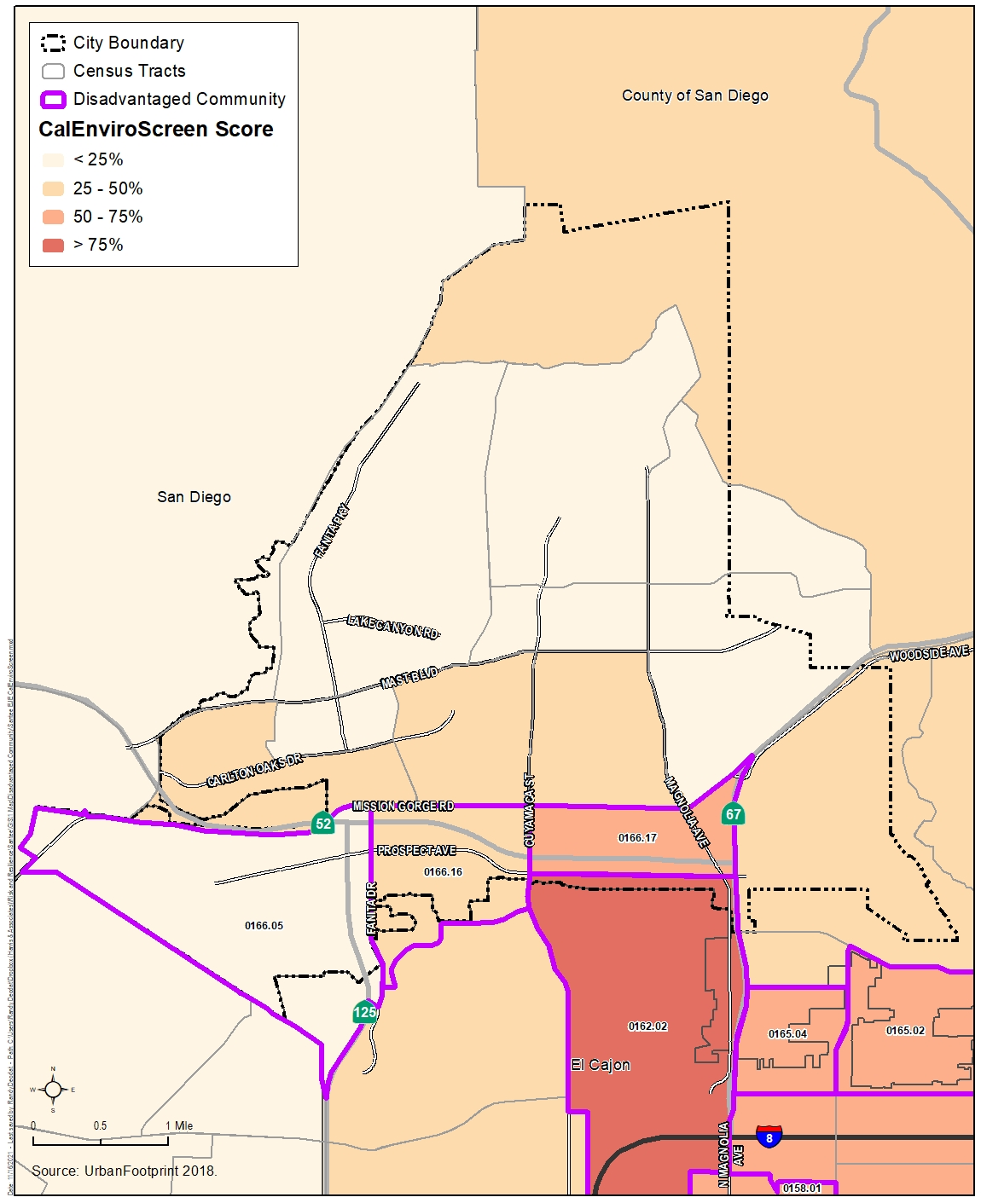

Figure 6.2. City of Santee Disadvantaged Communities: Statewide Median Income
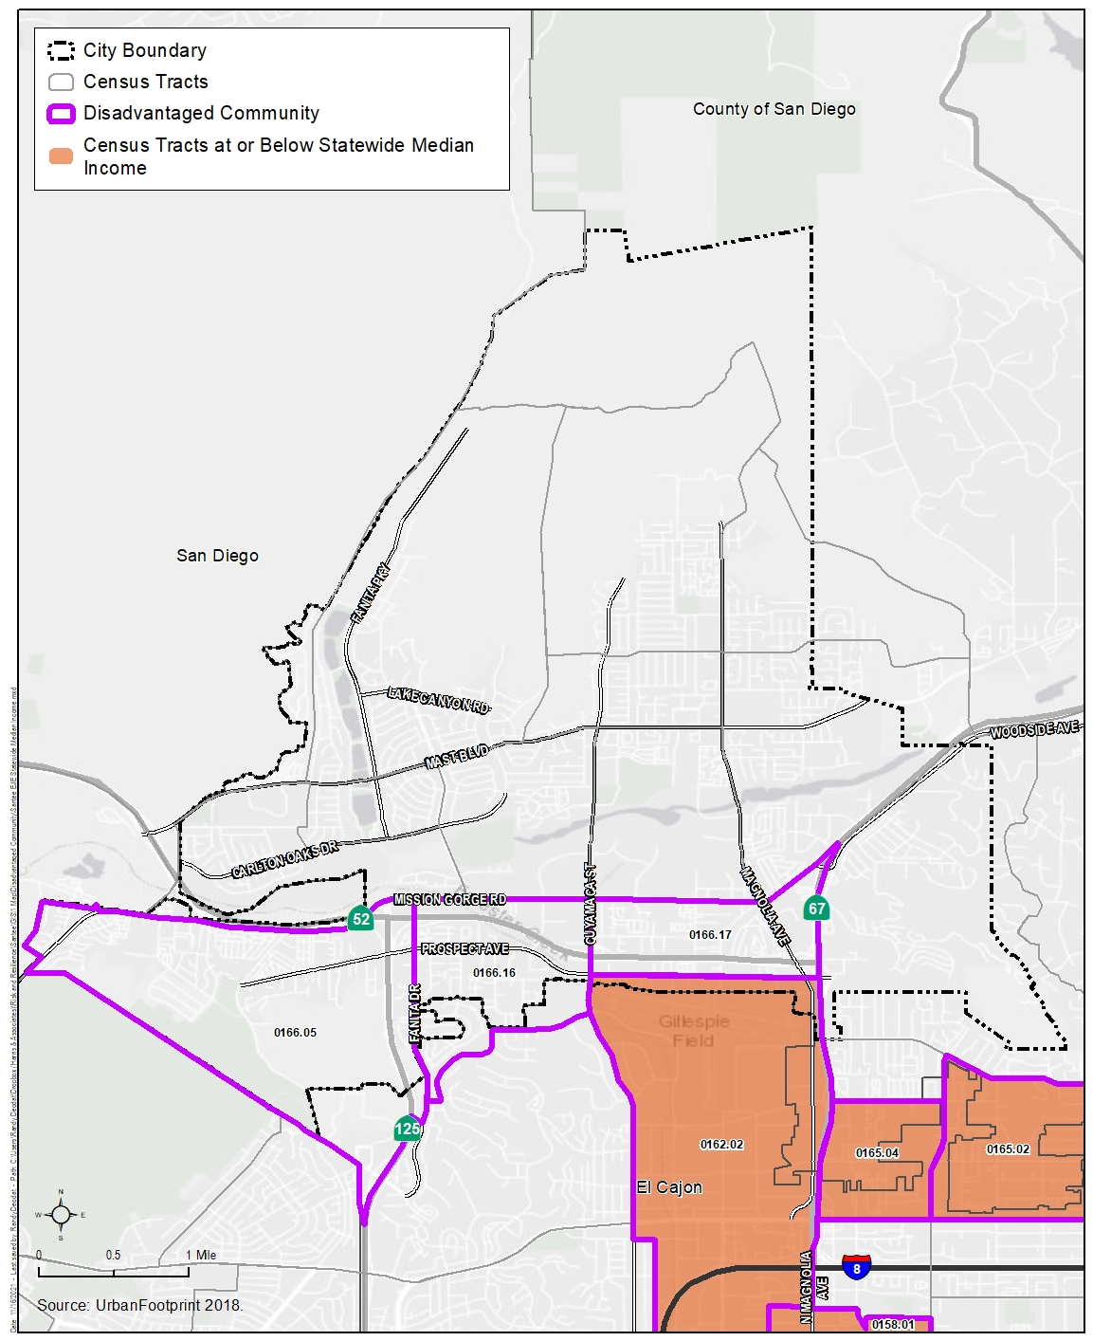

Figure 6.3. City of Santee Disadvantaged Communities: HCD State Income Limits
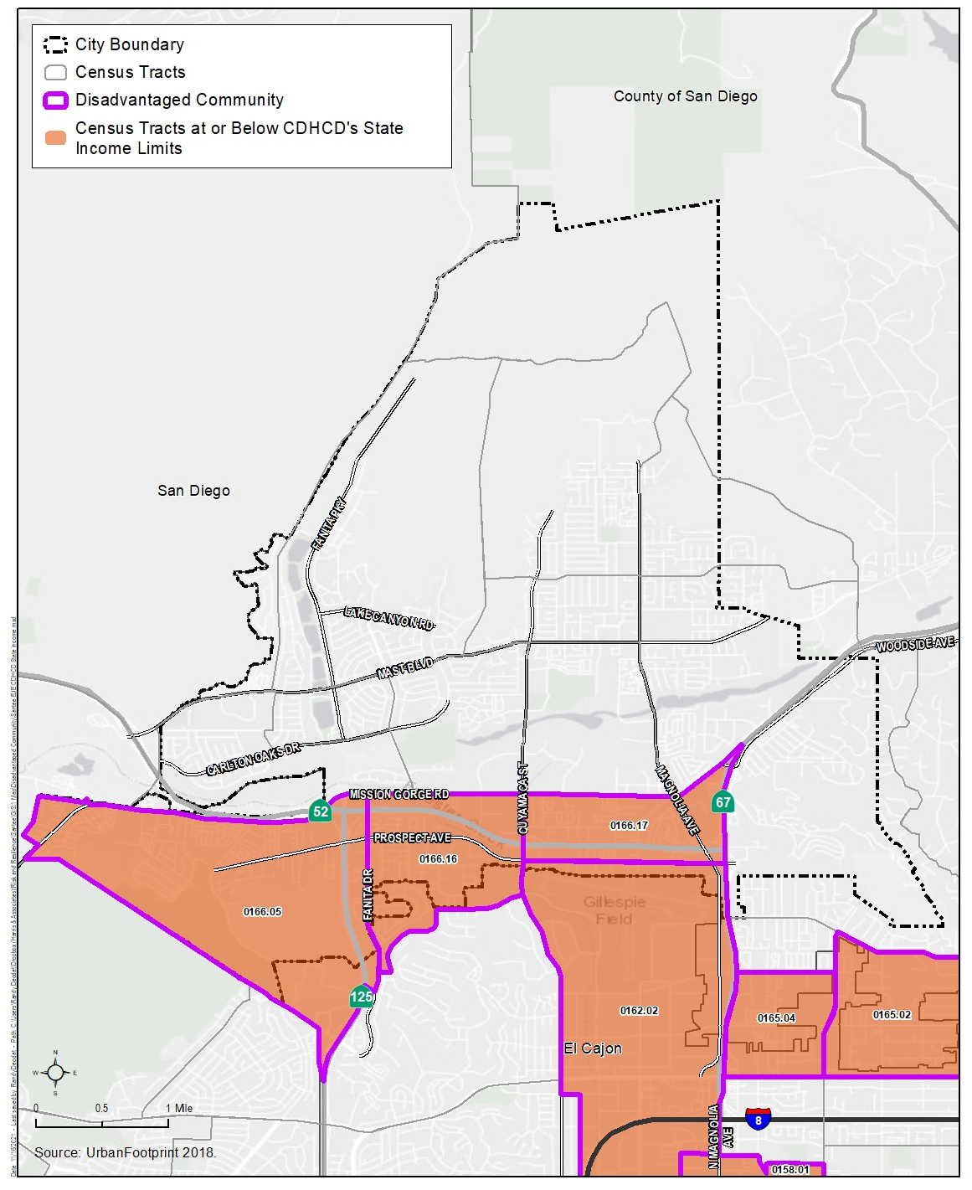

6.3 Key Findings of the Existing Conditions Assessment
The Environmental Justice Existing Conditions Assessment (Appendix D) assessed six environmental, health, and socioeconomic topic areas, including pollution exposure, access to public facilities and services, access to healthy food, access to physical activity and recreational opportunities, access to safe and sanitary homes, and unique or compounded health risks (due to climate change).
To assess existing conditions with respect to each environmental justice topic area, the City relied on U.S. Census data, which is the primary and standard source of high-resolution geographic information about the U.S. population; however, U.S. Census data can have large margins or error that are attributable to specific methodological decisions made by the U.S. Census Bureau. Therefore, U.S. Census data was supplemented by local data and knowledge, including the results of the Community Survey and community stakeholder meetings (refer to Section 6.1, Community Engagement). Stakeholders were able to “ground truth” data by providing individual observations of their lived experiences in Santee. The Community Survey also helped to quantify areas of concern to Santee residents. The key findings of the Environmental Justice Existing Conditions Assessment are listed below. See Appendix D for the full analysis of existing environmental justice conditions in Santee and Appendix E for the results of the Community Survey.

Pollution Exposure
The Environmental Justice Existing Conditions Assessment analyzed areas of Santee with poor air quality and issues related to water quality, accessibility, and affordability. Proximity to high-volume roadways, hazardous waste sites, and heavy industrial land use types and other high-emission sources can result in adverse health impacts. Disadvantaged communities are often disproportionately subjected to adverse air quality and water quality due to proximity to polluting activities and are more likely to have underlying medical conditions that may be worsened by pollution. As recommended by the OPR Guidelines, the City employed California Office of Environmental Health Hazard Assessment indicators to assess water quality, accessibility, and affordability. The Environmental Justice Existing Conditions Assessment identified the following key findings related to pollution exposure:
- Disadvantaged communities experience greater exposure to air pollutants due to their proximity to high-traffic corridors and industrial activity.
- While drinking water quality is not an issue for Santee, Santee’s disadvantaged communities experience greater instances of chemical, sediment, and sewage pollutants from illicit stormwater discharges due to their proximity to the San Diego River; however, these discharges do not impact the community’s potable water quality.
- Although not analyzed explicitly due to the lack of data availability, the pollution source that residents (46 percent of Community Survey respondents) are most concerned about is the prevalence of trash and debris throughout Santee, with many specifically pointing to homeless encampments along the river as a major source of pollution.

Access to Public Facilities and Services
For this analysis, access to public facilities and services included access to transit, healthcare, childcare, parks, and other civic facilities. The Environmental Justice Existing Conditions Assessment identified the following key findings related to access to public facilities and services:
- Many residences in disadvantaged communities are not within walking distance to their nearest school. However, residences in disadvantaged communities are generally within walking distance of daycare centers and transit, which can provide residents with opportunities to access other community services without using their personal vehicle.
- Despite low transit fares and well-distributed bus stops, most residents still rely on their personal vehicle. Nevertheless, 21 percent of Community Survey respondents indicated that heavy traffic restricted access to key destinations.
- Residents in disadvantaged communities are less likely to have health insurance, which may result in higher rates of avoidable emergency room visits.
- Several medical facilities serve the area in and around the City’s disadvantaged communities.

Access to Healthy Food
Access to healthy food is essential to improving health conditions. Many Californians also experience “food insecurity,” defined as a household’s inability to provide enough food for every person to live an active, healthy life. Although individuals make food choices, those choices are made within the context of what is consistently accessible, affordable, or available. The Environmental Justice Existing Conditions Assessment identified the following key findings related to access to healthy food:
- Disadvantaged communities have slightly less access to healthy food outlets compared to other areas in Santee and San Diego County. Less access to healthy food and higher prevalence of fast-food establishments in disadvantaged communities may contribute to higher obesity rates.
- While Santee has several food banks and summer meal program sites, the southwestern portion of Santee with disadvantaged communities is not served by these food distribution sites.
- Overall, Community Survey respondents felt that they had sufficient access to healthy food.

Access to Physical Activity and Recreational Opportunities
Increasing physical activity is one of the most important contributors to improved health. It helps people manage weight; reduces risk of cardiovascular disease, type 2 diabetes, osteoporosis, and some cancers; and improves mental health and well-being. The Environmental Justice Existing Conditions Assessment identified the following key findings related to access to physical activity and recreational opportunities:
- Disadvantaged communities in the southwestern portion of Santee have fewer sidewalks and bike paths compared to other areas of Santee, limiting their ability to use active transportation modes.
- Nearly 46 percent of Community Survey respondents indicated that limited access to and/or deterioration of City infrastructure and facilities that support physical activity, including sidewalks, bicycle lanes, parks, and recreation centers, is the most important issue for the City to address to ensure all residents have access to healthy living conditions.

Access to Safe and Sanitary Homes
Housing location, quality, affordability, and stability have health implications. Often, individuals who experience unique or compounding health risks face multiple, interrelated barriers to accessing safe, stable, and affordable housing. The Environmental Justice Existing Conditions Assessment identified the following key findings related to access to safe and sanitary homes:
- Although housing costs in Santee are less expensive than housing costs in other areas in the county and state, 49 percent of renters and 32 percent of homeowners in Santee are cost burdened.
- High housing costs impact renters in disadvantaged communities more severely because they often include low-income residents.
- Community Survey respondents were much more concerned with housing affordability than the safety and quality of homes—32 percent of respondents thought affordable housing is the most important issue for the City to address as opposed to the 2 percent of respondents who thought safe and sanitary housing is the most important issue.

Unique or Compounded Health Risks
Disadvantaged communities that suffer disproportionate environmental burdens are also likely to be more vulnerable to climate impacts. Climate change may even cause displacement from increased frequency or severity of hazards like flooding, drought, wildfire, extreme heat, and other impacts (refer to Section 5.3). The Environmental Justice Existing Conditions Assessment identified the following key findings related to unique or compounded health risks due to climate change:
- The area with the greatest vulnerability to extreme heat, which poses a significant public health threat, is the southern portion of Santee. However, overall, Santee, including disadvantaged communities, is not particularly vulnerable to extreme heat.
The Safety and Environmental Justice Element aims to address these issues by integrating the primary areas of concern identified in the Environmental Justice Existing Conditions Assessment (Appendix D) into a series of implementation measures outlined in Section 7. These measures have been written in consultation with stakeholders to create a document that provides a blueprint for a more equitable, sustainable quality of life in Santee.

Section 7. Goals, Objectives, and Policies
The City is adopting goals, objectives, and policies as defined below to address the different safety hazards and environmental burdens faced by the community:
- Goals: High-level objectives that address different safety and environmental justice topic areas, including those that were addressed in the Environmental Justice Existing Conditions Assessment (Appendix D).
- Objectives: Established focus areas and direction on how the City will accomplish each safety and environmental justice goal.
- Policies: Specific actions the City will take to advance a specific goal and objective.
In accordance with SB 379 and the process outlined in the California Adaptation Planning Guide, the City prepared a Vulnerability Assessment (Appendix A) that identifies the risks that climate change poses to Santee and the specific assets (i.e., critical facilities) and populations at risk from climate change impacts. The Safety and Environmental Justice Element includes several goals, objectives, and policies to address the potential for climate change-related impacts to critical facilities based on the results of the Vulnerability Assessment (Appendix A). In addition, the City prepared an Emergency Evacuation Route Analysis (Appendix B) in accordance with AB 747, SB 99, and AB 1409. The analysis identifies evacuation routes that are impacted by various hazard scenarios and the residential areas of the City that are especially vulnerable due to limited evacuation routes. The results of the Emergency Evacuation Route Analysis (Appendix B) when creating the goals, objectives, and policies related to public safety.
The OPR Guidelines recommend that local agencies work with residents to understand the environmental burdens and drivers of inequality when developing the Environmental Justice Element. Accordingly, the City prepared the Environmental Justice Existing Conditions Assessment (Appendix D), which includes information from the stakeholders and the Community Survey (Appendix E).
The City considered the findings from the Environmental Justice Existing Conditions Assessment (Appendix D) when creating the goals, objectives, and policies, which seek to address the following:
- Reduce unique or compounded health risks
- Promote civic engagement in the public decision-making process
- Prioritize improvements and programs
Overall Goals:
- The goal of the Safety Element is to minimize injuries, loss of life, and property damages resulting from natural and human-induced safety hazards.
- The goal of the Environmental Justice Element is to minimize the effects of climate change, pollution, and other hazards and environmental effects.

7.1 Safety Element

Goal 1: Reduce impacts from and improve the City of Santee’s capacity to adapt to natural hazards.

Objective 1: Minimize injuries, loss of life, and property damage resulting from flood hazards.

Policies
Policy 1.1: Encourage the use of innovative site design strategies within the floodplain, which ensure the minimization of flood hazards and maintenance of the natural character of waterways.
Policy 1.2: Require that developments proposed within a floodplain area use design and site planning techniques to ensure that structures are elevated at least 1 foot above the 100-year flood level.
Policy 1.3: Ensure that proposed projects that would modify the configuration of any of the three main waterways in Santee (San Diego River and Sycamore and Forester Creeks) are required to submit a report prepared by a registered hydrologist that analyzes potential effects of the project downstream and within the local vicinity.
Policy 1.4: Actively pursue the improvement of drainage ways and flood control facilities to lessen recurrent flood problems and include such public improvements in the Capital Improvements Program for Santee.
Policy 1.5: Pursue the identification of flood hazard areas along Fanita and Big Rock Creeks and apply protective measures where necessary.
Policy 1.6: Require a hydrologic study, including the analysis of effects on downstream and upstream properties and on the flood-carrying characteristics of the stream, for development proposed in the floodplain.
Policy 1.7: Ensure that critical emergency uses (hospitals, fire stations, police stations, the Emergency Operations Center, public administration buildings, and schools) are not in flood hazard areas or in areas that would affect their ability to function in the event of a disaster.
Policy 1.8: Prohibit development within the 100-year floodway, subject to the provisions of the City of Santee’s Flood Damage Prevention Ordinance.
Policy 1.9: Ensure that floodway areas are not included in the calculation of net area for the purpose of land division.

Objective 2: Increase awareness of geotechnical and seismic hazards to avoid or minimize the effects of hazards during the planning process for new development or redevelopment and to mitigate the risks for existing development.

Policies
Policy 2.1: Utilize existing and evolving geologic, geophysical, and engineering knowledge to distinguish and delineate those areas that are particularly susceptible to damage from landslides and slope instability, liquefaction, and dam inundation.
Policy 2.2: For projects proposed in areas identified in the geologic hazard category area, the geologic/geotechnical consultant shall establish either that the unfavorable conditions do not exist in the specific area in question or that they can be mitigated though proper design and construction.
Policy 2.3: As shown in Table A-1, Determination of Geotechnical Studies Required, of the Geotechnical/Seismic Hazard Study Group I, II, III, and IV facilities require a Geotechnical Investigation, a Geologic Investigation, and a Seismic Hazard Study specific to the project. Additionally, the State of California require reports for public schools, hospitals, and other critical structures to be reviewed by the State Architect.

Objective 3: Minimize injuries, loss of life, and property damage resulting from fire hazards.

Policies
New Development
Policy 3.1: Mandate that a proposed development in a State Responsibility Area or Very High Fire Hazard Severity Zone be approved only after it is determined that a Fire Protection Plan is in place that includes measures to avoid or minimize fire hazards, such as adequate water pressure to maintain the required fire flow at the time of development.
Policy 3.2: Ensure that all new development meets established response time standards for fire and life safety services and that all new development in State Responsibility Areas or Very High Fire Hazard Severity Zones requires fuel modification around homes and subdivisions.
Policy 3.3: Avoid expanding new residential development, essential public facilities, and critical infrastructure in areas subject to extreme threat or high risk, such as High or Very High Fire Hazard Severity Zones, or areas classified by the California Department of Forestry and Fire Protection as having an Extreme Threat classification on Fire Threat Maps unless all feasible risk reduction measures have been incorporated into project designs or conditions of approval.
Policy 3.4: Prohibit land uses that could exacerbate the risk of ignitions in High or Very High Fire Hazard Severity Zones, such as outdoor storage of hazardous or highly flammable materials, automobile service or gas stations, or temporary fireworks sales.
Policy 3.5: Prohibit land uses that could place occupants at unreasonable risk in High or Very High Fire Hazard Severity Zones, such as areas with large events or assembly of people and healthcare facilities.
Policy 3.6: Encourage the use of conservation easements or establish a Transfer of Development Rights Program in undeveloped wildland areas within High or Very High Fire Hazard Severity Zones.
Policy 3.7: Require the installation of fire hydrants and establishment of emergency vehicle access, notably before construction with combustible materials can begin on an approved project.
Policy 3.8: Require emergency access routes in developments to be adequately wide to allow the entry and maneuvering of emergency vehicles to ensure that new development has adequate fire protection.
Policy 3.9: Mandate that proposed development satisfy the minimum structural fire protection standards in the adopted edition of the California Building Standards Code and California Fire Code; however, where deemed appropriate, the City of Santee shall enhance the minimum standards to provide optimum protection.
Policy 3.10: Mandate that all new development in the Very High Fire Severity Zones comply with the most current version of the California Building Code and California Fire Code.
Policy 3.11: Mandate that all new development meet or exceed Title 14, California Code of Regulations, Division 1.5, Chapter 7, Subchapter 2, Articles 1–5 (starting with Section 1270) (SRA Fire Safe Regulations), and Title 14, California Code of Regulations, Division 1.5, Chapter 7, Subchapter 3, Article 3 (starting with Section 1299.01) (Fire Hazard Reduction Around Buildings and Structures Regulations), for State Responsibility Areas and/or Very High Fire Severity Zones.
Existing Development
Policy 3.12: Increase resilience of existing development in high-risk areas built prior to modern fire safety codes or wildfire hazard mitigation guidance.
Policy 3.13: Mandate that public and private landowners for all existing land uses comply with all applicable state and local requirements and implement site-specific safety measures that mitigate to a low-risk condition around or near public facilities, infrastructure, and natural resources.
Policy 3.14: Provide information regarding defensible space and building retrofits to achieve a low-risk condition.
Policy 3.15: Require public and private landowners to minimize the risk of wildfire moving from wildland areas to developed properties or from property to property by increasing structural hardening measures (e.g., fire-rated roofing and fire-resistant construction materials and techniques), maintaining and improving defensible space on site, and supporting vegetation management in adjacent undeveloped areas.
Policy 3.16: Require structures with fire protection sprinkler systems to provide for outside alarm notification.
Policy 3.17: Mitigate existing non-conforming development to contemporary fire safe standards (e.g., road standards, vegetative hazards). Support state legislation that would provide tax incentives to encourage the repair or demolition of structures that could be considered fire hazards.
Infill Development
Policy 3.18: Prioritize infill development within the existing developed footprint to reduce vehicle miles traveled; improve access to jobs, services, and education; increase active transportation choices; avoid future unfunded infrastructure repair and maintenance liabilities; and avoid hazardous or environmentally sensitive open space areas.
Policy 3.19: Ensure that all infill development projects within State Responsibility Areas or Very High Fire Hazard Severity Zones are required to comply with applicable state or local fire safety and defensible space regulations or standards and any applicable fire protection or risk reduction measures identified in locally adopted plans.
Policy 3.20: Ensure that discretionary infill projects may be required to prepare a project-specific fire hazard and risk assessment and incorporate project-specific risk reduction measures, subject to the determination and approval of the Fire Marshal.
All Development
Policy 3.21: Support the continuation of long-term maintenance of fire hazard reduction projects, such as a weed abatement program (existing), community fire breaks, and private and public road clearance.
Policy 3.22: Ensure that the distribution of fire hydrants and capacity of water lines is adequate through periodic review. Collaborate with the Padre Dam Municipal Water District to ensure that the City’s water supply location and long-term integrity are sufficient and future water supply needs are met.
Policy 3.23: Encourage and support the delivery of a high level of emergency services through cooperation with other agencies and use of available financial opportunities.
Policy 3.24: Encourage the continued development, implementation, and public awareness of fire prevention programs.
Policy 3.25: The Santee Fire Department shall continue to be involved in the review of development applications to minimize fire hazards. Considerations shall be given to adequate emergency access, driveway widths, turning radii, future water supply needs, fire hydrant locations, needed fire flow requirements, street addressing, and signage.
Policy 3.26: Coordinate with the Padre Dam Municipal Water District on future water supply needs and existing water infrastructure constraints and deficiencies that could affect the City’s ability to meet fire flow requirements.
Policy 3.27: Ensure that the timing of additional fire station construction or renovation (or new services) relates to the rise of service demand in Santee and surrounding areas.
Policy 3.28: Ensure that re-development after a large fire complies with the requirements for construction in the Very High Fire Hazard Severity Zones for fire safety.
Policy 3.29: Ensure that the planning and design of re-development in very high Fire Hazard Severity Zones minimizes the risks of wildfire and includes adequate provisions for vegetation management, emergency access, and firefighting while also complying with current fire codes.
Policy 3.30: Support mutual aid agreements and communications links with the County of San Diego and the other municipalities participating in the Unified San Diego County Emergency Service Organization.
Policy 3.31: Provide adequate staffing, equipment, technology, training, and funding for the Santee Fire Department to meet the existing and projected service demands and response times.

Goal 2: Improve the City of Santee’s capacity to prevent and respond to criminal activities.

Objective 4: Minimize injuries, loss of life, and property damage and losses resulting from criminal activities.

Policies
Policy 4.1: Encourage citizen participation in the Neighborhood and Kids Watch Programs and promote the establishment of new neighborhood watch programs to encourage community participation in the patrol and to promote the awareness of suspicious activity.
Policy 4.2: Incorporate Crime Prevention through Environmental Design principles into site planning for new developments and renovations of existing developments, considering the concepts of defensible space, surveillance, territoriality, access control, and maintenance.
Policy 4.3: Encourage the upgrading of building security requirements.
Policy 4.4: Involve law enforcement personnel in the review of new development applications through participation in the Development Review process.
Policy 4.5: Ensure that structures are adequately identified by street address and lighted sufficiently to deter criminal activity.
Policy 4.6: Work with the school districts in the establishment of a permanent School Resource Officer program or similar measure to provide a law enforcement presence at City schools.

Goal 3: Improve public safety and minimize injuries, loss of life, and property damage resulting from transportation-related hazards.

Objective 5: Minimize injuries, loss of life, and property damage resulting from traffic hazards.

Policies
Policy 5.1: Continue to review traffic safety problems annually and enforcement of parking regulations.
Policy 5.2: Promote the use of traffic control devices such as signals, medians, and other street design measures along busy roadways to regulate, warn, and guide traffic, thereby diminishing traffic hazards.
Policy 5.3: Encourage ridesharing and the use of transit and other transportation systems management programs to reduce the number of vehicle miles traveled and traffic congestion.
Policy 5.4: Preclude through-city truck traffic on local roadways and limit truck routes through Santee to principal and major arterial roadways.
Policy 5.5: Promote the establishment of shared driveways and reciprocal access between adjoining properties to reduce the number of curb cuts and conflicting traffic movements on major roads.

Objective 6: Improve the safety and functionality of light-rail transit.

Policies
Policy 6.1: Consider methods of improving service safety along and across the trolley line in coordination with San Diego Association of Governments, San Diego Metropolitan Transit System, and other relevant agencies.
Policy 6.2: Coordinate with San Diego Metropolitan Transit System to encourage transit stops in areas serving vulnerable populations, such as near senior housing projects, medical facilities, major employment centers, and mixed-use areas.

Objective 7: Minimize injuries, loss of life, and property damage resulting from airport hazards.

Policies
Policy 7.1: Continue reviewing all development proposed in the Gillespie Field Airport Influence Areas using the Airport Land Use Compatibility Plan, which provides guidance on appropriate land uses surrounding airports to protect the health and safety of people and property within the vicinity of an airport. Ensure consistency determinations are received from the Airport Land Use Commission to ensure that design features are incorporated into the site plan to address identified aircraft safety and noise hazards.
Policy 7.2: Continue to discourage the establishment of additional high-risk uses, including schools, hospitals, nursing homes, and daycare centers in Airport Safety Zones and receive consistency determinations from the Airport Land Use Commission.
Policy 7.3: Receive final airspace determination from the Federal Aviation Administration for projects in Airport Influence Areas in accordance with Code of Federal Regulations, Title 14, Part 77, Safe, Efficient Use, and Preservation of the Navigable Airspace.

Goal 4: Improve the City of Santee’s capacity to prevent and respond to emergencies and hazardous materials incidents.

Objective 8: Ensure the efficient control of emergency operations during natural or human-caused disasters.

Policies
Policy 8.1: Continue to hold periodic disaster exercises in cooperation with the appropriate state and federal agencies.
Policy 8.2: Update the adopted Santee Emergency Operations Plan periodically to ensure the safety of residents, employees, and visitors in times of natural or human-caused disaster.
Policy 8.3: Maintain an Emergency Operations Center to coordinate resources, information, and communication, which would strengthen the City of Santee’s ability to detect and respond to threats.

Objective 9: Minimize the risk of damage to people, property, and the environment caused by hazardous materials.

Policies
Policy 9.1: Continue to implement the County of San Diego’s Hazardous Waste Management Plan or develop and implement an equivalent plan.
Policy 9.2: Continue to participate in the San Diego County Joint Powers Authority Hazardous Materials Response Team in dealing with hazardous materials incidents.
Policy 9.3: Require that any potential hazardous materials issues be fully investigated at the environmental review stage prior to project approval.
Policy 9.4: Review any proposed uses involving the use, transport, storage, or handling of hazardous waste to ensure that such uses will not represent a significant risk to surrounding uses or the environment.
Policy 9.5: Continue to provide for a household hazardous waste collection program for Santee residents as part of the contract with the City of Santee trash franchisee.
Policy 9.6: Control the location, manufacture, storage, or use of hazardous materials in Santee through Zoning Ordinance implementation and the development review process.
Policy 9.7: Encourage safe and proper disposal of household hazardous waste.
Policy 9.8: Promote safe, environmentally sound means of solid waste disposal for the community.
Policy 9.9: Investigate ways to encourage businesses to recycle their waste.
Policy 9.10: Continue to implement the Construction and Demolition Diversion Ordinance as required by Cal Recycle.

Goal 5: Increase Santee’s resiliency to climate change-related impacts.

Objective 10: Build capacity to adapt to climate-related hazards through resilient emergency management and hazard mitigation strategies.

Policies
Policy 10.1: Integrate findings of climate vulnerability into emergency planning, including mitigation, preparedness, response, and recovery efforts. In doing so, the City of Santee will respond to any unique challenges in the community identified through the Vulnerability Assessment.
Policy 10.2: Ensure that emergency management activities are conducted equitably and are responsive to the needs of all community members, primarily by communicating emergency plans in many different formats and in multiple languages, as appropriate, and conducting outreach with and to seek feedback from members of the community who face equity issues.
Policy 10.3: Continue to collaborate with local and regional partners to support business resiliency through preparedness education, trainings, and resources.
Policy 10.4: Collaborate with local, regional, state, and federal partners to provide community-wide outreach to educate people on how to prepare for and recover from climate change effects.
Policy 10.5: Provide information on the benefits of the resiliency of existing residential and commercial development through structural strengthening, fire safe landscaping, and energy efficiency upgrades.
Policy 10.6: Coordinate with transportation agencies to identify local and regional transportation corridors that are at risk from climate change effects while using the best available science and resilient design features to improve resiliency to extreme climate events.
Policy 10.7: Coordinate with regional transit providers to identify alternative routes, stops, and modes of transit if normal infrastructure is damaged or closed as a result of extreme events.
Policy 10.8: Promote climate preparedness and provide outreach to vulnerable populations.

Objective 11: Increase resiliency to the impacts of extreme heat.

Policies
Policy 11.1: Increase the energy reliability of municipal facilities to withstand increased energy demands.
Policy 11.2: Continue expedited review of building permits for solar equipment and electric vehicle charging stations.
Policy 11.3: Encourage the conservation of energy during peak demand hours.
Policy 11.4: Promote adequate protection for outdoor workers and people experiencing homelessness from extreme conditions.
Policy 11.5: Provide information to the public in cooperation with community-based organizations to ensure that emergency shelters and cooling centers are available during climate events, such as extreme heat events, poor air quality, severe weather events, and other highly hazardous conditions.
Policy 11.6: Encourage shade trees near buildings, in parking lots, and along bike and pedestrian pathways.
Policy 11.7: Promote reverse 911 calls to notify residents of serious heat events or natural disasters and encourage residents to register into the AlertSanDiego system.

Objective 12: Increase resiliency to the impacts of wildfire.

Policies
Policy 12.1: Continue to require fire prevention planning and defensible space in all new development within Very High Fire Hazard Severity Zones or wildland-urban interface.
Policy 12.2: Review development proposals and coordinate with regional transportation agencies, as needed, to ensure that multiple evacuation routes are available under a range of scenarios and to identify alternative routes that are accessible to people without life-supporting resources.
Policy 12.3: Continue to educate the public on the importance of fire safety with information on topics including but not limited to defensible space, evacuation routes, and road clearance, with a focus on reaching at-risk, vulnerable populations.
Policy 12.4: Identify fire-prone habitats to plan for increased risk of larger and more frequent wildfires.

Objective 13: Increase resiliency to the impacts of extreme precipitation.

Policies
Policy 13.1: Continue to encourage the implementation of low-impact development (e.g., rain gardens, rainwater harvesting, green roofs) to reduce flooding.
Policy 13.2: Continue to promote the application of nature-based solutions (e.g., greenways, tree trenches) to improve resilience and preserve biodiversity.
Policy 13.3: Continue to encourage the use of climate-smart landscaped surfaces (e.g., permeable pavement, stormwater parks, green streets) in new and existing development.

Objective 14: Increase resiliency to the impacts of drought.

Policies
Policy 14.1: Provide information on water efficiency and conservation efforts.
Policy 14.2: Continue to implement the City of Santee’s Water Efficient Landscape Ordinance for private and public projects.
Policy 14.3: Provide information on building code requirements for water conservation features (e.g., low-flow toilets, faucets, appliances).
Policy 14.4: Explore programs to expand access to limited water resources for at-risk, vulnerable populations (e.g., people experiencing homelessness).

7.2 Environmental Justice Element

Goal 1: Reduce pollution exposure and improve air quality.

Objective 1: Continue to minimize the potential impact of pollution on disadvantaged communities by mitigating the factors and conditions that contribute to exposure.

Policies
Policy 1.1: Continue to protect natural resources from pollution, such as trash and debris in creeks, rivers, and storm drainage areas, especially in areas where transient populations are prevalent.
Policy 1.2: Increase maintenance of public spaces, such as parks and trails, to protect natural resources from pollution.
Policy 1.3: Continue to reduce the potential danger related to the use, storage, transport, and disposal of hazardous materials to an acceptable level of risk.
Policy 1.4: Continue to protect the air, water, soil, and biotic resources from damage by exposure to hazardous materials.

Objective 2: Maintain and improve air quality, especially in areas identified as disadvantaged communities, by defining sources of air pollution and reducing emissions from said sources.

Policies
Policy 2.1: Continue to maintain or improve the current air quality level within the City of Santee’s jurisdiction.
Policy 2.2: Remove particulate matter from mobile source emissions through implementation of the Sustainable Santee Plan’s public transit, active transportation, and electrification strategies.
Policy 2.3: Seek to partner with the San Diego County Air Pollution Control District and the California Department of Transportation to establish a mitigation program, such as a roadside vegetation barrier program, to reduce the impacts of pollution, notably for homes in the disadvantaged communities bounded by Magnolia Avenue, Prospect Avenue, Cuyamaca Street, and Mission Gorge Road.
Policy 2.4: Explore creating a program to provide education on how to improve air quality for City residents impacted by air pollutants, especially those living within proximity to Gillespie Field.
Policy 2.5: Seek to partner with the San Diego County Air Pollution Control District to (1) establish a mitigation program to reduce the impact of air pollution on disadvantaged communities and (2) create targeted permit inspection programs in disadvantaged communities to help ensure enforcement of air quality permits.
Policy 2.6: Create land use patterns that encourage people to bicycle, walk, or use public transit to reduce emissions from mobile sources, such as plans that (1) require vegetative barriers to be included in industrial developments near residential areas in Santee and/or (2) improve tree canopy and promote green infrastructure development in disadvantaged communities, particularly the neighborhoods that do not already have access to green space.
Policy 2.7: Encourage stronger pollution controls at facilities in/near disadvantaged communities, especially the neighborhoods around Magnolia Avenue, Prospect Avenue, Cuyamaca Street, and Mission Gorge Road.

Goal 2: Promote access to public facilities and services.

Objective 3: Promote access to public transit by increasing frequency of buses and trolleys, decreasing travel duration for commuters, and updating system networks to connect riders to priority areas, such as shopping centers, schools, and parks and recreation facilities.

Policies
Policy 3.1: Implement the Santee Parks and Recreation Master Plan to increase access to diverse, high-quality parks, green space, recreation facilities, and natural environments for disadvantaged communities.
Policy 3.2: Work with the San Diego Metropolitan Transit System and the San Diego Association of Governments to encourage transit providers to establish, maintain, and increase frequency of routes to jobs, shopping, schools, daycares, parks, and healthcare facilities that are convenient to the disadvantaged communities in both the southeastern and the southwestern portions of Santee.
Policy 3.3: Promote and support the continued expansion of the San Diego Trolley system that benefits residents of Santee, especially in higher-density areas. Work with the San Diego Metropolitan Transit System to ensure that public transportation is provided from disadvantaged communities to commercial and recreational facilities. Work with the San Diego Metropolitan Transit System to increase frequency of the Green Line, particularly during weekends, which provides access to and from the City of Santee and the City of San Diego.
Policy 3.4: Encourage the use of alternative transportation modes, such as walking, cycling, and public transit. Maintain and implement the policies and recommendations of the Active Santee Plan and the San Diego Association of Governments San Diego Regional Safe Routes to School Strategic Plan to improve safe bicycle and pedestrian access to major destinations.
Policy 3.5: Coordinate with the San Diego Metropolitan Transit System and San Diego Association of Governments to provide efficient, cost-effective, and responsive systems; multimodal support facilities; and adequate access near and to and from transit stops for bicyclists and pedestrians, including children and youth, older adults, and people with disabilities.
Policy 3.6: Encourage and provide ridesharing, park and ride, and other similar commuter programs that eliminate vehicles from freeways and arterial roadways. Encourage businesses to provide flexible work schedules for employees and employers to offer shared commute programs and/or incentives for employees to use public transit.
Policy 3.7: Work to increase public transit ridership among transit-dependent populations by providing greater access to public transit throughout Santee.

Objective 4: Improve the quality of public facilities and promote equitable access to community (public) spaces.

Policies
Policy 4.1: Prioritize seeking public funding to upgrade public facilities in disadvantaged communities, particularly the neighborhoods around Magnolia Avenue, Prospect Avenue, Cuyamaca Street, and Mission Gorge Road.
Policy 4.2: Continue the City of Santee’s maintenance and operation of parks and other recreational spaces throughout Santee, especially in the regions along the river, with more frequency. Provide and maintain the highest level of service possible for all community public services and facilities.
Policy 4.3: Continue to evaluate current agreements and work to improve joint-use agreements with schools for access to indoor facilities and use of fields to adopt a more cooperative approach to providing services to the community.
Policy 4.4: Explore providing more community centers throughout Santee, especially in residential areas that lack a community center within walking distance from home, such as the southwestern areas of Santee.
Policy 4.5: Prioritize new investments in community-building facilities that will foster a sense of belonging among its residents.

Objective 5: Continue to create a “livable community” by offering supportive community programs and services, providing alternative transportation choices, and promoting equitable, affordable housing.

Policies
Policy 5.1: Create a vibrant town center by developing a connected system of multimodal corridors that encourages walking, biking, and riding public transit. A mobility hub should be considered at the existing Santee Trolley Square to provide features such as bike-share, bike parking, car-share, neighborhood electric vehicles, real-time traveler information, demand‐based shuttle services, wayfinding signage, bicycle and pedestrian improvements, and urban design enhancements.
Policy 5.2: Continue to implement the Santee Town Center Specific Plan, which provides retail commercial, office, recreational, and other appropriate uses to establish a focal point for Santee.
Policy 5.3: Allow for the development of a wide range of commercial and residential building and structure types in Santee and ensure that development in Santee is consistent with the overall community character and contributes positively to Santee’s image.
Policy 5.4: Ensure that industrial uses are compatible with adjacent land uses, ensure that natural and human-induced hazards are adequately addressed in the location and intensity of development in Santee, and minimize land use conflicts between land uses in adjacent areas and existing and planned land uses in Santee.
Policy 5.5: Continue to increase sidewalks, crosswalks, and safety for people who walk and/or use mobility devices, such as wheelchairs.
Policy 5.6: Implement the Complete Streets Policy in the Santee General Plan Mobility Element. [SB 1000 Toolkit]
Policy 5.7: Continue to plan for and implement a comprehensive network of safe pedestrian facilities to promote pedestrian travel.
Policy 5.8: Continue to design pedestrian walkways in a way that promotes walking by providing a safe, aesthetically pleasing path of travel.
Policy 5.9: Maintain access for pedestrian travel where it already exists and provide it where it does not to prevent or eliminate barriers to pedestrian travel.
Policy 5.10: Coordinate with local school districts and nonprofit organizations to improve access and resources to engage in active forms of transportation (e.g., bicycles, skates, helmets, and related equipment) for disadvantaged communities.

Goal 3: Promote access to physical activity and recreational opportunities.

Objective 6: Improve access to and connectivity between community services, including group meetings, recreation programs, and health classes.

Policies
Policy 6.1: Continue to provide a comprehensive program of recreational services for all ages, with an emphasis on programs for children and youth.
Policy 6.2: Continue to consider alternative recreation programs, such as providing basketball equipment to private groups, using church and commercial center facilities, and closing streets to through-traffic, where feasible, in neighborhoods with park deficiencies.
Policy 6.3: Provide readily accessible meeting space and inclusive programming at the community centers to meet the needs of people of all ages, physical conditions, and socioeconomic situations, especially Santee’s diverse communities, including but not limited to the art and lesbian, gay, bisexual, and transgender communities.
Policy 6.4: Encourage service clubs, civic groups, individual donors, and others to help develop recreational facilities. Encourage private employee recreation in business and industrial areas to provide recreational opportunities for employees.
Policy 6.5: Consider providing affordable and free educational programming in disadvantaged communities to highlight practices that can improve one’s health, such as physical activity and healthy eating.
Policy 6.6: Actively seek public and private funding sources to support recreation development, programs, and operation in the process of reviewing recreation programming to ensure that recreation programs reach all segments of the community.
Policy 6.7: Collaborate with organizations like California Walks to improve active transportation in Santee through policy, project, and program development and implementation; grant writing; and neighborhood needs assessments.

Objective 7: Continue to create green spaces, such as community gardens, open spaces, and public parks, that support food education, promote healthy lifestyles, and foster community building.

Policies
Policy 7.1: Continue to create safe, attractive spaces for recreation, including well-lit parks and pedestrian paths, through implementation of the Santee Parks and Recreation Master Plan, which is a roadmap used to address the need for additional trails for activities such as biking and hiking to improve connectivity throughout the Santee and to provide a system of public parks and recreation facilities that serve the residents of Santee.
Policy 7.2: Continue to provide adequate recreational acreage and facilities in all areas of Santee by identifying vacant lots and underused public land that can be turned into neighborhood-run community gardens. Provide additional park and recreational facilities for Santee residents, which could include a combination of local parks, trails, school playgrounds, and other public facilities that meet part of the need for local recreational facilities.
Policy 7.3: Encourage the development of a San Diego River Park with passive recreation uses throughout Santee as part of an overall master plan concept for the entire San Diego River. Encourage the inclusion of recreational facilities in all mixed land use developments, especially in the Santee Trolley Square Town Center.
Policy 7.4: Locate mini-parks in the built-up areas of Santee where recreational facilities are needed and where available land is limited. Pursue the development of additional publicly owned parks and recreation facilities that are distributed throughout Santee to meet the needs of all residents.
Policy 7.5: Continue and expand the City of Santee’s community garden program and provide information on how existing community gardens operate and how residents can get involved.
Policy 7.6: Assess and, if feasible, develop open land for community gardens.
Policy 7.7: Identify and implement opportunities to incorporate open spaces suitable for community gardens into larger development projects.

Objective 8: Continue to create a “livable community” by investing in environmental education initiatives and streetscape beautification projects.

Policies
Policy 8.1: Consider creating an environmental education program that will include the following to encourage the appreciation of Santee’s natural resources:
- Development of trails, interpretive signs, and overlooks at public parks adjacent to sensitive environments
- Encouragement of private environmental organizations to sponsor wetlands enhancement programs and to provide docents for wetlands tours
- Coordination with school districts to use specified areas as outdoor learning laboratories
Policy 8.2: Consider developing and implementing a Green Infrastructure Plan, including a combination of stormwater features, habitat, trees, and other greenery.
Policy 8.3: Identify strategies for grassroots implementation of green infrastructure and restoration by Santee residents, such as through the promotion of eco-literacy with a focus on urban gardening.

Goal 4: Promote access to healthcare.

Objective 9: Expand healthcare access and readiness by working with partners at the regional, state, and federal levels to increase affordability of physical and mental healthcare services.

Policies
Policy 9.1: Encourage new healthcare facilities, including mental health facilities, to locate to Santee, with a focus on areas where residents lack health insurance or are underinsured, such as the southwestern portion of Santee.
Policy 9.2: Encourage existing healthcare organizations to provide safety improvement and service enhancements, as needed, to implement new technologies and best industry practices.
Policy 9.3: Explore partnerships with local and regional healthcare providers to provide free community healthcare and dental screenings and services throughout the year, particularly in disadvantaged communities.

Goal 5: Improve access to healthy food.

Objective 10: Improve the nutrition and overall health of the population by expanding the already existing network of food banks and meal sites into neighborhoods with disadvantaged communities.

Policies
Policy 10.1: Encourage the establishment and operation of additional farmers markets, farm stands, ethnic markets, mobile health food markets, and convenience/corner stores that sell healthy foods, including fresh produce where feasible and appropriate.
Policy 10.2: Encourage new developments to include a healthy food supply or edible garden (e.g., urban garden).
Policy 10.3: Work with nonprofits to expand and diversify alternative food access points, such as farmers markets and community-supported agriculture, and other healthy and local food distribution models.
Policy 10.4: Prioritize healthy food supplies in economic development efforts, especially in areas where a healthy food supply, farmers market, or community garden is not within a half mile of residential areas.
Policy 10.5: Work with food banks that serve the Santee community to maintain them as a food source to Santee residents, farmworkers, and youth.
Policy 10.6: Provide healthy food options at all municipal buildings and at City of Santee and County of San Diego events where food is made available by the City or the County.
Policy 10.7: Find incentives that encourage school districts to develop a program that integrates gardening and nutrition, making the connection between healthy food choices and fresh, locally grown produce.
Policy 10.8: Use its social media and newsletter to promote messages regarding healthy eating habits and food choices and information about food assistance programs, such as the Supplemental Nutrition Assistance Program (SNAP).

Goal 6: Improve access to safe and sanitary homes.

Objective 11: Continue to ensure community health and well-being by supporting rehabilitation programs, enforcing municipal codes, and supporting affordable housing projects that allow for members of disadvantaged communities, such as low-income residents, to live in safe, healthy housing.

Policies
Policy 11.1: Continue to support and coordinate with social service providers and regional agencies to address the housing-related needs of Santee residents, particularly those with special needs. Continue the operation of the Residential Rehabilitation Program, which offers a limited amount of low-interest, deferred loans to income-eligible homeowners to facilitate home improvements and/or correct any health and safety or building code violations.
Policy 11.2: Continue to prioritize and enforce the existing Buildings and Construction Code based on safety and blight as required through existing—and, if necessary, expanded—code enforcement efforts. Continue to use the City of Santee’s Code Compliance Program to bring substandard units into compliance with City of Santee codes and to improve overall housing quality and neighborhood conditions in Santee.
Policy 11.3: Continue to use HOME Investment Partnerships and other funding sources to assist residents with extremely low, very low, and low incomes with housing rehabilitation Citywide. Develop and maintain collaborative efforts among nonprofits, for-profit developers, and public agencies to encourage the development, maintenance, and improvement of affordable housing.
Policy 11.4: Continue to provide information to the public regarding resources for housing repairs for single-family homes, multi-family properties, and mobile or manufactured homes to address unsafe and unhealthy conditions in neighborhoods.
Policy 11.5: Continue to educate and/or provide resources and weatherization (i.e., weatherproofing) measures that can improve housing conditions and reduce energy costs.

Objective 12: Increase affordable housing so households can put their income toward other goods and services, healthcare needs, and basic necessities and so households can avoid overcrowding, displacement of residents, and increased homelessness.

Policies
Policy 12.1: Address housing affordability through the Housing Element and Land Use Element to optimize land use for housing and to encourage affordable housing development.
Policy 12.2: Consider establishing a Community Revitalization and Investment Authority in the Santee Town Center area that would allow the City of Santee to use a portion of the property tax increment generated in that area to develop affordable housing and otherwise support Santee Town Center community revitalization projects.
Policy 12.3: Encourage both the private and public sectors to produce or assist in the production of housing, with particular emphasis on housing affordable to lower-income households, including extremely low-income households, and housing suitable for people with disabilities, older adults, large families, and female-headed household.
Policy 12.4: Ensure that all new housing development and redevelopment in Santee is properly phased in amount and geographic location so that City of Santee services and facilities can accommodate growth.
Policy 12.5: Coordinate with affordable housing developers and social service providers in Santee to provide Santee residents with education on how to qualify and apply for affordable housing and other housing-related needs.
Policy 12.6: Increase affordable homeownership opportunities for Santee’s low-income households and provide free homeownership education programs.
Policy 12.7: Collaborate with local social service providers to address the needs of Santee’s homeless population.

Goal 7: Promote community involvement in decisions.

Objective 13: Increase community involvement and participation in defining community needs, establishing local priorities, and creating programs to meet these needs.

Policies
Policy 13.1: Establish and clearly communicate the purpose of outreach efforts and the role the public shall play in decisions or outcomes through the City of Santee’s social media and newsletter to share updates, resources, and other information from the City of Santee.
Policy 13.2: Provide multi-lingual requirements for published City of Santee notices and materials, meetings, and facilitation events, where appropriate.
Policy 13.3: Leverage online tools for community engagement when beneficial, including videos and podcasts, e-comments, online forums, interactive web-based mapping, interactive planning, and tools that allow community members to use data and create their own reports. Consider instituting broadband initiatives, such as providing laptops or internet hotspots to the households in Santee affected by inadequate internet access (i.e., “digitally divided” households).
Policy 13.4: Leverage offline tools for community engagement and continue to work with local media services, such as television and radio stations, to ensure adequate public awareness of events, City of Santee resources, recreation opportunities, and policy decisions under consideration.
Policy 13.5: Collaborate with community-based organizations that have relationships, trust, and cultural competency with target communities to outreach for local initiatives and issues.
Policy 13.6: Continue to hold meetings and other public engagement forums at accessible locations and times, especially evenings, to include a wide range of residents. Consider holding virtual meetings alongside in-person meetings to enable more residents and other stakeholders to conveniently participate in public meetings.
Policy 13.7: Prioritize outreach efforts to target communities that will be most impacted by an issue or a decision.
Policy 13.8: Continue community outreach that introduces residents to the City of Santee’s functions and services while equipping residents to get involved in their community.

Goal 8: Unique or compounded health risks.

Objective 14: Implement the Sustainable Santee Plan to help communities reduce greenhouse gases that cause climate change and to adapt to a changing climate with more extreme, more common weather phenomena.

Policies
Policy 14.1: Invest in census tracts in the areas of Santee that are more exposed to extreme heat events to build community resilience to and minimize impacts from climate change-induced phenomena.
Policy 14.2: Reduce greenhouse gas emissions, increase renewable energy, and promote energy efficiency through implementation of the Sustainable Santee Plan.
Policy 14.3: Prioritize disproportionately vulnerable populations for adaptation and mitigation investments identified in the Local Hazard Mitigation Plan.
Policy 14.4: Plan responsive measures to wildfire events. Provide public information on emergency preparedness, evacuation, shelters, food, water, and recovery in both Spanish and English. Use the City of Santee’s social media and newsletter to provide information for climate-related hazards.
Policy 14.5: Work with the County of San Diego and community-based organization to identify resources and funding sources for those who may otherwise not qualify for financial assistance from the Federal Emergency Management Administration in the event of a disaster.
Policy 14.6: Prevent or limit significant increases in housing costs or essential supplies (“price gouging”) following disasters either through ordinances or other measures.
Policy 14.7: Prioritize dissemination of public information on emergency preparedness, evacuation, shelters, food, water, and recovery in languages primarily spoken by the ethnic and immigrant groups in the community.
Policy 14.8: Implement green infrastructure projects, including tree planting in disadvantaged communities, through implementation of a Green Infrastructure Plan through implementation of the Sustainable Santee Plan, Urban Forestry Plan, and private development proposals.
Policy 14.9: Integrate the natural and human-made landscapes of Santee to enhance the quality of life, revitalize older neighborhoods and community places, and sustain a beautiful, distinctive, and well-organized community for Santee residents.

Objective 15: Prioritize the health and safety of residents to create a resilient, adaptable community.

Policies
Policy 15.1: Continue to create an environment that promotes racial, ethnic, and religious tolerance and is free from discrimination and continue to support community and religious efforts and programs that advance tolerance and embrace diversity and anti-discrimination.
Policy 15.2: Use tools and services, such as Neighborhood Watch, law enforcement, community services, rehabilitation loan programs, code compliance, and waste management services, to support and enhance neighborhoods and streetscapes in need of revitalization.

Section 8. Implementation
Gov. Code, Section 65302(g)(2)(C), Section 65302(g)(3)(C), and Section 65302(g)(4)(C), require jurisdictions to establish a set of feasible implementation measures designed to carry out the goals, policies, and objectives established in the Safety Element of a General Plan. The policies outlined in Section 7 function as implementation measures designed to carry out the Element’s goals and objectives in compliance with the Gov. Code sections identified above.
The City will be responsible for ensuring that implementation of the policies identified in this Safety and Environmental Justice Element are monitored on an ongoing basis. The City is required to report on the implementation status of the Santee General Plan Elements in the City’s Annual Progress Report in accordance with Gov. Code, Section 65400(a). The Annual Progress Report also informs the public of the City’s progress toward meeting the community’s goals. The Annual Progress Report is required to be prepared and submitted to City Council, the OPR, and the HCD by April 1 of each year. Additionally, implementation of policies identified in this Safety and Environmental Justice Element will be tracked and discussed during other regular City department meetings.
The policies will be implemented by various City departments and authorities. For example, the Santee Fire Department will be responsible for implementing policies related to wildfire response (e.g., Safety Policy 3.2, Environmental Justice Policy 14.4). Implementation of policies related housing, planning, and code compliance (e.g., Safety Policies 6.2 and 7.1, Environmental Justice Policies 12.4 and 14.2) will be the responsibility of the City’s Development Services Department. The City’s Community Services Department is responsible for implementation of policies related to recreational opportunities in Santee (e.g., Environmental Justice Policies 6.3 through 6.5). The City will implement these policies in coordination with the appropriate agencies, departments, and non-governmental organizations, as well as other jurisdictions.
The City acknowledges it is important to review the plan regularly and update it at least once every 8 years per Gov. Code, Section 65302(g)(5). The City will also ensure that as new safety hazard and equity information is discovered or produced, City staff will review and determine the appropriateness of incorporation. As part of this effort, as major disasters and other significant events affect Santee, City staff will be convened to review and assess the Safety and Environmental Justice Element.
The public will continue to be involved whenever the Safety and Environmental Justice Element is updated and as appropriate during the monitoring and evaluation process. Before the adoption of updates, the City will provide the opportunity for the public to comment on the updates. A public notice will be published before the meeting to announce the comment period and meeting logistics. Moreover, the City will engage stakeholders in community safety and environmental justice planning.
Various existing federal, state, and local programs and strategies can be used in Santee to reduce the potential public safety hazards and environmental justice issues described in this Element. The Safety and Environmental Justice policies established in this Element must be integrated in the long-term with regional and state efforts to promote public safety and equity. The information in this Element, including results from the Vulnerability Assessment (Appendix A), Emergency Evacuation Route Analysis (Appendix B), and Environmental Justice Existing Conditions Assessment (Appendix C), will be used by the City to help inform updates and the development of local plans, programs, and policies. The City also incorporated the County’s 2018 MJHMP into this Safety and Environmental Justice Element, as recommended by AB 2140. If the 2023 update to the MJHMP is adopted prior to approval of the Safety and Environmental Justice Element, the City will incorporate that adopted plan by reference. However, much of the information included in this Element was informed by information gathered for preparation of the 2023 MJHMP update.

Appendix A. Vulnerability Assessment

Appendix B. Emergency Evacuation Route Analysis

Appendix C. Geotechnical/Seismic Hazard Study

Appendix D. Environmental Justice Existing Conditions Assessment

Appendix E. Environmental Justice Community Survey Results

The 2010 MJHMP was incorporated into the Santee General Plan by Resolution 08-2011 on February 9, 2011.
The Disaster Mitigation Act of 2000 requires all local governments to create such a disaster plan to qualify for hazard mitigation funding.
REPEAT Project. 2022. Preliminary Report: The Climate and Energy Impacts of the Inflation Reduction Act of 2022. Prepared by J.D.Jenkins, E.N. Mayfield, J. Farbes, R. Jones, N. Patankar, Q. Xu, G. Schivley. Accessed November 2022. https://repeatproject.org/docs/REPEAT_IRA_Prelminary_Report_2022-08-04.pdf.

