Month, Date, Year

The Honorable [Tribal Contact Name, Title]
[Tribe]
[Address]
[City, CA Zip Code]

RE: Tribal Notification of Grouse Ridge Vegetation Treatment Project

Dear [CONTACT NAME],

This is the University of California (UC Regents) formal consultation notice to [TRIBE], regarding the Grouse Ridge Vegetation Treatment Project (Project). Serving as the lead agency under CEQA, UC Regents propose to implement vegetation treatments on 1,134.3 acres of land within the Grouse Ridge Research Forest in Nevada County (see attached figure) to reduce wildfire risk and achieve other forest health benefits.
These treatments are seeking CEQA coverage under the Program Environmental Impact Report (PEIR) for CAL FIRE’s California Vegetation Treatment Program (CalVTP), using its Project-Specific Analysis checklist; the CalVTP PEIR was certified in December 2019. Although consultation pursuant to Public Resources Code section 21080.3.1 was completed under the CalVTP PEIR, this notice serves to request additional information regarding potential impacts to cultural resources from the proposed treatment actions, as required by CalVTP Standard Project Requirement CUL-2.
The treatment types and treatment activities under the current Project are consistent with the certified CalVTP PEIR. Treatment types that would be implemented in the proposed project area are fuel break and ecological restoration. Proposed treatment activities include manual and mechanical treatments, prescribed burning, and herbicide application.
Treatment Types
Fuel Breaks. In strategic locations, fuel breaks create zones of vegetation removal and ongoing maintenance, often in a linear layout, that reduce wildfire risk and support fire suppression by providing responders with a staging area or access to a remote landscape for fire control actions. Only shaded fuel breaks would be implemented within the treatment areas. In forested areas, the tree canopy would be thinned to reduce the potential for a crown fire to move through the canopy; however, larger trees would remain. The shade of the retained canopy also helps reduce the potential for rapid re-growth of shrubs and sprouting hardwoods and can reduce rill and gully erosion.
Ecological Restoration. Ecological restoration treatments would be implemented outside of the WUI treatment areas and shaded fuel break treatment areas. Treatments would seek to return the landscape closer to native conditions where natural fire processes can be reestablished and habitat quality can be improved, including controlling and eliminating non-native, invasive plants and excess fire fuel buildup from fire exclusion practices. Specific restoration objectives include: reduce extremely dense cover of invasive species that have adapted to readily occupy sites following wildfire; reforest burned areas with conifer species; and promote forest health by reducing the percent cover of understory brush, hardwoods, and suppressed conifers, raising the average (i.e., quadratic mean) diameter of stands by removing smaller trees and brush, increasing the average height to the bottom of live crowns, and increasing the spacing between canopy trees.
Treatment Activities
Prescribed Burning. Prescribed burning consists of two general types, underburning or pile burning. Underburning uses low intensity surface fires that would be broadcast in specific areas to control vegetation, reduce fuel loads, and enhance the growth or vigor of the residual trees. Underburning has been prescribed for units that are located within a WUI to reduce surface and ladder fuels. Project partners would implement an understory burn using patterned lighting techniques and timing the fires during periods of high humidity and high fuel moisture content to partially remove understory and groundcover vegetation. Most pile burns are designed to reforest areas that were previously burned in wildfires. These units would be planted following site preparation and burning. Prescribed burning would also be used to thin out very dense hardwood and brush vegetation that, because of steep and rocky slopes, cannot be treated by mechanical methods.
Mechanical Vegetation Treatment. Mechanical treatments may include mowing, masticating, piling, and ripping. These treatments may use skid steers, excavators, dozers, and masticators. Mechanical treatment activities include three categories of mastication: extreme, heavy, and light. Extreme mastication typically includes dense hardwoods and/or conifers that are large in height and diameter (i.e., up to 10 inches diameter at breast height [dbh]). Heavy mastication includes treating brush, small hardwoods (i.e., up to 6 inches dbh), and small saplings that are overstocked and need thinning. Light mastication typically occurs in areas previously treated, and the vegetation being removed includes small diameter trees, grass, or brush.
Manual Vegetation Treatment. Manual treatment would be implemented using hand tools and hand-operated power tools to cut, clear, or prune herbaceous and woody species. Activities would include: thinning trees with chainsaws, loppers, or pruners; cutting undesired competing brush species above ground level to favor desirable species and spacing; pulling, grubbing, or digging out root systems of undesired plants to prevent sprouting and regrowth; and placing mulch around desired vegetation to limit competitive growth. Manual treatments would be implemented using one or more hand crew(s) and chainsaws. Hand-cutting and piling as well as selective thinning are the two specific treatments that are being proposed.
Herbicide Application. Herbicide application will comply with the U.S. Environmental Protection Agency label directions, as well as California Environmental Protection Agency and Department of Pesticide Regulation (DPR) label standards. Only ground-level application would occur. Several herbicide application methods are available for use by on-the-ground personnel, including as paint-on stems, backpack hand-applicator, or hack and squirt. It is anticipated that a foliar application approximately 6 to 12 months following vegetation cutting would be the most common treatment. It is possible that hack and squirt application may occur at least 3 months prior to cutting of hardwoods. Stump painting immediately following cutting of hardwoods may also be implemented. The application method chosen would depend on the written recommendations of an independent Pest Control Advisor licensed by DPR. Herbicides that may be applied include: Glyphosate (isopropylamine salt, potassium salt, dimethylamine salt & diammonium salt) and Imazapyr (isopropylamine salt).
UC Regents is the lead agency for the Grouse Ridge Vegetation Treatment Project. Please contact UC Regents in writing at the address below, within 30 days of your receipt of this notice, if your Tribe has any information or concerns related to the Project that you would like to share. If standard mail is to be used, the letter must be postmarked with a date that is within 30 days of your receipt of this notice. Please be advised that the result of the Sacred Lands File query conducted through the Native American Heritage Commission on [Month, Day, Year], was negative.
[Agency Contact Name, Title]
[Agency Name]
[Address]
[City, CA Zip Code]
Email: [email address]

Sincerely,

[Agency Contact Name, Title]

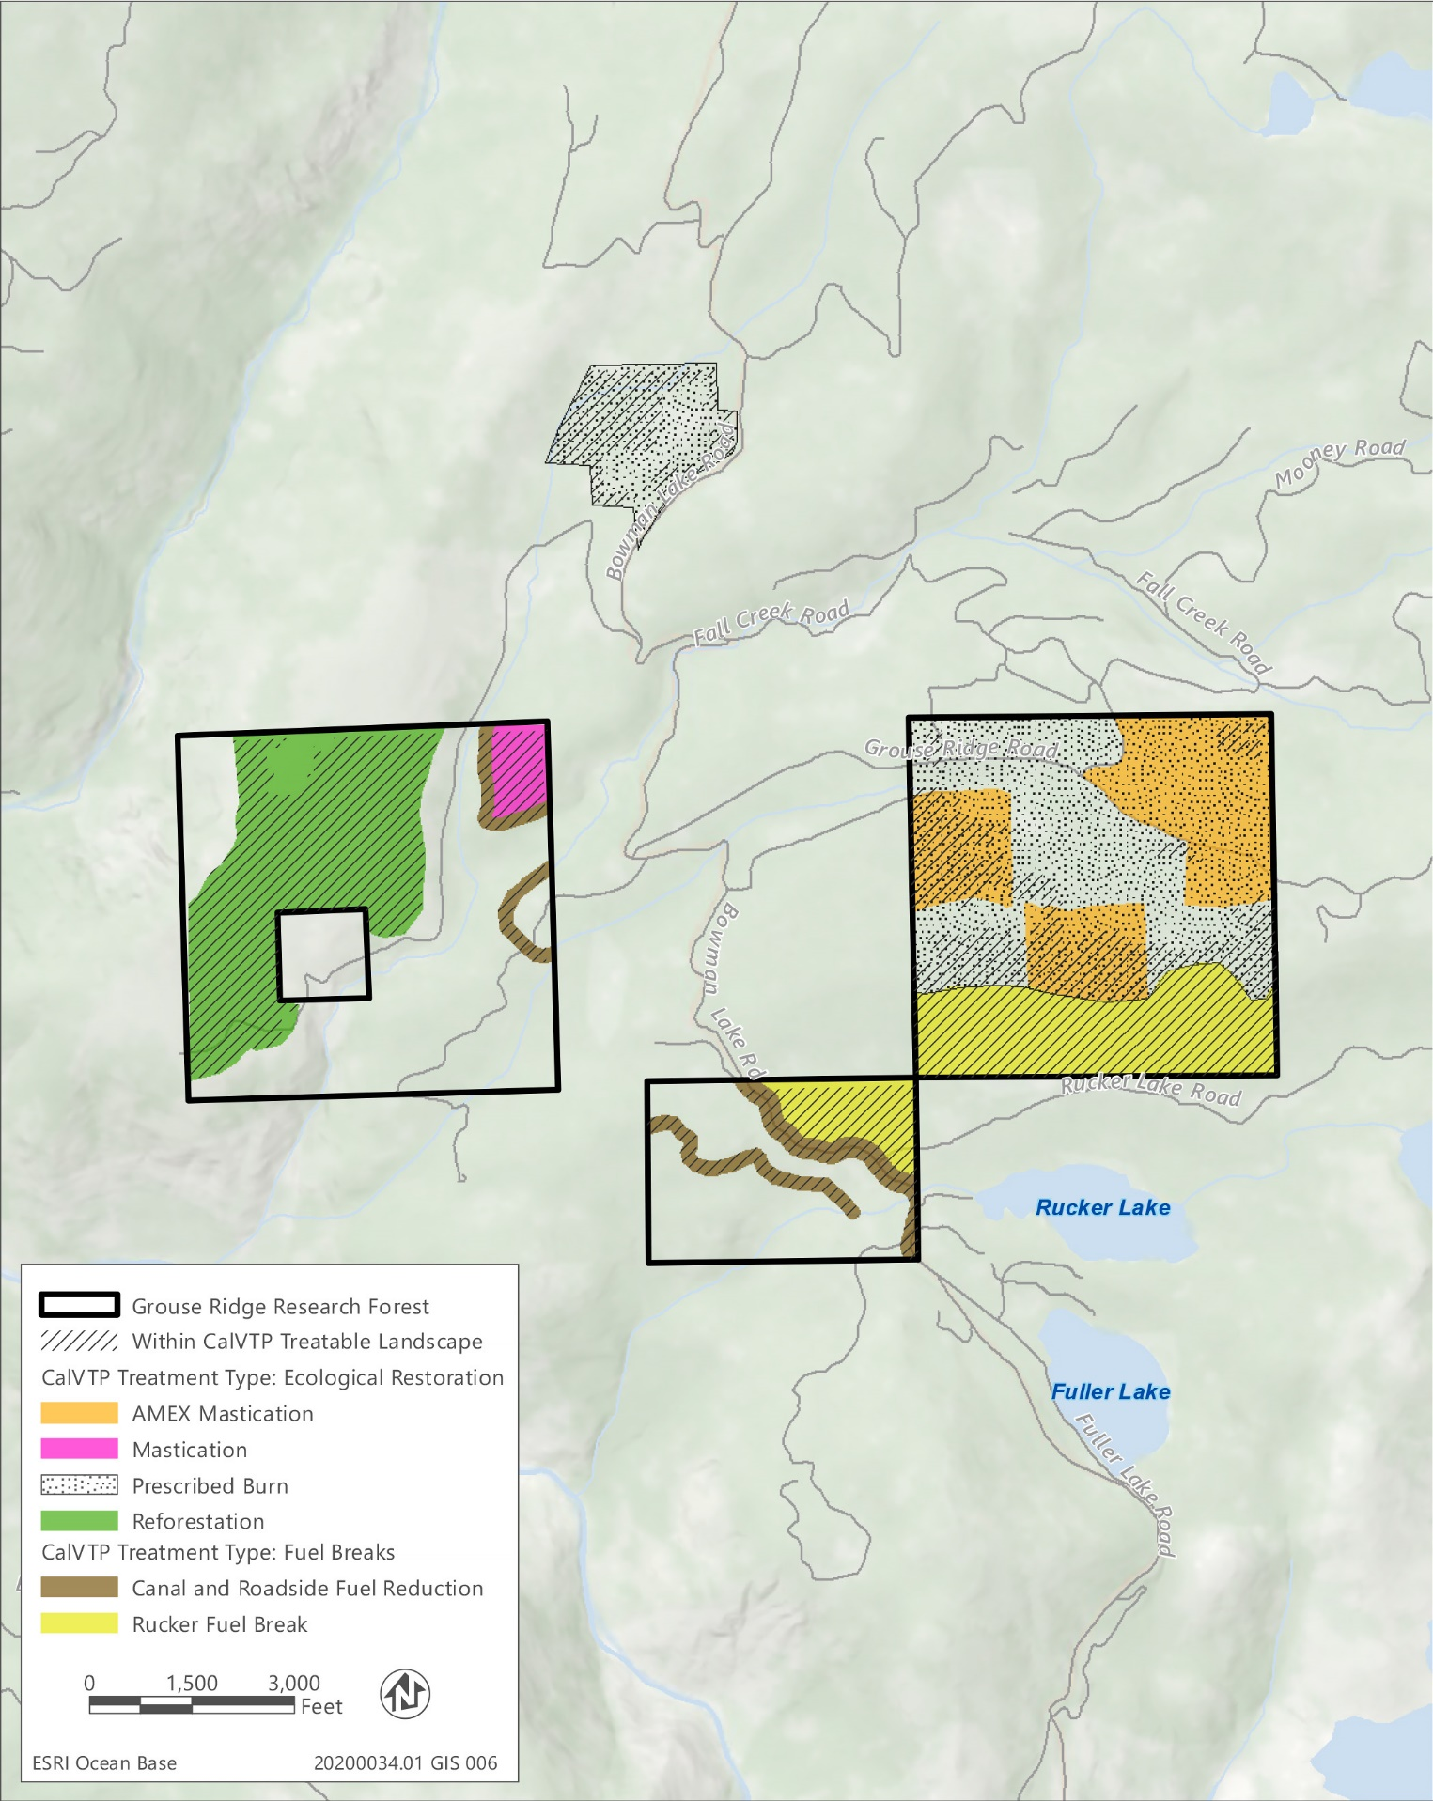
Grouse Ridge Vegetation Treatment Project Treatment Areas

