Table of Contents
1. Overview 1
1.1 Purpose and Content 1
1.2 Moraga-Orinda Fire District Responsibility for Fire Protection in Orinda 2
1.3 Relationship to Other Local Plans and Codes 2
1.4 Community Profile 8
1.5 Climate Change Vulnerability 9
2. Public Safety Issues 13
2.1 Emergency Preparation and Response 13
2.2 Flood and Inundation Hazards 22
2.3 Seismic and Geologic Hazards 29
2.4 Fire Hazards 39
2.5 Hazardous Waste and Materials 48
2.6 Additional Climate-Related Hazards 49
3. Goals, Policies, and Actions 56
3.1 Emergency Preparation and Response 56
3.2 Flood and Inundation Hazards 58
3.3 Seismic and Geologic Hazards 59
3.4 Fire Hazards 61
3.5 Hazardous Waste and Materials 63
3.6 Additional Climate-Related Hazards 64
Appendix
Appendix A: Vulnerability Assessment Results 74
Tables
Table 1 Implementation Measures 66
Figures
Figure 1 Residential Parcels with Evacuation Constraints 16
Figure 2 Evacuation Routes 17
Figure 3 Evacuation Constraints (Scenario 1) 19
Figure 4 Evacuation Constraints (Scenario 2) 20
Figure 5 Evacuation Constraints (Scenario 3) 21
Figure 6 Flood Hazard Zones 24
Figure 7 Dam Inundation 27
Figure 8 Regional Fault Lines 31
Figure 9 Liquefaction Hazard Zones 34
Figure 10 Landslide Susceptibility 37
Figure 11 Wildfire Hazard Severity Zones 43
Figure 12 Wildland-Urban Interface Zones 44
Figure 13 Land Uses in the Very High Wildfire Hazard Severity Zone 45
Figure 14 Historic Wildfire Burned Areas 47

Overview

Purpose and Content
The Safety Element is a state-mandated General Plan element that must identify potential natural and human-created hazards that could affect the City of Orinda’s (City’s) residents, businesses, and services. The purpose of the Safety Element is to establish a framework that anticipates these hazards and prepares the community to minimize exposure to these risks.
The Safety Element conveys the City’s goals, policies, and actions to minimize the hazards to safety in and around Orinda. It identifies the natural and human-caused hazards that affect existing and future development, describes present and expected future conditions, and sets policies and standards for improved public safety. This includes efforts to minimize physical harm to the buildings and infrastructure in and around Orinda to reduce damage to local economic systems, community services, and ecosystems.
Some degree of risk is inevitable because the potential for many disasters cannot be eliminated completely, and the ability to predict such disasters is limited.
The Safety Element serves the following functions:
Develops a framework by which safety considerations are introduced into the land use planning process.
Facilitates the identification and mitigation of hazards for new development, and thus strengthens existing codes, project review, and permitting processes.
Presents policies directed at identifying and reducing hazards in existing development.
Strengthens earthquake, flood, dam inundation, and wildland fire preparedness planning and post-disaster reconstruction policies.
Identifies how natural and climate-related hazards are likely to increase in frequency and intensity in the future and provides policies to increase community resilience through preparedness and adaptation.
The Safety Element addresses the topic of public health and safety following state requirements, as presented in Section 65302(g) of the California Government Code. State law requires that the Safety Element contains background information and policies to address multiple natural hazards, analyze the vulnerabilities from climate change and contain policies to improve climate change resilience, and assess residential areas with evacuation constraints. The public safety issues in Orinda include emergency preparedness and response, flood and inundation hazards, seismic and geologic hazards, fire hazards, hazardous waste and materials, as well as other climate-related hazards, such as drought, extreme heat, and severe weather. The Safety Element identifies goals and policies for each of these hazards. The policies in the Safety Element are intended to be high-level policies that provide a framework for safety efforts and guide decision making. These policies are carried out by corresponding implementation measures which are actions, procedures, programs, or techniques.

Moraga-Orinda Fire District Responsibility for Fire Protection in Orinda
The Moraga-Orinda Fire District (MOFD) provides fire protection and paramedic services in Orinda. MOFD was formed on July 1, 1997, as a fully integrated, independent special district. It was formed through the consolidation of the Moraga Fire Protection District and the Orinda Fire Protection District to provide more efficient fire protection and emergency medical services to the communities of Moraga and Orinda and the surrounding unincorporated areas, including the communities of Canyon and Bollinger Canyon.
MOFD encompasses 42 square miles, protecting approximately 38,500 residents in a combination of urban city centers; consisting of a combination of metropolitan, urban, suburban, and rural residential housing density areas; a major college campus; and a mix of large regional parks, open spaces, reservoirs, and recreation areas.
MOFD provides professional fire protection services to the communities of Moraga, Orinda, and Canyon. The City of Orinda also maintains a comprehensive Automatic Aid Agreement for fire protection and emergency medical aid services with neighboring agencies, including Contra Costa Fire Protection District, Berkeley Fire Department, Oakland Fire Department, the El Cerrito-Kensington Fire Department, and CAL FIRE. The City of Orinda is signatory to the California Mutual Aid Fire Protection System (Coastal Region [Mutual Aid Region II]). The mutual aid agreement covers fire, police, medical, communication, and transportation services and facilities. Alameda County is the Regional Mutual Air Coordinator for Law and Emergency Medical Services and Contra Costa County is the Regional Mutual Aid Coordinator for Fire. This agreement was established to aid with major emergency incidents anywhere in the state. Orinda also participates in state and local mutual aid agreements for emergency management, coroner, and petrochemical response services and with the Red Cross, California Resiliency Alliance, Volunteer Center of the East Bay, and Contra Costa Crisis Center.

Relationship to Other Local Plans and Codes
The Orinda Safety Element does not exist in a vacuum but is instead one of several plans that address community public safety and related topics. These other plans include other General Plan elements, the Contra Costa County Local Hazard Mitigation Plan, the Contra Costa Countywide Community Wildfire Protection Plan, the Moraga-Orinda Fire District Community Wildfire Protection Plan, and various local regulations. The Safety Element should be consistent with these other plans to minimize conflicts between documents and ensure that the City has a unified strategy to address public safety issues. The Safety Element incorporates information, technical analyses, and policies from these other documents where appropriate to help support this consistency.

General Plan Elements
The Orinda General Plan was adopted in 1987. It includes an introduction and four chapters, which cover seven state-mandated elements:
Land Use and Circulation Chapter (containing the Land Use Element; the Open Space, Parks, Schools, and Utilities Element; and the Circulation Element)
Housing Element
Environmental Resources Chapter (containing the Conservation Element, the Safety Element, and the Noise Element)
Growth Management Element
The Safety Element provides policy direction and designs safety improvements that complement the intent and policies of other General Plan elements. Crucial relationships exist between the Safety Element and the other General Plan elements. How land uses are determined in areas prone to natural hazards, what regulations limit development in these areas, and how hazards are mitigated for existing development, are all among issues that tie the elements together. For instance, the Land Use and Circulation Chapter diagrams and policies must consider the potential for various hazards identified in the Safety Element and must be consistent with the policies to address those hazards. The Conservation Element in the Environmental Resources Chapter is also closely tied to the Safety Element. Floodplains, for example, are not only hazard areas, but often serve as sensitive habitat for threatened or endangered species or provide recreation or passive open space opportunities for residents and visitors. As such, flood and inundation policies balance the need to protect public health and safety with the need to protect habitat and open space. Safety Element policies, especially those concerning evacuation routes and critical facilities, must also be consistent with those of the Land Use and Circulation Chapter. State Route 24 is Orinda’s primary evacuation route, supported by routes designated as major or primary arterials in the city. This Safety Element is consistent with the other elements of the Orinda General Plan.

Contra Costa County Local Hazard Mitigation Plan
In collaboration with the City and other local agencies and special districts, the County of Contra Costa prepared the 2018 Local Hazard Mitigation Plan (LHMP) in accordance with the federal Disaster Mitigation Act of 2000 and the Federal Emergency Management Agency’s (FEMA’s) LHMP guidance. Contra Costa County’s LHMP is a plan that assesses hazard vulnerabilities from natural and human-caused hazards, including risk to people and facilities, and identifies mitigation actions to reduce or eliminate hazard risks in Contra Costa County, including in incorporated communities. The LHMP includes a dedicated annex for Orinda, which discusses Orinda’s characteristics and history, development trends, hazard mitigation capabilities, integration with other hazard mitigation planning efforts, and vulnerabilities of specific facilities and infrastructure. The mitigation actions in the LHMP include both short-term and long-term strategies, and involve planning, policy changes, programs, projects, and other activities. These mitigation actions are identified based on assessments of hazards, vulnerabilities, and risks and the participation of a wide range of stakeholders and the public in the planning process. Local governments are required to develop a hazard mitigation plan as a condition for receiving certain types of non-emergency disaster assistance.
The LHMP and Safety Element address similar issues, but the Safety Element provides a higher-level framework and set of policies that pertain to the safety of the city, while the LHMP focuses on more specific mitigation, often short-term, actions to enable jurisdictions to better protect lives, property, and natural systems. The LHMP, as its name implies, focuses on mitigation-related actions, while the Safety Element also includes policies related to emergency response, recovery, and preparation activities. LHMPs form the foundation for a community’s long-term strategy to reduce disaster losses and break the cycle of disaster damage, reconstruction, and repeated damage. The current 2018 LHMP, certified by FEMA, is incorporated into this Safety Element by reference, as permitted by California Government Code Section 65302.6. It is available online at: https://www.contracosta.ca.gov/6415/Local-Hazard-Mitigation-Plan.

Contra Costa Countywide Community Wildfire Protection Plan
In collaboration with the Contra Costa County Fire Chiefs Association, Hills Emergency Forum, and stakeholder committee members, the Diablo Fire Safe Council prepared and published the 2019 Contra Costa Countywide Community Wildfire Protection Plan (CWPP). The Contra Costa Countywide CWPP is the result of an area-wide planning effort. It provides a snapshot of current wildfire protection challenges and capabilities, identifies, and prioritizes areas for hazardous fuel reduction, and recommends types and methods of vegetation management that may help protect the affiliated communities from wildfire losses. The goal of the plan is to reduce hazards through increased information and education about wildfires, hazardous fuels reduction, actions to reduce structure ignitability and other recommendations to assist emergency preparedness and fire-suppression efforts. Most notably, it is intended to help facilitate a coordinated effort between the various stakeholders. The Contra Costa Countywide CWPP complements local agreements and existing plans for wildfire protection for a coordinated effort in determining appropriate fire management actions. The fire protection agencies in Contra Costa County, including MOFD, are predominately responsible for implementing the CWPP.

Moraga-Orinda Wildfire Action Plan / Moraga-Orinda Fire District Community Wildfire Protection Plan
The Moraga-Orinda Wildfire Action Plan/Moraga-Orinda Fire District Community Wildfire Protection Plan (MOFD CWPP) is an appendix to the Contra Costa Countywide CWPP and provides an analysis of wildfire hazards and risks in the communities MOFD serves. This document enhances long-standing collaboration between local agencies and organizations and existing plans for wildfire protection to create a coordinated effort to determine appropriate wildfire management actions. The MOFD CWPP looks at similar issues found in the Contra Costa Countywide CWPP but allows for a more detailed evaluation and customized recommendations for MOFD communities. The goal of the MOFD CWPP is to reduce wildfire risks through increased education, hazardous fuel reduction, progressive fire code adoption, and increased inspection and enforcement of defensible space regulations to reduce structure ignitability and other recommendations to assist emergency preparedness and fire-suppression efforts. The MOFD CWPP is intended to be a multi-year document that identifies and organizes efforts in a collaborative and mutually supporting manner.

Fire Codes

California Fire Code
The California Fire Code contains regulations related to the construction, operation, and demolition of buildings and other structures to minimize the risk of fire and explosion. It is consistent with nationally recognized and accepted practices for safeguarding life and property from the hazards of fire and explosion; reducing dangerous conditions arising from the storage, handling, and use of hazardous materials and devices; and minimizing hazardous conditions in the use or occupancy of buildings or premises. The California Fire Code also contains provisions to assist emergency response personnel. Every three years, new editions of the state codes are published. The new codes and local amendments reflect changes in technology, fire safety techniques, and the building industry. Effective January 1, 2020, these codes became the minimum standards for the State of California. Title 14, Division 1.5, Chapter 7 of the California Code of Regulations establishes state responsibility areas (SRAs) and Fire Safe Regulations for those areas, as well as in Very High Fire Hazard Severity Zones (FHSZs) in local responsibility areas (LRAs), which include Orinda. These regulations constitute the basic wildland fire protection standards of the California Board of Forestry and establish minimum wildfire protection standards in conjunction with building, construction, and development in SRAs. Article 2 includes fire extinguisher test standards and procedures, Article 2 includes fire-prevention standards for multiposition small engines, and Article 5 includes standards for cooperative fire-protection contracts during the non-fire season.
MOFD has made amendments to the California Fire Code due to existing climatic, geologic, and topographical conditions in Orinda and elsewhere in MOFD’s service territory. These amendments are described in detail in the text that follows and establish additional standards and regulations for the activities covered in the California Fire Code, going beyond the statewide code. MOFD evaluated the local amendments to the California Fire Code as a tool for addressing the fire problem and concerns within its territory, which will establish and maintain an environment for a high level of fire and life safety to all persons who work and live within MOFD boundaries. MOFD is the lead for local implementation of the California Fire Code. The City also ratified the California Fire Code as part of its California Building Code adoption process.
The California Fire Code (and Building Code) is required to be renewed every 3 years. The deadline for adoption of the next Fire Code is January 1, 2023.

California Fire Code – Ordinance NO. 20-01
On September 22, 2020, MOFD completed the ratification process for Ordinance 20-01 Fire Code adoption. This Ordinance adopted the 2019 California Fire Code with certain amendments, and by reference, the 2018 International Fire Code, published by the International Code Council. By adopting the 2019 Fire Code, MOFD enforces a code that is consistent with state regulations. Amendments include definitions such as clearly defined Fire Protection Plans and where they will be required, general safety provisions such as banning the use of combustible ground cover, fire service features, and fire protection and life safety systems. It also includes exterior hazard abatement requirements, which are intended to identify hazard areas and mitigate the risk to life and structures from wildland fire exposures, fire exposures from adjacent structures, and mitigate fires from spreading to or from wildland fuels that may threaten life, overwhelm fire suppression capabilities, or result in property loss. Other amendments involve fire, fire safety during construction and demolition, water supply for fire protection, general provisions for hazardous materials, and the prohibition of explosives and fireworks. The new fire code requirements took effect October 7, 2020.

Fuels Mitigation and Fire Prevention

Wildland Urban Interface – Fire Area Ordinance 20-02
On June 17, 2020, the MOFD Board of Directors adopted Ordinance 20-02. This Ordinance designates certain identified areas within MOFD’s territory as a wildland-urban interface (WUI) fire area, meaning that homes and other structures are built in areas of flammable wild vegetation, and therefore, the area is at significant risk from wildfires. Consequently, the designation of most of Orinda as WUI areas requires that newly constructed buildings meet heightened standards for fire-safe construction and landscaping to protect the buildings and occupants.

Burn Ban Ordinance 20-03
On July 15, 2020, the MOFD adopted Ordinance 20-03, which established requirements and restrictions pertaining to banning open burning and recreational fires during high fire conditions and provides enforcement options and penalties. Every year, open burning, campfires, bonfires, and recreational fires escape control and require an emergency response from fire agencies. This Ordinance reduced the threat posed by uncontrolled wildfire by restricting the time of year that open burning is allowed. It also places restrictions on fires during hazardous fire conditions. Open burning on all lands within the jurisdiction of MOFD is prohibited when CAL FIRE issues a burn suspension in SRAs. Open burning is also prohibited on all lands within the jurisdiction of MOFD at any time the Fire Chief or their designee finds that atmospheric conditions or other local circumstances present a hazard to the community. The prohibition on open burning applies to open burning, campfires, bonfires, portable outdoor fireplaces, ceremonial fires, and recreational fires, as defined in the 2019 California Fire Code.

MOFD Ordinance 22-02
On March 16, 2022, the MOFD Board of Directors adopted Ordinance 22-02, which established requirements for undeveloped parcels and certain low-density, large, developed parcels. This ordinance requires these parcels within MOFD’s territory (i.e., all parcels within the City of Orinda) to follow a set of fuel break standards to protect against uncontrolled wildfire spread. Fuel breaks are a critical tool intended to reduce fire spread rates and intensity to allow the timely containment of wildfire. This ordinance requires that the creation of fuel breaks do not result in the taking of endangered, rare, or threatened plant or animal species, significant erosion, or sedimentation of surface waters. A request to modify the fuel break requirements may be permitted if these conditions make it impractical to create and maintain a required fuel break.
Select Community Efforts to Improve Safety and Resiliency
The City and its local partners, including MOFD, already have several policies and programs in place to help protect the community from wildfires and other hazards. Some of the established programs include:
Reg Flag Days
During red flag days (days when weather conditions create an elevated risk of a wildfire breaking out), the City imposes parking restrictions on both sides of El Toyonal starting from the eastern edge of Camino Pablo to ending at the intersection of Vista Del Orinda, as well as both sides of Loma Vista Drive. Because some roadways within the city are emergency vehicle access roads and inaccessible to the public the City or MOFD would need to open these roadways to provide access during an emergency evacuation event to help ensure safe evacuations and emergency vehicle access in the neighborhood. In 2022, the City Council authorized expansion of Red Flag Day parking restrictions in the Miner Road area and those will be implemented in the Spring of 2023.
Community Wood Chipping Program
As part of MOFD’s fuel mitigation efforts, the District enacted a Wood Chipper Program which operates seasonally and is intended to assist residents in reducing vegetation by facilitating the chipping of material produced in quantities too large for green bins and too small for commercial chipping providers. Starting in 2021, the City also offers a year round chipper service to Orinda residents.
Building and Fire Codes
MOFD has made amendments to the California Fire Code due to existing climatic, geologic, and topographical conditions in Orinda and elsewhere in MOFD’s service territory. These amendments establish additional standards and regulations for the activities covered in the California Fire Code, going beyond the statewide code. The City also ratified the California Fire Code as part of its California Building Code adoption process. To minimize fire damage and loss, the City’s building Code and MOFD’s Fire Code, based on California Code of Regulation Title 24, sets standards for building and construction. It requires the provision of adequate water supply for firefighting, fire-retardant construction, and minimum street widths, among other things.

Fire Prevention Efforts by Other Agencies

East Bay Municipal Utilities District
Every year in preparation for the fire season, the East Bay Municipal Utilities District (EBMUD) plans vegetation management and weed abatement activities around their facilities and along their rights-of-way. These activities include mowing, weeding, pruning, trimming, chipping, the use of goats, and herbicide application. EBMUD also leases some of their watershed lands for cattle and horse grazing, which provides additional vegetation management.
If a PSPS occurs, the power outage may affect any of EBMUD’s water facilities. Outages are expected to last up to two days; however, depending on weather conditions and power restoration efforts some outages may last longer. A PSPS event could force EBMUD to switch to backup generators and pumps to power pumping plants, water treatment plants and other key facilities to keep water flowing, maintain storage and fire flow, and keep water distribution lines pressurized. In advance of a PSPS event, EBMUD stations portable generators and pumps at designated key facilities, fills water tanks to near maximum capacity, and works to keep generators fueled during peak demand periods.

East Bay Regional Park District
The East Bay Regional Park District (EBRPD) has been implementing fuel management practices for decades. As EBRPD’s fuels management activities have expanded, the Stewardship Department has played an increasingly large role in the fuel management program, which includes:
- Clearing heavy underbrush and thinning dense park forests.
- Reducing vegetation with cattle, goat, and sheep grazing.
- Removing hazardous trees.
- Monitoring effects on habitat and wildlife populations.
Each year EBRPD thins and removes hazardous vegetation on over 1,000 acres to reduce fire hazards. EBRPD also recently received fire hazard reduction grant funding from FEMA.

Pacific Gas and Electric Company
PG&E’s 2022 Wildfire Mitigation Plan outlines PG&E's program to reduce wildfires. Key strategies in this plan include:
- Undergrounding utility lines: PG&E has a program to underground 10,000 circuit miles of distribution lines in areas of high fire threats, eliminating the ignition risk for these power lines.
- Increased safety settings: Configuring electrical equipment on power lines to automatically shut off power if an object comes into contact with a distribution line.
- Vegetation management: Continuing vegetation management activities.
- Enhanced inspections: Providing more frequent and detailed inspections of power lines.
PG&E is undergrounding powerlines in areas with the greatest impact on reducing wildfire risk and outages for their customers. In Contra Costa County, PG&E is planning to complete approximately six miles of undergrounding this year. In Orinda, the City is working with PG&E on a $1.5 million undergrounding project just north of El Toyonal Road which is estimated to begin construction in 2024. Additionally, PG&E recently completed less than one mile of undergrounding work in Orinda near Lost Valley Road and Don Gabriel Way as part of their wildfire safety efforts.

Community Profile
The City of Orinda is in the western portion of Contra Costa County, covering approximately 12.7 square miles. The topography in Orinda varies from low-lying valleys to rolling hills. Orinda is a semi-rural community characterized by hilly oak woodlands and multiple creek tributaries that feed San Pablo Creek. The city is bisected by State Route (SR-) 24 and the Bay Area Rapid Transit (BART) tracks. Orinda is a nearly built-out residential community with large undeveloped watershed lands north and west of the city, and a compact downtown on both sides of SR-24.
Orinda is home to approximately 19,078 residents and 7,167 households and supports about 5,495 jobs. The Orinda Union School District is the largest employer in the city with about 335 employees. There are five Orinda Union School District Schools, which include Del Rey Elementary, Glorietta Elementary School, Sleepy Hollow Elementary, Wagner Ranch Elementary, and Orinda Intermediate School. Orinda also contains Miramonte High School, part of the Acalanes High School District.
In 2019, the median age of all people in Orinda was 48.7. There were 4,449 residents aged 65 and older in 2019, which represents approximately 22.6 percent of the population. The five largest ethnic groups in Orinda are White (Non-Hispanic) (72%), Asian (Non-Hispanic) (16%), two or more (non-Hispanic) (5.12%), White (Hispanic) (3.97%), and two or more (Hispanic) (1.22%).
Orinda has a Mediterranean climate, with rain in the winters and hot, dry summers. Hot and dry Diablo winds occur in the fall and spring. Winter rains fall from November to April. On average, annual high temperatures in Orinda range from 58 degrees Fahrenheit (°F) in January to 78°F in August. Low temperatures range from 42°F in January to 56°F in August. The city receives an average of approximately 24.99 inches of precipitation annually. Most precipitation falls during the winter months with rare occurrences of summer storms.
Orinda’s primary transportation access is from SR-24. SR-24 connects Orinda to SR-13, Oakland, and Alameda County to the west, and Lafayette and Interstate 680 to the east. Other major roadways include Camino Pablo and Moraga Way. County Connection provides local bus transit options, and BART provides regional rail transit services.

Climate Change Vulnerability
Changes to the global climate system are expected to affect future occurrences of natural hazards in and around Orinda. Many hazards are projected to become more frequent and intense in coming years and decades, and in some cases, these trends have already begun. Key climate change considerations that affect Orinda include increasing temperatures and changes in precipitation. Overall, precipitation levels are expected to decrease slightly, with more years of extreme precipitation events and droughts that last longer and are more intense. According to California’s Fourth Climate Change Assessment, Orinda can expect to experience various changes to climate-related hazard events.
What is vulnerability?
Vulnerability is the degree to which natural, built, and human systems are susceptible to harm from exposure to stresses associated with environmental and social change and from the absence of a capacity to adapt.
Source: California Governor’s Office of Emergency Services. 20202. California Adaptation Planning Guide. https://www.caloes.ca.gov/climate.
Wildfire risk in Orinda is high and hotter, drier weather because of climate change, is expected to lead to an increase in wildfires in the surrounding area and across Contra Costa County. Climate change is expected to cause an extended wildfire season. Dry conditions are anticipated earlier in the year, leaving most of the region in moderate to extreme drought conditions prior to summer. These continued dry conditions with above-normal temperatures through spring will leave fuel moisture levels lower than normal increasing the potential for wildfire activity. Increased winds will result in more erratic fire behavior, making fires harder to control. Furthermore, an extended wildfire season increases the likelihood that Diablo wind events coincide with wildfires, which can allow wildfires to spread more rapidly. Across the region, more frequent and intense wildfires may also create poor air quality for Orinda.
Increasing local and regional fire frequency can create recurring air quality degradation events leading to respiratory health impacts. Increased air emissions from urban growth and development may also add to these air quality problems. Health impacts associated with air pollution are typically most severe for young children, senior citizens, and those already suffering from respiratory or cardiovascular disease. Outdoor workers, individuals experiencing homelessness, and others who may experience particularly high levels of air pollution exposure are also vulnerable.
Warmer temperatures are projected to cause an increase in extreme heat events. The number of extreme heat days, defined in Orinda as a day when the high temperature is at least 91.4°F, is expected to rise from a historical annual average of 4 to 15 by the middle of the century (2035 to 2064), and to an average of 27 by the end of the century (2070 to 2099). In addition to the increases in extreme heat events, Orinda is expected to see an increase in the average daily high temperatures. The number of warm nights, defined in Orinda as a day in April through October when the minimum temperature is above 58.3°F, is expected to rise from a historical annual average of 6 to 53 by the middle of the century (2035 to 2064), and to an average of 117 by the end of the century (2070 to 2099). Extreme heat and warm nights pose a significant human health risk, especially to senior citizens, outdoor workers, and persons who do not have access to adequate cooling, including people experiencing homelessness. Some buildings and infrastructure systems may be damaged by very high temperatures, constraining their ability to meet community needs.
Both droughts and floods are expected to become more frequent as rainfall is expected to occur in fewer, more intense storms due to climate change. Although Orinda is likely to experience minimal change in overall annual precipitation levels from climate change, the region is also expected to see an increase in the number of extreme precipitation events. As a result, floods are expected to occur more often in Orinda, and climate change may expand the parts of the city that are considered prone to flood. Climate change is expected to also increase the frequency and severity of droughts that cause soil to dry out and condense. When precipitation does return, dry ground means that more water runs off the surface rather than being absorbed into the ground, which can lead to floods and result in debris flows along slopes and hillsides.
Severe weather events, such as strong storms and high winds, may become more frequent and intense due to climate change. Climate change is expected to cause an increase in intense rainfall, which is usually associated with strong storm systems. Heavy rainfall may also contribute to an increased risk of landslides in the hills around Orinda. In Orinda, most severe weather consists of atmospheric rivers, heavy rains, or thunderstorms. The types of dangers posed by severe weather vary widely and include injuries or deaths, damage to buildings and structures, fallen trees, roads blocked by debris, and fires sparked by lightning.
Climate change can increase the rates of infection for various diseases because many of the animals that carry diseases are more active during warmer weather. There are a number of diseases that are linked to climate change and can be harmful to the health of Orinda community members, such as hantavirus pulmonary syndrome, Lyme disease, and West Nile fever. Many of these diseases are carried by animals, such as mice and rats, ticks, and mosquitos, which are usually seen as pests even if they do not cause infections. Warmer temperatures earlier in the spring and later in the winter can cause these animals to be active for longer periods, increasing the time that these diseases can be transmitted.

Vulnerability Assessment Results
Under California law, the Safety Element is required to include a vulnerability assessment that looks at how people, buildings, infrastructure, and other key community assets may be affected by climate change. The City conducted a Climate Change Vulnerability Assessment in the winter of 2022 to analyze Orinda’s susceptibility to climate-related hazards. Orinda’s vulnerability assessment, prepared in accordance with the most recent available guidance in the California Adaptation Planning Guide, assesses how seven different climate-related hazards (drought, extreme heat, flooding, human health hazards, landslides, severe storms, and wildfire and smoke) may affect 53 different population groups and community assets. Each population or asset received a score of V1 (minimal vulnerability) to V5 (severe vulnerability) for each climate-related hazard. The Climate Change Vulnerability Assessment indicates that Orinda’s populations and assets are most vulnerable to wildfire and smoke, severe storms, and landslides. Overall, populations in Orinda tend to be most vulnerable to wildfire and smoke, extreme heat, human health hazards, and flooding, which directly affect health outcomes. The most vulnerable communities include households in poverty, seniors living alone, persons with chronic illness and/or disabilities, and low-resourced people of color.
Citywide, energy delivery is vulnerable to multiple hazards, including severe storms, such as high winds that can trigger public safety power shutoff (PSPS) events, extreme heat that reduces the capacity and strains the system, and wildfires that damage the system, ultimately disrupting energy service. Furthermore, energy delivery services, specifically electricity delivery, is subject to harm during extreme heat events. Extreme heat can lead to power outages by causing mechanical failure of grid equipment, heat damage to power lines, and by creating a high demand for electricity to power air conditioners, all of which place stress on the network. This is likely to lead to greater service disruptions. These conditions can damage communication infrastructure, decreasing network capacity. There may be a higher demand for communication services during severe storms, potentially putting stress on the network and increasing the risk of service interruptions.
PSPS events or interruptions in energy service can create vulnerabilities for Orinda community members. A loss of electricity can cause a loss of refrigeration for food and medical supplies, limit cooking, cause loss of cooling (particularly dangerous during extreme heat events), lighting, and limited or no access to the Internet or other information systems. Many businesses are forced to close during a power outage, causing economic hardships and depriving community members of important services, such as grocery stores, gas stations, and banks/ATMs. Power outages may also be harmful to people who depend on electrically powered medical devices.
Climate change is also expected in the parts of the city that are considered prone to flooding. As a result, homes and commercial properties within and adjacent to the 100-year floodplain (i.e., properties adjacent to San Pablo Creek) will likely experience an increase in the frequency and magnitude of flood events in future years. Increases in damaging flood events in the city are expected to cause greater property damage, public health and safety concerns, displacement, and loss of life. The City’s water treatment services may be impacted by flood events, which may damage water infrastructure and interrupt service. Increased flooding in the city may also impact the operation of the BART railway, roads, and bridges, as well as electrical substations and transmission lines.
Climate change could affect the transportation network and associated economic activity within Orinda by creating strain on transportation infrastructure, resulting in impacts to travel behavior, goods movement, and supply chain business continuity. Transportation infrastructure such as roadways, bridge supports, and railways are all potentially at increased risk due to severe storms, flash floods, higher temperatures, landslides, and increased wildfire risk. When parts of the transportation infrastructure network fail, typical travel routes for both passenger travel and goods movement may be affected, including SR-24 and other major roadways. Disruption of these local transportation roadways due to hazards such as flooding, landslides, or wildfire could significantly impact the transportation of goods and services provided in the city, the economic vitality of the community, and the livelihood of many businesses. Similarly, residents that rely on BART as a means of transportation for work could be greatly impacted by disruptions in the operation of the railway.
The Safety Element includes goals, policies, and implementation actions to increase community resilience and help lower vulnerability scores, particularly for the populations and assets that received a score of V4 or V5 in the Vulnerability Assessment. A full list of the Vulnerability Assessment results can be found in Appendix A.

Public Safety Issues
This section outlines the existing and likely future hazardous conditions and other public safety issues in Orinda and policy responses to these issues. The public safety issues in Orinda include:
Section 2.1: Emergency preparedness and response
Section 2.2: Flood and inundation hazards
Section 2.3: Seismic and geologic hazards
Section 2.4: Fire hazards
Section 2.5: Hazardous waste and materials
Section 2.6: Additional climate-related hazards (drought, extreme heat, and severe weather)
This section provides details pertaining to probable locations each hazard or issue is likely to occur (per availability of data), past notable events in and around Orinda, agencies responsible for providing protection from these public safety issues, and other background information required by the State of California Government Code Section 65302(g)(4). Goals and policies are identified following the discussion of each hazard identified, and implementation actions that support one or more of the Safety Element policies are provided in Table 1 at the end of this Safety Element.
The results of the Vulnerability Assessment are integrated into the hazards and other public safety issues previously mentioned.

Emergency Preparation and Response

Local Emergency Response
The Orinda Police Department and MOFD conduct emergency preparedness activities in Orinda. Local police services are provided by contract with the Contra Costa County Sheriff’s Department. MOFD’s Operations Division consists of emergency response personnel and equipment. MOFD is an “All-Risk” agency, providing a full range of emergency response services, including structural and wildland fire suppression, response to hazardous materials incidents, urban search and rescue, and basic and advanced life-support emergency medical services. The daily emergency response staffing for the entire fire district is 18 personnel. This staffing includes one battalion chief, four three-person engine companies, one three-person truck company, and four paramedic ambulances. All MOFD emergency response personnel are either emergency medical technicians (EMTs) or paramedics. The Operations Division assists the Fire Prevention Division with public education and information programs designed to prepare the citizens of MOFD for disasters and other emergency incidents. The Prevention Division also conducts routine fire inspections on apartment buildings in the community.
The truck and engine companies are staffed with at least one paramedic, and therefore have the ability to immediately administer advanced life support (ALS) pre-hospital emergency medical care upon their arrival. When a medical emergency is reported, the closest engine company is dispatched in conjunction with one of the three MOFD ambulances. In addition to MOFD’s ambulances, MOFD uses the services of private air ambulances (helicopters) to transport severely injured or burned patients to the appropriate Bay Area hospital.
In recent years, the County of Contra Costa has expanded its emergency preparedness planning. The County of Contra Costa is required under state law to prepare and maintain a Standardized Emergency Management System (SEMS) Multi-hazard Functional Plan. The California Governor’s Office of Emergency Services has extensive guidelines outlining the requirements of the Contra Costa County SEMS.

Community Warning Systems
Orinda uses the Contra Costa County Community Warning System (CWS) to notify residents and businesses within Contra Costa County that are impacted by, or are in danger of being impacted by, an emergency. The CWS provides basic information about incidents and what specific protective actions (shelter in place, lockdown, evacuate, avoid the area, etc.) are necessary to protect life and health. The CWS is a partnership of the Contra Costa County Office of the Sheriff, the Contra Costa County Health Services Department, other government agencies, industry, news media, and the non-profit Community Awareness and Emergency Response organization. Depending on the urgency, severity, and certainty of the threat, some combination of the following alerting devices may be activated to registered users with as much as notice as possible:
Sirens in special safety zones
Emergency Alert System (EAS) on television and radio (KCBS 740 AM)
Telephone Emergency Notification System
Cell phone alerts
National Oceanic and Atmospheric Administration (NOAA) weather radios
Twitter and Facebook
Alerts are distributed via voice, text, and email messages through the CWS Telephone Emergency Notification System. This computerized system makes telephone calls to the known telephone numbers in the vicinity of the hazard based on the incident-specific issues.
Other systems include the Emergency Alert Systems (EAS) and the Emergency Digital Information System (EDIS). The EAS is a national public warning system commonly used by state and local authorities to deliver important emergency information, such as weather and AMBER alerts, to affected communities. EAS participants – radio and television broadcasters, cable systems, satellite radio and television providers, and wireline video providers. FEMA, the Federal Communications System, and the NOAA’s National Weather Service (NWS) work collaboratively to maintain the EAS and Wireless Emergency Alerts, which are the two main components of the national public warning system and enable authorities at all levels of government to send urgent emergency information to the public. The EDIS is a wireless emergency and disaster information service operated by the State of California Governor’s Office of Emergency Services and is an enhancement to the EAS. These systems are available in multiple languages.

Emergency Evacuation
With advanced warning, evacuation can be effective in reducing injury and loss of life during a catastrophic event. Figure 1 shows residential parcels with evacuation constraints. All parcels within an evacuation constraint are in a least one hazard-prone area and may have only one emergency evacuation route. The lack of multiple emergency access points limits roadway access for these properties, which may create difficulties if there is a need to evacuate. Due to the hilly topography and suburban cul-de-sac design throughout the city, some neighborhoods have only one or two access points. As a result, access can easily be compromised during an emergency. The Sleepy Hollow and El Toyonal neighborhoods are particularly isolated. Figure 2 shows the potential evacuation routes throughout the city. Primary emergency access and evacuation routes include SR-24, which intersects the city from northeast to southwest, as well as Moraga Way and Camino Pablo (north-south roadways). Some roadways within the city are emergency vehicle access roads and inaccessible to the public. The City or MOFD would need to open these roadways to provide access during an emergency evacuation event. Orinda has imposed parking restrictions on El Toyonal during red flag days (days when weather conditions create an elevated risk of a wildfire breaking out) to help ensure safe evacuations and emergency vehicle access in the neighborhood. In 2022, the City Council approved the expansion of the Red Flag Day parking restrictions to the Miner Road area. The City is exploring enacting red flag day parking restrictions on additional roads.
In preparation for wildfires and other disasters, the City uses Zonehaven Aware, which is a comprehensive evacuation support system supported by the Contra Costa County CWS. Zonehaven Aware provides the community with critical evacuation updates, resources, and latest updates on active incidents. In the event of a wildfire or an emergency situation, the Orinda Police Department and MOFD can issue evacuation warnings or evacuation orders for impacted areas. These notices are issued for a zone with an evacuation status. In Orinda, the community is separated into 28 zones (i.e., Zone ORI-E001 through Zone ORI-E028). The County’s website has an interactive evacuation map lookup tool that enables residents with the ability to find possible evacuation routes based on their address and respective zone.
The City also has an established evacuation zone map with standardized evacuation zones. The City has 26 evacuation zones (i.e., ORI01 through ORI26), which differ somewhat from the zones in the Zonehaven Aware system. All evacuation routes in Orinda face a potential disruption from wildfire, flooding, or earthquake, which may block roadways, damage the roadway surface, or collapse bridges and overpasses. In the event of widespread disruption to local evacuation routes, remaining evacuation routes may become congested, slowing down evacuation of the community or specific neighborhoods. This issue may be compounded since evacuation routes for Orinda will also likely serve as evacuation routes for surrounding communities, and so potential disruptions may have regional effects.
- Residential Parcels with Evacuation Constraints
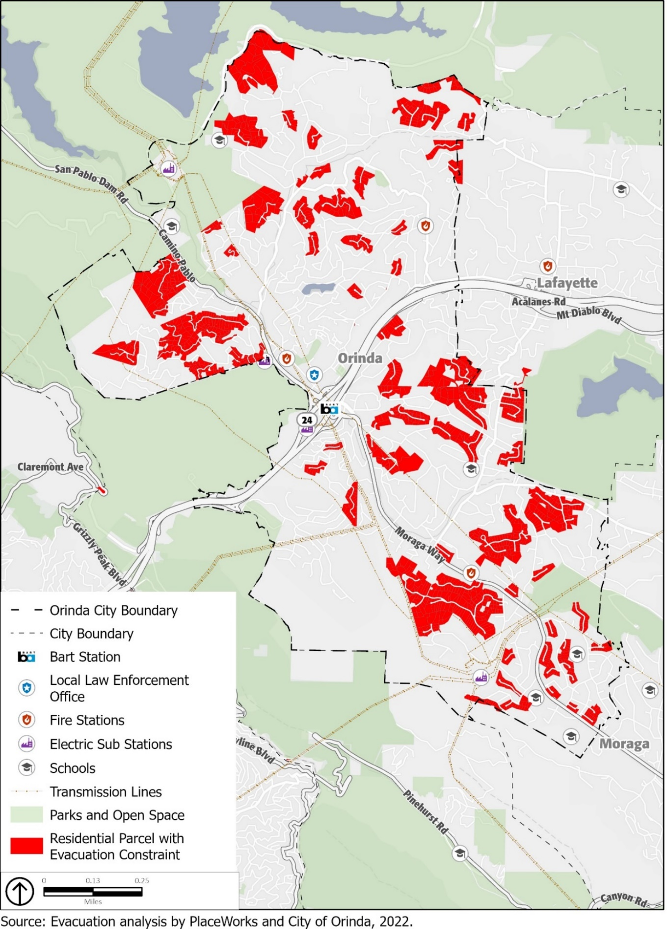
- Evacuation Routes
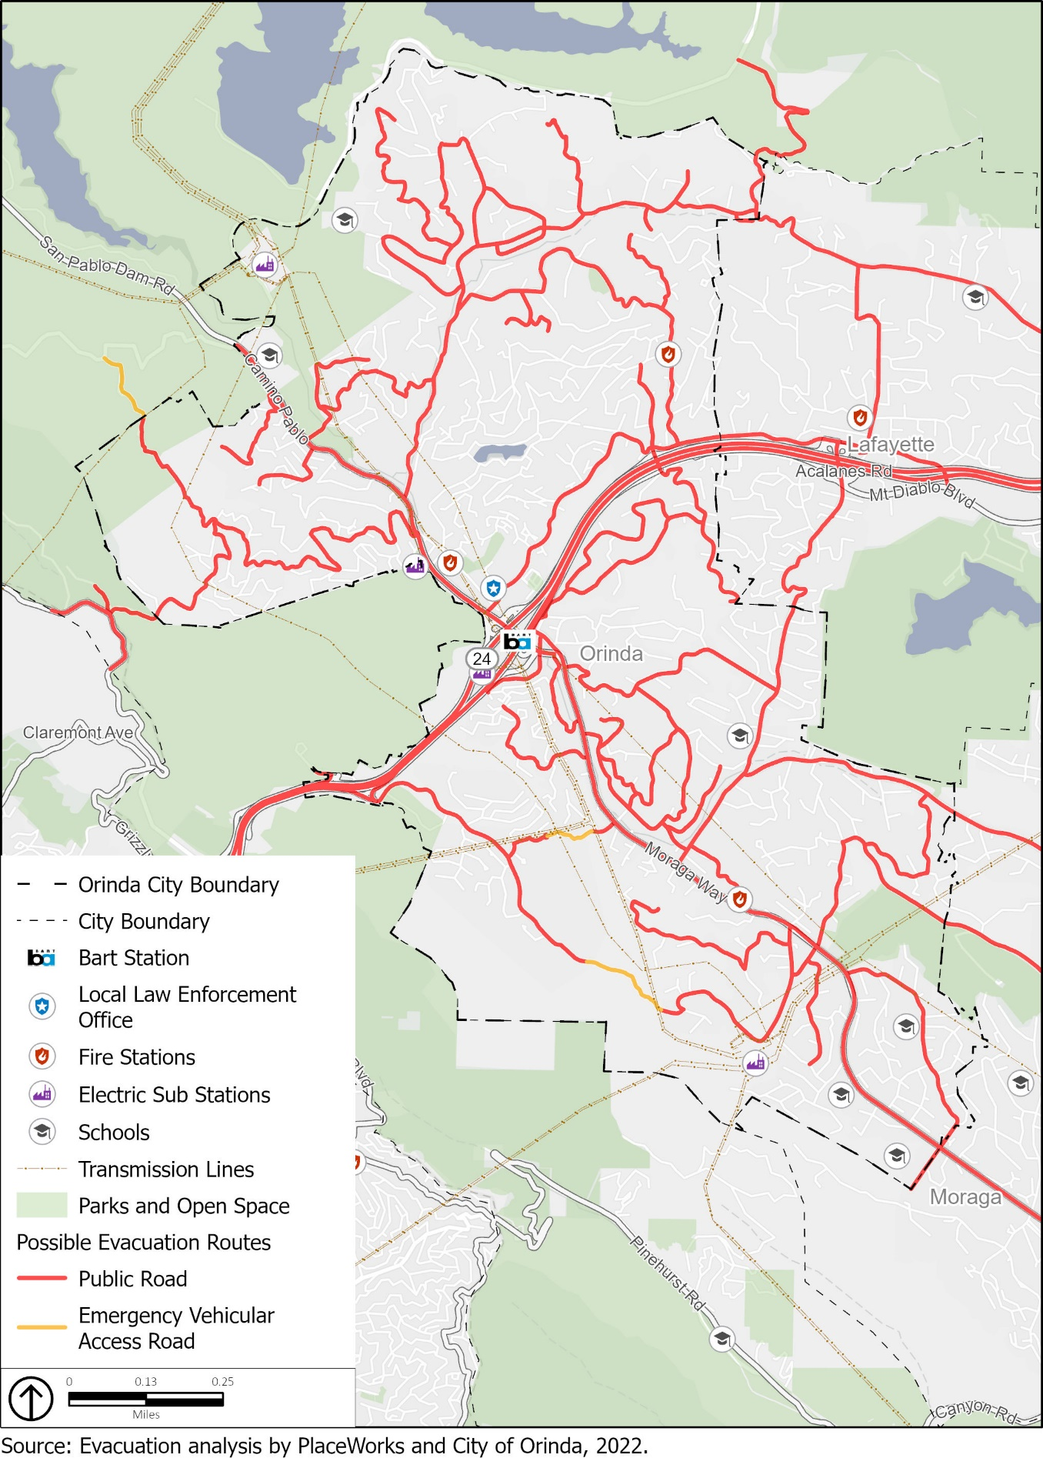

Evacuation Study
The City assessed likely evacuation routes and their capacity, safety, and viability under different evacuation scenarios as part of the City of Orinda Evacuation Analysis conducted in Fall 2022. The 2022 City of Orinda Evacuation Analysis is located on the City’s website at https://www.planorinda.com/safety-element. The Evacuation Analysis identifies the areas in Orinda where community members are likely to need the most time to evacuate and where there are higher concentrations of people who may need additional time or assistance evacuating. The analysis considers three emergency scenarios that may require an evacuation. It is a generalized analysis of how emergency conditions may affect evacuation behavior in Orinda and is not meant to model the particulars of any specific emergency event. Although the City prefers to conduct evacuations in phases using the zones discussed above, this analysis considers a mass evacuation of all of Orinda at once. This analysis also includes impacts of some Moraga and Lafayette residents evacuating using surface streets in Orinda.
For each scenario, the City considered which direction residents may evacuate in (referred to as a "safety gateway”), given the proximity and capacity of roadways. Most residents are expected to evacuate on SR-24 in either the eastbound or westbound directions, although some may evacuate toward San Pablo Dam Road, Grizzly Peak Boulevard, and others. Scenario 1 assumes that only SR-24 and Mt. Diablo Boulevard are available for evacuation. Scenario 2 assumes that three additional safety gateways in Orinda are open: San Pablo Dam Road, Shepherd Canyon Road, and Grizzly Peak Boulevard (plus Pinehurst Road, which would only be a viable evacuation route for some Moraga residents). Scenario 3 assumes SR-24, Mt. Diablo Boulevard, and Shepherd Canyon Road (plus Pinehurst Road for some Moraga residents) are open.
The City analyzed the capacity of intersections for each household between its residence and the preferred safety gateway and identified the level of congestion that is likely to occur during a widespread evacuation. Based on this analysis, the City can determine the neighborhoods that are likely to be the most traffic-constrained and so may need the longest time to evacuate. Additionally, the City considered that some people are likely to need more time or assistance evacuating. These persons include people without access to a personal vehicle or reliable communications, senior citizens, persons with disabilities, and families with young children. Areas with higher concentrations of people likely to need more time or assistance may add further constraints to the evacuation network.
In general, the areas with the least evacuation constraints are the neighborhoods along Wilder Road, along Camino Pablo/Moraga Way between Claremont Avenue and Brookside Drive, and along Bates Boulevard and Orindawoods Drive near SR-24. Neighborhoods along El Toyonal above Loma Vista Drive also have a low level of constraint in scenarios where it is feasible to evacuate northbound along San Pablo Dam Road.
The most constrained neighborhoods are those along Hall Drive, along Crestview Drive, and those south of Orinda Oaks Park. Figures 3, 4, and 5 show the levels of constraint for the three scenarios, along with Housing Element opportunity sites and potential development sites under the Downtown Precise Plan.
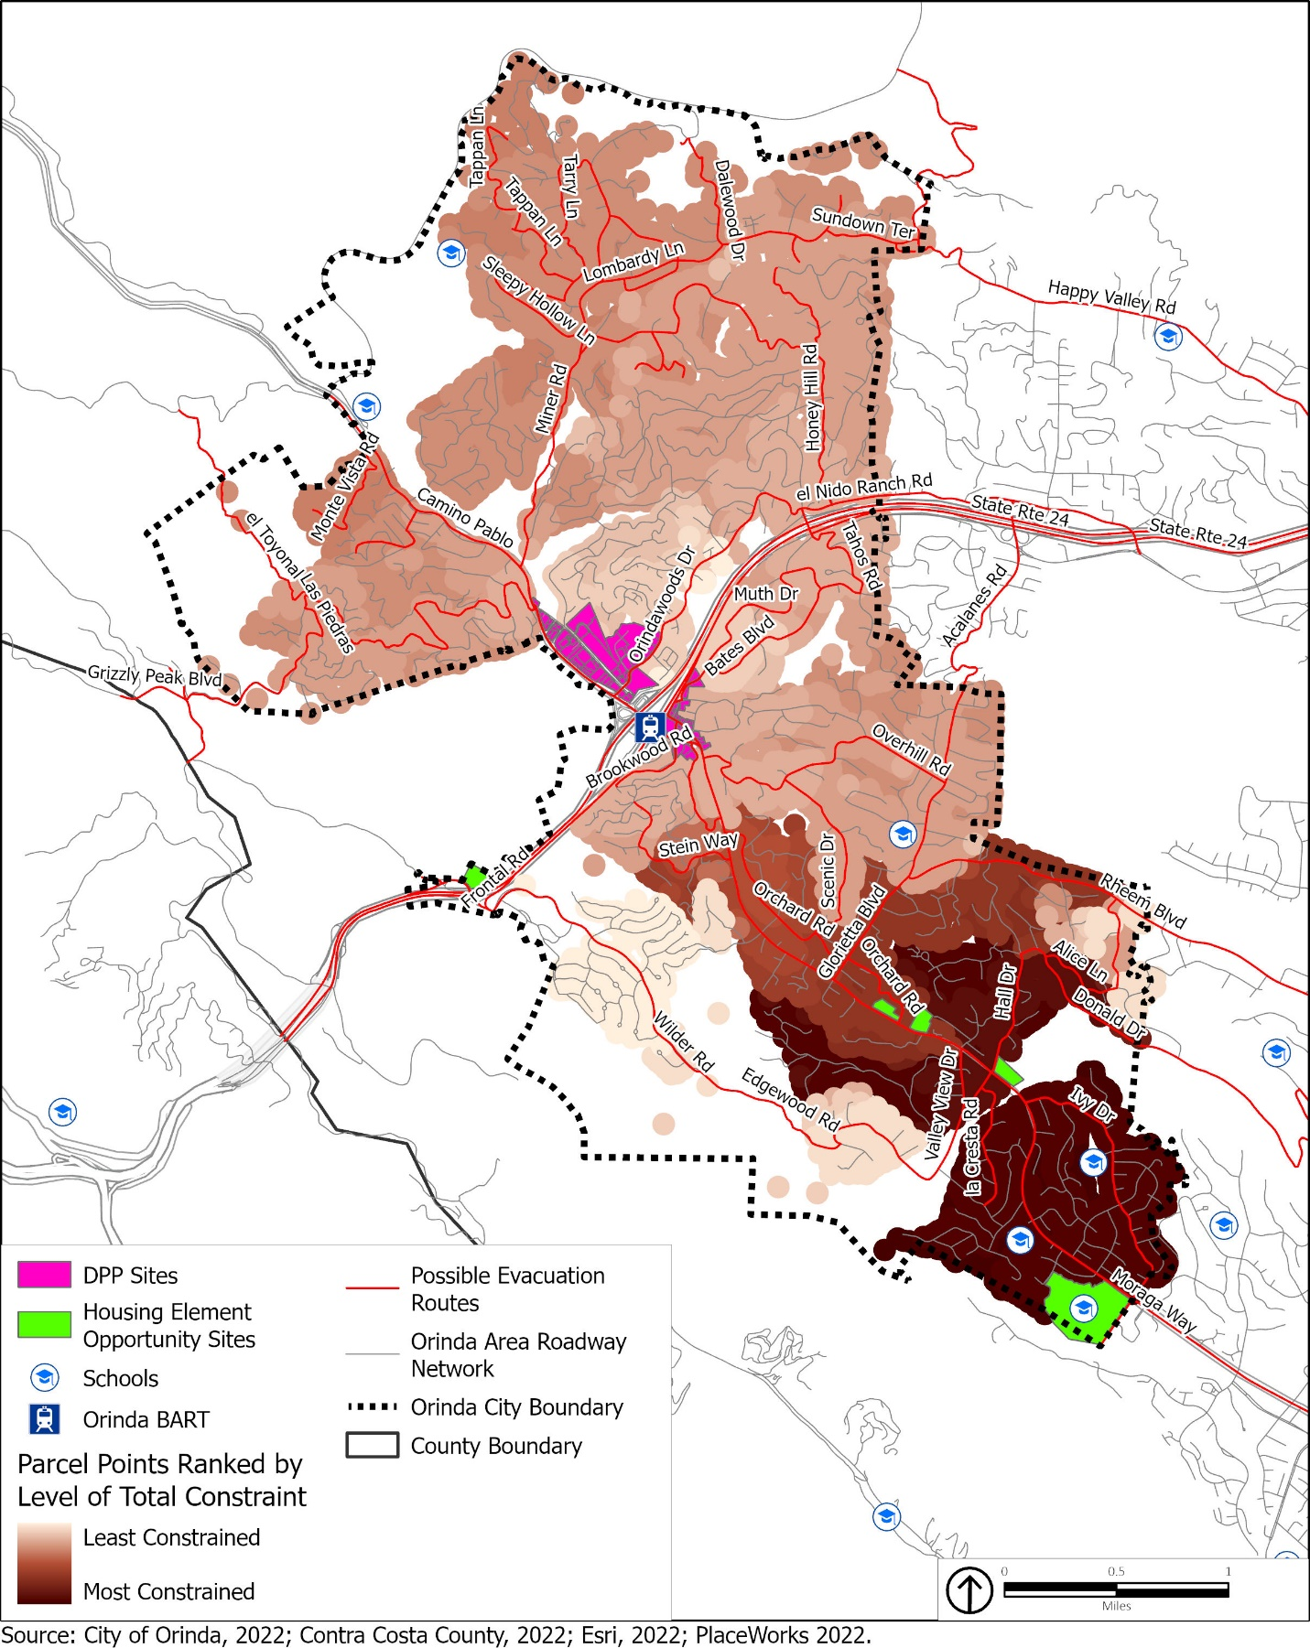
- Evacuation Constraints (Scenario 1)

- Evacuation Constraints (Scenario 2)
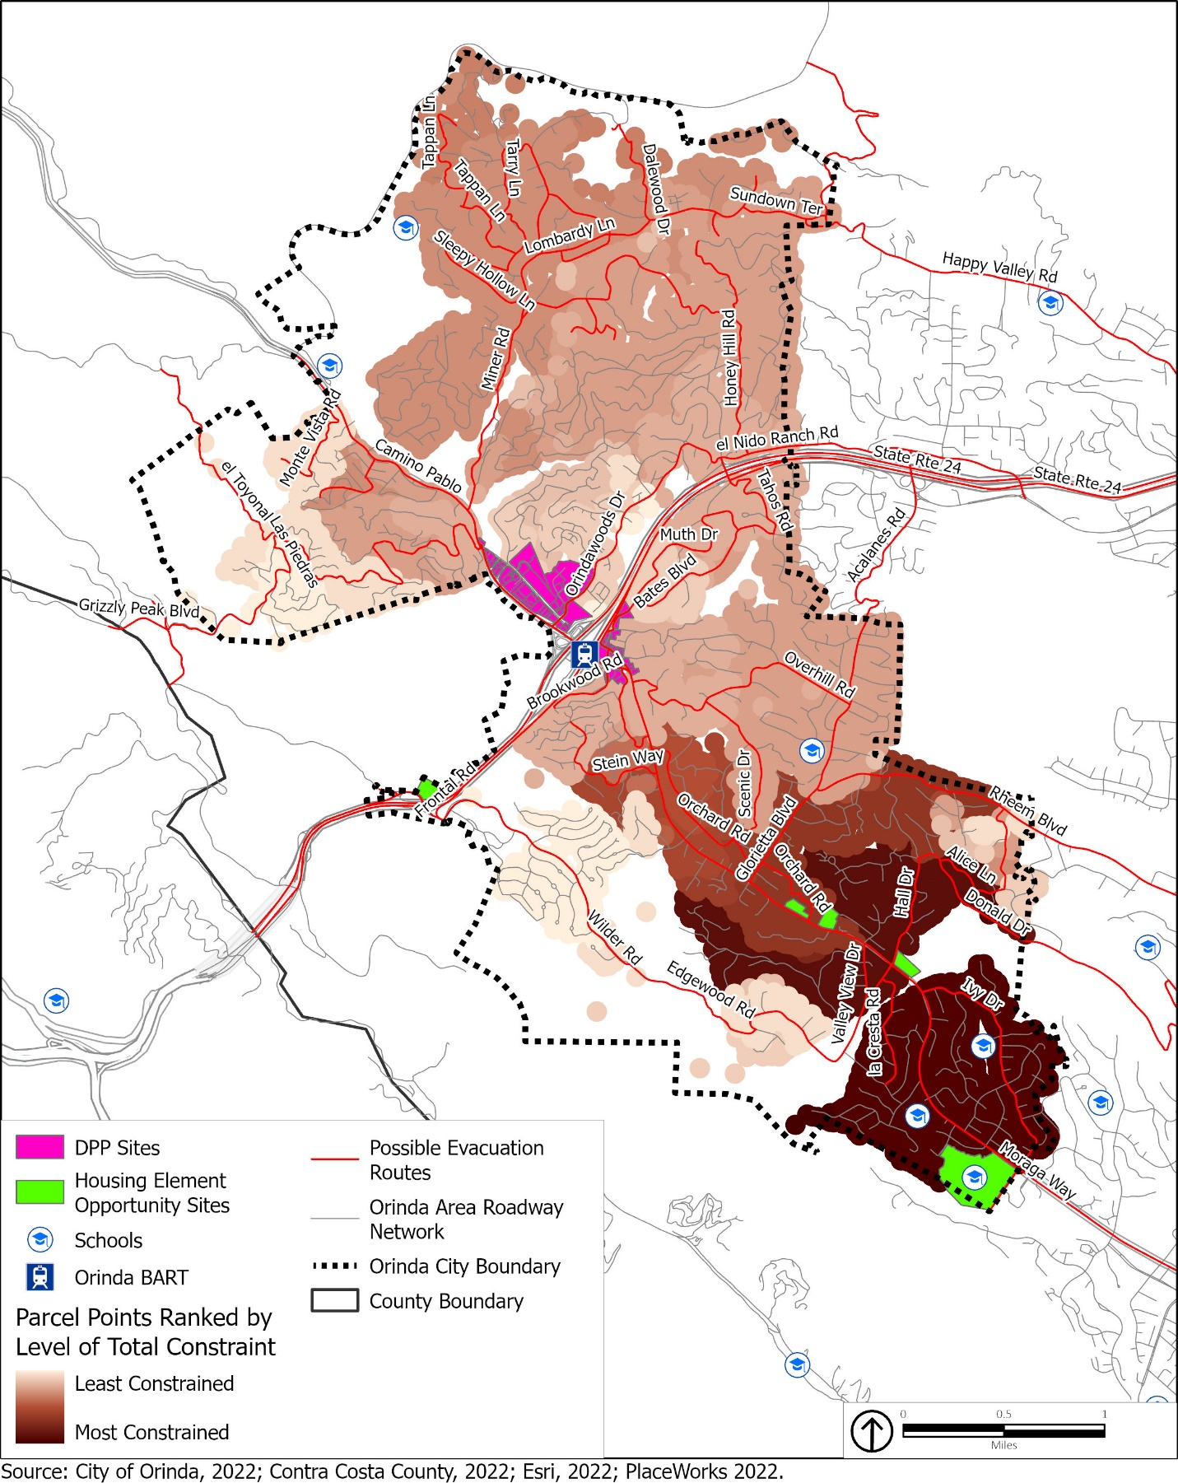
- Evacuation Constraints (Scenario 3)
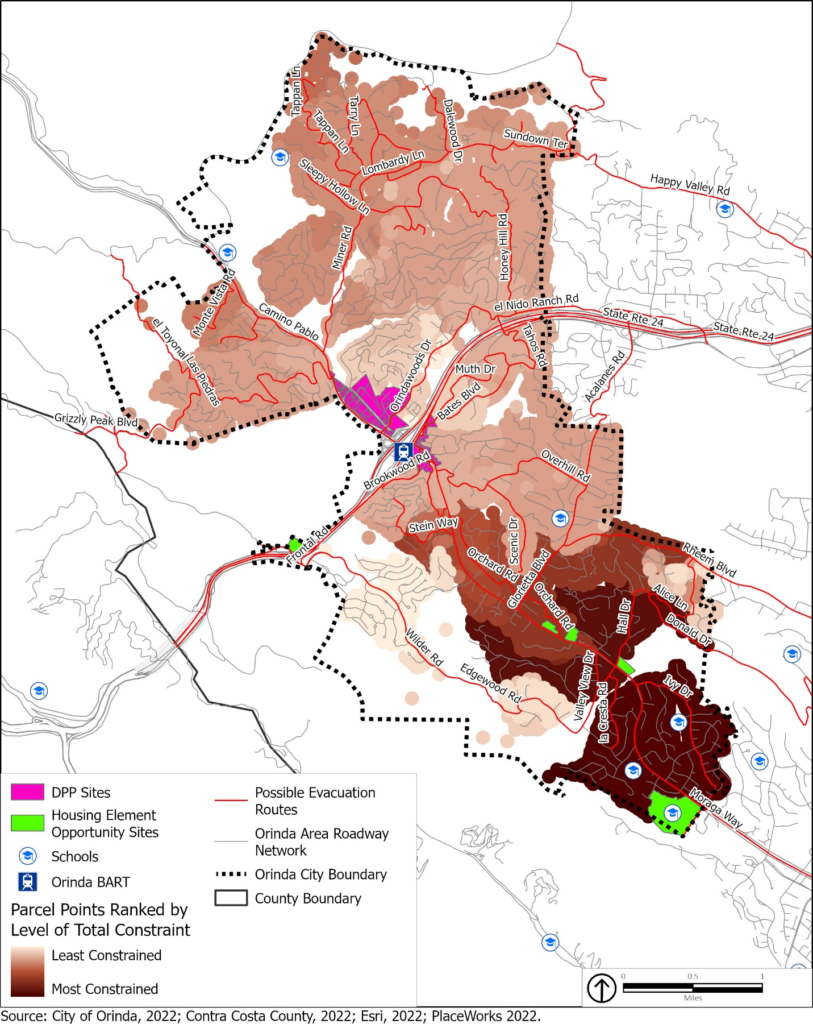
Although landslides are not likely to create widespread evacuation, the City also considered that landslides may block specific roadways. Landslides can interfere with evacuations, as well as affecting passenger and goods movements, as discussed in the Vulnerability Assessment. In the evacuation study, the City ranked different segments for their susceptibility to landslides. This includes segments of SR-24 and its on- and off-ramps, parts of Wilder Road, Orindawoods Drive, El Toyonal, and Donald Drive, among others.
Based on the results of the evacuation study, the City has prepared recommendations to increase the effectiveness of evacuation efforts. This includes infrastructure and other capital improvements, changes to regulations and policies, and new programs. Some of these recommendations have been incorporated into the policies in this Safety Element. The Safety Element will serve as the overarching framework and provide support for implementation of the recommendations from the evacuation study.

Flood and Inundation Hazards
Flooding is the rising and overflowing of a body of water onto normally dry land. History highlights floods as one of the most frequent natural hazards impacting communities in Contra Costa County. Floods are among the costliest natural disasters in terms of human hardship and economic loss nationwide, causing substantial damage to structures, landscapes, and utilities, as well as life-safety issues. Flooding can be extremely dangerous, and even six inches of moving water can knock a person over given a strong current. Floodwaters can transport large objects downstream, which can damage or remove stationary structures, such as dam spillways. Ground saturation can result in instability, collapse, or other damage. Objects can also be buried or destroyed through sediment deposition. Floodwaters can also break utility lines and interrupt services. Standing water can cause damage to roads, foundations, and electrical circuits. Other problems connected with flooding and stormwater runoff include erosion, sedimentation, degradation of water quality, losses of environmental resources, and certain health hazards.
Floods are usually caused by large amounts of precipitation, either from a period of very intense precipitation or a long period of steady precipitation. Historically, Orinda has been at risk of flooding primarily during the winter and spring months when stream systems swell with heavy rainfall. This type of flood results from prolonged, heavy rainfall and is characterized by high peak flows of moderate duration and by a large volume of runoff. Flooding is more severe when prior rainfall has resulted in saturated ground conditions. Flooding susceptibility in Orinda is primarily associated with San Pablo Creek which runs south to north throughout the city, as well as smaller-scale and flash flood events.
Occasionally, flash flooding from short-duration, high-intensity precipitation events (often during summer thunderstorms) may occur. Such events can occur even during a drought. Flash floods can tear out trees, undermine buildings and bridges, and scour new channels. In urban areas, flash flooding is an increasingly serious problem due to removal of vegetation and replacement of ground cover with impermeable surfaces such as roads, driveways, and parking lots. The greatest risk from flash floods is occurrence with little to no warning.
Developments create impermeable surfaces and reduce the total surface area that can absorb water. Stormwater runoff is augmented by water flows from development contributing to street flooding. Moreover, developed areas generate irrigation water runoff from landscaping, which may channel stormwater and other runoff flows into nearby underdeveloped areas and street gutters.
Areas at an elevated risk of flooding are generally divided into 100- and 500-year flood zones. A 100-year flood zone has a 1-percent chance of experiencing a major flood in any given year and a 500-year flood zone has a 0.2-percent chance of flooding in any given year. Figure 6 shows the 100- and 500-year flood zones in and around Orinda.
The 100-year floodplain in Orinda is primarily concentrated along San Pablo Creek, which intersects the community from the northwest to the southeast. Small portions of the city encompass the 500-year floodplain, which include the downtown area, Lake Cascade, areas near the BART station and SR-24, as well as areas to the northwest near the base of the San Pablo Reservoir. During heavy rainfall events, the city is subject to flooding of residential areas, including the areas in the vicinity of San Pablo Creek.
Agencies responsible for flood control in Orinda include the Unites States Army Corps of Engineers (USACE), Contra Costa County Flood Control and Water Conservation District (FC District), East Bay Municipal Utility District (EBMUD), Federal Insurance Administration (FIA), and the Department of Water Resources (DWR).
The USACE identifies the need for and constructs major flood-control facilities. It also develops flood and dam inundation maps and reports.
The FC District covers all of Contra Costa County, including its cities, and owns property throughout the county for the purpose of constructing and maintaining regional flood-control facilities, including approximately 79 miles of channels, creeks, and other drainage and 30 detention basins and dams. The FC District works to reduce flood risk, promote stormwater quality, and restore and enhance natural resources in an environmentally sensitive manner for the communities throughout Contra Costa County.
EBMUD supplies water for Contra Costa County and is the owner of two dams in the vicinity of Orinda: San Pablo Dam, a hydraulic fill dam, and Briones Reservoir, an earthen dam. These dams store water for flood control and for downstream users.
FEMA manages the National Flood Insurance Program (NFIP), providing insurance to the public in communities that participate in the program. FEMA is the main federal government agency contact during natural disasters and publishes the Flood Insurance Rate Maps (FIRM), which identify the extent of flood potential in flood-prone communities based on a 100-year flood (or base flood) event.
The FIA is the primary agency that delineates potential flood hazard areas and floodways through the FIRMs and the Flood Boundary and Floodway Map. Flood insurance is required of all homeowners who have federally subsidized loans.

- Flood Hazard Zones
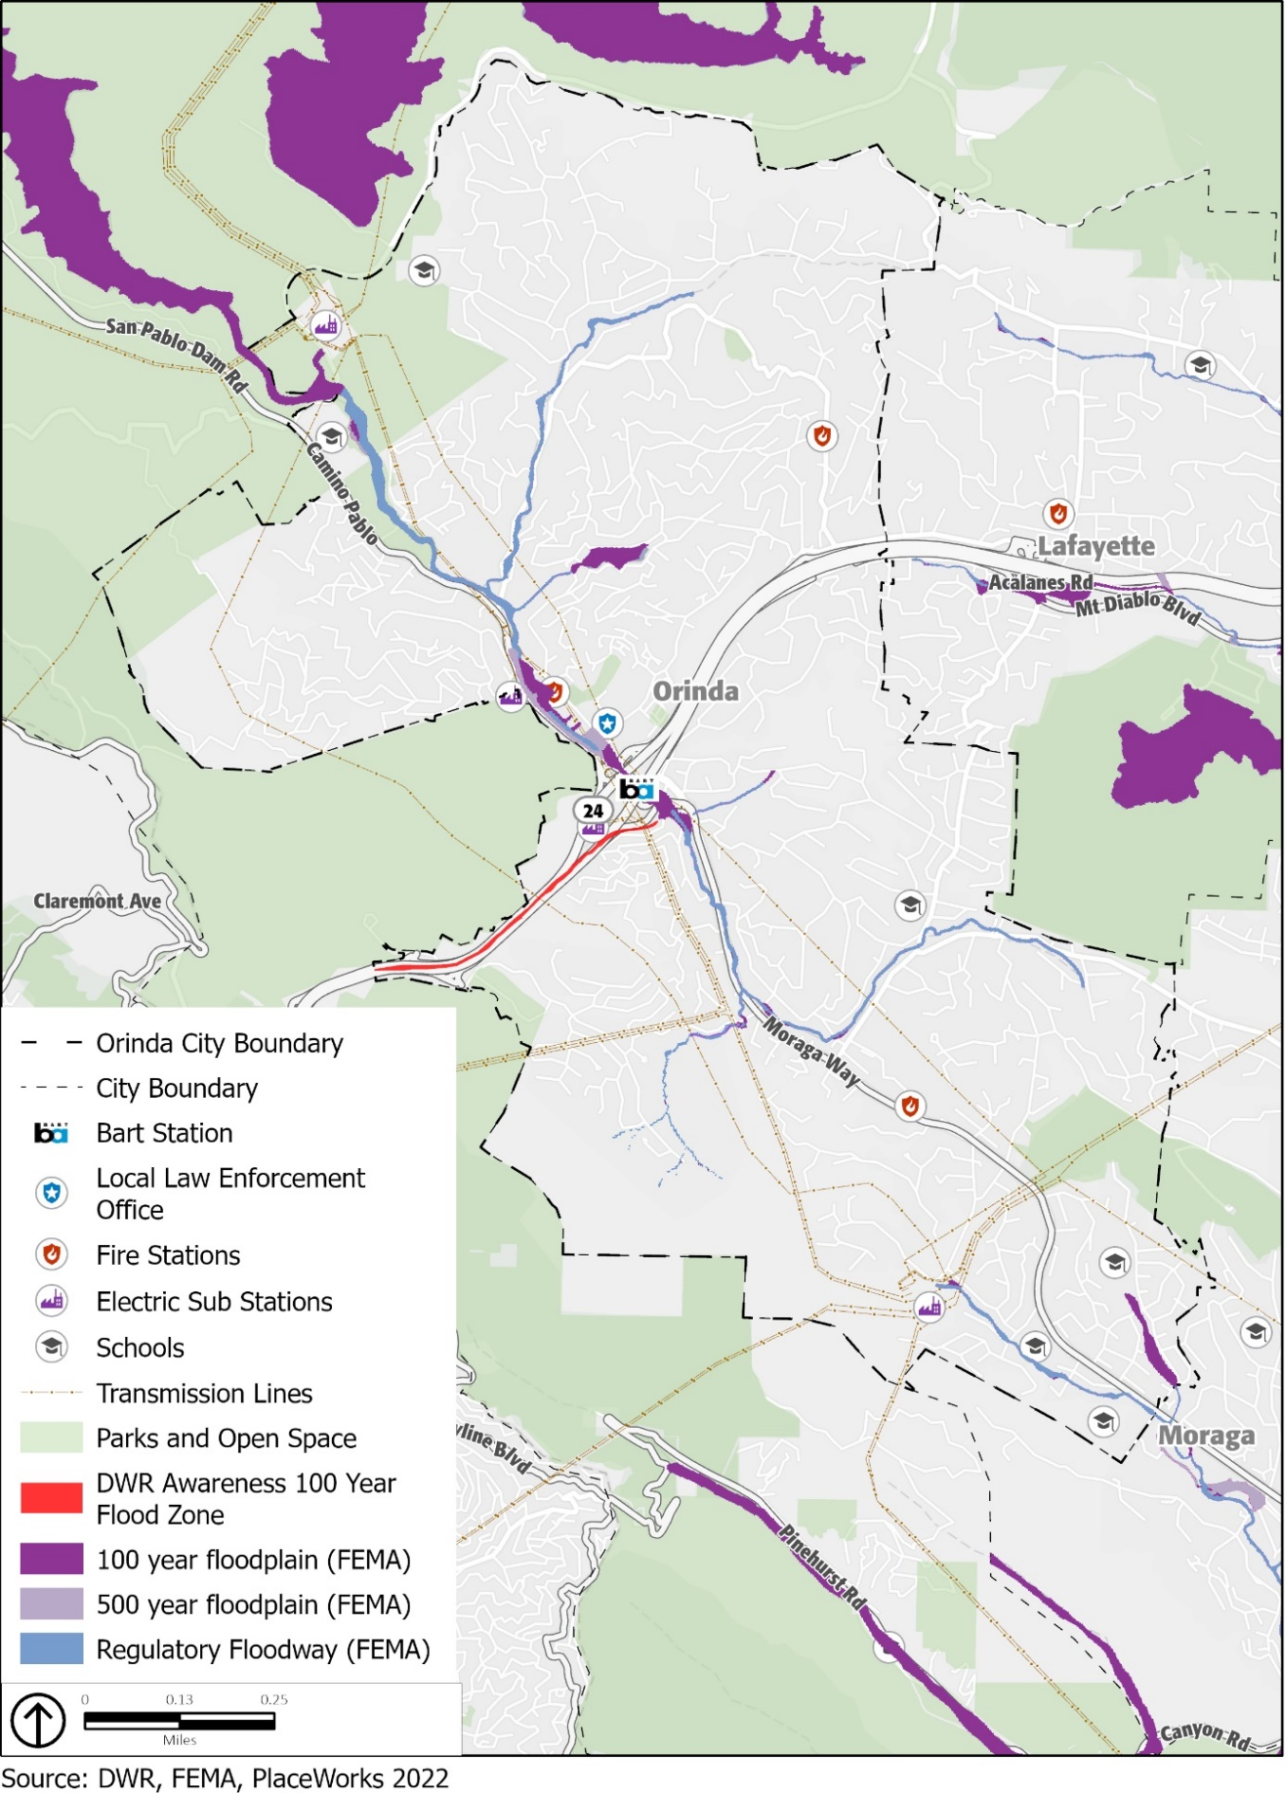
DWR is responsible for managing and protecting California’s water. DWR works with other agencies to benefit the state’s people, and to protect, restore, and enhance the natural and human environments. DWR also works to prevent and respond to floods, droughts, and catastrophic events that would threaten public safety, water resources and management systems, the environment, and property.
Floodplains can change over time; the floodplain and watercourse of a stream can also be affected by anthropogenic (or human) influences, such as the development of land into residential or commercial structures and the resulting reduction of pervious land, resulting in increased stream flow, the construction of bridges or culverts, or the creation of levees or other impoundment structures that control the flow in the watercourse.

Dam Failure
A dam failure is an uncontrolled release of water from a reservoir through a dam because of structural failures or deficiencies in the dam, usually associated with intense rainfall or prolonged flooding. Dam failures can range from minor to catastrophic and can potentially harm human life and property downstream from the failure. In addition, ecosystems and habitats are destroyed because of waters flooding them. Although dam failures are very rare, these events are not unprecedented. There are four major causes of dam failures:
Overtopping: These failures occur when a reservoir fills too high with water, especially in times of heavy rainfall, leaving water to rush over the top of the dam. Other causes of this type of failure include settling of the crest of the dam or spillway blockage.
Foundation defects: These failures occur as a result of settling in the foundation of the dam, instability of slopes surrounding the dam, uplift pressures, and seepage around the foundation. All of these failures result in structural instability and potential dam failure.
Piping and seepage failures: These failures occur as a result of internal erosion caused by seepage and erosion along hydraulic structures such as the spillways. Erosion may also be caused by animal burrows and cracks in the dam structure.
Conduit and valve failure: These failures occur as a result of problems with valves and conduits.
Many dam failures are also the secondary result of other natural disasters, such as earthquakes, landslides, extreme storms, or heavy snow-melt. Other causes include equipment malfunction, structural damage, and sabotage.
Three dams regulated by the State of California are in the Orinda area:
San Pablo Dam, a hydraulic fill dam owned by EBMUD
Briones Reservoir, an earthen dam owned by EBMUD
Lake Cascade Dam, an earthen dam owned by the Orinda Country Club
Figure 7 illustrates areas in the city that would be affected by inundation if any of these dams failed. In the event of a dam failure at the Briones Reservoir, land south of Briones Dam to San Pablo Reservoir would flood, as would land immediately to the east of San Pablo Dam Road and Camino Pablo. If Lake Cascade Dam were also to fail, flooding would affect additional land, extending almost to downtown Orinda. Failure of the San Pablo Dam would not affect Orinda as flood waters would flow toward the San Pablo Bay.
In Orinda, a major earthquake could cause a dam failure. Dams are constructed with safety features known as “spillways” that allow water to overtop the dam if the reservoir fills too quickly. Spillway overflow events, often referred to as “design failures,” result in increased discharges downstream and increased flooding potential. In a dam failure scenario, the greatest threat to life and property typically occurs in those areas immediately below the dam since flood depths and discharges generally decrease as the flood wave moves downstream. The primary danger associated with dam failure is the high-velocity flooding downstream of the dam and limited warning times for evacuation.
EBMUD, the owner of the San Pablo Dam and Briones Reservoir, has a comprehensive Dam Safety Program. EBMUD proactively inspects upgrades and improves its dams and water supply structures as needed and in consultation with regulatory agencies. Engineers monitor dams using instruments, monthly visual inspections, and periodic dam safety reviews to prevent loss of life, personal injury, and property damage from the failure of dams. The safety of each dam is re-evaluated with advances in geotechnical, structural, and earthquake engineering and if there is evidence of seepage or ongoing ground movement.
The Federal Energy Regulatory Commission (FERC), as required by federal law, has reviewed and approved comprehensive emergency action plans (EAPs) for each of these dams. The EAP minimizes the threat to public safety and the response time to an impending or actual sudden release of water from project dams. The EAP is also designed to provide emergency notification when floodwater releases may present the potential for major flooding.
As mandated by the National Dam Inspection Act, the USACE has the authority and responsibility for conducting inspections of all dams. The purpose of these inspections is to check the structural integrity of the dam and associated appurtenant structures, ensuring protection of human life and property. Periodic inspections disclose conditions that might disrupt operation or dam safety.

- Dam Inundation
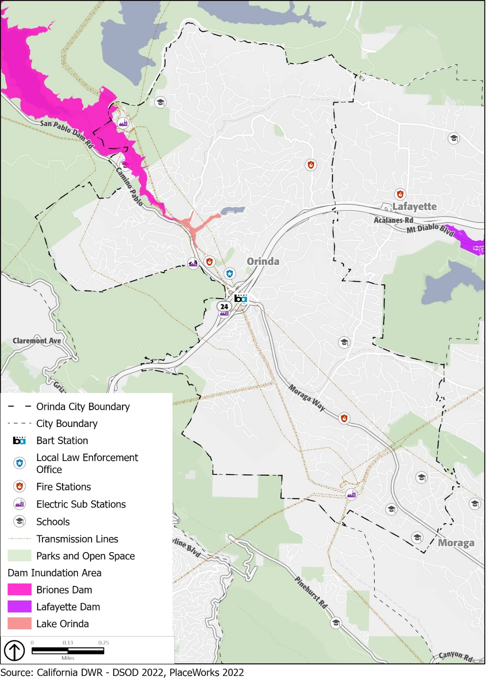

Past Occurrences
Floods are a regular feature in California and are the cause of the second-greatest number of disaster declarations in the state. A series of storms from December 17, 2005, to January 12, 2006, caused extensive flooding throughout Northern California. Widespread county flooding occurred after 2 to 4 inches of rain fell on the area in about 24 hours. Urban flooding-initiated landslides contributed to the damage and small streams and creeks overflowed their banks. Much of the damage was done in Walnut Creek, Richmond, San Pablo, Martinez, and Orinda. In total across the county, flooding resulted in approximately $22 million in property damage. Included in the damages were schools, park areas, and several government structures. In all of Contra Costa County, community members filed approximately 165 claims for personal assistance due to flooding.
In 2012, a series of significant winter storms affected the county during late November and early December. The first storm arrived November 28 and then was followed by three more winter storms. Each brought strong and gusty winds, heavy rainfall, high surf, and flooding to the region. The second storm happened on the first and second of the month, with the third and final storm on December 5th. During heavy rainfall, a 24-inch culvert failed and collapsed, opening a 20-foot sinkhole on Tarabrook Drive, causing the Orinda City Council to declare a state of emergency. In total, flooding resulted in approximately $250,000 of property damage.
In 2017, a winter storm event caused major damage in Orinda, including a sinkhole at Miner Road that caused a failure of the San Pablo Creek culvert and led to flooding of adjacent private properties. Property damages in Orinda amounted to approximately $3 million.

Potential Changes to Flood Risk in Future Years

Likelihood of Future Occurrence
Historically, extended heavy rains have resulted in floodwaters that exceed normal high-water boundaries and cause damage in Orinda. Flooding has occurred both within the 100- and 500-year floodplains and in other localized areas. As land uses and climate conditions shift and as improvements are made to flood-control channels, the size of these flood zones is likely to change. The potential for a dam failure event in Orinda is likely to remain a risk in future years, although the odds of such events are expected to remain very low.

Climate Change and Flooding
Floods are among the most damaging natural hazards in Contra Costa County, and climate change is expected to make flood events worse. Although climate change may not change average precipitation levels significantly, scientists expect that it will cause more years with extreme precipitation events. This means that more years are likely to see particularly intense storm systems that drop enough precipitation over a short enough period to cause flooding. Because of this, floods are expected to occur more often in Orinda and climate change may expand the parts of the city that are considered prone to flood. Although there are no specific flooding projections for the city, flood events are expected to become more frequent, and it is possible that the areas subject to flooding will expand. There are some indirect effects of climate change that may also increase flooding in the city. Climate change is expected to increase the frequency and severity of droughts that cause soil to dry out and become hard. When precipitation does return, more water runs off the surface than is absorbed into the ground, which can lead to floods.
While the risk and associated short- and long-term impacts of climate change are uncertain, experts in this field tend to agree that among the most significant impacts include those resulting from increased heat and precipitation events that cause increased frequency and magnitude of flooding. Increases in damaging flood events will cause greater property damage, public health and safety concerns, displacement, and loss of life. Displacement of residents can include both temporary and long-term displacement, increase in insurance rates, or restriction of insurance coverage in vulnerable areas.

Seismic and Geologic Hazards
Seismic and geologic hazards are risks caused by the movement of different parts of the Earth’s crust, or surface. Seismic hazards include earthquakes and hazardous events caused by them. Geologic hazards are other hazards involving land movements that are not linked to seismic activity and are capable of inflicting harm to people or property.

Seismic Hazards
Seismic activity occurs along boundaries in the Earth’s crust, called faults. Pressure along the faults build over time and is ultimately released, resulting in ground shaking that we refer to as an earthquake. Earthquakes can also trigger other hazards, including surface rupture (cracks in the ground surface), liquefaction (causing loose soil to lose its strength), landslides, and subsidence (sinking of the ground surface). Earthquakes and other seismic hazards often damage or destroy property and public infrastructure, including utility lines, and falling objects or structures pose a risk of injury or death.

Earthquakes
While Orinda is at risk from many natural and human-caused hazards, the event with the greatest potential for loss of life or property and economic damage is an earthquake. This is true for most of the San Francisco Bay Area region, since damaging earthquakes affect widespread areas, trigger many secondary effects that can overwhelm the ability of local jurisdictions to respond. The Bay Area region lies within the active boundary between the Pacific and the North American tectonic plates. The Pacific Plate is constantly moving northwest past the North American Plate at a rate of about 2 inches per year. Earthquakes in the Bay Area region result from strain energy constantly accumulating across the region because of the motion of the Pacific Plate relative to the North American Plate. The San Andreas Fault is the major plate boundary and has the potential to cause the strongest earthquakes.
Earthquake risk is very high in Contra Costa County, including the City of Orinda, due to the presence of several active faults in the region, the Calaveras North Fault, Concord-Green Valley Fault, Greenville Fault, Hayward Fault, and Mount Diablo Fault. No Alquist-Priolo Earthquake Fault Zones are in the city. Figure 8 shows the location of regional faults.
Calaveras Fault (North Central): The Calaveras (North Central) Fault is a major branch of the San Andreas Fault. It extends 76 miles from the San Andreas Fault near Hollister to Danville at its northern end, approximately 8 miles from Orinda. The Calaveras Fault is one of the most geologically active and complex faults in the Bay Area (USGS, 2003). According to the 2018 Contra Costa County LHMP, the probability of experiencing a Magnitude 6.7 or greater earthquake along the Calaveras Fault in the next 30 years (beginning from 2018) is 26 percent.
Concord-Green Valley Fault: The Concord-Green Valley Fault, named for being located under the City of Concord, is connected to the main Green Valley Fault. The fault extends from Mount Diablo to the Carquinez Strait, about 11 miles from Orinda at its closest point. It is under high stress and has a 16-percent probability of experiencing a Magnitude 6.7 or greater earthquake in the next 30 years (beginning from 2018).
Greenville Fault: The Greenville Fault zone extends from northwest of Livermore Valley along the Marsh Creek and Clayton faults toward Clayton Valley. It is about 14 miles from Orinda at its closest point.
Hayward Fault: The Hayward Fault is an approximately 45-mile-long fault that runs through some of the Bay Area’s most populated areas, including San Jose, Oakland, and Berkeley. It is approximately 3 miles from Orinda at its closest point. The Hayward Fault is increasingly becoming a hazard priority throughout the Bay Area because of its increased chance for activity and its intersection with highly populated areas and critical infrastructure. The probability of experiencing a Magnitude 6.7 or greater earthquake along the Hayward Fault in the next 30 years (beginning from 2018) is 33 percent. An earthquake of this magnitude has regional implications for the entire Bay Area, as the Hayward Fault crosses transportation and resource infrastructure, such as multiple highways and the Hetch-Hetchy Aqueduct.
Mount Diablo Fault: The Mount Diablo thrust fault runs from Walnut Creek to Livermore, approximately 8 miles from Orinda at its closest point. It plays a role in the continued uplift of Mount Diablo.

- Regional Fault Lines
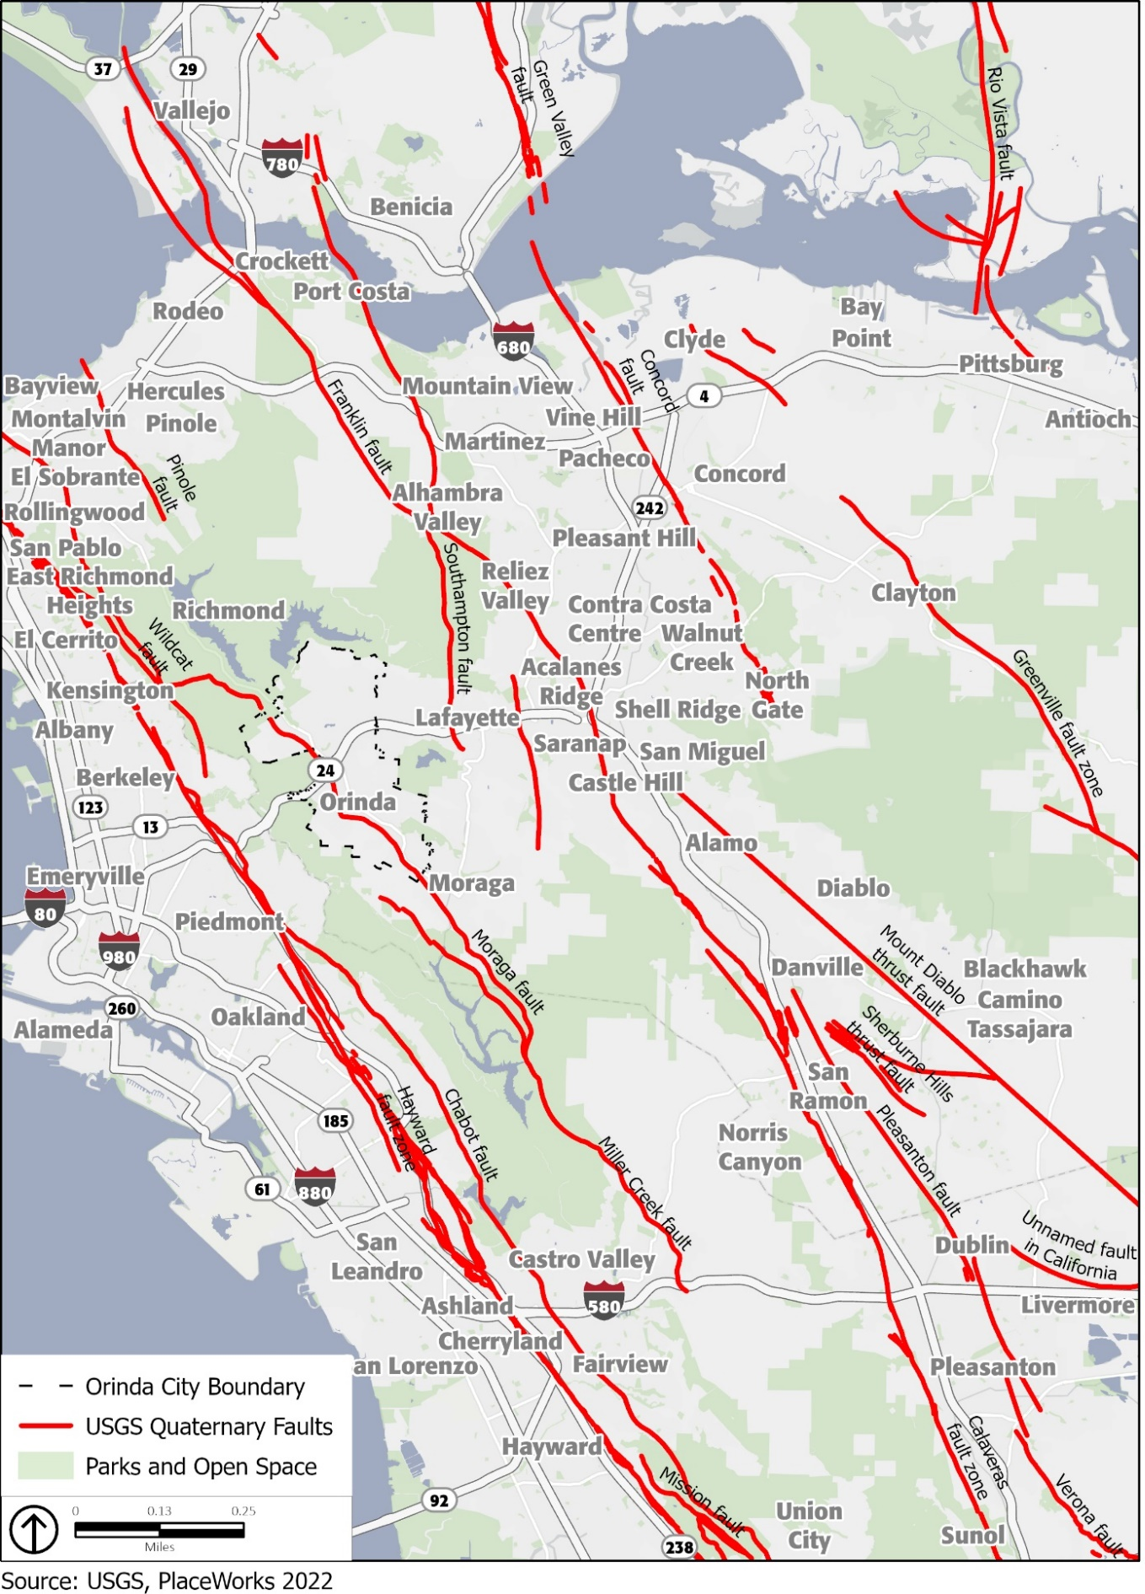

In the event of an earthquake, the location of the epicenter, as well as the time of day and season of the year, would have a profound effect on the number of deaths and casualties, as well as property damage. There are a number of small-scale earthquakes that happen weekly, but larger-scale or catastrophe shaking is less likely. Property and human life in Orinda are at risk for a significant earthquake causing catastrophic damage and strains on response and mitigation resources.
The county experiences hundreds of minor quakes and tremblers each month from the myriad of faults in the area. Other faults, both in and outside Contra Costa County, may also be capable of generating significant earthquakes with damaging effects in the county. A major quake could happen at any time.
In Orinda, earthquake effects may include ground shaking, fault rupture, landslides, liquefaction, subsidence, and seiches. Earthquakes can also cause human-caused hazards such as urban fires, dam failures, and toxic chemical releases. A major earthquake along any of these five faults could result in substantial casualties and damage resulting from collapsed buildings, damaged roads and bridges, fires, flooding, and other threats to life and property. Most of the loss of life and injuries from earthquakes are due to damage and collapse of buildings and structures.
Building codes for new construction have generally been made more stringent following damaging earthquakes. However, in Orinda, structures built prior to the enactment of these improved building codes have generally not been upgraded to current standards and are vulnerable in earthquakes. In Orinda, approximately 6,207 homes, or 83 percent, of all housing was constructed prior to 1980.

Orinda Geologic Hazard Abatement District
The Orinda Geologic Hazard Abatement District (GHAD) was formed on March 4, 2008, by the Orinda City Council and includes the Orinda Oaks and Wilder developments. The Board of Directors for the Orinda GHAD are members of the Orinda City Council. The Orinda GHAD is responsible for prevention, mitigation, abatement, and control of geologic hazards within the GHAD boundaries, including mitigating or abating landslides and erosion hazards that could directly affect properties within those boundaries.
The Orinda GHAD currently has maintenance and monitoring responsibilities for all parcels within the Orinda Oaks development. However, the GHAD does not yet perform maintenance or monitoring responsibilities within the Wilder development and cannot perform such services until the responsibilities for doing so are transferred by the developer to the GHAD and the GHAD Board of Directors accepts such responsibilities. The GHAD is limited to overseeing and supervising the open space general physical maintenance of the open-space areas to prevent, mitigate, control, or abate erosion, sedimentation, and potential landslide hazards.

2017 Orinda Seismic Study
In December 2017, the City conducted a seismic study that assessed seismic risks in downtown Orinda and potential soft-story multifamily residential buildings. Contra Costa County Principal Structural Engineer Thom Huggett, accompanied by City staff, performed a visual assessment for unreinforced masonry buildings and soft-story buildings. These two building types were selected because they are easy to identify and can be evaluated efficiently. The buildings identified were evaluated as subject to “maximum considered earthquake ground motion,” which is defined in the California Building Code as the most severe effect of an earthquake for which buildings are designed. The study noted that there are several buildings that may appear to have soft-stories or other risks in the city. However, the study found that there are no apparent unreinforced masonry buildings or soft-story buildings in downtown Orinda. During a City Council meeting on January 16, 2018, the staff recommended no action regarding seismic retrofitting of structures in Orinda based on the analysis resulting from the 2017 visual assessment, which aligned with the 2006 state-wide update on unreinforced masonry buildings.

Other Seismic Hazards
In addition to the direct physical damage that can result from the motion of the earthquake, damage can result from liquefaction. Liquefaction occurs where water-logged soils near the ground surface lose compaction during strong ground motion. This can cause building foundations to shift and can result in significant structural damage. Soils susceptible to liquefaction are typically found in areas of low-lying, current, or former floodplains. Portions of the city within or directly adjacent to the floodplains of the San Pablo Creek are areas of the greatest peak ground acceleration. These areas are likely to experience the strongest shaking during an earthquake event, which could result in severe liquefaction. However, a majority of the city is within an area of low or very-low liquefaction risk. Very high liquefaction risk is limited to the areas adjacent to San Pablo Creek and Lauterwasser Creek. Figure 9 shows the areas facing an elevated liquefaction risk in Orinda.

- Liquefaction Hazard Zones
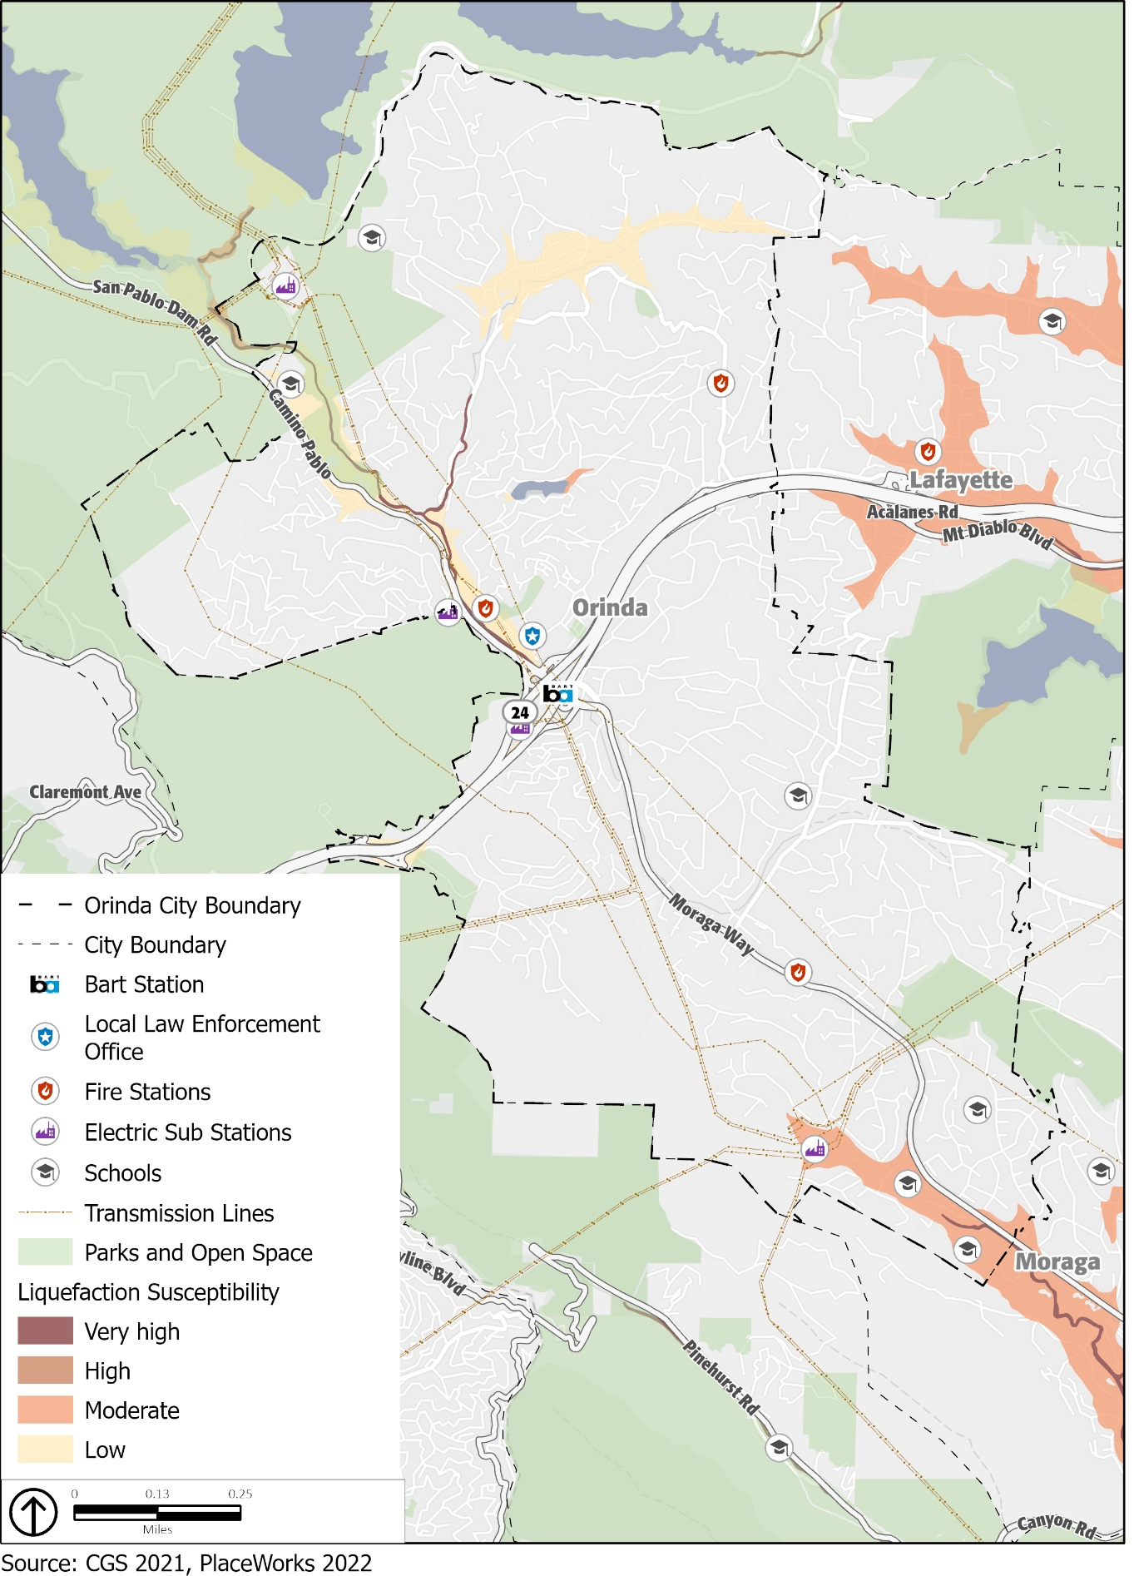
While most of the city is not susceptible to liquefaction, it is a potentially destructive secondary effect of strong seismic shaking. Liquefaction is the complete failure of soils, occurring when soils lose shear strength and flow horizontally. Liquefaction occurs primarily in saturated, loose, fine- to medium-grained soils in areas where the groundwater table is within approximately 50 feet of the surface. Shaking causes the soils to lose strength and behave as liquid. Excess water pressure is vented upward through fissures and soil cracks and can result in a water-soil slurry flowing onto the ground surface. This subsurface process can lead to near-surface or surface ground failure that can result in property damage and structural failure. Groundwater that is less than 10 feet to the surface can cause the highest liquefaction susceptibility, with lower groundwater levels causing lower liquefaction risks. Site-specific geotechnical studies are the only practical and reliable way of determining the specific liquefaction potential of a site; however, a determination of general risk potential can be provided based on soil type and depth of groundwater.
In most cases, proper design and construction of subgrade soils and building foundations provides a mechanism to mitigate the risk of seismic hazards to an acceptable level in conformance with the California Building Code. The representation of areas having a liquefaction potential is only intended as notification to seek further site-specific information and analysis of this potential hazard as part of future site development. It should not be solely relied upon, without site-specific information and analysis, for design or decision-making purposes.
Seismic seiches are waves that can occur in a body of water as a result of seismic shaking. Orinda has a large wastewater treatment facility located within its city limits that could be damaged and/or shutdown during a seiche event within the tanks, although this is considered unlikely.

Geologic Hazards
Geologic hazards, such as landslides and erosion, depend on the geologic composition of the area. Landslides and rock falls may occur in sloped areas, especially areas with steep slopes, and usually in areas of loose and fragmented soil. Landslides, rockfalls, and debris flows occur continuously on all slopes; some processes act very slowly, while others occur very suddenly, often with disastrous results. There are predictable relationships between local geology and landslides, rockfalls, and debris flows. Slope stability is dependent on many factors and interrelationships, including rock type, pore water pressure, slope steepness, and natural or human-made undercutting.
Landslides are often triggered by other natural hazards such as earthquakes, heavy rain, floods, or wildfires, so landslide frequency is often related to the frequency of these other hazards. In Contra Costa County, landslides typically occur during and after severe storms, so the potential for landslides largely coincides with the potential for sequential severe storms that saturate steep, vulnerable soils. According to the National Centers for Environmental Information’s storm event database, Contra Costa County has been impacted by severe storms at least once every three years. In Contra Costa County, landslides and mudslides are a common occurrence and have caused damage to homes, public facilities, roads, parks, and sewer lines in particular.
Due to the hilly terrain of the city, landslides are a hazard of significant concern in Orinda. The city has experienced numerous landslides in the past and as a result, much of Orinda’s slopes are unstable. Figure 10 illustrates areas in Orinda that are most susceptible to landslides. A majority of the city is within a very high landslide susceptibility class. Orinda is historically subject to landslides; in fact, landslides are the primary physical process that shapes the topography in the local area. Landslides occur on hillsides throughout the city and generally occur in winter during high precipitation years. Multiple critical communication, power, water, wastewater, bridges, fire district, and school facilities are at moderate to high risk for landslide.
Orinda is susceptible to hazards related to erosion, or the geological process in which earthen materials are worn away and transported by natural forces such as water or wind, causing the soil to deteriorate. Eroded topsoil can be transported into streams and other waterways. Water erosion is the removal of soil by water and transportation of the eroded materials away from the point of removal. The severity of water erosion is influenced by slope, soil type, soil water storage capacity, nature of the underlying rock, vegetation cover, and rainfall intensity and period. The Impact of soil erosion on water quality becomes significant, particularly as soil surface runoff. Highly erosive soils can damage roads, bridges, buildings, and other structures.

Past Occurrences
Orinda is in a region of high seismicity with numerous local faults nearby. While major earthquakes are rare in Orinda, minor earthquakes occur more often. The San Andreas Fault, the fastest-slipping fault along the Pacific and North American Plate boundary, has caused earthquakes of magnitude 7.8 and 7.9 in the past, including the 1906 San Francisco earthquake. In 1989, the Loma Prieta earthquake, which also originated along the San Andreas Fault, produced a magnitude 7.2 earthquake. The earthquake caused extensive damage and created a seven-county major disaster area, including Contra Costa County.
Landslides, however, are a common occurrence and are the primary physical process that shapes the topography in the city. Landslides have occurred on hillsides throughout the city and generally occur in winter during high precipitation years.
In 2005, the City of Orinda declared local emergency after $1.053 million in damages occurred as a result of storms during middle- to late-December. The storms caused mudslides onto public roadways throughout the city. Additionally, there were reports of tree, landslides, flooding, and sewer break damages at 22 private properties.
In 2008, the Zander Drive landslide reactivated 10 years after residential development encroached onto lands underlain by the landslide, resulting in $2 million in property damages. The landslide measured 200 feet across, extended 1,000 feet from Zander Drive down to San Pablo Creek, and had a maximum depth of 115 feet. Three properties were impacted, two homes were demolished, and the City purchased and remediated one of the properties because it was deemed too expensive to maintain. According to CAL Engineering and Geology Inc., the landslide is at least 1,000 years old. In previous years, it was active in the winters of 1969-70 and 1982-83 before sliding again in 1998. To ensure that the hillside along Zander Drive will withstand another slide, the city shored up and will continue to maintain the dirt at the bottom of the wall rather than constructing new retaining walls.
- Landslide Susceptibility
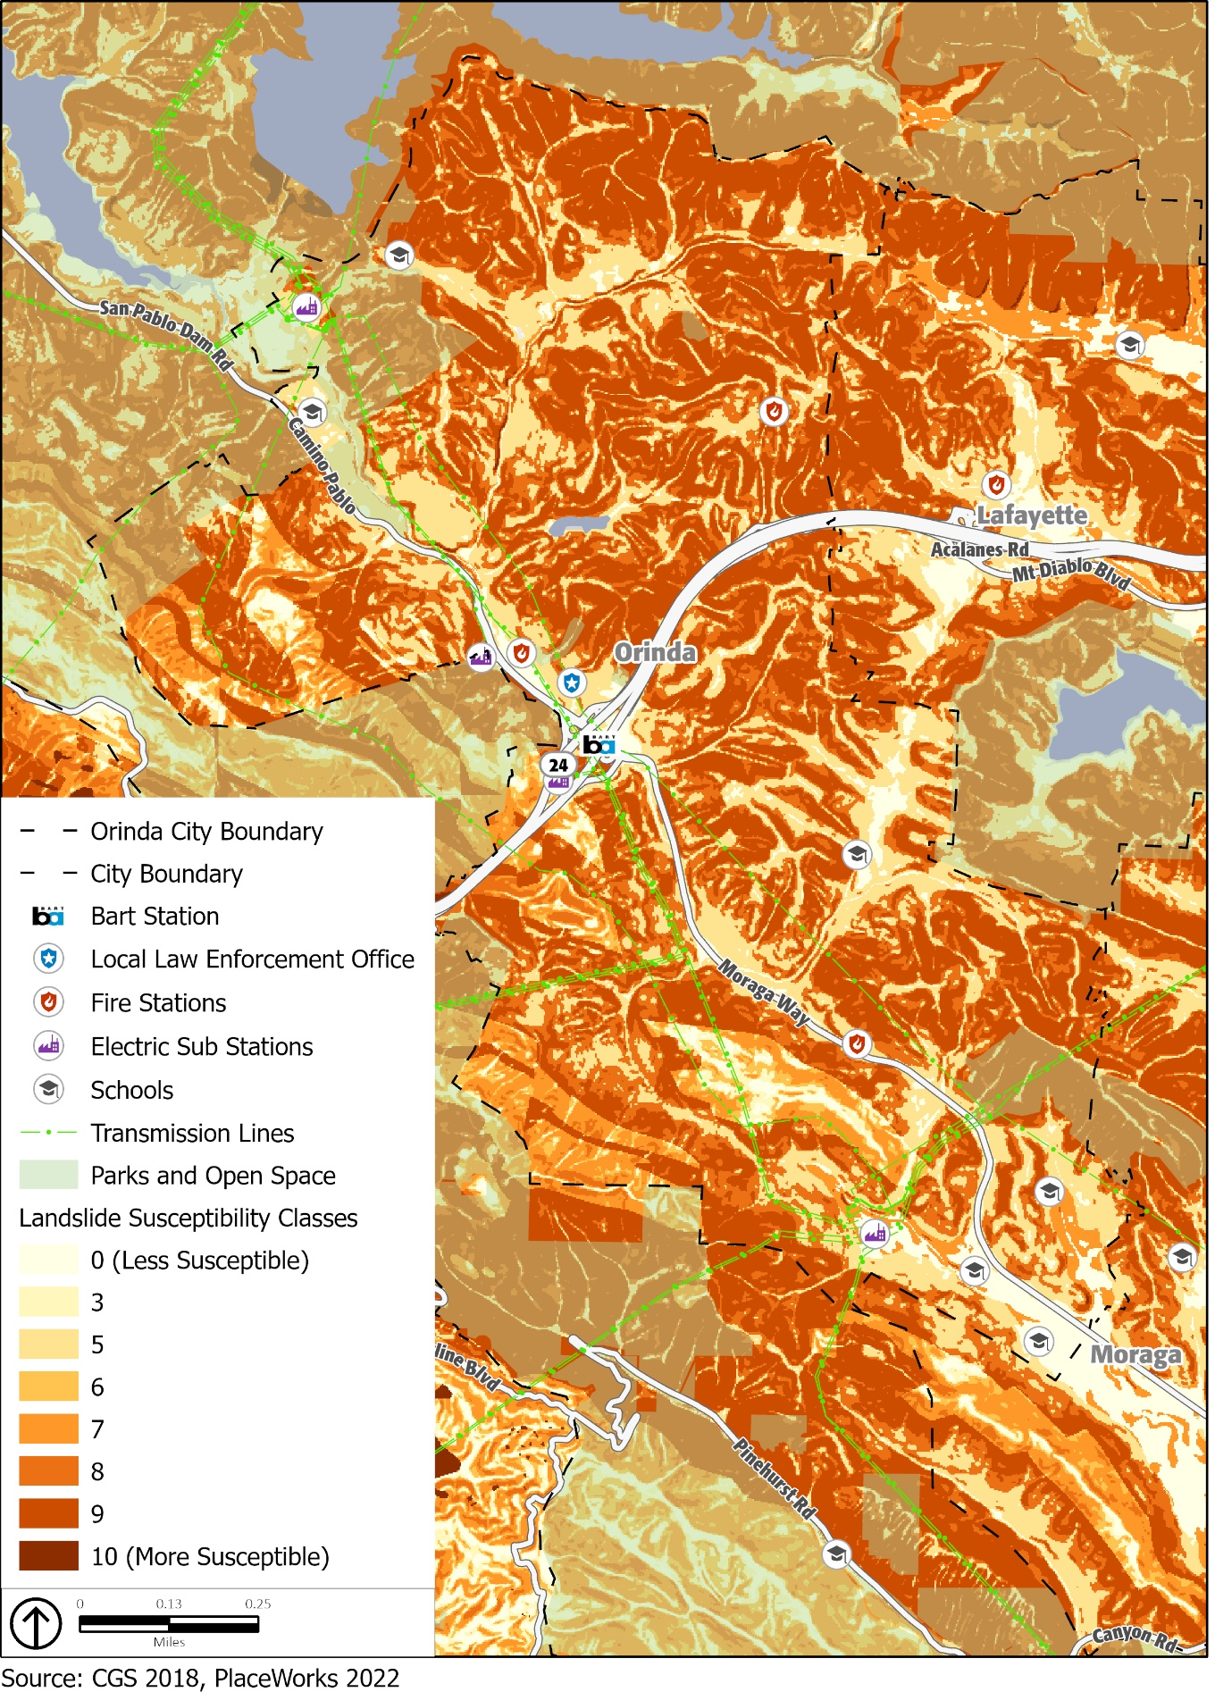
In 2012, a series of significant winter storms affected the county during late November and early December. The second storm happened on the first and second of the month, with the third and final storm on December 5th. During heavy rainfall, 69 properties with downed trees and landslides were reported to City’s Public Works Department from December 2 through December 5.
In 2017, a winter storm event caused major damage in Orinda, including property damage in the city that amounted to approximately $3 million. Storm damage included downed trees, flooding, and landslides.

Potential Changes to Geologic and Seismic Risk in Future Years

Likelihood of Future Occurrence

Seismic Risk
Earthquakes are likely to continue to occur on an occasional basis and are likely to be small. Most are expected to cause no substantive damage and may not even be felt by most people. Major earthquakes are rare, but a possibility in the region. A major earthquake along any of the nearby faults could result in substantial casualties and damage, although the greatest risk in Orinda is from the Hayward Fault due to its proximity and high potential to cause a severe earthquake. A major earthquake on the Hayward Fault could damage or destroy the BART tunnel or Caldecott Tunnel between Orinda and Oakland, limiting access in and out of the community.
Based on historical data and the location of Orinda relative to active and potentially active faults, the city will likely experience a significantly damaging earthquake. If serious shaking does occur, newer construction is in general more earthquake resistant than older construction because of improved building codes.

Geologic Risk
Geologic risks, such as landslides, are common occurrences in Orinda. With significant rainfall, additional failures are likely in the community’s landslide hazard areas and minor to moderate landslides will likely continue to impact the area when heavy precipitation occurs, as they have in the past.

Climate Change and Geologic and Seismic Hazards
While climate change is unlikely to increase earthquake frequency or strength, the threats from seismic and geologic hazards are expected to continue. Climate change may result in precipitation extremes (i.e., wetter rainfall periods and drier dry periods). While total average annual rainfall may not change significantly, rainfall may be concentrated in more intense precipitation events. Heavy rainfall could cause an increase in the number of landslides or make landslides larger than normal. Increased wildfire frequency can destabilize hillsides due to loss of vegetation and change soil composition, which can contribute to greater runoff and erosion. The combination of a generally drier climate in the future, which will increase the chance of drought and wildfires, and the occasional extreme downpour, is likely to cause more mudslides and landslides. Impacts from these conditions would compound landslide potential for the most susceptible locations.

Fire Hazards
Fire hazards include both wildfires and urban fires. The combination of complex terrain, Mediterranean climate, and productive natural plant communities, along with ample natural ignition sources, has created conditions for extensive wildfires. Wildfire is a hazard of very high concern for the City of Orinda. Historically, the fire season extended from early summer through late fall of each year during the hotter, dryer months, although it is increasingly a hazard that can occur year-round. Fire conditions arise from a combination of high temperatures, low-moisture content in the air and plant matter, an accumulation of vegetation, and high winds.
Three types of fires are of concern to Orinda: (1) wildfires, (2) wildland-urban interface fires, and (3) structural fires.

Wildfires
Wildfires occur on mountains, hillsides, and grasslands. Fuel, weather, and topography are primary factors that affect how wildland fires spread. In and around Orinda, grassland and woodland habitat provide highly flammable fuel that is conducive to wildfires. These plant species are capable of regeneration after a fire, making periodic wildfires a natural part of the ecology of these areas. The climate of Orinda and the surrounding area keeps the grass dry and more readily combustible during fire season. Seasonal drought conditions exacerbate fire hazards.
Wildfire potential for Contra Costa County is typically greatest in the months of August, September, and October, when dry vegetation coexists with hot, dry winds, known as Diablo winds. Diablo winds come from the north and northeast, carrying extremely dry air at a high velocity, usually in the San Francisco Bay Area. The name “Diablo wind” refers to the fact that the wind blows into the inner Bay Area from the direction of Mount Diablo in Contra Costa County. These hot, dry winds can quickly desiccate vegetation and other combustible materials and can push a fire down or up a slope at very high speeds. These winds often occur during the spring and fall but are especially dangerous in the driest months of late summer and fall. During these times, controlling a fire becomes far more difficult. Seasonal drought conditions exacerbate fire hazards. Areas adjacent to the city that are susceptible to wildfires are also of concern as these conditions could exacerbate vulnerabilities within the city. These areas include SRA lands in the Sibley Volcanic Regional Preserve, the Tilden Nature Area, the hillsides around the San Pablo and Briones Reservoirs, and the Briones Regional Park, as well as LRA lands around the Lafayette Reservoir Recreation Area and hillsides in Lafayette, north of SR-24.
Because areas of the city with natural vegetation are extremely flammable during late summer and fall, wildfire is a serious hazard in undeveloped areas and on large lot home sites with extensive areas of un-irrigated vegetation. Grassland fires are easily ignited, particularly in dry seasons. These fires are relatively easily controlled if they can be reached by fire equipment, although after a fire, the burned slopes are highly subject to erosion and gullying. While brush-lands are naturally adapted to frequent light fires, fire suppression in recent decades has resulted in heavy fuel accumulation on the ground. Wildland fires, particularly near the end of the dry season, tend to burn fast and very hot, threatening homes and leading to serious destruction of vegetative cover. A wildland fire can generate a destructive crown fire, which is a fire that burns materials at the top of trees, spreading from treetop to treetop. They can be very intense and difficult to contain.
Many species of oaks are relatively tolerant to fire and are known to be part of California’s fire-dependent ecosystem. In general, oak woodlands are well adapted to periodic fire in the landscape. However, fire suppression in the 20th century has led to an increase of ton per acre of various fuel types. The buildup of dense understories and higher density of small trees enhance the risk of high-severity fires under hot, dry, and windy conditions. The combustibility of the fuel depends on its moisture content, physical structure, and chemical content. The drier the fuel, the more flammable it will be. Regardless, all vegetation in the region reaches some degree of combustibility during the dry summer months and, under certain conditions, during the winter months.
In addition, tree mortality due to drought, sudden oak death, and forest pest (beetles) have increased densities of dead fuels and contributed to higher fire risk in the Bay Area. Under moderate drought conditions, oak woodlands generally present low fire risk, and treatments that remove ground fuels further reduce risk of high-severity fire. High-intensity fires increase the likelihood of a fire growing and spreading quickly. Furthermore, the production of burning embers carried through the wind can lead to spot fires, which occur beyond the immediate perimeter, and these are often the primary cause of ignition for structures. In Orinda, an oak woodland wildfire has the potential to spread rapidly due to the community’s steep topography, fuel load, and climatic conditions during the summer and fall make fire suppression challenging.

Wildfire Smoke
Increasing statewide fire frequency can create recurring air quality degradation events leading to respiratory health effects. Wildfire smoke consists of a mix of gases and fine particulate matter from burning vegetation and materials. The pollutant of most concern from wildfire smoke is fine particulate matter (PM_{2.5}). PM_{2.5} from wildfire smoke is damaging to human health due to its ability to deeply penetrate lung tissue and affect the heart and circulatory system. Although wildfire smoke presents a health risk to everyone, sensitive groups may experience more severe acute and chronic symptoms from exposure to wildfire smoke, such as children, older adults, people with chronic respiratory or cardiovascular disease, or people experiencing low socioeconomic status.

Wildland-Urban Interface Fires
The wildland-urban interface (WUI) is an area where buildings and infrastructure (e.g., cell towers, schools, water supply facilities) mix with areas of flammable wildland vegetation. The WUI is composed of both interface and intermix communities. The distinction between these is based on the characteristics and distribution of houses and wildland vegetation across the landscape. Intermix WUI refers to areas where housing and wildland vegetation intermingle, while interface WUI refers to areas where housing is in the vicinity of a large area of dense wildland vegetation. The Wildfire Influence Zone refers to an area of wildfire-susceptible vegetation up to 1.5 miles from the WUI. Hundreds of homes now border major forests and brush areas in California. Human-caused fires are the leading cause of wildland fires, and with thousands of people living near and visiting wildland areas, the probability of human-caused fires is growing.
In the WUI, efforts to prevent ignitions and limit wildfire loss hinge on hardening structures and creating defensible space through a multi-faceted approach, which includes engineering, enforcement, education, emergency response, and economic incentive. Multiple strategies in the WUI help to limit the spread of fire and reduce the risk to people and property.

Structural Fires
Orinda is also at risk from structural fires. These fires occur in built-up environments, destroying buildings and other human-made structures. Structural fires are often due to faulty wiring or mechanical equipment, combustible construction materials. The absence of fire alarms and fire sprinkler systems often exacerbate the damage associated with a structural fire. Structural fires are largely from human accidents, although deliberate fires (arson) may be a cause of some events. Older buildings that lack modern fire safety features may face greater risk of damage from fires. To minimize fire damage and loss, the City’s building Code and MOFD’s Fire Code, based on California Code of Regulation Title 24, sets standards for building and construction. It requires the provision of adequate water supply for firefighting, fire-retardant construction, and minimum street widths, among other things. The Fire Prevention Division is tasked with providing the highest level of fire prevention through public education, inspection, code enforcement, and detailed plan review. Under the direction of the Fire Marshal, Fire Prevention Division personnel strive to provide the public with the most updated information available to safely protect their home or place of business from fire and hazards.

Fire Hazard Zones
CAL FIRE establishes Fire Hazard Severity Zones (FHSZs) designating each as moderate, high, or very high severity. Incorporated areas, such as Orinda, are considered LRAs. Areas in the northwest and central northern portion of the city are within a Very High FHSZ. Many of these high-risk areas are also the most difficult to access, as they are at the end of winding roads bordering undeveloped hillsides. Furthermore, areas adjacent to the city that are susceptible to wildfires are also of concern as these conditions could exacerbate vulnerabilities within the city.
MOFD designates almost all of Orinda as a Wildland Urban Interface-Fire Area (FA). Residential development in the WUI-FA, the introduction and proliferation of exotic species, accumulated fuel because of the exclusion of naturally occurring fire, and climate change-driven compression of the historic rainy season exacerbates the fire problem. Taken together, these factors result in more people, property, critical infrastructure, and natural resources in harm’s way on a more frequent basis. While large-scale wildfires do not occur every year, wildfire incidents driven by extreme weather conditions have repeatedly been difficult to contain.
A combination of factors, including weather, topography, and vegetation put Orinda, including both the Very High FHSZ and the WUI-FA, at a high risk of wildfire hazards. Figure 11 shows the wildfire hazard severity zones in and around Orinda and Figure 12 identifies the WUI-FA. CAL FIRE periodically reviews and revises the FHSZ boundaries based on updated modeling and scientific information. Users should consult the most recent available mapping, available from CAL FIRE’s Fire and Resource Assessment Program (FRAP) at https://frap.fire.ca.gov/. Future updates to this Safety Element will incorporate new mapping data as it becomes available.
Most of the land in Orinda’s Very High FHSZ is used for low-density residential development, with lot sizes of at least 20,000 or 40,000 square feet. There are also some parcels with low-density residential on lot sizes of at least 10,000 square feet, planned residential developments, very low-density residential, and parks. Some sections of the Very High FHSZ are part of Orinda’s Ridgeline Overlay Development Zone. Figure 13 shows the land uses in the Very High FHSZ.
In March 2022, MOFD recognized the Wilder Subdivision (located west of Moraga Way between Stein Way and Glorietta Boulevard) as a Shelter-In-Place community. Although the subdivision is located in the WUI-FA, it was built with several features meant to reduce potential damage from wildfires, including at least 100 feet of defensible space around all structures, ignition-resistant roofs, and roads and driveways that can accommodate two-way traffic and firefighting equipment. These features help allow residents who are unable to evacuate to remain in their homes during a wildfire, although MOFD advises Wilder Subdivision residents to still evacuate if a wildfire comes near if possible.

Fire Protection
As described in Section 1.2, fire protection in Orinda is provided by MOFD. MOFD protects significant critical infrastructure and several target hazards and high-risk parcels in Orinda, including the Orinda Senior Village Apartments, Monteverde Senior Apartments, Orinda Convalescent Hospital, Lake Cascade Dam, a major power grid, the California Gas Transmission Company natural gas transmission line, SR-24, the four-bore Caldecott Tunnel, BART railway, the BART Berkeley Hills Tunnel, and thousands of high-value single-family homes. The CWPP identifies specific target hazard areas and occupancies within Orinda based on the potential fire hazard level, risk potential, and the number of occupants that may require assistance during an emergency. In the City of Orinda, target hazards include the Orinda Senior Village Apartments, the Monteverde Senior Apartments, and the Orinda Convalescent Hospital. No areas in Orinda are currently lacking access to fire protection services.
MOFD operates three fire stations in Orinda:
Fire Station 43 at 20 Via Las Cruces
Fire Station 44 at 295 Orchard Road
Fire Station 45 at 33 Orinda Way
MOFD also operates two fire stations in Moraga.

- Wildfire Hazard Severity Zones
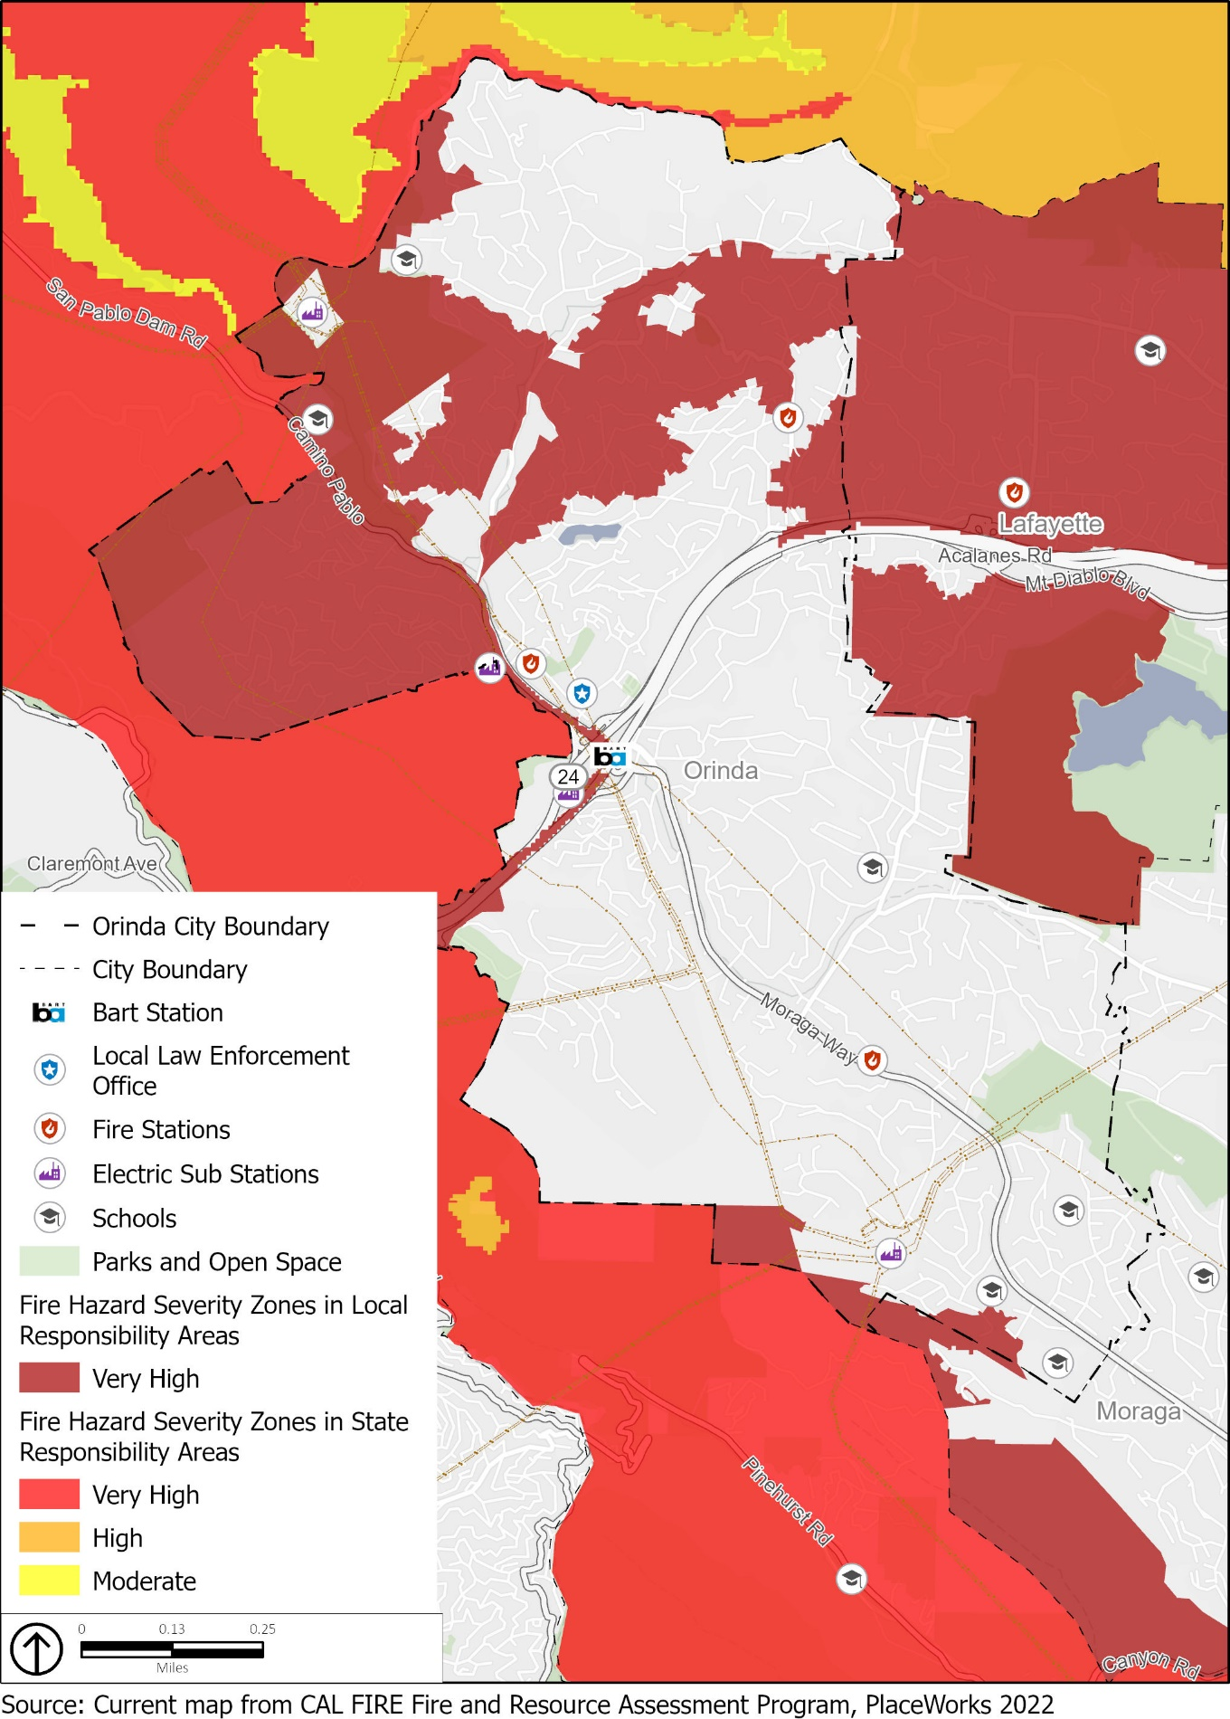
- Wildland-Urban Interface Zones
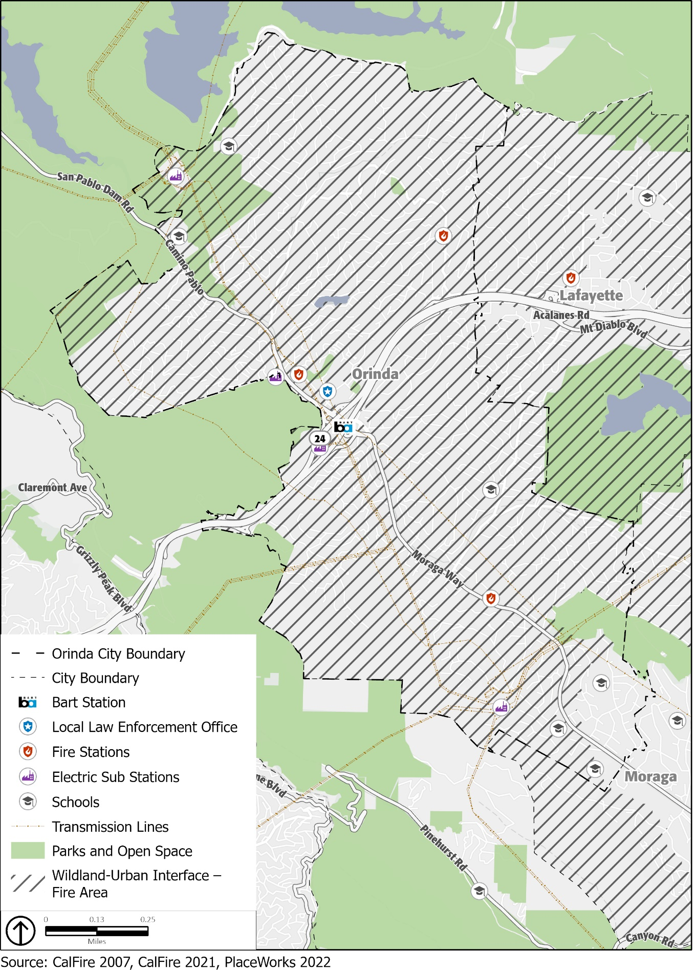
- Land Uses in the Very High Wildfire Hazard Severity Zone
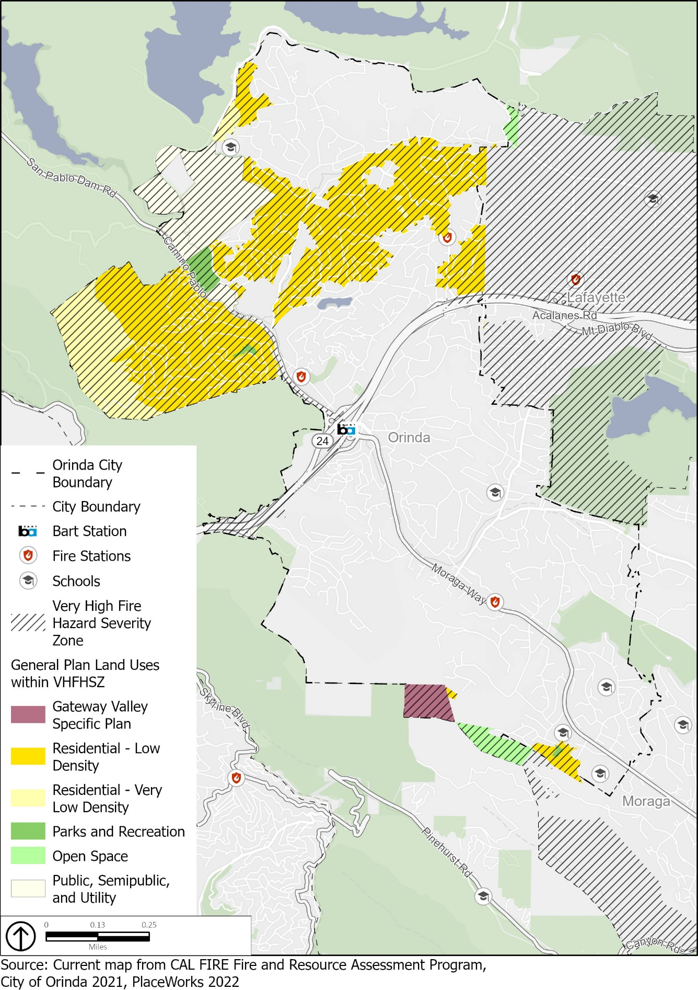

Past Occurrences
There is limited detailed information on historic fires in the Orinda area. However, a regional look at the 15 fires in the vicinity of the Caldecott Tunnel from 1923 to 1991 shows a common pattern of ignitions during critical Diablo wind conditions in the fall, occurring every 10 to 20 years.
There is one historical record of a wildfire occurring in Orinda, which was the Sibley Fire #2. The wildfire occurred in 1998 and was the result of arson. The fire began in the Sibley Volcanic Regional Preserve, encroaching on the hillsides in the southwestern area of Orinda. In total, the fire burned approximately 200 acres. Although Orinda has not experienced a major wildfire within the city limits, the city is directly east of the Oakland Hills, which in 1991 suffered one of the worst wildland-urban interface firestorm disasters to ever strike the United States, with 25 deaths, 150 injuries, and destruction of 2,900 structures, causing losses in excess of $1.5 billion. In total, the Oakland Hills Tunnel fire burned approximately 1,622 acres. It remains the third-deadliest and third-most destructive wildfire in California’s recorded history. Figure 14 shows the areas burned by past wildfires near Orinda.

Potential Changes to Fire Risk in Future Years

Likelihood of Future Occurrence
The wildfire season in Contra Costa County typically lasts from June through November. Extreme weather conditions during periods of low humidity, low fuel moisture, and high winds also contribute to the severity of any potential wildfires. Extreme weather conditions during periods of low humidity, low fuel moisture, and high winds also contribute to the severity of any potential wildfires. Fires occurring during these times typically burn hot and fast and are difficult to control unless initial suppression occurs immediately. Wildfire for Orinda is a great concern given its Very High FHSZ and WUI-FA designations, as well as the area’s unique ecology – particularly the topography, climate, and vegetation, which provides the setting for recurrent catastrophic wildfires. Moreover, the community consists of, and is surrounded by, undeveloped hillsides, which makes these areas high risk for wildfire. Wildfire will continue to be a high-risk hazard for personal safety and property damage in Orinda and smoke impacts from local and regional wildfires are likely to continue to be problematic. The likelihood of structural fires occurring in the city is low since these fires are usually the result of human accidents or mechanical issues in buildings.

Climate Change and Wildfire
Changing climate conditions are expected to increase the fire risk in and around Orinda. Warmer temperatures brought on by climate change can exacerbate drought conditions. Droughts can kill or dry out plants, creating more fuel for wildfires. Warmer temperatures are also expected to increase the number of pest outbreaks, such as the pine beetle, creating more dead trees and increasing the fuel load. Hot, dry spells may also increase disease and insect infestations resulting in higher fuel loads. Increased winds will result in more erratic fire behavior, making fires harder to contain. Warmer temperatures are also expected to occur later in the year, extending the wildfire season, which is likely to begin earlier in the year and extend later than it has historically. Wildfires occurring later or earlier in the year are more likely to occur during Diablo wind events, which can cause wildfires to move more quickly and increase the likelihood to burning in the WUI areas.
- Historic Wildfire Burned Areas
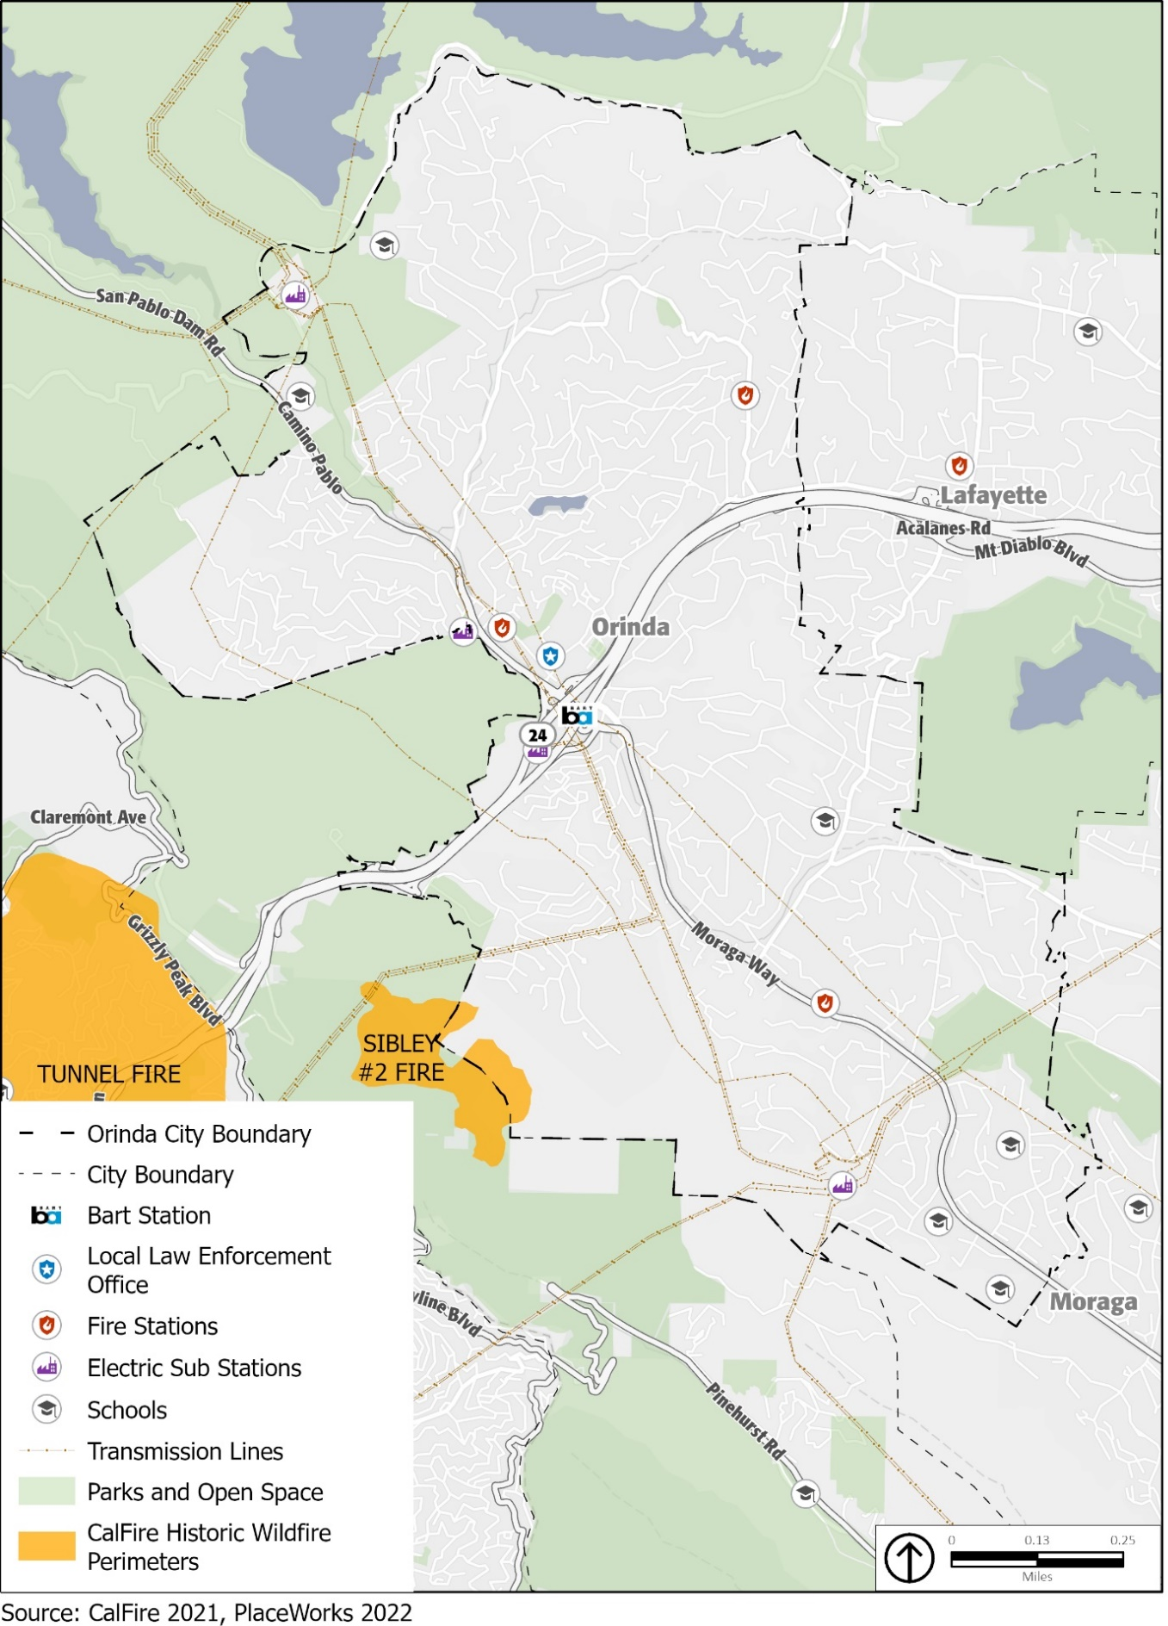

Hazardous Waste and Materials
Hazardous materials are materials that pose a significant risk to public safety or human or environmental health. These include toxic chemicals, flammable or corrosive materials, petroleum products, and unstable or dangerously reactive materials. They can be released through human error, malfunctioning or broken equipment, or as an indirect consequence of other emergencies (e.g., if a flood damages a hazardous material storage tank). Hazardous materials can also be released accidentally during transportation, as a consequence of vehicle accidents.
A release or spill of bulk hazardous materials could result in fire, explosion, toxic cloud, or direct contamination of water, people, and property. The effects may involve a local site or many square miles. Health problems may be immediate, such as corrosive effects on skin and lungs, or gradual, such as the development of cancer from a carcinogen. Damage to property could range from immediate destruction by explosion to permanent contamination by a persistent hazardous material.
Most hazardous materials in the region are being transported on truck routes along major roadways, such as SR- 24 that pass through Orinda. The most vulnerable areas along this route are considered the on-/off-ramps and interchanges. Since 1970, there have been no reported roadway hazardous materials incidents.
Hazardous materials and waste within Orinda are managed by the Certified Unified Program Agency (CUPA), a local administrative agency within the County of Contra Costa Environmental Health Division. The CUPA consolidates, coordinates, and makes consistent the regulatory activities of several hazardous materials and hazardous waste programs, including Hazardous Materials Management, California Accidental Release Prevention, Hazardous Waste Management, Underground Storage Tanks, Aboveground Storage Tanks, and Emergency Response.
Several state agencies monitor hazardous materials/waste facilities. Potential and known contamination sites are monitored and documented by the Regional Water Quality Control Board (RWQCB) and the California Department of Toxic Substances Control (DTSC). A review of the leaking underground storage tank (LUST) list produced by the RWQCB and the DTSC EnviroStor database indicates one active voluntary cleanup site at 37 Moraga Way and 12 other LUST cleanup sites with closed cases.
If a hazardous material spill poses an imminent public health threat, the City will support local regulating agencies in notifying the public. The transport of hazardous materials/wastes and explosives through the city is regulated by the California Department of Transportation (Caltrans). SR-24 is open to vehicles carrying hazardous materials/wastes; however, State law prohibits transporting many types of hazardous materials through the Caldecott Tunnel except between 3 am and 5 am. Transporters of hazardous wastes are required to be certified by the United States Department of Transportation and manifests are required to track the hazardous waste during transport. The danger of hazardous materials/waste spills during transport does exist and will potentially increase as transportation of these materials increases on SR-24. MOFD, Contra Costa County Emergency Services Division, and Contra Costa County Division of Environmental Health are responsible for hazardous materials accidents at all locations within the city.

Potential Changes to Hazardous Materials in Future Years

Likelihood of Future Occurrence
Given that there have been no hazardous materials incidents in transport through the city in the past 50 years, it is unlikely a hazardous materials incident will occur in Orinda on a frequent basis. Moreover, according to Caltrans, most incidents are related to releases of fluids from the transporting vehicles themselves and not the cargo, thus the likelihood of a significant hazardous materials release within the city is more limited and difficult to predict.

Climate Change and Hazardous Materials
Climate change is unlikely to substantially affect hazardous materials transportation incidents. However, increases in the frequency and intensity of hazards, such as floods, landslides, and severe storms, may create a greater risk of hazardous materials releases during these events.

Additional Climate-Related Hazards

Drought
A drought is an extended period when precipitation levels are well below normal. Drought is a normal part of the climate cycle. Drought may cause losses to agriculture; affect domestic water supply, energy production, public health, and wildlife; or contribute to wildfire. Like most of California and the western United States, Orinda chronically experiences drought cycles. Drought impacts the city’s water supply, which may in severe instances, ultimately makes less water available for people, businesses, and natural systems.
Less snow falling in mountainous areas causes water levels in lakes and reservoirs to drop, which can affect recreation activities. Local ecosystems that are not well adapted to drought conditions can be more easily harmed by it. During drought events, the flow of water in creeks and streams is reduced, creating more slow-moving or standing water. This can concentrate sediment and toxins in the low water levels, causing harm to plants and animals. Droughts can also indirectly lead to more wildfires, and the stress caused by water shortages can weaken plants, making them more susceptible to pests and diseases.
The U.S. Drought Monitor recognizes a five-point scale for drought events: D0 (abnormally dry), D1 (moderate drought), D2 (severe drought), D3 (extreme drought), and D4 (exceptional drought). According to the U.S. Drought Monitor, the most intensive drought conditions in recent years occurred during most of 2014, when all of Contra Costa County was classified as being in “extreme” drought. More recently, in 2021, from April through the end of the year, the county was also classified as being in “extreme” drought. As of March 2022, Contra Costa County, including Orinda, was classified as being in “severe” drought. During severe drought conditions, water shortages are common and water restrictions may be imposed to meet essential community needs. EBMUD’s 2020 Water Shortage Contingency Plan contains actions to implement and enforce regulations and restrictions for managing a water shortage when it declares a water shortage emergency under the authority of the Water Code.
Orinda’s water supply comes from imported water. The Orinda Water Treatment Plant is the heart of the EBMUD water distribution system, delivering water to the City of Orinda. EBMUD’s water supply begins at the Mokelumne River watershed in the Sierra Nevada and extends 90 miles to the East Bay, passing through the Sacramento-San Joaquin Delta. The Mokelumne Aqueducts convey the Mokelumne River supply from Pardee Reservoir, located upstream of Camanche Dam, across the Sacramento-San Joaquin River Delta (Delta) to local storage and treatment facilities in the East Bay. After treatment, water is distributed to the incorporated cities and unincorporated communities in Alameda and Contra Costa Counties that EBMUD serves. Snowmelt in the Sierra Nevada accounts for approximately 90 percent of EBMUD’s drinking water supply. Approximately 10 percent of the water supply originates as runoff from the protected watershed lands in the East Bay area.

Potential Changes to Drought in Future Years

Likelihood of Future Occurrence
Drought is different than many of the other natural hazards in that it is not a distinct event and usually has a slow onset. Drought can severely impact a region both physically and economically, affecting different sectors in different ways and with varying intensities. Adequate water is the most critical issue for commercial and domestic use. As the population in the city continues to grow, so will the demand for water. However, water supply is currently considered adequate to meet projected water needs through the year 2050. As demonstrated in the 2020 Urban Water Management Plan, EBMUD shows adequate capacity to accommodate the demand through 2050 through a diversified and resilient portfolio that includes recycled water and conservation programs.
Based on historical information, the occurrence of drought in California, including Contra Costa County, is cyclical, driven by weather patterns. Drought has occurred in the past and will occur in the future. Periods of actual drought with adverse impacts can vary in duration, and the period between droughts is often extended. Although an area may be under an extended dry period, determining when it becomes a drought is based on comparing observed precipitation with what is normal (climatologic), comparing soil moisture and crop conditions with what is normal (agricultural), or by looking at how much water is contained in snow, the level or flow rate of moving water, water in reservoirs, or groundwater levels (hydrologic). However, how individuals recognize drought depends on the ways in which it affects them. The impacts from drought include reduction in water supply and an increase in dry fuels.

Climate Change and Drought
Although droughts are a regular feature of California’s climate, scientists expect that climate change will lead to more frequent and intense droughts statewide. Overall, precipitation levels are expected to stay similar, and may even increase in some places. However, the state’s current data say that there will be more years with extreme levels of precipitation, both high and low, as a result of climate change. This is expected to cause more frequent and intense droughts compared to historical norms that cause soil to dry out and become hard. When precipitation does return, more water runs off the surface than is absorbed into the ground, which can lead to floods. Higher air temperatures are expected to increase evaporation, causing more water loss from lakes and reservoirs, exacerbating drought conditions. Reduced winter precipitation levels and warmer temperatures have greatly decreased the size of the Sierra Nevada snowpack (the volume of accumulated snow), which in turn makes less fresh water available for communities throughout California, including the imported water supply for Orinda. Continued decline in the Sierra Nevada snowpack volume is expected, which may lead to lower volumes of available imported water. Depending on the location and emissions levels, the state Cal-Adapt database indicates the snowpack (i.e., snow water equivalent) for the Tahoe-Sierra Integrated Regional Water Management Region in the spring is expected to decline from a historical average of 16.1 inches to an average of 7.8 inches (a 52 percent decrease) by the middle of the century (2035 to 2064), and an average of 2.9 inches (an 82 percent decrease) by the end of the century (2070 to 2099).
If heat-trapping emissions continue unabated, more precipitation will fall as rain instead of snow, and the snow that does fall will melt earlier, reducing the Sierra Nevada spring snowpack by as much as 70 to 90 percent. How much snowpack will be lost depends in part on future precipitation patterns, the projections for which remain uncertain. However, even under wetter climate projections, the loss of snowpack would pose challenges to water managers and hamper hydropower generation.

Extreme Heat
While there is no universal definition of extreme heat, California guidance documents define extreme heat as temperatures that are hotter than 98 percent of the historical high temperatures for the area, as measured between April and October of 1961 to 1990. Days that reach this level are called extreme heat days. In Orinda, the extreme heat threshold is 91.4°F. An event with five extreme heat days in a row is called a heat wave.
Health impacts are the primary concern with this hazard, though economic impacts are also an issue. The Center for Disease Control and Prevention (CDC) recognizes extreme heat as a substantial public health concern. Historically, NOAA data indicates that about 175 Americans succumb to the demands of summer heat, although this number has increased in recent years. From 2004 to 2018, studies by the U.S. Department of Health and Human Services indicate that there is an average of 702 deaths annually that are directly or indirectly linked to extreme heat.
In 2019, Contra Costa County reported an extreme heat event from June 9th to the 11th. The combination of high pressure and strong offshore flow resulted in an early season heat wave across the Bay Area. Multiple daily records were broken across the region due to the heat. Three fatalities were reported during the heat event; one person died as a direct result of heat-related illness, while two others drowned while attempting to cool down during the heat wave.
In 2021, Contra Costa County reported an extreme heat event from July 9th to the 11th. Daytime highs rose above 100°F with locations across the East Bay up to 110°F. Overnight lows remained warm, particularly across higher elevations where temperatures were between 70°F and 80°F in the early mornings. There were no reported fatalities as a result of this heat event. Trees and vegetation in urban forestry are most useful as a mitigation strategy when planted in strategic locations around buildings or to shade pavement in parking lots and on streets.
Extreme heat events are dangerous because people exposed to extreme heat can suffer a number of heat-related illnesses, including heat cramps, heat exhaustion, and (most severely) heat stroke. As reflected in the Vulnerability Assessment, elderly persons, small children, chronic invalids, those on certain medications or drugs, and persons with weight and alcohol problems are particularly susceptible to heat reactions. The elderly and individuals below the poverty level are the most vulnerable to extreme heat. Nursing homes and elder-care facilities are especially vulnerable to extreme heat events if power outages occur, and air conditioning is not available. In addition, individuals below the poverty level may be at increased risk to extreme heat if use of air conditioning is not affordable. Areas with lower extreme heat thresholds are not necessarily at lower risk, as persons and community assets used to cooler temperatures may be less prepared for extreme heat events.
A majority of homes in Orinda are older homes and were constructed over 42 years ago. Given that approximately 6,207 homes, or 83 percent of all housing, were constructed prior to 1980, some homes are unlikely to have air conditioning and may lack effective insulation. Therefore, people living in these homes, especially vulnerable populations, are at higher risk for heat-related illnesses from extreme heat events.
Orinda consists of oak woodland habitat that provides shade for much of the residential areas in the community. Streets and sidewalks are also well-shaded throughout many parts of the city, including the downtown area. Trees and other vegetation in the natural and urban environment help to lower surface and air temperatures by providing shade and through evapotranspiration. Evapotranspiration, alone or in combination with shading, can help reduce peak summer temperatures by 2°F to 9°F.,
Very high temperatures can harm plants and animals that are not well adapted to them, including natural ecosystems. Extreme heat can increase the temperature of water in lakes, streams, creeks, and other water bodies, especially during drought events when water levels are lower. In some cases, water temperatures may exceed comfortable levels for several plants and animals, causing ecological harm. Outdoor workers in construction or landscaping are also much more exposed to the elements than most people, so they are more susceptible to extreme heat conditions and the potential illnesses associated with very high temperatures.
Indirectly, extreme heat puts more stress on power lines, causing them to run less efficiently. The heat also causes more demand for electricity (usually to run air conditioning units), and in combination with the stress on the power lines, may lead to brownouts and blackouts.

Potential Changes to Extreme Heat in Future Years

Likelihood of Future Occurrence
Extreme heat tends to occur on an annual basis and is likely to continue occurring annually. Due to Orinda’s inland location on the east side of the East Bay Hills and relatively low elevation, high temperatures will continue to be a more common occurrence than cold temperatures.

Climate Change and Extreme Heat
The warmer temperatures brought on by climate change are likely to cause an increase in extreme heat events. Depending on the location and emissions levels, the state Cal-Adapt database indicates the number of extreme heat days is expected to rise from a historical annual average of 4 to 15 by the middle of the century (2035 to 2064), and an average of 27 by the end of the century (2070 to 2099).
Overall, Orinda is expected to see an increase in the average daily high temperatures. Depending on the future severity of climate change, the state Cal-Adapt database indicates the annual average maximum temperature is expected to increase from a historical annual average of 65.4°F to an average of up to 69.7°F by the middle of the century (2035 to 2064), and an average of up to 72.7°F by the end of the century (2070 to 2099). Although the temperature increases may appear modest, the projected high temperatures are substantially greater than historical norms. These increases also make it more likely that an above-average high temperature will cross the extreme heat threshold. As temperatures increase, Orinda will face increased risk of death from dehydration, heat stroke, heat exhaustion, heart attack, stroke, and respiratory distress caused by extreme heat.

Severe Weather
Severe weather is generally any destructive weather event, but usually occurs in Orinda as localized storms that bring heavy rain, hail, thunderstorms, and strong winds. Severe weather is usually caused by intense storm systems, although types of strong winds can occur without a storm. The types of dangers posed by severe weather vary widely and may include injuries or deaths, damage to buildings and structures, fallen trees, roads and railways blocked by debris, and fires sparked by lightning. Severe weather often produces high winds and lightning that can damage structures and cause power outages. Lightning from these storms can ignite wildfires and structure fires that can cause damage to buildings and endanger people. Objects such as vehicles, unprotected structures (e.g., bus stops, car ports), fences, telephone poles, or trees can also be struck directly by lightning, which may result in an explosion or fire.
A relatively common weather pattern that brings southwest winds and heavy rain to California is often referred to as an atmospheric river. Atmospheric rivers are long, narrow regions in the atmosphere that transport most of the water vapor carried away from the tropics. These columns of vapor move with the weather, carrying large amounts of water vapor and strong winds. When the atmospheric rivers make landfall, they often release this water vapor in the form of rain or snow, often causing heavy rains that can lead to flooding and mudslide events. From March 13th to March 16th, 2012, a series of storm systems from the Gulf of Alaska brought gusty winds and periods of heavy rain across the San Francisco and Monterey Bay areas. During this heavy storm, a series of accidents occurred, which included a roadway accident on SR-24 near Wilder Road in Orinda.
A thunderstorm is a rain event that includes thunder and lightning. A thunderstorm is classified as “severe” when it contains one or more of the following: hail with a diameter of three-quarter inch or greater, winds gusting in excess of 57.5 miles per hour (mph), or tornado. However, tornadoes are uncommon in Contra Costa County; only four have been recorded in the county since 1950. On April 16, 2018, the City of Orinda experienced a widespread storm event that brought hail measuring approximately 0.25 inches, thunder, and lightning.
High winds, often accompanying severe storms, can cause significant property damage, threaten public safety, and have adverse economic impacts from business closures and power loss. High winds, as defined by the National Weather Service, are sustained wind speeds of 40 mph or greater lasting one hour or longer, or wind gusts of 58 mph or greater for any duration. These winds may occur as part of a seasonal climate pattern or in relation to other severe weather events, such as thunderstorms. Contra Costa County experiences high wind on an annual basis. On January 4, 2008, Contra Costa County reported 110 mph winds in the East Bay Hills and Diablo Range. During this high wind event, a very strong cyclone slammed into the San Francisco and Monterey Bay areas, bringing rain, high winds, record high surf and coastal flooding. Hundreds of thousands of residences and businesses were without power, some for several days due to high winds toppling power lines. Millions of dollars in property damage was reported due to falling trees hitting cars and structures as well as damage to roads due to heavy rain. On December 11, 2014, Contra Costa County reported 83 mph winds. This atmospheric river event brought heavy rain and gusty winds with a strong winter storm that impacted the Bay Area for several days in mid-December.
All wind events pose several different types of threats. By themselves, the winds pose a threat to the health of people and structures in the county. Dust and plant pollen blown by the wind can create breathing problems. The winds can blow roofs off buildings and cause tree limbs to fall on structures. High winds also increase the threat of wildfires. Winds may dry out brush and forest areas, increasing the fuel load in fire-prone areas. Winds may spark wildfires by knocking down power lines or causing them to arc. If wildfires do start, high winds can push flames quickly into new areas, contributing to rapid spread of wildfires and making them harder to control.

Public Safety Power Shutoff Events
Electricity utilities throughout California, including PG&E, have begun to occasionally “de-energize,” or turn off the electricity for power lines that run through areas where there is an elevated fire risk. This is intended to reduce the risk of power lines sparking or being damaged and starting a wildfire. As previously described, these activities, called public safety power shutoff events, also known as PSPS events, result in a loss of power for customers served by the affected power lines. A PSPS event may occur at any time of the year, usually during high wind events and dry conditions. PSPS events may be limited to specific communities or they may affect broad swaths of the state. In October 2019, PG&E conducted one large-scale PSPS event, shutting off power to approximately 740,000 customers in 35 counties across the state, including customers in Orinda. Several PSPS events also occurred in 2020. While smaller, these events still affected thousands of PG&E customers across Contra Costa County, including Orinda.
PSPS events can impact emergency management activities. A loss of power can make it more difficult for homes or businesses to receive emergency notifications if needed. PSPS events can also create vulnerabilities for community members that lack backup power supplies and depend on electricity for heating or cooling homes and buildings, lighting, and internet. PSPS events may also be harmful to people who depend on electrically powered medical devices. Additionally, community members may be faced with economic hardships and be deprived of important services, such as grocery stores, gas stations, and banks/ATMs. Traffic lights and other traffic-control systems may not work, which can complicate any evacuation needs and may hinder emergency response. Although critical public health and safety facilities often have backup generators, the loss of power may also disable other key infrastructure systems.

Potential Changes to Severe Weather in Future Years

Likelihood of Future Occurrence
According to historical hazard data, severe weather is an annual occurrence in Contra Costa County. Damage and disaster declarations related to severe weather have occurred and will continue to occur in the future. Heavy rain and thunderstorms are the most frequent type of severe weather occurrences in the county. Wind and lightning often accompany these storms and have caused damage in the past. However, actual damage associated with the primary effects of severe weather have been limited. It is the secondary hazards caused by severe weather, such as floods and fire that have had the greatest impact on the county. In general, any severe storm that affects Contra Costa County has local effects in Orinda as well. Thunderstorms, high winds, and lightning can each have localized impacts on infrastructure, properties, and public safety. Transportation, including freight shipping, faces increased congestion when severe storms occur.

Climate Change and Severe Weather
Climate change is expected to cause an increase in intense rainfall and strong storm systems, which is usually associated with strong storm systems. This means that Orinda could see more intense weather resulting from these storms in the coming years and decades, although such an increase may not affect all forms of severe weather. While average annual rainfall may increase only slightly, climate change is expected to cause an increase in the number of years with intense levels of precipitation. Heavy rainfall can increase the frequency and severity of other hazards, including flooding.

Goals, Policies, and Actions

Emergency Preparation and Response

GOAL S-1:
A community that effectively minimizes threats to public health, safety, and welfare resulting from natural and human-caused hazards.
Policies

Policy S-1 In coordination with the County of Contra Costa, implement and update the Contra Costa County Local Hazard Mitigation Plan, as directed by the California Governor’s Office of Emergency Services and the Federal Emergency Management Agency, and maintain mutual-aid agreements with federal, state, and local agencies as well as the private sector, to assist in:
- Clearance of debris in the event of seismic hazards, collapsed buildings or structures, or other circumstances that could result in blocking emergency access or regress
- Heavy search and rescue
- Fire suppression
- Hazardous materials response
- Temporary shelter
- Geologic and engineering needs
- Traffic and crowd control
- Building inspection

Policy S-2 Incorporate the Contra Costa County Hazard Mitigation Plan and the City of Orinda Annex, approved by the Federal Emergency Management Agency in 2018, into this Safety Element by reference, as permitted by California Government Code Section 65302.6, to ensure that emergency response and evacuation routes are accessible throughout the city.

Policy S-3 Coordinate with local and State Emergency Management agencies using the Standardized Emergency Management System (S.E.M.S.) and National Incident Management System (N.I.M.S.) to facilitate multiagency emergency response.

Policy S-4 Continue to cooperate with other public agencies to ensure adequate medical and other emergency services, including assessing and projecting future emergency service needs.

Policy S-5 Maintain inter-jurisdictional cooperation and coordination, including automatic aid agreements, with fire protection and suppression agencies in Contra Costa County.

Policy S-6 Ensure that communication, educational and informational materials, assistance in preparedness activities, and evacuation and short-term recovery activities are available in multiple languages and formats appropriate for people with access and functional needs.

Policy S-7 Ensure that communication systems used by emergency responders and key City staff have sufficient redundancy and resiliency to meet City needs during and after a hazard event.

Policy S-8 Ensure that the City is able to prepare for and respond to large-scale disasters through coordination and sharing data, experience, and strategies with other emergency management agencies in state or regional efforts on disaster planning.

Policy S-9 Locate critical facilities outside of known hazard zones, including 100-year and 500-year flood hazard zones, dam inundation zones, very high fire hazard severity zones, and Wildland-Urban Interface zones. If facilities must be located in these zones, design and site them to minimize potential damage and increase their ability to remain operational during and after hazard events.

Policy S-10 Develop and implement an evacuation assistance program, in coordination with Contra Costa County Transportation Authority, Seniors Around Town, and paratransit and dial-a-ride agencies to help those with limited mobility, lack of access to a vehicle, and other at-risk populations evacuate safely.

Policy S-11 Coordinate with emergency responders, engineers, and Caltrans to identify and maintain additional potential evacuation routes to ensure adequate capacity, safety, and viability of those routes in the event of an emergency, including making improvements to existing roads to support safe evacuations as needed.

Policy S-12 Explore expanding contra-flow lanes and red flag parking restrictions to support safe evacuations on critical roadways.

Policy S-13 Continue to work with schools, senior care centers, and similar facilities to improve evacuation planning and preparation

Policy S-14 Continue to revise and improve the Evacuation Analysis and its recommendations as appropriate during future updates to the Safety Element and Hazard Mitigation Plan, including in coordination with surrounding jurisdictions.

Policy S-15 Continue to coordinate with MOFD to conduct emergency services training in support of appropriate goals and standards for training efforts.

Flood and Inundation Hazards

GOAL S-2:
A community that seeks to avoid and minimize risk and damage from flood hazards in the city.
Policies

Policy S-16 Land development shall be consistent with the natural carrying capacity of nearby creeks, streams, and other waterways to address potential hazards associated with development near sensitive riparian areas, such as erosion and flooding.

Policy S-17 For new construction and proposals for substantial improvements to residential and nonresidential development within 100-year floodplains, as mapped by the Federal Emergency Management Agency (FEMA) or as determined by site-specific hydrologic studies for areas not mapped by FEMA, the City of Orinda shall apply a minimum level of acceptable risk and disapprove projects that cannot mitigate the hazard to the satisfaction of the Building Official or other responsible agency. Areas outside of the 100-year floodplains should be considered for future risk because climate change may expand areas of the city that are currently considered flood prone.

Policy S-18 Development on parcels containing or bordering the floodway shall only be allowed if the proposed structures can be adequately floodproofed and will not contribute to property damage or risks to public safety. Such developments shall be required to be capable of withstanding flooding and minimize the use of fill. Compatible uses shall not, however, obstruct flows or adversely affect upstream or downstream properties with increased velocities, erosion backwater effects, or concentrations of flows.

Policy S-19 Update stormwater infrastructure design requirements and retrofit storm drainage systems as needed, subject to funding availability, to maintain consistency with federal, state, and local regulatory requirements and to convey runoff for more intense storms resulting from climate change.

Policy S-20 Condition new development to maintain or minimize post-development peak runoff rate and average volume similar to predevelopment conditions, to the maximum extent feasible. Consider use of green infrastructure and low impact development that use on-site infiltration to slow runoff during peak periods. Where this is not feasible, the increase shall be mitigated.

Policy S-21 Cooperate with the Contra Costa County Flood Control and Water Conservation District and other jurisdictions to pursue funding to finance improvements to storm drainage and flood control facilities.

Policy S-22 Continue to coordinate with the East Bay Municipal Utilities District and the Orinda Country Club to assess the dam inundation risk in Orinda and upgrade facilities and infrastructure at risk.

Seismic and Geologic Hazards

GOAL S-3:
A community that seeks to minimize risks to public health, safety, and welfare resulting from geologic and seismic hazards.
Policies

Policy S-23 Minimize fault rupture hazards through enforcement of the following policies:
- Require geologic studies or analyses for critical, lifeline, and high-occupancy structures and high-risk structures within 0.5 miles of all Quaternary faults shown on the Earthquake Fault Studies Zones map (see Figure 8: Regional Fault Lines).
- Require geologic trenching studies within all designated Earthquake Fault Studies Zones unless adequate evidence is presented, as determined and accepted by an approved Geotechnical Engineer or Engineering Geologist. The City of Orinda may require geologic trenching of nonzoned faults for especially critical, vulnerable, or lifeline structures
- Require infrastructure systems, such as energy, communications, and transportation infrastructure, that cross a fault be designed to resist fault rupture for the maximum plausible earthquake scenario.
- Support efforts by the California Department of Conservation, California Geological Survey, to develop geologic and engineering solutions in areas of ground deformation due to faulting and seismic activity but where a fault cannot be reliably located.
- Encourage and support efforts by the geologic research community to better define the locations and risks of faults in and around the City of Orinda. Such efforts could include data sharing and database development with regional entities, other local governments, private organizations, utility agencies or companies, and local universities.

Policy S-24 New development, including subdivisions, new construction, and remodels or expansions of existing structures, shall minimize exposure to seismic hazards through site planning and building design.

Policy S-25 A geotechnical investigation and report shall be required for all new development in landslide and liquefaction zones. Any other facility that could create a geologic hazard, such as a road on hillside terrain, must also conduct such an investigation. Evidence of probable geologic hazard shall require a geotechnical study by a registered soil engineer or registered geologist that shall be reviewed by geotechnical consultants selected by the City.

Policy S-26 Require new development in areas prone to geologic hazards (e.g., landslides, steep topography, slope instability), including the Orinda Geologic Hazard Abatement District, to be designed to adequately reduce these hazards, including minimizing the loss of native vegetation. Grading plans; environmental assessments; engineering and geologic technical reports; and irrigation and landscaping plans, including ecological restoration and revegetation plans, shall be required as appropriate to ensure the adequate demonstration of a project’s ability to mitigate these potential impacts.

Policy S-27 Require new development in hillside areas to prepare drainage plans to direct runoff and drainage away from potentially unstable slopes.

Policy S-28 Encourage retrofits to existing buildings and critical infrastructure, including key roadways, that improve resiliency to geologic and seismic hazards.

Fire Hazards

GOAL S-4:
A community that seeks to avoid and minimize the risk of loss of life, injury, and property loss from wildfires and urban fires.
Policies

Policy S-29 Cooperate with the Moraga-Orinda Fire District (MOFD) in developing additional standards, guidelines, and local ordinances to ensure provision of adequate fire protection and emergency medical service for all persons and property in the community.

Policy S-30 Continue coordination with MOFD to ensure a high level of fire protection to residential and commercial development to avoid or minimize wildfire hazards associated with new land uses, consistent with MOFD standards, including encouraging the location of new development outside of the Very High Fire Hazard Severity Zones (see Figure 11: Wildfire Hazard Severity Zones).

Policy S-31 Coordinate with MOFD and landowners to develop and maintain fuel breaks in dedicated open space and fire-access easements.

Policy S-32 Encourage new development to occur outside of Very High Fire Hazard Severity Zones. Any development that does occur in the Very High Fire Hazard Severity Zones or Wildland-Urban Interface Zones (see Figure 11: Wildfire Hazard Severity Zones and Figure 12: Wildland-Urban Interface Zones) must prepare project-specific fire protection plans, in addition to complying with all applicable state and local building and fire code regulations. Fire protection plans shall include a risk analysis, discussion of fire response capabilities, compliance with fire safety requirements (defensible space, fire protection infrastructure, building ignition resistance, etc.), appropriate mitigation measures and design considerations for any non-conforming fuel modification, maintenance, and education for residents.

Policy S-33 Develop and update programs as needed that ensure recovery and redevelopment after a large fire and that reduce future vulnerabilities to fire hazard risks through site preparation, redevelopment layout design, fire-resistant landscape planning, and fire-retarding building design and materials.

Policy S-34 Support and coordinate with MOFD in reviewing development proposals to ensure that new development be located where fire and emergency services have sufficient capacity to meet project needs or require that they be upgraded to provide necessary capacity as part of the proposed development activities.

Policy S-35 Continue to require review by the Planning Department and Moraga-Orinda Fire District prior to the issuance of development permits for proposed construction projects and conceptual landscaping plans in Very Fire Hazard Severity Zones identified by CAL FIRE and Wildland-Urban Interface Zones (see Figure 11: Wildfire Hazard Severity Zones and Figure 12: Wildland-Urban Interface Zones). Plans for proposed development in such areas shall include, at a minimum:
- Site plan, planting plan, planting palette, and irrigation plan to reduce the risk of fire hazards and with consideration to site conditions, including slope, structures, and adjacencies.
- Development and maintenance of defensible space.
- Multiple points of ingress and egress to improve evacuation, emergency response, and fire equipment access, and adequate water infrastructure for water supply and fire flow that meets or exceeds the standards in the California Fire Safe Regulations (Section 1273 and 1274 of the California Code of Regulations – Title 24, Division 1.5, Chapter 7, Articles 2 and 3).
- Class A roof materials for new and replacement roofs.
- Location and source of anticipated water supply

Policy S-36 Coordinate with the East Bay Municipal Utilities District to maintain an adequate, long-term water supply for fire suppression needs for the community.

Policy S-37 Support measures that help firefighting crews and emergency response teams respond to fire hazards or work under low-visibility conditions, such as high-visibility signage for streets and building addresses that meet or exceed the standards in the California Fire Safe Regulations (Sections 1273 and 1274 of the California Code of Regulations – Title 24, Division 1.5, Chapter 7, Articles 2 and 3).

Policy S-38 Continue to uphold fire-resistant landscaping and defensible space requirements for new residential and commercial development. All new residential development must comply with MOFD and California Fire Safe Regulations (Section 1276 of the California Code of Regulations – Title 24, Division 1.5, Chapter 7, Article 5), as well as Chapter 17.17 (Landscaping) of the Municipal Code, which requires all planted material to conform to the fire-safe vegetation list in the City of Orinda Landscape Guidelines.

Policy S-39 Require proposed development to provide adequate access for fire and emergency vehicles and equipment that meets or exceeds the standards in the California Fire Safe Regulations (Sections 1273 and 1274 of the California Code of Regulations – Title 24, Division 1.5, Chapter 7, Articles 2 and 3).

Policy S-40 Identify existing public and private roadways in fire hazard severity zones and the wildland-urban interface (WUI) that are not in compliance with current fire safety regulations, including road standards for evacuation and emergency vehicle access, vegetation clearance, and other requirements of the California Fire Safe Regulations (Sections 1273 and 1274 of the California Code of Regulations - Title 14, Division 1.5, Chapter 7, Articles 2 and 3), to the extent resources are available. Work at retrofitting City-owned roadways as needed to meet current standards and require private property owners to do the same, to the extent feasible and given the absence of other site constraints.

Policy S-41 Continue to coordinate with PG&E to underground power lines throughout the community, especially in the wildland-urban interface and fire hazard severity zone areas where wildfire risk is greatest.

Policy S-42 Collaborate with MOFD to provide roadside fuel reduction, defensible space, and vegetation management, particularly along evacuation routes.

Policy S-43 Support efforts by MOFD and other regional partners to establish an extensive community education and motivational program regarding Wildfire Risk Reduction, Home Hardening, and Emergency Preparedness, including development and maintenance of defensible space.

Hazardous Waste and Materials

GOAL S-5:
A community with effective, citywide management and disposal of hazardous materials and hazardous materials wastes.
Policies

Policy S-44 Coordinate with the Contra Costa County Emergency Services Division, Contra Costa County Division of Environmental Health, and MOFD and support efforts to reduce the level of risk from toxic and hazardous materials in Orinda by regulating the transportation and storage of these materials in the community, and through an educational program on the proper disposal methods for hazardous, toxic, and polluting materials.

Policy S-45 Require public disclosure of all companies, facilities, buildings, and properties that use, store, produce, and/or import/export any hazardous materials and wastes in the city. The City will maintain and share its inventory with the Contra Costa County Environmental Health Department.

Policy S-46 Ensure that the use and disposal of hazardous materials in the city complies with local, state, and federal safety standards.

Policy S-47 Encourage use of on-site green infrastructure to protect and enhance community water quality and use of landscape design (e.g., berms, grasslands, plantings) to either contain released hazardous materials or to process and/or absorb pollutants to prevent them from infiltrating the soil or watershed.

Policy S-48 Maintain the organizational framework for implementation of the California Standardized Emergency Management System (SEMS) and the National Incident Management System (NIMS).

Additional Climate-Related Hazards

GOAL S-6:
A resilient community able to adapt to climate-related hazards.
Policies

Policy S-49 Establish one or more equitably-located resilience hubs in Orinda. Ensure that resilience hubs are not in areas at risk from hazard impacts, to the extent possible; offer refuge from extreme heat and extreme weather events as well as poor air quality and disasters; and are equipped with renewable energy generation and backup power supplies. Such facilities should be in easily accessible locations and available to all community members. Resilience hubs consist of new well‐used, existing, community‐serving facilities that are upgraded to provide local communities with shelter, water, and electricity during these events or disasters.

Policy S-50 Use the reported data and findings of applicable local, regional, or state documents or plans pertaining to climate-related hazards that could impact the City of Orinda, including the California Climate Change Assessment, the California Adaptation Planning Guide, and the Safeguarding California Plan to inform decision-making and foster increased community resilience to climate-related hazards.

Policy S-51 Prepare for a reduced long-term water supply resulting from more frequent and severe drought events, including working with regional water providers to implement extensive water conservation measures and ensure sustainable water supplies, including for fire suppression needs.

Policy S-52 Renovate existing City-owned assets and design future facilities to incorporate renewable energy generation systems, battery storage systems, and energy-efficient design and features, as feasible.

Policy S-53 Coordinate with East Bay Municipal Utilities District to explore ways to improve and increase energy storage capacity and generation efficiency.

Policy S-54 Coordinate with the Contra Costa County Transportation Authority to increase shading and heat-mitigating materials on pedestrian walkways and at transit stops.

Policy S-55 Encourage new developments and existing property owners to incorporate sustainable, energy-efficient, and environmentally regenerative features into their facilities, landscapes, and structures to reduce energy demands and improve on-site resilience. Support financing efforts to increase community access to these features.

Policy S-56 Promote the use of drought‐tolerant green infrastructure, including landscaped areas, as part of cooling strategies in public and private spaces.

Policy S-57 Use natural resources and infrastructure to absorb the impacts of climate-related hazards and associated natural hazards, as feasible.

Policy S-58 Coordinate with neighboring communities to develop an extreme heat response plan that designates cooling centers and establishes a temperature threshold triggering citywide notification and coordination for opening designated cooling centers to the public.

Policy S-59 Collaborate with the Contra Costa County Department of Public Health and healthcare providers to minimize medical-supply-chain disruptions for facilities in Orinda.

Policy S-60 Increase the resiliency of City-owned structures to severe weather events and support homeowners and business owners to increase the resilience of their buildings and properties through retrofits, weatherization, and other improvements.

- Implementation Measures

Implementation Action |  | Applicable Policy or Policies | Responsible Department or Agency | Time Frame | Funding Source
IA-1 | The City shall continue to work with the County to update the Local Hazard Mitigation Plan upon its expiration to ensure that Orinda maintains eligibility for pre-disaster mitigation funding. | S-1 | Planning Department | Ongoing | General Fund
IA-2 | The City shall continue to maintain agreements with other local, state, and federal agencies to ensure coordinated disaster response. | S-1  S-6 | Planning Department / Moraga-Orinda Fire District / Police Department | Ongoing | General Fund
IA-3 | Maintain automatic aid agreements with other fire protection/suppression agencies in Contra Costa County. | S-5 | Moraga-Orinda Fire District | Ongoing | General Fund
IA-4 | The City shall evaluate, and as feasible enact, recommendations in the City of Orinda 2022 Evacuation Analysis and other pertinent analyses to improve safe evacuations in Orinda. | S-11  S-12  S-14 | City Manager’s Office | By 2024 | General Fund / Bond Funding / Sales Tax
IA-5 | The City shall update the Municipal Code as necessary to comply with state requirements and projections of future flood risks for flood control. | S-17  S-19 | Planning Department | Ongoing | General Fund
IA-6 | The City will update its policies and standards, if necessary, to remain consistent with state and federal standards for floodplains and urban development in areas subject to flooding. | S-17 | Planning Department | Ongoing | General Fund
IA-7 | Develop and implement minor repairs and replacement of City-maintained drainage facilities as problems are identified through the ongoing storm drain planning and inventory work, during the storm season or through ongoing inspections. | S-19 | Public Works and Engineering Department | Ongoing | General Fund / Drainage Impact Fees
IA-8 | Consult with the Contra Costa County Flood Control District as well as upstream and downstream jurisdictions regarding regional approaches for the planning, construction, operation, and maintenance of drainage and flood-control facilities. Include these entities in the referral of project applications as appropriate. | S-19  S-21 | Planning Department | Ongoing | General Fund
IA-9 | The City shall conduct regular cleaning and maintenance of storm drains along key roadways, especially in advance of the rainy season. The City shall address potential ponding and the need for storm drain improvements on major roadways subject to funding availability. | S-21 | Public Works and Engineering Department | Ongoing | General Fund
IA-10 | Coordinate with the State Division of Safety of Dams to ensure that the City is aware of the timeline for the maintenance and inspection of dams whose failure would impact their jurisdiction. | S-22 | Planning Department / Public Works and Engineering Department | Ongoing | General Fund
IA-11 | Provide information to the public on ways to reinforce buildings to reduce damage from earthquakes and what to do in the event of an earthquake. | S-24 | Planning Department | Ongoing | General Fund
IA-12 | Study building safety measures and revise the building code to: (1) Include building practices that minimize seismic and geologic risks for new residential buildings to the greatest feasible extent.  (2) Require any additional building practices that minimize seismic risks for paved areas and foundations of buildings, as needed. | S-24 | Planning Department / Public Works and Engineering Department / Contra Costa Conservation and Development Department / Contra Costa County Building Department | Ongoing | General Fund
IA-13 | The City will update and maintain standards designed to avoid geologic hazards, mitigate for soils-related constraints, reduce impacts to hydrological and drainage conditions, and minimize erosion resulting from site grading and preparation, construction, and ongoing operations. Projects will be conditioned to include measures to avoid geologic- and soils-related impacts, as necessary.  The City will require a geotechnical evaluation prior to construction of buildings intended for public occupancy in areas with potential risk related to geologic conditions or soil limitations, as identified on maps maintained by the City. The geotechnical evaluation shall evaluate all relevant risks, which may include but are not limited to erosion, landslide, expansive soils, subsidence, and seismic activity. Recommendations from the geotechnical evaluation shall be incorporated into the subject project or plan in order to reduce risk to levels acceptable to the City. The City will also incorporate geotechnical evaluations and recommendations into its own public investments, as appropriate. | S-25 | Contra Costa Building Department | Ongoing | Project applicant funding
IA-14 | Conduct slope stabilization practices on existing public property and support slope stabilization activities on private property located on unstable hillside areas, especially slopes with recurring failures where City property or public right-of-way is threatened from slope instability, or where considered appropriate and urgent by the City of Orinda Engineer, or Moraga-Orinda Fire District. | S-26 | Public Works and Engineering Department / Moraga-Orinda Fire District | Ongoing | General Fund / Fines / Project applicant funding
IA-15 | Coordinate with Moraga-Orinda Fire District to continue implementing a long-term fire protection training program and continue public education efforts, including to at-risk populations, to inform the community of wildland and urban fire hazards and ways to minimize damage caused by fires. | S-29 | Planning Department / Moraga-Orinda Fire District | Ongoing | General Fund
IA-16 | The City shall work with CAL FIRE and Moraga-Orinda Fire District to ensure maintenance of existing fuel breaks, vegetation clearance, and emergency access routes for effective fire suppression on public and private roads. | S-30  S-31 | Planning Department / Moraga-Orinda Fire District | Ongoing | General Fund
IA-17 | Continue to implement the City’s and the Moraga-Orinda Fire District’s most currently adopted Fire Codes to ensure that development is constructed in a structurally safe manner. To the extent feasible, conduct periodic fire safety inspections to ensure compliance with adopted codes. | S-35 | Moraga-Orinda Fire District | Ongoing | General Fund / Fines
IA-18 | Identify and improve areas lacking adequate water service for firefighting, including capacity for peak load under a reasonable worst-case wildland fire scenario determined by Moraga-Orinda Fire District. The City shall identify areas lacking adequate water service, including areas where future development may occur. | S-36 | Planning Department / Moraga-Orinda Fire District | Ongoing | General Fund
IA-19 | Continue to consult and coordinate with PG&E to acquire underground utility funding for Orinda. | S-41 | Planning Department / Moraga-Orinda Fire District | Ongoing | PG&E Electric Undergrounding Program
IA-20 | Designate the Moraga-Orinda Fire District as the keeper of a database of all properties in Orinda engaging with hazardous materials and include such information as their address, their owner’s contact information, and a list of all the hazardous materials on site. | S-45 | Moraga-Orinda Fire District | Ongoing | General Fund
IA-21 | Require that construction activities cease if ground or water contamination is discovered during construction until the contamination is reported and the extent of the contamination, as well as necessary actions for remediation, have been identified to the satisfaction of the appropriate agency. Require that remediation activities be completed to the satisfaction of the appropriate responsible agency (i.e., Contra Costa County Environmental Health Department, San Francisco Regional Water Quality Control Board, Department of Toxic Substances Control, or the City of Orinda, depending upon the type of contamination). | S-46 | Moraga-Orinda Fire District | Entitlement process and through routine inspections | General Fund
IA-22 | The City shall work with local schools and community centers to create resilience hubs that can serve as gathering places during emergencies and interruptions in services, and contain access to water, electricity, and other necessary services. | S-49 | Planning Department / Public Works and Engineering Department | Ongoing | General Fund
IA-23 | The City shall integrate the results of the Climate Change Vulnerability Assessment into other City planning documents where feasible, including, the Local Hazard Mitigation Plan, Zoning Ordinance, building code, and other applicable codes. | S-50 | Planning Department / Contra Costa Conservation and Development Department | By 2023 | General Fund
IA-24 | The City shall review the climate adaptation and resiliency strategies and shall update them as needed to ensure compliance with state laws and community needs. | S-51  S-52 | Public Works and Engineering Department | Every 8 years | General Fund
IA-25 | The City shall review and as needed update the Vulnerability Assessment to incorporate new technology, programs, and policies to improve adaptation to climate-related hazards. | S-51  S-52 | Public Works and Engineering Department | Ongoing | General Fund
IA-26 | Where feasible, the City shall encourage the use of existing natural features and ecosystem processes, or the restoration of, when considering alternatives and adaptation projects through the conservation, preservation, or sustainable management of open space. This includes, but is not limited to, the conservation, preservation, or sustainable management of any form of aquatic or terrestrial vegetated open space, such as parks, rain gardens, and urban tree canopies. It also includes systems and practices that use or mimic natural processes, such as permeable pavements, bioswales, and other engineered systems, such as levees that are combined with restored natural systems, to provide clean water, conserve ecosystem values and functions, and provide a wide array of benefits to people and wildlife. | S-54  S-55  S-56  S-57 | Planning Department | Ongoing | General Fund / Development Fees

Appendix A: Vulnerability Assessment Results
The table below shows the results of the Vulnerability Assessment prepared for Orinda, in accordance with the requirements of Senate Bill 379. For each population or asset that may be vulnerable to each climate-related hazard, the population or asset is scored on a scale of zero to five:
0: Not vulnerable
V1: Minimal vulnerability
V2: Low vulnerability
V3: Moderate vulnerability
V4: High vulnerability
V5: Severe vulnerability
The vulnerability scores reflect both the severity of climate-related impacts and the ability of populations and assets to resist and recover from these effects. Refer to the “Climate Change” and “Vulnerable Populations and Assets” sections of the Safety Element for additional details on the Vulnerability Assessment method.

 |  | Drought | Extreme Heat | Flooding | Human Health Hazards | Landslides | Severe Storms | Wildfire
Populations | Children (under 10) | - | V4 | V3 | V3 | V4 | V3 | V4
 | Cost-burdened households | V3 | V3 | V3 | V3 | V3 | V2 | V3
 | Households in poverty | V4 | V5 | V5 | V5 | V4 | V4 | V5
 | Immigrant communities | - | V5 | V4 | V5 | V3 | V4 | V5
 | Linguistically isolated persons | - | V3 | V3 | V3 | V3 | V3 | V4
 | Low-income households | V3 | V3 | V3 | V3 | V3 | V3 | V3
 | Low-resourced people of color | V4 | V5 | V4 | V5 | V3 | V4 | V5
 | Outdoor workers | V3 | V5 | - | V4 | - | V3 | V5
 | Overcrowded households | V3 | V3 | V3 | V4 | V2 | V2 | V3
 | Persons experiencing homelessness | - | V5 | V5 | V5 | - | V5 | V5
 | Persons with chronic illnesses and/or disabilities | - | V5 | V4 | V5 | V4 | V4 | V5
 | Persons without a high school degree | - | V2 | V3 | V2 | V2 | V2 | V3
 | Persons without access to lifelines | - | V3 | V4 | V3 | V3 | V3 | V4
 | Renters | - | V2 | V3 | V2 | V3 | V2 | V3
 | Seniors (65+) | - | V4 | V3 | V4 | V4 | V3 | V4
 | Seniors living alone | - | V5 | V4 | V5 | V5 | V4 | V5
 | Unemployed persons | - | V3 | V3 | V3 | V2 | V3 | V3
Buildings and Infrastructure | Bicycling and pedestrian trails | - | - | V3 | - | V3 | V2 | V4
 | Bridges | - | - | V3 | - | V3 | V4 | V2
 | Communication facilities | - | V2 | - | - | V3 | V3 | V3
 | Community centers | - | V1 | - | - | V2 | V2 | V3
 | Electrical transmission infrastructure | - | V4 | - | - | V4 | V4 | V5
 | Cooling centers | - | V1 | - | - | V3 | V2 | V3
 | Flood control and stormwater infrastructure | - | - | V3 | - | V3 | V3 | V1
 | Government administration facilities | - | V1 | - | - | V4 | V2 | V3
 | Hazardous materials sites | - | - | - | - | V3 | V3 | V2
 | Homes and residential structures | - | V3 | V4 | - | V4 | V4 | V4
 | Libraries | - | V1 | - | - | V4 | V2 | V3
 | Major roads and highways | - | V2 | V4 | - | V5 | V3 | V4
 | Natural gas pipelines | - | V3 | V2 | - | V4 | - | V4
 | Parks and Open Space | V3 | V3 | - | - | V4 | V3 | V3
 | Public safety buildings | - | V1 | - | - | V3 | V3 | V2
 | Schools | - | V3 | - | - | V4 | V3 | V3
 | Transit facilities | - | - | V4 | - | V2 | V2 | V2
 | Water and wastewater infrastructure | - | - | - | - | V4 | V2 | V3
Economic  Drivers | Education | - | V2 | V2 | V3 | V3 | V3 | V3
 | Finance and insurance | - | V3 | V3 | V3 | V2 | V2 | V3
 | Health care and social assistance | - | V2 | V2 | V3 | V2 | V2 | V3
 | Major employers | - | V3 | V3 | V4 | V3 | V3 | V3
 | Professional, scientific, and technical services | - | V3 | V3 | V2 | V2 | V2 | V3
Ecosystems and Natural Resources | Oak woodlands | V3 | V3 | V2 | - | V2 | V3 | V5
 | Grassland | V3 | V2 | V2 | - | V2 | V2 | V3
 | Riparian | V4 | V2 | V3 | - | V3 | V4 | V4
 | Scrub | V3 | V2 | V2 | - | V2 | V3 | V4
 | Wetlands and vernal pools | V4 | V4 | V1 | - | - | V3 | V3
Key Services | Communication services | - | V2 | V3 | - | V3 | V4 | V3
 | Emergency medical response | - | V3 | V3 | V3 | V3 | V2 | V2
 | Energy delivery | V2 | V4 | V4 | - | V4 | V5 | V5
 | Government administration & community services | - | V1 | V2 | V2 | V1 | V2 | V2
 | Public safety response | - | V3 | V3 | V3 | V3 | V2 | V3
 | Public transit access | - | V3 | V4 | V2 | V3 | V4 | V4
 | Solid waste removal | - | - | V3 | - | V3 | V3 | V3
 | Water and wastewater | V3 | V3 | V4 | - | V4 | V3 | V4

This page intentionally left blank.

The wildland-urban interface (WUI) is an area where buildings and infrastructure (e.g., cell towers, schools, water supply facilities) mix with areas of flammable wildland vegetation.
Bedsworth, Louise, Dan Cayan, Guido Franco, Leah Fisher, Sonya Ziaja. (California Governor’s Office of Planning and Research, Scripps Institution of Oceanography, California Energy Commission, California Public Utilities Commission). 2018. Statewide Summary Report. California’s Fourth Climate Change Assessment. Publication number: SUMCCCA4-2018-013.
Alquist-Priolo Earthquake Fault Zones are regulatory zones surrounding the surface traces—a line on the Earth’s surface defining a fault—of active faults in California.
Tetra Tech. 2018, January. Contra Costa County Hazard Mitigation Plan. Volume 1-Planning Area-Wide Elements.
United States Census Bureau. 2016 - 2020 American Community Survey 5-Year Estimates: Year Structure Built.
Unreinforced masonry buildings are generally composed of earthen materials such as brick, stone, adobe, or hollow concrete blocks. Most were constructed prior to 1933, predating modern earthquake-resistant design. The masonry is not strengthened with embedded steel bars or by other means and is therefore called “unreinforced.” In earthquakes, the masonry walls (especially parapets) tend to disconnect from the building and fall outward, creating a hazard for people below and sometimes causing the building to collapse.
The term “soft story” has come to mean a multi-story wood-frame residential building prone to collapse under earthquake loads. In technical documents, a “soft story” is a type of irregularity that triggers special considerations for seismic evaluation and design; a structure can have a soft-story irregularity regardless of its age, occupancy, structural material, or height.
Huang, J., H. Akbari, and H. Taha. 1990. The Wind-Shielding and Shading Effects of Trees on Residential Heating and Cooling Requirements. ASHRAE Winter Meeting, American Society of Heating, Refrigerating and Air-Conditioning Engineers. Atlanta, Georgia.
Kurn, D., S. Bretz, B. Huang, and H. Akbari. 1994. The Potential for Reducing Urban Air Temperatures and Energy Consumption through Vegetative Cooling. ACEEE Summer Study on Energy Efficiency in Buildings, American Council for an Energy Efficient Economy. Pacific Grove, California.

