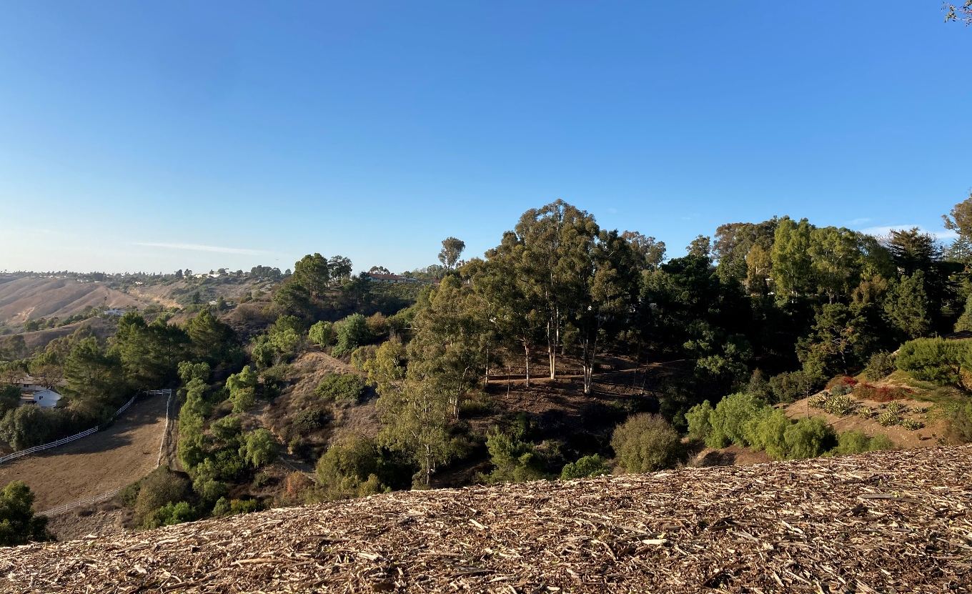
Rolling Hills General Plan
Safety Element
prepared by
City of Rolling Hills
Planning and Community Services
2 Portuguese Bend Road
Rolling Hills, California 90274
prepared with the assistance of
Rincon Consultants, Inc.
706 South Hill Street, Suite 1200
Los Angeles, California 90014
April 2021

Table of Contents
Introduction 1
City Setting 1
Regulatory Setting 1
Critical Facilities and Infrastructure 3
Hazards of Concern 6
Geologic Hazards 6
Flooding 10
Wildland and Urban Fires 13
Hazardous Materials 16
Community Communication 16
Emergency Response and Evacuation 16
Disease Prevention 19
Climate Change 20
Vulnerable Populations and Assets 20
Vulnerability Assessment Results 21
Goals, Policies, and Implementation 23
Hazard Mitigation 23
Community Communication 30
Climate Change Adaptation and Resilience 38
References 41
Tables
Table 1 Rolling Hills Climate Summary 1
Table 2 Rolling Hills Demographic Characteristics 2
Table 3 Active Faults Located in 50 Miles of Rolling Hills 9
Figures
Figure 1 Critical Facilities Map 5
Figure 2 Landslide Hazard Zones 7
Figure 3 Faults in the Vicinity of Rolling Hills 8
Figure 4 Rolling Hills Liquefaction Hazard Areas 11
Figure 5 Dam Inundation Areas 12
Figure 6 Fire Hazard Zones 14
Figure 7 Existing Evacuation Routes Error! Bookmark not defined.
Appendices
Appendix A Existing Conditions Report

Introduction
The Safety Element provides the City of Rolling Hills’ (City’s) goals, policies, and actions to minimize the hazards to safety in and around Rolling Hills. The Element evaluates natural and human-caused safety hazards that affect existing and future development and provides guidelines for protecting the community from harm. The Element describes existing and potential future conditions and sets policies for improved public safety. The goal of the Safety Element is to reduce the risk of injury, death, property loss, and other hardships to acceptable levels.

City Setting
Rolling Hills covers an area of approximately three square-miles on the Palos Verdes peninsula, approximately 18 miles south of downtown Los Angeles. The topography of the city and peninsula area is unique in that it rises above the Los Angeles Basin with rolling hills, steep slopes, and canyons. The city itself is in the San Pedro Hills. Due to its location near the coast, the area is generally cooler and has fewer air quality concerns compared to the nearby Los Angeles Basin. Table 1 summarizes the climatology of the area.
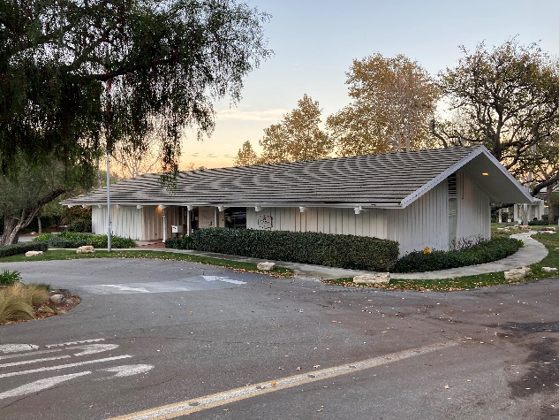
Rolling Hills City Hall
Rolling Hills is a residential community that consists of large parcels and ranch-style homes and has a sizable older adult population of about 513 (28% of the city’s total population). Important community demographic data for Rolling Hills is included in Table 2. The city is also an equestrian community, as many of residents are horse owners or have horses on their property.

Regulatory Setting
Section 65302(g) of the California Government Code requires that the General Plans include a Safety Element for the protection of the community from any unreasonable risks associated with the effects of seismically induced surface rupture, ground shaking, ground failure, tsunami,

Table 1 Rolling Hills Climate Summary
Climate Character | Estimate
Average Maximum/Maximum Temperature (Fahrenheit) | 72/79
Average Minimum/Minimum Temperature (Fahrenheit) | 52/44
Average Total Precipitation (inches) | 13.6
Source: WRCC 2016

Table 2 Rolling Hills Demographic Characteristics
Demographic Characteristics | Estimate
General
Total Population | 1,860¹
Population under 10 years | 7 percent
Population over 65 years | 28 percent¹
Race | 77 percent White, 18 percent Asian, 5 percent Hispanic/Latino
Disability (hearing, vision, cognitive, ambulatory) | 12 percent
Housing
Total Households | 645¹
Average Household Size | 2.76
Owner-occupied Households | 96 percent
Population over 65 years living alone | 15 percent of those over 65 years
Employment
Unemployment Rate | 6 percent
Poverty Rate | 2 percent
Median Income | $ 239,000
Insurance Coverage | 97 percent
¹Information obtained from the Community Wildfire Protection Plan, which is includes more recent data than the U.S Census
Source: U.S. Census 2018

seiche, and dam failure; slope instability leading to mudslides and landslides; subsidence and other geologic hazards; flooding, and wildland and urban fire. In addition, Safety Elements are required to address non-hazard specific issues such as peak load water supply, evacuation routes, and military installations.
Senate Bill 379, adopted on October 8, 2015, requires cities to include climate change adaptation and resilience into the general plan process. To comply with SB 379, this Safety Element includes a vulnerability assessment; adaptation and resilience goals, polices, and objectives; and feasible implementation measures.
Senate Bill 99, adopted August 30, 2020, requires the cities to “identify residential developments in any hazard area identified in the safety element that does not have at least two emergency evacuation routes.” SB 99 doesn’t define neighborhood and State guidance on how to address Senate Bill 99 is expected at the end of 2021.

Relationship to Other Documents
The Rolling Hills Safety Element is one of several plans that address safety in the City. The Safety Element must be consistent with these other plans to ensure the City has a unified strategy to address safety issues. The Safety Element includes information and policies from the following documents to ensure consistency.

Other General Plan Elements
The Safety Element is one section of the Rolling Hills General Plan. Other elements include Land Use, Transportation, Housing, Conservation, Open Space and Recreation and Noise. Policies in these other elements may related to safety issues. Information and policies in the Safety Element should not conflict with those in other elements.

Hazard Mitigation Plan
The City’s Hazard Mitigation Plan includes resources and information to assist the City of Rolling Hills, its residents, and public and private sector organizations in planning for hazard events. The Plan provides a list of activities that may assist the City in reducing risk and preventing loss form future hazard events. The action items address multi-hazard issues, as well as activities specifically for reducing risk and preventing losses relating to earthquake, land movement, wildfire, and drought.

Community Wildfire Protection Plan
The City’s recently adopted the Community Wildfire Protection Plan (CWPP) seeks to reduce wildfire risk in Rolling Hills. The Plan was developed collaboratively among stakeholders including the community, the City of Rolling Hills, the Rolling Hills Community Association, and the Los Angeles County Fire Department, and the Los Angeles Sheriff’s Department. The Plan includes fire mitigation and evacuation strategies for the community.

Critical Facilities and Infrastructure
Critical facilities are places that provide emergency services or serve people who would be impacted by an emergency. Examples include hospitals, fire stations, police stations, emergency services facilities, utility facilities, and communication facilities. Critical facilities can also include the transportation system and schools. Due to the size and composition of Rolling Hills, many of the critical facilities that serve the city are located outside of city limits. No areas in Rolling Hills have been identified as lacking emergency service. Critical facilities that serve the city are shown in Figure 1 and include:
- Rolling Hills City Hall: 2 Portuguese Bend Road, Rolling Hills, CA
- Rolling Hills Community Association: 1 Portuguese Bend Road, Rolling Hills, CA
- Rancho Del Mar High School: 38 Crest Road West, Rolling Hills, CA
- Storm Hill Park: Agua Magna Canyon, Rolling Hills, CA
- Los Angeles County Sheriff’s Lomita Station: 26123 Narbonne Avenue, Lomita, CA
- Los Angeles County Fire Station No. 56: 12 Crest Road West, Rolling Hills, CA
- Los Angeles County Communications Tower: 5741 Crestridge Road, Rancho Palos Verdes, CA
- Southern California Edison Electrical Substation: Crestridge Road, Rancho Palos Verdes, CA
- Southern California Edison Electrical Substation: Tarragon Road, Rancho Palos Verdes, CA
- Southern California Edison Electrical Substation: 27873 Hawthorn Boulevard, Rancho Palos Verdes, CA
- California Water Service Reservoir: Palos Verdes Drive North/Palos Verdes Drive East (SW corner), Rolling Hills Estates, CA
- California Water Service Reservoir: 3960 East Crest Road, Rancho Palos Verdes, CA
- California Water Service Reservoir: Via Canada, Rancho Palos Verdes, CA
- California Water Service Reservoir: 1 Spur Lane, Rolling Hills, CA
- California Water Service Reservoir: 60 Eastfield Drive, Rolling Hills, CA
- Portuguese Bend Road
- Crest Road

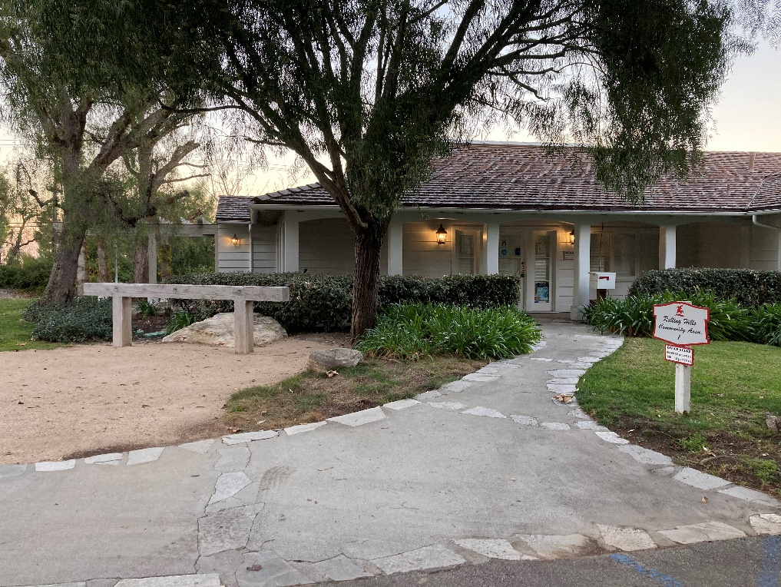
Rolling Hills Community Association
Figure 1 Critical Facilities Map
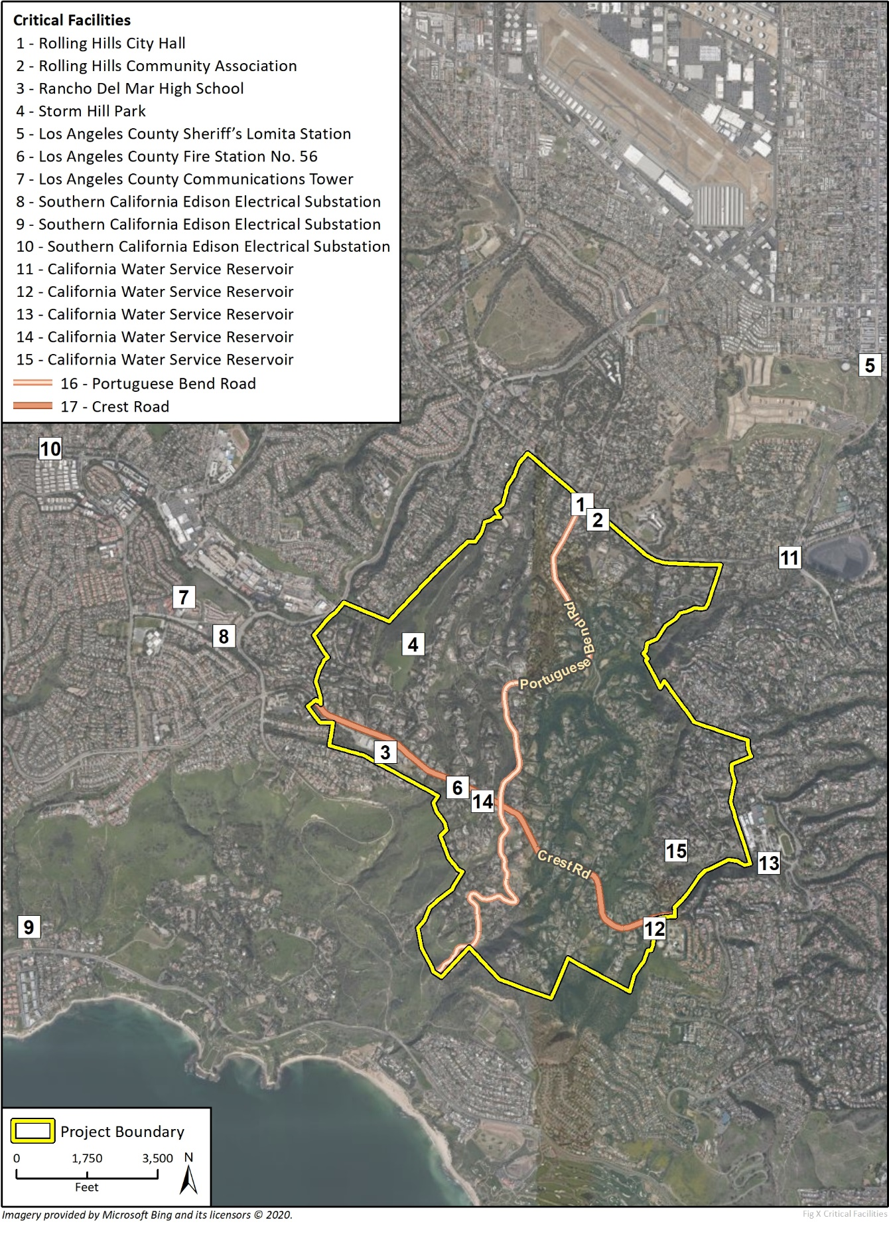

Hazards of Concern

Geologic Hazards
Geologic processes that pose a threat to life, health, property, or infrastructure are considered geologic hazards. Natural geologic hazards that have the potential to affect Rolling Hills include seismic hazards, landslides, liquefaction, expansive soils, and weathering. In most cases, these natural processes cannot be prevented; however, the magnitude of destruction resulting from natural geologic hazards can be reduced through planning policies and measures.

Landslide Hazards
Landslide activity refers to a wide range of gravity driven downslope earth movement, including rockslides, rotational slips, mudslides, and shallow debris flows. Geological and geomorphological conditions such as soil type, soil strength, slope angle, and slope height predispose slopes for failure. Other factors affecting the susceptibility to slope failure include the amount of precipitation, vegetation on the slope, groundwater seepage, and human modifications to the slope. Landslides often result in damage to property and roadways and can cause them to become unsafe due to displacement of the subsurface.
Much of the existing development in Rolling Hills is located on hilly terrain and have a greater potential to experience landslide hazards. Many of the canyons in Rolling Hills exhibit steep slopes with little vegetation coverage, leaving them susceptible to slope failure. Figure 2 shows the landslide zones in the City of Rolling Hills, as mapped by the California Geological Survey (CGS). Landslide activity has been well documented in the region. Relicts of landslides and rockslides are present throughout the City of Rolling Hills. The following major landslides have occurred in and adjacent to the city. All are in the landslide hazards areas identified in Figure 2:
- Portuguese Bend Landslide: Beginning in 1956 over approximately 270 acres in Rancho Palos Verdes
- Abalone Cove Landslide: Beginning in 1974 over 80 acres in Rancho Palos Verdes
- Klondike Canyon Landslide: Beginning in 1979 over to the south near the coastline
- Flying Triangle Landslide: Beginning in 1970s or 1980s over approximately 70 acres in the southeast area of the city
The Flying Triangle Landslide continues to impact the southeast portion of the city through impacts to private roads and above-ground utility lines. This area is relatively unsuitable for development due to the ongoing changes in topography.

Seismic Hazards
Rolling Hills is in a seismically active region of southern California. The last major earthquake in the Los Angeles area was the 5.1 magnitude La Habra earthquake in 2014. Rolling Hills is within 50 miles of the Whittier fault, Newport-Inglewood fault, Palos Verdes fault, Malibu Coast fault, Cabrillo fault, Santa Monica fault, and Redondo Canyon fault. Analysis of seismic data from the region indicates that the Whittier and Newport-Inglewood faults may generate a maximum credible earthquake of magnitude 7.2 and 7.4, respectively (SCEC 2013). Figure 3 shows the faults in the vicinity of Rolling Hills.
Typically, seismic shaking and fault rupture are primary hazards as they occur as a direct result of the interaction between the seismic wave energy and the earth’s surface. Secondary hazards, such as liquefaction and earthquake-induced landslides, occur as a result of the primary earthquake hazards.

Figure 2 Landslide Hazard Zones
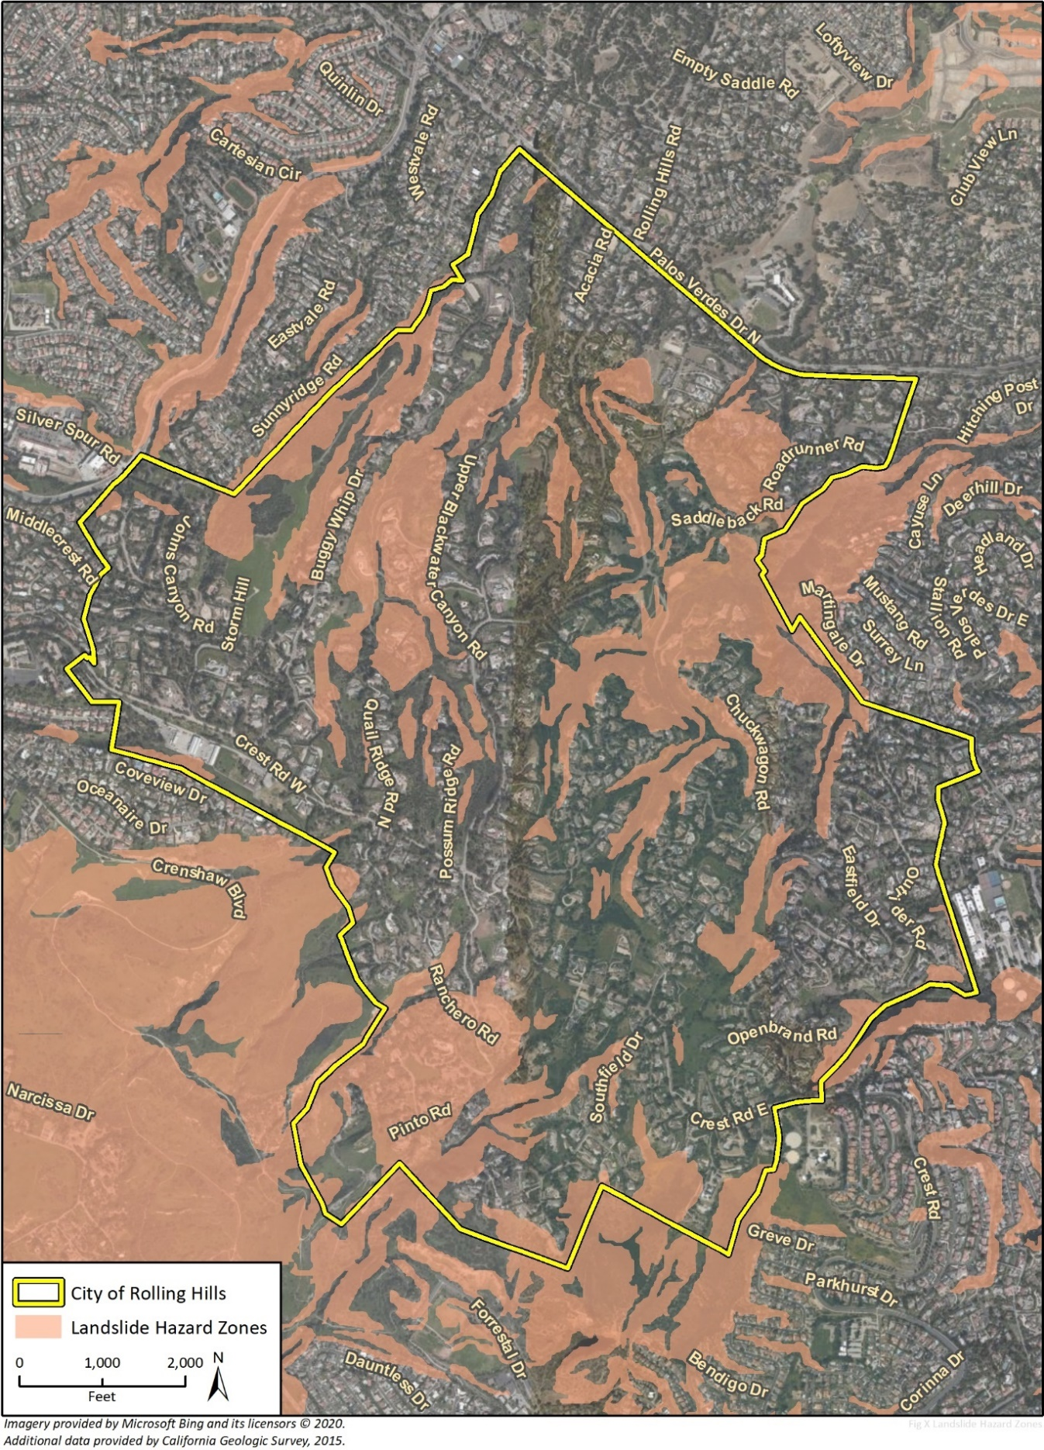
Figure 3 Faults in the Vicinity of Rolling Hills
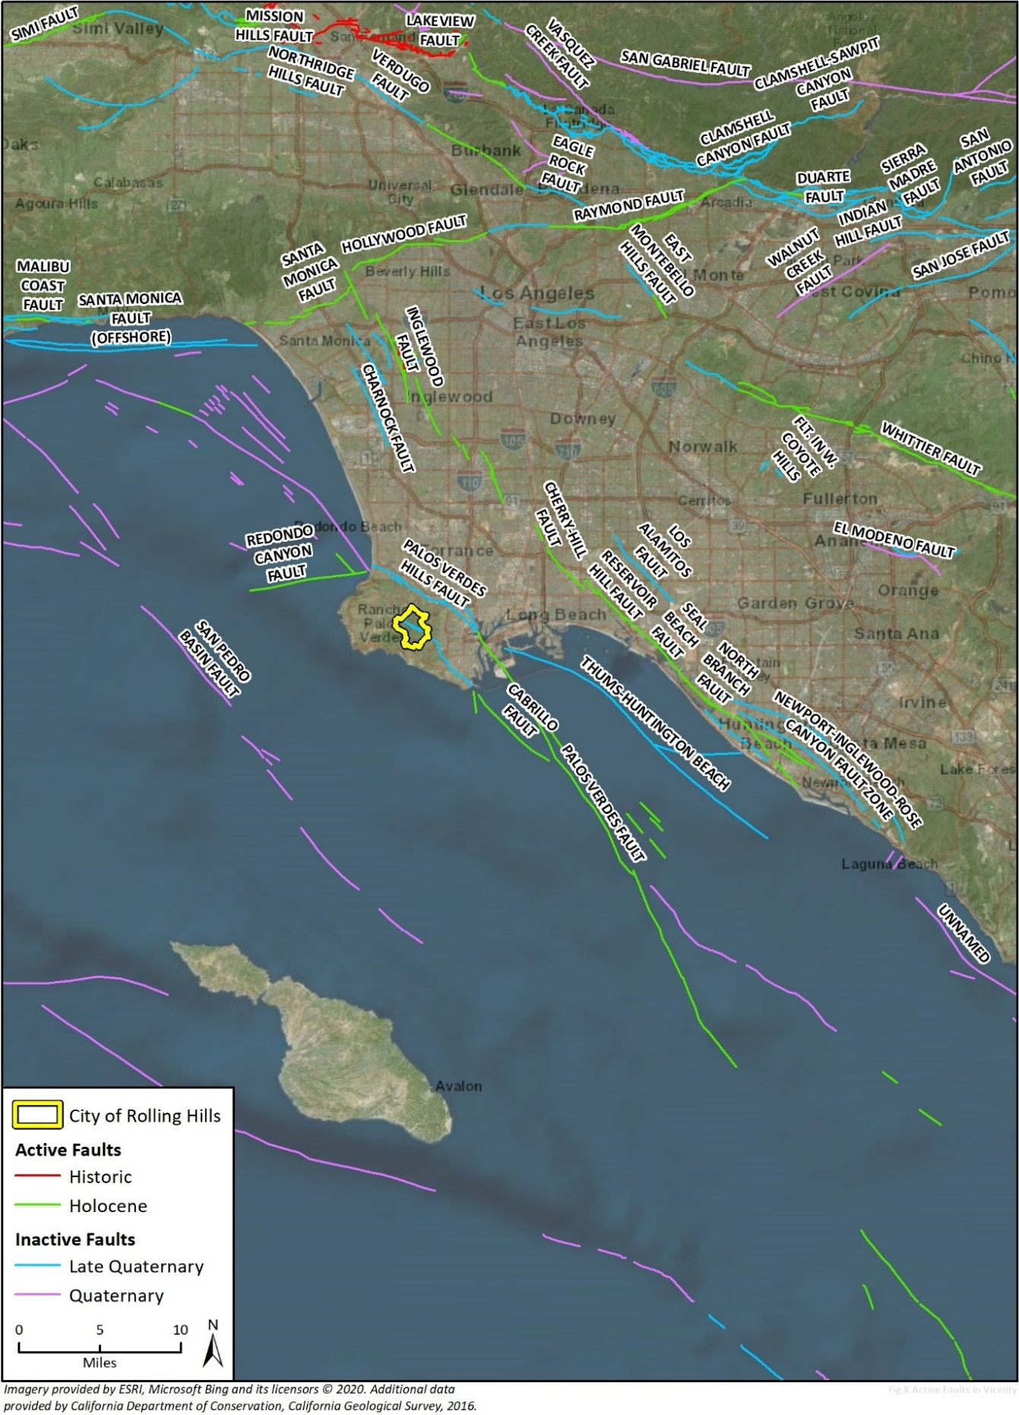

Often, earthquake activity can result in other effects such as building damage/collapse, infrastructure failure, pipeline breakage, and damage to transportation and communication facilities. The size of the earthquake and distance from the fault rupture zone typically determine the severity of these events.

Seismic Shaking
Seismic shaking, or ground shaking, refers to the movement of the earth’s surface resulting from the energy release by an earthquake. Seismic shaking is typically the primary cause of property damage resulting from earthquake activity. Seismic shaking can destroy buildings, roadways, powerlines, and pipelines. Energy transmitted through the ground can travel hundreds of miles and may cause damage in many locations simultaneously. Closer proximity to the fault rupture area results in stronger shaking in that location.
The amount of ground shaking that occurs in a location depends on the magnitude of the earthquake, the distance from the epicenter, and local soil conditions. The intensity of ground shaking is related to the peak ground velocity during an earthquake. According to the CGS Map Sheet 48, the earthquake shaking potential for Rolling Hills is moderate. The intensity of seismic shaking is measured using the Modified Mercalli scale.
According to the CGS, an active fault is one that has experienced surface movement in the past 11,000 years. The city is located near a number of active faults, including the Cabrillo Fault in city limits. Table 3 includes a list of nearby faults, their respective distance from the city, the maximum credible earthquake generated from each fault, and the likelihood of earthquake occurrence in each case.
The San Andreas fault is located approximately 80 miles to the east of Rolling Hills. Although the San Andreas fault is located at a greater distance from the city, seismic shaking originating from earthquakes occurring along the San Andreas fault poses a threat to the city. Figure 3 identifies the active and inactive faults located in the city and vicinity.

Fault Rupture
Fault Rupture occurs when seismic movement on a fault break through the earth’s surface. Hazards related to fault rupture arise when structures are built near or on top of an active fault. While there are a number of seismically active faults in the city and region, there are no active faults with the potential for ground rupture, defined by the Alquist-Priolo Earthquake Fault Zoning Act and delineated by CGS. Figure 3 shows the designated Alquist-Priolo study zones, the closest of which is the Newport-Inglewood Fault approximately nine miles northeast of the city.

Table 3 Active Faults Located in 50 Miles of Rolling Hills
Fault Name* | Approximate Distance from Rolling Hills
Whittier | 25 miles east
Newport-Inglewood | 9 miles east
Palos Verdes | Located in the City boundaries in the Northeast
Malibu Coast | 20 miles northwest
Cabrillo | Located in the City boundaries in the southwest
Santa Monica | 20 miles north-northwest
*All faults listed are active. An active fault is one that has experienced surface movement in the past 11,000 years.

Liquefaction and Settlement
Liquefaction is a ground failure phenomenon that occurs as a result of a seismic event. Liquefaction increases water content in surface soils until the soil reaches a semi-liquid state, contributing to a reduction in support, and ultimately resulting in shifting or subsidence of buildings and utilities. Ground failure typically occurs when the following conditions exist:
- Loose, unconsolidated granular soils
- Shallow groundwater
- Strong seismic ground shaking
While Rolling Hills has moderate to high seismic shaking potential, the subsurface soils generally lack saturated alluvial deposits and thick, granular soils. Figure 4 shows the liquefaction hazard areas, which are in the low-lying areas to the east and north, generally surrounding the Los Angeles Harbor and Harbor Lake. Liquefaction potential for Rolling Hills is low, as shown in Figure 4.

Earthquake Induced Landslides
Ground failure or destabilization of slopes resulting from an earthquake can also occur following seismic activity in the form of Earthquake-Induced Landslides. Earthquake-induced landslides typically occur in areas with steep slopes or unstable soil conditions. As discussed above under Landslide Hazards, the risk of landslide activity in Rolling Hills is high. Much of the city overlies areas that have been identified as landslide zones by the CGS. Risk of landslide activity increases following rainfall events that result in saturated soils. Both shallow and deep seeded landslides have historically occurred in the city.

Flooding
Rolling Hills participates in the Federal Emergency Management Agency’s (FEMA) National Flood Insurance Program. According to the FEMA flood maps, the city is not located in a flood hazard area and currently has a less than 0.2 percent annual chance to be inundated by flood waters as a result of a storm event (FEMA 2008). Overall, the city is not in any immediate risk from flooding caused by overflowing water bodies or heavy rains. However, runoff and minor flooding pose a risk if drainage systems fail along canyon bottoms, where natural drainage leads.

Dam Inundation
No water storage facilities that the State of California identifies as dams are located in Rolling Hills. Just outside city limits are three water storage facilities identified as dams, which include:
- Palos Verdes Reservoir. Owned by the Metropolitan Water District of Southern California and located at the southeast corner of Palos Verdes Drive East and Palos Verdes Drive North. According to the California Department of Water Resources, the reservoir can hold approximately 1,100 gallons of water and has an extremely high downstream hazard.
- 10 MG Walteria and 18 MG Walteria. Two reinforced concrete tanks which are owned by the City of Torrance and located at Crenshaw Boulevard and Crest Road. The tanks can hold 31 and 58 acre-feet (AF) of water, respectively.
Senate Bill 92, adopted in 2017, is a new dam safety requirement that requires dam owners to map the downstream inundation areas for dams governed by the Department of Water Resources. Figure 5 shows the inundation areas for the nearby water storage facilities. Due to their locations and the topography of the area, the inundation areas do not enter or affect any portion of the city.

Figure 4 Rolling Hills Liquefaction Hazard Areas
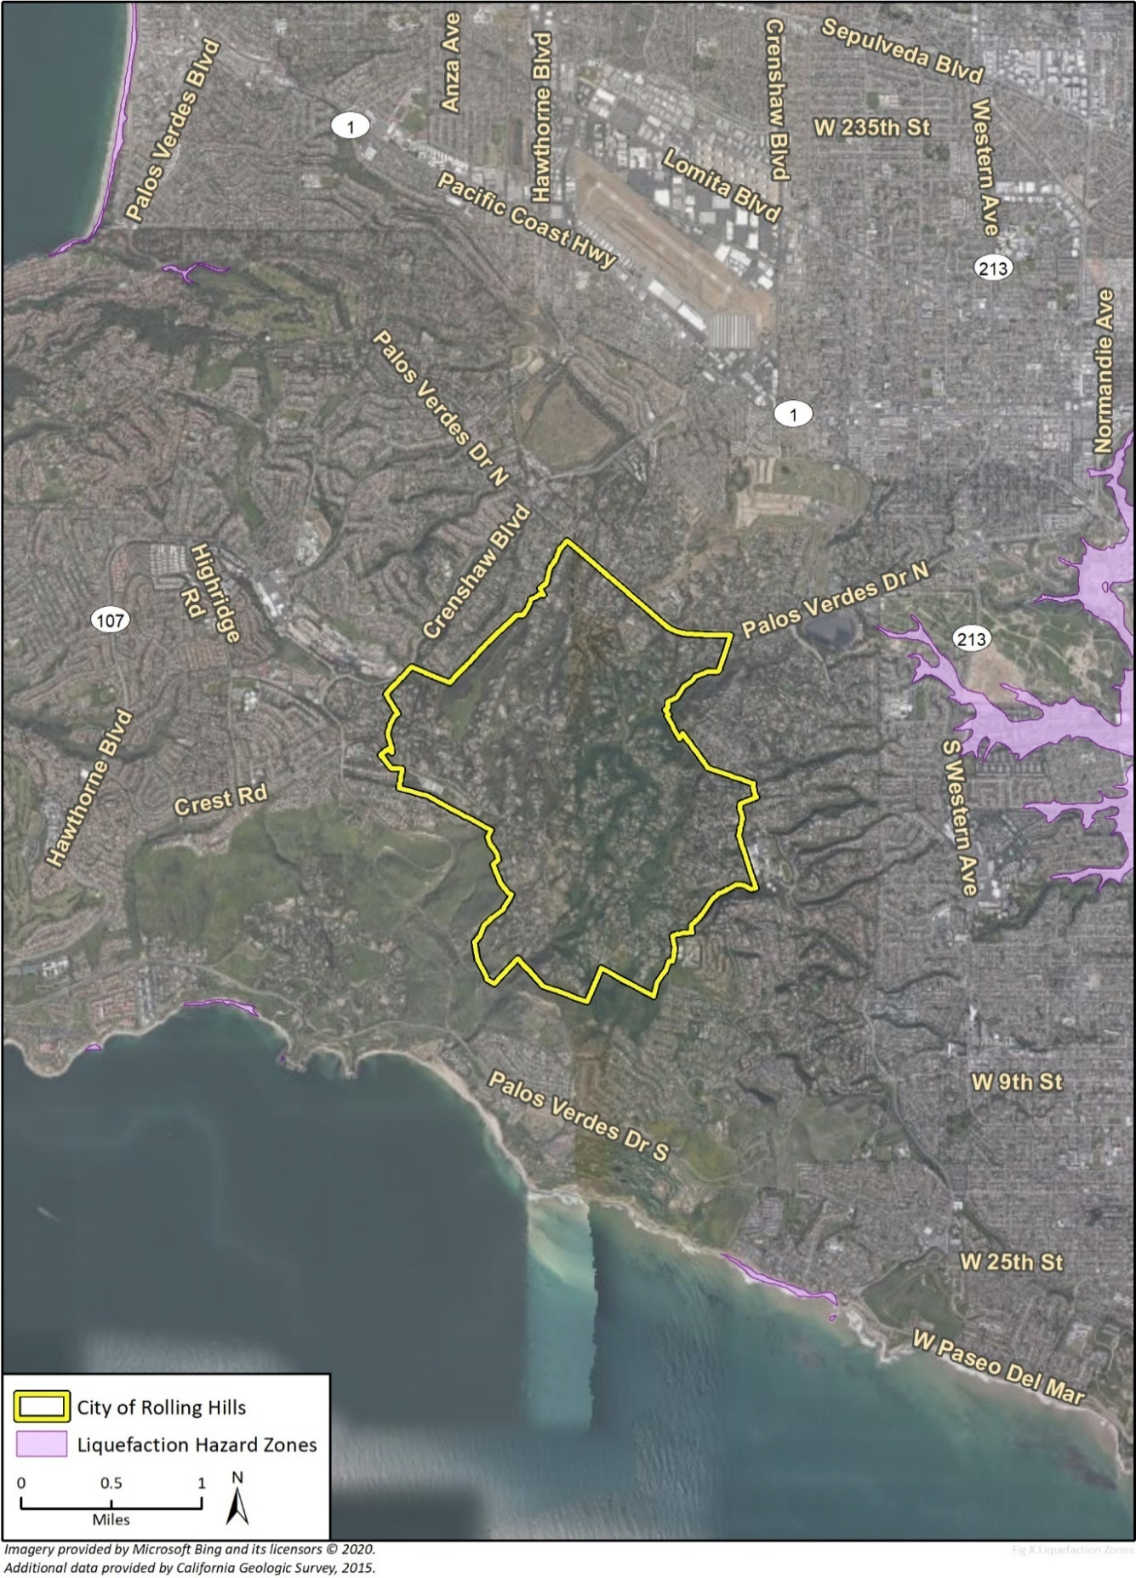
Figure 5 Dam Inundation Areas
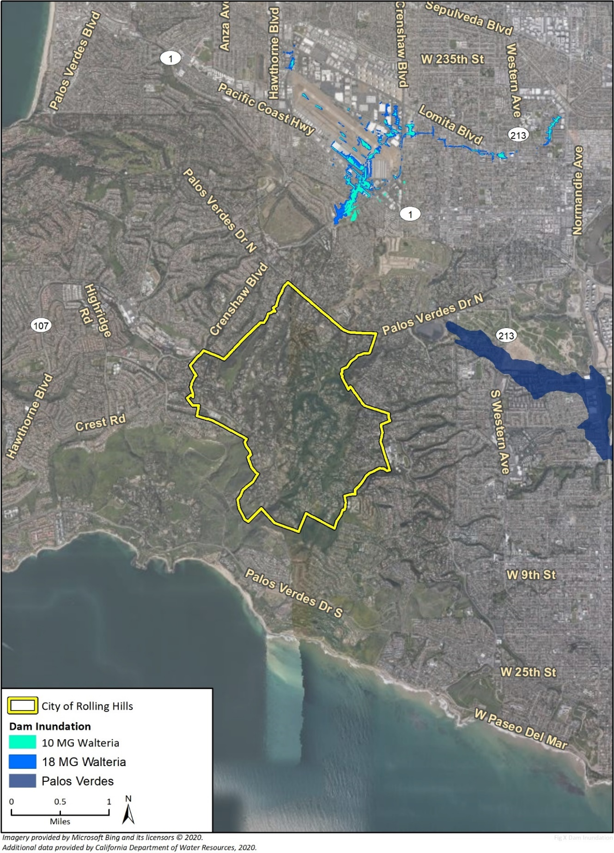

Wildland and Urban Fires
The entire City of Rolling Hills is designated a Very High Fire Hazard Severity Zone (VHFHSZ) by the California Department of Forestry and Fire Protection (CalFire), as shown in Figure 6. Rolling Hills terrain is comprised of several large and steep canyons that limit and challenge vegetation management and present conditions where a fire can quickly travels up and downslope to nearby homes. Due to the rural nature and large residential lots, many homes are surrounded by more substantial vegetation and dense brush than in more suburban settings. The bridle trails for hikers and equestrian access also contain dense vegetation and management difficulties, which contributes to the fire risk of the city. Electrical power lines pose a
hazard to starting fires in the city if lines are not automatically de-energized when knocked down by extreme weather or if the surrounding vegetation is not adequately managed.
There is a history of fires in the city and the surrounding Palos Verdes Peninsula. Three major fires have been documented on the Peninsula and in the city in:
- 1923: an estimated 4,000 acres burned in Palos Verdes Hills
- 1945: 3,000 acres burned
- 1973: approximately 900-925 acres burned, 12 homes destroyed, and 10 homes damaged
- 2005: 212 acres burned near Del Cero Park
- 2009: 230 acres burned, 6 homes damaged, and forced 1,200 residents on the Peninsula to evacuate
- 2015: 3 acres burned
For many of the developed residences in the city that are vulnerable to fires, their risk may increase with construction techniques that

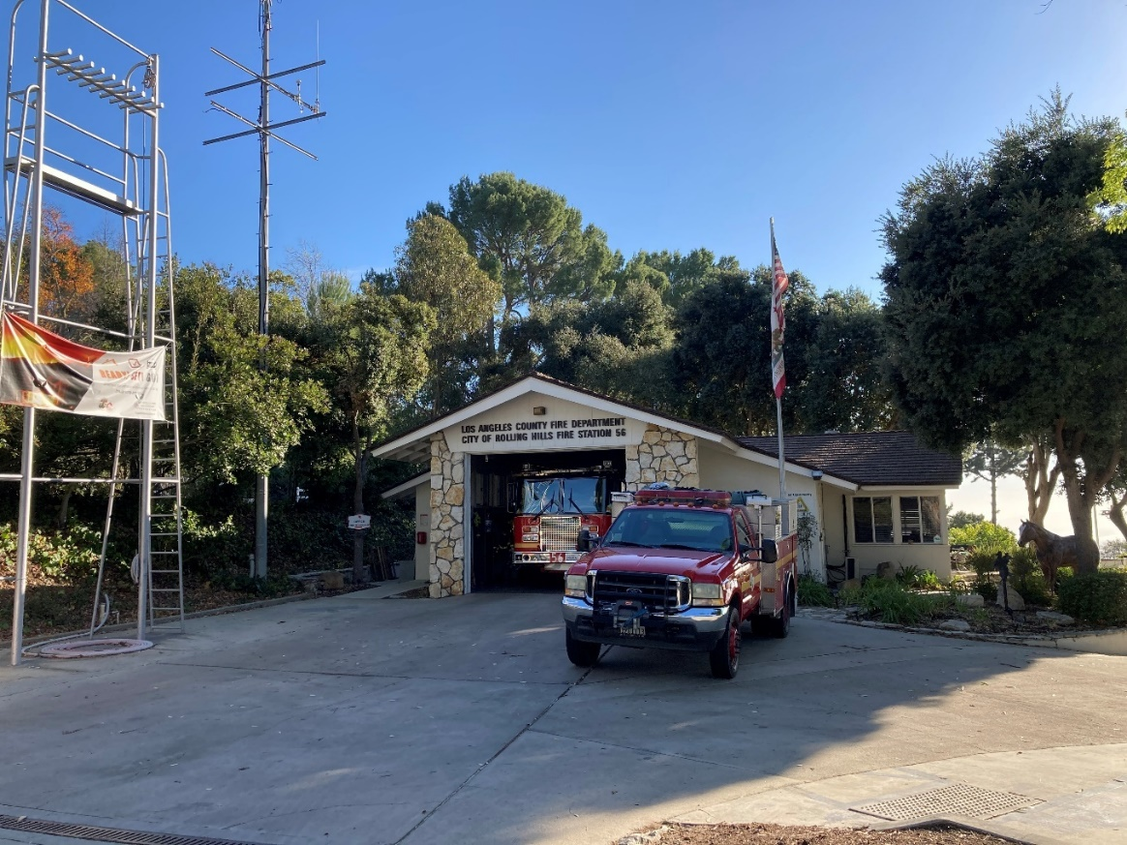
Los Angeles County Fire Station No. 56

Figure 6 Fire Hazard Zones
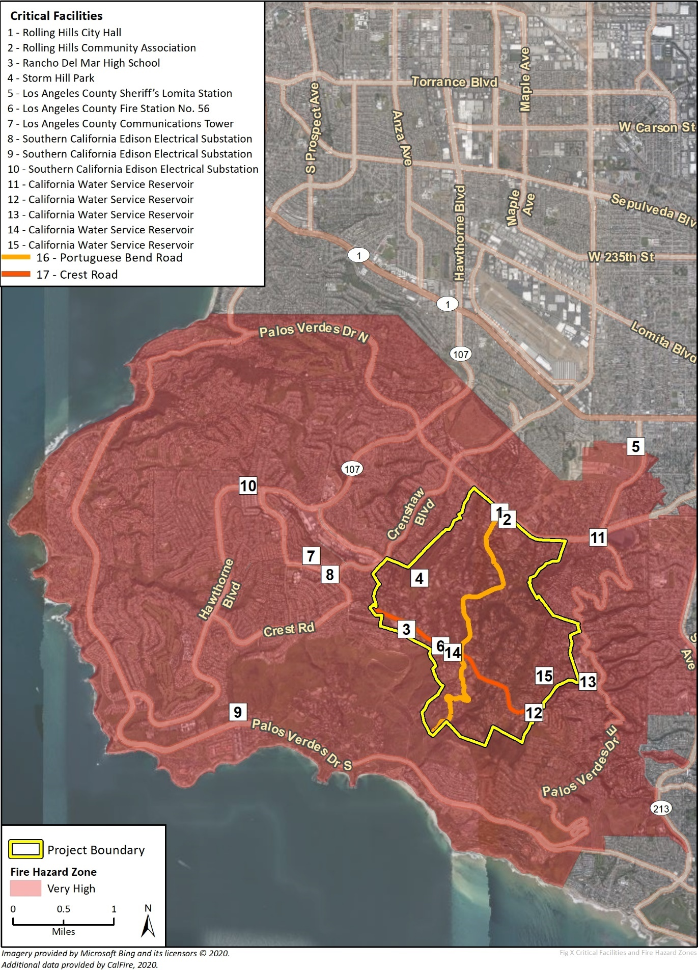

may not meet current wildfire standards. Rolling Hills Building Code and Los Angeles County Fire Department, under the VHFHSZ standards, require new development to include more stringent design and material standards for roofing, eaves, and rafter tails as well as exterior finishes and fire buffer zones. While compliance with these standards reduces the vulnerability to new structures, existing structures that have not complied with these standards may be susceptible to undue fire risk.

Existing Fire Risk Reduction Strategies
- Rolling Hills Municipal Code (RHMC) Chapter 8.24 Abatement of Nuisances, Chapter 8.30: Fire Fuel Abatement, and Chapter 15.20 Fire Code
- Los Angeles County Fire Department Fuel Modification Plans
- Los Angeles County Fire Code Section 4908
- Rolling Hills Community Wildfire Protection Plan vegetation management standard recommendations
- Rolling Hills Community Association fire fuel management strategies

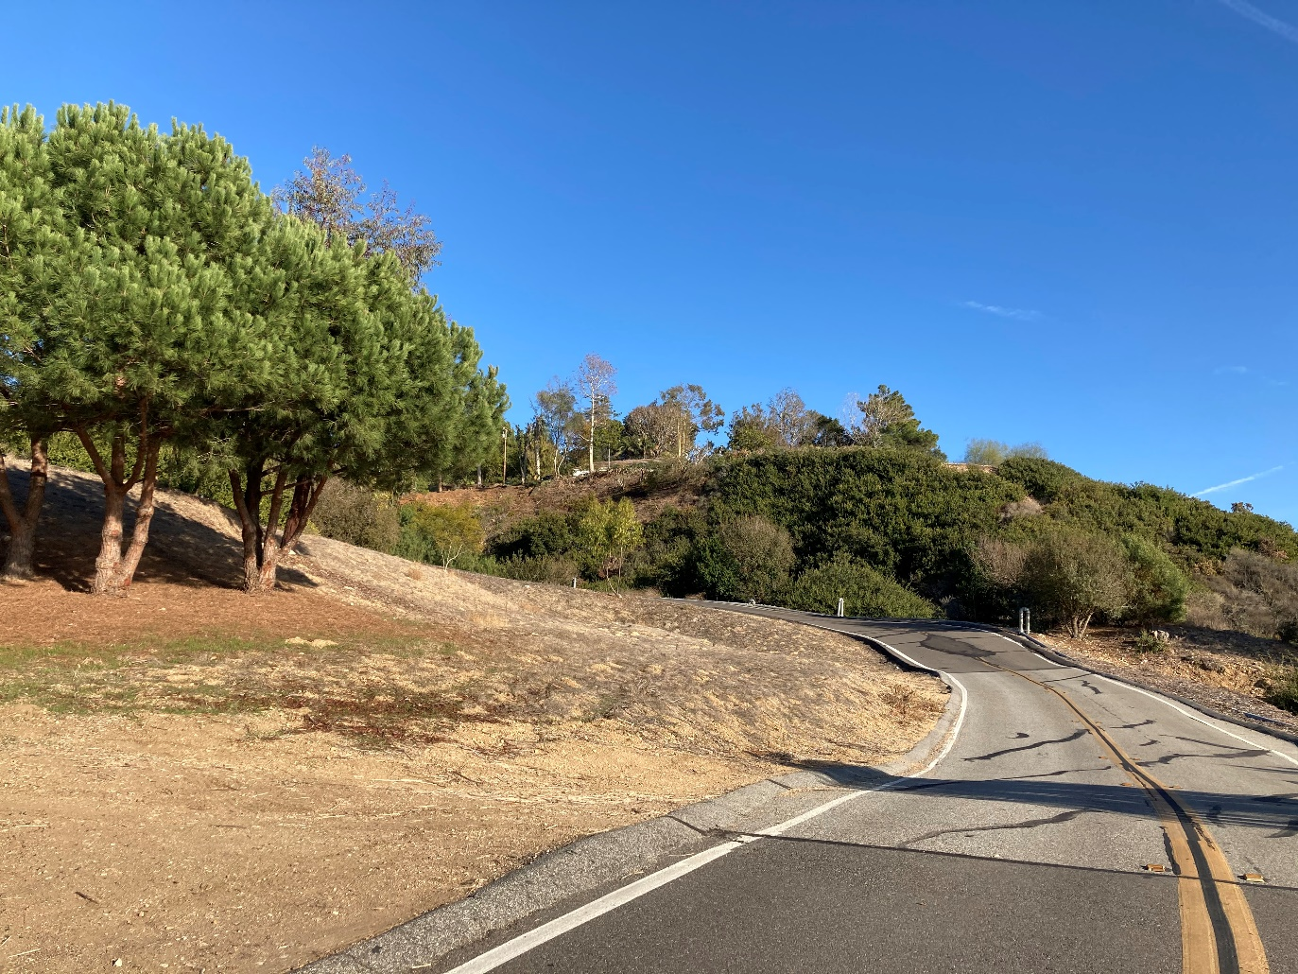
Portuguese Bend Road, south of Crest Road

Hazardous Materials
According to the Department of Toxic Substances Control (DTSC), there are no hazardous waste sites or facilities in Rolling Hills (DTSC 2020). The city and surrounding area do not contain heavy industrial uses that would create a hazardous material risk in the event of a spill, release, or natural disaster.
The city is not located near any major transit routes involving transport of a substantial quantity of hazardous material through the city. However, the nearby oil refineries (located along Sepulveda Boulevard approximately six miles northeast) and Port operations (located approximately three miles to the east) could create air quality impacts if wind patterns and release events occur. Air quality impacts are discussed in the Open Space and Conservation Element of the Rolling Hills General Plan.

Community Communication

Emergency Response and Evacuation

Police Response and Crime
The Los Angeles County Sheriff’s Department is contracted with the city to provide police services and protection to the city. The Lomita Station of the Sheriff’s Department located at 26123 Narbonne Avenue serves the city.
According to the Lomita Station crimes report from January 1, 2020, through June 30, 2020, Rolling Hills had three reported crimes (LACSD 2020). The crimes were related to theft, assault, and burglary. Outside the city limits and in the Lomita District, 433 crimes were reported during this same period, 71 of which were violent crimes (LACSD 2020). The difference in crimes in the city and the surrounding area is attributed to the private nature of the city. There are three entrances to the city, all of which are gated and staffed 24 hours a day. Visitors are required to be on a resident’s guest list to enter city limits, reducing crime in the city and demand on Los Angeles County Sheriff’s Department.

Fire Response
The Los Angeles County Fire Department provides emergency operations support to the City and participates in the California mutual aid system. Mutual aid is emergency assistance that is dispatched upon request across jurisdictional boundaries. Fire Station 56, located at 12 Crest Road West, serves the city under Battalion 14, which also serves the remaining Palos Verdes Peninsula, Lomita, and Catalina Island. Fire response constraints in the city include ability to access certain homes or areas due to inadequate road widths for fire maneuvering. One of the major topics of concern related to fire response in the city relates to vegetation clearing along roadways. Ten-foot clearance on each side of the roadway, especially the limited access roads, is important for fire response and evacuation during a fire, according to Scott Hale, Assistant Fire Chief.

Evacuation Strategies and Routes
Because a variety of hazards could affect city residents, it is vital to identify critical routes for evacuation in the event of a major event.
Senate Bill 99, adopted August 30, 2020, requires the cities to “identify residential developments in any hazard area identified in the safety element that does not have at least two emergency evacuation routes.” Due to the size of Rolling Hills and that it has four evacuation routes, no neighbors have been identified as not having two evacuation routes. As shown on the Figure 7, the evacuation routes also connect to major roadways in the area that are multi-directional such as Crenshaw Boulevard, Palos Verdes Drive North and Palos Verdes Drive East.
Figure 7 Existing Evacuation Routes 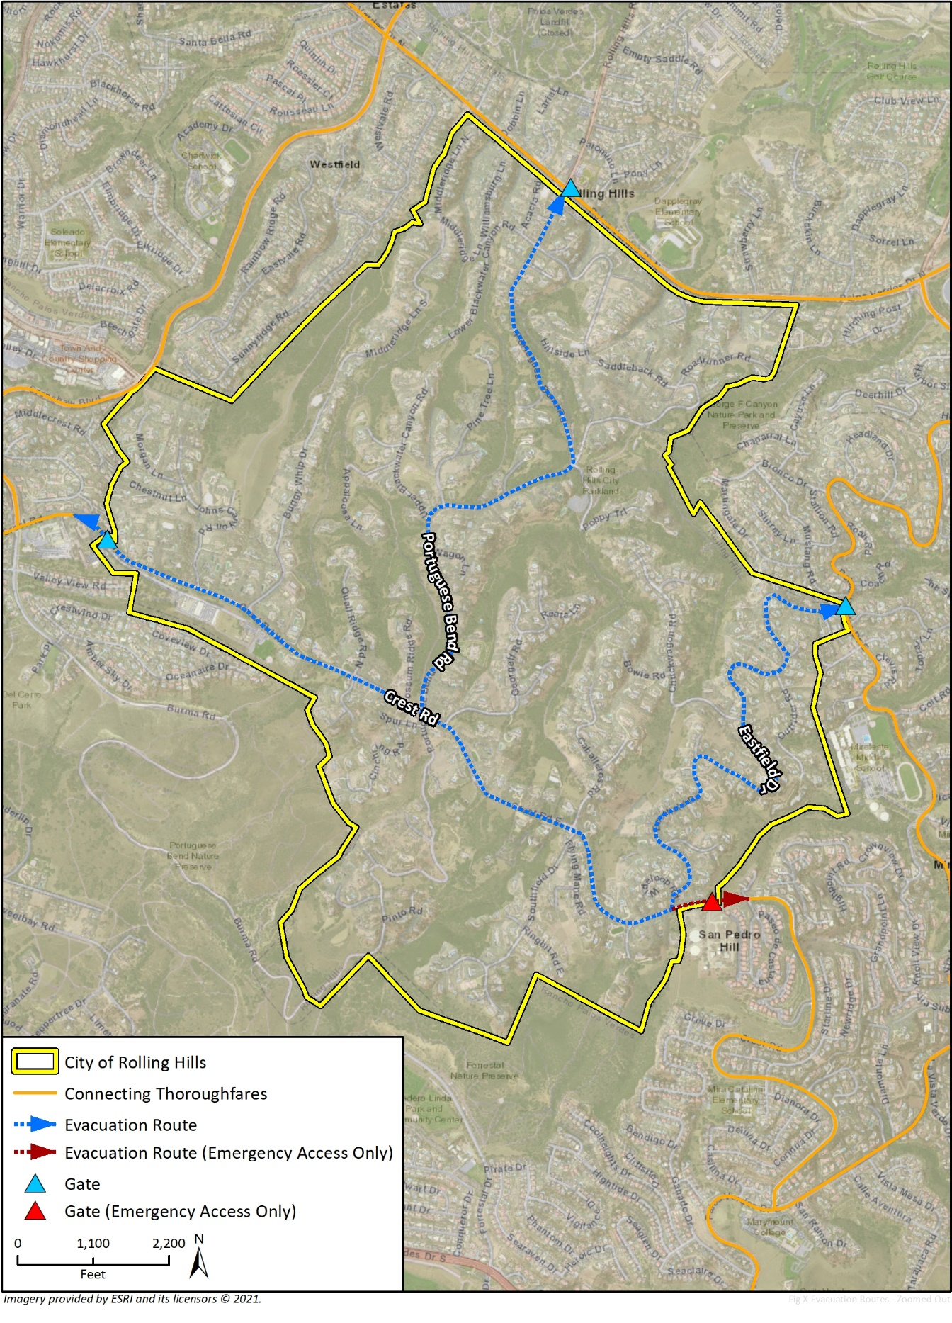

Error! Reference source not found. identifies the existing evacuation routes in the city, which are:
- Main Gate at Rolling Hills Road and Palos Verdes Drive North
- Crest Gate at Crest Road near Crenshaw Blvd
- Eastfield Gate at Eastfield Drive and Palos Verdes Drive East
- Crest Road East Gate at the end of Crest Road East
Crest Road East Gate has been updated with a motor and has no guards. This gate is available as an emergency exit to the city during emergencies. The City’s recently adopted CWPP establishes evacuation strategies and methodologies, including:
- Using the City’s Block Captains as important coordinators for residents
- Communication goals between the City, emergency responders, Rolling Hills Community Association, and residents
- Details for residents regarding how people get notified during an evacuation
- Responsibilities and operations of the Emergency Operations Center

Disease Prevention
As evidenced by the COVID-19 pandemic, unforeseen infectious diseases can be disastrous for communities, especially vulnerable groups such as older adults, and people with compromised immune systems. The City worked diligently during the pandemic to minimize risk to community members. The Block Captains regularly checked in on old adults in the community, finding out what residents needed, helping run errands, and providing hand sanitizer Additionally, the City disseminated information regularly including where to buy groceries at the beginning of the pandemic, testing information, and more. Policies regarding infectious disease can help expedite recovery and prepare the community for future risks.

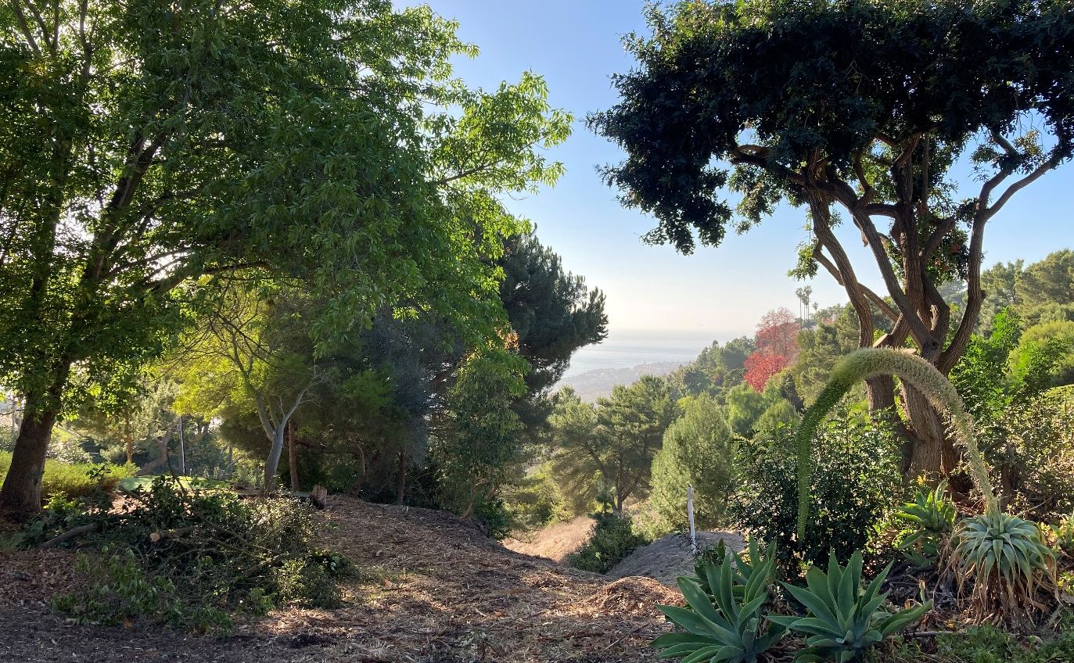
Fire Station Trail

Climate Change
Climate change is expected to affect future occurrences of natural hazards in and around Rolling Hills. Some hazards are projected to become more frequent and intense in the coming decades, and in some cases, climate impacts have already begun.
In developing the Safety Element, the City competed a Climate Change Vulnerability Assessment consistent with Government Code Section 65302(g), which assesses how the populations and assets in Rolling Hills are vulnerable to different climate hazards. The full Climate Change Vulnerability Assessment can be found in Appendix A: Existing Conditions Report. According to the Vulnerability Assessment, the city is most vulnerable to wildfire impacts, extreme heat, and landslide impacts from climate change.
According to the Vulnerability Assessment and the California’s Fourth Climate Change Assessment, Rolling Hills can expect the following changes to natural hazard events:
- Projected annual average maximum temperature is expected to increase in Rolling Hills between 1.8- and 6.6-degrees Fahrenheit (°F) compared to 1990, depending on the greenhouse gas (GHG) emissions scenario.
- Extreme heat events are also expected to increase in Rolling Hills. The annual number of average extreme heat days is projected to increase from a baseline of 4 between 1950 and 2005 to 8 or 14 between 2030 and 2099, depending on the GHG emissions scenario.
- Although only small changes in average precipitation are projected, the Los Angeles Region, which includes Rolling Hills, is expected to experience dry and wet precipitation extremes and higher frequency and severity of storms. Increasing storm intensity may exacerbate landslide hazards in the city. Warmer and drier conditions state-wide could increase the prevalence of drought conditions that could impact Rolling Hills.
- Wildfire is projected to increase over all of southern California.

Vulnerable Populations and Assets
As climate change occurs, communities will be affected to varying degrees and impacts depending on the hazard as well as how sensitive the communities are to impacts. Virtually all people and assets in a community will be affected by climate change in some way, but some communities may be more sensitive. The Vulnerability Assessment identified the following sensitivities:

Populations
- Children. Approximately 6.6 percent of the total population in Rolling Hills are ten years old or younger.
- Persons in Poverty. This is identified for people living in households with an income below the poverty limit, which is $26,200 for a household of four people. There are approximately 26 people in Rolling Hills who live in poverty, or approximately 1.6 percent of the total population for whom poverty status can be determined.
- Persons with Chronic Health Conditions. These are people who have a long-term or permanent health condition that can create regular challenges in their day-to-day lives. These health problems include obesity, cancer, heart disease, and arthritis. In addition, those with any kind of disability, including mobility challenges, hearing, or vision impairments, behavioral disabilities, and challenges living independently or taking care of themselves. Approximately 11.5 percent of the population have identified having a disability.
- Renters. These are people who live in homes that they (or the head of their household) do not own. Approximately 24 housing units, or 4 percent of the housing units in Rolling Hills, are renter-occupied.
- Older Adults. These are persons 65 years or older are more at risk for climate change impacts, especially those living alone. 28 percent of the population of Rolling Hills are over 65 years, and 15 percent of those over 65 years live alone.
- Limited English Proficiency. Approximately three percent of households have identified being limited English-speaking. Of those, a majority spoke Asian and Pacific Island languages and Spanish.

Infrastructure
- Access Roads. These roadways are one of a few, or the only, ways in and out of some communities or neighborhoods. The single or limited number of entry and exit points does not make the road itself more vulnerable than other roads, but loss of these roadways can effectively cut off large numbers of people from other areas in the Palos Verdes Peninsula and the rest of Los Angeles County. Portuguese Bend Road and Crest Road are the primary access roads into and out of the city.
- Bridle Trails. Throughout the community are over 25 miles of trails available to residents and non-city residents who obtain permits. The trails are maintained by the Rolling Hills Community Association and located primarily in canyon areas.
- Electrical Substations. Electrical substations are facilities that convert electricity from one voltage to another, making it suitable for long-distance transmission or for use by homes, businesses, and other electrical customers. There are no electrical substations located in city limits, but three are located near the city in Rancho Palos Verdes and owned/operated by Southern California Edison.
- Electrical Utility Lines. These lines transmit and deliver electricity from Southern California Edison to the city. The city has both underground and overhead electric utility lines.
- Natural Gas Transmission Pipelines. Natural gas pipelines carry large volumes of natural gas between communities. There are no transmissions lines in the city. One transmission line ends at the intersection of Rolling Hills Road and Palos Verdes Drive, adjacent to city limits.
- Water Reservoirs and System. The system that stores and supplies drinking water for residents. Palos Verdes Water District of the California Water Service supplies water to Rolling Hills. There are two California Water Service water reservoirs in the city limits.

Services
- Public Safety Response. Public safety services are provided by law enforcement and fire agencies. These agencies include the Los Angeles County Sheriff and Fire Departments.
- Water Services. These services involve treating and transporting water to be used by customers and transporting and treating wastewater so it can be safely released into the environment. California Water Service provides drinking water to the city.
- Energy Delivery. Energy services in Rolling Hills include electricity and natural gas delivered through utility lines from Southern California Edison and Southern California Gas Company.

Vulnerability Assessment Results
The Vulnerability Assessment indicates that the city’s populations, infrastructure, and services are most vulnerable to wildfire, extreme heat, and extreme precipitation events.

Populations
Vulnerable populations such as older adults, residents with chronic health conditions, and those with financial trouble are most at risk to extreme heat and wildfire impacts.
28 percent of the city’s population is over 65 years. Older adults do not adjust as well as young people to sudden changes in temperature and are more likely to have medical conditions that can worsen with extreme heat (CDC 2017a). Older adults who are living alone are even more at risk as the actions necessary to mitigation extreme heat are more difficult alone. Getting water, changing clothes, showering, or turning on the air conditioner may be more difficult for older adults with physical disabilities and do not have a partner to assist them. Extreme heat can be highly dangerous to persons with chronic health conditions, because very high temperatures can exacerbate diabetes, cardiovascular conditions, respiratory ailments, and other diseases. Some of these people have weakened immune systems which can make them more likely to contract illnesses and vulnerable to human health hazards. In addition, they may be taking medications that make the effects of extreme heat worse (CDC 2017b). While there are not many households in poverty in the city, those who are have limited financial resources to upgrade their homes to have air conditioning to better resist extreme heat.
Older adults, residents with chronic health conditions, and those with financial trouble are the populations most at risk to wildfire impacts. Older adults are almost three times more likely to die in a fire than the overall population (USFA 2017), and typically have increased mobility or mental health issues. Therefore, older adults, especially those in the city living alone, have more difficulties evacuating to safe areas when there is a need. Those in Rolling Hills with limited financial resources are more unlikely to retrofit their homes to better resist climate-related hazards such as wildfires. In addition to direct impacts, indirect impacts such as poor air quality also creates public health hazards to the city. Recent California wildfires in August and September 2020 had areas of California recording the worst air quality in the world and highlighted the hazards of secondary impacts from wildfires, which could impact the city from fires throughout the State. Older adults and individuals with chronic health conditions are likely to be impacted most by these secondary impacts. Also, those with limited finances or without air conditioning would be impacted by secondary smoke impacts that occur during local and regional wildfires.

Infrastructure
Access roads, residential structures, and community facilities and government buildings are the most vulnerable infrastructure to wildfire and extreme precipitation impacts from climate change.
All city infrastructure is located in a VHFHSZ. Portuguese Bend Road and Crest Road are critical for access to and evacuation from many areas of the city. Wildfires may not significantly damage the infrastructure, but they could result in closure or the inability to travel on them during wildfire events, which can isolate areas of the city and create severe health and safety risks. Wildfires are unlikely to substantially damage trails directly, but they can force widespread trail closures which are an important asset to the community.
The greatest potential impact of life and well-being would be to residential structures, which are the primary structures in the city. In addition, impacts to Rolling Hills Community Association and City Hall structures would impact community functions and government services.
Critical infrastructure most at risk in Rolling Hills to minor flooding impacts and landslides from increased storms would be access roads, bridle trails, electrical utility lines, and water systems. Because Portuguese Bend Road and Crest Road are critical for access to and evacuation from the city, any damage or closure can effectively isolate areas of the city, potentially creating severe health and safety risks. Bridle trails are predominantly located in canyon areas, which would be more susceptible to flooding and landslides. Landslides could impact utilities, as seen in the existing Flying Triangle Landslide area, which has moved utility lines above ground in certain areas due to the continuous movement of the earth in this area. Due to the limited accessibility of the city, there is a medium potential for impacts to access roads and bridle trails and a low potential impact for the remaining vulnerable infrastructure.

Services
Energy delivery, specifically electricity delivery, could be impacted from increased wildfires. Direct impacts to Southern California Edison electricity transmission infrastructure could impact power in the city. In addition, utility companies have begun shutting off power to areas to avoid wildfires during times when weather creates high wildfire risk. Public safety services could be strained during wildfire events, which are expected to increase.
Overall, climate change impacts from wildfire are projected to have the greatest potential impact to the city.

Goals, Policies, and Implementation

Hazard Mitigation

Goal 1 Minimization of Loss of Life, Injury, and Property Damage Resulting from Geologic Hazards
Policy 1.1 Ensure that existing structures throughout the City meet seismic safety standards and that new facilities are developed to updated standards.
Implementation Measure 1.1.1: The City will work with Los Angeles County Building and Safety Department and other agencies to ensuring that all proposed structures in the city meet current seismic safety code requirements.
Timing: Immediate and ongoing
Agency: Planning Department
Funding: General Fund
Policy 1.2 Support earthquake strengthening and provision of alternative or backup services, such as water, sewer, electricity, and natural gas pipelines and connections, especially in areas of high seismic or geologic high hazard or where weak segments are identified by existing or future studies.
Implementation Measure 1.2.1: Require future development in active fault areas to provide geotechnical studies indicating the location of the fault trace relative to proposed improvements and identify appropriate mitigation. The City will evaluate the seismic risk to existing infrastructure in these areas and where appropriate, examine the feasibility of mitigating the risk over time.
Timing: Immediate and ongoing
Agency: Planning Department and Public Works
Funding: General Fund and private developers
Policy 1.3 Enforce seismic design provisions from the California Building Code into all development and ensure adequate review and inspection.
Implementation Measure 1.3.1: The City will work with Los Angeles County Building and Safety Department and other agencies to ensuring that all proposed structures in the city meet current seismic safety code requirements.
Timing: Immediate and ongoing
Agency: Planning Department/Public Works
Funding: General Fund and private developers
Implementation Measure 1.3.2: Require fault investigations along traces of the Palos Verdes and Cabrillo faults to comply with guidelines implemented by the Alquist-Priolo Special Studies Zone Act. Buildings for human occupancy should be set back a minimum of 50 feet from those faults that are shown to be active or from fault traces where the risk cannot be determined.
Timing: Immediate and ongoing
Agency: Planning Department/Public Works
Funding: General Fund and private developers
Policy 1.4 Require review by a structural engineer when a critical building or facility undergoes substantial improvements.
Implementation Measure 1.4.1: City staff will review existing ordinances to ensure that the appropriate review requirements are included in them. In addition, the Seismic Safety Ordinance will require a structural engineer to review development proposals in designated Special Studies Zones.
Timing: Immediate and ongoing
Agency: Planning Department/Public Works/Building & Safety Department
Funding: General Fund and private developers
Policy 1.5 Require site specific geotechnical analysis in liquefaction or landslide hazard zones, including in and adjacent to the Chandler landfill. Require analysis of projected climate change impacts related to slope stability changes after wildfires and develop mitigation strategies for new areas deemed at risk to slope instability.
Implementation Measure 1.5.1: Future development in areas designated as having a liquefaction risk will be required to evaluate and mitigate the risk prior to development via the environmental review process.
Timing: Immediate and ongoing
Agency: Planning Department/Building & Safety Department
Funding: General Fund and private developers
Policy 1.6 Ensure that water supplies are not interrupted by seismic events such as surface rupture, ground shaking or ground failure.
Implementation Measure 1.6.1: The City will conduct a seismic vulnerability assessment of current water supply systems to address peak load water supply requirements. If the vulnerability assessment indicates a potential interruption of water supply due to damage from a seismic event, designate emergency sources of water.
Timing: Immediate and ongoing
Agency: Planning Department/Building & Safety Department
Funding: General Fund
Policy 1.7 Discourage development adjacent to earthquake faults and other geological hazards.
Implementation Measure 1.7.1: All development will comply with the Seismic Hazards Overlay Zone.
Timing: Immediate and ongoing
Agency: Planning Department
Funding: General Fund and private developers
Policy 1.8 Prohibit residential development on non-engineered fill of any kind.
Implementation Measure 1.8.1: The City will continue to enforce the Building Code and the requirement to install methane barriers for new construction in the vicinity of the landfill.
Timing: Immediate and ongoing
Agency: Planning Department
Funding: General Fund
Policy 1.9 Regularly review technical data on public safety and seismic safety for use in the decision-making process.
Implementation Measure 1.9.1: City staff will update and amend the Master Environmental Assessment when appropriate following the review of more site-specific geotechnical studies and reports.
Timing: Immediate and ongoing
Agency: Planning Department
Funding: General Fund
Policy 1.10 Continue to require preliminary investigations of tract sites by State-registered geotechnical engineers and certified engineering geologists (Chapter 70 County Building Code) and ensure regular inspection of grading operations.
Implementation Measure 1.10.1: The City will continue to enforce the Building Code and Safety regulations.
Timing: Immediate and ongoing
Agency: Planning Department
Funding: General Fund

Goal 2 Minimization of Loss of Life, Injury, and Property Damage Due to Flood Hazards
Policy 2.1 Maintain storm drains to prevent local flooding and debris flows, and encourage residents to assist in maintaining those drains that are the responsibility of the homeowner.
Implementation Measure 2.1.1: The City will cooperate with the Los Angeles County Public Works Department to maintain storm drains in the City.
Timing: Immediate and ongoing
Agency: Public Works Department
Funding: General Fund
Implementation Measure 2.1.2: The City will encourage homeowner maintenance of storm drains by developing educational materials to be added to the City website and included in the City’s newsletter.
Timing: Immediate and ongoing
Agency: Public Works Department
Funding: General Fund
Policy 2.2 Avoid construction in canyon bottoms and participate in the National Flood Insurance Program. Require new development or expansion of existing development adjacent to canyons to assess potential environmental impacts from increased run-off and erosion and evaluate appropriate mitigation. Mitigation measures should address projected impacts from climate change.
Implementation Measure 2.2.1: The City will implement the General Plan's Land Use Policy and evaluate the flood hazard potential and address climate change impacts in future environmental review. The City will ensure that development in areas designated as a Flood Hazard Overlay Zone mitigates potential flood impacts.
Timing: Immediate and ongoing
Agency: Planning Department
Funding: General Fund and private developers
Implementation Measure 2.2.2: The City will require the submission of soil engineering reports for land development permits when soil erosion problems are suspected.
Timing: Immediate and ongoing
Agency: City Manager
Funding: General Fund and private developers

Goal 3 Minimization of Loss of Life, Injury, and Property Damage Resulting from Fire Hazards
Policy 3.1 Develop stringent initial site design and on-going maintenance standards incorporating adequate mitigation measures into individual developments to achieve an acceptable level of risk, considering the increased risk associated with increased wildland fire hazards due to climate change.
Implementation Measure 3.1.1: The City will work with the Los Angeles County Fire Department, Los Angeles County Sheriff’s Department, and Rolling Hills Community Association to review current standards for wildfire prevention and improve standards and/or regulations where required.
Timing: Immediate and ongoing
Agency: City Manager
Funding: General Fund
Implementation Measure 3.1.2: The City will implement recommended fire mitigation strategies from the Community Wildfire Protection Plan including infrastructure hardening and vegetation management for and around existing and new development.
Timing: Immediate and ongoing
Agency: Planning Department/Building & Safety Department
Funding: General Fund
Policy 3.2 Reduce potential fire ignition sources.
Implementation Measure 3.2.1: The City will continue to implement the utility undergrounding projects described in the Community Wildfire Protection Plan.
Timing: Immediate and ongoing
Agency: City Manager
Funding: General Fund
Implementation Measure 3.2.2: Designate and publicize emergency access routes with the city and sub region. Prioritize undergrounding of utilities to enhance reliability of emergency access routes and minimize conflagration hazards from fallen power lines.
Timing: Immediate and ongoing
Agency: City Manager
Funding: General Fund
Policy 3.3 Develop and implement a comprehensive retrofit strategy for existing structures.
Implementation Measure 3.3.1: The City will develop and implement a comprehensive retrofit strategy for existing structures and lifeline utilities in very high fire risk areas to increase public safety and reduce the risk of property loss and damage during wildfires.
Timing: Immediate and ongoing
Agency: Planning Department/Building & Safety Department
Funding: General Fund
Implementation Measure 3.3.2: Enforce existing ordinances and regulations that apply to roofing materials. The City will enforce a Class A Roofing Ordinance for all structure, as described in the Community Wildfire Protection Plan. The City will require old roofs to be removed prior to reroofing to increase the fire-resistance of the structure.
Timing: Immediate and ongoing
Agency: Planning Department/Building & Safety Department
Funding: General Fund
Policy 3.4 Ensure that all new residential development has at least two emergency evacuations.
Implementation Measure 3.4.1: The City will review and update emergency response and evacuation plans and procedures annually to reflect current conditions and community needs.
Timing: Immediate and ongoing
Agency: Planning Department/Building & Safety Department
Funding: General Fund
Implementation Measure 3.4.2: Create secondary access in communities with single access.
Timing: Immediate and ongoing
Agency: City Manager
Funding: General Fund
Implementation Measure 3.4.3: Identify special populations and large animals, especially horses, that may need assistance to evacuate.
Timing: Immediate and ongoing
Agency: City Manager
Funding: General Fund
Policy 3.5 Whenever feasible, locate the following outside flood and fire hazard zones: health care facilities, emergency shelters, fire stations, emergency command centers, and emergency communications facilities.
Implementation Measure 3.5.1: The City will require review of new essential facilities and, as necessary, development of measures to avoid flood and fire hazard impacts.
Timing: Immediate and ongoing
Agency: Planning Department/Building & Safety Department
Funding: General Fund and private developers
Policy 3.6 Educate residents on fire hazard reduction strategies to employ on their properties, focusing on the most vulnerable populations such as older adults and individuals with chronic health conditions.
Implementation Measure 3.6.1: The City will promote vegetation management strategies outlined in the Community Wildfire Protection Plan (i.e., fuel management in canyons and fire fuel management standards for individual properties) in the City's quarterly newsletter, through the website, brochures, videos, and block captain meetings.
Timing: Immediate and ongoing
Agency: Planning Department and City Manager
Funding: General Fund
Policy 3.7 Work with the County to ensure that all fire equipment remains operable and adequate to respond to a major disaster
Implementation Measure 3.7.1: City staff will monitor the City's fire protection rating and cooperate with the Fire Department in the correction of deficiencies.
Timing: Immediate and ongoing
Agency: City Manager
Funding: General Fund
Policy 3.8 Require new development to meet or exceed hardening requirements in the most current version of the California Building Codes and California Fire Code.
Policy 3.9 Evaluate evacuation route capacity, safety, and viability under a range of emergency scenarios as part of the next update to the Rolling Hills Hazard Mitigation Plan, in accordance with AB 747.
Policy 3.10 Update the City's development standards to be in conformance with title 14, CCR, division 1.5, chapter 7, subchapter 2, articles 1-5 (commencing with section 1270) (SRA Fire Safe Regulations) and title 14, CCR, division 1.5, chapter 7, subchapter 3, article 3 (commencing with section 1299.01) (Fire Hazard Reduction Around Buildings and Structures Regulations).
Policy 3.11 Minimize risks to existing development by identifying existing non-conforming development to contemporary fire safe standards, in terms of road standards and vegetative hazard, and requiring all development to meet or exceed CCR, division 1.5, chapter 7, subchapter 2, articles 1-5 requirements (SRA Fire Safe Regulations).
Policy 3.12 Require fire protection plans for all new development.
Policy 3.13 Require all properties in the city to enforce precautionary measures to create defensible space including, but not limited to, maintaining a fire break by removing brush and flammable vegetation located within 30 feet of the property, maintaining any tree adjacent to or overhanging any building free of dead or dying wood, and maintaining roofs free of leaves, needles, or other dead vegetation growth, as described in the Rolling Hills Hazard Mitigation Plan.
Policy 3.14 Evaluate the City’s capacity to adequately suppress wildfire, taking into account water supply availability, as part of the next Rolling Hills Hazard Mitigation Plan update.
Policy 3.15 Coordinate with Palos Verdes Water District to support the provision of adequate water availability throughout the City and provision of adequate water storage to meet future peak fire demand during times of peak domestic demands.
Policy 3.16 Maintain emergency roadways and improve them as necessary and appropriate to ensure ongoing serviceability.
Policy 3.17 Establish and maintain community fire breaks and fuel modification/reduction zones, including public and private road clearance.
Policy 3.18 Require that all homes and businesses have visible street addressing and signage.

Goal 4 Minimization of Impacts to Life and Property Associated with the Use, Storage, or Transport of Hazardous Materials
Policy 4.1 Restrict the travel of vehicles carrying hazardous material through the city.
Implementation Measure 4.1.1: The City will ensure the Los Angeles County Sheriff's Department and the California highway Patrol enforce licensing and current laws regarding the transport of hazardous materials through the city.
Timing: Immediate and ongoing
Agency: City Manager
Funding: General Fund
Policy 4.2 Monitor and limit the use and production of hazardous materials by businesses and industries in the city to ensure that such use does not pose a substantial risk to the community.
Implementation Measure 4.2.1: The City will ensure that the Los Angeles County Fire Department conducts regular inspections of major users in the city and that users of large quantities of hazardous materials maintain required hazardous materials business plans. The Emergency Services Coordinator will monitor the results.
Timing: Immediate and ongoing
Agency: City Manager
Funding: General Fund
Policy 4.3 Support the County Compliance Guideline for Hazardous Wastes and Materials objectives and enforcement of current Fire Code regulations regarding the storage of hazardous materials.
Implementation Measure 4.3.1: The City's Emergency Services Coordinator will review current ordinances and practices to ensure that everything possible is being done to implement the County's Compliance Guideline for Hazardous Wastes and Materials.
Timing: Immediate and ongoing
Agency: City Manager
Funding: General Fund
Policy 4.4 Work to promote the safe use and disposal of household hazardous wastes.
Implementation Measure 4.4.1: The City will implement those programs outlined in the Household Hazardous Waste Element.
Timing: Immediate and ongoing
Agency: City Manager
Funding: General Fund

Community Communication

Goal 5 Protection of the Community from Disasters and Emergencies
Policy 5.1 Designate and develop specific critical facilities as emergency centers to serve the entire City and work with other cities to maintain existing trauma care facilities that serve the region.
Implementation Measure 5.1.1: The City will meet with other communities in the region to discuss the loss of trauma care centers in the region. The City will examine the feasibility of establishing the development of a critical/trauma care unit at one of the local clinics or hospitals in the region. The City will consider the establishment of such a facility as part of the discretionary review of future development proposals involving clinics, hospitals, or medical offices.
Timing: Immediate and ongoing
Agency: City Manager
Funding: General Fund
Policy 5.2 Cooperate with the Los Angeles County Sheriff’s Department to ensure that law enforcement services are ready and available to serve the city in the event of a major disaster.
Implementation Measure 5.2.1: City staff will monitor the City's contract and budget with the Sheriff’s Department to ensure that adequate service levels are maintained.
Timing: Immediate and ongoing
Agency: City Manager
Funding: General Fund
Policy 5.3 Develop and coordinate medical assistance procedures in the event of a major disaster.
Implementation Measure 5.3.1: City staff will develop and update the Emergency Operations Plan and maintain the Learn How to Prepare for and Survive a Disaster in the City of Rolling Hills Estates document, which will be distributed to the community. The update of the Emergency Operations Plan will include an assessment of current emergency service and projected emergency service needs, and goals or standards for emergency services training for City staff and volunteers.
Timing: Ongoing
Agency: City Manager
Funding: General Fund
Policy 5.4 Inventory and, where necessary, acquire supplemental disaster communication equipment and other equipment, tools, and supplies used by Block Captains during an emergency.
Implementation Measure 5.4.1: City staff will complete an inventory of infrastructure needed to support emergency communications and equipment needed for use by Block Captains and the City to communicate during emergencies, as described in the Community Wildfire Protection Plan.
Timing: Immediate and ongoing
Agency: City Manager
Funding: General Fund
Implementation Measure 5.4.2: A survey will be done by the City periodically to establish an inventory of equipment which could be used in the event of a major disaster.
Timing: Immediate and ongoing
Agency: City Manager
Funding: General Fund
Policy 5.5 Ensure that adequate provisions are made to supply drinking water for extended periods of time in the event of a major disaster.
Implementation Measure 5.5.1: City staff will inventory sources of potable water that could be used in the event of an emergency and the means to distribute that water to residents and others in the Planning Area.
Timing: Immediate and ongoing
Agency: Public Works Department
Funding: General Fund
Policy 5.6 Develop procedures to follow in the event of wildfire, flooding, erosion, and possible reservoir failure and investigate ways of reducing the likelihood of their occurrence.
Implementation Measure 5.6.1: The City will update the Hazard Mitigation Plan every five years to reduce the risk from hazards by identifying resources, information, and strategies for risk reduction, while helping to guide and coordinate mitigation activities throughout the city.
Timing: Immediate and ongoing
Agency: City Manager
Funding: General Fund
Implementation Measure 5.6.2: City staff will develop and maintain an Emergency Operations Plan, which will set forth an operating strategy for managing potential emergencies (as described in the Hazard Mitigation Plan)
Timing: Immediate and ongoing
Agency: City Manager
Funding: General Fund
Policy 5.7 Ensure that City Hall maintains a current emergency supply of water, food, blankets, and first aid to provide for all employees for a 3-day period.
Implementation Measure 5.7.1: A City staff person will be assigned the task of compiling a list of supplies and maintaining an adequate stockpile.
Timing: Immediate and ongoing
Agency: City Manager
Funding: General Fund
Policy 5.8 Encourage private businesses to develop disaster preparedness plans for their employees.
Implementation Measure 5.8.1: The City will prepare and distribute a brochure outlining recommendations for stockpiling supplies for employees.
Timing: Immediate and ongoing
Agency: City Manager
Funding: General Fund
Policy 5.9 Encourage residents to attend periodic training programs on wildfire mitigation and disaster planning, and to develop disaster preparedness and evacuation plans.
Implementation Measure 5.9.1: The City will work with the RHCA and Block Captains to launch a communication and education program that will include a workshop on How to Develop an Evacuation Plan for your Family, as described in the Community Wildfire Protection Plan.
Timing: Immediate and ongoing
Agency: City Manager
Funding: General Fund
Implementation Measure 5.9.2: The City will work with the RHCA and Block Captains to promote training programs on wildfire mitigation and disaster planning through the newsletter and the City website.
Timing: Immediate and ongoing
Agency: City Manager
Funding: General Fund
Policy 5.10 Support the development and further implementation of a peninsula-wide disaster plan.
Implementation Measure 5.10.1: The City will coordinate its disaster planning efforts with neighboring jurisdictions in the region as part of Hazard Mitigation Plan updates
Timing: Immediate and ongoing
Agency: City Manager
Funding: General Fund
Policy 5.11 Increase public awareness of City emergency response plans, evacuation routes and shelters, and in ways to reduce risks at the home and office, focusing on the most vulnerable populations such as older adults and individuals with chronic health conditions.
Implementation Measure 5.11.1: The City will prepare communication materials outlining procedures to follow in the event of a major disaster. These materials will be distributed to every household and business in the city.
Timing: Immediate and ongoing
Agency: City Manager
Funding: General Fund
Implementation Measure 5.11.2: The City will maintain the City-wide Neighborhood Watch program.
Timing: Immediate and ongoing
Agency: City Manager
Funding: General Fund
Implementation Measure 5.11.3: The City will define refuge areas in the event of a wildfire event to include in the Emergency Operations Plan. This effort will be led by the Fire Department and the Sherriff’s Department.
Timing: Immediate and ongoing
Agency: City Manager
Funding: General Fund
Implementation Measure 5.11.4: The City will distribute educational materials for large animal evacuation, consistent with Community Wildfire Protection Plan recommendations. This will include adding the information to the City website and including it in the City’s newsletter during the fire season.
Timing: Immediate and ongoing
Agency: City Manager
Funding: General Fund
Implementation Measure 5.11.5: The City will work with Block Captains to provide emergency education and information through the City’s newsletter and website and by providing workshops and seminars described in the Community Wildfire Protection Plan.
Timing: Immediate and ongoing
Agency: City Manager
Funding: General Fund
Policy 5.12 Maintain a Hazard Mitigation Plan.
Implementation Measure 5.12.1: The City will coordinate with the American Red Cross and Los Angeles County Fire, Sheriff, and Public Social Services to develop specific plans for responding to emergencies as part of Hazard Mitigation Plan updates. The City will submit copies of its Hazard Mitigation Plan to the Los Angeles County Fire and Sheriff’s Departments for review. The City will review similar plans prepared by neighboring cities.
Timing: Every five years
Agency: City Manager
Funding: General Fund
Policy 5.13 Ensure maximum accessibility throughout the city in the event of a disaster.
Implementation Measure 5.13.1: The City will ensure that multipurpose trails are maintained in order to be serviceable by emergency vehicles in the event of a disaster.
Timing: Immediate and ongoing
Agency: City Manager
Funding: General Fund
Policy 5.14 Coordinate emergency planning efforts with building managers of high-occupancy facilities, dependent care centers (nursing homes, day care centers, etc.) and critical facilities located in the city to facilitate emergency response.
Implementation Measure 5.14.1: The City will provide communication materials outlining emergency procedures to all critical facilities. The City will cooperate with the Los Angeles County Fire Department during the inspection of these facilities.
Timing: Immediate and ongoing
Agency: City Manager
Funding: General Fund
Policy 5.15 Ensure the reliability of essential facilities such as communications towers, electrical substations, water services, and first-response buildings in the event of an emergency through promoting grid resilience and energy independence. Work to implement on-site power generation through solar photovoltaic systems and battery storage.
Implementation Measure 5.15.1: The City will work with telecommunication providers to identify opportunities to improve reliability of cell service throughout the city.
Timing: Immediate and ongoing
Agency: City Manager
Funding: General Fund
Implementation Measure 5.15.2: The City will work with electricity and natural gas providers to identify opportunities to promote grid resilience.
Timing: Immediate and ongoing
Agency: City Manager
Funding: General Fund
Implementation Measure 5.15.3: The City will seek funding to enhance telecommunication service.
Timing: Immediate and ongoing
Agency: City Manager
Funding: General Fund
Implementation Measure 5.15.4: The City will provide educational materials to residents (i.e., newsletter, webpage, brochure) to promote solar panels and battery storage installation on existing development.
Timing: Immediate and ongoing
Agency: City Manager
Funding: General Fund
Policy 5.16 Minimize the risk of spread of infectious diseases and associated economic disruption.
Implementation Measure 5.16.1: The City will coordinate with the County of Los Angeles Public Health Department to provide testing and contact tracing resources to the Rolling Hills community.
Timing: Immediate and ongoing
Agency: City Manager
Funding: General Fund
Implementation Measure 5.16.2: The City will maintain up-to-date public health services on the City’s website.
Timing: Immediate and ongoing
Agency: City Manager
Funding: General Fund
Implementation Measure 5.16.3: The City will explore the need for additional marketing campaigns to promote public safety protocol among City departments.
Timing: Immediate and ongoing
Agency: City Manager
Funding: General Fund
Implementation Measures 5.16.4: The City will partner with local non-governmental organizations (NGOs) to provide additional support and services in the city.
Timing: Immediate and ongoing
Agency: City Manager
Funding: General Fund
Implementation Measures 5.16.5: The City will partner with community groups and neighborhood organizations to advertise what resources are available to residents.
Timing: Immediate and ongoing
Agency: City Manager
Funding: General Fund
Policy 5.17 Increase access to essential resources and facilitate effective communication in the community to accelerate recovery following such a disaster.
Implementation Measure 5.17.1: The City will connect the newly unemployed with talent-seeking industries, such as through a job portal.
Timing: Immediate and ongoing
Agency: City Manager
Funding: General Fund
Implementation Measure 5.17.2: The City will supplement federal relief efforts, such as creating a resilience fund for residents to assist those in need.
Timing: Immediate and ongoing
Agency: City Manager
Funding: General Fund
Policy 5.18 Provide City officials with a basis for disaster preparedness decision making and establish a public education program for disaster preparedness
Implementation Measure 5.18.1: The Emergency Services Coordinator will conduct quarterly meetings with City personnel to ensure they are familiar with procedures outlined in the Hazard Mitigation Plan and Emergency Operations Plan.
Timing: Immediate and ongoing
Agency: City Manager
Funding: General Fund
Policy 5.19 Establish a line of command to ensure that the decision-making process will function satisfactorily in the event of a major disaster.
Implementation Measure 5.19.1: The City will implement the Hazard Mitigation Plan.
Timing: Immediate and ongoing
Agency: City Manager
Funding: General Fund
Policy 5.20 Coordinate with citizen groups, such as Block Captains, and organizations to establish a viable body to provide emergency assistance in the event of a natural disaster.
Implementation Measure 5.20.1: The City Emergency Services Coordinator will work with local equestrian groups and other organizations to establish a Rolling Hills Estates Search and Rescue Team.
Timing: Immediate and ongoing
Agency: City Manager/Public Works
Funding: General Fund
Policy 5.21 Encourage cooperation among adjacent communities to provide back-up law enforcement assistance in emergency situations.
Implementation Measure 5.21.1: The City will submit copies of its Hazard Mitigation Plan updates to the Los Angeles County Fire and Sheriff’s Departments for review. The City will review similar plans prepared by neighboring cities.
Timing: Immediate and ongoing
Agency: City Manager
Funding: General Fund
Policy 5.22 Incorporate health threats into early warning systems.
Implementation Measures 5.22.1: Partner with the Los Angeles County Vector Control District and the Los Angeles County Department of Public Health to develop and enhance disaster and emergency early warning systems to incorporate objective data and information for potential health threats such as heat-illness, illnesses complicated by low air quality, precipitation events, and vector borne diseases due to climate change hazards.

Goal 6 Maintenance of Public Safety for All Residents
Policy 6.1 Work with, and support the Sheriff’s Department in crime prevention and law enforcement efforts, to make sure there are adequate resources to meet the needs of the community.
Implementation Measure 6.1.1: The City will conduct an annual review of its contract with the Los Angeles County Sheriff’s Department to ensure current service standards are maintained. Alternatives will be considered if service levels are considered inadequate.
Timing: Immediate and ongoing
Agency: City Manager
Funding: General Fund
Policy 6.2 Cooperate with neighboring cities, Los Angeles County, California State and U.S. Federal agencies in crime prevention and law enforcement.
Implementation Measure 6.2.1: The City will continue to regularly coordinate with all law enforcement agencies in combating crime.
Timing: Immediate and ongoing
Agency: City Manager
Funding: General Fund
Policy 6.3 Evaluate the incidence of crime and develop measures needed to deter crime or apprehend the criminals.
Implementation Measure 6.3.1: The City will monitor crime statistics for the peninsula and the city. The City will meet with Los Angeles County on a regular basis to discuss programs, ordinances, and other measures that will be effective in combating crime.
Timing: Immediate and ongoing
Agency: City Manager
Funding: General Fund

Climate Change Adaptation and Resilience

Goal 7 Protection of the Community from the Effects of Climate Change
Policy 7.1 The City will continue to enforce updated State-mandated water conservation regulations.
Implementation Measure 7.1.1: The City will continue to update the City’s zoning ordinance as necessary to enforce and implement State-mandated water conservation regulations.
Timing: Immediate and ongoing
Agency: Planning Department
Funding: General Fund
Policy 7.2 Prepare for and adapt to the effects of climate change by considering climate change vulnerability in planning decisions, including those involving new public facilities and private development.
Implementation Measure 7.2.1: The City will:
- Re-evaluate the City’s Climate Change Vulnerability analysis over time, as new data becomes available
- Update mitigation strategies and the City’s vulnerability and adaptive capacity, as appropriate
- Identify opportunities for new goals and policies related to climate change using the best available data.
Timing: Immediate and ongoing
Agency: Planning Department/Building & Safety Department
Funding: General Fund
Policy 7.3 Amend the local building code to account for climate change stressors
Implementation Measure 7.3.1: The City will amend the local building code to take into account additional stressors on buildings including, increased storm events and intensity, flood proofing for intermittent inundation, slope/soils, subsidence risk and erosion potential in securing foundations, building materials to reduce the impacts of high heat days, and fireproofing in preparation for increasing fire risk.
Timing: Immediate
Agency: Planning Department/Building & Safety Department
Funding: General Fund
Policy 7.4 The City will engage surrounding jurisdictions in climate adaptation planning.
Implementation Measure 7.4.1: Ensure the community’s engagement strategy for climate adaptation planning includes surrounding jurisdictions to identify synergies and harmonization of policies.
Timing: Immediate and ongoing
Agency: Planning Department
Funding: General Fund
Policy 7.5 Partner with the South Bay Cities Council of Government to implement climate adaptation strategies at the sub-regional level.
Implementation Measure 7.5.1: Collaborate with the South Bay Cities Council of Governments Senior Services Working Group to ensure that service providers in and around Rolling Hills are educated on the climate risks of the area and steps they can take to better serve and protect vulnerable groups in Rolling Hills.
Timing: Immediate and ongoing
Agency: Planning Department
Funding: General Fund
Implementation Measure 7.5.2: Implement climate adaptation strategies that can address issues at a local and sub-regional level and issues in which coordination and pooling of resources (i.e., emergency centers, transit agency support in an emergency, and large animal evacuation centers) is a benefit to all participating communities.
Timing: Immediate and ongoing
Agency: Planning Department
Funding: General Fund
Policy 7.6 Update emergency/disaster response measures to account for increased heat days.
Implementation Measure 7.6.1: As part of the Hazard Mitigation Plan and Emergency Operations Plan, update response measures to account for an increased number of heat days and their impacts on current and future response mechanisms such as warning systems, emergency response and medical service coordination, and shelters.
Timing: Every five years
Agency: Planning Department
Funding: General Fund
Policy 7.7 Provide education on heat related illness.
Implementation Measure 7.7.1: Incorporate links and references on the City website and incorporate interpretive signage at multi-use path trailheads providing education on heat related illness and personal care steps.
Timing: Immediate and ongoing
Agency: Planning Department
Funding: General Fund
Policy 7.8 Require air conditioning alternatives.
Implementation Measure 7.8.1: Require alternatives to air conditioning such as ceiling fans, air exchangers, increased insulation and low-solar-gain exterior materials to reduce peak electrical demands during high heat events to ensure reliability of the electrical grid.
Timing: Immediate and ongoing
Agency: Planning Department
Funding: General Fund

References
California Department of Toxic Substances and Control (DTSC). 2020. Envirostor. https://www.envirostor.dtsc.ca.gov/public/map/?myaddress=rolling+hills%2C+ca. Accessed August 2020.
Center for Disease Control (CDC). 2017a. Heat and Older Adults. https://www.cdc.gov/disasters/extremeheat/older-adults-heat.html. Accessed September 2020.
____. 2017b. Heat and People with Chronic Medical Conditions. https://www.cdc.gov/disasters/extremeheat/medical.html. Accessed September 2020.
Federal Emergency Management Agency (FEMA). 2008. Flood Insurance Rate Map 06037C1940F.
Los Angeles County Sheriff’s Department (LACSD). 2020. Lomita Station Part I Crimes. http://shq.lasdnews.net/CrimeStats/CAASS/Patrol-CurrentMonth-YTD.PDF. Accessed August 2020.
____. 2019. Hazard Mitigation Plan. January 16, 2019.
____. 2020. Community Wildfire Protection Plan. July 2020.
Southern California Earthquake Center (SCEC). 2013. Hazards and Threats Earthquakes List of Major Active Surface Faults in Southern California. March.
U.S. Census Bureau. 2018. Rolling Hills, City 2018 ACS 5-Year Estimates. https://data.census.gov/cedsci/table?q=Rolling%20Hills%20city,%20California&g=1600000US0662602&tid=ACSDP5Y2018.DP05&hidePreview=false.
Western Region Climate Center (WRCC). 2016. Period of Record Monthly Climate Summary. https://wrcc.dri.edu/cgi-bin/cliMAIN.pl?ca8973. Accessed August 2020.

Appendix A
Existing Conditions Report

An older adult is any adult over the age of 65 years old.
“Beginning in” is defined as the first noted event of major rock movement
The Rolling Hills Block Captain Program is a city-sponsored, resident-based community program of volunteers. Their role is to get to know neighbors, help them to prepare for an emergency, and be a liaison between first responders and City of Rolling Hills during an emergency.
The Vulnerability Assessment uses two GHG emissions scenarios: Representative Concentration Pathway (RCP) 4.5 and RCP 8.5. RCP 4.5 describes a scenario in which GHG emissions peak around 2050 and then decline. RCP 8.5 is the scenario in which GHG emissions continue to rise through 2050 before leveling off around 2100.

