PROFESSIONAL FORESTERS REGISTRATION PROGRAM POLICIES OF THE BOARD
The following policies have been readopted by the State Board of Forestry and Fire Protection at an open meeting held on July 14, 2021 upon the recommendation of the Professional Foresters Examining Committee (PFEC). The policies are intended to provide general information and guidance to registrants and other interested parties and are neither mandatory nor enforceable in their own right. These policies will remain in effect until such time as the Board with notice to the public and in consultation with the PFEC determines otherwise.

POLICY NUMBER 1: REVIEW OF REVIEW OF APPLICATIONS FOR REGISTRATION AS A PROFESSIONAL FORESTER
All applications are reviewed first by the Executive Officer of Foresters Registration who determines what further action to be taken based upon Public Resources Code (PRC), Sections 750 et seq., and Title 14, California Code of Regulation (14 CCR), Sections 1600, et seq. as follows:
- Applications which are incomplete will be returned to the applicant for completion, or retained pending submission of supporting documents. In order to avoid unnecessary delays in application processing, applicants are strongly encouraged to use appropriate care to ensure the application is complete prior to initial submission. In some cases, delays arising from deficient applications may preclude the Board from being able to accept the application for filing within the prescribed deadlines.
- The applicants whose applications are complete and verified as meeting the experience requirements, will have their names forwarded to the Professional Foresters Examining Committee with recommendation of authorization to take the examination.
- If an applicant’s qualifications are unclear or in doubt, the application is reviewed by the Professional Foresters Examining Committee and appropriate action may be taken. The Committee may request clarifying information.

POLICY NUMBER 2: RPF EXAMINATION SCORING
Examinations are scored by two Registered Professional Foresters in good standing retained as Expert Examiners. The Examiners independently grade each question for each applicant working off of copies of the original examination responses completed by applicants. The name of every applicant is kept confidential, as the applicant’s number is the only identification provided on examination responses.
Applicant responses are graded utilizing an answer key developed concurrent with the drafting of the examination, as well as forestry texts, reference materials, and professional expertise. The Examiners may also encounter other appropriate responses by applicants that are not found in the answer key and these will be counted in an applicant’s favor.
The Examiners then meet with the Executive Officer of Foresters Registration to report their scores for each applicant response and compare them for variation. When there are instances in which the Examiners’ scoring of a response varies considerably, the Examiners’ discuss their respective reasons for the score and make adjustments where necessary and appropriate. The Examiners’ scores for each response are summed and averaged to determine the composite score for each response. The Examiners’ composite scores for each of an applicant’s responses are then summed and averaged to determine the overall examination score.

POLICY NUMBER 3: MAINTENANCE AND ACCESSIBILITY OF APPLICANT/REGISTRANT RECORDS

The following provides the basis by which applicant and registrant records are maintained by the Office of Professional Foresters Registration and the manner in which they may be accessed:

Files pertaining to an individual applicant or registrant shall be made available only to that person or their designee in writing. Professional Foresters Registration staff or designated persons acting in an official capacity regarding registration may also be granted access to this information. Applicant files will be retained two (2) years from the year of receipt.

(b) The names of persons denied qualification for the examination or registration will not be released, and information about those denied will not be supplied to anyone except the applicant or other person designated in writing, and those acting in an official capacity regarding Professional Foresters Registration.

(c) Applicant examinations will be retained at least 45 days after mailing of the examination results to each individual applicant. Pursuant to 14 CCR §1645, within thirty (30) days of the examination results notice, an applicant who fails to receive a passing score on the examination may submit a request in writing for a copy of the examination questions and/or a copy of their answers. Answers returned shall be absent any Expert Examiners grading marks. These documents are subject to a fee covering the direct cost of duplication, as determined by the Executive Officer. Applicant examination scores will only be released to the individual applicant and will not otherwise be released in summary form correlating to applicant numbers, names of license numbers under any circumstance. Computerized data regarding exam results and educational substitution for qualifying experience will be retained by applicant number. This data retention commenced in 1986.

(d) The registrant’s file and the corresponding computerized data will be maintained while the RPF or Certified Specialist such as a Certified Rangeland Manager (CRM) is currently registered. Upon approval of withdrawal, computerized data regarding the status of the license will be retained; the original data will be restored upon approval of request for reinstatement. Files will be retained during withdrawal status. Persons whose license is revoked through disciplinary action will be treated in this same manner.

(e) A confidential list showing all RPF’s and Certified Specialists (CRMs), and preferred mailing addresses will be maintained indefinitely starting in 1984. Statewide list showing only registration number, name and license status is available to the public.

(f) RPFs and Certified Specialists (CRMs) whose registration is voluntarily relinquished, revoked for non-renewal, or who have passed away, will have their files held for two years from the year of occurrence.

(g) Access to investigation files and records is governed by various California Codes. When disciplinary actions by the Board involving suspension or revocation occur, the public has the right to know those items specified in 14 CCR §1612.2. Unless the Board’s decision is overturned by a reviewing court order, the circumstances or conditions imposed are available only in the form presented in the Licensing News and news release.

POLICY NUMBER 4: NOTIFICATION OF DISCIPLINARY ACTION
This Policy became redundant prior to re-adoption of licensing policies on October 4, 2000 with the Board’s adoption of 14 CCR §1612.2 (Notification of Disciplinary Action).

POLICY NUMBER 5: COMPILATION AND DISTRIBUTION OF REGISTRANT LISTS
The following describes the two (2) kinds of registrant lists that are generated by the Office of Professional Foresters Registration. All lists are available to the public through the Board’s website per Policy 3, Item (e). A duplication fee may be charged at the discretion of the Executive Officer of Foresters Registration.
Statewide Consumer List - All RPFs and Certified Specialists (CRMs) are listed by registration number, name, and status of license.
Consultant Lists - An RPF may request on their initial licensing or renewal form to be listed in this directory. The directory of consulting RPFs and Certified Specialists (CRMs) is compiled by county of residence. The list may contain information on the geographic area for which the RPF would provide consulting services designated as “timber region” or “statewide”. The list may also provide information on the RPFs participation in the California Forest Improvement Program (CFIP).
The service is provided as supplemental to the records kept by Professional Foresters Registration, and there is no intent to develop or maintain a business directory.
A statement will be included on the consultant list that the Association of Consulting Foresters (ACF) maintains a separate list of their members, and provide the address to request same.
All listed information will come directly from the renewal information form as submitted by the RPF/Certified Specialist (CRM), and will include:
  - Name - The registrant’s first and last name with registration number is the first line printed.
  - Address - Consultants will have their business name, address and phone listed as noted on the renewal information form.
  - Geographic Area of RPF availability to provide consulting services.
  - Participation in the California Forest Improvement Program (CFIP).

At a minimum, lists will be revised annually after the renewal process is complete.

POLICY NUMBER 6: RESPONSE TO COMPLAINTS OF UNLICENSED PRACTICE OF FORESTRY OR A CERTIFIED SPECIALTY
Non-licensed persons using the title of, or acting in the capacity of a “Professional Forester” or “Certified Specialist” (such as Certified Rangeland Manager) without being registered, or otherwise exempted, are acting illegally (Public Resources Code Section 766) and complaints of such activity shall be investigated in the manner and to the extent deemed appropriate by the Executive Officer. The Executive Officer shall provide a summary of all received complaints to the Professional Foresters Examining Committee and identify the extent to which they were investigated.
If the investigation, expert witness, or Executive Officer’s evaluation show sufficient cause, the case may be referred to the District Attorney or the Attorney General, as appropriate. Such prosecution may be based upon unfair or unlawful business practices, or false and misleading advertising.

POLICY NUMBER 7: SUMMARY OF LEGAL AUTHORITIES FOR PURPOSE OF CLARIFYING GROUNDS FOR RPF/CERTIFIED SPECIALIST DISCIPLINARY ACTION UNDER RESOURCES CODE, SECTION 778
Causes for professional discipline of an RPF or Certified Specialist (CRM) identified in PRC 778 include felony convictions substantially related qualifications, functions, or duties of a registered professional forester; deceit, misrepresentation, fraud, material misstatement of fact, incompetence, or gross negligence in professional practice; and fraud or deceit in obtaining the professional registration or certification.
The Board deems it unnecessary to adopt regulations to define the terms deceit, misrepresentation, fraud, material misstatement of fact, incompetence, or gross negligence because these are commonly understood terms that are well-established in the common law, case law, or statute, and for which ascertainable standards may be articulated through the common knowledge and understanding of members of the RPF/Certified Specialist (CRM) profession, when necessary. (Cranston v. City of Richmond (1985) 40 Cal.3d 755, 763-766; Rand v. Board of Psychology (2012) 206 Cal.App.4th 565,582.) Nonetheless, the following representative definitions are offered for illustrative, informational purposes as general reference and guidance.
Deceit
Is a fraudulent and cheating misrepresentation, artifice, or device, used by one or more persons to deceive and trick another, who is ignorant of the true facts, to the prejudice and damage of the party imposed upon. (Black’s Law Dictionary.) Deceit can include any of the following:
(A) The suggestion, as a fact, of that which is not true, by one who does not believe it be true; or,
(B) The assertion, as a fact, of that which is not true, by one who has no reasonable grounds for believing it to be true; or,
(C) The suppression of a fact, by one who is bound to disclose it, or who gives information of other facts which are likely to mislead for want to communication of that fact; or,
(D) A promise made without any intention of performing it.
(Civil Code, Section 1710); Vogelsang v. Wolpert (1964) 227 Cal.App.2d 102, 108-109.)
Fraud
Is an intentional perversion of the truth for the purpose of inducing another person in reliance upon it to part with some valuable thing belonging to the person or to surrender a legal right. (Black’s Law Dictionary.) "Fraud is a generic term which embraces all the multifarious means which human ingenuity can devise and are resorted to by one individual to gain an advantage over another by false suggestions or by suppression of the truth. In its general or generic sense, it comprises all acts, omissions, and concealments involving a breach of legal or equitable duty and resulting in damage to another, or the taking of undue or unconscientious advantage of another; . . . Fraud has also been defined as any cunning, deception, or artifice used to circumvent, cheat, or deceive another." (Vogelsang v. Wolpert (1964) 227 Cal.App.2d 102, 108-109.).

Incompetence
Is lacking ability, legal qualification, or fitness to discharge a required duty. (Black’s Law Dictionary.) The technical term "incompetency" is a relative one generally used in a variety of factual contexts to indicate an absence of qualification, ability, or fitness to perform a prescribed duty or function. … It is commonly defined to mean a general lack of present ability to perform a given duty as distinguished from inability to perform such duty as a result of mere neglect or omission. (Pollack v. Kinder (1978) 85 Cal.App.3d 833, 837-838.) “Professionals are expected to have the ability to recognize conduct evincing unfitness to practice their profession. … “[S]tandards of due care and competence are commonly established by the generally accepted practices and procedures within the professional community.” (Rand v. Board of Psychology (2012) 206 Cal.App.4th 565, 582.)

Material Misstatement of Fact
[A]n omission or misstatement of fact is material if there is a substantial likelihood that a reasonable person would consider it important in “evaluating” the information disclosed against the purpose for which disclosure was required. (People v. Hedgecock (1990) 51 Cal.3d 395, 406-407.) A ‘misrepresentation’ is ‘material’ if it would be likely to affect the conduct of a reasonable man with reference to the transaction in question.” (Costello v. Roer (1946) 77 Cal.App.2d 174.)

Misrepresentation
Is any manifestation by words or other conduct by one person to another that, under the circumstances, amounts to an assertion not in accord with the facts. (Black’s Law Dictionary.) The Restatement (Second) of Torts defines negligent misrepresentation as follows: One who, in the course of his business, profession or employment, or in any other transaction in which he [or she] has a pecuniary interest, supplies false information for the guidance of others in their business transactions, is subject to liability for pecuniary loss caused to them by their justifiable reliance upon the information, if he [or she] fails to exercise reasonable care or competence in obtaining or communicating the information. (Restatement (Second) of Torts §552 (1981).)

Gross Negligence
The case law has defined gross negligence as ‘‘the want of even scant care or an extreme departure from the ordinary standard of conduct.” (Eastburn v. Regional Fire Protection Authority (2003) 31 Cal.4th 1175, 1185–1186.) “‘Ordinary negligence’—an unintentional tort—consists of a failure to exercise the degree of care in a given situation that a reasonable person under similar circumstances would employ to protect others from harm. ‘Gross negligence’ long has been defined in California and other jurisdictions as either a ‘want of even scant care’ or ‘an extreme departure from the ordinary standard of conduct.’” (Jimenez v. 24 Hour Fitness USA, Inc. (2015) 237 Cal.App.4th 546, 555.) “Professionals are expected to have the ability to recognize conduct evincing unfitness to practice their profession. … “[S]tandards of due care and competence are commonly established by the generally accepted practices and procedures within the professional community.” (Rand v. Board of Psychology (2012) 206 Cal.App.4th 565, 582.)
The Board has adopted a regulation (14 CCR § 1613) to identify felonies that are substantially related qualifications, functions, or duties of a registered professional forester for purposes of PRC 778(a). That regulation states:
“[A] felony shall be considered to be substantially related to the qualifications, functions, or duties of an RPF or Certified Specialist, if, to a substantial degree, it evidences present or potential unfitness to perform the functions authorized by Article 3 [commencing with Section 750)] of the Public Resources Code.
Such felonies may include, but not be limited to; felony convictions which demonstrate dishonesty or breach of fiduciary responsibility or which involve any of the following:
(a) violations of PRC 778, or felony sections of the Business and Professions Code, Health and Safety Code, and Public Contracts Code;
(b) damage to natural resources including, but not limited to, arson;
(c) violations related to:
(1) Division 1, Chapter 2.5, Article 3 of the Public Resources Code, or
(2) Division 4, Part 2, Public Resources Code, or
(3) Division 1.5, Title 14, California Code of Regulations.”
For purposes of this regulation, the term fiduciary* is also a commonly understood term that is well-established in the law and does not require a regulation to define it, and the following representative definition is offered for illustrative, informational purposes as general reference and guidance.
* Fiduciary means a person holding the character of a trustee, or a character analogous to a trustee, in respect to the trust and confidence involved in it and the scrupulous good faith and candor it requires. A person acts in a fiduciary capacity when the business transacted is not the fiduciary’s own or for his or her own benefit, but for the benefit of another person. (Black’s Law Dictionary.)

POLICY NUMBER 8: PROCESSING OF A COMPLAINT AGAINST A RPF OR CERTIFIED SPECIALIST (DISCIPLINARY REVIEW PROCESS) Note:
The disciplinary process is governed by the Public Resources Code (PRC); Title 14 California Code of Regulation (14 CCR), Evidence Code (EC), Code of Civil Procedure (CCP), and Government Code (GC). For the benefit of interested persons, the following provides a representative narrative of the typical sequence followed in implementing these Codes. The attached flow charts are a visual presentation of this process.
Any portion of this policy that is not a summary of existing statutory or regulatory requirements constitutes recommended policies that the Executive Officer is encouraged to utilize as best practices designed to promote a fair complaint resolution process for the RPF/Certified Specialist (CRM). It is within the discretion of the Executive Officer to determine that the facts pertaining to the processing of a particular complaint warrant deviation from these guidelines, provided that the Executive Officer should be prepared to explain the basis for utilizing alternate procedures to the PFEC and the Board.

The Complaint
A complaint can be filed by a person, in writing, with Professional Foresters Registration, or the Board of Forestry and Fire Protection (Board) can proceed upon its own (PRC, Section 775). The RPF’s/Certified Specialist’s (CRM’s) vested property right of the license is protected under “due process”. The Executive Officer should initially verify that the allegations in the complaint if substantiated, constitute grounds for possible disciplinary action (i.e., fraud, deceit, misrepresentation, gross negligence, etc; PRC, Section 778). If the matter is, or becomes, a criminal court action, the administrative action will likely be delayed until a judicial determination is rendered.

Confidentiality
A complaint is a CONFIDENTIAL matter (GC §6254(f), and §11183). The identity of the person filing the complaint remains confidential throughout the investigation (EC §1041). This may become public information if hearing testimony from the complainant is required or if the person’s identity is otherwise pertinent to the case. If the complaint does not come under the grounds for discipline, the RPF/Certified Specialist (CRM) may still be notified that a complaint was received and of their subsequent exoneration. Confidentiality will likely limit the amount of information that can be provided.

Processing a Complaint
The Executive Officer may take the matter to the Professional Foresters Examining Committee (PFEC) at any stage of processing.
The Executive Officer will investigate all complaints of alleged conduct that are subject to disciplinary action. However, the Executive Officer may exercise discretion as to the level of investigation that is necessary and appropriate under the circumstances. The Executive Officer shall provide a summary of all received complaints to the Professional Foresters Examining Committee and identify the extent to which they were investigated.
For instance, if the failures of RPF/Certified Specialist (CRM) responsibility are well-documented (e.g. violations, citations, court records, or other documents), the Executive Officer may determine that minimal investigation is required. At a minimum, the RPF/Certified Specialist (CRM) should be given an opportunity to provide his or her side of the story in response to the issues of concern (allegations). The RPF/Certified Specialist (CRM) should be advised that the reply may be used against him or her in the process, and may choose not to respond. If needed, expert witnesses may be involved to establish RPF/Certified Specialist (CRM) prudent standards of conduct given the same set of circumstances. If the RPF/Certified Specialist (CRM) is willing to admit to any failures of responsibility, the Executive Officer may suggest the RPF/Certified Specialist (CRM) sign a Stipulated Agreement implementing specified discipline (i.e., suspension--some portion of which may be “stayed” thereby triggering probation; or revocation).
On the other hand, when the issues are not well-documented, the Executive Officer may initiate a more thorough investigation. This may involve professional investigators from the Department of Consumer Affairs, which is the agency most involved with California licensing boards. The investigator gathers the evidence of what occurred and is subject to the Evidence Code. Professional investigator direction and advice is provided by the Executive Officer, and in some cases, independent RPFs/Certified Specialists (CRMs). The investigator interviews witnesses while stressing the confidential nature of the matter, and gathers leads as appropriate.
As soon as all information necessary for professional investigation is obtained, the RPF/Certified Specialist (CRM) should be notified by the Executive Officer who will explain that Professional Foresters Registration is coordinating an investigation on complaint allegations. The Executive Officer may enumerate the allegations to the RPF/Certified Specialist (CRM) under investigation or the investigator may make the allegations known when presenting questions. When the RPF/Certified Specialist (CRM) is personally contacted by the investigator, the RPF/Certified Specialist (CRM) should be asked if he/she is willing to be interviewed to discuss facts important to the case. The RPF/Certified Specialist (CRM) may also make a written statement. The RPF/Certified Specialist (CRM) may refuse to be interviewed. The investigator may ask the RPF/Certified Specialist (CRM) details about occurrences important to the case. Information gathered may be used against the RPF/Certified Specialist (CRM).
These stages in the process are sensitive because many RPFs/Certified Specialists (CRMs) feel they should be able to face his/her accuser at this point. Because no Accusation has been filed, there is no accuser. Many RPFs/Certified Specialists (CRMs) feel they should have an attorney present when talking with the investigator, but it is not required. Only facts are being gathered for consideration by the PFEC to recommend appropriate action. At any time evidence warrants criminal action, however, the investigator may, prior to gathering statements, remind the RPF/Certified Specialist (CRM) of his or her rights not to answer questions and that any statements made can be used as part of the disciplinary process and any related criminal action. A Criminal Complaint may be independently requested by Consumer Affairs, Division of Investigation, or a District Attorney if the evidence warrants such action.

Peer Review
The Executive Officer reviews the RPF’s/Certified Specialist’s (CRM’s) response to the allegations, stipulated Agreement, or investigation report with the PFEC. Statements made and evidence presented in the review, however, could be used in an Accusation.
When incriminating evidence is sufficient at any time in the process, one or more RPFs/Certified Specialists (CRMs) serving as “Expert Witnesses” may be assigned to examine the situations regarding the complaint.
Consistent with long-standing precedents relating to professional conduct, “standards” of performance are established using the “prudent forester concept” where the evaluation by independent RPFs/Certified Specialists (CRMs) of similar qualifications and experience, is used to establish proper and prudent actions in any specific situation.

Disciplinary Recommendations
The possible action recommended by the PFEC to the Executive Officer at this point can include: 1) Exoneration; no further action warranted, 2) Confidential Letter stating the Committee’s concerns, 3) Private Reprimand issued by the Board, 4) Board approval of Stipulated Agreement, or 5) filing of an Accusation. Cases are considered ‘closed’ upon Exoneration, PFEC issuance of a Confidential Letter, or Board issuance of a Private Reprimand. Cases are not considered ‘closed’ upon Stipulated Agreement or the filing of an Accusation.
Formal Hearing Procedures of the Administrative Procedures Act
Formal administrative disciplinary proceedings are conducted pursuant to the adjudicative hearing provisions of the Administrative Procedure Act (GC 11500 et seq.). The remaining provisions of this policy summarize the relevant provisions of that Act, as it read on the date that these PFEC policies were adopted. This policy may not reflect recent amendments to the statutes, which prevail over any inconsistencies in this policy.

The Accusation
If disciplinary action without a Stipulated Agreement is anticipated, the Executive Officer, in coordination with counsel from the Attorney Generals’ Office, prepares a formal Accusation. Filing the Accusation with the Office of Administrative Hearings makes the matter public, and the Accusation is available upon request.
Sent with the Accusation, the Statement to Respondent notifies the RPF/Certified Specialist (CRM) that a Notice of Defense may be filed requesting a hearing. At this point, the RPF/Certified Specialist (CRM) is advised he/she may want to seek representation by legal counsel. The RPF/Certified Specialist (CRM) is not entitled to access privileged investigation working notes or attorney work product. The evidence which will be submitted at the hearing, including reports of any witnesses, can be obtained so he/she may prepare a defense. This is called “discovery.” (GC §11507.6)
If the RPF/Certified Specialist (CRM) finds the evidence to be submitted at the hearing is true and complete, he/she should be provided another opportunity to accept, on the merits of the Accusation, possible Board disciplinary action, instead of proceeding with the hearing. This is done by signing a Stipulated Agreement which imposes license suspension or revocation with conditions satisfactory to the Board as appropriate discipline.

Hearing
In the absence of a Stipulated Agreement, an Administrative Law Judge (ALJ) weighs the investigation evidence and the standards of prudent conduct established by the expert witnesses against the evidence provided by the accused RPF/Certified Specialist (CRM). The cost of each party’s counsel is borne by the respective party. The accused RPF/Certified Specialist (CRM) can provide self-representation (no counsel) proposed decision for Board action. The ALJ is encouraged to utilize the Disciplinary Guidelines in 14 CCR §1612.1 and Criteria for Rehabilitation in 14 CCR §1614.

Board Actions from Hearings Findings
A second counsel from the Attorney General’s Office represents the Board in considering the decision of the ALJ. In considering the decision of the ALJ, the Board may adopt, modify the recommendations, send the entire matter back to the same ALJ, or reject the proposed decision and review the case on the record and arrive at a decision (GC §11517). The proposed decision of the ALJ is not binding, unless the Board fails to act within a specified time period. Acting within the specified time period, the Board shall render the final decision relative to suspension or revocation. The Board’s final options are: 1) exoneration, 2) suspension, or 3) revocation of license. The Board may allow the RPF/Certified Specialist (CRM) to complete existing contracts if action is taken. In a suspension, part can be “stayed” which creates probation, provided that the businesses or clients with whom the respondent has a contractual or employment relationship must be notified and public notification of the discipline shall occur as provided per 14 CCR §1612.2. The Board may specify possible conditions for rehabilitation for consideration when the RPF/Certified Specialist (CRM) later requests license reinstatement. The Government Code, Section 11522, requires that a minimum of one year pass before the Board can consider a petition for reinstatement. The applicant may submit evidence of rehabilitation.

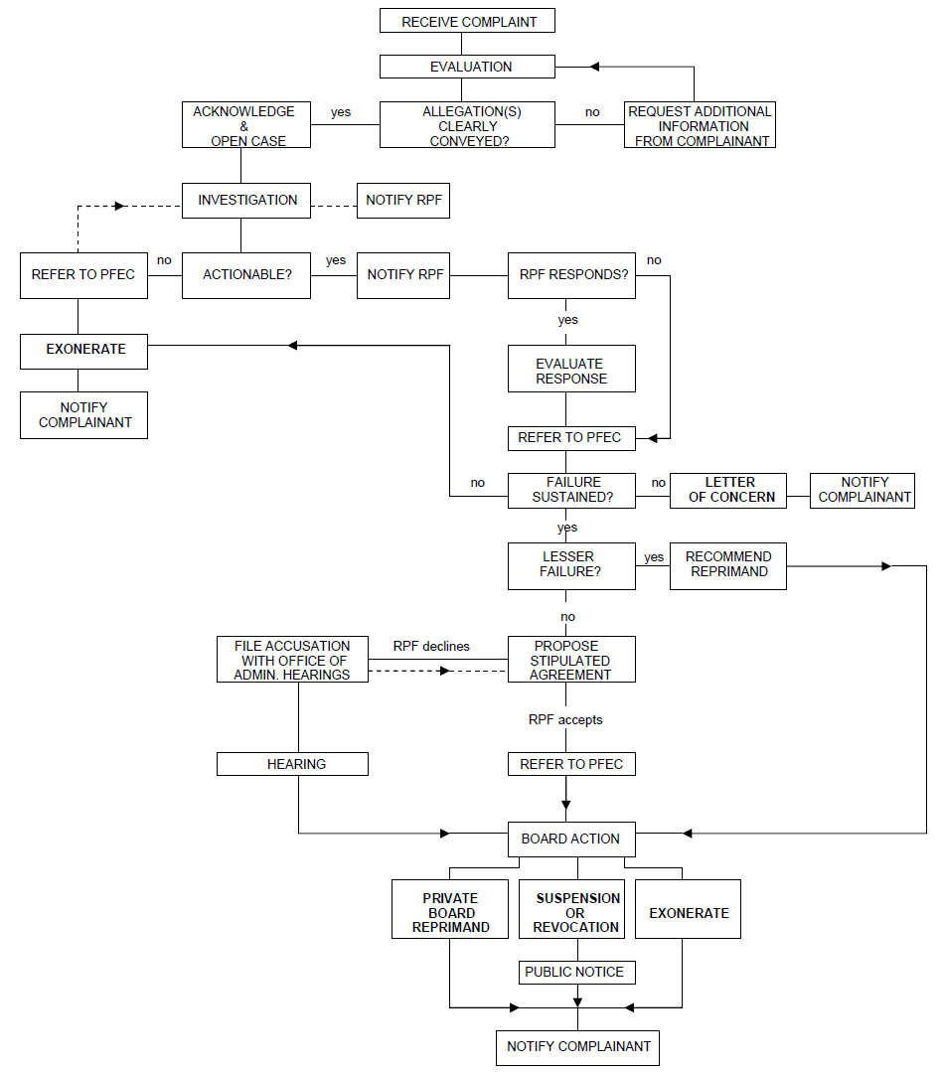
Complaint Against RPF

License Suspension or Revocation
(ref: Government Code §11517)
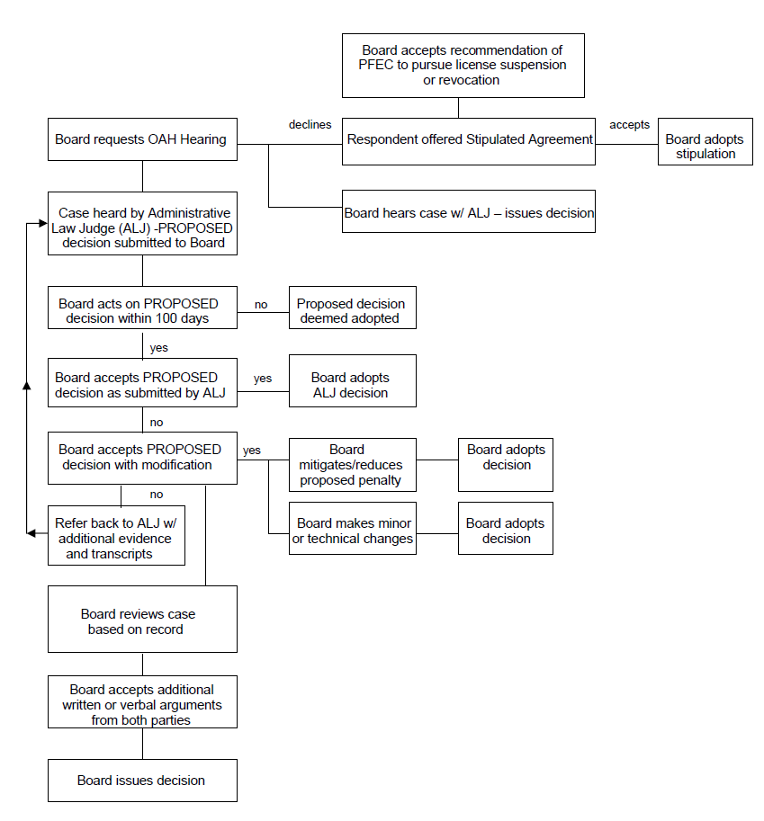

POLICY NUMBER 9: PROCEDURE FOR FILING OF A COMPLAINT WITH THE OFFICE OF PROFESSIONAL FORESTERS REGISTRATION
If a person wishes to file a complaint of professional misconduct against a Registered Professional Forester or Certified Specialist (CRM), the complaint must be submitted in writing, and mailed to Professional Foresters Registration, P.O. Box 94426, Sacramento, CA 94244- 2460, (916) 653-8031.
For purpose of providing direction to the Executive Officer of Foresters Licensing, the Board of Forestry and Fire Protection (Board) suggests that all complaints be filed in a consistent format and include the following information:
- The identity of the person who is the subject of the complaint, including his or her license number if known;
- A short description of the transaction or circumstances involved;
- The date and place (city or county) where the events occurred;
- The identity and addresses or telephone number of any other person(s) who have knowledge of the events described;
- A description of the loss, damage or other adverse consequences of the licensee’s conduct;
- Copies of pertinent portions of any plans, reports, letters, business records or other documents which support the complaint.
All complaints should contain the following verification:

VERIFICATION
I CERTIFY UNDER PENALTY OF PERJURY OF THE LAWS OF CALIFORNIA THAT THE FACTS STATED HEREIN ARE TRUE AND CORRECT TO THE BEST OF MY KNOWLEGE AND BELIEF.
DATE:
CITY OR PLACE:
SIGNATURE:
NOTE TO COMPLAINANTS: The complainant will receive a letter from Professional Foresters Registration acknowledging receipt of the complaint approximately 3 weeks after submittal. The complaint will then go through an initial review by the Executive Officer. You may be contacted by the Board to provide clarification or additional information. If a complaint you file results in prosecution, it is possible you may be compelled to testify in the case. You will be notified if this is necessary. You will also be notified of the conclusion of the matter and whether disciplinary action resulted, as appropriate.

POLICY NUMBER 10: REVIEW OF PROBATIONARY WORK PRODUCTS
As part of some stipulated agreements between the Board of Forestry and Fire Protection (Board) and disciplined RPFs to resolve licensing cases, independent review is required of written professional work documents done by the RPF while on probation before they are submitted to the California Department of Forestry and Fire Protection (Department) for review and possible approval. This includes, but is not limited to, standard timber harvesting plans, emergency timber harvesting plans, modified timber harvesting plans, and any other type(s) of plans involving timber harvest or major amendments to any of these documents the Board may create in the future. Depending on the nature of the case, this review may also apply to Confidential Archaeological Addenda, stocking reports and other THP or non THP related documents.
It is the intent of the Board that this type of review will increase the thoroughness and completeness of the work that goes into professional documents prepared by the RPF. The terms of an individual stipulated agreement are determined on a case by case basis. However, for informational purposes, a general summary of issues that an RPF can expect to be addressed in detail in the stipulated agreement include, among others, the following issues:
- Designation of which documents must be reviewed,
- Designation of qualifications for a reviewer, such as that the RPF be licensed, not currently subject to any pending disciplinary actions, and not subject to any conflicts of interest in the matter.
- Establishing specific standards governing the review process, such as requirements for field or office checks, documentation of the review process, correcting identified deficiencies in reviewed documents, and certification of reviewed documents.
- Establishing that the disciplined RPF is solely responsible for arranging for, and incurring the costs of, the independent review of his/her work product while on probation.

POLICY NUMBER 11: GUIDANCE ON THE PRACTICE OF FORESTRY AS IT RELATES TO OTHER PROFESSIONS

Introduction

The Professional Foresters Law, Public Resources Code §750, et seq. provides that a Registered Professional Forester (RPF) must be involved in projects that require the application of forestry principles and techniques for managing forested landscapes. Forested landscapes are those upon which are growing or naturally capable of growing in perpetuity significant stands of native conifer and/or hardwood trees and their associated vegetation types. These landscapes are typically tree dominated and not devoted to non-forestry commercial, urban or farming uses (Public Resources Code §754).
The Professional Foresters Law provides that a professional forester may only perform forestry services in those areas of expertise for which the person has achieved competency through training or experience. When a professional forester’s expertise is exceeded in a particular activity, the forester is compelled to utilize the services of other qualified experts including but not limited to arborists, archaeologists, botanists, civil engineers, ecologists, fisheries biologists, geologists, hydrologists, land surveyors, landscape architects, range scientists, soil scientists, or wildlife biologists. The Professional Foresters Law does not preclude these other environmental professionals from the application of their knowledge and expertise outside of the practice of forestry.

Statement I:
The Board recognizes consistent with the Professional Foresters Law, Public Resources Code §752(b), that there are other environmental professionals capable of supplying technical information relative to particular features of a forested landscape setting by virtue of education, training and experience.
The Board endorses an interdisciplinary approach in the management and treatment of natural landscapes. Just as the Professional Foresters Law requires that an RPF interact with other qualified experts when the RPF’s expertise is exceeded in the context of a particular activity, the Board finds that other qualified experts should likewise interact with RPF’s as appropriate to the environmental setting.

Statement II:
The Board recognizes that forested landscapes may be identified using a variety of vegetation classification systems including but not limited to the California Wildlife Habitat Relationship System (see the California Department of Fish and Game website link to the CWHR System (http://www.dfg.ca.gov/whdab/html/cwhr.html) and the California Department of Forestry and Fire Protection-Fire and Resources Assessment Program link to CWHR map layers (http://frap.cdf.ca.gov/data/frapgismaps/select.asp)); A Manual of California Vegetation by Sawyer and Keeler-Wolf; CDFG’s Vegetation Classification and Mapping Program (VegCAMP); various California Native Plant Society (CNPS) publications; and Preliminary Descriptions of the Terrestrial Natural Communities of California by R.F. Holland (updated 1996).

Statement III:
The Professional Foresters Law provides that the practice of forestry and rangeland management on forested landscapes includes among other things actions directed toward fuels management, forest protection, grazing on forested rangelands, timber growing and utilization, forest inventory, forest economics, forest valuation and finance, and the evaluation and mitigation of impacts from forestry activities on watershed and scenic values. Tasks associated with the practice of forestry and rangeland management include but are not limited to the following:
- Development of fuel hazard reduction prescriptions. Participation in the interdisciplinary development of technical aspects of wildfire protection plans.
- Evaluation of fire hazard, pest conditions (insects and disease), and the effects of damaging agents on the overall health of forests and woodlands. Development of treatments for the prevention and control of damage to forests and woodlands.
- Management planning and prescription development in support of wood product utilization.
- The determination of diameter, height, form, weight, growth rate, volume, or age of individual or groups of trees; or interpretation of such determinations to support forest management actions or the treatment of forest cover in general.
- The determination of economic value of a particular forest or woodland.
- Quantification or modeling of past, present, and future forest carbon stocks on forested landscapes for the purpose of monetization of various forest carbon pools.
- The evaluation of forest/woodland conditions in response to past management actions and the development of mitigation measures for remediation or control of potentially deleterious effects.
- Recommendations regarding prescriptive grazing on forested rangelands.

Statement III (Continued):
The Board recognizes that performance of the following tasks does not constitute the practice of forestry or rangeland management unless the tasks are exclusively directed toward the management and treatment of forests and woodlands:
- Providing retention or removal recommendations for trees associated with specific development improvements.
- Classification of vegetative or habitat types as indicated in item II above.
- Collection of tree species data (i.e. number of trees per acre, tree diameters, heights, etc.)
- Characterization of individual tree condition (i.e. pathology, injury assessment, health and vigor rating, etc.)
- Valuation or appraisal of individual tree(s) value, or loss as landscape elements, for trees associated with development.
- Preparation of tree protection plans pursuant to jurisdictional requirements if it is concluded by the Lead Agency that individual or groups of trees shall be retained on site in proximity to construction activities.
- Mapping, acreage/canopy cover determination or other site evaluations through photogrammetry, Geographical Information Systems (GIS), and/or surveyed location of individual or stands of trees.
- Mitigating or recommending mitigation of impacts from previous or proposed land use activities by other environmental experts within their field of expertise.
- Determinations of significance under CEQA.

Statement IV:
The Board acknowledges that pursuant to 14 CCR §15149(b) a CEQA document such as an EIR is not a technical document that must be prepared solely by state registered professionals. CEQA documents are intended to disclose for public benefit and agency review the potential adverse effects of a proposed project on the environment and to identify ways to reduce or mitigate such potential adverse effects. The extent to which full and accurate disclosure of potential adverse effects and mitigations necessitates the preparation of technical studies by state licensed professionals is at the discretion of the lead agency consistent with Professional Foresters Code and State Laws.
.

POLICY NUMBER 12: GUIDANCE ON THE CERTIFIED RANGELAND MANAGER PROGRAM

Introduction
The purpose of this policy statement is to clarify those management activities on rangelands that are most appropriately carried out by a Certified Rangeland Manager (CRM). The Professional Foresters Law, Public Resources Code §750, et seq. provides for the issuance of specialty certificates, “… in such fields of specialization as the Board may by regulation establish” (PRC §762). The only specialty certificate currently provided by Board regulation is that of the Certified Rangeland Manager. This specialty was created in 1995 through the efforts of the California Section of the Society for Range Management with the support of the California Department of Forestry and Fire Protection. In so doing, the California Section, now the California-Pacific Section (Cal-Pac SRM) sought to promote and strengthen professional standards in all activities devoted to rangeland resources. The Cal-Pac SRM professional certification is designed to distinguish and maintain a professional level of rangeland management expertise and provide continuing education and accreditation services to the profession.
The Board of Forestry and Fire Protection, through its Professional Foresters Examining Committee (PFEC), provides administrative oversight and annual review of the Society’s program to ensure compliance with State-mandated requirements to fully protect the public’s interest.
A Certified Rangeland Manager applies scientific principles to the art and science of managing rangelands. Rangelands are lands supporting grass, shrub, and savanna vegetation types pursuant to the Cal-Pac SRM Program for Certification of Professional Rangeland Managers (14 CCR §1651(c)). This program of certification is a service provided by Cal-Pac SRM as a means for demonstrating and supporting the special expertise required to practice as a Certified Rangeland Manager. Pursuant to 14 CCR §1651(a), a CRM shall perform professional services only in those subjects in which he or she is competent by training and experience.
The CRM license is required for professional practice of rangeland management on non-federal forested landscapes as a specialty authorized under a modification of the Professional Foresters Licensing Act (AB1903, January 1,1992) that requires the Registered Professional Forester license for the practice of forestry. The CRM license recognizes expertise that is desirable, and recommended for all rangeland management activities, but it is not legally required unless the activity occurs on forested landscapes.

Statement I:
The Board recognizes that rangelands may be identified using a variety of vegetation classification systems including but not limited to the California Wildlife Habitat Relationship System (see the California Department of Fish and Wildlife website link to the CWHR System (https://wildlife.ca.gov/Data/CWHR) and the California Department of Forestry and Fire Protection-Fire and Resources Assessment Program link to CWHR map layers (https://map.dfg.ca.gov/metadata/ds1327.html); A Manual of California Vegetation by Sawyer and Keeler-Wolf; CDFG’s Vegetation Classification and Mapping Program (VegCAMP); various California Native Plant Society (CNPS) publications; and Preliminary Descriptions of the Terrestrial Natural Communities of California by R.F. Holland (updated 1996).
“Forested landscapes” are defined by California Code of Regulations, title 14, section 754 as “tree dominated landscapes and their associated vegetation types on which there is growing a significant stand of tree species, or which are naturally capable of growing a significant stand of native trees in perpetuity, and is not otherwise devoted to non-forestry commercial, urban, or farming uses”. "Rangeland" means the land on which the existing vegetation, whether growing naturally or through management, is suitable for grazing and browsing. "Rangeland" includes any natural grasslands, savannas, shrublands, deserts, woodlands, and wetlands which support a vegetative cover of native grasses, grass-like plants, forbs, shrubs, or naturalized species. "Rangeland" is “land that is dominated by vegetation other than trees. Many woodlands (including Eastside ponderosa pine, pinyon, juniper, chaparral, and oak woodlands) are included in ‘rangelands’ because their response to range management principles and activities are similar to those of other shrubby ecosystems.”
The Board further recognizes the boundaries between forests and rangelands and the associated professional practices are often overlapping. Thus, the CRM license requirements apply to any landscape of mixed forested and non-forested vegetation types with significant interactions of range and forest management.

Statement II:
Tasks associated with the practice of rangeland management include but are not limited to the following:
- Drafting rangeland management plans to meet specific natural resource objectives, including:
  - Vegetative fuel management on rangelands;
  - Control or management of invasive species;
  - Reintroduction or increase of desirable species;
  - Improvement of economic viability of rangeland;
  - Mitigation of potential environmental effects.
- Developing and implementing means of improving or maintaining watershed function.
- Conducting rangeland inventories and assessments.
- Making recommendations regarding prescriptive grazing on rangelands.
- Planning and implementation of rangeland monitoring programs.
- Providing recommendations regarding conservation of, and regard for, rangeland as an expression of open space, viewshed, watershed and other public benefits.

Statement III:
The Board recognizes that performance of the following tasks does not constitute the practice of rangeland management, under the Professional Foresters Law, unless the tasks are principally directed toward the management and treatment of rangelands:
- Mapping, acreage/vegetative cover determination or other site evaluations through photogrammetry, Geographical Information Systems (GIS), and/or surveyed location.
- Mitigating or recommending mitigation of impacts from previous or proposed land use activities by other environmental experts within their field of expertise.
- Determinations of significance pursuant to the California Environmental Quality Act (CEQA).
It is important to note that, pursuant to PRC §757, landowners are specifically exempted from the necessity of compliance with the Professional Foresters Law, including the provisions of the CRM Program, when directly managing their own lands. It is likewise noteworthy and illustrative of the distinction between the roles of the CRM and the Registered Professional Forester (RPF) that pursuant to 14 CCR §1651(b), a CRM providing range management services related to rangeland resources on forested landscapes must consult with a RPF if there are potential impacts on related forest resources. And conversely, RPFs providing services related to forest resources must either have rangeland experience or consult with a CRM if there are potential impacts on related rangeland resources.

Statement IV:
The Board acknowledges that pursuant to 14 CCR §15149(b) a CEQA document such as an EIR is not a technical document that must be prepared solely by state certified professionals. CEQA documents are intended to disclose for public benefit and agency review the potential adverse effects of a proposed project on the environment and to identify ways to reduce or mitigate such potential adverse effects. The extent to which full and accurate disclosure of potential adverse effects and mitigations necessitates the preparation of technical studies by state certified professionals is at the discretion of the lead agency consistent with Professional Foresters Code and State Law.

Opinion of California Deputy Attorney General Shana Bagley received by Eric Huff, then Executive Officer, Foresters Licensing, California Board of Forestry and Fire Protection, July 25, 2008.

