EMC-2017-008 - November 10, 2017 - EFFECTIVNESS MONITORING AND EVALUATION: DO RULES MINIMIZE FIR MORTALITY FROM ROOT DISEASE AND BARK BEETLE INTERACTIONS VERSION #2
Investigators:
Richard Cobb, PhD (PI); Assistant Professor, Department of Natural Resources and Environmental Science, Cal Poly
Chris Lee, PhD; Forest Health Specialist, California Department of Forestry and Fire Protection Matteo Garbelotto, PhD; Cooperative Extension Specialist, Adjunct Professor, Department of Environmental Science, Policy, and Management, UC Berkeley

Cooperators:
Nick Kent; Forester, Collins Pine Co
David Rizzo, PhD; Professor, Department of Plant Pathology, UC Davis
Beverly Bulaon, Forest Entomologist, USDA Forest Service - Forest Health Protection

Background and Purpose
This proposal seeks to evaluate several sections of the Forest Practice Rules for their effectiveness in controlling fuels accumulation in the face of devastating bark beetle outbreaks in true fir stands. Our project focuses on fir engraver beetle (Scolytus ventralis) and seeks to understand if treatments for the control of Heterobasidion root disease create forests that are more resilient to beetle outbreak, therefore better meeting the spirt of the California Forest Practices Act to create healthy, productive, and appropriately stocked forests. We propose a series of tests of existing California Forest Practice Act rules in an effort to understand how FPA implementation on a long-term basis influences forest health. We focus on beetle outbreak in true fir forests because these stands have yet to reach crisis mortality levels when viewed at the state scale but, the frequency of Heterobasidion infections, and the distribution of both biological agents of mortality across the Sierra Nevada suggests the potential for a highly damaging outbreak. A companion project with the USDA Forest Service Sonora Service Center (Forest Health Protection – Evaluation Monitoring) aimed at validating and improving estimates of mortality in fir provides: 1) a rich set of reference study plots 2) a spatial dataset on patterns of fir mortality on public and private lands, and 3) a mechanistic risk projection for a variety of forest conditions. The present proposal complements, but is not dependent on the latter project; we aim to develop stand-level solutions to protect against future or ongoing mortality from bark beetle-root disease interactions on private timberlands while testing techniques that can be implemented on public lands. Because fir mortality levels are relatively limited, the timing for testing and implementing rules- based treatments is excellent.
The recent drought and the subsequent bark beetle outbreak in pine represents a major and ongoing “Rare or Large Event” (ECM strategic plan section 4) and has resulted in significant economic (200 million USD state expenditures as of 2016) and ecological cost in Sierra Nevada forests. Fir forests are at substantial risk of a second outbreak wave given that fir engraver beetle builds up more slowly and is more closely tied to drought than the Dendroctonus beetles which attack pine (Aukema et al. 2008, 2010). Weaker Scolytus beetles are strongly associated with Heterobasidion-infected trees, suggesting increased water stress in trees with root infections predisposes these individuals to bark beetle attack, increases beetle reproduction, or both (Cobb et al. 1973, Garbelotto et al. 1999, Gonthier et al. 2001,

2005). Scolytus ventralis outbreak often requires an external event to reach outbreak levels compared to Dendroctonus bark beetles that attack pine, with drought or a weakening of tree defenses due to non- lethal but well-established root infections as the most likely inciting factors in California fir forests (c.f.
Raffa et al. 2008). Heterobasidion occidentale is the most widespread root pathogen in Sierra Nevada fir forests (Slaughter and Parmeter Jr 1989, Otrosina and Garbelotto 2010), and white and red fir silvilculture often requires treatments or changes in the timing of harvesting to minimize infection and subsequent losses. In particular, repeated, frequent entries into the stand produce large numbers of stumps and cause damage to residual trees that facilitate Heterobasidion infections (Barnard 1991, Swedjemark and Stenlid 1993, Garbelotto and Gonthier 2013), so improvements in these practices may facilitate rules for limiting fuels accumulation by reducing mortality from large events such as those caused by bark beetles. However, treatment options for controlling or preventing bark beetle outbreak are poorly developed for western fir forests (Fettig et al. 2007), possibly due to a lack of integrating with root disease dynamics. Understanding how well the Forest Practice Rules limit biologically-driven mortality will be important for revising rules and guidelines so that they maintain forest health and productivity in the future.
The southern Sierra serves as a stark justification for this applied research and monitoring in fir forests which have densified in the last century while also becoming more important as state-level water resources (Bales et al. 2006, Dolanc et al. 2014). Emergency actions to control bark-beetle related fuels accumulation are being aggressively implemented across the region on private and public lands, but these treatments are primarily triage aimed at prioritizing dead tree removal from infrastructure and homes. In on lands managed by the Collins Pine partners on this project, fir timber resources have suffered relatively little damage from fir engraver beetles but, Heterobasidion pathogens are widely distributed. Here, we evaluate existing Collins Pine fir silvicultural practices and associated treatments (stump treatment with borates, avoiding of wounding residual fir stems, optimizing fir-to-fir spacing, and sanitation/salvage operations) for their effectiveness in addressing fuels accumulation, stocking, and control of pests/pathogens (Aim 1). We will complement this observational study with a set of experimental treatments to reduce infection, mortality, and fuels (Aim 2). A set of long-term study plots on federal lands, primarily on the western Sierra Nevada slope, where Heterobasidion dynamics, tree mortality, and fuels accumulation has been monitored over the last 60 years (last surveyed in 2014) will be leveraged as an additional set of reference comparisons including high mortality stands (Aim 3). The combined results will be used in a critical evaluation of relevant Forest Practice Rules; specifically 14 CCR
§1038 (b). The study also provides insight into application of 14 CCR §917.9/937.9/957.9 (b) and 14 CCR
§ 913.3/933.3/953.3 (b)). We will evaluate the need for rule modifications in light of treatment efficacy and the magnitude of the current bark beetle outbreak (Aim 4).

Critical Question Themes:
This project focuses primarily on theme 6 - Wildfire Hazard (ranked high priority) but will also address additional themes influenced by the distribution of dead wood including themes 7 & 10 (wildlife habitat and structures; ranked low priority).

Relationship to Broader Cal Fire priorities and objectives
This project tests the effectiveness of specific rules with a combination of evaluation of existing treatments and application of a designed experiment. All stand-level field data also provides insight into several state and regional management goals related to forest health. First, the data collected in this

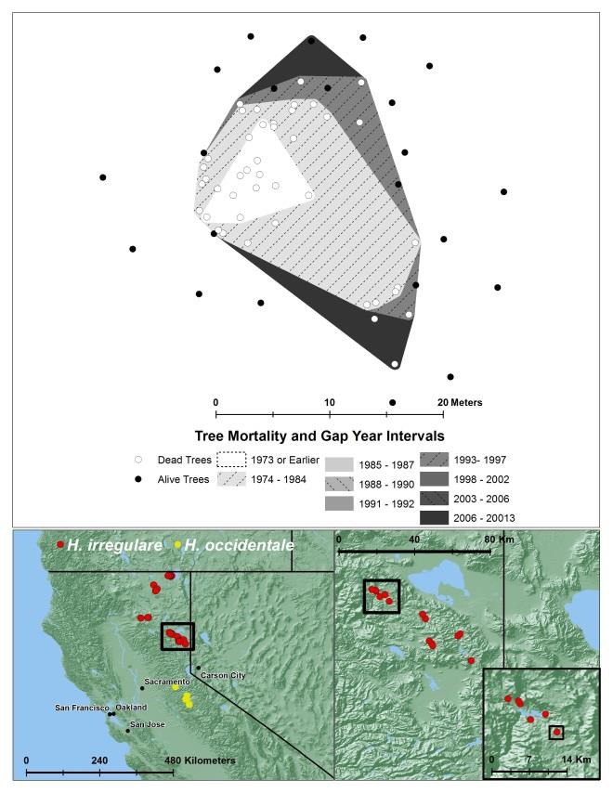
study provide some of the best assessment of the rare and large bark beetle mortality event by including reference sites in locations with heavy fir mortality. By assessing the rates and cumulative amounts of tree mortality in different treatments, in sites with varying biomass and species composition this work has strong potential to provide insight into the cumulative effects to carbon storage, relationships between tree mortality and wildfire, and also yield insight into challenges to stocking resulting from region-scale tree mortality. Our group is in the process of developing a companion project focused on evaluating the accuracy of annual aerial tree mortality detection monitoring conducted by the U.S. Forest Service. This companion project is aimed at providing accurate assessments of fir (primarily) and pine (secondarily) tree mortality over the last five years including an analysis of the mechanisms by which large mortality centers (>250 ac) emerge (root disease, bark beetles, fire, land use). These large centers in fir- dominated forests appear to be caused by coalescence of smaller mortality polygons, which suggests widespread Heterobadision disease centers are leading to local intensification of Scolytus beetle attacks. The Forest Service project does not include any experimental treatments to control or prevent these
Figure 1. An example long-term study plot showing changes in disease center size and direction of expansion; locations of additional long-term forest health study plots (reference sites).
outbreaks. Both projects will provide estimates of the amount of living biomass lost due to biological agents (root disease and bark beetle; see also Cobb et al. 2012). However, our EMC proposal also has potential to provide guidelines for minimizing this mortality on federal lands where the Forest Practice Rules do not apply, thereby improving forest health management well beyond Collins Pine lands.

Forest Practice Rule(s) addressed by this project:
14 CCR §1038 (b) (Exemption): Landowners, LTOs and RPFs utilize this Rule for fast sanitation/salvage response in beetle-attacked or diseased stands. It allows quick stand entry without the need to follow the THP process in its entirety as long as a cap on harvested volume (≤ 10% of stand volume) is observed. The question in the case of the Heterobasidion-bark beetle system is whether the repeated quick entries facilitated by this rule can, without mitigating treatments, lead to increases in root disease, bark beetles, and resulting fuels accumulations.
14 CCR § 913.3/933.3/953.3 (b) (Sanitation/Salvage): This operation involves removing insect-attacked or diseased trees to facilitate health of the residual stand, but unlike the Exemption rule above, this is done as part of the normal THP process.
14 CCR §917.9/937.9/957.9 (b) (Prevention Practices): This section of the Rules directs RPFs and LTOs to identify feasible methods for minimizing the impact of destructive insects and diseases to residual trees and regeneration. This serves the twin purposes of tending the growing stand and preventing future

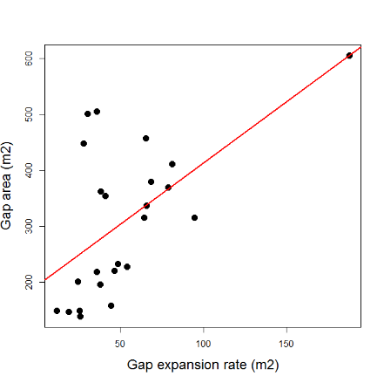
buildups of fuels and hazard trees. Addressing slash treatments as outlined in Technical Rule Addendum No. 3 is an important method to achieve this in pine silviculture. This proposed ECM project starts with the observation that an analogous method in true fir silviculture may consist of implementing certain logging actions to avoid wounding residual stems and certain post-harvest treatments to residual stems and stumps to minimize subsequent infection. These techniques may be effective in limiting spread of Heterobasidion root disease, particularly in fir where the pathogen is able to infect trees via wounds from logging activities. Stumps and stem wounds serve as key sources of Heterobasidion infection and spread within true fir stands, and conventional pathology knowledge in California suggests that fir engraver beetles rarely attack trees uninfected by this root disease (Cobb et al. 1973, Slaughter and Parmeter Jr 1989).
Figure 2. Gap expansion rate as a predictor of total disease center size after 50 years of Heterobasidion root disease in Sierra Nevada true fir forests.

Specific Aims (with activity timing):
Aim 1 (2018-2019): Evaluation of existing true fir silvicultural practice: We will partner with Collins Pine to assess true fir Heterobasidion infection levels, incidence of fir engraver beetle attack, and Heterobasidion spore loads at the stand level in California fir silvicultural systems. We will also apply the Browns Transect (Brown et al. 1981) technique which has been successfully used to assess disease- generated fuel levels for other diseases (Metz et al. 2011, Valachovic et al. 2011). Treatments will include, stump borate application, sanitation/salvage logging, differing levels of harvest-related wounding at the stand level, local untreated and unharvested stands. Additionally, a set of long-term study plots on Forest Service lands (El Dorado, Plumas, & Stanislaus National Forests) will serve as a second set of reference comparisons; these plots have been assessed for Browns fuels and also include cumulative mortality – with spatial and temporal mapping of mortality timing (Figure 1) – collected over 45-60 years (depending on location).
Hypothesis 1: Heterobasidion inoculum loads are driven by the combined effects of fir density and the prevalence of fir with root disease symptoms. Expectations: root disease prevalence is more important than fir density in driving inoculum. Treatments that are most effective in limiting infection sources will have the greatest benefit in terms of reducing root disease-bark beetle mortality dynamics.
Hypothesis 2: Treatments aimed at controlling root disease prevalence reduce local inoculum but with variable effectiveness. Expectations: sanitation logging that eliminates wounding to standing trees is the most effective, stump treatments are intermediately effective due to high inoculum loads, the effectiveness of salvage/sanitation logging depends on the previous two factors, and no treatment leads to the highest local inoculum levels.
Methods: A diversity of pre-harvest stand conditions, harvest extent, and management for Heterobasidion and bark beetles have been applied on Collins Pine lands and applied by the company in timber harvests on neighboring public lands. A full assessment of field measurements will be matched to records of stand treatments. Reference sites will primarily be located on nearby public lands (Plumas National Forest) where we have a ~50 year record of Heterobasidion disease center dynamics, fir engraver beetle incidence, and tree growth rate data (Figure 1; Slaughter and Parmeter Jr. 1995, Rizzo and Slaughter 2001). A standard set of plot, disease (mortality, tree health), and frequency of bark

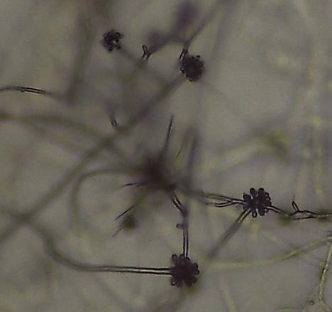
beetle attack on individual trees, and standard method for Heterobasidion spore trapping will be conducted at each study plot (Gonthier et al. 2001, Otrosina and Garbelotto 2010). A Heterobasidion isolate collection will be developed using a combination of coring from symptomatic trees and spore trapping at each plot to categorize species and local or exogenous sources of infection (collaboration with M Garbelotto UC Berkeley). Our previous study of Heterobasidion disease centers suggests initial rates of disease-center expansion are strong predictors of total disease-center extent after 50 years (Figure 2) suggesting actions at the early stages of outbreak will be effective in limiting pathogen spread.
Figure 3. Characteristic conidiophores of the asexual state of Heterobasidion collected in October 2017 from Collins Pine lands. These cultures were recovered using the coring method proposed in Aim 2.
Aim 2 (2018-2020): We will conduct a designed experiment to assess the effectiveness of several chemical controls on Heterobasidion colonization of fir. On Collins Pine lands, we will apply three chemical treatments: borates (Cellutreat® Nisus Corporation, Rockford TN), urea (Sigma-Aldreich, St. Louis, MO), and local soil fungal inoculum on intentional wounds at two heights (ten
trees per treatment). Urea is an inexpensive and commonly used compound to protect against fungal infection and has antagonistic effects on Heterobasidion and is unlikely to cause damage to living trees (Oliva et al. 2008). In contrast, borates are well known inhibitors of Heterobasidion infection in stumps but have not been tested in living trees (such as fir wounds) and may cause phytotoxicity. The last treatment will apply local mineral soil to wounds in an attempt to introduce Trichoderma to fir.
Trichoderma is a common soil fungi that is widely applied to protect nut trees (almond, pistachio, walnuts) against airborne heart rot fungi. While Trichoderma is untested for Heterobasidion occidentale, this would be an especially low-cost protective treatment. Each treatment will be contrasted with a set of control treatments where wounds will be untreated.
Methods: Sixty individual fir trees without Heterobasidion root disease symptoms, but located within areas with documented high levels of fungal inoculum, will be selected for this experiment (see Figure 3). Each tree will be sampled with an increment borer at the base in three locations to isolate previous Heterobasidion infections. We aim to treat at least 10 trees per treatment, and pre-screening trees gives us the flexibility to exclude trees which already have infections, or to add additional trees to the experiment if more than 40 are found to lack infections. Wounding will be applied in autumn 2018 as this will provide time to assess all trees for previous infection and as this period is known to have active Heterobasidion dispersal (Figure 3). Treatments will be applied after all wounds have been created to better simulate forest harvest practices and in accordance with product guidelines (within 6 hrs of cutting). Treatments will be reassessed in 2019 and 2020 using coring and direct culturing from sampled wood (in collaboration with Co-PI Matteo Garbelotto at UC Berkeley).
Hypothesis 1: Competitive exclusion of Heterobasidion is possible with any of our treatments as long as inoculum levels are adequate. Expectations: Borates and urea treatments are untested for living trees; it is likely that borate treatments will be the most effective, but these could come with a cost to tree growth or crown health due to phytotoxicity resulting from the chemical treatments. Urea applications are also likely effective and less likely to harm living trees. Soil inoclum may be effective but is likely to

depend on the local populations of species such as Trichoderma harzianum and whether these organisms will become established long enough to exclude Heterobasidion infections (through end of experiment).
Aim 3 (ongoing, completion by 2019): We will leverage a rich set of long-term measurements of Heterobasidion-bark beetle dynamics on nearby federal lands which have been surveyed every 5-10 years since 1971 or 1956. We will use existing disease data (Figure 2) and Browns transects fuels measurements (not shown) in our Forest Service plot network as a comparison of application of Forest Practice Rules compared to lands where these rules do not apply. These sites provide the capacity to contrast application of the rules to 1) stands with no stump treatments, 2) stands with post-harvest burning to dispose of stumps and other slash, and different levels of fir-spacing via thinning practices aimed at reducing fuels.
Methods: A common set of methods for stand assessment applied in aims 1 & 2 have been applied to create the existing dataset. A series of linear models that integrate random effects for site and other factors will be evaluated and integrated into these models. A resurvey of these plots has been proposed as part of an Evaluation Monitoring proposal to the Forest Service and will be used in treatment evaluation if the project is funded (note: the success of this step is not dependent on the Forest Service proposal). A subset of 10 plots selected to best approximate no-treatment scenarios on Collins Pine lands will be selected for spore trapping in order to assess variation in inoculum levels with differences in stand isolation, local fir density, and local disease prevalence.
Hypothesis 1: Stump treatments result in smaller disease centers but do not affect disease prevalence in local stands. Expectations: while stump treatments can protect individual trees from transmission via root grafting, these treatments may not be effective at the stand level due to infection via above-stump wounds. Stump treated stands may have smaller disease centers but no differences in inoculum between stump-treated and untreated stands, or no difference in disease center frequency. The implication of this finding is that wounding during harvesting practices could be more important for limiting root disease emergence and subsequent fir engraver beetle outbreak. Stand isolation and local fir density are also likely to drive variation in inoculum levels with smaller and more isolated stands experiencing lower inoculum.
Aim 4 (2019-2020): By quantifying the effectiveness of specific Forest Practice Rules, we aim to understand their capacity to limit tree mortality and provide guidance for revision to address the historic bark beetle outbreak.

Methods:
This synthesis activity will attempt to estimate the amount of stand-level biomass which can be conserved by tree-level treatments (borates, urea, Trichoderma) and other practices to control the combined threat of Heterobasidion and bark beetle in fir forests. We will model treatment efficacy in a series of counter-factual (‘what if’) scenarios to understand how much biomass could be conserved through greater application of treatments to limit these biological agents of tree mortality. Model estimates will be compared with true fir mortality in the Sierra Nevada since 2010 using Forest Service aerial detection monitoring data and our long-term dataset in Heterobasidion-impacted fir forests.
Detailed plot methods

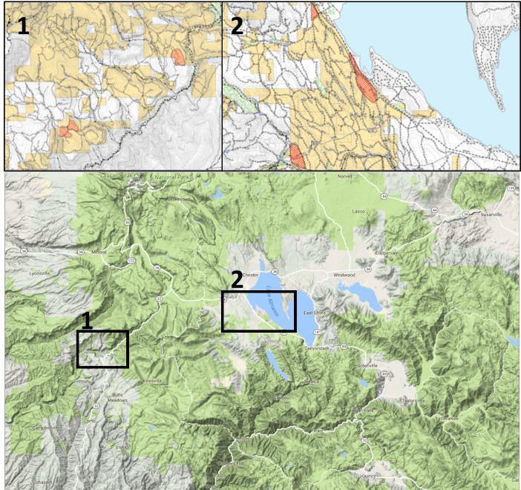
Plot-level measurements follow a standard protocol to facilitate comparison between new study plots on Collins Pine lands and long-term datasets. We will establish 60 plots on Collins Pine lands using a one-to-one ratio of treated and control plots in 2018. Previous treatments include,
Figure 4. Study area near Chester, CA. Collins Pine lands with candidate stands suitable for aims 1&2 (in red).
(1) sanitation harvesting of dead/dying trees (14 CCR § 913.3/933.3/953.3 (b)), (2) stump treatment with borates, and (3) varying levels of wounding during harvesting. Sanitation harvesting and borate treatments are well documented on lands owned or managed by Collins Pine and suitable areas for paired control plots are nearby (Figure 4). Differences in wounding during harvesting will be assessed with a transect method where a rapid assessment of basal area, stem density, evidence of fir engraver attack, and symptoms of Heterobasidion infection will be conducted at 25m intervals on a 200 m transect. Two transects (at perpendicular angles) will be established in each
candidate stand; these measurements are effective in determining local insect or pathogen prevalence (Rizzo and Slaughter 2001), which is additional information needed before treatments can be applied (Aim 2) or in evaluation in the observational study (Aim 1).
Spore monitoring is extremely simple: either 1-cm-thick wood disks or a selective medium is exposed for 4-24 hrs in petri plates on the forest floor and then observed over a 2-week period to enumerate emerging colonies of the asexual state (Garbelotto et al. 1999, Garbelotto and Gonthier 2013; Figure 3). Within each plot, we will develop an isolate collection of Heterobasidion and determine local species diversity that will serve as the basis for any future genetic analysis to refine inoculum source (with M. Garbellotto, UC Berkeley). Understanding inoculum levels places treatment benefits in the context of landscape-level pathogen dynamics. In some circumstances, local treatments that reduce inoculum production could be overcome by inoculum from outside the stand.
Analysis of existing data (Aim 3) will include a series of statistical and epidemiological models will be developed for Heterobasidion / fir engraver beetle interactions. Previous analysis has focused on describing the rates and dynamics of root disease but a further analysis will examine existing data on fuel levels and fir engraver incidence with spatially explicit empirical models.
Estimated funding request: This is a three-year project administered through Cal Poly. We aim to support a full-time, two year MS student project in the Natural Resource and Environmental Science Department and two-to-four undergraduate senior thesis projects. Student projects will focus on data analysis, model synthesis and evaluation of specific rules. The following information is for information purposes only and represents an estimate of expenses. Should we be invited to submit a proposal budget, this information must be reviewed and approved by the Cal Poly Grants Development Office who will submit a formal proposal on behalf of the investigators.

Category | Description | Year 1 | Year 2 | Year 3 | Total
Personnel
 | Summer salary (1 month) | $8,593 |  |  | $8,593
 | Summer salary (1 month) |  | $8,979 |  | $8,979
 | Summer salary (0.5 month) |  |  | $4,692 | $4,692
 | Undergraduate salary (303 hrs) | $4,545 |  |  | $4,545
 | Undergraduate salary (606 hrs) |  | $9,090 |  | $9,090
 | Graduate student (850 hrs) | $15,300 |  |  | $15,300
 | Graduate student (850 hrs) |  | $15,300 |  | $15,300
 | Subtotal personnel | $28,438 | $33,369 | $4,692 | $66,499
Fringe Benefits
 | Faculty summer | $859 | $898 | $469 | $2,226
 | Undergraduates | $205 | $409 | $0 | $614
 | Graduate Student | $1,530 | $1,530 | $0 | $3,060
 | Subtotal Fringe | $2,594 | $2,837 | $469 | $5,900
 | Total personnel | $31,032 | $36,206 | $5,161 | $72,399
 | Travel (total) | $2,500 | $1,500 | $1,000 | $5,000
 | Supplies (total) | $1,500 | $0 | $0 | $1,500
Subcontract | UC Berkeley (pathogen analysis) | $25,000 | $0 | $0 | $25,000
 | Total other direct costs | $26,500 | $0 | $0 | $26,500
 | Total direct costs | $60,032 | $37,706 | $6,161 | $101,399
Indirect cost | Cal Poly (25%) | $15,008 | $9,427 | $1,540 | $19,725
Total Cost |  | $75,040 | $47,133 | $7,701 | $129,874

Literature Cited:
Aukema, B. H., A. L. Carroll, Y. Zheng, J. Zhu, K. F. Raffa, R. Dan Moore, K. Stahl, and S. W. Taylor. 2008.
Movement of outbreak populations of mountain pine beetle: influences of spatiotemporal patterns and climate. Ecography 31:348–358.
Aukema, B. H., J. Zhu, J. Møller, J. G. Rasmussen, and K. F. Raffa. 2010. Predisposition to bark beetle attack by root herbivores and associated pathogens: roles in forest decline, gap formation, and persistence of endemic bark beetle populations. Forest Ecology and Management 259:374–382.
Bales, R. C., N. P. Molotch, T. H. Painter, M. D. Dettinger, R. Rice, and J. Dozier. 2006. Mountain hydrology of the western United States. Water Resources Research 42:W08432.

Barnard, E. L. 1991. Incidence of Heterobasidion annosum and Other Root-Infecting Fungi in Residual Stumps and Roots in Thinned Slash Pine Plantations in Florida. Plant Disease 75:823.
Brown, J. K., R. D. Oberheu, and C. M. Johnston. 1981. Handbook for inventorying surface fuels and biomass in the Interior West. USDA For. Serv. Gen. Tech. Rep. INT-129.
Cobb, F. W., J. R. Parmeter, D. L. Wood, and R. W. STARK. 1973. Root pathogens as agents predisposing ponderosa pine and white fir to bark beetles. Pages 8–15 in E. G. Kulman, editor. Proc. Fourth Int. Conf. on Fomes annosus. Athens, Georgia.
Cobb, R. C., J. A. N. Filipe, R. K. Meentemeyer, C. A. Gilligan, and D. M. Rizzo. 2012. Ecosystem transformation by emerging infectious disease: loss of large tanoak from California forests. Journal of Ecology 100:712–722.
Dolanc, C. R., H. D. Safford, S. Z. Dobrowski, and J. H. Thorne. 2014. Twentieth century shifts in abundance and composition of vegetation types of the Sierra Nevada, CA, US. Applied Vegetation Science 17:442–455.
Fettig, C. J., K. D. Klepzig, R. F. Billings, A. S. Munson, T. E. Nebeker, J. F. Negrón, and J. T. Nowak. 2007. The effectiveness of vegetation management practices for prevention and control of bark beetle infestations in coniferous forests of the western and southern United States. Forest Ecology and Management 238:24–53.
Garbelotto, M., F. W. Cobb, T. D. Bruns, W. J. Otrosina, T. Popenuck, and G. Slaughter. 1999. Genetic structure of Heterobasidion annosum in white fir mortality centers in California. Phytopathology 89:546–554.
Garbelotto, M., and P. Gonthier. 2013. Biology, Epidemiology, and Control of Heterobasidion Species Worldwide. Annual Review of Phytopathology 51:39–59.
Gonthier, P., M. M. Garbelotto, and G. Nicolotti. 2005. Seasonal Patterns of Spore Deposition of Heterobasidion Species in Four Forests of the Western Alps. Phytopathology 95:759–767.
Gonthier, P., M. Garbelotto, G. C. Varese, and G. Nicolotti. 2001. Relative abundance and potential dispersal range of intersterility groups of Heterobasidion annosum in pure and mixed forests. Canadian Journal of Botany 79:1057–1065.
Metz, M. R., K. M. Frangioso, R. K. Meentemeyer, and D. M. Rizzo. 2011. Interacting disturbances: wildfire severity affected by stage of forest disease invasion. Ecological Applications 21:313–320.
Oliva, J., N. Samils, U. Johansson, M. Bendz-Hellgren, and J. Stenlid. 2008. Urea treatment reduced Heterobasidion annosum s.l. root rot in Picea abies after 15 years. Forest Ecology and Management 255:2876–2882.
Otrosina, W. J., and M. Garbelotto. 2010. Heterobasidion occidentale sp. nov. and Heterobasidion irregulare nom. nov.: A disposition of North American Heterobasidion biological species. Fungal Biology 114:16–25.
Raffa, K. F., B. H. Aukema, B. J. Bentz, A. L. Carroll, J. A. Hicke, M. G. Turner, and W. H. Romme. 2008.
Cross-scale drivers of natural disturbances prone to anthropogenic amplification: the dynamics of bark beetle eruptions. BioScience 58:501–517.
Rizzo, D. M., and G. W. Slaughter. 2001. Root disease and canopy gaps in developed areas of Yosemite Valley, California. Forest ecology and management 146:159–167.
Slaughter, G. W., and J. R. Parmeter Jr. 1989. Annosus root disease in true firs in northern and central California national forests. Pages 70–77 Proceedings of the Symposium on Research and Management of Annosus Root Disease.
Slaughter, G. W., and J. R. Parmeter Jr. 1995. Enlargement of tree-mortality centers surrounding pine stumps infected by Hetetobasidionannosum in northeastern California. Canadian Journal of Forest Research 25:244–252.
Swedjemark, G., and J. Stenlid. 1993. Population dynamics of the root rot fungus Heterobasidion annosum following thinning of Picea abies. Oikos:247–254.

Valachovic, Y. S., C. A. Lee, H. Scanlon, J. M. Varner, R. Glebocki, B. D. Graham, and D. M. Rizzo. 2011.
Sudden oak death-caused changes to surface fuel loading and potential fire behavior in Douglas- fir-tanoak forests. Forest Ecology and Management 261:1973–1986.

