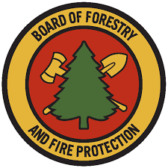

Range Management Advisory Committee
State Lands Grazing License and Land Management
Guidance Packet

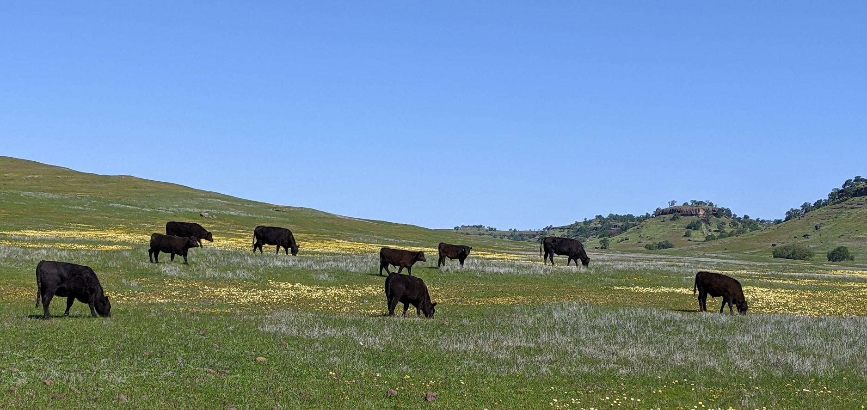

May 2024

Table of Contents:

Background | 1
Foreward | 1
Team Members | 1
Introduction | 2
Grazing License Outline | 2
License Outline Specifics | 3
Land/Grazing Management Plan Outline
Management Plan Outline Specifics
References and Resources
Grazing Licenses
Land/Grazing Management Plans
Monitoring
Other Resources
Frequently asked questions (DGS Q & A)
List of Appendices:

Appendix A: Grazing Agreements for Public Lands
Appendix B: Comprehensive Land/Grazing Management Plan Template

Background: The Range Management Advisory Committee (RMAC) is authorized by Section 741 of the Public Resources Code of the State of California to provide a source of counsel for the Board of Forestry and Fire Protection (Board) concerning the rangelands of California. The mission of RMAC is to consider issues related to California’s rangeland resources, provide recommendations on addressing them, facilitate strong relationships with local, state and federal agencies and develop solutions that are based on environmental, social, and economic information that is current, data-driven, and considers diverse perspectives. This Guidance Packet meets RMAC’s Strategic Plan objective to “Share information and education with Certified Range Managers and government agency rangeland and forestry staff to grow professional knowledge in the field of rangeland health.”

Foreword: A subcommittee of the RMAC developed a Grazing License Outline (“Grazing Agreements for Public Lands”, Appendix A) and a Management Plan Outline (“Comprehensive Land/Grazing Management Plan Template”, Appendix B) to guide and support California government agencies in utilizing managed livestock grazing as a management tool to enhance ecological values and reduce fire fuels loads on public lands. This Guidance Packet was developed as a supplement to the Grazing License and Management Plan Outlines to provide more in-depth information related to specific Outline items and to provide a directory of related resources. Many historical sustainable grazing management programs exist on state lands that can serve as a model to those looking to utilize grazing as a land management tool on public lands. Together, these documents provide tools to assist agency staff in streamlining the implementation of grazing management programs as well as providing resources to guide existing grazing programs. While developed for use on California’s Public Lands, the principles within these documents can be applied to other public and private lands.

Team Members:
Lance Criley; RMAC, U.S. Department of Agriculture (USDA) United States Forest Service
Jeanette Griffin; California Department of Fish & Wildlife (CDFW)
Richard M. Ross; RMAC, legal counsel
Kevin Conway; Jackson State Demonstration Forest
Tony Psihopaidas; State Department of General Services
Lawrence Ford*; LD Ford Rangeland Conservation Science
Bart Cremers*; RMAC, WILDLANDS and rancher
Tracy Kay Schohr*; U.C. Cooperative Extension and rancher
Katie Delbar; USDA Farm Service Agency and rancher
Advisor: Kristina Wolf*, California State Board of Forestry & Fire Protection

*Certified Rangeland Manager, licensed under a specialty certificate within the California’s Forest Practice Rules under California Board of Forestry and Fire Protection
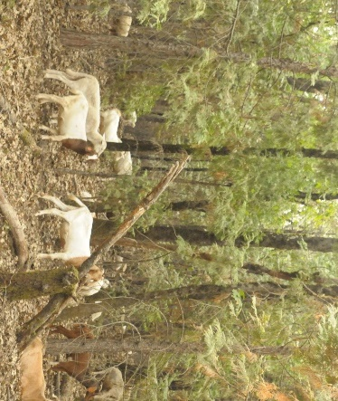
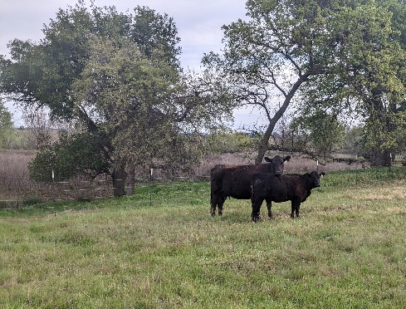
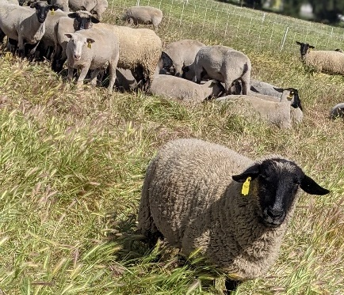

Introduction
When grazing is chosen as a management tool, the Land Manager must keep in mind that the management measures and parameters must be compatible with the livestock operation and allow for a profitable livestock enterprise. Understanding the annual schedule of both the animals and the livestock industry are important in developing a successful grazing program on any site. A successful program will balance the site-specific habitat needs with the needs of the livestock operation to develop a plan that optimizes both. It is important to understand that any one site is part of a larger grazing system, and the livestock have seasonal requirements and limitations as does the other land within the grazing system. For instance, there are typical grazing seasons for any type of livestock, which a Land Manager needs to understand and consider when developing a Management Plan and Grazing License. Starting or ending a grazing license at a non-conventional time of year may make it difficult for grazers to accommodate, may make it financially less viable for a grazer, and therefore may make it more difficult to find someone willing to graze. Often the timing when livestock go to one property may be dictated by when they have to leave another property, either based on environmental conditions such as feed or water availability or lease stipulations. Extensive planning goes into securing forages throughout the year that meet the livestock’s requirements and they are not generally moved around on a whim. Livestock are not simply waiting somewhere until spontaneously needed at another location. For these reasons, it is important for Land Managers to seek input from experienced livestock managers and rangeland managers before finalizing the Grazing License and Grazing Management Plan details. This Guidance Packet will explain some of these concepts and provide additional information to help Land Managers better understand what needs to be considered when developing a Grazing License and Grazing Management Plan.

The Grazing License Outline (Appendix A) and the Grazing Management Plan Outline (Appendix B) were developed as templates, with general language that could be applied to any property or project, with the addition of site-specific details. Some of the items within the outlines are self-explanatory such as the parties involved, property location, assessor’s parcel numbers, etc. Other items such as structuring grazing fees may have several options with different implications and may require more specific knowledge of grazing systems or livestock production. The following section contains a list of explanations and additional information as is relates to specific items in the Grazing Agreements for Public Lands document (Appendix A). The next section contains explanations and additional information pertaining to specific items from the Comprehensive Land/Grazing Management Plan Template (Appendix B). These sections are followed by a list of References and Resources providing additional information on these subjects.

Grazing License Outline

It can be helpful when putting together a Grazing License to also develop and attach various exhibits to clearly illustrate boundaries of the property on an aerial photo, assessors parcels, fencing, infrastructure, etc. In addition to these exhibits, when managing sensitive habitat areas, a land management plan should be developed to include habitat stewardship goals, grazing management goals, and monitoring (see Appendix B “Comprehensive Land/Grazing Management Plan Template”). The grazing license should focus primarily on the legal aspects of the agreement and work in conjunction with the management plan that focuses on the stewardship of the land. The following explanations pertain to the corresponding numbered item in the Grazing Agreements for Public Lands document (Appendix A) and are meant to highlight items to be taken into consideration and to provide additional information to land managers to assist in the decision-making process when developing a Grazing License.

License Outline Specifics

2. Description of the property
c. As part of the Agency’s authority to lease the property, they may also need to include non-discrimination language and Americans with Disabilities Act language.

3. Term of License, termination, or extension
A grazing agreement can be structured to cover any duration, depending on Agency policies. A typical grazing license would be one year minimum, up to five years or more. In general, a longer-duration license is more desirable to the grazing tenant, allowing them to plan long-term. A tenant is also more likely to make improvements to the site if they know they can benefit from the improvements for several years. A longer-term agreement also benefits the Agency by not having to seek a new tenant and conduct the bid process annually, and it also provides continuity of management. A potential downfall of a longer-term agreement is that if a tenant has a multi-year agreement, it can be more difficult to switch tenants if management is not performed to expectations. Tenants are generally less likely to make any improvements on the property if they don’t know how much return they will get in the form of continued use. Ideally a grazing tenant would treat the land well no matter the duration of the agreement, but a longer-term agreement incentivizes taking care of the land because the tenant knows they are coming back the next year. One way to offer some security and incentive to the tenant if Agency policies prohibit a multi-year agreement is to offer an automatic renewal for a given number of years.
b. Possession vs. occupation, for example if you move onto an allotment do you take possession or just occupy in conjunction with other users.
c. It is common for grazing to be seasonal on a site, based on the site’s habitat management needs, availability of forages and water, nutritional value of forages, and the livestock’s needs. These seasons generally correspond to a “winter” grazing season, October or November to May or June, and a “summer” grazing season from May or June to October or November. The License should specify on/off dates with the ability to move these dates earlier or later in the season in any given year, based on annual conditions. For example, in a poor rain year, livestock may need to be removed from winter pasture earlier than normal due to lack of forages or water availability. Under the same circumstances summer pasture may become drier earlier, or may have less snow which melts earlier, allowing the lease to start earlier than normal. In a year with abundant rainfall, a winter lease may last longer to remove excess vegetation later in the season, to take advantage of high-quality forages later in the season, or water availability may extend the grazing season. A summer lease may start later due to excess snow that melts later in the season or a later thaw. These environmental factors affect not only the site that the livestock are currently grazing but could also affect the site that the livestock are moving to for the next season. For this reason, there should be a strong working relationship between the land manager and the grazing tenant so that decisions such as altering the duration of the grazing season can be made with input from both sides, with enough advance notice for planning.
d. Many different circumstances could trigger early termination of the grazing agreement from either party in the agreement. A catastrophic environmental occurrence such as drought, fire, or flooding could cause damage to infrastructure or loss of feed, rendering the site ungrazeable. Other examples of why a tenant may want to terminate an agreement early could be plant toxicity, water source contamination, disease, or unmanageable predation. Poor management such as not following the terms of the grazing license, not following the Grazing Management Plan, or failing to meet performance standards could cause early termination of the grazing agreement by the land owner. In general, if the cause for early termination is environmental or vandalism and not the fault of the grazing tenant, the tenant would be credited a prorated portion of the rent and may be credited the lost grazing seasons, once the site is grazeable again, rather than having to bid on the grazing again. If the cause of early termination is the fault of the tenant, such as not meeting performance standards or not following the license terms, then the tenant generally does not receive any payment credit. It is important to note that performance standards must be clear and measurable in order to be enforceable in circumstances such as early termination of a grazing agreement.
e. If Agency policies limit the length of a grazing agreement to one year, automatic term renewals can be used to offer incentive and security to the potential tenant. For example a license agreement could be written to automatically renew for three annual terms if the licensee continually complies with the associated Grazing Management Plan and meets performance standards. This gives the licensee the security of a three-year grazing agreement and the incentive to make improvements on site which benefit the licensee and can also benefit the property and future tenants.

4. Rent or payment; credits for improvements
a. Rent payments can be structured around several parameters, each with their own benefits and drawbacks. Typical methods to calculate payments include a per acre basis, a per head basis, an animal unit month basis, or by weight gain. The per acre and per head options could be based on an annual basis which would be the same regardless of how long the grazing season lasts, or on a monthly basis depending on how long the site is grazed each season. The per acre per year structure is the easiest method to use because the land manager doesn’t need to keep track of how many animals are on site or how long they are there, the fee is the same regardless. However, this method can also lead to overgrazing, as a tenant is more likely to maximize the number of animals or length of season to recuperate their cost since there is no cost increase to graze more. They may also be less likely to remove livestock in a poor forage year since they are paying for grazing regardless. This is especially true if a tenant has overpaid in an effort to secure the grazing license. In order to alleviate some of these potential problems, a maximum stocking rate or off date can be included in the grazing license as well as performance standards in an associated grazing plan. In addition, the rent could be structured on a per acre per month basis so that if the lessee removes their animals due to poor forage conditions, they are not still paying.
Paying on a per head or animal unit month (AUM) basis can work well from an ecological standpoint as it can reduce the incentive to overutilize the site because the more animals or time spent on site cost more for the licensee. Since the tenant only pays for what they use, if they must remove animals in a poor feed year, they are not charged for that feed. However, this could also lead to undergrazing because the lessee is only paying for the animals that are there, so they could leave areas ungrazed or undergrazed which might not meet management goals. Also, this method requires more accounting by the landowner to track the number of animals and on off dates, or a certain amount of trust that the licensee will accurately report this information. The screening that occurs during the bid process should help to select a trustworthy licensee. An animal unit is equivalent to one 1,000-pound cow and her nursing calf, and an animal unit month is the amount of forages required to support an animal unit for one month. More information on AUMs and AUM equivalencies across species can be found in the link in the References & Resources – Other Resources section below.
Rent can also be assessed on a per pound of gain rate. This would require use of a certified scale to weigh the livestock when they arrive at the beginning of the grazing season and when they are shipped at the end of the grazing season. This method would be geared more toward a stocker grazing operation than a cow/calf operation and rent payments could be low in a drought year where the cattle do not gain well.
Another payment option which can benefit both parties is to offer fee credits for improvements. These improvements could include building fence, building corrals, or developing or expanding the water system. A per foot price for fence or an overall project cost would be agreed upon before hand and this value would be credited toward the rent payment after the work is completed. The same idea could be applied to management practices that go beyond the scope of normal grazing such as exotic weed treatment or an intensified grazing treatment on part of the property that requires more labor or temporary fencing. This additional work which is credited toward the rent payment benefits the tenant as it guarantees that rent payments go directly to the property in the form of infrastructure that can be used in future grazing seasons or potential increased forages in the case of vegetation treatments. It also benefits the landowner by getting work done on the land in the form of permanent infrastructure that they own that will benefit the property for years as well as potential habitat improvements. Agency policies may vary on whether they can offer credits for on-site improvements or if they require cash payments for rent.
There is not one correct fee structure that fits all situations and multiple options could work for one situation. The positives and negatives should be weighed for each site and each situation and ultimately it will come down to the type of livestock used, site-specific parameters, and Agency preferences.

6. Uses of the property
a. Explain the distinction between a “license to graze” and a “license of the property”. Also explain what the term ”lease” means and talk about exclusive use of property.

8. Maintenance, repairs, and improvements
a. Generally, the property owner is responsible for providing all infrastructure on site in good working order at the beginning of the grazing term. The licensee is typically responsible for general maintenance to keep the infrastructure in working order throughout the grazing term. The grazing license should clearly specify these details. A dollar threshold may be specified in the license signifying when something goes beyond the responsibility of the licensee (maintenance) to the responsibility of the landowner (repair). An example of this might be the tenant conducting routine maintenance on a pump, but when the pump fails, the landowner repairs or replaces it. Another example could be the tenant maintains broken fence wire throughout the season but if a car crashes into the fence, knocking out gates and brace posts, the landowner replaces that. If the tenant will be responsible for building or maintaining fencing, the property owner should consider including fence specifications in the license. California Food and Agriculture Code § 17121 describes a Lawful fence as the following:

A lawful fence is any fence which is good, strong, substantial, and sufficient to prevent the ingress and egress of livestock. No wire fence is a good and substantial fence within the meaning of this article unless it has three tightly stretched barbed wires securely fastened to posts of reasonable strength, firmly set in the ground not more than one rod apart, one of which wires shall be at least four feet above the surface of the ground. Any kind of wire or other fence of height, strength and capacity equal to or greater than the wire fence herein described is a good and substantial fence within the meaning of this article. The term “lawful fence” includes cattle guards of such width, depth, rail spacing, and construction as will effectively turn livestock.

This lawful fence definition is a minimum standard. Some land owners might consider specifying spacing between t-posts (12 feet is an accepted standard), weight of t-posts (1.33 pounds/foot is an accepted standard), and number of wires (four to five is an accepted standard) when the lessee will be repairing and replacing fence, in order to maintain acceptable standards on site. Some agencies prefer to use “wildlife friendly” fences which may include smooth top and bottom wires at specific heights to allow for easier wildlife passage while still containing livestock. These fences can be compatible with cattle but are less compatible with sheep and goats. Any desired fence specifications should be detailed in the license.

10. Additional limits or restrictions on ranching/farming practices
c. Often a license will have language prohibiting use of offroad vehicles or limiting vehicle travel to designated roads. ATVs are an important management tool for many grazing operations used for everything from checking, treating, and gathering livestock to hauling nutrient supplements to checking and fixing fences. Most of these activities cannot be limited to designated roads. It is important in the license to distinguish between recreation vehicle use and use of vehicles for management purposes. AVTs used for animal management and husbandry should be exempted from restrictions. There may be instances of sensitive areas that should be avoided with ATVs, in which case, these areas should be clearly mapped and described in the license.

11. Subcontracting
a. Subcontracting or subletting is when the party who enters into the grazing license then rents all or a portion of the property to another party for their use. The party initially selected for the lease may no longer be involved once they subcontract the grazing. Subcontracting is generally not accepted as it involves a potentially unknown third party who was not part of the application or screening process. In addition, since the person grazing the property is not on the grazing license it can be difficult to enforce performance standards and can have legal ramifications if something goes wrong on site.
This section should also address the policy on taking in “pasture cattle”. This is a term used when the licensee grazes cattle they do not own. An example would be if the licensee brought in stocker cattle, owned by someone else, who was paying the licensee on a per-pound-of-gain basis to feed and manage the cattle for the season. This is similar to subcontracting but has some distinct differences. The main difference is that the licensee is still managing the livestock and the grazing and is still the on-site presence. With subcontracting, the licensee would be hands-off while a third-party would bring in the livestock and conduct the management on site. Taking in “pasture cattle” is generally more accepted in grazing agreements than subcontracting but should be considered on a case-by-case basis, depending on the situation. This can also be addressed in the “Entry” section of the license (Section 7) that outlines who is allowed to enter/use the property.

14. Damage or Destruction
a. This section should specify policies for the livestock, payment credits, and future use of the property if the property is damaged by an act of nature vs. vandalism vs. the fault of the licensee. The same policies would apply as were described in section 3b. above.

Land/Grazing Management Plan Outline
Land that is managed by State Agencies often has specific management objectives ranging from recreation to wildlife habitat. When grazing is used as a management tool there are generally grazing management objectives ranging from habitat enhancement to fire fuel reduction. These objectives should be clearly outlined in a Land Management Plan or Grazing Management Plan. These plans can range from simple to complex, but at the very least they should clearly outline the objectives of the management and how success of these objectives will be measured. It is recommended that Management Plans be developed with a Certified Range Manager and with input from an experienced livestock manager. More information can be obtained working with the regional RCD or local UC extensions agent. One common aspect of management plans is monitoring. Monitoring can be used to measure the effectiveness of management practices at meeting the objectives. Many resources have been published detailing various rangeland monitoring methods and their uses. A monitoring regime is project specific and should be tailored toward the specific site and specific objectives. For these reasons, this document will not get into specific monitoring methodology, as it is much too vast of a subject area. However, many useful monitoring resources are provided below in the References & Resources section.

The Land/Grazing Management Plan Outline (Appendix B) was designed to assist land managers in developing a proper Management Plan for use on a working landscape. The Outline details the critical items to be included in any Management Plan as well as additional items for inclusion in a comprehensive plan. While the comprehensive plan is recommended, the condensed plan still compiles all the resources necessary for a successful Management Plan. The outline guides the land manager in developing a Management Plan from resource assessment and management objectives through monitoring and adaptation. The following section elaborates on specific items from the Land/Grazing Management Outline (Appendix B) that warrant further discussion and clarification.

Management Plan Outline Specifics

References & Resources:

Grazing Licenses:

A Guide to Livestock Leases For Annual Rangelands: University of California Agriculture and Natural Resources, 2020. https://anrcatalog.ucanr.edu/pdf/8679.pdf

Guide to Regenerative Grazing Leases: Opportunities for Resilience – Published in 2022, this booklet provides dozens of resources and reference for land managers. This publication focuses on livestock grazing leases on private lands, but can provide useful resources and case studies for public land managers. https://www.californiafarmlink.org/resources/guide-to-regenerative-grazing-leases-opportunities-for-resilience/

Land/Grazing Management Plans:

Monitoring:

Suggested resource from public comments on Management Plan Outline, referring to the bullet point under 6.1 (monitoring methods and variables): https://extension.oregonstate.edu/animals-livestock/beef/monitoring-key-successful-grazing-management

Guide to Regenerative Grazing Leases: Opportunities for Resilience
https://www.californiafarmlink.org/resources/guide-to-regenerative-grazing-leases-opportunities-for-resilience/ I realize this reference is here twice. Ultimately in the section above, but this one is included to preserve the associated Public Comment until resolved.

Other Resources

University of California Cooperative Extension Livestock and Natural Resources Advisors: A network of scientists and educators located across the state of California that can provide technical advice on the development of grazing programs, assist with solicitation of grazing opportunities to the livestock industry, and more. UC Cooperative Extension Advisors conduct science-based extension and outreach; along with scientific studies to advance sustainable livestock grazing management.

Certified Rangeland Mangers: There are over 100 individuals in California that are a "Certified Rangeland Manager" (CRM), licensed under the California Board of Forestry and Fire Protection. These professionals can serve as technical advisors to state agencies looking to implement grazing programs. Learn more at https://casrm.rangelands.org/index.html.

Determining Carrying Capacity and Stocking Rates: NDSU Extension
https://www.nrcs.usda.gov/sites/default/files/2022-10/Determining%20Carry%20Capacity%20and%20Stocking%20Rates%20_ND.pdf

Other items to deal with

- Include a process for making decisions, resolving conflict, and settling on details of the agreement.
- Do we want to give any general monitoring guidelines in the Guidance Document such as when RDM monitoring would be appropriate vs. vegetation heights, vs. species relevè, etc. or some combination? Or does that start to get too complex?

Notes related to specific items above:

- From Land Management Plan Action Team:
  - Differentiate various purposes of land management plans, and tier any plan to existing planning documents.
  - We strongly recommend following the comprehensive plan template outlined in the Land Management Planning document; and recognize that some entities will not have the resources to complete it, thus requiring a condensed template.
  - Those authorizing such planning must identify who is to be responsible for developing these plans (usually the landowner, not the lessee/licensee if public lands).
  - Those authorizing such planning must also identify who will be responsible for conducting the required monitoring (usually the landowner, with supplementary monitoring by the licensee).
  - We strongly recommend employing professional expertise (such as a state-licensed Certified Rangeland Manager) to lead plan development and conduct the monitoring on non-federal rangelands covered by state resources code. Those authorizing such planning must identify who will pay for such services (usually the landowner).
  - Plan for pilot implementations of these templates as well as a review period for these templates after 3-5 years for testing, adjustments, and updates,.
  - RMAC should develop a Bibliography and Glossary to supplement the Land/Grazing Management Plan template, to be made available on a dedicated website.
  - Note: need to cite the FAC about “good and substantial fence”, and address conflicts between FAC and some agency guidelines.

Conduct of such work is required to comply with state resources code. Note that landowners are exempt from these requirements when directly managing their own lands. Refer to Professional Foresters Examining Committee (PFEC) Policy 12 “Guidance on the Certified Rangeland Manager Program” approved by the California Board of Forestry on July 14, 2021 (https://casrm.rangelands.org/pdfs/pfec-policy-statements-adopted-july-14-2021_ada.pdf ) and California Deputy Attorney General Bagley’s 2008 analysis (http://www.elkhornsloughctp.org/uploads/files/1223682249DAG%20Opinion%20on%20CRM.pdf ).

