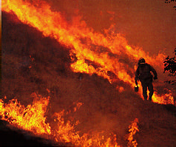

Safety Element
S A N L U I S O B I S P O C O U N T Y G E N E R A L P L A N

TABLE OF CONTENTS
SAN LUIS OBISPO COUNTY DEPARTMENT OF PLANNING AND BUILDING

County of San Luis Obispo

SAN LUIS OBISPO COUNTY GENERAL PLAN

SAFETY ELEMENT

County of San Luis Obispo

Board of Supervisors
Harry Ovitt, District 1 Shirley Bianchi, District 2 Peg Pinard, District 3 Katcho Achadjian, District 4 Michael Ryan, District 5

Planning Commission
Clifford J. Smith, District 1 Doreen Liberto-Blanck, District 2 Pat Veesart, District 3
Diane Hull, District 4 Wayne Cooper, District 5

Department of Planning and Building
Victor Holanda,AICP, Director Bryce Tingle, AICP, Assistant Director
Warren Hoag, AICP, Principal Planner, Project Manager John Nall, Principal Environmental Specialist
John Kelly, Supervising Mapping/Graphics Technician Dan Lambert, Mapping/Graphics Technician

Technical Advisory Committee

County of San Luis Obispo:
Ron Alsop, County Office of Emergency Services Susan Litteral, Engineering
Tony Boyd, Engineering Ben Stewart, CDF/County Fire Ben Parker, CDF/County Fire
Robert Lewin, CDF/County Fire
City Representatives:
Helen Elder, Arroyo Grande
Steve DeCamp/Gary Kaiser, Atascadero Thomas Sullivan/Sandra Bierdzinski, Grover Beach
Shauna Nauman, Morro Bay Mary Oien, Paso Robles
Glen Matteson, San Luis Obispo

Consultant Team
Fugro West, Inc.
Crawford Multari Clark & Mohr Don Asquith, PhD, CEG
Cal Poly, Landscape Architecture Department (GIS)

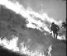
Cover Photo by Richard R. Hansen

A Contents
- Introduction 1
Relationship to Other General Plan Elements 2
Limitations 2
Legal Requirements for Preparing a Safety Element 2
Goals — Policies — Implementation Measures 3
- Emergency Preparedness 4
Critical Facilities 6
- Water Hazards 8
Flood Hazards 8
Tsunami and Seiche 9
Dam Inundation 10
- Fire Safety 12
- Geologic & Seismic Hazards 15
Seismic Hazards 15
Fault Rupture Hazards 15
Groundshaking Hazards 16
Liquefaction and Seismic Settlement 17
Slope Instability and Landslide 18
Coastal Bluff Erosion 20
- Other Safety Issues 21
Aircraft Hazards 21
Radiation Hazards 21
Hazardous Materials/Pesticide Hazards 22
Electromagnetic Fields [EMF] 23
Radon 23
Hazardous Trees 23
Hazards from Unreinforced Masonry Buildings 23
Technical Background Report
Go to Maps

Technical Background Report Section B
Geology & Seismicity Water Hazards
Fire Hazards Other Hazards
Emergency Planning and Response References

Maps Section C
Map 1 Geology of San Luis Obispo County
Map 2 Fault Hazards County of San Luis Obispo
Map 3 Liquefaction Hazards County of San Luis Obispo Map 4 Landslide Hazards County of San Luis Obispo Map 5 Flood Hazards County of San Luis Obispo
Map 6 Dam Inundation County of San Luis Obispo Map 7 Fire Hazard Zones County of San Luis Obispo
Map 8 Emergency Response Zones County of San Luis Obispo

Chapter 1: Introduction
All of us wish to avoid the loss of life, property and economic well-being as a result of disasters, and to accomplish a rapid recovery.
This Safety Element has two basic principles:
- be ready for disaster, and
- manage development to reduce risk.

The first part of this element addresses the first premise – emergency preparedness. Most natural disasters will require the combined efforts of our emergency service providers. The provision of emergency services requires trained people, good information, high quality and well maintained equipment, reliable communication systems, and steadfast commitments.
The second part of the element describes the various types of disasters, focusing principally on fire, flood and geologic hazards. The purpose of this section is to describe the physical effects of the disaster and provide standards for reducing the risk of exposure to the hazards. When distilled, the rules are quite simple: build above the floodwaters, where the fire fuel is low, and on stable ground.
It is acknowledged that attempts to avoid possible disasters may occasionally conflict with individuals’ rights in their property. Consequently, this element has been drafted to recognize and balance constitutional rights with risks. To this end, the standards in this element have been examined to determine if they meet the test of proper regulation: that there is a clear and definable connection between the rule and the reason for having it. The County will continue to maintain its authority and responsibility to reduce and eliminate unreasonable risk, and do so with the appropriate respect for property rights.

The residents of San Luis Obispo County are subject to a variety of natural and human- caused hazards. Natural hazards are processes such as earthquakes, landslides, flooding, and wildfires, and have been occurring for thousands, even millions of years. These natural processes have played an essential role in shaping the topography and landscape of San Luis Obispo County, and become “hazards” when they disrupt or otherwise affect the lives and property of people. Risk that is associated with natural and human-caused hazards can be separated into three general categories for the purposes of this element:
Acceptable Risk. This is the level of risk below which no specific action by government is deemed to be necessary to further reduce the consequences of a hazard.
Unacceptable Risk. This is the level of risk above which specific action by government is deemed necessary to protect life and property.
Avoidable Risk. This is a hazardous risk that can be averted while still achieving the individual or public objective.

The concept of acceptable risk may seem difficult to comprehend at first, but this type of risk is part of everyday life. Almost all activities have some degree of risk and there is no such thing as a risk- or hazard-free environment.

The cost of providing protection generally increases with the severity of the hazards and the level of risk reduction that is desired. At some point, however, the cost of providing protection becomes prohibitive when compared to the benefits derived. Scientific expertise can determine the magnitude of the hazard and estimate the probable effects, but the public ultimately determines how much risk to assume and the acceptable level of protection.
To evaluate what is considered to be “acceptable” risk, the following factors should be considered.
Severity of Potential Losses. Will the loss from an event be large or small? Potential losses include loss of life, injury, property and environmental damage and loss of function.
Probability of Loss. How often is the event expected to occur? The probability that hazards will occur should be evaluated in light of their possible effect on structures or human activities.
Capacity to Reduce Risk. What financial and human resources are available? Risk reduction depends on current technology, available financial and human resources, and established priorities.
Adequacy of Knowledge. How well do we understand the risk? This is an important factor in estimating the probability that a hazard will occur.
In making land use decisions, the severity and the probability of loss should be considered.

Relationship to Other General Plan Elements
The Safety Element is one of several Elements that comprise the General Plan. Section 65300.5 of the California Government Code requires the General Plan and its Elements to be “an integrated, internally consistent and compatible statement of policies...”

The Safety Element is closely linked to the Land Use and Open Space Elements of the General Plan. The Land Use Element designates the general distribution of land uses within the planning area, as well as standards for population density and building intensity. To avoid unreasonable public risk, the Land Use Element must take into account the public safety hazard identification and evaluation in the Safety Element. By limiting development density in areas that may be subject to significant geologic and other safety hazards, the risk of loss of life and property can be minimized. One of the purposes of the Open Space Element is to preserve open space for public health and safety, including areas that require special management and regulation because of hazardous or special conditions (e.g., earthquake fault zones, flood plains, unstable soil areas, and high fire risk areas).

Limitations
The Safety Element provides a general evaluation of potential public safety hazards on a county-wide basis. The hazard identification and evaluation is based on general literature available at the time of the Element’s preparation. No site specific evaluations were performed for this Element.
The maps in this plan show the general areas of potential hazards, but should not be interpreted as to precisely define hazard areas. The Safety Element is intended to be used for general land use planning purposes only, and should be used to identify where detailed site investigations would be required for new development. But it should be an important reference guiding all land use decisions.

Legal Requirements for Preparing a Safety Element
The Safety and Seismic Safety Elements first became mandatory parts of the General Plan in 1975 when the California Legislature adopted Senate Bill 271. This legislation required cities and counties to adopt, at a minimum, General Plan policies relating to fire safety, flooding, and geologic hazards. In 1984 the Legislature adopted Assembly Bill 2038 which expanded the list of mandatory issues that were to be evaluated in the Safety Element. This legislation also combined the Safety Element and the Seismic Safety Element into a single document. The Safety Element should provide the direction and resources to help reduce death, injuries, property and environmental damage, and the economic and social dislocation resulting from natural hazards. While it is required to focus on fire, flooding, geologic, and seismic hazards, jurisdictions may address any relevant safety issues that are considered important.

Goals — Policies — Implementation Measures
To make land use decisions that minimize the potential for loss of life, injury, and property damage from natural and human-caused hazards, it is necessary to have an understanding of the causes and potential effects of the hazards that may affect San Luis Obispo County. A description of the geologic, flooding, fire, and other safety hazards that may affect the County is provided in the Technical Background Report of this Element. A summary of the conclusions of the Technical Background Report that will influence future land use decisions is provided in each following section.

The San Luis Obispo County Multi-Jurisdictional Hazard Mitigation Plan (MJHMP) for San Luis Obipso County was developed in accordance with the Disaster Mitigation Act of 2000 (DMA 2000) and followed FEMA’s Local Hazard Mitigation Plan guidance. The MJHMP incorporates a process where hazards are identified and profiled, the people and facilities at risk are analyzed, and mitigation actions are developed to reduce or eliminate hazard risk. The implementation of these mitigation actions, which include both short and long-term strategies, involve planning, policy changes, programs, projects, and other activities. Clicking this link allows you to access the San Luis Obispo County MJHMP, which has been incorporated into this element by reference.

In the following sections, several components appear regularly.
Preparedness. The element begins with this as a separate topic. Each subsequent area has a preparedness component. It is essential to maintain our ability to respond to natural and man-made disasters.
Education. An informed citizenry will carry on their activities in a way that reduces the potential for disaster to occur or be exacerbated and will be better equipped to deal with disasters when they occur.
Existing Environment. The built environment can be improved to reduce the threat of disaster. This is geared mostly towards improving structures and their surroundings.
Land Use Planning. Future development should always be planned with careful consideration toward reducing the threat of property and environmental loss. While many considerations are involved in development, safety should be paramount.

Each section contains some or all of the following components:
Goal. This is the desired end state or condition that we would like to achieve.
Policy. This defines the approach to achieving goals.
Implementation Measures. These are specific actions the County or other interested parties should take. They take the form of standards (regulatory mechanisms) or programs (other advisory actions that are not regulatory).
Chapter 2: Emergency Preparedness

Goal S-1: Attain a high level of emergency preparedness
Emergency preparedness is necessary to avoid or minimize the loss of life and property as a result of natural and technological disasters, to reduce the social, cultural, environmental and economic costs of disasters, and to assist and encourage the rapid recovery from disasters. An important part of preparedness is the careful assessment of risks before an emergency occurs. Policies and implementation measures to advance this goal are classified as follows:

Policy S-1 Response
Support the response programs that provide emergency and other services to the public when a disaster occurs. The focus of response activities is saving lives and preventing injury, and reducing immediate property damage.

Implementation Measures:
Program S-1 Provide funding to insure the readiness of response teams.
Program S-2 Work before disasters occur to make sure there are few or no bureaucratic obstacles to performing emergency operations. This can be done using the Standardized Emergency Management System, an emergency response and coordination system used throughout California.
Program S-3 Establish a program that will reduce the time and effort required to get permits necessary to perform emergency repair work. To the extent that it can be done beforehand, provide the Engineering Department with sufficient resources to procure permitting assistance. For example, work in riparian corridors may require permits from the U.S. Fish and Wildlife Service, California Department of Fish & Game, and perhaps the Army Corps of Engineers.
Program S-4: Develop a set of response programs designed to identify evacuation routes and their capacity, safety, and viability under a range of emergency scenarios
- Maintain and update a Countywide Evacuation Zone map encompassing approximately 570 evacuation zones, to be modified as needed
- Maintain and develop a flexible software system designed to support evacuations for different disaster types through:
- offering inputs such as the evacuation zone, the target destination for vehicles, the time frame available for residents to evacuate, and optional factors including blocked roads, modified maximum road speeds, and the ability to manually increase the estimated number of vehicles on the road and;
- providing the output for “Total Clearance Time”, described as “the time between the first vehicle leaving the zone and the last vehicle reaching the destination”
- Generate scenarios that identify timelines and congestion points within designated evacuation zones to enable effective resource allocation for evacuation support.
- Update Emergency Operations Plan Annex 9: Protective Actions to determine and map specific evacuation routes based on best available science and practices where feasible.

Policy S-2 Emergency Preparedness
Continue to improve preparedness programs that educate and organize people to respond appropriately to disasters. They include education and awareness programs for individuals, families, institutions, businesses, government agencies and other organizations.

Implementation Measures:
Program S-5 Support efforts to help ensure local agency compliance with the State’s Standardized Emergency Management System.
Program S-6 Support education in the schools that teaches our children how to avoid dangers and how to behave during an emergency.
Program S-7 Support the efforts of many organizations – government, radio, newspapers and TV stations, utilities, emergency response providers, Office of Emergency Services and our health community – that provide an outreach and education program to our community. Support the efforts and education of people with disabilities to respond appropriately to emergencies.
Program S-8 Sponsor and support programs pertaining to emergency/disaster preparedness and response protocols and procedures. Distribute information about emergency preparedness to residents, community groups, schools, religious institutions, transient occupancy establishments, and business associations.

Policy S-3 Coordination
Improve coordination among City, County and State programs, and among others working to reduce the risks of disasters. This should also include improved coordination with the news media. This will result in more effective preparedness, response and recovery from disasters.

Implementation Measure:
Program S-9 Continue to improve information transfer to the media during emergencies. Official liaisons should meet with media representatives on a regular basis to improve coordination.

Policy S-4 Information Systems and Research
Expand and keep current the database of safety related information. Knowledge about disasters and the area we live in is growing. New information must be made available to the public and decision makers. Regularly update the GIS data as new information becomes available.

Implementation Measures:
Program S-10 Fund and maintain a Geographic Information System (GIS) that includes the data layers of this safety element. Continue to build the GIS with additional information as it becomes available.
Program S-11 Seek from other government, academic and private organizations new data that can be used for emergency preparedness and response. Using data developed elsewhere can result in savings.
Program S-12 Endeavor to share information with other nearby jurisdictions, and with private and public organizations.

Policy S-5 Risk Assessment
Continue investigations that reduce or eliminate long term risks. Risk assessment activities, effectively carried out, can improve the efficiency and reduce the cost of response and recovery from disasters.

Implementation Measures:
Program S-13 Structural Committee. Maintain a committee of building professionals who review County regulations, building code updates and other information in order to maintain the currency of our codes and procedures.
Program S-14 Develop additional training for building and safety personnel to keep up with current knowledge.
Program S-15 The County should consider hiring a County Geologist who is a State of California Certified Engineering Geologist to assess risks in geologically hazardous areas.
Program S-16 Develop a program of wildfire risk assessment. Assist with personnel training and assessment activities.
Program S-17 Update Emergency Operations Plan Annex 9: Protective Actions to identify and map residential development in hazard areas lacking a minimum of two evacuation routes.

Critical Facilities/Post-Disaster Recovery and Reconstruction
These are structures and services that provide emergency assistance after a major disaster. They include police and fire stations, schools, hospitals and roadways that are designated evacuation routes. These are described in Chapter 5 of the Technical Background Report.

Policy S-6 Critical Facilities, Recovery and Reconstruction
After a major disaster, assist public and private efforts that must be made for short-term and long-term rebuilding, the provision of housing for those displaced, resumption of services, and resumption of business and government functions. In order to make this effort effective, critical facilities must be maintained and upgraded as technology and population demands increase.
Program S-18 Participate in the development of programs and procedures that emphasize coordination between appropriate public agencies and private entities to remove debris and promote the rapid reconstruction of the County following a disaster event and facilitate the upgrading of the built environment as expeditiously as possible.

Policy S-7 Post Disaster
Following the initial mitigation efforts from a disaster, a long-term recovery process will begin. The purpose will be to assess damage, reduce economic loss, assist citizens with care and sheltering and repair critical infrastructure. Agencies needed to participate in this process will be identified through the regular emergency planning process.
Implementation Measures:
Program S-19 Provide comprehensive assistance to all agencies and organizations involved in disaster recovery through planning, engineering and funding. Maintain critical facilities for responsiveness to disasters.

Chapter 3: Water Hazards
GOAL S-2: Reduce damage to structures and the danger to life caused by flooding, dam inundation and tsunami.
Exposure of the public to water-related hazards can result from flooding, dam failure, and beach erosion.
Flooding and its effects are issues of concern throughout San Luis Obispo County, as a number of water courses flood during periods of heavy rain. This section will describe potential flooding hazards, as well as locations throughout the County where these conditions may occur. Winter storms bring large amounts of runoff to areas not accustomed to high flows and often to areas damaged by summer fires. The runoff can carry with it debris and sediment that can clog drainage systems, block creek channels, and damage structures.
Dam inundation would result from the sudden failure of a dam and the release of the impounded water. Although it is very unlikely that a large modern dam would suddenly fail, the effects of this hazard could be catastrophic. Therefore, this hazard is evaluated in this chapter.
Beach erosion results in the loss of sand from coastal areas. This hazard can accelerate the rate of erosion of coastal bluffs, and can also contribute to increased wave-related damage to coastal structures.

Flood Hazards
Flooding generally occurs in response to heavy rainfall events when streams, rivers, and drainage channels overtop their banks. Flooding may also occur in low-lying areas that have poor drainage, even during moderately sized storms. Many factors can increase the severity of floods, including fires in watershed areas, the placement of structures or fill material in flood-prone areas and areas of tidal influence, and increased runoff that results from the development of impervious surfaces such as roadways and rooftops. For planning purposes, the flood event most often used to delineate areas subject to flooding is the 100-year flood. This is an event that statistically has a one percent chance of occurring in any given year.

Policy S-8 Flood Hazards
Strictly enforce flood hazard regulations both current and revised. FEMA regulations and other requirements for the placement of structures in flood plains shall be followed. Maintain standards for development in flood-prone and poorly drained areas.

Implementation Measures:
Standard S-20 To the extent practicable, do not allow development in areas of high flood hazard potential.
Standard S-21 Discourage single road access into remote areas that could be closed during floods. Additional access ways should be planned.
Standard S-22 Review plans for construction in low-lying areas, or any area which may pose a serious drainage or flooding condition.
Standard S-23 Do not allow development which will create or worsen known flood and drainage problems.

Policy S-9 Reduce Flood Damage
Reduce flood damage in areas known to be prone to flooding, such as Los Osos, Avila Valley, Santa Margarita, Cambria, Oceano and others.

Implementation Measures:
Program S-24 Augment the database of information regarding low-lying areas. Add information developed during winter storms to the GIS database.
Program S-25 Inventory and reevaluate where appropriate known local flood prone areas in the County. Develop a prioritized list of proposed capital improvement projects for low-lying, flood prone areas.
Program S-26 Seek funding to implement capital improvement projects for low-lying, flood prone areas.
Program S-27 Secure the necessary permits to perform flood-related preventive maintenance and repair. Ensure that all flood-related work in riparian areas minimizes impacts to biological resources.

Policy S-10 Readiness and Response
Fire and law enforcement agencies will maintain and improve their ability to respond to water hazard emergencies throughout the County.

Implementation Measure:
Program S-28 Each fire and law enforcement agency will train personnel to a level appropriate to their position and responsibilities to adequately and safely respond to water hazard emergencies.

Tsunami and Seiche
A tsunami is a wave caused by a displacement of the ocean floor, usually by movement along a fault. As the wave approaches shore, it increases in size and can cause extensive damage to coastal structures. Several small tsunami events have been recorded in San Luis Obispo County, however, previous studies have predicted a maximum tsunami wave “runup” of approximately 9.5 feet above sea level for a 100-year event. Wave runup could be increased substantially if a tsunami occurred during a major storm. Tsunamis are only a concern for coastal areas. Seiche (pronounced seish) is a wave generated by earthquake in a lake, reservoir or harbor. Although faults are near several of our reservoirs, seiche is not considered a significant risk in San Luis Obispo County. Large waves in these waterbodies are not anticipated because they are not large enough.
damage to coastal structures. Several small tsunami events have been recorded in San Luis Obispo County, however, previous studies have predicted a maximum tsunami wave “runup” of approximately 9.5 feet above sea level for a 100-year event. Wave runup could be increased substantially if a tsunami occurred during a major storm. Tsunamis are only a concern for coastal areas. Seiche (pronounced seish) is a wave generated by earthquake in a lake, reservoir or harbor. Although faults are near several of our reservoirs, seiche is not considered a significant risk in San Luis Obispo County. Large waves in these waterbodies are not anticipated because they are not large enough.

Policy S-11 Tsunami
Access information to increase the understanding and response to tsunamis.

Implementation Measures:
Program S-29 Work with federal agencies to better understand the hazard of tsunamis.
Program S-30 Improve ability to respond to tsunami warnings provided by NOAA’s Alaska Tsunami Warning Center.

Dam Inundation
Dam inundation is the flooding of lands due to release of impounded water resulting from the failure or overtopping of a dam. Although the probability of this type of hazard occurring is highly unlikely, it warrants consideration in the Safety Element because there are several dams and reservoirs in San Luis Obispo County.

Potential Causes of Dam Failures
Dam failures can result from a number of natural or human causes. Earthquakes, improper siting, fast rising flood waters, erosion of the dam face or foundation, and structural/ construction flaws can all contribute to a dam breach and ensuing release of impounded water. Other reservoir-related flooding events have resulted from massive, fast-moving landslides that have displaced large volumes of water contained in a reservoir. Such a rapid displacement of water can cause large quantities of water to travel over the dam, resulting in downstream flooding.

Major Dams in San Luis Obispo County
The County has several large publicly owned dams, as well as a number of smaller privately owned dams (see Table 1). These dams are under the jurisdiction of the State of California Division of Safety of Dams. The division conducts periodic reviews to evaluate dam safety. Lopez Dam is slated for seismic improvements.

TABLE 1: Major Dams and Reservoirs in San Luis Obispo County
Name | Owner | Capacity (acre-feet) | Type of Facility
Lopez Canyon | SLO County Flood Control & Water Conservation District | 51,000 | Earth
Nacimiento | Monterey County Water Resources Agency | 350,000 | Earth
Righetti | Private | 591 | Earth
Salinas | Corps of Engineers | 23,000 | Concrete
Terminal | SLO County Flood Control | 844 | Earth
Twitchell | Bureau of Reclamation | 240,000 | Earth
Whale Rock | Whale Rock Commission | 40,000 | Earth

Effects of Dam Inundation
The severity of downstream effects resulting from a dam failure will be directly related to the manner in which the dam fails. A failure resulting from the erosion of a breach in an earthfill dam would likely result in a flood wave that builds gradually to a peak, then declines until the reservoir is empty. If a dam were to fail rapidly, however, a flood wave would be formed quickly and then be followed by a gradual decline in flood water.
The failure of a dam could cause flooding, injury, loss of life, and property damage due to inundation, erosion, debris and sediment deposition. Other effects include damage to community infrastructure and interruption of public services. Health hazards from the release of sewage may also result.

Policy S-12 Dam Failure
Minimize the risk of dam failure.

Implementation Measures:
Program S-31 Work with appropriate agencies at the state and federal levels to assist with the inspection and maintenance of dams to minimize the risk of failure.
Program S-32 Maintain a dam failure evacuation plan with guidance for public officials on emergency notification and evacuation instructions, including use of the emergency alert system to notify the public.

Chapter 4: Fire Safety
GOAL S-4: Reduce the threat to life, structures and the environment caused by fire.
Fires can cause significant life, property and environmental losses, and can occur in both urban and rural settings. Urban fire hazards can be influenced by a variety of factors, including building location and construction characteristics, access constraints, the storage of flammable and hazardous materials, as well as inadequate supplies of fire suppression water, and response time for fire suppression personnel. Fire-related hazards in rural areas generally result from the development of residences in hillside or other areas with dense vegetation. Development that occurs in wildlands and “urban/wildland interface” areas may be subject to a significant wildfire hazard.
Fires are also an important component of San Luis Obispo County’s ecosystem. Wildlands must burn periodically to naturally maintain viable environments. Fuel maintenance (controlled burns, mowing, cattle grazing and other means) is a necessary replacement to uncontrolled wildland fires because of threats to human habitation. Development patterns in rural lands can reduce the ability to manage fuel and defend “values at risk”. Development in inappropriate locations may require fuel modification that results in environmental damage.
Fire response in the county is provided by several agencies, including CAL FIRE/County Fire Department, the various fire departments in the seven cities and several of the unincorporated areas, as well as federal fire agencies. These policies and programs are applicable to all. Many of these fire agencies have coordinated mutual aid programs. which are further detailed in the Community Wildfire Protection Plan’s “San Luis Obispo County Fire Services Mutual Aid Plan”.

Policy S-13 Pre-Fire Management
Ensure that new development is carefully located, to reduce the number of people, structures, and acres at risk from wildfire with special attention given to higher fire risk areas.

Implementation Measures:
Standard S-33 Require that new development in State Responsibility Areas (SRAs) and very high fire hazard severity zones (VHFHSZ) comply with the most current versions of the California Building Code and California Fire Code.
Standard S-34 Defensible space should be required around all structures in high and very high fire hazard areas. Site and design development to minimize the likelihood of a wildfire spreading to structures by minimizing flammable vegetation within a development.
Standard S-35 Reduce hazard vulnerability of future development in VHFSZ by requiring adequate access points, road standards, and vegetative management to comply State and San Luis Obispo County Consolidated Fire Codes.
Standard S-36 Minimize the populations exposed to fire hazards by requiring new residential development and essential public facilities to be located outside of VHFHSZ as identified in Land Use View when feasible and by assigning land use designations, density allowances, and roadway classifications that reflect site-specific constraints and hazards.
Program S-37 Support programs and plans consistent with state law that requires fuel management and modification, and that balance fuel management needs to protect structures with the preservation of native vegetation and sensitive habitats.
Policy S-14 Facilities, Equipment and Personnel
Ensure that adequate facilities, equipment and personnel are available to meet the demands of fire fighting in San Luis Obispo County based on the level of service set forth in the fire agency’s master plan.

Implementation Measures:
Program S-38 The CAL FIRE/County Fire Department and County Planning shall evaluate population and settlement patterns, incident trends and values at risk every five years to determine where new fire stations and staff are needed and where existing facilities need augmentation so that the agency’s master plan can be updated as needed.
Program S-39 Continue to plan for future equipment, communication systems, station and personnel requirements. The County Fire Department will be responsible for communicating its needs to the Board of Supervisors and the County Administrative office. The CAL FIRE/County Fire Department and other fire agencies will be responsible for fleet management, ensuring that future vehicle needs are identified; replacement schedules and funding mechanisms are established; maintenance and rotation schedules are developed and met.
Program S-40 Use information generated during the update of the various area plans of the County General Plan to improve fire suppression capabilities. The County Planning Department will coordinate with the CAL FIRE/County Fire Department and other fire agencies as new information is developed.

Policy S-15 Readiness and Response
The CAL FIRE/County Fire Department will maintain and improve its ability to respond and suppress fires throughout the County.
Implementation Measures:
Standard S-41 Ensure Fire protection staffing, facilities, and equipment are sufficient to provide adequate response time for new development.
Program S-42 The CAL FIRE/County Fire Department will be responsible for training fire fighters to a level appropriate to their position and responsibilities, provide emergency medical care training, job-required specialized training, maintain and enhance training materials and instruction techniques, and provide educational incentives for all personnel.
Program S-43 Work to continually improve information resources about the location of fire hazard areas and the structural resources and other values at risk within them.
Program S-44 Maintain a fire-related GIS data base. This information will also be used to assist decision-makers with analyzing development proposals. Update the database when the pending re-evaluation of the fire hazard severity maps by CAL FIRE/County Fire Department becomes available.
Program S-45 Identify and define areas within Very High Fire Hazard Severity Zones that do not meet the access and evacuation routes outlined in the State Minimum Fire Safe Regulations. For identified areas, create practical mitigation measures and strategies detailed improvement plans.

Policy S-16 Loss Prevention
Improve structures and other values at risk to reduce the impact of fire. Regulations should be developed to improve the defensible area surrounding habitation.

Implementation Measures:
Program S-46 Work with landowners to increase the resilience of existing development in very high fire hazard severity zones built prior to modern fire safety codes or wildfire hazard mitigation guidance for defensible space, road standards, and vegetative hazards.
Program S-47 Require any exception to the State and San Luis Obispo County Consolidated Fire Codes to adhere to the process outlined in CCR Title 14 § 1270.07, subject to approval by the County Fire Marshal.
Standard S-48 Require a defensible space in VHFHSZs to be located, designed, and constructed to provide adequate defensibility and minimize the risk of structural loss and life safety resulting from wildland fires. The area need not be cleared of all vegetation, but be able to provide fire fighters with enough room to defend structures and maneuver. Each situation will differ, so the permit granting authority will need flexibility in reviewing fire safety plans.
Standard S-49 Review development plans by fire safety personnel to assure adequacy of access for equipment, water supplies, construction standards, and vegetation clearance.
Standard S-50 Continue to insure that sufficient water supplies are available for protection of structures and encourage other built-in fire protection systems such as sprinklers.
Chapter 5: Geologic & Seismic Hazards
GOAL S-5: Minimize the potential for loss of life and property resulting from geologic and seismic hazards
Geologic conditions define the stability of the ground below a site, and how that site will respond to the natural forces of earthquakes and weather. The frequency and strength of earthquakes will depend on the activity, number and style of faults that pass through or can influence a particular region. Geologic and seismic conditions are characterized to help assess the vulnerability of development to seismic and geologic hazards.

Seismic Hazards
San Luis Obispo County is located in a geologically complex and seismically active region. Seismic, or earthquake-related, hazards have the potential to result in significant public safety risks and widespread property damage. Two of the direct effects of an earthquake that are required to be considered as part of the Safety Element include the rupture of the ground surface along the trend or location of a fault, and ground shaking that results from fault movement. Other geologic hazards that may occur in response to an earthquake include liquefaction, seismic settlement, landslide, tsunami, and seiche. Other hazards, such as slope failure, flooding from a dam failure, fires, and structural hazards that may be related to earthquakes, are evaluated in separate sections of the Safety Element.

Fault Rupture Hazards
Fault rupture refers to displacement of the ground surface along a fault trace. Rupture of the ground surface along a fault trace typically occurs during earthquakes of approximately magnitude 5 or greater. Fault rupture can endanger life and property if structures or lifeline facilities are constructed on, or cross over, a fault. Fault rupture tends to occur along or within a zone of linear traces of previous ruptures that define the fault zone, and as sympathetic movement on adjacent or intersecting faults. Map 2 in the Technical Background Report identifies three active faults in San Luis Obispo County that are currently zoned under the State of California Alquist-Priolo Fault Hazards Act: the San Andreas, the Hosgri-San Simeon, and the Los Osos. The report also identifies at least 17 other faults that are considered potentially active or have uncertain fault activity in the County.

Policy S-17 Fault Information
Information on faults and geologic hazards in the County should continue to be updated. The County will enforce the General Plan and applicable building codes that require developments, structures, and public facilities to address geologic and seismic hazards through the preparation and approval of geotechnical and geologic reports. Appointment of a County Geologist will improve implementation of the goals, policies, programs and standards of this Element by assuring more objective review and consistent enforcement of hazard mitigation measures county-wide than is possible under the present system of project review.
Program S-51 The County should consider maintaining on its staff a State of California Certified Engineering Geologist to review reports, technical documents, and plans for conformance with applicable codes and regulations pertaining to mitigation of potential geologic and seismic hazards; and to disseminate information to the public to improve awareness of geologic hazards and seismic safety.
Standard S-52 When qualified staff is not available internally, the County may elect to require applicants to provide documentation that reports, technical documents, and plans be reviewed by an independent consultant licensed with the State of California to practice in their area of expertise. In such cases, the independent consultant should review and render an opinion as to whether the documents were prepared in accordance with standard practices, applicable codes and regulations pertaining to geologic hazards.
Program S-53 Maintain and add to the GIS database prepared for this element with the purpose of improving the quality of the geologic and fault mapping within jurisdictional boundaries to incorporate new and updated information; and encourage CDMG to provide new and updated geologic hazard data for inclusion in the database.

Policy S-18 Fault Rupture Hazards
Locate new development away from active and potentially active faults to reduce damage from fault rupture. Fault studies may need to include mapping and exploration beyond project limits to provide a relatively accurate assessment of a fault’s activity. The County will enforce applicable regulations of the Alquist-Priolo Earthquake Fault Zoning Act pertaining to fault zones to avoid development on active faults.

Implementation Measures:
Standard S-54 The County will continue to enforce elements of the General Plan, based on the Alquist-Priolo Earthquake Fault Zoning Act, that require geologic studies to be performed so that habitable structures and essential facilities will be sited away from active and potentially active faults.

Groundshaking Hazards
Groundshaking refers to the motion that occurs in response to local and regional earthquakes. Groundshaking can endanger life and safety due to damage or collapse of structures or lifeline facilities. Structures in seismically active areas, such as California and specifically San Luis Obispo County, should be designed to resist seismic forces resulting from earthquakes.

Uniform Building Code requirements, as modified by amendments applied by state and local agencies, set forth the minimum design and construction standards for structures to resist seismic forces. The Uniform Building Code currently requires that structures be designed to resist a minimum seismic force resulting from ground motion having a ten percent probability of being exceeded in a 50-year period.

The Technical Background Report indicates that many areas of the County, and its Cities, have experienced groundshaking in response to local and regional earthquakes in the past, and are likely to experience groundshaking again in the future. These building codes are typically updated every three years to reflect a progressive review of the performance of structures and lifelines (pipelines, roads, etc.) that have been subject to or damaged by earthquakes in the past.

The 1997 Uniform Building Code contains substantial revisions to the seismic design standards for structures, but has not yet been adopted by all local agencies. The new code will require designers to consider higher seismic forces for the design of structures that are located close to faults. Application of the 1997 building code would recognize the seven faults in San Luis Obispo County, listed in Table 4-4 of the Technical Background Report, that are considered to be active or potentially active according to the California Division of Mines and Geology (CDMG). Tables 4-5 and 4-6 of the report list 17 other faults that are also considered to be active or potentially active according to the CDMG or other published sources. The new building code therefore only provides the minimum number of faults that should be considered for design. Design professionals should consider additional faults, such as those that may be listed in Tables 4-5 and 4-6, to be consistent with locally accepted practices and knowledge of seismicity.

Policy S-19 Reduce Seismic Hazards
The County will enforce applicable building codes relating to the seismic design of structures to reduce the potential for loss of life and reduce the amount of property damage.

Implementation Measures:
Program S-55 Enforce applicable building code regulations pertaining to the design of structures and grading relative to seismic hazards.
Program S-56 Adopt new Uniform Building Code requirements, when necessary, to promote the use of updated design standards.
Program S-57 Encourage investigations to improve the existing characterizations of faults in areas of existing or proposed development, and their potential to generate damaging earthquakes, for the purpose of assisting in the design of structures to resist seismic loads. Implement appropriate design standards and building codes that address local seismic conditions.

Liquefaction and Seismic Settlement
Liquefaction is the sudden loss of soil strength due to a rapid increase in soil pore water pressures resulting from groundshaking during an earthquake. Seismic settlement is the reduction of volume within a saturated or unsaturated soil mass due to groundshaking during a seismic event. Seismic settlement may occur simultaneously or independent of liquefaction. Map 3 in the Technical Background Report identifies areas that have a low, medium or high potential to be underlain by soils that could be vulnerable to liquefaction or seismic related settlement in response to local or regional earthquakes. It should be noted that the map only provides a qualitative assessment that liquefiable soils could be present within the noted areas based on regional geologic mapping. Liquefaction potential, and its potential to present a hazard, can only be assessed through site-specific studies and subsurface exploration. The currently adopted Uniform Building Code requires that the potential for liquefaction be assessed for the design of all structures.
The magnitude and duration of groundshaking are also important factors in causing liquefaction to occur. The larger the earthquake magnitude, and the longer the duration of strong groundshaking, the greater the potential for liquefaction to occur in an area that is susceptible to the hazard.
As indicated in the Technical Background Report, the areas most likely to be vulnerable to liquefaction are underlain by younger alluvium where groundwater and granular sediments are present. Areas potentially underlain by liquefiable alluvium are low lying lands adjacent to rivers, creeks, beaches, and estuaries.
As evidenced by the 1989 Loma Prieta and 1994 Northridge earthquakes, liquefaction is a predictable event. The evaluation of liquefaction potential is based on subsurface exploration consisting of drilled test holes and engineering analysis of the soil conditions. When analysis indicates that there is a potential for liquefaction, the hazard should be avoided. If that is not possible, then the condition can typically be mitigated by supporting structures on deep foundations, modifying the ground to densify granular soils, designing structures to withstand estimated settlements associated with liquefaction, or siting structures away from potentially liquefiable soils.

Policy S-20 Liquefaction and Seismic Settlement
The County will require design professionals to evaluate the potential for liquefaction or seismic settlement to impact structures in accordance with the currently adopted Uniform Building Code.
Implementation Measures:
Standard S-58 Amend the LUE/LCP as-needed to incorporate medium to high liquefaction hazard areas identified in the Technical Background Report within the Geologic Study Area (GSA) combining designations.
Standard S-59 The County will enforce current building code requirements that require the potential for liquefaction to be addressed in the design of structures.
Standard S-60 The County will require geotechnical studies to be performed for habitable or important structures (as defined by the building code) sited in areas having moderate to high liquefaction potential as defined in Table 4-15 of the Technical Background Report. The geotechnical study should evaluate the potential for liquefaction and/or seismic related settlement to impact the development, and mitigation to reduce these potential impacts, if needed.

Slope Instability and Landslides
Landslides and slope instability can occur as a result of wet weather, weak soils, improper grading, improper drainage, steep slopes, adverse geologic structure, earthquakes, or a combination of these factors. Slope instability can occur in the form of creep, slumps, large progressive translation or rotational failures, rockfall, debris flows, or erosion. Areas of potential landslide hazards are indicated on Map 4 and discussed in the Technical Background Report.
Landslides can result in damage to property and cause buildings to become unsafe either due to distress or collapse during sudden or gradual slope movement. Structures constructed in steep terrain, possibly on stable ground, may also experience landslide hazards if they are sited in the path of potential mud flows or rockfall hazards. Current practices define a slope as being stable when slope stability analysis indicates that the slope has an estimated factor of safety against instability of at least 1.5 under static loading conditions, and at least 1.1 under pseudostatic (earthquake) loading conditions when applying a horizontal pseudostatic coefficient of at least 0.15. More stringent slope stability criteria, or dynamic stability analyses, may apply to improvements designed under the jurisdiction of some agencies.
Despite current codes and policies that discourage development in areas of known landslide activity or having a high risk of landslide, there are a considerable number of homes and developments that are impacted by landslide activity in the County each year. These types of slope instability problems are often foreseeable, provided a detailed review of the landslide and geologic hazard conditions are adequately assessed by qualified professionals as part of the site development process. In areas that can be made suitable only with extensive mitigation, developments often require heavily engineered or nonstandard designs to address adverse geologic conditions. These systems often allow the project to be developed, but because of the higher degree of uncertainty associated with development in high landslide hazard areas, there is also a need for the property owner to accept a higher degree of risk than would typically be accepted in areas that have a low potential to being impacted by landslides.
Problems often arise since future occupants or owners of the developed property are not represented when cost or risk management decisions are being made that facilitate development of the site. Because of inherent problems that are often associated with development in high landslide hazard areas, the County should seek ways to further discourage development in the areas having a high potential for being impacted by landslides or slope instability, and to encourage that adequate assessments of these hazards be made a part of the development process.

Policy S-21 Slope Instability
The County acknowledges that areas of known landslide activity are generally not suitable for residential development. The County will avoid development in areas of known slope instability or high landslide risk when possible and continue to encourage that developments on sloping ground use design and construction techniques appropriate for those areas.

Implementation Measures:
Standard S-61 For developments in areas of known slope instability, landslides, or slopes steeper than 20 percent, the stability of slopes shall be addressed by registered professionals practicing in their respective fields of expertise. For subdivisions, such studies should be performed prior to delineating lot lines and building envelopes.
Standard S-62 New development will not be permitted in areas of known landslide activity unless development plans indicate that the hazard can be reduced to a less than significant level prior to beginning development.

Registration/Title | Practice
Civil Engineer | General application of engineering principals to the built environment as related to the design and construction of buildings, roads, bridges, pipelines, water and sewage treatment facilities, flood control projects, grading and other public works.
Structural Engineer | Specialized application of civil engineering to the design and analysis of building or other structures to resist forces from static load due to gravity, and dynamic loads such as may result from earthquakes, wind, or waves.
Geotechnical Engineer | Specialized application of civil engineering to the interaction of earth materials with earth retention systems, structural foundations, slope stability, or other civil engineering works. The terms “geotechnical engineer” and “soils engineer” are synonymous.
Registered Geologist | General application of the science of geology to determine the location, composition and orientation of earth materials, and utilizing this knowledge of the earth and its constituent rocks, minerals, liquids, gases and other materials for the benefit of mankind.
Certified Engineering Geologist | Specialized application of geology to the safe development and grading of land, building of structures, search for groundwater resources, and repairing of geologic hazards.

Standard S-63 Expansion will not be permitted to existing structures or developments in areas of known landslide activity except when it will reduce the potential for loss of life and property.
Standard S-64 Development proposals will be required to mitigate the impacts that their projects contribute to landslides and slope instability hazards on neighboring property, and appurtenant structures, utilities, and roads; such as emergency ingress and egress to the property, and loss of water, power or other lifeline facilities.
Standard S-65 Enforce current building code requirements and applicable ordinances and sections of the General Plan that pertain to development on sloping ground.
Standard S-66 Require slope stability evaluations for developments in areas of moderate or higher landslide risk as indicated in the Technical Background Report.

Policy S-22 Readiness and Response
Fire and law enforcement agencies will maintain and improve their ability to respond to seismic emergencies throughout the County.

Implementation Measure:
Program S-67 Each fire and law enforcement agency will train personnel to a level appropriate to their position and responsibilities to adequately and safely respond to seismic emergencies.

Coastal Bluff Erosion
Coastal erosion occurs during large storms. Waves erode the coastline at varying rates, depending upon the geology. Coastal bluffs on the marine terraces are the most likely to result in hazards. Homes and other structures built near the edge are threatened by the retreat of the bluff.

Policy S-23 Coastal Bluffs
Development shall not be permitted near the top of eroding coastal bluffs.
Program S-68 Require coastal bluff erosion studies to determine the rate or erosion and the resulting safe distance from the top of the bluff for development, in accordance with the LCP.
Chapter 6: Other Safety Issues
GOAL S-6: Reduce the potential for harm to individuals and damage to the environment from aircraft hazards, radiation hazards, hazardous materials, electromagnetic fields, radon, and hazardous trees.
Aircraft Hazards
There are three public airports in the county: San Luis Obispo, Paso Robles and Oceano. In rural areas, there are numerous private landing strips. Each of the three operating airports has designated hazard zones extending from the end of each active runway. Hazards associated with the County’s airports are principally related to the risk of an aircraft accident and to the aircraft noise levels along primary flight paths. These hazards are addressed by each airport land use plan. Noise occurring at these airports is addressed in the Noise Element.

Policy S-24 Aircraft Hazards
Reduce the potential for disaster from airport and land use conflicts in conjunction with the Airport Land Use plans.

Implementation Measures:
Program S-69 Coordinate County and City planning at airport safety zones.
Standard S-70 General plan and zoning for land uses situated off the end of active runways should be low density, and preferably open space or agriculture. Update and rezone airport safety zones for appropriate land uses to comply with adopted airport land use plans.
Program S-71 Maintain Aircraft Rescue Fire Fighting (ARFF) response, training and equipment to Federal Aviation Administration (FAA) standards and work to continue to achieve National Fire Protection Association (NFPA) recommendations for ARFF.

Radiation Hazards
The Diablo Canyon Power Plant is the primary radiation hazard risk in San Luis Obispo County. An uncontrolled release of radioactive material would have the potential to result in significant health and safety impacts. To prepare for potential emergency situations that might develop at the power plant, extensive warning, reporting, and response plans have been developed. Updated information regarding the Emergency Response Plan is distributed to the public each year. There are additional radiation hazards in the County, mostly low-level radioactive waste from medical facilities and elsewhere. The hauling, handling and disposal of these materials are governed by federal regulations.

Policy S-25 Radiation Hazards
Maintain a high level of emergency preparedness and information to the public.

Implementation Measure:
Program S-72 Work with PG&E to review and update information about emergency preparedness and evacuations.

Hazardous Materials/Pesticide Hazards
Due to the quantity and frequency with which hazardous materials are shipped through San Luis Obispo County, transportation-related accidents pose the most significant hazardous material risk to the residents of the County. Major modes of hazardous material transportation include the use of U.S. Highway 101, various state highways, the Union Pacific Railroad tracks, and numerous underground pipelines. In addition to the potential for transportation-related releases of hazardous materials, potential exposure of the public to hazardous materials can result from their use by industry, agriculture, commercial, and service establishments. Household use of hazardous materials also has the potential to result in their release into the environment.
The transportation, storage and use of pesticides in home, agricultural and commercial settings in San Luis Obispo County also poses potential hazards to the public. The transportation, storage and use of pesticides applied by agricultural and structural pest control businesses is governed by comprehensive regulations. The County Agricultural Commissioner’s office is the enforcement agency for these regulations and a resource for information about pesticide identification; labeling; storage; transportation and disposal; use; application methods and equipment; and knowledge about local pesticide use practices.

Policy S-26 Hazardous Materials
Reduce the potential for exposure to humans and the environment by hazardous substances.

Implementation Measures:
Program S-73 Review commercial projects which use, store, or transport hazardous materials to ensure necessary measures are taken to protect public health and safety.
Standard S-74 Work with CalTrans to require all transport of hazardous materials to follow CalTrans approved routes.
Program S-75 Inform residents along approved haul routes of the potential for hazard release.

Policy S-27 Pesticide Hazards
Reduce the potential for pesticide exposure to humans and the environment.

Implementation Measures:
Program S-76 Work with emergency first responders and 9-1-1 emergency dispatch operators to ensure they know to contact the County Agricultural Commissioner’s office for technical assistance in the event of a pesticide-related emergency.
Program S-77 Work with pesticide applicators (including commercial applicators and other users such as homeowners) to ensure necessary measures are taken to protect public health and safety.
Program S-78 Provide information and technical guidance to encourage implementation of Integrated Pest Management (IPM) strategies.

Electromagnetic Fields [EMF]
The transmission of electricity and the use of electrical appliances results in the creation of electromagnetic fields. At this time, the evidence of potential health hazards from the delivery and usage of electric power is incomplete and inconclusive. Until the necessary information is available to make informed decisions about possible health effects resulting from the long-term exposure to electromagnetic fields, individuals and local jurisdictions may wish to consider adopting an avoidance strategy which keeps residences and workplaces away from high tension lines. Such a strategy would include adopting measures to avoid electromagnetic field exposures when it is reasonable, practical, relatively inexpensive, and simple to do so.

Policy S-28 EMF
Reduce the potential for health hazards from electromagnetic fields.

Implementation Measures:
Program S-79 Maintain a prudent avoidance strategy relative to high voltage transmission lines. EMF standards established by the California Energy Commission and Public Utilities Commission (if any) should be applied.
Program S-80 Continue to monitor the information available regarding EMF hazards.

Radon
Radon is a naturally occurring gas produced by the breakdown of uranium in soil, rock, and water. Accumulations of this gas inside structures can become a significant health hazard because radon is known to cause lung cancer. The threat of radon is very low in a well ventilated structure. Basements, which are rare in this region, are common problem areas.

Policy S-29 Radon
Reduce the potential for health hazards from radon through education.

Implementation Measure:
Program S-81 Inform the citizens of San Luis Obispo County where the high radon risk areas are and how to prevent problems. Prepare a mailing for County residents regarding the dangers of radon and what can be done.

Hazardous Trees
Pine pitch canker is threatening the health of pine trees throughout the County. This disease can result in the death of a pine tree in a relatively short period of time. If an infected tree is not properly removed, it can spread the disease. The tree may also become a safety hazard if it becomes uprooted and falls during a storm. Other trees become hazards because of their age or from storms.

Policy S-30 Hazardous Trees
Reduce the danger to people and property from trees that are weakened and susceptible to falling or limb loss during storms.

Implementation Measures:
Program S-82 Identify areas of urban forest that merit management plans.
Program S-83 Prepare and implement a forest management plan for urban forest areas, especially Cambria.
Program S-84 Maintain or remove trees in roadways that have been determined to pose a hazard.

Hazards from Unreinforced Masonry Buildings
In a strong earthquake, any type of structure may experience some level of damage resulting from ground shaking. Some types of construction materials generally perform better in earthquakes than others, and almost any material can be designed in such a manner so as to be safe during an earthquake. For example, modern structures made with wooden and steel frames, or reinforced concrete blocks, will typically withstand moderate to strong earthquake ground shaking with little threat of building failure or major damage. Buildings made of unreinforced masonry, however, typically provide little earthquake resistance. To address public safety risks posed by unreinforced masonry buildings, the California Legislature passed Senate Bill 547 in 1987. This bill required local jurisdictions to identify unreinforced masonry buildings, and to develop a program to mitigate potentially hazardous structures.
There are also state standards for building construction, improvement and upgrades, including seismic standards, for hospitals and other medical facilities. The state Office of Statewide Health, Planning and Development approves and enforces hospital facility standards throughout the state for both public and private hospitals.

Policy S-31 Unreinforced Masonry Buildings
Reduce the danger to people and property from unreinforced masonry buildings.
Implementation Measure:
Program S-85 Continue to study buildings and require reinforcement through enforcement of applicable design standards. Maintain the list of unreinforced masonry buildings. It should be noted that both public and private hospital seismic enforcement falls under the authority of the state Office of Statewide Health, Planning and Development.

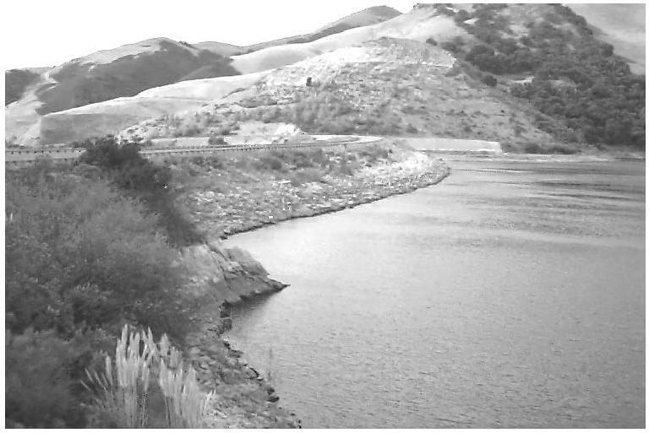

Safety Element
S A N L U I S O B I S P O C O U N T Y G E N E R A L P L A N

TECHNICAL BACKGROUND REPORT

SAN LUIS OBISPO COUNTY DEPARTMENT OF PLANNING AND BUILDING

County of San Luis Obispo

Board of Supervisors
Harry Ovitt, District 1 Shirley Bianchi, District 2 Peg Pinard, District 3 Kacho Achadjian, District 4 Michael Ryan, District 5
Planning Commission
Clifford J. Smith, District 1 Doreen Liberto-Blanck, District 2 Pat Veesart, District 3
Diane Hull, District 4 Wayne Cooper, District 5
Department of Planning and Building
Victor Holanda,AICP, Director
Bryce Tingle, AICP, Assistant Director
Warren Hoag, AICP, Principal Planner, Project Manager John Nall, Principal Environmental Specialist
John Kelly, Supervising Mapping/Graphics Technician Dan Lambert, Mapping/Graphics Technician
Technical Advisory Committee
County of San Luis Obispo:
Ron Alsop, County Office of Emergency Services Susan Litteral, Engineering
Tony Boyd, Engineering
Ben Stewart, CDF/County Fire Ben Parker, CDF/County Fire Robert Lewin, CDF/County Fire

City Representatives:
Helen Elder, Arroyo Grande
Steve DeCamp/Gary Kaiser, Atascadero
Thomas Sullivan/Sandra Bierdzinski, Grover Beach Shauna Nauman, Morro Bay
Mary Oien, Paso Robles
Glen Matteson, San Luis Obispo

Consultant Team
Fugro West, Inc.
Crawford Multari Clark & Mohr Don Asquith, PhD, CEG
Cal Poly, Landscape Architecture Department (GIS)

B Contents
- Emergency Response & Planning 1
San Luis Obispo County Office of Emergency Services 1
Disaster Response and Planning 2
Incident Command System 2
Multi-Agency Coordination 3
Mutual Aid Agreements 3
Operational Areas 3
Operational Area Satellite Information System (OASIS) 3
Emergency Response Corridors and Evacuation Routes 3
- Water Hazards 5
Flooding 5
Dam Inundation 17
Coastal Erosion 22
- Fire Hazards 27
Wildfires 27
Urban Fire Hazards 35
- Geology & Seismicity 47
Geologic Time Scale 47
Regional Geology 48
Stratigraphy 50
Seismicity 51
Fault Activity 51
Measurement of Earthquakes 53
Faults in San Luis Obispo County 53
Fault Rupture 69
Unincorporated San Luis Obispo County 71
Groundshaking 75
Liquefaction 84
Tsunami and Seiches 87
Slope Stability 90
Subsidence 98
- Other Hazards 101
Hazardous Materials 101
Radiation Hazards 106
Electromagnetic Fields 112
Structural Hazards 115
Airport Hazards 118
Hazardous Trees 119
Radon Hazards 120
- References 123
Technical Background Report County and Cities of San Luis Obispo

List of Tables
- Emergency Response & Planning
None.

- Water Hazards
Table 2-1: Major Dams and Reservoirs in San Luis Obispo County 17

- Fire Hazards
Table 3-1: Likely Fire Hazard Severity Rated by Fuel Conditions Only 28
Table 3-2: Major Wildfires in San Luis Obispo County Since 1931 30
Table 3-3: Urban/Wildland Interface Areas of San Luis Obispo County 33
Table 3-4: Fire Stations in the Unincorporated Areas of San Luis Obispo County 38

- Geology & Seismicity
Table 4-1: Geologic Time Scale 47
Table 4-2: Seismotectonic Domains in San Luis Obispo County 51
Table 4-3: Modified Mercalli Intensity Scale 54
Table 4-4: Faults Listed in Current CDMG Database 55
Table 4-5: Other Faults in and near San Luis Obispo County 56
Table 4-6: Thrust Faults Interpreted by Namson & Davis (1990) 57
Table 4-7: Selected Historical Earthquakes with Mw>5.0 in Coastal Central California
from 1830 through 1989 67
Table 4-8: Fault Rupture Hazard 70
Table 4-9: Sources of Ground Shaking in the Vicinity of Arroyo Grande 80
Table 4-10: Sources of Ground Shaking in the Vicinity of Atascadero 81
Table 4-11: Sources of Ground Shaking in the Vicinity of Grover Beach 82
Table 4-12: Sources of Ground Shaking in the Vicinity of Morro Bay 82
Table 4-13: Sources of Ground Shaking in the Vicinity of Paso Robles 83
Table 4-14: Sources of Ground Shaking in the Vicinity of San Luis Obispo 84
Table 4-15: Vulnerability to Liquefaction 85
Table 4-16: Historical Tsunamis 88
Table 4-17: Landslide Hazard and Slope Instability Potential 92

- Other Hazards
Table 5-1: Diablo Canyon Power Plant Protective Action Zones (PAZ) and
Public Education Zones (PEZ) 107
Table 5-2: Examples of Magnetic Fields at Distances from Appliance Surfaces 111

- References
None.

1 Emergency Response & Planning
Most emergencies that occur in San Luis Obispo County can be managed by law enforcement, fire, rescue, and emergency medical services that are available within the cities and unincorporated areas. During a disaster or other large scale emergency, however, these agencies may be overwhelmed and may not have sufficient resources to respond to all calls for assistance. Additionally, disasters often create emergency situations that are not commonly faced on a day to day basis. To effectively respond to emergency situations, San Luis Obispo County has developed and adopted a number of emergency preparedness plans and programs. Provided below is an overview of disaster response and planning programs that have been implemented in the County, and the organizations that are responsible for developing and implementing the plans.

San Luis Obispo County Office of Emergency Services
The primary responsibilities of the County Office of Emergency Services (OES) include the following:
- Planning for response to disasters and unusual emergencies throughout the unincorporated area of the County.
- Coordinate disaster response efforts of various agencies, cities, and districts throughout
the County.
- Provide public information to the cities and unincorporated areas of the County during a large emergency.
- Disseminate information such as storm warnings to the public.
- Provide emergency planning assistance to any jurisdiction in the County.
- Coordinate multiple jurisdictional disaster training drills.
- Provide information to the public on matters related to emergency preparedness and threats that the County faces.
- Maintain mutual aid procedures for public works agencies.
- Provide nuclear power plant emergency response training to the County, cities, and various agencies.
- Interact with the Federal Emergency Management Agency (FEMA), the State Office
of Emergency Services, local governments, and utility companies, to ensure that adequate emergency response procedures are maintained.


In the event of a disaster or other emergency, the role of OES is to assist in coordinating emergency response activities throughout the County. If necessary, the County Emergency Operations Center (EOC) would be activated to help coordinate disaster response actions. EOC would be staffed with representatives from the County OEC, Fire Department, Sheriff, California Highway Patrol, County Health Department, State Office of Emergency Services, the Red Cross, public utilities, and other County departments. One of the primary responsibilities of EOC is to prioritize the deployment of fire resources and law enforcement units. EOC establishes response priorities from information and reports that may be received from a variety of sources, including the Sheriff Department’s Aero Squadron which can perform aerial damage assessments, law enforcement and fire departments, cities, and service districts that are located throughout the County. Mutual aid requests to the State Office of Emergency Services are also be made through EOC.

OES is responsible for the operation of the Emergency Alert System which is a network of radio and television stations that can be used to disseminate information to the public regarding an emergency situation. To enhance existing communication systems that may be disrupted after a major disaster, the services of the Amateur Radio Services (ARES) organization are available to the County. ARES is made up of a group of ham radio operators who can provide radio communication services to locations and entities throughout the county and state.

Another role of the County OES is to assist in emergency and disaster recovery operations. This can include coordinating the provision of shelter for victims, follow-up building inspections, clean-up and repair activities, and starting the extensive financial/cost recovery process when the emergency situation is over. Recovery operations that are facilitated by OES would be coordinated with agencies such as FEMA, the State Office of Emergency Services, the Red Cross, and other local agencies.

Disaster Response and Planning
Another major function of the County OES is the preparation and maintenance of the Emergency Operations Plan (EOP). This plan provides guidance, procedures, and County policies pertaining to emergency planning and response. It is not the intent of EOP to supersede the response procedures or emergency response plans that have been prepared by other agencies, such as CAL FIRE or city fire departments. EOP provides support for the agencies that have the primary responsibility for responding to an emergency incident. EOP is primarily comprised of five emergency plans: 1) the Earthquake Response Plan; 2) Hazardous Materials Emergency Response Plan; 3) Dam Failure Evacuation Plan; and 4) Nuclear Power Plant Emergency Response Plan; 5) Storm Emergency Plan.

Another important component of the County’s emergency response planning and response program is the Standardized Emergency Management System (SEMS). SEMS was created as a result of the 1991 East Bay Hills Fire in Oakland, California, with the passage of Senate Bill 1841 (Government Code section 8607). This legislation went into effect in September 1994, and is intended to improve the coordination of state and local emergency response in California. In response to SEMS legislation, and other cooperative efforts between emergency response agencies that are located in San Luis Obispo County, emergency response plans that have been adopted by the County and each of the county’s seven cities are similar in content and format. In Grover Beach, Morro Bay, and the City of San Luis Obispo, the Fire Department is responsible for maintaining local emergency response plans. In Paso Robles, the Department of Emergency Services is responsible for maintaining local emergency response plans. In Arroyo Grande, and Atascadero, the Police Department is responsible for maintaining local emergency response plans.

The implementation of SEMS is based on five basic functions. These functions are briefly described below.

Incident Command System
The Incident Command System (ICS) is an emergency management system that is used primarily at the location of an emergency or at multiple emergency response sites. Through ICS, a personnel resource and management structure is established to coordinate emergency response efforts.

Multi-Agency Coordination
This function coordinates efforts of numerous agencies and organizations to facilitate decisions for overall emergency response activities. Multi-agency coordination generally takes place among agencies within a jurisdiction, such as between police, fire, and public works departments. Inter-agency coordination generally takes place between different jurisdictions or between agencies at different levels, such as between cities, and between cities and the county.

Mutual and Automatic Aid Agreements
No single community or agency has sufficient resources to cope with all emergencies for which the potential exists resulting in the creating mutual and automatic aid agreements between various emergency service agencies at federal, state, and local levels. Mutual aid is requested by an agency after all local resources have been exhausted, whereas automatic aid is a type of mutual aid that provides a predetermined level of assistance to a jurisdiction under a specific hazard event.
In California, a Master Mutual Aid Agreement was originally signed in 1950. Under this agreement, cities, counties, and the state joined together to provide a program of voluntarily providing services, resources, and facilities to jurisdictions when local emergency response resources are inadequate.
The California Fire Assistance Agreement (CFAA) further outlines mutual aid between California Office of Emergency Services (Cal OES - Representing the California Fire and Rescue Mutual Aid System), California Department of Forestry and Fire Protection (CAL FIRE), and the five Federal Fire Agencies (USDA Forest Service, USDI National Park Service, Bureau of Land Management, Fish and Wildlife Services, and Bureau of Indian Affairs) for the purpose of coordinating the use of and reimbursement for local government Fire and Rescue resources used at wildfire incidents. The agreement outlines that the first 12 hours of resource utilization at an incident is at no charge to the requesting agency, with reimbursement for mutual aid being provided if the incident extends beyond 12 hours.

In addition to state and federal aid agreements, emergency service agencies within San Luis Obispo County also execute mutual and automatic aid agreements through the SLO County Mutual Aid Plan, internally maintained memoranda of understanding (MOUs), and as outlined in fire department staffing agreements between CAL FIRE and contracted jurisdictions.

Requests for mutual and automatic aid services are processed through the County’s
Emergency Command Center (ECC) and State OES.

Operational Areas
An operational area consists of a county, and all political subdivisions within that county. The purpose of the operational area is to coordinate resources and information between the member agencies. The operational area also serves as a link in the system of communications between the state’s emergency operation centers and the operation centers of local jurisdictions. In San Luis Obispo County, the Disaster Planning Advisory Committee (DPAC) is the organization that coordinates operational area issues. DPAC is comprised of representatives from the county, each city, special districts, County Office of Education, and other local agencies.

Operational Area Satellite Information System (OASIS)
OASIS is a satellite based communications system with a high frequency radio backup. The purpose of this system is to ensure that communications with the State Office of Emergency Services and other important state and federal agencies is maintained during an emergency.

Emergency Response Corridors and Evacuation Routes
Response corridors and evacuation routes are roadways that would typically be used by response vehicles or the general public in an emergency situation. These roadways are generally arterials and other major roadways that offer sufficient width for emergency response vehicles. Roads that are used as response corridors/evacuation routes usually follow the most direct path to or from various parts of a community. These roadways, however, are also generally used for traffic circulation within the community and may be subject to congestion which may delay emergency response times.

The County OES no longer designates certain roadways as response or evacuation routes for most potential emergency situations. The practice of designating specific roadways was discontinued because an emergency situation could easily cause a designated roadway

to be impassable or dangerous to use. This was demonstrated during the Highway 41 fire that occurred in 1994 when U.S. 101 was closed and could no longer be used as an evacuation route. Roadways that would be used in emergency situations would be the most suitable roadways that are still functioning in a safe condition.

The only official evacuation routes that are still designated by OES are roadways that should be used in the event that an evacuation of the areas surrounding the Diablo Canyon nuclear power plant is required. The evacuation routes that have been designated include Highways 1, 41 and 101 to the north, and Highways 1, 101, and 227 to the south.

Arroyo Grande
Emergency Response Corridors and Evacuation Routes
Major roadways in Arroyo Grande that would likely be used by emergency response vehicles and for evacuation purposes include U.S. 101, Grand Avenue/West Branch Street/ Carpenter and Corbett Canyon Road (Highway 227), Traffic Way, Oak Park Road, Valley Road, and Cherry Avenue/ Branch Mill Road.

Atascadero
Emergency Response Corridors and Evacuation Routes
Major roadways in Atascadero that would likely be used by emergency response vehicles and for evacuation purposes include U.S. 101, Highway 41, Traffic Way, Curbaril Avenue, Atascadero Road, Lewis Avenue, West Front Street, and El Camino Real.

Grover Beach
Emergency Response Corridors and Evacuation Routes
Major roadways in Grover Beach that would likely be used by emergency response vehicles and for evacuation purposes include U.S. 101, Highway 1, Grand Avenue, North 4th Street, Atlantic City Avenue, Farroll Road, and Oak Park Boulevard.

Morro Bay
Emergency Response Corridors and Evacuation Routes
Major roadways in Morro Bay that would likely be used by emergency response vehicles and for evacuation purposes include Highways 1 and 41, Morro Bay Boulevard, Harbor Street, Main Street, Kern Avenue, Atascadero Road, and South Bay Boulevard.

Paso Robles
Emergency Response Corridors and Evacuation Routes
Major roadways in Paso Robles that would likely be used by emergency response vehicles and for evacuation purposes include U.S. 101, Highway 46, Vine Street, Riverside Avenue, 13th Street, 24th Street, South River/Niblick Road, and Creston Road.

City of San Luis Obispo
Emergency Response Corridors and Evacuation Routes
Major roadways in the city of San Luis Obispo that would likely be used by emergency response vehicles and for evacuation purposes include U.S. 101, Highways 1 and 227, Foothill Boulevard, Chorro Street, Higuera Street, Marsh Street, Santa Rosa Street, Johnson Avenue, Broad Street, Santa Barbara Avenue, Los Osos Valley Road, Laurel Lane, Pismo Street, Monterey Street, Madonna Road, and California Boulevard.
Return to Table of Contents

2 Water Hazards
Exposure of the public to water-related hazards may result from several types of events and processes. In the County of San Luis Obispo and its cities, water hazards can result from flooding, dam failure, and coastal erosion in coastal areas.
Flooding and its effects are issues of concern throughout San Luis Obispo County, as a number of water courses present a potential flood hazard during periods of heavy rain. This section will describe potential flooding hazards as well as locations throughout the County where these conditions may occur.
Dam inundation would result from the sudden failure of a dam and the release of the water that it was impounding. Although it is very unlikely that a modern dam would suddenly fail, the effects of this hazard could be catastrophic. Therefore, this hazard is evaluated in this chapter.
Coastal erosion results in the loss of soil from coastal areas. This hazard can accelerate the rate of erosion of coastal bluffs, and can also contribute to increased wave-related damage to coastal structures.
Flooding
Hazard Description
A flood may be defined as a temporary increase in water flow that results in the overtopping of the banks of a river, stream, or drainage channel, resulting in the inundation of areas adjacent to the channel that are not normally covered by water. The “floodplain” is the relatively flat or lowland area adjoining a stream that is subject to periodic inundation by floodwater. The term “floodway” is used to describe the channel of a river or stream and the adjacent area that must be reserved to discharge 100-year flood water.
Flood events may occur in response to the amount, distribution, and intensity of precipitation. Most storms are relatively small and do not seriously disrupt people and the land on which they live. Occasionally, however, a storm of great magnitude will occur, causing serious damage and disruption to the landscape and its inhabitants. The relationship between great storms and their rates of occurrence is known as the magnitude- frequency concept. The magnitude of an event refers to its size, and the frequency refers to the number of times a given event occurs during a specified period of time. Fortunately, magnitude and frequency are inversely related,
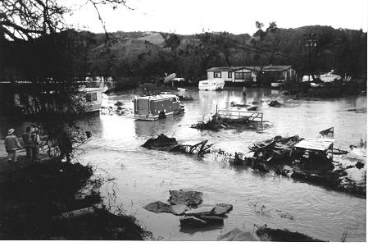
meaning that events of great magnitude and force occur infrequently, and smaller events occur more often.
In addition to flooding that can result from water overtopping the banks of a river, stream or drainage channel, localized flooding may occur in low spots or where storm water infrastructure is unable to accommodate peak flows during a storm event. In most cases, localized flooding is a short-term problem that dissipates quickly after intense rainfall episodes cease. However, ponded water that can result from inadequate drainage can result in substantial property damage.

Measuring Flood Events
Floods are generally described in terms of their frequency of occurrence. For example, the 100-year flood is an event that has a one-percent chance of being equaled or exceeded in any given year. There is a certain element of risk associated in using this type of designation, as the prediction of a flood of a particular magnitude is based on probability and an element of chance is involved. According to statistical averages, a 25-year flood should occur on the average once every 25 years, but two 25-year floods could conceivably occur in any one year. For planning purposes, the flood frequency most often used to delineate floodplain boundaries is the 100-year flood. The magnitude of a flood can be measured in terms of its peak discharge, which is the maximum volume of water (in cubic feet per second) passing a point along the channel during given time interval. The depth of water present at any given point along the channel is dependent upon the peak discharge and the cross-sectional area of the channel at the point in question.
Influences on Flooding Impacts
A number of natural and artificial factors can adversely influence the magnitude and frequency of flooding along streams and drainage channels. Some of the more common factors are described below.
Natural factors can include the excessive growth of brush and trees within drainage channels, which may obstruct runoff water flows and cause an increase in floodwater heights. Fires within watershed areas can also cause increased flooding, resulting from the removal of vegetation that helps to control the amount and rate of storm water runoff. Without protective vegetation, soil erosion is also increased and the additional sediment can accumulate in drainage channels, decreasing their capacity.
The encroachment of urban development is perhaps the most serious artificially-induced change in drainage basin and floodplain characteristics that can increase the magnitude and frequency of flooding. Urbanization results in increased impervious ground surface area (pavement, rooftops, etc) which decreases the amount of runoff that will infiltrate into the ground and the lag time between rainfall hitting the ground and when it collects in drainage channels. The combined effect of increased runoff and decreased concentration time will cause more frequent and severe floods. Urban development can also result in the placement of structures and fill material in floodplain areas. This reduces the space available for holding floodwaters, causing the water level and rate of flow to increase. Bridges and other structures placed in stream channels can obstruct water flow, particularly if flood debris collects around the structure. The damming effect of water against a bridge can cause sufficient pressure to result in damage or failure of the bridge.
To protect urban development from the impacts of flooding, stream channels are often “channelized” (straightened and/or lined with concrete or other material) to move the water through the channel more efficiently. However, as runoff water emerges from the channelized section of the stream, it is often delivered to an unchannelized down-stream section at rates and velocities that the natural section of the stream is not capable of adequately carrying. This can result in increased flooding impacts downstream from the channelized portion of the creek.
Effects of Flooding
The extent of damage caused by any flood depends on a variety of factors, such as topography, the depth and duration of flooding, velocity of flow, sediment load carried by, and deposited by, the flood, the extent of development located in the flooded area, and the effectiveness of weather forecasting, flood warnings, and emergency operations.

In general, a flood depth of three feet and a velocity of three feet per second has the potential to result in a significant threat to human safety.
While there are some benefits associated with flooding, such as the replenishment of beach sand, and nutrients to agricultural lands, it is generally considered a hazard to development in floodplains. Direct impacts of flooding can include injuries and loss of life, damage to structures and property, damage to roads, communication facilities and other infrastructure, damage to vegetation and crops, and health hazards from ruptured sewage lines and damaged septic systems. Secondary impacts include the cost and commitment of resources for floodfighting services, clean-up operations, and the repair or replacement of damaged structures.
Flood Hazard Abatement
In San Luis Obispo County, the County Flood Control and Water ConservationDistrict, through the County Engineering Department, is responsible for protecting life and property from flood hazards. The District has the authority to maintain and construct flood control improvements on major drainage facilities located throughout the County.
Historic Flooding
San Luis Obispo County has experienced severe flooding events that have resulted in extensive property damage. Flooding hazards are most likely to exist along major river and stream courses including the Salinas River, San Luis Obispo Creek, Santa Rosa Creek, Arroyo Grande Creek, Morro Creek and Huerhuero Creek. Areas that have been recently affected by flooding impacts are the areas most to be likely to be affected by future events. Therefore, a historical perspective of the effects of recent flood events can provide useful insight in land use planning and reduction of future flood hazard risks.
January-February, 1969. In January of 1969, a series of storms delivered rainfall totals that ranged from approximately 12 inches in Paso Robles, to 21 inches in San Luis Obispo over an eight-day period. In February, another series of storms delivered over 5 inches of rain in Paso Robles and 9.5 inches in San Luis Obispo. In a report prepared by the U.S. Army Corps of Engineers, the following account of storm-related damage was provided:
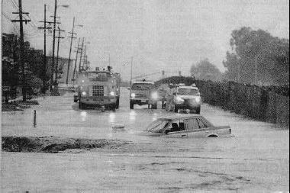
“The most severe damages to urban property occurred in the City of San Luis Obispo, where the San Luis Obispo Creek channel became clogged with debris and flow in the channel overtopped the channel banks and moved down the main streets of the City. Massive mobilization efforts during and after the January flood by the City of San Luis Obispo and the Corps of Engineers prevented additional damages to urban property during the February flood. Severe
damages were sustained by streets, highways, and utilities throughout the County. The water-supply system of Cambria was damaged in the floods and large parts of the town were without electricity; residents were advised to drink only boiled water because of the possibility that the local water supply might be contaminated. The destruction and damage of sewerlines and sewage-treatment plants at many locations posed a threat to the lives and health of many residents. The sewage-treatment plants at Morro Bay, Avila Beach, and Pismo Beach were inundated by both floods. Debris and raw sewage piled up on the beaches and carried in the streams posed serious threats to health until emergency cleanup operations were completed.”

January, 1973. Much like the floods of 1969, the 1973 storm produced a ten-hour period of unusually heavy rainfall. San Luis Obispo Creek, and its tributary, Stenner Creek, overtopped their banks and inundated a wide area of downtown San Luis Obispo.
January and March, 1995. Serious flooding occurred in all coastal and many inland streams. San Luis Obispo Creek caused damage in the City of San Luis Obispo, and especially near the ocean, where the San Luis Bay Golf Course and other properties received extensive damage. Cambria was completely inundated, with water as deep as six feet on Main Street.
San Luis Obispo County
Flood Hazard Potential
The National Flood Insurance Program (NFIP), which is administered by the Federal Insurance Administration (a component of the Federal Emergency Management Agency), requires communities to adopt land use restrictions for the 100-year floodplain in order to qualify for Federally-subsidized flood insurance. The program requires that within areas designated as a 100-year floodplain, building floor elevations must be a minimum of 12 inches above flood water levels. Areas within the designated floodway must be reserved to discharge the 100-year flood without cumulatively increasing the water surface elevation more than one foot. Generally, buildings and structures that would obstruct flood flow or be subject to flood damage are prohibited within the floodway.
To implement the NFIP, areas throughout San Luis Obispo County that are subject to inundation from the 100-year and 500-year floods are depicted on Flood Insurance Rate Maps. The most recent Flood Insurance Rate Maps for San Luis Obispo County were prepared in 1982 and 1985.
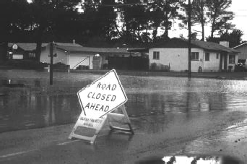
The unincorporated areas of San Luis Obispo County that may be subject to inundation from a 100-year storm event are generally depicted on Map
5. This map shows areas subject to inundation from a 100-year storm, and does not necessarily depict areas that may be affected by local drainage problems. Due to the scale and generalized nature of this map, official Flood Insurance Rate Maps should be consulted when assessing potential flood hazards at a particular property.
A Flood Insurance Study (FIS) conducted by FEMA for San Luis Obispo County noted that runoff in the streams of the County is small, with appreciable
flows occurring only during and immediately after precipitation. However, during large storms, streamflow increases rapidly, and flood waters can contain high amounts of debris, causing major flood damage. For many of the water courses that are located in the County, areas that may be inundated in response to 100-year storm events are located adjacent to or near the stream or river channel. Since many of the County’s watercourses are located in mountainous or remote areas with little or no development, flooding events along these rivers and streams generally result in minimal impacts. Other watercourses that are located in the County, however, have floodplains that extend well beyond the defined stream or river channel. When a flood occurs along one of these watercourses, and it is located in or near an area that is urbanized, damage to property and infrastructure can be widespread.

In the southern portion of the County, Arroyo Grande Creek, San Luis Obispo Creek, and their respective tributaries, are watercourses that pass through urbanized areas and that have caused major floods. The north coast area of the County also contains a number of short, steep-gradient creeks that can experience rapid increases in water flows in response to storm events in Cambria. Santa Rosa Creek is such a watercourse that has caused significant flooding events. The largest water course in the inland portion of the County is the Salinas River, which is located adjacent to numerous incorporated and unincorporated communities. Although the floodplain of the Salinas River can be extensive, it is generally contained within the river channel. Other major inland water courses include the Estrella River and San Juan Creek. Due to the generally remote locations of these watercourses, flooding impacts are generally not significant.
Major unincorporated communities of San Luis Obispo County that have been mapped by FEMA as being located within the 100-year floodplain are described below. The 100- year floodplain is generally used to define areas that are vulnerable to flooding hazards.
South Bay
The South Bay area of the County (including the communities of Baywood Park, Los Osos, and Cuesta-by-the Sea) has not been identified as being located within a 100-year storm floodplain by the most recent Flood Insurance Rate Maps (FEMA, 1985). Flooding in response to a 100-year storm is generally confined to shoreline areas surrounding Morro Bay. There are locations in this area, however, that are subject to chronic localized flooding. After a significant rain, localized flooding occurs throughout the Los Osos area. Numerous intersections within the community experience flooding during storm events, including 8th Street at El Morro Avenue, 17th Street at Paso Robles Avenue, Los Olivos Avenue at Fairchild Way, Ferrell Street, Don Avenue at Mitchell Drive, Los Osos Valley Road at Palisades Avenue, and Ramona Avenue at 11th Street. A study of Los Osos drainage problems has been completed.
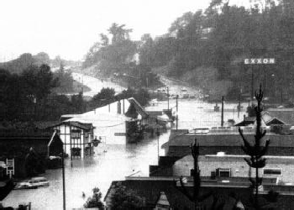
Cambria
Santa Rosa Creek has a history of flooding which has caused severe erosion of the creek banks as well as damage to phone and gas lines, water wells, and bridges. Major bank erosion in the past has caused complete interruption of the town’s water supply. The 100-year floodplain for Santa Rosa Creek is generally confined to the creek channel and surrounding areas south of Main Street. However, the West Village business area along Main Street has been subjected to severe flooding as a result of recent flood levels that overtopped the banks of Santa Rosa Creek (FEMA, 1985).
Cayucos
100-year flood areas near the community of Cayucos are predominately confined to areas adjacent to Cayucos Creek, Little Cayucos Creek, and Willow Creek. Several limited areas of the community along these areas have been designated as being in a 100-year floodplain. These areas include a portion of “B” Street near Ocean Boulevard, between Cayucos Creek and “E” Street, and an area near Willow Creek and Ocean Boulevard (FEMA, 1985).

Nipomo
Flooding in the community of Nipomo occurs primarily along Nipomo Creek and its tributaries, such as Deleissiques Creek and Tefft Road Creek. The 100-year floodplain along these creeks encompasses areas adjacent to the watercourses, along with extensive areas located east of U.S. Highway 101 between Mehlschau Road to the west and Price Street to the east (FEMA, 1985).
Oceano
Flooding in Oceano results from flows in Arroyo Grande Creek and Meadow Creek. The most significant inundation area is near the creeks’ confluences with the ocean. Areas subject to flooding as a result of a 100-year storm generally extend south of Highway 1 and west of Pismo Road. Flooding would occur at the Oceano County Airport and surrounding properties, along with extensive areas located to the south of the community (FEMA, 1985).
San Simeon
Flooding in and near the community of San Simeon Acres could result from flows in Pico Creek and Arroyo Del Padre Juan. Pico Creek is located to the north of the community, while Arroyo Del Padre Juan is located in the southern portion. The 100- year floodplains of these creeks generally follow the creek channel, but due to their location near urbanized areas, they have the potential to result in flooding impacts to developed areas (FEMA, 1985).
Templeton
Watercourses located in and near the community of Templeton include the Salinas River, which is located to the east of the town and Toad Creek, which is located north of Old County Road near the center of the community. The 100-year floodplain of the Salinas River near Templeton is confined to the river channel and does not significantly affect the community. The floodplain for Toad Creek is not extensive, however, due to its location relative to downtown Templeton, a 100-year flood along this watercourse would have the potential to affect adjacent properties (FEMA, 1982).
San Miguel
The community of San Miguel is located west of the Salinas River, and north of the confluence of the Estrella River with the Salinas River. The 100-year floodplain of the Salinas River near San Miguel is confined to the river channel and does not significantly affect populated areas of the community (FEMA, 1982).
Creston
The community of Creston is located between the west and middle branches of Huerhuero Creek. The 100-year floodplains of these creeks are located adjacent to the western and eastern edges of the community and could have the potential to affect adjacent developed properties (FEMA, 1982).
Shandon
The community of Shandon is located southwest of the confluence of San Juan Creek with the Estrella River. The 100-year floodplains of these watercourses are not located within the town of Shandon, but are located adjacent to developed areas. These water courses also cross State Routes 41 and 46 near the town. Flooding along these watercourses could have the potential to adversely effect access to and from the community (FEMA, 1982).
Rural Areas
Many areas are isolated or forced into excessively long detours during and after floods due to flood impacts on roads. These access impacts are a significant “flood hazard.”

Ordinances and Regulations
The San Luis Obispo County Land Use Ordinance and Coastal Zone Land Use Ordinance (Titles 22 and 23 of the County Code), provides standards for the preparation and submittal of drainage plans for new development. These regulations specify when drainage plans are required, the contents of an adequate drainage plan, drainage standards, and the plan review and approval process. The Land Use Ordinances also contain the County’s Floodplain Ordinance, which specifies development standards for areas that have a Flood Hazard (FH) combining land use designation. The development standards contained in the Floodplain Ordinance pertain to land use permit processing and construction standards for new development located in areas that have the potential to be inundated by a 100- year flood.
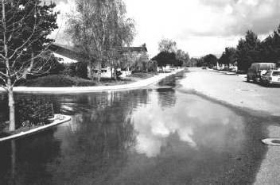
Arroyo Grande
Flood Hazard Potential
The National Flood Insurance Program (NFIP), which is administered by the Federal Insurance Administration (a component of the Federal Emergency Management Agency), requires communities to adopt land use restrictions for the 100-year floodplain in order to qualify for Federally-subsidized flood insurance. The program requires that within areas designated as a 100-year floodplain, building floor elevations must be a minimum of 12 inches above flood water levels. Areas within the designated floodplain must be reserved to discharge the 100-year flood without
cumulatively increasing the water surface elevation more than one foot. Generally, buildings and structures that would obstruct flood flow or be subject to flood damage are prohibited within the floodway.
To implement the NFIP, areas throughout Arroyo Grande that are subject to inundation from a 100-year and 500-year floods are depicted on Flood Insurance Rate Maps (FEMA, 1984). The areas of Arroyo Grande that may be subject to inundation from the 100-year storm event are generally depicted on Map 5. Due to generalized depiction of potential flooding areas provided by this Safety Element, official Flood Insurance Rate Maps should be consulted when assessing potential flood hazards at a particular property.
Areas of potential flooding in response to a 100-year storm are located adjacent to Canyon/Meadow Creek on the west side of the City, adjacent to Corbett Canyon and Arroyo Grande Creeks in the eastern portion of the City, and a limited area along Los Berros Creek in the southeastern portion of the City. Areas that would be inundated in response to a 100-year flood along these creeks are generally located along stream channels; however, in isolated areas, adjacent properties could be adversely affected. Near the confluence of Corbett Canyon and Arroyo Grande Creek, the 100-year floodplain widens, resulting in impacts to properties between Crown Terrace and Mason Street. The floodplain along Arroyo Grande Creek also widens slightly on the north and south sides of U.S.
101. Although areas subject to flooding from a 100-year flood are limited, floodwater could cause roadways such as Bridge Street, Traffic Way and U.S. 101 to become impassable, thereby hindering travel and response efforts.
Map 5 depicts areas subject to inundation from a 100-year storm, and does not necessarily depict areas that may be affected by local drainage problems. The City has worked to alleviate drainage problems in areas such as the North Hills area, the Oro and Stagecoach

area, Brisco Road area, Sunrise Terrace, Strother Park, the Town and Country Shopping Center, and the Soto Sports Complex.
Ordinances and Regulations
Ordinance Number 366 C.S. of The Arroyo Grande Municipal Code establishes the “Flood Hazard” (F-H) zoning district. The purpose of the ordinance is to promote the public health, safety, and general welfare, and to minimize public and private loses due to flood conditions.
Atascadero
Flood Hazard Potential
The National Flood Insurance Program (NFIP), which is administered by the Federal Insurance Administration (a component of the Federal Emergency Management Agency), requires communities to adopt land use restrictions for the 100-year floodplain in order to qualify for Federally-subsidized flood insurance. The program requires that within areas designated as a 100-year floodplain, building floor elevations must be a minimum of 12 inches above flood water levels. Areas within the designated floodway must be reserved to discharge the 100-year flood without cumulatively increasing the water surface elevation more than one foot. Generally, buildings and structures that would obstruct flood flow or be subject to flood damage are prohibited within the floodway.
To implement the NFIP, areas throughout Atascadero that are subject to inundation from a 100-year and 500-year flood are depicted on Flood Insurance Rate Maps (FEMA, 1982). The areas of Atascadero that may be subject to inundation from a 100-year storm event are generally depicted on Map 5. Due to generalized depiction of potential flooding areas provided by this Safety Element, official Flood Insurance Rate Maps should be consulted when assessing potential flood hazards at a particular property.
The Salinas River is located in the northeastern and eastern areas of the City. The floodplain of the river is generally removed from the developed areas, however, properties on the east side of Hidalgo Avenue, Sycamore Road, and Capistrano Avenue could be affected by flooding during a 100-year storm. The 100-year floodplain of the Salinas River extends across a segment of Curbaril Avenue. The crossing of Halcon Road over the Salinas River is frequently washed-out in storm events and would be washed-out during a 100- year storm event.
Atascadero Creek extends through the central portion of the City, but has a limited potential for flooding impacts as the 100-year floodplain is generally confined to the channel and adjacent properties. Where Atascadero Creek crosses U.S. 101 and State Route 41, a 100-year flood could cause inundation of the portions of the highways. This would have the potential to result in significant local and regional transportation impacts.
Although the 500-year floodplain is not generally used for planning purposes, it should be noted that the area designated as being located within the 500-year floodplain of the Salinas River and Atascadero Creek encompasses approximately 1.5 square miles of the central portion of Atascadero.
In the southeastern portion of Atascadero, flooding hazards could result from 100-year flows in several branches of Paloma Creek. Identified inundation areas are primarily located adjacent to the creek channels, although some more extensive areas could also be affected. In the western portion of the City, flooding along Graves Creek would primarily be restricted to the stream channel.

Map 5 depicts areas subject to inundation from a 100-year storm, and does not necessarily depict areas that may be affected by local drainage problems. Atascadero has historically experienced drainage and related flooding problems in an area known as the Amapoa/ Tecorida Basin, which is located to the east of Atascadero Creek and Morro Road, and south of U.S. Highway 101. This area has been subject to building moratoriums and fee programs to pay for drainage improvements. In recognition of this drainage problem, the lower portion of the basin has a Flood Hazard (FH) overlay zoning designation.
The Amapoa/Tecorida drainage basin has been prone to flooding for a variety of reasons. The primary cause of flooding in this area results from storm events which cause water flows in Atascadero Creek greater that the 17-year design storm to overtop the Atascadero Lake spillway channel banks and flow into the Amapoa/Tecorida basin. Other factors that have contributed to inadequate drainage in this area include flat topography and low water velocities increasing run-off volumes due to urban development, undersized drainage culverts and channels, particularly at Highway 101, and the lack of a formal method to maintain existing drainage facilities on private property (Draft Amapoa/ Tecorida Master Drainage Study, 1995).
A variety of control strategies for correcting the drainage deficiencies of the Amapoa/ Tecorida area have been proposed. These measures include improvements to the Atascadero Lake spillway, construction of a new storm drain along Highway 41, requiring drainage analysis for projects located within the basin that increase building density, and provision of a mechanism to facilitate the maintenance of drainage facilities on private property. Construction of the storm drain along Highway 41 has already begun.
Ordinances and Regulations
The City of Atascadero’s Zoning Ordinance, 9-3.600, FH (Flood Hazard) Overlay Zone, identifies areas where terrain would present new developments and their users with potential flood hazards. In addition, Ordinance No. 193, An Ordinance Adding Chapter 5 to Article 7 of the City of Atascadero Municipal Code Relating to Flood Damage Prevention, provides further guidance to reduce flood damage. It is the purpose of this ordinance to promote the public health, safety, and general welfare, and to minimize public and private loses due to flood conditions. Also, Ordinance No. 304 amended Title 6, Chapter 13 of the Atascadero Municipal Code to provide a mechanism to allow the Fire Chief to order the removal of weeds, rubbish, and similar material that has the potential to become a flooding hazard.
Grover Beach
Flooding Hazard Potential
The National Flood Insurance Program (NFIP), which is administered by the Federal Insurance Administration (a component of the Federal Emergency Management Agency), requires communities to adopt land use restrictions for the 100-year floodplain in order to qualify for Federally-subsidized flood insurance. The program requires that within areas designated as a 100-year floodplain, building floor elevations must be a minimum of 12 inches above flood water levels. Areas within the designated floodway must be reserved to discharge the 100-year flood without cumulatively increasing the water surface elevation more than one foot. Generally, buildings and structures that would obstruct flood flow or be subject to flood damage are prohibited within the floodway.
To implement the NFIP, areas throughout Grover Beach that are subject to inundation from the 100-year and 500-year floods are depicted on Flood Insurance Rate Maps (FEMA, 1984). The areas of Grover Beach that may be subject to inundation from a

100-year storm event are generally depicted on Map 5. Due to generalized depiction of potential flooding areas provided by this Safety Element, official Flood Insurance Rate Maps should be consulted when assessing potential flood hazards at a particular property.
Isolated areas of potential flooding in response to a 100-year storm are located in the northern and western portions of the City that are adjacent to Meadow Creek. Flood hazard areas in the northern portion of the City are restricted to an area south of U.S. 101 and north of Nacimiento Avenue. A mobile home subdivision is located in this area. In the western part of the City, flooding could affect areas located west of the Union Pacific Railroad tracks.
Map 5 depicts areas subject to inundation from a 100-year storm, and does not necessarily depict areas that may be affected by local drainage problems. Local flooding conditions currently exist in two isolated areas within the City where properties are located below street level. One parcel is located at South 5th Street and Manhattan Avenue. This parcel is subject to flooding from 50-year storm event if sandbags are not used or if cars are parked on the street. The second parcel is located at south 6th Street and Mentone Avenue. A 75-100 year storm event will flood this property, however, an asphalt berm has been constructed which alleviates flooding under storms of lesser magnitude (City of Grover Beach, Written Correspondence, 1996).
Ordinances and Regulations
Sections 7300-7361, Chapter 3 - Flood Damage Prevention Regulations, of the Grover Beach Municipal Code addresses flood hazards relative to public health, safety and general welfare. The purpose of these regulations is to minimize public and private loses due to flood conditions.
Morro Bay
Flooding Hazard Potential
The National Flood Insurance Program (NFIP), which is administered by the Federal Insurance Administration (a component of the Federal Emergency Management Agency), requires communities to adopt land use restrictions for the 100-year floodplain in order to qualify for Federally-subsidized flood insurance. The program requires that within areas designated as a 100-year floodplain, building floor elevations must be a minimum of 12 inches above flood water levels. Areas within the designated floodway must be reserved to discharge the 100-year flood without cumulatively increasing the water surface elevation more than one foot. Generally, buildings and structures that would obstruct flood flow or be subject to flood damage are prohibited within the floodway.
To implement the NFIP, areas throughout Morro Bay that are subject to inundation from the 100-year and 500-year floods are depicted on Flood Insurance Rate Maps (FEMA, 1985). The areas of Morro Bay that may be subject to inundation from a 100- year storm event are generally depicted on Map 5. Due to generalized depiction of potential flooding areas provided by this Safety Element, official Flood Insurance Rate Maps should be consulted when assessing potential flood hazards at a particular property.
Flooding in the City of Morro Bay could occur as a result of flows in Morro Creek, Little Morro Creek, Chorro Creek and the several smaller creeks located in the northern portion of the City. Flooding from Morro Creek and Little Morro Creek in response to a 100-year storm would inundate areas between Little Morro Creek Road and Highway 41 on the east side of Main Street, and an extensive area north of Embarcadero Road on the west side of Main Street. Flooding from these creeks could potentially render State Highway 1 bridges over these waterways unusable during a major storm. During the

rains of 1995 Highway 1 was closed through Morro Bay due to flooding. Flooding from Chorro Creek would affect the eastern portion of the City, primarily areas east of South Bay Boulevard and Morro Bay State Park. In 1995, flooding from Chorro Creek inundated Twin Bridges (now Chorro Creek Bridge) for several days, forcing travelers from Los Osos to detour through San Luis Obispo in order to reach Morro Bay. The new Chorro Creek Bridge, completed in 1996, was constructed at a higher elevation than Twin Bridges to avoid future closures due to flooding. The creeks located in the northern portion of the City traverse areas that have been extensively developed with residential uses. In 1995, houses located along Alva Paul Creek, and other houses in north Morro Bay, were flooded. Also, the area between Highway 41 and Radcliffe Street flooded in 1995 causing much property damage to both residences and businesses. In the isolated areas where the creek floodplains extend beyond the stream channels, flooding impacts could also be significant.
Ordinances and Regulations
Local flood regulations for the City of Morro Bay are provided in sections 14.72.010-
14.72.060 of Chapter 14.72- Flood Damage Prevention contained in the Morro Bay Municipal Code. The intent of these regulation are to reduce public and private loses due to flood damage.
Paso Robles
Flooding Hazard Potential
The National Flood Insurance Program (NFIP), which is administered by the Federal Insurance Administration (a component of the Federal Emergency Management Agency), requires communities to adopt land use restrictions for the 100-year floodplain in order to qualify for Federally-subsidized flood insurance. The program requires that within areas designated as a 100-year floodplain, building floor elevations must be a minimum of 12 inches above flood water levels. Areas within the designated floodway must be reserved to discharge the 100-year flood without cumulatively increasing the water surface elevation more than one foot. Generally, buildings and structures that would obstruct flood flow or be subject to flood damage are prohibited within the floodway.
To implement the NFIP, areas throughout Paso Robles that are subject to inundation from the 100-year and 500-year floods are depicted on Flood Insurance Rate Maps (FEMA, 1981). Flood mapping for the City of Paso Robles and the analysis of Hueruero Creek was not complete at the time this report was produced. The areas of Paso Robles that may be subject to inundation from a 100-year storm event are generally depicted on Map 5. Due to generalized depiction of potential flooding areas provided by this Safety Element, official Flood Insurance Rate Maps should be consulted when assessing potential flood hazards at a particular property.
Several watercourses are located within Paso Robles that have the potential to cause flooding impacts. The Salinas River is the major watercourse located in Paso Robles, and runs through the center of the City. Flows in the Salinas River that could result from a 100-year storm are primarily contained in the river channel. On the west side of the City, flooding from Mountain Springs Creek could affect isolated residential areas located along 21st, 22nd, and 23rd Streets. The area located adjacent to and west of U.S. 101 and south of 24th Street could also be inundated by runoff from a 100-year storm. In the southwestern portion of the City, 100- year flooding events could result in the inundation of areas along Pacific Avenue, 4th Street and Paso Robles Boulevard. In the eastern portion of the City, several unnamed creeks have 100-year floodplains that would primarily affect the creek channel and adjacent properties. In the northern portion of the City, Huerhuero Creek could cause isolated areas of flooding along the road that leads to the Paso Robles Municipal Airport.

Ordinances and Regulations
The City of Paso Robles Municipal Code, Chapter 21.14 Flood Damage Prevention Regulations specify methods of reducing flood losses. A variety of standards relative to construction, utilities, and manufactured homes are provided to minimize public and private losses due to flood conditions.
City of San Luis Obispo
Flooding Hazard Potential
The National Flood Insurance Program (NFIP), which is administered by the Federal Insurance Administration (a component of the Federal Emergency Management Agency), requires communities to adopt land use restrictions for the 100-year floodplain in order to qualify for federally-subsidized flood insurance. The program requires that within areas designated as a 100-year floodplain, building floor elevations must be a minimum of 12 inches above flood water levels. Areas within the designated floodway must be reserved to discharge the 100-year flood without cumulatively increasing the water surface elevation more than one foot. Generally, buildings and structures that would obstruct flood flow or be subject to flood damage are prohibited within the floodway.
To implement the NFIP, areas throughout the City of San Luis Obispo that are subject to inundation from the 100-year and 500-year floods are depicted on Flood Insurance Rate Maps (FEMA, 1981). The areas of San Luis Obispo that may be subject to inundation from a 100-year storm are generally depicted on Map 5.a. Due to generalized depiction of potential flooding areas provided by this Safety Element, official Flood Insurance Rate Maps should be consulted when assessing potential flood hazards at a particular property.
The City of San Luis Obispo is traversed by several creeks, including San Luis Obispo Creek and its major tributaries, Stenner Creek, Brizziolari Creek and Prefumo Creek. The 100-year floodplains for these creeks encompass extensive areas of the City on the east and west sides of U.S. 101, including the downtown area. Historic flooding on San Luis Obispo Creek, such as the floods of 1969,1973, and 1995, have resulted in substantial property damage.
Map 5 depicts areas subject to inundation from a 100-year storm, and does not necessarily depict areas that may be affected by local drainage problems in response to storms that are of a magnitude less than a 100-year storm. Several areas in the downtown of San
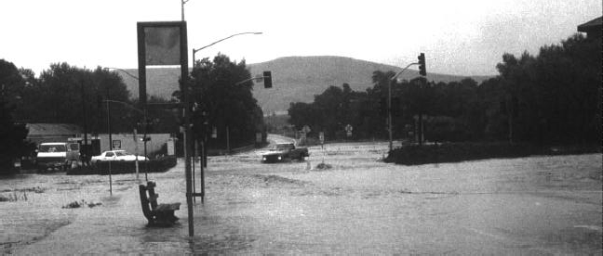

Luis Obispo are subject to localized flooding. Areas that may experience drainage problems during moderately sized storms include the vicinity of Santa Rosa Street, Broad Street, Prado Road, and Laguna Lake.
Ordinances and Regulations
Sections 17.84.010-17.84.170 within Chapter 17.84, Flood Damage Prevention Regulations of the San Luis Obispo Municipal Code set forth means to reduce losses from floods. These standards focus on areas located within or near the 100-year floodplain. Section 8.12.010-8.12.010 of the Municipal Code provides a mechanism for the City to require the removal of dangerous obstructions in streambeds that have the potential to obstruct water flow.
Dam Inundation
Hazard Description
Dam inundation is the flooding of lands due to the release of impounded water resulting from the failure or overtopping of a dam. Although this occurrence is highly unlikely, it warrants consideration in the Safety Element because San Luis Obispo County has several dams and reservoirs.
Potential Causes of Dam Failures
Dam failures can result from a number of natural or man-made causes. Earthquakes, improper siting, fast rising flood waters, erosion of the dam face or foundation, and structural/construction flaws can all contribute to a dam breach and ensuing release of impounded water. Other reservoir-related flooding events have resulted from massive, fast-moving landslides, that have displaced large volumes of water contained in a reservoir. Such a rapid displacement of water can cause large quantities of water to travel over the dam, resulting in downstream flooding.
Major Dams In San Luis Obispo County
San Luis Obispo County has several large publicly owned dams, as well as a number of smaller privately owned dams. Table 2-1 summarizes the dams and reservoirs in the County as well as their capacity and type of construction.
Effects of Dam Inundation
The severity of downstream effects resulting from a dam failure will be directly related to the manner in which the dam fails. A failure resulting from the erosion of a breach in

Table 2-1: Major Dams and Reservoirs in San Luis Obispo County
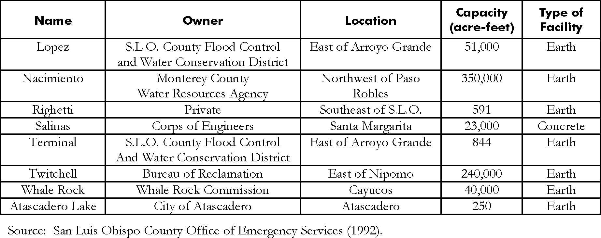

an earthfill dam would likely result in a flood wave that builds gradually to a peak, then declines until the reservoir is empty. If a dam were to fail rapidly, however, a flood wave would be formed quickly and then be followed by a gradual decline in flood water.
The failure of a dam could cause flooding, injury, loss of life, and property damage due to erosion, debris and sediment deposition. Other effects include damage to community infrastructure and interruption of public services. Health hazards from the release of sewage may also result. To oversee planning for such potentials, the California Office of Emergency Services (OES) maintains a dam failure inundation mapping and emergency procedure program. This program encompasses inundation mapping, inundation map waivers and emergency procedures.
Owners of dams are required to submit inundation maps to state OES for review and approval in accordance with guidelines issued by that office. Inundation maps represent the best estimate of where water would flow if a dam failed completely and suddenly with a full reservoir. However, later downstream changes, such as major land contour alterations, may affect the actual inundation pathway. There is no known requirement for planning if a waterway, such as a stream, below a dam is dry, low flowing or full and flowing, when developing inundation maps. Inundation maps are an approximation of where the water would flow.
San Luis Obispo County
Dam Failure Hazard Potential
In response to the disastrous failure of the Saint Francis Dam in Los Angeles County, the State of California has been responsible for inspecting dams since 1929. In recognition of potential safety impacts that could be associated with a dam failure, section 8589.5 of the California Government Code requires that inundation maps for all dams, except those dams meeting the waiver conditions specified by the California OESs, be prepared by dam owners and be submitted to the California OES. Dam inundation maps are prepared primarily for emergency preparedness plans for the affected jurisdictions. Dam inundation, as depicted by the hazard maps, is not considered a probable occurrence, because the identified hazard areas are based on a severe instantaneous dam failure due to a catastrophic event having a relatively low probability of occurrence. In addition, the State Division of Safety of Dams periodically inspects dams for safety, including seismic stability. When necessary, existing dams are upgraded as new technology becomes available.
In the event of dam failure emergency, the San Luis Obispo County Office of Emergency Services would implement the County’s Dam Failure Evacuation Plan. This plan includes alerting affected populations using the Emergency Alert System and mobilizing emergency response personnel. Public safety vehicles and public address systems can be used to notify the public. For the Lopez, Terminal and Whale Rock dams, the Early Warning Siren System could be used to alert the public.
San Luis Obispo County
Dam Inundation Hazard Potential
The Nacimiento Dam is located within San Luis Obispo County, however, it is owned and operated by the County of Monterey. Due to the proximity of the Nacimiento Dam to Monterey County, the primary impacts in the event of a dam failure would be to Camp Roberts and Monterey County. As a result, Monterey County maintains an Emergency Action Plan for the Nacimiento Dam. A dam that is located in Monterey County, the San Antonio Lake Dam would effect very few homes in San Luis Obispo County in the event of a complete dam failure. Other major dams that are located in San

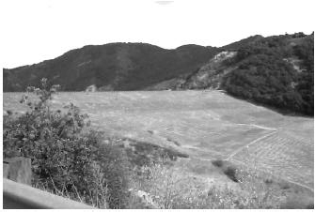
Luis Obispo County with the potential to result in significant life, safety, and property damage impacts in the event of a catastrophic failure, are identified below. Each of the inundation areas described below assumes that each reservoir would be filled to capacity at the time of a dam failure.

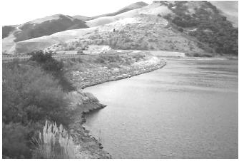
Lopez Dam. Lopez Dam is located approximately three miles northeast of the intersection of Orcutt Road and Lopez Drive in San Luis Obispo County. In the event of a complete dam failure when Lopez Lake reservoir would be at full capacity, water from the dam would flow in a westerly direction, following Arroyo Grande Creek, and flood an area extending approximately 3,000 feet in each direction of the centerline of the channel. Water flows would pass through Arroyo Grande, Grover Beach, and portions of Oceano, before entering the Pacific Ocean (San Luis Obispo County OES, 1992). Substantial impacts to life and property in these communities would likely result. Lopez Dam was under study for possible seismic retro-fitting during the update of this Element. Until this issue is resolved, Lopez Dam is being maintained at 83 percent capacity.
Failure of the Lopez Dam would have the potential to affect a large number of people and public facilities.
These could include: Arroyo Grande Community Hospital, Arroyo Grande High School, Biddle Park, Pismo State Beach/Oceano Campground, Oceano Airport, Oceano Elementary School, South County Water Pollution Control Plant, and the Union Pacific Railroad (San Luis Obispo County OES, 1992).
Righetti Dam. Righetti Dam is located approximately 1.1 miles east of Islay Hill in San Luis Obispo County. A failure of the Righetti dam would result in the release of water into West Corral de Piedra Creek. Assuming the reservoir was full at the time of failure, it is estimated that the water released from the dam would inundate an area extending between 200 and 1,000 feet on either side of the centerline of the creek. The flow of water from the reservoir would likely dissipate by the time it reached Highway 227. The area that would be affected by a sudden release of water is sparsely populated, and no critical facilities would be affected (San Luis Obispo County OES, 1992).
Salinas/Santa Margarita Reservoir Dam. Salinas Dam is located approximately 1.4 miles northeast of the intersection of Pozo and Santa Margarita Lake Roads in San Luis Obispo County. A sudden failure of the Salinas Dam would result in the release of water from Santa Margarita Lake in a northern direction into the Salinas River. Assuming Santa Margarita Lake was at capacity at the time of the failure, it is estimated that the water released from the dam would inundate an area extending between 300 and 500 feet on either side of the centerline of the river, and isolated low-lying areas up to the Atascadero area. At Atascadero, the flood area would widen to approximately 1,000 feet on both sides of the river centerline, and would continue past Templeton and Paso Robles to the Wellsona railroad siding. At Wellsona, the inundation area would widen to approximately 2,000 feet and continue to San Miguel, where the inundation area would narrow somewhat until the

Lopez Dam

water enters Monterey County. Most of the water that could be released from Santa Margarita Lake would be confined to the Salinas River channel. Therefore, the potential for damage to structures is minimal, although isolated residences would likely be affected. Numerous major roadways could also be affected, including Highways 41, 46, and 58 (San Luis Obispo County OES, 1992). At the time this report was produced, the City of San Luis Obispo was proposing to expand the capacity of the reservoir by installing a gate in the spillway of the existing dam.. In the event that the lake capacity is expanded, the limits of the dam failure inundation area would need to be revised.
Terminal Dam. Terminal Dam is located approximately 0.7 miles southwest of the intersection of Orcutt Road and Lopez Drive in San Luis Obispo County. In the event of a complete failure of the Terminal Dam, water would be released in a southern direction into Arroyo Grande Creek, and would flow between 300 and 1,000 feet along the centerline of the channel for approximately 2.5 miles. Several residences could be affected by this water flow, however, potential risks to life and property is considered to be relatively low (San Luis Obispo County OES, 1992).
Twitchell Dam. Twitchell Dam is located approximately 6 miles east of the intersection of Highway 101 and State Route 166-East, near the County line. In the event of a complete dam and levee failure, water from Twitchell Reservoir would primarily flow into Santa Barbara County. Isolated areas around the Oso Flaco area of San Luis Obispo County could be affected; however, potential inundation impacts are not expected to result in a significant risk to life or property. Major transportation routes that could be affected by a sudden failure of the Twitchell Reservoir Dam include Highway 1 and U.S. Highway 101 near the County Line and Union Pacific Railroad (San Luis Obispo County OES, 1992).
Whale Rock Dam. Whale Rock Dam is located approximately 1.4 miles east of the intersection of Highway 1 and Cayucos Creek Road in San Luis Obispo County. In the event of a complete dam failure, water from Whale Rock Reservoir would flow southward along Old Creek. Assuming the reservoir was full at the time of failure, it is estimated that the water released from the dam would inundate an area extending approximately 1,000 feet on each side of the centerline of the creek. The released water would then flow across Highway 1 and into the community of Cayucos at 13th Street and Ocean Boulevard. West of Ocean Boulevard, the area of flooding could widen to include 3rd Street to the north and Willow Creek to the south, until the flow dissipates into the Pacific Ocean. Significant impacts to life and property to approximately one-third of the community of Cayucos could result from a catastrophic failure of the Whale Rock dam when the reservoir is full (San Luis Obispo County OES, 1992).
Atascadero Lake Dam. According to the Atascadero Police Department (1993); “Atascadero Lake Dam is located about one mile west of U.S. Highway 101, on State Highway 41. In the event of complete dam failure, with the lake at full capacity, water is expected to flow in a northerly direction, in an irregular fan-shaped area, covering the Morro flats/Tecorida area, into the Atascadero Creek. The depth of water at any point is not expected to exceed two feet. The water would then run east, dissipating into the Salinas River. The total population affected by this dam failure should not exceed 100.”

Arroyo Grande
Dam Inundation Hazard Potential
Lopez Dam. In the event of a complete dam failure when Lopez reservoir was at full capacity, water would flow in a westerly direction, following Arroyo Grande Creek, approximately 3,000 feet in each direction of the centerline of the channel. Water flows would pass through Arroyo Grande, Grover Beach, and portions of Oceano, before entering the Pacific Ocean. Substantial impacts to life and property in these communities would likely result.
The County Office of Emergency Services estimated that failure of the Lopez Dam would have the potential to affect a large number of people and public facilities. These could include: residential and business occupants, Arroyo Grande Community Hospital, Arroyo Grande High School, and Harloe Elementary School (San Luis Obispo County OES, 1992).
Atascadero
Dam Inundation Hazard Potential
Salinas/Santa Margarita Reservoir Dam. A sudden failure of the Salinas Dam would result in the release of water in a northern direction into the Salinas River. Areas between 300 and 500 feet of the centerline of the River, along with isolated low-lying areas could be inundated up to the Atascadero area. At Atascadero, the flood area would widen to approximately 1,000 feet on both sides of the river centerline, and would continue past Templeton and Paso Robles to Wellsona. At Wellsona, the inundation area would widen to approximately 2,000 feet on each side of the river centerline up to San Miguel, where the inundation area would narrow somewhat until the water enters Monterey County. Most of the water that could be released from the Santa Margarita Reservoir would be confined to the Salinas River channel. Therefore, the potential for damage to structures is minimal, although isolated residences would likely be affected. Numerous major roadways could also be inundated, including State Routes 41, 46, and 58 (San Luis Obispo County OES, 1992). At the time this report was produce, the City of San Luis Obispo was proposing to expand the capacity of the reservoir by installing a gate in the spillway of the existing dam. In the event that the lake capacity is expandedd, the limits of the dam failure inundation area would need to be revised.
Atascadero Lake Dam. According to the Atascadero Police Department (1993); “In the event of complete dam failure, with the lake at full capacity, water is expected to flow in a northerly direction, in an irregular fan-shaped area, covering the Morro flats/Tecorida area, into the Atascadero Creek. The depth of water at any point is not expected to exceed two feet. The water would then run east, dissipating into the Salinas River. The total population affected by this dam failure should not exceed 100.”
Grover Beach
Dam Inundation Hazard Potential
Lopez Dam. In the event of a complete dam failure when Lopez reservoir was at full capacity, water would flow in a westerly direction, following Arroyo Grande Creek, approximately 3,000 feet in each direction of the centerline of the channel. Water flows would pass through Arroyo Grande, Grover Beach, and portions of Oceano, before entering the Pacific Ocean. Substantial impacts to life and property in these communities would likely result.
Failure of the Lopez dam would have the potential to affect a large number of people and public facilities. These could include but are not limited to: Grover Heights School, City Hall, and the Union Pacific Railroad (San Luis Obispo County OES, 1992).

Morro Bay
Dam Inundation Hazard Potential
The City of Morro Bay has not been identified as being in a location that would be affected by the failure of a large dam.
Paso Robles
Dam Inundation Hazard Potential
Salinas/Santa Margarita Reservoir Dam. A sudden failure of the Salinas Dam would result in the release of water in a northern direction into the Salinas River. Areas between 300 and 500 feet of the centerline of the River, along with isolated low-lying areas could be inundated up to the Atascadero area. At Atascadero, the flood area would widen to approximately 1,000 feet on both sides of the river centerline, and would continue past Templeton and Paso Robles to Wellsona. At Wellsona, the inundation area would widen to approximately 2,000 feet on each side of the river centerline up to San Miguel, where the inundation area would narrow somewhat until the water enters Monterey County. Most of the water that could be released from the Santa Margarita Reservoir would be confined to the Salinas River channel. Therefore, the potential for damage to structures is minimal, although isolated residences would likely be affected. Numerous major roadways could also be inundated, including State Routes 41, east bound 46, and 58 (San Luis Obispo County OES, 1992).
San Luis Obispo
Dam Inundation Hazard Potential
The City of San Luis Obispo has not been identified as being in a location that would be affected by the failure of a large dam.
Coastal Erosion
Hazard Description
The coastline is in a constant state of change, adjusting to the forces of waves, currents, tides, and sediment deposition. These forces create a flow of sand along the coastline known as littoral drift. Littoral drift generally flows southward along the California coast. The amount of sand present at a beach remains in equilibrium only when the amount of sand deposited is equal to the amount of sand washed away. Since the forces controlling the deposition and removal of sand rarely balance each other exactly, the coastline is almost always in a dynamic state of either recession or advancement.
Sandy beaches are formed largely by the weathering of inland rocks and the transport of sediment to the sea by rivers and streams. The amount of sand on the beach also varies with the seasonal changes in wave action. For example, during winter months when wave activity is increased, waves striking the beach strip away accumulated sand and leave the beach with a rocky appearance. Conversely, in summer months which have low to moderate wave activity, sand tends to accumulate, resulting in a wider sandy beach. Long-term advancement or erosion of beaches is affected by long-term weather patterns as well as changes in sediment transport caused by human intervention. Man- made shore protection devices (SPD) can also affect shoreline changes.
Influences on Coastal Erosion Impacts
Humans have the ability to alter the configuration of the shoreline by influencing long- and short-term erosion rates. One of the major causes of beach erosion is the construction of dams and other structures along creeks and rivers that trap sediment and prevent it from reaching the ocean. This deprives the shoreline of the material that would replenish beach sand supplies. Coastal structures such as groins, jetties, seawalls, and breakwaters

can also alter littoral drift. Beach groins and breakwaters, for example, can trap littoral sand and build beaches over a limited area but by doing so, they reduce the amount of sand that flows to down-current beaches. This can result in a rapid loss of beach sand in downcurrent beaches. Seawalls are often used to protect seacliffs from erosional effects of wave action. However, these structures can reflect wave energy to strip protective beach sand at an accelerated rate. This may ultimately result in increased seacliff erosion rates, particularly at sections of coastline adjacent to the seawall.
Effects of Coastal Erosion
Erosion of beach sand removes the natural barrier which protects landforms and structures from the potentially destructive wave action. The end result can be the direct destruction of roads, homes, and other structures by waves whose force is no longer dissipated by wide beaches. As beaches are eroded away, the amount of recreational beach available to the public is greatly reduced. Also, changes in beach geometry can alter the wave characteristics of a particular site. For example, as sand is carried out to sea during winter months, an offshore sand bar is likely to develop and cause waves to break further offshore. If the supply of sand is interrupted by human intervention and an offshore sand bar is unable to develop, waves may strike much closer to the shoreline and accelerate coastal erosion. Marine life is also affected by shoreline changes although specific impacts are difficult to predict.
Historical Rates of Coastal Erosion in San Luis Obispo County
The process of coastal erosion is highly complex and depends on a number of factors such as geologic formation, groundwater seepage, and exposure to wave energy. The coastline along the County of San Luis Obispo is variable in terms of geologic composition and exposure to wave energy. Sections of the coast range from rocky coastline to sandy beaches backed by cliffs, to sandy beaches backed by sand dunes. Due to these variances along the shoreline, erosion characteristics also vary significantly.
It is important to note that coastal erosion occurs episodically, mainly during periods of intense wave action that coincides with high tides. Although erosion occurs episodically, it is typical to report rates of coastal erosion as a yearly average. This is the method employed to quantify the rate of seacliff erosion. Typically, annual rates of coastal erosion range from about three inches a year to more than one foot a year. However, it does not necessarily mean that erosion will behave this way each year. Due to difficulties in obtaining accurate erosion data, reported rates of erosion presented in the following sections must only be considered as approximations in characterizing coastal erosion rates and vulnerability.
Cambria
Coastal Erosion Hazard Potential
Cambria is primarily characterized by narrow beaches backed by low cliffs approximately 20 feet-high. This section of coastline is subject to moderate to heavy wave action mostly from northerly swells. The coast in the area is comprised of a rock unit called the Cambrian slab which is a local, colloquial name for the Cretaceous-age sandstones that form the resistant rock headlands in the area. Since sandstone is fairly resistant to erosion, cliff retreat rates in Cambia are relatively low when considering the wave energy imposed on this area. However, according to Griggs and Savoy (1985), present developments along Windsor Avenue are considered to be in danger from wave action and are currently experiencing rates that average seacliff retreat of two to three inches per year.

Cayucos
Coastal Erosion Potential Hazard
Shorelines in Cayucos are similar to those found in Cambria; however, there are several important differences that effect the erosion potential. Cayucos is also backed by low cliffs (about 20 feet-high) but has wider beaches than those found in Cambria. In the winter months, however, the sandy beaches virtually disappear and waves strike directly against the bluffs. The Cayucos shoreline faces south; therefore, its beaches are partially protected from northerly swells. However, wave action in this area is significant. The seacliffs are comprised of Franciscan melanges, characterized by blocks of rocks often surrounded by small zones of sheared or crushed rock that tend to erode easily. Some zones contain more erosion resistant rock blocks that have been exposed as the weaker blocks have eroded away.
For example, the bluffs along Pacific Avenue and Studio Drive in Cayucos contain extensive blocks of sheared serpentine that act like seawalls and slow erosion. However, during the intense storm waves of 1983, even these seemingly resistant blocks were breached at some spots. As a result, the bluff receded as much as 20 feet. Rates of erosion are highly variable along this coastline, and range from 6 to 10 inches per year according to Griggs and Savoy (1985). In response to the storm waves of 1983, emergency rip-rap and numerous seawalls were constructed. Even with this protection, rapid erosion rates can be expected to continue in the future.
Downtown Cayucos is another area of concern. Built upon the unconsolidated sediment deposited from the Cayucos creek, this area is susceptible to shoreline erosion. Upcoast from the downtown area along Lucerne Avenue and extending north to the undeveloped bluffs, the shoreline is comprised of Franciscan melange containing erodable rocks with high silt contents. Also, unconsolidated clays form approximately the upper 10 feet of these bluffs and contribute to rates of cliff retreat through a landslide-type mechanism. During rainy months when the ground becomes wet, the low permeability of the clays tends to perch or elevate the ground water table. Consequently, these saturated soils cause increased soil loss due to slope instability and slumping of the sea cliff face.
Morro Bay
Coastal Erosion Potential Hazard
From Atascadero State Beach and continuing south through much of Montana de Oro State Park, the Morro Bay coast is fronted by large sand dunes that provide protection for developments located on terrace materials behind the sand
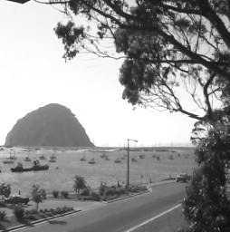
dunes. Due to the construction of the Morro Bay Harbor Breakwater and the presence of Morro Rock, the littoral drift north of Morro Bay has been interrupted and the coast has accreted, or extended, seaward. In about 50 years, the beach has widened about 250 feet near San Jacinto Avenue and almost 500 feet in front of Morro Bay High School according to Griggs and Savoy (1985). This tombolo, or sandbar, provides protection for developments in this region. South of Morro Rock, the bay is protected by the sandspit which provides a barrier to wave attack that would otherwise impact the developed areas along the Embarcadero.

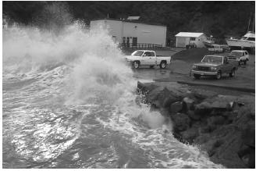
Los Osos
Coastal Erosion Potential Hazard
From the Morro Rock extending into Montana de Oro State Park, large sand dunes protect the community of Los Osos from potential wave hazards. Coastal development in the area from Montana de Oro State Park through Port San Luis is unlikely due to the current land uses. Erosion rates for shorelines of geology similar to this area range from approximately 4 to 6 inches per year according to Griggs and Savoy (1985).
Port San Luis
Coastal Erosion Potential Hazard
Port San Luis and the coastline surrounding San Luis Bay is well protected from the predominant northwesterly swells by the 2,300 foot long Port San Luis breakwater. However, little protection is offered from southerly swells. The Port San Luis area is backed by 100 foot-high cliffs which descend eastward into approximately 30 foot-high cliffs. Proceeding eastward from Port San Luis toward Avila Beach, protective rip-rap has been placed adjacent to Avila Beach Drive in to protect the roadway from storm waves. Just east of the mouth of the San Luis Obispo Creek, and extending eastward to Fossil Point, the
community of Avila Beach is fronted by a 300 foot-wide beach which provides little protection from storm waves. According to Griggs and Savoy (1985), winter storm waves of 1983 damaged the concrete seawall which runs parallel to Front Street. Housing developments in this area experienced landslide activity as well as cracking of foundations and roads. The recreational pier at Avila Beach was also severely damaged. Historic storms have shown that both Port San Luis and Avila Beach are susceptible to coastal damage resulting from storm waves, especially those generated from southerly swells. Griggs and Savoy (1985) classify this region with a “moderate risk” with respect to possible coastal damage incurred by storm waves.
Pirates Cove
Coastal Erosion Potential Hazard
From Fossil Point proceeding eastward to Shell Beach, the coastline is characterized by offshore rocks and sea stacks backed by high (30-100 feet) eroding cliffs. According to the Department of Navigation and Ocean Development (1977), oil storage tanks formerly located just east of Fossil Point were “endangered by cliff erosion.” Griggs and Savoy (1985) suggest rates of seacliff retreat ranging from 4 to 7 inches per year for the Shell Beach coastline. Furthermore, they indicate that “catastrophic rockfall is an important agent of erosion” in this area. Although many homes located very near the coastline of Shell Beach are protected by seawalls, bulkheads, sandbags, and rip- rap, Griggs and Savoy (1985) characterize this stretch of coastline as a “high risk” with respect to possible coastal damage incurred by storm waves.
Grover Beach
Coastal Erosion Potential Hazard
Grover Beach is fronted by sandy beaches backed by low active dunes covered with dense vegetation, a golf course, and a mobile home park. The sandy beaches provide structures with moderate protection from storm waves. However, during the winter storms of 1983, timber beach access ramps were damaged. According to Griggs and

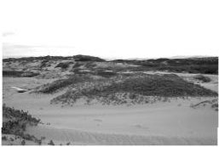
Savoy (1985) the Grover Beach shoreline is classified as a “moderate risk” with respect to possible coastal damage incurred by storm waves.
Oceano
Coastal Erosion Potential Hazard
Oceano is generally fronted by wide sandy beaches backed by low active dunes. These dunes provide protection for structures located near them, however they are subject to erosion during storm surges at extreme high tides. According to Griggs and Savoy (1985) continuous vehicle traffic on the beach and dunes is
hindering dune protection with respect to erosion. Although these sand dunes offer dwellings protection from storm waves, the winter storms of 1983 damaged structures and destroyed timber ramps which provided vehicular beach access. Therefore, according to Griggs and Savoy (1985), this region is characterized with a “moderate risk” and a “high risk” region adjacent to the Arroyo Grande Creek mouth with respect to coastal erosion.
South County
Coastal Erosion Potential Hazard
From Oceano southward to the San Luis Obispo/Santa Barbara County line, the coastline is described by the Department of Navigation and Ocean Development (1977) as “sandy beaches backed by active dunes with sparse vegetative cover, high intermediate old dunes with vegetative cover, marshes, and lakes.” Although the dune face is wave cut and experiences frequent slides, Griggs and Savoy (1985) classify this region with a “moderate risk” with respect to coastal erosion.
Return to Table of Contents

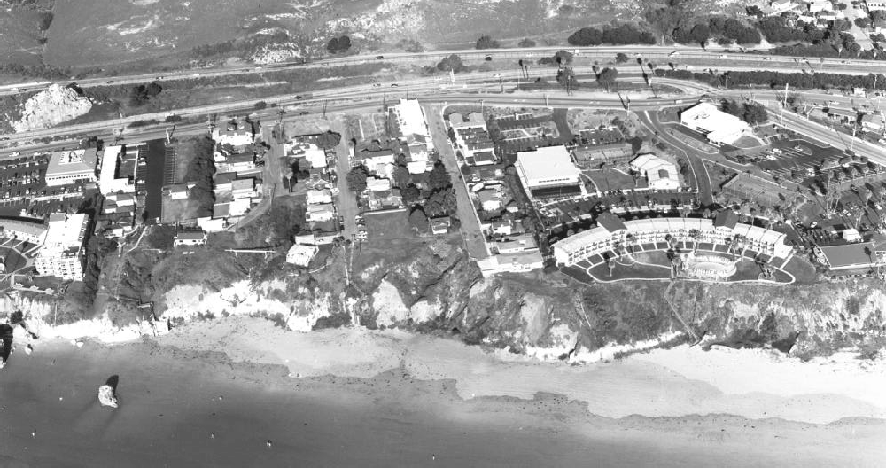

3 Fire Hazards
The public is exposed to fire-related hazards from two potential sources: wildland fires and fires that occur in urban settings. This section will describe general conditions under which both types of fires may occur, factors that may contribute to increased fire hazards, and conditions within the County of San Luis Obispo and its cities that have the potential to increase fire-related impacts.

Wildfires
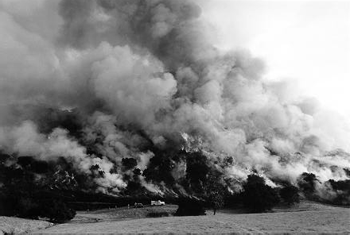
The term “wildfire” refers to fires that usually result from the ignition of dry grass, brush or timber. Wildfires commonly occur in areas that are characterized by steep, heavily vegetated hillsides, which makes suppression of the fire difficult. Wildfires play an important role in the ecology of many natural habitats; however, as urban development moves into areas susceptible to wildfire hazards, risks to human safety and property increase.
To describe an area where urban development has been located in proximity to open space, or “wildland” areas, the term “urban/wildland
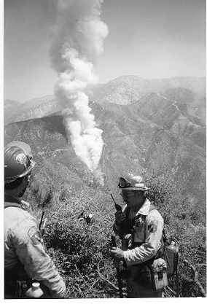
interface” is commonly used. The most common type of urban/wildland interface results when urban development occurs on the fringe of existing urban areas, adjacent to wildland vegetation. Other interface conditions can be created when urban development is intermixed with wildland vegetation, or when pockets of wildland vegetation occur inside developed areas. The communities of Cambria and Nipomo are examples of intermixed urban/wildland interface areas. Fires that occur in urban/wildland interface areas affect both natural resources and developed areas, and have been described as: “a fire moving from a wildland environment, consuming vegetation for fuel, to an environment where structures and buildings are fueling the fire” (California Resources Agency, 1996).

Hazard Description
Influences on Wildfire Impacts
The fire hazard severity assigned to state responsibility areas for fire protection area dependent upon the historic climate, fuel conditions (vegetation), and topography. Based on these parameters, the fire hazard severity is determined to be either very high, high, or moderate. Currently, population density or the number of structures in a given region have no influence in the determination of the fire hazard severity for a particular region. Human actions influence the potential for wildfires. These four factors (historic climate, fuel conditions, topography, and human actions) are briefly described below.

Fire Hazard Severity Zones (FHSZ)
California Department of Forestry and Fire Protection (CAL FIRE) develops and maintains maps that track fire hazard severity based on conditions like fire history, vegetation, terrain, and weather through their Fire and Resource Assessment Program (FRAP). These fire hazard severity zones (FHSZ) reflect the potential for fire hazards in an area and range from Very High, High, to Moderate FHSZ, and are shown in Map 7. Figure 1 below shows Local, State, and Federal Responsibility Areas in San Luis Obispo denoting which agencies are responsible for fire suppression in that area.

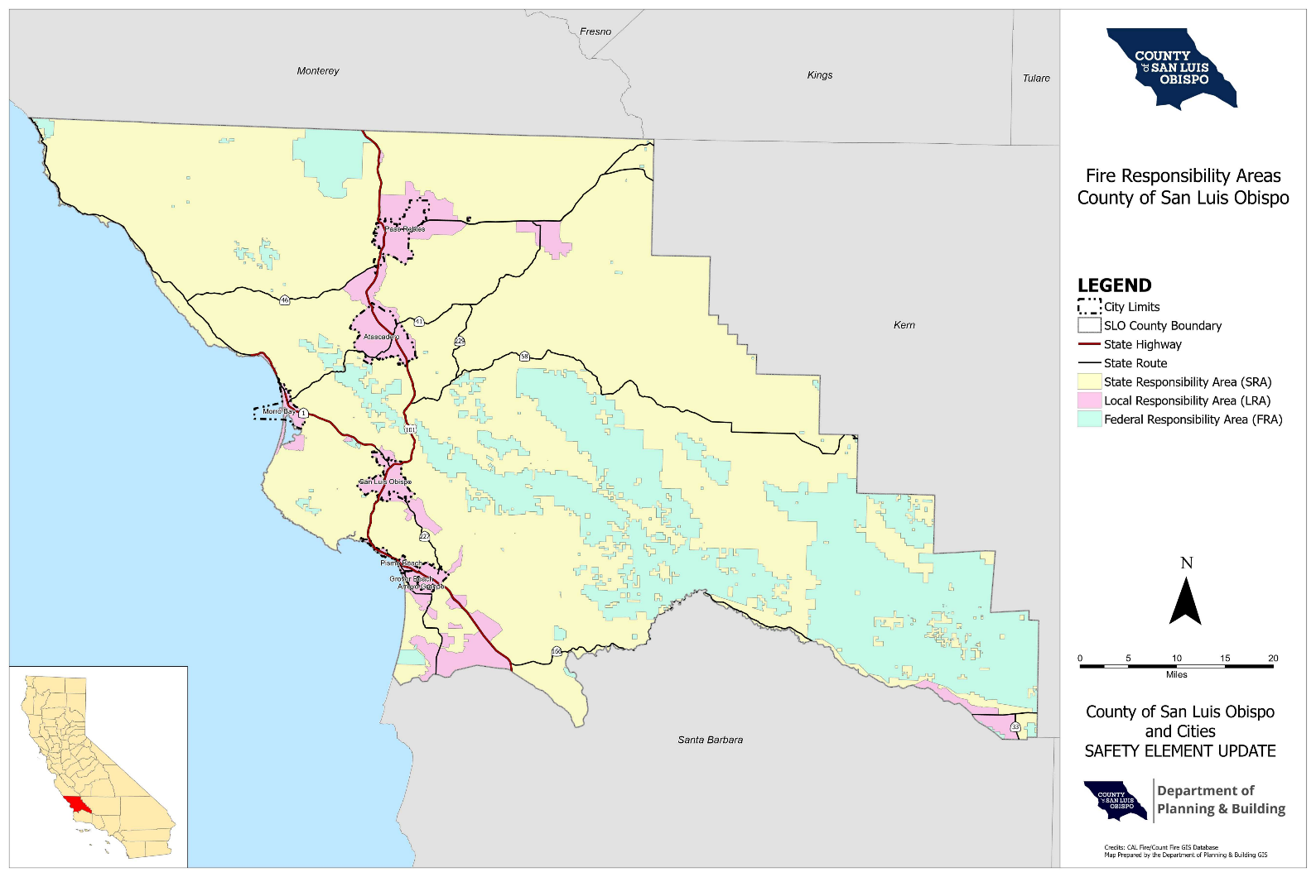
Unincorporated communities in the county fall within SRAs and are served by CAL FIRE for fire suppression services. CAL FIRE is a state agency, and thus land use and development projects in SRAs are subject to requirements found in state building code and fire safety code. These standards reduce the risk associated with fire hazard and are reflected in implementing strategies of Policy S-17 in Chapter 4 Fire Safety.
Figure 1: Fire Responsibility Areas

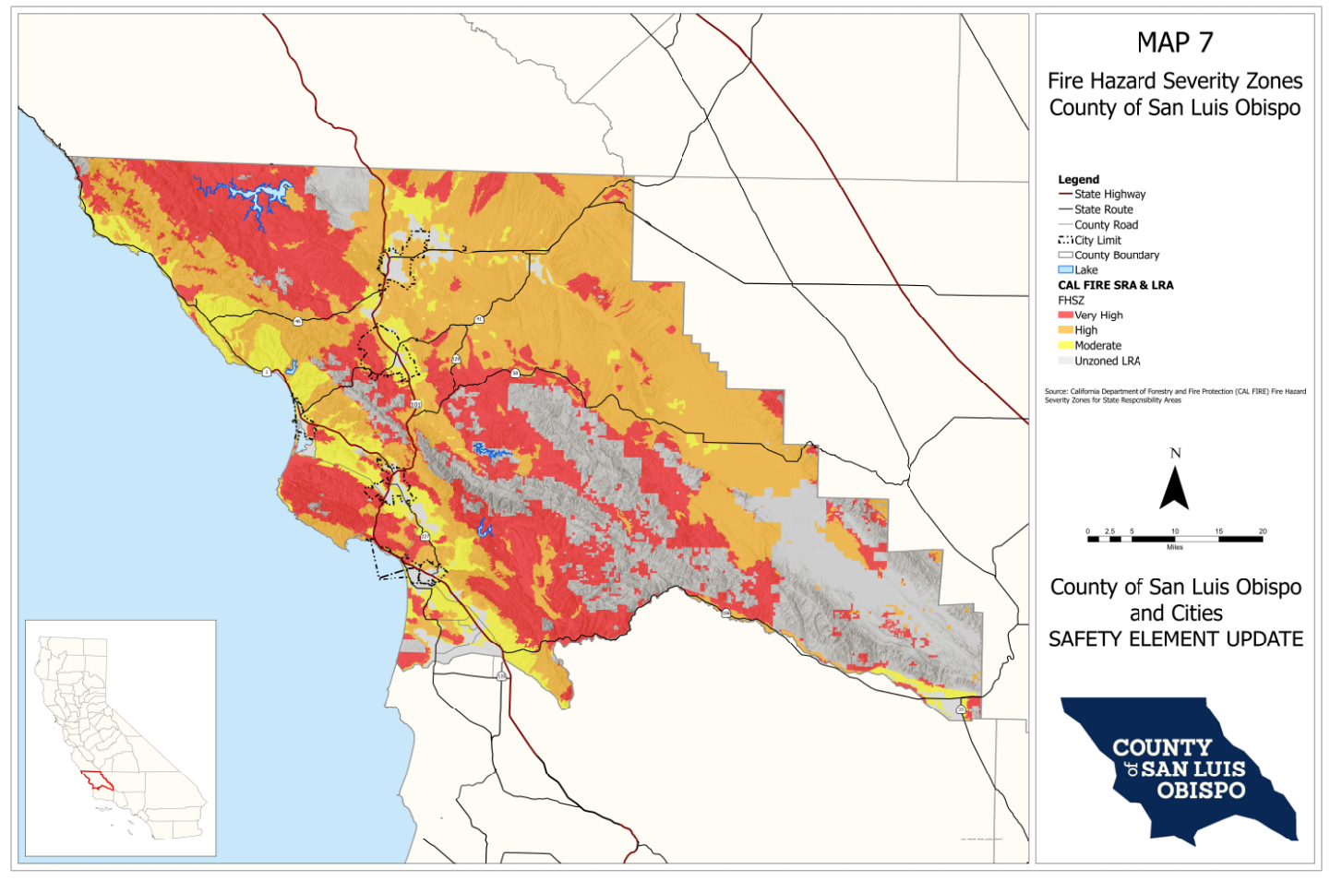

San Luis Obispo County Fire Hazard Severity Zone Map. Source:Office of the State Fire Masrshal
Historic Climate
The climate in San Luis Obispo County is generally referred to as “Mediterranean” with warm dry summers and relatively cool, moderately wet winters. Rainfall throughout the County occurs primarily between November and April, and ranges between 20-25 inches per year in the coastal

areas, to less than 10 inches per year in inland areas. Climatic conditions throughout the County range from the cool, damp coastal areas, to hot and dry inland areas.. Because summers are generally warm and dry, the risk of wildfires is highest in late summer and early fall. Fog and cool weather that are common in the coastal regions help to maintain moisture levels in vegetation along the coast, which helps to minimize fire risk. The hot and dry conditions of the Santa Lucia Mountains and the inland plains and valleys of the County, however, can quickly desiccate vegetation resulting in an increased fire risk.
Other weather-related elements can have complex and important effects on wildfire intensity and behavior. Wind is of prime importance because as wind velocity increases, the rate of fire spread also increases. Gusty and erratic wind conditions can cause a fire to spread irregularly, making it difficult to predict its path and effectively deploy fire suppression forces. Relative humidity is also an important fire-related weather factor . As humidity levels drop, the dry air causes vegetation moisture levels to decrease, thereby increasing the likelihood that plant material will ignite and burn.
Fuel Conditions
A large portion of the County is covered by natural vegetation. This vegetation can be grouped into approximately 14 regimes, each of which contributes varying degrees to fire hazard severity. Table 3-1 depicts general vegetation communities that are found throughout the County, and their likely relative fire hazard severity rated by fuel conditions only. The likely fire hazard severity depicted in Table 3-1 can be influenced by many factors, including the age of vegetation, accumulation of dead plant material, vegetation management programs that may have been implemented, period of time since a stand of vegetation was last burned, historic climate, and topography of the region. Chaparral plant communities present the most significant fire hazard severity, as this type of vegetation burns with intense heat and the amount of fuel available to burn can be very high if the area is not properly managed or has not been recently burned. Controlled burning is one method that can greatly reduce the fire hazard severity for a given area. In developed areas, some ornamental plantings can provide hazardous fuel loading. A significant increase in dead material as the result of insect or disease infestations can lead to a much higher fire hazard. The pitch canker infestation in Cambria is an example of this problem.
Topography
Steep terrain plays a key role in the rate at which wildfires spread, as fires will normally burn much faster uphill. Generally, when the gradient of a slope doubles, the rate of spread of a fire will also double. Steep topography also channels air flow, thereby creating erratic wind patterns. Fire suppression in steep areas is also complicated by limited accessibility, and the effectiveness of firefighters and equipment are hampered by lack of access roads.

Table 3-1: Likely Fire Hazard Severity Rated by Fuel Conditions Only
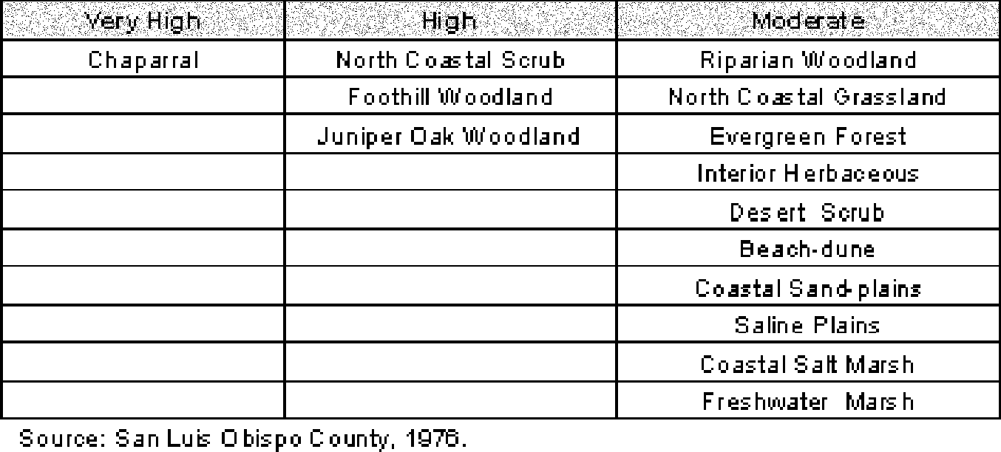

Human Actions
Most wildfires are ignited by human action, and may result from direct acts of arson, carelessness, or accidents. Many fires originate adjacent to roads and highways, often as a result of the careless disposal of cigarettes or other burning objects from passing automobiles. Recreation areas that are located in high fire hazard areas, such as within the Los Padres National Forest, also result in increased human activity that can increase the potential for wildfires to occur.
Effects of Wildfires
Wildfires have several types of impacts on the natural environment. Some ecosystems are dependent upon recurrent fire to survive, and have adapted to reestablish themselves after a fire. These types of adaptations are common in the chaparral plant community, which typically has a very high wildfire risk. After a wildfire stops burning, the burned land is laid bare of its protective vegetation cover and is susceptible to excessive run-off and erosion from winter storms. The intense heat from the fire can also cause a chemical reaction in the soil that makes it less porous, and the fire can destroy the root systems of shrubs and grasses that aid in stabilizing slope material. When the winter rains come, the possibility of severe landslides and debris/mud flows is greatly increased.
In addition to damage to natural environments, wildfires result in a high risk for personal injury, loss of life to inhabitants of the fire area and firefighters, and losses of structures and personal property. Public utilities are often strained by the impacts of wildfire, including depletion of water reserves, downed power lines, disrupted telephone service and blocked roads. Furthermore, flood control facilities may be inadequate to handle an increase in storm runoff, sediment, and debris that is likely to be generated from barren, burned- over hillsides. The impacts of wildfires on developed areas is being used by CAL FIRE to reevaluate fire hazard on certain sites. Cambria, with its extensive development in a declining native forest, will likely increase from moderate to high fire hazard in the reevaluation process.

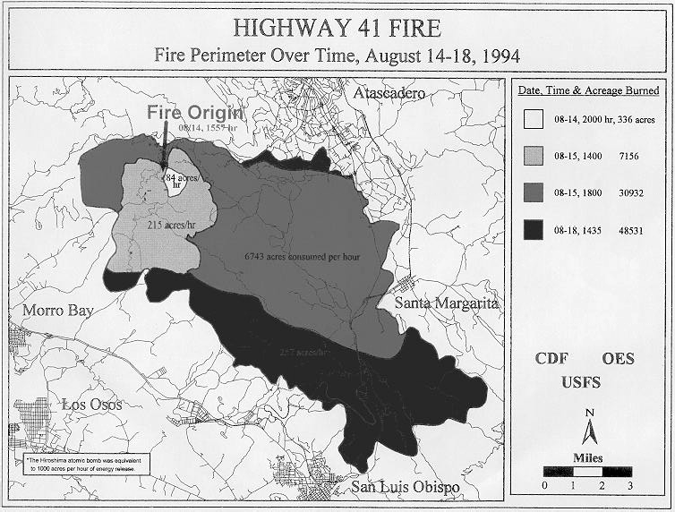

Table 3-2: Major Wildfires in San Luis Obispo County Since 1900 (Fires Greater than 20,000 acres)

Fire Name | Year | Approx. Acres Burned | Damages
Avenal’s Fire | 1917 | 21,242 | Unknown
Unnamed Fire | 1921 | 63,909 | Unknown
Unnamed Fire | 1922 | 25,637 | Unknown
Machesna Fire | 1939 | 28,313 | Unknown
Pilitas #1 Fire | 1950 | 22,844 | Unknown
Sam Jones Fire | 1953 | 35,455 | Unknown
Big Dalton Fire | 1953 | 67,701 | Unknown
Weferling Fire | 1960 | 51,451 | Unknown
Buckeye Fire | 1970 | 42,307 | Unknown
Las Pilitas Fire | 1985 | 84,271 | Destroyed 10 homes
Highway 41 Fire | 1994 | 50,729 | Destroyed 42 homes, 61 other structures, and 91 vehicles
Highway 58 Fire | 1996 | 106,969 | Destroyed 13 homes, numerous other structures & vehicles
Logan Fire | 1997 | 49,490 | None (remote, unpopulated area)
Chimney Fire | 2016 | 46,344 | Destroyed 49 homes and 21 other structures
Alamo Fire | 2017 | 28,834 | Destroyed one home and 13 other structures
Source: FRAP

Historic Wildfires in San Luis Obispo County
Significant wildfires have occurred throughout San Luis Obispo County. Most recently, the Logan fire that occurred in 1997 burned 50,000 acres and cost $6 million to put out. No structures were lost in the Logan fire. Also, the Highway 41 and Highway 58 fires that occurred in 1994 and 1996 caused widespread and substantial damage. The Highway 41 fire resulted in the destruction of 42 homes, 61 other structures, and 91 vehicles. A total of 48,531 acres were burned and an estimated $7,000,000 in property loss damages occurred. The Highway 58 fire burned 106,668 acres and resulted in the loss of homes and 14 structures.
A summary of major wildfires that have occurred in San Luis Obispo County is provided on Table 3-2. This table, however, does not list the numerous smaller fires that have occurred throughout the County. Several areas of the County that have been subject to a high number of smaller fires include the Santa Margarita area, which has experienced numerous fires 50-500 acres in size, and areas west of Nipomo that have experienced numerous fires 50-300 acres in size. Still another location with a high occurrence of wildfires is near the Nacimiento Reservoir, located in the northwest portion of the County.
Fire Prevention and Response
An extensive amount of literature exists pertaining to steps that can be taken to reduce the potential for wildfires. Additionally, a number of legislative and advisory standards have been developed. Although these measures cannot eliminate the risk of wildfire- related damages, they can help to substantially reduce the associated risk. Wildfire hazard reduction measures generally include implementation of the following precautions.
Use fire resistant building materials and construction methods. Many standards have been adopted to reduce the use of combustible building materials in high fire hazard areas. Standards for fire resistive building materials and construction methods are

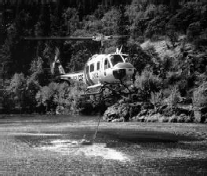
provided by the California Building Code, California Fire Code and Fire Safe Regulations, and specific sections of the California Health and Safety Code. Additionally, AB 3819, which was adopted after the disastrous Oakland/Berkeley Hills fire of 1991, and the major wildfires that occurred in southern California in 1993, requires the California State Fire Marshall to establish building standards for areas that have been designated with a high wildfire severity rating by the California Department of Forestry and Fire Protection.
Provide defensible space around structures. This broad measure includes a number of specific actions that can be taken to minimize wildfire risks. Providing a defensible space area around a structure
serves a dual function of limiting fuel for the fire to approach the structure, as well as providing a position from which fire fighters can combat the blaze. Wildfire risk reduction and management practices can include the removal or thinning of highly combustible vegetation, the use and maintenance of fire resistant plantings, providing clearings around structures and other combustible materials, and the implementation of a variety of other fuel reduction and fire prevention/suppression measures. Specific measures that should be implemented depend upon the type of structures to be protected and their proposed use, expected fire characteristics, and infrastructure that would be available in the event of a fire.
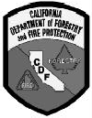
Provide adequate water supply. Water that is used for fire suppression purposes, and the pressure under which it is delivered, is referred to as “fireflow.” The fireflow that would be required for a specific development is dependent upon a variety of factors, including the type of construction, the use or occupancy of the structure, and the location of surrounding structures. For new residential development, adequate fireflows may range from 1,000 to 2,000 gallons per minute at 30 psi, for a period of up to three hours. Several standards can be used to calculate the actual fireflow requirements for a specific project.
Provide adequate access. Adequate access to structures includes providing roadways that are passable by large fire-fighting equipment. This requires roadways to have adequate widths, as well as gradients, bridges, and turn-around areas that accommodate fire trucks.

Responsibilities for the prevention and suppression of wildfires in San Luis Obispo County belong to the U.S. Forest Service (USFS) in areas contained within the Los Padres National Forest, to the California Department of Forestry and Fire Protection (CAL FIRE) in wildland areas outside of the Forest boundaries, and the Bureau of Land Management (BLM), for areas under their jurisdiction and to individual cities within their incorporated areas.

CAL FIRE is responsible for providing fire suppression services on approximately 1.4 million acres of San Luis Obispo County. As the major fire fighting force in the County, CAL FIRE fully or cooperatively maintains 18 fire stations that are located throughout the County. Fire stations that are managed by CAL FIRE are located in the following areas: North of the City of San Luis Obispo and the San Luis Obispo Airport, Cayucos, Cambria, Nipomo and Nipomo Mesa, Morro Toro (Highway 41 between Atascadero and Morro Bay), Oak Shores (Lake Nacimiento), Heritage Ranch (Lake Nacimiento), Avila Valley, Santa Margarita, Paso Robles, Simmler, Meridian (Highway 46 east of Paso Robles), Creston, Shandon, La Panza, and Las Tablas (Lake Nacimiento). CAL FIRE maintains an extensive collection of fire fighting equipment in San Luis Obispo County, including engines, aircraft, bulldozers, water tenders, and heavy rescue vehicles.

The USFS maintains fire stations in the areas of Pozo, and Pine Canyon (Highway 166), along with a helicopter base near Lopez Lake. The USFS fire stations are also equipped with specialized wildfire fighting equipment and personnel. The BLM maintains a fire station in the Carrizo Plain area of the County.
CAL FIRE, USFS, and BLM have entered into a mutual aid agreement for the purpose of wildfire protection in San Luis Obispo County. Mutual aid agreements are reciprocal arrangements in which fire protection agencies share personnel and equipment during emergency situations. Cities and fire protection districts are also participants in various mutual aid and auto aid agreements, including the State Master Mutual Aid agreement.

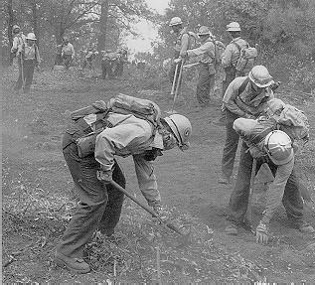
Hazard Analysis
San Luis Obispo County
Local Wildfire Hazards
San Luis Obispo County is exposed to a variety of wildfire hazard conditions ranging from very low levels of risk along the coastal portions of the County, to extreme hazards in the inland and chaparral covered hillsides of the Santa Lucia Mountains. CAL FIRE has undertaken a program to map areas of potential wildfire risk, and to describe the potential for wildfires to occur in a given area, several risk classifications have been used. Currently, fire hazard severity is a function of fuel conditions, historic climate, and topography. Population density or the number of structures in a particular region are not currently used to
determine the fire hazard severity for a particular region. Areas throughout the County have been designated as having a “Very High Severity Hazard,” “High Hazard,” or “Moderate Hazard.” In San Luis Obispo County, most of the area that has been designated as having a “Very High Severity Hazard” is located in the Santa Lucia Mountains, which extend from Monterey County to the north, to Santa Barbara County to the south. These areas exhibit the combination of vegetative fuel, topography, and human proximity that contribute to an extreme fire hazard potential. The fact that an area is in a Moderate Hazard designation does not mean it cannot experience a damaging fire. It only means that the probability is reduced, generally because the number of days a year that the area has “fire weather” is less. Wildfire risk designations for San Luis Obispo County, as identified by CAL FIRE are depicted on Map 7.
CAL FIRE is planning to reevaluate the fire hazard severity mapping for the County to give greater weight to population density and concentrations of structures in proximity to higher risk areas.
Unincorporated communities within the County that are subject to increased wildfire risks are generally those communities like Cambria and Nipomo where development has resulted in the creation of an urban/wildland interface zone. Table 3-3 identifies communities that are located in or near wildland areas and that have an increased risk of wildfire-related hazards.
When residential development occurs within or adjacent to an area that has a high wildfire hazard severity, the ability of fire fighting forces to combat a fire may also be impaired. When residences are located in the vicinity of wildfire, typical fire fighting techniques, such as the use of backfires, may not be feasible. Additionally, fire fighting equipment and personnel may be used for structure protection, instead of being used to fight the

Table 3-3: Urban/ Wildland Interface Areas of San Luis Obispo County
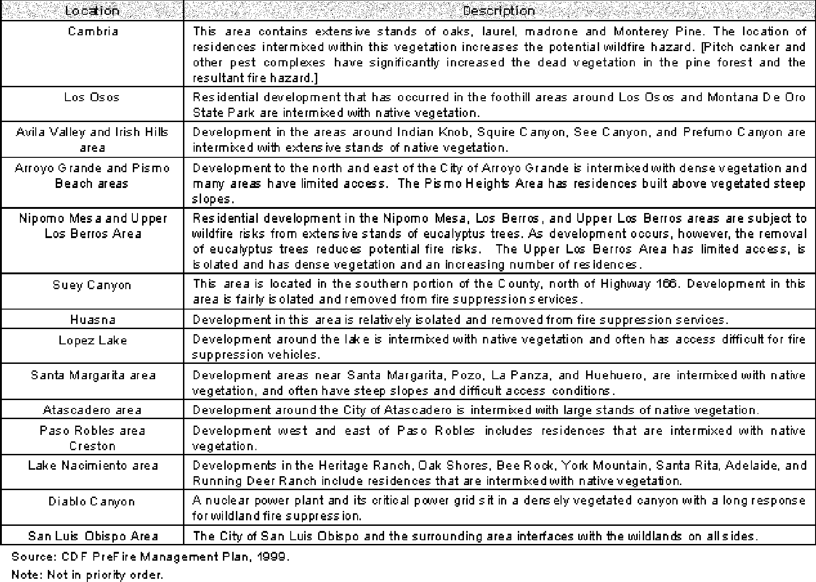

fire. This results in the need for additional equipment to effectively minimize structural losses and to control the fire.
Some unincorporated communities located within the County are not confronted with a high wildfire risk. These communities include much of the South Bay area, Cayucos, and Oceano. This low wildfire risk results primarily from the type of vegetation that is dominant throughout these areas. The low-growing native grasses and shrubs found in these communities presents a minimal vegetative fuel source and a corresponding low wildfire risk. Additionally, in the coastal communities, cool marine influenced temperatures and relatively high humidity levels help to minimize potential wildfire risks.

Arroyo Grande
Local Wildfire Hazards
The majority of Arroyo Grande is located in a generally flat valley that has been developed with urban and agricultural uses. The northern and eastern portions of the City, however, are hilly and contain parcels that are within or contiguous to grassland and forested areas. Fire protection for the residences located within these urban/wildland interface zones may be constrained by heavy fuel loads, steep slopes, limited access, and in some areas, limited water supplies. Specific areas of the City that have been identified as having potential fire suppression deficiencies are listed below.
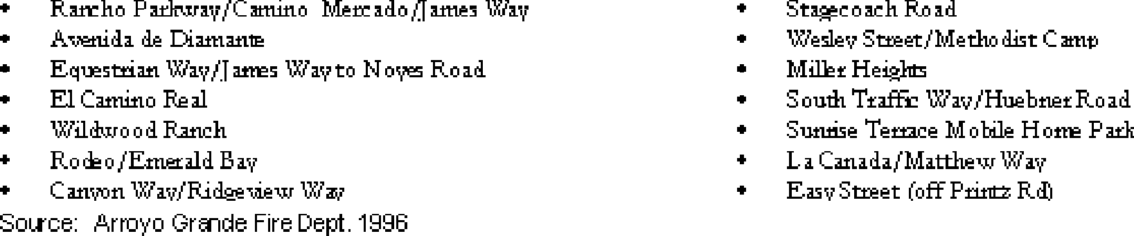

Atascadero
Local Wildfire Hazards
Wildfire and urban fire hazards are closely related in Atascadero as a result of extensive residential development that has occurred in the hilly portions of the City where flammable grassland, chaparral and oak woodland habitat is located. Much of the City can be described as being wildland/urban interface area. Several areas in Atascadero qualify as Bates-rated areas, indicating a very high hazard potential for wildfire at the urban edge. Portions of the City that have been identified as having an elevated risk for potential wildfire impacts are listed below.
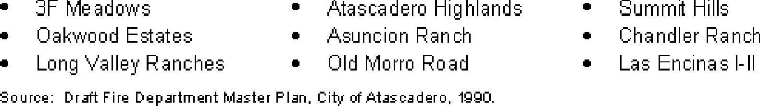

Factors that contribute to an elevated fire risk in these areas are described below.

Microclimate. Localized afternoon winds from the northwest are common in the western portion of the City. These winds are associated with inland valley heating and cooler air currents flowing from the ocean. These gusty winds can cause a grass fire to spread and shift direction in an rapid and unpredictable manner.
Topography. Much of the residential development within the City has occurred in areas with moderate to steep topography. Areas that exceed 30 percent slope are subject to rapid flame spread, and often have poor access for fire suppression equipment.
Vegetation. Areas of the City with dense stands of chaparral vegetation face an elevated risk of wildfire. In areas where chaparral vegetation has not been burned in more than 20 years, fuel loading (the amount of vegetation that is available to be burned) averages from 7 to 10 tons per acre. Drainages with oak woodlands have fuel loading that can exceed 15 tons per acre. Chaparral vegetation contains a variety of compounds, such as waxes, turpentines, and resins that cause this type of vegetation to burn intensely and at extremely high temperatures. Air temperatures in chaparral fires can exceed 1,500 degrees. The intensity of the fire that results from chaparral vegetation makes it difficult to extinguish.

Grover Beach
Local Wildfire Hazards
Grover Beach is not confronted with a significant wildfire hazard because of its location on the coast away from vegetated hillsides. High humidity levels and cool ocean-influenced temperatures also limit the potential for wildfires to occur. Open areas containing annual grasses are present in areas throughout the City, but do not represent a major wildfire risk.

Morro Bay
Local Wildfire Hazards
Morro Bay is not confronted with a significant wildfire risk, primarily due to the type of vegetation that is found throughout the City. Vegetation in the area is mostly limited to low-growing grasses and scattered shrubs, characteristic of disturbed North coastal Grasslands habitat. High humidity levels and cool ocean-influenced temperatures also limit the potential for wildfires to occur.

Areas of the City near Morro Bay State Park contain some native vegetation that present a moderate wildland/urban interface fire hazard. However, because these areas are not contiguous to other high fire hazard areas, they do not present a significant wildfire risk.

Paso Robles
Local Wildfire Hazards
Paso Robles is located in the Salinas River Valley, adjacent to the foothills of the Santa Lucia Mountains. Extensive oak woodlands, grasslands, and chaparral communities occur in the vicinity of Paso Robles, and present a high wildfire risk. The risk of wildfire within the City of Paso Robles, however, is moderate because most development has occurred in the flatter portions of the City, away from the flammable foothill vegetation. Developed areas that are adjacent to significant stands of native vegetation and that may be subject to wildfire hazards are located in incorporated areas west of the City. A fire that begins in this area could migrate towards the City posing potential wildfire risks, particularly for areas of the City located between 14th and 38th Streets (Hemp, 1997).

Future residential development within the City is most likely to occur in the eastern portion of the City. While not as mountainous as the areas further to the east, this portion of the City is also adjacent to areas containing significant amounts of native vegetation. Therefore, there is the potential for a wildfire to affect this part of the City.

City of San Luis Obispo
Local Wildfire Hazards
The City of San Luis Obispo is confronted with one of the more hazardous urban/ wildfire risks in the County because of its location near the foothills of the Santa Lucia Mountains and the Irish Hills. For planning purposes, the entire perimeter of the City should be considered as an urban/wildland interface area. Specific areas with an increased wildfire hazard include the foothills northeast and southwest of the City and on Cerro San Luis Obispo, Bishop Peak, Chumash Peak, and Islay Hill. Although the Las Pilitas and Highway 41 fires that occurred in 1985 and 1994 did not result in property losses within the City limits, structures in the City were threatened by these fires (Dougherty, 1997). The Fire Prevention Code that has been adopted by the City considers all areas within the jurisdictional limits of the City to be subject to regulations pertaining to hazardous fire areas, such as requiring the installation of fire resistive roofing materials.

Urban Fire Hazards
Hazard Description
Influences on Urban Fire Hazards
The risk to life and property resulting from fires in urban settings is influenced by many factors. Some of the factors that must be considered when assessing potential urban fire hazards and the appropriate level of fire protection that should be provided include the following:

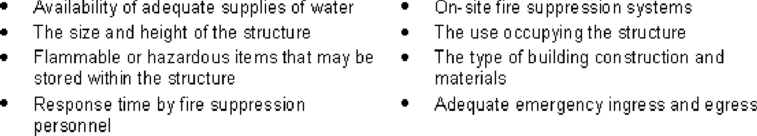

Different types of structures and land uses present their own fire prevention and suppression characteristics and potential problems. In the developed area throughout San Luis Obispo County, residential structural fires are the predominate urban fire risk. This risk is increased when development is located in urban/wildland interface areas, such as hillside and canyon areas. The additional fire risk associated with residential development in urban fringe areas results from the proximity of structures to flammable vegetation, the increased distance from fire protection services, limited access, and potential for low fire flows for combating fires.
Effects of the Hazard
The potential for loss of life and property from urban fire hazards is greatest in places where large groups of people gather, such as offices, stores, hotels, and theaters. Uses which may suffer large monetary losses due to a major fire include businesses, factories, and shopping areas. Types of development and conditions that present the most difficult fire-protection problems in urban areas include:
- Multiple-story, wood frame, high-density apartment developments;
- Developed areas where structures have little or no setbacks;
- Structures that contain combustible roofing and other building materials;
- The storage, handling, and use of hazardous materials; and
- Natural disasters.

Fire Prevention and Response
Fire prevention is a primary objective and the major activity of fire departments in urban areas. After a fire starts, it is the objective of the fire department to minimize the damage to life and property. To minimize potential fire risks, a variety of legislative and advisory programs have been developed. Some of these programs include:
California Fire Code
This Code may be adopted by local jurisdictions, with amendments, and provides minimum standards for many aspects of fire prevention and suppression activities. These standards include provisions for access, water supply, fire protection systems, and the use of fire resistant building materials.
California Health and Safety Code and the California Building Standards Code
The Health and Safety Code provides regulation pertaining to the abatement of fire- related hazards. It also requires that local jurisdictions enforce the California Building Standards Code, which provides standards for fire resistive building and roofing materials, and other fire-related construction methods.
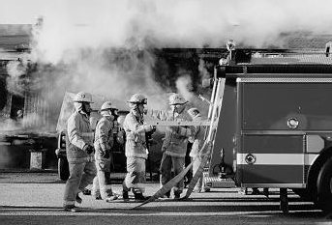
Title 14 of the California Code of Regulations These regulations pertain to fire prevention and engineering measures for new construction.
Title 14 of the Public Resources Code
These regulations provided additional fire prevention and suppression standards.
Assembly Bill 337 (Bates Bill)
In response to the Oakland Hills fire of 1991, this bill was passed in 1992. It requires brush clearance and fire resistant roof material (Class A or B) to be used on all new construction that is located in areas

designated as being a “Very High Fire Hazard Severity Zone.”
After a fire has started, the time necessary for fire fighters to respond to the scene is a critical factor in protecting public safety and minimizing property damage. Optimum response times (approximately five minutes or less) can typically be provided if a fire station is less than 1.5 miles from the response location in an urbanized area. When making determinations about fire station locations, the type and density of development that exists in an urbanized area, along with future land use plans, should be considered. Other factors that may also influence the location of fire stations includes roadway and traffic conditions, topography, and possible access obstructions such as freeways and railroad tracks.
The amount of water that is available to fight a fire, along with the pressure at which the water is delivered and for how long it can be provided, is referred to as “fireflow.” Building construction, the proximity to other structures, the proposed use of the structure, and the provision of on-site fire protection systems, are all considered when determining the minimum fire flow that is required to provide adequate fire suppression protection. In urban areas, fireflow requirements may typically range between 1000 and 5000 gallons per minute for two to five hours. Actual fireflow requirements are calculated based on site conditions.
Senate Bill 1241
Senate Bill (SB) 1241 was passed in 2012 is aimed at protecting current and future development from wildfire. The bill requires local jurisdictions to incorporate fire hazard planning as a component of Safety Elements by providing information and requirements for fire hazard severity zones (FHSZ). The bill aims to protect existing and future development in FHSZ and reduce financial and staff strains for fire suppression agencies by improving fire safety and reducing the need for fire suppression.
Requirements of SB 1241 have been incorporated into the implementing strategies in Chapter 4 Fire Safety.

Hazard Analysis
San Luis Obispo County
Existing Fire Protection Services
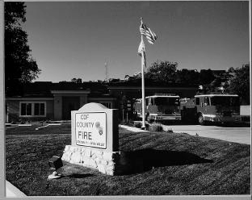
Urban fire prevention and suppression services for the unincorporated areas of San Luis Obispo County are provided by a combination of agencies and departments, including the California Department of Forestry and Fire Protection (CAL FIRE), the County of San Luis Obispo, fire protection districts, community service districts, and volunteer fire companies. CAL FIRE is responsible for the administration of the fire stations that serve the unincorporated areas of the County not within fire protection or other special districts, and provides equipment and training for the volunteer stations. Table 3-4 lists the existing fire stations that are located in the unincorporated areas of the County, and what agency/ department is responsible for the station operation. The locations of the listed fire stations are depicted on Map 8.
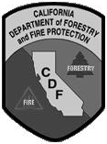
Ordinances and Regulations
Several local ordinances direct fire prevention activities within San Luis Obispo County. These include Chapter 19.20, Construction Standards of Title 19, of the County Code; as well as Section 22/23.05.050 et. seq. of the Land Use Ordinance and Coastal Zone Land Use Ordinance. These sections of Titles 22 and 23 contain standards pertaining to the preparation and review of fire safety plans, fire safety standards, site access, and driveway requirements. In addition, the provisions of the California Fire Code have been adopted by San Luis Obispo County.

Table 3-4: Fire Stations in the Unincorporated Areas of San Luis Obispo County
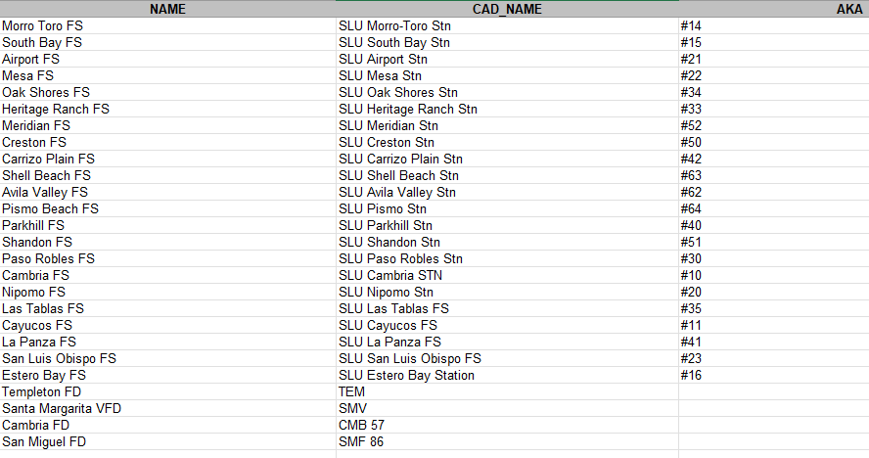

Local Fire Hazards
Los Osos
Existing Fire Protection Services
Fire suppression, fire prevention, and paramedic services within the community of Los Osos are provided by the Los Osos Community Services District Fire Department. The fire station is located at 2315 Bayview Heights Drive and is centrally located within the community. The Department is presently staffed with eight full-time professional firefighters and officers, along with four Contract Firefighters and 20 Reserve Firefighters that work part-time. A full-time secretary is included in the staff of 32 personnel. Fire response equipment that is operated by the Department include:

(2) 1500 gpm pumpers;
(1) 1250 gpm pumper;
(1) 150 gpm brush patrol;
(1) Paramedic rescue squad; and
- Command unit.

Local Fire Hazards
The area is characterized by low to medium density housing and limited commercial activities. Surrounding the developed community are hundreds of acres of agriculture and chaparral covered lands, including Montana de Oro State Park. The chaparral covered lands present a moderate fire hazard during most of the year due to the coastal influence;

however, these lands present a high fire hazard area that is weather-induced during some times of the year.

Ordinances and Regulations
The California Fire Code and SRA Fire Safe Regulations have been adopted as a local ordinance, and the Department enforces the County of San Luis Obispo Land Use Ordinance along with Title 14 and some sections of Title 24 of the California Administrative Code.

Cayucos, Cambria, Nipomo, and Oceano
Each of these communities are developed with primarily low-density residential uses with supporting commercial uses. With the general absence of dense or hazardous land uses, basic fire protection and response needs are met by providing a minimum level of structural fire protection. However, Cambria and Nipomo’s fire needs are greater because their intermixed wooded areas are urban/wildland interfaces representing a higher level of risk than the other coastal communities. Fire protection services could be improved in these communities by providing additional fire fighting equipment, increasing water supplies, and continuing to add full-time professional fire fighting personnel to augment existing volunteer forces. As density increases and if fuel conditions become more hazardous in areas like Nipomo and Cambria, these areas may require additional mitigation measures and fire protection. However, the cost of providing additional fire prevention and suppression services must be weighed against the need for additional protection and the benefit that may be derived.

Arroyo Grande
Existing Fire Protection Services
Fire suppression and prevention services within the Arroyo Grande are provided by the City of Arroyo Grande Fire Department. The City’s only fire station is located at 140 Traffic Way. The station was constructed in 1980 and is considered to be adequate to serve the fire protection needs of the City. The Fire Department is staffed with a professional fire chief, plus a volunteer force. Fire response equipment that is operated by the City includes:
(2) 1500 gpm pumper;
(1) 1250 gpm pumper;
(1) 1500 gpm, 75-foot elevated stream ladder truck;
(1) heavy rescue squad;
(1) 500 gpm combination brush/structure engine;
(1) 95 gpm brush truck;
(1) hazardous material unit; and
(1) mass casualty unit.

Ordinances and Regulations
The City of Arroyo Grande adopted the 2022 California Fire Code with several amendments.
Local Fire Hazards
Urban fire hazards in Arroyo Grande are generally associated with residential development that has occurred within the rural portions of the City, or the urban/wildland interface zone. Increased fire risk in these areas generally results from potential access problems for fire fighting equipment, and reduced fire flows. In the more urban portions of the City, no concentrated areas with deficient access or water supplies have been identified. Access and fire flow requirements that are required for new construction are based on the requirements of the California Fire Code.

Atascadero
Existing Fire Protection Services
Fire suppression and prevention services within Atascadero are provided by the City of Atascadero Fire Department. The Department is presently staffed with 15 professional firefighters. The City operates two fire stations: Station No. 1 is located at 6005 Lewis Avenue, and Station No. 2 is located at 9801 West Front Street. Fire response equipment that is operated by the City includes:

(2) 1250 gpm pumper;
(1) 1000 gpm pumper;
(1) State-owned 1,000 gpm pumper; and
(2) Mini pumpers

In a report titled Draft Master Plan for Fire and Life Safety Services (1990), it was recommended that a new fire station be considered in the southwest section of the City in the vicinity of Santa Ana Road and Santa Lucia Road. Another new station was recommended for the northwest portion of the City near San Ramon and Del Rio Roads. These stations were recommended because of the excessive distance from the present stations to these areas of the City. Properties have been purchased for these stations, however, it is uncertain when funding will be available for their construction.
Ordinances and Regulations
City Ordinance No. 304 amended Title 6, Chapter 13 of the Atascadero Municipal Code to provide a mechanism to allow the Fire Chief to order the removal of weeds, rubbish, and similar material that has the potential to become a fire or health and safety hazard. If compliance with the order is not provided in a reasonable period of time, the City may contract to have the hazard abated. A tax lien for the cost of removing the hazard will then be placed on the property until it is paid. City Ordinance 661 adopted the 2022 edition of the California Fire Code, with certain revisions, as part of Title 4 Public Safety.
Potential Fire Hazards
Urban fire hazards in Atascadero are closely related to wildfire hazards, and are generally associated with residential development that has occurred in the hillside and perimeter areas of the City, or the urban/wildland interface zone. Residential development that has occurred in the hillside areas of the City has resulted in a condition where extensive areas with native vegetation are intermixed with residential uses. Fire suppression in these areas is often made difficult due to limited access, large quantities of fuel material near structures, inadequate hydrant spacing, and reduced fire flows. In response to the requirements of AB 337 (Bates bill), three areas within the City have tentatively been designated as “Very High Fire Hazard Severity Zones.”
Not all of the City is affected by fire protection issues associated with the urban/wildland interface zone. In the main commercial area of the City, no significant access or water supplies problems have been identified.
Access and fire flow requirements that are required for new construction are based on the requirements of the California Fire Code. Fire sprinklers are required for structures exceeding 5,000 square feet and all new construction is required to have Class A roofing material or better. If it is not feasible for new development to meet the specified minimum requirements, the Fire Department may consider alternative methods of fire protection, such as the provision of fire sprinklers within residential structures.

Grover Beach
Existing Fire Protection Services
Fire suppression and prevention services within Grover Beach are provided by the Grover Beach Fire Department. This department is a volunteer organization, headed by a Public Safety Director. The City’s only fire station is located at 867 Ramona Avenue. Earthquake safety deficiencies have been identified for the fire station structure that will require modifications to correct. The City is attempting to secure funding that would be used for modifications to the existing station or to build a new station. Fire response equipment that is maintained by the Department includes the following:
(2) 1,500 gpm pumpers;
(1) 1,000 gpm pumper; and
(1) Rescue squad truck.

Ordinances and Regulations
The 2022 California Fire code provides the basis for fire regulations in the City of Grover Beach.

Local Fire Hazards
The low density urban development that is predominant in Grover Beach helps to minimize potential urban fire prevention and suppression hazards. The City has historically had a fire suppression problem related to inadequate spacing of fire hydrants, which can limit the effectiveness of fire suppression efforts. New development proposals are reviewed to ensure that adequate access to fire hydrants is provided. Fire flow and access requirements for new development are based on the specifications contained in the California Fire Code.

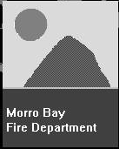
Morro Bay
Existing Fire Protection Services
Fire suppression and prevention services within the City of Morro Bay are provided by the Morro Bay Fire Department. The Department is staffed by professional fire fighters and a volunteer force. The City’s main fire station is located at 715 Harbor Street, and an unstaffed station is located in the northern portion of the City at 460 Bonita Street. Both stations have design and construction deficiencies that could result in structural damage in the event of an earthquake. A site for a new fire station site has been identified on the southwest corner of Highway 1 and San Jacinto Street. Fire response equipment that is operated by the City is listed below.

(2) 1,500 gpm pumpers;
(1) 750 gpm pumper;
(1) 75-foot elevated stream ladder truck;
(1) 4-wheel drive squad vehicle;
(1) hazardous material vehicle; and
(2) harbor boats with 250 gpm pumps.

Ordinances and Regulations
The City of Morro Bay has adopted several fire prevention ordinances as part of the municipal code (MBMC) to address several general and specific fire safety concerns. Fire prevention ordinances include the following:

MBMC Chapter 8.12: Weed abatement. This ordinance provides a mechanism to allow the Fire Chief to order the removal of weeds, rubbish, and similar material that

has the potential to become a fire or health and safety hazard. If compliance with the order is not provided in a reasonable period of time, the City may contract to have the hazard abated. A tax lien for the cost of removing the hazard will then be placed on the property until it is paid.

MBMC Section 8.16.280: Solid waste management, burning refuse. This section of the Municipal Code prohibits the burning of refuse within the City limits.

MBMC Chapter 14.08: Fire Code. This chapter of the Municipal Code adopts the California Fire Code, with amendments.

MBMC Section 14.60.200: Automatic sprinkler systems-fire resistive roofs. These regulations require the installation of fire sprinklers in new buildings that exceed 5000 square feet, existing buildings over 5000 square feet where modifications are proposed that will increase potential fire risk, and all new construction west of the Embarcadero. As part of the fire resistive roof requirements, wood shake and shingle roofs are prohibited.

MBMC Section 14.60.210: Spark Arrestors. This section requires spark arrestors on all chimneys.

Local Fire Hazards
Fire protection issues of concern in the City of Morro Bay occur in the northern portion of the City where dense residential development, as well the construction of hillside homes, present potential suppression problems. Poor access in the waterfront area of the City also presents a potential fire protection hazard. Another fire protection risk that exists within the City pertains to the presence of older buildings in the downtown area that do not provide fire-resistant construction and have minimal side yard setbacks.
In the northern portion of the City, residential development has occurred in hillside areas. Difficult access for fire vehicles and the potential for steep topography to contribute to the spread of fire create an increased fire suppression risk in the hillside areas. Other residential development in the northern portion of the City has resulted in dense concentrations of structures with minimum setbacks. To address previous problems that were associated with low water pressure for fire suppression purposes in the northern section of the City, new water lines were installed in the 1980’s. Water supply capabilities are now adequate throughout the City. For new construction, fireflow and access requirements are based on the provisions specified by the California Fire Code, which has been adopted by the City (Jones, 1997).
Access to the waterfront area of the City is constrained by two factors: crowded conditions, particularly in the summer months; and poor access to buildings that front the water. Building access in the waterfront area is also constrained by the presence of numerous structures that do not provide sideyard setbacks. To help address these issues, the City operates two fire boats, however, the vessels have minimal pumping capabilities. The City has also adopted an ordinance that requires automatic sprinklers to be installed in all new construction located to the west of The Embarcadero. The acquisition of the City’s elevated ladder truck has also improved the Fire Department’s ability to apply fire suppression water to structures in the waterfront area (Jones, 1997).

Paso Robles
Existing Fire Protection Services
Fire suppression and prevention services within Paso Robles are provided by the Department of Emergency Services. The Department of Emergency Services operates

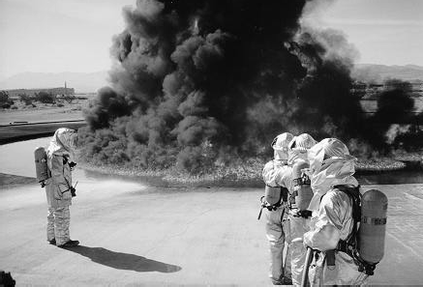
three fire stations: Station No. 1 is located at 13th and Spring Streets, Station No. 2 is located at Santa Fe Avenue and Creston Road in the Sherwood Acres area, and Station No. 3 is at the Paso Robles Municipal Airport. All three stations are small and have difficulties accommodating the size of modern fire trucks. The Department is staffed by 6 professional fire firefighters, providing for two on-duty personnel at any one time, along with a contingent of volunteers. Fire response equipment that is maintained by the Department includes the following:

(3) 1,500 gpm pumpers;
(2) 1,250 gpm pumper; and
(1) 1,000 gpm airport crash truck.

Ordinances and Regulations
The City has adopted the most current Fire Code with certain amendments. The City has also adopted a weed abatement ordinance.
Local Fire Hazards
Conditions that contribute to urban fire hazards in Paso Robles are primarily associated with access difficulties from the existing fire stations, providing adequate fire suppression service at the Paso Robles Airport, and reliance on volunteer fire fighting personnel. In addition, there are approximately 40 buildings beyond the effective reach of fire ground ladders. This will require acquisition of an aerial truck with at least a 75-foot reach.
Access problems from the existing fire stations are created by U.S. Highway 101 which splits Paso Robles roughly in half, creating eastern and western segments of the City. With limited access to and across the highway from City surface streets, fire trucks often cannot take a direct route to an emergency call on the opposite side of the highway.
Fire fighting equipment at the Paso Robles airport consists of a government surplus crash truck. This vehicle, however, often has mechanical problems that limit its effectiveness. Another fire suppression constraint at the airport is the absence of fire hydrants within the runway area. Airports will often provide subterranean hydrants within the runway that provide a source of fire suppression water. Without any hydrants near the runway area, the only water available for fire suppression in the event of a runway accident is what can be carried on the response vehicles. A potential safety and access conflict with the location of the airport fire station also results from existing airport operations. Located adjacent to the fire station is a helicopter flight-training school. This results in students making practice take-offs and landings adjacent to the fire station. It is possible that access to and from the fire station could be impeded in the event of a training accident (Hemp, 1997).
The Paso Robles Department of Emergency Services relies on volunteer fire fighters to supplement the permanent staff of six career fire fighters. On occasion, there has been insufficient response by the volunteers to adequately respond to emergency calls. A shortage of trained personnel responding to a major emergency would have the potential to result in significant life and safety hazards to the community and the fire fighters.

Generally, adequate fire flows are available for fire suppression purposes throughout the City. For new construction within the City, fire flow and access requirement are based on the provisions of the California Fire Code. These requirements may be modified based on the needs of a particular project. For example, residences may be required to provide structural sprinkler systems if response times from a fire station would not be sufficient to provide adequate protection.

San Luis Obispo
Existing and Planned Protection Services
Fire suppression and prevention services within San Luis Obispo are provided by the City of San Luis Obispo Fire Department. The Department is staffed with 54 full-time personnel, and has four fire stations at the following locations:
- Station No. 1, 2160 Santa Barbara Avenue;
- Station No. 2, 136 North Chorro Street;
- Station No. 3, 1280 Laurel Lane; and
- Station No. 4, 1395 Madonna Road.

Fire Station No. 1 was relocated to its present location in June 1996. The Fire Department reports no structural or operational deficiencies that are associated with the fire stations (Dougherty, 1996). With the existing fire stations, the Department generally achieves its goal of providing a four-minute or less response time for emergency calls. Fire response equipment that is maintained by the City includes the following:
(5) 1,500 gpm pumpers;
(1) 1,250 gpm pumper;
(1) 1,000 gpm pumper; and
(1) Aerial truck.

Ordinances and Regulations
The City of San Luis Obispo has adopted the California Fire Code with amendments. Chapter 8.08 of the Municipal Code pertains to hazardous weeds and debris, and provides a mechanism to allow the Fire Chief to order the removal of weeds and debris that has the potential to become a fire, health, or safety hazard. If compliance with the order is not provided in a reasonable period of time, the City may contract to have the hazard abated. A tax lien for the cost of removing the hazard will then be placed on the property until it is paid.
The City has also adopted ordinances regarding the installation of fire sprinklers in existing structures and the use of fire resistive roof materials. The fire sprinkler ordinance requires the installation of sprinklers in unreinforced masonry buildings in the downtown area at the time that the structure is retrofitted for seismic safety. For new construction and the installation of new roofs, the City requires automatic fire sprinklers in all but small accessory structures, and fire resistive roof material.

Local Fire Hazards
Urban fire protection issues in the City generally pertain to providing fire suppression services in the downtown area, and low fire flows that may occur in portions of the City that are at a higher elevation than surrounding areas. Another fire protection concern pertains to the ability to provide fire protection services to areas that may be annexed to the City.

Although it is not considered to be a significant problem, providing fire suppression services in the downtown area of the City can be constrained by marginal fire flows, minimal building and occupancy separations, poor access, and hydrant locations. These hazards can be increased further by old structures that did not use fire resistive building materials and do not provide fire sprinklers. To address these issues, the City has recently upgraded water mains in the downtown area, and has adopted a fire sprinkler ordinance (Dougherty, 1996).

Generally, adequate fire flows are available for fire suppression purposes throughout the City. For new construction within the City, fire flow and access requirements are based on the provisions of the California Fire Code. Elevated portions of the City, however, can experience low fire flows resulting from a loss of water pressure. To address this problem, the City has installed pump stations, and has required new development to install water storage tanks that supplement existing fire flows. With the implementation of measures such as these, there are no significant areas located in the City that have inadequate water supplies for fire suppression purposes.

Return to Table of Contents

4 Geology & Seismicity
Geologic hazards in San Luis Obispo County include seismicity related to fault rupture and ground shaking, liquefaction, tsunamis and seiches, slope instability and landsliding, and subsidence. These hazards can result in damage to public and residential buildings, interrupt transportation systems, damage lifelines such as buried utilities and power lines, and result in loss of life. The influence on public safety depends on the geologic and seismic conditions at a specific location. A review of regional and local geologic conditions can provide a basis for identifying areas where public safety might be impacted by these hazards for planning purposes. Site specific studies are needed to evaluate if hazards will affect a particular property, and if and how they could be mitigated for a specific project or development.
Certain geologic formations or soil sediments are more prone to some geologic hazards, such as landslides, liquefaction, and settlement. Similarly, the location and activity of a fault determines the potential hazards for ground rupture or seismic damage. To help correlate the geologic conditions with the potential hazards to public safety and infrastructure, a discussion of the geologic and seismic safety of the County is necessary.
Geologic Time Scale
Geologic rock formations or units are typically correlated with other rock formations in relation to geologic time. Similarly, the potential hazard that a fault may pose is defined in relation to its activity in geologic time. Therefore, the geologic time scale and the various names of eras, periods, and epochs that constitute the time scale, are important terms that form the basis for much of the following discussions. A simplified geologic time scale is provided in Table 4-1.

Table 4-1: Geologic Time Scale
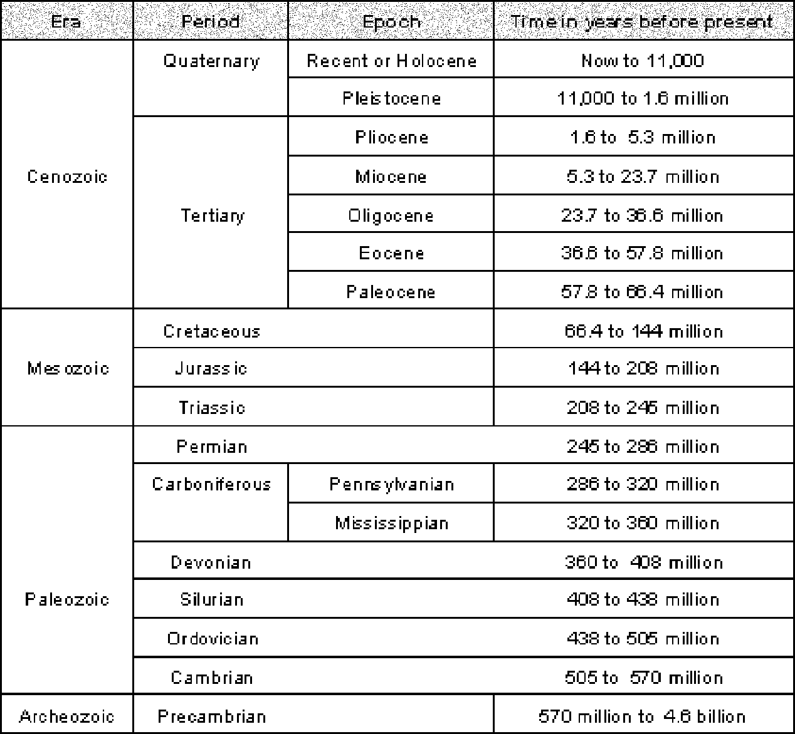

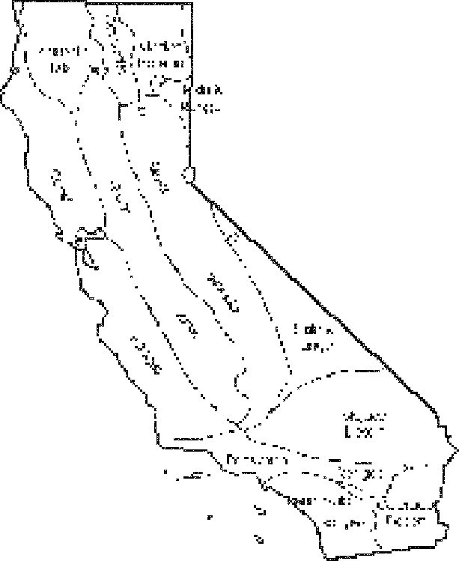

Geomorphic provinces of California. (Norris & Webb, 1990)
Regional Geology
Structural Geology
Geologically, California is divided into several physiographic or geomorphic provinces, including the Sierra Nevada range, the Central (Great) Valley, the Transverse Ranges, the Coast Ranges, and others. San Luis Obispo County lies within the Coast Range geomorphic province of California.
The portion of the Coast Range province that comprises the coast of central California was formed at the intersection of two tectonic plates: the Pacific to the west, and the North American plate. The compressive and shearing motions between the tectonic plates resulted in a complex system of active strike-slip faults, reverse faults, thrust faults and related folds (bends in rock layers) (Clark and others, 1994).
The various rock types found throughout the County, and the type and severity of folding and faulting that has occurred in these rocks, allow for the division of San Luis Obispo County area into four structurally and physiographically

distinct areas, called seismotectonic domains. The domains include the Santa Maria-San Luis Range domain, the Coastal Franciscan domain, the Salinian domain, and the Western San Joaquin Valley domain. The seismotectonic domains are bounded by major Quaternary- age faults that divide the County into areas of distinct styles of faulting, seismic activity and geology. A description of the domains is presented below:
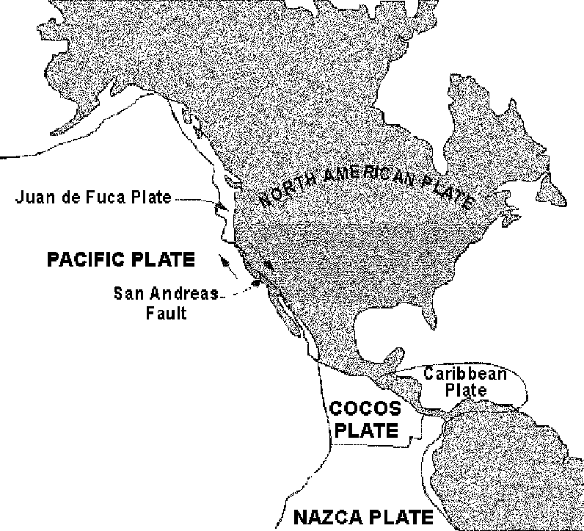
Santa Maria Basin-San Luis Range Domain (SMB-SLR). The Santa Maria Basin- San Luis Range domain (SMB-SLR) comprises the southwestern area of the County, including Nipomo, Oceano, Grover Beach, Arroyo Grande, western San Luis Obispo, Avila, Los Osos, and the adjacent hills of the San Luis Range and Irish Hills. The domain forms a transition between the Transverse Range geomorphic
province to the south, and the Coastal Franciscan domain to the north.
The surface geology in the low-lying areas of the domain predominately consists of Quaternary and Holocene sediments of alluvium, dune deposits, and Paso Robles Formation. The terrain in the coastal areas is generally characterized by moderate relief, bound by the steep terrain of the uplifted San Luis Range to the east.
Fault and fold trends within the domain generally trend northwesterly. The faults are generally northwest-striking reverse faults, with mainly reverse and left-lateral strike-slip fault movement. There are at least two recognized active faults in the domain, the

The San Andreas Fault in California is a transform
fault along which the Pacific Plate slides nothwestward relative to the North American Plate at a rate of about 7 1/2 cm per year. (Levin, 1986)
Hosgri fault and the Los Osos fault. Several moderate magnitude earthquakes have occurred in the SMB-SLR domain (Clark and others, 1994).

The main geologic hazards in this area are groundshaking and liquefaction or seismic related settlement of alluvium within low lying areas, and tsunamis and coastal erosion in ocean front areas. As a result of the moderate relief within the western and more developed portion of the domain, the landslide hazard is relatively low. There are, however, relatively severe landslide hazards within the steeper terrain and less developed areas of the Santa Lucia Range and Irish Hills.

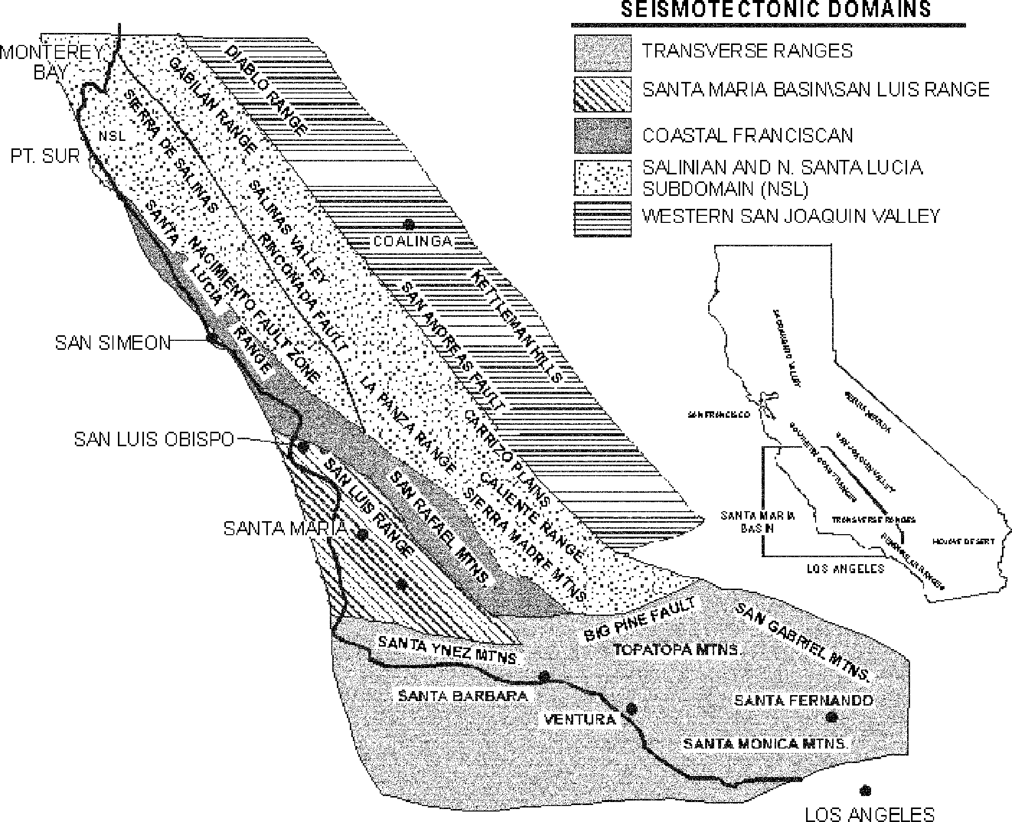
Coastal Franciscan Domain. The Coastal Franciscan domain generally lies along the mountains and hills associated with the Santa Lucia Range. The domain incorporates the coastal communities of Morro Bay, Cayucos, Cambria and San Simeon, and the western slope of the Santa Lucia Range in San Luis Obispo and east of Arroyo Grande. The Santa Lucia Range resulted from uplift during the Pliocene and Quaternary periods.
The surface geology within the domain consists of a northwest-trending sliver of largely Franciscan formation rocks, bounded by the Hosgri fault and West Huasna fault on the west and the Nacimiento fault and the Rinconada fault on the east. The domain is characterized by moderate rates of earthquake activity during the Quaternary period and has numerous northwest-striking, mainly northeast-dipping faults, with uncertain potential to generate future earthquakes (Clark and others, 1994).
The main geologic hazards associated with this domain are groundshaking, liquefaction or seismic related settlement of alluvium in the low lying areas of the coastal portion of the domain, tsunami and coastal erosion in ocean front areas, and severe landslide potential on moderate to steep hillsides. The slopes of the Santa Lucia Mountains are underlain by mostly the Franciscan Formation and other Cretaceous age rocks that are considered to be the formations most susceptible to landslides in the County.
Salinian Domain. The Salinian domain is located in the northern and eastern portion of San Luis Obispo County, including the communities of Paso Robles, Templeton,



Kinds of faults. (Levin, 1986)
Shandon, and Atascadero. The domain extends south-southeast to also include the Carrisa Plains area.
This large domain is part of a northwest-trending tectonic terrain within the California Coast Ranges, characterized by granitic and crystalline metamorphic basement rocks (Compton, 1966). The Salinian domain has a moderate- to high-relief western region characterized by abundant northwest-striking faults with historical earthquake activity, and an eastern region characterized by generally low relief and few recognized surface faults (Clark and others, 1994). Historical seismicity in the Salinian domain is concentrated mainly along its right-lateral strike-slip boundary faults (Nacimiento and San Andreas), and is relatively sparse within the central portion of the domain.
Seismically, the Salinian domain away from the San Andreas fault is relatively quiet (Dehlinger and Bolt, 1987). The pronounced difference in seismic character between the Salinian domain and the adjacent Coastal Franciscan domain (with moderate to high seismicity) is attributed to the differences in the strength of the rocks that comprise their respective zones.
The Salinian domain has a generally lower occurrence of geologic hazards in comparison to the SMB-SLR and Coastal Franciscan domains. The main geologic hazards associated with this domain are groundshaking, liquefaction or seismic related settlement of alluvium in the low lying areas and landslide potential in hillsides of moderate to steep slopes that have experienced large to moderate size landslides in some formations.
Western San Joaquin Valley Domain. The Western San Joaquin Valley domain (WSJV) bounds the edge of the County along the eastern edge of the San Andreas fault. The San Andreas fault separates the Salinian domain on the west from the Western San Joaquin Valley domain on the east. No major communities of San Luis Obispo County overlie the WSJV domain, but it is important because of its relationship to the San Andreas fault.
As discussed by Clark and others (1994), recent geologic activity in the WSJV domain is characterized by thrust and reverse faulting and associated folding. The 1983 Coalinga earthquake (magnitude, M, equalled 6.7) demonstrated the seismic potential associated with the active folds in the WSJV domain.
Geologic characteristics of each of the domains are summarized in Table 4-2 - Seismotectonic Domains in San Luis Obispo County.
Stratigraphy
Stratigraphy is the branch of geology which describes the formation, composition, sequence, and properties of stratified (sedimentary) rocks. The major stratigraphic units (geologic formations) in San Luis Obispo County are shown on Map 1 - Geology.
Except for regional mapping by Jennings (1958), there has not been a systematic geologic mapping program conducted for San Luis Obispo County that incorporates existing data into a county-wide regional map. As part of this study, geologic maps for the San Luis Obispo County area by Dibblee (1971; 1972a, 1973; 1974), Hall (1973a; 1973b; 1974), Hall and Prior (1975), Hall and others (1979), and McClean (1994, 1995) were digitized to form a regional geologic map for San Luis Obispo County (see Map 1). That data was then digitized and compiled into a GIS format to generate the various geologic hazards maps.

Table 4-2: Seismotectonic Domains in San Luis Obispo County
Modified from Clark and others (1994)
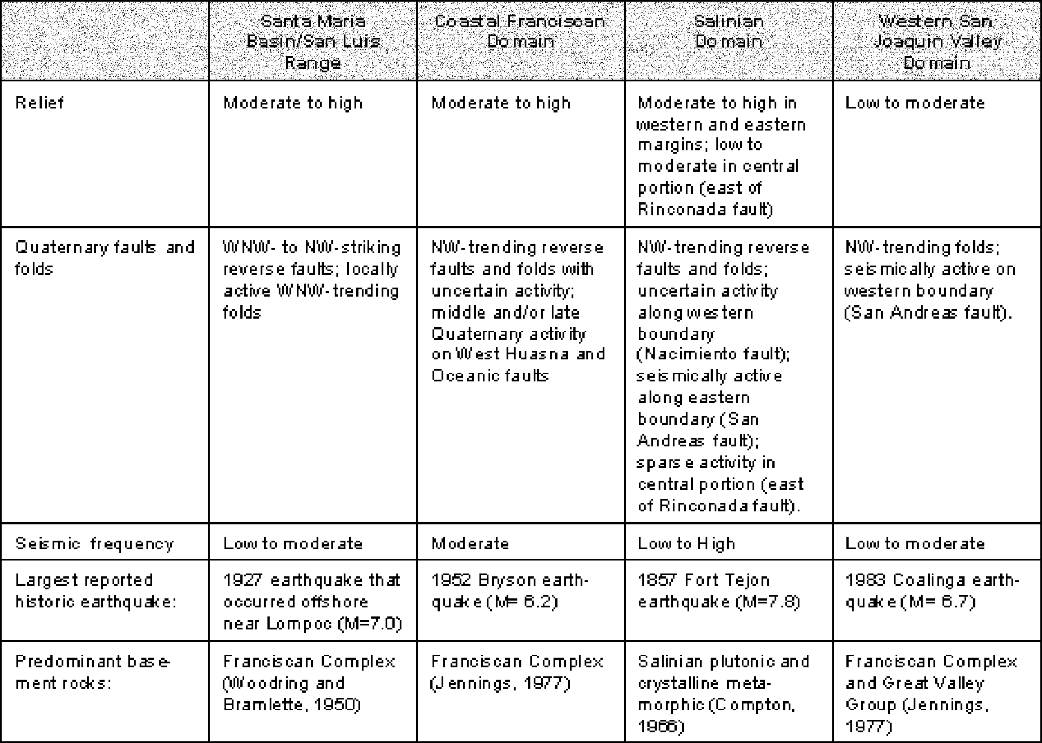

Seismicity
San Luis Obispo County is located in a geologically complex and seismically active region. Seismic, or earthquake-related hazards, have the potential to result in significant public safety risks and widespread property damage. Two of the direct effects of an earthquake that are required to be considered as part of the Safety Element include the rupture of the ground surface along the location of a fault, and ground shaking that results from fault movement. Other geologic hazards that may occur in response to an earthquake and that are evaluated in this section include liquefaction, seismic settlement, tsunami, seiche and landsliding. Other hazards, such as flooding from a dam failure, fires, and structural hazards that may be related to earthquakes, are evaluated in separate sections of the Safety Element.

Fault Activity
A classification system has been devised by the California Division of Mines and Geology (CDMG) to describe fault activity and the potential for future fault movement. Providing a mechanism for determining and describing the activity of a fault is important because faults that exhibit signs of geologically recent (active within the past 11,000 years) movement are considered the most likely to experience movement in the near future. Therefore, active faults are generally thought to have the greatest risk to public safety with regard to fault rupture potential. Most agencies, however, will consider potentially
active faults (active within the past two million years) as being capable Kinds of folds. (Levin, 1986)

of generating future earthquakes. Faults classified as inactive are not considered to present a significant fault rupture hazard or seismic source.
To address this hazard, California has adopted the Alquist-Priolo Special Studies Zones Act (APSSZA) of 1972. The APSSZA act was updated in 1994 and the title was revised to the Alquist-Priolo Earthquake Fault Zoning Act (APEFZA). The intent of this Act is to minimize the chance for structures with human occupancy to be built over active faults by requiring a geological investigation for new development within designated active earthquake fault zones. For purposes of implementing the Act, it is assumed that the area within 50 feet of an active fault is underlain by active branches of the fault, until proven otherwise by an appropriate geologic investigation.
Terms used by CDMG to describe fault activity are defined below.
Historically Active (HA). Faults on which earthquakes have occurred during historic time (within the last 200 years) are classified as historically active.
Active (A). Faults that show evidence of displacement during the most recent epoch of geologic time, the Holocene, are classified as active. The Holocene epoch is generally considered to have begun about 11,000 years ago.
Potentially Active (PA). Faults which displace geologic formations of Pleistocene age but show no evidence of movement in the Holocene period can be considered to be potentially active. Pleistocene time is the period between about two million years ago and 11,000 years ago. The exception is that certain Pleistocene faults can be presumed to be inactive based on direct geologic evidence of inactivity during the Holocene time or longer.
Inactive (IA). Faults which show no evidence of movement during the past two million years and show no potential for movement in the future are classified as inactive.
As defined, the terms used by CDMG to describe fault activity are essentially based on the recurrence of fault rupture at a particular location, or the amount of time that has passed since a fault last ruptured.
Most active faults are identified on the basis of surface expression of previous fault movements, or observation of fault displacements in relatively shallow excavations or outcrops. In addition to the known active faults with surface expression, there is also a potential for earthquakes on “buried” or “blind” thrust faults that are more active at depth but have poor expression of this activity at the ground surface. The 1983 Coalinga and 1994 Northridge earthquakes have been attributed to fault movement on blind thrust faults (Wentworth and Zoback, 1989; Working Group on California Earthquake Probabilities, 1995). Geophysical research by Shaw and Suppe (1994a, b) identified subsurface patterns which they believe represent blind thrust faults in the southern California area. Cross sections prepared by Namson and Davis (1990) across the Santa Maria Basin and southern Coast Ranges of San Luis Obispo County identify a fold and thrust belt they believe to be seismically active. On the basis of the limited data available concerning the reoccurrence intervals and other earthquake parameters, it is difficult to fully evaluate the shaking hazard from blind thrust faults. However, as shown by the widespread damage from the 1994 Northridge earthquake, blind thrust faults can produce strong ground motion that can effect widespread areas and cause significant damage.

Measurement of Earthquakes
There are several systems used to measure earthquake ground shaking. In 1935, Charles Richter developed a system to measure an earthquake’s strength in terms of its magnitude (Richter magnitude, Mr), which is commonly referred to as the Richter scale. Richter magnitude is defined as the logarithmic measurement of the maximum amplitude, as recorded on a seismograph, calculated at a distance of 100 kilometers (62 miles) from the earthquake. Richter magnitude is fixed to an event and measured values do not vary with distance. With the use of a logarithmic scale, an increase of “1” on the Richter scale (e.g., a 5.0 to a 6.0) represents an approximate 32-fold increase in earthquake energy released by the event.
The Richter scale is limited by its ability to measure very strong seismic events associated with great earthquakes. In response to this inconsistency, the most commonly used scale today is the moment magnitude system. The moment magnitude is related to the physical size of fault rupture, the movement across the fault, and the strength of the rock that is faulted. The seismic movement is calculated by the strength of the rock (shear modulus) multiplied by the area (length times width) of the fault rupture surface and by the displacement of the fault during the earthquake. The moment magnitude system symbol is Mw (Smith and Chisholm, 1998).
Earthquake induced ground shaking can be measured quantitatively as ground surface acceleration, the speed at which the ground moves with respect to the force of gravity
(g). An upward vertical ground acceleration of 1.0 g from an earthquake would throw loose objects into the air because the downward force of gravity was overcome by the force of the groundshaking in response to an earthquake. A qualitative description of the intensity of an earthquake, or the degree of shaking in terms of the damage at a particular location, can be provided using the Modified Mercalli Scale. This scale is general in nature and provides a description of the effects of the earthquake at a particular site, ranging from the Roman Numeral “I” (felt by very few individuals) to “XII” (damage is total). Reported intensity ratings for an earthquake can vary from region to region, and will be influenced by factors such as the size of the earthquake, the geologic conditions of the site, and the quality of building construction. Earthquake intensity descriptions that are used by the modified Mercalli scale are provided on Table 4-3.
To describe the largest earthquake event that may be produced by a particular fault, the terms “maximum probable earthquake” and “maximum credible earthquake” are commonly used. A maximum probable earthquake is the largest event that is expected to be produced by the fault within a certain time frame. The selected time period will typically correspond to the life expectancy of the structure. Therefore, a maximum probable earthquake magnitude is commonly used to design most structures.
A maximum credible earthquake is the largest estimated event that could be produced by a fault, regardless of time. For the design of critical structures, such as dams, hospitals, power plants, and emergency response facilities, the maximum credible earthquake is often used. Current building codes define “maximum moment magnitude,” and the “upper bound earthquake” for the design of structures.
Faults in San Luis Obispo County
The location of the major mapped faults within San Luis Obispo County are shown on Map 2. This map is meant to be used for general planning purposes only and not as a substitute for detailed geologic evaluation necessary to evaluate fault locations. CDMG Special Publication 117 (1997a), Guidelines for Evaluating and Mitigating Seismic Hazards

Table 4-3: Modified Mercalli Intensity Scale

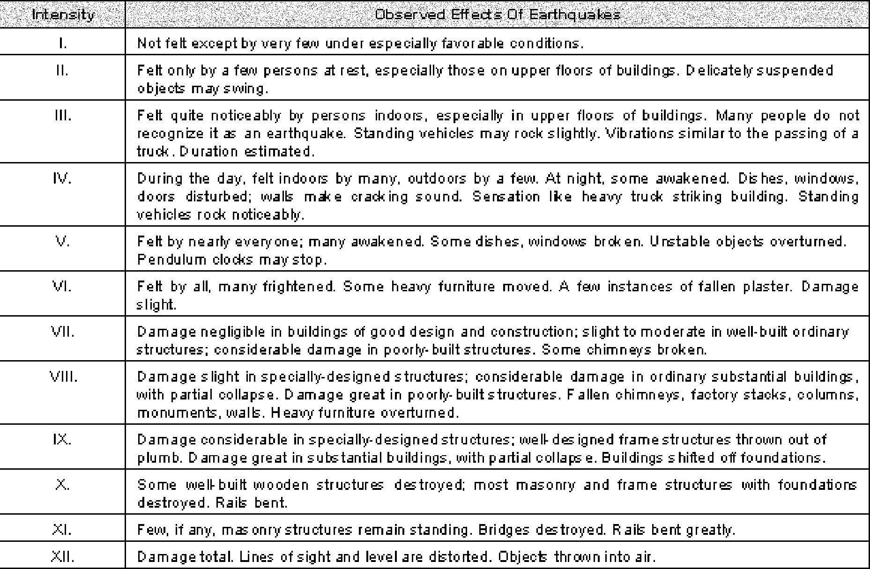

in California, developed standards for seismic evaluations. That document presents guidelines for assessing regional seismic hazards, site-specific fault evaluations, and mitigation of earthquake induced hazards.
Building codes being developed for 1997 would require that CDMG maintain a database of faults that are considered to be capable of generating strong ground motion from future earthquakes. A summary of the current fault database that is being disseminated by CDMG via a World Wide Web site (http://www.consrv.ca.gov/dmg) is presented on Table 4-4. It should be noted, however, that there are many faults that are likely capable of generating future earthquakes in San Luis Obispo County that are not accounted for on Table 4-4. A summary of other faults that have been mapped in and near San Luis Obispo County are presented in Table 4-5.
Additionally, there is a potential that areas of the County are underlain by blind thrust faults that can not easily be identified from review of surface geology. A summary of blind thrust faults that may underlie portions of the County according to Namson and Davis (1990) are presented in Table 4-6. The faults presented in Tables 4-5 and 4-6 are faults that are considered by most local practitioners but are not addressed in the current data base maintained by CDMG.
The location of the fault referred to in Tables 4-4 and 4-5 are shown on Map 2. A description of those faults follows.
Arroyo de Oso Fault. See San Simeon-Hosgri fault zone.
Arroyo Laguna Fault. See San Simeon-Hosgri fault zone.

Table 4-4: Faults Listed in Current CDMG Database¹

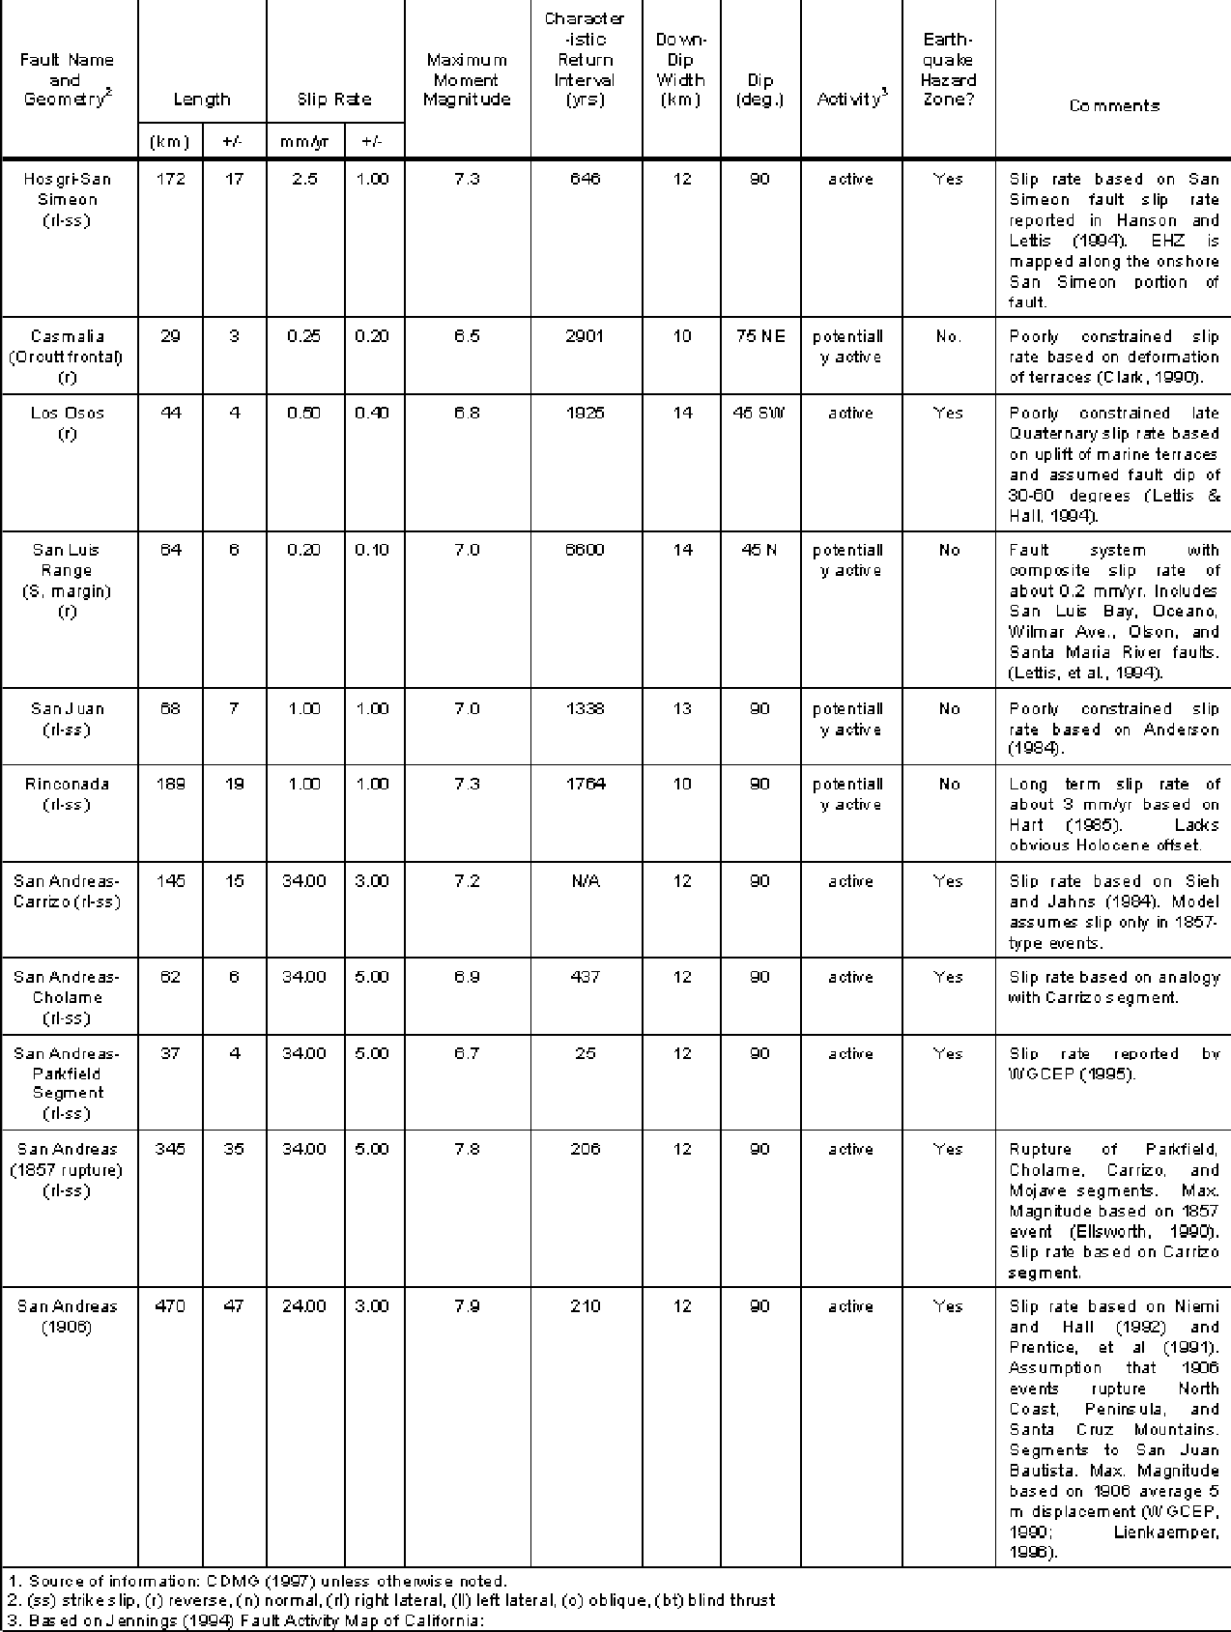

Table 4-5 - Other Faults in and near San Luis Obispo County¹

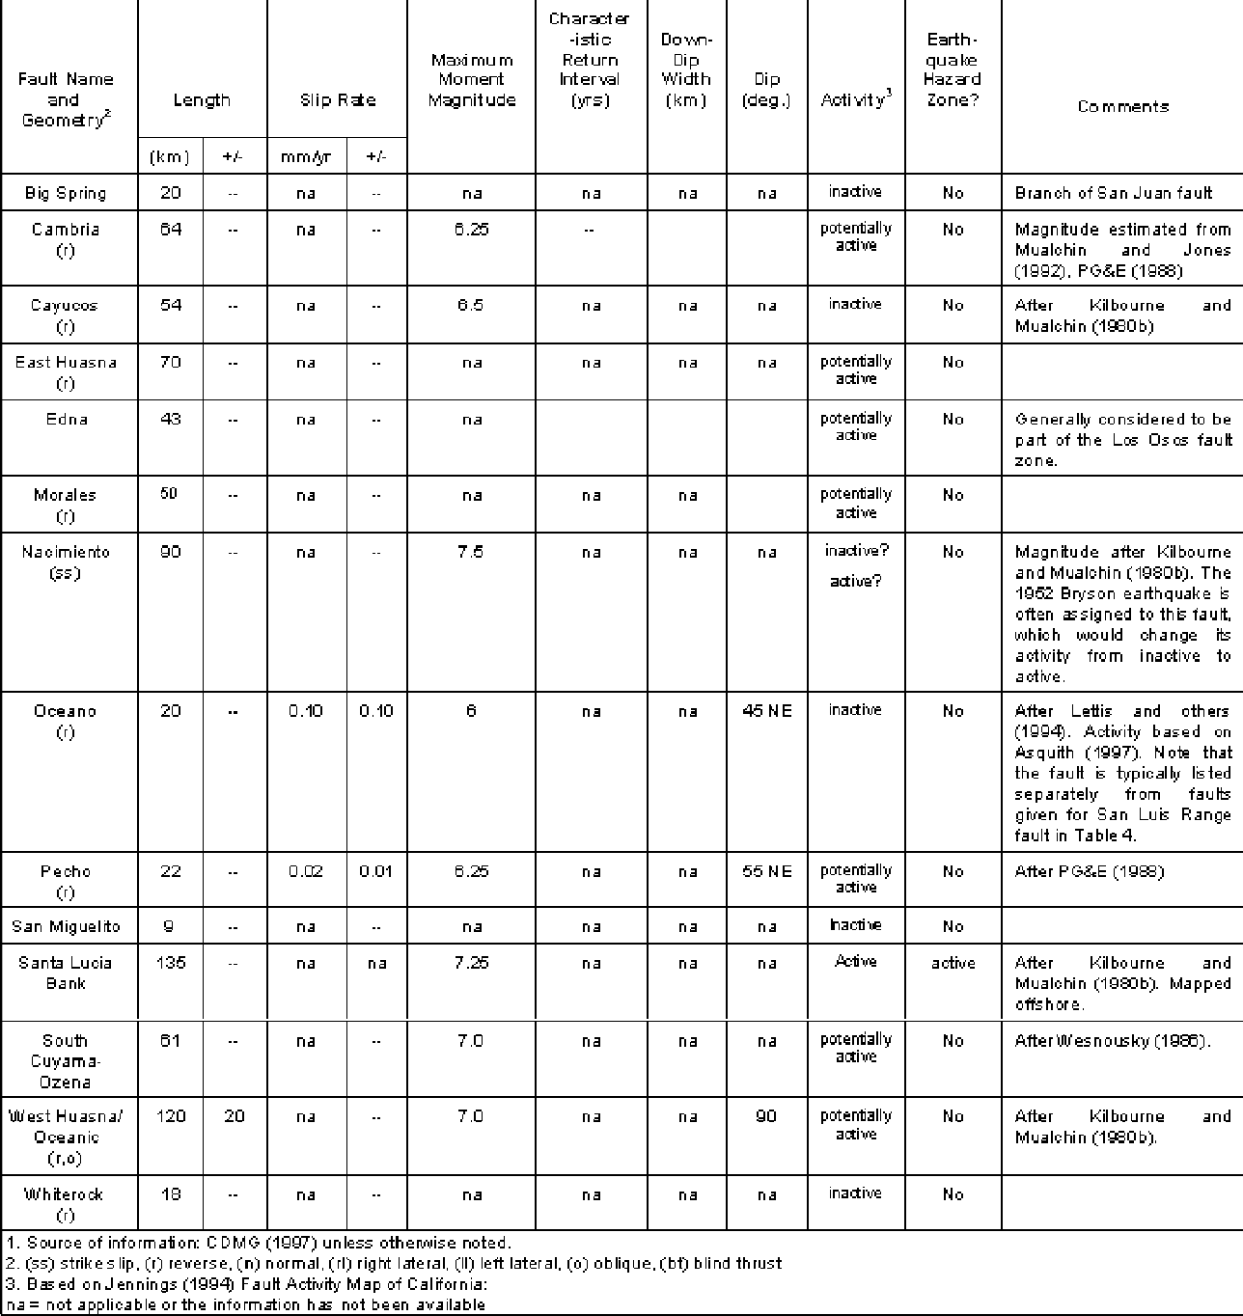
Blind Thrust Faults. The 1983 Mw 6.7 Coalinga earthquake, the 1987 Mw 5.9 Whittier Narrows earthquake, and the 1994 Mw 6.7 Northridge earthquake demonstrate that moderate to large earthquakes can occur on blind thrust or reverse faults without ground surface rupture. To date, the subsurface (blind thrust) faults that have caused earthquakes are associated with active Quaternary geologic structures comprised of folds in the bedrock units. In most areas, geodetic studies have shown that those structures are actively growing through coseismic uplift of the axis of anticlines (Stein, 1985). This strongly indicates a link between faulting at depth and near-surface fold development. Research by Suppe (1983) has shown that the association between folding at the surface with faulting at depth can be kinetically modeled using fault-bend or fault-propagation folding

Table 4-6: Thrust Faults Interpreted by Namson & Davis (1990)¹

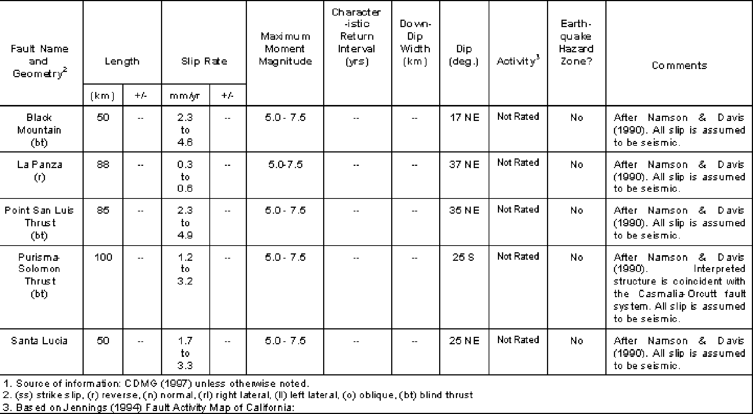

techniques. Several large thrust faults are postulated beneath southern California (Shaw and Suppe, 1994a, 1995b; Working Group of California Earthquake Probabilities, 1994).
Based on evaluation of geophysical data, subsurface oil well data, and previous geologic surface mapping, Namson and Davis (1990) hypothesized the presence of several blind thrust faults beneath the Santa Maria basin and San Luis Obispo County area, including the coastal cities and San Luis Obispo. These faults are listed in Table 4-6, and are concealed, low angle thrusts referred to as the Black Mountain fault, La Panza fault, Point San Luis fault, Purisima-Solomon fault, and the San Lucia fault. Their model suggests that the thrust ramps merge into a regional detachment at a depth of 11 to 14 kilometers. On the basis of their structural evaluation, Namson and Davis (1990) conclude that the thrust ramps are capable of generating moderate to large earthquakes of magnitude Mw 5.0 to magnitude Mw 7.5. The Namson and Davis model suggests that blind thrust faults could pose a significant seismic risk throughout the County.
As part of their model, Namson and Davis (1990) estimated that there has been on the order of 27 kilometers of lateral shortening in an east-west direction in the last two to four million years. That corresponds to a convergence rate of 6.7 to 13.4 mm/yr. By geologic standards, these convergence rates are very high, suggesting an active tectonic environment. The Namson and Davis model is controversial, with an opposing argument (Lettis and others, 1994; PG&E, 1988) that movement along faults such as the Los Osos, San Luis Bay, and Wilmar Avenue faults accommodate for the regional convergence assigned by Namson and Davis.
Big Spring Fault. See San Juan fault.
Cambria Fault. The northwesterly trending Cambria fault is approximately 64 kilometers long, including an 8 kilometer projection across eastern Estero Bay. Hall and Prior (1975)

show the fault coming back onshore near Morro Bay, and converging with the Oceanic and West Huasna fault near San Luis Obispo. The fault, located within the Coastal Franciscan domain, has been mapped locally as a reverse or thrust fault (Jennings, 1994; Kilbourne and Mualchin, 1980b); Hall (1974). Weber (1983) noted that a terrace deposit in the Cambria area may be displaced by the Cambria fault, with an apparent 3-inch step in elevation of the terrace surface near Ellysly Creek but could not be confirmed during review by CDMG (Manson, 1985). The Cambria fault is considered potentially active.
Casmalia Fault (Orcutt Frontal-Pezzoni Fault). Several authors have hypothesized the presence of a fault zone along the northeast flank of the Casmalia Range and Solomon Hills and running offshore just south of the mouth of the Santa Maria River. Krammes and Curran (1959) and Crawford (1971) originally defined the Orcutt Frontal fault as a high angle, southwest-dipping reverse fault on the basis of subsurface oil well data. PG&E (1988) referred to the Orcutt Frontal fault as the Casmalia fault and continued the mapped fault trace offshore to intersect the Hosgri fault. PG&E considered the Casmalia fault to be a continuous, high-angle range-front reverse fault with probable surface expression. Other authors such as Crouch and others (1984), Nitchman (1988), and Namson and Davis (1990) believe that the high-angle faults mapped as the Orcutt frontal fault are discontinuous, secondary faults in the hanging wall of a major blind thrust fault system.
The CDMG fault activity map (Jennings, 1994) shows the Casmalia fault as a west- northwest striking, 20-kilometer long fault along the northeastern flank of the Casmalia Range. The Orcutt frontal fault is interpreted to have Quaternary offset and is considered potentially active (Jennings, 1994). The 1980 magnitude Mw5.1 earthquake that occurred offshore, near the mouth of the Santa Maria River, is plotted along the offshore segment of the Orcutt frontal fault as mapped by Namson and Davis (1990) which suggests that the fault could be seismically active.
Cayucos Fault. The Cayucos fault is mapped by Hall (1974, Hall and Prior, 1975) trending northwest though the community of Cayucos between the Oceanic and Cambria fault zones. Hall and Prior (1975) map a trace of this fault zone as the San Bernardo and Morro Bay faults, which have not been differentiated from the Cayucos fault for the purposes of this study. Kilbourne and Mualchin (1980b) indicate that the Cayucos fault offsets Oligocene-age sediments but apparently not Miocene-age sediments. Geologic mapping by CDMG (Jennings, 1994) indicates that the Cayucos fault is a pre-Quaternary fault, therefore, the fault is considered inactive.
Chimineas Fault. See San Juan fault.
East Huasna Fault Zone. The East Huasna fault zone trends north-northwest for a distance of about 70 kilometers from near Sisquoc in Santa Barbara County northward through the central portion of the Coastal Franciscan domain until it intersects with the South Cuyama fault about 20 kilometers east of the City of San Luis Obispo. For the most part, the East Huasna fault is located within fairly steep terrain that has not been studied in great detail. Geologic mapping by Vedder and others (1986a, 1986b, 1988) suggests that the East Huasna fault is a near vertical to steeply westward dipping reverse fault that bounds the eastern flank of the Huasna syncline and locally brings Franciscan basement rocks to the surface. Geologic mapping by CDMG (Jennings, 1994) indicates that the East Huasna fault offsets Quaternary earth materials, therefore, the fault is considered potentially active.
Edna Fault. See Los Osos and Edna fault zones.

Espfnasa Facdt. See Ririconada fault.
- FoxezzCanyon Fault. See Santa Maria Rver and Foxen Canyon faults.
Hosgrl Fault. See San Simeon-Hosgri fault zone. Indian Knob Fault. See Nos Osos and Edna fault zones. Jolon FaulC See Rnconada fault
La Panza Fault. The northwest trending La Panza fault has been mapped for 71
kilometers along the western base of the La Panza Range (Jennings, 1994). Estimated sfip rates range from approximately 0.3 mm to 0.6 mm a year (Namson and Davis, 1990). The La Panza fault has been identified as a thrust or reverse fault by Clark and others (1994), with northeasterly dips ranging from 37 to 55 degrees (Namson and Davis, 1990). The reverse nature or the fault is responsible ror uplift of the La Panza Range (Dibblee, 1976). The La Panza fault is considered potentially active.
£os Osos and Edna Fault Zones. The Los Osos fault zone has been mapped generally in an east/west orientation, along the northern flank of the lrlsh Hills. The western end of the onshore fault zone is located near the community of Los Osos, and the eastern end is located near U.S. Highway 101. To the east of U.S. Highway 101, the fault may continue along the northeast flank of the Irish Hills as the Edna fault zone. The Edna
” fault and the Indian Knob faults are both mapped by Ha)l (1973) just west of the trend or the projection of this fault zone, and have not been differendated kom the Los Osos fauli ror the purposes of evaluating the potential seismic source capability.
The location and recent activity of various strands of the Los Osos fault zone is discussed by PG&E (\988), Treiman (1989). and Lettis and Ha\I (\994). The PG&E report idenñfies the Lees Osos fault zone as including both the Los Osos and the Edna faults, and identifies the Los Os‹ s fault as being offset Holocene sediment, and is therefore considered to be active. Data presented by Lettis and Hall (1994) indicates that the Los Osos fault zone is a west-northwest stfiking reverse fault that extends from the Hosgri fault (offshore) eastward up to 35 miles to an intcrsection with the West Huasna fault near Twitchell Reservoir.
The California Division of Mines and Geology (Treiman, 1989) conducted field evaluañons for the main strand of the Los Osos fault near the intersection of Los Osos Va)ley Road and Foothill Road. This investigation indicated that faulting activity has taken place along
“ the main strand of the fault within the last 11,000 years. This evidence of recent activity resulted in the establishment of an Earthquake Fault Zone by CDMG in 1989 under the A)qulst-Priolo Act. The Earthquake Fault Zone is located ncar the westerly limits of the
“ City of San Luis Obispo. It should not be interpreted that the active portion of the main trace of the Los Osos Fault is limited only to the designated Earthquake Fault Zone.
Rather, the limits of the established Earthquake Fault Zone correspond to the limits of '^ the available information provided by studies peJormed by Hall (1973), Hall and Prior (1975), and PG&E (1988). As additional information about other segments of the fault
is provided by additional studies, it may be appropriate for CDMG to expand the ‘“ Earthquake Fault Zone.
The Edna fault strikes northwest ror a distance of about 25 miles along the northern limb of the Pismo syncline within the San Luis Range. Hall (1973) shows both Pliocene and Late Pleistocene formations displaced by the Edna fault. Geologic studies by Lettis

Technical Bactgmund Report County and Cities of flan Luis Obispo



and Hall (1994). confirm that the Edna fault has no late Quaternary age movement. CDMG (Treiman, 1989, Jennlngs, 1994) considers the Edna fault to have Quaternary- age movement therefore, the fault 1s consldered potentially actlve.

Hall (1973a) rriapped a second thrust fault. the Indlan Knob faulC about one mllesoutheast of the Edna fault (Flgure 1-1). On the basls of‘meager field and stratigraphic evidence.” Hall (1973a) esdmated that “there has been approximately 1,000 feet of reverse-slip movement" on the Indlan Knob fault. The activity status of the Indian Knob fault is uncertain, but is assumed to be slmllar to the Edna fault (potentially active).



Mapplng by £ettis and Hall(1994) and reœnt unpublished geotœhnical studio by Asqulth (1997) suggest that the Los Oses fault may segment or splay wlthin the commun)ty of Los Oses. Asqulth (1997) mapped a northwest-southeast strlklng fault strand that may offset the main snand of the Los Osos fault. The locadon of the northwest-southeast fault strand has been lnferred based on ground water levels and other geologlc mndldons. The actlvity of this fault segment ls unknown, but is inferred to be potendally active or posslbly active. The existence and actlvlty of thls fault segment is of concem because it is located several hundred feet south of the South Bay ftre stadon and the Sunnyside Elementaiy School.
Assumlng an overall fault length of 35 mlles, the Los Osos fault has the potential to generate an earthquake wlth a magnltude Mq6.75. PG&E (1988) estimated a sllp rate r

0.1 to 0.6 mm/yr and a surface displacement of 1.6 to 5 meters per event. More reœntly, Lettls and Hali (1994) esdmated a vertical sllp rate of approxlmately 0.2 to 0.8 mm/yr. CDMG reports a sllp rate of 0.5 + .4 mm/yr (see Table 4-4).

Morales FaulL The Morales fault zone 1s mapped by Dlbblee (1973) and Vedder and Repenrdng (1975) as an east-west to northwest trending reverse thrust fault that runs along the Cuyama Valley in the southeast area of the County. The fault 1s marilfested as a complex array of faults of dlverse types and orientaUons that run for about 50 km from the San Andreas fault to the east to the southern end of the San Juan - Btg Sprlng fault zone. Jennlngs (1994) Indicates that the Momles fault 1s potentially active.
Morro Bay Fault. See Cayucos Fault.



Naclmlento Fault Zone. The Nacimiento fault zone is described by Han (1976) as an Ill-defined, complex array of northwest trending faults of diverse types and ages. The Naclmlento fauit zone separates the soft rocks of the Coastal Franciscan domain on the west from the prlmarlly {pariitic rocks of the Salinian domain on the east. As discussed by Hart (1976), the fault zone ”lies on trend, both locally and regionally with faults and fau)t zones generally Identified as the Naclmiento fault along the southeastem portion by Hall and Corbota (1967) and Vedder and Brown (1968) and Sur-Nacimiento fault to the northwest (}ennlngs, 1958; Page, 1970).” Based on mapping by several invesdgators, it appears that the Naclmlento fault zone 1s not a slngle fault Hue of specific age, but rather a complex zone of branchlng and discontinuous faults of diverse orientations, movement and ages. The fault zone is more or less defined by a narrow sinuous outcrop band of Franciscan melange.
Although mapped as a regional fault by many investigators, the Nacimiento fault zone is not Included as pan of the data base of California fau)ts by CDMG. The fault reportedly does not have surflclal features suggestive of Quaternary movement, and is considered inacdve Jennings, 1994). However, the Bryson earthquake of 1952 is sometimes assigned to the Nacimiento fau)tzone which contradicts the Jennings activity, and would make the
County and Citim ofsan Puis Oblspo Technical 8aclground Jteport

fault seismically acfive. The Bryson earthquake, which occurred in a rural area of northern San Luis Obispo County, is poorly understood and may be attributed to movement on other faults such as the active San Simeon or potentially active Rinconada fault zones.
Oceano Fault. As described by Lettis and others (1994) , the Oceano fault is a 20- kilometer-long northwest-striking reverse fault that extends from north of Santa Maria westward into the SanLuis Obispo Bay. The Oceano fault is not exposed or geomorphically expressed. On the basis of subsurface geophysical and well data from the Nipomo area, the fault is interpreted to dip 40 to 50 degrees to the northeast with an offset of as much as 122 to 183 meters (PG&E, 1988). Southeastward, the vertical separation decreases and probably dies out in the Santa Maria Valley. Northwesterly, near the coast, estimates of the slip rate along the onshore portion of the fault are based on vertical separation of an unconformity between the Foxen Canyon formation and overlying marine terrace deposits of probable Pliocene or early Pleistocene age. Oil and water well data indicates that the vertical separation of that unconformity in the Nipomo area is about 77 to 126 meters and decreases to about 27 meters at the coast (PG&E, 1988).
Review of the existing iriformafion by Asquith (1997) suggests that there is no evidence from existing geophysical data, well data, or exposures within the bluffs of Nipomo Mesa that the Oceano fault extends above the late Tertiary formatioris. Assuming an age of one to two million years for the uncoriformity underlying Quaternary deposits yields a net slip rate for the Oceano fault of 0.04 to 0.20 mm/yr near Nipomo, decreasing to
0.01 to 0.04 mm/yrnearthe coast. Because the fault potentially displaces early Pleistocene deposits, the Oceano fault is conservatively considered to be potentially acfive by current state standards (Jenriings, 1994). There is no evidence that the fault should be classified as active (Asquith, 1997).
Oceanic Fault. See West Huasna/oceanic Fault Zone.
Olson Trace. See San Miguelito fault.
Orcutt Frontal-Pezzorii Fault. See Casmalia Fault.
Pecho Fault. The northwest-trending Pecho fault lies entirely offshore west and south of Point San Luis. On the basis of geophysical evidence (PG&E, 1988) , the fault is expressed geomorphically by a trend of discontinuous seafloor scarps that extends about five kilometers from near the Hosgri fault zone at the latitude of Pecho Creek southeast toward San Luis Obispo Bay. The trend is characterized by irregular, southwest-facing scarps in Franciscan or middle Tertiary bedrock. The fault is interpreted to be a nearly vertical to steeply northeast-dippingreverse fault that displaces early Heistocene sediments on the order of 17 meters. On the basis of the inferred late Quaternary offset (in the last 18,000 years), the fault is considered to be potentially active.
Pezzorii Fault. See Casmalia Fault.
Pismo Fault. Hall (1973a) maps afault trace north and adjacent to the Wilmar Avenue fault as the Pismo fault. The Pismo fault ruris northwest along the base of the hills that form the western margin of the Santa Lucia Range. Lettis and others (1994) indicates the Pismo fault disrupts lower Miocene Pliocene rocks, but not Quarternary sediments. The Pismo fault is therefore inactive.
Reliz Fault. See Rinconada Fault.

Technical Bockf;round Report County and Cities of San Luis Obispo
G1

Rinconada Fault. The Rinconada fault is characterized by a linear, narrow, near-vertical zone of faults about 189 kilometers long that is located along the western margin of the La Panza Range. The Rinconada fault is inferred to be part of a zone of faults including the Jolon, San Marcos, Espinosa, and Reliz faults that extends from Monterey Bay southward to its juncture with the Nacimiento fault (Hart 1976; 1985).
As described by Hart (1976), the Rinconada fault zone is well defined over most of its length and is recognized as one of several closely spaced, parallel to branching faults that clearly truncate all pre-Quaternary geologic units. Large-scale strike-slip movement along the fault zone is indicated by a predominance of right-lateral displaced drainages along various segments of this fault. The Rinconada fault clearly offsets the Paso Robles Formation indicating Pliocene to early Pleistocene activity. Late Pleistocene to Holocene activity is suggested by sag ponds, locally offset and clockwise-rotated drainages, faint aerial photographic lineaments in younger alluvium in the Rinconada drainage area, and possible crudely located, scattered seismic epicenters in the vicinity of the mapped trace of the fault zone.
Based on Hart (1985), CDMG (1996) has assigned a long-term slip rate of 3 mm/yr to the fault. Hart (1985) indicates that evidence of late Quarternary displacement of the fault is indirect but fairly strong based on a preponderance of well-defined, large-scale geomorphic features. Hart further states that the lack of geomorphic features in young alluvium, normally associated with strikeslip faults, suggests the fault has been inactive during the Holocene time. Nonetheless, CDMG considers the Rinconada fault to be potentially active.
San Andreas Fault Zone. The San Andreas fault zone is located along the eastern border of San Luis Obispo County. This historically active fault has a length of over 960 kilometers and forms the tectonic boundary between the Pacific Plate to the west and the North American Plate to the east. Numerous major earthquakes have been recorded on the San Andreas fault, and it is generally considered to pose the greatest earthquake risk to California. The San Andreas fault is likely capable of producing a maximum credible earthquake of magnitude Mw 8.25.
The San Andreas fault has been divided into several segments (Working Group, 1988; Working Group of California Earthquake Probabilities, 1995; CDMG, 1996). The Cholame segment extends from Cholame southeastward for about 62 kilometers. Characteristic fault displacement along this segment of the San Andreas fault is approximately 5 ± 2 meters, with a slip rate of 34 ± 5 millimeters per year (Working Group on California Earthquake Probabilities, 1995). This segment has an earthquake recurrence interval of 437 years for a magnitude Mw6.9 event.
The Carrizo segment of the San Andreas fault extends from southeast of Cholame for approximately 145 kilometers. The estimated recurrence interval for earthquakes along this segment is 206 years, with a slip rate of 34 ± 5.0 millimeters per year, and a displacement of 7 ± 4 meters (Working Group on California Earthquake Probabilities, 1995). This study predicts an 18 percent probability of a rupture on the Cholame and Carrizo segments of the San Andreas fault for the period between 1994 and 2024.
The San Andreas fault is zoned under the Alquist-Priolo act as shown on Map 2. Historically, activity on the San Andreas fault includes the 1857 Fort Tejon earthquake that is believed to have ruptured 345 kilometers of the Parkfield, Cholame, Carrizo and Mojave segments of the fault with a magnitude Mw 7.8 earthquake.

See Cayucos fault.
San Juan Fault.
Andreas fault (Hart and others, 1986). Vedder and others (1986c) map an extension of this fault zone as the Chimineas fault through the Chimineas Ranch area. Dibblee (1973)

Juan fault into the Carrizo Plain area. The Chimineas and Big Spring faults have not been differentiated from the San Juan fault for the purposes of this study. The fault is located
Pleistocene and possibly Holocene deposits. The estimated maximum moment magnitude for the San Juan fault is Mw7.0. Slip rates for the approximately 68-kilometer-10m fault are estimated to range from 0.75 to 2.50 mm/yr (Anderson, 1984). On the basis of the reported fault displacements, the San Juan fault is classified as potentially active.
San Luis Bay Fault. On the basis of onshore geologic studies, offshore drill holes, and geophysical data (PG&E, 1988), the San Luis Bay fault is interpreted to be a west-northwest striking reverse fault located along the coast near Avila Beach. Geologic data presented by PG&E suggests that the San Luis Bay fault has a maximum length of about 19 kilometers (including both onshore and offshore segments). The onshore portion of the fault is estimated to have a length of 4.5 kilometers (PG&E, 1988). In the near-surface, the fault dips about 15 to 40 degrees to the north, however the dips steepen to about 70 degrees at depth. Long-term slip rates estimated from offset marine terraces are in the range of 0.02 to 0.11 mm/yr, suggesting a fairly low activity and recurrence intervals of about 35,000 years for a magnitude Mw6 earthquake (PG&E, 1988). Mapping by Lettis and others (1994) indicates that the fault cuts strata of Pleistocene age terrace deposits, and is considered potentially active by CDMG.
San Luis Range Margin. See San Luis Bay, Wilmar Avenue, Olson, and Santa Maria River faults.
San Marcos Fault. See Rinconada Fault.
San Miguelito Fault. The San Miguelito fault is a 9-kilometer-long, west-northwest- striking zone within the San Luis Range located along the southwestern margin of the San Luis Obispo syncline. As described by Lettis and others (1994), the fault juxtaposes Miocene and Pliocene volcanic and sedimentary rocks on the northeast against Mesozoic basement rocks on the southwest, and is interpreted to be a high-angle, generally northeast- dipping fault zone with predominately normal dip-slip displacement. The northwestern part of the fault is characterized by intense folding and some localized shearing, but no mappable fault traces (Clark and others, 1988). Faulted upper Pliocene rocks of the Pismo Formation show that movement along the fault has occurred since late Pliocene (Hall 1973, 1981). Trenching studies and detailed mapping by Lettis and others (1994) indicates that the San Miguelito fault is not an active late Quaternary structure. On the basis of studies by Lettis and others (1994) the San Miguelito fault is considered inactive.
West of the mappable trace of the San Miguelito fault, the Olson Trace has been mapped by Lettis and others (1994) on the basis of a disruption in the marine terrace sequence. The Olson Trace is interpreted to trend approximately east-west with a moderate to steep dip to the north, and is apparently primarily an up-to-the-north reverse slip fault (Lettis and others, 1994). The Olson Trace is considered inactive by CDMG.
San Simeon-Hosgri Fault Zone. The San Simeon-Hosgri fault system generally consists of two fault zones: the Hosgri fault zone represented by a series of faults that are mapped

Technical Background Report

off of the San Luis Obispo County coast; and the San Simeon fault zone, which appears to be associated with the Hosgri, and comes onshore near the pier at San Simeon Point. Hanson and Lettis (1994) map a western trace of this fault zone as the Arroyo del Oso fault. Manson (1985) refers to the eastern-most trace of the faults as the Arroyo Laguna fault. For the purposes of this study, the Arroyo del Oso and Arroyo Laguna faults have not been differentiated from the San Simeon fault.
This fault system has been the subject of considerable investigation and debate regarding its slip rate, sense of slip, southern termination, and dipping geometry (Clark and others, 1994). On the basis of studies by Hanson and Lettis (1994) and Hall and others (1994), the San Simeon fault zone appears to be a narrow zone or a single fault at San Simeon Bay, but north of the bay, it appears to splinter into several branches. On the basis of displaced Holocene-age sediments, investigators estimate Holocene-age slip rates in the range of 1 to 3 mm/yr . Two of the San Simeon fault strands yield net slip estimates of three to seven feet per event. On the basis of the slip rate and net slip per event, Hall and others (1994) estimated a recurrence interval of 600 to 1,800 years for large surface events on the fault. These studies have determined that the San Simeon fault zone shows multiple displacements of Holocene deposits. Therefore, the fault is considered to be active (Jennings, 1994), and a Earthquake Fault Zone has been established along strands of the fault by the Division of Mines and Geology under the Alquist-Priolo act as indicated on Map 2.
The Hosgri fault zone has been interpreted to extend from the northern termination west of the southern San Simeon fault in the Cambria/Point Estero area to its southern termination offshore of Point Pedernales (PG&E, 1988). The fault is located entirely offshore, where conventional geologic mapping and paleoseismic studies cannot be performed. On the basis of geophysical work by Steritz and Luyendyk (1994), the Hosgri fault is characterized as a near-vertical oblique right-slip fault along most of its length. An alternative interpretation of the southern Hosgri fault zone by Cummings and Johnson (1994) suggests that both the vertical and lateral slip decreases to the south and the fault dies out offshore from Point Arguello. On the basis of studies performed for PG&E (1988), the Hosgri fault (offshore and not rated) is interpreted to have late Quaternary strike-slip displacement along a high-angle northwest strike fault zone.
Santa Lucia Bank/Offshore Faults. Mapping by PG&E (1988) has identified a zone of deformed marine platforms interpreted to be the Santa Lucia Bank fault zone. The zone trends northward off the coast of San Luis Obispo County. The zone of faulting was interpreted from geophysical logs of the offshore area as part of the Diablo Canyon project and USGS funded research for offshore oil potential. Jennings (1994) indicates portions of the Santa Lucia Bank fault zone to be active. The remaining portions apparently show Quaternary offset and are considered potentially active. The fault is mapped by Jennings (1994) at least 30 kilometers off of the San Luis Obispo County coast at its closest point.
In addition to the Santa Lucia Bank fault zone, there are numerous unnamed offshore faults shown on regional geologic maps. These faults typically are depicted as extensions of onshore faults or as discontinuous, fairly short thrust fault segments that are generally less than five kilometers in length. As with the Hosgri and Pecho faults, there is a high degree of difficulty involved with evaluating these faults because they can not be directly observed. The existing geophysical data generally is from deep seismic exploration and does not include shallow subsurface data acquisition that could be used to estimate fault activity. If the discontinuous fault elements represent a continuous fault surface, there is a potential for earthquakes on some of the unnamed features to occur.

Santa Maria River and Foxen Canyon Faults. The Santa Maria River and Foxen Canyon faults are buried northwest-striking reverse faults that extend from south of Sisquoc in Santa Barbara County about 40 kilometers northward to north of Nipomo. The faults have no surface expression where concealed by late Pleistocene and Holocene alluvium (Manson, 1985). The fault trace is buried and is inferred to parallel the Santa Maria River and U.S. Highway 101 on the basis of interpretation of oil well and seismic data. The fault zone is mapped by Jennings (1994) as extending into the southern end of the Wilmar Avenue fault zone, and shows the Santa Maria River fault as potentially active.
Serrano Fault. See West Huasna/Oceanic fault zone.
South Cuyama Fault. The South Cuyama fault is located in the Salinian domain. It extends from roughly New Cuyama northwest to Garcia Mountain, a distance of approximately 61 kilometers. The South Cuyama fault is a west dipping thrust or reverse fault responsible for the uplift of the Sierra Madre Range (Clark and others, 1994), and is potentially active (Dibblee, 1971; Jennings, 1994).
Sur-Nacimiento Fault. See Nacimiento Fault Zone.
West Huasna/Oceanic Fault Zone. The West Huasna/Oceanic fault zone trends north- northwest for approximately 100 kilometers through the central portion of the Coastal Franciscan domain. The fault extends from approximately the Santa Maria River on the south to San Simeon on the north. Hall and Prior (1975) map a trace of this fault zone as the Serrano fault near Morro Bay, which has not been differentiated from the larger West Huasna-Oceanic fault zone for the purposes of this study. The West Huasna fault, as mapped by Jennings (1994), extends about 30 kilometers from the Santa Maria River northward to near San Luis Obispo. The Oceanic fault continues northward from near San Luis Obispo to San Simeon.
Hall (1973a) interprets the West Huasna fault zone to consist of low- to high-angle reverse faults cut by a younger set of nearly vertical faults. The last recognizable movement along the fault zone took place during the late Miocene. More recent episodes of faulting during the late Pliocene and Pleistocene are possible if the West Huasna and Edna fault zones have the same history (Hall, 1973a). CDMG (Jennings, 1994) considers the West Huasna fault to have late Quaternary movement, therefore the fault is considered potentially active.
Whiterock Fault. The Whiterock fault is mapped as a parallel thrust to the Morales fault towards the westerly end of the Cuyama Valley. Jennings (1994) indicates that the Whiterock fault is inactive.
Wilmar Avenue Fault. The western segment of the Wilmar Avenue fault strikes west- northwest and extends westward from Arroyo Grande Creek about seven kilometers to an area offshore near Pismo Beach, where the fault is exposed in the seacliff. At Arroyo Grande Creek, the eastern segment of the fault extends in a southeasterly direction following U.S. Highway 101 to the Santa Maria River. The fault is known primarily from a sea cliff exposure near Wilmar Avenue in the City of Pismo Beach, where it displaces the 120,000-year-old terrace a vertical distance of 6.4 meters (Nitchman and Slemmons, 1994).
As discussed by Nitchman and Slemmons (1994), the eastern segment of the Wilmar Avenue fault extends approximately six kilometers between Price Canyon and Arroyo Grande Creek. The eastern section of the fault is not exposed at the surface and is interpreted as a blind reverse fault that has formed a surficial monocline. That interpretation
Technical Background Report County and Cities of San Luis Obispo

is based partially upon geologic data obtained from the “Farmboy” quarry where there are steeply folded rocks on the north side of U.S. Highway 101 and essentially flat rocks of about the same age on the south side of the highway.
Mapping by Nitchman and Slemmons (1994) indicates that the western segment of the Wilmar Avenue fault, located northwesterly of Arroyo Grande Creek, has displaced late Quaternary marine terrace deposits, but extensive urban development along the projected trace of the fault preclude recognition of possible Holocene activity. On the basis of the available geologic data, the Wilmar Avenue fault should be considered as potentially active. However, as discussed by Nitchman and Slemmons (1994), the fault is part of the seismogenic southwestern boundary zone of the San Luis/Pismo block system and could pose a seismic hazard to nearby communities. Although there is no evidence for surface movement along the eastern fault segment southeast of Arroyo Grande Creek, that portion of the fault is interpreted by Nitchman and Slemmons (1994) to be a blind thrust fault that has not propagated to the surface. If that interpretation is correct, there is a potential for the eastern portion of the fault to generate damaging earthquakes. Additional studies are needed to further evaluate the seismogenic potential of the fault.
Historical Seismicity of San Luis Obispo County. San Luis Obispo County is located within an active plate margin tectonic environment. The central California coast has a history of damaging earthquakes, primarily associated with the San Andreas fault and faults within the Transverse Range to the south. However, there are a number of magnitude Mw5.0 to Mw6.2 which affected large portions of the Central Coast (PG&E, 1988). Some of these historical earthquakes with a magnitude of 5.0 or greater (compiled by Clark and others, 1994) are summarized on Table 4-7.
Large historical earthquakes, with magnitudes greater than Mw6.5, have occurred only in the Transverse Ranges, offshore Santa Maria Basin, and along the San Andreas fault. The recent seismic activity indicated by this historical record (from 1969 to 1989) indicates significant earthquake activity occurred along the San Andreas fault, and moderate activity in a broad area along sections of the Hosgri, San Simeon, Los Osos, Nacimiento and possibly the West Huasna fault zones. The historical earthquake record in California spans less than 200 years and provides only a partial indication of seismic hazard. The absence of earthquakes on many recognized active faults and fault-related folds in California probably reflects recurrence intervals greater than the historic record, rather than lack of potential for future damaging earthquakes.
Earthquakes with magnitudes of Mw5.0 to Mw5.5, or less, generally result in minor damage that is typically localized near the epicenter region. Larger earthquakes that have been felt in the County during the last century have generally occurred outside of the County, and include events such as the Mw7.0 Lompoc earthquake in 1927 and the Mw7.7 Arvin- Tehachapi earthquake of 1952. Other more recent earthquakes, such as the 1983 Coalinga earthquake (Mw6.7), 1989 Loma Prieta earthquake (Mw7.1), 1992 Landers earthquake (Mw7.5), and the 1994 Northridge earthquake (Mw6.6) were felt in the County; however, no damage to structures is known to have occurred.
An evaluation of the effects that historic earthquakes have had in San Luis Obispo County is useful to document the levels of shaking that have occurred in the past and that may likely occur again in the future. Several historic earthquakes are described below.
1830 San Luis Obispo Earthquake. The 1830 earthquake is noted in the annual report from the Mission, and has an estimated magnitude of 5 (PG&E, 1988). The location of

Table 4-7: Selected Historical Earthquakes with Mw 5.0 in Coastal Central California from 1830 through 1989
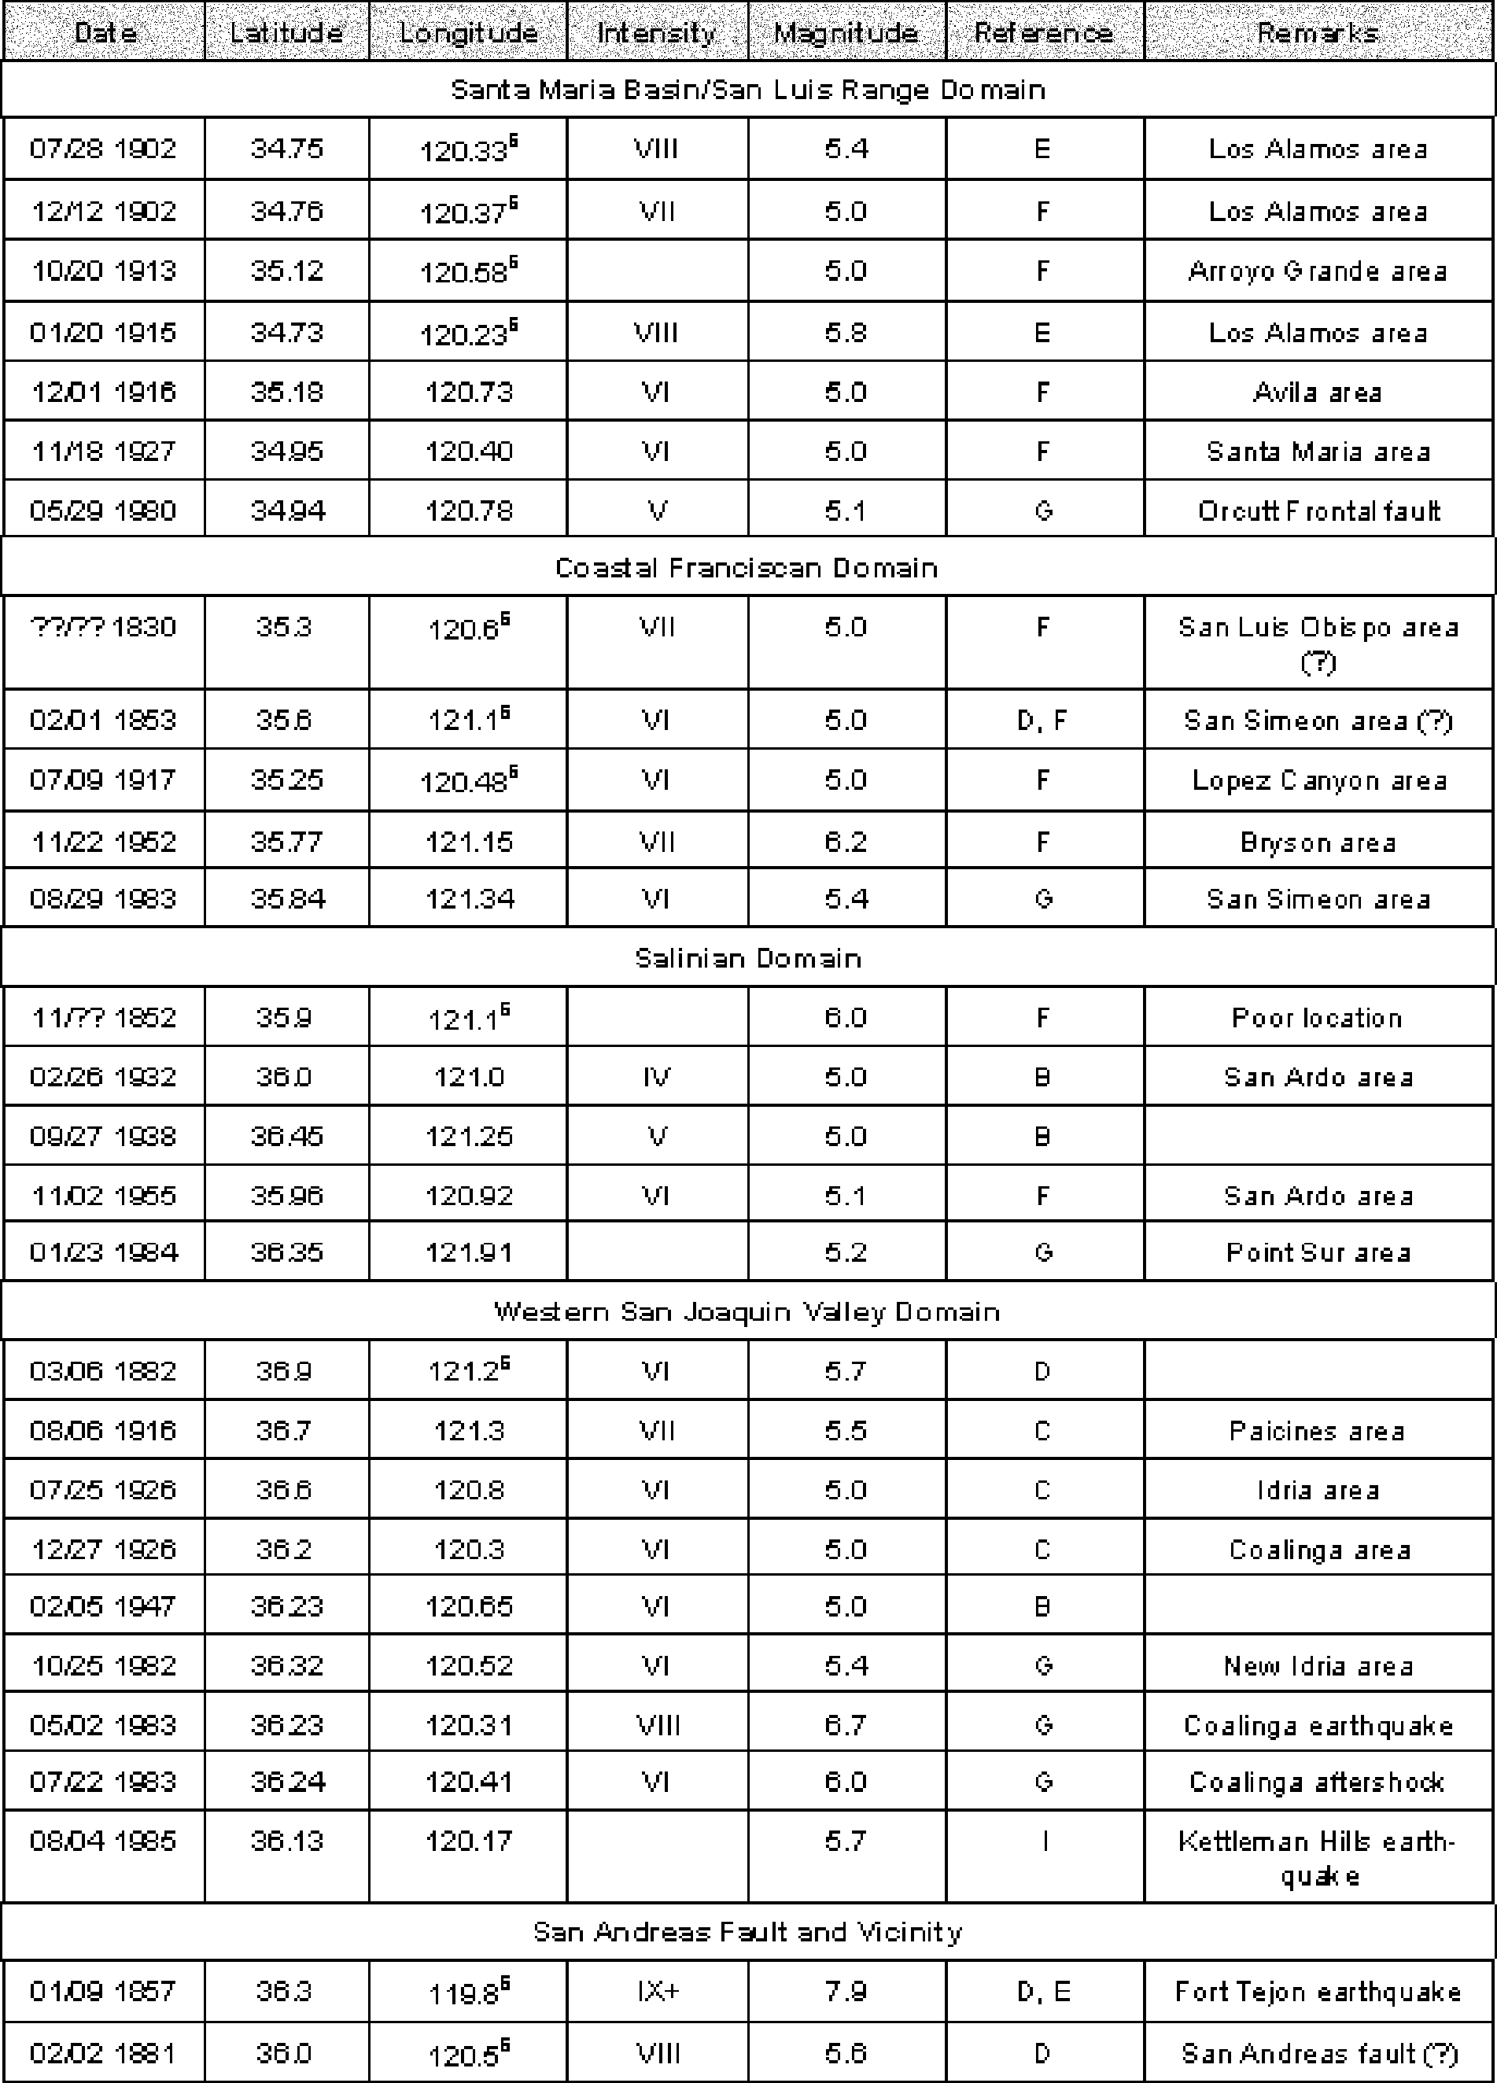

County and Cities of San Luis Obispo

Table 4-7: Selected Historical Earthquakes with Mw>5.0 in Coastal Central California from 1830 through 1989 (continued)
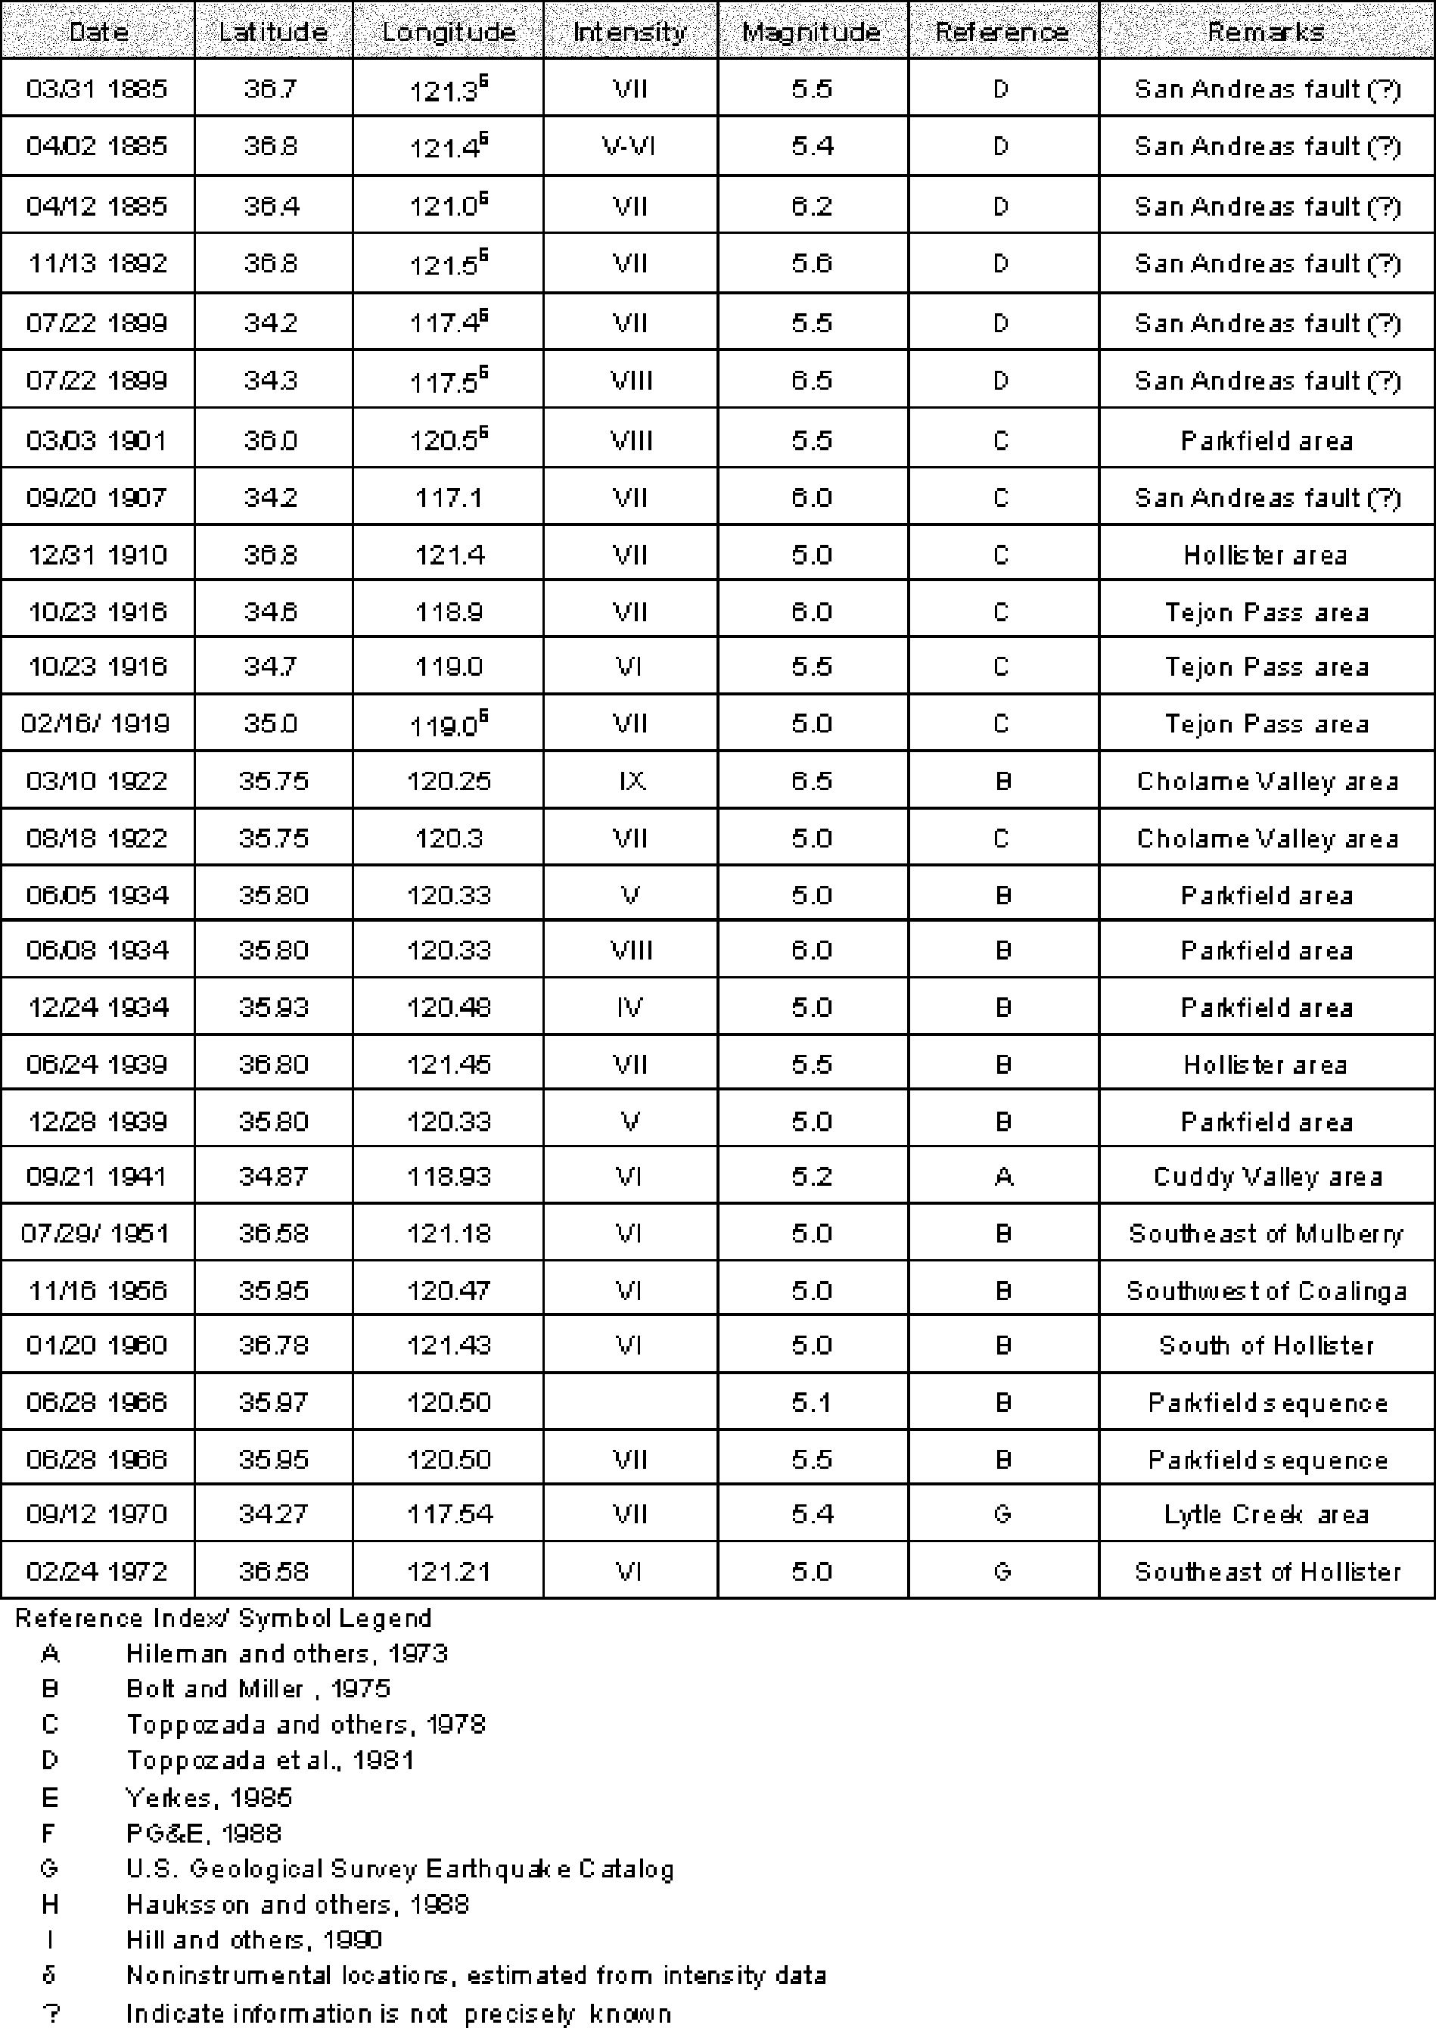

the event is poorly constrained and cannot be attributed to a specific fault source, but the earthquake reportedly occurred somewhere near San Luis Obispo.
1906 San Francisco Earthquake. This earthquake has been studied in detail and the effects in San Luis Obispo County have been documented. Modified Mercalli intensity ratings ranged from III-IV in the inland and north coast portions of the County, and IV- V in the south coast areas. The higher intensities were felt in areas underlain by alluvial soil, while the lower intensities occurred in areas underlain by bedrock formations.
1916 Avila Beach Earthquake. This magnitude Mw5.1 event occurred offshore of Avila Beach in San Luis Bay. The earthquake reportedly resulted in tumbling smokestacks of the Union Oil Refinery at Port San Luis, and a landslide that blocked the railroad tracks. The maximum intensity appears to be approximately VI (PG&E, 1988), but the available descriptions of the shaking are somewhat limited.
1952 Arvin-Tehachapi Earthquake. This Mw7.7 magnitude earthquake occurred on the White Wolf fault, located south and west of Bakersfield. Throughout most of the County, ground shaking intensities of VI were felt. Intensities of IV-V were experienced in the northwest portion of the County, and magnitude VIII intensities were felt in the Cuyama area, in the southeast portion of the County. The higher intensities were likely due to closer proximity to the earthquake epicenter.
1952 Bryson Earthquake. This magnitude Mw6.2 earthquake likely occurred on the Nacimiento fault, and resulted in intensity ratings of VI throughout most of the western portion of the County. Intensities of IV-V were experienced in the eastern portion of the County. Higher intensities were generally felt in the coastal valley areas that are underlain by alluvial soils.
1934 and 1966 Parkfield Earthquakes. These earthquakes had magnitudes of Mw6.0 and Mw5.5, respectively, and occurred on the San Andreas fault in the northeast corner of the County. Earthquake intensities generally conformed to anticipated characteristics for events of this size, with intense shaking (VII-VIII) being limited to a relatively small area near the epicenters of the quakes. Moderate shaking was experienced in most of the central and western parts of the County. A variation from the expected intensity characteristics was experienced in the La Panza area during the 1934 earthquake. La Panza is approximately 40 miles south of the fault rupture area, but experienced earthquake intensities of VII.
Fault Rupture
Hazard Description
A fault is a fracture in the earth’s crust along which movement has occurred either suddenly during earthquakes or slowly during a process called creep. Cumulative displacement may be tens or even hundreds of miles if movement occurs over geologic time. However, individual episodes are generally small, usually less than several feet, and are commonly separated by tens, hundreds, or thousands of years. Damage associated with fault-related ground rupture is normally confined to a fairly narrow band along the trend of the fault. Structures are often not able to withstand fault rupture and utilities crossing faults are at risk of damage. Fault displacement involves forces so great that it is generally not feasible (structurally or economically) to design and build structures to accommodate this rapid displacement.
Geologic research (Ziony and Yerkes, 1985) has shown that historically active and active faults (i.e., those with Holocene displacement) are the most likely sources for potential

damage associated with fault rupture. The Alquist-Priolo Earthquake Hazard Zone Act (AP) was developed by the State of California to regulate development near active faults and mitigate the surface fault rupture hazard. The Act identifies active earthquake fault zones and restricts building habitable structures over known active or potentially active faults. Out of necessity, utilities, roads, and bridges often cross known active and potentially active faults.
Fault displacement can also occur in the form of barely perceptible movement called “fault creep.” Damage by fault creep is usually expressed by the rupture or bending of buildings, fences, railroads, streets, pipelines, curbs, and other linear features. Excellent examples of fault creep can be seen in the Carrizo Plain area of eastern San Luis Obispo County where gradual creep on the San Andreas fault has offset stream beds, roadways, and fence lines. In addition, there is also the potential for coseismic creep, where movement on a fault is triggered by an earthquake on another nearby fault.
As mentioned above, historically active and active faults are generally thought to present the greatest risk for future movement and, therefore, have the greatest potential to result in fault rupture hazards. A common problem in determining where ground displacement may occur is identifying the location of the fault. Many faults are hidden beneath deep accumulations of soil. Additionally, fault displacement may occur in rupture zones (similar to the Landers and Loma Prieta earthquakes) instead of along a single fault trace. Another consideration is that detailed geologic studies have not been performed in large portions of San Luis Obispo County. With the difficulties associated with mitigating the effects of fault rupture and in determining the precise location of faults, the most effective method to minimize fault rupture hazard is to avoid placing structures in proximity to suspected fault locations.
Because of the presence of numerous active and potentially active faults in San Luis Obispo County, it is appropriate to consider the potential for ground surface rupture due to faulting. Portions of the Los Osos, San Simeon-Hosgri, and San Andreas faults have been designated active by CDMG under the Alquist-Priolo Fault Zoning Act legislation. The approximate limits of the earthquake fault zones recommended by CDMG are shown on Map 2. Guidelines for evaluating and mitigating seismic hazards in California are discussed in a recent publication by CDMG (1997).
Effects of Surface Rupture
Permanent effects of ground displacement may include abrupt changes in the ground surface elevation, damage and possible destruction of structures, alteration of surface drainage patterns, changes in ground water levels, misalignment of streets, and changes in the gradient of sewer and water utilities. A qualitative description of fault hazard potential is presented below.

Table 4-8: Fault Rupture Hazard
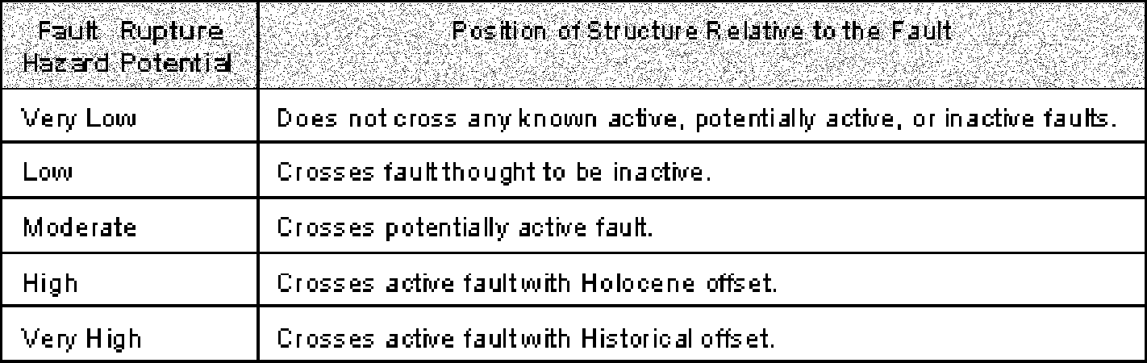

Unincorporated San Luis Obispo County
Fault Rupture Hazard Potential
Active and potentially active faults in San Luis Obispo County are shown on Map 2. Active faults identified by the Alquist-Priolo Fault Zoning set include the San Andreas, San Simeon-Hosgri, and Los Osos faults. Fault zonation is continually updated and reviewed by CDMG, and it is likely that other faults in addition to those currently listed by CDMG will be added to the list in the future.
Tables 4-4, 4-5, and 4-6 list major faults that have been mapped in San Luis Obispo County. The potential for fault rupture hazards along other faults listed in Table 4-4 as inactive faults is generally considered to be low. However, this hazard should be considered when placing a structure near or over any suspected fault location.
The following paragraphs briefly discuss the fault rupture hazard potential for the several unincorporated areas of the County including Cambria, Cayucos, Nipomo, Oceano, the South Bay area, San Miguel, Santa Margarita, and Templeton.
Cambria
Mapped faults in the vicinity of Cambria include the Cambria and Oceanic faults, and the offshore Hosgri fault. Although the offshore Hosgri fault is considered to be active and a likely source for future seismic events, it does not itself provide a fault rupture hazard to onshore facilities.
The potentially active Cambria fault consists of a complex web of thrust faults that trend northwest along Highway 1 into the town of Cambria. In the vicinity of Cambria, the fault zone extends from the eastern portion of the town eastward for about two kilometers. The potentially active Oceanic fault zone (Jennings, 1994) consists of a zone of northwest trending faults located about 8 kilometers northeast of Cambria. Because the faults are considered to be potentially active, they present a moderate fault rupture hazard to the town of Cambria. Further studies to evaluate the activity of the faults are warranted prior to placing structures near the mapped fault traces.
Cayucos
Faults in the vicinity of Cayucos include the Cayucos, Cambria, and Oceanic fault zones. Geologic mapping by Kilbourne and Mualchin (1980) and Hall and Prior (1995) mapped the buried trace of the northwest striking Cayucos fault beneath the town of Cayucos. The fault is considered to be inactive and therefore results in a low potential to serve as a fault rupture hazard. Although CDMG considers the Cayucos fault to be inactive (Jennings, 1994), it is often undesirable to site structures over any fault as a result of nonuniform foundation support conditions and the potential for coseismic movement that could result from earthquakes on other nearby faults.
The northwest striking Oceanic fault zone is located about two kilometers northeast of Cayucos. The Cambria fault zone is mapped by Hall and Prior (1975) as going offshore north of Cayucos, and returning to shore as a broad zone of faults passing through Cayucos between the cemetery and Willow Creek. These faults are considered to be potentially active and therefore present a moderate fault rupture hazard. Further studies to evaluate the activity of the faults are warranted, prior to placing structures near the mapped fault traces.

Nipomo
The faults in the Nipomo area include the Santa Maria River, Wilmar Avenue, Oceano and West Huasna faults. The buried trace of the Santa Maria River/Wilmar Avenue fault is inferred to parallel U.S. Highway 101 in the vicinity of Nipomo. The Oceano fault generally is trending northwest across the Nipomo Mesa and into the town of Oceano. The West Huasna fault is mapped along the eastern side of the valley. As discussed in the fault descriptions portion of the text, those faults generally have a subdued topographic expression and are considered to be potentially active by CDMG. Review of the Oceano fault by Asquith (1997) suggests that the fault is inactive. On the basis of that information, potentially active faults present moderate fault rupture hazard in the Nipomo area. The inactive Oceano fault presents a very low potential as a fault rupture hazard. Although the Oceano fault is inactive, it is often undesirable to site structures over any fault as a result of nonuniform foundation support conditions and the potential for coseismic movement that could result from earthquakes on other nearby faults. Further studies to evaluate the activity of the Wilmar Avenue and West Huasna faults are warranted, prior to placing structures near the mapped fault traces.
Oceano
The only known mapped fault in the vicinity of Oceano is the Oceano fault. The buried trace of the potentially active Oceano fault is interpreted to strike northwest along the southwestern side of the Cienega Valley about 1,000 meters southwest of Oceano, and goes offshore near the mouth of Arroyo Grande Creek. Although the fault is classified as potentially active by CDMG, review of the Oceano fault by Asquith (1997) suggests that the fault is inactive. The Oceano fault presents a very low fault rupture hazard to Oceano. Although the Oceano fault is likely inactive, it is often undesirable to site structures over any fault as a result of nonuniform foundation support conditions and the potential for coseismic movement that could result from earthquakes on other nearby faults.
South Bay
As discussed herein, the South Bay area includes the communities of Los Osos, Cuesta- by-the-Sea, Baywood Park, and the south Morro Bay area. Mapped faults in the South Bay area include the active Los Osos fault. As mapped by Lettis and others (1994), the Los Osos fault consists of a several hundred meter wide zone of west-northwest striking lineaments and scarps located along the southern side of the Los Osos Valley. Portions of the Los Osos fault have been zoned active by CDMG (Treiman, 1989). Several investigators (Lettis and others, 1994; Asquith 1997) have postulated that a splay of the Los Osos fault trends northwest beneath the town of Los Osos. Asquith (1997) provides the most detailed evaluation of the fault’s location, and has mapped the splay just west and running parallel to the extension of Farrell Avenue. The location of the “Strand B” splay of the Los Osos fault is shown on Map 2.
As discussed previously, the activity of this fault segment is unknown, but is inferred to be at least potentially active or possibly active. On the basis of ground water data, Asquith (1997) infers that the northwest-southeast striking fault splay is an effective ground water barrier in wind blown sand formations at shallow depths, suggesting that the fault is active. This could be of concern because the inferred fault splay is located several hundred feet south of the South Bay fire station and the Sunnyside Elementary School. On the basis of this information, the Los Osos fault and related branches present a moderate to very high fault rupture hazard to the area. Further studies to evaluate the location and activity of the fault are warranted, prior to placing structures near the mapped fault traces.

San Miguel
As indicated on Map 2, the data reviewed does not indicate that there are mapped active or potentially active faults in San Miguel.
Santa Margarita
The only mapped fault in the Santa Margarita area is the potentially active Rinconada fault. The fault trends northwest through the Santa Margarita area near Pozo Road, Trout Creek, and the Salinas River. According to Hart (1985), although there is a preponderance of evidence that indicates movement along the Rinconada fault during the late Quarternary, the fault lacks any geomorphic features within young alluvium to suggest the fault is active. Because the Rinconada fault is potentially active, it poses a moderate fault rupture hazard to this area. Further studies to evaluate the activity of the faults are warranted, prior to placing structures near the mapped fault traces.
Templeton
The only mapped fault in the Templeton area is the western trace of the potentially active Rinconada fault system referred to as the Jolon fault. The fault trends northwest through the community just south of the junction of Highways 46 and 101. According to Hart (1985), although there is a preponderance of evidence that indicates movement along the Rinconada fault during the late Quarternary, the fault lacks any geomorphic features within young alluvium to suggest the fault is active. Because the Rinconada fault is potentially active, it poses a moderate fault rupture hazard to this area. Further studies to evaluate the activity of the faults are warranted, prior to placing structures near the mapped fault traces.
Arroyo Grande
Fault Rupture Hazard Potential
Mapped faults in the City of Arroyo Grande are the potentially active Wilmar Avenue fault and the inactive Pismo fault. As described by Nitchman and Slemmons (1994), the Wilmar Avenue fault is exposed in the seacliff near Pismo Beach and the buried trace of the fault is inferred to strike northwest-southeast parallel and adjacent to U.S. Highway 101 beneath portions of Arroyo Grande. Within the City limits, the Wilmar Avenue fault is mostly concealed by deep alluvium along Arroyo Grande Creek. The potentially active fault presents a moderate potential fault rupture hazard to the City. The inactive Pismo fault presents a very low potential fault rupture hazard. Further studies to evaluate the activity of the faults are warranted, prior to placing structures near the mapped fault traces.
Atascadero
Fault Rupture Hazard Potential
Mapped faults in the vicinity of Atascadero are the potentially active Rinconada fault and the Nacimiento fault zones. The Rinconada fault and its western associated fault, the Jolon, is mapped trending northwest along the eastern City limits. The fault mostly lies east of the Salinas River and outside the City limits. According to Hart (1985), although there is a preponderance of evidence that indicates movement along the Rinconada fault during the late Quarternary, the fault lacks any geomorphic features within young alluvium to suggest the fault is active. Because the Rinconada fault is potentially active, it presents a moderate fault rupture hazard to the City of Atascadero. Further studies to evaluate the activity of the faults are warranted, prior to placing structures near the mapped fault traces.
The Nacimiento fault zone consists of a nearly 10-kilometer wide northwest trending, complex fault zone located in the Santa Lucia Range of southwest Atascadero. The

Nacimiento fault zone is classified as inactive by CDMG (Jennings, 1994), but is believed to be coincident with the location of the epicenter for historic earthquakes that suggest the fault is seismically active. Given the uncertainty of the Nacimiento fault’s activity, further studies to evaluate the activity of the faults are warranted, prior to placing structures near the mapped fault traces.
Grover Beach
Fault Rupture Hazard Potential
The only mapped fault near Grover Beach is the potentially active Wilmar Avenue fault. As described by Nitchman and Slemmons (1994), the Wilmar Avenue fault is exposed in the seacliff near Pismo Beach and the buried trace of the fault is inferred to strike northwest-southeast generally along the alignment of U.S. Highway 101 past Grover Beach. The mapped location of the fault runs along a portion of the northern city limits for Grover Beach. The Wilmar Avenue fault apparently offsets late Quaternary deposits; therefore, it is considered potentially active and presents a moderate fault rupture hazard to the City. Further studies to evaluate the activity of the fault are warranted, prior to placing structures near the mapped fault traces.
Morro Bay
Fault Rupture Hazard Potential
The only known mapped faults in the City of Morro Bay are the potentially active Cambria fault and possible splays of the active Los Osos fault system. The Cambria fault is mapped within the eastern limits of the City. The Cambria fault consists of a complex system of thrust faults located primarily in the hills northeast of Morro Bay. The potentially active fault presents a moderate fault rupture hazard to City developments in that area. The Los Osos fault is active, but presents essentially no fault rupture hazard to the City as it is only mapped in undeveloped areas. Further studies to evaluate the activity of the faults are warranted, prior to placing structures near the mapped fault traces.
Paso Robles
Fault Rupture Hazard Potential
The only known mapped fault within the City of Paso Robles is the Rinconada fault. The potentially active Rinconada fault is mapped through southwestern Paso Robles and crosses Highway 101 just south of Spring Street. A trace of the fault is also identified by Dibblee (1971) as running up Spring Street, which corresponds to a line of hot springs that once existed in this area but have since been capped and buried. As a potentially active fault, the Rinconada presents a moderate fault rupture hazard to the City. Further studies to evaluate the activity of the faults are warranted, prior to placing structures near the mapped fault traces.
The northern end of the potentially active La Panza fault is located about 20 kilometers southeast of the Paso Robles, near the town of Creston. The northwest striking La Panza fault is about 75 kilometers long. The Huerhuero fault is a possible extension of the La Panza and is mapped trending northwest along Huerhuero Creek south of Highway 46, but is not within the current City limits.
San Luis Obispo
Fault Rupture Hazard Potential
CDMG (Treiman, 1989) has mapped the active Los Osos fault through a portion of the City, which strikes northwest-southeast along the southwestern margin of the Los Osos Valley. Treiman (1989) conducted field evaluations for the main strand of the Los Osos fault near the intersection of Los Osos Valley Road and Foothill Road, and found evidence of movement in the last 11,000 years. This evidence of recent activity resulted in the

establishment of an Earthquake Fault Zone by CDMG in 1989 under the Alquist-Priolo Fault Zoning Act. It should not be interpreted that the active portion of the main trace of the Los Osos Fault is limited only to the designated Earthquake Fault Zone. Rather, the limits of the established zone correspond to the limits of the available information provided in site specific studies that show a preponderance of evidence of recent fault activity in that area. As additional information about other segments of the fault are provided by additional studies, it may be appropriate for CDMG to expand the zone. On the basis of the above data, the Los Osos fault presents a high to very high fault rupture hazard to City developments near and southwest of the Los Osos Valley Road area. Additional geologic studies are warranted to locate proposed structures in the vicinity of the mapped trace of the fault away from postulated splays.
Other faults that are near the borders of San Luis Obispo are the West Huasna, Oceanic, and Edna faults. These faults are considered to be potentially active and present a moderate fault rupture hazard to developments in their vicinity.
Groundshaking
Hazard Description
Sudden slip along all or part of a fault surface releases energy that has accumulated within the earth’s crust and radiates that energy in the form of earthquake waves in all directions away from the source. As the waves pass through an area, they produce the shaking effects that are the predominant cause of earthquake damage. In general, groundshaking intensity diminishes as the distance from the earthquake epicenter increases. The loss of earthquake energy that occurs as distance from the fault increases is called “attenuation.” Numerous attenuation relationship theories have been proposed by various scientists, and these theories are frequently revised and updated as more information about the behavior of earthquakes is learned.
Groundshaking has historically resulted in a significant risk to life and property damage. The extent of loss that can result from groundshaking was demonstrated by the 1989 Loma Prieta and 1994 Northridge earthquakes which resulted in the loss of many lives and property and infrastructure damage in the billions of dollars.
Groundshaking can also trigger secondary seismic phenomenon such as liquefaction, lateral spreading, seismically induced settlement and slope instability, tsunami and seiche, and other forms of ground rupture and seismic response.
San Luis Obispo County is located in a geologically complex and seismically active region that is subject to earthquakes and potentially strong groundshaking. The intensity of groundshaking at a particular site or structure is a function of many factors including: 1) earthquake magnitude, 2) distance from the epicenter, 3) duration of strong ground motion,
4) local geologic conditions (soil type and topography), and 5) the fundamental period of the structure. A brief description of those factors is presented below.
Earthquake Magnitude. Earthquake magnitude, as measured by either the Richter or Moment Magnitude scale, is a measurement of energy released by the movement of a fault. As the amount of energy released by an earthquake increases, the potential for groundshaking impacts also increases.
Distance From Epicenter. Earthquake energy generally dissipates (or attenuates) with distance from a fault. Over long distances, this loss of energy can be significant, resulting in a significant decrease in groundshaking with increased distance from the epicenter.

Duration of Strong Shaking. The duration of the strong groundshaking constitutes a major role in determining the amount of structural damage and the potential for ground failure that can result from an earthquake. Larger magnitude earthquakes have longer durations than smaller earthquakes.
Local Geologic Conditions. The geologic and soil conditions at a particular site have the potential to substantially increase the effects of groundshaking. The thickness, density, and consistency of the soil, as well as shallow ground water levels, have the potential to amplify the effects of groundshaking depending on the characteristics of the earthquake. In general, the presence of unconsolidated soils above the bedrock surface can amplify the groundshaking caused by an earthquake.
Fundamental Periods. Every structure has its own fundamental period or natural vibration. If the vibration of groundshaking coincides with the natural vibration period of a structure, damage to the structure can be greatly increased.
The extent of damage suffered during an earthquake can also depend on non-geologic factors. The type of building and its structural integrity will influence the severity of the damage suffered. Generally, small, well constructed, one- and two-story wood and steel frame buildings have performed well in earthquakes because of their light weight and flexibility. Reinforced concrete structures will also usually perform well. Buildings constructed from non-flexible materials, such as unreinforced brick and concrete, hollow concrete block, clay tile, or adobe, are more vulnerable to earthquake damage.
Effects of Groundshaking
The primary effect of groundshaking is the damage or destruction of buildings, infrastructure, and possible injury or loss of life. Building damage can range from minor cracking of plaster to total collapse. Disruption of infrastructure facilities can include damage to utilities, pipelines, roads, and bridges. Ruptured gas and water lines can result in fire and scour/inundation damage, respectively, to structures. Secondary effects can include geologic impacts such as coseismic fault movement along nearby faults, seismically induced slope instability, liquefaction, lateral spreading, and other forms of ground failure and seismic response.
Seismic Risk
Seismic risk associated with earthquakes and public safety is being addressed on an ongoing basis by local, state and federal agencies. The most significant elements of this assessment are the building codes and regulations that define acceptable risks and govern seismic design standards for residential, public, and infrastructure buildings and facilities.
Building safety and construction is regulated predominately by the requirements contained in the Uniform Building Code (UBC), which is published periodically by the International Congress of Building Officials (ICBO). The UBC provides minimum standards that represent current practices in building safety and the construction of earthquake-resistant structures. The building requirements of the UBC can be adopted by local jurisdictions, with amendments when necessary.
Previous editions of the UBC have recognized the seismic exposure of San Luis Obispo County to groundshaking hazards by categorizing the entire County within Seismic Zone IV, the most stringent category for seismic design in the UBC. According to UBC standards, structures in Zone IV should be designed to the same seismic criteria regardless of their proximity to faults. The 1997 UBC, not yet adopted by the State of California, still classifies the County within Seismic Zone IV; however, the code now considers soil profile type

and a near-source factor in the design of structures. Additional seismic hazards such as amplification of ground motion and liquefiable foundation support soils are considered in the selection of the soil profile type. The near-source factor considers modifications for design based on the closest distance to a potential seismic source (faults), the maximum moment magnitude, and the slip rate of the fault. These types of parameters, as identified in the CDMG database, are summarized for selected San Luis Obispo faults in Table 4- 4, and are being updated on an ongoing basis by CDMG. Design professionals may recommend that structures also consider faults that are not listed in Table 4-4. A summary of other faults in San Luis Obispo County is presented in Tables 4-5 and 4-6, which may be considered in addition to those listed by CDMG. Ongoing studies are also being performed by CDMG to map seismic hazards for areas founded on soil profiles subject to ground failure during seismic events.
Groundshaking Hazard Potential
Groundshaking caused by fault movement during an earthquake has the potential to result in significant life, safety, and property damage impacts throughout San Luis Obispo County. Groundshaking may occur as a result of movement along a fault located within the County or along a more distant fault. Similarly, an earthquake on any one of the faults in the County limits could affect each of the Cities within the County. Since proximity to the causative fault is an important factor in assessing the potential severity of groundshaking impacts, this analysis focuses on faults located in San Luis Obispo County.
Two recent studies by CDMG have estimated potential ground acceleration that could be experienced in California. Mualchin and Jones (1992) deterministically estimated the maximum credible ground acceleration that could be generated by active and potentially active faults. Deterministic peak horizontal ground accelerations from this study range from a low of 0.4 g in the central portion of the County to a high of about 0.7 g along the San Andreas, Rinconada, Oceanic-West Huasna, and coastal fault zones.
It should be noted that the attenuation relationships used by Mualchin and Jones (1992) and others to predict strong ground motion are based on empirical correlation to historic ground motion records. As a result of statistical deviations associated with these techniques, ground motions higher than those estimated can occur for the potential earthquakes being considered, plus or minus 50 percent or more. It should also be noted that the ground accelerations shown on Mualchin and Jones are for maximum credible earthquakes, which considers the greatest potential earthquakes that could occur, and does not consider the probability of that earthquake occurring within a given time period.
CDMG (1996) published a probabilistic seismic hazard map for the State of California with contours showing the peak horizontal ground acceleration with 10 percent probability of being exceeded in 50 years. The western portion of the County has a 90 percent probability of experiencing ground accelerations in the range of 0.3 g to 0.4 g in the next 50 years. The eastern portion of the County adjacent to the San Andreas fault has a 90 percent probability of experiencing a peak ground acceleration of 0.5 g to 0.7 g in the next 50 years. Again, the statistical variance in estimated ground acceleration could easily be plus or minus 50 percent of the estimated ground motion.
San Andreas Fault
The San Andreas fault is one of the most seismically active faults in California and presents a significant groundshaking risk to San Luis Obispo County, especially to communities located in the eastern portion of the County. Because of the proximity of the fault and the relatively high probability of a major earthquake in the near future, the San Andreas fault is generally considered the most likely source for strong ground motion in the County.

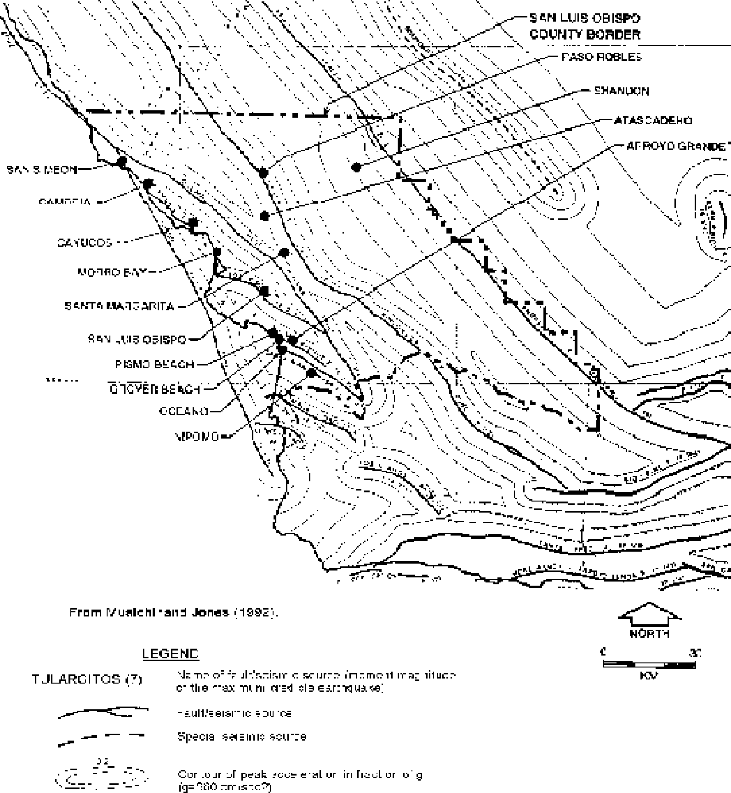

Coastal Faults
There are numerous active and potentially active faults in the western portion of the county and in the offshore area that have the potential to generate strong ground motion. Those faults are shown on Map 2 and listed in Tables 4-4, 4-5, and 4-6. On the basis of recent studies by PG&E (1988), the most likely earthquake sources for generating strong ground motion in the coastal region of San Luis Obispo County are considered to be the San Simeon-Hosgri, Los Osos, and Santa Lucia Bank and offshore faults, which are shown as active faults by CDMG (Jennings, 1994). Other potentially active faults that are thought to be seismically capable of generating strong ground motion include the Wilmar Avenue/Santa Maria River, Oceano, Pecho, West Huasna-Oceanic, Cambria, Casmalia (Orcutt Frontal-Pezzoni), Nacimiento, and Rinconada faults.
Blind Thrust Faults
A potentially significant source of strong motion in San Luis Obispo County is buried or blind thrust faults and thrust ramps hypothesized beneath the Santa Maria Basin and coastal areas of San Luis Obispo County by Namson and Davis (1990). The ramps described by Namson and Davis are the Point San Luis, Santa Lucia, Black Mountain and

La Panza faults. On the basis of their evaluation, Namson and Davis hypothesize that there are several blind thrust faults and a regional detachment fault located between about three to 14 kilometers beneath the San Luis Obispo County area. Based on comparison with the 1983 Coalinga, 1987 Whittier Narrows, and 1994 Northridge earthquakes and a database of worldwide earthquakes, they estimate that the thrust faults/ ramps beneath the central California coast could produce earthquakes with magnitudes in the range of magnitude Mw5.0 to Mw7.5.
As demonstrated by the 1994 Northridge earthquake, blind thrust faults have the potential to produce strong ground motion and significant structural damage without surface fault rupture. In addition, strong ground motion measurements from the Northridge earthquake demonstrate that: 1) earthquakes on blind thrust faults can produce ground accelerations in excess of those currently estimated by conventional attenuation relationships for areas directly above the thrust fault/ramp, and 2) there can be a significant amplification of the ground motion due to the variation in alluvium depth and properties, referred to as a “basin effect”. There is a potential for both of the above conditions in the coastal and central San Luis Obispo County areas if a large earthquake were to occur on a buried or blind thrust fault.
Amplification of Ground Motion
Research has shown that areas that are underlain by layers of unconsolidated, recent alluvium and unconsolidated soil material with high ground water have an increased risk of experiencing the damaging effects of groundshaking (Ziony and Yerkes, 1985). During the Loma Prieta earthquake, ground motion was amplified up to 4 times as it moved up through the San Francisco Bay muds and caused significant damage to the Oakland Bay Bridge and collapsed the Nimitz Freeway structure even though they were located more than 60 km from the earthquake.
Areas within the County that are underlain by recent alluvial sediments (Qal) are depicted on Map 1. Those areas include the coastal valleys and plains and interior valleys near annual streams and water sources. The coastal areas considered to be at increased risk to amplification of ground motion include the Los Osos Valley, San Luis Valley, South Bay area, Cambria, Cayucos, and the Grover Beach/Oceano/Arroyo Grande areas. Inland, the main area with an increased risk appears to be along the Salinas River and Rinconada Creek. There may also be a potential for earthquake induced groundshaking damage along Cholame Creek, Estrella Creek, and the Paso Robles area.
To help quantify the risk associated with earthquake induced groundshaking and secondary phenomena such as liquefaction, previous regional geologic studies by the United States Geologic Survey (USGS) and CDMG have generally classified regions on the basis of three factors: 1) soil/bedrock type; 2) depth to ground water; and 3) level of anticipated strong ground motion. The above three factors are generally subdivided further to more fully evaluate the level of risk depending on the available data.
San Luis Obispo County
Ordinances and Regulations
In San Luis Obispo County, the UBC was adopted with amendments into the County Building and Construction Ordinance, Section 19.01.012, Title 19 of the County Code.
Arroyo Grande
Groundshaking Hazard Potential
The City of Arroyo Grande is proximal to active and potentially active faults capable of producing strong ground motion in response to seismic events. Table 4-9 lists faults in

Table 4-9: Sources of Ground Shaking in the Vicinity of Arroyo Grande

Fault | Approximate Distance (kilometers)* | Maximum Earthquake | Maximum Probable Earthquake | Anticipated Acceleration Range (g)
Wilmar Avenue | 0 | 6 ½ | 4 | 0.1 - 0.7
Blind Thrust Point San Luis | 0 | 7 ½ | 6 | 0.2 - 0.8
Los Osos | 6 | 7 | 5 | 0.1 - 0.5
Pecho | 9 | 6 ¹/₄ | 3 | <0.1 - 0.3
Hosgri | 25 | 7 ½ | 6 ½ | 0.1 - 0.2
Casmalia | 21 | 7 ½ | 6 | 0.1 - 0.3
La Panza | 32 | 7 ½ | 5 | 0.05 - 0.2
San Andreas | 62 | 8 ¼ | 8 | 0.1 - 0.2
*Measured from the intersection of Branch and Mason Streets

the vicinity of Arroyo Grande considered to be potential sources of relatively strong ground shaking.
With a high probability for producing a major earthquake in the near future, the San Andreas fault and the offshore Hosgri fault present the most likely groundshaking hazard to Arroyo Grande. Other faults that have the potential to generate strong ground motion in Arroyo Grande include the active Los Osos fault, and the potentially active Wilmar Avenue, Pecho, and Orcutt frontal faults. Although the probability, or return interval, on one of these closer faults is lower, the peak ground acceleration that could result from a near-field event would likely be significantly greater than would be expected from a high probability event on the San Andreas or Hosgri faults. In addition to the mapped faults, there is also a potential for strong ground motion associated with earthquakes on hypothesized buried thrust faults beneath the coastal area.
Portions of Arroyo Grande that are underlain by layers of unconsolidated, recent alluvial soil material have an increased risk of experiencing the damaging effects of groundshaking. These areas are considered to be at an increased risk because of the amplifying effect that can occur when unconsolidated soil materials are subject to groundshaking. Major areas within Arroyo Grande that are underlain by recent alluvial sediments are depicted on Maps 1 and 3.
Ordinances and Regulations
The City of Arroyo Grande has adopted the Uniform Code for Building Conservation. This code belongs to a family of codes, published by ICBO, that correlate with the UBC to provide jurisdictions with a complete set of building-related regulations for adoption.
Atascadero
Groundshaking Hazard Potential
The City of Atascadero is proximal to active and potentially active faults capable of producing strong ground motion in response to seismic events. Table 4-10 lists faults in the vicinity of Atascadero considered to be potential sources of relatively strong ground shaking.
With a high probability for producing a major earthquake in the near future, the San Andreas fault presents the most likely source of groundshaking to Atascadero. The closest

Table 4-10: Sources of Ground Shaking in the Vicinity of Atascadero
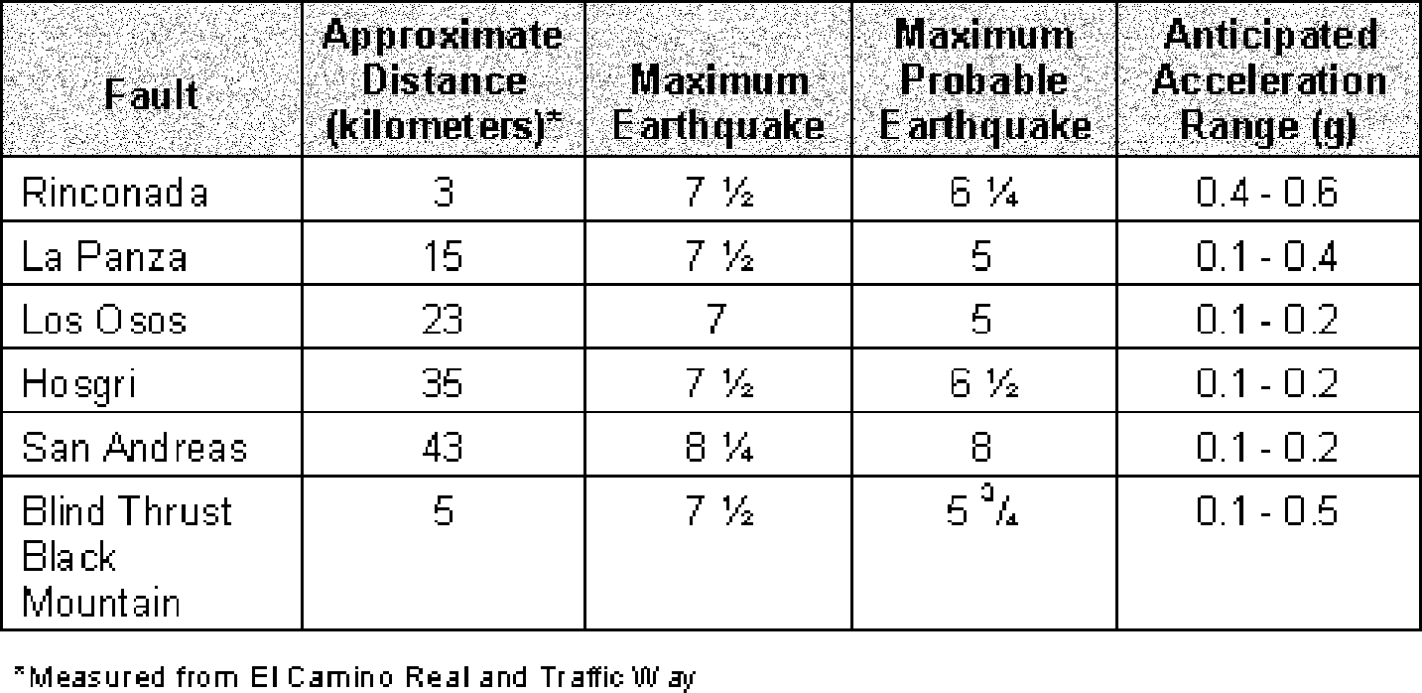

mapped fault is the potentially active Rinconada fault which has the potential to generate a magnitude 6¼ to 7½ earthquake with an estimated ground acceleration in the range of 0.4g to 0.6g., which, if it were to occur, could have a widespread damaging effect on the City. Other faults that have the potential to generate strong ground motion in Atascadero include the active Los Osos and Hosgri faults but are located at some distance from the City and therefore pose a lesser ground motion hazard. In addition to the mapped faults, there is also a potential for strong ground motion associated with earthquakes on hypothesized buried thrust faults beneath the La Panza and Santa Lucia Ranges.
Portions of Atascadero with an increased risk of experiencing the damaging effects of groundshaking are those areas that are underlain by layers of unconsolidated, recent alluvial soil material. Areas within Atascadero that are underlain by recent alluvial sediments are depicted on Maps 1 and 3.
Ordinances and Regulations
In Atascadero, the UBC was adopted by Ordinance No. 248, which amended Title 8 (Building Regulations) of the Atascadero Municipal Code.
Grover Beach
Groundshaking Hazard Potential
The City of Grover Beach is proximal to active and potentially active faults capable of producing strong ground motion in response to seismic events. Table 4-11 lists faults in the vicinity of Grover Beach considered to be potential sources of relatively strong ground shaking.
With a high probability for producing a major earthquake in the near future, the San Andreas fault and the offshore Hosgri fault present the most likely sources of groundshaking to Grover Beach. Other faults that have the potential to generate strong ground motion in Grover Beach include the active Los Osos fault, and the potentially active Wilmar Avenue, Pecho, Orcutt frontal faults. In addition to the mapped faults, there is also a potential for strong ground motion associated with earthquakes on hypothesized buried thrust faults beneath the coastal area.
Portions of Grover Beach that are underlain by layers of unconsolidated, recent alluvial soil material have an increased risk of experiencing the damaging effects of groundshaking. Major areas within Grover Beach that are underlain by recent alluvial sediments are depicted on Maps 1 and 3.

Table 4-11: Sources of Ground Shaking in the Vicinity of Grover Beach

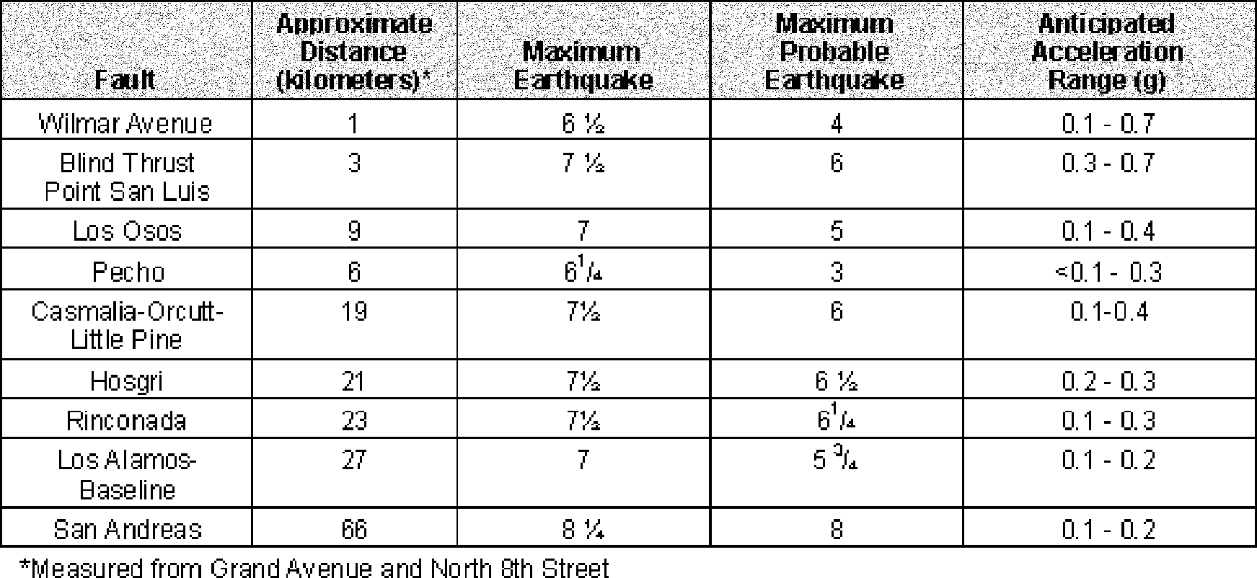
Ordinances and Regulations
In Grover Beach, the UBC was adopted by Ordinance No 95-5, which amended Municipal Code section 8101-8110.
Morro Bay
Groundshaking Hazard Potential
The City of Morro Bay is located in proximity to active and potentially active faults capable of producing strong ground motion in response to seismic events. Table 4-12 lists faults in the vicinity of Morro Bay considered to be potential sources of relatively strong ground shaking.
With a high probability for producing a major earthquake in the near future, the San Andreas and the offshore Hosgri fault present the most likely sources of groundshaking to Morro Bay. Other faults that have the potential to generate strong ground motion in Morro Bay include the active Los Osos fault, and the potentially active Wilmar Avenue, Rinconada, Pecho (offshore) and Santa Lucia Bank (offshore) faults. In addition to the mapped faults, there is also a potential for strong ground motion associated with earthquakes on hypothesized buried thrust faults beneath the coastal area.

Table 4-12: Sources of Ground Shaking in the Vicinity of Morro Bay
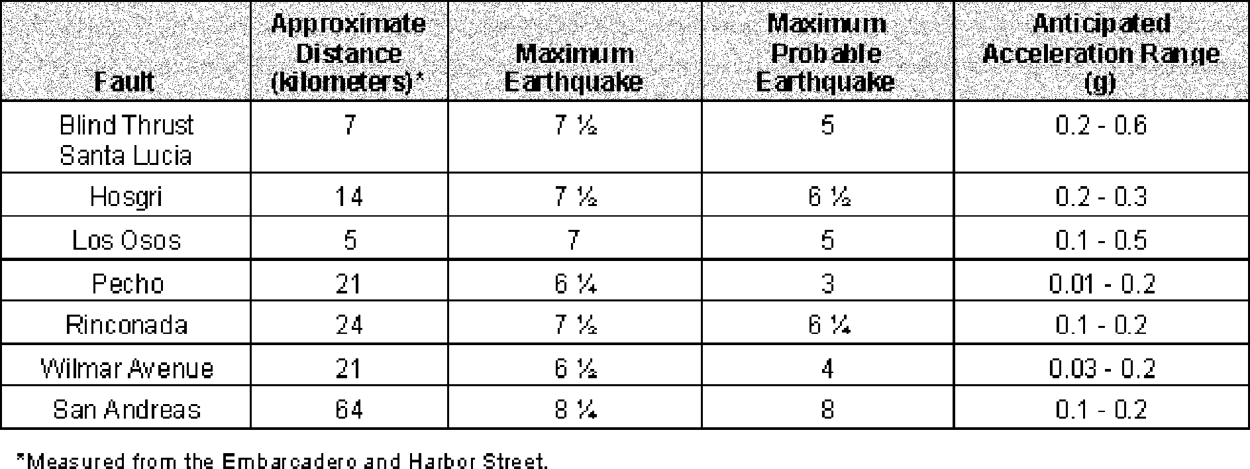

Portions of Morro Bay that are underlain by layers of unconsolidated, recent alluvial soil material have an increased risk of experiencing the damaging effects of groundshaking. Major areas within Morro Bay that are underlain by recent alluvial sediments are depicted on Maps 1 and 3.
Ordinances and Regulations
In Morro Bay, the UBC was adopted in Chapter 14.18 (Ordinance No. 450) of the Municipal Code. In 1996 the City Council amended Chapter 14.18 to provide for voluntary compliance with California and Safety Codes sections 19160-19169.
Paso Robles
Groundshaking Hazard Potential
The City of Paso Robles is proximal to active and potentially active faults capable of producing strong ground motion in response to seismic events. Table 4-13 lists faults in the vicinity of Paso Robles considered to be potential sources of relatively strong ground shaking.
With a high probability for producing a major earthquake in the near future, the San Andreas fault presents the most likely source of groundshaking to Paso Robles. The closest mapped fault to Paso Robles is the potentially active Rinconada fault which has the potential to generate a magnitude 6¼ to 7½ earthquake, which, if it were to occur, could have a widespread damaging effect on the City. In addition to the mapped faults, there is also a potential for strong ground motion associated with earthquakes on hypothesized buried thrust faults beneath the Paso Robles area.
Portions of Paso Robles that would have an increased risk of experiencing the damaging effects of groundshaking are those areas that are underlain by layers of unconsolidated, recent alluvial soil material. Areas within Paso Robles that are underlain by recent alluvial sediments are depicted on Maps 1 and 3.
Ordinances and Regulations
In Paso Robles, the UBC is adopted in Chapter 17.04 of the Municipal Code.
City of San Luis Obispo
Groundshaking Hazard Potential
The City of San Luis Obispo is proximal to active and potentially active faults capable of producing strong ground motion in response to seismic events. Table 4-14 lists faults in the vicinity of San Luis Obispo considered to be potential sources of relatively strong ground shaking.

Table 4-13: Sources of Ground Shaking in the Vicinity of Paso Robles
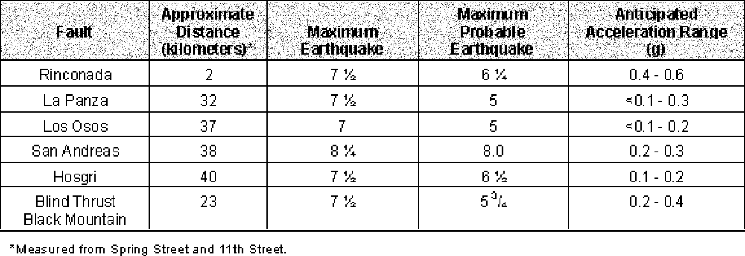

Table 4-14: Sources of Ground Shaking in the Vicinity of San Luis Obispo
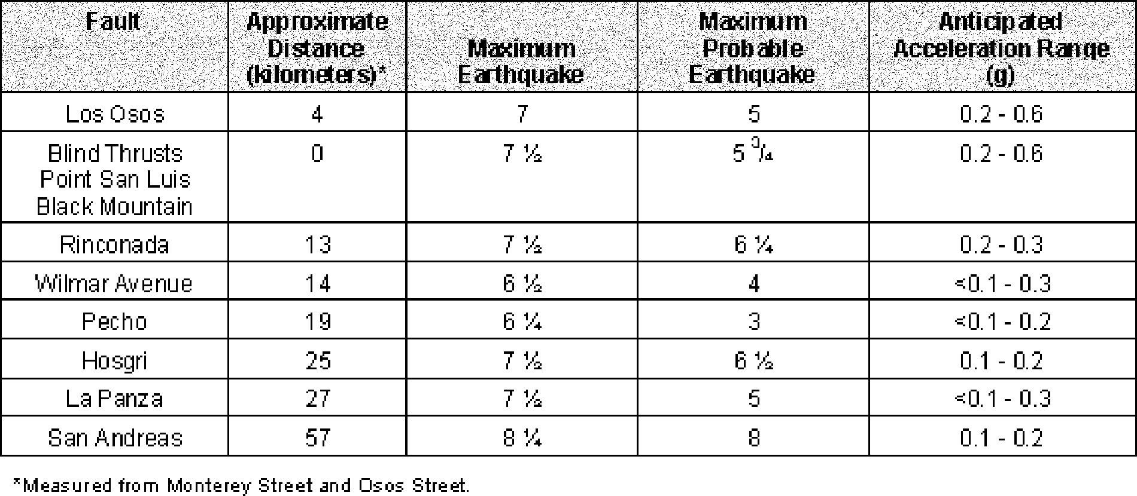

With a high probability for producing a major earthquake in the near future and proximity to the City, the San Andreas fault and the offshore Hosgri faults present the most likely sources of groundshaking to the City of San Luis Obispo. Other faults that have the potential to generate strong ground motion in San Luis Obispo includes the active Los Osos faults. In addition to the mapped faults, there is also a potential for strong ground motion associated with earthquakes on hypothesized buried thrust faults beneath the coastal area.
Portions of the City of San Luis Obispo that are underlain by layers of unconsolidated, recent alluvial soil material have an increased risk of experiencing the damaging effects of groundshaking. Areas within San Luis Obispo that are underlain by recent alluvial sediments are depicted on Maps 1 and 3.
Ordinances and Regulations
In the City of San Luis Obispo, the UBC is adopted in Chapter 15.04 of the Municipal Code.
Liquefaction
Areas that have geology that may be susceptible to liquefaction are indicated in Map 3. Liquefaction potential is dependent on site-specific features that can only be assessed by a detailed evaluation of subsurface conditions at a particular location. Planners and public agencies often use mapping of alluvial areas, such as indicated on Map 3, as a guide for knowing when they should request site-specific studies to evaluate liquefaction potential and its impact on development. These general maps of alluvial areas are often misinterpreted by subsequent agencies and/or practitioners as depicting areas where liquefaction hazards are known to exist. Care should be exercised in how these maps are used, and what interpretations can be made from them.
Hazard Description
Liquefaction is defined as the sudden loss of soil strength due to a rapid increase in soil pore water pressures resulting from seismic groundshaking. In order for liquefaction to occur, three general geotechnical characteristics should be present: 1) ground water should be present within the potentially liquefiable zone; 2) the potentially liquefiable zone should be granular and meet a specific range in grain-size distribution; and 3) the

potentially liquefiable zone should be of low relative density. If those criteria are present and strong ground motion occurs, then those soils could liquefy, depending upon the intensity and duration of the strong ground motion. Liquefaction that produces surface effects generally occurs in the upper 40 to 50 feet of the soil column, although the phenomenon can occur deeper than 100 feet. The duration of ground shaking is also an important factor in causing liquefaction to occur. The larger the earthquake magnitude, and the longer the duration of strong groundshaking, the greater the potential there is for liquefaction to occur.
Effects of Liquefaction
When liquefaction of the soil does occur, buildings and other objects on the ground surface may tilt or sink, and lightweight buried structures (such as pipelines) may float toward the ground surface. Liquefied soil may be unable to support its own weight or that of structures, which could result in loss of foundation bearing or differential settlement. Liquefaction may also result in the development of cracks in the ground surface followed by the emergence of a sand/water mixture, typically referred to as a sand-boil. In areas underlain by thick deposits of saturated, loose granular sediment (such as alluvial valleys or beaches), subsidence as much as several feet may result. Because the alluvial sediments are a heterogeneous mixture of soil types with variable thickness, the resulting settlement is often differential. The differential settlement can cause significant damage to rigid structures such as buildings and linear features such as pipelines and highways.
Liquefaction may also lead to the lateral spreading of soft saturated soils. Lateral spreading is a form of slope instability that results when the lateral movement of a soil-block toward an unconfined free face can occur when a layer of soil below the ground surface liquefies. An example of where lateral spreading may occur is adjacent to stream banks. Lateral spreading has been reported to occur on slopes of less than five percent, but it is difficult to evaluate the magnitude of the potential lateral spreading.
Liquefaction Hazard Potential
The areas of the County most susceptible to the effects of liquefaction are those areas underlain by young, poorly consolidated, saturated granular alluvial sediments. These soil conditions are most frequently found in areas underlain by recent river and flood plain deposits. Table 4-15 summarizes a general guide for assessing the vulnerability that some soil/bedrock types may have towards liquefaction.
Map 3 indicates areas of low to high liquefaction potential based on the geologic units mapped in these areas. Holocene-age alluvium (Qa), and beach deposits may have a high to very high liquefaction potential depending on their density and the depth to ground water. Dune sediments (Qds, Qos) and pleistocene-age alluvial deposits (Qoa) and terrace deposits (Qt) generally have a moderate liquefaction potential. The Pleistocene-age Paso Robles Formation (QTp), Tulare Formation (QTt) and unnamed valley sediment (QTu),

Table 4-15: Vulnerability to Liquefaction


which consist primarily of weakly cemented silty sand, is exposed in large areas of the County and also have a moderate liquefaction potential. Areas underlain by Pliocene or older bedrock (including sandstone, shale, granite, and Franciscan rocks) are considered to have a very low to nil liquefaction potential.
County of San Luis Obispo
Portions of coastal San Luis Obispo County are underlain by sediments that may be vulnerable to liquefaction. Developed areas that may be underlain by geologic units having a higher potential for liquefaction are the coastal communities of Oceano, Avila, South Bay, Cayucos, and Cambria. Inland communities that have development adjacent to rivers or major creeks and drainages may have limited areas that have a high potential for liquefaction hazards to exist. These inland communities include Nipomo, Santa Margarita, Templeton, and San Miguel. Large portions of the County east of Highway 101 are underlain by Quarternary age formational sediments and alluvial materials that have a low to moderate potential for liquefaction. Site-specific studies are needed to evaluate if a geologic unit actually contains potentially liquefiable materials and if they require mitigation for development.
Arroyo Grande
Liquefaction Hazard Potential
The areas of Arroyo Grande that have a high potential to be underlain by potentially liquefiable sediments are those areas underlain by younger alluvium (Qa). The younger alluvium underlies most of the low-lying downtown areas south of Branch Street and along Grand Avenue. Higher elevations at the west end of the City, and north of Highway 101 and Branch Street are underlain by older Quarternary sediments comprised of sand dune deposits (Qos) and the Paso Robles Formation (QTp) that have a moderate potential to be underlain by liquefiable soils. Site-specific studies are needed to evaluate if a geologic unit actually contains potentially liquefiable materials, and if they require mitigation for development.
Atascadero
Liquefaction Hazard Potential
The areas of Atascadero that have a high potential to be underlain by potentially liquefiable sediments are those areas underlain by younger alluvium (Qal). Portions of the City in the low lying areas adjacent to Atascadero Creek, Graves Creek, and the Salinas River are mapped as being underlain by younger alluvium. Other portions of the City are undeveloped. A majority of the City is underlain by older alluvium and Paso Robles Formation, which are considered to have a moderate liquefaction potential. Site-specific studies are needed to evaluate if a geologic unit actually contains potentially liquefiable materials, and if they require mitigation for development.
Grover Beach
Liquefaction Hazard Potential
The areas of Grover Beach that have a high potential to be underlain by potentially liquefiable sediments are those areas underlain by beach sand and young alluvium (Qa). High ground water levels can be expected near the Pacific Ocean and adjacent to Meadow Creek. Areas underlain by dune sand (Qds) and older sediments that have a moderate potential to contain liquefiable materials are mapped as older dune deposits (Qos). Site- specific studies are needed to evaluate if a geologic unit actually contains potentially liquefiable materials, and if they require mitigation for development.

Morro Bay
Liquefaction Hazard Potential
The areas of Morro Bay that have a high potential to be underlain by potentially liquefiable sediments are those areas underlain by beach and sand dune deposits (Qs) and younger alluvium (Qa). A majority of the City is underlain by these alluvial, estuarine, beach and sand dune deposits. High ground water levels can be expected in the Embarcadero area and other beach front areas. Flood plain areas along Chorro, Little Morro and Morro Creeks are also underlain by younger alluvium (Qa). The higher elevations of the City are underlain by older alluvium (Qoa), old dune sand (Qos), Franciscan Formation (KJf), and volcanic (Td) bedrock, and have a moderate to nil potential to be underlain by liquefiable sediments. Site-specific studies are needed to evaluate if a geologic unit actually contains potentially liquefiable materials, and if they require mitigation for development.
Paso Robles
Liquefaction Hazard Potential
The areas of Paso Robles that have a high potential to be underlain by potentially liquefiable sediments are those areas underlain by younger alluviuam (Qa). Geologic mapping indicates that most of the City of Paso Robles is underlain by late Pleistocene and older alluvial deposits (Qoa) and Paso Robles Formation (QTp) that have a moderate potential to be underlain by liquefiable soils. Portions of the City that are located on recent alluvium in the low lying areas adjacent to the Salinas River (or its tributaries) appear to have the highest potential for liquefaction. Site specific studies are needed to evaluate if a geologic unit actually contains potentially liquefiable materials, and if they require mitigation for development.
City of San Luis Obispo
The areas of the City of San Luis Obispo that have a high potential to be underlain by potentially liquefiable sediments are those areas underlain by younger alluvium (Qa). Most of the City of San Luis Obispo is underlain by alluvium. Other portions of the City that are underlain by older alluvium are considered to have a moderate liquefaction potential. Areas of the City located on Monterey Formation, Franciscan Formation, or other bedrock units have a very low to nil liquefaction potential. Site specific studies are needed to evaluate if a geologic unit actually contains potentially liquefiable materials, and if they require mitigation for development.
Tsunami and Seiches
Hazard Description
Tsunamis (pronounced soo-nom-ee) are ocean waves generated by vertical movement of the sea floor. The movement is typically caused by earthquake-related faulting, but can also result from submarine landslides or volcanic eruptions. San Luis Obispo County could be affected by tsunami caused by fault-related ground displacement on a local offshore fault, or on a more distant fault. A common source of tsunami affecting California in the past has been earthquakes on faults off the coast of Chile and the North American coast (up to Alaska).
In the open ocean, tsunami waves have a long wavelength (distance from the crest of one wave to the crest of the succeeding wave) normally over 100 miles, and a very low amplitude (height from crest to trough). As these waves approach shallow water, their speed decreases from a deep water speed of over 600 miles-per-hour to less than 30 miles-per-hour. The wave energy is transferred from wave speed to wave height. Thus, waves as high as 100 feet have been formed.

Tsunamis are a unique hazard because the arrival time of a wave generated far out at sea can be predicted fairly accurately. Unfortunately, the intensity of the wave when it reaches shore cannot be accurately predicted. Tsunamis are sometimes preceded by a trough or recession of ocean water that can attract people to the shore to examine what appears to be a very low tide.
Seiches are defined as oscillations of enclosed and semi-enclosed bodies of water, such as bays, lakes, or reservoirs, due to strong ground motion from seismic events, wind stress, volcanic eruptions, and local basin reflections of tsunami. Seiches can result in the creation of long-period waves which can cause water to overtop containment features or cause seiche runup on adjacent land masses, similar to tsunami runup. The intensity of the damage caused by a seiche is proportional to the magnitude and proximity of the event causing the seiche, and the amount of freeboard present at the time of the seiche. Freeboard is defined as the vertical distance from the free surface of the water to the top edge of the containment structure.
Effects of Tsunami
The threat of tsunami-related damage is primarily confined to low-lying coastal areas. If the gradient is shallow, tsunami waves can travel upstream into river channels. The primary effects of a tsunami can be widespread destruction and damage to coastal structures. In 1964 in Crescent City, California, tsunami waves up to 20-feet high caused more than $11 million dollars in property damage and resulted in 11 deaths.
According to Kilbourne and Mualchin (1980a), the following historical tsunami have occurred in the area:

Table 4-16: Historical Tsunamis
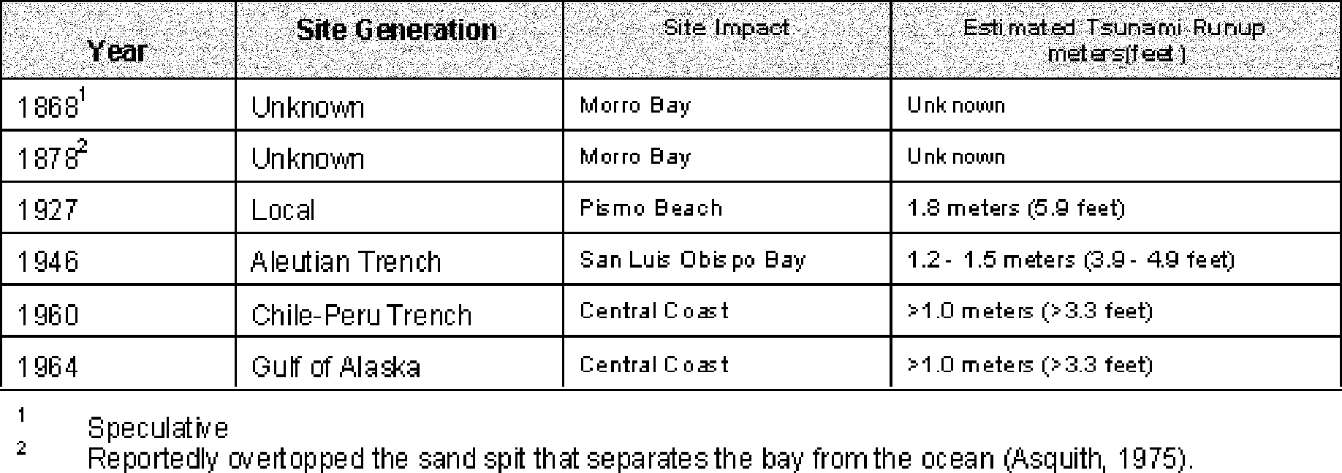

Large tsunamis have not been common on the Central Coast of California. So few tsunamis have been recorded that the historical record is not extensive enough to develop accurate recurrence predictions. The largest recorded tsunami to affect California was caused by an earthquake in the Santa Barbara Channel in 1812. Resulting tsunami runup waves are reported to have been up to 50 feet above sea level at Gaviota, and 35 feet above sea level at Santa Barbara.
PG&E (1973) reported that the historical record for San Luis Obispo County includes no tsunamis that have exceeded the normal tidal range. PG&E (1973) suggests that faulting in the offshore area could generate tsunami wave height as great as six feet. In San Luis Obispo County, coastal areas near Port San Luis, Cayucos, and San Simeon were designated

as having a “potential danger” from tsunami. This potential hazard level was the lowest risk designation included in the study. The potential for damage to coastal structures would be increased if the tsunami event were to coincide with a high tide.
As noted in the above table, the historic record shows tsunamis generated from far-field sources. Houston and Garcia (1978) estimated the 100- and 500-year tsunami runups in the study area based on far-field source generation locations (such as the Aleutian or Chile-Peru Trenches). On the basis of their study, the estimated tsunami runup along the Cayucos/Morro Bay coastline is approximately 9.5 feet to 24.2 feet for the 100-year and 500-year events, respectively. Those runups were calculated using astronomical high tides, and compare well with recorded tsunamis that have occurred in Crescent City and other locations along the California coast. However, according to Kilbourne and Maulchin (1980), the worst case scenario would occur if a tsunami occurred during a meteorological high tide (storm surge), which would add an estimated 14.5 feet (4.5 meters) to the runup values calculated by Houston and Garcia (1978). Thus, with a worst case scenario, the estimated tsunami runup for the 100-year and 500-year would be approximately elevation 24 and 39 feet above mean sea level, respectively.
The Houston and Garcia (1978) study did not evaluate the tsunami runup potential generated from local seismic events or local submarine landslides. It is difficult to model the tsunami runup magnitudes based on local events; however, it is thought that local events can generate tsunami of equal magnitudes as far-field tsunami sources (Kilbourne and Mualchin, 1980a).
San Luis Obispo County
Tsunami Hazard Potential
The tsunami hazard for the San Luis Obispo County coastal areas is greatest for those communities or portions of communities located below the estimated elevations for the 100- to 500-year events, that is, below elevation 24 and 39 feet above mean sea level, respectively. In general, much of the coast of San Luis Obispo County is protected from tsunami hazards by wide beaches, coastal dunes, or sea cliffs that provide protection to coastal developments. Coastal developments most vulnerable to the tsunami hazards are those located near mouths of coastal streams that drain into the Pacific Ocean, such as San Simeon Creek in San Simeon; Cayucos Creek, Little Cayucos Creek, Old Creek and Willow Creek in Cayucos; Morro Creek and Alva Paul Creek in Morro Bay; Chorro Creek in Morro Bay and the South Bay area; San Luis Obispo Creek in Avila; and Meadow Creek and Arroyo Grande Creek in Oceano. The severity of the exposure to the tsunami hazard will vary locally depending on specific natural and artificial coastal conditions.
Seiche Hazard Potential
Seiches could occur in any reservoir located in the County, and in Morro and San Luis bays. According to Kilbourne and Mualchin (1980a), seiches have been recorded in San Francisco, Monterey, and San Pedro bays. The extent of potential seiche runup within Morro Bay is unknown, but is thought to be less in magnitude than the affects of potential tsunami.
Arroyo Grande
Tsunami Hazard Potential
The City of Arroyo Grande has no coastal exposure and is therefore not vulnerable to tsunami hazards.

Atascadero
Tsunami Hazard Potential
The City of Atascadero has no coastal exposure and is therefore not vulnerable to tsunami hazards.
Grover Beach
Tsunami Hazard Potential
Specific analyses have not been performed for Grover Beach to estimate the potential tsunami runup height. The tsunami hazard is greatest for that portion of the community located below elevations of the 100-year to 500-year events, that is, below elevations 24 and 39 feet below mean sea level, respectively. Additional areas of potential hazard are along the mouth of Meadow Creek. In general, portions of coastal Grover Beach are protected from tsunami hazards by wide beaches and coastal dunes. The severity of the exposure to the tsunami hazard will vary locally depending on specific natural and artificial coastal conditions.
Morro Bay
Tsunami Hazard Potential
Specific analyses have not been performed for Morro Bay to estimate the potential tsunami runup height. The tsunami hazard is greatest for that portion of the community located below elevations of the 100-year to 500-year events, that is, below elevations 24 and 39 feet below mean sea level, respectively. Additional areas of potential hazard are along the mouths of Morro Creek and Alva Paul Creek, and within the bay at Chorro Creek. In general, much of the coast of Morro Bay is protected from tsunami hazards by wide beaches, coastal dunes, or bluffs that provide protection to coastal developments. The
severity of the exposure to the tsunami hazard will vary locally depending on specific natural and artificial coastal conditions.
Paso Robles
Tsunami Hazard Potential
The City of Paso Robles has no coastal exposure and is therefore not vulnerable to tsunami hazards.
San Luis Obispo
Tsunami Hazard Potential
The City of San Luis Obispo has no coastal exposure and is therefore not vulnerable to tsunami hazards.
Slope Stability
Hazard Description
Landslides result when the driving forces that act on a slope (i.e. the weight of the slope material, and the weight of objects placed on it) are greater than the slope’s natural resisting forces (the shear strength of the slope material). The down-slope movement of earth material, either as a landslide, debris flow, mudslide, or rockfall, are part of the continuous, natural process of erosion. This process, however, can be influenced by a variety of causes that change the stability of the slope. Slope instability may result from natural processes, such as the erosion of the toe of a slope by a stream, or by ground shaking caused by an earthquake. Slopes can also be modified artificially by grading, or by the addition of water or structures to a slope. Development that occurs on a slope can substantially increase the frequency and extent of potential slope stability hazards.
Areas susceptible to landslides are typically characterized by steep, unstable slopes in weak soil/bedrock units which have a record of previous slope failure. Conversely, areas

with little topographic relief underlain by geologic formations of high strength generally have a low potential for slope-related hazards. There are numerous factors which effect the stability of the slope, including: slope height and steepness, type of materials, material strength, structural geologic relationships, ground water level, and level of seismic shaking. Slope steepness or gradient is an important consideration with regard to slope instability. Slopes with an inclination of 5 horizontal to 1 vertical (5h:1v, about 11 degrees) are normally fairly stable unless the earth materials exposed in the slope are very weak. As the gradient increases, the potential for slope instability increases. Slopes steeper than about 2h:1v in weak materials are prone to long term instability. Generally, sandy or granular soils and rock units are stronger and less likely to be associated with large scale landsliding then are soil and rock units composed of fine-grained silt and clay.
In many slope failures, water is an important component. Water adds to the weight of the slope material, thus increasing the driving force. Water can also facilitate movement by decreasing the strength of the soil along a “slip plane” or a zone of weakness in the materials, and by providing a buoyant upward force against the base of the landslide. Water may be added to a slope as a result of development (i.e. through irrigation, septic systems, and changes in drainage) or naturally as a result of rainfall. Heavy rains, particularly in areas that have been affected by wildfires, can trigger debris flows and mudslides, which can be a particularly destructive form of down-slope movement.
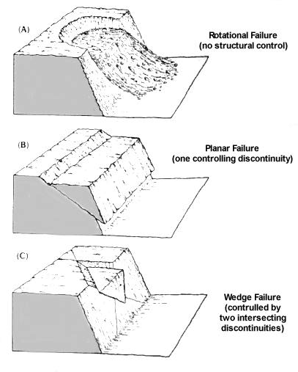
Methods to minimize potential landslide hazards can best be implemented prior to development that may cause, or be affected by, slope movement. The risk of slope movement can usually be reduced by performing a geologic/geotechnical study of the existing geologic conditions, and by implementing an appropriately engineered grading plan. Many jurisdictions have adopted specific guidelines for geologic/geotechnical studies in hillsides areas. CDMG (1997) provides minimum standards for geologic studies to address slope stability issues. Mitigating landslide hazards
after development occurs, however, can be constrained by the presence of existing structures and multiple property owners. Remedial methods to correct the effects of slope movement in developed areas may include measures such as dewatering the hillside, buttressing or retention of the slope, or removing the unstable material. However, these measures may be expensive and difficult to implement, depending on the size of landslide.
This appraisal of potential landslide hazards is intended to be used as a general guide for land use planning purposes, only. It should not be considered as a substitute for performing appropriate geologic and soils investigations, or a substitute for providing proper site design and engineering of individual development projects. The data typically needed to adequately assess the potential for slope-related hazards must be obtained as part of a detailed geologic/geotechnical study of the site, along with an evaluation of proposed terrain modifications. This type of site specific evaluation should be conducted at the time a specific project is proposed.
Effect of structure on planar slope failures.

Effects of Landslides
Downslope movement can range from the almost imperceptible creep of soil and rock material to the sudden mass movement of an entire hillside. Soil creep generally produces fissures in the soil, cracked building foundations, tilting utility poles and trees, and damaged underground utilities. Mass slope movement during a landslide can cause substantial damage to buildings, roads, and infrastructure. Sudden slope movement can also result in permanent changes to topography and drainage patterns, such as the temporary damming of streams. Construction on slopes steeper than about 20 percent gradient typically require some type of special grading, modified foundation design, or site modification to address sloping ground conditions and reduce the potential for slope instability.
Map 4 presents a summary of landslides hazards related to slope gradient and topography that were identified within the study area based on currently available information. The data presented on Map 4 is limited, and areas of slope instability exist locally that are not shown on this and other regional geologic maps. Criteria that were used to evaluate the potential for landslide hazards as shown on Map 1, as well as factors that can be indicative of slope instability locally, are summarized below:

Table 4-17: Landslide Hazard and Slope Instability Potential
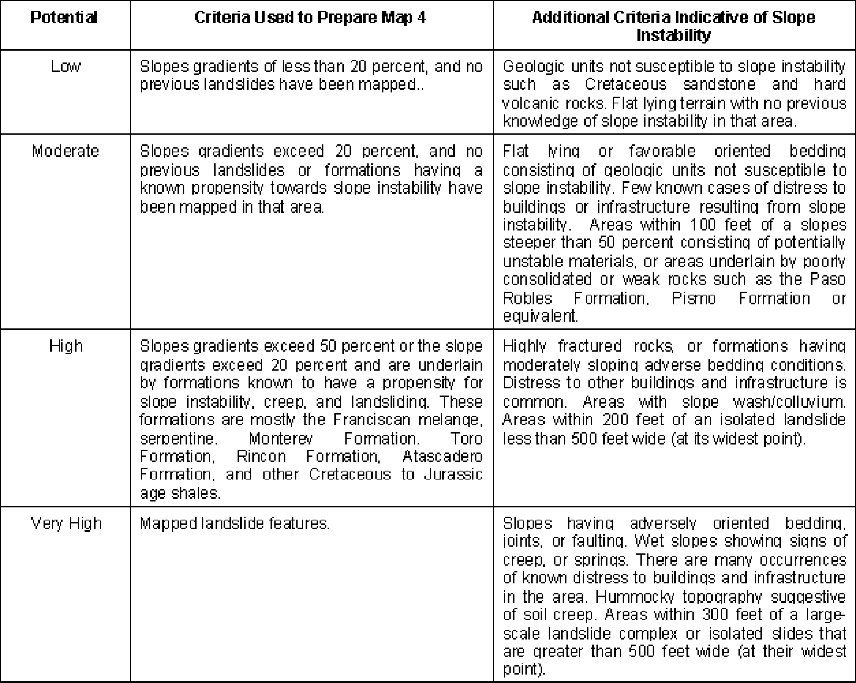

Landslide Hazard
In San Luis Obispo County, there are several geologic formations commonly associated with slope stability problems. As noted on Map 4, those geologic units include the Franciscan, Rincon, Toro, and Monterey formations. Of these, the Franciscan is the most notorious formation known for slope instability. Numerous landslides within the Franciscan complex are observable along the Highway 1 corridor from San Luis Obispo to San Simeon. Numerous landslides have also been mapped in the Franciscan and Toro formations along Highway 101 on the Cuesta Grade. Landslides in the Franciscan formation have impacted residences, roadway facilities, pipelines, and other

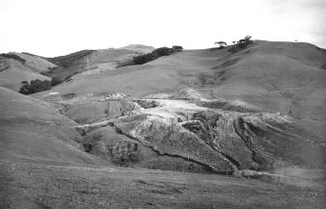
State water line, Reservoir Canyon.

infrastructure in the County. The Rincon and Toro formations have a similar geologic history of landsliding, but are generally not as widespread as the Franciscan. [An active landslide has also been identified in the vicinity of Harbor Terrace near Port San Luis Harbor west of Avila Beach.]
Geologic formations located in the County that present a moderate slope stability hazard potential include the Quaternary bedrock units such as the Paso Robles Formation and formations of equivalent age and composition. The susceptibility of areas underlain by these formations to slope stability impacts will vary based on a variety of site specific factors, such as slope, the orientation of bedding planes, rainfall, characteristics of the overlying soil, and the type and extent of proposed slope modifications. In some areas, slopes may be stable in a natural condition, but alterations to the hillsides to accommodate urban development may cause unstable conditions that could adversely affect future development. Prior to the initiation of new development that could be adversely affected by slope movement, site specific evaluations are necessary to determine the hazard potential and to identify engineering design methods to minimize the risk of landslide-related damage.
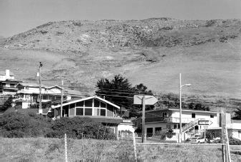
Numerous large landslides are also mapped in the steep mountainous terrain of the Santa Lucia, La Panza and Caliente Mountain ranges and many canyons. Landslides of this type have been mapped in nearly all of the formations and are generally related to steep slopes, adverse geologic structure, weak or weathered formations, faulting, and wet slopes.
Cayucos.
To date, only limited geologic mapping has been performed to evaluate the presence of landslides in the hillside areas of the County. Most of the geologic studies to date have focused on large scale geologic structure, faulting, or other geologic issues and did not specifically evaluate landsliding. A significant
amount of additional studies need to be performed to identify and evaluate landslides to help reduce the potential for long term damage related to slope instability. General guidelines for those studies are presented in publications by CDMG (1997) and other agencies.

Ordinances and Regulations
The Uniform Building Code, which has been adopted by the County of San Luis Obispo with certain amendments, requires that site specific investigations be performed for development located in hillside areas. Investigations and practices typically required for hillside development include the following:
- Conduct thorough geologic/geotechnical studies by qualified geotechnical engineers and engineering geologists.
- Require both engineering geologists and geotechnical engineers during construction
to confirm preliminary findings reported during initial studies.
- Require certification of the proposed building site stability in relation to the adverse effects of rain and earthquakes prior to the issuance of building permits.
- Mandate coordination between the civil engineer and the project engineering geologist
and geotechnical engineer during construction grading.
- Require mitigation of on-site hazards caused by grading that may affect adjoining properties, including erosion and slope instability.

Sections 22/23.05.020 et. seq. of the San Luis Obispo County Land Use Ordinance and Coastal Zone Land Use Ordinance, Titles 22 and 23 of the County Code, contain the County’s grading ordinance. This ordinance outlines specific requirements for grading permits, procedures for reviewing and approving grading permits, inspection requirements for completed grading projects, and erosion and drainage requirements. Section 22/
23.07.080 defines general requirements for identifying Geologic Study Areas (GSA) that would require a geology report to address landslide hazards.
Arroyo Grande
Landslide Hazard Potential
A majority of the existing development in Arroyo Grande is located on gently inclined alluvial valley sediments and the hilly terrain north of Branch Street. The potential for slope stability hazards in valley areas is low to very low. The potential slope instability is greatest in the hilly areas of the City. The potential for slope instability in the sloping terrain can mostly be mitigated by applying building code requirements that provide minimum requirements for building construction and grading on sloping ground as those areas are not known to be underlain by large landslide features or notoriously unstable formations. However, there are relatively steep hillsides and canyons near the City, and as development moves into those areas, there could be greater potential for slope stability related concerns. A thorough geologic/geotechnical study should be prepared prior to development for projects planned in those areas. General guidelines for those studies are presented in publications by CDMG (1997) and other agencies.
Ordinances and Regulations
The Uniform Building Code, which has been adopted by the City of Arroyo Grande with certain amendments, requires that site specific investigations be performed for development that is located in hillside areas. Investigations and practices that are typically required for hillside development include the following.
- Conduct thorough geologic/geotechnical studies by qualified geotechnical engineers and engineering geologists.
- Require both engineering geologists and geotechnical engineers during construction
to confirm preliminary findings reported during initial studies.
- Require certification of the proposed building site stability in relation to the adverse effects of rain and earthquakes prior to the issuance of building permits.

- Mandate coordination between the civil engineer and the project engineering geologist and geotechnical engineer during construction grading.
- Require mitigation of onsite hazards caused by grading that may affect adjoining
properties, including erosion and slope instability.

Title 7, Chapter 1, of the Arroyo Grande Municipal Code provides development standards adopted by the City pertaining to excavation, grading, erosion, and sediment control. This chapter specifies performance standards and other requirements intended to protect public health and safety and minimize hazards from excavation and filling activities.
Atascadero
Landslide Hazard Potential
Development in Atascadero generally has occurred in two areas: along the alluvial valley of the Salinas River and Highway 101, and in the relatively steeply sloping terrain of the Santa Lucia Mountains west of Highway 101. The primary bedrock geologic units exposed in the area include the Tertiary-age Santa Margarita, Vaqueros, and Monterey formations, and Cretaceous-age unnamed, Franciscan, Toro, and Atascadero formations (Dibblee, 1971, 1973, 1974). The potential for slope instability in the alluvial valleys is low to moderate because of fairly gentle slopes. Development in steeper hillside areas have a known history of slope instability, and a moderate to very high hazard potential for slope instability problems. Localized undercutting by streams or development could cause instability. Appropriate geologic studies should be performed prior to development to evaluate this increased level of risk.
The Franciscan and upper Cretaceous formations are exposed along the eastern flank of the Santa Lucia Mountains (Hart, 1976). These formations are the predominate geologic unit in the hilly southwestern portion of the City. In this area, Hart (1976) mapped 50 separate landslides encompassing 268 acres. The City has recently made repairs in this area to roadways damaged from landsliding. Although some of the mapped landslides may now be relatively stable, the concentration of old and recent landslides are indicative of relatively unstable slope conditions. This area is considered to have a high to very high potential for slope instability. Thorough geologic/geotechnical study should be prepared prior to development for projects planned in those areas. General guidelines for those studies are presented in publications by CDMG (1997) and other agencies.
Ordinances and Regulations
The Uniform Building Code, which has been adopted by the City of Atascadero with certain amendments, requires that site specific investigations be performed for development that is located in hillside areas. Investigations and practices that are typically required for hillside development include the following.
- Conduct thorough geologic/geotechnical studies by qualified geotechnical engineers and engineering geologists.
- Require both engineering geologists and geotechnical engineers during construction
to confirm preliminary findings reported during initial studies.
- Require certification of the proposed building site in relation to stability to the adverse effects of rain and earthquakes prior to the issuance of building permits.
- Mandate coordination between the civil engineer and the project engineering geologist
and geotechnical engineer during construction grading.
- Require mitigation of on-site hazards caused by grading that may affect adjoining properties, including erosion and slope instability.

Sections 9-4.138 through 9-4.146 of the Atascadero Zoning Ordinance provide development standards adopted by the City pertaining to excavation, grading, erosion, and sediment control. These sections specify performance standards and other requirements intended to protect public health and safety and minimize hazards from excavation and filling activities. In Atascadero, any grading on slopes at or exceeding ten percent must undergo environmental review pursuant to the California Environmental Quality Act (CEQA).
Grover Beach
Landslide Hazard Potential
Grover Beach is characterized by fairly gently inclined slopes with gradients of less than 50 percent on slopes consisting of older alluvium and late Pleistocene dune sands. The potential for slope stability concerns is low. Locally, there may be a potential for shallow slope failures in loose dune sands on areas of steep terrain. The potential for slope instability in the sloping terrain can mostly be mitigated by applying building code requirements that provide minimum requirements for building construction and grading on sloping ground as these areas are not known to be underlain by large landslide features or notoriously unstable formations.
Ordinances and Regulations
The Uniform Building Code, which has been adopted by the City of Grover Beach with certain amendments, requires that site specific investigations be performed for development that is located in hillside areas. Investigations and practices that are typically required for hillside development include the following.
- Conduct thorough geologic/geotechnical studies by qualified geotechnical engineers and engineering geologists.
- Require both engineering geologists and geotechnical engineers during construction
to confirm preliminary findings reported during initial studies.
- Require certification of the proposed building site stability in relation to the adverse effects of rain and earthquakes prior to the issuance of building permits.
- Mandate coordination between the civil engineer and the project engineering geologist
and geotechnical engineer during construction grading.
- Require mitigation of on-site hazards caused by grading that may affect adjoining properties, including erosion and slope instability.

Sections 8400 through 8423 of the Grover Beach Municipal Code provides development standards adopted by the City pertaining to excavation, grading, erosion, and sediment control. These sections specify performance standards and other requirements intended to protect public health and safety and minimize hazards from excavation and filling activities.
Morro Bay
Landslide Hazard Potential
Numerous studies have documented unstable, landslide prone slopes in the Morro Bay area east of Highway 1 and north of Highway 41 (Coast Laboratories, 1975; Staal, Gardner, and Dunne, 1987; Earth Systems, 1995; Fugro, 1997). Many of the landslides mapped in the area are associated with the Franciscan melange. These landslide hazards that have impacted residential development and lifeline facilities and are most prevalent on west- facing slopes. Areas throughout the City where steep topography and geologic formations prone to slope stability problems are located are depicted on Map 4. Although some of the mapped landslides may now be relatively stable, the concentration of old and recent

landslides are indicative of relatively unstable slope conditions. This area is considered to have a high to very high potential for slope instability. Thorough geologic/geotechnical study should be prepared prior to development for projects planned in those areas. General guidelines for those studies are presented in publications by CDMG (1997) and other agencies.
The potential slope instability is greatest in the hilly areas of the City. The potential for slope instability in the sloping terrain can mostly be mitigated by applying building code requirements that provide minimum requirements for building construction and grading on sloping ground, as these areas are not known to be underlain by large landslide features or notoriously unstable formations.
Ordinances and Regulations
The Uniform Building Code, which has been adopted by the City of Morro Bay with certain amendments, requires that site specific investigations be performed for development that is located in hillside areas. Investigations and practices that are typically required for hillside development include the following.
- Conduct thorough geologic/geotechnical studies by qualified geotechnical engineers and engineering geologists.
- Require both engineering geologists and geotechnical engineers during construction
to confirm preliminary findings reported during initial studies.
- Require certification of the proposed building site stability in relation to the adverse effects of rain and earthquakes prior to the issuance of building permits.
- Mandate coordination between the civil engineer and the project engineering geologist
and geotechnical engineer during construction grading.
- Require mitigation of on-site hazards caused by grading that may affect adjoining properties, including erosion and slope instability.
General Plan policies S-6.1 and S-7.1 and Coastal Plan policies 9.04 and 9.07 require that geology and soils reports be prepared to identify and evaluate potential adverse conditions from grading activities in specific areas of the City.
Paso Robles
Landslide Hazard Potential
A majority of the existing development in Paso Robles is located in areas of gently rolling hills with slope inclinations between 50 percent to 20 percent or less. The primary bedrock geologic unit in the area is the Paso Robles Formation (Dibblee, 1971, 1973; Hart, 1976). However, the Paso Robles Formation contains localized areas of relatively weak clay units, which are susceptible to small- to large-sized landslides. These landslides are not well mapped regionally, but are often identified by site specific studies.
The Salinas River flood plain is also an area of extensive development in the Paso Robles area. Because of the fairly gentle slopes, the potential for slope stability concerns in this area is generally low. The bedrock strata is locally folded and faulted and is subject to localized undercutting by streams or development. If the bedding becomes laterally unsupported, there is an increased potential for instability. Appropriate geologic studies should be performed prior to development to evaluate this increased level of risk. General guidelines for those studies are presented in publications by CDMG and other agencies.
Ordinances and Regulations
The Uniform Building Code, which has been adopted by the City of Paso Robles with certain amendments, requires that site specific investigations be performed for

developments located in hillside areas. Investigations and practices typically required for hillside development include the following
- Conduct thorough geologic/geotechnical studies by qualified geotechnical engineers and engineering geologists.
- Require both engineering geologists and geotechnical engineers during construction
to confirm preliminary findings reported during initial studies.
- Require certification of the proposed building site stability in relation to the adverse effects of rain and earthquakes prior to the issuance of building permits.
- Mandate coordination between the civil engineer and the project engineering geologist
and geotechnical engineer during construction grading.
- Require mitigation of on-site hazards caused by grading that may affect adjoining properties, including erosion and slope instability.

Title 20 of the Paso Robles Municipal Code provides development standards that have been adopted by the City pertaining to excavation, grading, erosion, and sediment control. These sections specify performance standards and other requirements intended to protect public health and safety and minimize hazards from excavation and filling activities.
City of San Luis Obispo
Landslide Hazard Potential
A majority of the development in San Luis Obispo is in the valley area with a low to very low potential for slope instability. However, the hillside areas to the east, north and west of the City, as well as along the flanks of the Morros, are underlain by the Franciscan melange, which is the source of significant slope instability. Areas of the City with steep topography and geologic formations prone to slope stability problems are depicted on Map 4. Because of the past slope stability related problems, a thorough geologic/ geotechnical study should be prepared prior to development for projects planned in those areas. General guidelines for those studies are presented in publications by CDMG (1997) and other agencies.
Ordinances and Regulations
The Uniform Building Code, which has been adopted by the City of San Luis Obispo with certain amendments, requires that site-specific investigations be performed for development that is proposed in hillside areas. Investigations and practices that are typically required for hillside development include the following
- Conduct thorough geologic/geotechnical studies by qualified geotechnical engineers and engineering geologists.
- Require both engineering geologists and geotechnical engineers during construction
to confirm preliminary findings reported during initial studies.
- Require certification of the proposed building site stability in relation to the adverse effects of rain and earthquakes prior to the issuance of building permits.
- Mandate coordination between the civil engineer and the project engineering geologist
and geotechnical engineer during construction grading.
- Require mitigation of on-site hazards caused by grading that may affect adjoining properties, including erosion and slope instability.

Subsidence
Hazard Description
One of the consequences of excessive ground water withdrawal from an aquifer that lacks a rigid framework is compaction of the aquifer. The water itself supports part of

the load of the overlying materials and also keeps the grains of the aquifer loosely packed. When the water is removed from the intergranular spaces, the weight of the overlying rocks packs the grains together more closely. This can not only reduce permanently the capacity of the aquifer, but also cause serious lowering, or subsidence, of the ground overlying the aquifer. Areas most vulnerable to subsidence are those underlain by loose, compressible clay-rich soils, in an area with excessive ground water withdrawal and general lowering of the water table.
Effects of Subsidence
Subsidence can cause many structural problems. Most seriously affected are linear infrastructure facilities sensitive to slight changes in gradient, such as sewers and pipelines. Subsidence can also result in damage and settling of buildings. Symptoms of settlement or subsidence are cracking around door frames and windows, tilting of structures, and popping or breaking of glass from windows.
County of San Luis Obispo
Subsidence has been documented along Los Osos Valley Road in the southern part of the City of San Luis Obispo. The subsidence occurred as a result of ground water extraction from municipal wells that resulted in settlement of compressible soils in the Laguna Lake area and eastern Los Osos Valley.
There are several oil field operations in the southern coastal areas, and in the eastern part of the County. There are no known reports of subsidence in these areas. Subsidence and associated impacts on existing buildings has been documented in the Cuyama Valley; however, the subsidence likely occurred as a result of collapse of arid soils in that region following the introduction of infiltrating water. The potential for collapse in arid soil environments should be further evaluated as development occurs in the southeastern part of the County.
Arroyo Grande
There have been no known reports of subsidence in the City of Arroyo Grande. However, there may be potential for future subsidence problems because much of the community is underlain by potentially compressible clay alluvium. Future studies should consider the potential for subsidence due to lowering ground water levels within the saturated alluvium.
Atascadero
Alluvial deposits along the Salinas River and their tributaries have a long history of water well use and heavy ground water extraction. However, the soils and aquifer materials are generally too coarse, and extraction are relatively limited, to pose a significant potential subsidence problem. There have been no known reports of subsidence in the City of Atascadero.
Grover Beach
There have been no known reports of subsidence in the City of Grover Beach.
Morro Bay
There have been no known reports of subsidence in the City of Morro Bay.
Paso Robles
Alluvial deposits along the Salinas River and their tributaries have a long history of water well use and heavy ground water extraction. However, the soils and aquifer materials are generally too coarse, and extraction are relatively limited, to pose a significant potential

subsidence problem. There have been no known reports of subsidence in the City of Paso Robles.
City of San Luis Obispo
Subsidence has been documented along Los Osos Valley Road in the southern part of the City of San Luis Obispo. The subsidence occurred as a result of ground water extraction from municipal wells that resulted in settlement of compressible soils in the Laguna Lake area and eastern Los Osos Valley. The subsidence in this area has since been avoided by discontinuing ground water removal activities.
Return to Table of Contents

5 Other Hazards
Health and safety hazards that affect residents in San Luis Obispo County are not limited to geologic processes, and fire- and water-related hazards. A variety of other hazards, resulting primarily from man-made conditions, can result in public safety risks. Evaluated in this chapter are safety hazards resulting from the use and transportation of hazardous materials, radiation from the Diablo Canyon nuclear power plant, electromagnetic fields created by electrical transmission lines and household appliances, structures that may be unsafe in an earthquake, airport operations, and dead or dying trees.
Hazardous Materials
More than 60,000 chemical substances are manufactured in the United States, and are used extensively for industrial, manufacturing, commercial, agricultural, and household use. The benefits that are derived from such extensive use of chemicals are significant; however, the mismanagement of these substances can cause health, safety, and environmental impacts.
Hazardous materials use in manufacturing is widely known; however, hazardous materials are also commonly used by agricultural, commercial, and service establishments that are located throughout San Luis Obispo County. Examples of common businesses that rely on the use of hazardous materials include automobile service stations, hospitals and medical labs, dry cleaners, water treatment facilities, agricultural production, and a variety of light manufacturing uses. Households are also a major source of hazardous material use and hazardous waste generation, resulting from the use of paints, solvents, cleaners, pesticides and other similar products.
Due to the widespread use of hazardous materials, accidental releases at user locations are likely to occur from time to time. These types of incidents are usually small and are contained quickly with little risk to the public. The most significant risk resulting from an uncontrolled release of hazardous materials is likely to result from the transportation of large quantities of these substances through the County using truck or rail transportation. Another potential source of a hazardous materials release in San Luis Obispo County is from a limited number of underground pipelines that predominately carry petroleum products. In the event of a leak or rupture, these pipelines could result in significant health and safety
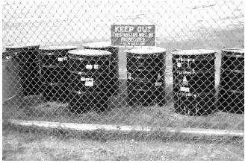
impacts, as well as environmental damage.
Effects of Hazardous Material Releases Most hazardous material incidents that may occur within the County will be small isolated events that can be contained quickly and with minimum impact to health and safety. A large or highly toxic release of hazardous materials, however, may require evacuation of the affected area, technical expertise to control the event, and limitations on access to the area of the release. Other short- and long-term impacts may include surface and ground water degradation, air pollution, fire, explosion, and health

impacts to wildlife, livestock, and humans. Clean-up of hazardous material releases may also result in significant expenditures of public funds.
Hazardous Material Management Regulations
The growing public concern regarding the use and possible mismanagement of hazardous materials has prompted the passage of numerous federal, state, and local regulations regarding their use, storage, transportation, handling, processing, and disposal. Many of the regulations pertaining to the use and storage of hazardous materials at individual businesses are contained in the California Fire Code, which has been adopted by the County. Regulations pertaining to the transportation of hazardous materials are contained in the California Vehicle Code.
Regulations pertaining to local monitoring and control of hazardous material use by businesses are contained in California Health and Safety Code (section 25550 et seq.). These regulations require businesses that use or store hazardous materials in excess of specified quantities to provide information regarding the type and amount of hazardous materials that are used onsite, and to prepare emergency response plans that are to be implemented in the event of a hazardous material release. Businesses are also inspected on a periodic basis to ensure that handling, storage, and disposal practices conform to regulatory requirements. These regulatory requirements are commonly referred to in a “Business Plan.” In San Luis Obispo County, the County Environmental Health Department has been appointed as the administering agency for Business Plans. In addition to the requirement to prepare Business Plans, businesses that use or store specified quantities of substances that have been listed as “acutely hazardous materials” may be required to prepare a Risk Management and Prevention Program, which describes specific safety and record keeping measures, and potential consequences of a materials release.
Hazardous Material Release Response
To address the potential for an uncontrolled hazardous material release in San Luis Obispo County, and to ensure that adequate resources are available to respond to a significant hazardous material release, the County Office of Emergency Services has prepared a Hazardous Materials Emergency Response Plan (1994). The objectives of this plan are to:
- Protect the public in the event of a hazardous material emergency;
- Provide rapid and effective warning to citizens that may be affected by a hazardous material release;
- Identify the responsibilities of local, state, and federal agencies; and

- Describe the emergency organization and management systems necessary to implement the Plan.

Bleeder line, Farrall Road, Arroyo Grande.
In the event of a hazardous materials release in San Luis Obispo County that occurs off of a state highway, the fire agency of jurisdiction where the release has occurred has incident command authority. For hazardous material releases that occur on highways or other roadways that the California Highway Patrol (CHP) has jurisdiction over, the CHP will assume incident command authority. Both the local fire departments and the CHP are supported by the San Luis Obispo County Environmental Health Department, which may provide the only response to small hazardous material release incidents.

The California Department of Fish and Game (CDFG) responds to hazardous material incidents for the purpose of minimizing impacts to fish and wildlife. The DFG also serves as the lead state agency in determining the completion of cleanup when natural resources are threatened. The U.S. Department of Defense and the
U.S. Department of Energy are responsible for hazardous material incidents that involve their respective facilities. Hazardous material releases that occur in or that contaminate marine waters fall under the jurisdiction of the U.S. Coast Guard and the CDFG. A “Unified Command” is used when there is more than one agency or jurisdiction with a management responsibility for a hazardous material release.
Due to the common threat that a hazardous material incident could occur anywhere in the County, the County of San Luis Obispo, all seven cities, fire departments located throughout the County, and a variety of other agencies and jurisdiction, have entered into a regional hazardous material cooperative agreement which provides mutual aid response to hazardous materials emergencies. This program has resulted in the creation of a specialized team of personnel to respond to hazardous material emergencies.
Having a common hazardous material response team allows for the sharing of expenses that would otherwise prohibit most jurisdictions in the County from having similar response capabilities. The purpose of the response team is to “carry out the abatement and emergency control of hazardous conditions and stabilize the same, until these conditions can be turned over to the appropriate authority for further disposal” (OES, 1994). The response team is comprised of firefighters from various jurisdictions throughout the County. When a hazardous material response is required, a primary response vehicle is dispatched from a centralized location, with other team members from other jurisdictions reporting directly to the incident location. Response vehicles are located in strategic areas throughout the County.
Hazard Analysis
San Luis Obispo County
Due to the quantities and frequency with which hazardous materials are shipped through San Luis Obispo County, transportation-related accidents pose the most significant hazardous material risk in San Luis Obispo County. Major transportation routes such as U.S. Highway 101 and the Union Pacific Railroad are used to transport hundreds of thousands of tons of hazardous materials through the County each year. These major north/south transportation corridors extend through or near many of the major incorporated and unincorporated communities of the County, thereby exposing a significant portion of the County’s population to the potentially significant effects of an accidental transportation-related release.
Major east/west highways that are located in the County, such as State Routes 41, 46, and 166, are also used by hazardous material hauling traffic. Although these roadways have lower traffic volumes than U.S. 101, they are two-lane routes that include potential hazards such as steep grades, reduced visibility, sharp turns, and remote locations.
The transportation of hazardous materials is not restricted to truck and rail facilities in San Luis Obispo County. Other systems that are used to carry hazardous materials include a network of pipelines that are predominately used to carry petroleum- related products such as crude oil, natural gas, and fuel products. In support of the

pipeline facilities, there are numerous pumping stations, production and storage facilities that also have the potential to result in an uncontrolled release of hazardous materials.
Although the most significant risk of a hazardous material release in San Luis Obispo County would likely result from a transportation-related accident, a variety of businesses and industrial operations that are located throughout the County use and store significant quantities of hazardous materials. Releases that occur at business and industrial sites can occur suddenly or result from underground leaks that can go undetected or unreported for an extended period of time. Areas with significant subsurface contamination resulting from undetected leaks of petroleum products from underground pipelines and above ground storage facilities include Avila Beach, Tank Farm Road, and the Guadalupe Dunes areas. Other areas that have the potential to experience hazardous material releases include areas that have been developed with concentrations of light industrial and manufacturing uses. An example of such an area is located in the vicinity of the San Luis Obispo County Airport and Tank Farm Road, where numerous small manufacturing and light industrial uses have been established.
To mitigate the potential danger of hazardous materials, specific governmental agencies maintain inventories of the names, locations and substances used by individual businesses and other entities. Per state and federal law, the County Environmental Health Department maintains lists of what materials are used at fixed facilities and where they are used. In addition, Environmental Health and other agencies perform inspections of these facilities to ensure compliance with state and federal standards.
Arroyo Grande
The most significant hazardous material-related risk in Arroyo Grande results from the transportation of hazardous materials along U.S. Highway 101, which is used to ship thousand of tons of hazardous materials each year. Highway 101 runs through the center of Arroyo Grande and a major release of hazardous materials on this roadway would have the potential to expose a significant portion of the City’s population to significant health and safety impacts. Another potential source of a hazardous material release in Arroyo Grande is from a number of oil, fuel and natural gas pipelines that are located in the City.
Hazardous material use by businesses that are located in the City is limited. There are no particular areas where commercial, manufacturing, or industrial establishments that use or store significant quantities of hazardous materials are concentrated. The most significant hazardous material use and storage that occurs in and around the City is from farming operations that use and store agriculture-related products such as fertilizers and pesticides (Fibich, 1997).
Atascadero
The most significant hazardous material-related risk in Atascadero results from the transportation of hazardous materials along U.S. Highway 101 and the Union Pacific Railroad, which are used to ship thousand of tons of hazardous materials each year. Highway 101 runs through the center of Atascadero and a major release of hazardous materials on this roadway would have the potential to expose a significant portion of the City’s population to significant health and safety impacts. The Union Railroad tracks are located along the eastern portion of the City, near the Salinas River. A release of hazardous material from the railroad could expose a large number of people to a

significant health and safety risk, as well as resulting in significant environmental damage.
Hazardous material use by businesses that are located in the City is limited. There are no particular areas where commercial, manufacturing, or industrial establishments that use or store significant quantities of hazardous materials are concentrated. Some of the most significant hazardous material use and storage that occurs in the City is from industrial park-type uses, manufacturing uses such as cabinet shops, and a propane distribution terminal (McCain, 1997).
Grover Beach
The most significant hazardous material-related risk in Grover Beach results from the transportation of hazardous materials along the Union Pacific Railroad, which is used to ship thousand of tons of hazardous materials each year. In 1986, nine railroad cars derailed; three of which were carrying iso-butane. Although their were no leaks, 3000 residents and visitors were evacuated. The Union Pacific Railroad tracks are located along the western portion of the City, near the ocean and residential areas. A release of hazardous material from the railroad could expose a large number of people to a significant health and safety risk, as well as resulting in significant environmental damage.
There are no particular areas within Grover Beach with large concentrations of industrial or other types of land uses that use large quantities of hazardous materials are concentrated. However, there is a gasoline distribution station and an industrial area located south of Farroll Road, in Grover Beach. Perhaps the most significant threat to public safety from hazardous materials results from the periodic incidents of illegally disposed hazardous wastes that are dumped within the City.
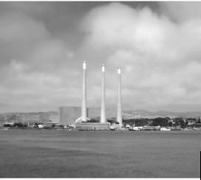
Morro Bay
The potential for hazardous material transportation-related hazards to impact the City of Morro Bay is somewhat reduced when compared to the inland cities of San Luis Obispo County. Transportation-related hazardous material risks are not as prevalent in Morro Bay because it is not located adjacent to U.S. Highway 101 or the Union Pacific Railroad tracks. The major roadway serving the City of Morro Bay is Highway 1, which is not used to transport hazardous materials to the same extent that Highway 101 and the railroad are used.
Within the City of Morro Bay, however, there are industrial operations that store and use substantial quantities of hazardous materials. The most significant of these uses is the PG&E power plant. The City of Morro Bay Fire Department works
cooperatively with PG&E on an ongoing basis to address potential concerns, and reports that there is a good relationship between the plant and the Fire Department regarding the use and storage of hazardous materials. A prominent concern of the Fire Department regarding the plant does not result from direct plant operations, but is related to the transportation of acid material that is used in the emission control systems of the plant through the City (Cassel, 1997).
Another hazardous material concern in the City of Morro Bay is not related to the industrial use of hazardous materials, but results from periodic incidents where containers with unidentified contents wash up on one of the City’s beaches. When this occurs, the City/County hazardous material response team is called.

Other hazardous material concerns pertaining to the City of Morro Bay are related to the location of various petroleum industry facilities that are located in or near the City. These facilities include several pipelines and the Estero Marine Fuel Terminal that is located to the north of the City.
Paso Robles
The most significant hazardous material-related risk in Paso Robles results from the transportation of hazardous materials along U.S. Highway 101 and the Union Pacific Railroad, which are used to ship thousand of tons of hazardous materials each year. Highway 101 and the railroad tracks run through the center of Paso Robles and a large release of hazardous materials on either of these major transportation corridors would have the potential to expose a significant portion of the City’s population to significant health and safety impacts, as well as resulting in significant environmental damage. Another highway that runs through Paso Robles is State Route 46. This east/west roadway serves as a direct route from U.S. Highway 101 to the Kettleman Hills hazardous waste disposal facility in Kings County. Paso Robles possesses 19.9 percent of all stationary hazardous materials generators in San Luis Obispo County.
City of San Luis Obispo
The most significant hazardous material-related risk in the City of San Luis Obispo results from the transportation of hazardous materials along U.S. Highway 101 and the Union Pacific Railroad, which are used to ship thousand of tons of hazardous materials each year. Highway 101 and the railroad tracks run through the center of the City and a large release of hazardous materials on either of these major transportation corridors would have the potential to expose a significant portion of the City’s population to significant health and safety impacts, as well as resulting in significant environmental damage.
Another hazardous material concern in the City is the presence of numerous underground pipelines that are used to transport natural gas and oil products. An accidental release of hydrocarbons from a pipeline would have the potential to result in significant environmental damage, explosions, and other health and safety impacts.
Within the City, there are approximately 140-150 businesses that use hazardous materials in sufficient quantities to require that they file a Business Plan with the Fire Department in accordance with the requirements of the California Health and Safety Code. While most of these businesses do not store large amounts of hazardous materials, there are several industrial uses that use and store substantial quantities of hazardous materials (Redel, 1997).
Radiation Hazards
The Diablo Canyon Nuclear Power Plant is located about 12 miles southwest of the City of San Luis Obispo. The plant has two power-generating units that are both pressurized water reactors. Each reactor has an electrical generating capacity of about 1,100 megawatts. Unit 1 began commercial operation on May 7, 1985, and Unit 2 was put online on March 13, 1986.
The electricity generating process at the power plant relies on the process of “fission,” where uranium atoms are split, resulting in the creation of heat. This heat is used to create steam, which is then used to spin a turbine and generator, which creates electricity. The plant is designed to use slightly enriched uranium dioxide as a fuel.

Table 5-1: Diablo Canyon Power Plant Protective Action Zones (PAZ) and Public Education Zones (PEZ)
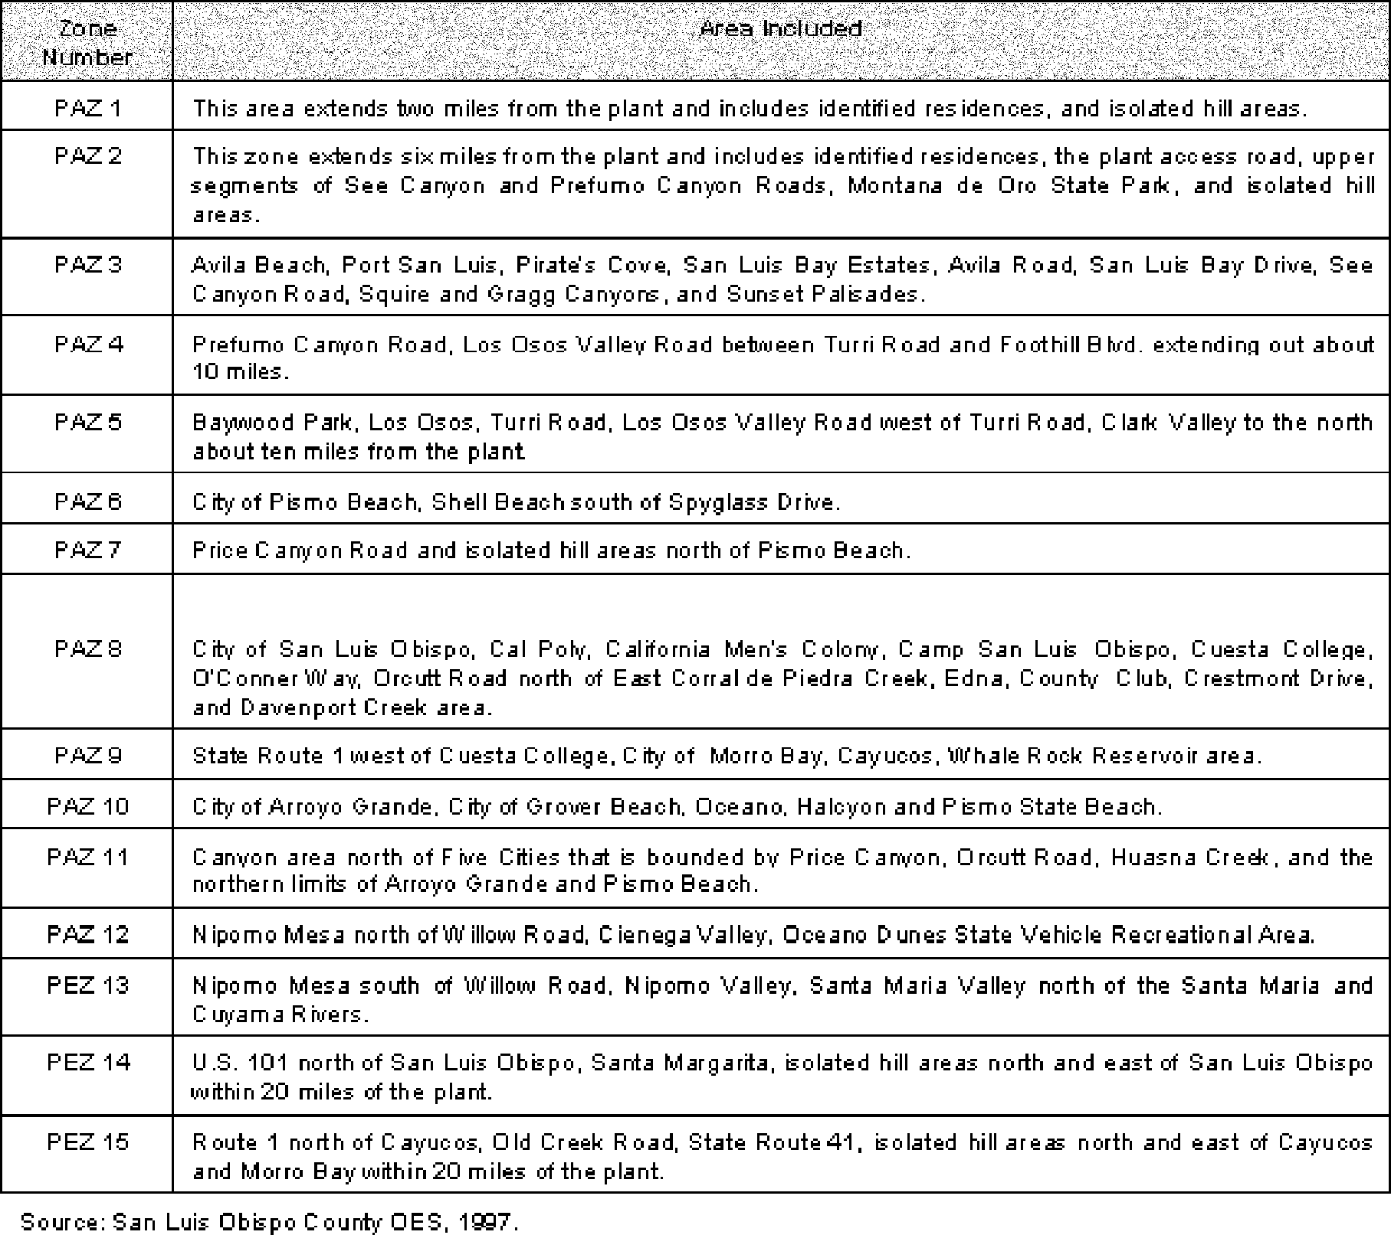

This fuel poses no major risk in its unirradiated state since it is of very low radioactivity. However, after being in the core during operation of the reactor, the fuel becomes extremely radioactive from fission by-products. These highly radioactive by-products would be the main hazard in a nuclear power plant accident.
To control power plant operations and the potential for a release of radioactive material, the plant is provided with multiple safety systems and barriers. These systems, however, cannot provide absolute certainty that a system failure will not occur. To prepare for potential emergency situations that might develop at the power plant, extensive warning, reporting, and response plans have been developed. The response plan for an emergency at the Diablo Canyon Nuclear Power Plant is contained in a document called the County/Cities Nuclear Power Plant Emergency Response Plan. Updated information on the Emergency Response Plan is distributed to the public each year, as required by federal law.
Emergency Response Plans
The area around the power plant has been divided into two types of zones for emergency planning purposes: the Basic Emergency Planning Zone, and the Public

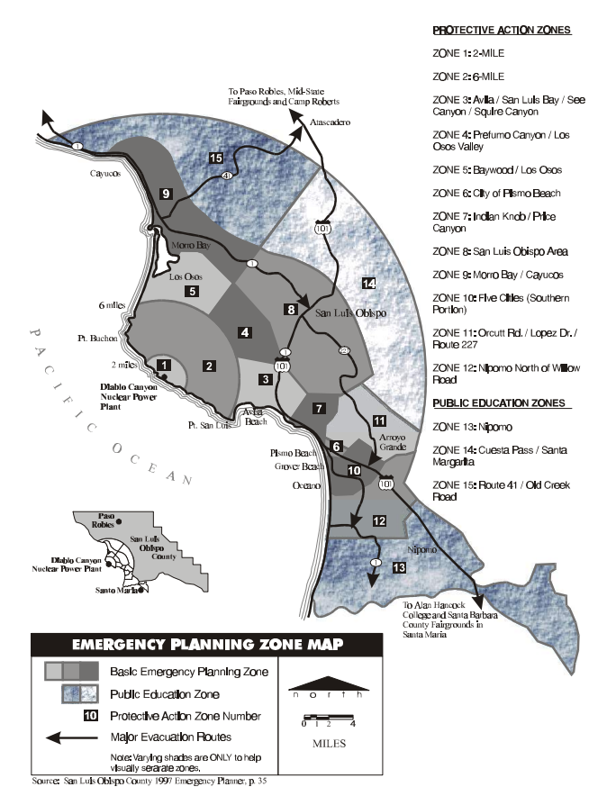

Education Zone. The Basic Emergency Planning Zone is roughly a 14-mile circle around the power plant. Since it is unlikely that the entire Basic Emergency Planning Zone would be affected by a power plant emergency, it has been divided into 12 smaller subzones called Protective Action Zones. These zones are depicted on the figure on the following page and are described in Table 5-1. The Public Education Zone extends out from the power plant approximately 20 miles and has been divided into three zones. It is unlikely that people in a Public Education Zone would need to take protective actions in the event of a power plant emergency.
SIREN INFORMATION
IF YOU HEAR A STEADY SIREN 3 TO 5 MINUTES
TUNE YOUR RADIO TO 920 AM, 1400 AM OR 98.1 FM FOR INFORMATION
WHEN AT SEA, TUNE TO MARINE CHANNEL 16
Two basic factors would determine what, if any, emergency response actions would be required in any of the Protective Action Zones: the amount of radioactive material that is released, and the speed and direction of the wind. Based on the nature and severity of the emergency, a variety of warning and response plans could be implemented. Several of these planning programs are described below.
Many of the programs described below are overseen and required by state and federal agencies. The Federal Emergency Management Agency (FEMA) provides regulatory guidelines on what local agencies’ emergency plans must contain. FEMA requires the county and other local agencies to demonstrate the adequacy of the plans through drills and exercises on an annual or bi-annual basis.
In addition to FEMA, agencies such as the Nuclear Regulatory Commission (NRC) and state Department of Health Services (DHS) provide oversight and guidance on many health related issues. These issues including standards for monitoring potential radiological releases, and providing policies and guidance on protective guidelines such as issuing Potassium Iodine (often referred to by its chemical component identifier “KI”) for emergency workers or the public (KI can block radioactive iodine from being absorbed into the thyroid gland). Local agencies must rely on state and federal policies and guidelines dealing with issues such as public distribution of KI when planning emergencies at nuclear power plants. Local agencies will continue to monitor developments in this area.
Radiological Waste Transportation
In order to be prepared for the possibility of a transportation accident involving hazardous substances, all seven incorporated cities, all other fire agencies in the county, and a number of county agencies participate in the Regional Hazardous Materials (Haz Mat) Response Team. The Haz Mat Response Team is jointly made up of every fire department in the county, as well as the County Environmental Health Department, and has firefighters trained to the highest level of hazardous material response, including incidents involving radiological materials.
While the transportation of radiological waste is regulated by the federal government, local agencies would need to receive specialized training and equipment before large quantities or high levels of such material were moved through the area. In lieu of local agencies, federal or state agencies should provide response teams during periods when such material is being moved. In other areas of the country, the U.S. Department of Energy has provided such training to local agencies. Similar training would be needed for response agencies in this area. Federal agencies generally work with local governments to plan and prepare for transports of radiological and similar wastes.
Emergency Alert System
Formerly known as the Emergency Broadcast System, the Emergency Alert System is a network of radio stations that would broadcast information about the power plant emergency. Information that would be provided may include announcing the Protective

Action Zones that are affected by the emergency and describing what actions residents should take.
Early Warning Siren System
If a power plant emergency becomes serious enough to warrant evacuation of one or more Protective Action Zones, or it is decided that residents should take shelter, Early Warning Sirens will be activated. These sirens create a loud steady tone for three to five minutes, and alert residents to tune in to the Emergency Alert System for more information. In addition to providing warnings regarding the Diablo Canyon power plant, the sirens can be used to provide warnings about other emergencies, such as hazardous material incidents, dam failure, or tsunami. Sirens are tested on an annual and quarterly basis.
Evacuation
If it is determined that certain Protective Action Zone areas should be evacuated, the Early Warning Sirens in that zone would be activated and specific information about the evacuation would be provided by the Emergency Alert System radio stations. In the event of an evacuation, residents would be directed to go to the home of a person outside of the affected area, or to go to a specified reception center that would be operated by the Red Cross. Reception centers would be located at Camp Roberts to the north, and the Santa Barbara County Fairgrounds in Santa Maria to the south. Plans for providing public transportation to the evacuation centers have been developed, and include specific collection points where bus transportation would be provided.
Sheltering
Sheltering means staying inside with all doors, windows, and ventilation systems closed. Sheltering reduces exposure to radioactive material and reduces the chances of breathing in or receiving body surface contamination from radioactive material. Taking shelter in a wooden house reduces exposure approximately 10 percent. A brick or concrete structure reduces exposure by approximately 40 percent, and a large office or industrial building can reduce exposure by up to 80 percent.
School Evacuation
Public, private, and parochial schools within the Basic Emergency Planning Zone have developed emergency plans that would be implemented in the event of a power plant emergency. As a precaution, public school officials may decide to close their schools and move students to an Evacuation Center for School Children before any public action is required. If an evacuation of a specific Protective Action Zone is ordered while schools are in session, public school children in that zone will be evacuated. Evacuation Centers for School Children would be located at the Mid-State Fairgrounds in Paso Robles, and at Allan Hancock College in Santa Maria.
Power Plant Emergencies
Emergency situations that might occur at the Diablo Canyon power plant can be described using emergency classification levels that were developed by the federal government. At each level, PG&E must immediately notify local, state, and federal officials, who would implement appropriate emergency response actions. Under the adopted classification system, not all emergencies mean a release of radioactive material has occurred or is expected. The four levels of emergency are described below.

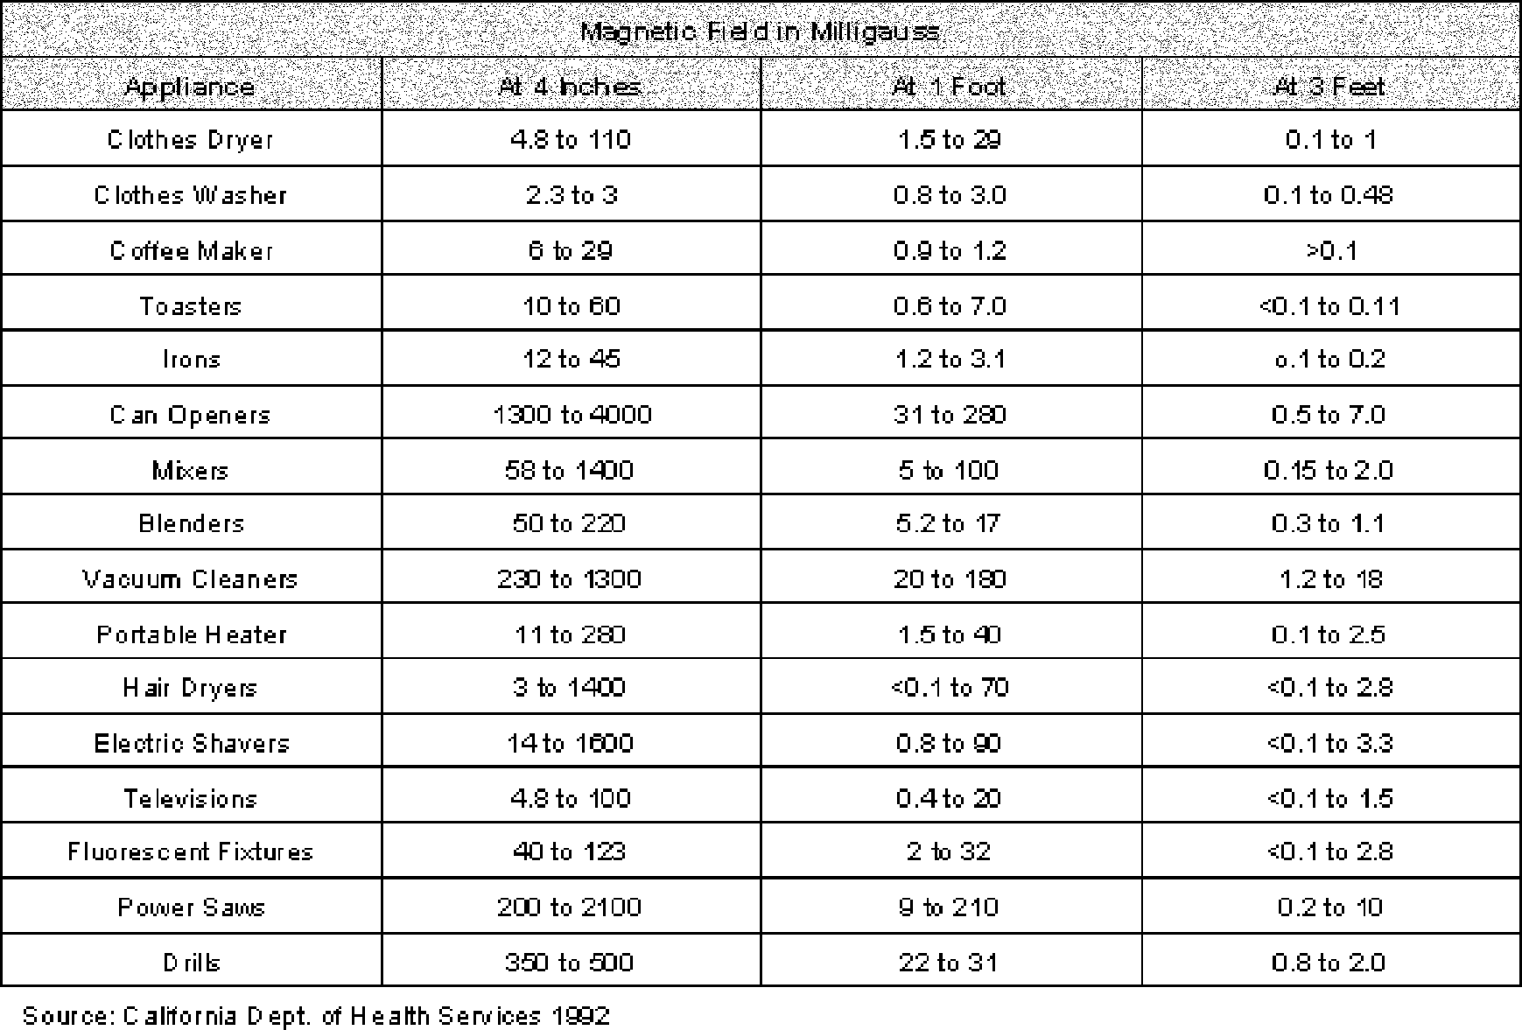
Table 5-2: Examples of Magnetic Fields at Distances from Appliance Surfaces

Notification of Unusual Event
This classification is declared for an abnormal condition at the plant, that indicates a potential degradation of the level of safety at the plant. No releases of radioactive material requiring offsite monitoring are expected unless further degradation of safety systems occurs.
Alert
An alert would be declared for an actual or potential substantial degradation of the level of safety at the plant. This would prepare emergency personnel to respond if necessary. Any radioactive releases would be expected to be limited to a small fraction of the EPA Protective Action Guideline exposure level, but would not be expected to require protective action beyond the plant boundary. Early warning sirens would not likely be activated and news reports would provide information about the situation. Other official actions that may take place include the possible closure to Montana de Oro State Park and the closure of certain public schools.
Site Area Emergency
A site area emergency would be declared in the event of an actual or likely failure of plant functions that are needed for public safety. If a radioactive release occurred, it would not be expected to require protective measures farther than one-half mile from the plant. If evacuation or sheltering is recommended for the public in any Protective Action Zone, sirens would be sounded and the Emergency Alert System would be activated to provide further information.

General Emergency
A general emergency would be declared if very abnormal plant conditions caused or might lead to actual or imminent core degradation or melting, with potential for loss of containment integrity. Sirens would be sounded, the Emergency Alert System would be activated, and the Protective Action Zones closest to the plant would likely be evacuated. Evacuation or sheltering in other zones within the Basic Emergency Planning Zone may also be required.
Electromagnetic Fields
The most common type of electricity that is used in the United States is alternating current (AC), where the current does not flow steadily in one direction but moves back and forth at a rate of 60 times per second. Wherever there is electric current, there are also electric and magnetic fields which are created by the electric charges. Electric fields arise from the amount of the charge, and magnetic fields result from the motion of the charge.
Electric fields are measured in term of volts per meter (V/m) or kilovolts (1000 volts) per meter (kV/m). The earth has a natural static electric field of about 120 to 150 V/ m at ground level. Natural static electric fields occurring beneath clouds and during dust storms can be significantly more intense. Almost all household appliances create an electric field derived from the voltage on the appliance even when not in use, if the appliance is connected to an electrical supply. Electrical fields may be effectively shielded or blocked by objects such as earth, trees, or buildings.
Magnetic field intensity is measured in units referred to a “Gauss” (rhymes with “mouse”). Values are also reported in milliGauss (0.001 Gauss = 1 mG). The earth has a natural static magnetic field of approximately 0.05 Gauss or 500 mG at middle latitudes. Unlike electric fields, magnetic fields cannot be blocked by structures.
Electric and magnetic fields are created by high voltage electric transmission lines, distribution lines that bring electricity into structures, and from all common household appliances that use electricity. The strength of electric and magnetic fields that are produced by the transmission and use of electricity diminish quickly as the distance to the source of the field increases. Table 5-2 indicates how rapidly the strength of magnetic fields from common household appliances dissipates as distance is increased from the source.
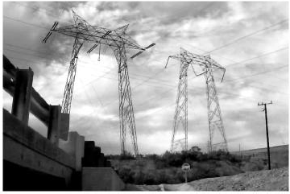
Other common sources of magnetic fields are cellular phones, computers, and appliance transformers. Electric and magnetic fields associated with the use of electricity differ from other types of electromagnetic energy such as x-rays and microwaves. For example, x-rays have so much energy that they can “ionize” or break up molecules such as the DNA that makes up human genetic material. Microwaves are absorbed by water in tissue, and by doing so, the water and tissue is heated. Radio frequency fields from radio and television transmitters are another step “weaker” than microwaves. Although they alternate millions of times per

second compared to electric fields that alternate 60 times per second, radio frequency fields lack the energy to ionize molecules, and can only heat body tissue when a subject is very close to the source. Electric and magnetic fields, by contrast, do not have enough energy to break chemical bonds or to heat body tissues.
Because electric and magnetic frequency fields that are usually present in the environment do not ionize molecules or heat tissues, it was previously believed that they have no effect on biological systems. In the mid-1970s, however, a variety of laboratory studies demonstrated that biological changes can be produced by these weak fields.
Current scientific research has focused on exposure to electromagnetic fields (EMF) rather than electric fields. Although preliminary studies have raised the possibility of emotional, behavioral, and reproductive effects, the greatest public concern has arisen because of media reports about epidemiological studies showing a statistical association of magnetic fields with cancer. Epidemiological studies relate the occurrence of disease in human populations to exposures suspected of being causes of disease. The epidemiological studies have yielded some results supporting a relation between cancer occurrence and exposure to magnetic fields, and some studies have found no relation.
In late 1990, the California Office of Health and Environmental Assessment prepared a report entitled “Evaluation of the Potential Carcinogenicity of Electromagnetic Fields” which reviewed epidemiological and laboratory studies. The report concluded the because of uncertainties regarding the basic nature of the interaction between EMF and biologic processes, it would be inappropriate to classify EMF as a carcinogen in the same way that chemical carcinogens are classified. In early 1991, the EPA’s Science Advisory Board reviewed the reports and concluded that there is insufficient data to determine a cause and effect relationship and that more research is needed.
In January 1991, the California Public Utilities Commission (CPUC) began an investigation of its role in mitigating health effects, if any, of EMFs from utility facilities and power lines. In November 1993, the CPUC issued interim decision 93-11-01, which, in part, stated: “it is not appropriate to adopt any specific numerical standard in association with EMF until we have a firm scientific basis for adopting any particular value.” This decision also included requirements for developing design guidelines for utilities to use in reducing EMF from new and upgraded facilities at no or low cost. No or low cost is defined as being less than four percent of the total cost of a budgeted project.
Due to their high voltage and high EMF exposure potential, electric transmission and distribution lines are commonly identified as an EMF exposure source. The intensity of electromagnetic fields created by power lines is dependent upon the line voltage, the height above the ground or the depth below the ground, electrical phasing configuration, and the distance from the line.
The Pacific Gas and Electric Company reports that for distribution lines of 21,000 volts (21 kV)and less, the magnetic field strength under the line would be 2-36 mG. At a distance of 50 feet, the field strength drops to 1-6 mG, and at 100 feet, it drops further to 1-2 mG (PG&E, 1994). The EPA reports that a person standing under a typical 230 kV power transmission line is likely to be at least 20 or more feet away from the line, depending on its height above the ground. Under these

conditions, the magnetic field under the line is probably less that 120 mG. One hundred feet away, the magnetic field strength drops to about 15 mG, and 300 feet away the field is probably less than 2 mG. The actual strength of the magnetic field will vary depending on the current moving through the line, as magnetic fields will be higher during times of peak electricity usage.
Based on a graph of electric field strengths provided from the Southern California Edison Company, and not scientific research data, the California Department of Education has adopted limits for locating school sites near high voltage power transmission line easements (Merritt, 1994). The adopted setbacks are listed below:
- 100 feet from the edge of easement for 50-133 kV lines;
- 150 feet from the edge of easement for 220-230 kV lines; and
- 350 feet from the edge of easement for 500-550 kV lines.

Throughout San Luis Obispo County, there is a network of power transmission lines as well as a number of substations and switching stations. There are also two major power generating facilities, including the natural gas burning facility in the City of Morro Bay and the Diablo Canyon nuclear power plant. High voltage transmission lines that emanate from these plants are also located throughout the County. The prior figure depicts the location of major electric power lines and facilities that are located in San Luis Obispo County.
At this time, the evidence of potential health hazards from the delivery and usage of electric power is incomplete and inconclusive. A substantial amount of research has been conducted; however, more is needed to answer the many questions and uncertainties that must be resolved to formulate sound public policy. Until the necessary information is available to make informed decisions about exposure to EMFs, individuals and the County and cities may wish to consider adopting a “prudent avoidance” strategy. Prudent avoidance means adopting measures to avoid EMF exposures when it is reasonable, practical, relatively inexpensive, and simple to do so. For individuals, this may mean not using electric blankets, moving the computer monitor further away from the user, and avoiding the use of electric appliances when manual powered appliances are also available. For jurisdictions, this may mean adopting new development standards that minimizes EMF exposure near sensitive areas (e.g. schools, playgrounds, and hospitals), minimizing the creation of new EMF fields in areas with existing high exposures, informing citizens of projected EMF strengths during the design or environmental review phases for new substations, transmission and distribution lines, and limiting public exposure to EMFs in siting new substations and transmission/distribution lines when practical alternatives exist.
Structural Hazards
In a strong earthquake, generally of Richter magnitude 5 or more, any type of structure may experience some level of damage resulting from ground shaking. This damage may range from minor cosmetic damage, such as cracked plaster, to complete structural failure and collapse. If a structure is inadequately designed or constructed to withstand the forces of earthquake caused ground shaking, the level of damage that may be suffered is likely to be high. After each major earthquake, important lessons are learned regarding the ability of structures to resist the effects of groundshaking, and updated building codes incorporate these lessons as new construction requirements. As a result, modern building techniques incorporate numerous design and construction methods

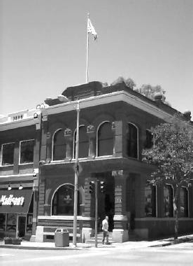
to help buildings and other structures resist the forces of earthquake caused ground shaking.
It is generally not economically or structurally feasible to build a totally earthquake-proof structure. Therefore, there is a certain level of earthquake-related damage risk associated with all structures. The level of risk that is considered to be acceptable by the public is typically determined by the cost of providing additional protection, the importance that the structure be able to resist damage and remain functional after a strong earthquake, and the probability that a structure will fail during an earthquake. For these reasons, buildings used for fire and police stations, schools, hospitals, and other “critical” uses, are generally designed and constructed to withstand higher levels of groundshaking than “non-critical” structures.
The performance of a structure in an earthquake will be influenced by many factors; however, structures with similar construction materials and building techniques generally exhibit similar response characteristics. Factors that can influence building performance in an earthquake can include site specific geologic conditions; the shape of the building and other structural design characteristics; the magnitude and duration
of strong shaking and other earthquake characteristics; building material; and construction quality. Certain types of building materials and construction techniques have demonstrated the ability to resist strong ground motion better than other types of building techniques and materials. Listed below is a brief summary of some of the earthquake response characteristics that are typically associated with different types of building construction materials.
Wood Frame Buildings
Small one- and two-story wood frame structures generally withstand the effects of ground shaking quite well. These buildings rarely collapse, primarily because of their flexibility and light weight. Large wood frame buildings of two stories or more may be badly damaged during an earthquake, but usually do not collapse. Unfortunately, wood frame buildings are prone to damage by fires that often occur after a large earthquake.
Steel Frame Buildings
These structures are very flexible and will usually survive ground shaking well. As in all types of structures, defects in construction such as poorly welded structural members can result in increased levels of damage.
Reinforced Masonry Buildings
When properly designed and constructed, reinforced masonry structures can survive the effects of ground shaking quite well. However, these types of structures are brittle, and in strong quakes may crack and have a higher potential for collapse than wood and steel frame structures. Improper concrete mix, structure design, or inadequate reinforcement will substantially increase the potential for structural failure.
Unreinforced Masonry Buildings
These types of structures consist of buildings made of unreinforced concrete and brick,

hollow concrete blocks, clay tiles, and adobe. Buildings constructed of these materials are heavy and brittle, and typically provide little earthquake resistance. In small earthquakes, unreinforced buildings can crack, and in strong earthquakes, they have a tendency to collapse. These types of structures pose the greatest structural risk to life and safety of all general building types.
Non-structural items and building components can also influence the amount of damage that buildings suffer during an earthquake. Unreinforced parapets, chimneys, facades, signs, and building appendages can all be shaken loose, creating a serious risk to life and property.
As described above, unreinforced masonry buildings generally perform poorly in strong earthquakes, and have a high potential to suffer extensive damage. Due to the public safety risks that are posed by unreinforced masonry buildings, the California legislature passed Senate Bill 547 (Government Code section 8875 et seq.). This legislation went into effect January 1, 1987, and required all cities and counties located in Seismic Zone 4 (this includes San Luis Obispo County) to conduct an inventory of potentially hazardous structures, including unreinforced masonry buildings. After the survey was completed, jurisdictions were required to develop a program to mitigate potentially hazardous structures. All proposed mitigation programs were required to be reported to the appropriate legislative body of the city or county and filed with the Seismic Safety Commission. SB 547 requires the inventory and establishment of a mitigation program that, at minimum, includes notification to the legal owner that the building is considered to be one of a general type that historically has little resistance to earthquake related loads.
County of San Luis Obispo
To comply with the requirements of SB 547, the County of San Luis Obispo adopted the Uniform Code for Building Conservation as part of Title 19 (Building and Construction Ordinance) of the County Code. Surveys that were conducted to identify potentially unsafe unreinforced masonry buildings identified about 80 structures that will require modifications to meet specified earthquake resistance structural standards. Identified structures that require seismic retrofit are generally located in various areas, mostly urban. The County’s ordinance implementing SB 547 requires the owners of identified unreinforced buildings to demolish or complete modifications to the structure prior to 1997 to 2000, depending upon the building’s use and number of occupants.
Arroyo Grande
To comply with the requirements of SB 547, the City of Arroyo Grande adopted the Uniform Code for Building Conservation. Surveys that were conducted to locate potentially unsafe unreinforced masonry buildings identified very few structures that would have required modifications to meet specified earthquake resistance structural standards. Most of the buildings identified as unreinforced masonry buildings were located in the Village Area. The City worked closely with property owners, and through voluntary measures, minimum earthquake resistance improvements were made to all but one building.
Atascadero
To comply with the requirements of SB 547, the City of Atascadero adopted Ordinance No. 226, which amended Title 8 of the Atascadero Municipal Code to include the requirements of the Uniform Code for Building Conservation. Surveys that were conducted to identify potentially unsafe unreinforced masonry buildings identified 20

structures that will require modifications to meet specified earthquake resistance structural standards. The City’s ordinance implementing SB 547 requires the owners of identified unreinforced buildings to demolish or complete retrofits to the structure prior to the year 1996. However, at the time this report was produced, the City’s ordinance implementing SB 547 was being revised in order to extend the retrofit deadline.
Grover Beach
To comply with the requirements of SB 547, the City of Grover Beach adopted ordinance number 95-5 (Municipal Code section 8103) which adopted the requirements of the Uniform Code for Building Conservation. Surveys that were conducted to identify potentially unsafe unreinforced masonry buildings originally identified 19 structures that required modifications to meet specified earthquake resistance structural standards. These structures are located on Grand Avenue. The City’s ordinance implementing SB 547 does not have a deadline date.
Morro Bay
To comply with the requirements of SB 547, the City of Morro Bay Municipal Code section 14.18 adopts the requirements of the Uniform Code for Building Conservation. Surveys conducted to identify potentially unsafe unreinforced masonry buildings identified 15 structures that would require modifications to meet specified earthquake resistance structural standards. These structures are generally located in the downtown area (Morro Bay Boulevard and Main Street). Four of the buildings were retrofitted in 1992-93 and all building owners were served with an order to comply with the City’s Municipal Code section 14.18 in 1991. In 1996, the City Council amended section 14.18 of the Municipal Code to provide for voluntary compliance in accordance with California and Safety Codes sections 19160-19169.
Paso Robles
To comply with the requirements of SB 547, the City of Paso Robles adopted Ordinance No. 696 which adopted the requirements of the Uniform Code for Building Conservation. Surveys that were conducted to identify potentially unsafe unreinforced masonry buildings identified [structures that will require modifications to meet specified earthquake resistance structural standards. Identified structures that require seismic retrofit are generally located in the downtown area. The City’s ordinance implementing SB 547 requires the owners of identified unreinforced buildings to demolish or complete modifications.
City of San Luis Obispo
To comply with the requirements of SB 547, the City of San Luis Obispo adopted Ordinance No. 1287 which adopted the requirements of the Uniform Code for Building Conservation. Surveys that were conducted to identify potentially unsafe unreinforced masonry buildings identified 127 structures that will require modifications to meet specified earthquake resistance structural standards. 67 percent of the identified structures that require seismic retrofit are generally located in the downtown area. Ordinance No. 1323 requires the owners of identified unreinforced buildings to demolish or complete modifications to the structure prior to the year 2017. In the interim, property owners are required to complete partial strengthening as a condition of reroofing the building.
Airport Hazards
San Luis Obispo has three airports, San Luis Obispo, Paso Robles and Oceano. In rural areas, there are numerous private landing strips. Each of the three operating airports has designated hazard zones extending from the end of each active runway. Safety hazards associated with the County’s airports are principally related to the risk of an aircraft

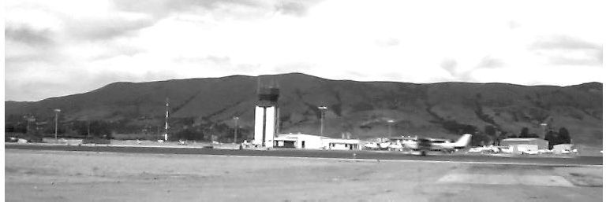

accident and are addressed by each airport’s land use plan adopted in compliance with Section 21675 of the California Public Utilities Code. Noise occurring at these airports, is addressed in the Noise Element.
San Luis Obispo

This is the largest airport in the County, providing commuter and private service to the region. Three major airlines operate commuter service (flying 15 to 35 seat propeller planes) to Los Angeles, San Francisco and Sacramento. Other smaller companies also provide regular and charter service. The airport is located south of the City of San Luis Obispo in the Edna Valley. The area to the east of the airport is undeveloped property (at various times large projects have been proposed for this area) and vineyards. Surrounding the airport is the industrial and commercial area known as the “Airport Area” of the County. This area has long been under consideration for annexation to the City and will continue to develop. Most aircraft risk would be to properties to the west and northeast of the airport.
Paso Robles
The second largest airport in the County is located in the northeast portion of the City of Paso Robles, near the California Youth Authority facility. As well as that facility, this municipal airport is near low and medium density residential uses in the Jardine Road area to the east. Areas north and south of the airport are relatively undeveloped. The airport is used primarily by private aircraft, although on occasion (usually because of fog) flights will re-route to Paso Robles from San Luis Obispo. The airport also has an active sky diving business (15 to 20 flights per week). There have been occasional conflicts (real or perceived) between aircraft and jumpers. The airport is also used extensively by state fire fighting aircraft during wildland fire season.
Oceano
The smallest of the three airports, Oceano is mostly used for private aircraft. The airport is located south of the community of Oceano. It has a single runway which has row of crop fields to the east; and a residential area and the Pacific Ocean to the west.
Hazardous Trees
Mature trees can be an integral part of a community, often providing a distinctive appearance and helping to establish and define the character of the community. Examples of how trees can help to define the identity of a community can be seen in several locations in San Luis Obispo County. These examples include the Monterey pine trees of Cambria, eucalyptus trees of the Nipomo area, and the oak trees of the Paso Robles area. To help preserve trees from indiscriminate or unnecessary removal, the County of San Luis Obispo Land Use

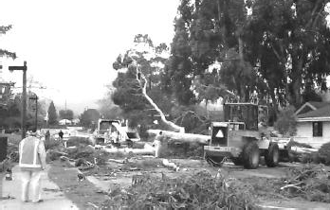

Ordinance (section 22.05.060) specifies conditions where a permit is required to be obtained prior to the removal of certain trees within urban and village areas. One of the criteria for removing a tree is when it is “dead, diseased beyond reclamation, or hazardous.”
A condition that is threatening the health of the Monterey pine trees in the Cambria area is the pine pitch canker. This disease, native to Mexico and the southeastern United States, was first found in California in 1986. Since then, it has been found in 16 counties, and is spread by insects, the use of contaminated tools, and the transport of infected
wood. The pine pitch canker is considered to be a significant threat to the continued survival of the Monterey pine ecosystem. Monterey pine trees were once common along the California coast approximately 11,000 years ago, but changing weather conditions, and more recently, development pressure has limited the occurrence of native Monterey pine trees. Large native stands of the trees are now only found in the Ano Nuevo, Monterey, and Cambria areas.
If a tree becomes infected with the pine pitch canker, the disease can spread quickly, and can result in the rapid death of the tree. If an infected or dead tree is not properly removed, it not only becomes a threat to spread the disease, but can also result in a safety threat, as a large dead tree is a fire hazard as well as presenting the potential to become uprooted and to fall during a storm. The proper and timely removal of dead trees from the Cambria area has recently presented problems, particularly when the dead tree(s) is located on a vacant lot, or a lot with an absentee owner. This can become a problem because trees that are infected with the pine pitch canker can die so rapidly, the property owner(s) may not be aware that a problem exists.
Radon Hazards
Radon is a naturally occurring gas that is produced by the breakdown of uranium in soil, rock, and water. Radon cannot be detected by sight, taste, or smell, and it is estimated to cause between 7,000 and 30,000 lung cancer deaths per year. The most common source of exposure to radon is from the accumulation of the gas inside structures. The Surgeon General and EPA recommend testing for radon, and reducing radon in homes that have high levels. EPA uses a continuous exposure level of 4.0 pCi/L (picoCuries per liter of air) as a guidance level at which remedial action is recommended. Based on indoor
radon data from the EPA/State Residential Radon Survey of California conducted during 1989-90, the average indoor radon level for the 15 residences surveyed in San Luis Obispo County was 2.7 pCi/L.
Radon enters a structure because the air pressure inside the building is usually lower than the air pressure in the soil around the building foundation. Because of this difference in pressure, radon can be drawn into a structure through foundation cracks and other openings. Two factors that contribute to a structure’s indoor radon levels are the geology the structure is founded on and the construction of the stucture. Stuctures founded on uranium sources or geologic formations with high

equivalent uranium (eU) concentrations are at a higher risk of exhibiting elevated indoor radon levels. Generally, Mesozoic granitic rocks, Tertiary sedimentary rocks derived from them, and Tertiary marine sedimentary rocks tend to exhibit increased eU concentrations. Also soils with high permeability allow movement of radon gas to a greater extent than low permeability soils. The construction of a structure also affects the indoor radon level. Structures that are well sealed but allow infiltration through the foundation are more likely to exhibit higher indoor radon levels than structures with a sealed foundation. Structures that are built partly below grade, or structures that are cut into a hillslope, are more likely to exhibit higher radon levels than structures built with slab-on-grade or raised floor systems.
Numerous techniques exist to limit the infiltration of radon into new construction. Preventing or sealing cracks that may develop in the foundation slab will help prevent radon from entering the structure. For existing buildings, methods to reduce radon exposure usually include the installation of fans and exhaust systems designed to expel radon gas and improve the circulation of air throughout the structure.
Return to Table of Contents

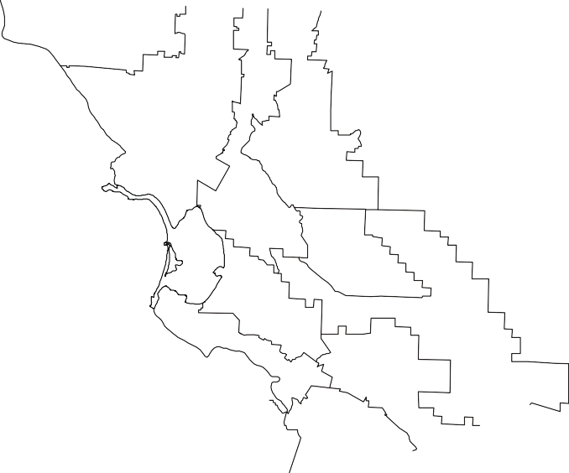


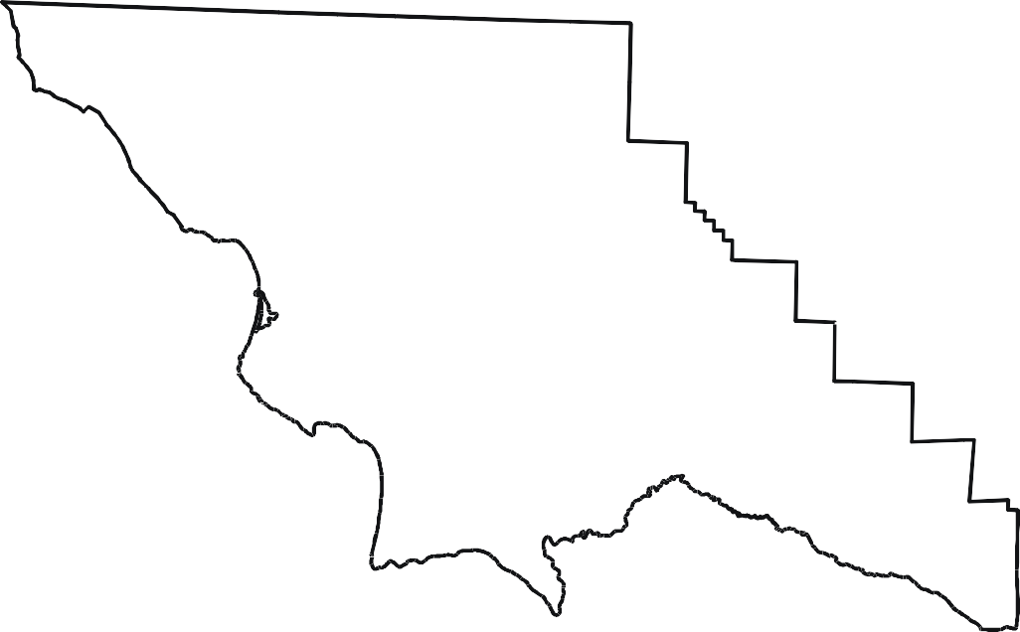

Safety Element
S A N L U I S O B I S P O C O U N T Y G E N E R A L P L A N

MAPPING

SAN LUIS OBISPO COUNTY DEPARTMENT OF PLANNING AND BUILDING
December 1999

